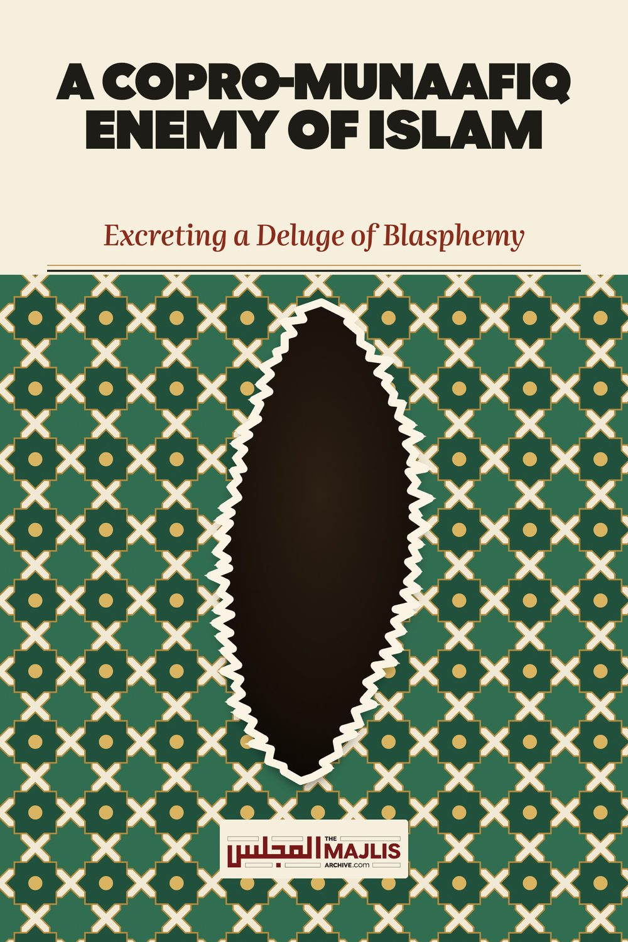

A Copro Munaafiq Enemy of Islam
The Majlis · Voice of Islam
Mujlisul Ulama of South Africa

About this edition
This is a reproduction by The Majlis Archive (themajlisarchive.com) of a publication of The Majlis, Mujlisul Ulama of South Africa, made and published with their permission.
The PDF as The Majlis issued it is the original. This edition was read from that PDF's own structure and checked against it letter for letter; where the two differ, the PDF is correct.
Checked: 70 paragraphs, 0 differing; a second, independent PDF reader finds 100.0% of the PDF's words here.
Nothing has been reworded, added or removed.

BY: The Majlis PO Box 3393 Port Elizabeth 6056

A COPRO-MUNAAFIQ ENEMY OF ISLAM EXCRETING A DELUGE OF BLASPHEMY
One miserable munaafiq moron, Fawad Ahmed in America, has peddled a bundle of copro najaasat in an article which confirms that this stercoraceous, western bootlicker is just one more rubbish planted into the fabric of Muslim society by his kuffaar illuminati/free mason handlers.
The munaafiq peddles a satanic view totally abnegating the five daily Fardh Salaat in particular, and the whole of Islam in general, yet the shaitaani jaahil professes to be a Muslim. According to the jaahil munaafiq, Salaat can mean anything and everything, except 'Namaaz' or the Five Daily Fardh Salaat.
The view which the epistasis bred by Iblees La-een disgorges is a cog in the western kuffaar machinery of scuttling Islam. The western kuffaar with their illuminati, freemason and orientalist components under Yahood supervision and conspiratorial direction have always and are still conspiring dark and sinister plots to undermine and destroy Islam. For giving practical expression to their plots, they have succeeded in the process of mental and intellectual colonization of the brains of Muslims who study at their universities. Consequently, they have enlisted numerous of their surrogates who masquerade as Muslims whilst in reality they all are munaafiqeen worse than the munaafiqeen who had flourished during the age of Rasulullah (sallallahu alayhi wasallam).
These munaafiqeen have been indoctrinated and tutored to firstly scuttle the Four Math-habs since these Math-habs constitute the greatest bulwark of Islam. Only the Four Math-habs are the sole repositories of the Sunnah as expounded in the Ahaadith of Rasulullah (sallallahu alayhi wasallam). The moron munaafiq, like all other moron munaafiqeen in the employ of the enemies of Islam, pretends to be an 'authority' of the Qur'aan. All these moron munaafiq surrogates of the kuffaar western orientalists, Free Masons and Yahoodi Illuminati, offering perfunctory allegiance to Islam, peddle their kufr twaddle in the name of the Qur'aan. They dig out verses which they submit to their copro-opinions to extract copro-conclusions of conspicuous kufr. About these copro-rubbishes, Hadhrat Umar (radhiyallahu anhu) said: "Verily, the people of (copro) opinion are the enemies of the Sunnah."
While these munaafiq rubbishes whose brains are deranged with stercoraceous substances excreted into their sensorium by Iblees La-een, reject in entirety the Sunnah of Rasulullah (sallallahu alayhi wasallam), the Qur'aan Majeed which these illegitimate offspring of the Devil-in-Chief do not overtly reject, declares with clarity and emphasis:
"Verily, for you in Rasulullah there is a Beautiful Pattern of Life (Uswah Hasanah) for those who have hope in Allah and the Day of Aakhirah, and they remember (make thikr) of Allah in abundance."
This Uswah Hasanah is commanded by the Qur'aan which the copro-munaafiq bootlicker of the Yahood illuminati has not dared to denounce and reject. It is this Qur'aanic Uswah Hasanah which is termed "The Sunnah", and which is structured on the Ahaadith in exactly the same way as the authenticity of the Qur'aan Majeed is rooted in and substantiated by the Ahaadith. Innumerable Qur'aanic aayaat command adoption of the Sunnah by ordering obedience to the Rasool. "Obey Allah and obey the Rasool…." (Qur'aan in innumerable verses)
The moron munaafiq, an agent of Iblees La-een, makes an utter fool of himself by labouring abortively to deny and refute the Sunnah meaning of the term 'Salaat' commanded in the Qur'aan. In his miserable, stupid and absolutely bunkum attempt to negate the Islamic meaning of Salaat and to deny that the Qur'aanic command of Salaat applies to the Five Daily Fardh Salaat, he conspicuously advertises his compound ignorance. Even Iblees is aghast at the copro-rubbish which the mouth of the copro-munaafiq excretes.
The Ahaadith and Sunnah apart, even a kaafir who reads the Qur'aan will understand that the term Salaat in the Qur'aan is specific in meaning, and that it refers to institutional/ritual worship (ibaadat), and not to any literal meaning or some satanically conjectured copro-abberation of kufr.
The command in the Qur'aan is to perform Salaat at specific times and fixed times. Thus, Allah Ta'ala declares in the Qu'raan:
"Verily, Salaat is obligatory on the Mu'mineen at fixed times.
(An-Nisaa', Aayat 103)
"Establish Salaat at the two extremities of the day and during portions of the night." (Hood, Aayat 114)
"Establish Salaat from the setting of the sun until the darkness of the night, and also the Fajr Salaat. Verily, the Fajr (Salaat) is attended (by the Angels)."
(Al-Israa', Aayat 78)
"And during the night perform Tahajjud as Nafl (extra) for you."
(Al-Israa', Aayat 79)
The following aayat explicitly mentions Fajr and Ishaa' Salaat by name:
"O People of Imaan! Those whom your right hands own and those who have as yet not reached maturity should seek permission from you (to enter your private rooms) on three occasions: before Fajr Salaat……..and after Isha' Salaat."
(An-Nur, Aayat 58)
Regarding Jumuah Salaat, the Qur'aan states:
"When the call (Athaan) is announced for Salaat on the Day of Jumuah, then hasten to the Thikr of Allah." (Al-Jumuah, Aayat 9)
"When the Salaat has been discharged, then spread out in the land…"
(Al-Jumuah, Aayat 10)
The Qur'aan commands performance of Salaat in Jamaat. "And make Ruku' with those who make Ruku' ". That is: Perform Salaat with Jamaat.
Commanding facing the Qiblah when performing Salaat, the Qur'aan states: "And, wherever you may be, turn your face towards Musjidul Haraam."
In several verses of Surah Baqarah this statement repeatedly ordains the Qiblah direction for the ritual ibaadah of Salaat.
The Qur'aan particularly commands that the "Middle Salaat" be guarded: "And, guard Salaat (especially) the Middle Salaat." (Al-Baqarah, Aayat 238)
The following aayat conspicuously affirms that Salaat is a ritual act of ibaadat:
"O People of Imaan! Do not come near to Salaat whilst you are intoxicated."
(An-Nisaa', Aayat 43)
The command to perform Qasr Salaat, i.e. to reduce four raka'ts to two, along the journey also affirms that Salaat is a ritual act:
"When you travel in the land, then there is no blame on you if you reduce Salaat if you fear that the kuffaar will cast you into trial.." (An-Nisaa', Aayat 101)
"When they (the munaafiqeen such as the copro-munaafiq) stand for Salaat, they stand indolently." (An-Nisaa', Aayat 142)
"O People of Imaan! When you intend to perform Salaat, then wash your faces…." (Al-Maaidah, Aayat 6)
This Aayat explains the full Wudhu which has to precede the ritual Salaat. This fact conspicuously illustrates the gross jahaalat and copro-nifaaq of the jaahil wallowing in compound jahaalat. What type of concept is it which requires the performance of Wudhu?
"And, when you call (recite the Athaan) towards Salaat, they (the kuffar and the copro-munaafiqeen), make a mock and amusement of it." (Al-Maaidah, Aayat 58)
"Thus, after you have performed Salaat, then remember Allah standing, sitting and lying down on your sides (i.e. in all conditions)." (An-Nisaa', Aaayat 103)
All these aayaat affirm with clarity that Salaat is a ritual act of ibaadat and not some stupid, ambiguous concept spawned by the copro-brains of the copro-munaafiq. Besides these verses, the Qur'aan is replete with dozens of Aayaat which establish with clarity that Salaat is a specific ritual act of Ibaadat.
The details of Salaat performance are explained in the Ahaadith which the rubbish munaafiq denies in entirety. So vermiculated are his copro-brains that he denies the Five Pillars of Islam, yet this agent of Iblees professes to be a 'Muslim'. He has surpassed Iblees in kufr and villainy by branding Salaat (Namaaz) a "waste of time" and "paralysing intellect". Only a devil bereft of intelligence whose intellect is totally colonized and corrupted by his western illuminati/freemason masters and fossilized by the villainy of kufr, and in the employ of the plotters conspiring to destroy Islam, is able to excrete and disgorge the kufr and blasphemous rubbish which this Iblees, the victim of intellectual convulsions of kufr and nifaaq propagates.
The kufr rubbish which the jaahil shaitaan has excreted does not warrant an academic response. The purpose for refuting him is to make Muslims aware of the dark plots which the kuffaar of the West, strangled in the grip of the Yahood illuminati, have conspired in their attempts to deracinate Islam. In pursuance of this diabolical plot, the enemies have harnessed into the conspiracy munaafiqeen whom they have educated, indoctrinated, intellectually colonized, and prepared to sow the seeds of kufr, dissension and moral corruption in the Ummah.
This Fawad Ahmed of the U.S.A. is one such villainous munaafiq. There are myriads of such surrogates prowling the world and plying the kufr trade of their western masters.
All movements and sects which propagate the discardence of the Four Math-habs are the initiatives of the western kuffaar. The kuffaar having understood that the only way in which to destroy Islam is to eliminate the Math-habs which teach pure Islam – the Qur'aan and the Sunnah. The common thread running through all sects which have mushroomed after the era of the Salaf-e-Saaliheen propagate the theme of discardence of the Math-habs and subjecting the Qur'aan to opinion. All later day sects propagating anti-Math-habism were aberrations created by the British to foster their divide and rule conspiracy concept. The journalist, David Livingstone wrote an excellent treatise exposing the British conspiracy. He states:
"The communal effort to codify the intricacies of Islamic law is one of the great intellectual achievements of history. And by the ninth century, it was decided that four leading schools would be recognized as representative of Sunni orthodoxy. The schools, known as a Maddhabs, differed on minor points, but were considered mutually compatible.
Therefore, Islamic law was essentially incorruptible. From that point forward, the Doors of Ijtihad ("independent reasoning") were considered closed.
This posed a challenge to the British "Divide and Conquer" strategy of creating sects based on corruptions of the religion. Therefore they sponsored a wave of these so-called "Revivalists" who all demanded a re-opening of the Doors of Ijtihad, beginning with Mohammed Abdul Wahhab, in the mid- 1700s.
Wahhab, a crypto Jew, was sponsored by another crypto-Jew, Ibn Saud, the progenitor of Saudi Arabia. He denounced the Maddhabs and called for a return to the sources, the Quran and Sunnah, undefiled by "human" opinion. He also called a "Jihad" against the Muslims, first within Arabia, and ultimately against the Ottoman Empire.
In 1932, again with British support, the Saud clan seized control of Arabia, which they proceeded to name after themselves. They also seized al Haramain, the sacred precincts of Mecca and Medina and masqueraded as defenders of Sunni Islam.
In 1933, they signed away oil concessions to the Rockefellers' Standard Oil, now Exxon Mobil, the world's third largest company by revenue, and the second largest publicly traded company by market cap. 90% of Saudi revenues from oil, largely managed by the Rockefellers' Exxon Mobil.
The extraordinary Saudi wealth was a key factor in their support for the spread of Wahhabism, as well as the related Salafi movement, which have since essentially become one.
Salafism began in the eighteenth century, headed by a notorious imposter and British agent by the name of Jamal ud Din al Afghani. Afghani was not only the Grand Master of the Freemasons of Egypt, but also a pivotal figure in the European Occult Revival, which included H. P. Blavatsky and Aleister Crowley. Afghani was also an original source of the Masonic teachings of the wayward Nation of Islam in the US.
Afghani's British handler, Wilfred Scawen Blunt, was the first to propose the establishment of a British controlled "Caliphate" (leader of the entire Muslim community) to replace the Ottoman Empire. The idea of a neo-caliphate was later actively pursued by T. E. Lawrence, aka "Lawrence of Arabia," who managed the Arab Revolt against the Ottoman Empire on behalf of the Illuminati Royal Institute for International Affairs (RIIA), the sister organization of the Rockefellers' CFR."
The stupidity of the moron munafiq is indeed colossal, for while he moronically refutes the entire framework and bodywork of Islam structured on the Qur'aan and Sunnah, he accepts the Qur'aan whose authenticity is based on the very Ahaadith which he negates. Minus Ahaadith, there is no Qur'aan. Every aayat of the Qur'aan was authenticated by the Hadith, and nothing else. The rejector of Hadith cunningly provides fuel for the rejecters of the Qur'aan's authenticity, and they are aware of this, since rejection of Ahaaadith is a fundamental constituent in the plot to undermine and eliminate Islam. But, obviously these devils who masquerade as Muslims will never achieve their sinister goal, for the Qur'aan Majeed declares:
"They (the enemies of Islam, including these munaafiqeen) plot to extinguish the Light of Allah with their mouths, and (but) Allah intends to complete His Noor even though the kaafiroon detest it."
This miserable munaafiq, Fawad Ahmed, like all the other bootlickers whose brains have been colonized and convoluted by the western orientalist gang of illuminati, is a cog in the kuffaar conspiracy to destroy Islam. To achieve this pernicious and satanic objective, they manipulate the Qur'aan with their kufr interpretation to bamboozle ignoramuses for entrapment in the snare of kufr plotted by the colonial masters of these surrogate bootlickers and bootleggers.
The bootlicking munaafiq claims that the five daily Fardh Salaat were adopted by Muslims from the Zoroastrians. His stupid excretion of blasphemous flotsam is cluttered with such copro-absurdities which should only be dismissed with contempt. Even baboons stare agape and aghast at the donkey rubbish which the copro-munaafiq disgorges.
The munaafiq implies that for fourteen centuries, Islam was misunderstood right at the inception, that is, by even Rasulullah (sallallahu alayhi wasallam) and the Sahaabah. The moron munaafiq alludes that even they did not understand the meaning of Salaat nor the Qur'aan as a whole. The abominable conclusion of this rubbish kufr disgorged by the illuminati bootlicker is that while Islam was an unknown concept since its inception, he has discovered the 'true' meaning of Islam in August 2014. He has effectively claimed prophethood by presenting his stupid and blasphemous version of 'islam' which is nothing but a deluge of kufr. This copro-munaafiq comes fully within the purview of the Qur'aanic aayat:
"He (Allah) casts rijs (filth) on those who lack brains."
The copro-munaafiq's sensorium is divinely filled with rijs and najaasat hence he vomits coprokufr and his brains haemorrhage with kufr of the most contemptible brand. When the tap of a barrel filled with filth is opened, only filth emerges. Similarly, when the copro-munaafiq opens his noxious mouth, nothing but coprokufr, rijs and najaasat are excreted by his mouth. About copro-munaafiqs of his ilk, the Qur'aan Majeed says:
"And from men is he who disputes in (the laws of) Allah without knowledge, and he follows every rebellious shaitaan.
Muslims should be on their guard when confronted by these copro-munaafiqeen surrogate agents of the orientalist enemies of Islam. Recognize them from their trash talks in rejection of the Sunnah/Ahaadith and the Four Math-habs. Recognize them from the deluge of blasphemy and kufr which pours from every mal-oon aperture of their bodies. Their trap is discardence of the Math-habs and their deception is the hypocritical red herring of 'Qur'aan, the original source'. All of these copro-munaafiqs are ensconced in the conspiratorial dens of Iblees operated by the Yahood illuminati, freemasons and orientalists – all of this lot of kufr flotsam are the western kuffaar.
A religion without Salaat, Zakaat, Saum, Hajj and the entire host of masaa-il which the copro-munaafiq refutes, is NOT Islam. Although the copro-munaafiq character rubbishes into total abnegation all the Faraa-idh, Waajibaat, Sunan and Nawaafil Acts of Islam, he cowardly calls his copro-concept of a religion 'islam'. The reason for this is that the natural attributes of a munaafiq are cowardice, deception and treachery. True to form, this confounded kuffaar-bootlicking copro-munaafiq is just too damned scared to call his shaitaani concept by a copro-name befitting his excretion. Thus, he subjects the Qur'aanic aayat to his copro-opinion acquired from his illuminati kuffaar masters, then he dubs his religion 'islam'. The appropriate name for his religion is SATANISM.

