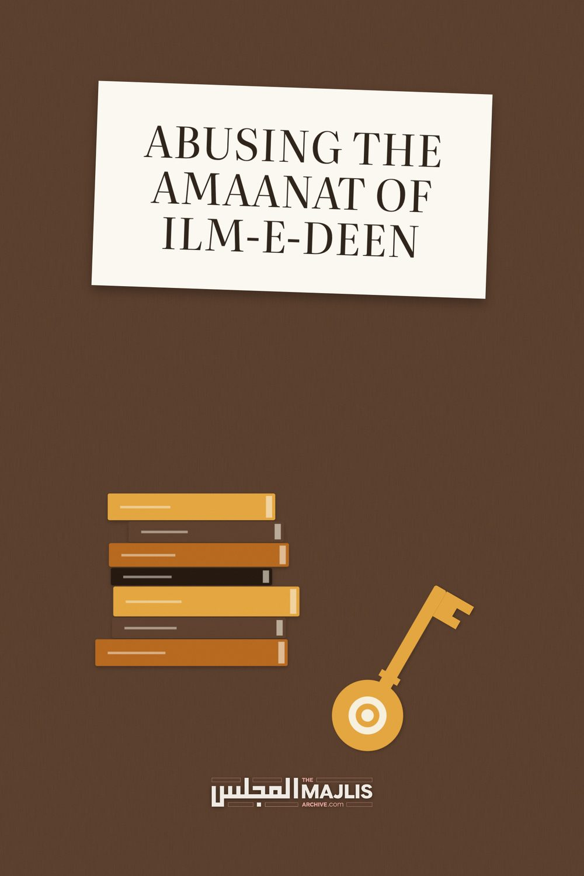

Abusing The Amaanat Of Ilm-E-Deen
The Majlis · Voice of Islam
Mujlisul Ulama of South Africa

About this edition
This is a reproduction by The Majlis Archive (themajlisarchive.com) of a publication of The Majlis, Mujlisul Ulama of South Africa, made and published with their permission.
The PDF as The Majlis issued it is the original. This edition was read from that PDF's own structure and checked against it letter for letter; where the two differ, the PDF is correct.
Checked: 86 paragraphs, 0 differing; a second, independent PDF reader finds 100.0% of the PDF's words here.
Nothing has been reworded, added or removed.

MUJLISUL ULAMA OF S.A.
6056, South Africa

THE INJUSTICE OF THE MADAARIS
Hadhrat Maulana Ashraf Ali Thanvi (Rahmatullah alayh) had the following advice for the managements of the Madaaris:
"The Madaaris should understand that it is not necessary to teach the full course (i.e. the Dars-e-Nizaami – Aalim-Faadhil course) to every student. This should be taught selectively to only such students who have a natural compatibility, ability and affinity (with Ilm), and in whom there is Fahm-e-Saleem (sound intelligence).
Those students who lack in these qualities should be taught only the necessary masaa-il (for daily life). After teaching them the Dhuroori masaa-il, they should be advised to branch out into the world to earn.
Every person is not endowed with the ability to become a Muqtada (a leader/guide in the Muslim community). Some (in fact most) are totally unfit. To impart the full course of Ilm to them (and granting them Molvi certificates) is like handing a sword to a dacoit. It is khiyaanat (abuse of Trust).
Nowadays the Mudarriseen and Muhtamimeen (Ustaadhs and Principals) are totally oblivious of this concern. They do not scrutinize the students to determine who among them are qualified for pursuing this Ilm (at the higher level). All of them do not have munaasabat (natural affinity and compatibility with Ilm) nor do they have fahm-e-saleem. Why do they not select from among the Talaba only those who are fit for pursuing this course?
A special course should be arranged for students who lack the natural ability (for the Aalim-Faadhil course of study). They should not be taught further than this special course which should cover the Dhuroori masaa-il."
(End of Hadhrat Thanvi's advice)
Hadhrat Maulana Ashraf Ali Thanvi (Rahmatullah alayh) has described the abject putrid state of the Madaaris in mild terms. The corruption in the Madaaris at all levels, now about 70 or 80 years after the above observation of Hadhrat Thanvi, has multiplied manifold. The moral corruption of both Students and Ustaadhs today could not have been imagined by Hadhrat Thanvi (Rahmatullah alayh)
in his era which was comparatively a time of sanity – a time of khair.
The lamentable condition of the Madaaris of this age is the consequence of not accepting and even not believing what Rasulullah (Sallallahu alayhi wasallam) said. He said: "He who imparts Ilm to someone unfit (for it) is like one who garlands khanaazeer (swines) with diamonds, pearls and gold."
The truth should not be swept under the carpet. The preponderance of ulama-e-soo' in our time and the deluge of absolute morons bearing the 'Molvi' title, are the direct consequences of ignoring the command of Nabi (Sallallahu alayhi wasallam). Ilm at the higher level is imparted to just any stupid, moron, immoral Tom, Dick and Harry. What type of ulama can therefore be expected from such muck? Rasulullah (Sallallahu alayhi wasallam) himself has described such molvis and sheikhs as 'MUCK'.
"The Saalihoon are departing (in quick succession from this dunya). Then there shall remain only the HUFAALAH (MUCK) such as the chaff/muck/waste of barley or dates. Allah will have no care whatsoever for them."
The Madaaris are living testimony for this lamentable state of affairs described by Rasulullah (Sallallahu alayhi wasallam) and the illustrious Auliya.
What type of Molvi can a scoundrel dressed in bermuda pants and T-shirt, kicking a ball and indulging in kuffaar sport ever be? The Madrasah management should hang its head in shame for having established sports grounds on the Waqf property to enable students studying Qur'aan and Hadith, carrying around big Tafseer and Hadith kutub, to indulge in haraam kuffaar sport in flagrant rejection of Rasulullah (Sallallahu alayhi wasallam) banning all sport as haraam. With kuffaar sport, how is it ever possible for the students to have hearts focussing on Ilm, Allah Ta'ala and the Aakhirat?
It appears that the Ulama who are operating Madaaris are scandalously ignorant of the meaning of a Darul Uloom. They fail to understand that in the background of a Darul Uloom is silhouetted Ghaar-e-Hira which is the Fountain of Ilm-e-Wahi which is being imparted in a Darul Uloom or which is supposed to be taught in such an Institution. What affinity does kuffaar sport and other western paraphernalia have with Ghaar-e-Hira?
The Madaaris today are Signs of Qiyaamah. Among these Signs, Rasulullah (Sallallahu alayhi wasallam) said:
"Knowledge (of the Deen) will be acquired for purposes other than the Deen." Another Sign mentioned in the Hadith is that "the dunya will be pursued with the amal of the Aakhirat".
These Signs of Qiyaamah are being conspicuously and flagrantly displayed by the Madaaris. That is why so many molvis of this age take to immoral media such as facebook, video and television portraying their ugly snouts which will be branded in Jahannam. Regarding such snouts of molvis hideously portrayed on the haraam immoral media, the Qur'aan Majeed says: "Soon shall We brand him on the snout."
Having squandered their years at an institution imparting the Knowledge of the Qur'aan for the sake of the dunya, not for the acquisition of Allah's Pleasure, these corrupt molvis, in pursuit of worldly wealth, name and fame, bootlick the leaders and the affluent members of the community. Thus, they excel in halaalizing riba for the haraam banks. They form haraam so-called 'shariah' boards obsequiously serving the fussaaq, fujjaar and kuffaar capitalist bank owners, digging into the kutub and tearing out of context texts to churn out haraam fatwas to legalize all the riba, faasid and baatil bank contracts, plastering these baatil deals with Islamic sounding terminology. They ingest the Fire of Jahannam into their bellies with remuneration paid for fabricating 'fatwas' of permissibility for haraam products.
The root of the rot is in the Madaaris. The Asaatizah teach merely to earn, and the students study with the same motives for which secular students pursue secular education at the immoral universities. The two sets of knowledge are mutually repellent. While the objective of universities is worldly prosperity, the Maqsad of Ilm-e-Deen is the Aakhirat. The niyyat of the Taalib-e-Ilm should therefore not be even Da'wat and Tableegh. He should not pursue the Ilm of the Deen to enable him to operate a darul Ifta or to be an Imaam in a Musjid, or to earn a livelihood. His only niyyat should be Allah's Pleasure and Prosperity in the Aakhirat.
Therefore, only a handful of Students should be allowed to pursue the Aalim-Faadhil course. Such Students are not in need of a long certificate nor to be turbaned. The goal is the Aakhirat, hence there is the need to dispense of these trappings which no longer have any valid meaning. The only purpose for such paraphernalia nowadays is riya and takkabbur. Rectification of niyyat is of imperative importance. There will be no barkat in the Student's knowledge if his intention is contaminated with a corrupt niyyat.
Allaamah Abdul Wahhaab Sha'raani (Rahmatullah alayh) says in his kitaab, Tambeehul Mughtarreen:
"Wahab Bin Munabbah said: 'He who pursues the dunya with the amal of the Aakhirat, Allah Ta'ala will make his heart blind. His name will be listed in the record of Jahannam."
Sufyaan Thauri (Rahmatullah alayh) said: "My mother said to me: 'O my son, do not acquire Ilm if it is not your intention to practise accordingly. On the Day of Qiyaamah it (Knowledge) will be a great calamity for you (if your intention is not to practise on it).' "
The corrupt niyyat of the Darul Uloom's management constrains them to tolerate all the filth and immorality in which today's students indulge. The objective is to promote the image of the Madrasah, hence the need to expand the buildings and increase the number of students. Riya and takabbur are the motivation for all the jalsahs of today's madaaris. There is no longer any benefit in these functions which have outlived their utility. Waste, pomp and show are the salient features of these functions which are bereft of Deen. Hadhrat Sufyaan Thauri (Rahmatullah alayh) said:
"Seldom will an Aalim be saved from ujub (vanity and pride) if his circle of dars (his madrasah) is large."
If a cloud would pass overhead while Hadhrat Sufyaan Thauri (Rahmatullah alayh) was engaged in teaching his students, he would immediately become silent until the cloud had passed, and he would say: "I fear that the cloud may contain stones which will be showered on us."
Once a student laughed during the dars of Hadhrat A'mash (Rahmatullah alayh). He severely reprimanded the student and expelled him. Reprimanding the student, he said: "You pursue Ilm which Allah Ta'ala has commanded, yet you laugh." Then Hadhrat A'mash (Rahmatullah alayh) did not speak with this student for two months. What should we comment about students indulging in kuffaar sport, facebook pornography, movies and the like? Their brains and hearts are saturated with the filth of immorality and perversion. Yet, they will be 'molvis' tomorrow to subvert and undermine the Deen, and to mislead the masses.
When Hadhrat Sufyaan Thauri (Rahmatullah alayh) had abandoned teaching Hadith, people questioned him in this regard. He explained: "By Allah! If I knew that any of you desires to acquire Ilm only for the Sake of Allah, then I would go to his house to teach him. I will not inconvenience him to come to me."
When someone asked Hadhrat Sufuyaan Bin Uyainah (Rahmatullah alayh) to explain why he does not engage in teaching Hadith, he responded: "By Allah! I do not see any of you fit to learn Hadith nor am I qualified for imparting the knowledge of Hadith."
Proffering naseehat to the Asaatizah, Hadhrat Shaddaad Bin Hakeem (Rahmatullah alayh) said: "Only he who has these qualities should teach (Hadith). If he is lacking in these attributes, he should not take to this profession (of teaching Hadith). The attributes are:
• He should remind people of the bounties of
Allah Ta'ala so that they are grateful to Him
• He should remind them of sins so that they resort to Taubah.
• He should warn them of the enmity of shaitaan so that people stay aloof from him."
Hadhrat Ibn Mubaarak (Rahmatullah alayh) was asked: "Who is the most contemptible person?" He said: "He who earns the dunya by means of his Ilm, amal and the Deen."
Hadhrat Ikramah (Rahmatullah alayh) said: "Impart Knowledge to him who will fulfil the rights of the Ilm. The Aalim should teach such a person who will practically implement the Knowledge."
Hadhrat Sha'bi (Rahmatullah alayh) said: "The Aadaab of the Ulama demand that they practise on whatever they have learnt. When they make amal, they will abstain from mingling with people. The Aalim will then be lost to the people. They will then search for him. When they search for him, the Aalim fearing fitnah for his Deen, will flee from them."
It is mentioned in the Hadith that on the Day of Qiyaamah the worst punishment will be inflicted on an Aalim who had not derived benefit from his Knowledge. Rasulullah (Sallallahu alayhi wasallam) said:
"Soon will there dawn an age when all the Aabids (pious worshippers) will be jaahil and all the ulama will be fussaaq."
That age has already dawned. We are currently in that predicted age. The Ulama are grovelling nowadays in fisq, fujoor, bid'ah and even kufr.
Hadhrat Hasan Basri (Rahmatullah alayh) said: "Do not be from among such people who acquire the Knowledge of Ulama, but acquit themselves as juhala."
Hadhrat Umar Ibn Khattaab (Radhiyallahu anhu) said: "I fear most for this Ummah such a person who is an Aalim with his tongue, but a jaahil at heart."
Hadhrat Fudhail Bin Iyaadh (Rahmatullah alayh) said: "I cry when I see the dunya playing with an Aalim. It is indeed lamentable to hear that an Aalim went for Hajj with expenses provided by a trader."
Hadhrat Hasan Basri (Rahmatullah alayh) said: "The punishment for an Aalim is the death of his heart. The death of the heart occurs when the dunya is pursued with the amal of the Aakhirat. He seeks the proximity of the people of the dunya with the Deen."
Hadhrat Sayyid Bin Meelab (Rahmatullah alayh) said: "When you see an Aalim at the door of the wealthy, then know that he is a thief."
Hadhrat Umar Ibn Khattaab (Radhiyallahu anhu) said: "When you see an Aalim having love for the dunya, then be suspicious of him. A man will become engrossed in something he loves."
Hadhrat Auzaai (Rahmatullah alayh) said: "When the qaari is concerned with the adornment of words, then khushoo' (humility and fear) disappears from the qaari and the listeners."
Hadhrat Nabi Isaa (Alayhis salaam) said: "The Aalim who does not act according to his knowledge is like a woman who commits adultery in secret. When she becomes pregnant, she is disgraced. Such will be the condition of an Aalim bereft of practice on the Day of Qiyaamah. Allah Ta'ala will humiliate him"
When Hadhrat Sufyaan Thauri (Rahmatullah alayh) met Hadhrat Fudhail Bin Iyaadh (Rahmatullah alayh), the latter said: "O Assembly of Ulama! Once you were lanterns brightening the cities. But now you are only darkness. Formerly, you were Stars of Guidance. In the darkness of ignorance people would acquire guidance from you. But now you are lost. You visit the rulers, sit on their carpets, eat their food and accept their gifts. Then you sit in the Musjid narrating Ahaadith from Rasulullah (Sallallahu alayhi wasallam). By Allah! Knowledge is not acquired for such acts."
Hearing this admonition, Hadhrat Sufyaan sobbed uncontrollably.
Hadhrat Sufyaan Bin Uyainah (Rahmatullah alayh) said: "Do not impart Knowledge to a Taalib-e-Ilm if you discern in him an increase in worldly desires. You will be aiding him to enter into Jahannam."
Hadhrat Zunnun Misri (Rahmatullah alayh) said: "We have seen such people who became increasingly averse with the world as their Knowledge increased. But now we see the converse. Worldly lusts increase with the increase in knowledge. They indulge inordinately in worldly luxuries."
Hadhrat Sufyaan Bin Uyainah (Rahmatullah alayh) said: "How is it possible for a reciter of the Qur'aan to practise in accordance with its teachings when he sleeps away the entire night, abstains from fasting during the day and consumes haraam and mushtabah food?"
Hadhrat Umar Bin Abdul Azeez (Rahmatullah alayh) said: "If the qaaris were alive (i.e. spiritually), they would have felt burning flames in their stomachs on account of the haraam food they consume. But they do not perceive this because they are dead. They wander around devouring carrion and fire."
Hadhrat Hasan Basri (Rahmatullah alayh) said: "I abhor that an Aalim fills his stomach with even halaal food. What should I say when an Aalim satiates himself with haraam food?"
Hadhrat Abdullah Bin Mubaarak (Rahmatullah alayh) said: "Nowadays, eating haraam and mushtabah food has overwhelmed the Ulama. It has become their salient habit. They are drowned in the indulgences of lust and the stomach. They have made their knowledge a net to entrap the dunya."
Hadhrat Fudhail Bin Iyaadh (Rahmatullah alayh) said: "If corruption had not overwhelmed the Ulama, they would have been the best of people. But they have made Knowledge a profession for earning the dunya. Thus, they have become the most contemptible species in the heavens and on earth."
Hadhrat Sufyaan Thauri (Rahmatullah alayh) said: When you see a Taalib-e-Ilm increasing in knowledge without making amal thereon, then do not impart knowledge to him. If you see the Student being careless regarding haraam and halaal in his food and garments, then do not teach him so that it will not be a proof against you on the Day of Qiyaamah. (Teaching such unfit students will be a calamity on the Day of Qiyaamah)."
Hadhrat Hasan Basri (Rahmatullah alayh) said: "If a person acquires vast knowledge and engages in abundant ibaadat which transforms him into a pillar or like a dried out maskeezah (skin water container), but he is not careful of the food that he ingests, whether it is halaal or haraam, none of his ibaadat is accepted by Allah Ta'ala."
Hadhrat Abdullah Bin Mubaarak (Rahmatullah alayh) said: "If a man who is the bearer of the Qur'aan (i.e. an Aalim) inclines to the dunya, he has made a mockery of the Aayaat of Allah Ta'ala."
Imaam Ahmad Bin Hambal (Rahmatullah alayh) would cease teaching a Student if he observed that the student was not spending a portion of the night in ibaadat.
There is an avalanche of similar advice and admonition by the Sahaabah and the Auliya. Abuse of the Amaanat of Ilm-e-Wahi culminates in the production of ulama-e-soo' who are the primary architects of the immoral lifestyle of the Ummah. Someone asked Rasulullah (Sallallahu alayhi wasallam): "When will it be the Hour (of Qiyaamah)?" Rasulullah (Sallallahu alayhi wasallam) responded: "When Amaanat is destroyed." The Sahaabi asked: "How will Amaanat be destroyed?" Rasulullah (Sallallahu alayhi wasallam) said: "When the issue (of trust) is assigned to someone unfit for it."
This is one of the worse acts of khiyaanat committed by the Madaaris. They assign the sacred Amaanat of Qur'aanic Knowledge to totally unfit students who will manipulate the Ilm for the acquisition of the carrion and filth of the dunya.
We are not suggesting that the Madaaris execute the advices of the Salafus Saaliheen in exactitude. This, we are aware, is not possible in our age. The lofty standard of Taqwa and life of austerity of the Salafus Saaliheen are ideals of a bygone era which will never return to this Ummah. But it is expected that the Madaaris move within the shadow of these advices and admonition. The confines of the Shariah may not be transgressed one iota.
A Madrasah is supposed to be a Bastion of the Deen. It has to be a citadel of Hidaayat. But today, the Madaaris are abodes of zulmat churning out hufaalah on a massive scale. Instead of being guides for the Ummah, these products are the mudhilleen for whom Rasulullah (Sallallahu alayhi wasallam) had expressed the greatest fear. He said that he feared the aimmah mudhilleen more than even Dajjaal.
It is of vital importance for the Madaaris managements to overhaul the system of ta'leem. This does not mean interference with the Dars-e-Nizaami curriculum. It is the best syllabus and shall remain so. The current system prevailing in the Madaaris has absolutely no affinity with tarbiyat and islaah-e-nafs. In fact, the system enhances sin and transgression. Encouragement for haraam sports, sports fields on Madrasah property, futile jalsahs and functions of riya, haraam and mushtabah food, smoking, even drugs, cellphones, newspapers, un-Islamic dress, emphasis on worldly objectives, etc. have ruined the Madaaris and the Talaba.

