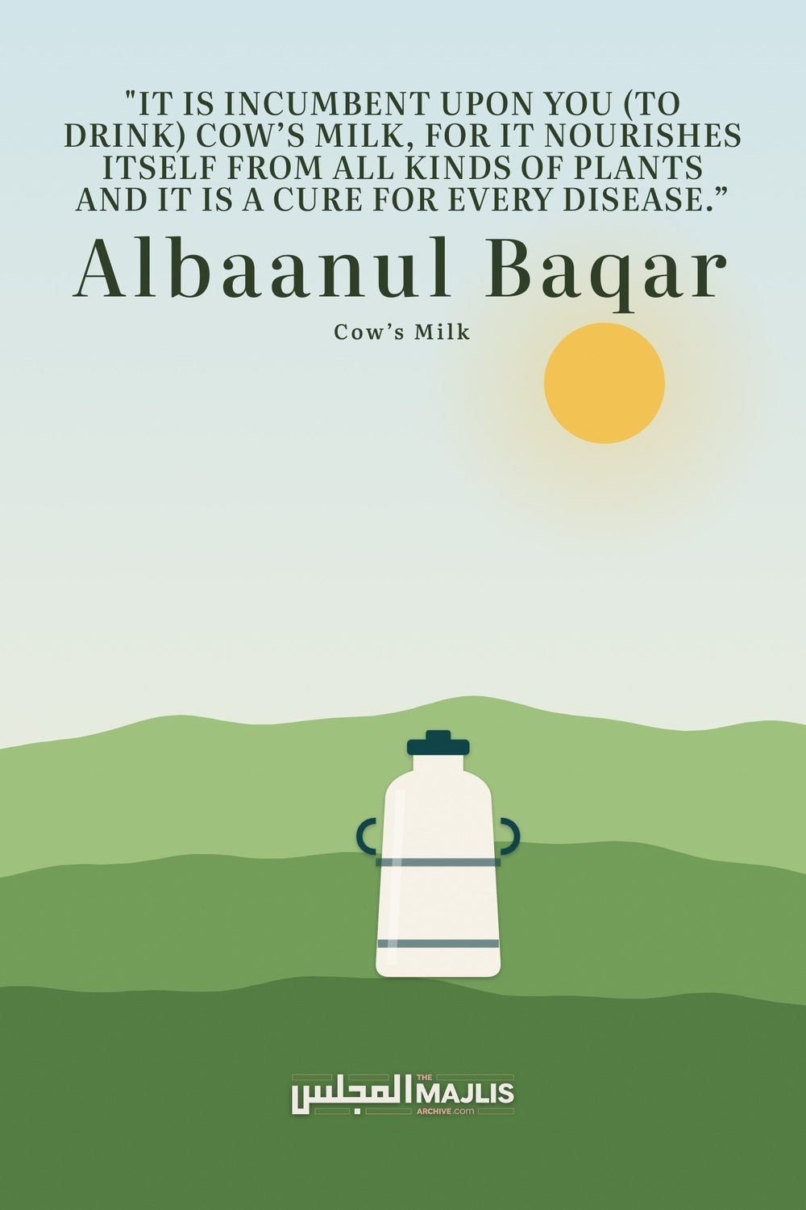

Albaanul Baqar Cows Milk
The Majlis · Voice of Islam
Mujlisul Ulama of South Africa

About this edition
This is a reproduction by The Majlis Archive (themajlisarchive.com) of a publication of The Majlis, Mujlisul Ulama of South Africa, made and published with their permission.
The PDF as The Majlis issued it is the original. This edition was read from that PDF's own structure and checked against it letter for letter; where the two differ, the PDF is correct.
Checked: 123 paragraphs, 0 differing; a second, independent PDF reader finds 98.3% of the PDF's words here.
Nothing has been reworded, added or removed.

"It Is Incumbent upon you (to drInk) cow's mIlk, for it nourishes itself from all kinds of plants and It Is a cure for every dIsease."
BY:
The Majlis PO Box 3393 Port Elizabeth 6056, South Africa

PROCESSED MILK
By A Brother from the UK
I refer to the recent Majlis article on TURMERIC MILK.
I believe that the processed milk found in most shops nowadays is quite harmful to health. There are many people who suffer from what the doctors label "lactose intolerance", who are unable to consume processed milk. In reality, such intolerance is the body's natural reaction to toxicity.
The fact that many people are still able to drink such milk does not negate the existence of toxicity, in the same way as people today are able to stomach the world of toxic junk foods, while a minority do exhibit intolerance to the very same junk foods.
I have also found that many people who suffer from lactose intolerance are able to drink raw, unprocessed milk without any issues. For example, I have an uncle who has had lactose intolerance since his childhood. Supermarket milk would make him vomit. A few years ago he became practically bedridden and homebound due to some strange illness which no doctor was able to diagnose.
I started giving him raw milk to drink regularly. He was not only able to drink it without any of the reactions or signs of intolerance which his body would exhibit from processed milk since his childhood, but also his health seemed to improve dramatically.
I composed a short article on raw milk a while ago, which I have attached below.
RAW, UNPASTEURISED AND UNPOLLUTED MILK FROM HUMANELY REARED, PASTURE-FED COWS IS A CURE FOR ALL DISEASES

"It is incumbent upon you (to drink) cow's milk, for it nourishes itself from all kinds of plants and it is a cure for every disease." (Authentic Hadith recorded in the Musnad of Abu Hanifah and other collections)

"Use cow's milk as treatment for disease, for indeed I anticipate that Allah places in it a cure, for indeed it eats from every (kind of) plant."
[Authentic Hadith recorded by al-Hakim, at-Tabarani and others]

"Incumbent upon you is cow's milk, for indeed it is a remedy (for all diseases), and its butterfat is a cure. However, beware of its meat, for indeed its meat is (a cause of) disease."
[Authentic Hadith recorded by al-Haakim]
Allah Ta'ala says in the Qur'an, confirming the numerous benefits of uncontaminated milk:
"Indeed for you, in livestock is a lesson. We give you drink from that which is in their bellies, and for you in them are numerous benefits, and from them you eat." (Qur'an 23:21)
It is important to note that almost all commercially available milk nowadays is NOT raw, organic, and from grass-fed cows/goats, etc. Instead it is pasteurised, homogenised and the milked animals have usually been fed artificial food and hormones, injected with poisonous vaccines, and raised in inhumane conditions.
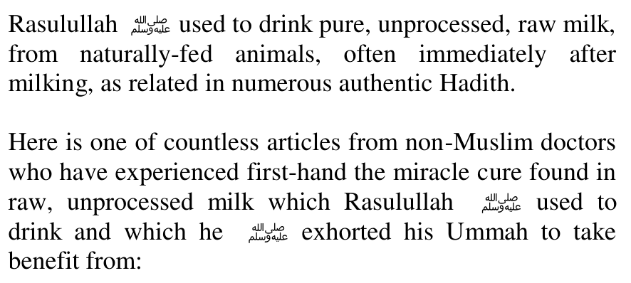

THE MILK CURE
The following is an edited version of an article by Dr. J. R. Crewe, published in Certified Milk Magazine. The milk used was, in all cases, the only kind of milk available in those days—raw milk from pasture-fed cows, rich in butterfat.
The treatment is a combination of detoxifying fast and nutrient-dense feeding.
Note that Crewe quotes William Osler, author of a standard medical textbook of the day. Thus, this protocol was an orthodox, accepted therapy in the early 1900s.
For fifteen years the writer has employed the certified milk treatment in various diseases and during the past ten he had a small sanitarium devoted principally to this treatment. The results obtained in various types of disease have been so uniformly excellent that one's conception of disease and its alleviation is necessarily changed. The method itself is so simple that it does not greatly interest most doctors and the main stimulus for its use is from the patients themselves.
The therapy is simple. The patients are put at rest in bed and are given at half hour intervals small quantities of milk, totalling from five to ten quarts of milk a day. Most patients are started on three or four quarts of milk a day and this is usually increased by a pint a day.
The treatment is used in many chronic conditions but chiefly in tuberculosis, diseases of the nervous system, cardiovascular and renal conditions, hypertension, and in patients who are underweight, run-down, etc. Striking results are seen in diseases of the heart and kidneys and high blood pressure. In cases in which there is marked edema, the results obtained are surprisingly marked. This is especially striking because so-called dropsy has never been treated with large quantities of fluid.
With all medication withdrawn, one case lost twenty-six pounds in six days, huge edema disappearing from the abdomen and legs, with great relief to the patient. No cathartics or diuretics were given. This property of milk in edema has been noted in both cardiac and renal cases.
Patients with cardiac disease respond splendidly without medication. In patients who have been taking digitalis and other stimulants, the drugs are withdrawn. High blood pressure patients respond splendidly and the results in most instances are quite lasting. The treatment has been used successfully in obesity without other alimentation. One patient reduced from 325 pounds to 284 in two weeks, on four quarts of milk a day, while her blood pressure was reduced from 220 to 170. Some extremely satisfying results have been obtained in a few cases of diabetics.
When sick people are limited to a diet containing an excess of vitamins and all the elements necessary to growth and maintenance, which are available in milk, they recover rapidly without the use of drugs and without bringing to bear all the complicated weapons (and side-effects) of modern medicine
Under the head of Treatment in Chronic Gastritis, Osler has said, "A rigid milk diet should be tried" (Principles and Practices of Medicine, by William Osler, M.D., eighth edition - a standard medical textbook used widely by medical practitioners of that age). Under the heading of treatment in many diseases, it was true that he had little to say about drugs but did say a good deal about diet and particularly as in most every instance he recommended large quantities of milk.
Under chronic Bright's disease (p 704) he says, "Milk or buttermilk should constitute for a time, the chief article of food." Under treatment of cancer of stomach (p 505), he says many patients do best on milk alone. Under treatment of rheumatic fever (p 378), he says, "Milk is the most suitable diet." With Olser as a background, one need not hesitate to go a bit farther. In fact, practically all medical men are agreed as to the value of milk as a food, and as an important part of the diet in the treatment of many diseases. But as the chief remedy in the treatment of disease, it is seldom used.
For more than 16 years I have conducted a small sanitarium where milk is used almost exclusively in the treatment of various diseases. The results have been so regularly satisfactory that I have naturally become enthusiastic and interested in this method of treating disease. We used good Guernsey milk, equal to 700 calories to the quart.
Interestingly, diseases that have no similarity respond equally to this treatment.
For instance, psoriasis clears up beautifully. The improvement in tuberculosis or nephritis is equally interesting but there is no similarity in these diseases. I once heard a very distinguished medical man discussing a case of psoriasis. He said,
"This was the worst case of psoriasis I have ever seen. This boy was literally covered from head to foot with scales. We put this boy on a milk diet and in less than a month he had a skin like a baby's." To me, this means that there was evidently some nutritive substance or vitamin or glandular secretion lacking, that was furnished by the milk.
It is well known that there is no time in the life of practically any mammal, but especially of the human, when the body is so beautiful and perfect as during the period when milk is the only food. It will be admitted that there is no period in life when the body is so perfect as in infancy, the infant being fed on milk from a healthy mother.
The Arabs are said (Encyclopedia Brittanica) to be the finest race, physically, in the world. Their diet consists mostly of milk and milk products with fruits and vegetables, and some meat.
You are all familiar with the writings of Colonel McCarrison, a medical officer in the British Army. He tells us that for nine years he was stationed in India in a district in the Himalayan Mountains. He said that the natives were very fine physically, that they retained a youthful appearance to advanced age and lived long and that they were very fertile. During the nine years of his residence there he saw practically no disease, no cases of malignancy or of abdominal disease. The diet of these people was simple and consisted principally of vegetables and fruits and milk and milk products
Steffanson wrote most interestingly of the Eskimo, who, when uncontaminated by civilized conditions were hardy and robust.
The experience of seeing many cases of illness improve rapidly on a diet of raw milk has suggested more and more the feeling that much of modern disease is due to an increasing departure from simple methods of preparing plain foods.
The treatment of various diseases over a period of 18 years with a practically exclusive milk diet has convinced me personally that the most important single factor in the cause of disease and in the resistance to disease is food. I have seen so many instances of the rapid and marked response to this form of treatment that nothing could make me believe this is not so.
We have often seen most satisfactory results in the treatment of anemia, including pernicious anemia, on a milk diet. I have repeatedly seen a marked reduction in the size of simple and toxic thyroid, with improvement in the symptoms of the toxic one. In prostatic diseases and associated conditions, this treatment will achieve rapid and marked improvement in the infection and in the reduction of the gland and lessening of obstruction. A professor of surgery in one of our state universities once said to me, "Since I have used your method in preparing prostate cases, I have had most excellent results and no mortality." I replied that if he had continued the treatment a little longer, he would not need to operate. All infections of the urinary tract are greatly improved by this treatment.
An old friend of mine, a woodworker, aged 74, had a marked heart lesion and complete prostatic obstruction, so that it was necessary to use a permanent catheter. He had been taking digitalis but this was discontinued, and he received no medication of any kind. The prostate was very large and the residual urine very foul. His recovery has been rapid, and he has been able to work since that time and is now in very good health at 77 years of age.
Another local man was treated six years ago for a severe chronic winter cough and prostatic disease, which necessitated his getting up many times at night. He volunteered the information a few days ago that he had no more trouble with any illness since that time.
Indeed we had a number of patients who took the treatment for "beauty treatment." The tissues become firmer and the general appearance is markedly improved.
Hypertension responds with equal gratification. The blood pressure improves rapidly. I have never seen such rapid and lasting results by any other method. One of the patients lived almost exclusively on milk for more than three years.
About ten years ago a very sick man came to the Sanitarium suffering from a severe cystitis and nephritis. He was a diabetic. As milk contains about five percent milk sugar, it was feared that he could not manage this amount of sugar. But he did manage it, and improved in every way and in eight weeks was sugar free.
My experience with milk diet in diabetes has been limited, but very interesting. These few patients, only seven or eight, have been much pleased with the results. Insulin was used for a time in some of the cases. They all became sugar free, or nearly so, after from four to ten weeks. From the fact that these patients were able to use a much more liberal diet than diabetics usually can take [after the treatment], it would seem to indicate that at least a partial regeneration of the pancreas is not impossible.
There is a large class of patients who are ill but in whom no definite organic lesion can be found. These patients are often underweight. They may consume a fairly large amount of food but they do not gain in weight or strength. These patients do respond admirably to our system of large quantities of milk.
The chief fault of the treatment is that it is too simple... and it does not appeal to the modern medical man.
(End of the Doctor's dissertation)
The Dua of our Nabi (Sallallahu alayhi wasallam) After drinking milk, Rasulullah (Sallallahu alayhi wasallam) would recite the follow Dua:

O Allah! Grant us Barakat in it, and give us more.

TURMERIC MILK
Turmeric and Milk have natural Antibiotic properties.
Including these two natural ingredients in your everyday diet can prevent diseases and infections.
Turmeric when mixed with milk can be very beneficial for a number of health problems. This is an effective remedy to fight hazardous environmental toxins and harmful microorganisms.
RECIPE for Turmeric Milk:
Take 1 inch piece (FRESH) Turmeric root.
If Fresh type is not available then use 1 level tsp Turmeric Powder.
¼ teaspoon of black pepper 150mls or I glass Milk.
Boil Turmeric and Milk for 15 minutes.
Strain the milk (remove fresh Turmeric piece out). Cool it and drink this milk.
Benefits of Turmeric Milk:
Anti Inflammatory:
Turmeric milk is anti inflammatory and that can prevent and protect arthritis and stomach ulcers. This is also known as "natural aspirin" that can cure headaches, swelling and pain.
Cold and Cough:
Turmeric Milk is considered as a best remedy for cold and cough due to its antiviral and antibacterial properties. It gives instant relief to sore throat, cough and cold.
Arthritis:
Turmeric Milk is used to cure arthritis and treat swelling due to rheumatoid arthritis. It also helps to make the joints and muscles flexible by reducing the pain.
Aches and Pains:
Turmeric golden milk gives the best relief from aches and pains. This can also strengthen the spine and joints in the body.
Antioxidant:
Turmeric milk is an excellent source of antioxidants which fight free radicals.
This can cure many ailments.
Blood Purifier:
Turmeric Milk is considered as an excellent blood purifier and cleanser. It can revitalize and boost blood circulation in the body.
It is also a blood thinner that cleanses the lymphatic system and blood vessels from all impurities.
Liver Detox:
Turmeric milk is a natural liver detoxifier and blood purifier that boosts liver function. It supports the liver and cleanses the lymphatic system.
Bone Health:
Turmeric milk is a good source of calcium which is a must to keep the bones healthy and strong. Turmeric milk lowers bone loss and osteoporosis.
Digestive Health:
It is a powerful antiseptic that promotes intestinal health and treats stomach ulcers and colitis. This helps in better digestive health and prevents ulcers, diarrhea and indigestion.
Menstrual Cramps:
Turmeric milk works wonders as it is antispasmodic that eases menstrual cramps and pain. Pregnant women should take golden turmeric milk for easy delivery, improved lactation and faster contraction of ovaries.
Rash and Skin Redness:
Ancient queens took turmeric milk baths for soft, supple and glowing skin.
Similarly drink turmeric milk for glowing skin. Soak turmeric milk in a cotton ball apply on the affected area for 15 minutes to reduce skin redness and blotchy patches.
This will make the skin more radiant and glowing than before.
Weight Loss:
Turmeric milk helps in the breakdown of dietary fat. This can be useful to control weight.
Eczema:
Drink a glass of turmeric milk everyday to treat eczema.
Insomnia:
Warm turmeric milk produces an amino acid, tryptophan that induces peaceful and blissful sleep.

PASTEURIZATION – THE DEGRADATION OF MILK MILK & MILK PRODUCTS
Another factor contributing to the degradation of today's milk is pasteurization. We have been taught that pasteurization is beneficial, a method of protecting ourselves against infectious disease, but closer examination reveals that its merits have been highly exaggerated. The modern milking machine and stainless steel tank, along with efficient packaging and distribution, make pasteurization totally unnecessary for the purposes of sanitation. And pasteurization is no guarantee of cleanliness. All outbreaks of salmonella from contaminated milk in recent decades- and there have been many- have occurred in pasteurized milk. This includes a 1985 outbreak in Illinois that struck over 14,000 people causing at least one death. The salmonella strain in that batch of pasteurized milk was found to be genetically resistant to both penicillin and tetracycline.121 Raw milk contains lactic-acid-producing bacteria that protect against pathogens. Pasteurization destroys these helpful organisms, leaving the finished product devoid of any protective mechanism should undesirable bacteria inadvertently contaminate the supply. Raw milk in time turns pleasantly sour, while pasteurized milk, lacking beneficial bacteria, will putrefy.
But that's not all that pasteurization does to milk. Heat alters milk's amino acids lysine and tyrosine, making the whole complex of proteins less available; it promotes rancidity of unsaturated fatty acids and destruction of vitamins. Vitamin C loss in pasteurization usually exceeds 50 percent; loss of other water-soluble vitamins can run as high as 80 percent; the Wulzen or anti-stiffness factor is totally destroyed as is vitamin B12 needed for healthy blood and a properly functioning nervous system. Pasteurization reduces the availability of milk's mineral components, such as calcium, chloride, magnesium, phosphorus, potassium, sodium and sulphur, as well as many trace minerals. There is some evidence that pasteurization alters lactose, making it more readily absorbable. This, and the fact that pasteurized milk puts an unnecessary strain on the pancreas to produce digestive enzymes, may explain why milk consumption in civilized societies has been linked with diabetes.
Last but not least, pasteurization destroys all the enzymes in milk- in fact, the test for successful pasteurization is absence of enzymes. These enzymes help the body assimilate all bodybuilding factors, including calcium. That is why those who drink pasteurized milk may suffer from osteoporosis. Lipase in raw milk helps the body digest and utilize butterfat.
After pasteurization, chemicals may be added to suppress odor and restore taste. Synthetic vitamin D2 or D3 is added -the former is toxic and has been linked to heart disease while the latter is difficult to absorb. The final indignity is homogenization, which has also been linked to heart disease.
Powdered skim milk is added to the most popular varieties of commercial milk- one-percent and two-percent milk. Commercial dehydration methods oxidize cholesterol in powdered milk, rendering it harmful to the arteries. High temperature drying also creates large quantities of cross-linked proteins and nitrate compounds, which are potent carcinogens, as well as free glutamic acid, which is toxic to the nervous system.
Modem pasteurized milk, devoid of its enzyme content, puts an enormous strain on the body's digestive mechanism. In the elderly, and those with milk intolerance or inherited weaknesses of digestion, this milk passes through not fully digested and can build up around the tiny villi of the small intestine, preventing the absorption of vital nutrients and promoting the uptake of toxic substances. The result is allergies, chronic fatigue and a host of degenerative diseases.
All the healthy milk-drinking populations studied by Dr. Price consumed raw milk, raw cultured milk or raw cheese from normal healthy animals eating fresh grass or fodder. It is very difficult to find this kind of milk in America. In California, New Mexico and Connecticut, raw milk is available in health food stores, although such milk often comes from cows raised in confinement.
In many states you can buy raw milk at the farm. If you can find a farmer who will sell you raw milk from old-fashioned Jersey or Guernsey cows (or from goats), tested free of tuberculosis and brucellosis and allowed to feed on fresh pasturage, then by all means avail yourself of this source.

