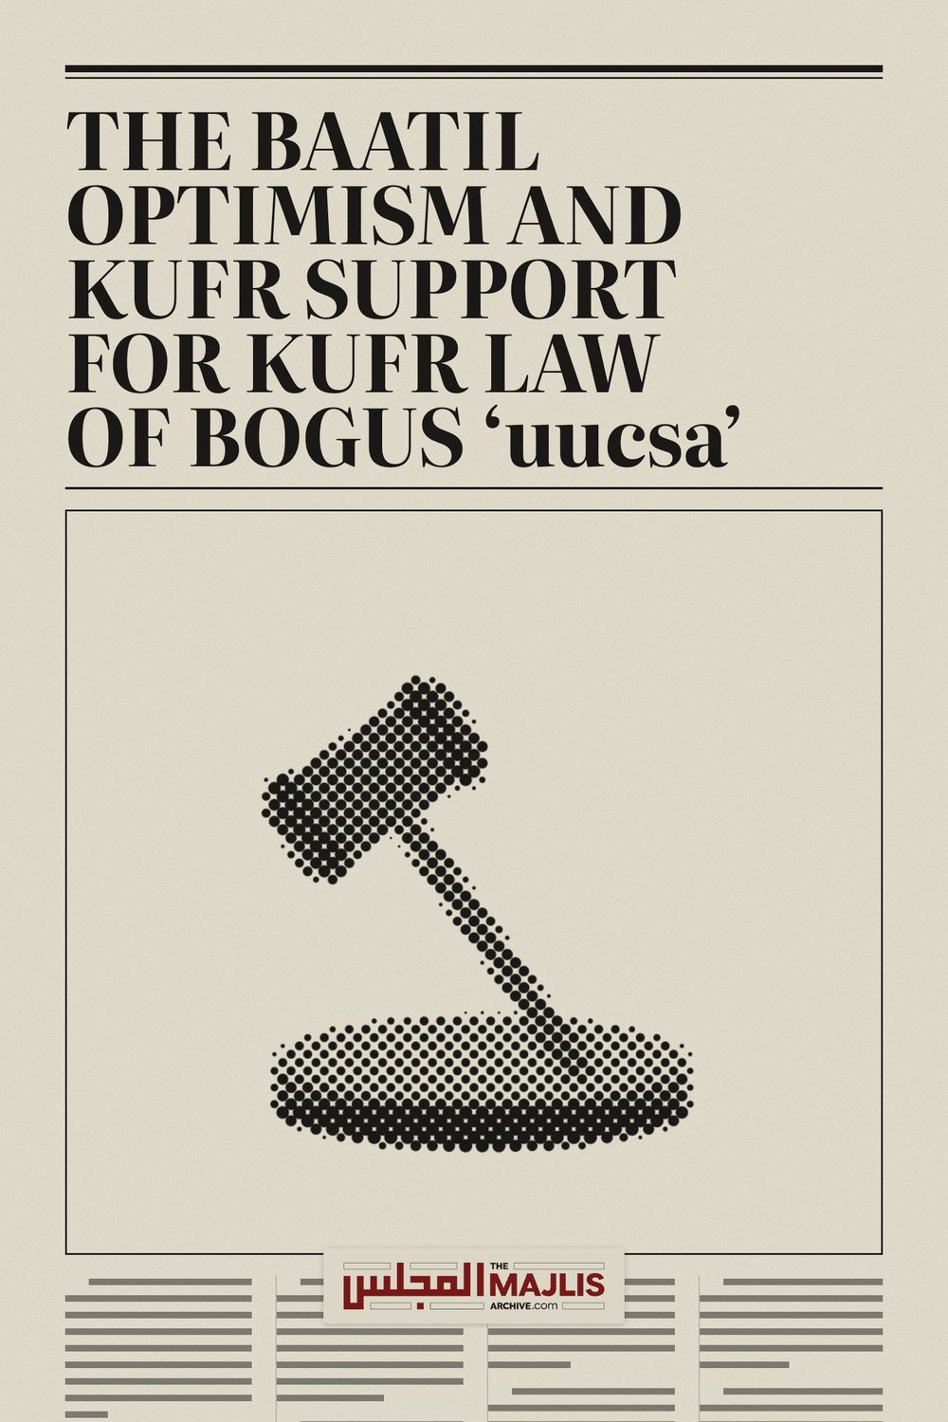

BAATIL OPTIMISM AND KUFR SUPPORT FOR KUFR LAW
The Majlis · Voice of Islam
Mujlisul Ulama of South Africa

About this edition
This is a reproduction by The Majlis Archive (themajlisarchive.com) of a publication of The Majlis, Mujlisul Ulama of South Africa, made and published with their permission.
The PDF as The Majlis issued it is the original. This edition was read from that PDF's own structure and checked against it letter for letter; where the two differ, the PDF is correct.
Checked: 60 paragraphs, 0 differing; a second, independent PDF reader finds 100.0% of the PDF's words here.
Nothing has been reworded, added or removed.

6056, South Africa

THE BAATIL OPTIMISM AND KUFR SUPPORT FOR KUFR LAW
(They – the human and jinn devils whisper their evil and adorned statements to one another) so that the hearts of those who do not believe in the Aakhirat incline to it (to their kufr), so that they become pleased with it, and so that they may indulge in whatever they (these kuffaar)
fabricate." (Al-An'aam, Aayat 113)
What! Should I (Rasulullah –Sallallahu alayhi wasallam)
search for another judge besides Allah whilst it is He Who has revealed to you (O Muslimeen!) the Kitaab with detailed explanation. And (even) those to whom We have given the Kitaab (Tauraah) know that it has been revealed from your Rabb with the Haqq. Therefore, do not become of the doubtful ones."
(Al-An'aam, Aayat 114)
In a stupid statement issued by one Yusuf Patel on behalf of BOGUS 'uucsa', the kufr judgment of the Western Cape High Court is welcomed. The welcoming of the judgment of the court by an entity professing to be Muslim, speaks volumes for the jahaalat of the characters who constitute this BOGUS entity. The Jaahil, Yusuf Patel states in the statement that BOGUS
'uucsa' "supports the legal recognition of Muslim marriages, and their consequences, on the basis that the relevant legislation must be consistent with Islamic law."
The aforementioned two Qur'aanic Verses have full application to Yusuf Patel and the charlatans of BOGUS 'uucsa' whom he represents. They scheme with even the kuffaar- with the kuffaar Women's Centre and other kuffaar entities – to fabricate laws which are repugnant and in direct conflict with the Shariah.
They are pleased with the haraam ruling of the judge of the kuffaar court although Allah Ta'ala is the Only and the Best Judge Who has revealed for the Muslim Ummah via Rasulullah (Sallallahu alayhi wasallam), the perfect and final Law of the Shariah which has been handed to us fully explained in every detail. Since these miserable traitors to the Deen come within the full glare of the abovementioned Qur'aanic Verses, it is not at all surprising that they express their welcome and optimism for the ruling of the kuffaar court – a ruling which DOES NOT in the slightest degree conform with the Shariah. It is satanically hallucinatory to believe that the kufr law envisaged by the judgement would ever be consistent with the Shariah.
Their obsequious compliance and acceptance of kufr concepts and kufr laws contain all their trademark Isghaa' (i.e. inclination to the fabrications of the kuffaar) which they invariably display when they collude with those whose objective is the imposition of kuffaar concepts and laws on Muslims. No contribution for the benefit of Islam and Muslims can ever be expected from these charlatans who parade as Muslims. They have for years, in fact decades, demonstrated their zindaqah (blasphemy and heresy) in their haraam efforts to get the kufr marriages bill forced down the throats of Muslims. But, Allah Ta'ala has thwarted them, hence their illegitimate offspring (the MMB) has been aborted.
Whilst people usually flaunt their perceived excellences on the basis of knowledge, wealth and the like, these charlatans of the BOGUS 'uucsa' MPL/MMB clique flaunt plain ghabaawah and kufr.
The averment of secular legislation recognizing Muslim marriages and their consequences being consistent with Islamic law, is a dastard deception dunked with conspicuous kufr – a stupid red herring to deceive and mislead the Muslim community. It is impossible for the secular law of this country which has appointed the kufr constitution as its god, to enact any law for the recognition of Muslim marriages and their consequences to ever be consistent with the Shariah. On almost every issue there is diametric conflict between the secular laws of the country and the Holy Laws of the Shariah of Allah Azza Wa Jal. It is only a man who is egregiously ignorant or a treacherous scoundrel who will claim that the intended secular legislation can ever be consistent with the Shariah.
The Jaahil says in his statement that we should "seize the window of opportunity that the judgement offers us. This is a cunning ruse for initiating a new chapter in the MPL-MMB shaitaani saga in which these traitors to Islam had miserably slogged and laboured to compromise, change and even extinguish the Shariah's laws pertaining to Islamic marriages and their Islamic consequences. The judgement of the kuffaar court offers no 'window of opportunity'. The stupidity of Patel is lamentable and even laughable for the nonsensical suggestion.
Muslims may not crawl like sewerage-drain rats through a window of kufr to accept on a platter what is rijs (filth) according to Allah Azza Wa Jal. We are commanded to submit to Allah's Law. The Qur'aan Majeed states: "Follow that (Law) which has been revealed to you from your Rabb besides Whom there is no god but He, and ignore the Mushrikeen."
(Al-Anaam, Aayat 115)
Whilst the Qur'aan Majeed commands Muslims to turn away and ignore the laws of the kuffaar which they formulate for our ingestion, the Zanaadaqah of BOGUS 'uucsa' welcome the laws of kufr and see optimism in it. The Command of Allah Azza Wa Jal is to follow the Laws which He has revealed. If in a kuffaar situation such as is prevailing all over the world in this era of evil and godlessness, the authorities of the country refuse to accommodate the Muslim community regarding matters of Shar'i importance, then the only options for us are Sabr and Dua. We cannot welcome laws which have no affinity with Islam nor can we be optimistic of laws which are enacted to scuttle the Shariah nor can we be a party to concede to the transmogrification of the Shariah.
The judgement of the secular court in no way whatever favours the Shariah. Any legislation to recognize Muslim marriages is fraught with the stark kufr consequences provided by the kufr standards and kufr spirit of the kufr constitution. The consequences of secular recognition of Muslim marriages will in entirety ignore the Shariah's consequences of Islamic marriages and Islamic Divorces. It is not simply a matter of recognizing the validity of Muslim marriages. The actual evil is the kufr consequences which legal recognition spawns. Then there is a vast chasm between secular consequences and Shar'i consequences. The two sets of consequences are mutually repellent. Thus, it is a satanic deception to discern optimism in the judgement of the court.
The brains and hearts of these charlatans whose objective is to transmogrify the Deen to make it compatible with kuffaar law, have been blocked and constricted by Allah Ta'a'la. They therefore, perennially seek to submit the Shariah to secularism, not only in laws, but also in attitude and morality. Depicting these miserable characters, the Qur'aan Majeed states:
"Whomever Allah intends to mislead, He narrows and constricts his breast (so that it appears to him that) he is ascending into the sky (with the greatest difficulty). Thus, does Allah cast rijs (filth and his punishment) on those who have no Imaan." (Al-Anaam, Aayat 125)
The brains of the chaps of BOGUS 'uucsa' have been cast into disequilibrium and their hearts have been fossilized with kufr by the divinely cast RIJS. They have been debarred from Hidaayat, the attainment of which appears to them to be as difficult as ascending into the sky, a feat which they fail to accomplish.
The Jaahil says: "The legislative process will unfold with or without us; we can choose to remain indifferent or adopt a hostile or unrealistic attitude at our own peril."
The response for this drivel is that the 'legislative process' has always, unfolded without us – without taking into account the Muslim community. This was the position in the apartheid regime, and it remains unchanged today under the ANC regime. Their legislation unfolds in terms of their kufr constitution to which they demand the submission of our Shariah. We, therefore are compelled by these circumstances to remain distant and indifferent to any laws which the government enacts. There is no such creature of 'freedom of religion' in a secular state whether the country is non-Muslim or Muslim. The provision of 'freedom of religion' enshrined in secular constitutions is a massive farce and a false principle to dupe the ignorant masses and to soothe the bootlickers such as the BOGUS 'uucsa', NNB jamait and the MJC cartel of Zanaadaqah.
There is no peril for Muslims in 'indifference' and the so-called 'unrealistic attitude'. The peril is actually in co-operating with the authorities to mutilate the Shariah with hybrid legislation which the Ulama will be required to hoist on the ignorant community. As long as Muslims themselves do not betray the Shariah by compromising the immutable Divine Law of Allah Azza Wa Jal, the Deen will remain pure and unadulterated by stercoraceous kufr which is the quotient of a satanic equation consisting of factors which the Qur'aan Majeed describes as zukhruful qawl (satanically adorned clichés) which the Shayaateenul Ins (Human Devils) and the Shayaateenul Jinn (Jinn Devils) whisper to one another. This whole satanic conglomerate of MPL, MMB and now the court's judgement, is a foul copro venture based on the subjugation and ultimate effacement of the Shariah. The slightest compromise and submission of the Shariah to any of the hybrid proposals for which the BOGUS 'uucsa' cartel is infamous, is intolerable and unacceptable to Muslims. Of our own willing accord, we cannot be a party to the transmogrification of Allah's Shariah.
By abstention from the process of mutilating the Shariah with man-made kufr provisions, we retain the pristine purity of the Deen which Muslims will practise to the best of their ability as permitted by circumstances in a setting which does not condone the freeplay of our Deen. No one should be deceived by the canard of 'freedom of religion'.
Making an averment full of stupid sound and laughable fury, the Jaahil states:
"The choice as highlighted in the Judgment is a stark one: either a case-by-case uncertain, chaotic development, or a viable, practical statutory framework which is designed to remove the difficulties on the ground and vindicate the rights of the vulnerable."
Firstly, who are the 'vulnerable' entities mentioned by the Jaahil? He is referring to the women who run to the kuffaar court seeking aid and haraam boodle in terms of the kuffaar laws of the land. No decent Muslim woman will ever take the haraam route to a secular court for such 'relief' which is in stark conflict with the provisions which Allah Azza Wa Jal has ordained for her as consequences of Talaaq.
No secular court can ever vindicate the rights of women as envisaged by the Shariah of Allah Ta'ala. The 'rights' which the secular court confers to so-called Muslim women who seek kuffaar assistance to override the Shariah, are kufr rights, not rights granted by the Shariah.
The 'difficulties' of women to which the Jaahil refers are generally of their own making- spawned by their greed and kufr dissatisfaction with the Shariah. The Shariah rules that the divorcee is entitled to maintenance from her ex-husband for the Iddat period only. The kuffaar court grants her haraam maintenance for years or even life. Thus, the woman preferring kufr law, effaces her Imaan and accepts everlasting perdition in Jahannam in the Aakhirat.
The Shariah has its own rules and ways for dealing with matrimonial problems and issues. Even recalcitrant husbands can be dealt with by the Shariah despite the fact that the Ulama lack coercive power to enforce the decrees of the Shariah. But the women and the bootlickers such as BOGUS 'uucsa' are not satisfied with the decrees of the Shariah, hence the clamour for kufr measures to override Allah's Law.
The 'case-by-case' scenario mentioned by the Jaahil is the making of murtaddaat (women who have reneged from Islam by rejecting the Law of Allah Ta'ala). Both the 'case-by-case' and the stupid 'practical statutory framework' which these Juhala laud and applaud, are kufr measures. These kufr options are not choices for Muslims. Both are scenarios for the murtaddeen. Thus, the 'highlighting of choices' in so far as Muslims are concerned is hogwash.
Conspicuously advertising his jahaalat, Mr.Yusuf Patel of BOGUS 'uucsa' avers: "...legal recognition of Muslim marriages and their consequences would contribute towards the protection of Muslim rights from unconstrained judicial interference as is the case presently."
This is a stupid lie which boggles and defies credulity. Judicial interference in the Shariah is a foregone certainty. It is incumbent for the judges to interpret, distort, mutilate and mangle the Shariah to conform with the kufr constitution and with the laws it has spawned by way of legislation. Debunking the copro-view of the Jaahil, Justice Moseneke of the Constitutional Court ruled:
Courts are required not only to apply customary law but also to develop it. Section 39 (2) of the Constitution makes plain that when a court embarks on the adaptation of customary law it must promote the spirit, purport and objects of the Bill of Rights. The adaptation of customary law serves a number of important constitutional purposes. Firstly, this process would ensure that customary law, like statutory law or the common law, is brought into harmony with our supreme law and its values, and brought in line with international human rights standards. Secondly, the adaptation would salvage and free customary law from its stunted and deprived past. And lastly, it would fulfil and reaffirm the historically plural character of our legal system, which now sits under the umbrella of one controlling law – the Constitution.
Far from protecting Muslim rights, any legislation recognizing Muslim marriages will with certitude override the Shariah. The courts will have the right to adapt Islamic Law to promote the spirit and objects of the kufr Bill of Rights. The courts will ensure that Shariah Law is subjected to the constitution and what they describe as their 'supreme law and its values'. The courts have to ensure that religious law is mutilated to conform to international human standards although in reality we find only barbaric standards prevailing internationally. Such adaptation according to the Constitutional Court "and free customary law from its stunted and deprived past". Such is the description for even the Shariah which the charlatans and Zanadaqah find acceptable and which they describe as "protection of Muslim rights". May Allah Ta'ala destroy these evil, treacherous shayaateenul ins who are out to scuttle the Deen in the name of Islam.
"They intend to extinguish the Noor (Deen) of Allah with their mouths whilst Allah will complete (and perfect) His
Noor even though the kaafiroon abhor it."
(Qur'aan)
These charlatans of BOGUS 'uucsa' are deviated Fussaaq whose primary mission in life is to subvert, transfigure and mutilate the Shariah of Allah Azza Wa Jal in their drunken pursuit for the attainment of their despicable nafsaani objectives of hub-e-maal and hubb-e-jah (the love for wealth and the love for name and fame). About such Fussaaq, the Qur'aan Majeed states: "They (seek to) please you with their mouths whilst their
hearts are averse (to what their mouths proclaim). And, most of them are Faasiqoon. They trade the Aayaat (the
Shariah) of Allah for a miserable price thereby preventing (others) from His Path. Verily, what they are doing is indeed evil."
In the name of Islam they proffer ideas and statements adorned with Islamic hues to confuse and deceive the ignorant ones whose support they canvass, and which they deem necessary for attaining their shaitaani agenda. With their mouths they disgorge deceptive statements – statements which their hearts repulse, but which they deem expedient for luring and misleading those who lack adequate Islamic knowledge to distinguish between Haqq and Baatil. This is their attitude of nifaaq which the aforementioned Qur'aanic Aayat severely castigates.
"And, upon us is to only deliver the Clear Message."
(Qur'aan)
25 Zil Hajj 1439 - 6 September 2018

