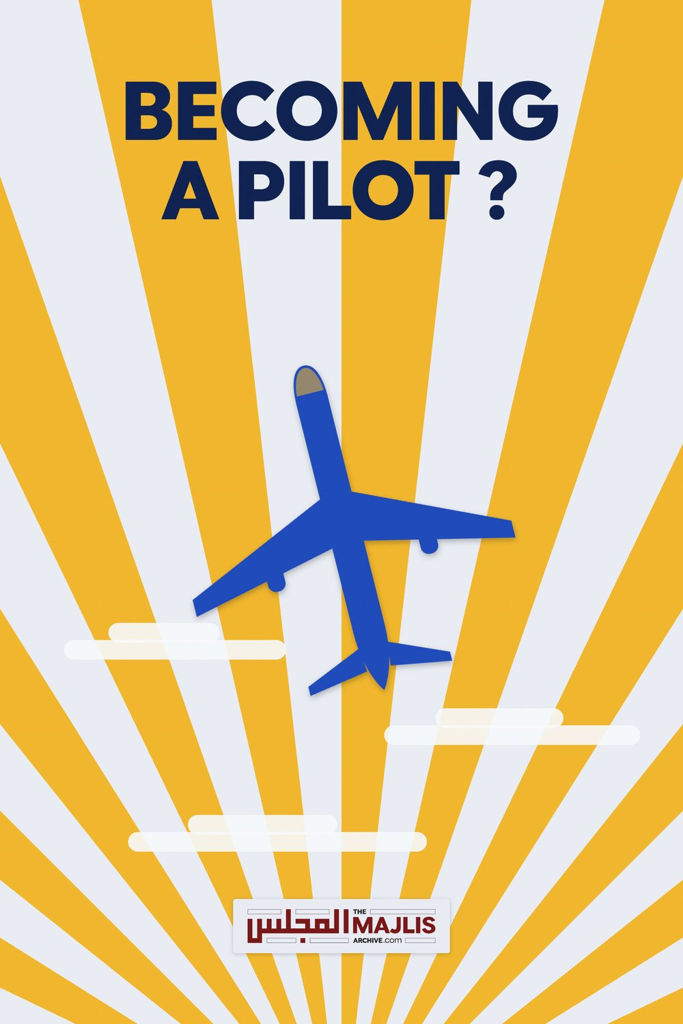

Becoming A Pilot
The Majlis · Voice of Islam
Mujlisul Ulama of South Africa

About this edition
This is a reproduction by The Majlis Archive (themajlisarchive.com) of a publication of The Majlis, Mujlisul Ulama of South Africa, made and published with their permission.
The PDF as The Majlis issued it is the original. This edition was read from that PDF's own structure and checked against it letter for letter; where the two differ, the PDF is correct.
Checked: 66 paragraphs, 0 differing; a second, independent PDF reader finds 100.0% of the PDF's words here.
Nothing has been reworded, added or removed.

PUBLISHED BY: MUJLISUL ULAMA OF S.A. PO Box 3393
Port Elizabeth, 6056 South Africa

IN A CAULDRON OF IMMORALITY – FISQ AND FUJOOR –
The following question as reproduced hereunder, regarding working as a pilot, was asked by someone to a Darul Uloom:
Working as a pilot Q: Is it permissible for a man to work as a pilot even though they serve alcohol in the plane?
A: It is permissible provided this profession will not prevent him from his Deeni obligations and responsibilities, and he will be able to protect and safeguard himself from strange women and he is quite confident that he will not get involved in sins (whether minor or major). (End of the Mufti's fatwa)
This fatwa flummoxed me. I was a pilot for some years, but have abandoned this profession. As a pilot for a commercial airline the duties amongst others are as follows:
1. A pilot, according to his company policy has to transport alcohol that is consumed on the flight. Though the captain has the authority to say what can be transported on his aircraft, he will not transport items that may cause physical harm to a person but he transports alcohol. My concern is the following hadeeth:
Abu Dawood (3674) and Ibn Maajah (3380) narrated that Ibn 'Umar said: The Messenger of Allaah (peace and blessings of Allaah be upon him) said: "Allaah has cursed alcohol, the one who drinks it, the one who pours it, the one who sells it, the one who buys it, the one who squeezes (the grapes etc.), the one for whom it is squeezed, the one who carries it and the one to whom it is carried."
Is it a sin or not to transport the alcohol in the work that the Muslim chooses for himself as his career? 2. The Muslim pilot is compelled to wear the tie, a symbol of the cross of the Christians. Will this not affect the level of Iman of a person?
Is this a sin or not? Is wearing the tie not a sin?
The hadeeth that comes to mind that he who imitates a people will be resurrected with them. Is it a sin or not to wear the tie in work that the Muslim chooses for himself as his career?
3. The Muslim pilot, he is forced to wear his trousers below the ankles as company policy. Whereas the hadeeth wherein Rasulullah sallallahu alaihi wa sallam is reported to have said that the one who wears his trousers below the ankles will be in the fire of Hell.
Is it a sin or not for the Muslim pilot to keep his pants below the ankles for this work that he chooses to do? Is wearing the pants below the ankles not a sin?
4. The Muslim pilot has to work with female pilots and sit alone with her in a locked cockpit for many hours. And also sleep alone with her in the same crew rest on board the plane where these females have no shame and change in front of the Muslim pilot. Whereas Rasulullah sallallahu alaihi wa sallam is reported to have said:
Narrated by al-Bukhaari (1862) and Muslim (1341). And he (blessings and peace of Allah be upon him) said: "No man is alone with a woman but the Shaytaan is the third one present."
Narrated by al-Tirmidhi (1171)
'Whoever believes in Allaah and the Last Day, let him not be alone with a woman who has no mahram present, for the third one present will be the Shaytaan." (Ahmad)
"And come not near to zina, for verily it is faahishah (filth and immorality) and an evil way." (al-Isra' :32) "Hayaa' (modesty) is a branch of faith." (Bukhaari)
Is it a sin or not to be alone with a woman in the work that the Muslim chooses for himself as his career? And sleep with her alone in the crew rest room on the plane? He is compelled by company policy to do so.
5. The Muslim pilot controls the power to the entertainment system where hundreds of passengers are faced with the public tv screens and their own personal screens showing movies, dancing half naked women, music as well as the possibility of playing games of chance and other sins on these in flight entertainments systems. Is it a sin for the Muslim pilot to put on this entertainment system that allows the passengers to become involved in sin? The hadeeth that comes to mind is that he who initiates something will get the sin of all those who took part from it? The Qur'aan also confirms this.
6. The Muslim pilot controls the power to the galley/ kitchen power where haraam food is cooked and served to the passengers.
Does he get the sin for putting this power to the galley where this food is then cooked, almost all of the food being haraam?
7. The Muslim pilot's working hours or life and environment are spent mostly or almost exclusively in the company of non-Muslim males and females. This can be for days or many hours in a day.
Is this a sin or not to choose such a work where he will spend most of his time with non- Muslim males and females with the accompanying evils when he has other choices to earn his rizq? Our pious elders teach us that to become closer to Allah Ta'ala one needs to remove oneself from a bad environment, but in this instance until retirement a Muslim pilot will be in this bad, evil and immoral environment. (The Qur'aan commands that we abstain from kuffaar company and cultivate the company of the pious.—The Majlis)
Considering all of the above is it permissible for a Muslim to work as a pilot for a commercial airline in the example given above?
Lastly knowing full well that our rizq is written and we are required to work and earn it, but is it permissible to voluntarily pursue a profession / job which is almost 100% haraam? I can say that it is the base desires or nafs that constrain a Muslim to become a pilot.
Should a Mufti or Aalim not look at the whole situation and then advise whether Muslims should be pilots or not? Or should a Mufti only say it is permissible thereby opening the door for the Muslim pilot's Iman to be corrupted?
This writer has been a pilot, was exposed to all of the above evils and witnessed the effect of the Iman being attacked and corrupted. With such a multitude of haraam acts committed by the pilot in a career that is chosen almost always only for ones own desires and nafs, how can this profession ever be permissible? With no consideration of whether it will affect ones Iman or take one closer or further from Allah Ta'ala, how can a Mufti rush to issue a fatwa of permissibility? It is clear that the Mufti Sahib is in the complete dark about what it entails to be a pilot. It is a life of immorality, yet many Muslims look up with respect to a pilot – Na-oozubillah!
From the question and answer given above and the questions I have asked Muhtarram Mufti Saab to clarify, how can an ordinary pilot who is not an Aalim or Mufti know whether the above are sins or not? Is it not dangerous to leave this to a Muslim to go and become a pilot, spend hundreds of thousands of rands and many years, then maybe belatedly discover that it is a sin to be involved in such a career? Or he may destroy his dunya and Aakhirat if he never discovers that he passes his life in evil and sin. Should we not discourage or close the door for the Iman of any Muslim to be corrupted by stating that such a career is not permissible? Giving a fatwa of permissibility creates many serious problems later on for the pilot and his family.
There was no compelling Shar'i need or necessity for a Muslim to put himself in the 'brave' job environment. Despite all the evil and immorality attendant to this career is it still permissible to say it is ok for Muslims to become pilots and work in such an evil environment? If the answer is yes, please let me know why, Jazaakallaah.

SUMMARY OF THE HARAAM FACTORS
• trousers below ankles • wearing the tie • no topee • eating from utensils in which pork is served and alcohol drunk
• company of the kuffaar for long hours and days – staying almost the entire life in bad company
• solitude with lewd females; sitting alone and sleeping alone with females in a confined and locked secluded environment
• transporting alcohol • controlling the power to the haraam music, half naked women on movies, videos, photography, etc.
• controlling the power that makes the haraam food hot which is served to passengers
According to a study from the University of Valencia Scientists say that just five minutes alone with an attractive female raise the level of cortisol in man. Cortisol is the body's stress hormone which is produced by the body under physical or psychological stress and has been linked to heart disease. Researchers in the study tested 84 male students by asking each one to sit in a room and solve a Sudoku puzzle. Two strangers, one male and one female, were also in the room. When the female stranger left the room and the two men remained sitting together, the volunteer's stress levels did not rise. However, when the volunteer was left alone with the female stranger, his cortisol levels rose. Researchers believe that chronically elevated cortisol levels can worsen medical condition and can disrupt almost all of the body's processes. This puts humans at increased risk of numerous health problems, including: Heart disease, sleep problems, digestive problems, depression, obesity, memory impairment and worsening skin conditions, such as eczema.
COMMENT BY THE MAJLIS: Leave alone 5 minutes in seclusion with a faahishah or even a Saalihah, Allah Ta'ala has forbidden even an intentional fleeting look of a second at a ghair mahram. The kuffaar experts have discovered the physical harms and dangers of such haraam seclusion as the abovementioned dissertation shows. Remember that every haraam act has twofold harmful consequences: physical and spiritual. The consequences transpire in this world as well as in the Aakhirat. Every act executed in conflict with the Shariah is unnatural and abnormal, hence the consequences will necessarily be disastrous physically and spiritually. In fact, sitting in a chair just vacated by a ghair mahram has adverse spiritual effect on one's Imaan. This is on the authority of Imaam Abu Hanifah (Rahmatullah alayh). According to the illustrious Fuqaha of Islam, a man should not even drink water from a glass from which he sees a woman drinking. He should not respond to her Salaam, nor should she offer Salaam to him. What now should be concluded from a man sleeping alone with a prostitute in a restricted cabin? What reaction does the man suffer when she changes her dress in this secluded space in the presence of the male? The mufti who had issued the fatwa of permissibility clearly suffers a dearth of brains.
Allah Almighty says: (Say O Muhammad!) "(But) the things that my Rabb has indeed forbidden are Al-Fawahish (great evil sins, immorality, every kind of haraam sexual misdemeanour, and contact with the opposite sex) whether committed openly or secretly) {Sûrat Al-A'râf – The Heights (The Walls with Elevations) -verse33}.
"Whoever believes in Allaah and the Last Day, let him not be alone with a woman who has no mahram present, for the third one present will be the Shaytaan." (Ahmad)
"And come not near to unlawful sex. Verily, it is a Faahishah (i.e. anything that transgresses its limits: a great sin, and an evil way that leads one to hell unless Allaah Forgives him)" (al-Isra': 32)
"Hayaa' (modesty) is a branch of faith." (Bukhaari) Al-Nawawi (may Allah have mercy on him) narrated in Sharh Muslim (14/153) that there is consensus of the Ulama that it is haraam for a man to be alone with a woman who is not his mahram. This was narrated by al-Haafiz in al-Fath (4/77). "Being alone with" (khalwah)
refers to when the man and woman are in a place where no one can see them.
The scholars of the Standing Committee for Issuing Fatwas were asked: Does khalwah ("being alone with") refer to when a man is alone with a woman in some house, far away from the eyes of people, or does it refer to any situation in which a man is alone with a woman, even if they can be seen by others?
They replied: What is meant by the "being alone with" (khalwah) that is forbidden in sharee'ah is not only when a man is alone with a woman who is not his mahram in a place where they cannot be seen; rather it also includes situations in which he is alone with her in a place where she can converse with him and he can converse with her, even if they can be seen by other people, but their words cannot be heard, whether that is out in the open or in a car or on the roof of a house, and so on. That is because khalwah has been forbidden because it is the harbinger of zina and the means that leads to it. So everything that could lead to that, even making an arrangement to do that later, comes under the ruling of physical khalwah or being alone in a place where they cannot be seen. (In fact, the Qur'aan and Hadith forbid even looking. Khalwat is vastly more ruinous and destructive. – The Majlis)
(End of the letter of the ex-pilot to the mufti)
The Brother continues:
In the interest of Haq and so that the Ummah may be saved from being misguided, this sinful servant feels obliged to ask for a clear answer. If it is permissible or not permissible to work as a commercial pilot for an airline in the light of the information provided above. This sinner feels that it is the duty of the Ulema e Haqq to inform the public.
Ibne Abbaas Radhiyallahu anhu narrates that Rasulullah (sallallahu alayhi wasallam) said: "He is not one of us who does not show kindness to our youngsters, does not show respect to our elders, and does not enjoin unto good and does not forbid from evil." (Tirmidhi)
By remaining silent when Muslims look upon someone in a respected position of leadership and guidance, will we not be held accountable for remaining silent and for not warning the Ummat about the dangers of such an evil a job as a pilot? Several months after my letter to the Mufti, he still has not responded. This sinner is confused as to why an Aalim does not reply to a question asked with sincerity regarding Deen, when the hadeeth states clearly:
"Whoever is asked about [Deeni] knowledge and withholds it will have a bridle of fire placed on him on the Day of Judgment." In some narrations there is the addition, "with respect to religious knowledge by which Allah benefits people." [Abu Dawud, Tirmidhi, Sahih Ibn Hibban, Ibn Maja]. (End of the Brother's lament.)

COMMENT BY THE MAJLIS
The Brother has adequately addressed this haraam problem. He has outlined the numerous factors of evil which renders this type of work haraam. There is absolutely no doubt that to be a commercial pilot is haraam.
Much comment is not needed. While the Brother is 100% correct in his conclusions, the mufti is 100% in baatil (falsehood and error manifest). This mufti's fatwa of permissibility for a profession riddled with filth, fisq and fujoor is mind boggling. Every sincere Muslim will readily understand on the basis of the facts provided that to work as a pilot is Haraam. The mufti should retract his highly erroneous fatwa and not misguide the ignorant ones by seeking refuge in silence. Rasulullah (Sallallahu alayhi wasallam) said:
"The one who is silent regarding the Haqq is a dumb shaitaan."

