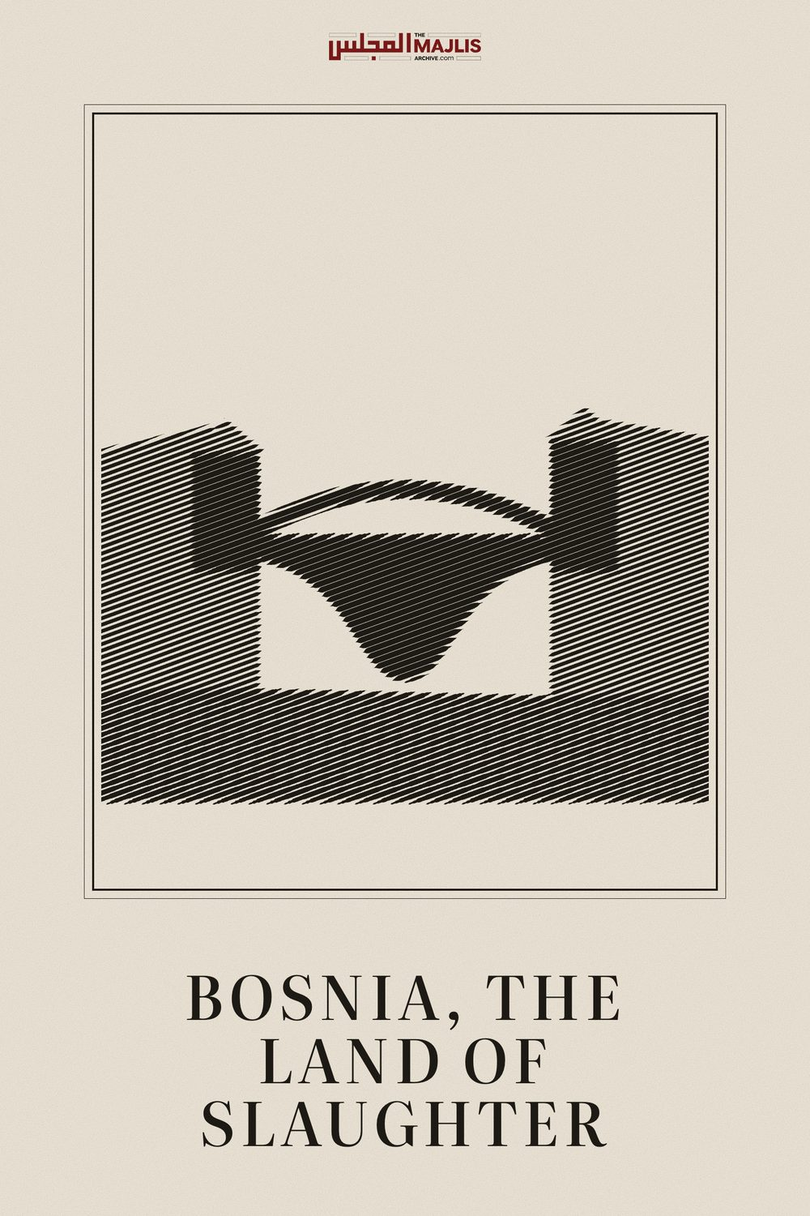

BOSNIA, THE LAND OF SLAUGHTER
The Majlis · Voice of Islam
Mujlisul Ulama of South Africa

About this edition
This is a reproduction by The Majlis Archive (themajlisarchive.com) of a publication of The Majlis, Mujlisul Ulama of South Africa, made and published with their permission.
The PDF as The Majlis issued it is the original. This edition was read from that PDF's own structure and checked against it letter for letter; where the two differ, the PDF is correct.
Checked: 308 paragraphs, 0 differing; a second, independent PDF reader finds 100.0% of the PDF's words here.
Nothing has been reworded, added or removed.

BOSNIA, THE LAND OF SLAUGHTER

MUJLISUL ULAMA OF SOUTH AFRICA

Port Elizabeth

South Africa

'A TRUE HELL': HOW THREE SREBRENICA SURVIVORS DEFIED DEATH 30 YEARS AGO
Amid a genocide in which more than 8,000 people were killed, they crawled through slush, trekked through forests, and dodged bullets and bombs. They lost much of their families. And they won't let the world forget.

By Alma Milisic
Published On 12 Jul 2025
Before the war scattered his family, Nedzad Avdic loved geography.
He had just entered his teens. Growing up in the village of Sebiocina in Srebrenica municipality, close to the border with Serbia, Avdic could explain the difference between clustered and dispersed settlements. He learned how one could tell north from south by noticing which side of a tree the moss grew on, and discovered how to find constellations and navigate by the North Star.
"I didn't study it for survival," Avdic, now 47, would later write in his memoir. "I studied it because I loved it."
But in the spring of 1995, three years into a conflict that still scars the Balkans, he would come to live in the geography of eastern Bosnia, trudging through forests alongside 8,000 other Bosniak men and boys, trying to survive.
Avdic was 17 by then and living in a United Nations-run refugee camp in the valley of Slapovici, just south of Srebrenica, a small town in eastern Bosnia nestled in a deep valley near the Drina River, which has historically served as a natural border with Serbia. At the time, Srebrenica had a population of just 6,000 and was locally known for its ancient silver deposits, from which it took its name – the Bosnian word for silver is srebro.
The UN camp, built on previously uninhabited land, was home to more than 3,000 displaced Bosniaks, South Slavic Muslims native to Bosnia and Herzegovina, who lived in rows of Swedish-donated wooden cabins. There was no electricity, no plumbing and never enough food.
Bosnia was a young country then, newly independent after the collapse of Yugoslavia, having declared independence on March 1, 1992, after a public referendum. At the time, Bosnia's population was ethnically diverse – roughly 44 percent Bosniak, 31 percent Serb and 17 percent Croat – making it one of the most multiethnic republics of the former Yugoslavia.
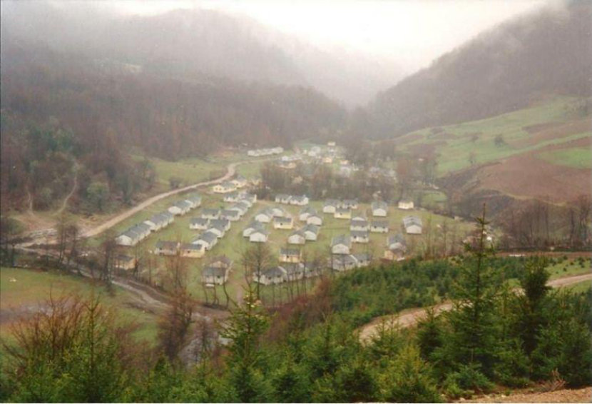
The Slapovici refugee camp, located in Srebrenica municipality, sheltered at least 3,000 Bosniak refugees during the last two years of the Bosnian War [Photo courtesy of Nedzad Avdic]
By then, Bosnian Serbs had proclaimed what they would call Republika Srpska, a notional quasi-state that the community's political leaders wanted to carve out from Bosnia, ostensibly to defend its interests.
Only a month later, on April 6, Bosnian Serb forces, backed by Serbia, launched a war to seize territory and expel non-Serbs towards that goal. Towns close to the border were shelled, civilians forced out, and families like Avdic's had to flee.
His family – father Alija, mother Tima, and three younger sisters – would be uprooted several times throughout the war: first from their home in Sebiocina, then from makeshift shelters in Srebrenica town, before they reached the refugee camp in Slapovici.
In 1993, after a Serb attack on a schoolyard that killed 56, many of them children, and wounded more than 70, Srebrenica and its surrounding villages were declared a UN "safe area," by the UN Security Council along with five other towns and cities in Bosnia. The declaration demanded an "immediate cessation of armed attacks by Bosnian Serb paramilitary units against Srebrenica" and that Serbia and Montenegro, then called the Federal Republic of Yugoslavia, "immediately cease the supply of military arms" to the Bosnian Serb paramilitary forces. But the Serb bombardment of the town and its neighbouring villages never stopped.
At the time, Avdic told Al Jazeera, "We believed the war would eventually end – that it had to."
"The United Nations was there, the Blue Helmets, and we told ourselves the darkness couldn't last forever. Of course, we all feared for our lives – we knew that on any given day we could be killed," he said.
"But the scale of what would happen next was beyond anything we could have imagined."

The offensive begins (July 6–10, 1995)
At dawn on July 6, 1995, the hills around Srebrenica thundered with artillery fire. It was the start of Operation Krivaja '95, an offensive ordered by Radovan Karadzic, then president of the self-proclaimed Republika Srpska, aimed at capturing the enclave.
In the Slapovici refugee camp, Avdic woke to the sound of shelling.
"It just wouldn't stop," Avdic said. "It was clear it had become too dangerous to stay."
As Karadzic's troops approached, Avdic and his family left on foot – he says on July 8 or July 9 – fleeing into the hilly forests towards villages near Srebrenica.
"Reaching those villages was our last refuge," he said.
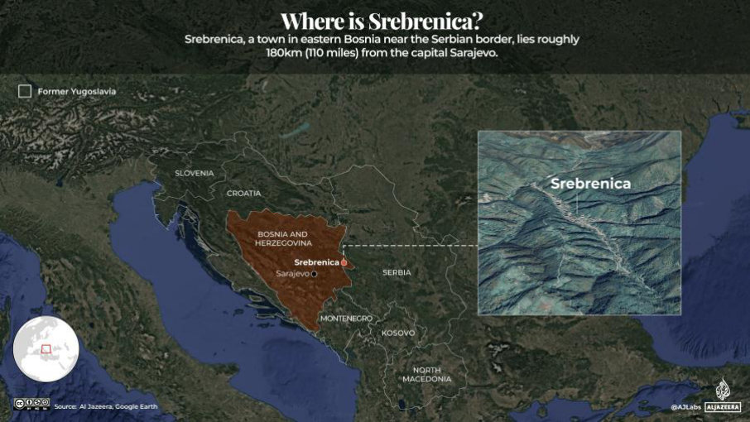
Inside the town of Srebrenica, Hajrudin Mesic, 21, heard the same explosions from his family's apartment. He had already lost two of his four brothers to the war – Idriz, 36, on March 3 from a sniper, and Senahid, 23, from shelling in the 1993 schoolyard attack on Srebrenica. Now, in July 1995, it felt like the town itself was about to fall.
"That morning [July 6], everything shook," he said.
The army of Republika Bosnia and Herzegovina in Srebrenica – part of the country's main military force, formed in April 1992 to defend against Serb aggression and made up largely of local defenders – had been disarmed by the United Nations two years earlier in exchange for peacekeeping, and had few resources with which to fight back. Dutch peacekeepers were present, but by then, their positions had already been pushed back several times by the 25,000-soldier strong Army of Republika Srpska, the Bosnian Serb military force, leaving the town's outskirts exposed.
On July 10, Serb forces started entering the town. Mesic was in the bathroom when his mother began pounding on the door.
"'Hajrudin, son, get out, the bullets and shrapnel are falling in our living room,' I remember my mother screaming. They [the Bosnian Serb Army] were already in the town."
He grabbed a makeshift bag and slipped out with his elderly parents, mother Zaha and father Selim, and his two remaining brothers, Hasan and Safet, darting through side streets, using buildings for cover.
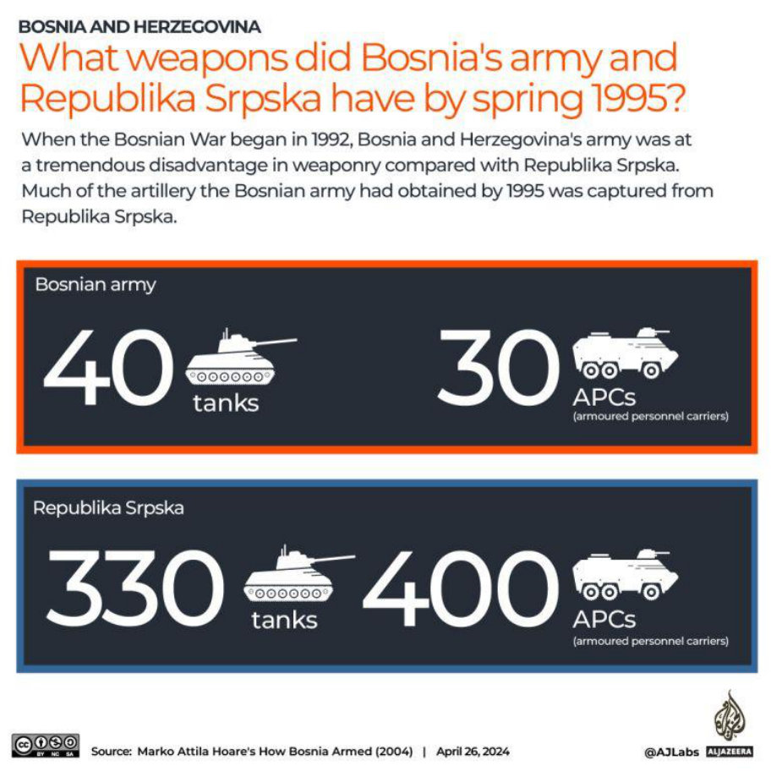

Srebrenica falls
Across town, 16-year-old Emir Bektic and his family realised it was time to run on the morning of July 11.
That day, Bektic's father, Redzep, returned to their home in Srebrenica covered in blood. A child had died in his arms after a shell hit a nearby village which was under bombardment and where Redzep had volunteered to help carry the dead and wounded. "Srebrenica is no more," he said. "We have to leave."
After years of surviving shelling, starvation and isolation, the enclave had collapsed. At about 4pm on July 11, General Ratko Mladic, leader of the Bosnian Serb forces, entered the UNdeclared safe area. They started separating Bosniak women, young children and the elderly from men and boys, promising that the first group would be allowed UN shelter.
Word spread among the 60,000 people in the enclave at the time – Srebrenica municipality's pre-war population of 35,000, and the rest of the people who had been pushed out of neighbouring areas by the Bosnian Serb forces.
Bosniaks fled in two directions: women and children moved towards the UN base in the village of Potocari, while between 12,000 and 15,000 unarmed men and boys set off into the hills, bound for Tuzla, the closest city beyond Bosnian Serb reach, nearly 100 kilometres to the north. It was a "free zone" that would guarantee their safety.
Bektic and his father joined the forest-bound column. His mother and sister went to the UN base. "One question hung in the air," he said. "Will we ever see each other again?"
Meanwhile, Mesic and his family also chose to split – his elderly parents went to the UN base in Potocari, while he and his two brothers went to the woods.
It was the same with Avdic, his father and uncle. Avdic's mother and his sisters headed to the UN base in Potocari, while they marched towards Tuzla.
On July 11, at about 6 -7pm local time, after two days of travelling on foot from the refugee camp in Slapovici, they reached the villages of Jaglici and Susnjari, approximately 15 kilometres (9 miles) away, where they joined thousands of other men and boys. But the villages were under bombardment. The horses and cattle that people were using to ferry the dead and wounded panicked, running helter-skelter. "In that chaos, I lost my father," Avdic said.
He suddenly found himself engulfed in a crowd of strangers. "I didn't recognise a single face around me," he said. In a panic, he began shouting for his father, pushing through the mass of people, calling his name over and over.
"But I never saw him again," he recalled. "Surrounded by thousands of people, I still felt utterly alone."
He joined them on the long walk through the dark forests of eastern Bosnia, hoping to reach Tuzla.

The death march
The route to Tuzla, which remained under Bosnian government control throughout the war, was thick with oak, beech and pine, but also scattered with a dry, brittle fern native to Bosnia's forests in summer. Temperatures were punishing, climbing as high as 34 to 36 degrees Celsius (93–97 degrees Fahrenheit) in the July heat. Every step through the dry undergrowth risked exposure. The crack of a branch or the rustle of dried ferns could give away their position to nearby Serb forces.
"We walked in silence," recalled Bektic. "Not out of discipline, because of fear. No one wanted to attract death."
"I was exhausted, hungry, and thirsty. We'd only managed to grab whatever food we could find in the house before marching through the woods. There was no time to prepare. That journey … all of it … was almost unbearable for me at 16."
On the night of July 12, at Kamenicko Brdo, 40 kilometres (25 miles) from Tuzla, the group that Bektic and his father were part of reached a stream.
Overwhelmed by thirst, Bektic bent down to drink, but the water was thick with mud. "It wasn't really water. It was more like muddy sludge. I felt sand in my mouth," he said.
Still, that single mouthful was all he had. Moments later, chaos erupted. Serb soldiers cut through the column, pulling out 15 to
20 people who had crossed the stream. They were ordered to climb a small hill and sit. Then came the words that changed everything: "You are prisoners."
"At that moment, they [the Bosnian Serb soldiers] were only debating one thing – how to kill us," he said. "Some of them said, 'Let's kill them right here,' while others suggested, 'No, let's take them down to the stream and slaughter them there.'"
Exhausted and terrified, Bektic laid his head in his father's lap.
"No matter what happens, we'll stay together. Just stay with me. Don't fall asleep," his father said.
But Bektic did fall asleep and woke up only the next afternoon to find that he was leaning against a beech tree, alone.
"My first instinct was to search for my father," Bektic said.
He called out. Waited. Searched. "Maybe he had gone to get water. Maybe he would come back."
He didn't, leaving Bektic with a lifetime of questions: What had happened to his father? Had he been marched to his death by the soldiers? Had his father propped him against the tree in the dark to hide him from the Bosnian Serb Army? How had he slept through it all?
"The last thing I remember from that night is his embrace."
After days on his own in the forest, Bektic found another group of Bosniaks, among them his uncle and his two cousins. But Serb soldiers soon surrounded them again, demanding surrender. Some tried to escape and were shot. As they were marching down the road, Bektic passed "hundreds of murdered people" in the heat, and he had to be careful not to "step on a body".
They were taken to a hill and ordered to sit in rows. A Serb commander announced that some boys would be released, and that any boy who wanted to go should stand up. Several boys about Bektic's age stood up.
"At that moment, none of us really understood what was happening", Bektic said.
"My uncle insisted that I get up and go, and we quietly argued," he said. "I just wanted to stay with my uncle. I had started to feel safe again, and no matter what happened, I wanted to remain by his side.
"My mother and sister had gone to Potocari, and I had no news of them. My father was somewhere in the forest – killed or taken, I didn't know. I was completely alone, and just being with my uncle and among other people I knew made me feel a little more safe."
But eventually, he caved to his uncle's pleas.
"Go," the commander said. As he stood up, he saw buses lined up in the valley below and ran towards them. He caught the last one just as its doors were closing. The bus was packed with women and children coming from the UN base in Potocari, going towards Tuzla. "Don't ask anything," one woman told him as they covered him with a blanket.

'Clapping for our executioners'
Further west in the forest, on July 13, near the village of Kamenice in Bratunac municipality – a former Bosniak village that had been burned and destroyed by Serb forces in 1993 – Avdic's group was also cut off by soldiers. "They [the Bosnian Serb military] threatened us over megaphones, saying they'd bomb us if we didn't surrender," he said. "Then they promised to treat us under the Geneva Conventions."
"At first, they acted civilly. Then it started. The beatings. The insults. The humiliation."
Avdic was somewhere near the front. The soldiers told them to leave their belongings, that everything would be returned. He left his bag, with family photos inside, next to a tank. Standing there on the road, he still remembers that tank in front of him, and the vehicles nearby. On one of them, written in Cyrillic, were the words: The Queen of Death.
Other vehicles began to arrive – civilian Volkswagen Golfs, packed with soldiers sitting on the hoods, roofs, and inside. More soldiers followed. Then came blue and white police cars, still the pre-war Yugoslav models.
The police remained behind as Bosnian Serb soldiers ordered men and boys to start jogging towards a meadow about a kilometre from Kamenice. As they crossed the asphalt road, buses filled with refugees from Potocari pulled up and were forced to stop. The captured men were now blocking the road.
"Among them, I recognise a girl I went to school with," said Avdic. "And it's obvious that some of the refugees in the buses recognise some of the people in our column, too. Women are crying as they probably recognised their family members among us – sons, brothers, fathers."
Eventually, the men and boys were ordered to continue running towards Kamenice, while the buses moved in the opposite direction towards Tuzla.
They reached a meadow in the destroyed Bosniak village of Sandici. "The grass was already trampled, as if someone had played football there," Avdic recalled. "Others had been there before us. And they had already been taken away."
Only later, while testifying before the International Criminal Tribunal for the former Yugoslavia (ICTY) in The Hague, would Avdic learn what had happened on that same meadow just hours earlier: Ramo Salkic, a captured Bosniak refugee, had been filmed calling out to his teenage son Nermin to join him where the Serb soldiers stood. That footage, used as key evidence in the prosecution of the Srebrenica genocide, showed the chilling moment of surrender. Both father and son were later executed.
That night, a Serb soldier told Avdic and others, "You'll be returned to your families. Everything will be fine." But the voice dripped with sarcasm, Avdic recalled.
"They placed us all in rows and laid the wounded ahead of us." Then came the order: lie down, hands behind heads – and applaud. "All of us, together, as hard as we could," Avdic said. "We spent two to three hours doing that." By the time the clapping stopped, the wounded were gone. "They had been taken into nearby houses and killed," he said. "Gunfire echoed all around us."
Then came the shouting: "Long live the king! Long live Serbia!" The soldiers forced them to chant with them in unison, like a choir.
Packed into trucks, Avdic and others were then driven through Bratunac town near Srebrenica and beyond. "Serbs cursed us from the sidewalks, threw stones," he said.
The July heat, he recalls, was "unbearable" inside the truck. "I remember peering through a hole in the tarpaulin [on the side of the truck]. In fact, that hole is what helped me breathe, so I wouldn't suffocate. People around me were losing consciousness. They couldn't breathe," he said. "A true hell."
With no water and unable to bear the thirst, people started drinking their own urine, he said.
"They were screaming, shouting, asking for water, saying: 'Open the tailgates, or kill us already. We can't take it any longer.'"
Avdic tried to keep track of time, but after hours without food or water, he could no longer focus. Bosniak men on the truck who had earlier seen a UN vehicle pass by – and had hoped it was coming to rescue them and take them to Tuzla – began to lose hope. Rumours spread that they weren't heading to Tuzla after all, but to Bijeljina, a city northeast of Tuzla near the border with Serbia, where Serbian nationalist paramilitary groups were maintaining a concentration camp.
They drove like that for about 50km, until they arrived at a school in Petkovici, about 70km from Srebrenica. By that time, it was already the morning of the next day, July 14.
As the men were offloaded from the trucks and forced into the school, soldiers began beating those in the front with rifles and pipes.
"It was chaos," Avdic said. "They couldn't strike everyone fast enough."
Inside the school, more Serb soldiers were waiting. One shouted, "Whose land is this?" Another answered, "This is Serb land – always has been, always will be." The men were forced to repeat the phrase in unison.
The ground-floor classrooms were already packed. Screams echoed from behind closed doors. Avdic and the others were taken upstairs to the second-last classroom on the first floor. Inside, he recognised his uncle. He learned that they had been together earlier in the meadow, but Avdic had not noticed him then.
At one point, people started whispering about escape. "We should try jumping out the windows … or making a run for the doors," someone said. "Maybe someone would survive that way, otherwise, we are all going to be killed."
Hearing the commotion, Serb soldiers stepped in and tried to calm the crowd. "The Red Cross is coming, prepare to be exchanged."
"And we all believed it. In a situation like that, you'd believe anything for a chance to survive," Avdic said.
His shirt was still soaked with urine from the journey, so he turned to the person next to him and asked if they had a spare T-shirt. A man sitting next to him pulled out one and handed it over. "The Red Cross was coming, and I felt embarrassed to be seen like that, all soaked. I was shy," he said.
The soldiers started taking men out of the classroom, five or six at a time. When it was his turn to go outside, Avdic asked his uncle to come with him. "But he refused. He stayed behind."
Once out in the hallway, soldiers ordered him and others to undress, tied their hands and marched them downstairs. He followed with others, leaving the clean shirt behind.
There was blood in the hallway, bodies in front of the school, and more at the main entrance. He expected to be shot right there. But the soldiers loaded them back onto a truck.
Once the truck was full, the soldiers fired a few bullets through the tarp to scare those inside. Screams filled the air as some people were hit and wounded. Bodies crushed against each other, but Avdic, who was not hit, managed to stay on his knees.
Amid cries around him, Avdic recognised a voice behind him: "It was my geography teacher."
The truck started moving. When it finally stopped, it was about midnight. The men and boys were again ordered to get out.
Soldiers began pulling people out again. By now, Avdic was sure that they were to be executed. "It all happened so fast," Avdic said. "I tried to hide behind others, pressing myself into the crowd – but so was everyone else, each person trying to shield themselves behind someone else."
But Avdic had also accepted that he was going to die.
"The only thing I wanted at that moment was to drink some water. I felt devastated that I'd die thirsty."
As he looked ahead, he saw what felt like an endless crowd — thousands of men. Then, the gunfire began, sudden and fierce. He couldn't recall the exact moment he was hit. There was chaos, shouting, bodies dropping all around him. Then – blackness.
When he regained consciousness, pain surged through his body. His right arm and side were burning; his whole body trembled. The stench of gunpowder clung to the air. Bullets had been fired at point-blank range – they had torn through the group without mercy. Bodies lay all around him.
In the haze, he heard voices, soldiers nearby. One said, "Check if anyone's still alive." Another replied coldly, "They're all dead."
Then came silence, followed by the sound of vehicles pulling away. Somewhere nearby, he noticed a man still moving. He called out softly, "Are you all right?" The man responded, "I am. Come. Untie me."
"I can't … I can't …" Avdic whispered. His voice faded in and out.
Somehow, after what seemed like eternity, he managed to gather his strength and crawl over to the man, who had survived, almost unharmed, because he had been crushed under the weight of the bodies falling on him, and so, was saved from the bullets.
With nothing else to use, Avdic began chewing through the ropes that bound the man, slowly and painfully. Thread by thread.
The soldiers were gone, so the man stood up and began to walk. Avdic, still tied and injured, crawled beside him, over the bodies of executed men and boys, some still warm. They stumbled into a concrete drainage canal hidden in the brush, where the man untied Avdic's wrists and began to carry him. When the man grew too tired, Avdic would drag himself forward on his stomach, inch by inch.
They survived on wild apples plucked from trees. Weakened and bleeding, Avdic would beg the man, "Please, leave me behind. Save yourself." But the man refused, every time.
For days, they crept through dense forests, dodging Serb patrols, slipping past scorched Bosniak homes, and sleeping in the ruins of villages burned years earlier. Each time Avdic could go no farther, the man pointed to the next hill and whispered, "Just that one more … then we'll stop."
Eventually, they crossed into Bosnian-held territory in Zvornik near Tuzla, barely alive.
"Someone poured water on me," Avdic later recalled. "And I cried. That's when I knew. I had survived."

A shoelace
After surviving the shelling of his apartment in Srebrenica, Mesic joined the column fleeing through the forest with his two brothers, Hasan, 36, and Safet, 34, on July 11, while their parents had already taken refuge at the UN base in Srebrenica.
After a day or two of moving, the column stalled – likely near Kamenica, a village in the Zvornik municipality near the border with Serbia – and was attacked by soldiers. Kamenica was one of the deadliest points along the escape route from Srebrenica, where Bosnian Serbs killed hundreds of men through a series of ambushes as they tried to flee through the forest.
A fierce barrage of gunfire rained down on them. Mesic's brother Hasan was shot in both arms.
Amid the chaos, Mesic and his brothers tried to keep moving, but he lost sight of both Safet and Hasan.
"I couldn't see them any more," he said.
He pressed on with a small group of survivors, carrying the wounded through the woods.
At one point, rain began to fall, and the survivors welcomed it. "It masked our steps," he recalled. "Soaking wet, exhausted, we lay down and slept side by side, in the mud, under the rain."
Along the route, he reunited with a close friend, who shared his brother's name, Hasan. "Only then did I feel a little safer again," Mesic recalled. "I wasn't alone any more."
But Mesic, Hasan and their group would have to face more gunfire. In the forests above Kamenica, the narrow trails had turned into visible roads, beaten down by thousands of desperate feet.
Locals called it the trla, a tragic corridor etched into the landscape by death marches. Serb forces were already there, lying in wait.
"They let us pass, and then opened fire," Mesic said. "Many were killed."
He hit the ground along with Hasan. "I remember the sound of them changing rifle magazines," he said. Hasan was shot. "Please don't leave me," he begged.
"I didn't, I couldn't," Mesic said.
Once again, Mesic survived, with Hasan.
By the time the two reached Brezik village, 50 kilometres (about 30 miles) from Tuzla, Mesic's shoes had long fallen apart. He was walking in thin socks that had torn, and his feet were blistered. In one hand, he clutched several small, bruised wild pears which he had picked up in the forest – "the kind even livestock wouldn't eat," he said.
"But we were starving. I couldn't let them go."
They were close to what they believed was free territory when bullets hit the dirt around them again. "We have made it so far," Mesic told his friend. "But I don't know if we'll make it this time."
Serb soldiers were positioned on nearby houses, so the two crawled through high, uncut grass to avoid being noticed until they fell into an abandoned Serb army trench. Inside, they found two wounded Bosniak men and a boy, who had been shot by the soldiers. The men died in front of them. The boy, 16-year-old Musa, was bleeding heavily from his leg.
"He looked at me and said, 'Do you have a shoelace? Anything I can tie my leg with?'" Mesic recalled. "You think I had shoelaces? I didn't even have shoes."
In pain and panic, Musa began to cry out: "Serbs! I'm wounded! Come help me!" From somewhere beyond the trench, a voice called back: "Drop your weapon first!" Musa answered, "I don't have a weapon! I'm a kid!"
"He still believed someone might help," Mesic said.
But no help came. Musa was shot and killed where he lay.
Realising they may be next, Mesic and Hasan ran for their lives under fire, slowing down only once the soldiers were out of range. "I still had the pears in one hand."
It was night, and they decided to wait for dawn before moving again.
But suddenly, Mesic heard someone calling out to them.
About 30 metres away, there was a soldier waving, motioning for them to come over. Mesic said to Hasan, "He's calling us. Maybe he's one of ours?" Hasan replied, "Are you kidding? That's a Chetnik [a Serb nationalist fighter or paramilitary]." "If it was a Chetnik, he wouldn't be smiling like that – he'd shoot us from here," Mesic said. Hasan still didn't want to go. Mesic was torn. He said again, "He's smiling, that's something only a friend would do." Then, next to the soldier calling out to them, Hasan recognised his friend Sakib. "It's our army! It's Bosniaks!" he told Mesic. The terrain of Brezik is rugged and broken up, and the two had crossed into Bosniak-controlled territory without realising it.
They ran towards the Bosnian soldiers, who gave them bread. They had survived.

The ones who lived
Days later in Tuzla, Mesic was reunited with his parents, who had given him up for dead.
Meanwhile, the bus Bektic had boarded in Potocari took him to Tisca, from where he walked as part of a civilian column to Kladanj, near Tuzla. "Even though I was part of a long column, I still felt completely alone," he said. "But I survived. And that means I have to speak."
In 2004, the International Criminal Tribunal for the former Yugoslavia (ICTY) ruled that the Srebrenica killings were genocide. Serb leaders Radovan Karadzic and Ratko Mladic were both convicted of genocide – Karadzic in 2016, Mladic in 2017.
In 2007, the International Court of Justice recognised Srebrenica as an act of genocide and found that Serbia failed in its obligation to prevent it.
In just a few days in July 1995, more than 8,000 Bosniak men and boys were murdered. Their remains were scattered across mass graves, many of them later disturbed in efforts to hide the crime. At least 25,000 women and children were expelled from the town. According to the State Commission of Bosnia and Herzegovina, approximately 25,000 women were raped during the war. The actual number is believed to be significantly higher, as many survivors likely have never come forward because of the stigma associated with rape. In 2006, Bosnia and Herzegovina became one of the first countries to legally recognise survivors of wartime sexual violence, but children born of wartime rape weren't recognised until 2022.
To this day, more than 1,000 families are still waiting to find and bury their loved ones killed in the Srebrenica genocide. Those found are being buried in Potocari.
In the early 2000s, Avdic testified at The Hague in the trials of those accused of committing genocide in Srebrenica. He later co-wrote a book with his sister, The Hague Witness, now translated into English and being translated into Arabic. He lost his father, three uncles – including the one who was with him in the school in Petkovici, an aunt, three cousins, and many others in the genocide. From his immediate family, his mother Tima and his three sisters had survived. He never got back the family photographs he had left in his bag. Today, he lives in Srebrenica.
Mesic lost four brothers, including Hasan and Safet – the brothers he was fleeing Srebrenica with – and 24 relatives on his mother's side. Hasan, who was shot in both his arms, was eventually killed by stepping on a mine placed by Bosnian Serb forces. His remains were found and laid to rest at the Potocari cemetery, while Safet is still missing to this day. Mesic lives in Sarajevo, where he teaches history and geography. Each year, he takes his students to Srebrenica and the memorial in Potocari.
Bektic lost about 10 of his family members and relatives, among them his father Redzep, who was found in a mass grave in Kamenica. His uncle and two cousins, who were with him, were also executed. Today, Bektic lives in Sarajevo and is the author of A Dawn Alone, a personal account of his survival during the Srebrenica genocide, translated into English and Turkish.
SOURCE: AL JAZEERA

INTRODUCTION
The Naseehat reproduced in this Introduction was published in Al-Haq in Muharram 1413 – July 1992. It was the occasion of the massacre and genocide of the Bosnian Muslims who were being ruthlessly eliminated by the Serb savages and their western backers.
This Naseehat holds good for the current genocide ravaging Palestine. The only difference is that in Palestine the savagery, barbarism and villainy are magnified perhaps a hundred fold.

THE BLOOD OF BOSNIA
The blood of Muslims is drenching and soaking the sands of Bosnia. The mass murder and slaughter of a whole nation by Christian Serb animals and savages who have unleashed a reign of brutality against the Bosnian Muslims are being placidly condoned by a world which most vociferously proclaims the slogans of justice and democracy.
People are asking: 'Who can help Bosnia?' – 'Who will stop the killing?' Such calls are impliedly directed to the US and Europe. But why should these leaders of kufr and agents of Shaitaan move against their Serb brethren to save a Muslim community earmarked for extermination?

CONSPIRACY
The holocaust which the world is silently observing in Bosnia is part of a larger conspiracy engineered by the west against the World of Islam. The present brutal massacres of the Muslims of Bosnia should not be viewed as an isolated episode. It is part of the western plot against Islam.
The aim of the western kuffaar is to exterminate the Bosnian Muslims as a viable Muslim nation. An independent Muslim nation in control of its own destiny in the midst of Europe is intolerable to the west. A Muslim country cannot be allowed to flourish in Europe by the enemies of Islam. Such an independent Muslim country in Europe, according to western understanding, will constitute a bridge linking Europe to the other Asian Muslim lands. A powerful Islamic bloc with a strong foothold in Europe is logically unthinkable to the west.

WESTERN DECEIT
The flabby stance and slight noises emerging from the US surrogate – the United Nations – most are designed to pull wool over the eyes of the world. The silly and hypocritical stance of the west against Serbia should not befuddle Muslims into believing that this Satan is on the side of the Muslims of Bosnia. It is stupid and 'islamically illogical to expect the US and Europe to act resolutely against their Christian savage Serb brethren to save a Muslim nation which the Shayaateen of the US and Europe have connived to eliminate.

ONE BREED
Islam proclaims:
All kufr is one breed!
Kufr is the very antithesis of Imaan. Muslims cannot be so naive as to look askance to the enemies of Islam for aid and succour. In fact, the Bosnian Muslims are being brutally pillaged, plundered and exterminated with the collusion of the US and Europe. When Iraq had invaded Kuwait, the US and its cronies let off an avalanche of protest and propaganda accusing Iraq of atrocities which were all trumped up to organize support for the impending American invasion and aggression against the Muslims of Iraq – not against Saddam. In the conspiracy of Satan it was deemed imperative to act against the Muslims of Iraq and cripple it to a degree that for a long time to come it will not pose a danger to Israel.
In its mad craving to demoralize and destroy a Muslim Nation, the US embarked on a mad propaganda drive to mobilize world support for its planned aggression against Iraq. Posing as the defender of an aggressed people and the friend of the weak, the US together with its allies brutally attacked Iraq with such military forces which the world had never witnessed before. In the process of achieving its plot, it brutalized and destroyed Iraq.

NEW WORLD ORDER
The US justified its brutal attack of aggression by promising a 'New world order of justice and peace' in which the strong will not trample on the weak. Only stupid people and slaves of kufr digested such drivel. What has now happened to the US's 'New world order of justice'? It was so swift to act brutally and aggressively against Iraq, yet it fails to do anything to curb the murderous activities of its savage brethren, the Serbs. While Muslims cannot and should not expect the west to step forward to aid the Muslims of Bosnia, it is necessary to point out to these kuffaar and shayaateen that Muslims are not so stupid to swallow the arrant nonsense which they are tabling at the UN against the Serbs. Muslims do understand that all the superficial protestations against the Serbs calmly offered by the west are merely designed to appease the inflamed feeling and conscience of the Ummah.

GREATER EVIL
Worse than the actual conspiracy of the US and Europe is the deafening silence and inactivity of the governments of Muslim countries. In their support for the US against their brother Iraq, Muslim governments threw in their miserable lot with the US Devil-in-Chief. Nor did some Muslim countries hesitate in sending armies to collude with the kaafir west in the conspiracy to kill Iraqi Muslims. Yet today, we are confronted with a shocking and deafening silence on the fate of the Bosnian Muslims. Indeed, the impervious attitude of detachment from the Ummah being displayed by Muslim governments is scandalous.

SPINELESS
Most, if not all, Muslim governments have been planted by the US. While one cannot fault the logic of the US in its global operations and conspiracies, the Ummah must take up issue with the evil, hypocritical and spineless political leaders at the helm of affairs in Muslim countries.
They are among the worst of villains being all cogs in the conspiratorial machine of the US.
There exist several dozen so-called independent Muslim states in the world. They command enormous wealth, manpower and resources. Yet, they have become so impotent and so spineless that they lack the stamina and enthusiasm to even raise a slogan of protest when their Muslim brothers and sisters are being brutally massacred daily in Bosnia. They lack the ability to even bark like toothless dogs. Indeed, they have demonstrated to the Ummah that they are enemies of Islam worse than even the US and Britain. Their collusion with the west, be it voluntary or enforced – represents a stab in the back for the Ummah of Islam.
The acts of collusion with the west by these evil Muslim government are deeds of high treason against Islam and the Ummah.

AIDING THEIR BRETHREN
Serbia has not hesitated to come to the aid of its brethren in Bosnia to pursue the brutal aggression and policy of extermination directed against the Muslims of that country. Croatia is aiding its brethren fighting the Serbs. In deﬁance of the so-called world protest which any way is a sham, Serbia has sent its armies which are engaged in a systematic policy of murder, expulsion and extermination of the Muslims of Bosnia. Yet, no Muslim country offers any aid to the Muslim community hemmed in on all sides by the savages of Serbia.
While Turkey is in the best position to act against the aggressors, it dare not raise a finger because in actual fact, Turkey is a satellite of the US. It cannot act without the direction of Mr.Bush.
Turkey has always been swift to bombard the Kurds agitating for a land of their own. Since action against the Kurds serves the global interests of the US, Turkey is let free to use military action against the Kurds. But, in defence of Bosnian Muslims being mercilessly murdered and expelled from their homes, Turkey which has the closest ties with Bosnian Muslims, finds itself absolutely impotent and spineless.

ISLAMIC CONFERENCE?
The recent so-called Islamic conference of Muslim states held in Istanbul to discuss the heart-rending plight of the Bosnian Muslims, was an utter disgrace. It was a spineless exhibition and an utter squander of time and money. It will not be far-fetched to assume that this so-called 'Islamic' conference was simply designed to allay the shock and feelings of Muslims all over the world who expect Muslim countries to act determinedly in such a momentous upheaval and genocide of Muslims as is being enacted by Christian savages in Bosnia. While the spineless political leaders of Muslim countries were sitting in air-conditioned halls engaging in stupid and futile prattle, their Muslim brethren in Bosnia were being mercilessly plundered, pillaged and murdered.

CRY OF PITY
Bosnia's desperate appeal for Muslim backing fell on deaf ears at the recent 'emergency' meeting of the so-called Organization of Islamic Conference held by the foreign ministers of 46 Muslim countries in Istanbul.
The Bosnian Foreign Minister appealed to Muslim countries to back foreign military intervention to bring to an end the slaughter of Muslims by the Serbs. But the Foreign Minister was wasting his time pleading to a bunch of spineless political leaders out on a picnic in Istanbul. The hearts of these political leaders at the helm of affairs in Muslim lands are impregnated by kufr, hence the misery and horror which the Bosnian Muslims are suffering do not strike any responsive chord in them.
These impervious political leaders, foreign ministers, presidents and prime ministers cannot be members of this Ummah of Islam. If the eye pains, the whole body will suffer. But, the attitude exhibited by these callous political leaders justifies the assumption that they are evil shayateen masquerading as Muslims.
Content with their adoption of ineffective resolutions of hollow sympathy and hypocritical offerings of support, the political leaders of Muslim states meekly and obediently toe the line chalked out for them by their mentor, the US. They proclaim themselves as independent sovereign states while they are the spineless slaves of the United States and the West. They are compelled to dance like apes to the tune set by their kufr masters in America, England and France. They are a disgrace to Islam and they have betrayed the Ummah for a miserable price.
It is a shocking revelation of impotency, corruption and disgrace to observe 46 so-called independent Muslim countries holding an emergency meeting to discuss the horrors and the slaughter of a whole Muslim nation, yet these miserable drones fail to come up with a plan to thwart and neutralize the savage enemy. These evil political leaders have transformed all the lands of Islam into satellites of the kuffaar powers. They sport Muslim names while their hearts brim over with kufr and nifaaq. Be it Saudi Arabia, Pakistan, Egypt, Algeria or any of the other myriad of so-called Muslim states, they are all of the same ilk. They survive on kufr – they pedal kufr and they are destroying the lands of Islam with their kufr. The fate which overtook the president of Algeria must necessarily overtake all these tyrants who are the miserable fronts of the West.

A HEROIC STAND
The valiant resistance put up by the Bosnian Muslims inspite of the extremely heavy odds against them is solely due to the fact that there still remains something of Islam in them.
Fighting tyranny and brutality is a natural trait of Imaan. No matter the degree of degradation into which Muslims have become submerged, they are still capable of making heroic sacriﬁces and valiant defence. The Imaan of Muslims demand that they go down fighting. It is inherent in a Muslim to die honourably, not cowering with cowardice which is an inherent attribute of the kuffaar.

OVERWHELMING ODDS
Indeed the odds against the Bosnian Muslims are overwhelming. Muslim irregulars are hemmed in on all sides. They fight with light arms. They are pitted against a fully mobilized savage army of Serbian kuffaar who have taken up positions with heavy military equipment on the surrounding hills overlooking the largely defenceless Muslim populace. Supported by the army of Yugoslavia, the Serbian barbarians are daily pounding the Muslim population with heavy weapons. In this brutal manner is the Muslim population being demoralized and brutalized.
Despite these staggering odds against them, the Bosnian irregular Muslim fighters are putting up a heroic stand. Even if they are defeated, they can hold their heads high for they went down fighting, not running.

ATROCITIES
At vulnerable points where there are no Muslim ﬁghters to resist the cowardly advance of the Serbian savages, these kuffaar gain entry and manage to overwhelm the unarmed defenceless Muslim people and a virtual reign of horror and terror is let loose by these barbarians. Women are ravaged, infants are brutally murdered, people are cruelly expelled from their homes and whole villages are set alight.
But neither these overwhelming odds nor the unspeakable atrocities and carnage perpetrated by the Serbian savages have dimmed the resolve of the Bosnian Muslims to fight valiantly for their honour. Five months of horror has not diminished their determination to stand up against the brutal Serbian animals. May Allah Ta'ala grant them aid – Unseen
Aid – from His Side. There is no one and nothing that can today come to the aid of the brutalized Muslim brethren of Bosnia other than Allah's Aid.

IMAANI WEAKNESS
When the Bosnian Muslims are capable of displaying so much heroism despite their Deeni and Imaani weaknesses, one can imagine the flying success and victory which a Nation of Muslims grounded in Imaan and adorned with spiritual elevation can achieve. The power and victory of the Ummah are acquired on the basis of an Imaan adorned with all the moral and spiritual excellences of' Islam. No power can withstand the thrust of an Ummah which has graduated in Roohaani Power. This, alas, is lacking in the Ummah of today.

OUR DUA
For the moment, the dua of the whole Ummah must be for Allah's Aid to come to the Muslims of Bosnia. May Allah Ta'ala save them from the plundering and pillaging of the Serbian savages.

THEIR PLOT
Bosnian villages and towns crowded with tens of thousands of Muslims who had fled their homes and who were expelled by the Serbs, are being encircled by the kuffaar armies bent on exterminating the defenceless Muslim civilians. In these villages without Bosnian Muslim defenders, the brutal Serbs perpetrate the most heinous atrocities. The aim is to decimate the Muslims of Bosnia and to prevent the creation of a Muslim state in Europe. These horrendous massacres and carnage are all enacted in fulfilment of the grand western conspiracy to destroy Islam. But never will they achieve their nefarious and pernicious plot. The Qur'aan says about these plots of the kuffaar:
"THEY PLOT AND ALLAH PLANS AND ALLAH IS THE BEST OF PLANERS."

AFLAME!
The City of Sarajevo is much in the news on account of the Serb concentration and desperate attacks in the bid to capture the city. But besides Sarajevo, the entire Muslim Bosnia is aflame. The impression beings conveyed is that the carnage is taking place mainly in Sarajevo. This is false. Throughout Bosnia, the savage Serbs are rampantly perpetrating their horrendous and murderous acts of barbarism. There is no place today on earth like Muslim Bosnia, hemmed in so thoroughly by forces of the most brutal kind such as the Serb savages.

THE CARNAGE
Hungry and shaken by two months of bombardment, Sarajevo residents came out of hiding last week during a rare moment of peace. As they lined up to buy bread, three mortar shells, ﬁred by Serbian irregulars from a nearby hill, exploded in the crowded marketplace, killing at least 16 people and wounding more than 100. Moments later local TV cameramen captured the gore: survivors moaning and twitching in their own blood, severed limbs scattered among the dead and dying. Rescuers had to dodge sniper ﬁre to reach the victims. One man, the lower part of his leg blown off, crawled toward the TV camera, begging for help.
Already sickened by the widely broadcast atrocities of Serbian-controlled forces, U.S. Secretary of State James Baker was outraged by the massacre in Sarajevo. The carnage was so appalling that Washington, after months of foot-dragging, stiffened its resolve to get tough on Belgrade. Having watched the European Community repeatedly fail to restore order, Baker had come to regard the growing Yugoslav conﬂict as a test of U.S. leadership in a post-cold-war world. Meeting with his chief advisers, he urged them to keep pushing hard at the United Nations for swift, blanket economic sanctions against Serbia and Montenegro. Baker didn't have to mention military intervention – everyone in the room knew that if economic sanctions failed, force was the only remaining option.
No danger: A year ago, when Yugoslavia first dissolved into ethnic war, the Bush administration saw little need for stepping in. No allies were in immediate danger; no strategic or economic interests were threatened. The Balkan dispute looked like a messy regional affair: by seceding, Slovenia and Croatia had taken matters into their own hands. Besides, no one seemed blameless when it came to shedding blood. Exhausted from the recently concluded gulf war, the administration was content to let the EC take the lead in trying to restore peace. Washington was slow to recognize the breakaway republics, fearful that without negotiations with Serbia, civil war would erupt in Croatia and Bosnia, which both contain large numbers of ethnic Serbs. But Baker failed to anticipate the reactions of Serbian President Slobodan Milosevic – who misread U.S. forbearance as a green light to build a greater Serbia.
Even as Serbia advanced on Croatia, the U.S. State Department could argue that Milosevic was still trying to hold Yugoslavia together. "But his aggression in Bosnia crossed a new threshold," says a Baker adviser. Image after televised image of attacks on innocent civilians exposed Milosevic as an aggressor willing to carry his conﬂict across borders. "It's pretty clear that he's going to do the same thing to the [ethnic]
Albanians in Kosovo province as he's doing to the Muslims in Bosnia," says a State Department official, warning that a widening war could spill over into Yugoslavia's neighbors. Fed up with the dissension among the EC members-Britain and Germany wanted action; France did not – Baker decided Washington had to act.
He decided to take unilateral steps as part of a strategy to elicit the EC's cooperation through tough talk, arm-twisting and embarrassment. "I don't think that the world is going to be willing to continue to accept a humanitarian nightmare," Baker said en route to Europe, where he used every occasion to push sanctions imposed by the United Nations under Chapter 7 of its charter, which also permits military action. The pressure tactics worked: last week the EC voted a partial trade embargo, and the U.N. Security Council imposed more sweeping economic sanctions.
But with the passage of a punishing U.N. resolution, is anyone serious about military intervention?"
TIME MAGAZINE

LAND OF SLAUGHTER
Serbia's dream of dominance has soaked in blood the republics of what was once Yugoslavia. The U.S. and Europe can no longer look away.
WHEN WAR FIRST broke out in Croatia a year ago, Americans dismissed the senseless violence with a regretful tut-tut, while Europeans clung to the hope that people would soon come to their senses. But as the ﬁghting has spread south and east, igniting Bosnia-Herzegovina and threatening to engulf other independence-minded regions of the former Yugoslavia, hope has evaporated that sanity will prevail. The toll is terrible: more than 12,000 people dead, tens of thousands missing and wounded, 1.5 million men, women and children forced to flee their homes. Those numbers only begin to hint at the horror, which U.S. Secretary of State James Baker characterized two weeks ago as a "humanitarian nightmare."
From Bosnia come daily tales of gut-wrenching savagery, few more appalling than last week's butchery in the capital of Sarajevo. Civilians were lured from their homes by a lull in the ﬁghting to line up for bread and ice cream, when three 82-mm mortar shells smashed into the crowd. At least 25 people were killed and an additional 100 injured. While the brutality may have startled outsiders, Sarajevans were not surprised.
Just the night before, shells had slammed into a maternity hospital, killing three newborns.
In Muslim towns along Bosnia's eastern borders with Serbia and Montenegro, Serbian guerrillas have been waging what amounts to an "ethnic cleansing" campaign since early April Last week the village of Turalici took its turn. "They encircled the place and cut off communications," says Nijaz Rustemovic, 36, a Muslim engineer who lives in nearby Kladanj. "They went door to door and expelled the people who hadn't already ﬂed. Then they spilled oil all around and lit the village on fire." Other cleansings have reportedly included executions of scores of people. In Croatia, Serbian irregulars continue to expel Croats from areas near the Danube where Serbs predominate, despite the presence of U.N. peacekeeping troops. There are reports that Croats and Muslims have responded in kind against Serbs.
Americans and Europeans can no longer wish the Balkan problem away.
"This is no ordinary war," says Sylvana Foa of the office of the U.N. High Commissioner for Refugees. "We are hearing stories about families having to watch fathers and sons walk through mineﬁelds, and summary executions for the hell of it." While comparisons to the international disbelief, blindness and indifference that
In Bosnia, hope has evaporated that sanity will prevail. The death toll only hints at the savagery.
enabled Hitler to carry out his "final solution" are overblown, Baker hinted at such a parallel on May 24 at an international conference in Lisbon. It was just bracing enough to renew Western determination to halt the slaughter.
Humanitarian considerations aside, Europeans have a keen self-interest in seeing calm restored to the Balkans. When people run for their lives across not only internal borders but international ones as well, the financial consequences are heavy. According to the U.N., 1.25 million people, most of them Bosnians and Croatians, remain within the boundaries of old Yugoslavia. An additional 250,000 have sought sanctuary, mostly in Western Europe; tens of thousands more have probably slipped over borders illegally to stay with relatives. Already the largest forced movement of Europeans since World War II, this flood may be just the beginning. The UNHCR fears that if the ﬁghting in Bosnia is compounded by an eruption of hostilities in Kosovo, yet another ethnically divided territory about to explode, the number of people in flight could rapidly escalate to 3 million.
The tide of people leaving Bosnia is not just a consequence of the war; it is an objective. Serbs, who lay claim to one-third of Croatia and some 70% of Bosnia's territory; hope that enforced ethnic homogeneity will ensure their lock on seized areas.
Many are willing to go to almost any length to realize their dream of a Greater Serbia. Abdulrahman, 26, a Bosnian Muslim who fled from Zvornik, describes how he and two friends were on their way to the bakery to buy bread when they were nabbed by Serbian soldiers of the federal army and subjected to a night of abuse. Threatened with beatings, they were forced to kneel, butt their heads against a wall and sing 'songs impugning the virtue of Muslim women. "We sang," he says, "but they beat us anyway."
Serbs, Croats and Muslims fleeing Bosnia not only out of fear but also because they cannot get enough to eat. The food shortages hardly approach the crisis in Somalia, but for people accustomed to a steady diet, the diminishing supply is a hardship. "On even days we have beans," says Vladimir Pozek, a software analyst in Sarajevo. "On odd days, macaroni." Little relief is in sight. Both the UNHCR and the Red Cross suspended operations in Bosnia two weeks ago after workers were repeatedly threatened and a Red Cross official was killed while leading a convoy of goods.
Those who make it to other republics fare better. In Croatia most of the displaced are put up in private homes. People who have been relocated within Croatia qualify for state aid; those who come from Bosnia rely on relief supplies from international aid organizations. The majority of the almost 40,000 Bosnians who have sought refuge in the Serbian capital of Belgrade have also been placed in private homes. While many of these newcomers are Serbs, there are also large numbers of Croats and Muslims. "No one so far has specified that they'll only take a Serb or a Croat or a Muslim," says Vidanka Misic of the Red Cross. "The people who want to help don't care whom they help." No action has been taken against these Good Samaritans by the nationalistic government of Slobodan Milosevic. Presumably he views these resettlements as part of his divide-and-conquer strategy.
To handle fresh arrivals, international relief agencies have opened shelters in hotels, schools and public buildings. As these facilities rapidly ﬁll up, tent cities are being planned. But as more of the Balkans is consumed by ethnic strife, safe havens may become harder to ﬁnd. "Many of the Croats who sought shelter in Bosnia are now paying for it," says Foa. Last week 2,000 Bosnians who had fled to Belgrade were packed off by the Red Cross to Kosovo. These people may soon be on the move again: the territory's predominant Albanian population recently voted to secede from Serbia, raising the prospect of armed conflict there next.
WHILE THE WAR IS RIPPING apart the intricately entwined ethnic mix of the old Yugoslavia, the makeshift arrangements of the dispossessed sometimes forge new bonds. Jelena Pekez, 27, a Croat from the Bosnian town of Jajce, is married to a Serb. Vesna Gacic, 29, a Serb from the Bosnian town of Mostar, is married to a man of Croatian and Muslim descent. Both women fled to Kosmaj, south of Belgrade: Pekez left just ahead of a total blockade of her hometown, Gacic after a frightening 20-day stay in an underground shelter. When the two women's paths crossed at a center set up by the Red Cross, they kept their distance. But the things they held in common – a loss of home, a hatred for the violence – drew them closer. Now they operate the center together, coordinating the lives of 79 residents, almost half of them children. When one woman grieves, the other supplies the strength. There are more bad days than good. "I've lost my identity," says Gacic. "I'm no one now."
Both Pekez and Gacic are lucky in one respect: they have their husbands with them. It is far more common for the men and boys to stay behind to protect their homes and fight. Aida Catovic, 32, left Sarajevo on May 18 with her two small children. They escaped just in time: the next convoy out was detained by Serbian gunmen, who took 5,000 people hostage for three days. After taking the gruelling bus ride to Split in Croatia, Catovic flew to Zagreb. Now living with distant relatives of her in-laws, she waits anxiously for the daily call from her husband in Sarajevo. "The only question I ask is, 'Are you all still alive?' " she says. "And every day I worry what the answer will be tomorrow." Families are not always in agreement about
Serbian militia go door to door and expel people who haven't already fled. Then they spill oil all around and light the village on fire.
whether they should separate – and they do not always have a choice. Desanka Blacic, 36, a Serb, turned up hysterical and penniless in Belgrade last week with her three year-old son, having fled the Bosnian village of Kastilj. Her husband, a member of a militia protecting the self-proclaimed Serbian state within Bosnia, had told her, "Just get out, go anywhere." She tried to compel her 13-year-old son to leave with her, but he refused. "If Father is killed here," the boy said, "I want to die with him." Just recounting that story reduces the woman to tears.
Marica Josipovic, by contrast, is dry-eyed when she tells her tale. A sturdy, hard-faced Serbian woman of 50 years, she fled to Kosmaj from Prud, a predominantly Croatian town in Bosnia. Her husband remains behind, not by choice but because he was forced by a Serbian militia to fight. Josipovic says neither she nor her husband has any interest in killing neighbors with whom they have lived harmoniously for years. Before Josipovic left, she was on comfortable enough terms with the Croatians next door to ask them to mind her goats. She says conscripts on both sides of the conflict sneak home at night to guard their own property, often standing shoulder to shoulder; when the sun rises, they report for duty in opposing camps.
Such accounts speak to a reality that the current carnage obscures: in many villages, ethnic groups have coexisted peacefully for centuries. Probably they would have continued that way had it not been for the zealous ambitions of their nationalist leaders. Serbia's Milosevic is not the only one to whip up ethnic hostility. Croatian President Franjo Tudjman, no less brutal a dictator or ardent a nationalist, used the fighting in his republic to pummel Serbs and attempt to impose total control over any who stayed in Croatian territory. Now Tudjman is taking advantage of Bosnia's war to occupy areas settled by Croats. His government has reportedly negotiated with Belgrade to carve up Bosnia between the Serbs and Croats, leaving the Muslim population with next to nothing. It is an open question whether citizens will be able to set aside their anger and return to their neighborly habits when the guns are silenced.
As it is, few can hope to return to their homes in the foreseeable future. Most know that the lives they built have been razed to rubble. Red Cross personnel have noticed that when children ﬁrst arrive at temporary shelters, they speak of coming from Croatia or Bosnia; within a few weeks, however, they identify themselves as refugees. Adults are also relinquishing former ties. "I grew up with Serbs. We chased women together when we were young," says David Becirovic, 35, a Muslim businessman from Sarajevo who now camps with his wife, two children and 100 other people in a sports hall in downtown Zagreb. He says the drumbeat of Serbian leaders, who declare that any Serb who doesn't join the battle is a traitor, has made Sarajevo an alien place. "I used to have the feeling I knew half the city," he says. "Now that's gone."
Not surprisingly, some of the homeless have concluded that a more promising future lies elsewhere in Europe. But the E.C. countries, their economies already strained by recession; are not eager to be swamped by refugees who will need housing, jobs and welfare beneﬁts. Germany has been particularly responsive, shelling out $51 million this year in refugee assistance and taking in 115,000 – refugees – almost twice as many as Hungary, which has the second largest inﬂux. Germany's appeal owes much to its 800,000 guest workers of Yugoslav origin. "Practically everybody has a relative or a friend living in Germany." says Wolf Oschlies, a Yugoslav specialist at Cologne's Federal Institute for Eastern European and International Studies.
Bonn made one feeble attempt to stem the flow in early May but backed down when an international outcry ensued. Understandably, Germans are a bit irked that other countries should be so quick to criticize and so slow to act themselves. Many countries haven't even paid their full portion of the UNHCR'S $140 million aid program; as a result, the organization has received only about a third of the funding. Germany fears that the incoming refugees could reach 1 million. "Why would they go back?" asks Oschlies. "All they have there is inflation, unemployment and war, and many of them have no homes to go back to."
For many of the homeless, this is all just so much dithering. Becirovic, who would like to move abroad, has been on a wild-goose chase since late April. First, he tried to make his way to Germany, where a generous asylum law enables refugees to stay for an extended period. But the Austrians wouldn't let Becirovic and his family across their border without German visas. Then he turned to Western embassies in Zagreb. "The Americans refer me to their embassy in Vienna, but I can't get there without a visa," he says. He has run up against the same problem with the Swiss and British. There was a bright moment when he secured a visa from the Swedes – but once Bosnia received Western recognition as an independent state, the Swedes were at a loss what to do with a Bosnian who has a Yugoslav passport. "It's a vacuum," he says. "No one knows how to treat us."
Europe is beginning to devise a plan. At a meeting two weeks ago in Vienna, representatives from 10 countries, the UNHCR and the Red Cross adopted a strategy to offer displaced persons on-the-spot shelter from the conﬂict rather than asylum in other countries. While the message can be read as "Stay out," the plan is not entirely cynical: most displaced persons would rather stay put anyway. Fully three-quarters of a group of 2,000 refugees who fled from Dubrovnik to the Italian border province of Friuli last November crossed back into Croatia within three months.
The question is whether there will be anything to return to when and if Croats, Muslims and Serbs end their ﬁghting. So far, property damage is estimated as high as $100 billion. For the youngest generation, home has become a threat, not a refuge. Last week at the center in Kosmaj, four-year-old Natasha ran up to her mother in tears. A boy had taunted Natasha, saying she had to return home to Mostar in Bosnia, where the girl had recently spent three weeks underground. "Don't worry," her mother soothed. "We won't ever go back to Mostar again." When the little girl smiled, the mother looked as though she would cry. – Reported by Bruce Crumley/Paris,
James I Graff/Zagreb and John Moody/Belgrade

TIME MAGAZINE

THE BUTCHER OF THE BALKANS
Sly, intelligent and ruthless, Slobodan Milosevic is acting out a fantasy of power in Yugoslavia that so far knows no bounds.
By James L. Graff Belgrade
FROM A LEATHER CHAIR IN his spacious office in Belgrade, with a tin of his beloved cigarillos within reach, Serbian President Slobodan Milosevic strives to keep the war at arm's length. In a rare interview, perhaps granted to deflect the blame for the carnage in Bosnia-Herzegovina, he contended that Yugoslavia's bloody dissolution stems solely from the secessionist demands of the other republics. "All processes in the contemporary world tend toward integration," he said. "Nationalistic tendencies are against that general flow, that big river, that Mississippi." Confused? There is this clarifying coda: "In Serbia nationalists are not in power."
That is just double-talk. Of course nationalists are in power in Serbia, embodied in this pudgy-faced man with a belligerent jaw who has seized on generations of ethnic hatreds and resentments to turn what was Yugoslavia into a slaughterhouse. There are, as Milosevic rightly insists, "no innocent sides" in the civil war, nor is he the only unsavory populist who has
Nothing interests him but Serbian success, even if it means tens of thousands dead and dispossessed emerged from more than four decades of communism. But he is far and away the most destructive. More than any other single person, Milosevic is responsible for the bloodshed by his unyielding determination to see all Serbs united in one country carved from territory the communists left – fairly or unfairly – to other republics. He is the power behind Radovan Karadzic, the militant leader of Bosnia's Serbs, and he has effective command of the old Yugoslav army; he could cool their operations if he were so disposed. But, says a European Community diplomat who has dealt with Milosevic intensively, "nothing interests him but Serbian success, even if it means tens of thousands of dead and dispossessed."
There is not a flinch or a scruple when Milosevic talks – which is how he continues to pursue his dream against a rising tide of international opprobrium and opposition in Serbia. In his view, it is neither the thundering artillery of the Serb-dominated Yugoslav army nor the process of "ethnic cleansing" of Serbian regions in Croatia and Bosnia that has earned him the world's outrage.
MILOSEVIC, SAYS A European diplomat who knows him well, "is a brigand and a fanatic, but a sly, intelligent and sophisticated one."

TIME MAGAZINE

UN COURT DENIES MLADIC, WHO LED BOSNIA'S SREBRENICA MASSACRE, EARLY RELEASE
Ratko Mladic filed the request to be released on health grounds last month, saying he only had a few months to live.
Published On 30 Jul 2025
A United Nations war crimes court has denied a request from Ratko Mladic, an infamous Bosnian Serb military leader during the 1992 to 1995 Yugoslav wars, who oversaw the Srebrenica massacre, to be released early to Serbia on health grounds.
Judge Graciela Gatti Santana at the International Residual Mechanism for Criminal Tribunals, the court tasked with handling remaining cases from the Yugoslav war crimes tribunal, said on Tuesday that Mladic's condition did not meet the threshold of an "acute terminal illness" required for early release.
Mladic, known as the "Butcher of Bosnia", was sentenced to life imprisonment in 2017 over genocide, war crimes and crimes against humanity. He had filed a request to be freed on June 3, 2025, saying he only had a few months to live…
"The information before me demonstrates that the compelling humanitarian circumstances invoked by Mladic as a basis for his release are not substantiated."
Mladic, 83, was sentenced by the UN tribunal for the former Yugoslavia for his role in terrorising the civilian population during the 43-month siege of the Bosnian capital Sarajevo and the 1995 Srebrenica massacre.
Some 8,000 Muslim men and boys were slaughtered in Srebrenica by Bosnian Serb forces in July that year.
The Srebrenica genocide was the bloody crescendo of the Bosnian war, which erupted during Yugoslavia's dissolution, as Bosnian Serbs sought to carve out Serb-dominated areas by ethnic cleansing against the country's two other main ethnic populations – Croats and Muslim Bosniaks. Until the Russia-Ukraine war, the Bosnian war was considered the most violent conflict in Europe since the end of World War II.
Mladic has long been described by his lawyers as sick and frail. In their latest request, they said he suffered from an incurable illness and that "his remaining life expectancy is measured in months," according to a filing seen by the AFP news agency…
Mladic was arrested in Serbia in 2011 after 16 years on the run and is serving his sentence in The Hague. SOURCE: AL JAZEERA AND NEWS AGENCIES

COMMENT
Now the savage butcher who had engineered the brutal massacre of 8000 Bosnian Muslims is crying for mercy on 'humanitarian grounds'. Now when he is rotting with diseases in prison, he begins to understand the existence of something termed 'humanitarian'.
All of these savage, barbaric butchers, including Netanyahu, the son of the Devil, and the cunning Clown Trump, are among the worst of cowards and sub-satanist specimens of creation. The chap now shamelessly pleads 'humanitarian' grounds which he did not understand while brutally and mercilessly butchering the thousands of unarmed Muslim civilians.
Trump, Netanyahu and their vile savage confederates will not escape the Divine Punishment which has been decreed for them. They will then all cry and ask for mercy on 'humanitarian' grounds.

