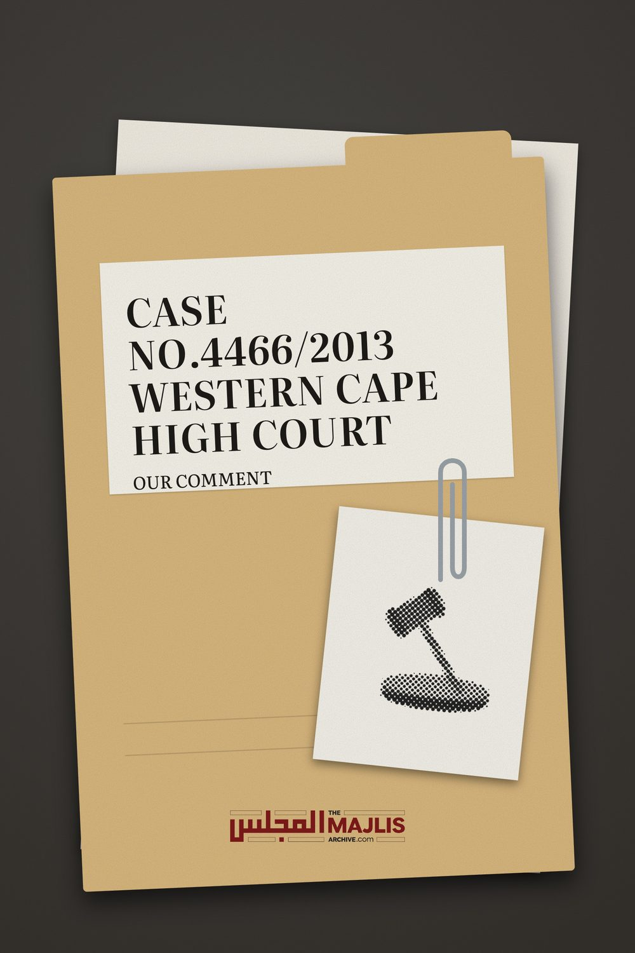

Case No4466 /2013
The Majlis · Voice of Islam
Mujlisul Ulama of South Africa

About this edition
This is a reproduction by The Majlis Archive (themajlisarchive.com) of a publication of The Majlis, Mujlisul Ulama of South Africa, made and published with their permission.
The PDF as The Majlis issued it is the original. This edition was read from that PDF's own structure and checked against it letter for letter; where the two differ, the PDF is correct.
Checked: 62 paragraphs, 0 differing; a second, independent PDF reader finds 100.0% of the PDF's words here.
Nothing has been reworded, added or removed.

MUJLISUL ULAMA OF SOUTH AFRICA Port Elizabeth South Africa
mujlisululama@gmail.com

WESTERN CAPE HIGH COURT
N A JUDGMENT in a case in the Western Cape High Court, Judge Rogers made certain comments which are tantamount to disparaging Islam. There is therefore a need to comment to put the issue into proper perspective and also for the edification of the honourable judge. In his judgment, the honourable Judge Rogers commented as follows:
"The evidence in this case shows that a husband in an Islamic union may throw off his wife with relative ease and informality."
"The vulnerability of women in Islamic marriages arises primarily from the ease and relative informality with which an Islamic union may be dissolved at the instance of the husband."
"The mandatory holding of hearings by the Master when the dissolution of an Islamic marriage is in dispute would not address this source of vulnerability which is a matter of substantive Islamic law." (Emphasis ours).
The fundamental error of the honourable judge is his equation of husband miscreancy with Islamic law. The judge has understood the misconduct of a husband in the manner of dissolving his marriage to be a 'matter of substantive Islamic law" whilst in fact, this notion is utterly baseless.
Before having embarked on comments which are disparaging of Islam, it was only proper for the honourable judge to have apprized himself of what exactly the 'substantive law of Islam' is on the issue of marriage and its laws of dissolution. The judge's preterition of Islamic teaching on this score, either due to obliviousness or unexpected unawareness, is not in consonance with the prestigious status of a high court judge who deems it appropriate to comment on issues which he believes pertain to substantive Islamic law. Most assuredly, the haraam method in which miscreant husbands dissolve their marriages with informality at the behest of their carnality, is never part of "substantive Islamic law" as the honourable judge has baselessly inferred.
Let us now present 'Islamic substantive law' on this issue. Let us firstly refer to the Qur'aan.
"And if you fear discord between them (husband and wife), then appoint an arbiter from his (the husband's) family, and an arbiter from her (the wife's) family. If they both desire reformation, then Allah will reconcile them. Verily, Allah is the All-Knower (Who is) Aware."
(Aayat 35, Surah An-Nisaa')
In the substantive law of the Shariah when there is a rupture in the husband-wife relationship, the first step commanded by the Qur'aan is the appointment of two arbiters – one from the husband's family and one from the wife's family. The obligation of the two Hakams (Arbiters) is to make the utmost endeavour to reconcile the parties. The arbiters will listen to both the husband and wife and advise them along the path of reformation and reconciliation. The procedure commanded by Allah Ta'ala in this verse is to prevent separation and dissolution of the marriage.
"Divorce is twice. (Thereafter, the wife) is either retained in good faith or released with kindness."
Both these Qur'aanic commands firmly debunk the honourable judge's conclusions of 'throwing off the wife', the "relative ease of dissolving the marriage", and "the vulnerability of women in Islamic marriages".
Commenting on his erroneous conclusions, the honourable Judge Rogers said: "The evidence in this case shows that a husband in an Islamic union may throw off his wife with relative ease and informality." The judge has mistakenly understood the husband's action as being part of the 'substantive law' of Islam whereas this is incorrect. The evidence in the case does not show what the judge has understood. It only shows that the husband has acted in diametric violation of the Islamic procedure of administering Talaaq.
If the honourable judge had apprized himself adequately of the substantive Islamic law pertaining to the procedure of Talaaq administration, he would not have arrived at the grossly inaccurate conclusions which he has expressed in such terms which are disparaging to Islam.
The Qur'aan explicitly commands that should the marriage fail and end in divorce, the termination should be effected with Ihsaan, i.e. with kindness. The Islamic concept of Ihsaan precludes whatever notoriety the deceased husband and the family may have perpetrated towards the woman who maintained that she was still in Nikah at the time of the demise of her husband. It is grossly unjust to hold Islam liable for the misdemeanours and injustices of its adherents who in his age largely follow western culture which gravely erodes humanity.
The only evidence in front of the judge was the un-Islamic conduct of the deceased husband and his heirs who had un-Islamically expelled the second wife, their stepmother, from her rightful home. However, due to lack of Islamic knowledge the honourable judge equated the misconduct of the parties with 'substantive Islamic law'.
In the Hadith, Rasulullah (sallallahu alayhi wasallam) said: "The most abhorred of the lawful things is divorce." Another Hadith states: "When divorce is issued, the Throne of Allah shudders." Once when it was reported to Rasulullah (sallallahu alayhi wasallam) that a man had pronounced Talaaq thrice in one session, he (Rasulullah – sallallahu alayhi wasallam), stood up in anger and exclaimed: "Do people make a mockery of the Book of Allah whilst I am still among them? Seeing the extreme anger of Rasulullah (sallallahu alayhi wasallam), a Sahaabi asked: "Should I not kill this person?"
In a genuine Islamic state – there are none today – the Islamic Court can even order a man who trifles with Talaaq in this despicable manner, to be flogged. Such punishment is termed Ta'zeer.
On the basis of the Qur'aan and Sunnah, the 'substantive law of Islam', as formulated by the Fuqaha (Jurists) sets out such a procedure for the administration of divorce which belies the conclusions of the honourable judge. According to the Shariah, it is not permissible for the husband to issue Talaaq during the menstrual state of the wife nor is it permissible to issue two or three Talaaq in a single utterance or in a single period of purity (Tuhr) regardless of how extended such a period may be.
If the husband is determined to separate and end the marriage, he should pronounce one divorce in such a period of purity known as Tuhr (which is the pure period following a menstrual cycle) in which sexual relations did not transpire. He may no pronounce two or three Talaaq in the same Tuhr. To do so is haraam. The humanity of Islamic substantive law is such that despite the divorce having been issued, the husband has the right to revoke the Talaaq within the Iddat and reconcile with his wife without the need for renewing the marriage. The Iddat is a period of several months. Thus, there is ample time for raw tempers and malicious attitudes to evaporate for creating an atmosphere amenable for reconciliation if there is any such hope.
After expiry of the Iddah, the Talaaq is transformed into Baa-in, i.e. it now becomes irrevocable. While the parties may still reconcile, a fresh Nikah has to be performed. Furthermore, reconciliation cannot be imposed on the woman after expiry of the Iddat. Once the Talaaq has been transformed into Baa-in, there is then no need for a second and a third Talaaq. The woman is free to marry any other man.
This Islamic procedure is indeed a far cry from the judge's comment: "…a husband in an Islamic union may throw off his wife with relative ease and informality"
The 'vulnerability' of the woman in the case, mentioned by the judge, is not the effect of Islamic substantive law. It is the consequence of the evil of people who act in contravention of the sacred Law of Allah Ta'ala. The "human drama and emotions at play" were the effects of man's villainy and have no truck with the substantive law of Islam as the comments of the judge imply.
The honourable Judge Rogers further commented: "Without talking to the applicant (i.e. the wife) Imam Saban gave Moosa (the husband) a Talaq certificate. In accordance with Islamic rites, this dissolved the marriage. The applicant was seven months pregnant with their second child…"
We really are unaware of the factual position. Nevertheless, we shall comment on the face value of the judge's statement. Firstly, the right of issuing Talaaq is vested in the husband, not in the Imam or anyone else. There was no need for the husband to obtain a Talaaq from Imam Saban for the simple reason that the Imam had no such right. Secondly it was haraam for the husband to issue Talaaq to the wife while she was pregnant. He had to wait until after delivery of the babe. It was the bounden duty of Imam Saban to have advised the husband of this substantive law of the Shariah. Thirdly, it was haraam for Imam Saban to have supported the husband in the issuance of Talaaq whilst the woman was pregnant and in the absence of the fulfilment of the Qur'aanic command to appoint two arbiters to endeavour areconciliation. Fourthly, the understanding that the certificate of Imam Saban had terminated the Nikah, is incorrect. The judge does not understand substantive Islamic law, hence he has confused issues. The certificate which Imam Saban issued could only confirm the validity of a Talaaq which the husband had already issued notwithstanding the haraam procedure adopted by him. It is not the Imam's certificate which dissolved the marriage.
In so far as the substantive law of Islam is concerned, the honourable Judge Rogers has erred in his conclusions and comments which are tantamount to a disparagement of the Shariah.
There still remains one aspect relative to Talaaq for elucidation. That is the legal validity in terms of the Shariah of the Talaaqs which a miscreant husband issues in conflict with the sacred procedure ordained by the Shariah. There is no gainsaying that Talaaq regardless of the haraam method adopted by the husband, is valid. The three Talaaqs uttered in a single, reckless emotional outpour are valid and take immediate effect. The marriage is irrevocably and finally terminated.
This aspect will be understood by means of an analogy. That is, if an intelligent person wants to understand it, the analogy will suffice.
Handling a gun is extremely simple. It can be fired with extreme ease – 'ease and informality' in the words of the honourable judge. Pulling the trigger of a licensed gun is very easy. If in anger a man recklessly pulls the trigger, the consequences are dire. No amount of regret and remorse will reverse the consequences of having pulled the trigger. Will it be intelligent and proper to lay the blame for the man's reckless handling of the licenced firearm, at the door of the authorities who had granted the licence for the gun? Is it intelligent to fault the 'substantive gun laws' for the ease and recklessness with which the gun was handled and the trigger pulled? Obviously the honourable judge and all men of intelligence will not argue that "the source of the problem is a matter of substantive firearm law". The recklessness of the user of the licensed gun cannot be equated to the substantive firearm laws. Similarly, the recklessness of the husband who is in violation of the substantive Islamic law pertaining to the procedure of issuing Talaaq cannot be ascribed to the Shariah. It is therefore palpably erroneous for the honourable judge to have commented: "…this source of vulnerability….is a matter of substantive Islamic law."
The honourable judge commented: "The circumstances of this case afford an illustration of the woman's vulnerability." This vulnerability is completely unrelated to substantive Islamic Law. The vulnerability of the woman in this case, who on the basis of her claim was the second wife still in the Nikah of her husband at the time of his death, and the stepmother of the heirs, stems from her own weakness, the villainy of her stepchildren and the abdication of duty of her Asbaat (relatives on the paternal side, e.g. father, brother, son, uncle, nephew, etc.). Her predicament has absolutely no relationship with substantive Islamic Law.
If Muslims abandon western culture and adopt Islamic culture, women will not be vulnerable. The western laws for addressing a divorcee's vulnerability, impose the obligation of supporting the woman on the ex-husband who has become a total stranger to her by virtue of the divorce. It is manifestly unjust and uncultured to impose on a man the duty of supporting a woman who has become lawful for another man. The ex-husband remarries and has the duty to support his new family as well as his children by his former wife. Supporting the woman who has become lawful for another man is an unjust imposition of a burden on an unrelated man. Islam does not condone such injustice.
At the same time, Islam does not abandon the woman. She is not cast to the winds and the wolves in a true Islamic society. The duty of support devolves on all her Asbaat relatives. In an ideal Islamic state, the Court will impose this duty on the Asbaat if they voluntarily seek to shirk their incumbent obligation. Thus, in terms of Islam, the divorced woman is not vulnerable. She is vulnerable in terms of western/secular/manmade laws. In the attempt to address such vulnerability, secular western law illogically and unjustly sets the close relatives free and imposes the burden on an unrelated man, viz., the ex-husband.
Ascribing the woman's vulnerability to substantive Islamic law is a misapplication of the mind which in turn is the effect of lack of Islamic knowledge. It is only with such knowledge that substantive Islamic law can be understood.
The honourable judge commented: "Without talking to the applicant (the second wife in this case) Imam Saban gave Moosa (the husband) a Talaq certificate." If this is factual, it may not be attributed to substantive Islamic law. Imam Saban, if indeed he is guilty of this deed, had erred in his conduct, for he was in violation of the Qur'aan and acted in conflict with substantive Islamic law.
The judge said: "Naziema Bardien is Moosa's adult daughter from an earlier marriage. She considered herself to have an interest in Moosa's estate." Yes, she is right. As a daughter she is entitled to her share of inheritance in exactly the same way as the other daughters of Moosa, and if he has no other daughters, then her share is half the share of a son.
Summing up the facts of the case, the honourable judge said: "The applicant (i.e. the second wife) claims that during October 2010 Tashrick and Bardien forced her out of the family home where she had lived with Moosa and that her belongings were thrown into the yard. The applicant was thereafter obliged to live in shelters or on the street."
If the scenario has been correctly depicted, and there is no reason to believe the contrary since it was not contested or denied, then again the pitiful condition of the stepmother may not be ascribed to the Shariah. Culpability for this villainy is the burden of Tashrick and Bardien (the two stepchildren of the applicant). Their conduct is worse than the behaviour of animals. Islam has conferred an elevated pedestal to the stepmother.
In Islam, a stepmother holds the same status as the mother. As far as honour, respect, care and maintenance are concerned, it is the Waajib (incumbent) duty of the stepchildren to uphold all these requisites of Islamic morality which are integral to substantive Islamic law. Rasulullah (sallallahu alayhi wasallam) said:
"Among the noblest of good deeds is that a man treats kindly the family of the friends of his father after his demise." The stepmother, i.e. the father's second wife, is his best friend. It is indeed callous and haraam for the stepchildren to evict their stepmother from the family home. It was tantamount to evicting their own mother. She has as much entitlement as them to live in the house. Her expulsion from the home was most abominable, unjust and cruel. This barbarous act may not be attributed to substantive Islamic law.
Assuming that at the demise of Moosa, she was not in his Nikah, then too, his children had the Waajib duty of supporting her in the way they would support their own mother. Expelling her from the home and throwing her belongings in the yard were barbarous acts not expected of Muslims.
The honourable Judge Rogers commenting on the letter issued by the MJC (Muslim Judicial Council), said: "The MJC has no statutory authority or religious authority finally to determine questions as to whether a marriage has been validly concluded or dissolved in accordance with the tenets of Islam."
That the MJC has no 'statutory' authority is accepted. But the judge's denial of the religious authority of the MJC is a stupendous error. We fail to discern the rationale for this incongruency. The MJC is a council of Ulama – qualified Islamic Theologians - who enjoy Islamic religious authority to decide on matters pertaining to the Shariah. While the secular authorities, including the High and Supreme Courts of the country lack religious authority to determine questions as to whether a marriage has been validly concluded or dissolved in accordance with the tenets of Islam, the MJC as a Council of Ulama, enjoys this authority.
If the Ulama lack this authority, who then possesses this authority? The honourable judge has miscalculated and misunderstood the capacity in which the MJC acts and discharges its religious functions. The judge is entitled to find on the basis of the evidence that a Nikah subsists or a Talaaq was issued or not issued, or the Iddah has expired or not expired. But, the secular court has no Islamic authority to determine the validity or invalidity of Islamic institutions or to issue a decree of Talaaq or to interpret any Islamic injunction to suit or conform to the constitution or any law of the land. Yes, the court may reject an Islamic injunction which it deems to be in conflict with the constitution, but it has no right to transmogrify the Shariah by way of interpretation.
The Ulama are the final and highest authorities for determining the validity or invalidity of Islamic institutions. This authority is not conferred to them by way of western democratic procedures, but by the direct investiture of the Holy Prophet of Islam. The Muslim masses have no say in this determination. The honourable judge has erred by coupling religious authority with statutory authority. The equation is improper.

THE BROADER CONSTITUTIONAL RELIEF
Under this caption, the legal representatives of the applicant, sought the following relief:
"…….the essential purpose of prayers B7 and B8 is to achieve an outcome in which a marriage solemnized in accordance with Islamic rites can be dissolved only by a decree of divorce in terms of the Divorce Act."
For obvious reasons the court did not grant this preposterous prayer. A decree by a secular court in terms of the Divorce Act, cannot dissolve a Nikah concluded in terms of the Shariah. A Muslim woman who takes the route to the secular court for maintenance or any mundane gains, too will not accept this position. If she is a Muslim at heart, she will know that even a thousand such secular court decrees will not release her from the Nikah. She will know that as long as her husband has not issued Talaaq or a Faskh has not been granted by an Ulama Body, she will remain in the Nikah of her husband, and will not be able to marry another man. The prayer is thus a preposterous superfluity.
This demand is, furthermore, in conflict with the constitutional imperative of freedom of religion. It constitutes a gross infringement of the right to religious freedom. In view of the gross incongruity of this and similar demands by the legal representatives of the applicant, the Master of the Court appropriately commented. Referring to the Master's comment, the judge said:
"The Master says, and I have no reason to doubt, that the topic is a sensitive one and that some Islamic stakeholders consider that the proposed legislation will trench upon their fundamental right to freedom of religion as guaranteed by 15 (1) of the Constitution."
Commenting further, the honourable judge said: "For obvious reasons a court would be most reluctant to make orders affecting the substantive law in this area. It is a sensitive subject requiring widespread consultation. ……….Ms Bawa acknowledged that the orders sought in prayers B7 and B8 would be very blunt instruments. They may give considerable offence to sectors of the Islamic community."
Most certainly any interference in the Shariah by the state will give considerable offence to the vast majority of Muslims. The vast majority of the Muslim community has unambiguously voiced opposition to the proposed Muslim Marriages Bill (MMB). Secular interpretation of the Shariah and the transmogrification of Islamic Law are intolerable to Muslims. Due to the widespread and intensive opposition to and rejection of the MMB by the Muslim community, it is not possible for the legislature "to bring appropriate legislation before Parliament" as observed by the honourable judge. There exists in the current legal dispensation adequate scope for Muslims to manoeuvre in a manner which will not bring them into violation of the Shariah. On the other hand, MMB is pure conflict with the Shariah.

