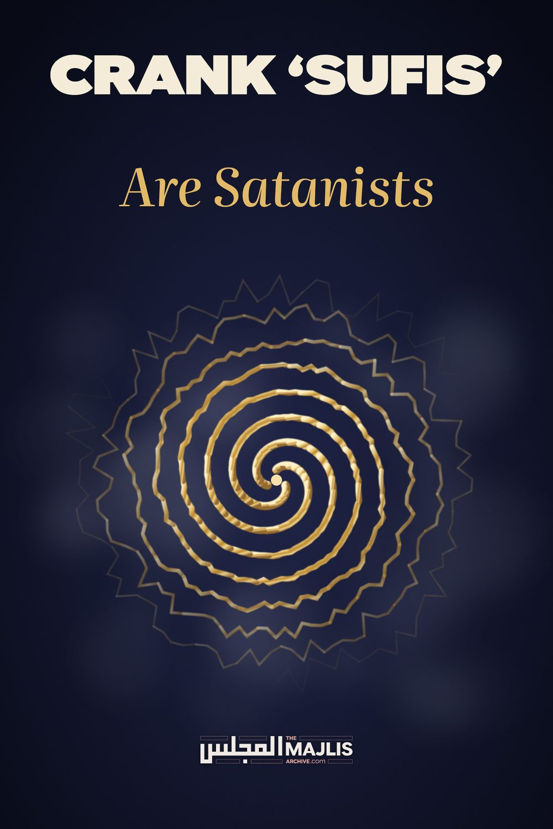

Crank ‘Sufis Are Satanists
The Majlis · Voice of Islam
Mujlisul Ulama of South Africa

About this edition
This is a reproduction by The Majlis Archive (themajlisarchive.com) of a publication of The Majlis, Mujlisul Ulama of South Africa, made and published with their permission.
The PDF as The Majlis issued it is the original. This edition was read from that PDF's own structure and checked against it letter for letter; where the two differ, the PDF is correct.
Checked: 118 paragraphs, 0 differing; a second, independent PDF reader finds 100.0% of the PDF's words here.
Nothing has been reworded, added or removed.

CRANK 'SUFIS' Are Satanists
By:
Mujlisul Ulama of S.A.
Port Elizabeth, 6056

South Africa

A BROTHER'S QUANDARY AND QUERIES
I wanted to ask since a long time about issues like Hizbul Bahr and Durood Tunjeena, etc. Although our Akaabir endorsed it, my question is that why isn't this a bid'at and an addition to Deen, especially when they are given preference over Masnoon Duas and A'maal?
Hizbul Bahr was taught to Imam Shazli (Rahmatullah alayh) in dream or by way of ilhaam. Durood-e-Tunjeena was taught to another buzurg. Both claim that Rasullah (sallallahu alaihi wasallam) came and taught them in their dream/ilhaam. My question is: Why would Rasulullah (sallallahu alayhi wasallam) come and teach a new thing when there are so many azkaar such as Istighfaar, etc. in Ahadith to remove difficulty/hardship?
Can it be shaytaan trying to take away people from Masnoon Ibadaat and Azkaar? A few years ago a khalifah of Shaykh Zakriyyara published a card in Pakistan that said that Durood-e-Tunjeena should be read a certain number of times because of the troubles on Pakistan.
If someone says these remedies have proven to be useful then, all Azkaar and all Qur'anic aayats have aathaar (effects). They are beneficial for some, while not for others.
The same with Sufi Azkaar. Although no one claims them to be Sunnat, firstly today no one practises the Masnoon Azkaar. Secondly more preference is given to them in the Silsilas like Naqshbandi, than to Masnoon Azkaar. Infact I haven't seen any shaykh or Deobandi Ulama in general encouraging the Masnoon Azkaar in contrast to Salafis here. They put much stress on Masnoon Azkaar.
Could the dreams seen of Rasulullah (sallallahu alayhi wasallam) be deceptions of shaytaan? I read in a book that if someone came to Ibn Sireen (rahmatullah alayh) and told him that he saw Rasulullah (Sallallahu alayhi wasallam) in a dream, he would ask for the description. If it matched the real description, he would say: 'Yes, you have seen him.' If not, then he would say: 'You have seen someone else.'
Similarly another buzurg said that shaytaan can come in a form of buzurg and tell you this is Tasulullah (Sallallahu alayhi wasallam) while in reality it is not Rasulullah (Sallallahu alayhi wasallam).
Last year I saw a dream that I am in Masjid and Rasulullah (Sallallahu alayhi wasallam) is leading the Salaat. I look at him and I say this is not him. He didn't look like this. Because the man I saw was very different. I believe shaytaan shows these dreams to trick one into believing that he is a big 'buzurg'.
If these dreams are true, then why doesn't Rasulullah (Sallallahu alayhi wasallam) ever appear and reprimand these big so-called buzurgs. If he does not then it means there are two deens. One was what He brought and the other one after his death. One for Sahaabah and Salaf and another one for later day buzurgs.
For example you have many times written about Maulana Tariq Jameel and his deviance. He himself tells a story of him having gone to Rawdhah Mubarak (Rasulullah's Holy Grave) where he read the Shajarah of Rasulullah (Sallallahu alayhi wasallam). As he was returning a man came running to him and said: 'Are you Tariq Jameel'? He said: 'Yes'. The man said: 'I was sitting and fell asleep here and saw Rasulullah (Sallallahu alayhi wasallam) in a dream. He conveys to you his salaam.'
Why doesn't Rasulullah (Sallallahu alayhi wasallam) ever reprimand them on their wrong actions. I have met Tariq Jameel many times and stayed with him. This person is so full of takabbur (pride) which I can't even explain. His face does not have the softness of a real buzurg. He gives special time to rich people and rich businessmen, but for poor people he does not have any time nor does he even say salaam.
Secondly is the issue of Shaykh Zulfiqar. In his safarnama (an account of his travels) of Russia, he says that he was given 'orders' by Rasullah (sallallahualayhi wasallam) to go to Russia. In Russia he claims that he spread the Naqshbandi Silsila etc. In his book he describes meeting a young 16 year old 'beautiful dosheeza' (girl) who said to him I want to marry you. Then towards the end an airhostess comes to him and says: 'Put your finger on my chest and make tawajjuh on me.' The Shaykh declines. Then she says: 'OK, let me kiss your clothes.' Shaykh asks the mufti with her, and the mufti says: 'Gunjaish hai" (i.e. There is scope for this.). Then the air-hostess comes forward and kisses his clothes. All this apart from whatever you (i.e. The Majlis) wrote in your articles.
My question is: Why doesn't Rasulullah (sallallahu alaihi wasallam) ever come to reprimand these 'buzurgs' for their brazen transgressions, for example the above episode, or why did you have your daughter's wedding in the most expensive hotel in Dubai? Why does Rasulullah (Sallallahu alayhi wasallam) always appear in dreams/visions as if he is pleased with these flagrant sinners?. Why and how can he ever be pleased with them when they distort and disregard the Shariah so much and so brazenly?
Shaykh Zulfiqar and his sons have set up a cold drink factory in Jhung in Pakistan, and all his mureeds there buy his cold drinks. Isn't this exploitation and using the Deen for the dunya for monetary gains?
Recently Shaykh Zulfiqar was taken to a police station while he was in Burma. Someone sent me a picture of him sitting in the police station. I accept it is haraam and Alhamdulillah, I stay away from pictures, but it was sudden. I saw his face in the police station. His colour was changed and he was so frightened. I know they will say Hazrat Moosa (Alaihis salaam) was also frightened, but a buzurg of such a big stature should not be frightened by just questioning at the police station.
When he came back to Pakistan to his madrasah there is a video was circulated of his welcome. He comes in a brand new land cruiser which costs around 1.5-2 crore rupees in Pakistan which is not a small amount. He is entering the gates of his madarasah where some people from the madrasah have gathered showering flowers on him.
Why don't they ever get reprimanded in dreams for all this extravagance and adoption of the behaviour of kuffar and fussaq?

ANSWER AND COMMENT
(1) Sight should not be lost of the fact that the Auliya enjoy a very close proximity with Allah Ta'ala. Kashf, Ilhaam and Ru'yah Saalihah Saadiqah are irrefutable realities which are experienced by the Auliya. Hence, a Dua, Thikr or Amal narrated by a genuine Wali of Allah Ta'ala should not be refuted. At the same time it should not be elevated to the status of Sunnah. True and pious dreams are one fortieth of Nubuwwat. This is confirmed in the authentic Ahaadih.
The dreams of these quack and crank 'buzrugs' are inspirations of shaitaan. Alternatively, their dreams are pure fabrications to deceive and ensnare the juhala to believe in their 'buzrugiat' (holiness and sainthood). It is possible for shaitaan to appear in the form of some wonderful 'noor' to even a genuine buzrug. If the true buzrug is not an Aalim of baseerat, he will likely be a victim in the snare of Iblees.
Once a genuine Aabid was travelling through the desert on foot on his way to Makkah Mukarramah. One night in the wilderness of Iraq, he beheld a wondrous sight. He saw in the sky a massive throne of glittering noor. A voice announced from the throne: 'I am Allah.'. The Aabid fell down in Sajdah glorifying Allah Ta'ala. Thereafter the 'noor' and the throne vanished. The Aabid was immensely please for having seen 'Allah'. When he reached Baghdad, he narrated his vision to the Ulama who explained to him that it was shaitaan for whom he had prostrated. Since the Aabid was a genuine Wali although not an Aalim, he accepted the ruling of the Ulama, and immediately headed back to the location where he had seen the 'noor'. On reaching the place, he loudly called out to shaitaan, challenging the mal-oon to make an appearance. But shaitaan understood the futility of making an appearance, hence did not appear.
Brother, your dilemma stems from a misunderstanding. You have understood these crank 'buzrugs' to be genuine Walis, hence you fail to understand why they are not reprimanded in their dreams by Rasulullah (Sallallahu alayhi wasallam) for their haraam shenanigans, and why they are only loaded with accolades in their dreams despite the conflict between the Shariah and their general lifestyle. These persons to who you have referred are fake 'buzroogs'. They are worse than ordinary sinners. So just as Rasulullah (Sallallahu alayhi wasallam) does not appear to the multitudes of people to reprimand them for their transgression, so too is it with these fraud 'buzroogs'.
There are instances of Rasulullah (Sallallahu alayhi wasallam) appearing in the dreams of true Auliya to reprimand them of any error which they may have committed. Once Rasulullah (Sallallahu alayhi wasallam), appeared in the dream of an ordinary Bedouin, instructing him to deliver a message to the Khalifa, Hadhrat Umar (Radhiyallahu anhu). The message was a reprimand for Hadhrat Umar (Radhiyallahu anhu). It intimated the impropriety of Hadhrat Umar (Radhiyallahu anhu) having instituted relief measures during a severe drought and famine. His resort to material ways to combat the effect of the drought was in conflict with the Tawakkul of a man of his lofty calibre. The solution for a drought is only Istighfaar, Taa-at and Dua.
Thus, Rasulullah (Sallallahu alayhi wasallam) did and may still appear to reprimand genuine Buzrugs, not cranks, quacks and frauds who rob people of their Imaan and morality.
The Auliya in fact do not promote their personal Ma'mulaat (Ibaadat practices) as acts of the Sunnah. Short-sighted and even ignorant mureeds and khalifahs commit excesses regarding the ma'mulaat of their Shaikhs. These underlings elevate the ma'mulaat to a higher status. With the passage of time, these ma'mulaat develop into bid'ah. It is just unfortunate that many genuine Buzrugs, despite their lofty status in the realm of Taqwa and Ibaadat, are not Fuqaha. Deficiency in this sphere overshadows the danger of their practices developing into Bid'ah in future. Many acts and practices which are today Bid'ah, were initiated with good intentions by genuine Buzrugs. It is precisely for this reason that Hadhrat Maulana Rashid Ahmad Gangohi (Rahmatullah alayh) had instructed his mureed to burn the booklet, Hadt-e-Mas'alah.
(2) There is nothing to proscribe a person from occasionally reciting Hizbul Bahr, etc. in his private capacity. The Durood/Thikr/Dua which is revealed to a Wali in a dream in which Rasulullah (Sallallahu alayhi wasallam) appears, is not meant for universal propagation. It is for the specific Wali a gift. It does not supersede whatever Rasulullah (Sallallahu alayhi wasallam) had taught during his lifetime. Such teachings were for the entire Ummah for all time.
When a genuine Buzrug who is accepted as a Wali by even the Ulama-e-Zaahir, informs that Rasulullah (Sallallahu alayhi wasallam) had imparted a certain thikr, etc. to him in a dream, it will be contumacious to deny it and accuse the Buzrug of having fabricated the Thikr. This is the methodology of the miscreant Salafis. The issue is not why would Rasulullah (Sallallahu alayhi wasallam) teach a new Durood. The fact is that the Wali will not fabricate falsehood. Ru'yah Saalihah (true and pious dreams) is one fortieth of Nubuwwat according to the Hadith, and such dreams will be experienced by the Men of Taqwa in all ages. Now when this is an undeniable fact of the Deen, it will not be permissible to summarily dismiss as a fabrication a Dua/Thikr/Dua which a genuine Buzrug has acquired in a dream/vision. The new Durood is not a new teaching for the Ummah. It is not for the Wali to impart the gift to the Ummah as a Sunnah teaching. But the Ulama should guard against any bid'ah developing, not only regarding such 'new' athkaar, but even related to Sunnah practices.
(3) Undoubtedly, shaitaan always attempts to ensnare people with bid'ah. But it is incorrect to infer that the Durood, etc. revealed to the Wali is from shaitaan. Hadhrat Shaazli (Rahmatullah alayh) was a genuine Wali of lofty status. It is not valid to brush off as a fabrication what he had acquired in the dream. Yes, if the person reporting the Thikr, Dua, etc., is a faasiq, faajir or a quack 'sufi' or crank such as Zulfiqar who does not observe the Zaahiri Shariah meticulously, then it will be proper to write him off and reject what he is claiming. Zulfiqar knows very little about the Naqshabandi Tareeqah, hence he manufactures shenanigans.
(4) The khalifah of Shaikh Zakariyya who had published the card as mentioned by you, acted stupidly. He was extremely short-sighted to say the least. Such persons initiate bid'ah. But it will be wrong to criticize Shaikh Zakariyya (Rahmatullah alayh) for the error of his Khalifah. The solution for Pakistan's troubles and problems is to observe the Shariah – to obey Allah Ta'ala – to abandon the fisq, fujoor and bid'ah which have become the way of life in that land. Making dua and reciting wazifahs will not avail whilst the moral rot is not arrested and eradicated.
(5) Another fact to understand is that some recognized and authentic Buzrugs are simple and not far-sighted. They are not Fuqaha and fail to see the damage which their personal Amal will cause in the future when their underlings (khalifas) elevate these ma'mulaat to the level of Sunnat or even Wujoob.
The Ishq of the Ush-shaaq Auliya sometimes overshadows their Fiqhi discernment, and this constrains them to sometimes stress on non-Sunnah athkaar which are all permissible, but which could and do lead to bid'ah as a consequence of their rigid observance. Consider Hadhrat Haaji Imdaadullah (Rahmatullah alayh). No one doubts his greatness in the field of Tasawwuf. He was an Imaam and Mujtahid in this sphere, hence illustrious Ulama who were veritable Fuqaha, such as Hadhrat Maulana Qaasim Nanotwi, Hadhrat Maulana Rashid Ahmad Gangohi and Hadhrat Maulana Ashraf Ali Thanvi (Rahmatullah alayhim) were his mureeds.
Nevertheless, when the kitaab, Haft-e-Mas'alah of Haaji Saahib was read to Hadhrat Gangohi, he ordered: "Take it to the bathroom and incinerate it." Hadhrat Gangohi was a Faqeeh. He foresaw the detrimental consequence of this kitaab which the Ahl-e-Bid'ah would utilize in support of their acts of hardcore bid'ah.
The Fuqaha nipped fitnah in the bud with their sharp Fiqhi discernment, hence they permitted no scope for even such permissibilities which they discerned would certainly develop into bid'ah fisq and fujoor. Thus, according to the Fuqaha Aimmah Mujtahideen, ghina (singing/nazams/nasheed) are mutlaqan haraam irrespective of not being accompanied by musical instruments. They are the authorities of the Shariah whom we have to incumbently follow, and this is acknowledged and affirmed by all the genuine Ush-shaaq Auliya.
It should be obvious that the emphasis placed on practices such as Hizbul Bahr, Khatm-e-Khwaajgaan, etc. is the effect of short-sightedness, and this undoubtedly, develops into bid'ah. The Sunnah becomes overshadowed and even displaced in favour of practices which have no origin in the Sunnah.
(6) Yes, shaitaan is able to interfere in the kashf/dream of a Buzrug. Furthermore, a Buzrug could also misinterpret his own ilhaam, etc. Therefore, the criterion should always be the Shariah, NEVER the ma'mulaat, dreams, kashf and ilhaam of the Buzrug. Even if the Buzrug flies in the air, walks on water and transforms stones into gold, it will be meaningless if his act is in conflict with the Shariah. Nothing can supersede the Shariah.
(7) Irrespective of any non-Sunnah thikr, etc. having proven to be useful and beneficial, the amal will be scaled on the standard of the Shariah. If it is in conflict with any tenet of the Shariah, its benefits will be ignored, and may not be presented in justification of practising the amal. Also, if the initially permissible amal has become contaminated with bid'ah, it shall be set aside and banned in terms of the principles of the Shariah. Even liquor, pork and gambling have benefits.
(8) Although verbally they do not claim that the athkaar, etc. are Sunnat, practically they elevate these acts to even wujoob, hence they become offended if others do not join in these non-Sunnah practices. In fact, even Mustahab acts, substantiated by the Sunnah, will be set aside and labelled bid'ah, if their status is elevated to wujoob or if any evils have become attached to the Mustahab practices.
(9) The emphasis which the shaikhs of this era are according the non-Sunnah athkaar is undoubtedly a grievous error which has given rise to bid'ah. The Tablighi Jamaat too is guilty of having introduced bid'ah with its emphasis on its specific methodology and with its scorn for other valid, beneficial, mubah methods of Tabligh.
(10) This dunya is the abode of trial and tribulation. It is here where Allah Ta'ala tests us. He has created an evil nafs in us and along with the nafs, shaitaan has also been created. Then Allah Ta'ala granted Insaan Aql and the Ta'leemaat of the Ambiya. These are our weapons with which we have to combat all the evil forces in the world. Thus, it would be nugatory of Allah's scheme if Rasulullah (Sallallahu alayhi wasallam) had to appear in the dreams of all people to inform them of their errors and to reprimand them. If this occurs to a Wali, it is a rare exception. But as a rule, it is nugatory of the Divine Scheme for people on earth that Nabi (Sallallahu alayhi wasallam) should appear in dreams and visions to direct them. The Shariah is adequate direction, hence Nubuwwat has ended.
(11) The so-called 'buzrugs' who flagrantly act in conflict with the Shariah are not genuine Buzrugs. It is possible that a genuine Buzrug would be reprimanded in a dream, but a fake, imposter and fraud 'buzrug' is worse than an aami jaahil. There is no reason why Rasulullah (Sallallahu alayhi wasallam) should appear in a dream to reprimand him.
Your confusion stems from the misunderstanding that the shaikhs of this era are Buzrugs. They are not genuine buzrugs. They advertise themselves as buzrugs whilst in reality they are frauds and bid'atis, or plain jaahils.
(12) The dream regarding the character, Tariq Jameel, should simply be dismissed as a fabrication. There is no need to be in a quandary in this regard. When the character flagrantly practises baatil, fisq and fujoor, then dreams about his 'virtues' should be set aside and rejected or attributed to shaitaani machination.
(13) Zulfiqar is another deceit who manipulates the Deen for his nafsaani objectives. You need not be confused about his claims. He flagrantly perpetrates haraam which he justifies with Deeni cover. If you expect men of this type to be reprimanded in dreams by Rasulullah (Sallallahu alayhi wasallam), then you should extend your expectation to the billions of other Muslims who are also practising fisq and fujoor like Tariq Jameel and Zulfiqar.
(14) The world is awash with frauds and cranks posing as shaikhs of Tasawwuf. They are signs of Qiyaamah. They pursue their despicable nafsaani objectives in the name of the Deen. This has been predicted by Rasulullah (Sallallahu alayhi wasallam). In today's climate, there is no longer guidance emanating from the Musaajid and the khaanqahs. About these times of corruption, Rasulullah (Sallallahu alayhi wasallam) said: "The Musaajid will be beautifully adorned structures, but bereft of hidaayat."
The khaanqas of the Auliya are lying desolate. They are spiritually barren.
Cranks and imposters are constructing elaborate buildings/mansions which they dub 'khaanqah' to beguile the ignorant and unwary. In our day, all so-called 'sufi' tariqahs should not be touched with even a barge pole. Stay far, very far from them. They are institutions of bid'ah and corruption. Singing the praises of the 'shaikh', singing nazams, public halqah thikr for nafsaani appeasement, merrymaking and gluttonous feasting are about the only activities of the 'khaanqas' of this age. There are no genuine Sufis. A professed 'buzrug' who does not strictly adhere to the Shariah, who accords preference to his amals over and above the rulings of the Fuqaha, is an imposter. He is dangerous for the Imaan of his mureeds.

MASNOON ATHKAAR
There are numerous forms of Thikr prescribed by Rasulullah (sallallahu alayhi wasallam). All forms of Masnoon Thikr are highly beneficial and efficacious. Any of these forms may be adopted and practised. You could devise your own Thikr programme by selecting from the variety of Athkaar some of which are reproduced hereunder:
(1) Recite 41 times.
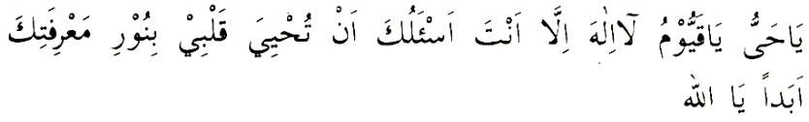

(2) Recite
500 times after Zuhr.
(3) After Asr recite
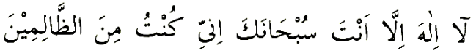
100 times.
(4) After Maghrib recite as much as you wish.
(5) After Isha', recite the following Istighfaar 70 times or 100 times
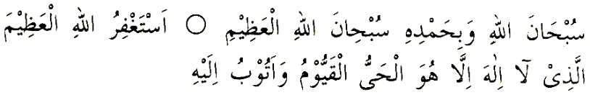
(6) In all states, while walking, sitting, lying down, working, etc.

constantly recite
(7) Every morning and evening, recite Surah Ikhlaas, Falaq and Naas, each one thrice.
(8) Recite the last Ruku' of Surah Baqarah every night.
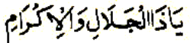
(9)
Recite as much as you wish.
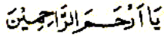
(10)
Recite as much as you wish.
(11)
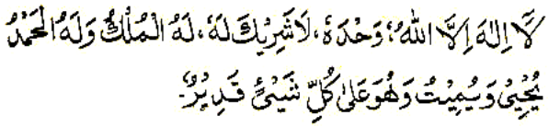
Recite as much as you wish. (12)
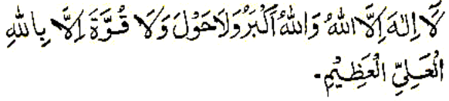
Recite as much as you wish.
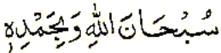
(13)
Recite as much as you wish.
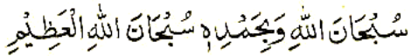
(14)
Recite as much as you wish. (15)
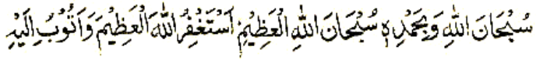
Recite as much as you wish.
(16)
Recite as much as you wish.
(17)
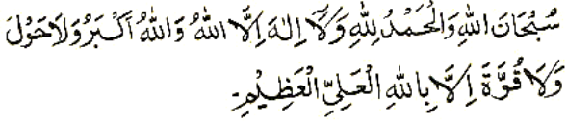
Recite as much as you wish.
(18) Durood Shareef should be recited daily as much as one wishes. It takes only six minutes to recite Durood Shareef 100 times.
Everyone should prescribe for himself/herself a programme of Thikr consisting of Nafl Salaat, Tilaawat, Istighfaar, Tasbeeh, Tahleel and Dua. Remember that the Best and most rewarding method of Thikr is the Silent Thikr. Besides keeping the tongue engaged in constant Thikrullaah in all walks of life, it is also necessary to sit in solitude for some time daily for Thikrullaah.
Rasulullah (sallallahu alayhi wasallam) said that on the Day of Qiyaamah among those who will be granted sanctuary in the Shade of the Arsh will be such people who engaged in Thikrullaah, silently, in solitude and tears flowed down their cheeks.

THE SPIRITUAL PROGRAMME
Some Masnoon forms of Thikr and Shaghl will now be explained, Insha'Allah.
(1) For enhancing the quality of Thikrullaah, Tahaarat is an essential requirement. Therefore, the Seeker of Allah Ta'ala should endeavour to be perpetually with wudhu. When wudhu breaks, apply pressure on the nafs and renew the wudhu so that you constantly remain under the special Rahmat of Allah Ta'ala. When both the body and the heart are pure – purified of all physical impurities and spiritual impurities (sin and futility), then the special Anwaar (rays of noor) which perpetually cascade from the Arsh of Allah Ta'ala will find a ready receptacle in your heart wherein to settle.
(2) Memorize all the short Masnoon Duas which Rasulullah (sallallahu alayhi wasallam) has instructed to be recited for every act. The Dua for eating, sleeping, dressing, leaving the home, entering the home, and the myriad of other short Masnoon Duas which encompass our entire life's activities, both mundane and spiritual, should be memorized. Until such time that you have not memorized all the Duas, recite Bismillaah when beginning any and every act.
(3) Punctually and regularly perform Tahyatul Wudhu, Ishraaq Salaat, Dhuhaa (Chaasht) Salaat, Awwaabeen and Tahajjud Salaat. Occasionally perform Taubah Salaat.
(4) Make Sadqah an integral part of your daily life. Give as you can afford even if it is one slice of bread. Never abandon Sadqah because you cannot afford to give a large sum of money. Allah Ta'ala looks at the niyyat, not at the amount.
(5) Without fail engage in Tilaawat of the Qur'aan Majeed daily. Fix your own quota of Tilaawat, and gradually increase it. Allah Ta'ala gives greater taufeeq when His bandah struggles along.
(6) Occasionally perform Salaatut Tasbeeh.
(7) Recite Istighfaar – any form of Istighfaar – at least 100 times daily.
(8) After Fajr Salaat recite Surah Yaaseen; after Zuhr, Surah Al-Fatah; after Asr, Surah Naba'; after Maghrib, Surah Waaqiah, and after Isha', Surah Mulk.
(9) After every Salaat, recite Aayatul Kursi and Tasbeeh Faatimi.
(10) Every night, devote a few minutes to solitude and meditate on the day's deeds and misdeeds, and on Maut and Qabr. Prescribe your own time duration for this shaghl. Even five minutes of daily meditation will prove vastly beneficial.
(11) Keep the tongue constantly engaged in Thikrullaah – any form of Thikr – Laa-ilaha illallaah, Allahu Allaah, Subhaanallaah, Allaahu Akbar, or any of the Asmaaul Husna. It is essential that the tongue remains perpetually engaged in Thikrullah whether walking, sitting, lying down, working and in every walk of life. This is the perpetual Thikr which is Waajib, and which is commanded by the Qur'aan and Hadith.
(12) If you have time available and you desire to practise more Thikr and Shaghl, then understand that the best and spiritually most efficacious forms of Thikr and shaghl are Nafl Salaat, Tilaawat, Istighfaar and Durood Shareef. No one, especially in this corrupt era of spiritual bankruptcy when true Mashaaikh of Tareeqat are no longer available, requires any Thikr or shaghl formula other than Nafl Salaat and Tilaawat of the Qur'aan Shareef. There are no superior athkaar and ashghaal to these Masnoon acts of ibaadat which were the primary acts of Thikr and shaghl of the Sahaabah.

