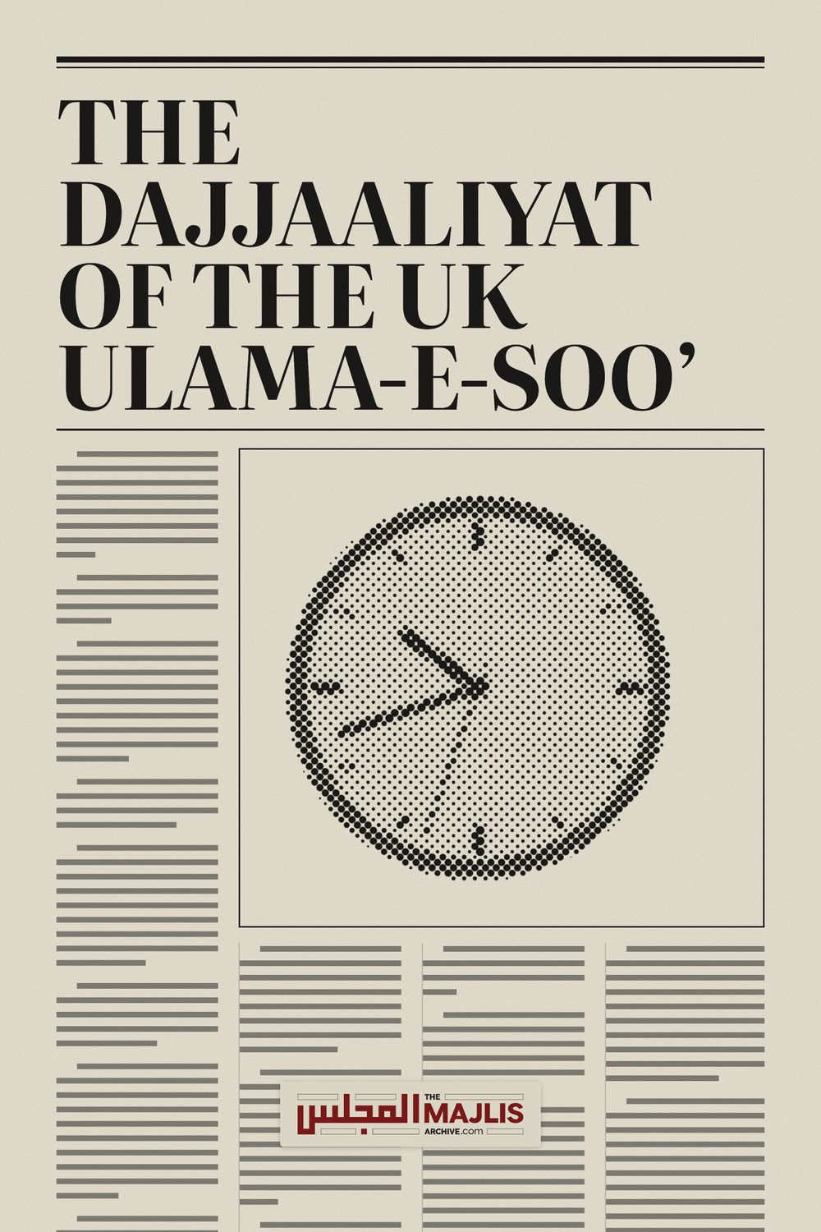

DAJJAALIYAT OF THE UK ULAMA-E-SOO
The Majlis · Voice of Islam
Mujlisul Ulama of South Africa

About this edition
This is a reproduction by The Majlis Archive (themajlisarchive.com) of a publication of The Majlis, Mujlisul Ulama of South Africa, made and published with their permission.
The PDF as The Majlis issued it is the original. This edition was read from that PDF's own structure and checked against it letter for letter; where the two differ, the PDF is correct.
Checked: 86 paragraphs, 0 differing; a second, independent PDF reader finds 100.0% of the PDF's words here.
Nothing has been reworded, added or removed.

By: The Majlis PO Box 3393 Port Elizabeth, 6056 South Africa

THE DAJJAALIYAT OF THE UK ULAMA-E-SOO'
While the world is awash with Ulama-e-Soo', bringing to fruition the prediction of Rasulullah (Sallallahu alayhi wasallam) who said that a "time will dawn when the worst of the people under the canopy of the sky will be the ulama", the U.K. ulama-e-soo' have outclassed and surpassed even the ulama-e-soo' of Bani Israaeel of bygone times.
Commenting on the villainous and treacherous haraam shenanigans of the U.K. molvis, sheikhs and cardboard buzrugs, a Brother from U.K. writes:
Assalaamualaykum
Respected Hadhrat
Several months ago, I had sent an email enquiring about the permissibility of moving to a remote area and live with the family away from the city either in a village or a low-populated suburb while there is no Musjid in the vicinity and it may be difficult to travel to the Musjid for the daily Fardh Salaats or even the Jumuah Salaat.
For some reasons I did not present the full context at the time and in your reply, you requested me to explain in detail due to the ambiguous nature of the situation. I had to delay and take some time to respond but inshaa Allah in this letter I shall provide some explanation and then hope for your advice. Jazaak Allah.
I live in the UK and the neighbourhood I am living in is a Muslim-majority area. There are plenty of Musaajid within walking distance of my house. However, I am not at ease, and I am very worried about the condition of the Muslims in this country. I am very concerned about the preservation of our Deen in its pristine purity and the protection of the Iman of our families.
I personally feel that the Ulamas and Shuyukhs in the UK are too much inclined towards modernism and liberalism, and worldliness is too much ingrained in the Darul Ulooms, the Ulamas class and the Talabul Ilm alike. Not to mention the soft and accommodating stance many of the Molwis and Muftis are adopting towards all types of deviancies such as Salafism, Barelwism or the Interfaith movement.
Amr bil Ma'roof wa Nahy anil Munkar is virtually non-existent. This tolerance for Baatil -however wise and peaceful it may appear to the unwary- is particularly grave and serious in my opinion. It certainly is most dangerous for the ignorant and trusting masses as it leaves guileless people treacherously exposed and prone to accept and mix with beliefs and deeds which may gradually lead to Kufr, Shirk and Bid'ah.
Nonetheless, up until recently, I was still maintaining the idea that there is still a remnant of the light of our Akaabir among some of them and they had not totally deviated from that path.
But it appears we have been misled by a façade of piety. The covid episode has been eye-opening. Indeed, the Ulamas in this country should have been our guides and our source of strength and reassurance when we had to face oppression due to the government's reaction and decisions during the covid episode and the practice of our beautiful Deen was impeded dramatically.
On the contrary, we found the Ulama to be the ones most instrumental in supporting the Zulm inflicted upon the Ummah by the government decisions. And their attitudes, actions, fatwas have been all acting as genuine agents of the governments, by endorsing the Covid measures while distorting and disregarding totally the rules and spirit of the Shariah.
Instead of helping the masses to protect their Imaan during those testing times (like it happened for example with many Ulamas and people in South Africa who fought against the scientific-atheist injunctions) most of the Ulamas in the UK and even the senior ones rather endorsed the government and medical authorities narrative.
It is possible that some of them did uphold the truth during the whole episode and bear honourably the status and position their Ilm is supposed to confer upon them. If it is the case, I must confess that I am mostly unaware about such attitude in the UK.
Regarding the most senior Ulama in the UK, their conducts have been disappointing, to say the least.
This was the case since the beginning of the pandemic when the Musaajid were closed for us.
The decision of the Ulamas, then, was to instruct people to perform Salaat at home and they implemented a system where Jamaat and Jumuah Salaats were performed in each Musjid by only five or so designated people in agreement with the authorities while the doors and gates of the Musjid were locked and entry into the Musjid was being denied for anyone else.
Being a layman and aware that I am lacking sufficient knowledge, I first tried to give them the benefit of the doubt and said to myself that, perhaps, due to the dire circumstances, they did their best and based their opinions on the lesser of two evils and advocated barring the community at large from the Musjid in order to secure the right to perform Salaat in the Musjid by at least a few people and thus avoid a complete closure of the Musjid and the total shutdown of Salaat taking place in the Musjid.
However, many signs in their attitude and their fatwas make me doubt this assumption and it rather seems that they believe in the concept of contagion as expounded by the modern medical and scientific mainstream conglomerate.
Whatever the case may be, the fact still remains that they actively participated to debar us and keep us aloof from the Musjid and we had to organize ourselves to at least perform Jumuah Salaat in other venues, without any guidance from them.
In fact, they were the main supportive agents acting to prevent us from performing Salaat in the Musjid. The least I can say is that they openly and effectively participated in the action of banning people from the Musjid during the pandemic and condoned this instruction and Zulm of the government under Islamic garb.
Moreover, even if keeping open the Musaajid was being difficult due to our weakness, the fact remains that they did not take care of protecting the Imaan of the masses and rather tried to justify the oppressive measures with Islamic pretence.
Even when Musaajid were allowed to be reopened again for everyone, Covid protocols have been enforced with their active participation. Thus, the donning of masks in Salaat, the implementation of gaps in the Sufoof, and hand sanitizing at the entrance of the Musjid were all measures fully endorsed and even promoted by the Ulamas in this country.
They condoned these regulations, and they most audaciously chose to support –under the guise of their Islamic leadership and authority – the Kaffir government interference into our Ibaadat and encroachment into the affairs of our Musjids. It is with their tacit approval and even their active help that the Muslims have been prevented from performing Jumuah Salaat and Fardh Salaats in Jamaat in the Musjid.
The same is true regarding the directive given -under Kuffar authority- to adopt such 'precautions' in the Musjid which distort the practice of Jamaat Salaat of the Muslims and discard most despicably the proper and Sunnah way of performing Salaat with Jamaat.
I must add that many of these Ulama and Imaams were very particular themselves in following the aforesaid protocols most diligently.
And lastly, when the Covid Vaccination program was being deployed, the major Ulamas organisations in this country encouraged the Muslims to accept and take the Covid vaccine.
Now, if I am quite frank, I must say that in my understanding any people who have participated in the implementation of the measures described above may have lost their Iman. Obviously, as a layman, to think about Takfeer on people is out of my scope.
Moreover, such a ruling on a grand scale would be difficult to consider as it would put us in a labyrinth predicament because we have no choice but to follow these same Molwis as Imaams in our Fardh and Jumuah Salaat even though they have not expressed any remorse whatever for what have been done during the Covid episode.
Nevertheless, I am stating the above point to emphasize and describe my concern clearly.
The situation is not comfortable at all for me.
These very Imaams and Ulamas have practically debarred us from the Musjid at the beginning of the pandemic.
Later on, these same Imaams and Ulamas have enforced the Covid protocols (hand sanitizer at the entrance of the Musjid, Masks in Salaat, and gaps in the Suffoof) in our Musjid.
To this day there is no regret or remorse for what has been done.
It is difficult to just forget everything and resume normally our lives as if nothing has happened. How can we just perform our Salaat behind these Imams and consider them to be our guides and leaders? How can we just let our children listen to their bayaans or learn the Deen from them?
And more generally how can we just live among the same people as if nothing really happened?
I am talking here about the Muslim masses. Majority of people in the UK to my knowledge just found it acceptable to abandon the Musjid and the Jumuah and later on to perform the Jamaat Salaats with all these covid protocols (unlike many people in South Africa for example who tried their best to resist and combat the oppression towards their religious beliefs and protect their musajid, their Salaat and their iman).
I find it not safe to just live here and not do anything. Only Allah Ta'ala knows what the future holds in stock for us. But I would not want to be caught in the same trap again. Yes, the last time we were surprised by the reaction of the Muslims and especially the Ulamas in the UK. I was really expecting better from them.
But now, I know and am I aware of the full facts. I have seen how they think and react and submit the Deen and the Shariah to the dictates of the mind colonizers of the West.
We cannot accept to be struck from the same place twice. Should any issue arise again, and a similar trial comes our way, we do not want to be in the same state of weakness and subject to such assault on the practice of our religion without being able to react in some way or another. I would feel ashamed to have remain unprepared and incapable of having some sort of control over the situation.
Yes, we are weak, and the solution simply and surely is Taubah and Inaabat ilallah on an individual as well as collective basis. Having said that, besides Sabr and Dua, and for those of us who cannot afford to do Hijrat which may not be possible or practical for whatever reasons in the present circumstances, are there any means a concerned person could adopt to strengthen his position and protect his family against the assaults of the enemies of the purity of our faith?
My assertion is that we, collectively as Muslims in the UK, are living in a state of humiliation not fitting for genuine Mu'mineen. We fear the Kuffar and their authority upon us to such an extent that we are prepared to trample on the perfect rules of our beautiful Deen in the hallucinated hope that our image as Muslims will not be tarnished in the eyes of our fellow countrymen and we are begging for them to accept us even at the cost of compromising on many important and necessary aspects of the Deen.
I would also like, in order to better contextualize my concerns, to state that the degenerate level of practice of the Deen and of Iman that we are witnessing from the Muslim masses in this country is to me alarming and only rubbing salt into the wound. Really, a person attached to the purity of Islam can only feel alienated into this environment. Nowadays, I am mostly spending my time between my home and the Musjid. But even in our Musaajid, the conduct by the Musallis is appalling. There is no Adab for the Musjid from many Musallis.
For example, western dress in the Musjid for Salaat is not a new phenomenon; but nowadays even this tends to become worse. Now, shorts or Bermuda pants, tight-fitting jeans or legging-type pants, very tight and short-sleeves t-shirts, wearing a sport cap (or rather being bare-headed when performing Salaat) and other lewd and immodest dress and attire are all common occurrence and accepted in the Musjid without anybody saying anything. I am sure such clothing would not even be accepted in certain places of the Kuffar (e.g. office work, etc).
Another example is the imperative and systematic use of the microphone in Salaat. Sometimes the volume is adjusted so high that the loud microphone sound not only disturb the peace and renders one's Khushu' and Khudoo' extremely problematic but it is even being physically uncomfortable. Yet nobody will object as if the device was absolutely necessary to use for the Salaat.
Respected Hadhrat, I have mentioned the Covid history and a few more points but there are many more considerations – some of which are grave and serious issues but would prolong this letter to a great length if I would make mention of them - that make me consider that it is not safe and rather highly dangerous for our Imaan and the Imaan of our children to live recklessly in such an environment even if we are ostensibly granted some -cosmetic- rights to practice our religion.
Please allow me to mention succinctly a couple more examples:
Consider the gargantuan mass consumption of commercially slaughtered chicken and meat by nearly all Muslims in this country.
Leaving aside all the other fundamental aspects of Islamic slaughtering necessary for rending meat halaal, take the issue of the Qibla requirement. Even if you believe this injunction to be Mustahab and not Wajib, how can you consciously decide to decisively abandon and abolish this Sunnah process and halaalize on a mass scale such meat for consumption for the Muslims.
Indeed, it is dreadful to think that Muslims families across generations 'are forced' to eat meat slaughtered in contradiction to the Shari'ah throughout their entire life. And remember that this 'islamic fraud' is being conducted under the endorsement and assent of the Ulamas.
Another example is the preponderance of production of digital images which have attained epidemic proportions and has infiltrated inside every stratum of the Islamic/Muslim society.
Every other crime is being perpetrated against the Shari'at in this country while the Ulamas are remaining silent -or worst-are the perpetrators and culprits themselves.
The situation is very worrying, and I am greatly concerned. Especially, we need to take care and protect our children in this environment. My concern is mainly the protection of the Iman of my family and the Tarbiyat of my children.
I cannot expand much more but, considering my personal experience and assessment, I would argue that a Muslim who is really and firmly attached to the Shariah is under constant threat in this country and there are two swords hanging over his head which continuously threaten to impede upon his practice of Islam freely.
The first one is the surveillance from governmental authorities and their intolerance towards Islamic beliefs notwithstanding the freedom of religion credo they deceptively display duping the people.
The second is the fear and lack of courage of the Muslim community (Ulamas included) who exert itself at all costs to preserve a good image in the British public eye even if that entails compromising and disfiguring our pure Deen and the Shariah along the way.
I humbly request Hadhrat's insight and advice on the following suggestions:
1) Would it be a good and beneficent enterprise for a group of sincere brothers -ideally with some knowledgeable ones among them- to join together and buy a large plot of land whereas they could build their houses and establish their own Musaajid and Madrassah/Maktab so that they can be autonomous as much as possible and independent in their decisions concerning their Deen and the lives of their families?
2) Alternatively, if the above is not possible, would it be desirable and beneficial, and a means of strength for them, if a few concerned brothers endeavour to live as close as possible in the same neighbourhood so that they can have more weight in the decisions affecting the local community? In that way, they should be able to have control more easily and effectively over the decisions affecting the community and ensure that these decisions remain islamically valid.
3) If the 2 above solutions are not valid or not practically possible, can someone choose to seclude himself with his family (I mean his household – wife and children) from the society and move away in a small village in the countryside or at least in a very low-populated suburb of a city so that he can focus, concentrate and dedicate himself to his Deen, his spiritual progress, the care of his wife and the tarbiyat of his children? Is it valid for him to choose to isolate himself and his family – from the harms of this society of Fitna – at such a remote place where he will be able to avoid any harmful interference and acquire peace of mind?
Additionally, as a secondary intention, it may reveal advantageous from a health perspective to move away from the city and live in an area less impacted by electromagnetic fields and air pollution. It may even be easier for growing and procuring organic Tayyeb food for the family.
Other than what Hadhrat would see fit to enlighten us with in regard to the points mentioned above, I am especially concerned with the following Mas'alah:
a) The Hadith condemns most vehemently the breaking away from the jamaat. Moreover, we are commanded to perform Salaat in Jamaat even if the Imaam happens to be a Faasiq.
Would any of the above propositions entails breaking away from the jamaat and come within the scope of the Hadith warning?
b) Regarding the third proposition, that is moving to a remote and secluded area to live, it may happen that it is very difficult to be within reach of a Musjid to perform Salaat in Jamaat and Jumuah Salaat as well. In the circumstances explained, would the person be sinful if he performs his daily Fardh Salaat at home with his family? And if he is unable to go for Jumuah Salaat because of the far-reaching distance of the Musjid, would it be acceptable for him to perform Dhuhr Salaat in Jamaat with his family on Fridays? Or is it necessary to choose living as near as possible to a musjid so that we can perform the 5 daily Fardh Salaats in the Musjid and even if the environment is quite bad, it is still a better solution?
I hope Hadhrat may advise us regarding the situation described above.
Jazaak Allah Khairan Wassalaam
(End of the Brother's Dissertation)

Answer and Comment
1) The first option mentioned by you is ideal. It is the best. If this option could be availed, it should be implemented.
2) If No.1 is not possible, then option No.2 is valid and should be adopted.
3) If both options are not possible, then the third option is valid.
4) If the Imaam of the Musjid happens to be a faasiq, then one should not abandon Jamaat Salaat. Perform behind even the faasiq imam. However, if one is living in a remote village, mountain, farm, etc. where there is no Musjid, then this does not mean one has separated oneself from the Jamaat. The warning in the Hadith does not apply to people who inhabit remote villages, farms, mountains and the like where Jumuah is not valid.
The Warning of separation applies to a location where there is a Musjid and the imaam is a faasiq. In this scenario if one does not attend the Musjid on account of the faasiq imaam, then one will be guilty of separating oneself from the Jamaat, and this is not permissible. The stricture does not apply to those living in remote places. Migrating to remote places to save one's Deen and Imaan does not mean separating oneself from the Jamaat as mentioned in the Hadith. The contexts differ.
5) If one lives in such a place where there is no Musjid and it is very difficult going to a Musjid in another place, then one should perform Salaat at home, and make Jamaat with whomever may be present. On Fridays, in such a scenario, one has to perform Zuhr just as a community living in a village performs Zuhr, not Jumuah, even if there is a Musjid in the small village.
We are living in such an era of fitnah about which Rasulullah (Sallallahu alayhi wasallam) said that a man will flee with his Imaan from city to city, town to town, village to village and mountain to mountain like a hunted fox with the hunter in hot pursuit. Those who strive to follow the Deen in this era of Fitnah come within the purview of the Hadith:
"The one who holds on to the Deen will be like one who holds a burning coal."
The worst shayaateen who are responsible for the destruction of the Ummah and morals of the Ummah are the Dajjaali molvis and sheikhs who are worse than even Khanaazeer. May Allah Ta'ala protect our Imaan and may our Imaan remain intact right until the time when the Rooh departs from this earthly abode.

