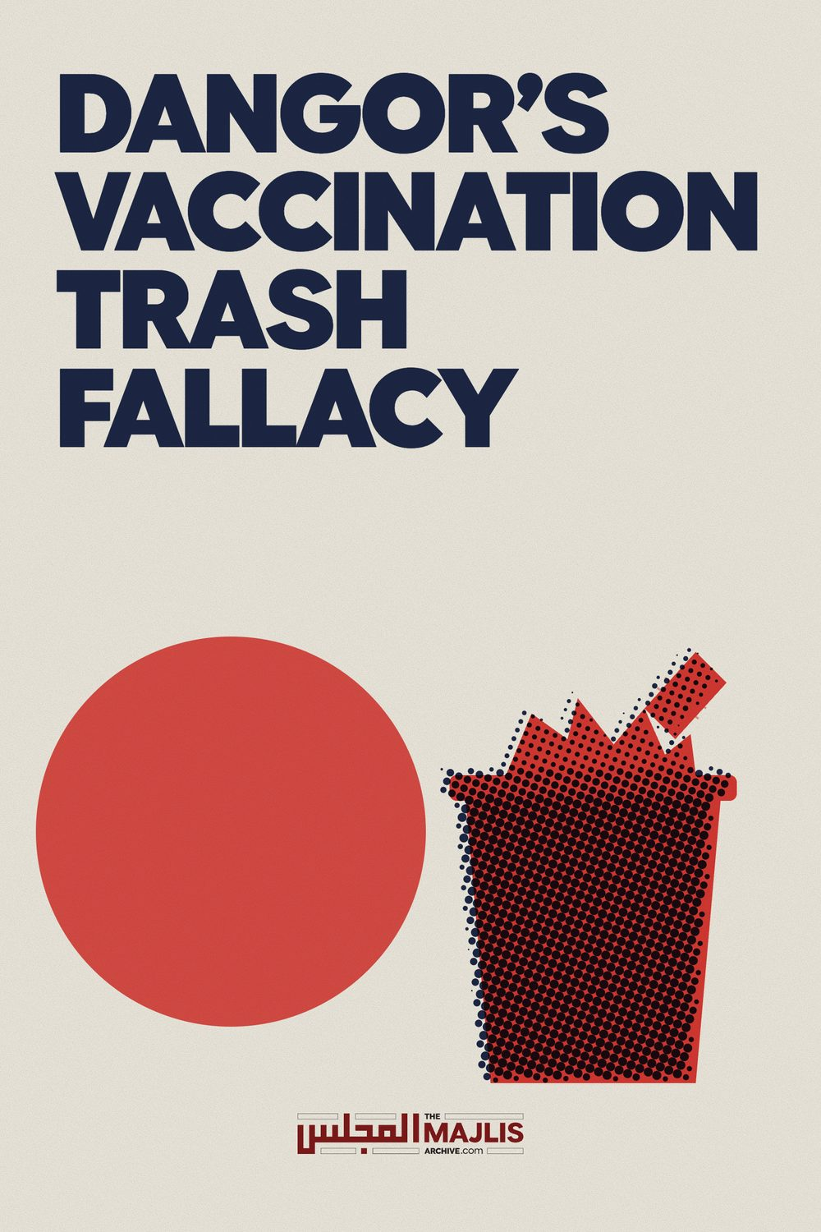

DANGORS VACCINATION TRASH FALLACY
The Majlis · Voice of Islam
Mujlisul Ulama of South Africa

About this edition
This is a reproduction by The Majlis Archive (themajlisarchive.com) of a publication of The Majlis, Mujlisul Ulama of South Africa, made and published with their permission.
The PDF as The Majlis issued it is the original. This edition was read from that PDF's own structure and checked against it letter for letter; where the two differ, the PDF is correct.
Checked: 72 paragraphs, 0 differing; a second, independent PDF reader finds 100.0% of the PDF's words here.
Nothing has been reworded, added or removed.

THE MAJLIS P.O. Box 3393 Port Elizabeth
6056, South Africa

VACCINATION

What is vaccination?
Vaccination is the introduction body of filth and poison, into the human body. In terms of the kuffaar hallucinatory theory, the satanic 'witchcraft' potion called 'vaccine' will combat and eliminate diseases which the Yahood have convinced the world will develop in the distant future.
Muslim doctors obsequiously swallow every bit of trash doled out to them by their western tutors who have fitted their brains within the narrow confines of straightjackets which admit no departure from the trash theories and concepts which have been imposed on the so-called Muslim 'intelligentsia' by years of indoctrination at the kuffaar university brothels and abodes of kufr, where they practically excel in fisq and fujoor, and lap up like dogs every trash idea disgorged into their inert and stultified brains by the atheist masters wallowing in kufr and janaabat. These inept doctors anchored to concepts of kufr, ludicrously set themselves up as authorities of the Shariah to administer the Deen to the Muslim masses when in reality they (these hopeless and miserable doctors) grossly lack in basic knowledge for the correct performance of Tahaarat and Salaat.
Shaitaan has harnessed them into his plot to further the Yahoodi immunization conspiracy to decimate mankind by the administration of this grotesque devilish 'medication' called vaccination and immunization.
It is interesting to note that whilst hundreds of western kuffaar medical experts have written thousands of pages of solid evidence in condemnation and damnation of the satanism of vaccination, there are no Muslim medical experts who have managed to liberate themselves from the intellectual straightjacket into which their brains have been welded. While the western medical experts have independently researched the satanism of vaccines, and presented the deluge of evidence which overwhelmingly confirms the horrors of immunization, our Muslim doctors behaving like obedient poodles, truckle at the feet of the vaccine Satanists, advertising and promoting the evil plot.
This glaring difference between the independence of western anti-vaccination experts and the degrading dependence of the poodles in our society who promote vaccination, demonstrates the malady of the inferior complex which Asians, Africans and Arabs have inherited from their colonial masters.
Clearly exhibiting this form of serfdom, the effect of mental colonization, professor Dangor is promoting the satanism of vaccination. He draws also support from the ulama-e-soo' who have to their credit the satanism of halaalizing carrion, riba, haraam pictography, television and other acts which are in flagrant violation of the Qur'aan and Sunnah.
The ensuing discussion will expose the stupidity and fallacy of professor Dangor's flotsam arguments.
Anyone interested in the evidence prepared by the experts may write to us for copies of the several booklets published on this topic. All are also available on the website www.themajlis.co.za
"And upon us is only to deliver the Clear Message."
(Qur'aan)

THE SATANISM OF VACCINATION
Question: Professor Suleman Dangor's article on vaccination appeared in a local newspaper. Please study his views and comment in the light of the Shariah – Jazaakallaah. Is the professor right?
Answer The professor is manifestly wrong. He has trespassed into the domain of the Shariah for which he is clearly unqualified. He cited several Fiqhi principles to bolster his baatil view of permissibility. The citation of the principles in the vaccination context displays his lack of understanding of these principles.
No argument in vindication of the harmful method of vaccination will have any validity as long as the protagonists of this satanic 'medication' fail to rationally respond to the solid medical arguments which the anti-vaccination experts have presented. The inability of the protagonists of the Yahudi plot of immunization to rationally refute the solid arguments of the opposition is the greatest evidence for the fallacy of the hallucinated benefits of vaccination.
The experts who have condemned and damned vaccines and the devilish system of immunization have written thousands of pages to prove the gravity of the dangers of vaccination.
Professor Dangor alleges: "The majority of mainstream ulama agree that immunization is permissible even if the vaccine contains a non-halaal ingredient, in this case, porcine gelatine."
What is Mr. Dangor's understanding of 'mainstream ulama"? What is the worth and status of this "mainstream ulama" in terms of the Shariah – the Qur'aan and Ahaadith? Just who are the ulama who constitute Dangor's "mainstream"?
Firstly, it should be well understood that the Shariah is the product of Divine Revelation, not the product of the corrupt opinion of corrupt molvis and sheikhs who specialise in halaalizing carrion and riba. The "mainstream ulama" to whom Dangor refers are the likes of the mudhilleen of the MJC, NNB jamiat of Fordsburg and other similar modernist and liberal scholars for dollars who are the slaves of the dunya and the nafs. In Hadith parlance they are described as ghuthaa (trash). This type of majority comes within the purview of the Qur'aanic stricture: "And if you follow their majority (the mainstream ghuthaa)
on earth, then you will become mushrikeen."
This "mainstream ulama" are in the words of the Qur'aan Majeed more astray than even cattle. They are plain stupid and lack the expertise to speak on vaccination. Their ears have been dinned with some rubbish explanations by some medical doctors who themselves are scandalously ignorant of the details of this satanic immunization programme. Thus they, the 'mainstream' clique of so-called ulama, swallowed the stupid theories and explanations presented by ignoramuses, and issued their corrupt stupid fatwas of permissibility.
Dangor has not provided a vestige of evidence in his article for permissibility in terms of the Shariah, for the simple reason that he lacks the Shar'i qualifications for issuing fatwa. His seeking refuge behind the skirts of ignorant "mainstream" molvis and sheikhs further displays his lack of understanding of the operation of the principles of the Shariah. He has amateurishly lumped together several Fiqhi principles without understanding their respective dimensions of operation. In a puerile and laughable endeavour to portray Shar'i expertise, this modernist, westernized professor of kufr education states:
"Apart from the most fundamental of the objectives of shariah (maqasid al-shariah), namely 'preservation of life', there are a number of maxims that could form the basis of the ijma – I use it here in its sense of majority consensus – of ulama in South Africa on the issue of measles vaccinations."
When an unqualified man seeks to acquit himself like an expert of the Shariah, he makes a fool of himself. Dangor's attempt to portray Shar'i expertise by his use of a smattering of Fiqhi terminology such as 'al-maqasid alshariah' extracts mirth. The 'preservation of life' as an objective of the Shariah is not a licence for the unbridled adoption of just any methods for securing the objective. The professor gentleman seeks to justify just any haraam method on the basis of the 'maxims' he has cited. The one such principle is "Necessity renders prohibited things permissible." But he fails to understand, due to lack of expert Islamic Knowledge, that even this principle has its restrictive sphere of operation. It is not to be employed recklessly and stupidly as these modernists juhhaal believe is permissible.
For example, the haraam method which is proposed for adoption in terms of the aforegoing principle, is itself restricted by the stipulation that it should not be harmful. Dangor does mention this principle, hence in his list of maxims, he has enumerated: "Harm may neither be inflicted nor reciprocated." And, "Harm must be eliminated or removed."
Since the objectives of both these Fiqhi principles do not apply to vaccination, the principle of "necessity...." cannot be applied. Vaccination has been proven by mountains of evidence to be extremely harmful. It is thus the infliction of harm which is the antithesis of the principle on which Dangor seeks to legalize the pork vaccine. Furthermore, far from eliminating or removing the harm, vaccination achieves the very opposite. It causes massive harm, hence this principle too which Dangor presented is inoperative with regard to vaccination.
Dangor also attempts to legalize the haraam pork vaccine on the basis of the principle: "The greater evil is repelled by the lesser evil." This principle too has its own restrictions. It is regulated by the stipulation of the non-availability of a halaal alternative. This principle cannot be applied to vaccination for the following reasons:
• There is no evidence to confirm that vaccination relative to the disease is the lesser evil.
• There is no evidence to prove that a halaal alternative medicine is not available for the disease. The claims of the kuffaar doctors wallowing in kufr and janaabat do not constitute evidence for halaalization of haraam.
• The lesser evil applies when the greater evil is a real existing issue at the time of applying the principle. Vaccination purports to 'prevent' future disease. Urine and faeces with their confirmed medicinal properties may not be consumed by a healthy person on the basis of the hallucination of contracting a disease in the future in terms of the theories of the kuffaar.
• In cases of current disease, vaccination is not the 'lesser evil'. Evidence proves that it is the worst evil – a satanic evil causing massive damage and harm to the human body.
Without applying his mind, Dangor proffers the principle: "A private injury is tolerated in order to ward off the public injury." In the citation of this Fiqhi principle, Dangor has confirmed his total confusion and lack of understanding of the operation of the principles of the Shariah. He should clearly demonstrate the applicability of the principle to his pork vaccine. Just how does it apply to vaccination?
In the vaccination scenario what is the 'private injury' and what is the 'public injury' to permit the employment of this principle? For the edification of Mr. Dangor it will be salubrious for him to understand this principle too does not enjoy unbridled latitude. It is haraam to kill one person to save a hundred other persons. Even if it has to be assumed that vaccination has benefits for a great number of people whilst causing harm to a negligible percentage, then too, this principle cannot be employed to legalize the devil's medicine (vaccination).
The brains of all people enjoy the same degree of sanctity. It will always remain haraam to damage the brain of one person on the basis of the theory that the infliction of damage to one brain will save a hundred brains. The satanic logic of the vaccination mob is that the 'negligible' percentage of vaccination damage is tolerable in view of the hallucinated 'mass benefits'. This shaitaani rationalizing is Islamically unacceptable, and no principle of Fiqh legalizes it.
Presenting another principle, he avers: "Harm must be prevented wherever possible." Yes, harm has to be prevented wherever possible by ways permitted by the Shariah, and its principles are invoked when there is evidence to confirm the existence of the harm. Furthermore, this principle refers to existing harm, not to hallucinated harm – not to non-existing harms – not to harms which are imagined for the future, or may even occur in future. The solution for future issues is Tawakkul on Allah Ta'ala, and the Qur'aan and Ahaadith are replete with innumerable advices and commands pertaining to Tawakkul.
Vaccination cannot be shoved within the scope of "tying the camel" which is not nugatory of Tawakkul. Tying the camel is a lawful and a natural method of prevention which is permitted and even ordered by the Shariah. On the contrary, vaccination is a haraam and harmful method with proven disastrous consequences. Therefore, this principle cannot be applied for halaalizing vaccination because this method itself is satanically harmful. Far from it preventing harm, it causes harm. Thus, the presentation of this principle is stupid and fallacious.
Without applying his mind, Dangor cites the following principle: "The repelling of evil is preferable to the acquisition of benefits." For the very same reasons explained above, this principle too is inapplicable to vaccination. Vaccination itself is the greater evil. Its repulsion is incumbent, not its acquisition. The principle will operate only where the evils and benefits are clearly demarcated, distinguishable and confirmed. The principle does not operate in the realm of hallucination nor in a scenario such as immunization, the harms and evils of which have been confirmed by a mass of expert evidence.
Without understanding what he is saying, Dangor mentions the principle: "Harm is not eliminated by another harm" In the vaccination scenario, this principle manifestly prohibits vaccination in view of the proven harm of the filth and poison of vaccines. The principle explicitly states that harm is not eliminated with harm. Our contention is that vaccination is not only harmful, but also in relation to the disease it is the greater harm.
Citing another Fiqhi principle, Dangor says: "The lesser of the two evils must be chosen." This principle will operate if the lesser evil is factually confirmed by evidence. Furthermore, even if the lesser of the two evils is known, the principle is not binding in all situations. For example: One evil is tadaawi bil haraam (i.e. medication with haraam substances). The other 'evil' is the sickness / disease. Even if there is certitude regarding the curing property of haraam medicine, tadaawi bil haraam is not incumbent. It is optional. It is not a 'must'. For this reason we see that the people of Taqwa had always abstained from tadaawi bil haraam on the basis of the Hadith:
"Verily, Allah did not create the shifa' (cure for diseases)
of my Ummah in substances made haraam for them."
If a person is on the verge of death due to starvation and haraam food is available, this principle will operate. It will be incumbent to consume the haraam food which is the 'lesser of the two evils' in this situation. On the contrary, if a man is faced with torture/death and kufr, then despite the permissibility of uttering kufr with the provision of Imaan being in the heart, this being the lesser evil, this principle will not operate. It is not a 'must' to opt for the lesser evil. In fact, it will be highly meritorious to accept the greater of the two evils in this case. Bearing the torture and embracing death will be preferable. Preservation of life is not the objective of the Shariah in this scenario.
It is quite clear that in presenting these Fiqhi principles, professor Dangor does not understand what he has disgorged. He has floundered in a maze of incongruities. Since he has failed to comprehend the attributes and restricted latitude of the principles, and the scenarios in which they may be employed, he has only displayed jahl-e-muraqqab.
Disgorging some more drivel, the professor avers:
"However, if these alternatives are not obtainable or prove too expensive then it is only logical to use medication containing non-halaal ingredients."
What appears 'logical' to the professor, is bunkum in terms of the Islamic perspective. The logical, encouraged and meritorious option in this situation according to Islam is to abstain from medicine which contains haraam ingredients. Notwithstanding the permissibility of availing of the haraam medicine, in terms of Islamic logic and Divine Advice, abstention is the preference. The Hadith quoted above as well as the practical example of the Sahaabah and the Auliya of all ages debunk the professor's logic.
Should we momentarily bestow on Mr. Dangor the favour of assuming that there is credibility in his 'logic', then too, it may not be applied to vaccination because this method of treatment is satanic. It causes massive damage. Disease, injury and death are its consequences.
Dangor further says: "Some scholars go to the extent of saying that even if a halaal alternative is available but the non-halaal is more effective, it is permissible to use the latter."
This view of some scholars is baatil and stands rejected. Dangor is a modernist liberal who is not anchored to any particular Math-hab among the Four Math-habs of the Ahlus Sunnah Wal Jamaat. His attempt of seeking to impose on Muslims the marjooh and mardood view of 'some scholars' is contumacious stupidity. He seeks to impose on us the view of moron 'scholars' from the institution which he terms "mainstream ulama". For him "mainstream ulama" constitutes a daleel because it suits his unbridled approach on this subject. Now he wildly vacillates between extremes, causing a fluctuation from "main stream ulama" to "some scholars" who obviously in terms of his own logic will not be from: "mainstream ulama". There is no consistency in Dangor's logic because it is in fact nafsaani logic which cannot be sustained by Islamic logic. The "mainstream ulama" of the current era are the Juhhaal and the Mudhilleen who in the words of Rasulullah (Sallallahu alayhi wasallam) are more dangerous than even Dajjaal-in-Chief.
Advertising jahl, Mr. Dangor with great puerility utters the following superfluity: "Are there juristic principles which render medication containing non-halaal substances permissible?" Then he proceeds to prove the permissibility of haraam medication on the basis of principles whose operation he clearly failed to grasp and comprehend. We have already dealt with his confusion regarding the Fiqhi principles.
At this juncture, it should be added that the aforementioned superfluity has been presented redundantly. There has never been any contention on the permissibility of haraam medication in certain situations. Every mediocre Student at Madrasah engaged in Fiqh studies is aware of the permissibility of tadaawi bil haraam. For Dangor to embark on a silly and redundant exercise of attempting to elaborate on an issue about which there exists no dispute is an example of the portrayal of his indulgence in futility which stems from jahl-e-murakkab.
These modernists who dwell in confusion as a consequence of having liberated themselves from the sacred fetters of the Math-habs, are swift in presenting as 'daleel' such ulama who are scholars for dollars, and even moronic in their views. The modernist so-called 'intelligentsia', despite their aversion for Ulama and holding them in contempt, even the one's whom they cite as 'daleel', are quick in accepting with alacrity the stupid 'fatwas' of the ulama-e-soo' when such views are palatable and supportive of western kuffaar concepts.
Dangor has not presented even a single argument which is acceptable to the Shariah for halaalizing the kuffaar vaccine filth and poison which has caused enormous destruction to the health and well-being of mankind. Those who enforce this satanic system of immunization, and those who aid and abet it with their corrupt fatwas are all satanists.
Vaccine is rijs (satanic filth). It is the rijs of faeces; the rijs of urine; the rijs of swines; the rijs of the pus of diseased animals; the rijs of human organs; the rijs of aborted foetuses, and it is the rijs which percolates from the brains of atheists – the divinely cast rijs which the Qur'aan confirms:
"And He (Allah) casts RIJS on (the brains) of those who lack aql (intelligence)."
They are worse and more astray than the dumb animals. These are the masters for whom the modernist Muslim professors and doctors offer humiliating allegiance and obeisance. Grounded in their kuffaar-fitted straightjackets, their brains are an oblation at the altar of the brains of their atheist intellectual masters whose brains are divinely cursed with the RIJS stated in the aforegoing Qur'aanic aayat.
In conclusion it is necessary to observe that the poor professor sahib cuts a pitiable, confused figure with the formidable silhouette of the Giants of Uloom looming in the backdrop. A man who seeks to enter the domain which is the preserve of the Fuqaha with his truncated understanding stemming from extreme myopicism which in turn is the malady of the lack of qualified Shar'i Uloom and the lack of Taqwa which is an imperative requisite for the Noor of Ilm, presents himself as a clown. It is totally unbefitting for the professor to even touch on the topic of Tawakkul, for he does not understand even the rudimentary steps in the process of the acquisition of this lofty WAAJIB attribute. Minus Tawakkul a man cannot be a Mu'min. Therefore our advice for professor Dangor is: Don't speak nonsense – nonsense which you seek to adorn with a smattering of Fiqhi terms, the true conception of which is beyond the stagnated limits of your intellectual cognition.
May Allah Ta'ala guide you and us, and keep our Imaan intact until the very moment when our souls take flight from the confines of their physical cages.

