

DEMISE OF MUFTI MUHAMMAD RAFI' UTHMAANI
The Majlis · Voice of Islam
Mujlisul Ulama of South Africa

About this edition
This is a reproduction by The Majlis Archive (themajlisarchive.com) of a publication of The Majlis, Mujlisul Ulama of South Africa, made and published with their permission.
The PDF as The Majlis issued it is the original. This edition was read from that PDF's own structure and checked against it letter for letter; where the two differ, the PDF is correct.
Checked: 107 paragraphs, 0 differing; a second, independent PDF reader finds 100.0% of the PDF's words here.
Nothing has been reworded, added or removed.

THE DEMISE OF MUFTI MUHAMMAD RAFI' UTHMAANI (Rahmatullah alayh) AND THE HARAAM SHENANIGANS OF THE KARONGI MUFTIS
By: Mujlisul Ulama of South Africa PO Box 3393 Port Elizabeth, 6056 South Africa

THE LEAGUE OF SHAITAAN
"…..They are under the impression that they are doing something valid (and good). Behold! Verily, they are certainly liars.
Shaitaan has overwhelmed them, and has caused them to forget the Remembrance of Allah. They are the league of shaitaan. Behold! The league of shaitaan are the losers.
Verily, those who oppose Allah and His Rasool, they are indeed the most disgraceful."

(Al-Mujaadalah, Aayaat 18, 19, 20)
"O People of Intelligence….those who have Imaan! Verily, Allah has revealed to you the Thikr – the Rasool who recites to you the clear Aayaat of Allah to extricate those who believe and practice virtue from darkness into light (Noor)…" (At-Talaaq, 10 and 11)

THE ZULM OF THE DESECRATION
Mufti Muhammad Rafi' Uthmaani (Rahmatullah alayh) of the Karongi Darul Uloom in Karachi, Pakistan passed away on 18 November 2022, but his Janaazah Salaat was deliberately delayed for no valid Shar'i reason, and performed two days later on 20 November 2022. In so doing those responsible for this haraam shenanigan were emulating the kuffaar whom they adore, thereby causing immense grief to the soul of the Marhoom Mufti Sahib.
In vindication of this haraam act of the inordinate delay of two days, and to placate the indignation of the masses, the Karongi Muftis, in their impuissant statement explained that the reason for the inordinate haraam delay was the absence of the deceased Mufti Sahib's son. His son was at the time holidaying in London, which constrained the delay.
Furthermore, to plaster their haraam act with some Shar'i veneer, the Karongi Muftis cited the following texts:
(1) "Allaamah Munaawi wrote: 'When the Janaazah is present at the Musalla (for the Janaazah Salaat), it should not be delayed in anticipation of more musallis nor for anything else because of the command (of Rasulullah –Sallallahu alayhi wasallam) to make haste with the Janaazah. Yes, it is appropriate to wait for the Wali if there is no fear of the body changing (i.e. deteriorating)." (Faidhul Qadeer)
(2) "The Shaafi Faqeeh, Allaamah Ramali wrote: 'There is nothing wrong in waiting for the Wali when his presence is hoped to be soon (an qurbin) and when there is no fear of the body deteriorating." (Nihaayatul Minhaaj)
(3) "The Hambali Faqeeh, Shaikh Najmuddin Al-Haraani wrote: 'It is permissible to wait to the extent that his relatives and friends and others assemble if this does not pose any difficulty and if there is no fear of the body deteriorating."
The aforementioned citations from the Kutub of Fiqh are the be-all of the 'dalaa-il' of the Karongi Muftis, whose chief is Mufti Taqi, for their stupendously haraam act of keeping the mayyit for two days – delaying Janaazah Salaat and Dafan (Burial) for two days in emulation of their kuffaar western masters whose culture they appear to be following and justifying with nonsensical arguments devoid of Shar'i substance.
Before we proceed to neutralize the flapdoodle and flaccid narrative of these miserable Muftis, the pertinent question is: Why did these Muftis not also present the Maaliki view? Despite being ostensibly Hanafis, they took the liberty of resorting to the Shaafi' and Hambali Math-habs in their exercise scrounging for dribs, drabs and flimsy technicalities on which to hold and justify their shocking and lamentable desecration of the body of Mufti Rafi' Uthmaani (Rahmatullah alayh), and to circumvent the explicitly clear ruling of the Shariah, which is a resounding and emphatic prohibition to deliberately delay the Janaazah for a reason NOT CONDONED AND ACCEPTED BY THE SHARIAH.
Furthermore, the straws which these Muftis have extracted selectively from the Kutub do not support their contention. The little delay allowed does not bring within its purview the haraam, satanic two-day delay in which the Mayyit was desecrated.
The reason proffered by the Karongi Muftis for desecrating the body of the Mayyit and for blatantly violating the Shariah's prohibition, was the absence of the Deceased's son who was enjoying his holiday in London, one of the capitals of the world of the Kuffaar where these Muftis have issued fatwas to halaalize the riba products of the kuffaar capitalist bankers. What was the son doing in the capital of Kufristan when his father was in an advanced stage of indisposition? Regardless of the reason for his presence in London, it is Islamically an unacceptable monstrosity to have desecrated the Deceased with the two-day haraam delay, and to have so brazenly violated the Waajib command of the Sunnah to make haste with the burial.
Mufti Taqi has a penchant for citing from the Maaliki kutub to conjecture and fabricate substantiation for his baatil fatwas of rendering 'halaal' the riba products of the western capitalist bankers. So why did these Muftis not cite the Maaliki ruling on the issue of delaying Janaazah Salaat and Dafan? The reason for their shenanigans is the total and unambiguous rejection by the Maaliki Math-hab – in fact by all Math-habs despite the silly and deceptive and abortive attempt to eke out support from the Shaafi' and Hambali Math-habs.
They presented some snippets from the Shaafi' and Hambali Math-habs to bamboozle the numerous indignant laymen who have reacted with disgust to the villainy perpetrated by the Karongi Muftis. But, men of intelligence even among the awaam (the laiety) are able to discern the stupidity and bankruptcy of the argument presented by the Karongi Muftis to deceive and mislead the ignorant ones.
This is what the Maaliki Math-hab states, and what is chagrin to the Karongi Muftis:
"In Al-Mudkhal it is explicitly mentioned: 'Verily, the Sunnah narrates that from (the acts of) honouring the Mayyit (making his ikraam), is to make haste with (Janaazah) Salaat on him and with his Dafan (Burial). Some of those Ulama who guard the Sunnah have said that when they (the people) arrive at the Musjid with the Mayyit (on the Day of Jumuah), then Janaazah Salaat will be performed on the Mayyit before the Khutbah, and the people of the Janaazah should be ordered to leave to attend to the dafan (burial).
He (the Imaam, etc.) should explain (teach) to them that in the event they are unable to make it for Jumuah after the burial, then JUMUAH IS WAIVED FOR THEM.' May Allah reward him with (abundant) goodness for guarding the Sunnah and alerting (Muslims) to the Bid'ah (of delaying the Janaazah)." (Haashiyatul Adawi)
Commenting on this ruling, the noble Author says:
"Verily, the obvious (meaning) of the kalaam of the Author of Al-Mudkhal is that the Sunnah is what has been mentioned even if there is no fear of the Mayyit changing (i.e. decomposition), and even if there is no fear of any harm to it. This is the apparent meaning understood from the mas'alah of the Ashraaf. His statement clarifies that when they (the carriers of the Janaazah) enter at time of the Khutbah, he (the Imaam) should order them with the
(Janaazah) Salaat and to depart for the burial of the mayyit)."
The Karongi Muftis are Hanafis. So why are they silent regarding the Hanafi Math-hab's ruling on this issue? Why did they not also seek to bolster their haraam fatwa with the Hanafi texts as well? The simple answer is that despite their laborious search, they could not find even a snippet in the Hanafi kutub to support their baatil fatwa.
According to the Hanafi Math-hab, if the Janaazah is ready on a Friday, then the only factor which legitimizes a few minutes of delaying the Janaazah Salaat and Dafan is the fear of losing Jumuah Salaat. On this issue, the Maaliki Math-hab goes to the extent of waiving Jumuah Salaat for the sake of swift and immediate Janaazah Salaat and Dafan of the Mayyit.
The utmost importance accorded to immediate and swift Janaazah Salaat and Dafan can be gauged and understood from the fact that if the Janaazah is ready, then the Janaazah Salaat will be performed first, then the Jumuah Khutbah. At this point the two Math-habs (Hanafi and Maaliki) differ. While the Hanafi Math-hab's view is that the Dafan (Burial) will take place after the Jumuah Salaat (not after two days), the Maaliki Math-hab says that for the people of the Janaazah, the Jumuah Salaat is waived. They should attend to the burial. Now where does the haraam two-day shaitaani delay feature in this picture of the Shariah?
Elaborating on the importance and need to make haste with the Janaazah Salaat and Dafan (burial), it is mentioned in Shaami:
"It is Makrooh (i.e. Makrooh Tahrimi which is akin to haraam since the consequence of both Makrooh Tahrimi and Haraam is the Fire of Jahannam) to delay his (the mayyit's) Salaat and his Dafan in anticipation of a big jamaat to perform Salaat after Jumuah Salaat, except when there is fear of missing Jumuah Salaat as a result of engagement in its burial."
Thus, when there is no fear of missing Jumuah Salaat, according to the Hanafi Math-hab, then Janaazah Salaat and the Dafan must be executed expeditiously. The Maaliki stance has already been stated above, namely, even if Jumuah Salaat has to be missed, it is acceptable while delaying the Janaazah Salaat and Dafan are intolerable. The Jumuah Salaat in this case is waived for those who are attending to the burial.
The Hanafi Math-hab further states:
"When it is feared that Jumuah Salaat will be missed, then Dafan (burial) will be after Jumuah Salaat." (Shaami) While burial will be immediately after Jumuah Salaat (not after two days), the Janaazah Salaat shall be incumbently performed before the Khutbah.
Also: "Dafan (when there is fear of missing Eid Salaat) shall be delayed, and Eid Salaat performed first while the Janazah Salaat shall be performed before the Khutbah." (Shaami)
While the demand of Qiyaas is that Janaazah Salaat should be performed even before the Eid Salaat, this demand has been set aside to avoid confusion in the ranks of the musallis. Those in the back rows may gain the impression that the Takbeer of the Janaazah Salaat was the Takbeer announcing the commencement of the Eid Salaat.
The two raka'ts Sunnats after the Fardh of Maghrib are Sunnatul Muakkadah which is tantamount to Waajib. However, if the Janaazah is ready, then Janaazah Salaat shall be performed after the Fardh while the Sunnatul Muakkadah Salaat will be delayed. This also indicates the utmost importance of the Janaazah Salaat and Dafan. In one view of the Ahnaaf, Janaazah Salaat shall be performed even before the Fardh Salaat if there is no fear of the Fardh becoming qadha.
The argument among the Fuqaha pertains to even a little delay, viz., should the Janazah Salaat and Dafan be before or after the Khutbah and Salaat. An inordinate satanic delay of two days is thus unimaginable. There is no difference on this prohibition.
In Fathul Ali Al-Maalik it is mentioned: "Delaying the burial of the mayyit one or two days is HARAAM in view of the probability of it changing (decomposing) and the defiling of his honour especially with abundant movement… It is therefore Waajib on the one to whom Allah has bestowed coercive power and on the Muslim community to vigorously prevent them from this (defilement of the mayyit, and to severely criticize them, and to threaten them, to imprison them and to beat them if speaking (that is naseehat) does not benefit. It is haraam for them to perpetrate this horrible act of baatil and evil folly."
This should be adequate edification for the Karongi Muftis who have subjectively presented such snippets from the Shaafi' and Hambali Math-habs which do not support their haraam two-day delay in any way whatsoever. Their presentation of snippets is designed to deceive and mislead the ignorant one. But the haraam two-day delay has constrained even laymen to react with abhorrence which in turn constrained the Karongi Muftis to issue their baatil fatwa.
Imaam Ahmad Bin Hambal (Rahmatullah alayh) said: "The honouring of the mayyit is making haste with him (with his ghusl, kafan and Janaazah). It is narrated that when Talhah Bin Al-Baraa' was sick, Nabi (Sallallahu alayhi wasallam) visited him. He (Rasulullah –Sallallahu alayhi wasallam) said: 'I certainly see the signs of Maut on Talhah. Therefore, inform me about it (i.e. his Maut), and make haste (with his burial), for verily, it is improper for the corpse of a Muslim to be kept in the midst of his family. The Ahaadith pertaining to making haste with the Janaazah are strengthened with the likes of the Hadith of Ali: 'O Ali! Never delay with three things: Salaat when its time dawns; the Janaazah when it is ready; and (marriage of) a young girl when her match is found."
Where did they imprison the Mayyit for two delays – in a freezer at a mortuary or left to lie exposed to the weather elements? Either way, they are damned. The 'delay' mentioned in the snippets and which the Karongi Muftis deceptively and baselessy utilized to vindicate their baatil fatwa does not fit in any one of these two options. They must own up and answer the question: What did they do with the body for two days? Where did they store it?
The permissible 'delay' refers to the little delay for people to gather for the Janaazah Salaat, and even such delay will not be permissible if there is fear of the body deteriorating in any way whatsover due to extreme heat for example. Delay is not permissible even in anticipation of more people participating in the Janaazah Salaat. As soon as the ghusl and kafan have been completed, the Janaazah Salaat should be performed, and immediately thereafter the Mayyit should be taken for burial. The desire of a wali 10,000 miles from the scene of the Mayyit never justifies the desecration caused by the haraam two-day delay.
But what did the Karongi Muftis do and legitimize? They allowed the mayyit to lay like a carcass without the Rahmat of the prescribed Janaazah Salaat. What solace can these Muftis and the family derive from such an abominable deprivation? What good did they offer the Mayyit by this inordinate haraam two-day delay? If they had genuine concern for the welfare of their Mayyit, never would they have caused so much distress and harm to it.
Selecting from the Math-habs technical snippets to bolster their haraam shenanigans, and specifically and conveniently adopting silence regarding this very explicit stance of the Maaliki Math-hab, should now be readily comprehensible.
The utmost importance assigned by the Shariah to immediate and quick Janaazah Salaat and Burial forms the basis for the Shariah's ruling to even perform the Janaazah Salaat before the Jumuah Khutbah, and in the case of the Maaliki Math-hab, to even proceed with the burial regardless of losing Jumuah Salaat, i.e. specifically for those attending to the burial. The delay is not permissible even if there is no fear of the body deteriorating in any way whatsoever.
Now just ponder on the zulm that these miserable Karongi Muftis have committed in the process of desecrating the body of Mufti Rafi' Uthmaani (Rahmatullah alayh). They allowed the body to lie like a dead animal carcass without barkat of the Dua of the Janaazah Salaat. For two days they had deprived the Mayyit of the Rahmat and Barkat which Allah Ta'ala has ordained for the Mayyit as soon as he/she dies. Rasulullah (Sallallahu alayhi wasallam) informed us that the pious Mayyit calls to his people: "Qaddi muni! (Send me ahead!). But what did these Muftis do? What have they learnt from the Hadith they teach in their Darul Uloom?
Waiting for the Wali does not mean a wait of two days. It never means an inordinate delay of days. It does not vindicate such a delay whereby the mayyit is left like a carcass for days without Janaazah Salaat and Dafan. The texts clearly state "an qurbin" which means soon, not days. The Wali may have been delayed by unforeseen circumstances whilst he is nearby and will be able to attend soon – very soon. The rule of waiting does not bring in its scope a wali who happens to be in another country or another city which constrains such inordinate delay which is in total conflict with the command of the Shariah to make haste.
Rasulullah (Sallallahu alayhi wasallam) said:
"Make haste with the Janaazah. If the deceased was pious, then the abode you are sending him/her is better (than this world where you are holding him/her). If the deceased is other than this (i.e. is impious), then it is evil. Remove it from your necks." (Bukhaari and Muslim).
"When the Janaazah is ready and the men carry it on their necks, and if the deceased is pious, he (or she) announces: 'Send me ahead.' (That is, hastily). And, if the deceased is impious, it wailingly says to his people: 'Alas! Where are you going with it (the janaazah). Everything is able to hear the wailing of the deceased except Insaan (people). If insaan had to hear, he would fall down unconscious." (Bukhaari)
"When one of you dies, do not hold (delay) him. Make haste with him to his grave." (Tibraani)
"It is improper that the corpse of a Muslim be kept in the midst of his (or her) family." (Abu Dawood)
This is the command of Rasulullah (Sallallahu alayhi wasallam) which the Karongi Muftis have flagrantly set aside to ostensibly accommodate the alleged desire of the son holidaying in London. The 'delay' mentioned by the Fuqaha is most certainly not the type of haraam delay permitted by the Karongi Muftis. It is preposterous to violate the Shariah thereby delaying Janaazah Salaat and Dafan for two days to satisfy the desire of the son who is 10,000 miles away enjoying his holiday in kufristan.
The son would have rendered his Marhoom father a wonderful service by remaining in London, reciting the Qur'aan and engaging in Dua-e-Maghfirat. Instead of benefiting his father, he has brought colossal grief and hardship by depriving his father from the Dua-e-Maghfirat prescribed by the Shariah, namely, Janaazah Salaat.
These people are extremely selfish and intoxicated with corrupt worldly objectives, hence they have recklessly harmed the Mayyit by depriving him of the immediate Rahmat of the Janaazah Salaat and Dafan. The Hadith explicitly prohibits the retention of the 'corpse' (jeefah) of a Muslim in his house. Its place is the Qabrustaan, not the home, AND MOST CERTAINLY NOT THE JAHANNAM OF THE MORTUARY'S REFRIGERATOR to which corpses are assigned to.
What did these Muftis do with the body of the Mayyit for two days? Where did they keep it? In the heat of that Asian country, a degree of decomposition most certainly sets in, if the body is not refrigerated like an animal's carcass. Did they refrigerate the body of the Marhoom Mufti? Did they leave it to decompose without rendering it into a carcass for the fridge/freezer? They are in a terrible quandary either way.
If the body was not refrigerated in the ugly, stinking mortuary which is a kuffaar project, then most certainly a degree of decomposition had occurred. In fact, deterioration takes place even in a refrigerator. In addition to the physical deterioration is the disgraceful act of treating the Mayyit like the carcass of an animal. In this case, the very texts cited by the Muftis damn and condemn them because it is explicitly stated in these ibaaraat that any such delay which leads to 'change' (decomposition) is not permissible.
If the Karongi Muftis claim that the body was not assigned to the mortuary for refrigeration, and that the unrefrigerated body did not begin decomposing despite the haraam two-day delay, then it must be said that they are liars.
If they had made a carcass of the Mayyit by assigning the body for refrigeration/freezing, then the villainy of the Muftis is worse. It is an intolerable act of desecration to which the Mayyit was subjected.
Haste with the Janaazah and burial has always been the practice of the Ummah from the very inception of Islam. There was no incumbent need for the inordinate delay of two days, and to leave the Mayyit like a carcass for two days without Janaazah Salaat. From whence did these Muftis dig up this abominable abnormality which has no basis in Islam?
There exists complete unanimity (Ijma') of all Math-habs regarding making haste with the burial. The 'delay' mentioned in the snippets cited by the Karongi Muftis is a mas'alah according to all Math-habs. This is the normal, permissible delay which is necessary for ghusl, kafan, and waiting for the musallis of the vicinity. Waiting for persons living in other towns and cities is not permissible. The Janaazah Salaat and Dafan may not be delayed in expectation of their arrival hours after the Mayyit is ready for Janaazah Salaat and burial.
The reason of the son being in London is absolutely puerile, silly and baseless. It was a notorious abomination to have left the Mayyit like an animal carcass for two days without having performed the prescribed Dua, i.e. the Janaazah Salaat to be immediately followed by Dafan.
It is imperative for the Karongi Muftis to expurgate themselves from the villainy they had perpetrated. This purification is achieved by Taubah and retraction of the baatil fatwa.
"…..They are under the impression that they are doing something valid (and good). Behold! Verily, they are certainly liars.
Shaitaan has overwhelmed them, and has caused them to forget the Remembrance of Allah. They are the league of shaitaan. Behold! The leage of shaitaan are the losers. Verily, those who oppose Allah and His Rasool, they are indeed the most disgraceful."
(Al-Mujaadalah, Aayaat 18, 19, 20)
"O People of Intelligence… those who have Imaan! Verily, Allah has revealed to you the Thikr – the Rasool who recites to you the clear Aayaat of Allah to extricate those who believe and practice virtue from darkness into light (Noor)…" (At-Talaaq, 10 and 11)

"SEEK A FATWA FROM YOUR HEART"
Said Rasulullah (Sallallahu alayhi wasallam) Academic Ilm is not a requisite for understanding the notoriety committed by the Karongi Muftis in general, and by Mufti Taqi in particular, he being the Wali in the absence of the son. Quick burial on the day when Maut occurred is a well-known embedded LAW of Islam of which all Muslims are aware, and even the kuffaar. The practice of burial on the same day has existed in Islam since the era of Rasulullah (Sallallahu alayhi wasallam). Therefore any invalid departure from this Waajib Sunnah is haraam and intolerable.
For Muslims – the masses – to understand the villainy perpetrated by the desecration of the Body of Mufti Rafi' Uthmaani (Rahmatullah alayh), fatwas are not required. The heart of the Mu'min convincingly testifies to the grievous and callous misdemeanour committed by the Karongi Muftis with their baseless fatwa.
When Rasulullah (Sallallahu alayhi wasallam) advised us – the Ummah – to seek a fatwa from our hearts, he referred to such simple issues which are readily comprehensible and as clear as daylight. But in our age Muftis are obscuring explicit Ahkaam of the Shariah with misinterpreted technicalities. Thus, the likes of Mufti Taqi has made 'halaal' pictography, bank-riba, television, the porn social media platforms, etc. These are explicitly haraam practices which the Mufti has halaalized with his stupid mismanipulation of Fiqhi technicalities which he has now extended to even the Janaazah.
The resultant obfuscation is ill-motivated – motivated by worldly considerations and nafsaani objectives. We are living in the era about which Rasulullah (Sallallahu alayhi wasallam) had predicted:
"The dunya will be searched for with the amal of the Aakhirah, and knowledge of the Deen will be acquired for purposes other than the Deen."

MUFTI TAQI'S DRAMA
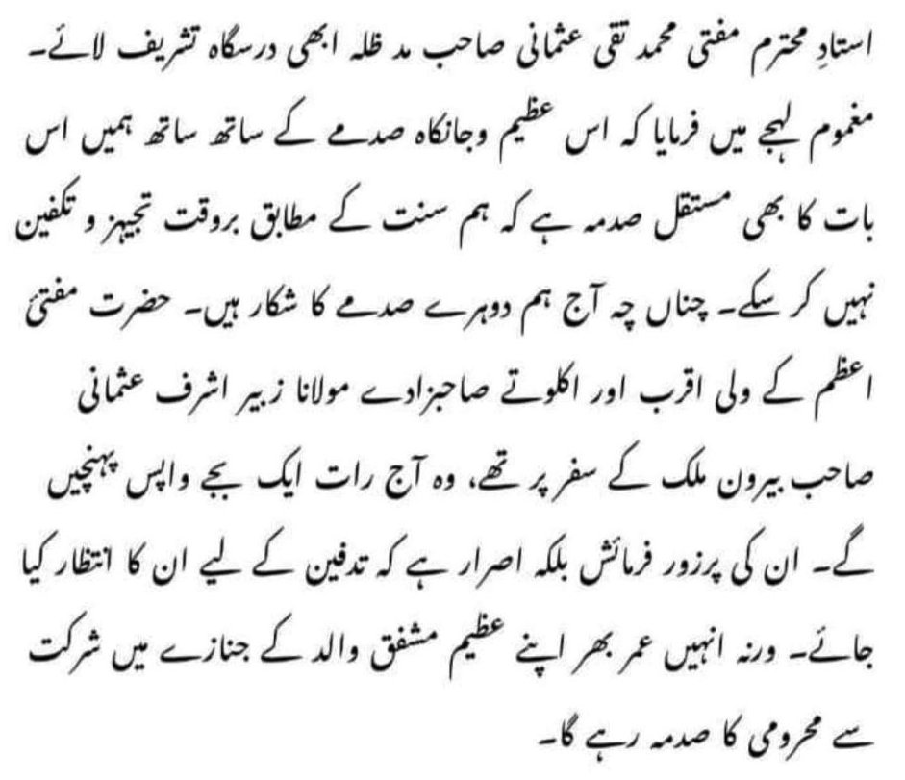

TRANSLATION
Respected Ustaadh Mufti Muhammad Taqi Uthmaani Saahib (m.z) has just now come to the classroom. In a sad voice he said:
"Added to this great and life-consuming grief we are also particularly grieved that we are unable to execute the Tajheez and Takfeen (Janaazah Salaat and Burial) on time according to the Sunnah. Thus, today we are the victims of a double grief.
The closest Wali of Hadhrat Mufti A'zam, the only son Maulana Zubair Ashraf Uthmaani Saahib was on a journey in a foreign country. He will be returning tonight at 1 o' clock. It is his emphatic insistence that the burial should wait for him otherwise he will be lifelong grieved for having been deprived of participation in the Janaazah of his great, affectionate father."
Indeed, this is a despicable act of drama to impress morons. The lifelong grief should be caused by the gross and blatant abandonment of the Sunnah for which Muti Taqi has portrayed an extremely fickle concern. The lifelong grief should be for having spiritually harmed the Marhoom with the haraam two-day delay which entailed the body lying like an animal carcass without the Dua of Rahmat prescribed by the Shariah having been administered.
What has happened to the brains of these Muftis who believe it prudent to abandon the Sunnah for the sake of an insistence which is not permissible? The act of grief by Mufti Taqi was stupid drama which cannot befool people of intelligence. The drama was enacted to sooth his own conscience and the conscience of his underlings.
"In fact man has baseerah over himself even though he presents excuses."
(Al-Qiyaamah, 14 and 15)
Deep down in the innermost recess of his heart, Mufti Taqi, the liberal who halaalizes haraam, is fully aware of the shenanigans perpetrated on the occasion of the demise of his brother (Rahmatullah alayh).

A MORONIC, SATANIC HARAAM ARRANGEMENT
Minutes prior to the publication of our Condemnation of the Karongi Muftis, the following information was conveyed to us:
"I just now rang the darul ifta of Darul Uloom Karachi and asked the Mufti Saheb who came on the phone: 'Where did they keep the mayyit of Mufti Rafi Saheb. Without hesitation he instantly said:
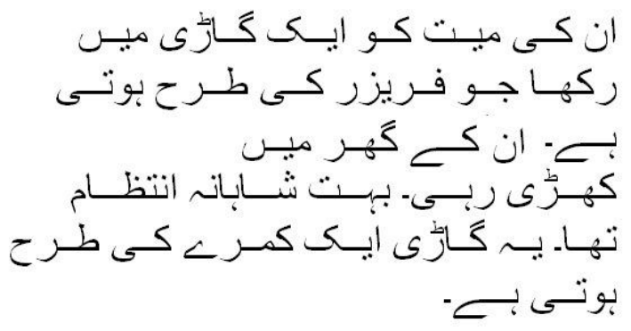

Translation
"His mayyit was kept in a van which is like a freezer.
That van was parked at his home. It was a very royal arrangement. This van is like a room."
This is the satanic, haraam arrangement which the moron 'mufti' described as being "a very royal arrangement". Brains have become totally vermiculated with fisq, fujoor and kufr, hence pure shaitaaniyat is viewed as royal treatment. The Body which was supposed to have been assigned to the Qabr was instead dumped in a room of Jahannam – the freezer mentioned in the Qur'aan Majeed as Zamhareer. In Qiyaamah, a form of punishment for the kuffaar will be intense cold – freezing in Zamhareer. These most unfortunate and miserable Karongi Muftis, headed by Mufti Taqi, had chosen Zamhareer for their august Mayyit instead of sending it forth to the Abode destined for him by Allah Ta'ala.
Mufti Taqi and his league of moron muftis must hang their heads in shame! They must get lost and disappear into some realm of oblivion for their villainy and notoriety.

Rasulullah (Sallallahu alayhi wasallam) said:
"Make haste with the Janaazah. If the deceased was pious, then the abode you are sending him/her is better (than this world where you are holding him/her). If the deceased is other than this (i.e. is impious), then it is evil. Remove it from your necks." (Bukhaari and Muslim). "When the Janaazah is ready and the men carry it on their necks, then if the deceased is pious, he(or she) announces: 'Send me ahead!.' (That is, hastily). And, if the deceased is impious, it wailingly says to his people: 'Alas! Where are you going with it (the janaazah). Everything is able to hear the wailing of the deceased except Insaan (people). If insaan had to hear, he would fall down unconscious." (Bukhaari) "When one of you dies, do not hold (delay) him. Make haste with him to his grave." (Tibraani) "It is improper that the corpse of a Muslim be kept in the midst of his (or her) family." (Abu Dawood)

