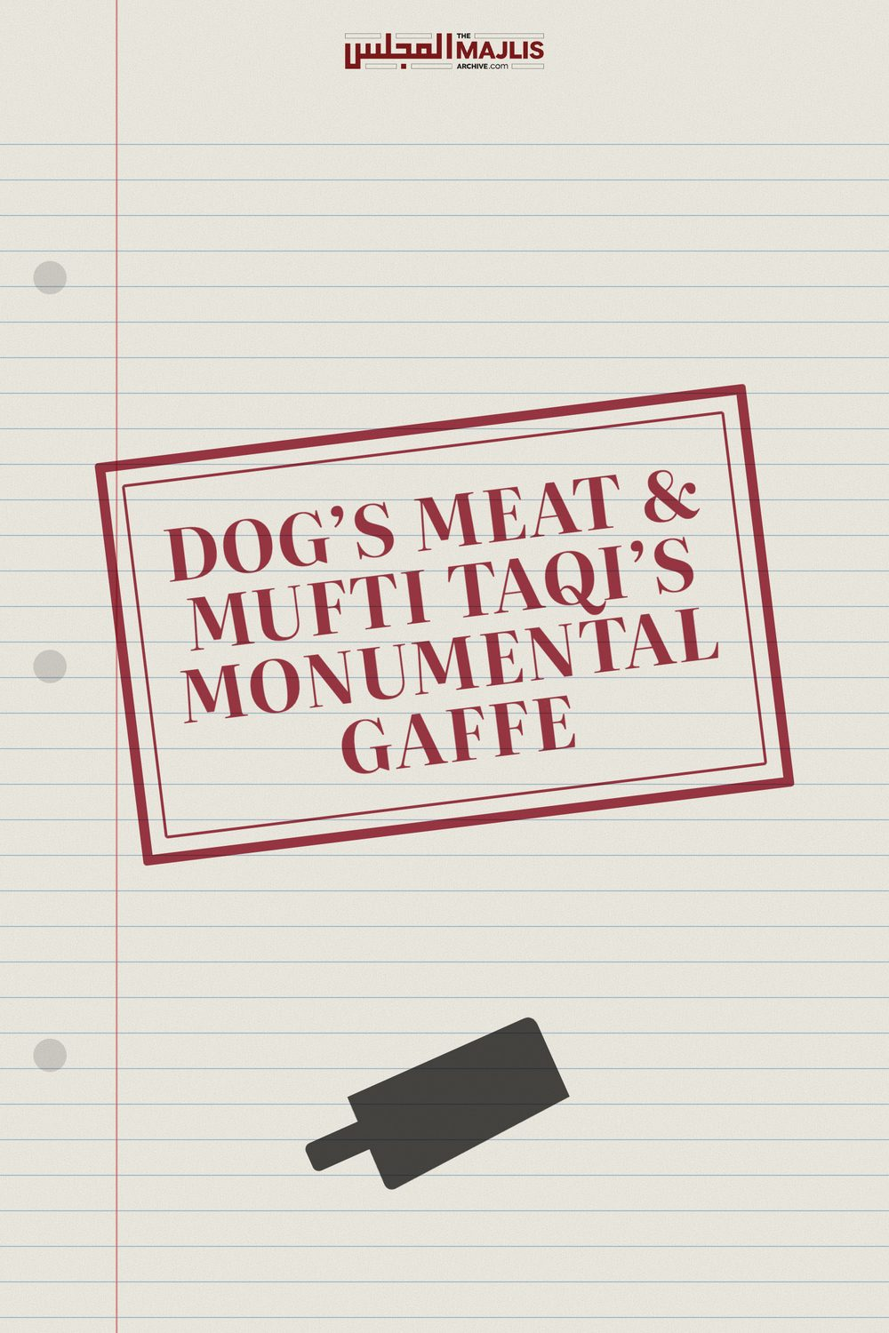

DOGS MEAT AND MUFTI TAQI
The Majlis · Voice of Islam
Mujlisul Ulama of South Africa

About this edition
This is a reproduction by The Majlis Archive (themajlisarchive.com) of a publication of The Majlis, Mujlisul Ulama of South Africa, made and published with their permission.
The PDF as The Majlis issued it is the original. This edition was read from that PDF's own structure and checked against it letter for letter; where the two differ, the PDF is correct.
Checked: 78 paragraphs, 0 differing; a second, independent PDF reader finds 100.0% of the PDF's words here.
Nothing has been reworded, added or removed.

DOG'S MEAT & MUFTI TAQI'S MONUMENTAL GAFFE

MUJLISUL ULAMA OF S.A. PO BOX 3393 PORT ELIZABETH, 6056 SOUTH AFRICA

DOG'S MEAT IN THE MAALIKI MATH-HAB

QUESTION
Molvi Haider Al Dhorat commenting on the lecture by Mufti Taqi during his recent visit to South Africa, said:
"And then he (i.e. Mufti Taqi) also made mention that according to Imam Malik (Rahmatullah 'Alayh), it is permissible to eat dog meat. It is permissible to eat dog meat. But according to Imam Abu Hanifa (Rahmatullah 'Alayh), it is not permissible. So Mufti Taqi Usmani Sahib (Damat Barakatuh) says in today's time if any person says it's permissible to eat dog meat, what will happen to him? You can well imagine. But this was the level of respect the great, great Imams had for one another, that even if they differed with one another, but they showed full respect, SubhanAllah! They showed full adab and respect. They did not... the breakdown of respect..." (End of quote)
Is this correct? Is it permissible according to the Maaliki Math-hab to consume dog meat?

ANSWER
The radio-television molvi is a jaahil of the first degree, hence he deemed it appropriate to peddle Mufti Taqi's monumental gaffe. If this jaahil chap had any Aql he would first have ascertained the veracity of the claim of halaal dog meat made by Mufti Taqi.
Mufti Taqi has a penchant for halaalizing haraam by means of weird baatil interpretation. Thus, he has made halaal bank riba, conversing freely with kuffaar females in the public, halaalizing haraam pictography, and participation in haraam anniversary functions where a host of haraam acts occurs. Diluting the Ahkaam of the Shariah to make these palatable and acceptable for the kuffaar, fussaaq and fujjaar has become his speciality.
In view of Mufti Taqi's drift from the Sunnah which was initiated by his haraam dalliance with the kuffaar capitalist banks, it is not at all surprising that he has now claimed that dog meat is halaal. Then he attributes the halaalizing of dog's meat to Imaam Maalik (Rahmatullah alayh).
Imaam Maalik (Rahmatullah alayh) and the Maaliki Fuqaha did not proclaim dog meat halaal. The Maaliki authority, Al-Hattaab states:
"According to Al-Hattaab, regarding the dog there are two views: Hurmat (being haraam) and Karaahat (i.e. Makrooh Tahrimi which is also forbidden). Ibn Abdil Barr has authenticated the view of Tahreem (i.e. it is Haraam). Al-Hattaab said: 'I have not seen in the (Maaliki) Math-hab anyone who narrated the Ibaahat (permissibility) of eating dog."
(Haashiyah Ad-Dasooqi)
"The Mu'tamad (reliable ruling) is that dog is Makrooh, and it has been said that it is
Haraam. There is no view of it being permissible."
(Ash-Sharul Kabeer lid Durdeer)
"Ibn Habeeb said: 'The People of Madinah did not differ regarding the Tahreem (being haraam) of the meat of wild animals, lions.
Wolves, hyenas and dogs."
(Al-Wdheehah)
"Regarding domesticated dogs, there are two views: Makrooh and Haraam. An opinion of it being permissible has not been seen. The one who attributes it (i.e. its permissibility) to
Maalik should be punished."
(Manhul Jaleel)
"Dogs are fanged predators.
According to Maalik it is Haraam…
Ibn Abdul Barr has authenticated that it is
Haraam. In Al-Jallaab he said: 'Dogs should not be eaten.' Al-Hattaab said:
'I have not seen in the Math-hab (of Maalik)
who have narrated permissibility of eating dog. It is not permissible for a Mufti to rule that eating dog is permissible."
(As-Halul Madaarik)
"Regarding the dog, the difference is in
Karaahat and Tahreem. Verily Ibn Abdul
Barr has authenticated the qawl of Tahreem.
Shaikh Daawood said: 'Whoever attributes the permissibility (of eating)
dogs to Maalik, should be punished.'
Thus, both Mufti Taqi and the jaahil molvi fellow should be severely punished for attributing the slander to Imaam Maalik (Rahmatullah alayh).
The Ta'deeb (Punishment) for such slanderous attribution, especially to such a great, illustrious personality as Imaam Maalik (Rahmatullah alayh), according to the Maaliki Math-hab, is quite severe. It varies between lashes and imprisonment.
"Al-Mawaaq narrating from bin Arfah said that Ta'deeb is (first/initially) by means of grave warning. If it is not beneficial, then lashing with a whip from one to three painful lashes. (Mawaahibul Jaleel)
"At-Ta'deeb is by means of imprisonment and severe whipping."
(Sharhul Kharshi)
"Imaam Maalik has mentioned that Ta'deeb is left to the discretion of the Qaadhi. He has also explicitly said that the perpetrator should be whipped, but he has not stipulated the number of lashes."
(Ibnul Maajishoon)
It is also mentioned in At-Taudheeh that when whipping, the back should be bared.
Now, there is much food for the thought of Taqi Sahib and the jaahil molvi who peddled the mullock of Taqi Sahib.
Understand well that the designation of 'Makrooh' in the Maaliki context as well as in the Hanafi Math-hab, means practically Haraam. Just as it is obligatory to abstain from things technically designated Haraam, so too is it compulsory to abstain from things classified Makrooh. Here it means Makrooh Tahrimi. The technical classification of Makrooh does not detract from the prohibition for practical purposes.
In the Maaliki Math-hab, there are two technical views regarding dog meat: Hurmat (i.e. Haraam) and Karaahat (i.e. Makrooh). As far as practical Prohibition is concerned, there is NO difference whatsoever. Hence the Maaliki Fuqaha state explicitly that no one in the Maaliki Math-hab has narrated Ibaahat (Permissibility). The Karaahat designation is in relation to the Haraam classification. These are technicalities which do not cancel the PROHIBITION of eating dog meat. Dog meat is practically HARAAM.
Thus, dog meat is Haraam according to the Maaliki Math-hab and according to all Math-habs. Mufti Taqi Sahib has disgorged monstrous mullock which the miscreant molvi has lapped up and disgustingly regurgitated thereby slandering Imaam Maalik (Rahmatullah alayh) and casting Muslims into confusion.
Furthermore, Mufti Taqi had made this ghutha claim in a self-vindictive spirit. He was attempting to exculpate himself from the many charges made against him. He has specifically selected the dog meat issue believing it to be halaal in the Maaliki Math-hab, because he was criticized for his baatil endeavour to halaalize riba in terms of the Maaliki Math-hab. By some egregious blunder he has inferred dog meat to be halaal in terms of the Maaliki Math-hab, hence he felt confident to proffer his misconception as 'sound' basis for singing his monotonous song of respecting different opinions.
The Majlis had refuted Mufti Taqi's claim of permissibility of charging penalty fees for late payment. He had baselessly attempted to halaalize the penalty riba by baatil and stupid interpretation of some Maaliki mas'alah. The detailed discussion is in our two booklets, Penalty of Default and Penalty on Late Payment is Interest. These booklets are available on our website.
Mufti Taqi had deceptively proffered an abortive attempt to legalize interest on late payment by resorting to ingenious interpretation of a mas'alah in the Maaliki Math-hab. We had criticized his abortive and utterly baseless attempt. Furthermore, we had criticized him on other haraam issues as well. In view of our strident criticism for his deviances, he cherishes an inveterate bughz for the Mujlisul Ulama. His emotional state has caused a disequilibrium in his intellectual functioning, hence he deemed it intelligent to come all the way from Pakistan to sing his monotonous song of 'ikhtilaaf' in South Africa. He should reflect and meditate on the Qur'aanic Aayat:
"In fact, man has baseerat (insight and full awareness) of his Nafs even if he presents excuses (to justify his baatil conduct)."
(Surah Al-Qiyaamah)
Instead of offering valid Islamic Naseehat for the ills, diseases and corruption in which the community is sinking, he only piped his song of ikhtilaaf. The extremely small minority who criticizes him does not accept his stupid pontification, viz, his song of ikhtilaaf. We shall continue to nail him and all the slaves of shaitaani and nafsaani deviance. As far as the masses are concerned, his monotonous song did not benefit them. The vast majority of molvis in the countries are his cronies, hence his self-vindictive acquittal was of no benefit for anyone. He was supposed to offer naseehat regarding the corruption in the Ummah and the resultant Athaab of Allah Azza Wa Jal. But he is lost.
Perhaps SANHA is seeking a licence for halaalizing dog meat, hence Taqi Sahib has set the process in motion with his chicanery - the fraudulent claim of dog meat being halaal in the Maaliki Math-hab.
His malice for those who criticize his baatil has induced him to cite the Maaliki Math-hab, albeit baselessly and slanderously, in an attempt to score some points. But he has made a terrible blunder with the dog meat issue. Any narration suggesting that dog meat is halaal according to Imaam Maalik (Rahmatullah alayh) is a false fabrication and a massive slander.
If dog meat was indeed halaal according to the Maaliki Math-hab, the Muqallideen of the other Math-habs would not criticize Imaam Maalik or the Maaliki Fuqaha. There are innumerable conflicts the Ahnaaf have with all Math-habs, but never can anyone cite any criticism of the Math-habs by The Majlis. According to the three Math-habs all sea animals are halaal. However, according to the Hanafi Math-hab, all sea animals besides fish are Haraam. Yet, never can anyone show that we had criticized the other Math-habs for their diametrically opposite view.
It is our belief that all Four Math-habs are on the Haqq since all of them base their masaa-il on the Qur'aan and Sunnah. Thus, Mufti Taqi's comment:
"In today's time if any person says it's permissible to eat dog meat, what will happen to him? You can well imagine!", is stupid wishful thinking being the effect of intellectual bankruptcy and spiritual fossilization.
Nothing will happen to anyone who claims a valid view of another Math-hab. If dog meat was indeed 'halaal' according to the Maaliki Math-hab, we would bypass it with silent respect just as we bypass the view of the other Math-habs which proclaim sea animals to be halaal.

DOGS AND HOT DOGS ARE FOR THE KUFFAAR!
