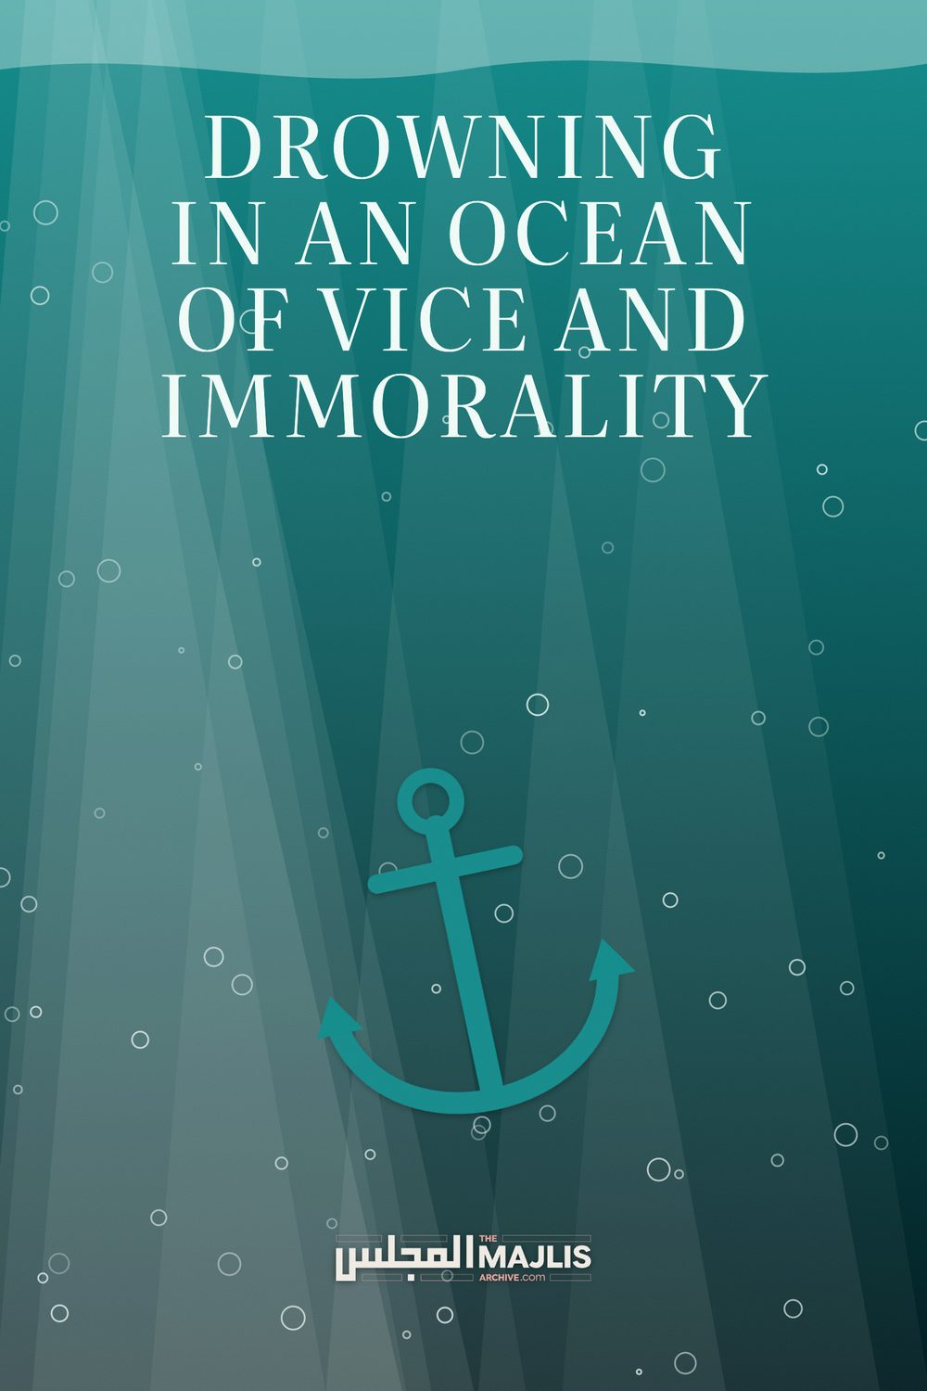

DROWNING IN AN OCEAN OF VICE AND IMMORALITY
The Majlis · Voice of Islam
Mujlisul Ulama of South Africa

About this edition
This is a reproduction by The Majlis Archive (themajlisarchive.com) of a publication of The Majlis, Mujlisul Ulama of South Africa, made and published with their permission.
The PDF as The Majlis issued it is the original. This edition was read from that PDF's own structure and checked against it letter for letter; where the two differ, the PDF is correct.
Checked: 65 paragraphs, 0 differing; a second, independent PDF reader finds 100.0% of the PDF's words here.
Nothing has been reworded, added or removed.

DROWNING IN AN OCEAN OF VICE AND IMMORALITY

THE MAJLIS PO BOX 3393 PORT ELIZABETH 6056, SOUTH AFRICA
SLIDING DOWN THE ABYSS OF MORAL, SPIRITUAL AND PHYSICAL DESTRUCTION – DOOMED IN THIS DUNYA AND THE AAKHIRAH
The Respected Professor Hoosen Vawda of Durban has quite frankly stated the truth by highlighting the pandemic of multifarious vices which is not only ruining and destroying the Islamic Morals of the Muslim community, but in the wake of the avalanches of evil, corruption and immorality comes the deracination of Imaan.
The gravity of the vice and immorality sweeping the Muslim community comes within the purview of the Qur'aanic Warning:
"When We intend to destroy (the inhabitants) of a Qaryah
(town / city, etc.), then we command its affluent people (i.e. grant them unfettered freedom) who then plunge into
(flagrant) immorality in the town. Then the decree (of
Athaab) becomes established on them. Then We utterly destroy them."
(Al-Israa', Aayat 16)
However, before deracinating a community and utterly destroying it, Allah Ta'ala sends reminders in the form of lesser punishments to jolt the criminals into realization so that they may abandon their folly which will lead to their doom in both worlds. Thus, the Qur'aan Majeed says:
"Most assuredly, we shall give them to taste of the lesser punishment, not the greater punishment for perhaps they will then return (to the Path of Rectitude –Siraatul
Mustaqeem).
If Muslims who are afflicted with the lesser punishment opt to remain blind and fail to understand the writing on the wall which is represented by the lesser punishment (Al-Athaabal Adnaa), then as sure as night follows day, the Greater Athaab (Al-Athaabal Akbar) will apprehend them and relegate them to history by means of unbearable punishment either in the form of natural disasters or the tyranny of kuffaar rulers. Such is the Way of Allah Azza Wa Jal. Confirming this Sunnah of Allah Ta'ala, the Qur'aan Majeed states: "Never will you find a change for Allah's Sunnah."

THE PROFESSOR'S REVELATION AND NASEEHAT
Recently, I am seeing the following challenges, in increasing numbers:- 1. Severe opioid as well as other street drugs addiction, ranging from 17 year olds to grandfathers, daughter-in-laws', fathers, Alims and even Huffaz. The problem is so deeply entrenched, that parents are now having drugs delivered to their homes. Mothers are so addicted that they are ignoring their 2 year old babies.
Certain, rehabilitation institutes are themselves subject to corruption, as well as some places of learning are also using these expensive drugs.
The epicentre is Overport, Musgrave, Umhlanga and Cowey Road in Durban while in Pietermaritzburg it is Northdale, centered around Muslim communities.
2. Rampant gender-based and domestic violence, with serious abuses of our respected mothers, sisters and children who are suffering in silence.
3. Alcohol consumption, cigarette and Vape smoking amongst both males and females is common and widely accepted.
4. Alternative sexual behavioural patterns, with families getting their sons married in the hope that the matrimonial union will "cure the problem", often ruining two lives and families. Wives are discovering their husbands wearing dresses when they come home, unexpectedly.
5. HIV carrier status in husbands who are infecting their spouses from being in contact with prostitutes.
6. Surfing of the internet for pornographic material, even by Alims, according to their spouses.
7. Serious psychological and psychiatric disorders in males affecting the whole family.
8. Gambling and associated indulgence in immoral activities amongst Islamic business people.
I not only feel morally and ethically obliged, but also Islamically motivated to take remedial measures to do something about this satanic maladies in our Islamic families.
Hence, I am approaching your Office to suggest a form of a mushwara, between the Alims of your organisation to formulate a strategy in order to combat the opioid pandemic and related problems in our people. My efforts in the past generated a response from Alims of "making duas and having sabr as these problems cannot be exposed". Since then the pandemic has expanded to unprecedented levels and is ruining our Islamic community, totally.
I will be most grateful for your feedback on the way forward, for if we ignore this additional pandemic, we will lose the battle as it is a serious challenge and we cannot "bury our heads in the sand", any longer. This problem is worse than the present Covid Crisis, where the addiction of various types is affecting Muslims of all ages, genders and from respectable families, of high socio-economic standing, who can afford these expensive drugs, to the delight of drug cartels amongst us.
The above is stated without prejudice or bias and in the best interests of the Muslim community and preventing moral degeneration, as well as a progressive degradation of our imaan, into an abyss of total disobedience to the Shariah, Hadith and the Glorious Quraan. Our Imaan has become an "ala carte" Islam where we are picking and choose what we like.
(End of the lament and concern of Professor Hoosen
Vawda)
We can supplement the list of vices provided by Professor Vawda with the following evils as well:
(9) Wife-swopping.
(10) Shiah-style prostitution termed mu'tah (temporary 'marriage') among university students and businessmen. (11) Fraud and dealing in stolen goods.
(12) Dealing in riba.
(13) Illicit contact between the sexes at so-called 'Islamic' schools, and girls madrasahs.
The evils indicated by Professor Vawda are not confined to only the province of Natal. This satanic deluge has submerged the entire community all over the country. In fact the entire Ummah, world-wide, is drowning in this cesspool of vice and inequity. Thus the miserable plight of the Ummah, which we observe in Syria, Burma, Sri Lanka, Palestine, China, India and elsewhere is the Athaab of Allah Ta'ala in consequence of the Ummah having traversed the point of no return in its insane indulgence in vice and immorality.
In South Africa Muslims are following the self-same trajectory towards ruin and destruction, which were the pathway of other Muslim communities in other countries. Allah Ta'ala is currently jolting us with samples of His 'lesser punishment', the latest being this 'pandemic'. If the Divine Warning is not heeded, the greater punishment will overwhelm and totally uproot us. Ponder on the plight of the Syrian, Rohingya and Chinese Muslims. We are not a chosen people who can afford to dwell in the dangerous deception of us being excluded from the heart-rending calamities which have befallen other Muslim communities.
The two primary causes for the moral degeneration and corruption of Muslims are abandonment of Amr Bil Ma'roof Nahy Anil Munkar by the Ulama, and parental abdication of their responsibilities and obligations to the Amaanat of children.
The Qur'aan Majeed states: "You are the noblest of nations created for mankind, for you command righteousness and you forbid evil, and you believe in Allah." (Aal-e-Imraan, Aayat 110)
The importance of Amr Bil Ma'roof can never be over-emphasized. Taking an oath by Time, Allah Ta'ala says: "By The Time! Verily, man is in (the state of total) loss except those who believe, practice righteousness, command the Haqq and command Sabr." (Surah Al-Asr)
The Tawaasee mentioned in this Surah refers to Amr Bil Ma'roof Nahy Anil Munkar.
The response of the Alims that the effort to combat vice is dua and sabr and to abstain from exposing the rot, is baseless and in conflict with the ta'leem of Islam. The rot may not be swept under the carpet. Silence is not the remedy for the conflagration in which the community is destroying itself. The first remedy is Amr Bil Ma'roof which is repeatedly emphasized in the Qur'aan and Hadith. Rasulullah (Sallallahu alayhi wasallam) had warned that in the wake of abstention from Amr Bil Ma'roof Nahy Anil Munkar comes the imposition of oppression and tyranny of the enemies.
It is the obligation of the Ulama to constantly highlight the evils which have attained pandemic proportions. The 'hikmat' which dictates silence and abandonment of Amr Bil Ma'roof is satanic deception.
The abyss of vice in which the community is incrementally sliding and destroying itself was initiated gradually by degrees. One vice gives rise to another evil. When the Ulama abandon their obligation in order to gain the pleasure of people, then they become so desensitized that not only will they fail to see the evil perpetrations of the people, but they will seek to chastise others who uphold the Pillar of Amr Bil Ma'roof. At this juncture do they employ satanic 'hikmat' to justify their abandonment of Amr Bil Ma'roof and to criticize other Ulama who adhere to this Waajib Injunction.
The evil and vice in which the community grovels were gradual accretions which have become embedded institutions due to Ulama complacency and even complicity. In many of the vices enumerated by Professor Vawda, Ulama too are implicated. The Madaaris have long ago abandoned the obligation of Tarbiyat, hence the students emerge as robots, not as genuine Ulama in the meaning of the Qur'aan. There is very little difference in terms of moral character between the present crop of Madaaris students and university students.
When the Ulama abandon their primary obligation, they cease being the Representatives of Rasulullah (Sallallahu alayhi wasallam). Then they, along with the community will be overtaken by Divine Chastisement. The Qur'aan Majeed states in this regard:
"Beware of such a fitnah (punishment) which will befall not only the (flagrant) transgressors among you."
The Ulama and the Buzrugs all will be overwhelmed. Then at that juncture, Rasulullah (Sallallahu alayhi wasallam) said that the tyrants and oppressors imposed over you will show no mercy to your little ones, and no respect for your elders.
Parents in this era behave like animals who discard their offspring. However, the difference between the beasts and parents of this age is that the latter have become sub-beast. Animals do care for their little ones until a certain age when the line distinguishing parents from offspring vanishes. But in this age both mother and father abandon their offspring to indulge in worldly and nafsaani pursuits. The mother who is supposed to be at home tending to her little ones, speeds off to work, dropping her little ones at some nursery / kindergarten institution.
Such institutions are unnatural and un-Islamic. The mother denies her children the tarbiyat which is the obligation imposed on her by Allah Ta'ala. Then for almost the entire age of tarbiyat the children are exposed in secular institutions to the suhbat of scoundrels, sexual maniacs, teachers with corrupt beliefs and morals. Added to this villainy is the drug menace which assails the children at schools. The drug cartels have their agents prowling schools and universities to draw the children into their net of abomination from which extrication is an almost total impossibility. Rare are the cases who are cured in rehabilitation institutions.
Minus Taqwa (Fear for Allah) there is absolutely no hope for the reformation of Muslims. This vital ingredient is today extinct. Even the Ulama who spend their lives teaching Qur'aan and Hadith are bereft of this essential attribute without which a man cannever be an Aalim. He can become a molvi, but not an Aalim if he is devoid of Taqwa. The Qur'aan Majeed says:
'Verily, of the servants of Allah only the Ulama fear Him."
Today the molvis and sheikhs have become mercenaries. Among the signs of Qiyaamah mentioned in the Hadith is that the Knowledge of the Deen will be imparted and acquired for worldly and nafsaani pursuits and objectives. The world will be left without true Ulama. Rasulullah (Sallallahu alayhi wasallam) said:
"The Saalihoon are departing (from the world) one after the other (in quick succession). Then will remain only the hufaalah (scum) such as the chaff of dates or barley. Allah will have no care for them."
When even the Ulama are devoid of feeling for the welfare of the Ummah, and when even parents abandon their children to the vicissitudes and vagaries of life and scoundrels, then there is simply no hope for the reformation of this Ummah. It now appears that we are awaiting only Allah's Athaab. We are not deriving lesson from other suffering segments of the Ummah all over the world. We conduct ourselves as if we are cocooned in safety, yet the fires of ruin are burning all around us.
The list of vices provided by the Professor Sahib mirrors and awfully ugly and dangerous image of our community firmly plodding the path of moral, spiritual and physical destruction, the consequences of which are too ghastly to contemplate – consequences in this world and in the Aakhirah.
We can fill a bulky volume with letters from innumerable people – Ustaadhs, Students, Apas and others explaining the immorality and villainy in their institutions of 'learning'. This Ummah is rotten – rotten to the core. May Allah Ta'ala have mercy on us. There seems to be no hope.

