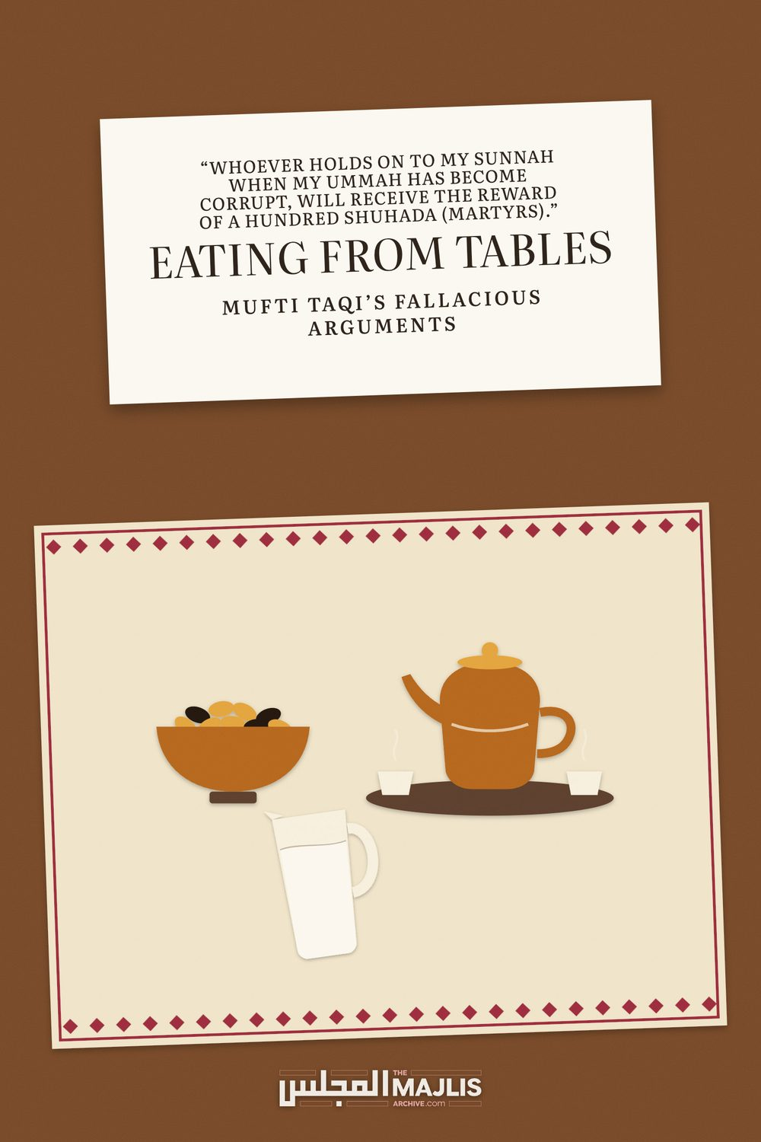

EATING FROM TABLES
The Majlis · Voice of Islam
Mujlisul Ulama of South Africa

About this edition
This is a reproduction by The Majlis Archive (themajlisarchive.com) of a publication of The Majlis, Mujlisul Ulama of South Africa, made and published with their permission.
The PDF as The Majlis issued it is the original. This edition was read from that PDF's own structure and checked against it letter for letter; where the two differ, the PDF is correct.
Checked: 129 paragraphs, 0 differing; a second, independent PDF reader finds 100.0% of the PDF's words here.
Nothing has been reworded, added or removed.

"whoever holds on to my sunnah When my ummah has become corrupt, Will receive the reward of a hundred shuhada (martyrs)."

EATING FROM TABLES muftI taQI's FALLACIOUS ARGUMENTS
BY:
Mujlisul Ulama of S.A. PO Box 3393 Port Elizabeth 6056, South Africa

EATING FROM TABLES – MUFTI TAQI'S ARGUMENT TO NULLIFY THIS SUNNAH
Question To substantiate his view of sitting on the ground to eat NOT being Sunnah, Mufti Taqi Usmani has also proffered the following argument. Is his advice right? Since he has presented the stance of his father, Hadhrat Mufti Muhammad Shafi (Rahmatullah alayh) in his support, please comment in detail for the benefit of the Ummah at large who believes that it is Sunnah to eat on the ground. His latest argument is:
Mufti Taqi Usmani narrates an incident told by his father. One day, he and his companions travelled from Deoband to Delhi. Arriving in Delhi, they needed a place to eat and entered a hotel as no other options were available. Since hotels are arranged with tables and chairs, two companions hesitated, insisting they would not eat at a table because sitting on the ground to eat aligns more closely with the Sunnah. They proposed spreading a handkerchief on the floor and having the waiter serve them there.
His father (Mufti Muhammad Shafi) advised against this, stating, "It is not a matter of shame but of practicality. If you eat on the ground here, people may ridicule this Sunnah, leading to its mockery and disrespect. Disrespecting a Sunnah is a grave sin, potentially leading to disbelief. May Allah protect us."
He then recounted the story of Sulaiman al-A'mash (a renowned hadith scholar and teacher of Imam Abu Hanifa). A'mash, whose vision was impaired, had a student with a limp who always accompanied him. When they walked through the marketplace, people would mockingly remark about "the blind teacher and his lame student." A'mash suggested the student should not accompany him to avoid such ridicule.
The student argued, "Why should we avoid this when we gain reward, and they bear sin?" A'mash replied, "It is better for both of us to be saved from such situations rather than benefit while they sin." (End of Mufti Taqi's argument)

ANSWER

Tables & Chairs in conflict with the Sunnah
In our booklet, Table & Chairs & a Corrupt Fatwa, which was a refutation of Mufti Taqi's fallacious claim, we have proffered an elaborate rebuttal of his baatil opinion. The book is available on our website.
His latest 'daleel' as stated above, did not feature in our refutation, hence we shall now proceed to refute this latest baseless argument which he has presented in negation of the Sunnah practice of the Ummah – a practice which has the support of more than fourteen centuries of Ta-aamul. In this era in close proximity to Qiyaamah, almost 15 centuries after the inception of Islam, Mufti Taqi is the first person who has mustered up the temerity of challenging the Sunnah status of the Sunnah practice of sitting on the ground to eat.

Hadhrat Mufti Muhammad Shafi (Rahmatullah alayh)
Let it be well understood that notwithstanding the seniority, knowledge, erudition and piety of Hadhrat Mufti Muhammad Shafi (Rahmatullah alayh) whom we revere, we are not his muqallideen. Our Taqleed is restricted to Imaam Abu Hanifah (Rahmatullah alayh), and we follow the Sunnah of Rasulullah (Sallallahu alayhi wasallam) as it has reached us reliably from the Sahaabah. This Sunnah cannever be nullified by the interpretations and opinions of Ulama who have appeared on the horizon many centuries after the Sahaabah.
The opinion of Hadhrat Mufti Shafi (Rahmatullah alayh) or that of any other great Aalim of the Haqq, if in conflict with the Sunnah shall be set aside, and not proffered as 'daleel' for scuttling the standing Sunnah practice known and practiced by the Ummah. Let us examine the ingredients of the narrative proffered by Mufti Taqi.
The hotel in Delhi The incident happened in Delhi which abounds with hundreds of Musaajid, numerous Madaaris/Darul Ulooms, millions of Muslims and where there is no compulsion to act in contravention of the Sunnah. In fact, the famous Madaaris, Abdur Rabb and Madrasah Ameeniyyah which existed long before Darul Uloom Deoband are located in Delhi.
We too were in Delhi. During our days of Ta'leem in Jalalabad, we had to occasionally go to Delhi. We would buy food and have our meals in peace and comfort in the sehen area of some Musjid, especially the large Jumuah Musjid. We did not experience any difficulty to sit on the ground in Sunnah style.
Hadhrat Mufti Shafi (Rahmatullah alayh) in the first instance had erred going to the hotel. Ulama generally gravitate to the Musaajid, not to hotels. There was no need for him to go to the hotel. One of his associates should have procured the food and they should have sat like the Talaba in some Musjid to eat in peace, comfort and in obedience to the Sunnah. The impression conveyed that there was no other venue besides the hotel, is basless and incorrect.
The owner of the hotel and the staff were all Muslims. It was not a Hindu hotel. Despite them not being keen practising Muslims, they were fully aware of the Sunnah practice, hence they would not have considered it 'stupid' for Ulama to sit on the ground. The idea of being 'ridiculed' is fallacious and stems from the attitude of inferiority complex acquired by even senior Ulama as an effect of the desensitization of Imaani attitudes and inhibition to act in conflict with the Sunnah. Such abhorrent desensitization is the effect of association and mingling with those who incline to modernism and hold the Sunnah in disdain.
Furthermore, hotels in Muslim countries do cater for those who desire privacy. They have rooms to accommodate purdah nasheen families. In fact, in Egypt which is a modern country where the people have a warped conception of the Sunnah, more warped than Mufti Taqi's dissonant concept of the Sunnah, we had been provided with the facility in a hotel to eat on the ground. Our group consisted of approximately 20 Huffaaz students and some Ulama. We were treated with considerable respect. In fact after meals, the hotel staff requested that some of the students to recite Qira't.

A matter of 'practicality'?
Hadhrat Mufti Shafi's understanding that sitting on the floor was not practical is egregiously erroneous. Nothing, yes nothing, rendered it impractical. His two associates had already arranged for sitting on the ground. So what was the impracticality? There was no prohibition by the hotel.
Allah Ta'ala says in the Qur'aan Majeed: "In fact man has insight of his nafs even though he proffers excuses." What is deep down in the heart is known, and it cannot be eliminated by means of excuses. The excuse which Hadhrat Mufti Shafi (Rahmatullah alayh) had stated comes within the purview of this Qur'aanic Aayat. It was an implausible excuse.
The hotel did not refuse. The space was available, yet the decision was taken by Ulama to spurn the Sunnah. Assuming that the hotel did not allow sitting on the ground, then the group should have proceeded to some Musjid for their meals and for rest in peace. In fact, the Ulama were not supposed to have been in the hotel. They went to the hotel fully aware of the practice and etiquettes of the hotel, yet they decided to go there. There was absolutely no incumbency to disgracefully hang around in a hotel where the atmosphere and environment were decidedly inimical to the Sunnah. In essence it was 'shame / embarrassment' for the ignorant worldly people who are the bootlickers of the west which had deterred the group from the Sunnah and constrained them to abandon the Sunnah. They were embarrassed and felt ashamed of eating on the ground. What will these modernists say? Hence they opted for abandoning the Sunnah.
Disrespecting the Sunnah This argument is fallacious. Even Muslims of a worldly kind, especially in India, a century ago, were not flagrantly disrespectful of the Sunnah despite them not adhering to it. The argument of Hadhrat Mufti Shafi (Rahmatullah alayh) was extremely far-fetched. It is devoid of Shar'i substance.
Since this fallacious idea has been proffered by a very senior Aalim of the Haqq, viz., Hadhrat Mufti Muhammad Shafi (Rahmatullah alayh), we deem it beneficial for dispelling this erroneous idea by narrating some of our personal experiences in this regard. While we do not generally narrate our personal experiences, in this case we deem it appropriate in the interests of providing support for the Sunnah.
At the government house in Kabul It was soon after the expulsion of the Russians from Afghanistan. Rabbaani was the president. This writer was in a group of twelve Pakistani Ulama on a visit to Afghanistan. When the president was informed of the presence of a South African Aalim in the group, he extended an invitation to have meals with him. The invitation was accepted. We proceeded to the government palace.
On arrival, we found the large ornate tables prepared for the food to be served. The tables and chairs were of an ornate kind. This was the government palace of the Russians. Everything was in western style. The tables were set to accommodate more than a hundred persons, government personnel, guests, etc. The scenario was decidedly abhorrent for this writer.
I explained to the Ulama with whom I was that I shall not be joining them for meals, and that I shall wait for them in the vehicle. They were immensely perturbed and argued that Rabbaani had specifically expressed his desire to meet the South African Aalim. I explained that regardless of the president's desire. He has his protocols, and I have my Sunnah protocols. It was necessary for the host to have enquired about the protocols of the guest so that the latter would not be put to inconvenience and discomfort.
I advised our Ulama group to locate the chap who is in charge of the place and to explain that an arrangement for us be made in an adjacent room to sit on the ground. The chap in charge was located. However, he declined. He was unable to accommodate us. Nevertheless, I was firm in my resolve not to act in contravention of the Sunnah so flagrantly in public. The Ulama in the group were perplexed and worried.
Whilst we were arguing the issue, in came president Rabbaani flanked by armed bodyguards. I instructed a Maulana colleague in our group: "Here comes the president. Go and explain the Sunnah directly to him and our stance." The Maulana Sahib stepped forward sheepishly and confronted the president. On hearing the request of the Maulana, President Rabbaani, turning to me said apologetically: "I apologize for the inconvenience. True, it is the Sunnah to eat on the ground. Do forgive us. We have just come in from the mountains and found the place as it is."
Then he called the chap in charge and instructed: "Arrange for the guests in the other room. I shall join them." The arrangement was made for us. While the other dignitaries, etc. were eating in the hall, the president sat with us on the floor and expressed considerable happiness. Even after meals, he remained sitting on the floor engaging us in conversation.
With Shah Mas'ud This was the second incident. Shah Mas'ud also invited us to his headquarters in Bagram. The food was spread on tables. When our stance was explained, Shah Mas'ud accommodated us with considerable respect and we all sat on the floor in Sunnah style.
In Bangladesh In 1999 this bandah was arrested and detained in jail in Bangladesh. After six months detention I was let out on bail. The charges related to terrorism and the like, and I remained in Bangladesh for another six months since my passport was confiscated. I was not allowed to leave the country in view of the pending trial.
Since the government was aware of the baseless and bunkum charges against me, on my release I was befriended by the Minister of Law and Justice. It was election time. The Minister requested me to accompany him on his election campaign. I accepted his request and travelled with him in his car to many far-spread villages.
Enroute we stopped at a government guest house. The Minister was expected to stop at the guest house.
When we reached, I observed that the food was about to be served. Of course, everything was in western style –tables and chairs.
At least Rabbaani and Shah Mas'ud in Afghanistan had a good idea of the Sunnah. But in Bangladesh, the Sunnah was absolutely unknown. The personnel present were high ranking officers from the army, air force and navy. There was no semblance of the Deen on them. It was as if I was in total kuffaar company. All of them were westernized modernists from whom percolated only kufr.
As we entered, I reacted without delay and said: "You gentlemen may have your meals on tables. However, I am more comfortable with the Sunnah and I shall sit on the ground." So, saying, I quickly sat on the ground a few metres from the tables. Undoubtedly, they were flabbergasted, bewildered. They cast puzzled looks. How did they practically react? Despite their modernism, there was no need for me to avail of the advice proffered by Hadhrat Mufti Muhammad Shafi (Rahmatullah alayh). Far from ridiculing or attempting to sway my stance, the Minister of Law announced that he was joining me on the ground. He ordered the dastrkhaan to be spread. Then, Alhamdulillah, hidaayat dawned on all the officers present. All of them joined this bandah on the ground and happily participated in the meals. Not a single one of them sat at the tables. They did not express any ridicule nor made any untoward comments.
'Ridicule, mockery, disrespect leading to kufr' These statements are figments of the imagination unfortunately stemming from an inferiority complex which is the effect of desensitization which in turn produces the contemptible attitude of Istikhfaaf (regarding an act as being insignificant). Desensitization is a silent shaitaani malady which creeps on the mind by imperceptible degrees. Senior Ulama, pious Ulama and even Auliya become victims of the satanic disease of desensitization.
Hadhrat Aishah Siddiqah (Radhiyallahu anha) narrating a Hadith said that in bygone times there was a city with 60,000 inhabitants. While 40,000 were fussaaq-fujjaar, 20,000 were such Auliya whose a'maal (virtuous deeds) were like the a'maal of the Ambiyaa (Alayhimus salaam). Allah Ta'ala commanded Jibraeel (Alayhis salaam) to destroy the town with all its inhabitants.
Hadhrat Jibraeel (Alayhis salaam), vastly surprised, supplicated to Allah Ta'ala regarding the 20,000 Auliya. Allah Ta'ala commanded that all of them should also be destroyed with the Punishment. Allah Ta'ala explained to Jibraeel (Alayhis salaam) that despite the Taqwa of the 20,000 Auliya, all of them were desensitized. They had become accustomed to the fisq and fujoor of the 40,000 people. Their sins and disobedience had become acceptable norms. The Auliya, in addition to abstaining from Amr Bil Ma'roof Nahy Anil Munkar, socialized and fraternized with the fussaaq and fujjaar. Thus, Allah Ta'ala assigned them to the same category to which the 40,000 belonged. The Athaab therefore engulfed them as well. There are other similar episodes of Athaab overtaking desensitized Ulama and Auliya during bygone times.
The excuses proffered to justify abandonment of Sunnah practices on the basis of Fiqhi technicalities such as Sunnat Aadiyah, come within the purview of the Qur'aanic Aayat: "In fact, man has baseerat (insight) of his nafs even though he proffers excuses (to justify his infractions)." There is no ridicule, no mockery, no shame and no disbelief in the wake of making amal on the Sunnah of our Beloved Nabi (Sallallahu alayhi wasallam). On the contrary, there is Izzat (Honour and Respect) in upholding the Sunnah.
Furthermore, the thawaab for reviving 'dead', neglected and abandoned Sunnat practices is immense. Rasulullah (Sallallahu alayhi wasallam) said:
"He who clings to my Sunnah when my Ummah has become corrupt, will receive the reward of a 100 martyrs."
The idea of a Sunnat being disrespected if it is given practical expression in a scenario where Islam is ghareeb (forlorn, strange and friendless), is fallacious. It was on the basis of this imaginary figment that the advice to abandon the Sunnah was given. Making amal on the Sunnah is practical Tableegh which is extremely effective. It opens an avenue of Hidaayat whereas abandonment of the Sunnah on the basis of the fallacies proffered is in reality killing the Sunnah.
Mufti Taqi himself had dispelled the idea of 'disrespect and ridicule' being involved in eating on the ground in Sunnah style. An act which the kuffaar and modernists will ridicule and mock is to pick up a morsel of food which has fallen from one's hand, then to eat it. This is the Sunnah. While Mufti Taqi was still an Aalim of Haqq, he had glowingly praised this Sunnah and had dismissed the idea of ridicule and mockery. But today he has changed his tune. Thus, while he was still following the Haqq prior to his metamorphosis, he stated:
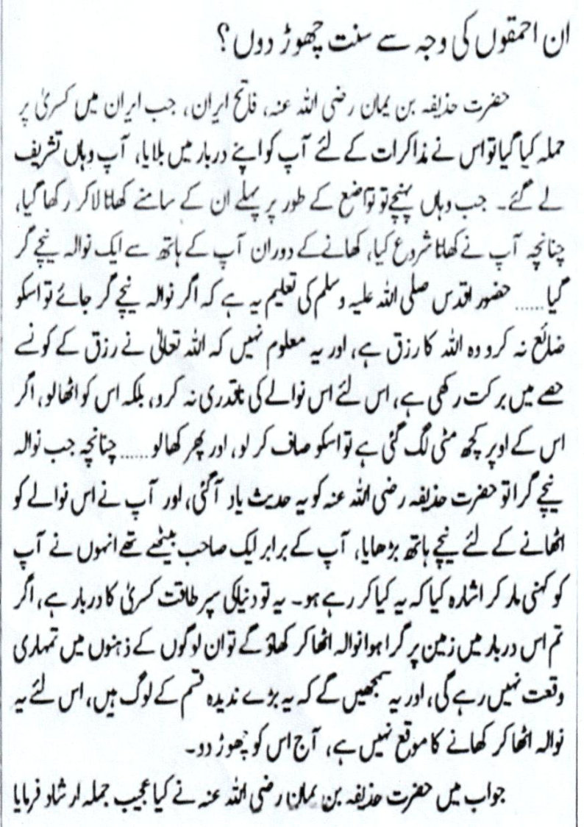
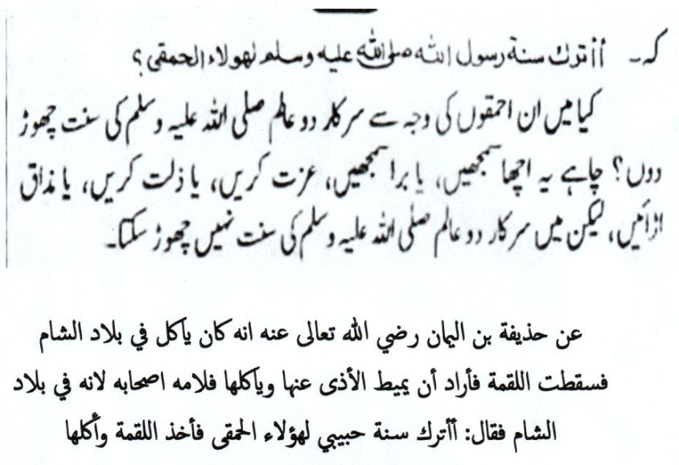

Translation
"Should I abandon the Sunnat for these morons? (This caption of Mufti Taqi is actually the statement of the Sahaabi, Hadhrat Huzaifah –Radhiyallahu anhu)
When Hadhrat Huzaifah Bin Yamaan (Radhiyallahu anhu), the Conqueror of Iran, had attacked Iran, Kisra (the emperor of Iran) had called him for talks at his palace. When Hadhrat Huzaifah arrived at the palace, food was presented with humility.
Whilst Hadhrat Huzaifah was eating, a morsel of food slipped from his hand and fell on the ground. It is the teaching of Rasulullah (Sallallahu alayhi wasallam) that if a morsel of food falls, it should not be destroyed. It is Rizq from Allah Ta'ala and it is not known in which portion of the food has Allah Ta'ala created barkat. Therefore the morsel should not be regarded with disdain. It should be picked up, dusted and consumed.
Hadhrat Huzaifah (Radhiyallahu anhu) remembering this Hadith, stretched his hand to pick up the morsel. A colleague sitting alongside, nudged him with his elbow and indicated: 'What are you doing. This is the court of the superpower Kisra. If you pick up the fallen morsel of food and eat it, these people will have no respect for you. They will think that we are a greedy and uncouth people. This is not the occasion for picking up the morsel. Today, leave it."
In response, Hadhrat Huzaifah (Radhiyallahu anhu) made a wonderful statement. He said: "Should I abandon the Sunnah of Rasulullah (sallallahu alayhi wasallam) for these morons.?" Regardless of what they will think –good or bad, whether they disgrace us or make a mockery, the Sunnah of Rasulullah (Sallallahu alayhi wasallam) may not be abandoned."
(End of Mufti Taqi's comment)
Now, do we follow the advice of Mufti Shafi (Rahmatullah alayh) or the command of Hadhrat Huzaifah (Radhiyallahu anhu) who vociferously declared the upholding of the Sunnah in the presence of the kaafir king and his noblemen. Mufti Taqi, in his comments on this Sunnah act, had not decried it on the basis of ridicule and mockery which he now imagines in relation to eating on the ground when kuffaar and modernists are present.
Hadhrat Huzaifah (Radhiyallahu anhu) discerned absolutely no disrespect in observing a Sunnat act which most certainly was viewed with disdain and aversion by the kaafir king and his noblemen. On the contrary, Hadhrat Huzaifah (Radhiyallahu anhu) insulted the king and his noblemen by loudly saying: "Shall I abandon the Sunnah of my Beloved for these morons?"
He acquitted himself on the basis of his vibrant Imaan. While we, due to Imaani deficiency, do not advocate the adoption of Hadhrat Huzaifa's strident tone, we do emphasize the imperative need to act on the Sunnah and not to justify its abandonment with flaccid arguments.
More of Mufti Taqi's support for the Sunnah are randomly cited. Despite believing that it is permissible to eat from tables, he says in his Islaahi Khutbaat, Volume 5:
• "The closer one is to the Sunnah, the more barkat will there be, and the reward will be more."
• "It is best to make arrangements to sit on the ground to eat."
• "In it is more thawaab, more humility, and it is the closest to the Sunnah of Nabi-e-Kareem (Sallallahu alayhi wasallam). May Allah Ta'ala with His Rahmat bestow to us the taufeeq to be closest to the Sunnah."
We are required to follow the Sunnah. The criterion is the Shariah – the Qur'aan and the Sunnah, not the errors of the Ulama. Great Ulama too commit errors and many errors. It was the way of Bani Israaeel to appoint their Ulama and Buzrugs as 'gods' besides Allah Ta'ala. Hence, they would follow their ulama and buzrugs if their fatawaa appealed to the nafs regardless of the conflict with the Shariah. Condemning them, the Qur'aan Majeed states: "They take as gods their ahbaar and ruhbaan besides
Allah…."
Allaamah Abdul Wahhaab Sha'raani (Rahmatullah alayh) as well as other senior Fuqaha said: "He who takes hold of the nawaadir (rarities and obscurities) of the Ulama, verily he has made his exit from Islam."
It is not permissible to proffer as daleel the nawaadir of Ulama to justify abandonment of any hukm or Sunnah act. The tendency of juniors of this age to cite nawaadir of the Akaabir in justification of Shar'i infractions and abandonment of Sunnah, regardless of the technical classification, is despicable.
The act or opinion of the senior Aalim of Haqq shall be weighed on the scale of the Shariah. The Sunnah shall not be weighed and adjusted in terms of the opinions of the Ulama if such opinions conflict with the Shariah/Sunnah. The conflicting opinion shall be set aside, not elevated to the status of the Shar'i daleel and practice.

Hadhrat A'mash (Rahmatullah alayh)
There is absolutely no daleel in the anecdote of Hadhrat A'mash (Rahmatullah alayh) for justifying abandonment of the Sunnah. Ordering his student not to accompany him was not in violation of any Sunnah act. There is nothing in this episode to justify abandonment of the Sunnah.
Hadhrat A'mash (Rahmatullah alayh) had merely acted in terms of what he deemed best in the circumstances. His decision did not adversely affect any Sunnat act. The student accompanying him was not a Sunnat act. Thus, Hadhrat A'mash (Rahmatullah alayh) did not prohibit any Sunnat act.
Furthermore, there is no certitude in claiming that the opinion of the student was incorrect. It was the opinion of one Aalim against that of another Aalim. Seniority is not the determinant and final word for establishing the Haqq.
Preference to a kaafir style is Kufr Abandoning or neglecting a Sunnat act of any classification due to lethargy or plain nafsaaniyat is sometimes sinful and sometimes disdainful depending on the Fiqhi classification of the act. However, to abandon the Sunnah, be it of the Sunnah Aadiyah or Zawaaid class, for giving preference to the kuffaar style/methodology is kufr.
Preferring any kaafir custom/practice over the Sunnah is kufr. Thus the Fuqaha have ruled: "While Miswaak is Sunnah, its denial (that its Sunnah status) is kufr." Hence, if a person due to spiritual lethargy does not use miswaak while accepting its Sunnah status, we shall not label him a faasiq. The same ruling applies to any Sunnah act described as Sunnat Aadiyah.
Fiqhi classification is not a licence for abandoning a Sunnat regardless of it being a Sunnat Aadiyah. The Fiqhi classification may not be used to justify abandonment or to dilute the Sunnah practice. For practical purposes all acts of Rasulullah (Sallallahu alayhi wasallam) are of great importance and rewardable.
The advice of eating from tables when in the company of modernists and kuffaar is the effect of cognitive dissonance which is the effect of inferiority which in turn is the product of desensitization. In terms of this lopsided, fallacious logic, all acts of the Sunnah for which modernists and kuffaar have an aversion will have to be abandoned to placate their kufr palates. They view the Athaan and Salaat with ridicule and mockery. Should we abandon these acts of Ibaadat on the basis of the advice Mufti Taqi proffers?
The entire Islam is repugnant to the kuffaar. Thus, Allah Ta'ala says in the Qur'aan Majeed:
"Never will the Yahood and Nasaara be pleased with you as long as you do not follow their religion. Say: 'The guidance is only the Guidance of Allah. If ever you were to follow their vain desires (whims and fancies) after the Ilm (of Islam) has come to you, you will then have no friend and no helper."
(Baqarah, Aayat 120)
It is the sacred function and obligation of the Ulama to promote the Sunnah, to encourage Muslims to adopt the Sunnah and to revive gone, forgotten and deadened acts of the Sunnah.
It is despicable for Ulama to find justification for diluting the Sunnah, for abandoning the Sunnah and to manipulate Fiqhi technicalities to entrench the kuffaar ways and customs which Muslims are emulating and aping.
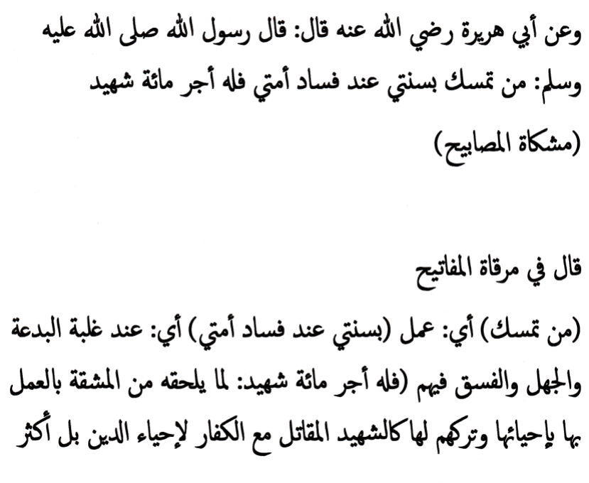

REVIVING THE SUNNAH
Rasulullah (Sallallahu alayhi wasallam) said:
"Whoever adheres to my Sunnah at the time of the corruption of my Ummah, will receive the reward of a hundred martyrs."
Reviving and adhering to the Sunnah are Waajib acts. Rasulullah (Sallallahu alayhi wasallam) referred to "My Sunnah" without differentiating between the then unknown technical categories of Sunnat Aadiya, etc. which the Fuqaha deemed appropriate for classifying the Sunnah for the edification of posterity.
All acts, practices and commands of Rasulullah (Sallallahu alayhi wasallam) are vital constituents of "My Sunnah". Thus, acts which are Fardh, Waajib, Mustahab, Sunnat Aadiyah and the like are all "My Sunnah". It is pure shaitaaniyat and nafsaaniyat to neglect, minimize and abandon "My Sunnah" on the basis of the Fiqhi classification of Sunnat Aadiyah or Sunnat Zaaid. Shaitaan inspires miscreant molvis and muftis to fulfil the dictates of their nafs and to justify such malpractice with the gimmick of technicalities.
It is the Waajib obligation of Muslims to adhere with rugged resolution to all the Acts of the Sunnah, and to resort to Taubah for the weakness of abstaining from Mustahab and Sunnat Aadiyah commands of Rasulullah (Sallallahu alayhi wasallam). It is Waajib to repent for neglecting any aspect of "My Sunnah". This Sunnah of our Nabi (Sallallahu alayhi wasallam) may not be considered as antique for assignment to the museum.
It is haraam to view any aspect of "My Sunnah" with Istikhfaaf as has become the habit of Mufti Taqi. How is it possible for a Mu'min whose Imaan is embedded in his heart to ignore the treasure of Thawaab consisting of the reward of a 100 Shuhada?
Commenting on this Hadith, Mullah Ali Qaari (Rahmatullah alayh) says in His Mirqaatul Mafaateeh:
"…'Fasaadi Ummati (the corruption of my Ummah), i.e. at the time of the preponderance of bid'ah, jahl and fisq. 'Then for him is the reward of a 100 martyrs' because of the difficulty of practicing (on the Sunnah during such times of corruption). The difficulty pertains to enlivening (the killed-off Sunnah) which the people have abandoned. The reward will be like that of a Shaheed who fights against the kuffaar to keep alive the Deen. In fact, his reward is even more."
It was solely due to the difficulty of adhering to the Sunnah on account of it having been abandoned that the Ulama group in the hotel found itself too weak to implement the Sunnah. Sadly, they wrongly believed that the modernists present would ridicule them, embarrass them and make a mockery of them if they had implemented the Sunnah. This was the effect of extreme Imaani deficiency. They were required to bring to mind the amal Hadhrat Huzaifah Bin Yamaan (Radhiyallahu anhu) who had picked up the morsel of food from the ground, dusted it and ate it in the presence of Kisra, the kaafir king and his noblemen, then commented to the one who offered exactly the same advice as Hadhrat Mufti Muhammad Shafi (Rahmatullah alayh had offered: "Should I abandon the Sunnah of my Beloved for the sake of these morons?" No, it was never possible!
While abandoning the Sunnah was acceptable for those Ulama to appease the diseased palates of the modernist Muslims, it was akin to kufr for Hadhrat Huzaifah (Radhiyallahu anhu). And, likewise should this be the attitude of the Mu'mineen in this age when the Sunnah has been killed off.
We are in the era regarding which Rasulullah (Sallallahu alayhi wasallam) said:
"Then shall there come such a time when the one who holds on to the Sunnah will be like one holding a burning coal."
It is just sad that the august group of Ulama in the hotel had lacked the spiritual mettle to hold on to "the burning coal." How will the dead and forgotten Sunnah ever be resuscitated and practised by further suppressing it as the august Ulama group had most dishonourably acted in the hotel where they were not supposed to have been?
Remember well, and understand well that if on account of Imaani deficiency a Shar'i infraction is committed, never find justification for it. Do not proffer excuses to justify sin and for abandonment of the Sunnah. Just regret and resort to Taubah.
May Allah Ta'ala guide this fallen and disgraced Ummah to understand its folly and to resort to Inaabat Ilallaah – to turn unto Allah Ta'ala with repentance and renewal of the Pledge of Obedience.

