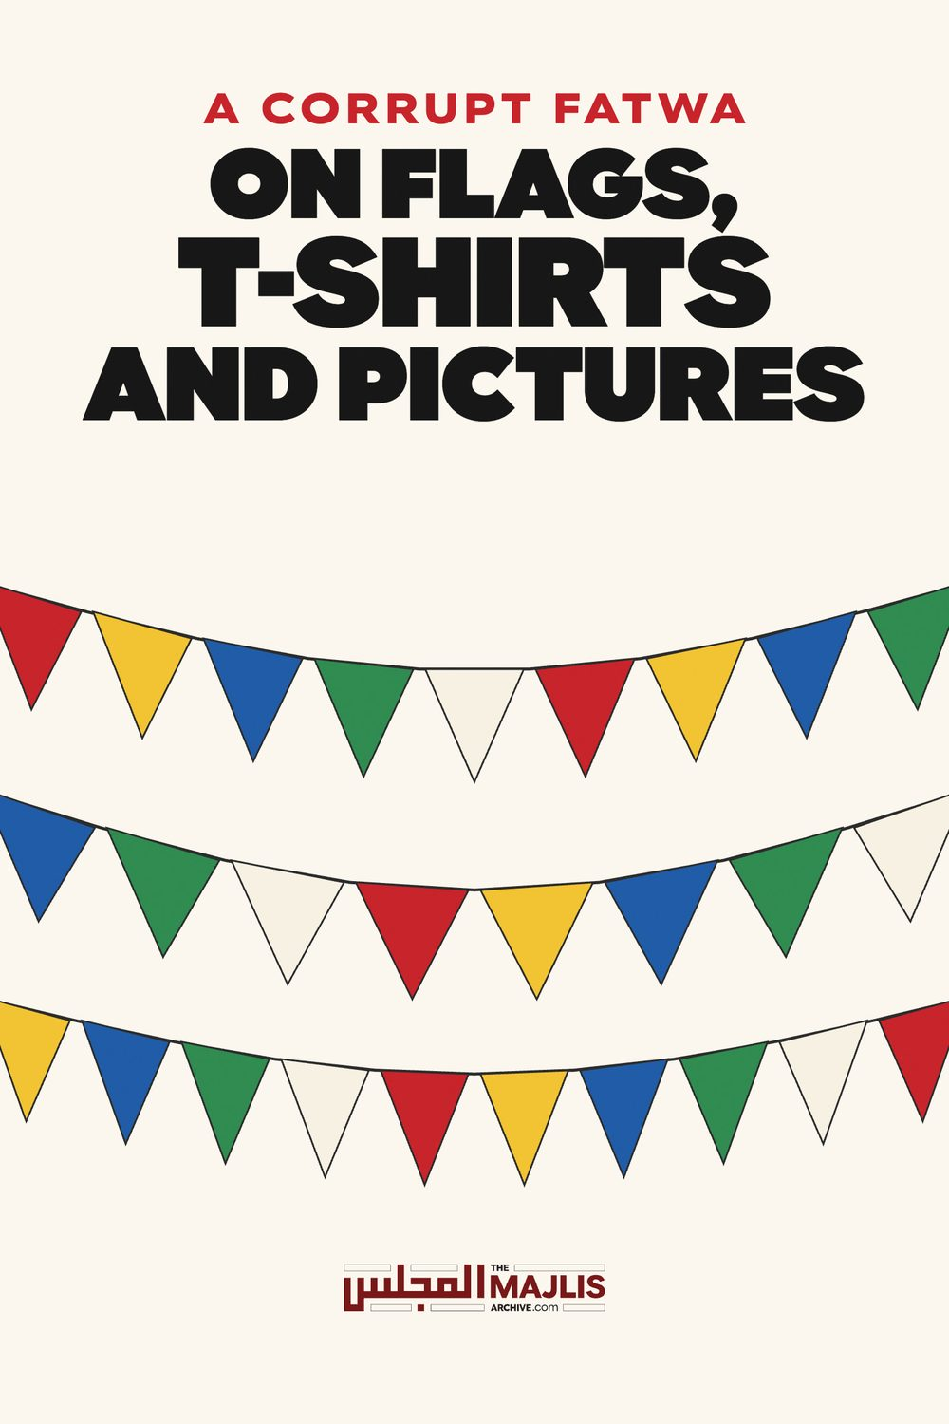

FLAGS, T-SHIRTS AND PICTURES
The Majlis · Voice of Islam
Mujlisul Ulama of South Africa

About this edition
This is a reproduction by The Majlis Archive (themajlisarchive.com) of a publication of The Majlis, Mujlisul Ulama of South Africa, made and published with their permission.
The PDF as The Majlis issued it is the original. This edition was read from that PDF's own structure and checked against it letter for letter; where the two differ, the PDF is correct.
Checked: 116 paragraphs, 0 differing; a second, independent PDF reader finds 100.0% of the PDF's words here.
Nothing has been reworded, added or removed.

MUJLISUL ULAMA OF S.A.
6056, South Africa

QUESTION
Please comment on the following Fatwa:
After issuing their relevant fatwa they quote a few Ibaarats (texts) which state that the Asl is ibaahah.
QUESTIONS
Selling T-Shirts with country flags; Advertising products with videos of people
Question 1. I want to sell T shirts with different country flags on them for the upcoming Soccer World Cup. Some of these countries are not majority Muslim countries (e.g. Portugal, Spain, France etc.). Will it be permissible to sell these t shirts?
2. What is the ruling on advertising products with videos of people using them? Sometimes products need a video demonstration, or a photo to show how to properly use them. What is a permissible way to do this?
The answers to your queries are as follows:
1. It is permissible to sell t-shirts with flags of the various countries imprinted on them, irrespective of the religious predominance in the respective country. However, one should avoid t-shirts with flags that have animate objects, religious depictions- like the Saudi flags, etc.
2. There are academic differences of opinions amongst contemporary 'Ulamaa and Muftis regarding digital photography. The Darul Iftaa advises to adopt taqwaa and avoid all forms of digital pictures and videos. You may revert to us with details of the product(s) you wish to advertise and we will try to assist you with suitable alternatives.
Is this fatwa correct according to the Shariah?

ANSWER
The fatwa is seriously flawed with incongruities. It is not valid in terms of the Shariah.
The Mufti did not apply his mind. It is clear that the Muftis of this age are egregiously ignorant of the fact that the objective of Ifta is to bring people closer to Allah Ta'ala. On the contrary, these muftis are entrenching the fisq and fujoor of people by resorting to technicalities. The Aakhirat is the furthest from their minds. Hence, whatever technical loophole they can dig out from the kutub, they will utilize to issue such lamentable fatwas which only give further impetus to the fisq and fujoor of people, thus further stunting their Imaan and increasing the chasm between Allah Ta'ala and His servants.

FLAGS AND T-SHIRTS
The flags of kuffaar countries are generally symbols of kufr. It is not permissible for Muslims to sell such flags and T-shirts with such flags even if the flags are without animate objects. Furthermore, such T-shirts are Tashabbuh bil kuffaar. It is haraam for Muslims to wear such garb.
The chap who asked the question clearly mentioned that he desires to sell such T-shirts "for the upcoming Soccer World Cup." It beggars Imaani credulity that a mufti fails to understand the colossal fisq and fujoor accompanying these haraam kuffaar games. A host of major sins are attached to these shaitaani games. To sell T-shirts associated in any way with these haraam activities is to aid and abet in sin and transgression. It is I'aanat alal ma'siyat. It is haraam by the explicit Nass of the Qur'aan Majeed.
By what stretch of aql did the mufti cite the principle of Al-Asl fil Ashyaa' Al-Ibaahat (the principle regulating things is permissibility), defies understanding. This principle has absolutely no relevance to the issue of selling flags and T-shirts.
If it be accepted that this Ibaahat principle is valid and applicable today, then too, the principle is conditioned with daleel which negates Ibaahat (permissibility). There are valid arguments which negate the applicability of the principle to the T-shirts and kuffaar flags. The Fuqaha clearly stipulate for the validity of the operation of this principle that the issue in terms of the Shariah is Maskoot anhu, i.e. the Shariah is silent on the matter.
Furthermore, if the Shariah is silent on a specific issue, however, there is Shar'i daleel for hurmat (prohibition/impermissibility), then obviously the question of Ibaahat recedes into oblivion. In Al-Kaafi Sharh Al-Bazudi, it is mentioned: "We do not say that Ibaahat is a principle established inceptionally by the Shariah and that there is no hurmat inceptionally in all things because human beings since the time of Aadam (Alayhis salaam) to the present time have not been left in vain (to wander about aimlessly like the holy bulls and cows of Hindu India) at any time whatsoever. Allah Ta'ala says (in the Qur'aan): 'There has not been an Ummah, but there was a Warner (a Nabi) among them. In the imposition (of the Shariah on people) there is prohibition of things and permissibility of things. Should we say that Ibaahat is the Asl in things as an inceptional Shar'i principle, it will lead to the abrogation of Takleef (i.e. the imposition of Shar'i ahkaam), and this is incorrect."
Ibn Ameer Haaj (Ibn Al-Muwaqqa Al-Hanafi) states in At-Taqreer Wat Tahreer: "Sadrul Islam said: 'After the incidence of the Shariah, wealth will be (regulated by the principle of) Ibaahat by Ijmaa' as long as the cause of hurmat (prohibition / impermissibility) has not appeared."
It should be understood that Ibaahat is not a principle to be employed loosely for just anything for according it permissibility as do the deviates of our age. If there is Shar'i daleel, this principle cannot be invoked, for it will mean abrogation of the Shariah. In Kashful Asraar Sharah Al-Bazdawi, it appears: "In terms of the view of those who say permissibility and impermissibility are known only on the basis of the Shariah, it will be said that the exception from prohibition is Ibaahat. Thus it is as if it is said: These things are haraam in the state of ikhtiyaar (volition, and permissible in the state of idhtiraar (dire straits). Therefore, Ibaahat in the state of dire need is also established by Nass (explicit command of the Shariah)."
Further negating the careless employment of this principle, it is mentioned in Ghamz Uyoonil Basaair: "Therefore, Tahreem (decreeing haraam) is more preferable to us. Verily, it is more preferable to us because in it is the abandonment of mubaah (a permissibility) for the sake of abstention from haraam, and this is better than its contrary.
.....The Asl in things is Ibaahat until there appears the daleel for negation of Ibaahat. This is according to the Math-hab of those Fuqaha who say that the Asl is Ibaahat. Similarly according to those who say that the Asl is Tahreem. It will be Tahreem until such time that there appears the daleel for negation of Tahreem."
Furthermore, this extremely contentious principle is weak of nature. It is not a holy writ. In Sharhul Manaar is mentioned: "Verily, Ibaahat being the Asl is not a Shar'i hukm. ......... There are two objections against the principle: 'Al-asl fil ashyaa' Al-Ibaahat'. (1) The apparent impression conveyed is that this is a unanimous principle. We have mentioned earlier that it is the view of some Hanafiyyah. (2) Verily, Al-Ibaahatul Asliyyah is not a Shar'i hukm........
This principle is according to some Hanafiyyah among whom is Al-Karkhi. Some of the Ashaabul Hadith said that the Asl is prohibition, and some of our Ashaab said that the Asl is Tawaqquf (non-committal)."
It is also stated in Ghamzul Uyoon: "Know that verily, that in which there is harm for a person or for others is beyond the pale of difference (i.e. there is unanimity in its prohibition)." Thus, it may not be argued that tobacco, for example, is halaal on the basis of the principle of Ibaahat because there is extreme dharar (harm) for human beings in this substance. This principle cannot be invoked to legalize dagga, claiming that it is only a plant, hence on the basis of this principle it is halaal. There is Shar'i daleel to negate the Ibaahat.
Another interpretation of this principle is: "Exemption from punishment on the basis of commission or omission." However, in negation of this view, Fakhrul Islam said: "This applies only to the era of Fatrah which was between Nabi Isaa (Alayhis salaam) and Muhammad (Sallallahu alayhi wasallam). ............"
In Raddul Muhtaar it is mentioned: "According to Ibnul Humaam, Al-Ibaahat is (the view) of the Jamhoor Hanafiyyah and Shaafi'iyyah. It is stated in Sharh Usoolil Bazdawiy: 'The majority of our Ashaab and the Ashaab of Shaafi'said: 'That things are on the (principle of Ibaahat) prior to the applicability of the Shariah's ruling of permissibility and prohibition. That is the Asl in such things, hence it is permissible for a person to whom the Shariah has not reached to consume whatever he desires.............. Consumption of carrion and drinking of wine are prohibited only by (Shar'i) proscription, hence Ibaahat (permissibility) has been decreed the Asl and Hurmat (prohibition) is the Aaridh (an external regulating factor)."
Al-Baidhaawi said: "The intention of those who say that the Asl in things is Ibaahat, is in such things in which there is benefit. However, regarding harmful things, the Asl is Tahreem (prohibition)."
There is copious discussion and interpretation of this principle which the Mufti Sahib has used, not only loosely, but baselessly. It has absolutely no relevance to T-shirts. It is moronic to say that on the basis of the Ibaahat principle it is permissible for women to unveil themselves in public since inceptionally, the face of woman is not aurah. Only a maajin mufti who is fit to be whipped and estopped from issuing fatwa will proffer such a corrupt and stupid 'fatwa'. There is valid Shar'i daleel for the Wujoob of veiling the face. Similarly, there is Shar'i daleel for the kuffaar T-shirts being impermissible, and this impermissibility has greater emphasis regarding such T-shirts which are associated with kuffaar sport which are accompanied by a host of Kabeerah sins.
Tashabbuh bil kuffaar, I'aanat alal ma'siyat and kufr symbols are factors which prohibit trading with such T-shirts and flags. The kuffaar sport connotation by itself is adequate for prohibition. But, in reality, this principle has no relevance with T-shirts and flags.
The Ibaahat principle will operate in issues on which the Shariah is silent and for which there are no apparent elements of prohibition. For example, kangaroo meat or any other animal for which there is no mention/ruling in the Shariah. Is it halaal or haraam? As long as there is no daleel to prove prohibition, it will be said that the meat is halaal.
If one visits a Muttaqi Muslim who exercises considerable caution regarding his food, one will not doubt the food he serves. The principle will be applicable here. But, in our age, when it is confirmed that 99% of the populace and 99% of even the molvis and sheikhs devour carrion, and that 99.9% of Muslim butcheries trade in haraam meat and chicken, then the principle of Ibaahat will not apply. Only a moron and a maajin mufti will apply this principle in a scenario where the vast majority of people devour excreta, and advise that as long as the najaasat is served in a Muslim's home, it will be halaal on the basis of Al-Asl fil Ashyaa' Al-Ibaahat.
The universally prevailing condition of the people – their wholesale devouring of haraam and their wholesale indulgence in fisq and fujoor, and their flagrant disregard for the Shariah in all spheres of life, negate the principle of Ibaahat in our time. Today the principle of Hurmat applies. All things will be regarded haraam unless proven to be halaal. The kuffaar manufacturers are fully aware of the halaal requisite, hence they will not reveal the true ingredients of their products. Compounding the evil is the mass halaaization of carrion by the cartel of 'halaal' certificate vendors such as SANHA, MJC, NIHT and the myriad of other agents of Iblees. Thus, there is no scope for the operation of the Ibaahat principle in today's scenario. Hadhrat Maulana Ashraf Ali Thanvi (Rahmatullah alayh) has also confirmed this fact, namely, that the Asl today is Hurmat.
Furthermore the mufti has cited this principle as if it is the final world. It is mentioned in Al Ashbaah Wan Nazaair that according to 'some Hanafiyyah' the principle is Ibaahat. According to some Muhadditheen, the principle is Al-Hazr (Prohibition). Other of our Fuqaha say that the principle is Tawaqquf (neither permissibility nor prohibition). A Shar'i daleel is essential for a ruling.
Technically, there are three views: Ibaahat, Tahreem and Tawaqquf. However, in reality, the consequences of all three are the same. For example: An unknown wild fruit is found growing in the bush/jungle. Is this fruit halaal or haraam? In terms of the Ibaahat view it is halaal. In terms of the second view, it is Haraam, and in terms of the third view the issue is indeterminate. However, if it is confirmed that the fruit is poisonous, then unanimously it will be haraam. In the same way, if it is confirmed that the fruit is not poisonous nor harmful, it will be unanimously halaal.
All three views are conditioned by daleel. If there is daleel to indicate prohibition, e.g. the fruit is poisonous, then both the Ibaahat and Tawaqquf fall away, and hurmat is confirmed. Similarly, if Shar'i daleel confirms that something is halaal, then the Tahreem and Tawaqquf view fall away.
Is giraffe halaal or haraam? According to the Ibaahat view it is halaal because there is no Shar'i daleel to negate its permissibility. On the other hand, rhino is haraam despite the fact that both the rhino and giraffe are herbivorous animals. Despite Ibaahat being the principle according to the Jamhoor Ahnaaf, our Math-hab rules that rhino and elephant are haraam. The Shar'i daleel of khubth (vile/evil/noxious) mentioned as a factor of prohibition in the Qur'aan, constitutes the condition for the cancellation of Ibaahat of rhino and elephant meat.
The principle may not be applied loosely and stupidly without taking into account the prevailing circumstances and the elements of Hurmat. It may not be argued that since apples are halaal, liquor made with apples will also be halaal in view of the Shariah being silent on the issue of apple liquor or strawberry liquor or pineapple liquor. The principle of Ibaahat cannot be utilized to halaalize such liquors. There is a Shar'i daleel to override this principle in this regard, and that is the prohibition of all intoxicants.
Similarly, when it is known that carrion is consumed by the vast majority of Muslims, it will be stupidity and perfidy to claim that on the basis of the principle of Ibaahat it is permissible to devour the food of all Muslims. Only a moron will conclude permissibility when there exists a Shar'i daleel to negate it. In this case, ghalbah zann (overwhelming probability bordering on certitude), overrides the principle of Ibaahat.
It is indeed moronic and totally unexpected of a mufti to apply the principle of Ibaahat to something such as a T-shirt with a logo of kufr or shirk or which is a garb of the kuffaar or which is worn to celebrate haraam kuffaar sport such as the World Soccer Cup with its accompaniment of a plethora of major sins. In the same way, it is stupid and haraam to claim that gold for males is halaal on the basis of the Ibaahat principle because there exists Shar'i daleel negating the principle on this issue.
In view of the universal preponderance of haraam and mushtabah in this age, and the concealment of ingredients by manufacturers with E-numbers and chemical designations, and the mass halaalization of carrion and haraam for monetary purposes, the only option for practical implementation is the principle of Tahreem. In other words, all things will be regarded as haraam unless confirmed as halaal by valid Shar'i daleel.

PICTURES
The claim by the mufti that "there are academic differences of opinion amongs contemporary Ulama and Muftis regarding digital photography", is not worthy of intelligent consideration. In the more than fourteen century history of Islam there has always been Ijmaa' (Consensus) of the Ummah on the hurmat of pictures of animate objects regardless of the method of production. All authorities of all Math-habs have ruled that such pictures are haraam.
Contemporary 'ulama' who claim that the production by the digital process of haraam pictures renders such pictures halaal, are like the carrion halaalizers. Their view is putrid and so silly that even children will mock and jeer at the ghutha they stupidly blabber. A haraam picture – a picture of an animate object – remains haraam regardless of the method of production. The method is not haraam. The picture produced is haraam. It is ludicrous for a genuine mufti to cite the views of such moron molvis and sheikhs in a subtle attempt to minimize the 14th century prohibition substantiated by Nusoos of the highest calibre of authenticity. In a nutshell, there is no difference whatsoever regarding the prohibition of pictures of animate objects. The utterly baseless ta'weel (interpretation) expectorated to halaalize haraam pictures render these molvis zanaadaqah.
The contention of digital images not being haraam pictures is absolutely stupid and it is ridiculous to aver that such a silly view is within the confines of 'academic' difference of opinion. Moron, zindeeq sheiks and molvis of our age hold the view that it is permissible to shave the beard, khamr (grape liquor) is halaal as long as one does not become drunk, that it is permissible for women to appear without Niqaab in front of ghair mahaareem, that it is permissible for women to undertake journeys without their mahrams, etc., etc. Such haraam differences may not be elevated to the category of academic difference of opinion simply because such rot and rijs are excreted by molvis and sheikhs who are actually agents of Iblees. Similarly, those molvis and sheikhs who claim that digital pictography of animate objects is halaal, are agents of Iblees. The devil manipulates them to undermine and demolish the Shariah.
Observing the prohibition is not a matter of Taqwa as the mufti seeks to convey. It is Fardh to abstain from pictures of animate objects.
The averment that a picture made with a camera or the digital process is not a picture, is ineffably preposterous. It is an insult to intelligence. Regardless of the method of producing a picture, the end product is a picture which is haraam if it is of an animate object. It is compound jahaalat to say that this stupid view is within the confines of academic difference of opinion. The ludicrousness of this weird view comes within the purview of the Qur'aanic Aayat:
"Thus does Allah casts rijs (filth) on those who are bereft of aql (intelligence)."
The brains of these molvis who have fabricated this satanic idea have been disfigured as mentioned in this Qur'aanic Aayat. That is why they are capable of expectorating shamelessly such trash which leaves even children gaping aghast. A picture is not a picture simply because a modern method has been selected for making it!!!!! The degree of stupidity underlying this convolution boggles the minds of even intelligent kuffaar who react with scornful mirth on hearing such absolute trash and rubbish.
There is absolutely no academic difference of opinion on the hurmat of pictures of animate objects regardless of the method of producing such images. The contemporary so-called ulama who have hallucinated and disgorged this effluvium of the permissibility of digital pictures, are morons who have exchanged the Deen for the miserable gains of this dunya. They search for just any type of ghutha for legalizing the prohibitions of the Shariah. Then they utilize their molvi status and inapplicable Fiqhi technicalities to bamboozle and mislead the ignorant masses. Every haraam fatwa is passed off as an effect of 'academic difference of opinion' whilst in reality it is the inspiration of Iblees.
The fatwa of the mufti on the issues of T-shirts, flags and pictures is baseless. It is devoid of Shar'i substance.
We have published several books on the issue of pictures. These books are available. You may write for copies.
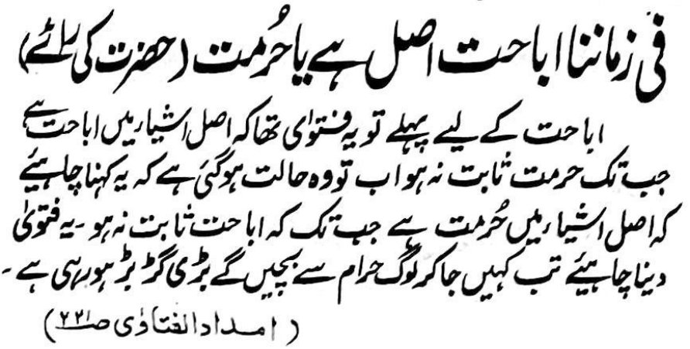

THE PRINCIPLE OF PROHIBITION
In the Shariah there is a principle which states: "Al-Asl fil ashyaa al-Ibaahah.", which means permissibility of things unless proven to be haraam. Things are initially permissible. However, a Shar'i daleel (proof of the Shariah) will render it unlawful.
If there is no such proof, the original rule of permissibility will remain.
Although there is a contrary view, the aforementioned principle is the popular version. However, in view of the changed circumstances which have resulted in total disregard for the Shariah, and ﬂagrant indulgence in fisq, fujoor and haraam, the opposite principle will apply to our times.
According to the contrary principle, all things will be haraam unless proven to be halaal. Commenting on the current situation, Hakimul Ummat Maulana Ashraf Ali Thaanvi (rahmatullah alayh) said: "For permissibility the earlier fatwa was that things are initially permissible until hurmat (prohibition) has not been proved. However, today the situation warrants saying: 'The Asl (principle) regarding things is hurmat (prohibition) until permissibility has not been prove. Only if this fatwa is issued, will people be saved from indulgence in haraam. Tremendous chaos prevails nowadays."
In this era, we observe the materialization of the Hadith which predicted that a time will dawn when people will be totally unconcerned from whence they obtain wealth. As long as they can lay their hands on wealth they are not concerned whether it is halaal or haraam. The insane craving is only for the acquisition of material items of 'pleasure' regardless of the manner in which the wealth is obtained.
This situation prevails in all spheres of life. Muslims have become so accustomed to consuming, buying and selling haraam food, etc. that it is no longer possible to eat the food of relatives and friends without circumspection and fear. Like animals Muslims are devouring haraam and mushtabah without the slightest tinge of conscience.
The preponderance of haraam in earnings, food, living conditions and in almost every aspect of life has smothered whatever vestige of inhibition to haraam the Muslim's heart should naturally have. Haraam earnings and haraam food corrupt and stunt the intellect. All celestial Noor is extinguished, hence the hearts of Muslims have become impervious and unreceptive to the Haqq (Truth) in the same way as the disfigured and spiritually deadened hearts of the kuffaar.

MORE DISCUSSION ON THE IBAAHAH PRINCIPLE
The following is an extract from our book, Haraam Bank Riba-Loans and The Haraam View of a Sciolist Jaahil 'Shaykh'.
In his attempt to legalize riba, the deviate resorts to ludicrous mental gymnastics, juggling with the concept of Wikaalat (Agency) and other principles which have no bearing whatsoever on the issue of bank loans. Thus, he says:
"The initial status of all kinds of transactions is that they are permissible. One of the well-known principles of the Hanafi School is that everything beside these three is permissible by default: 1. Bloodshed 2. Sexual acts 3. Rituals of worship..........Based on this, we say, everything is permissible unless it is proven to not permissible."
Regarding the bank loan issue, the introduction of the aforementioned principle is indeed moronic.
(1) There is no relationship between a bank loan encumbered with interest and this principle. The fundamental constituents of borrowing, lending and paying interest, determine the Shariah's ruling. A clear-cut ruling of prohibition of interest cannot be submitted to the contentious principle formulated by opinion.
The introduction of this principle, totally unrelated to the issue of bank interest loans, is a silly exercise in futility with which the deviate modernist attempts to obfuscate the conspicuous clarity of the prohibition of bank interest.
However, since he has moronically touched on this principle, it will be appropriate to discuss and refute its applicability to the issue under discussion. Atabek has abortively attempted to convey the idea that the principle: "The initial (hukm) regarding things is ibaahah (permissibility).", is the standard and accepted rule of the Hanafi Math-hab. This postulation is incorrect.
This is the principle of the Jamhur Shaafi' Fuqaha, not of the Hanafi Fuqaha. The following elucidation is presented in Al-Ashbaah wan Nathaair ala Math-habi Abi Hanifah:
"Is the Asl (the initial hukm) regarding things Ibaahah (permissibility) until such time that there is a daleel (evidence) to indicate the negation of ibaahah – and this is the Math-hab of Ash-Shaafi' (rahmatullah alah) – or is it (i.e. the Asl) Tahreem
(Prohibition) until there is daleel for Ibaahah? The Shaafi'iyyah attribute this (i.e. the Asl is Tahreem) to Abu Hanifah (Rahmatullah alayh).
In Sharhul Minaar it appears: Things are initially on Ibaahah according to some Hanafiyyah. Among them is Al-Karkhi. Some of the As-haab of Hadith say: The Asl in this is Al-Hazr (prohibition).
Our As-haab (the Hanafi Fuqaha) say: The Asl in it is Tawaqquf (Non-Committal), meaning that a hukm (of the Shariah) is necessary for it, but we are not aware of it by means of intelligence.
In Hidaayah appears: The Asl is Ibaahah."
In Al-Ash-Baah wan Nathaair (Shaafi'), the Shaafi' position is stated as follows:
"The Asl in things is Ibaahah until there is daleel to indicate Tahreem (Prohibition). This is our (i.e. Shaafi) Math-hab. According to Abu Hanifah the Asl is Tahreem (Prohibition) until there is a daleel to establish Ibaahah (Permissibility)."
In this sphere there are three principles: Ibaahah (Permissibility), Tahreem (Prohibition) and Tawaqquf (Non-Committal). Regarding these principles formulated on the basis of opinion, there is considerable difference of opinion. These principles are not cast in rock. They are not Mansoos on the basis of Wahi nor in terms of the Hadith.
Fuqaha of the same Math-hab subscribe to differing opinions. Among the Hanafis are those who hold the opinion of Ibaahah while others of the Hanafi Math-hab subscribe to the Tahreem view, and similar is the difference in the other Math-habs.
Furthermore, these principles are overridden by Shar'i Daleel. They will operate only in rare cases of absolute absence of Shar'i daleel. There is also no strict adherence to these principles among the Fuqaha. Consider an animal such as the giraffe (zaraafah). The Qur'aan and Ahaadith are silent regarding the permissibility or prohibition of giraffe. Those who subscribe to the Ibaahah principle opine that its meat is halaal while those holding the view of Tahreem say that it is haraam. Since there is no Shar'i basis for proclaiming giraffe haraam, the holders of the Ibaahah view say that it is halaal. On the other hand, Imaam Nawawi and Shiraazi who are Shaafi' authorities, proclaim giraffe haraam despite the Shaafi' principle of Ibaahah.
The Hanafis again, despite their principle of Tahreem, proclaim giraffe to be halaal since there is no Shar'i daleel for saying that it is haraam. From this, it is clear that the actual determinant is Shar'i daleel. If there is daleel for Ibaahah, the ruling will be permissibility. On the contrary, if there is daleel for Tahreem, the fatwa will be on hurmat. Also according to Imaam Ahmad Bin Hambal (Rahmatyllah alayh), giraffe is haraam despite the Asl of Ibaahah.
Although the principle of the Shaafi' Math-hab is Ibaahah, the majority of the Shaafi' Fuqaha have refrained from issuing a ruling regarding the giraffe. Neither do they say that it is halaal nor haraam despite their Ibaahah principle. (Al-Ashbaah wan Nathaair – Shaafi'). In Al-Ashbaah wan Nathaair of Imaam Jalaaluddin Suyuti, it is mentioned:
"The majority of the As-haab (Shaafi' Fuqaha) have not entertained this issue (of the giraffe) at all whatsoever, neither permissibility nor prohibition. Fataawa Qaadhi Husain and Imaam Ghazaali have explicitly said that it is halaal...............
Ash-Shaikh has categorically stated in At-Tanbeeh that it is haraam. In Sharhul Muhazzab, Consensus
(Ittifaaq) is narrated on this. And so too has Abul Khattaab of the Hanaabilah said. No one from the Maalikiyyah and the Hanafiyyah has mentioned it (the giraffe), nevertheless, their principles dictate it being halaal."
Taqiyuddin As-Subki (Shaafi') mentions in his Kitaab, Qadhaail Arab fi As-ilati Halab:
"Shaikh Abu Is-haaq has categorically stated in At-Tanbeeh that the giraffe is haraam........In Sharhul Muhazzab, Nawawi has narrated Ittifaaq (Consensus) on the giraffe's prohibition."
In the Kitaab, Asnal Mataalib fi Sharhi Raudhit Taalib it appears as follows:
"He says in Al-Majmoo' that verily, the giraffe is haraam without any difference of opinion." This is despite the Ibaahah principle on the basis of which other Shaafi' Fuqaha proclaim it to be halaal.
There exists considerable difference and argument and conflicting dalaa-il in the Shaafi' Math-hab regarding the permissibility or prohibition of the giraffe despite the Jamhur's principle of Ibaahah. On the other hand, despite the Tahreem principle of the Ahnaaf, the Hanafi Fuqaha say that giraffe is halaal. It should be quite evident that the determinant is Shar'i daleel.
Consider the example of the whale. In terms of the Shaafi' principle, Ibaahah applies, and not only to the whale, but to all sea animals. However, according to the Ahnaaf, whale and all sea animals are haraam despite a semblance of Shar'i daleel. Although a Hadith leads to the possible conclusion of the sea animal being a whale, the Hanafi Fuqaha do not accept that the sea animal described in the Hadith was a whale, hence they maintain its prohibition.
They have their own Shar'i dalaa-il for the hurmat of the whale and all sea animals. Thus, the emphasis is on Tahreem by the Ahnaaf. What is clear from the considerable difference, conflict and ambiguity in these principles is that the determinant is Shar'i Daleel which restricts and overrides the principles.
(2) The claim that this principle applies to trade transactions is erroneous. It applies to existing aspects of creation on which the Shariah is silent, e.g. animals, plants, a water channel whose ownership is unknown, i.e. whether it is private property or not, and any existent for which there is no ruling provided by the Qur'aan or Hadith. It is stupid and baatil to apply the principle of Ibaahah to a transaction or even a tangible substance merely because their names cannot be found in the Nusoos. It may not be said that vodka and whisky are halaal on the basis of the principle of Ibaahah. It may not be said that pudding is halaal on the basis of this principle of permissibility simply because the name, 'pudding' does not exist in the Qur'aan or Hadith. The imperative need will be to examine and establish what exactly are the ingredients and constituents of these substances. If the ingredients are haraam or the effect of the halaal ingredients is haraam such as intoxication, then the Shar'i daleel for Tahreem is confirmed.
Similarly, mortgages cannot be said to be halaal on the basis of the Ibaahah principle simply because this term is new and cannot be located in the Nusoos. The incumbent need is to examine and establish what mortgages are all about. The introduction of the Ibaahah principle in this regard demonstrates the jahaalat of Atabek. The simple issue in this regard is that a bank loan is encumbered with interest/riba, hence it is Haraam. There is absolutely no need for the invocation of any one of the three principles to determine the Shariah's verdict on bank-interest. It is glaringly Riba. Only brains welded by stupidity and aggravated by western liberalism and a bootlicking attitude, understand otherwise.
The mudhaarabah transaction of the so-called Islamic banks cannot be proclaimed halaal on the basis of the Ibaahah principle, and simply because it has an Islamic designation. The need is to examine the constituents of the contract to establish the Shar'i ruling. A plant, the properties of which are unknown – whether beneficial or poisonous – shall not be proclaimed halaal or haraam simply on the basis of the principles of Ibaahah and Tahreem. The demand is for establishing the ruling on the basis of Shar'i daleel. If examination confirms that the plant is poisonous, then obviously the verdict will be Tahreem. If it is not harmful or poisonous, the ruling will be Ibaahah.
It will indeed be a rarity for the total absence of Shar'I daleel to act as the determinant. In such rare cases, Tawaqquf will apply, thus rendering the issue to the Mushtabah realm. As far as bank loans are concerned, there is absolutely no ambiguity in their nature. A bank loan is pronounced haraam by the categorical Nusoos of the Qur'aan and Hadith. Only a stupid deviate having no affinity with the Shariah will muster the stupid audacity to invoke the principle of Ibaahah for the determination of a ruling for a bank loan which is encumbered with riba. The principle may not be used in conflict with a mansoos alayh law. The unnecessary and stupid introduction of the Ibaahah principle which is totally unrelated to bank interest/riba, has constrained this digression.

