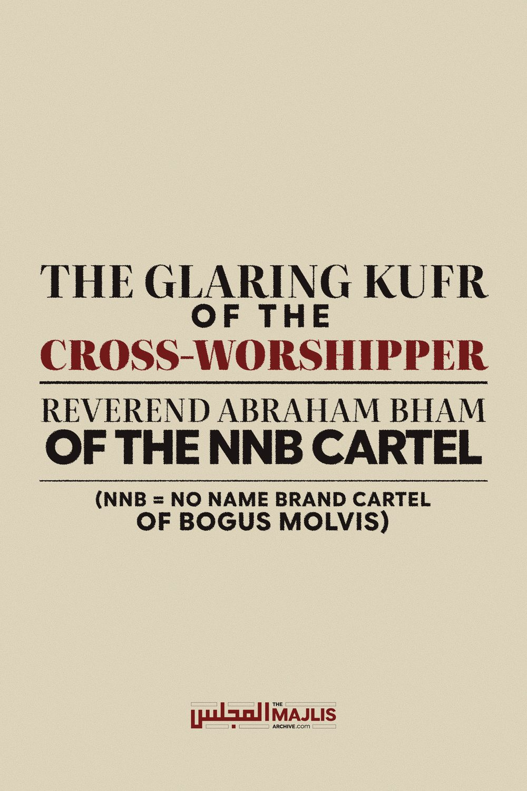

GLARING KUFR OF THE CROSS-WORSHIPPER
The Majlis · Voice of Islam
Mujlisul Ulama of South Africa

About this edition
This is a reproduction by The Majlis Archive (themajlisarchive.com) of a publication of The Majlis, Mujlisul Ulama of South Africa, made and published with their permission.
The PDF as The Majlis issued it is the original. This edition was read from that PDF's own structure and checked against it letter for letter; where the two differ, the PDF is correct.
Checked: 204 paragraphs, 0 differing; a second, independent PDF reader finds 100.0% of the PDF's words here.
Nothing has been reworded, added or removed.

THE GLARING KUFR OF THE CROSS-WORSHIPPER REVEREND ABRAHAM BHAM OF THE NNB CARTEL (nnb = NO NAME BRAND CARTEL OF BOGUS MOLVIS)

THE MAJLIS PO BOX 3393 PORT ELIZABETH 6056 SOUTH AFRICA

THE KUFR DISGORGEMENT OF THE MUNAAFIQ INTERFAITHER

QUESTION
Mr. Bham of Jusa made the following comments:
Transcript "…………………………..
Well, I, I, I was just thinking of the two things with regard to tolerance and compromise. One is, someone has the right to choose a religion which Allah Ta'ala says in the Quran, "Lakum deenukum waliyadeen." So, everyone has got the right to choose. ………………..
When you going into a prayer, or you're going into a situation where you have people who are doing different prayers, now, how different is it, that, from that of living in a country which has a constitution and the constitution says that all religions are equal according to this constitution. So, if you are so strident and so strict on your, that there is only one religion that is true, then why are you living in such a country, in which constitution says that all faiths are equal. So, you, you have to ask the question that if you feel that all faiths are not equal, Islam is the dominant religion and the constitution of that country speaks about that there should be no discrimination on the basis of religion, which of course, it suits us. It suits us because, in that particular situation, you got, uh, uh, a situation of allowing yourself to practice your religion. So, why, why are you staying in a country which has such a constitution?" (End of the Munaafiq Murtad's comments)
"Have you not seen those who think that they have Imaan (belief) in that which has been revealed to you and that which was revealed before you? They desire adjudication from Taaghoot (Shaitaan) whilst having been commanded to reject him." (An-Nisaa', Aayat 60)
"You will see those in whose hearts is a disease (of kufr and nifaaq) racing among them, saying: 'We fear that some misfortune may befall us." (Al-Maaidah, Aayat 52)

COMPOUND KUFR
The Kufr mullock which the Cross-Worshipper posing as a Muslim has excreted from his mouth is merely an addition to the blasphemy and kufr which have become the hallmark of this enemy of Islam. It is clear that he has been born for Jahannam – to be fuel for Jahannam. Regarding the worse scoundrels created by Allah Ta'ala, the Qur'aan Majeed states:
"We have created many from jinnkind and mankind to be fuel for Jahannam."
There is not an iota of doubt in the kufr of this vile specimen of insoforia. To bolster his kufr interfaith satanic idea of equality of religions and that the religions of kufr are acceptable, the vile copro Murtad cites the Qur'aanic Aayat: "For us is our Deen and for you is your deen." He satanically interprets this Verse to assign validity to the kufr interfaith ideology whose cardinal doctrine is that no religion is the absolute truth. All religions are equal according to this copro priest of the interfaith kufr religion.
The jaahil Murtad Reverend of the Cross is totally ignorant of the circumstance of the revelation of Surah Kaafiroon in which appears the Aayat which this specimen of Hufaalah has satanically misinterpreted. Surah Kaafiroon was revealed specifically to denounce and refute the interfaith proposals made by the Mushrikeen of Makkah.
The Unity of Religions Proposal Four of the Mushrikeen chiefs approached Rasulullah (Sallallahu alayhi wasallam) with an interfaith proposition. They proposed an interfaith compromise to Rasulullah (Sallallahu alayhi wasallam). The proposal was that they would worship his (Sallallahu alayhi wasallam) Allah if he worshipped their idols. In this way, they said, his and their religion would be one. This was the ideology of 'unity of religions' which is old hat dug up by the likes of the Reverend of the Cross. And, this is the same unity of religion concept propagated by rubbish copro documents such as the 'abraham accord' of the Clown Trump and lapped up by Murtadeen and Munaafiqeen slinking in the midst of the Ummah.
According to another narration, some of the most evil members of the Quraysh proposed that Rasulullah (Sallallahu alayhi wasallam) should worship their idols for a year and they would worship Allah for a year. Vigorously rejecting their kufr interfaith proposals, Rasulullah (sallallahu alayhi wasallam)
responded: "I seek Allah's refuge from worshipping anyone besides Him."
They then proposed that if Rasulullah (Sallallahu alayhi wasallam) at least kissed one of their idols, they were prepared to believe in him and would worship Allah. It was then that Allah revealed Surah Kaafiroon. Rasulullah (Sallallahu alayhi wasallam) proceeded to the Haram and loudly recited the Surah to the Quraysh gathered there. The Mushrikeen then lost all hope of compromising with Rasulullah. Their interfaith plot had miserably failed.
It is noteworthy that Rasulullah (Sallallahu alayhi wasallam) had emphatically rejected the ideology of dubious diplomacy which molvis of this era proffer to justify their abstention from Amr Bil Ma'roof Nahy
Anil Munkar. In lieu of just one kiss on an idol, the entire mushrik community would embrace Islam. If this episode had to transpire today, the copro cartel of molvis would have found an abundance of 'shar'i' substance for interpreting permissibility and encouragement to kiss idols. Their argument will be that an entire community of mushrikeen will accept Islam in exchange for just one slight kiss on an idol. That is why they are employing haraam methods such as haraam radios, television, video, etc. They claim that the 'good' which will transpire from these haraam methods outweighs the evil of the acts prohibited by Allah Ta'ala.
But here we have this miserable Reverend Bham worshipping under 12 crosses in a Christian church and flanked by priests and swamis. Now he seeks to sell his interfaith kufr with his satanic misinterpretation of Qur'aanic Verses.
Commenting on the particular Aayat which the jaahil Reverend of the Cross has satanically misconstrued, Mufti Muhammad Aashiq Ilaahi (Rahmatullah alayh) says in his Tafseer:
"Certain sects claim to be Muslims despite holding beliefs that expel them from the fold of Islam. When they are advised to return to the correct teachings of the Qur'aan and the Ahadeeth, they excuse themselves by saying: "For you is your religion and for me is mine." Such people misconstrue this verse to mean that every person is at liberty to adopt the beliefs and practices he wishes.
However, this Surah clearly addresses the Kuffaar, making it clear that their religion is irreconcilable with Islam. No beliefs can be entertained which contradict the teachings of the Qur'aan and the clear Ahadeeth of Rasulullah (Sallallahu alayhi wasallam) because these will expel a person from the fold of Islam. The leaders of these sects have beguiled their followers into adopting this attitude of "Do as you please and we will do as we please."
The Divine Abhorrence for religions other than Islam is stated with emphasis and great clarity in the Aayat:
"Fight them (the kuffaar) until there remains no fitnah and that the Deen is only for Allah.?"
(Al-Baqarah, Aayat 193)
"Fight those who do not believe in Allah and the Last Day, those who do not regard as unlawful that which
Allah and His Rasool have made haraam, and who do not accept the true Deen. (They are from) those who have been given the Kitaab (Tauraah). Fight them until they pay Jizya with their own hands in disgrace."
(At-Taubah, Aayat 29)
"Fight them until there is no fitnah and all
Deen is for only Allah."
(Al-Anfaal, Aayat 39)
When Muslims have the necessary power, the command is to fight the Kuffaar until Islam becomes the dominant religion. Furthermore, the 'tolerance' which Islam has granted its kuffaar (Zimmi) people is stipulated with 'disgrace' and payment of Jizyah as is confirmed in Aayat 29 of Surah Taubah.
The Qur'aan is replete with Aayaat stridently condemning all religions, and declaring that the ONLY true religion is the Deen of Islam. Thus, the Qur'aan states:
"Whoever searches for a religion other than Islam, never will it be accepted from him, and in the Aakhirat he will be among the losers.
(condemned for eternal perdition in the Fire.)"
(Aal-e-Imraan, Aayat 85)
The Aayat in Surah Al-Kaafiroon, which the Murtad Reverend cited in support of his interfaith kufr beliefs, does not give people a choice of religions. The Aayat only means that the non-Arab kaafir should not be compelled with the sword to accept Islam. It is noteworthy and of much significance that the negation of compulsion is for the Ajam (non-Arabs). As for the Arabs, Hadhrat Umar (Radhiyallahu anhu) had declared: "Either Islam or the Sword." Declaring absolutely no tolerance for the kuffaar, Rasulullah (Sallallahu alayhi wasallam) commanded on his Death-Bed:
"Expel the Yahood and Nasaara from the Arabian
Peninsula."
Allah Ta'ala did not give anyone the choice of adopting Kufr and Shirk. Those who accept any religion of kufr and shirk are the worst enemies of Allah Ta'ala. Allah Ta'ala has created Jahannam for them. "The Fire has been prepared for the kaafireen. (Qur'aan) What kind of choice is it to select kufr with the threat of everlasting Jahannam on one's head?
The Qur'aan explicitly mentions many nations who were obliterated by the Punishment of Allah Ta'ala for their kufr and shirk. How can any person who is not a Munaafiq ever accept that Allah Ta'ala has given people the choice of selecting kufr and shirk? Whoever opts for kufr, will be everlastingly doomed in Hell-Fire. Only one whose brains are deranged by satanic manipulation (Takhabbutush Shaitaan) is able to proffer the Aayat: "For you is your religion and for me is my religion", to bolster the shaitaani claim that Allah Ta'ala has given mankind the liberty of choosing between kufr and Imaan.
What kind of voluntary choice does a man have when a cocked loaded gun is held at his head? With the gun at his head he is told to choose between Imaan and Kufr. But if he opts for kufr, he will be eliminated. When Allah Azza Wajal has emphatically and explicitly warned that whoever chooses kufr/shirk will be cast into Jahannam eternally, how can any man of intelligence believe that he is free to choose a religion of kufr and shirk? The Gun of Jahannam is held at his head. If he opts for kufr, he will be ruined everlastingly.
The Constitution of Taaghoot The Munaafiq Murtad Reverend of the Cross seeks support for his kufr idea by presenting some stupidities from the constitution of Taaghoot. He seeks to overshadow the Qur'aan and the fundamental Aqeedah of Tauheed of Islam with the constitution of Kufr. Thus, the miserable jaahil cross-worshipper averred:
"So, if you are so strident and so strict on your (religion— The Majlis), that there is only one religion that is true, then why are you living in such a country, in which constitution says that all faiths are equal."
Note the following and digest it well:
(a) The Qur'aan commands us with the 'strident' attitude which Allah Ta'ala has embedded in our Imaan since our birth into this world. Kufr must be combatted stridently and with whatever power the Mu'mineen have.
(b) There is only ONE religion of Truth which the Qur'aan declares explicitly and with great emphasis. The Qur'aan is replete with the theme of only ONE TRUE RELIGION.
(c) We are living in this country by the decree of Allah Azza Wa Jal. We are not here as guests of the legion of Taaghoot. Our presence in this country is not the product of any favour bestowed upon us by the government or anyone else. Allah Ta'ala is the Creator of the country, and it belongs to Him Alone.
"Verily, the earth belongs to Allah. He grants it to whomever of His servants He wills."
(Qur'aan)
The country is the creation of Allah Ta'ala, and we are also His creation. He has decreed our presence in this country. That is why we are here.
(d) Our belief in Tauheed and in the irrefutable fact of Islam being the Absolute Truth, and in the fact that besides Islam there is no salvation, and in the fact that all other religions are false and figments of Satanism, and in the fact that the followers of all other religions are doomed for everlasting perdition in Hell-Fire, are allowed and upheld by even the constitution of Taaghoot which is the holy cow of the Reverend Cross-Worshipper.
The constitution of the country enshrines 'freedom' of belief and even of thought. Thus, our beliefs and thoughts in no way whatsoever are in conflict with even the religion of the constitution. Our beliefs do not create anarchy and disharmony in this land of Kufr.
Living in this country does not require eradication of our Imaan. We are not committing any criminal offence in terms of the constitution by believing that only Islam is the True Religion. But this miserable child of Iblees in his attempt to pull wool over the eyes of morons implies that those who believe in the absolute truth of Islam have no right to be in this country. Indeed his brains have been coprified by the stercoraceous manipulation of Iblees-in-Chief.
On what basis does the miserable lout believe that our presence in the country is untenable and criminal because of our belief in Tauheed being the one and only basis of salvation and truth?
Regardless of what the constitution of Taaghoot says about 'freedom of religion', the Qur'aan commands the Mu'min to shun all religions and to declare: "Verily, I call Allah as Witness, and you (kuffaar also) be witness that I am free from the (deities of shirk and kufr) which you associate (with Allah)." (Hood, Aayat 54)
What is the factor that prompted the murtad Reverend of the Cross to suggest that those who believe in the superiority of Islam and in the fact that only Islam is the Absolute Truth have no right of living in this country? When the bible of Taaghoot to which the Reverend of the Cross subscribes allows us the freedom to think and believe in whatever are the tenets of our Deen, then on what basis did this son of Iblees understand that Muslims have no right of stay in this country? The bible of Taaghoot states:

"FREEDOM OF RELIGION, BELIEF AND

OPINION
15. (1) Everyone has the right to freedom of conscience, religion, thought, and opinion."
(Chapter 2, Verse 15 (1) of the Bible of Taaghoot)
Thus, Muslims are free to believe that only Islam is the Absolute Truth; that all other religions are false. The moron murtad reverend of the cross is too stupid to understand what is recorded in the bible which he follows.
Which principle of Taaghoot's constitution and which law of the government do Muslims violate by believing that Islam is the only true religion? While this is not a crime even according to the kuffaar rulers, it is chagrin and detestable to the munaafiq who masquerades as a Muslim. His own kufr is abhorrent.
Furthermore, regarding liberty to choose, a Murtad is not given the choice to adopt whatever religion he satanically desires. For the Murtad the choice is between Islam and the Sword. Only a shaitaan of the calibre of the Reverend of the Cross can have the satanic temerity of saying that the Murtad may avail himself of the Aayat "For you your deen and for us our Deen".
His attempt to justify his kufr with the constitution of Taaghoot is baseless and satanic. Since the constitution supposedly grants 'freedom of religion', Muslims are not committing treason or any crime by claiming stridently that only one religion is true, and all other religions are false and ideologies of Iblees.
The son of Iblees avers:
"So, you, you have to ask the question that if you feel that all faiths are not equal, Islam is the dominant religion and the constitution of that country speaks about that there should be no discrimination on the basis of religion,………………….."
Now, who is the Muslim who has true Imaan who can doubt this brazen kufr of the Reverend of the Cross? The one who feels that all faiths are not equal and that Islam is the dominant religion – the only religion of Absolute Truth – is indeed a true Muslim, and whoever has a vestige of doubt regarding this fundamental belief on which eternal salvation hinges, is undoubtedly a kaafir. If he claims to be a Muslim, then this belief of kufr renders him a murtad of the worst order, and he will be among the arch-enemies of Allah Azza Wa Jal. His abode in the Aakhirah is everlasting residence in Jahannam.
It is of great importance for Muslims to understand that Salaat behind Reverend Bham, the Cross-Worshipper who believes that Islam is not the Absolute Truth, is not valid. He is a confirmed Murtad. He reeks of the abominable stench of kufr.

THE INTERFAITH PLOT AND TRAP
In this era of fitnah and fasaad the most dangerous trap for the elimination of Imaan is the satanic interfaith ideology to which Reverend Abraham Bham, the agent of Iblees subscribes. The onslaught on Islam is not a new conspiracy. It commenced from the very first day Rasulullah (Sallallahu alayhi wasallam) proclaimed the Aqeedah of Tauheed. This onslaught to eliminate Islam has continued persistently through the ages.
The interfaith ideology (that is the plot for eliminating Islam) has undergone a metamorphosis, moulting from one form to another while the objective always was the same plot of obliterating Islam. It had assumed a variety of forms. The Mushrikeen of Makkah had initiated the interfaith trap, but failed. Then they embarked on war, but failed. The Crusaders assumed the shaitaani liability of eliminating Islam, but failed.
In the current era, the headquarters of the conspiracy are the universities of the kuffaar. Their departments of Islamic studies are the traps of kufr in which Muslim students are ensnared. The worst kufr which is adorned with satanic logic, termed zukhruful qaul by the Qur'aan, is indoctrinated into the brains of Muslim students. Their brains are fitted into straitjackets of kufr. Regarding the Satanism propagated by the Islamic studies departments of the kuffaar universities, the Qur'aan Majeed states:
"Thus, We have appointed for every Nabi human and jinn shayaateen who whisper to each other zukhruful qaul (satanically adorned statements – traps of kufr) to deceive." (Al-An'aam, Aayat 112)
Another trap which the western kuffaar have managed to set up in the Ummah, is the snare of mercenary molvis of the ilk of Reverend Bham, Menk and a multitude of others. The trap of murtad, fussaaq and fujjaar molvis has managed to inflict great harm and damage in the Ummah. Nevertheless, inspite of all their plots and satanic machinations, there has always remained in the Ummah a Taaifah of Haqq – a small group of Ulama-e-Haqq – who has laid bare the villainy and evil of the murtaddeen and munaafiqeen masquerading as Muslims. They are the agents of Iblees via the channel of the Yahood and Nasaara. The Qur'aan Majeed states:
"They intend (with their plots) to extinguish the Noor of Allah with their mouths whilst Allah intends to complete His Noor even though the kaafiroon abhor it."
Here in this world Allah Ta'ala guards and completes His Noor (His Deen of Islam) via the agency of the Ulama-e-Haqq about whom Rasulullah (Sallallahu alayhi wasallam) said:
"There will always remain a group who will fight on the Haqq until the arrival of the Command of Allah
(that is, Qiyaamah).
Those who oppose them and those who do not aid them will not be able to harm them."
After all, this world is the abode of conflict between Imaan and Kufr – Haqq and Baatil, hence the battle will continue until the end of earthly time. Allah Ta'ala has created shaitaan who is the master of all the plots of the kuffaar. The arena for shaitaan's operation is this dunya (the world). Thus, there is no surprise in the pernicious machinations of the copro molvis of the ilk of the Reverend of the Cross. The plot in which he is inextricably entangled is only to be expected. It comes as no surprise. Plots to deracinate Islam must always be expected.
It should be noted that Reverend Abraham Bham and his cohorts of the NNB Cartel of molvis are subtly engaging in indoctrinating Muslim children with the interfaith kufr ideology. They are utilizing the so-called 'islamic' schools for achieving shaitaan's objective of implanting kufr into the children. Thus, the very same theme of 'freedom to choose a religion' is being taught to children on the basis of the Aayat of Surah Kaafiroon. This theme of kufr is part of their school syllabus.
Parents must beware! In these times the propagation of kufr is no longer the monopoly of the universities of the western kuffaar. So-called 'islamic' schools and so-called 'maktabs' operated by molvi agents of Iblees are indoctrinating the pupils with interfaith kufr, and this is done by means of gross satanic misinterpretation of Verses of the Qur'aan Majeed.
The Reverend of the Cross and his shaitaani cohorts had conspicuously demonstrated their KUFR during the shaitaani Covid era when in addition to wholeheartedly bootlicking the kuffaar by adopting all the haraam protocols of Bill Gates, they dastardly committed the following vile and pernicious acts of Satanism in their plot to stifle and scuttle Islam and turn Muslims away from the Deen:
(1) These agents of Iblees had closed the Musaajid (2) These agents of the western interfaith kuffaar had prohibited Jumuah Salaat and the daily Fardh Salaat in the Musaajid (3) These denizens of Jahannam had then committed the ultimate act of Blasphemy against Allah Azza Wa Jal by applying to the Kuffaar High court to close the Musaajid.
Therefore, beware of the Reverend of the Cross and beware of the molvis of the NNB Cartel who are all the ENEMIES of Islam. Regarding these Shayaatenul Ins (Human Devils), the Qur'aan Majeed states:
"O People of Imaan! Do not take as confidants those besides your own (sincere Mu'min) people. They leave no stone unturned to ruin you (and your Deen). They yearn for that which will bring suffering to you.
Verily, hatred (for you) has gushed from their mouths. But what their hearts conceal is worse. Verily, We have made clear the Aayaat to you, if only you can understand."
(Aal-e-Imraan, Aayat 118)

THE KUFR MANIPULATION OF THE QUR'AAN BY THE NNB CARTEL MUNAAFIQEEN

QUESTION
Campaigning in support of voting in the upcoming municipal elections, jusa, the so-called jamiatul ulama of South Africa, has quoted the following Aayat of the Qur'aan:
You are the best nation evolved for mankind. You enjoin what is right and forbid what is wrong and believe in Allah…
(Aal-e-Imran, Ayah 110).
Our questions are:
(1) What relationship does voting in a kuffaar dispensation have with the Qur'aan and Islam?
(2) Is it proper to adduce support for any facet of kuffaar politics from the Qur'aan Kareem?
(3) On what basis is voting in a kuffaar system 'enjoining right and forbidding wrong'?
(4) What is the status of those who extract support from the Qur'aan for kuffaar politics?
(5) Should Muslims vote?

ANSWER
What has constrained the Juhala Munaafiqeen from translating the full Aayat? They have proffered the Qur'aanic Aayat to support kuffaar politics, and the very Aayat which they have stupidly and deceptively presented condemns the kuffaar.
The cunning and deception of the Reverend of the Cross in particular and of his cohorts in the NNB Cartel of Juhala in general, are intentionally designed to befuddle the ignorant and unwary in the community. The partial translation of the Aayat which they grossly misinterpret is designed to beguile Muslims by ensnaring them into the Trap of Iblees who is the Father of all Taaghooti political systems, the NNB Cartel of Iblees says:
You are the best nation evolved for mankind. You enjoin what is right and forbid what is wrong and believe in Allah…
(Al-e-Imran, Ayah 110).
Noteworthy is the incomplete rendition of the translation. The complete and proper translation of the Aayat is:
"You (that is the Mu'mineen) are the best of nations taken out (i.e. created) for mankind. You command virtue and you prohibit evil, and you believe in Allah.
If the Ahl Kitaab (Yahood and Nasaara) believed
(had Imaaan), it would be best for them. (However)
some of them believe while most of them are
faasiqoon (i.e. kaafiroon)."
This Aayat of the Qur'aan Majeed pivots the description of Khairul Umam (the Best of Ummats) on two fundamentals: (1) Imaan Billaah (Belief in Allah), and the injunction of Amr Bil Ma'roof Nahyi
Anil Munkar. The Qur'aan and Ahaadith are replete with the rights and rules of this obligation of Amr Bil Ma'roof Nahyi Anil Munkar. There is absolutely no relationship between this Aayat and the elections of Taaghoot for which the Munaafiqeen of the NNB Cartel are campaigning.
Both fundamentals are lacking here. The politics are pure kufr and Taaghooti. This glorious Aayat is the very antithesis of all systems of Taaghoot, be it political, economic, social, etc., etc.
Stopping short of presenting the full translation of the Aayat is by deliberate design. Since the Aayat states that the majority of the people are faasiqoon, i.e. kaafiroon, the Munaafiq Reverend of the Cross and his vile henchmen of the NNB Cartel of Juhala, deemed it appropriate for sustaining their misinterpretation to conceal this portion of the Aayat.
How would these bootlickers of Taaghoot's legion explain to their kuffaar/faasiqoon political bosses that indeed all of them are part of that segment of mankind whom the Qur'aan label as kaafiroon, faasiqoon, zaalimoon, etc.? They were constrained to conceal the deleted portion of the Aayat because it castigates the kuffaar, and it knocks out the very bottom of their basis for adducing Qur'aanic sanction for the kuffaar system of voting.
Confirming these epithets for the kuffaar politicians who are the agents of Iblees, the Qur'aan Majeed states:
"Those who do not adjudicate according to that (Law) which Allah has revealed, verily they are indeed kaafiroon." (Al-Maaidah, Aayat 44)
"Those who do not adjudicate according to that (Law) which Allah has revealed, verily, they are indeed zaalimoon." (Al-Maaidah, Aayat 45)
"Those who do not adjudicate according to that (Law) which Allah has revealed, verily, they are indeed faasiqoon." (Al-Maaidah, Aayat 47)
"Have you not seen those who think that they have Imaan (belief) in that which has been revealed to you and that which was revealed before you? They desire adjudication from Taaghoot (Shaitaan) whilst having
been commanded to reject him."
(An-Nisaa', Aayat 60)
The Qur'aan commands rejection of the law of Taaghoot. But these miserable infusoria specimens of the NNB Cartel of Juhala propagate the very opposite, then they compound their kufr by citing the very Qur'aan which forbids what they are perpetrating.
"Whoever rejects Taaghoot and believes in Allah,
verily he has gripped a powerful handle for which there is no breaking."
(Al-Baqarah, Aayat 256)
The purpose of this brief article is not to expound in detail the prohibition of participating in voting and kuffaar politics. The intention is only to show the gross abuse tantamount to kufr committed by the Ghutha munaafiqeen who have sullied the glorious
Qur'aan by proffering the Qur'aanic Aayat to support their kufr voting campaign.
In two booklets, we have elaborated on the Shariah's prohibition of participation in kuffaar politics. Both booklets are available on our website. Hard copies are also available.
(1) Muslim Participation in Kufr Politics
(2) Voting – Becoming a Murtadd
If a person recites the Tasmiyah when slaughtering a pig or when consuming liquor, he loses his Imaan. There are some Masnoon Duas to recite when indulging in sexual relations with the wife. If a man recites these duas when indulging in zina, he loses his Imaan. In Haashiyah At-Tahtaawi it is mentioned:
"Sometimes reciting Bismillaah is haraam, for example when indulging in zina or in the state of the haidh (of one's wife), or when consuming liquor, or when eating a usurped item or a stolen item………. The authentic view is that it is KUFR to believe that this is halaal when committing it…….or it is committed with the attitude of istikhfaaf (disdainfully, contemptuously).
In Majmaul Anhaar it is mentioned:
"A person will be declared kaafir if he mocks with
Athkaar or he recites Bismillah when consuming liquor or when committing zina or anything which is absolutely haraam, or when playing chess and the like…………"
Thus, the ruling of Kufr will apply to these juhhaal munaafiq molvis of the NNB Cartel for having proffered an Aayat of the Qur'aan Majeed to support and encourage the Taaghoot's system of voting.
The minds of Muslims are boggled by the kufr manipulation of the Qur'aan Majeed – manipulated by these human devils posing as Muslims – manipulated for licking the boots of kuffaar politicians. On the Day of Qiyaamah, Rasulullah (Sallallahu alayhi wasallam) will complain to Allah Ta'ala:
"…..O my Rabb! Verily, my people took this
Qur'aan as an object for rebuffing."
(Al-Furqaan, Aayat 30)
The Rubbish Juhala are treating this Qur'aan Majeed as if it is a ball to be kicked about at will, whim and fancy.
"Verily, numerous of mankind are most certainly Faasiqoon. What! Do they search for the law of
Jaahiliyyah (kufr politics and the like)? Whose Law is more beautiful than the Law of Allah for people who have firm Yaqeen?
(Al-Maaidah, Aayat 50)
"O People of Imaan! Do not take the Yahood and
Nasaara as friends. They are mutual friends.
Whoever from among you (Muslims) befriends them,
verily he is of them. Verily Allah does not guide people who are zaalimeen (oppressors)."
(Al-Maaidah, Aayat 51)
"You will see those in whose hearts is a disease (of kufr and nifaaq) racing among them, saying: 'We fear that some misfortune may befall us'."
(Al-Maaidah, Aayat 52)
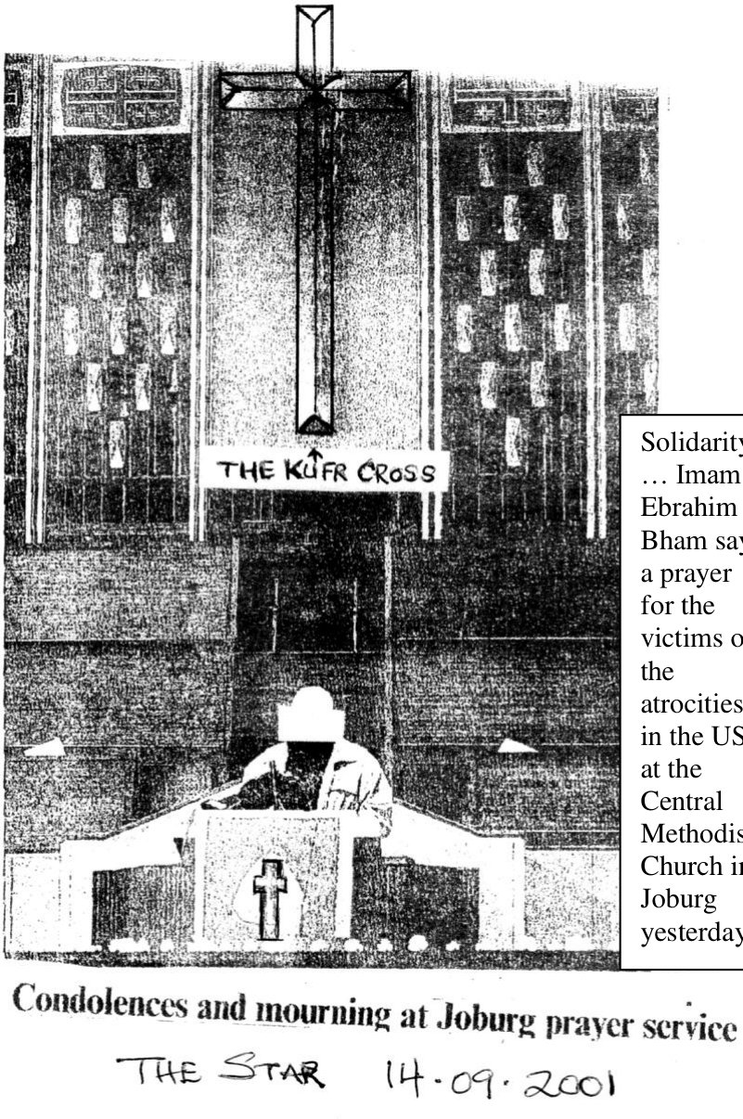
Solidarity … Imam Ebrahim Bham says a prayer for the victims of the atrocities in the US at the Central Methodist Church in Joburg yesterday.

