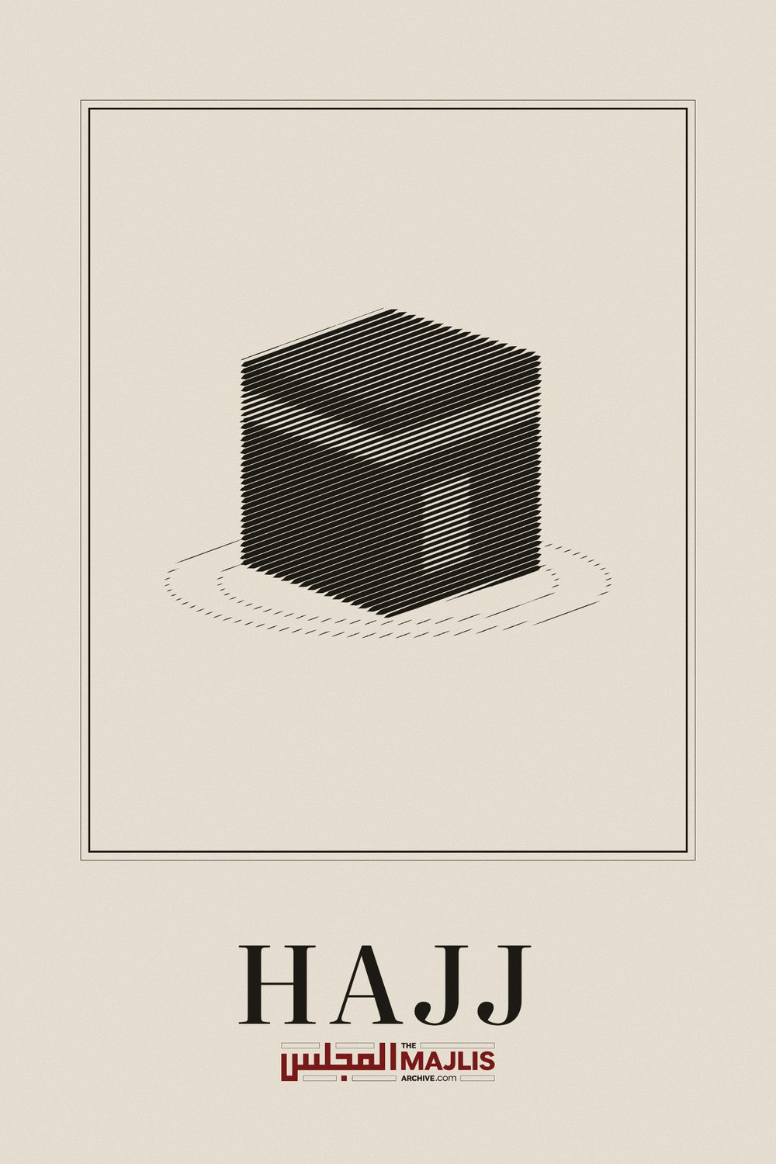

Hajj Book
The Majlis · Voice of Islam
Mujlisul Ulama of South Africa

About this edition
This is a reproduction by The Majlis Archive (themajlisarchive.com) of a publication of The Majlis, Mujlisul Ulama of South Africa, made and published with their permission.
The PDF as The Majlis issued it is the original. This edition was read from that PDF's own structure and checked against it letter for letter; where the two differ, the PDF is correct.
Checked: 610 paragraphs, 0 differing; a second, independent PDF reader finds 100.0% of the PDF's words here.
Nothing has been reworded, added or removed.

H AJ J
By: Hadhrat Maulana Masihullah Khan Sherwani (rahmatullah alayh) Senior Khalifah of Hadhrat Maulana Ashraf Ali Thanwi (rahmatullah alayh)
Translated By:
Mujlisul Ulama of South Africa – PO Box 3393 – Port Elizabeth –
6056 – South Africa Published By:
Young Men's Muslim Association, PO Box 18594, Actonville, Benoni,
1506, South Africa


INTRODUCTION
There are many books, elaborate as well as concise, on the subject of Hajj, Masha-Allah! Some of these books are in great detail covering all questions and aspects pertaining to Hajj. However, some friends have requested for a book of average degree on the subject of Hajj – a book which is neither too detailed nor too brief – so that the masa-il could be easily learnt and remembered. Thus, this booklet is the consequence of this request and wish of friends. While it has been endeavoured to refrain from excessive detail which makes remembering difficult, the brevity of the booklet is not such which excludes even the details which occur in abundance. May Allah Ta'ala in His Infinite Grace and Kindness accept this humble effort and may He confirm it a benefit for the Ummah, Ameen thumma Ameen.
MOHAMMED MASIHULLAH KHAN

FADHA-IL OF HAJJ
Before proceeding with the masa-il (rules) of Hajj, it is best to narrate some of the fadha-il (excellences and virtues) of Hajj. Knowledge of the virtues will develop in one the understanding of the value and importance of Hajj, creating enthusiasm and eagerness which in turn will result in proper fulfilment of the laws, etiquette and requirements of Hajj.
Allah Ta'ala says in the Qur'aan Shareef:
"Hajj of the Bait is obligatory on the people for the sake of only Allah on those who have the means towards it."
This gracious ayat mentions two things, viz., 1) "for the sake of Allah", i.e. ikhlas or sincerity.
2) Means and ability to perform the Hajj.
These two requirements will, Insha'Allah, be explained further on in the discussion on the relevant hadith. Another ayat of the Qur'an Shareef says:
"Thus, for the one who has resolved to make Hajj during it (the days of Hajj), there shall be no lewd talk, no transgression and no quarreling in Hajj."
Three acts are prohibited by this gracious ayat. These are:
1) Lewd talk which consists of two types. One kind of lewd talk is prohibited at all times. The evil and prohibition of such haraam talk are emphasised during Hajj. The second kind of lewd talk refers to sex talk with one's wife. Such lewd talk which is permissible with one's wife at other times is also prohibited during Hajj.
2) Transgression which also consists of two kinds. One type consists of all such sin which is forbidden at all times. Regarding such sin, the prohibition is of a greater degree during Hajj. The second kind of transgression refers to such acts which are prohibited on the special occasion of Hajj, e.g. the application of perfume, cutting hair, etc. During Hajj such acts previously permissible, become prohibited.
3) Quarrelling in general is evil. However, its prohibition is emphasised to a far greater degree during Hajj.
These prohibitions will be explained further in the discussion of the relevant ahaadith. The greatest attention has to be paid to these prohibitions.
Rasulullah (sallallahu alayhi wasallam) said that the one who performs Hajj with sincerity and refrains from lewd talk and sin, returns home purified of all sin-- as pure as he was the day he was born. In this hadith three things regarding Hajj are spoken of. The performer of Hajj who upholds these three things is given the best of glad tidings. According to this hadith, there are three conditions for the attainment of the great bounty spoken of. The Haaji who fulfils these three requirements will be the recipient of the wonderful bounty mentioned in the hadith. He emerges totally purified from all sin – major and minor.
The first and foremost condition stated in the hadith shareef is sincerity of intention, i.e. the Hajj has to be for the sake of only Allah Ta'ala. The Hajj should not be contaminated by the slightest vestige of worldly motive. The sincerity of intention should not be despoiled by any mundane motives, e.g. trade, touring, pleasure, name, pride, show, etc.
The performer of Hajj should first examine thoroughly his heart for any ulterior motives which usually are present to some degree. The hadith Shareef has forewarned us of the danger of a contaminated niyyat (intention). In this regard Rasulullah (sallallahu alayhi wasallam) said:
"Near to Qiyamat, the wealthy in my Ummah will undertake Hajj for the sake of touring and pleasure; the middle class in my Ummah will undertake Hajj for the sake of trade; the Ulama will undertake Hajj for the sake of riya (show) and the poor will undertake Hajj for the sake of begging."
Those who go on Hajj-e-Badl and accept payment other than the expenses the Hajj entails, come within the scope of those who perform Hajj for the sake of trade.
Bearing in mind the aforementioned hadith, the one who intends to go for Hajj should cleanse his heart from all vestiges of ulterior and worldly motives. He should resolve in his heart to serve only Allah Ta'ala and to strive for the attainment of His Pleasure only. He should strive to the fullest limit of his ability to inculcate sincerity of niyyat and fix his gaze on Allah Ta'ala. In this pursuit he should ignore all diversions. He should not bother or be diverted by waswas (shaitani thoughts) and auham (suspicions).
The second condition stated in the hadith shareef is abstention from lewd talk even if it be such talk which is permissible on other occasions. When even permissible sex talk becomes forbidden on the occasion of Hajj, lewd talk which is normally forbidden becomes prohibited in greater degree of emphasis during Hajj. Sexual relationship, sexual talk, sexual acts and signs are prohibited even with one's wife during Hajj. Such lewd talk excites passion which impedes the process of spiritual elevation of Hajj by diverting one into nafsaniyat (lowly desires of the carnal self).
The third condition appearing in the hadith shareef is abstention from sin. This refers to two kinds of sin, viz., such acts which are sinful at all times as well as such acts which have become sinful on account of the special occasion of Hajj. Sins which are forbidden at all times becomes prohibited to a greater degree because of Hajj, e.g. abuse, insult, quarrelling, fighting, etc. Even adoption of an argumentive attitude without actually arguing is also evil during Hajj. On the contrary, the adoption of virtue, kind disposition, tenderness in approach and speech as well as every such attitude and act which dispel hatred, fear and anxiety are praiseworthy and should be inculcated. Thus it appears in the hadith shareef:
"The beauty of Hajj is to talk tenderly and to feed (others according to one's means)."
It is therefore of utmost importance to maintain one's control and not to become inflamed by any act or statement of one's companions, which may be displeasing to one. Curb anger and exercise great patience. Never criticize anyone nor scandal or slander about any person even if his behaviour and attitude are unfriendly to you. Treat all with kindness, tenderness and dignity. Be humble and understanding. To harm others and to create inconveniences for them are haraam at all times. But, during Hajj these prohibitions are graver. A virtuous disposition demands patience. Bear with patience the difficulties others strew in your path and do not entertain malice and avarice. Restrain your tongue and never allow a harsh word to slip by. In short, guard your baatin (heart and soul) as well as your zaahir (external limbs). Uphold meticulously all the external rules and etiquettes of Hajj and seek forgiveness for sins committed in the past. During Hajj while consciously and actively guarding against all error and sin, seek forgiveness constantly.
By discharging Hajj in this careful and conscious way, one emerges purified from all sins. Such a purified person being a jannati is quite evident. This is stated in clear terms in another hadith:
"The reward of a Hajj filled with virtue is nothing but Jannat."
A Hajj filled with virtue is a Hajj devoid of sin and transgression; a Hajj in which all conditions, rules, prohibitions and etiquettes were fully observed; a Hajj in which the performer was fully imbued with humility.
Honour and shame do not permit the sincere performer of Hajj to confront anyone with bitterness and harshness. He is not so brazen as to behave in an uncultured manner. Tenderness in speech, salaam in abundance feeding and caring for others within one's means are imperative requirements for a virtuous Hajj. Among the virtues of Hajj, Rasulullah (sallallahu alayhi wasallam) said:
"He who dies during Hajj will be fully absolved. There will be neither reckoning nor punishment for him."
"The performer of Hajj and Umrah is the guest of Allah. His dua is accepted. If he seeks forgiveness, it is granted."
"When you meet one who has performed Hajj, make salaam to him and musaafahah (shake hands). Request him to make dua of maghfirat on your behalf before you even enter his house because he is a forgiven person."
Some ahadith pertaining to the virtues of Baitullah and related matters will be narrated here so that the importance of Hajj settles in the heart, thereby generating enthusiasm and yearning for Hajj. * Gazing at the Baitullah is also ibadat as well as a means of protection against nifaq (hypocrisy).
* Those who make tawaaf of the Baitullah are like those who make tawaaf of the Arsh of Allah Ta'ala.
From the hadith which mentions this, we can gauge the immense importance and excellence of tawaaf. Those who make tawaaf of Baitullah have been compared with those Malaaikah who are making tawaaf of the Arsh.
* He who performs two raka'ts Salaat at the Baitullah, emerges from sin as pure as he was on the day he was born.
* He who enters the Baitullah attains safety from punishment. * He who sits for while in the Baitullah intending thereby to obtain thawab with ikhlas and Iman, or gives charity while in the Baitullah, is forgiven all his sins. On the Day of Qiyamah he will rise without fear.
* He who kisses Hajrul Aswad is purified of sin and becomes pure like the day he was born.
* Hajrul Aswad is like the Hand of Allah Ta'ala on earth. By means of it Allah makes musaafahah (shakes hands) with whomever He pleases.
* All sins of the one who performs two raka'ts at Maqame Ibraheem are forgiven.
* He who performs two raka'ts below Mizabe Rahmat is purified of all sin and emerges as pure as he was the day he was born.
* The place between Maqame Ibraheem and Multazam is most loved (by Allah Ta'ala. Therefore, the one who is present there will also be most loved). Every virtuous act rendered in Makkah Mukarramah is multiplied a hundred thousand times.
* On the Day of Qiyamat, Hajrul Aswad and Maqame Ibraheem will each appear as Jabal Abi Qais. Each one will have two eyes, two tongues and a pair of lips. Both will bear evidence on behalf of those who had met them.
By this is meant that those who had visited them at Makkah Mukarramah will be blessed with the fortune of their intercession which will be made for forgiveness and salvation.
* According to Hadhrat Bin Umar (radhiyallahu anhu), Hajrul Aswad and Maqame Ibraheem are two yaqoot (precious stones) from Jannat. If Allah Ta'ala had not removed their celestial glitter (noor), the entire universe would have been lit up with their glow. * On the surface of the earth is no city besides Makkah Mukarramah in which there is the drink of the Abraar and the place of worship of the Akhyaar. (The Abraar and Akhyaar are two classes of Auliya, the identities of whom are concealed).
When Hadhrat Abdullah Bin Abbess (radhiyallahu anhu) was asked about this, he said that the musalla of the Akhyar is below Mizabe Rahmat and the drink of the Abraar is the water of Zam Zam.
* To look inside the Well of Zam Zam is also an act of ibaadat. * About Jabal Abu Qais, the hadith says that the first mountain to be created on earth was this mountain. Its excellence and rank are thus well-established. In the same way, the lands of Makkah Mukarramah enjoy priority and superiority over all other lands since these lands of Makkah Mukarramah were created first.
From the aforementioned ahadith of Nabi-e-Kareem (sallallahu alayhi wasallam) the excellence, importance and loftiness of the ibaadat of Hajj is borne out well. From these ahadith we can gather how great and wonderful the thawaab for this ibaadat of Hajj is. Those who present excuses to escape performance of Hajj are most unfortunate. Those who evade the performance of Hajj inspite of it being fardh on them, by tendering a variety of excuses and schemes, are indeed depriving themselves from wonderful and tremendous bounties. They suffer great deprivation and they are severely condemned by the hadith shareef.

WARNINGS FOR ABSTENTION FROM HAJJ
The Hadith Shareef declares that a person who inspite of having the means of performing Hajj and inspite of there being nothing to prevent him from so doing, but refrains from Hajj, may die a Jew or a Christian.
May Allah Ta'ala protect us from such a calamity.
A hadith of Rasulullah (sallallahu alayhi wasallam) states that a person who abstains from Hajj on account of a worldly purpose will see the Hujjaj returning before he has realized his aim. This means that either his motive will remain unfulfilled or its realization will be abnormally delayed. Postponing Hajj because of some worldly occupation or expediency is a deception of shaitaan and an excuse which is not valid.
The hadith also says that the man who refrains from performing Hajj because of the love for wealth, will squander his wealth in vile activities of sin which countenance the displeasure of Allah Ta'ala. The miscreant should therefore reflect and realize that by abstaining from hajj, wealth is not protected or saved, but will necessarily be squandered in avenues of sin and in return the punishment of Allah Ta'ala will be purchased. One will remain deprived of the wonderful bounties of Allah Ta'ala by such destructive and thoughtless disobedience.

FADHA IL OF MAKKAH
On the occasion of Rasulullah's (sallallahu alayhi wasallam) departure from Makkah Mukarramah on the Hijrat (Migration) journey, he stood at Kharoorah and exclaimed:
"By Allah! O Makkah! I know well that I love you more than other cities of Allah Ta'ala. Most certainly, you are the best land on the surface of the earth and Allah Ta'ala loves you more than the entire surface of the earth. If the mushrikeen did not expel me, never would I have departed."
According to the hadith, the spread of the ground commenced from Makkah Mukarramah. Out of the ground of Makkah Mukarramah was created the whole earth. It is for this reason that Makkah Mukarramah is known as Ummul Qura (the mother of towns). History records that the graves of Nabi Ismail (alayhis salaam) and of his mother, Hajirah (alayhas salaam) are located in the Hateem. Some say that their graves are located between Mizabe Rahmat and Babul Gharbi. The graves of Nabi Nooh, Nabi Hood, Nabi Shuaib and Nabi Salih (alahimus salaam) are located between Zam Zam and Maqame Ibraheem. Within the vicinity surrounding the Ka'bah are the graves of 300 Ambiya (alahimus salaam). Between Rukne Yamani and Rukne Aswad are the graves of 70 Ambiya (alayhimus salaam).
The first beings who made tawaaf of the Ka'bah were those Malaikah (Angels) whom Allah Ta'ala created 2,000 years before Nabi Adam (alayhis salaam).
Any Angel whom Allah Ta'ala despatches to execute some function or duty on earth, sets off on his journey from under the Arsh of Allah Ta'ala where he dons ihram.
His first stop is the Ka'bah Shareef where he performs seven tawaaf. He then performs two raka'ts Salaat at Maqame Ibraheem. Only thereafter does he depart to execute whatever duty has been imposed on him.
Rasulullah (sallallahu alayhi wasallam) said that besides Makkah Mukarramah there is no other place on the surface of the earth where 120 rahmats (mercies) descend daily. Of these, 60 mercies enshroud those who make tawaaf of Baitullah; 40 mercies descend upon those who are engaged in Salaat and 20 mercies are for those who gaze at Baitullah Shareef.
The hadith shareef also says that a day's residence in the sacred city is superior to a lifetime's stay elsewhere and nobler than a lifetime of fasting and of greater hope in obtaining the Rahmat of Allah Ta'ala.
Rasulullah (sallallahu alayhi wasallam) said that on the surface of the earth, Makkah Mukarramah is the only city for which all the Ambiya, Mursaleen, Malaikah and pious among man and jinn yearned. The one who enters Makkah Mukarramah and Madinah Tayyibah is purified from all forms of impurities in the same way as a furnace eliminates impurities from steel. In one hadith Rasulullah (sallallahu alayhi wasallam) said:
"On the Day of Qiyamah there will be no city from which there will rise such vast numbers of Ambiya, Asfiya, Atqiya, Abdal, Siddiqeen, Shuhada, Saliheen, Ulama, Fuqaha, Hukama, Zuhhad, Abideen, Hujjaj Durwaish and pious men and women as will rise from Makkah Mukarramah. They will rise on the Day of Qiyamah from the earth of Makkah in total safety and without any fear."
In another hadith, Rasulullah (sallallahu alayhi wasallam) said:
"Besides Makkah Muazzamah there is no city on the surface of the earth where Allah Ta'ala multiplies one virtue by 100,000 times."
The following statements of Nabi-e-Kareem (sallallahu alayhi wasallam) have been narrated in regard to the manifold multiplication of thawaab.
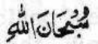
* He who says once in Makkah, will obtain from Allah Ta'ala the thawaab of said 100,000 elsewhere.
* A Qur'an completed in Makkah is equal in thawab to a 100,000 Qur'ans recited elsewhere.
* He who performs in Makkah Mukarramah one Salaat will have recorded in his Record of Deeds 100,000 Salaats. Salaat performed in jamat in Makkah Mukarramah is equal to 2,500,000 Salaats.
* Allah Ta'ala bestows the thawab of 100,000 fasts upon the one who fasts a single day in Makkah.
* He who gives in charity one dirham here (in Makkah) will obtain the thawaab of having given 100,000 dirhams.
* A person who performs a single virtuous act in Makkah Mukarramah obtains from Allah Ta'ala the thawaab of the amount of virtuous deeds which he can render in 60 years.
Regarding residence in the sacred city, Rasulullah (sallallahu alayhi wasallam) said:
* Living in Makkah Mukarramah is a great blessing. Migrating from Makkah (without valid reason) is a great misfortune. Remain there and be not frustrated because such is the attitude of shaitaan, the accursed.
* Residing in Makkah Mukarramah and earning only two halaal dirhams for one's livelihood are superior to earning 2,000 (halaal) dirhams elsewhere.
* Allah Ta'ala will keep at a distance of 500 years journey the person who bore the heat of Makkah Mukarramah patiently for even a single day. Allah will grant him His Proximity.
* Allah will decree the fire of Jahannum prohibited for the person who was ill in Makkah for even a single day.
* Allah will resurrect on the Day of Qiyamah in peace and safety the one who died in Makkah. There will be neither reckoning nor punishment for him. In peace and safety will he enter Jannat and I (i.e. Rasulullah – sallallahu alayhi wasallam) will be his intercessor.
* There will be no fear on the one who dies while on Umrah or Hajj. No reckoning will be asked of him. It will be said to him: Enter into Jannat in peace along with those who have been granted peace.
* On the surface of the earth there is no city other than Makkah Mukarramah for which the Doors of Jannat remain always open. Jannat has eight portals and all remain open for Makkah Mukarramah. One of these Doors opens from under Mizabe Rahmat; one Door opens from nearby Rukne Yamani; the third Door opens from near Rukne Aswad; the fourth from near Maqame Ibraheem; the fifth from near Multazam; the sixth from near Zam Zam and the seventh from above Mount Safa.
From these ahadith the lofty and honourable status of Makkah Mukarramah will be well understood. From the lofty rank of the sacred city may be inferred the status of honour of the inhabitants of Makkah Mukarramah. In regard to the status of the residents of Makkah Mukarramah, Rasulullah (sallallahu alayhi wasallam) said:
"Hark! The inhabitants of Makkah are the family of Allah.'' "On the Day of Qiyamah, Allah will resurrect the inhabitants of Makkah in peace and safety."
In view of the high rank of the inhabitants of Makkah Mukarramah explained by Rasulullah (sallallahu alayhi wasallam), it is incumbent that respect, love, honour and aid be offered to them.
About the Holy City, Rasulullah also said that on the entire surface of the earth there is no city besides Makkah in which there is an object which purifies one from sins by touching it. It purifies one so thoroughly of sin that one becomes as pure as one was on the day one was born. That object is Hajrul Aswad (the Black Stone).

THE TYPES OF HAJJ
There are three ways in which Hajj can be performed. They are: IFRAAD, QIRAAN, TAMATTU'.

IFRAAD
This form of Hajj consists of entering the state of ihram for only Hajj. In Ifraad, Hajj is performed without Umrah.

HAJJ QIRAAN
This form of Hajj consists of both Umrah and Hajj. A single ihram is adopted for both Umrah and Hajj. Both are rendered together.

TAMATTU'
This form of Hajj also consists of Umrah and Hajj. However, two different ihrams are adopted – one for Umrah and one for Hajj. Umrah is performed first – the whole Umrah or the greater part of the tawaaf of Umrah during the Hajj period. After this the ihram is removed if the performer of Hajj did not bring along hadi (sacrificial animal) and then again entering the state of ihram for Hajj.
If the performer of Hajj has brought along hadi, then ihram will not be removed after having performed the Umrah.
The Umrah and Hajj of the Tamattu' kind is performed in a single journey, i.e. after the Umrah of Tamattu' the Haajji will not return home, but will wait until after Hajj has been executed.
According to the Hanafi Math-hab, Qiraan is the best form of Hajj followed by Tamattu' then by Ifraad.

THE WAY OF MAKING HAJJ
When you have decided to go on Hajj then in all sincerity make taubah (repent for your sins) and seek Allah's forgiveness. Discharge all huqooq (rights) of others and pay all debts. Obtain the pardon of those whom you have wronged and also obtain the consent of your parents. If for some reason they are displeased with you, ensure that you make them happy and pleased with yourself. Do not allow takabbur (pride) and riya (show) to despoil your intention. Your intention in making Hajj must not be for the obtainal of the title of haajji. Your niyyat must be to only please Allah Ta'ala and not pursuit of any worldly or nafsani design. The expenses for your Hajj journey must be from only halal earnings because Allah Ta'ala does not accept a Hajj performed with haraam wealth. Discharge all ibadat obligations for which you are liable, e.g. Qadha Salaat and Qadha Saum (fasting).
Perform two raka'ts Salaat with the intention of making taubah. It is preferable to first take ghusl, then make the Salaatut Taubah of two raka'ts. After the two raka'ts recite Durood Shareef and Istighfar. While shedding tears, seek the forgiveness of Allah Ta'ala.
When setting out on the journey, recite the following dua:
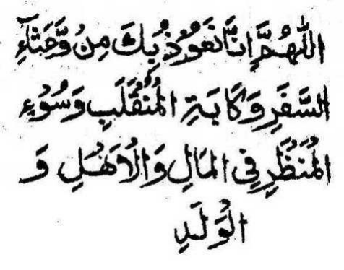
O Allah! We seek Your protection from the hardships of the journey, from a sorrowful return and evil affliction in wealth, family and children.
When mounting the vehicle of transport, recite:
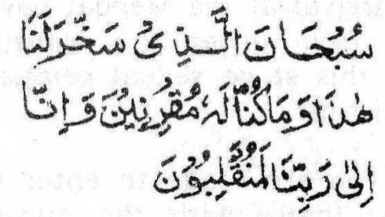
Glory unto Him Who has made subservient for us this vehicle. It was not within our power to subdue it. Verily, unto our Rabb will we most certainly return.
When reaching any place, town or city, recite:
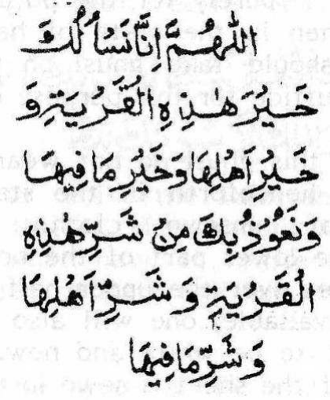
O Allah! We ask you for the good of this town and the goodness of its inhabitants and of the goodness of what is in it. We seek Your protection from the evil of this town, of its inhabitants and of what is in it.
When seated in the ship or plane, recite:
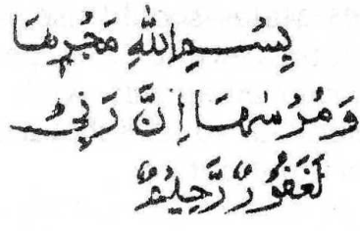
In The Name of Allah is its motion and its halting. Verily, my Rabb is Most Forgiving and Merciful.
When stopping over at some place, recite:
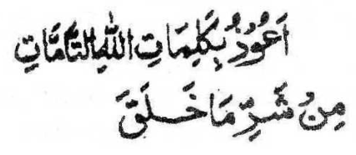
I seek protection by means of the perfect words of Allah from the evil of everything He created.
Upon arrival at the Meeqat have a hair-cut and remove the hairs from under the arm-pits and from below the navel. At this stage sexual relationship with one's wife is still permissible.
When you are ready to enter into the state of ihram, take ghusl (bath) with the niyyat of ihram. If you are unable to take ghusl, wudhu will suffice. The purpose of this ghusl is purely for the purpose of cleanliness, hence, even women in the state of haidh and nifas as well as children should take ghusl on this occasion. Tayammum will not suffice for this purpose on this occasion.
After this ghusl do not wear any sewn clothing. Your garments henceforth in the state of ihram will be two sheets of unsewn cloth. Wrap one sheet around the lower part of the body and cast the other sheet over the upper half of the body. If two cloths are not available, one will also suffice. It is mustahab for the cloths to be white and new. If not new then at least washed. If the sheet is sewn in the middle, it will be valid for wearing as Ihram. However, it is best that there be no stitching in the cloths. Apply perfume to the body and to the clothes. Males should use perfume that leaves no colour on the clothes while the perfume of women should be without fragrance, but with colour. The perfume should not be such a solid substance which retains its solidity even after application.
Thereafter perform two raka'ts. Be careful that it is not a makrooh time. If the niyyat for ihram is made even after Fardh Salaat, it will be valid. In the first raka't of the Ihram Salaat, recite Surah Kafiroon and in the second raka't recite Qulhuwallaahu Ahad (Surah Ikhlas). This Salaat is performed with the head covered and without idhtiba. (Meaning of idhtiba appears in the glossary). After the Salaam, sit facing the Qiblah and uncover the head.
Now in your heart make the niyyat of ihram. It is permissible to make the niyyat while standing as well as while seated in a vehicle. Niyyat or intention is actually a condition of the heart. It is not compulsory to utter words for the niyyat. However, one can also recite the niyyat verbally. The following is the niyyat.
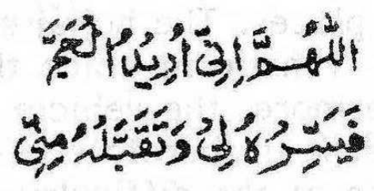
O Allah! I intend to make Hajj. Make it easy for me and accept it from me.
After having made the niyyat, recite the Talbiyah as follows:
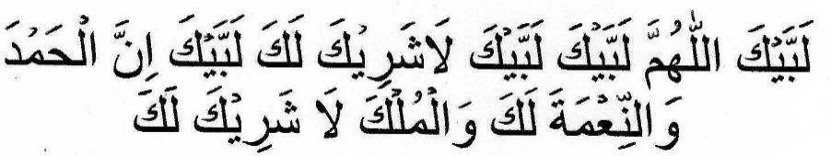
It is wajib (compulsory) to recite the Talbiyah once and Mustahab to recite it thrice. Men should recite the Talbiyah audibly while women have to recite it silently. Once the Talbiyah has been recited, one has entered into the state of ihram.
Henceforth during the state of ihram, recite the Talbiyah in abundance, especially when conditions, occasions and circumstances change, e.g. while mounting a vehicle, while dismounting, while climbing on an ascent, while descending, in the morning, in the evening, at night, when the eyes open from sleep, when meeting anyone, after every Salaat, etc.
During the state of ihram particular attention should be paid to the prohibitions, wajibat (compulsory acts) and mustahabbat (preferable and meritorious acts) of ihram. Besides these, there are no other specific acts of ibadat until entry into the Haram.
For those approaching from Jiddah, the Haram commences at a distance of 10 miles from Makkah Mukarramah. At this distance two white pillars mark the beginning or the boundary of the Haram. When about to enter the precincts of the Haram, get off from the vehicle and walk bare-footed into the Haram as far as you are able to. Nowadays entry into the Haram as well as the journey to Makkah Mukarramah is generally by means of motor transport. The vehicle-drivers do not halt at all places. The hujjaj should therefore not be perturbed if the vehicle in which they are travelling does not stop. Furthermore, the vehicle does not enter by way of Babul - Mualla. It is therefore best to make ghusl, etc., in Jiddah because of the difficulty along the route.
Enter the Haram with the greatest of humility and reverence, reciting Talbiyah, Thikr and Tahleel in abundance. Before entering Makkah Mukarramah, take ghusl. Enter Makkah Mukarramah by the way of the Qabrustan (cemetery) via Babul Mualla and recite:
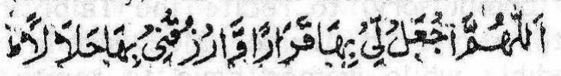
"O Allah! Grant for me therein an abode and grant me therein a halaal Rizq."
Between Musjidul Haram and Makkah Mukarramah is a place called Mad'a where dua should be made. Upon entering Makkah Mukarramah, it is Mustahab to make dua at Mad'a. Thereafter, if arrangements have already been made about your luggage, proceed directly to Musjidul Haram. If such arrangements have not yet been made then first attend to your luggage. Enter Musjidul Haram by the entrance known as Babus Salam. Enter with your right foot first and with great humility. Recite the Talbiyah as you enter and the following dua:
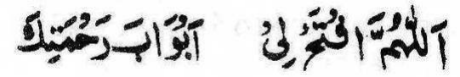
O Allah! Open for me the Doors of Your mercy.
As your gaze falls on the Baitullah Shareef, recite:
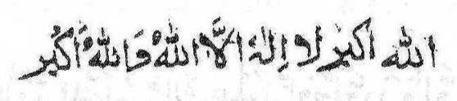
Thereafter make the following Masnoon dua:
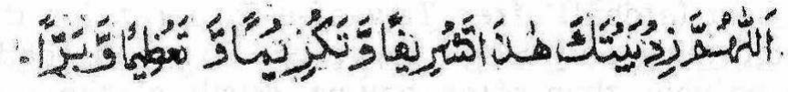
While reciting Talbiyah approach Hajr-e-Aswad and now perform Tawaaf. This Tawaaf is called Tawaaf Qudoom which consists of seven shauts or circumambulations. After completing the seven rounds (shauts) of the Tawaaf, kiss Hajr-e-Aswad (The Black Stone). Tawaaf Qudoom is now complete.
After Tawaaf Qudoom, while reciting the ayat
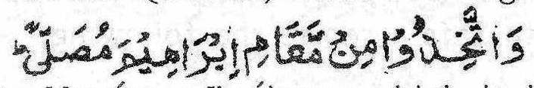
proceed to Maqam-e-Ibraheem which is in the eastern side of the Baitullah on the edge of the Mataaf. Mataaf is that area where the Tawaaf is made. Perform two raka'ts Salaat in such a way that Maqame Ibraheem comes in between you and the Baitullah Shareef. Recite Surah Kaafiroon in the first raka't after Surah Faatihah. In the second raka't recite Surah Ikhlas (Qulhuwallahu) after Surah Fatihah. If place is not available here then perform the two raka'ts inside Baitullah Shareef or in the Hateem or wherever place is available. This Salaat is the Salaat of the Tawaaf.
After the Salaat of the Tawaaf go to the Multazam and embrace it. In embracing it, place at times the right cheek on it and at times the left cheek. Raise both hands and make dua with great fervour and feeling.
Now go to the Well of Zam Zam. Facing the Qiblah drink as much of its water as you are able to. Drink the water in three draughts. Also pour of its water over your body and recite the following dua:
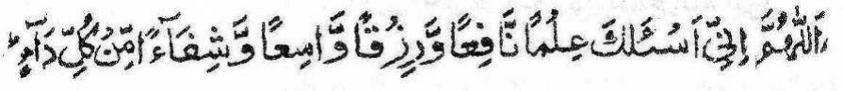
Sa-ee is best (afdhal) after Tawaaf-e-Ziyaarat for those who are performing only Hajj. However, if you intend to perform Sa-ee now, then after having drunk of the water of Zam Zam, make Istilam of Hajr-e-Aswad. Thereafter emerge from Babus Safa. Come out with the left foot first and recite the following dua:
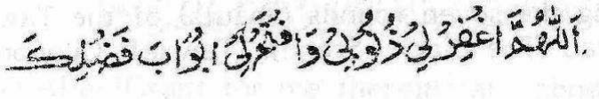
When you are near to Safa recite the following:
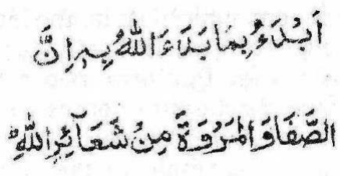
Climb onto Safa only so high that you are able to see the Baitullah Shareef through Babus Safa. Do not climb higher. Now face the Qiblah and raise both hands until the shoulders in the way in which hands are raised while making dua. Then recite the following dua silently thrice:
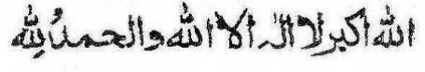
Recite Durood Shareef, then the following dua:
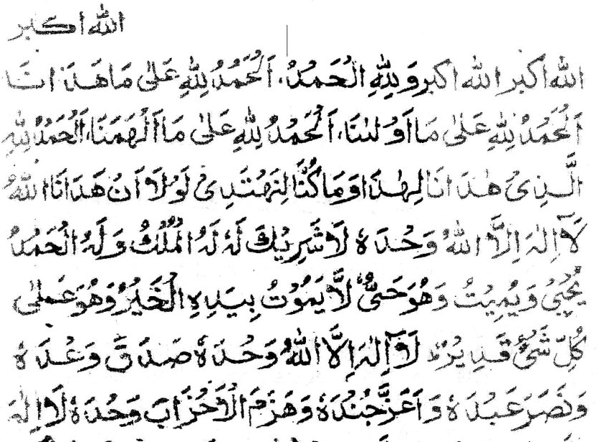
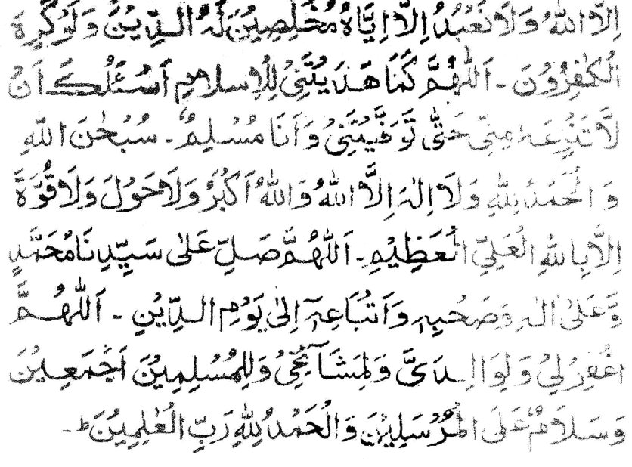
You are not restricted to these duas. You may make any dua you wish. If you have not memorized the above dua, ask any dua in your own language. Dua is in actual fact to petition and ask of Allah Ta'ala. Therefore, do so from the bottom of your heart and ask whatever you desire. Every now and again recite the Talbiyah. Remain here engaged in dua for quite a long time. The duration of your dua at this place should be about the time it will take to recite twenty five ayat.
After having made the dua, descend from Safa. Walk at your normal pace and engage in thikr and dua. In this way walk towards Marwah. Recite the following dua between Safa and Marwah:
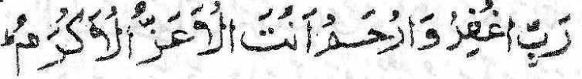
O my Rabb! Forgive me and have mercy. You are the Most
Majestic, the Most Gracious.
Besides this dua, make any dua of your heart's desire. Dua is readily accepted on this occasion. When you are about 3 metres from Sabz Meel (The Green Mile) which is located at the corner of the Musjid, start running at a medium pace. After passing the two Sabz Meel known as Meelain Akhzarain, walk again normally until you reach Marwah. Only men should run here.
On the first or second step of Marwah turn slightly towards the right and stand facing the direction of Baitullah. Remain standing so for a while and engage in thikr and dua in a similar manner as you did on Safa. This too is an occasion on which dua is accepted readily.
The distance from Safa to Marwah is called one shaut or circuit. On the way back from Marwah to Safa, again run a bit between Meelain Akhzarain (the two Sabz Meel). When climbing on Safa again make dua and thikr as you did in the beginning. The second shaut or circuit is now complete. Complete seven shauts (circuits) in this way. The seventh circuit will end on Marwah. In every shaut recite tasbeeh, dua and any form of thikr you are aware of. These seven circuits consist of the Sa-ee. After having completed the Sa-ee go to the edge of the Mataaf and perform two raka'ts Nafl Salaat.
The Mufrid, i.e. the one who is making only Hajj without Umrah, has to remain in Makkah Mukarramah in the state of ihram after he has made Tawaaf Qudoom and Sa-ee. He should in this period engage in as much Nafl Tawaaf as possible and abstain from the prohibitions of Ihram.
On the 7th Zil-Hajj, listen to the Imaam's Khutbah.
On the 8th Zil-Hajj after sunrise, leave for Mina so that you may perform Zuhr Salaat there in the Mustahab time. The night will be spent in Mina. Five Salaat, viz., Zuhr, Asr, Maghrib, Isha and Fajr will be performed in Mina.
On the 9th Zil-Hajj after it has become light, depart for Arafat by the route of Mount Dhabb. Recite Talbiyah and Takbeer along the way. Mount Dhabb adjoins Musjid Khaif in Mina. When your gaze falls on Jabal Rahmat in Arafat, make dua and recite Takbeer, Tasbeeh, Tahleel and Istighfar. Halt at Musjid Namrah which is at the edge of Arafat on the side of Makkah Mukarramah. Have your meals and make ghusl before zawal. Now go and sit in Musjid Namrah and listen to the Khutbah of the Imaam. Zuhr and Asr Salaat will be combined here. These two Salaat will be performed together during the time of Zuhr.
The following are the conditions for the validity of performing these two Salaat together.
1) The two Salaat have to be performed in or near Arafat. 2) It must be the 9th Zil-Hajj.
3) The Sultan or his representative has to be present.
4) lhram of Hajj in both Salats.
5) Zuhr Salat has to be performed before the Asr Salat.
6) Both Salat have to be performed in jama't. This condition will be fulfilled even if part of both Salat is obtained in jama't.
If any of the above conditions is lacking, it will not be permissible to perform these two Salat together. If any of the conditions is not fulfilled, each of the two Salat will compulsorily be performed in its time. Combination of the two Salat will then not be permissible.
After having completed these Salat proceed immediately to your place in Arafat. If it is possible to find place near to Jabal Rahmat (where the ground is covered with black stones) then stay over there. This was the place where Rasulullah (sallallahu alayhi wasallam) halted. This place is called Musjid Sakhrah. A low surrounding wall still indicates the position. If place is not available here, stay wherever place is available. The nearer to Jabal Rahmat the better. Do not climb on top of Jabal Rahmat. It is best to stand facing the Qiblah in your mauqaf (the place where you have halted). It is permissible to also sit and lay down.
When the Imam recites the Khutbah listen with great attention and humility. While in your mauqaf engage in dua until the evening. Do not involve yourself in futility, amusement, nonsensical talk, etc. Every now and again recite the Talbiyah, repent and seek forgiveness from Allah Ta'ala in abundance.
Although it is permissible for the hujjaj to fast on the day of Arafat, it is afdhal (best) not to fast. At the same time do not indulge in excessive eating and drinking.
At sunset, reciting 'Labbaik' and making dua, set off with the Imam for Muzdalifah along the route which leads between the two mountains. Walk peacefully and with dignity and humility. It is not permissible to depart from Arafat before sunset. Leaving before sunset will make obligatory the Shar'i penalty known as dum (an animal to be sacrificed). However, if one returns to Arafat before sunset (i.e. after having left before sunset), the penalty falls away. If the road is spacious, walk briskly and if crowded, walk slowly without inconveniencing anyone.
On reaching Muzdalifah, make ghusl or wudhu. It is afdhal (best) to stop over near to Musjid-e- Mash'are Haraam on the right hand side of the road. Do not stop in the road. Besides Wadi Muhassar, you may stop at any place in Muzdalifah. It is not permissible to stop in Wadi Muhassar.
Before attending to your luggage, perform Maghrib and Isha Salat together with one Athaan and one Takbeer (Iqaamah) during the time of Isha. The conditions for the validity of combining these two Salat are as follows:
1) The ihram of Hajj.
2) Wuqoof (halting) at Arafat must first be made.
3) To be at Muzdalifah.
4) To be the time of Isha.
5) To be the night of 10th ZilHajj.
6) To perform both Salat observing tarteeb (i.e. first Maghrib then Isha).
If any of the above conditions is lacking, it will not be permissible to combine these two Salat.
It is not permissible to perform Maghrib and Isha at Arafat or along the route. If this was done, the Salat will have to be repeated. Should you arrive at Muzdalifah before Isha, then too do not perform Maghrib Salat.
At Muzdalifah pass as much of the night as possible in ibadat because this night is superior to even the Night of Qadr.
In the morning, after Subh Saadiq, perform Fajr Salaat as early as possible while it is yet dark. Perform the Salaat with jamaat. However, if for some reason this is not possible, perform it alone. Thereafter, stand by Mash'ar-e-Haraam, face the Qiblah and engage in reciting Talbiyah, Tasbih and Tahleel. Raise the hands and make dua. About five minutes before sunrise, depart for Mina.
On reaching Wadi Muhassar, run through it, emerging from this valley in haste. When departing from Muzdalifah, take along seven tiny pebbles. It is permissible to pick up these pebbles along the route or from somewhere else. These pebbles should not be picked up from near the Jamraat.
On reaching Mina, go to Jamratul Uqba. Stand in the lower area, near to the Jamrah. Stand in such a way that Mina is on your right side and Makkah on your left. Hold a pebble with the thumb and the forefinger. Strike the Jamrah with it. Stop the recitation of the Talbiyah with the striking of the first pebble. When striking each pebble recite:

"In the Name of Allah. Allah is the greatest! (This Act) is a lament for Shaitan and a pleasure for Allah."
When striking the pebbles, raise the hand so that the arm is separated from the armpit. The act of pelting the Jamraat is known as Rami.
After having completed the Rami, do not remain there. Return to your place. The time for this Rami is from Subh Saadiq on the 10th until Subh Saadiq on the 11th. However, the Masnoon (Sunnat) time for the Rami is from sunrise until zawwaal (midday). After zawwaal to sunset, the time for Rami is Mubah (permissible) while the time from sunset to Fajr is Makrooh.
The next thing to do after the Rami of the 10th, is Qurbaani. There is greater merit in doing the Qurbaani with your own hands, if you are able to slaughter. I f you lack the ability to slaughter with your own hands, anyone may do so on your behalf. It is Mustahab to eat a bit of one's own Qurbaani meat. Therefore, if possible, eat some of it. You may also take of it as much as you wish and give the rest in Sadqah.
Qurbaani is Mustahab, not Waajib, for the Mufrid (the one who makes only Hajj---Hajj without Umrah). After Qurbaani has been made shave or clip the hair on the head. While doing this, sit facing the Qiblah. Shaving the head is afdhal (best) for men. It is haraam for women to shave their heads. When shaving the head, begin from the left side. After the head is shaved, recite Takbir.
Since it is not permissible for women to shave their heads, they should cut slightly more than one inch from their plaits. It is not permissible for a ghair mahram male to cut their hair.
After having shaved or clipped the hair, clip the moustaches and remove the hairs from under the arms and from below the navel. Then cut the nails. Bury all the hairs and the nails.
Now, one is released from Ihraam. All the prohibitions of Ihraam besides sexual relationship, fall away after the hair has been shaved or cut.
Return now to Makkah to make Tawaaf -e-Ziyaarat. It is afdhal (best) to make Tawaaf-e-Ziyaarat on the 10th Zil-Hijj, and it is permissible until sunset on the 12th Zil Hijj. If Sa-ee was not made at the time when Tawaaf-e-Qudoom was made, then Raml should also be made during Tawaaf-e-Ziyaarat.
If on the occasion of Tawaaf -e-Ziyaarat, one had already removed the Ihraam garments and had donned sewn clothing, then do not make Idhtibaa. However, if you still have the Ihraam garments on, then make Idhtibaa in Tawaaf -e-Ziyaarat.
After making the Tawaaf Salaat of Tawaaf -e-Ziyaarat, make Istilaam of Hajr-e-Aswad. Now emerge from Baabus Safaa and make Sa-ee.
If Sa-ee was made together with Tawaaf-e-Qudoom, then do not make Raml and Idhtibaa, in this Tawaaf -e-Ziyaarat.
After Tawaaf -e-Ziyaarat return to Mina and spend the night there. After the completion of Tawaaf-e-Ziyaarah, sexual relations are permissible.
On the 11th, after zawaal, Rami of the three Jamraat has to be made. It is Sunnat on this day (11th) to first pelt Jamrah Oola which is situated near to Musjid-e-Khaif. Then make Rami of Jamrah Wusta, i.e. the Middle Pillar, and lastly, make Rami of Jamrah Ukhra (also known as Jamrah Uqba),i.e. the third Pillar.
After making the Rami of the first Jamrah, step a bit forward. Now face the Qiblah, raise the hands and make dua. It is preferable to spend approximately twenty minutes (or the time taken to recite three quarters of a Juz) here in Dua, Tasbeeh, Takbir, Tahleel, Istighfaar, etc. If you are unable to stand so long, then stand at least as long as it would take you to recite 20 aayaat of the Qur'aan. Make similar Dua after the Rami of the middle Jamrah. Do not make Dua after the Rami of the third Jamrah. Return to your place of residence immediately after the Rami.
On the 12th, repeat the Rami in the same way. You are now free to leave Makkah Mukarramah. However, it is afdhal (of greater merit) to repeat the Rami on the 13th as well, after zawaal and to return to Makkah then.
When returning to Makkah Mukarramah, do so in complete humility. Along the route, perform Zuhr, Asr, Maghrib and Isha in Wadi Muhassab which is located on the road of Mina near to Makkah Mukarramah. Take a rest before proceeding to Makkah. If you are unable to stay over here for a while, then spend at least a few minutes even if it means only dismounting from the vehicle for a few moments. The Hajj is now complete.

THE STAY IN MAKKAH AFTER HAJJ
Now remain in Makkah Mukarramah as long as you wish. While here, perform Tawaaf and Umrah in abundance. However, render Urnrah after the 13th Zil-Hijj. When you decide to depart Makkah Mukarramah, perform Tawaaf-e-Wida (The Farewell Tawaaf). This Tawaaf is Waajib. Should one depart without having made this Tawaaf-e-Wida, it is incumbent (Waajib) to return if one has not yet passed beyond the confines of the Meeqaat. If one has already passed the Meeqaat without having made Tawaaf-e-Wida, then one has the choice of either paying the Dum penalty or donning Ihraam. Then, Umrah should be made and thereafter the Tawaaf-e-Wida. However, if after Tawaaf -e-Ziyaarat, a Nafl Tawaaf was made, then this Nafl Tawaaf will suffice in lieu of Tawaaf-e-Wida even if no niyyat of Tawaaf-e-Wida was made. But, it is afdhal to make Tawaaf-e-Wida at the very time of departing and not before.
After Tawaaf-e-Wida perform two raka'ts Tawaaf Salaat near to Maqam-e- Ibraheem. Then go to the Well of Zam Zam. Face the Qiblah and drink of its water as much as you can in three draughts. On each drink, gaze at the Baitullah and recite:
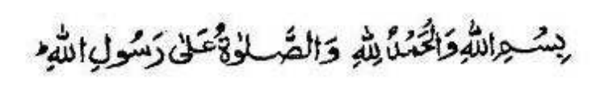
At the last drink, recite:
"O Allah! I ask you for beneficial knowledge, for abundance Rizq, and cure from all sicknesses."
After drinking of the holy water of Zam Zam, the water remaining in the container should be poured over the head, face and body. Now go to Multazam. Place your breast and right cheek against the wall of the Ka'bah and raise your right hand towards the Threshold of the Ka'bah. ln this state of humility, clinging to the Cloth of the Ka'bah, seek forgiveness from Allah Ta'ala. Shed tears, repent, recite Tasbeeh, Tahleel, Dua and Durood for a long while. If you are unable to shed tears, simulate the appearance of a crying person. Kiss the Threshold and make dua. Now make Istilaam of Hajr-e-Aswad and cast your gaze on the Ka'bah. Depart now with a heart filled with sadness. Walk away from the Ka'bah backwards---out through Baabul Wida. Give Sadqah to the poor and again make dua.
A woman in the state of haidh or nifaas is not permitted to make Tawaaf. Tawaaf-e-Wida is waived for her. Although there is no need for her to make Tawaaf-e-Wida because of her state, she should stand at Baabul Wida, outside the Musjid, and engage in dua. In the condition of haidh or nifaas, she must not enter the Musjid.

HAJJ QIRAAN
Qiraan is the performance of Hajj and Urnrah together in a single Ihraarn from the Meeqaat. The one who performs Hajj-e-Qiraan is known as a Qaarin.
When the Qaarin enters Makkah Muazzamah, he has to first perform the Tawaaf of Urnrah and its Sa-ee. There will be Raml and Idhtiba' in this Tawaaf. After completing the Sa-ee, the Qaarin makes a second Tawaaf. This second Tawaaf is Tawaaf-e-Qudoom. After this second Tawaaf, make again Sa-ee. This is the Sa-ee for the Hajj. After this, the Qaarin will render all acts of the Hajj as is done by the Mufrid (the one who performs only Hajj).
Qurbaani upon the Qaarin is Waajib. The Qaarin has to make the Qurbaani on the Day of Nahr (10th Zil Hijj) after the Rami of the Jimaar, but before shaving the head. It is essential that the Qurbaani be made in the Haram. It cannot be discharged elsewhere. Qurbaani has to be made, during the days of Nahr. Nevertheless, if the Qurbaani is made after the Days of Nahr, it will be valid, but sinful. When slaughtering the animal, the niyyat should be that Qurbaani of Qiraan is being made.
Should one lack the means for making Qurbaani of a goat or sheep, three fasts should be kept in lieu. These three fasts have to be kept before the Day of Nahr. A further seven days fasting should be kept after the Hajj. If the three fasts are not kept before the Day of Nahr (10th), then Dum penalty will be Waajib.
When keeping these seven fasts, it is necessary that the niyyat be made during the night.
The Qaarin has to make niyyat (intention) for both Hajj and Umrah. Recite the niyyat as follows:
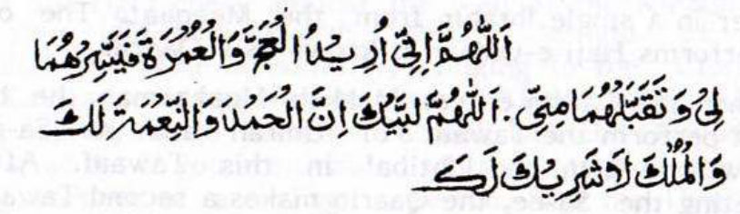
Then recite a second time:
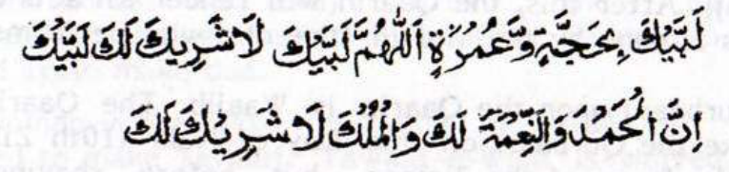

THE CONDITIONS OF QIRAAN
1) The whole Tawaaf of Umrah or at least four Shauts (circuits) have to be made during the months of Hajj.
2) The whole Tawaaf of Umrah or at least four Shauts have to be made before Wuqoof of Arafah.
3) Tying the Ihraam of Hajj before the full Umrah Tawaaf is made or before the greater part of the Tawaaf is made.
4) Tying the Ihraam of Hajj before the Umrah is invalidated. 5) Not nullifying the Hajj or Umrah by means of sexual relationship or irtidaad (i.e. becoming a renegade--- murtad).

TAMATTU'
Tamattu' is the performance of Umrah and Hajj in a single journey, during the months of Hajj, with two different Ihraam. One Ihraam for Umrah and one Ihraam for Hajj.
Hajj-e-Tamattu' is performed only by an Aafaaqee. An Aafaaqee is one who lives outside the Meeqaat limits. When the Aafaaqee who wishes to perform Tamattu', reaches the Meeqaat, he will don the Ihraam for Umrah. After making wudhu or ghusl, he will don the Ihraam garb and perform two raka'ts Nafl Salaat. After this Salaat, he has to open his head and recite the niyyat as follows:
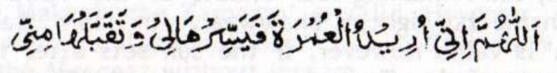
He then recites the Talbiyah. He is now in the state of Ihraam. He should now proceed to Makkah, perform Tawaaf-e-Qudoom and the Sa-ee. He has to abstain from all the prohibitions of Ihraam. After completing the Tawaaf and Sa-ee, he removes the Ihraam. He emerges from the state of Ihraam by either shaving his head or cutting his hair. He should now remain in Makkah until the 8th of Zil Hijj.
On the 8th of Zil Hijj he has to don the Ihraam of Hajj. It is better to don the Ihraam for Hajj even before the 8th. He has now to remain in the state of Ihraam until all the acts of Hajj have been discharged. The one who performs Tamattu' is called Mutamatti'.
It is Waajib upon the Mutamatti' to make Qurbaani. If he lacks the means of making Qurbaani, then he has to fasts ten days in the same way as the Qaarin has to.
The Mutamatti' renders all the acts of Hajj as the Mufrid does.

CONDITIONS OF TAMATTU'
1) The Mutamatti' must be an Aafaaqee (i.e. one who lives outside the Meeqaat). Those who live in Makkah or anywhere within the confines of the Meeqaat are not allowed to make Tamattu. 2) The whole Umrah or the greater part of the Umrah Tawaaf has to be made during the months of Hajj even if the Ihraam of Umrah and Hajj was donned before the months of Hajj, e.g. before sunset on the last day of Ramadhaan the Ihraam of Umrah was adopted, and after two or three Shauts of the Tawaaf were made, the sun set. Thus, the remaining four Shauts of the Tawaaf were made on the 1st night of Shawwaal. In this case the Tamattu' is valid. However, if the sun sets after four or more Shauts of the Tawaaf were made, the Tamattu' will not be valid because the greater part of the Tawaaf was made during Ramadhaan which is not among the months of Hajj.
3) The whole or the greater part of the Umrah Tawaaf has to be made before the Ihraam of Hajj. If this was not done, the Tamattu' will not be valid. The Hajj will in this case become Qiraan. 4) The Hajj and Umrah have to be made in the same year. If the Tawaaf of Urnrah was made during the Hajj months of one year and the Hajj was made in the following year, the Tamattu' is not valid even if one did not return home during this time.
5) Both Hajj and Umrah have to be made in the same journey. If after having made Urnrah during the Hajj months, one ends the Ihraam, returned home and then went back for Hajj, the Tamattu' is not valid. This will then not be known as Tamattu'. However, if one returned home before or after the Tawaaf of Umrah, but before shaving the head, and then went back for Hajj, the Tamattu' will be valid. Similarly, if after shaving the head, one went out of the precincts of the Haram, but not beyond the Meeqaat, the Tamattu' will be valid.
6) The Urnrah should not be invalidated. If the Umrah becomes invalid the Tamattu' will be nullified.
7) The Hajj should not be invalidated. If the Hajj becomes invalid, the Tamattu' is nullified.
(8) After completing the Umrah during the Hajj months, one should not take up permanent residence in Makkah.
* If the Ihraam for the Umrah of Tamattu' was not donned at the Meeqaat, but was adopted after reaching Makkah, the Tamattu' is valid. However, the Dum penalty will be obligatory since it is forbidden to go beyond the Meeqaat without Ihraam.
* If the Mutamatti' donned the Ihraam of Hajj from Hiel or Arafaat, the Tamattu' will be valid, but the Dum penalty will be Waajib since the Ihraam was supposed to have been donned in the Haram. The Dum penalty is Waajib or alternatively, one has to return to the Meeqaat which in this case is the Haram where the Mutamatti' dons the Ihraam for Hajj.
* For the validity of Tamattu' it is not conditional to don the Ihraam of Urnrah during the months of Hajj. But, it is a condition for the validity of Tamattu' that the greater part of the Tawaaf of Urnrah be rendered during the Hajj months, even if the Ihraam was donned prior to the Hajj months.
* For the Tamattu' to be valid, it is not conditional that both Hajj and Umrah are executed on behalf of the same person. If one act is for oneself and the other act on behalf of another person, the Tamattu' is valid. In fact, if one person delegates a man to perform Umrah on his behalf while another person appoints the same man to perform Hajj on his behalf, and both consented to Tamattu', then the Tamattu' thus performed is valid. However, the Dum of Tamattu, will be the obligation of the Mutamatti'. He has to pay for the Dum himself. If he is not by the means to afford an animal, then he should fast as described earlier.
* If Hajj and Umrah were executed during the months of Hajj and all conditions of Tamattu' fulfilled, the Tamattu' will be valid even if no niyyat for Tamattu' was made.

THE FARAAIDH OF HAJJ
Hajj has THREE fundamental Fardh (compulsory) acts, viz., (1) Ihraam: Making Niyyat with the heart for Hajj and reciting Talbiyah, i.e.
Labbayk Allahumma labbayk. Labbayka laa sharika laka labbayk.
Innal hamda wan-ni'mata laka wal-mulk. Laa shareeka lak.
(2) Wuqoof at Arafaat: This wuqoof (stay-over) at Arafaat is on the 9th Zil Hijj at any time from after zawaal until Subh Saadiq of 10th Zil Hijj, even if the Wuqoof is for just a moment.
(3) Tawaaf-e-Ziyaarat: This is the Tawaaf which is made at any time from Subh Saadiq on the 10th Zil Hijj until 12th Zil Hijj after the head is shaved or the hair cut.
If any one of these three Fardh acts is omitted, the Hajj is not valid. Omission of any of these acts cannot be compensated for by means of sacrificing an animal, etc. Should any one of these three Fardh acts be omitted, the Hajj becomes qadhaa, i.e. it will have to be performed again.

THE WAAJIBAAT OF HAJJ
Six acts are Waajib in Hajj.
(1) To stop over at Muzdalifah at the time of Wuqoof, i.e. during the night of the 10th Zil Hijj.
(2) To make Sa-ee between Safa and Marwah.
(3) Rami of the Jimaar, i.e. to strike the pebbles at the Jamraat. (4) Qurbaani, if the Haajji is a Qaarin or Mutamatti'.
(5) Halq (shaving the head) or Qasr (cutting the hair).
(6) Tawaaf-e-Widaa (The Farewell Tawaaf) for those living outside the Meeqaat.
If a Waajib act is omitted, the Hajj is still valid, but compensation has to be offered whether the omission is deliberately or by error. Sometimes the, jaza (i.e. the compensation) is Dum (an animal) and sometimes it is Sadqah. However, if a Waajib act is omitted on account of a valid reason, then jaza (compensation) is not obligatory.

THE SUNNATS OF HAJJ
(1) Tawaaf-e-Qudoom for the Mufrid Aafaaqee and the Qaarin. (2) Raml during Tawaaf-e-Qudoom.
(3) The Imaam has to deliver Khutbah at three places:
a. On the 7th Zil Hijj at Makkah Mukarramah. b. On the 9th Zil Hijj at Arafaat in Musjid Namrah before the two Salaats are performed together. c. On 11th Zil Hijj at Mina.
(4) To spend the 9th night at Mina.
(5) To proceed from Mina to Arafaat after sunrise on the 9th Zil Hijj.
(6) To depart from Arafaat with the departure of the Imaam. (7) To spend the night at Muzdalifah after returning from Arafaat. (8) To take ghusl in Arafaat.
(9) During the days at Mina, to spend the nights also at Mina. (10) To halt at Muhassab on returning from Mina even if just for a moment.
Besides the above, there are many other Sunnat acts of the Hajj. Deliberate neglect or omission of any Sunnat is sinful. Rendering the Sunnats is an act of great thawaab. If a Sunnat act is omitted, there is no jaza (compensation) or penalty to be paid. However, care should be taken not to omit the Sunnats since such omission reduces the thawaab of the Hajj.

THE MUSTAHABBAAT OF HAJJ
(1) Men have to recite the Talbiyah audibly.
(2) Reciting the Talbiyah in abundance.
(3) Qurbaani (sacrificing an animal) by the Mufrid.
(4) To take ghusl at the time of entering Makkah Mukarramah. (5) To stop near to Jabal-e-Rahmat in Arafaat if there is no congestion.
(6) To perform Zuhr and Asr Salaat together in Arafaat with Jamaat.
(7) During the duration of Wuqoof at Arafaat to recite Talbiyah and make dua in abundance.
(8) To halt at Mash'ar-e- Haraam during Fajr (morning) of the Day of Arafaat.
(9) To perform Fajr Salaat at Muzdalifah.
(10) To make Tawaaf -e-Ziyaarat on 10th Zil Hijj.
Mustahab is an act which is highly meritorious. Its thawaab is great. However, omission of Mustahab acts is not sinful. But, this does not mean that one should be neglectful in regard to the Mustahabbaat.

THE MAKRUHAAT OF HAJJ
Makruh acts are reprehensible and the thawaab of the Hajj is reduced by the perpetration of Makruh acts. The Hajj becomes defective by the commission of Makruh acts. Deliberate perpetration of Makruh acts is sinful. However, Makruh acts will not invalidate the Hajj. Among the prohibitions, only sexual intercourse which has been committed prior to the Wuqoof of Arafaat.
The following things are Makruh:
(1) The Imaam reciting the Khutbah before zawaal on the Day of Arafaat.
(2) After performing both Salaats together in Musjid Namrah, to remain long outside the limits of Arafaat.
(3) To depart from Arafaat before or after the Imaam.
(4) To make the Rami with pebbles obtained from near to the Jimaar or with pebbles of the Musjid or to break a big stone into bits and use the pieces for pelting.
(5) When terminating the Ihraam of Hajj or Umrah to shave only one quarter of the head or to cut hair from only a quarter of the head.
(6) During the days of Mina, to spend the nights in Makkah. (7) To make Wuqoof of Muzdalifah in Wadi Muhassar.

PROHIBITIONS OF IHRAAM
The following acts are prohibited during the state of Ihraam: (1) Sexual intercourse as well as all sex-play and acts and talks of romance.
(2) Quarrelling and fighting.
(3) Hunting land animals.
(4) To inform a hunter of the whereabouts of an animal.
(5) To aid a hunter in anyway whatever.
(6) To chase a wild animal.
(7) To break an egg of a wild bird.
(8) To injure any wild animal, even removing its feathers. (9) To sell wild animals.
(10) To purchase wild animals.
(11) To remove the milk of a wild animal.
(12) To cook the meat of eggs of wild animals.
(13) To kill lice.
(14) To throw lice in the heat of the sun.
(15) To wash clothing with the intention of killing lice.
(16) To instruct another person, directly or indirectly, to kill lice. (17) To dye one's hair.
(18) To use gum or any kind of hair conditioner.
(19) To apply perfume.
(20) To cut hair and nails or to ask another person to cut one's hair and nails.
(21) To cover the face or any part of the face.
(22) To wear sewn garments, e.g. kurtah, trousers, topee, etc.
(23) To wear such shoes or socks which conceal the raised bone in the front of the foot.
(24) To wear garments which have been dyed in saffron, kusum or any fragrant substances. However, if the garments so dyed have been thoroughly washed, leaving no fragrance, it will then be permissible to wear such garments.

MAKRUHAAT OF IHRAAM
The following acts are Makruh during the state of Ihraam: (1) To comb the hair or beard.
(2) To scratch the hair in such a way that hair or lice falls out. (3) To make khilaal in the beard.
(4) To sew the two ends of the lower Ihraam garment when this is not occasioned by a need to conceal the aurah.
(5) To tie knots in the upper garment or to tie it with pins, needles, etc.
(6) To smell perfume.
(7) To touch perfume.
(8) To sit in the shop of a perfume-seller so as to inhale the fragrance of the perfume.
(9) To unnecessarily tie a bandage on the body.
(10) To touch or to smell fragrant fruit and grass.
(11) To stand under the cloth of the Ka'bah in such a way that the cloth touches the head or face.
(12) To lay on one's stomach with one's face downwards on the pillow.
(13) To eat uncooked fragrant smelling food.
(14) To look with lust at the satar of one's wife.
(15) To throw any garment, e.g. coat, over the shoulders.

HAJJ THE IHRAAM OF A WOMAN
The Ihraam of a female is similar to that of a male. She too has to abstain from all the prohibitions and makruhaat of the state of Ihraam. However, there are some differences. It is permissible for a woman to wear sewn clothing. It is Waajib for her to keep her head covered. When concealing her face, she should not let the covering cloth touch her face since this is not permissible in Ihraam. The cloth covering her face should be hung over a special protuberance designed specifically for this occasion.
It is permissible for women to wear colorful garments provided there is no emission of fragrance from the garments. Women should recite the Talbiyah silently. so that their voices are not heard by men.
During Tawaaf women do not make Idhtiba and Ramal nor should they run between Meelain Akhzarain during the Sa-ee.
When there are crowds of people and congestion prevails, women should not touch Hajr-e-Aswad nor kiss it. They should not make the two raka'ts Tawaaf Salaat atnMaqaam-e- Ibraheem - They should not make the Rami nor climb onto Safa and Marwah. These obligations are waived for women when congestion and jostling of crowds prevail.
During the state of haidh they should neither make Tawaaf nor Sa-ee. If they postpone Tawaaf-e-Ziyaarat due to haidh and perform it later than 12th Zil Hijj, Dum is not obligatory on them.

ERRORS IN HAJJ AND KAFFAARAH
Errors which happen during Hajj are called Jinaayaat. There are two types of jinaayaat:
(1) Omission of the Waajib acts of Hajj.
(2) Commission of the Hajj prohibitions.
The prohibitions of Hajj are of two kinds:
(1) The prohibitions of Ihraam.
(2) The prohibitions of the Haram Shareef (the Holy Place).
Nine errors pertain to Ihraam and two errors to Haram. Thus, there are altogether eleven errors regarding the prohibitions of Hajj. These are as follows:
(1) To apply perfume.
(2) For men to wear sewn clothes.
(3) To cover the head and f ace.
(4) To remove lice from one's body.
(5) To kill lice.
(6) To remove hair from the body.
(7) To cut nails.
(8) To indulge in sexual relationship.
(9) To hunt or molest game (wild animals on land).
(10) To hunt in the Holy Precincts.
(11) To cut the grass or trees of the Haram.

PRINCIPLES GOVERNING THE ERRORS
There are several principles governing the errors committed. These will now be explained to facilitate better understanding of the errors.
FIRST PRINCIPLE: There are four ways in which the prohibitions of Hajj are committed:
(1) The prohibition is committed fully but because of a valid reason.
(2) The prohibition is committed partially but because of a valid reason.
(3) The prohibition is committed fully but without valid reason. (4) The prohibition is committed partially but without valid reason.
The Hukm (effect and rule) of each of these four ways of commission is different. The ruling applicable to each one is as follows:
(a) If the prohibition was committed fully, but because of a valid reason, Dum or Fasting or Sadqah becomes Waajib.
(b) If the prohibition was committed partially, but because of a valid reason, either Fasting or Sadqah is Waajib.
(c) If the prohibition was committed fully, but without valid reason, only Dum is Waajib. In this case there is no choice. (d) If the prohibition was committed partially, but without valid reason, only Sadqah is Waajib. Again, here is no choice.
SECOND PRINCIPLE: Dum is one goat or one sheep or a seventh share of a cow or camel.
THIRD PRINCIPLE: A whole cow or a whole camel is incumbent on only two occasions, as follows:
(1) Making Tawaaf-e-Ziyaarat in the state of Hadth-e-Akbar, i.e. the greater impurity or janaabat.
(2) To indulge in sexual intercourse after Wuqoof-e-Arafaat, but before shaving the head.
FOURTH PRINCIPLE: All conditions and requirements applicable to Qurbaani animals apply to the Dum animals as well. FIFTH PRINCIPLE: Sadqah in this context is half a Saa' (approximately 2,5 kg.) of wheat or the amount which is usually paid as Fitrah.
SIXTH PRINCIPLE: The Qaarin who commits jinaayaat in Ihraam before making Umrah is liable for two penalties since he is in two states of Ihraam. The Mufrid is liable for one penalty since he is in the state of one Ihraam. However, if the Qaarin entered the Meeqaat limits without Ihraam, only one Dum will be Waajib on him.
SEVENTH PRINCIPLE: Regarding the jinaayaat of the Haram and in the penalty pertaining to game on land, there is a choice of three ways of discharging the penalty. These are:
(1) The wild animal is to be valued and if a sacrificial animal (Dum) is available for this value or price, an animal will be purchased and slaughtered.
(2) This amount may be given in charity.
(3) One may fast instead.
Any one of these three penalties will suffice. If the option of fasting is chosen, one should consult an Alim for ascertaining the method of calculating the number of fasts to be kept. This number differs.
EIGHTH PRINCIPLE: Kaffaarah (penalty or compensation) is obligatory even if a prohibition of Ihraam is committed on account of a valid reason.
NINTH PRINCIPLE: If any act among the Waajibaat of Hajj is omitted without valid reason, penalty is incumbent.
TENTH PRINCIPLE: If any act among the Waajibaat of Hajj is omitted on account of valid reason, penalty is not obligatory. ELEVENTH PRINCIPLE: penalty is not incumbent on a minor nor on an insane person. However, if one became insane after having entered the state of Ihraam and later regained sanity, then penalty is obligatory for any omission of Waajib acts which had occurred.
TWELFTH PRINCIPLE: If one is unable to discharge the penalty immediately, payment at a later date will be valid.
* Deliberate commission of jinaayaat is a grave and major sin.
* Hajj is not accepted if jinaayaat are committed deliberately. * Discharging the penalty of Jinaayaat does not set one free from the sin. After payment of the penalty it is essential to make taubah (repent) and seek forgiveness from Allah Ta'ala.

THE RULES OF JINAAYAT
Some explanation and examples regarding the errors occurring during Hajj will now be given for better understanding. (1) If one enters the precincts of the Meeqaat without Ihraam, Dum is Waajib. If the Ihraam is adopted after entering the Meeqaat, one Dum is Waajib. However, if one returns to the Meeqaat and dons Ihraam there, then the Dum penalty falls away.
(2) One who enters the Meeqaat without Ihraam, may return to the Meeqaat as long as one has not entered Makkah Mukarramah and commenced the acts of Hajj. Until such time that one Shaut of Tawaaf has not been rendered, one may return to the Meeqaat and recite the Talbiyah there. In this case the Dum penalty falls away. (3) The penalty of a camel or Sadqah does not apply for the omission of any Waajib act of Umrah. In this case only a sheep or goat is obligatory. However, since the Ihraam of Umrah and the Ihraam of Hajj are the same, commission of the prohibitions of Ihraam will make Sadqah incumbent.
(4) If the Tawaaf of Umrah, the whole of it or part of it, even if it is just one Shaut, was performed in the state of either Hadth- e-Akbar (janaabat) or Hadth-e-Asghar (without wudhu), then Dum is Waajib.
(5) If Tawaaf-e-Qudoom, Nafl Tawaaf or Tawaaf-e-Wida' were performed without wudhu, the Sadqah penalty is half Saa' wheat (the amount of Sadaqatul Fitr) for every Shaut of the Tawaaf rendered without wudhu. If the amount or value of the Sadqah for all the Shauts is equal to the price of a Dum, then slightly less than the price of a Dum should be given as Sadqah. This same rule applies to less than half of Tawaaf -e-Ziyaarat made without wudhu.
(6) If the whole or the greater part of Tawaaf -e-Ziyaarat is made in the state of Hadth-e-Akbar (janaabat), the penalty is a camel or a cow.
(7) If less than half of Tawaaf -e-Ziyaarat or the whole of Tawaaf-e-Qudoom or Tawaaf-e-Wida' or Tawaaf-e- Nafl is made in the state of Hadth-e-Akbar, the penalty of one goat is Waajib. (8) If Tawaaf Ziyaarat was made in the state of janaabat and Tawaaf Wida' was made in the state of tahaarat (purity) during the days of Nahr (10th, 11th, 12th), then this Tawaaf Wida will be considered to be Tawaaf Ziyaarat. Tawaaf Wida' will have to be repeated. If it is not repeated, Dum is Waajib.
(9) If after making Tawaaf -e-Ziyaarat in the state of janaabat, Tawaaf-e- Wida' is made after the days of Nahr, then too, this Tawaaf will be considered to be Tawaaf -e-Ziyaarat. However, in this case two Dum will be Waajib---one being for the delay of Tawaaf -e-Ziyaarat and one being for the omission of Tawaaf-e-Wida'. If however, Tawaaf-e-Wida' is repeated, one Dum falls away.
(10) If Tawaaf -e-Ziyaarat was made without wudhu during the days of Nahr, but thereafter, Tawaaf-e-Wida' was made also during the days of Nahr, then this Tawaaf-e-Wida will be considered to be Tawaaf -e- Ziyarat.
(11) A Tawaaf performed in the state of Hadth-e-Akbar (janaabat) has to be compulsorily repeated. If it was performed without wudhu, repeating it is Mustahab. However, after repeating such a Tawaaf, the Sa- ee is not to be repeated.
(12) Omission of three, two or even one Shaut of Tawaaf -e-Ziyaarat makes Dum Waajib. However, if Tawaaf-e-Wida' is made during the days of Nahr, the spoilt Shauts of Tawaaf -e-Ziyaarat will be compensated for. In the case of Tawaaf-e-Wida', half a Saa' (the amount of Fitrah) has to be given in Sadqah for every defective Shaut.
(13) If four Shauts or more of Tawaaf -e-Ziyaarat were omitted, the Muhrim will remain in the state of Ihraam as long as he does not return and complete Tawaaf -e-Ziyaarat Women will remain haraam for him as long as he does not complete Tawaaf -e-Ziyaarat. If he does not complete Tawaaf -e-Ziyaarat, he remains in the state of Ihraam in relation to women. Everytime he indulges in sexual intercourse, one Dum becomes obligatory. The only way in which he can be set free from the Ihraam is to complete Tawaaf -e-Ziyaarat.
(14) If one, two or three Shauts of Tawaaf-e-Qudoom or Tawaaf-e-Wida' were omitted, the full Sadqah will be Waajib for every Shaut missed. If four or more Shauts were omitted, Dum is Waajib. However, if Tawaaf-e-Qudoorn was not performed at all, i.e. one did not even begin to perform it, then there is no penalty. But, omission of Tawaaf-e-Qudoom is evil and sinful.

SA-EE
(1) If the whole Sa-ee or the greater number of its Shauts were omitted without reason or the Sa-ee was made riding, Without valid reason, the Hajj will be valid, but Dum is Waajib. However, if the Sa-ee is repeated on foot, the Dum penalty falls away. (2) If one, two or three Shauts of Sa-ee were omitted without valid reason or executed while riding for no proper reason, Sadqah is Waajib for every Shaut.

WUQOOF AT ARAFAAT
(1) If one failed to reach Arafaat on the 9th Zil Hijj before sunset, the Hajj is not valid. Qadhaa of the Hajj is now obligatory. The Hajj has to be repeated.
(2) It is essential to remain in Arafaat until sunset. If one leaves Arafaat before sunset, it is incumbent to return there before sunset otherwise Dum becomes Waajib.

WUQOOF AT MUZDALIFAH
(1) It is Waajib to observe the tarteeb (consecutive order) of Maghrib and Isha Salaat. It is also Waajib to perform these two Salaats together at Muzdalifah. If the tarteeb was not observed or if the two Salaats were not performed together, Dum is obligatory. (2) If the Wuqoof of Muzdalifah is omitted without valid reason, Dum is Waajib. If omitted because of a valid reason, Dum is not Waajib. If women omit this Wuqoof because of the crowds and congestion, Dum is not Waajib, since such omission is on valid grounds in relation to females.
HAJJ RAMI
(1) In the following cases of omission, Dum will be Waajib:
* If the Rami of all four days is omitted.
* The whole Rami of any one day is omitted.
* The majority of the pebbles of a day is omitted, e.g. four pebbles on the 10th Zil Hijj were omitted or eleven pebbles of any other day.
(2) In the following cases of omission, the full Sadqah is Waajib for every pebble omitted:
* On the 10th Zil Hijj, three or less pebbles were omitted. * On the other days (11th, 12th, 13th), ten or less pebbles were omitted.
If the total amount of the Sadqah for all the pebbles omitted is equal to the price of a Dum, then Sadqah slightly less than the price of a Dum should be given.

HALQ, QASR, & ZABAH IN MINA
(1) Shaving the head for the termination of Ihraam is called Halq. If this Halq was done outside the precincts of the Haram, Dum is Waajib.
(2) If this Halq (i.e. shaving the head to end the state of Ihraam) was done outside the Haram and after the days of Nahr, then two Dum are Waajib.
(3) If one performed Umrah or Hajj and left the Haram without shaving the head, but returned to the Haram and shaved the head, then Dum is not Waajib. But, if he returned to the Haram after the days of Nahr and then only shaves the head, Dum is Waajib. (4) It is obligatory f or the Mufrid to observe tarteeb (sequence and order) between Rami and Halq (or Qasr). Rami has to be executed first and thereafter Halq or Qasr (cutting the hair on the head). If this consecutive order or sequence is not observed, Dum is Waajib.
(5) It is not permissible for the Qaarin and Mutamatti' to shave the head before Thabah (slaughtering an animal). It is Waajib for the Qaarin and Mutamatti' to observe the sequence (tarteeb) of the acts of Rami, Thabah and Halq or Qasr. Non-observance of the Tarteeb makes Dum Waajib.
(6) It is not permissible to cut the nails before shaving the head since the state of Ihraam lasts until the shaving or cutting of the hair. Thus, if all the nails of the fingers and toes were cut in one session, Dum is Waajib. If these were cut in four different sessions, then four Dum will be Waajib. If less than five nails were cut, then for each finger-nail or toe- nail cut, Sadqah is Waajib.

THE AUSPICIOUS PLACES
MEEQAAT: Meeqaat are those sacred places beyond which the traveller to Makkah Mukarramah may not journey without Ihraam. Those outside the Meeqaat, wishing to enter Makkah Mukarramah, have to adopt Ihraam. It is not permissible to pass these areas without being in the state of Ihraam.
According to Imaam Shaafi (rahmatullah alayh), Ihraam is adopted for Hajj. Therefore, it is not permissible to go into the confines of the Meeqaat without Ihraam. However, according to Imaam Abu Hanifah (rahmatullah alayh), Ihraam is not conditional with Hajj. Whenever one wishes to enter the Haram Shareef, it is necessary to be in Ihraam irrespective of the purpose for which one enters the Haram. The following are the names of the various Meeqaat limits:
ZUL-HULAIFAH: This is the Meeqaat for those who wish to enter Makkah Mukarramah from the direction of Madinah Tayyibah.
QARN: This place is along the road of Najd. It is the Meeqaat for those who approach Makkah Mukarramah from this way. YALAMLAM: This is a hill along the coast on the road of Yemen. This hill lies between Jiddah and Aden. Those approaching from the south and proceeding to Jiddah via Aden can sight this hill on the eastern shore between Aden and Jiddah. This is the Meeqaat for all those who approach from the south. ZAATUL IRQ: This place is situated about 32 miles from Makkah Mukarramah. This is the Meeqaat for the people of Iraq and all those who approach Makkah Mukarramah from this direction.
JUHFAH is a place about 48 miles from Makkah near to Rabigh. It is the Meeqaat for the people of Shaam and those approaching from that direction.

THE HARAM
Haram is the territory of several miles radius around Makkah Mukarramah. The Haram is apart from the Meeqaat. During the time of Rasulullah (sallallahu alayhi wasallam), sand-dunes indicated the boundaries of the Haram. After the time of Rasulullah (sallallahu alayhi wasallam), Muslim rulers erected landmarks to mark the boundaries of the haram.
On the road to Jiddah, several miles from Makkah Mukarramah, a huge landmark has been erected to indicate the boundary of the Haram on that side. On the road to Madinah Munawwarah at a place called Tan'eem, a landmark indicates the boundary of the Haram.
These precincts or boundaries were fixed by Rasulullah (sallallahu alayhi wasallam) on Divine instruction. It is not lawful to hunt within the limits of the Holy Precincts (the Haram) nor is it permissible to execute a person (even for valid reason) within the Haram. Similarly, it is not permissible to cut trees or to uproot grass in the Haram.

HIELL
The region stretching from the boundaries of the Haram to the Meeqaat is called Hiell. The above mentioned prohibitions of the Haram are permissible in Hiell.
* All the buildings surrounding the Ka'bah are also within the Haram. In addition to the above mentioned rules of the Haram, the rules pertaining to Musjids will also be applicable to these buildings. It is, therefore, not permissible to enter these adjacent buildings in the state of janaabat nor is it permissible to make Tawaaf of the Baitullah in the state of impurity.
HAJR-E-ASWAD: Hajr-e-Aswad or the Black Stone is a stone from Jannat. It was presented to Hadhrat Nabi Aadam (alayhis salaam) who fixed it in the Ka'bah Shareef. This sacred stone has a circumference of approximately 30 inches. Originally it was a glittering stone, extremely bright. When it was brought from Jannat its colour was snow-white. As a result of the sins of man it has progressively become black. This Stone is fixed in the southeastern corner of the Ka'bah Shareef on the outside at a height of about a meter. For some reason it has split into several pieces, hence it is enclosed in a silver capsule which holds together all the pieces. By kissing Hajr-e-Aswad, Allah Ta' ala forgives sins and increases the person in virtue.
ZAM ZAM SHAREEF: This is the sacred fountain of water which Allah Ta'ala in His infinite mercy created for the sake of Hadhrat Nabi Ismaail (alayhis salaam). A very deep and magnificent well has been built there now. A dome of marble covers it. Entry to the well is through a doorway. Although water is drawn from this well night and day ever since the time of Hadhrat Nabi Ismaail (alayhis salaam), the water-supply never decreases. Inspite of the water being slightly brackish, it has a wonderful taste and has miraculous curing properties. Its water is a proven cure for all types of physical ailments.
Annually on the 15th Night of Sha'baan, this sacred fountain becomes ebullient and attains its full force. Those who witnessed this event bear testimony to this marvellous and miraculous phenomenon which is beyond description. Both body and soul are enlivened by this water. As a mark of respect, its water is drunk standing. Those in the state of impurity do not use this water for wudhu or ghusl. After purifying themselves with other water, they pour this water over them to gain of its barkat. A dead person who is wrapped in kafan washed with this sacred water is indeed fortunate.
There are other wells as well from which water for drinking and general use is obtained. Brackish water from the other wells is used for washing and general purposes while the water from Nahr-e-Zubaidah is used for drinking and cooking. Nahr-e-Zubaidah is the canal constructed by Zubaidah (rahmatullah alayha), the wife Of Khalifah Haroon Rashid (rahmatullah alayh). This canal is among the wonders of the world. It bears testimony to the efficiency and competence of the experts who planned it while it is clear proof of Zubaidah's sincerity and of the fact that Allah Ta' ala has accepted her effort. At places this canal is covered while at some places it is open. A wonderful feature of this canal is its presence on even mountain peaks and in caves. To this day its source has not been established nor are all the places where it has been led to known. Very few people, even in Arabia, are aware of the locations and courses of this Canal.
MAQAAM-E-IBRAHEEM: According to the majority of Ulama, Maqaam-e-Ibraheem is the sacred stone on which Hadhrat Ibraheem (alayhis salaam) mounted when he was building the Ka'bah Shareef. The footprints of Hadhrat Ibraheem (alayhis salaam) are visible on this stone. When Hadhrat Ibraheem (alayhis salaam) was using this stone to stand on while building the Ka'bah Shareef, it miraculously increased and decreased in size as the occasion warranted.
According to some authorities, the entire Musjidul Haraam and every place of the sacred Haram are equal in significance to Maqaam-e- Ibraheem.
SAFAA: Adjoining the Sacred Haram on the south-eastern side was a hill. In the present time residences have been built on top of it and in the vicinity surrounding it. A number of steps have been made here for those who perform Tawaaf and Sa-ee.
MARWAH: Opposite Safaa is Marwah which also was a hill in the north western side. Here too, people have settled. The land in between these two hills was the tract along which Sayyidah Haajirah (alayhas salaam) ran several times to and fro, in great anxiety and worry, searching for water for her newborn babe, Hadhrat Ismaail (alayhis salaam). A magnificent arcade lined with shops exists today at this spot. Two green pillars are erected at the spot where the Hujjaaj have to run a bit. These pillars are called Meelain Akhdharain.
MINA: Makkah Mukarramah is situated in a valley, between two mountains. The mountain range stretches far towards the east and north. Three miles from Makkah Mukarramah in this mountainous region is the town of Mina. This is the place where Hadhrat Ibraaheem (alayhis salaam) intended to sacrifice his son, Hadhrat Ismaail (alayhis salaam) at the Command of Allah Ta'ala. It is for this reason that Hadhrat Ismaail (alayhis salaam) has been awarded the title, Thabeehullaah.
JAMRAAT: At Mina, on the occasion when Hadhrat Ibraheem (alayhis salaam) was taking his beloved son, Ismaail (alayhis salaam) for sacrificing, the accursed Shaitaan appeared in human form at three places. Each time he attempted to deter Nabi Ibraaheem (alayhis salaam) from proceeding on his holy mission of sacrifice. Each time Hadhrat Ibraheem (alayhis salaam) pelted the shaitaan with pebbles. The places where he pelted the shaitaan are marked by three short pillars which are known as the Jamraat. The first pillar is known as Jamrah Ula;the second, Jamrah Wusta and the last one, Jamrah Uqba.
MUZDALIFAH: This place is also situated in the same plain on the north eastern side. It is two or three miles further than Mina. This is a vast plain, Muzdalifah is not as developed as Mina. On the return from Arafaat, it is Sunnat to stay here overnight. ARAFAAT: Two or three miles ahead of Muzdalifah in this same mountain range is a vast plain surrounded by mountains. This glorious plain is known as Arafaat.
On the 9th Zil Hijj all the Hujjaaj (pilgrims) gather here in a mighty concourse and remain until sunset. It is Fardh to reach here before sunset. Due to the vast multitude of tents, one has to be careful when leaving one's own tent since it is difficult to find one's way back. A person searching for a lost one also gets lost here. If one gets lost here, the only place to link up again with ones companions is in the Haram Shareef.

ARKAAN (THE CORNERS) OF BAITULLAAH
The Baitullaah Shareef has four corners. Each corner is called a Rukn. At the north eastern corner on the outside, is a black round stone fixed at a height of about two metres. This corner is called Rukn-e- Aswad and the scone is called Hajr-e-Aswad.
In the south western corner at a height of about two metres a reddish stone is fixed. This corner is called Rukn-e-Yamaani because it is situated in the direction of Yemen.
The north western corner is called Rukn-e-Shaami because it is situated in the direction of the land of Shaam.
The corner in the direction of Iraq is called Rukn-e-Iraqi. MULTAZAM: Multazam is the area between the Door of Baitullah Shareef and Hajr-e-Aswad. It is Masnoon to lay here and make dua.
MUSJID KHAIF: This is the name of the great Musjid of Mina. It is located at the foot of the mountain in the north of Mina. MUSJID NAMRAH: This is the Musjid at the edge of Arafaat. WADI MUHASSAR: Wadi Muhassar is a plain adjoining Muzdalifah. When passing here, one has to run and emerge quickly. The Divine Punishment which destroyed the Companions of the Elephant who came to destroy the Ka'bah occurred here. MAUQAF: Mauqaf is the place where the Pilgrim stops over for executing acts of Hajj. The Plain of Arafaat and Muzdalifah are Mauqaf. The Hujjaaj have to stay over at these places.
MATAAF: This is the area around the Baitullah Shareef where Tawaaf is performed. This area has been tiled out in marble. HATEEM: The Hateem is part of the Baitullah Shareef. Approximately six Islamic yards of the original Ka'bah has not been included in the Ka'bah building. This adjoining open area of the Ka'bah is on the northern side of the Baitullaah Shareef. The Hateem is also known as Hajr-e-Khateerah.

THE BOUNDARIES OF THE HARAM OF MAKKAH MUKARRAMAH
The area of the Haram surrounds Makkah Mukarramah on the outskirts. Hunting, cutting grass and trees are not permissible within these Holy Precincts (i.e. the Haram of Makkah). If a wild animal was killed accidentally or a tree was cut, Kaffaarah (compensation) is Waajib.
Pillars as landmarks have been erected at the limits of the Haram Shareef. A pillar marking the boundary of the Haram is located on the road to Arafaat. In fact, two pillars are located at this boundary. Pillars marking. the boundaries have been erected at various distances around Makkah Mukarramah.
The eastern wall of Makkah Mukarramah is known as Soor Baabil Muamalaat. The sacred Qabrustaan (cemetery) and Jannatul Mualla are on that side. The north westerly wall facing Madinah Munawwarah is called Soor Baabil Shabeekah. The wall facing Yemen iscalledSoor Baabil YemenandSoor Baabil Maajin.
Makkah Mukarramah is surrounded by two mountains ranges. The one is called Jabal Abu Qubais and the other, Jabal Qeeqa'an. These two mountains together are called Akhshabatain. Jabal Abu Qubais is known as Akhshab Sharqi and Jabal Qeeqa'an is called Akhshab Gharbi.
Makkah Mukarramah is in the land of Hijaaz. Hijaaz is surrounded by Egypt, Shaam, Yemen and Iraq.

HAJJ THE TERMS OF HAJJ
ISTILAAM is to kiss Hajr-e-Aswad and to touch it with the hands. The mere touching of Hajr-e-Aswad and Rukn-e-Yamani is also Istilaam.
IDHTIBA' means to draw the upper sheet of the Ihraam garment under the right arm-pit and, casting it over the left shoulder, leaving the right shoulder bare.
AAFAAQEE is a person who lives outside the Meeqaat boundaries.
MUFRID is a person who performs only Hajj, i.e. Hajj without Umrah.
QAARIN is a person who performs Hajj and Umrah together with one Ihraam.
MUTAMATTI' is a person who performs Hajj and Umrah in the same journey, but with two separate Ihraams.
UMRAH is to enter into Ihraam from Hiell or Meeqaat and making Tawaaf of Baitullah and Sa-ee between Safa and Marwah. HIELL is the region between the Meeqaat and the boundaries of the Haram Shareef.
BATN URNAH is a veld near to Arafaat. Wuqoof is not permissible here since it is outside Arafaat.
WUQOOF is to halt at Arafaat and Muzdalifah.
RAMI is to pelt the Pillars symbolizing shaitaan.
JAMRAAT are the three Pillars which are pelted.
TALBIYAH is to recite the formula appearing on page 20
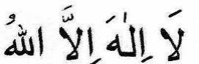
TAHLEEL is to recite HALQ is to shave the head. QASR is to cut the hair.
RAML is to walk in a soldierly style in the first three Shauts of Tawaaf.
SHAUT is one circumbulation of the Ka'bah. Going around the Ka'bah seven times, i.e. seven Shauts, constitutes a Tawaaf. SA-EE is to make seven circuits (Shauts) between Safa and Marwah.
IFRAAD is the performance of Hajj only.
QIRAAN is the performance of Umrah and Hajj together in one Ihraam.
TAMATTU' is the performance of Umrah and Hajj together in a single journey with two Ihraam.
YAUM-E-TARWIYAH is the 8th Zil Hijj.
YAUM-E-ARAFAH is the 9th Zil Hijj.
YAUM-E-NAHR is the 10th Zil Hijj.
AYYAAM-E-NAHR are the 10th, 11th and 12th Zil Hijj. DUM is the sacrificial animal which is stipulated as a penalty for violating the state of Ihraam and the Haram.
SADQAH is also a penalty for violations committed during the state of Ihraam. Its amount is the amount of Sadaqatul Fitr (Fitrah). JABAL QAZH is a mountain in Muzdalifah.
JABAL THABEER is a mountain at Mina.
JABAL RAHMAT is a mountain at Arafaat.
JINAAYAT is an error committed during the state of Ihraam.

SUMMARY OF THE COMPULSORY ACTS OF HAJJ

UMRAH
(1) Ihraam (2) Tawaaf. In this Tawaaf, Raml is Sunnat.
(3) Sa-ee.
(4) Halq or Qasr.

IFRAAD
(1) Ihraam.
(2) Tawaaf-e-Qudoom which is Sunnat. (3) Wuqoof-e- Arafaat.
(4) Wuqoof -e-Muzdalifah.
(5) Rami of Jamrah Uqba.
(6) Qurbaani.
(7) Halq or Qasr.
(8) Tawaaf -e-Ziyaarat.
(9) Sa-ee.
(10) Rami of the Jimaar.
(11) Tawaaf-e-Wida'.

QIRAAN
(1) Ihraam of Hajj and Umrah.
(2) Tawaaf of Umrah. Raml is Sunnat in this Tawaaf. (3) Sa-ee of Umrah.
(4) Tawaaf-e-Qudoom with Raml. This Tawaaf is Sunnat. (5) Sa-ee.
(6) Wuqoof -e-Arafaat.
(7) Wuqoof -e- Muzdalifah.
(8) Rami of Jamrah Uqba.
(9) Qurbaani.
(10) Halq or Qasr.
(11) Tawaaf -e-Ziyaarat.
(12) Rami Jimaar.
(13) Tawaaf-e-Wida'.
HAJJ TAMATTU'
(1) Ihraam of Umrah.
(2) Tawaaf of Umrah with Ramal. Ramal is Sunnat.
(3) Sa-ee of Umrah.
(4) Halq or Qasr.
(5) Ihraam of Hajj on 8th Zil Hijj.
(6) Wuqoof -e-Arafaat.
(7) Wuqoof -e-Muzdalifah.
(8) Rami Jamrah Uqba.
(9) Qurbaani.
(10) Halq or Qasr.
(11) Tawaaf -e-Ziyaarat.
(12) Sa-ee.
(13) Rami Jimaar.
(14) Tawaaf-e-Wida.
There are two types of Tamattu'. Here we have explained only the popular form of Tamattu'.

THE PLACES WHERE DUA IS ACCEPTED READILY
Dua is accepted by Allah 'Ta'ala readily at the following places: (1) Inside the Baitullah Shareef.
(2) Near to Hajr-e-Aswad.
(3) Under Meezaab-e-Rahmat.
(4) Near to Rukn-e-Yamaani.
(5) Near to Maqaam-e-Ibraheem.
(6) Near to the Jamraat.
(7) Near to the Multazam.
(8) Near to the Well of Zam Zam.
(9) On Mount Safa.
(10) On Mount Marwah.
(11) Between Safa and Marwah.
(12) Between Rukn-e-Yamaani and Maqaame Ibraheem.
(13) At Mina, especially in Musjid Khaif.
(14) At Arafaat.
(15) At Mash'arul Haraam'.
(16) Near to Mustajaar.
(17) In front of the entrance to the Ka'bah.
(18) In the Hateem.
(19) From wherever the Ka'bah is visible.
My honourable Brethren! Take advantage of this golden opportunity and engage fervently in dua. These are sacred and auspicious places where duas are quickly heard and readily accepted. Once you depart from the Holy Ka'bah and these sacred places of Makkah Mukarramah, you may not again attain this wonderful opportunity of securing such great blessings.

ON REACHING HOME
When you reach your hometown, recite the following dua:
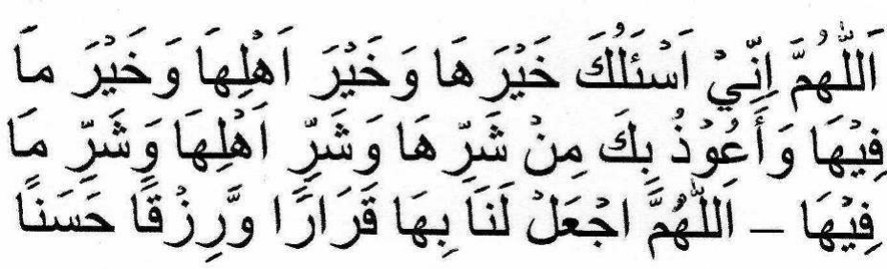
Translation: O Allah! I ask you for its goodness, the goodness of its inhabitants and the goodness in it. I seek your protection from its evil, the evil of its inhabitants and the evil of what is in it. O Allah! establish us in it and grant us a beautiful sustenance.
On entering your hometown, recite:
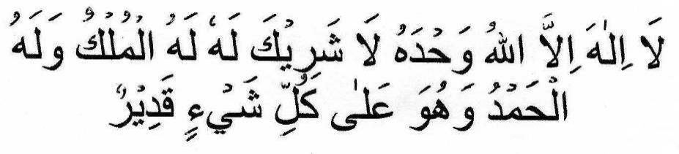
As far as is possible do not go home immediately nor arrive at night. Notify your family of your arrival. The best time to arrive back home is the time of Dhuhaa (about an hour or two after sunrise), if this is possible. If this is not possible, then in the late afternoon before sunset. Before going home, proceed to the Musjid and perform two Raka'ts Salaat if it is not a Makruh time. Make dua and express your thanks and gratefulness (shukr) to Allah
Ta'ala for your safe arrival home. Recite:
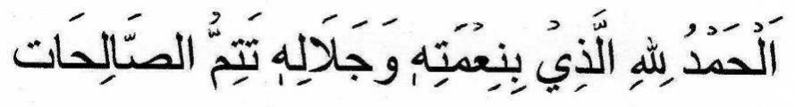
Make musafahah (shake hands) with whomever (i.e. Muslims) you meet. After entering your home, perform two raka'ts Salaat. Then recite the praises of Allah Ta'ala and express your shukr to Him. When people meet you, be humble and meet them happily and make dua. Before entering the city make special dua. The dua of the Hajji before entering the city is readily accepted by Allah Ta'ala.

CONCLUSION
The Rooh (soul) of all the actions and rites of the Hajj is the intention to renew Taubah (repentance) after returning from the auspicious journey. In addition, Taqwa (piety) has to be cultivated.
On returning from the sacred journey, strive in acts of virtue and piety.
The sign of Hajj-e-Mabroor (Hajj which Allah Ta'ala has accepted) is an improved spiritual condition. The sign of having achieved such improvement is eagerness to follow the Sunnah of Rasulullah (sallallahu alayhi wasallam), love and attachment for the world and worldly people diminishing and love for the Aakhirah and the people of Aakhirah increasing
