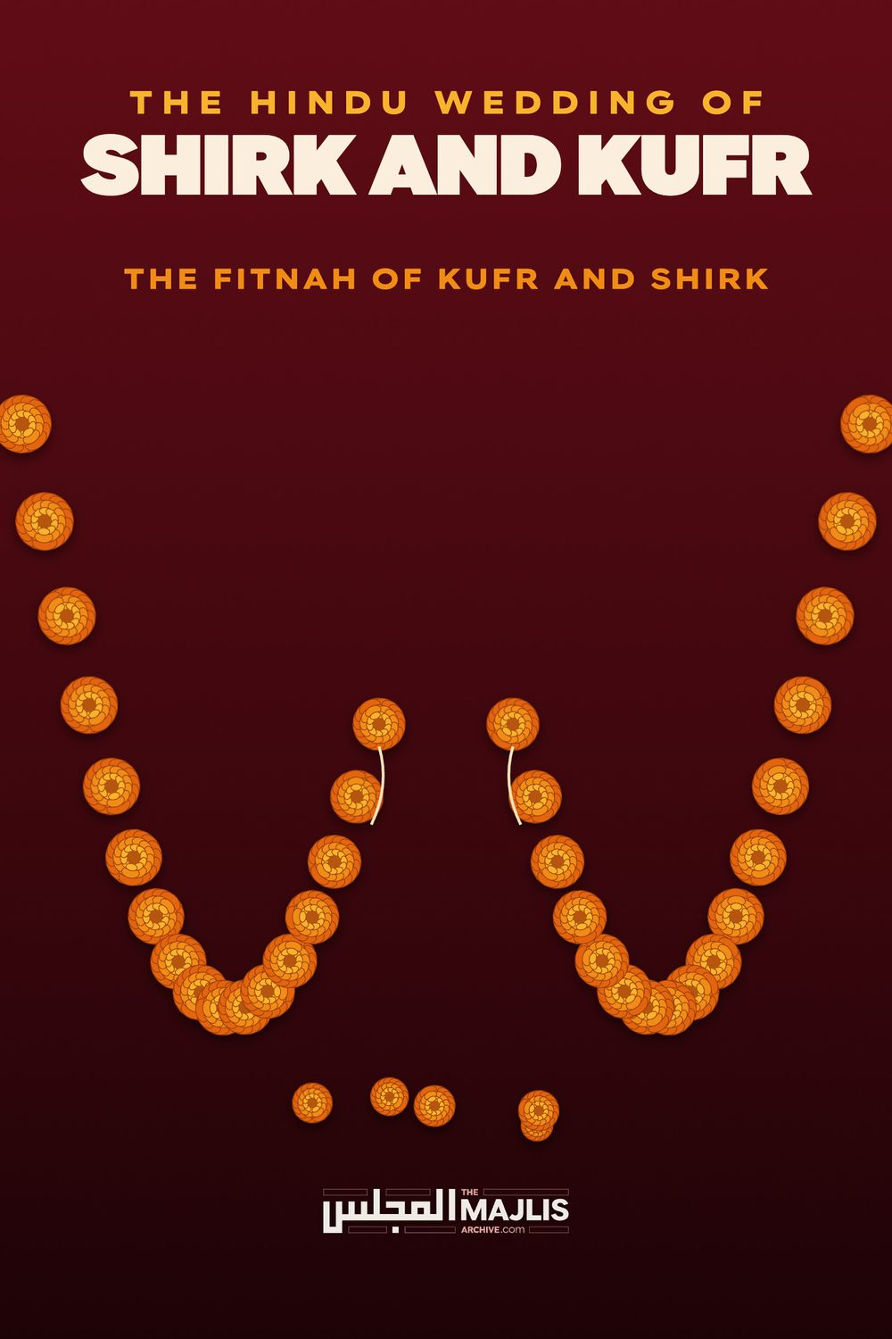

HINDU WEDDING OF SHIRK AND KUFR
The Majlis · Voice of Islam
Mujlisul Ulama of South Africa

About this edition
This is a reproduction by The Majlis Archive (themajlisarchive.com) of a publication of The Majlis, Mujlisul Ulama of South Africa, made and published with their permission.
The PDF as The Majlis issued it is the original. This edition was read from that PDF's own structure and checked against it letter for letter; where the two differ, the PDF is correct.
Checked: 341 paragraphs, 0 differing; a second, independent PDF reader finds 98.1% of the PDF's words here.
Nothing has been reworded, added or removed.

THE HINDU WEDDING OF SHIRK AND KUFR

By: THE MAJLIS Port Elizabeth, 6056

INTRODUCTION
Hadhrat Abdullah Bin Amr (Radhiyallahu anhu), narrating a Hadith, said:
"There will dawn over the people an age when they will assemble in their Musaajid and perform Salaat whilst not a single one of them will be a Mu'min."
Undoubtedly, the Fitnah mentioned in this Hadith is being incrementally played out in this age. This is the era of the dominance of the FITNAH OF KUFR AND SHIRK. The FITNAH of KUFR is embedded in the Muslim community of this era, world-wide.
The greatest achievement and victory of the colonial powers, especially Britain, was the establishment of kuffaar regimes in every Muslim country. Whilst, the colonialists had superficially relinquished political control of the lands of Islam, they are to this day in full control and domination of the greater part of the world. In this greater part, every Muslim country without exception, is a serf-state, a puppet state – a western kuffaar bootlicking state.
The colonialists have undoubtedly succeeded to impose kuffaar rulers and regimes in every Muslim country. While these rulers sport Muslim names, they are in fact kuffaar of a variety of sorts. They are Munaafiqeen, Zanaadaqah, Mulhideen and Murtaddeen.
The most effective kufr-producing machinery established by the western kuffaar for the mass production of munaafiqeen, zanaadaqah, mulhideen and murtaddeen, is their educational system. Brothel universities which dole out donkey degrees on the attainment of accomplishment in the variety of donkey sciences, are the primary machines of kufr in the satanic plot to destroy Islam.
One such product on whom centres this dissertation is Abraham Rasool who had recently been the centre figure in a Hindu wedding of shirk where a mock 'islamic' nikah was also concluded under the umbrella of shirk and kufr. This character has made stupid and abortive attempts to acquire Islamic licence for the marriage of shirk and kufr. He has abortively attempted to justify the blatant shirk and kufr perpetrated by so-called Muslim participants, including the juhala MJC sheikhs and hybrid 'maulana sheikhs'. In this regard he has proffered a silly, epistasisical vindication replete with kufr.
Instead of achieving his goal of exonerating himself, the bride, the groom and his MJC juhala cohorts from the Shariah's decree of Irtidaad, he has miserably failed. On the contrary, he has only succeeded in conspicuously portraying his kufr aggravated by shirk.
There are different categories of kufr. But the worst kufr is that kufr which is aggravated by the commission of shirk. The worst kind of kufr which is most abhorrent to Allah Azza Wa Jal is kufr aggravated by shirk. The Qur'aan Majeed states in regard to this type of kufr:
"Verily, Allah does not forgive that shirk be committed with Him. He forgives every (sin) besides this for whomever He wills."
In this brief treatise, the murtad's every stupid and baseless argument in vindication of the Hindu wedding of shirk is rebutted. It is abundantly clear from the kufr methodology adopted by this unfortunate soul that he has no affiliation with the Islam which stems from the Qur'aan and Sunnah – the Islam which was handed to the Ummah by the Sahaabah and which has reached us by authentic narrational transmission down the long corridor of Islam's more than fourteen century history.
The consequences of committing kufr, is the nullification of Imaan and of A'maal executed during the state of Imaan. It is imperative to repent, renew Imaan and Nikah. As long as the murtad does not adopt the process of re-entry into the fold of Islam, his Salaat, Saum, Zakaat, Hajj and every other deed of virtue will have no value whatsoever by Allah Ta'ala.
"Whoever exchanges Imaan for kufr, verily, he has lost the Straight Path."
(Al-Baqarah, Aayat 108)

The Hindu shirk-kufr wedding
And the baseless, flapdoodle vindication of the murtad
"Do not be grieved by those who hasten in kufr. Verily, they will not be able to harm Allah in the least bit. Allah wills that they do not have any share (of Jannat) in the Aakhirah. For them there is a painful chastisement. Verily, those who purchase kufr with Imaan, never can they harm Allah. For them there is a painful chastisement."
(Aal-e-Imraan, 176, 177)
Defending and justifying the blatant shirk and kufr of the wedding of his daughter in a Hindu ritual marriage ceremony saturated with shirk – the idolatrous worship of false deities – Mr. Abraham Rasool ludicrously says:
"I am sure that the fietna is fuelled by those who were not witness to the ceremony. Those, however, who were there would have witnessed the careful preservation of the maqasid (honour, family, chastity, faith etc); the observance of the fundamentals of the nikah (pure intentions, consenting adults, the exchange of the dowry, the sermon, the acceptance ceremony, the prayers, etc); the signing of a detailed contract of marriage (which dealt with complex issues of their life together and in relation to family); and they would also have been witness to the incorporation of urf or custom (Western, like the exchange of rings, and Malay, like the singing of Rosa, and Vedic, given the background of the groom)."
It is clear that Mr. Abraham does not have the haziest idea of the meaning of 'fitnah'. In fact, despite having been a politician at the helm, he is unable to even pronounce the term, hence the wrong spelling. He transliterates the word as 'fietna'. In addition, he lacks understanding of the meaning of 'fitnah'. Pointing out what is kufr and shirk, criticizing kufr and shirk, applying the Shariah's ruling of Irtidaad to the perpetrators thereof, calling a spade a spade in Shar'i terms by stating the Haqq of Hindu rituals being shirk and kufr, are NEVER fitnah. The proclamation of the Haqq is the command of the Qur'aan and Sunnah.
Allah Ta'ala states in the Qur'aan Majeed: "Do not cloak truth (the Haqq of Islam) with baatil (the falsehood of other religions) nor conceal the Haqq while you are aware."
In the mission of proclaiming the Haqq, Allah Ta'ala praising the Upholders of His Deen, says: "They do not fear the insults/criticism of those who insult (and criticize)."
Rasulullah (Sallallahu alayhi wasallam) said: "Proclaim the Haqq even though it is bitter."
Proclaiming the Haqq of Islam by those whom Islam does not permit to participate in the Hindu shirki wedding, is not reliant on being present at a ceremony of baatil, shirk and kufr. Abraham's defence of the 'ceremony' is a blatant and perverse admission of his acceptance of shirk and kufr. His contumacious justification of the Hindu wedding ceremony which is beyond the slightest vestige of doubt shirk and kufr, renders him a confirmed murtad. It is not the proclaimers of Allah's Law who "fuel fietna" (sic!). Abraham himself with his cohorts cavorting in the wedding of Hindu shirk have perpetrated such fitnah for which there is no maghfirat by Allah Azza Wa Jal. Allah Ta'ala states repeatedly in His Qur'aan Majeed: "Verily, Allah does not forgive that shirk with Him be committed while He forgives (sins) other than shirk for whomever He wills."
Forgiveness for shirk is possible only if the mushrik consciously and sincerely repents before he perishes. If a murtad guilty of shirk perishes prior to Taubah, then for him there is only everlasting perdition in Jahannam.
It is clear from Abraham's vindication and justification of the haraam ceremony of shirk, that he is bereft of Imaan. A Mu'min regardless of how ignorant he may be, will never ever defend Hindu rituals. Knowledge is not a requisite for understanding brazen shirk of Hindu rituals. Every Muslim, be he the most illiterate and uneducated, understands that Hindu rituals are shirk and kufr.
It is mind boggling that this man who professes to be a Muslim can believe that taking the Hindu 'holy' seven steps around the Hindu 'holy' fire, and chanting Hindu prayers of shirk to seven mythical deities is not shirk. It is only possible for a munaafiq who masquerades as a Muslim who can have the ugly audacity of defending such shirk and kufr.
Stupidly flaunting Shar'i expertise, the murtad states: "…the careful preservation of the maqasid…" His utilization of this Deeni term evokes mirth and disgust. Why will such a murtad who has liberated himself from the sacred Fetters of the Shariah, employ a term of the Shariah of which he lacks the faintest idea? In brackets, he describes the meaning of 'maqasid' as 'honour, family, chastity, faith, etc.". Clearly, he does not know what he has perfunctorily blurted out by using this word. The only discernable motive for a non-entity from the Islamic perspective, of Abraham's type to employ a term of Shar'i connotation is to come across as an 'expert' in the sphere of the Shariah. This motive is re-enforced by his laughable utilization and misappropriation of the Fiqhi technicality of 'urf' with which we shall deal later on in this dissertation, Insha-Allah. This type of stupidity is the effect of shaitaaniyat when it succeeds in penetrating the pericardium of mulhideen and zanaadaqah who set themselves up as experts of the Shariah.
For Abraham's edification, the term maqaasid is the plural of maqsad which means objective / goal / purport. Now this character said in his claptrap article:
"Those who were there (i.e. at the wedding of Hindu shirk—The Majlis) would have witnessed the careful preservation of the maqasid (sic!)." Then he explains maqasid as being 'honour, chastity, faith, etc.". Now if the term is substituted with his corrupt interpretation, his statement would read:
"Those who were there would have witnessed the careful preservation of honour, family, chastity, faith, etc."
If these issues are the 'maqasid', then of which concept or ideology are these abstract virtues objectives? Abraham has simply lumped together a couple of terms to sound altruistic and knowledgeable. And, just how were these "maqasid" preserved? Let us dilate a bit for the benefit of this chap and for others of his ilk, as well as for ignorant Muslims who have been cast into satanic confusion by the participation of murtad MJC ulama-e-soo' of the worst class.
Honour: How did the Hindu wedding of shirk and kufr preserve Islamic honour? Remember and understand well that what is honour to the mushrikeen and kuffaar is not necessarily honour according to Islam. According to Allah's Law, shirk and idolatry are most dishonourable and the worst of abominations, viler than murder and adultery. Thus, far from Islamic honour (ghairah) being preserved by submission to idolatry and Hindu rituals of shirk, it (Islamic Honour) is actually pummelled and effaced in entirety. Islamic and Imaani Honour cannever be preserved by participation in rituals of shirk and kufr.
The type of hybrid religious concept espoused by Abraham comes within the purview of the Qur'aanic Aayat:
"What! Do you believe in part of the Kitaab and commit kufr with part? The punishment for any of you who does so, is nothing but disgrace in this worldly life, and on the Day of Qiyaamah, they shall be driven to the worst of punishment."
"And they (the murtads, munaafiqeen and the like) say: 'We believe in part (of the Shariah) and we commit kufr (reject) part. And (in this way) they intend to forge an inbetween path (ideology of kufr). Verily, they indeed are the actual kaafiroon." We have prepared for the kaafireen a disgraceful punishment."
There is no 'inbetween' between Islam and Hinduism. These two are mutually repellent. Islam is extremely hostile and uncompromising in matters of shirk and kufr. There is no concept or ideology to bridge the chasm between Islam's Tauheed and the million mythical deities of Hindu shirk. Abraham's attempt to strike a balance between the two mutually repellent religions comes fully within the context and glare of the aforementioned two Qur'aanic verses.
Family: In which way was 'family' (or whatever this term denotes in Abraham's corrupt and stupid conception) preserved by undergoing the disgrace of participating in Hindu rituals of shirk? Preservation of the family is possible only in 100% submission to the Divine Shariah of the Qur'aan and Sunnah. How was the 'family' (and which family does Abraham mean?) 'carefully preserved' by taking the haraam evil seven steps in circumambulation of the shirk and kufr idolatrous practice around the fire of shirk, chanting to different idolatrous deities who have absolutely no existence?
On the contrary, participation in shirk and kufr by having a Hindu wedding, is an invocation for Allah's La'nat. This La'nat will ruin and destroy the family life of murtads who parade themselves as Muslims.
Chastity: Let Abrahams explain just how was Islamic Chastity (Haya / Iffah / Paakdaamani) 'carefully preserved' by submitting to the zillat of a wedding of Hindu shirk rituals? In fact, every aspect of chastity stemming from the bedrock of Imaan was violated at the haraam wedding of shirk and kufr. It is overwhelmingly clear that this fellow is entirely bereft of the understanding of Islamic chastity, hence his nonsensical rambling about family, chastity and faith.
The very first incumbent requisite for the preservation of Imaani Chastity is that a woman should not be seen in the public domain. She has to be concealed within the safety of her home sanctuary. With her emergence into the public domain, even if that domain is the Musjid, shaitaan becomes her companion and uses her as his snare for fitnah and fasaad. Now when even the Musjid is nugatory of her Chastity, what conclusion should be drawn from her actual participation in shirk and kufr in such a public domain which is constantly under the La'nat and Ghadab of Allah Azza Wa Jal? Instead of chastity being preserved, it was utterly wrecked, ruined and eliminated by the wedding of shirk and kufr.
Faith: What is Abraham's concept of 'faith'? Clearly it is not Imaan. His participation in the wedding of Hindu shirk, his ardent advocacy of participation in such shirk as prevailed at the wedding ceremony, his justification of the rituals of Hindu shirk and his intransigent, flaccid vindication of kufr and shirk conclusively portray his own kufr, and that he in entirety lacks the understanding of the meaning of Imaan – the Imaan which stems from the Qur'aan and Sunnah.
Leave alone active participation in Hindu rituals of shirk, it is kufr to even show a non-Muslim the direction to the temple or church on his request. Imaan is extremely delicate. It is effaced by the slightest contamination with shirk.
During the era of Jaahiliyyah, the Arabs would halt and rest themselves at a certain place on their journies. They would hang up their swords on a tree at this particular spot, which was known as Zaat-e-Anwaat. Once while on a Jihad expedition on the occasion of Hunain, some new Sahaabah on passing this spot requested that a halting/resting place such as Zaat-e-Anwaat be established for them as well. In surprise and indignation, Rasulullah (Sallallahu alayhi wasallam) said that their request was the same as the request made by Bani Israaeel when after their liberation from Fir'oun they came across a group of mushrikeen worshipping idols, they asked Nabi Musaa (Alayhis salaam) to construct for them similar idols of worship.
This episode should be adequate edification for confused, ignorant Muslims to understand the villainy and hurmat of actual participation in shirki rituals and justifying the shirk. When even seeking to emulate a kuffaar practice which was totally unrelated to idolatry was compared by Rasulullah (Sallallahu alayhi wasallam) to idolatry, then what is the fatwa for actual participation and defence of customs of shirk and kufr? In the participation in that haraam wedding was nothing but pure shirk and kufr which jettisoned Imaan out of the souls of the Muslim participants.
In a further extract from Abraham's hogwash vindication and justification of the Hindu wedding of shirk and kufr, the chap says:
"the observance of the fundamentals of the nikah (pure intentions, consenting adults, the exchange of the dowry, the sermon, the acceptance ceremony, the prayers, etc);
He is even unaware of the fundamentals of the nikah, hence he enumerates the aforementioned factors as 'the fundamentals of nikah'. The dowry, sermon and the prayers are not among the fundamentals of Nikah in terms of the Shariah. Furthermore, what does the misguided fellow mean by 'prayers'? Hindu ritual prayers or hollow, hypocritical 'duas' made in a haraam setting by murtad MJC personnel? Or does he refer to both kinds of baatil invocation?
The dowry (mehr), the sermon (khutbah) and the prayers (dua) after the Nikah are not the fundamentals of Nikah. The validity of Nikah is not reliant on these acts. 'Pure intentions' cannot be ascertained by the one who performs the Nikah nor by the witnesses. Intention is between the persons and Allah Ta'ala. The Shariah does not impose ascertainment of intention as a fundamental of Nikah.
The fundamentals of Nikah are only the Ijaab and Qubool in the presence of two Muslim male witnesses. Besides the Shariah requisites, it is abundantly clear that Abraham has included even the Hindu version in his hybrid marriage concept which is an illegitimate mix of Islamic and Hindu rituals, the quotient of which in terms of Islam is pure KUFR.
Advertising further his gross jahaalat of the Shariah and the demands of Imaan, Abraham says:
"the signing of a detailed contract of marriage (which dealt with complex issues of their life together and in relation to family); and they would also have been witness to the incorporation of urf or custom (Western, like the exchange of rings, and Malay, like the singing of Rosa, and Vedic, given the background of the groom).
The signing of "a detailed contract" has no Islamic significance. It does not form part of the Nikah ceremony of Muslims. Such a contract does not justify the adoption of shirk and kufr. The Nikah, far from being sanctified by contract, simply mars it. It has no Islamic origin. It is not a Sunnah practice, and despite the permissibility of having some form of contract, it does not justify the commission of kufr and shirk.
The incorporation of stupid haraam and shirk customs of western, malay and hindu communities simply compounds the najaasat of the wedding of shirk. These haraam acts do not dilute the shirk and kufr. They only aggravate the haraam scenario.
While mentioning the Western custom of exchange of rings and the stupid haraam Malay custom of the singing of Rosa, he is silent about the Vedic custom. He contents himself by merely mentioning the term 'vedic' without mentioning the actual custom as he has regarding the Western and Malay practices. The reason for this cunning silence is the conspicuous shirk of Vedic customs. Whilst the Western and Malay customs are haraam acts of fisq and fujoor, the Vedic customs are shirk.
Abraham most stupidly utilizes the Islamic term, 'urf' to describe the haraam practices of fisq, fujoor and shirk in a silly abortive bid to gain acceptability for the shirk of the wedding. He does not have the haziest idea of the meaning of Urf. Making a mockery of his intelligence and of himself, Abraham says:
"Urf has historically been crucial as Islam moved into uncharted territory, applying the fundamentals of the faith but remaining flexible on what people in those new territories were used to. The crucial question was always whether custom could be complementary or contradictory to the fundamentals."
This averment is baseless and displays his jahaalat. The assumed 'flexibility' envisaging the permissibility of the wholesale discardence of the entire Structure of Islam to accommodate customary practices as long as the "fundamentals of faith" are retained is a satanic canard urinated into the brains by the Devil-in-Chief. It is of the Zukhruful Qaul (satanically adorned ideas, theories and ideologies) which the Qur'aan mentions.
In fact, discardence of even the Furoo-aat (the particular acts of the Shariah apart from the Fundamentals) is kufr which eliminates the Fundamentals of Imaan. It is impossible to apply and maintain the fundamentals if the Furoo-aat are abandoned or rejected. Observance of the Furoo-aat in general, is imperative for the sustainment of the fundamentals of the faith. Practices and customs which are shirk and kufr eliminate Imaan. The fundamentals are meaningless and have no value and no validity by Allah Ta'ala if the adopted customs are shirk and kufr. Imaan is obliterated at the roots by such customary practices.
Thus, walking around the holy hindu fire chanting prayers to seven mythological deities and observance of other vedic customs, in entirety eliminate Imaan rendering the fundamentals absolutely meaningless. If the murtad performs Salaat his entire remaining life, pays Zakaat, performs Hajj, etc. without having confessed to Allah his error of kufr and without having repented and renewing his Imaan, such observance of the fundamentals does not have the value of the wing of a fly. It is all in vain.
Furthermore, the customary shirk and kufr practices of the Hindu religion, and customs emulated from any other kaafir community do not come within the scope of Islamic Urf. A condition for the validity of Urf is that the practice must not be in conflict with any Nass of the Shariah. A custom which is in conflict with the explicit rulings of the Shariah is mardood and mal-oon. It is satanic and there is no room in Islam for the customs of the Devils progeny.
The ludicrous averment: "Urf has historically been crucial as Islam moved into unchartered territory.." is devoid of Shar'i substance. For Islam there never was any 'unchartered territory'. Rasulullah (Sallallahu alayhi wasallam) was the Final Nabi with whom the long Chain of Nubuwwat terminated. The very termination of Nubuwwat signifies a panoptic Deen (Law/Way of life) encompassing all the nations of the world.
The Qur'aan is explicit in proclaiming the universality of the Nubuwwat of Rasulullah (Sallallahu alayhi wasallam). This universality supplemented with termination of Nubuwwat is in emphatic abnegation of the kufr idea/belief that any nation or land was 'unchartered territory' for Islam.
Islam was finalized and perfected within the very lifetime of Rasulullah (Sallallahu alayhi wasallam). Thus the Qur'aan Majeed states:
"This Day have I perfected for you your Deen, completed for you My Favour, and chosen for you Islam as your Deen."
The powerful Ship of Islam sailed powerfully through the storms of so-called 'unchartered territories', without being buffeted like a rudderless ship. It remained unscathed on its course of Siraatul Mustaqeem from its very inception to this day of our era. The pristine purity of the Deen has been safeguarded by the Ulama-e-Haqq of every age. Despite the ravages of satanism surrounding it, hitherto Islam has remained pure. The mass and mess of bid'ah, fisq, fujoor and kufr which the myriad of agents of Iblees had fabricated through the centuries have not succeeded to alter this Deen, leave alone efface it as was the fate of all other religions of bygone times.
Allah Ta'ala has sent a Mujaddid in each century to eradicate the weeds and poisons which had accumulated. During the course of each century, there were always Ulama-e-Haqq who were the bulwark and the fortifications of Islam.
Islam at no stage had shed anything of the Sunnah upon entry into so-called 'unchartered territory'. On the contrary, Islam imposed the Sunnah – its beliefs, practices, customs, etc. – on the peoples in the 'unchartered territories'. There was never a stage when Islam had acquired any accrual of baatil, kufr and shirk. The un-Islamic lifestyle and the anti-Sunnah cultures of people who entered the fold of Islam should not be confused with Islam. The zanadaqah, munaafiqeen and hidden murtaddeen seek to confuse the ignorant masses with the haraam cultures of different Muslim nations. They stupidly understand that such haraam ways of life were accepted and incorporated by Islam due to a 'flexibility' hallucinated by these zanadaqah morons. Thus, for example, the pompous lifestyle of the Spanish Muslims is equated with Islam whereas there never ever was any affinity between Islam and the Muslim style of life and law in Spain.
It is a colossal error to confuse the cultures of the various Muslim nations with Islam and the Sunnah. Since the time of Rasulullah (Sallallahu alayhi wasallam) to this day, Islam is the same. It has never undergone any metamorphosis. It never was a culture which had maintained a superficial institution of 'fundamentals of faith' while shedding its austere culture of the Sunnah along with its myriad of masaa-il encompassing every sphere and every action of the Muslim's life.
It is a huge canard and a deception to peddle the idea that Islam remained "flexible on what people in those new territories were used to." Islam never incorporated or accepted whatever muck of shirk, kufr, fisq and fujoor the people in the new territories had to offer. On the contrary, all beliefs, acts, practices, customs and the like which contravened the Qur'aan and Sunnah, were abolished. Whatever was valid on the basis of the principles of the Shariah was accepted. Such acceptance should not be confused with the satanic ideology of 'flexibility' of the morons, for 'flexibility' in their satanically disturbed brains is the equivalent of scuttling the Sunnah, i.e. the Shariah, as it has reached us most reliably by authentic narration and transmission down the centuries. The stupid averment of the murtad is rejected with contempt. It is disguised kufr to deceive the ignorant and the unwary.
The murtad further compounding his convoluted ideology of kufr, says:
"The crucial question was always whether custom could be complementary or contradictory to the fundamentals."
The idea presented in this statement is kufr. The customs of people were never complementary to Islam. The notion of Islam being in need of a complement is kufr. It is in negation of Allah's explicit declaration of the perfection and completion of Islam. The customs of people were either in conformity or in contradiction of Islam, never complimentary. If any custom conformed, it was acceptable. If it was contradictory, it was rejected. There was no dilemma on this score.
On the basis of his hallucinated idea of scope in Islam for complimentary practices, the murtad seeking to justify the kufr and shirk wedding, disgorges the following kufr muck:
"Applying this methodology to the Marriage Ceremony meant that a few of the Vedic traditions were incorporated, while others were not because either the groom's family were sensitive to our sensibilities or we found them not to be complementary."
Firstly, this idea is not Islamic methodology. It is a baatil methodology urinated into the brain by Iblees. Islam does not offer the slightest room for the incorporation of any Hindu/Vedic traditions. Such traditions far from being acceptable, are violently contradictory to the teachings and spirit of Islam. Everything of the Hindu religion is based on idolatry and shirk. The murtad's finding some Vedic traditions to be complimentary to Islam is in denial of the perfection and completion of Islam announced by Allah Azza Wa Jal in the Qur'aan Majeed. In addition, it is a partial acceptance of Islam. Partial acceptance is in fact rejection of the whole of Islam. It is in abnegation of the very Kalimah which is the Fundamental Basis of Islam. The Qur'aan Majeed commands:
"O People of Imaan, enter into Islam fully/wholeheartedly/in entirety, and do not follow in the footsteps of shaitaan. Verily, he is your open enemy."
This Aayat was revealed when some Jews had embraced Islam. Employing the type of 'rational' arguments advocated by the murtad to accommodate Hindu customs, they explained to Rasulullah (Sallallahu alayhi wasallam) their wish to maintain the Jewish practices observing the Sabbath (i.e. treating Saturday as a holy day), and abstaining from camel's meat. Also, since in terms of their 'rational' argument, the Tauraah was a Holy Book revealed by Allah Ta'ala, they recited it in Tahajjud Salaat. Furthermore, in their understanding Islam did not explicitly prohibit these practices.
Vehemently rejecting their line of reasoning and branding it to be of the footsteps of shaitaan, Allah Ta'ala revealed the aforementioned Qur'aanic Aayat. Rasulullah (Sallallahu alayhi wasallam) said: "I have come to you with clear signs. Even if Nabi Musaa (Alayhis salaam) was alive, he too would have had no option but to follow me."
In the tafseer of this Aayat, Mufti Muhammad Aashiq Ilaahi (Rahmatullah alayh) says:
The Order to Enter Completely Into lslaam Certain Muslims who had converted from Judaism wished to keep up some Jewish practices such as according esteem to Saturdays and abstaining from camel meat. They told the Prophet (sallallaahu-alayhi-wa-sallam) that since the Torah was also the book of Allaah, they recited it in their Tahajjud salaah. Allaah revealed the above verse on this occasion, informing them that after the advent of Islaam, no other religion should remain. ["Durrul Manthoor" and "Baydawi"]
Hadhrat Jaabir (radhiyallahu anhu) narrates that Rasulullaah (sallallaahu-alayhi-wa-sallam) said, "I have come to you with clear signs. Even if Hadhrat Moosa (Alayhi salaam) was alive, he too will have no option but to follow me." ["Ma'aalimut Tanzeel" (Vol.1, Pg.l83) from Ahmed and Bayhaqi as recorded in "Mishkaatul Masabeeh," Pg. 30]
Every Person Must Abide by The Laws of Islaam in Every Dominion This verse instructs every person to accept all the injunctions of Islaam and practise accordingly, irrespective of his position. This is binding upon the ruler and the subject, the big and the small, the employer and the employee, the businessman and fanner alike. Many people are under the misconception that Islaam is restricted to a few actions like salaah, fasting, zakaah, etc. They do not apply Islaam to their social, economic and political lives. They conduct business as they please, buying and selling any commodity they wish. Many people seek employment at any institution, not paying the slightest heed to whether it is Halaal or Haraam.
Many do not consider the Shari'ah in the matters of marriage, committing major sins in the process while thinking that the Shari'ah does not apply to occasions of rejoicing. They pay no heed to the advice given to them by the Ulema (religious scholars), saying that these scholars are merely standing in the way of progress. They consider their religion to be like the religion of those people who care not to mould their lifestyle within the framework of its restrictions (May Allaah save us from this).
Our Deen is perfect and complete, encompassing every aspect of life. There exists no aspect of life which is not included in its teachings. For one to practice some aspects of Deen while neglecting others, will be in conformance to the behaviour of those Jews who were addressed in Surah Baqarah. Allaah told them, "Do you believe in part of the book and reject part of it." [Surah 2, verse 85]
Many people merely claim to be Muslims while they do not even perform the Faraaidh of Deen, while others restrict the Deen to a few actions only. If they are advised to leave their Haraam employment, interest dealings, or trading in Haraam commodities, they do not accept. They waive this off saying that it is their livelihood which cannot be neglected. This foolish statement is tantamount to saying that earning one's livelihood brings complete freedom.
The Deviance of Political Leaders Some present day Islaamic countries employ methods in their administration that are learnt from the kuffaar. They enforce laws which are oppressive and contradict the Shari'ah. In spite of all this, they are audacious enough to claim the Islaamic identity of their countries. It is the sway of Shaytaan that makes them apply a limited number of Islaamic laws while turning a blind eye to many others. It is for this reason that, after instructing complete entry into Islaam, Allaah says, "And do not follow in the footsteps of Shaytaan, for verily he is your open enemy." It is indeed very strange that people swear and curse Shaytaan, yet pander to his wishes.
"If you err after the clear signs have come to you, then know that verily Allaah is Most Powerful, The All Wise." This verse makes it clear that it is not a light matter that a person does not enter into Islaam in spite of receiving full knowledge. This constitutes rebellion against Allaah who is All Powerful. None can overcome Him, nor escape His punishment. Allaah is All Wise and does not hasten to punish anyone. Therefore, no person should dwell under the misconception that he is safe from Allaah and will not be taken to task.
This Aayat conclusively debunks the rubbish theory of urf which the murtad has fabricated. Despite the Tauraah being Allah's Revelation, the truth of which has to be incumbently accepted by Muslims as an article of Faith, and despite abstention from camel's meat and observing the Sabbath having been commands of Allah Ta'ala, incorporation of these acts on the basis of stupid 'urf' was haraam and rejected by the Qur'aan Majeed.
The Qur'aan describes as Kaafiroon Haqqan (total kuffaar) those who accept part of the Deen and reject a part. In this regard, the Qur'aan says: "…They say: 'We believe in some (of the Shariah) and we disbelieve in some, and they seek to adopt a path between this. Indeed they are the actual (total) kaafiroon. We have prepared for the kaafireen a humiliating punishment."
This was the style of the Yahood and Nasaara, and this is the methodology of the zanadaqah of this Ummah who profess to be Muslims. Refuting these kuffaar, the Qur'aan says:
"What, do you believe in a portion of the Kitaab and reject a portion? The punishment of those among you who do so is nothing but humiliation in this worldly life and on the Day of Qiyaamah they will be driven to the severest punishment."
The murtad has fabricated a hotchpotch version of a convoluted 'islam' palatable to devils. It is a version which has no affinity with the Islam of the Qur'aan and Sunnah. Just imagine! Vedic traditions being complementary to Islam! This is a dastardly brazen profession of blatant kufr and shirk which the MJC juhala had condoned and even justified.
The episode of Zaat-e-Anwaat, mentioned earlier, (see page 15) should be salubrious enough for the edification of ignorant Muslims confused by the convoluted muck of kufr presented deceptively by the murtad.
Attempting to further substantiate his unsustainable kufr theory of perfecting Islam with complements from idolatrous religions, the murtad says:
"It can always be a matter of debate whether things are complementary or not, but the debate must be based on the rational meaning of the traditions"
The very notion of Islam ever being in need of complementary acts is baatil and kufr. There is no debate on this issue as stupidly alleged by the murtad. This Deen of perfection repels all acts and customs which are extraneous to it. Rasulullah (Sallallahu alayhi wasallam) has branded all complementary acts as bid'ah, and all bid'ah leads to Hell Fire. The averment of "the rational meaning of the traditions" is kufr drivel designed for the incorporation into Islam of kufr beliefs and practices. This kind of baatil theory underscores the complicity of the zanadaqah in the conspiracy to introduce kufr and shirk into the community in the name of Islam.
Most of the flotsam zanadaqah characters disgorged by the university machinery of kufr have already lost their Imaan long ago. They are now performing the functions of Iblees. At his behest and under his supervision, these villains of kufr flit in the community like impalpable shadows sowing their fitnah of kufr to undermine the Islam which has come down to us from the Sahaabah. Their concept of 'islam' with its wide latitude and satanic flexibility is a fertile abode for satanism, kufr and shirk, and this has been conspicuously demonstrated by the murtaddeen at the Hindu wedding of shirk.
Contrary to what the murtad claims, the basis of fitnah is the desire to mutilate the Shariah to conform to satanic norms and notions which are palatable for the kuffaar of all hues. Their greatest stumbling block for achieving their nefarious goals is the Shariah which is structured on the Qur'aan and Sunnah, hence the insane effort is to relegate this Divine Shariah to antiquity whilst it is the Word of Allah Azza Wa Jal.
Fitnah is never the effect of Amr Bil Ma'roof Nahy Anil Munkar. Fitnah is the consequence of flagrantly denying and violating the commands of Allah Azza Wa Jal. Just as the mushrikeen of Makkah had branded Rasulullah's Call to the Deen to be 'fitnah', so too does the murtad and his MJC murtaddeen cohorts label the proclamation of the Haqq by the Ulama to be 'fitnah'. The proclamation of Tauheed was the greatest 'fitnah' for the mushrikeen of Makkah. All hell broke loose when Rasulullah (Sallallahu alayhi wasallam) made the announcement of Tauheed. In like manner, the zanadaqah and murtaddeen have embarked on their programme of fitnah to achieve their insidious objective of scuttling the Divine Shariah so as to make way for the incorporation of just every brand of kufr, shirk, fisq and fujoor which the western kuffaar have elevated to the pedestal of civilization and culture. It is for this very reason that the miserable murtad lauds "interfaith services" and the kufr "ethic of our Bill of Rights and Constitution". Regardless of the total rejection of these kufr ideologies by Islam, the murtad seeks to hoist these Jahannami concepts on Muslims. But he is set to miserably fail.
They are the fattaan (insidious fitnah-mongers). They are the worst fitnah mongers whose mission is to undermine the Deen with kufr, shirk, fisq and fujoor.
Elaborating further on his kufr ideology, the murtad says:
"Urf is an act of inclusion and a mark of respect, trademarks of our South African experience, whether in the interfaith services against apartheid or the ethic of our Bill of Rights and Constitution."
Lack of expert Islamic knowledge coupled with the ideology of kufr libertinism acquired from a kufr university which fits the brains with straitjackets of kufr, has constrained the murtad to disgorge this effluvium which is a laughable stupidity termed jahl-e-murakkab. This statement testifies to the lack of understanding of the meaning of Urf in the Islamic context.
Urf is neither an act of stupid inclusion nor a mark of respect for customs of kufr, shirk, fisq and fujoor. While such baatil is undoubtedly the trademarks of the modernist zanadaqah, munaafiqeen and moron murtaddeen in a variety of avenues where they are always at pains to hoist baatil, haraam and kufr on the community, there is no scope in Islam for its operation. Their understanding of urf is kufr. However, since munaafiqeen and zanadaqah are generally cowards, they search for subtle and impalpable methods and ways to market their wares of kufr and villainy.
Citing interfaith services and the ethics of the Bill of Rights in vindication of the mass and mess of kufr and shirk perpetrated at the Hindu wedding, is preposterous. There is no truck between Islam and these kufr ideologies. Since it is quite manifest that the murtad is bankrupt in the field of Shar'i Uloom and Deeni understanding, he has miserably failed to bolster his kufr and irtidaad with Shar'i substance. It is absolutely ludicrous to include these ideologies of kufr into Islam on the basis of the convoluted and stupid notion of 'urf' portrayed by the murtad.

"Second hand accounts"?
The murtad character moronically scuttling his own 'rational' ideology of kufr, states in his claptrap dissertation:
"…but the debate must be based on the rational meaning of the traditions – as carefully and often humorously explained by the Vedic authority - and not on judgements based on superficial or prejudicial readings of second hand accounts."
Whilst he disparages Shar'i evidences, labelling it 'second hand accounts', he elevates the kufr of vedic ideology to the pedestal of honour and truth. From which first-hand account did he glean this shaitaaniyat?
Nothing but kufr gushes from this murtad's mouth. Firstly, the miserable chap does not define what he means by "second hand accounts". He is obviously referring to the Shariah whose grand edifice was structured on the Qur'aan and Sunnah by the illustrious Authorities of Islam of the first three golden eras of Islam which Rasulullah (Sallallahu alayhi wasallam) himself designated: Khairul Quroon (the best of ages). After the Khairul Quroon, Rasulullah (Sallallahu alayhi wasallam) said comes the era of 'kithb' (lies/falsehood) and Simaanah (obesity/fatness). Hence, Nabi-e-Kareem (Sallallahu alayhi wasallam) said: "Honour my Sahaabah, for verily, they are your Best. Then those after them, then those after them. Thereafter kithb will prevail." In another Hadith, Rasulullah (Sallallahu alayhi wasallam) said: "Then will come such people who love simaanah (obesity)."
While the murtad denies the Sunnah as the Source of the Deen, he elevated Hindu shirk mythology to the status of 'authority'. He dubs Rasulullah's Shariah 'second hand accounts'. In fact, by implication, the Qur'aan Majeed too is the effect of 'second hand accounts'. The authenticity of the Qur'aan, which the murtad pretends to accept, is in fact the effect of 'second hand accounts', viz. the Ahaadith. Minus the second hand accounts, there is no Qur'aan and no Islam. But for him Vedic 'authority' is first hand. He has attained the pinnacle of kufr or rather sunk to the bottom of the dregs of kufr.
In his claptrap of stupidity he glowingly speaks of the 'maqasid', the sermon of the marriage, the prayer (dua), the exchange of dowry, etc. Let this lost and miserable fellow explain the 'first hand' source from whence he had acquired these elements. We presume that by 'first hand' he refers to the Qur'aan. If so, then where in the Qur'aan are the sermon, the dua and the entire ceremony commanded? From which first hand Islamic authority did the murtad acquire the Malay song of Rosa, the western custom of exchanging rings and vedic customs of shirk which constrained him to approve of these rubbish practices and to treat them as effects and artefacts of some 'first-hand account'? His stupid talk of Shar'i rulings based on 'second hand accounts' is shaitaani excrement which is the prelude and nourishment for Irtidaad.
Uttering more claptrap, the chap says:
"Sadly, the debate has not been about the merits of the urf. We have rather seen edicts of kufr, vilification of honourable scholars, displays of ignorance even of the faith of those involved directly, assertions that there was no nikah, and suspicion of my family and I."
Again he displays his jahaalat. He does not have the haziest idea of the technical Shar'i meaning of Urf. What are the merits of Urf? What is the Shar'i definition of Urf? What are the conditions for the validity of Urf in Islam? Without understanding, he simply blurted out the word 'urf'.
The edicts of kufr directed at him, the marrying couple and the most dishonourable scholars for dollars are based on sound Shar'i basis. These murtaddeen attempt to hijack Allah's Shariah for the attainment of their haraam nafsaani maqaasid. The murtad lacks even a rudimentary comprehension of the operation of the principles of the Shariah and its ramifications into the Ahkaam. He therefore blurts out just any drivel disgorged by his nafs at the behest of shaitaan.
Those Ulama who have abstained from issuing the Waajib edicts of kufr which are imperative for the guidance of the masses and the safety of their Imaan, are described by Rasulullah (Sallallahu alayhi wasallam) as 'dumb devils'. Despite being fully aware of the blatant kufr and shirk flagrantly perpetrated in public, they opted for either silence or worse. In the worse scenario they flabbily and stupidly justified the worst sin of shirk which is the most abhorrent of all sins by Allah Ta'ala. Thus, the silent ones offered silent complicity, and those shayaateen who had justified the shirk with convoluted and corrupt interpretations have joined the ranks of the murtaddeen.
These murtaddeen are the worst fitnah-mongers, disseminating their fitnah of kufr and shirk in the name of the Deen, that which Allah Ta'ala has revealed for the deracination of shirk. Shirk is the ugliest antithesis of Tauheed. Yet the vile scholars for dollars have most despicably laboured to justify its hallucinated validity and permissibility for licking the boots of the politician. Pleasing Allah Ta'ala by denouncing the evil of shirk is the furthest from the vermiculated brains of these bogus sheikhs and hybrid molvi-sheikhs of the so-called MJC which does not understand the meaning of being a Muslim judicial body. These vile sheikhs and molvis are only pandering to the whims and fancies of politicians whom they believe will be able to assist them in the attainment of their mundance haraam goals.
Those who commit the fatal blunder of seeking the pleasure of the people are doomed in this dunya and the Aakhirah. Rasulullah (Sallallahu alayhi wasallam) said in regard to such villains:
"He who seeks the pleasure of the people by courting the Wrath of Allah, Allah casts him to the people."
Allah Ta'ala will not aid such villains. They will become the contemptible slaves of the politicians and other deviates whom they are at pains to bootlick. On the contrary, those whose maqsad is the Ridha (Pleasure) of Allah, Rasulullah (Sallallahu alayhi wasallam) assured:
"He who seeks the Pleasure of Allah and in this pursuit annoys the people, Allah suffices for him regarding the problems of people (i.e. their opposition will not harm him)."
Allah Ta'ala says in His Qur'aan Majeed: "If you have Sabr and adopt Taqwa, never will their plots harm you in the least." Thus, for the Mu'min, the determinant in all actions is Ridha-e-Ilaahi. It is the Waajib obligation of the Ulama to expose and condemn the fitnah of kufr and shirk which the zanaadaqah, munaafiqeen and murtaddeen in our midst cunningly plot to introduce to undermine the Deen and to hoist some hybrid ideology of kufr which could be passed off as 'islam' to unsuspecting and ignorant Muslims.
Their silence and complicity in shirk with their justification are insidious attempts to gain acceptance for the haraam Hindu wedding. Let them cavort in their shaitaaniyat. Soon will they see and understand what is the meaning of Athaab. While Hindu rituals of shirk are acceptable and even valid for the murtad and his ilk among the juhala sheikhs, the Shariah is abhorrent. The Shariah's proclamation of the Haqq as the primary demand of Tauheed is abhorrent for them. They are the type of creatures mentioned in the Qur'aan:
"They are like wild donkeys fleeing from a lion."
They flee from the Shariah like wild donkeys because they acquired kufr education at donkey, brothel universities where their brains were fitted with donkey straitjackets, hence they emerge from these donkey institutions with donkey tails of titles and degrees. Thus, the Qur'aan describes them as "wild donkeys".
Seeking to acquit himself as an expert of the Qur'aan, the miserable chap wallowing in shaqaawah says:
"The Quran is so clear: when dubious sources bring news, fatabayyanu! Clarify and verify! The onus is not on those about whom the fietna is. The onus is on those who make the allegation to present the proof. Indeed, this is when suspicion so easily becomes a sin."
What is this hallucinated false allegation of 'dubious sources'? Let the miscreant prove that the criticism is based on 'dubious sources'. In fact, he comes fully within the glare of the Qur'aanic aayat from which he has gleaned a word or two without understanding head or tail. What was not clarified? What was not verified?
The murtad has resorted to wild accusations. Can he cite just one aspect of the Ulama's criticism which is not based on verified facts? Every fact on which our criticism is based was an established reality which had prevailed at the Hindu-shirk wedding. Does he deny the firewalk 'tawaaf' dedicated to seven idolatrous mythological deities – the prayers of shirk – the hindu rituals? The entire criticism and edict of kufr and irtidaad are based on these kufr and shirk realities which had bedevilled the haraam wedding function.
The invitation card calling to the wedding of kufr and shirk enumerates the variety of shirk and kufr customs and hindu rituals. For the edification of the murtad and the for the information of confused Muslims the invitation card is reproduced here.
The Vedic Traditions Swagatam = Welcome of the Groom & Family Jaimala = The Garlanding Kanyadan = Joining of Hands Mangal Phera = Circling the Fire and he Seven Steps Mangal Sutra = Placing the Necklace Mithai = Exchanging Sweet Meats The Wedding Vows The Celebrations Exchange of Gifts Cutting the Cake Congratulatory Speeches Musical Tributes
Now judge for yourself, O Muslim!, and seek a fatwa from your heart according to Rasulullah's instructions: "Seek a fatwa from your heart." Even if a jaahil Muslim searches his heart with sincerity he will not fail to see and understand the glaring artefacts of shirk and kufr in the wedding invitation card. But the murtad, in order to befool and befuddle Muslims avers that the criticism of the shirk is not based on actuality – on acts and rituals of shirk which constituted integral practices of the wedding of shirk.

NO NIKAH?
The murtad rails against the edict which invalidates the shirk hindu ceremony to confirm that the nikah was not valid. Most assuredly there was no nikah according to Islam. The 'nikah' performed by whoever the moron imaam or sheikh may have been, has no validity in the Shariah. The indulgence in hindu rituals of shirk nullifies the 'nikah'. It was in reality a mock
'nikah' to pull wool over the eyes of ignorant Muslims. Even one element of shirk and kufr nullifies a nikah ceremony. Thus a couple who goes through a Hindu wedding is not considered husband and wife in terms of the Shariah. They will be wallowing in the state of zina (adultery) should they live as husband and wife.

HIS FITNAH
The murtad who is spreading fitnah with falsehood – falsely accusing the Ulama of having no valid basis for criticizing the fitnah of the shirk wedding, should know that the onus rests on him to prove that the Ulama had structured their criticism on baseless allegations. In the contrary, his claim is bland and baseless. The onus rests on him to prove his false accusation. He must substantiate with proof who or what were the 'dubious sources' from whom the information of the hindu wedding was acquired. The onus is on those murtaddeen who create and disseminate fitnah to present their proof. With grossly misleading statements uttered blandly, the murtad labours to justify the fitnah of shirk and kufr in which he, the MJC sheikhs, the man, the woman and all participants had wallowed. It is reiterated with emphasis that the nikah at the hindu wedding ceremony was not a valid Islamic nikah.

THE SHAHAADAH
Abraham claims:
"More importantly, they would have known that the groom embraced the shahada, an act that does not demand denouncing or rejecting his family, community or other essentials of his being and identity."
In this stupid averment he only portrays his own jahaalat. He is shockingly ignorant of the meaning of Imaan, and what makes a man a Muslim. Reciting the Kalimah a thousand times will not spawn Imaan if the reciter indulges in shirk and kufr. The Kalimah Shahaadat has absolutely no validity with indulgence in shirk and kufr. Such shaitaani indulgence negates and eradicates Imaan by the very roots. How is it ever possible for a man of Imaan – for a true Mu'min – to indulge in such horrendous shirk as the 'tawaaf' around the hindu holy fire dedicated to seven idolatrous deities? A Muslim is not in need of knowledge nor of brains to understand that such a character can never be a Mu'min.
Just showing a non-Muslim the direction to the temple is kufr. What conclusion is now to be drawn about a miserable chap who practically indulges in Hindu rituals of shirk?
A moron, bid'ati, quarter-baked so-called 'sheikh' of Cape Town who happens to be a member of pro-Shiah Bid'ati fraudulent institute, and also an executive member of the MJC, wrote to the Ulama of Morocco seeking a fatwa regarding the participants of this Hindu wedding which has led to the irtidaad of the characters associated with the Hindu shirk. The Moroccan authority whoever he may be, acquired the Fatwa from Shaikh Abdul Azeez Al-Audhi from the Sultanate of Oman. This Fatwa in Arabic with its English translation appears in full at the end of this treatise.
In the Fatwa is mentioned: "This (Hindu) marriage is baatil (false/null and void) because it was contracted between a Muslim woman and a Kaafir man who had not at all entered Islam. On the contrary he remains established on his kufr and deviation…In fact he follows the Hindu religion and he made tawaaf of the fire with his 'wife'. If she accepted it, then she (too) has committed kufr.
Tafreeq (compelling separation) immediately between them is Waajib……."
Since the fatwa does not comply with the whims, fancies and ulterior motive of the bid'ati hybrid
'sheikh' which it was solicited, he deemed it appropriate to suppress and sweep it under the carpet in the hope that it would not see the light of day. This is the type of so-called 'ulama' of which the world is today awash. In the words of Rasulullah (sallallahu alayhi wasallam): "They are astray, and leads others astray." They are the worse vermin "under the canopy of the sky".
The 'shahaadah' of the Hindu man who was the groom at the wedding of shirk is simply not valid. He remains a Hindu.

HIDAAYAT – GUIDANCE
In the penultimate paragraph of the kufr claptrap he has disgorged, Abraham has the audacity to say:
"May Allah guide us all through this world where our children will encounter diversity, and give us the wisdom to remain true to our fundamentals, but open to traditions and customs which constitute universal and shared values."
It is essential for the safety of Imaan for Muslims to understand that Hidaayat or the Guidance which leads to Najaat (Salvation) in the Aakhirah is only the Hidaayat granted by Allah Ta'ala. And, the sole repository of that Hidaayat is the Islam which the Sahaabah had transmitted to posterity on the authority of Rasulullah (Sallallahu alayhi wasallam). Minus Imaan, the consequence is everlasting Jahannam. And, Imaan precludes in entirety the inclusion of the slightest vestige of diversity which is extraneous to Siraatul Mustaqeem – the only Pathway leading to Allah Ta'ala.
In his averment of kufr, Abraham is unable to conceal the kufr which he attempts to subtly propagate. Islam is not a Deen of mere 'fundamentals'. This is a satanic misconception which the murtad seeks to slink into the community by employment of flowery terms. This Deen of Islam is a vast, Divine Tapestry of Ahkaam upholding and sustaining the Fundamentals. Mutilation of the Ahkaam which are inextricably interwoven with the Fabric of the Fundamentals demolishes the Fundamentals and eliminates Islam.
The world "where our children will encounter diversity" is a veritable spiritual minefield wherein the Mu'mineen are required to pick their way with exceptional care to avoid being blown up by the satanic ravages of kufr, shirk, fisq, fujoor and bid'ah. It is precisely for this reason that Allah Ta'ala has informed us in the Qur'aan that the only way for reaching the Ultimate Destination of Jannat is Siraatul Mustaqeem which has no room for the type of 'diversity' suggested by the murtad. Hence we have been commanded to daily supplicate dozens of times in our daily Salaat for the guidance of Siraatul Mustaqeem (The Straight Pathway leading to Jannat). This is the very first Dua in Surah Faatihah.
Vigorously rejecting the 'diversity' kufr of the murtad, the Qur'aan Majeed says:
"Verily, this (Deen of Islam) is MY Straight Siraat (Path). Therefore, follow it, and do not follow diverse pathways, for then these ways will diverge you from MY Path. This is what He (Allah) commands you with so that you attain Taqwa."
"And, unto Allah (leads) the Straight Path, and from it (the Straight Path) are crooked paths. If He had so desired, He would have guided you all."
However, Allah's Wisdom demanded that Hidaayat be precluded from entire mankind. That is the Divine Prerogative which no one has the right to question. Allah Azza Wa Jal has created a specific portion of mankind and jinnkind to be fuel and food for Jahannam. Among this nourishment for Jahannam are the munaafiqeen, zanaadaqah, mubtadieen, murtaddeen, etc.
There is no acceptability in Islam for such shaitaani diversity which finds accommodation for kufr and shirk. Diversity in this context comes within the scope of the Qur'aanic term jaa-ir (crooked paths leading to Hell) mentioned in the aforementioned Aayat.
The murtad's averment of being "open to traditions and customs which constitute universal and shared values", is a massive kufr canard. It demonstrates a disingenuous attempt to gain acceptance for the Hindu rituals of shirk which he and the participants in the haraam, baatil wedding of shirk had embraced. A man who professes to be a Muslim, but fails to understand the villainy of the hideous kufr and shirk of Hindu religious rituals demonstrates breathtaking ignorance of Islam. He simply does not have the haziest idea of the meaning of Tauheed and of the demands of Islam. It is this total lack of perspicacity which has blinded all those professed Muslims who found the rituals of shirk acceptable. How is it ever possible for a genuine Muwahhid (a Believer in Tauheed) to ever be at peace in a shaitaani gathering where mythical deities are worshipped, and where rituals of shirk are flagrantly and conspicuously practised?
If any of the MJC sheikhs or any other Muslims who had participated in the baatil shirki wedding did understand the error and evil of the rituals of shirk, yet remained as participants of the ceremony for fear of courting the indignation of the host instead of withdrawing with disgust, then they should understand that their vellication is also kufr. In fact, it was haraam for them to attend. The excuse of not having been aware of the rituals of shirk is a filthy lie because the invitation cards outline the whole ceremony of shirk and kufr with clarity. The fact is that their extremely deficient state of Imaan or perhaps lack of Imaan, could not prompt them into the action of refusing to answer the invitation, and of rectifying the gross error of attendance by storming out in disgust.
Islamic values are concepts which are exclusive to our Deen. These concepts are not universally shared. On the contrary, Islamic values are repugnant to the kuffaar while their values are generally inspirations of shaitaan and spawned by the nafs.
Kuffaar values and the ethos emanating from their great god, the manmade constitution, condones the murder of millions of babies. Such murder and mutilation of babies are accorded legality and 'civilized' acceptability under the satanic law of abortion. Similarly, it is among the universal values nowadays to legalize lesbianism, homosexuality and every sort of sexual perversion. Among their values is the welfare of minors. The secular court is the upper guardian of minors. But their values in this regard are repugnant to Islam. While the term, "in the best interests of the children" is common to the two mutually repelling cultures (Islamic culture and kuffaar cultures), the conceptions of what constitutes the 'welfare of children, and in their best interests', are widely divergent.
The Islamic values of shame, modesty, charity, moral reformation, kindness, etc., etc. widely differ from ideas and concepts bearing the same designations in other cultures. In brief, Islam does not recognize the concept of 'universal shared values'. The only acceptable and valid concept of values is the ideology which springs from the bedrock of Imaan which is the sole repository of Najaat in the Hereafter. Without the slightest hesitation the Mu'min says that all people outside the fold of Islam are doomed for everlasting perdition in the Aakhirah. There is no apology for this Truth emphasized by Allah Ta'ala in the Qur'aan Majeed in a multiple of Aayaat. The Qur'aan Majeed is replete with this theme.

THE VALID ISLAM
While the modernist zanaadaqah attempt to present Islam as an ideology which also tolerates other ideologies of even shirk, the Qur'aan Majeed eliminating every vestige of ambiguity which can cloud the understanding of the meaning of Islam states:
"Among the people are those who say: 'We believe in Allah and the Last Day whilst (in reality) they are not Mu'mineen. They (attempt to) deceive Allah and the Believers. However, they deceive none but themselves while they do not understand. In their hearts is a disease (the disease of nifaaq). Thus Allah increases them in the disease, and for them there is a painful punishment because of the lies they had uttered."
"When it is said to them (by the Rasool): 'Believe as the people (the Sahaabah) believe, they (the munaafiqeen) say: 'Should we believe as the ignoramuses (their reference to the Sahaabah) believe?' Behold! They are in fact the sufahaa' (the ignoramuses). But they know not."
This is the precise ideology of the murtad who propagates his idea of the acceptance of kufr diversity, that is, acceptance of the traditions and customs of the kuffaar regardless of their shirk, kufr, fisq and fujoor. These modernist liberals of the ilk of the murtad also brand the Muslims who are rigid in their concept of Imaan as 'ignoramuses', just as the munaafiqeen had branded the Sahaabah 'sufahaa'.
Thus, the valid Islam is the Islam of the People, not the kufr 'islam' which brains fitted with the straitjackets of kufr indoctrination spawn. Only the Islam which the Ummah has been following since the age of the Sahaabah is the valid Islam by Allah Ta'ala. The condition of Imaan is emphatically stated in the Qur'aan and Ahaadith. Allah Ta'ala says in the Qur'aan Shareef:
Whoever, male or female, practises deeds of virtue whilst he (or she) is a Mu'min, indeed they shall enter Jannat and they shall not be dealt with unjustly in the slightest measure."
This Islam of the Mu'mineen is Allah's Siraatul Mustaqeem. Any path of 'diversity' satanically advocated by the zanaadaqah and murtaddeen is never the Sabeelul Mu'mineen (the Path of the Mu'mineen) which has to be incumbently followed to be a Muslim. Thus, the Qur'aan Majeed states:
"Whoever opposes the Rasool after the guidance (of Islam) has been clarified to him, and he (then) follows a path other than Sabeelul Mu'mineen, We shall divert him to that (path of kufr) which he has adopted, and We shall cast him into Jahannam. Indeed it is an evil abode." "Verily, Allah does not forgive that shirk be committed with Him, but He forgives (other sins) besides this (shirk). Whoever commits shirk with Allah, verily, he has strayed, far astray."
Thus, the valid Islam is only that Islam which has reached us from the Sahaabah and which has been Sabeelul Mu'mineen (the Path of the Ummah of Muslims). All other ideologies and religions lead to Jahannam.

THE DISEASE
In the aforegoing Qur'aanic verses, Allah Ta'ala has mentioned that He increases the 'disease' of those who have hypocrisy in their hearts. Expounding the disease of Nifaaq (Hypocrisy), Imaam Maalik (Rahmatullah alayh) said that a munaafiq can be recognized from any one of the following acts and attributes:
• He contradicts or opposes any Qat'i belief of Islam, i.e. a belief which is based on proof of absolute certitude.
• Mocking or jesting with any belief or tenet of the Deen.
• Tahreef, i.e. interpolation or distortion of the Shar'i meanings/concepts.
Despite such vile perpetration, the person professes to be a Muslim. This type of munaafiq in terms of Qur'aanic terminology is called a mulhid. Regarding these munaafiqeen, the
Qur'aan states: "They are those who commit ilhaad (satanic distortion) in Our Aayaat." In Hadith parlance, this type of munaafiq is called zindeeq.
In Maa-riful Qur'aan, Mufti Muhammad Shafi' (Rahmatullah alayh) states:
"In view of his (this type of munaafiq's) kufr being substantiated and clarified by daleel, the ruling applicable to him is the same as is applicable to all kuffaar. There is no separate hukm for him."
The manner of acquittal of the Qur'aan Majeed, as is clear from the aforegoing Verses, is most significant for understanding the reality of Imaan. It is important to note that mere belief in the 'fundamentals' as claimed by the Abraham mulhid does not constitute Qur'aanic Imaan which is the fundamental basis of Islam. Debunking the ilhaad of the murtad mulhid, the Qur'aan Majeed explains that their claim: "We believe in Allah and the Last Day", being a profession of belief in the fundamentals, is not valid. Hence Allah Ta'ala negating such deceptive, hypocritical profession of faith in Islam, says: "In reality, they are not Mu'mineen."
Profession of belief in the fundamentals of Islam whilst accepting the customs and traditions of shirk and kufr is in reality rejection of the fundamentals. Islam never was a Deen consisting of mere belief in fundamentals. It is a detailed Deen applicable to every branch of life.
Even traditions which were revealed by Allah Ta'ala to bygone Ummats become artefacts of kufr if accepted after their abolition/abrogation. The examples of Thaat-e-Anwaat, camel's meat and the Sabbath have already been mentioned earlier. These were not traditions/customs of shirk and kufr. The latter two were at one stage commands of Allah Ta'ala. Despite this, their adoption constituted kufr for the Ummah of Muhammad (Sallallahu alayhi wasallam). What shall now be concluded about glaring traditions and customs of Hindu shirk such as walking seven times around a 'holy; fire chanting kufr incantations to a plurality of false mythical deities? What has happened to the brains of those Muslims who had participated in this shirk and kufr? The Qur'aan Majeed, explaining what has actually happened to their brains says:
"He (Allah) casts rijs (filth) on (the brains of) those who do not think."
The criterion for valid Imaan mentioned by Allah Ta'ala in the Qur'aan (as mentioned above), is: "Believe as the People believe." According to the Ijma' of all Authorities of the Shariah, the 'An-Naas' (The People) mentioned in this Aayat refer to the Sahaabah. Any brand or concept of imaan which is at variance with the Concept of Imaan of the Sahaabah is kufr. This is the type of kufr which the murtad advocates in subtle forms cunningly adorned with stupid terminology which may hoodwink only crass juhala.
About these mulhideen munaafiqeen, the Qur'aan Majeed says:
"O Rasool! Do not let those who hasten in kufr grieve you. They are from those who say with their mouths: 'We believe.', whilst their hearts do not believe………..They are those whose hearts Allah does not intend purifying. For them in this world is disgrace, and for them in the Aakhirah is a great punishment." They are great listers of lies and devourers of haraam."
A scrutiny of the modernist scoundrels with tails of donkey degrees will establish that they come within the purview of these Qur'aanic strictures. They all are mulhideen, munaafiqeen and murtaddeen conspiring to undermine the Shariah of the Qur'aan and Sunnah to make way for their corrupt ideology of kufr to be deceptively passed off as 'islam'.
Instead of seeking the Verdict of Allah's Shariah, the Qur'aan states: "What! Do they search for the law of Jaahiliyyah? Who is a more beautiful Lawmaker than Allah for people of firm faith?"
The murtad seeks to render the customs and traditions of Hindus and the kuffaar in general, palatable and acceptable to Muslims. In so doing, he and his ilk opt for the law of Jaahiliyyah. It is inconceivable that Muslims in whose hearts Tauheed is ingrained could ever bear the stench and abhorrence of customs of shirk and kufr.
Castigating the bosom friendship which the murtad has struck up with the mushrikeen, Allah Ta'ala says in the Qur'aan Majeed:
"You will see many of them (these zindeeqs/mulhids/murtads) befriending those who commit kufr (i.e. the kuffaar). Indeed vile is that which they send forth for themselves so that Allah's Wrath is on them, and in the Athaab shall they dwell forever."
Those who had answered the invitation to attend the wedding of shirk acted in obedience to Shaitaan. About them, the Qur'aan Majeed states: "Verily, the shayaateen whisper to their friends (the mulhids/munaafiqs/murtads) so that they dispute with you (O Mu'mineen!). If you follow them, then, verily you too are mushrikoon."
Let these miserable ulama-e-soo' of the MJC take note of this and similar other Qur'aanic and Hadith warnings. Perhaps their brains will be evacuated from the najaasat of the ilhaad of kufr. But the reality of the ulama-e-soo' is the disfigurement of their brains, hence they fail to comprehend simple realities of the Haqq. They are as the Qur'aan says: "Verily, the vilest creatures by Allah are the deaf and the dumb who have no aql." They are just unable to engage themselves cognitively, hence shaitaaniyat predominates their brains rendering them incapable of understanding Haqq and distinguishing between Haqq and baatil.

THE FINAL NAIL IN THE WEDDING COFFIN OF SHIRK AND KUFR
The Fatwa of Shaikh Abdul Azeez Al-Audhi of the Sultanate of Oman
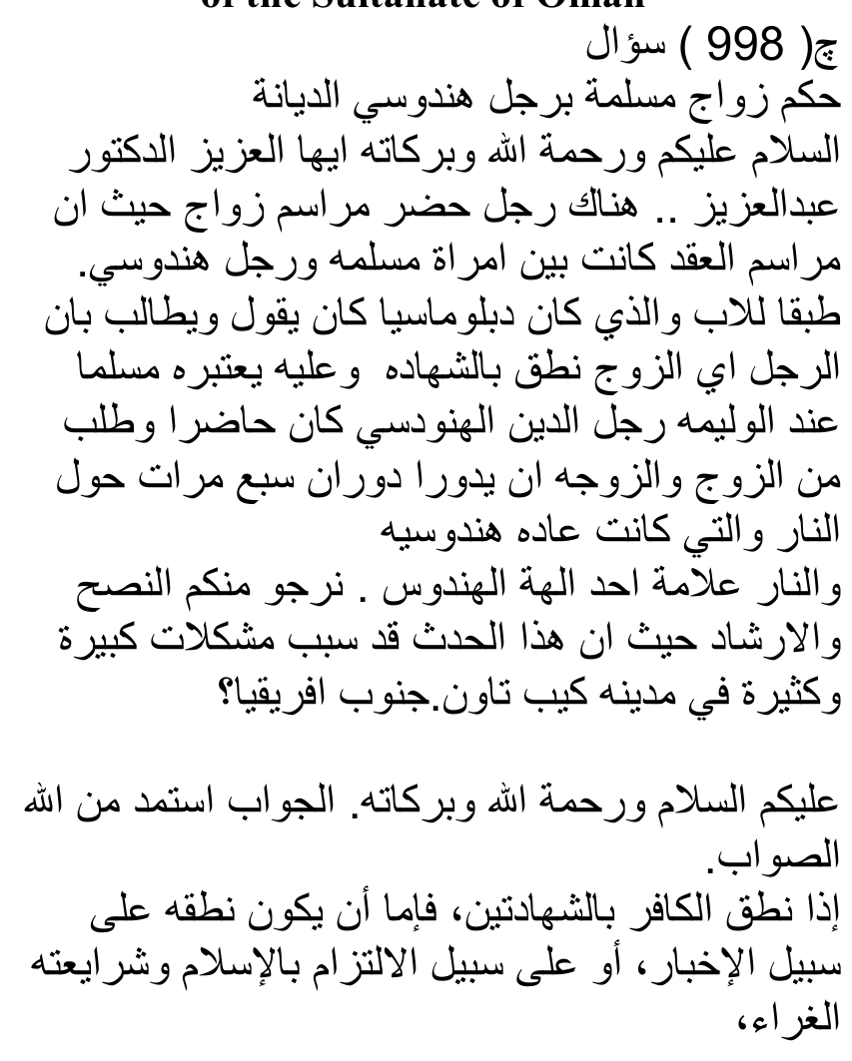
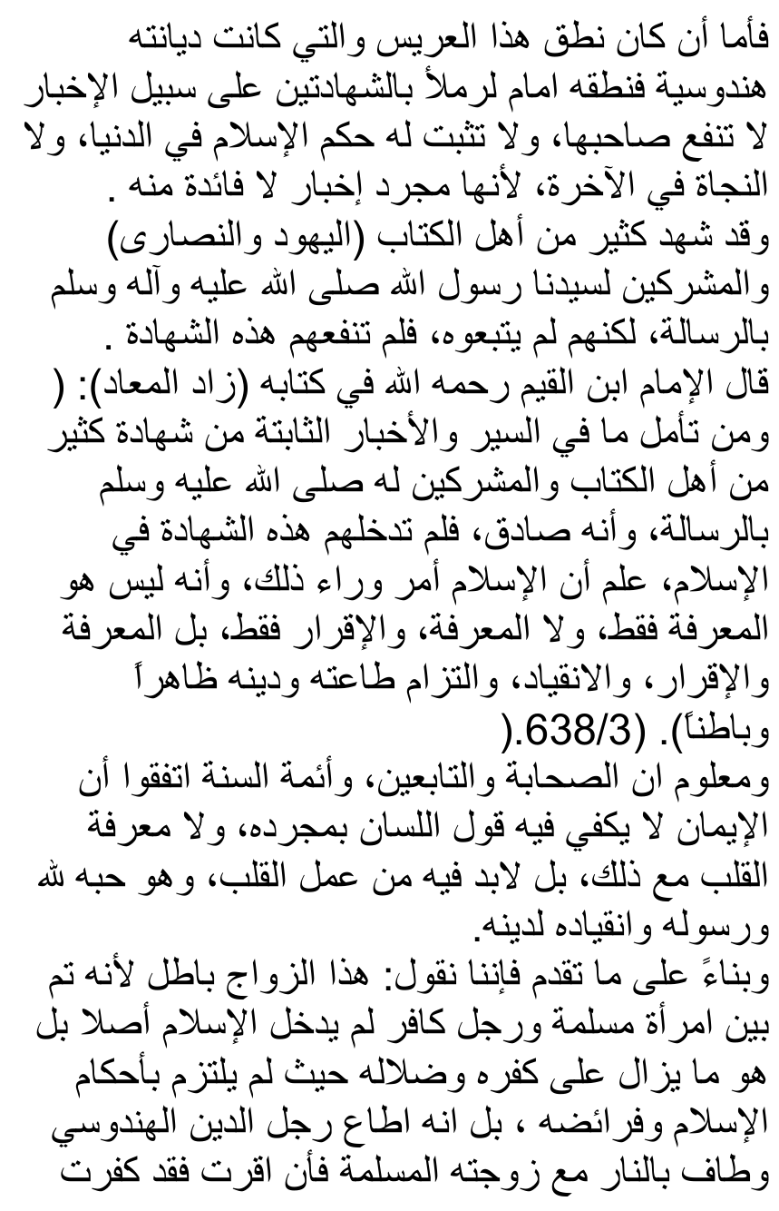
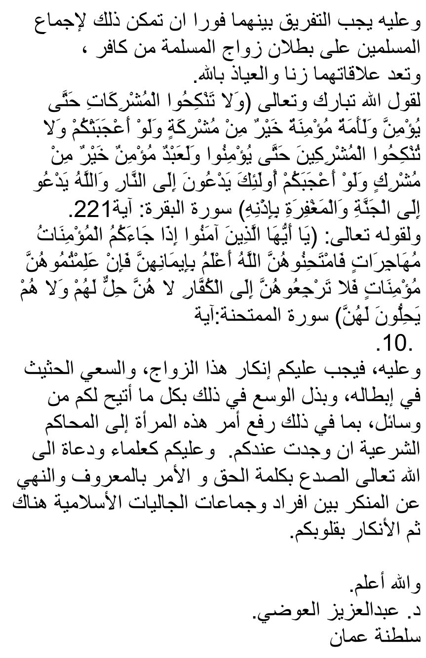
.10.

TRANSLATION OF THE FATWA
The following is the translation of the suppressed Fatwa of Shaikh Abdul Azeez Al-Audhi:
The Ruling on the marriage of a Muslim female with a Hindu man
Question Assalamu Alaikum Wa Rahmatullah Alayhi Wa Barakaatuhu. O Honourable Duktoor Abdul Azeez!
Here a man was present at a marriage ceremony between a Muslim woman and a Hindu man in conformity with (the religion) of the father. He (the father) who was a diplomat (referring to Abraham – The Majlis) maintained that the man, i.e. the husband, had proclaimed the Shahaadah, hence he is regarded a Muslim.
At the reception it was required from the groom and the bride to circumambulate around the fire seven times as is the Hindu custom. The fire is the symbol of one of the Hindu gods.
We hope from you, advice and guidance since this episode has caused intense and abundant difficulties in the City of Cape Town, South Africa.
Answer Alaikumus Salaam Wa Rahmatullahi Wa Barakaatuhu The answer: I seek aid from Allah for Rectitude.
When a kaafir professes the Shahaadatain, then he professes this either by way of information (merely making a statement – The Majlis), or by way of making incumbent (on himself) Islam and its glittering Shariah. If the public profession of the Shahaadatain by this groom whilst his religion is Hinduism was by way of information (ikhbaar), then it does not benefit the man, and the hukm of Islam is not confirmed for him in this world nor will there be salvation for him in the Aakhirah because there is no benefit in mere information (i.e. a hollow statement devoid of Imaani substance – The Majlis)
Numerous of the Ahl-e-Kitaab – Yahood and Nasaara – and mushrikeen had testified to the Risaalat (Prophethood) of our Sayyid Rasulullah (Sallallahu alayhi wasallam), but they did not follow him. Thus, this shahaadat did not benefit them. (The mushrik, Ghandhi and the atheist Bernard Shaw, and many other kuffaar had testified to the greatness and truth of Rasulullah –Sallallahu alayhi wasallam), and so did Abu Taalib, but their testification was in vain. It did not create Imaan in them and will not procure Najaat for them in the Aakhirah – The Majlis)
Imaam Inbnul Qayyim (Rahimahullah alayh) said in his kitaab, Zaadul Ma'aad:
"Whoever reflects on what is mentioned in history and the reliable narrations regarding the numerous people of Ahl-e-Kitaab and mushrikeen who had testified to the Risaalat of Rasulullah (Sallallahu alayhi wasallam), and that verily, he was true, but this shahaadat did not admit them into Islam, will understand (i.e. from this fact) that Islam is something besides this, and that it (Islam) is not merely to know, nor merely knowing and verbal expression. On the contrary, it is Ma'rifat, (to know and understand), iqraar (verbal expression), inqiyaad (submitting in obedience), and making incumbent his obedience and his Deen outwardly and inwardly."
It is known that the Sahaabah, Taabieen and the Aimmah of the Sunnah are unanimous that only verbal expression (of the Kalimah) is not sufficient for Imaan not even together with understanding of the heart. But, the amal of the heart is imperative for it (for Imaan), and that is love for Allah and His Rasool and obedient submission to His Deen.
Based on the aforegoing, we say: This marriage is baatil (null and void) since it was contracted between a Muslim woman and a kaafir man who had not entered Islam at all. On the contrary, he remained on his kufr and dhalaalah (deviation) in view of not having incumbently adopted the laws of Islam and its obligations. In fact, he followed the Hindu religion, and made tawaaf of the fire with his Muslim bride. If she had accepted (this), then certainly she committed kufr.
Immediate Tafreeq (separation) between them is obligatory because of the Ijmaa' of the Muslimeen on the butlaan (nullity) of marriage of a Muslim woman with a kaafir. Their relationship is zina – May Allah forbid- by virtue of the statement of Allah Tabarak wa Ta'ala: "Do not marry mushrikaat until they believe. A female Mu'minah slave is better than a mushrikah even though she is pleasing to you. And, do not marry mushrikeen until they believe. Verily a Mu'min slave is better than a mushrik even though he pleases you. They call you to the fire while Allah calls you to Jannat and Maghfirat with His permission. – Surah Baqarah, Aayat 221
And by virtue of Allah's statement: "O Believers! When the migrating Mu'minaat come to you, then put them to test. Allah knows best their Imaan. Thus if you know them to be Mu'minaat, then do not return them to the kuffaar. They are not lawful for them nor are they (the kuffaar men) lawful for them." (Surah Al-Mumtahinah, Aayat 10)
It is obligatory on you to reject this marriage and to vigorously endeavour to invalidate it, and to strive with all possible means (for achieving this invalidation). Also, the matter of this woman should be taken to the Islamic Court if it exists by you.
And, it is incumbent on you as Ulama and Du-aat to proclaim the Word of Haqq and Amr Bil ma'roof wan Nahya anil munakr to individuals and Muslim communities over there, then (as well) rejecting (this kufr) with the heart (is likewise obligatory on you). And Allah knows best."
(End of the Duktoor's fatwa)

OUR COMMENT
This fatwa is quite significant coming from a Shaafi' Shaikh who is of liberal orientation. He is not a 'fanatic' such as us Deobandis. He indulges in haraam photography and appears on the immoral social media channels. Nevertheless, modernists, liberals, zanaadaqah and murtaddeen can savour this fatwa with some relish. Perhaps Abraham's fossilized heart may become defossilized to glean the haqq from this fatwa emanating from a liberal Shaikh.
Huda is only from Allah Azza Wa Jal.

QUR'AANIC STATUS OF THE ZANAADAQAH
The Qur'aan Hakeem states with the greatest clarity the status of the zanaadaqah, munaafiqeen and murtaddeen so as to leave us in no doubt about the villainy and evil of these shayaateenul ins (human devils) lurking within the folds of the community awaiting opportunities for spreading their shaitaani fitnah to undermine Islam at the behest of their western kuffaar masters who had indoctrinated them with atheism and kufr at these brothel universities which dole out donkey degrees.

THEY ARE RIJS (FILTH)
"They (these munaafiqeen will take oaths by Allah for you (Muslims) when you return to them so that you may overlook their (nifaaq and villainy).
Dissociate from them. Verily they are RIJS (FILTH), and Jahannam is their abode. It is a (fitting) punishment for their perpetration."
(At-Taubah, Aayat 95)

THEY ARE ZAALIMOON
"They who fabricate on Allah lies after this (after the truth has been revealed), indeed they are the Zaalimoon." (Aal-e-Imraan, Aayat 94)

THEY ARE FOLLOWERS OF SHAITAAN
"Among the people is he who disputes about the Aayaat of Allah without (valid) Ilm (Knowledge of the Deen), and he follows every rebellious shaitaan." (Al-Hajj, Aayat 3)

THEY ARE THE TRUE KAAFIROON
"Verily, those who commit kufr with Allah and His Rasool, and they intend to differentiate between Allah and His Rasool (e.g. the so-called first hand and second hand accounts), and they say: 'We believe in a portion (i.e. the first hand account) and we reject a portion (the so-called second hand account), and they intend to adopt an inbetween path. Verily, they are the true (haqqan) kaafiroon. We have prepared for them a disgraceful punishment."
(An-Nisaa', 150, 151)

THEIR ULTIMATE FATE
"Whomever Allah guides, he will be guided, and whomever Allah misleads, never will you find for them friends besides Him. On the Day of Qiyaamah We shall resurrect them on their faces blind, dumb and deaf. Their abode is Jahannam." (Bani Israaeel, Aayat 97)
The aforegoing is a brief account of the status and fate of the zanaadaqah, munaafiqeen and murtaddeen. The Qur'aan is replete with a description of the status and fate of these followers of shaitaan.
These enemies of the Deen slinking within the folds of the community, sporting Muslim names and professing to be Muslims seek to undermine and extinguish the Islam of Rasulullah (Sallallahu alayhi wasallam) by fabricating, as the Qur'aan says, 'a path inbetween'. This 'inbetween path' is the convoluted concept of 'islam' which discards the Ahaadith of Rasulullah (Sallallahu alayhi wasallam), to leave the way open for gross misinterpretation of the Qur'aan to suit the kufr whims and fancies of these villainous agents of shaitaan. But they will not succeed.
"Verily, We have revealed the Thikr (the Qur'aan / the Deen of Islam. And verily We are its Protectors." (Qur'aan)

