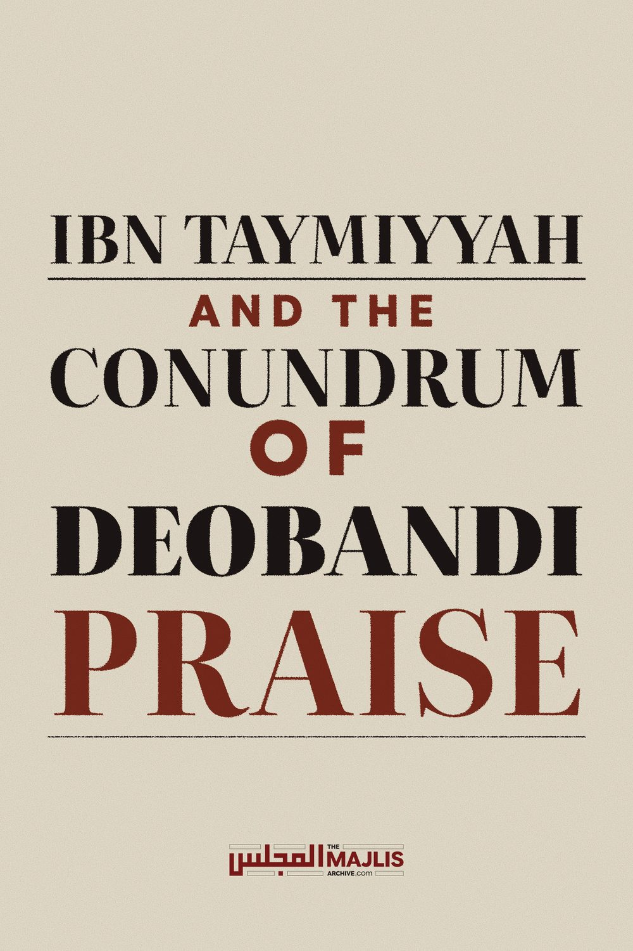

IBN TAYMIYYAH AND THE DEOBANDI PRAISE
The Majlis · Voice of Islam
Mujlisul Ulama of South Africa

About this edition
This is a reproduction by The Majlis Archive (themajlisarchive.com) of a publication of The Majlis, Mujlisul Ulama of South Africa, made and published with their permission.
The PDF as The Majlis issued it is the original. This edition was read from that PDF's own structure and checked against it letter for letter; where the two differ, the PDF is correct.
Checked: 75 paragraphs, 0 differing; a second, independent PDF reader finds 93.6% of the PDF's words here.
Nothing has been reworded, added or removed.

MUJLISUL ULAMA OF S.A.
6056, South Africa

INTRODUCTION
Some of our Akaabir Ulama of Deoband have lauded praise on Ibn Taimiyyah, and this created much obfuscation for laymen who have to contend with severe criticism of Ibn Taimiyyah by many other Ulama of Deoband.
To dispel this confusion, we reproduce in this brief article a question and its answer which appeared in The Majlis, Vol.24 No.8.
A Deeni Student in U.K. wrote an Addendum which further clarifies the conundrum of the praise of Ibn Taimiyyah by some Akaabir Ulama of Deoband. We reproduce the Addendum as well.
Mujlisul Ulama of S.A.
18 Rabiyuth Thaani1439 6 January 2018

QUESTION
Hadhrat Thanvi praised Imaam ibn Taymiyyah and Imaam ibn al-Qayyim, saying they were `Aarifeen, and he referred to Imaam ibn Taymiyyah with the title of Allaamah. Please comment.

ANSWER
In India there was at that time a great dearth of the kutub of Ibn Taimiyyah and Ibn Qayyim, hence most of our Akaabir of that era were unaware of the views of Ibn Taimiyyah. They were therefore justified to speak highly of Ibn Taimiyyah on the basis of the paucity of their awareness of his deviation. If you read some of our own publication of 40 years ago, you will find praise for Ibn Taimiyyah. That was due to our ignorance of his views.
It was years later when Hadhrat Husain Ahmad Madani (Rahmatullah alayh) came from Madinah to teach Hadith in Deoband, that he began to apprize our Ulama of the reality of Ibn Taimiyyah. We are under no obligation to follow Hadhrat Thanvi's view on this issue – a view based on insufficient information. Such 'taqleed' is in fact jumood (fossilization of the brains) which is condemned by the Fuqaha.
Consider the example of stock market shares. Since our Akaabir were unaware of the true meaning of this concept, and since it was erroneously explained to them by some traders and by the one who posed the question, they understood that it was a valid shirkat, hence they issued their fatwa of permissibility. However, those who are aware of this concept, understand its hurmat to be clearer than the sun's light at midday. Now making 'taqleed' of such an error of the Akaabir is satanic jumood (intellectual fossilization).

ADDENDUM BY A U.K. STUDENT OF THE DEEN
The authentic and only correct position regarding Ibn Taymiyyah as conveyed by a Deobandi authority who had had the opportunity to study many of Ibn Taymiyyah's books which were not available in India to most of the Akaabir of Deoband, is represented by the explicit statements below of Shaykh ul-Islam Maulana Husayn Ahmad Madani (rahmatullahi alayh), the Principal of Deoband for around 30 years. Expressing conviction on the Tajseem (anthropomorphism) of Ibn Taymiyyah, Shaykh-ul-Islam states:
"I am certain, having read his unpublished treatises, that he was guilty of innovation in beliefs, Tajseem and so on." (Anwaar ul-Baari)
Shaykh ul-Islam acquired this conviction only after having gained access to Ibn Taymiyyah's unpublished treatises and books in Madeenah which were not accessible in India:
"While I was staying in Madeenah Munawwarah, I saw [Ibn Taymiyyah's] writings and treatises. I even saw some books which are probably not found in any of the libraries of Hindustan. Having read all of them, I came to the conclusion – upon insight – that there was an open deviation and departure from the path of Ahlus Sunnah found in him." (Anwaar ul-Baari) Now that in this day and age the mass-publication and mass-propagation worldwide of Ibn Taymiyyah's books have made his anthropomorphism as clear as daylight (see explicit statements below), and virulent sects are fervently propagating such anthropomorphic beliefs, it would be moronic and an aid for Baatil for someone to dig up some earlier Malfooz (statement) of Maulana Husayn Ahmad Madani in praise of Ibn Taymiyyah while he was still in a state of ignorance or uncertainty regarding Ibn Taymiyyah's Tajseem. It would be similarly moronic and an aid for Baatil for someone to translate and propagate some Malfoozaat of Allamah Taaj ud Deen as-Subki, Allamah Abu Hayyaan al-Andalusi, Allamah Salah ud-Deen al-Alaai, Allamah Quwnawi, Allamah Zamlakani, and numerous others, in profuse praise of Ibn Taymiyyah, when the very same scholars turned extremely harshly against him later on, only after his Tajseem or his numerous other deviations became clear to them.
While the Salafis, Halafis (Salafis masquerading as Hanafis), and their like-minded breeds used to insinuate that the countless Fuqaha (jurists) throughout the ages who had carried out extremely harsh "Jarh Mufassar" (detailed criticism) on Ibn Taymiyyah, were all liars, fabricators, guilty of extreme bias, or part of a massive freemasonic-like conspiracy, in light of the mass-publication of Ibn Taymiyyah's works in this age and the absolute vindication of such "Jarh Mufassar", the Salafis are no longer able to maintain such irrational insinuations which tarnish the judgement and integrity of hundreds of upright scholars for the sake of their dear Mujaddid. "Hazrat-worship" (turning a blind eye to the flagrant evil of one's dear Mujaddid) has never been more evident than in the attitude of the salafi-like breeds towards the deviances of Ibn Taymiyyah. Furthermore, the status of the Salafis as Ahlul Hawaa (people of desires), their hypocrisy, and their double-standards, are most manifest in their indiscriminate application of the principle of "Jarh Mufassar takes precedence over Ta'deel" (i.e. detailed criticism overrides praise), and the sudden and absolute suspension of this principle in regards to Ibn Taymiyyah and his student Ibnul Qayyim. We shall elaborate more on this principle and the Nafsaani-based application of it by the Ahlul Hawaa such as the Salafis in a future article insha-Allah. Consider the following explicit transmission of Mullah Ali al-Qaari that the Salaf-us-Saaliheen would regard as Kaafir the one who attributes a direction to Allah:
"A group from them (Salaf-us-Saaliheen) and the Khalaf said, 'The one who believes in a direction [for Allah] is a Kaafir', as explicitly stated by al-Iraaqi. He said, 'This is the statement of Abu Hanifah, Maalik, Shafi'i, al-Ash'ari, and al-Baqillaani'" [Mirqaat ul-Mafaateeh]
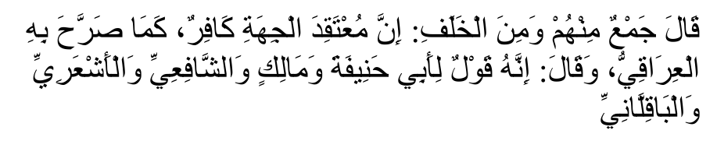
Now that in this age it is manifestly clear without the slightest doubt that Ibn Taymiyyah regarded Allah to be in a specific direction, with countless Salafi sects today propagating such a belief openly and shamelessly, it would be moronic and a complete disservice to the teachings of Mullah al-Qaari himself, to dig out some Malfoozaat of his in praise of Ibn Taymiyyah, while he was obviously ignorant of the fact that Ibn Taymiyyah firmly affirmed a belief that would warrant a Takfeer according to the Salaf whom Mullah al-Qaari himself approvingly quoted. Yet, the Mudaahins (psychophants) of this age do exactly this, thus advertising thoroughly their stupidity.
Perhaps a group of Deobandi Mudaahin Muftis, Maulanas and Shaykhs who have nothing better to do, should embark on the urgent task of digging out Malfoozaat of the Akaabir of Deoband in profuse praise of Maududi, the evil denigrator of the Ambiya (alayhis salaam) and the Sahabah (radhiyallahu anhum). Hadhrat Ilyas Khandelwi, for example, before passing away, paid glowing tribute to Maududi, indicating that Maududi's movement was far more important and valuable than the Tableegh Jama'at. It is obvious that many of the deviate beliefs of Maududi were yet hidden from Hadhrat Ilyas Khandelwi and other Akaabir who had praised him. And, even if some Akaabir did praise Maududi while cognizant of his denigration of the Ambiya (alayhis salaam) and Sahabah (radhiyallahu anhu), we are obliged to regard it as a lapse on their part, now that there no longer exists any ambiguity over Maududi's deviance.
While it is possible for righteous authorities of the past to have committed errors in Furoo' (e.g. certain fiqhi matters), without such errors impinging on their authority and integrity, to grant the same latitude for errors in Usool (e.g. Sifaat of Allah) is to spell the destruction of the Deen. Kufr shall always remain Kufr, regardless of the Nooraniyat shining from the perpetrator's face, or his monumental textual knowledge, or the length of his beard, or the extent of his Zuhd and Jihaad, or the numbers attending his Urs (death anniversary).
If we were to tolerate such evil as the anthropomorphism of Ibn Taymiyyah as vividly apparent in the explicit statements to come below, then justice and consistency would demand that we also tolerate the Baatil of all other deviate sects today. Exhibiting leniency towards such beliefs as Allah having a direction, body, size, Allah being able to sit upon the back of a mosquito, Hell-fire ending for even the Kuffaar, the beginninglessness of the Arsh etc. would entail tolerating all the deviances of the Barelwi grave-worshippers, modernists, feminists, progressives, etc. Perhaps even some of the more 'moderate' Shiah sects will then have to be shoved back into the Ummah.
Furthermore, in authentic Ahadith and narrations from the Salaf, it is clearly indicated that Mudaahanah
(tolerating evil) is THE primary cause of Allah's punishment which often takes the form of brutal Kuffaar armies such as those which are ravaging the Ummah today. According to the Shar'iah, deviations in Aqeedah of the degree of anthropomorphism are worse than adultery and murder. Knowingly propagating and aiding the cause of the leaders of anthropomorphism are worse than propagating adultery and murder.
Thus, the Mudaahin Maulanas, Muftis and Shaykhs of this age should understand that their praise and aid in service of Baatil are not trivial issues that can simply be consigned as Kuffaar-style "academia". They should reflect on their true intention of propagating such Malfoozaat of the Akaabir in praise of deviates which were obviously made in ignorance. Perhaps in the free-lancing deviances of Ibn Taymiyyah there exists a uniquely wide scope for justification for the Tafarrudaat (abominations / anomalies) of their own Hazrats.
A detailed treatise will be compiled elaborating on the beliefs of Ibn Taymiyyah regarding which the Salafi-lovers and the proponents of Mudaahanah bury themselves head-first, deep under the sand. Such is the explicit nature and unambiguous anthropomorphism in the statements of Ibn Taymiyyah which have only been recently published that even many of the most fanatic Salafi breeds have been constrained to adopt a stance of deafening silence regarding them.
For now, for the edification of the sincere Mudaahins who may consider rectifying their Mudahaanah, below is a small sample of explicit quotes straight from the books of Ibn Taymiyyah, whose existence is easily verifiable today, which lift the veil of ambiguity that may have shrouded for many centuries Ibn Taymiyyah's true beliefs which elicited the severe and now completely vindicated "Jarh Mufassar" of hundreds of Fuqaha throughout the ages.
Ibn Taymiyyah's fork-tongued and taqiyyah-like statements elsewhere in other books, in a fashion typical of Ahlul Hawaa, which successfully duped many a scholar, cannot render into non-existence the monstrosities cited below and many other statements of the same category of depravity, which are all absolutely irreconcilable with the true Aqeedah of Ahlus Sunnah wa'l Jama'ah.
Let us begin with Ibn Taymiyyah's explicit, non-taqiyyah affirmation of body (jism) and direction (jihat) for Allah. In one of his many refutations of the Ash'aris, Ibn Taymiyyah employs some typically perverse Salafi Kalaam to "prove" that it is necessary for Allah to have a body and direction, according to how these terms are defined by the Ulama of Ahlus Sunnah wal-Jama'ah:
"It is known that the vision [of Allah in the afterlife] which the Lawgiver has told [us] about cannot be affirmed while negating [for Allah] what they regard as a 'body'. Rather, affirming it [i.e. vision] necessitates [affirming for Allah] what they regard as a 'body' and 'direction'. It is clear that whoever tries to combine these two [i.e. affirmation of vision and negation of 'body' and 'direction'] is stubbornly refusing what is established by reason and by the senses." (Bayaan Talbees al-Jahmiyyah)
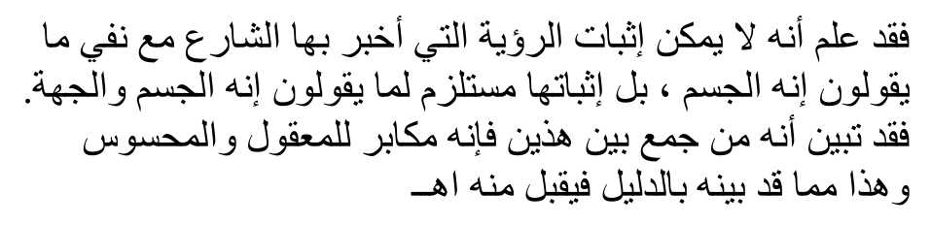
While asserting 'Jism' for Allah in the statement above, Ibn Taymiyyah was, no doubt, well aware of how his opponents defined 'Jism' i.e. "what they regard as a body". This clear-cut definition of 'Jism' of the Ulama of Ahlus Sunnah which Ibn Taymiyyah emphatically and shamelessly affirmed for Allah Ta'ala is:
"[Something with spatial] measurement of length, breadth and depth, which prevents something else from being present where it is, unless it moves from that place."
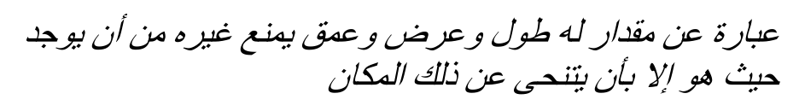
Ibn Taymiyyah employs more stupid Salafi Kalaam here to "prove" that it is impossible for Allah (azza wa jal) not to have a size:
"As for a thing not be described with increase and decrease, nor the absence of that, and it is existent without having a size, then that is inconceivable." (Bayaan Talbees al-Jahmiyyah)
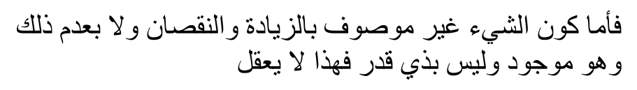
Ibn Taymiyyah explicitly affirms limits for Allah and the "Kufr" of denying limits for Allah:
"Allah, exalted is He, has a limit which nobody but Him knows. It is not permitted for anybody to imagine himself a demarcation to his limit, and rather he must believe in it and consign the knowledge of it to Allah. Allah's place also has a limit, namely [His place] on the Throne above His heavens; so that means two limits.…[Here he cited a number of texts from the
Qur'an which in his opinion show that Allah has a physical limit then he says:] This and what is like it are proofs that all show that [Allah has a] limit and whoever does not profess that has disbelieved in the revelation and denied the verses of Allah." (Muwaafaqah, vol. 2, p. 29)
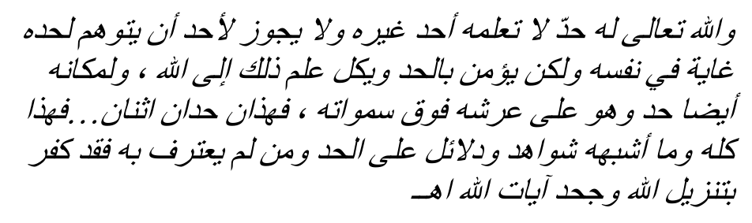
In his Bayaan Talbees al-Jahmiyyah, while gently refuting another Mujassim (anthropomorphist) who restricts Allah to only one limit, Ibn Taymiyyah makes clear that he believes Allah to have more limits from various sides.
Finally to end this short sample, Ibn Taymiyyah states that Allah is actually able to mount on the back of a mosquito, hence this is stupid Salafi Kalaamic "proof" that Allah is actually mounted on the throne: "If He wanted He could board/get on the back of a mosquito and it would hold Him up/carry Him by His power and the gracefulness of His Lordship; so what about a great throne greater than the seven heavens and the seven earths?" (Bayaan Talbees al-Jahmiyyah)
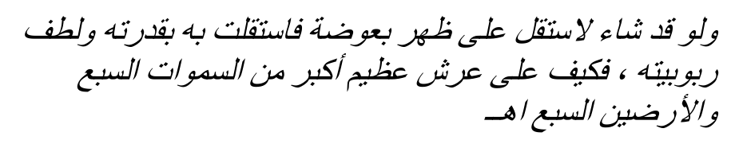
Observe the violent and irreconcilable conflict between Ibn Taymiyyah's explicit affirmation of body (tajseem), direction, size, limits for Allah, etc. with the pure Aqeedah of Rasulullah (sallallahu alayhi wasallam), the Sahabah (radhiyallahu anhu), and the Salaf-us-Saaliheen, as transmitted here by Imam Abu Ja'far Tahaawi (rahmatullah alayh) whom even the Salafis are constrained to accept as an authentic and uprighteous transmitter of the Aqeedah of the Salaf-us-Saaliheen:
"He (Allah Ta'ala) is transcendent beyond limits and boundaries, parts, limbs and instruments. The six directions do not contain Him like (the six directions contain) all created entities." (Aqeedat-ut-Tahaawiyyah)
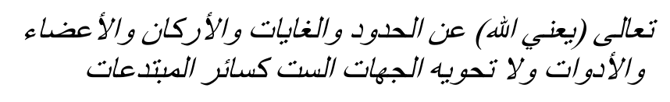
Furthermore, Imam Tahaawi transmits from the Salaf-us-Saaliheen the ruling of Kufr (disbelief) for the one who describes Allah with such attributes that can apply only to created entities which self-evidently includes direction, body, size, limits, ability to sit on the back of a mosquito, and other descriptions with which the Mujassimah such as Ibn Taymiyyah describe Allah Ta'ala:
"Whoever describes Allah with a meaning (or property) from the meanings (or properties) of man, he has committed Kufr (disbelief)." (Aqeedat-ut-Tahaawiyyah)

For the sincere seekers of truth, the "Malfoozaat" (statements) above will more than suffice in providing a glimpse into the abundant reasons due to which Ibn Taymiyyah was severely and rightfully disparaged (Jarh Mufassar) by innumerable righteous scholars in every age, and which thoroughly overrides any praise (Ta'deel) he received from others who had clearly not come across all his abominations in their full gory detail which include literally dozens of contraventions of Ijma' (consensus) in both the spheres of Aqeedah and Fiqh. The future article will highlight and examine many of those abominations in detail insha-Allah.

