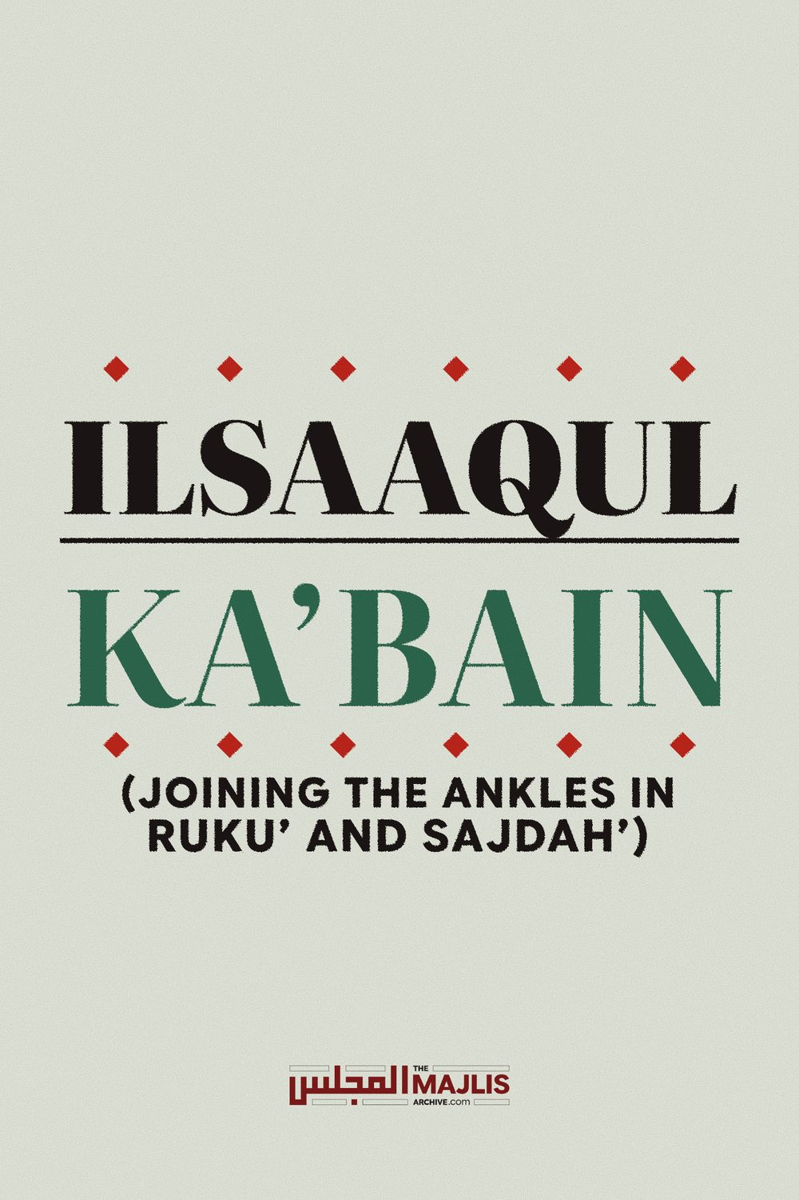

ILSAAQUL KA’BAIN
The Majlis · Voice of Islam
Mujlisul Ulama of South Africa

About this edition
This is a reproduction by The Majlis Archive (themajlisarchive.com) of a publication of The Majlis, Mujlisul Ulama of South Africa, made and published with their permission.
The PDF as The Majlis issued it is the original. This edition was read from that PDF's own structure and checked against it letter for letter; where the two differ, the PDF is correct.
Checked: 44 paragraphs, 0 differing; a second, independent PDF reader finds 100.0% of the PDF's words here.
Nothing has been reworded, added or removed.

ILSAAQUL KA'BAIN (JOINING THE ANKLES IN RUKU' AND SAJDAH')
BY: MUJLISUL ULAMA OF SOUTH AFRICA
PORT ELIZABETH
SOUTH AFRICA

ILSAAQUL KA'BAIN

(JOINING THE ANKLES)
Isaaqul Ka'bain or the joining the ankles in Sajdah has been transformed into a controversial issue by some plastic muftis who have a flair for digging up non-issues and kicking up much dust in their attempt to portray the non-issue as of fundamental importance. Whilst there is a minority view that the ankles during Sajdah should be placed together, it is in conflict with the view of the Jamhur Fuqaha of the Ummah. However, despite the Ilsaaq view being a weak view of a minority, the Jamhur Fuqaha and our Akaabireen have not made an issue of it. But, of late some molvis seeking to project the image of Ijtihaad have converted this mas'alah into a controversial one.
We believe that the retrogressive and divisive attitude of these molvis is the effect of consuming too much halaalized carrion chickens and halaalized carrion meat. Thus, their brains are contaminated with spiritual pollution which constrains them to acquit themselves so stupidly.
In Fataawa Mahmoodiyyah, Vol.9, page 335, Hadhrat Mufti Mahmoodul Hasan (rahmatullah alayh) says: "This is not such an important mas'alah to warrant such debate and dispute." On page 332, Hadhrat Mufti Sahib says:
"The mas'alah of Ilsaaq in the state of Ruku' (as well as in Sajdah) is not to be found in the Mutoon-e-Mutaqaddimah of Fiqh. Thus, this is not a mas'alah of Zaahirur Riwaayat because the Mutoon which have been acquired from Zaahirur Riwaayat are also bereft of this mas'alah."
For those who are interested in the dalaail of the Jamhur, the relevant texts from the kutub are reproduced here.
Fatawa Mahmoodiyyah Vol. 9
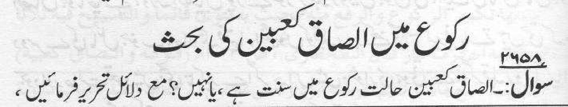
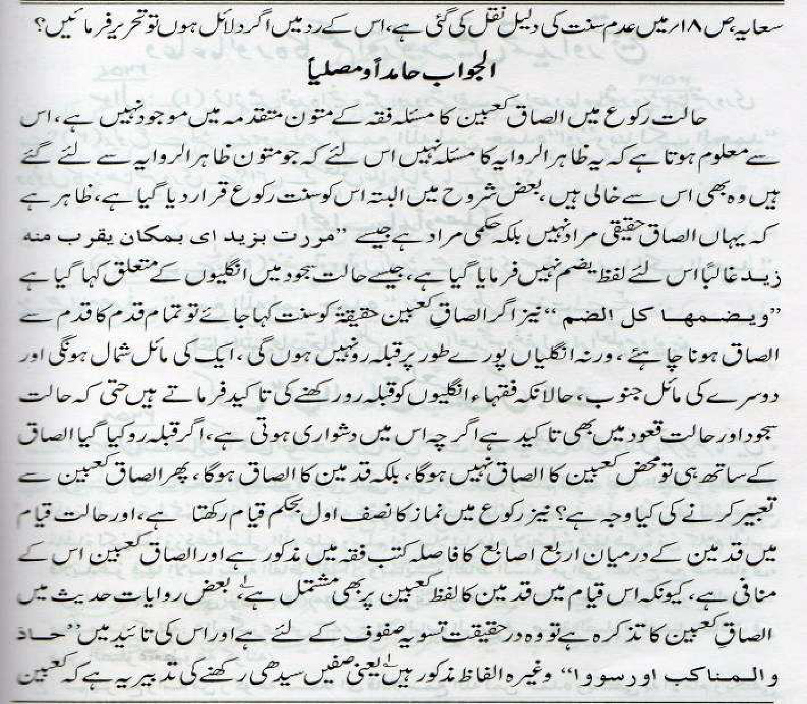
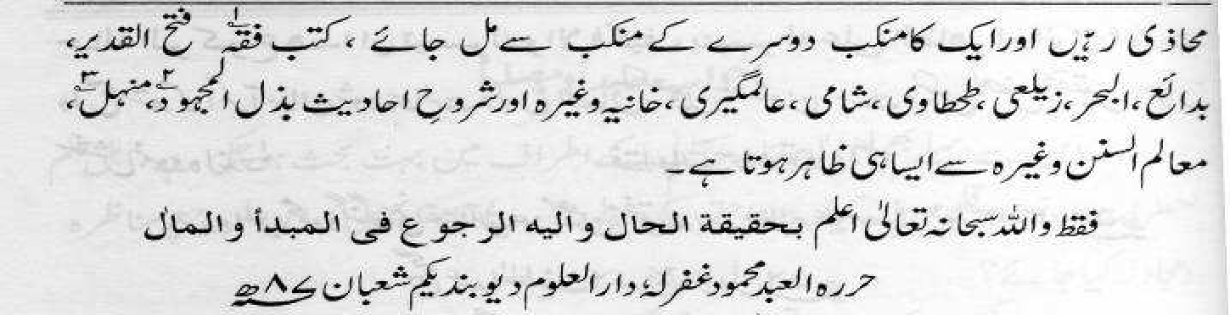
Imdaadul Ahkaam Vol 1
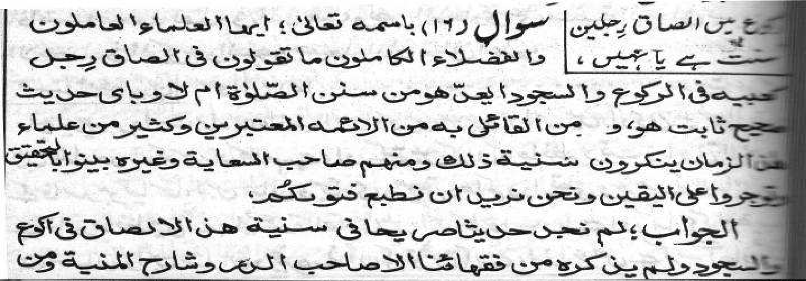
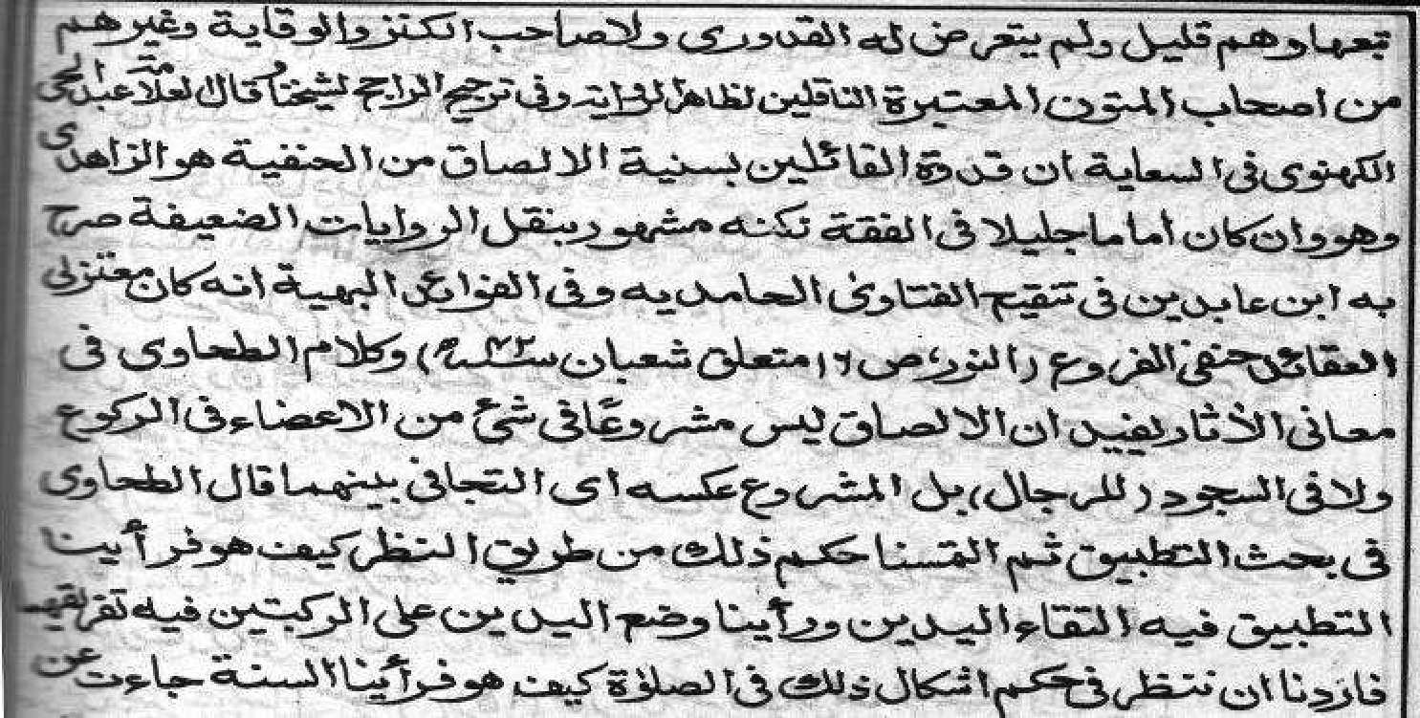
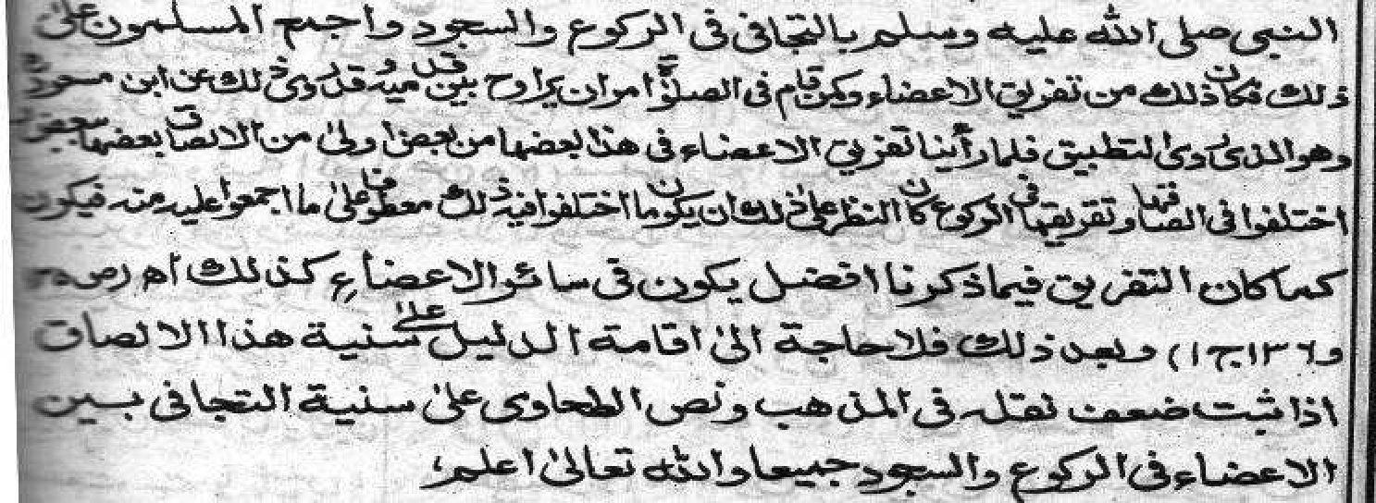
Ahsanul Fatawa Volume3 Page36-40
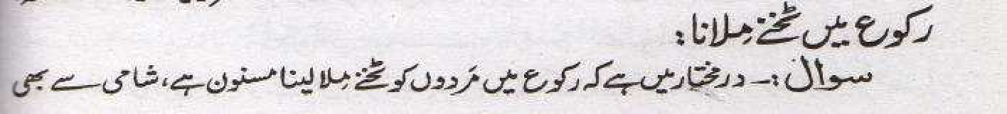
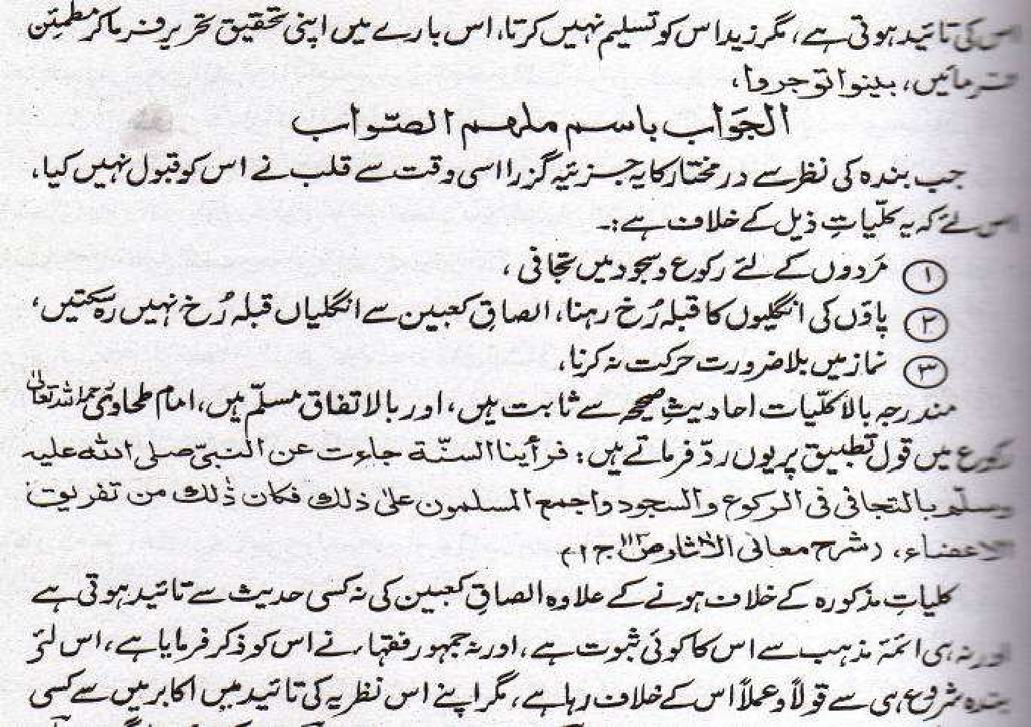
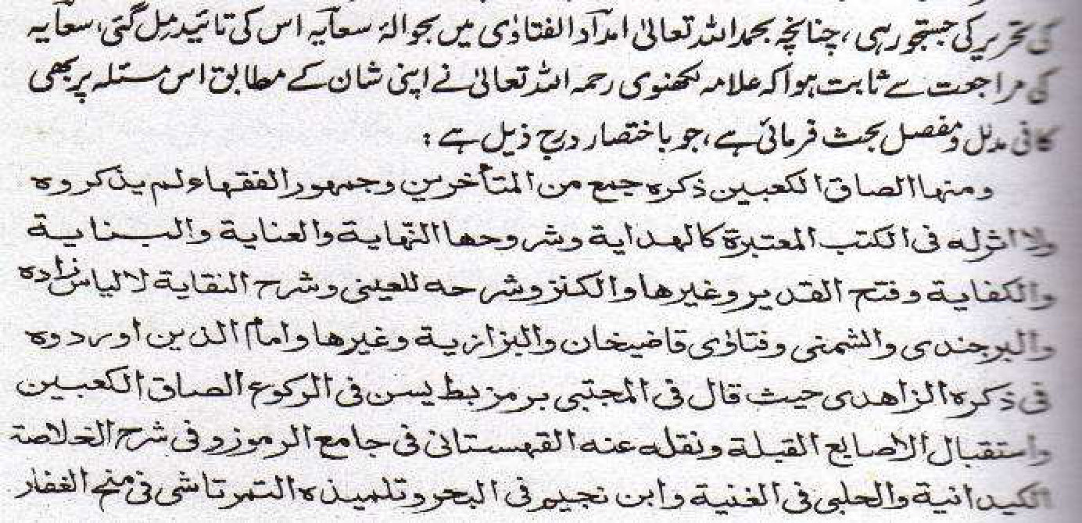
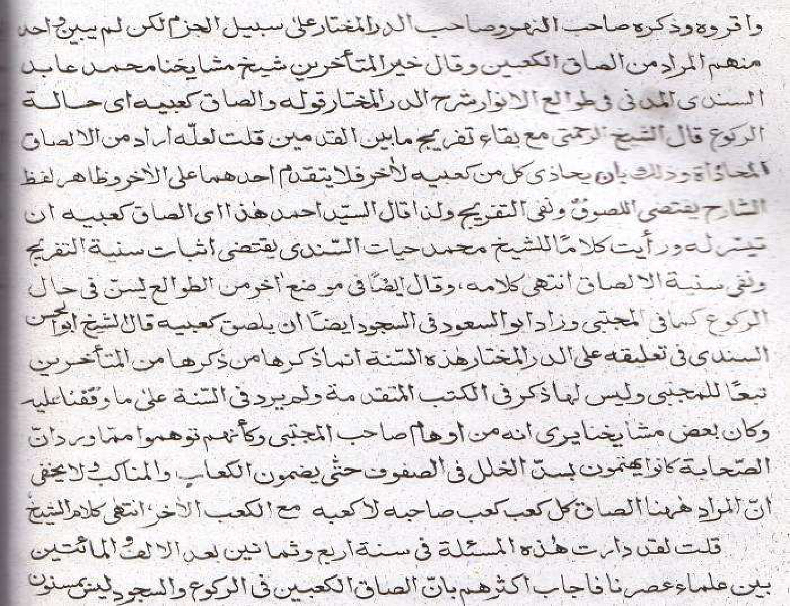
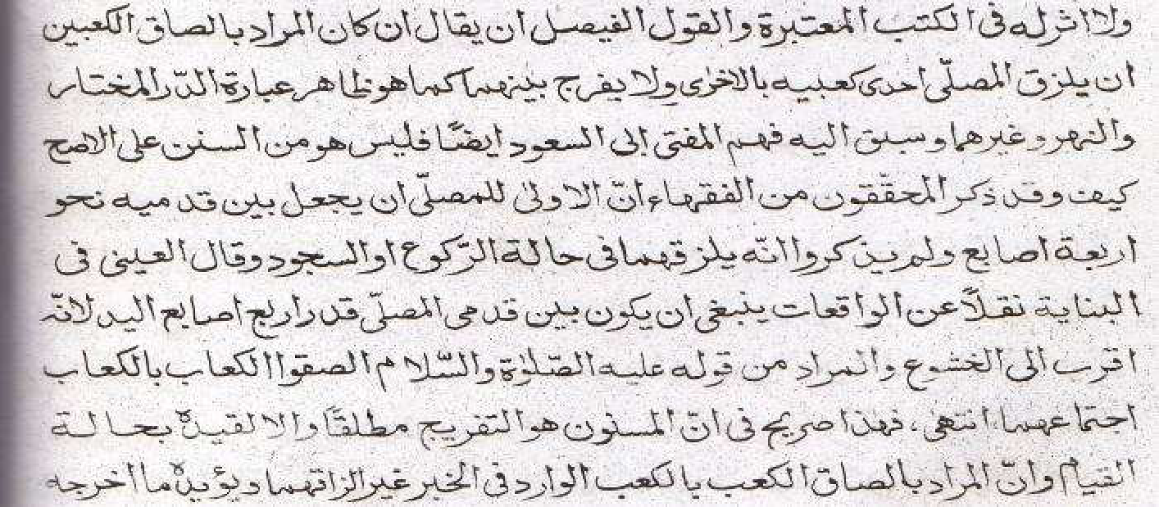
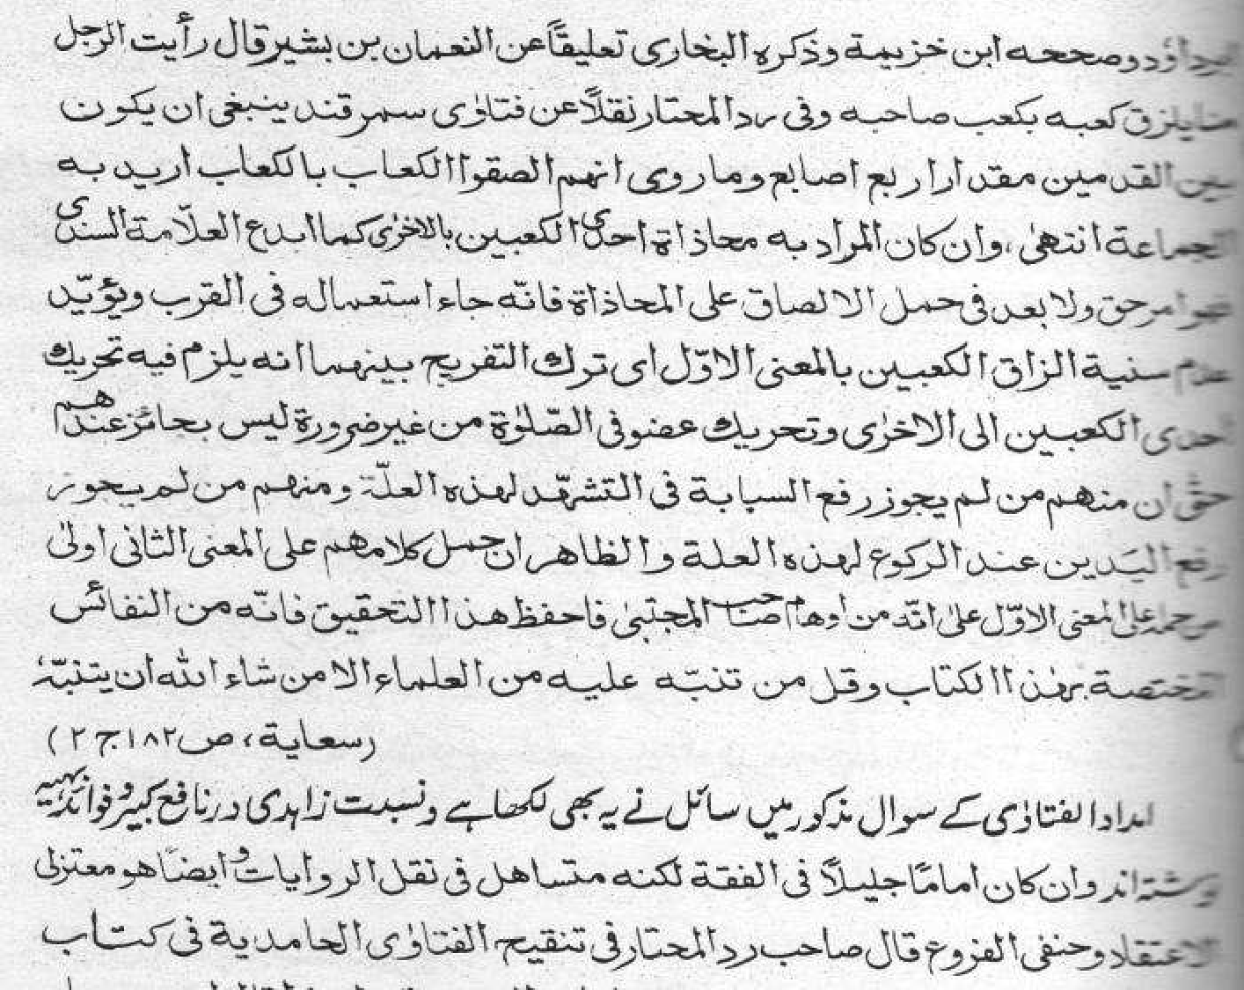
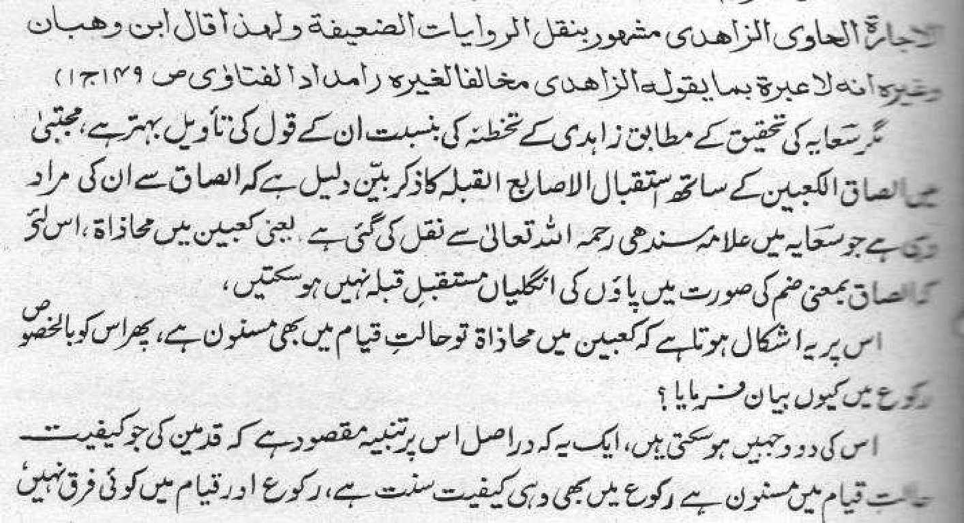
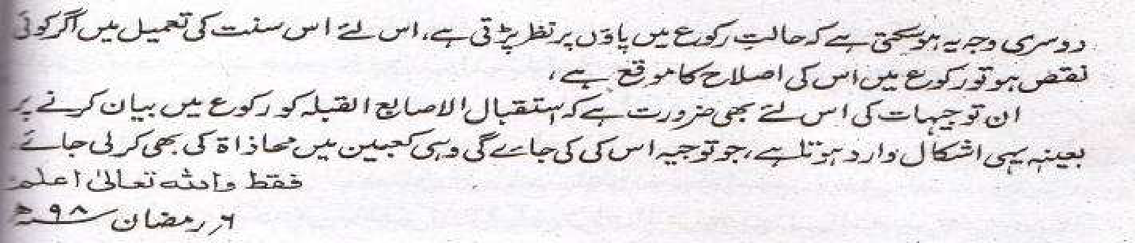
Ahsanul Fatawa Volume 3 Page 49-50
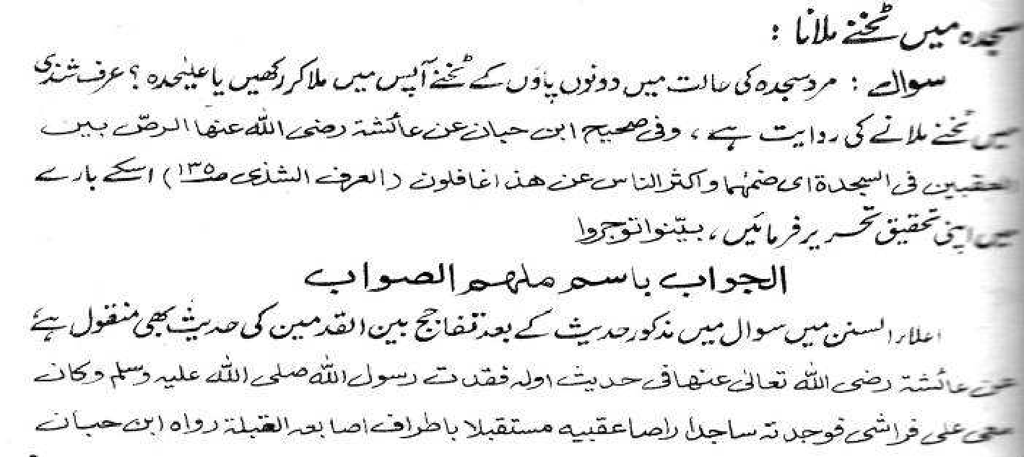
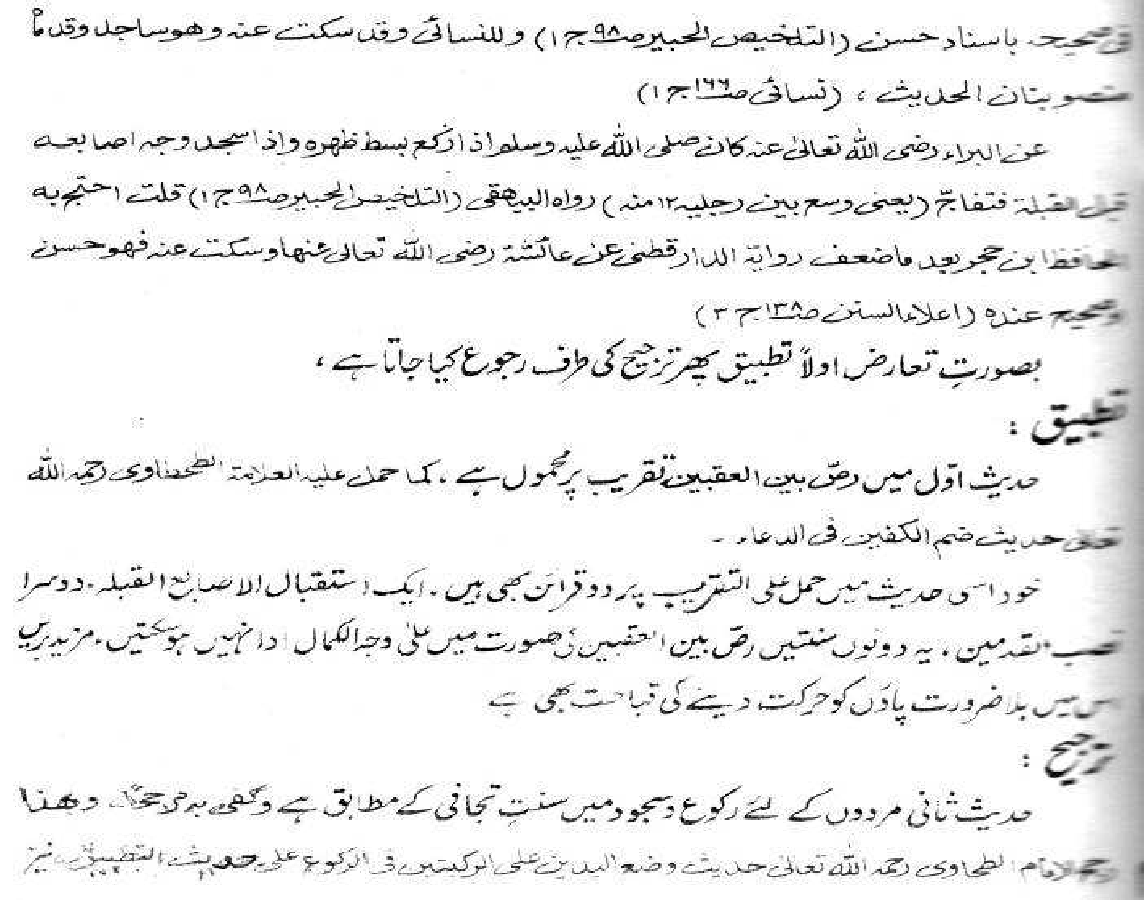
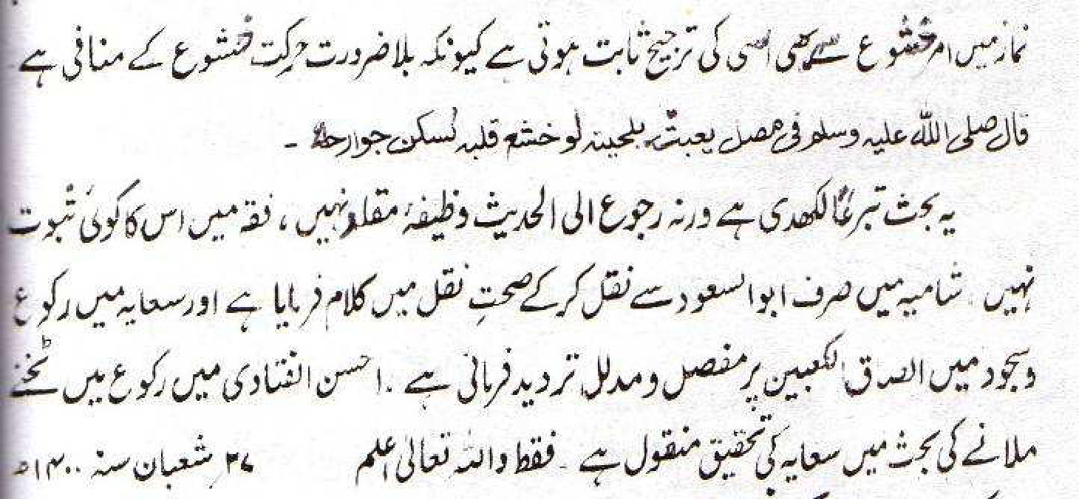

A SYNOPSIS
From the aforementioned dalaa-il of the Akaabir Ulama, the following facts are conspicuous and leave no scope for doubt and ambiguity regarding the practice of Ilsaaq Ka'bain in Ruku' and Sajdah:
(1) Imaam Tahaawi (rahmatullah alayh) categorically refutes Ilsaaq. Thus he says: "Therefore, we see that the Sunnah which has come from Nabi (sallallahu alayhi wasallam) is At-tajaafi fir Ruku' was-Sujood – separation of the ankles in both Ruku' and Sujood. The Muslimoon have enacted Ijma' on this."
(2) The meaning of ilsaaq in this context is muhaathaat, not dhamm (physical joining). The meaning is ilsaaq hukmi, not haqeeqi.
(3) This is not a mas'alah of Zaahirur Riwaayat. Therefore the emphasis on forging a controversy is jahaalat.
(4) According to Allaamah Abdul Hay Lukhnowi (rahmatullah alayh), the first person among the Ahnaaf who claimed that ilsaaq is Sunnah was Zaahidi. Zaahidi was mash-hoor for narrating dhaeef riwaayaat. Whilst he was Hanafi in furoo'i masaa-il, by I'tiqaad he was a Mu'tazili.
(5) According to Allaamah Zafar Ahmad Uthmaani (rahmatullah alayh): "There is no need to establish any daleel for the Sunniyyat of ilsaaq in view of the dhu'f of such narrations having been established in the Math-hab. Furthermore, Tahaawi has stated explicitly the Sunniyat of Tajaafi of the limbs in both Ruku' and Sujood."
(6) The Hadith narrated by Baraa' (radhiyallahu anhu), mentioned in I'laaus Sunan and narrated by Baihqi states: "When Rasulullah (sallallahu alayhi wasallam) made Ruku', he would spread his back, and when he made Sajdah he pointed his toes to the Qiblah and he separated (i.e. he separated his feet)." The term 'tafaaj-ja' is mentioned to describe the separation of the feet.
(7) Ahsanul Fataawa elaborately explains the mas'alah and answers the narrations from which joining the ankles has been concluded.
(8) A salubrious advice for the plastic 'mujathids' of today is what is mentioned in Ahsanul Fataawa, viz. "Rujoo' ilal Hadith is not the wazeefah (function) of the muqallid." The muqallid molvi sahib should cling to the Jamhur Fuqaha and not flaunt his silly and baseless 'ijtihaad'.

CONCLUSION
Ilsaaq of the ankles in both Ruku' and Sajdah is not Masnoon. The Sunnah is Tajaafi. Imaam Tahaawi's view is the final word on this mas'alah.

