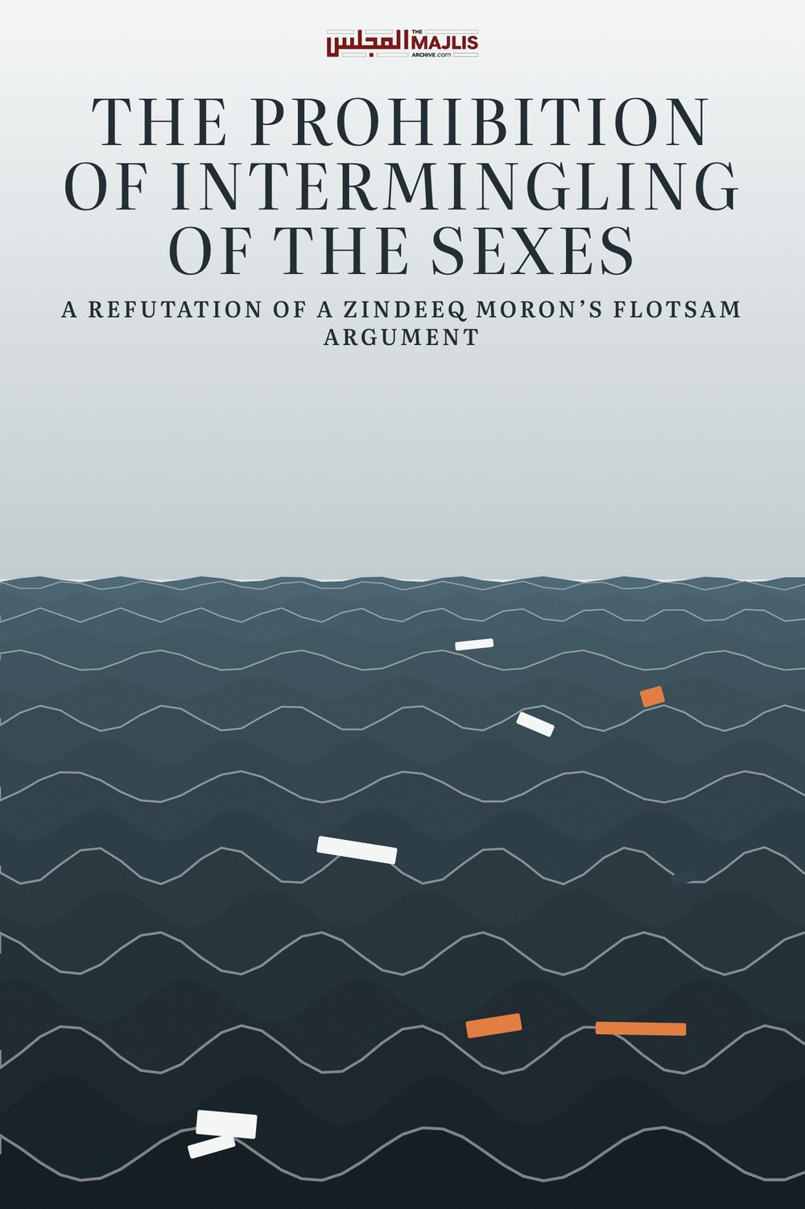

INTERMINGLING OF THE SEXES
The Majlis · Voice of Islam
Mujlisul Ulama of South Africa

About this edition
This is a reproduction by The Majlis Archive (themajlisarchive.com) of a publication of The Majlis, Mujlisul Ulama of South Africa, made and published with their permission.
The PDF as The Majlis issued it is the original. This edition was read from that PDF's own structure and checked against it letter for letter; where the two differ, the PDF is correct.
Checked: 64 paragraphs, 0 differing; a second, independent PDF reader finds 100.0% of the PDF's words here.
Nothing has been reworded, added or removed.

A REFUTATION OF A ZINDEEQ MORON'S FLOTSAM ARGUMENT
THE MAJLIS P.O. Box 3393 Port Elizabeth
6056, South Africa

ISLAM'S PROHIBITION OF INTERMINGLING OF THE SEXES
The following is a letter which a zindeeq representing some kufr renascence organization in the U.K. forwarded to us for comment and for the Shariah's ruling:
"The basic or default ruling of permissibility relates to the original rule concerning actions.
For one to argue that a matter is recommended/obligated or disliked/prohibited, that can only be done on the basis of textual evidences which would be utilised to substantiate either position.
Again we return to the issue that is clearly not well defined - mixing, intermingling - whatever that may mean. To take a tangible example: I was in the hospital today. I had to speak to various health professionals (consultants, doctors, nurses) regarding a patient. These professionals were both male and female. Is the contention that standing near those professionals and asking about the patient prognosis is prohibited? If the contention is yes, then the obvious question is: upon what legal basis is that being argued from?
One can marshal statements but we need to see the evidential basis upon which the position is built from."
AND
The shariah provides clear rulings setting out the standards for behaviour / and detailing what is prohibited- e.g being in seclusion a non mahram man and woman, as Shaytan will be the third, Actions are by intentions etc
From a cursory look at the links you've sent, there is no specific evidence outlining a general prohibition for an ill defined "mixing"
AND
We are not an authority The authority is the book of Allah and the Sunnah of his Messenger saws For one to claim that there is a general prohibition upon any form of interaction or mixing between the sexes, they must provide textual evidence to substantiate it The command to refer back to Allah and his Messenger saws in clearly set out in Quran 4:59
(End of the murtad's letter)

THE LAW OF ISLAM AND OUR COMMENTS
The authors of the stupid argument pertaining to intermingling of sexes are morons, and most probably murtaddeen. No matter what Shar'i proofs are proffered, they will not accept. They masquerade as Muslims. It is therefore futile to even attempt to convince them. Nevertheless, for the benefit of Muslims who may be deceived by the stupid arguments, we shall discuss and refute the bunkum which this haraam kuffaar-type renaissance organization has disgorged.
(1) Their claim: "The basic or default ruling of permissibility relates to the original rule concerning actions."
Firstly, this is not a unanimous principle of the Shariah. Secondly, the morons lack the basic intelligence to even understand the operation of this principle. All actions do not come within the scope of the principle of permissibility. Fornicating with a pig or a gorilla is an action. There is no specific nass (explicit ruling) of the Qur'aan or Ahaadith to prohibit this action. Only a moron with vermiculated brains and decomposed morality as consequences of satanic manipulation will refer these abominable action to the "original rule of permissibility".
Consuming the faeces of a pig is an action. There is no explicit prohibition pertaining to this action. Only satanic morons will thus imply that eating pig faeces is halaal in terms of the 'original rule of permissibility'. Similarly there are countless actions which healthy brains and healthy Imaan will immediately understand to be haraam even without recourse to the Qur'aan, Hadith or any other Proofs of the Shariah.
Consider the Shaafi' mas'alah pertaining to sea-food. According to the Shaafi' Math-hab, all sea animals are halaal except the sea-pig. Yet there is no explicit nass to proclaim the sea-pig haraam. Nevertheless, despite this fact, and the fact of the prohibition being in conflict with the Shaafi' principle and also in conflict with the principle of 'original permissibility of things', the Shaafi' Math-hab decrees that sea-pig is haraam.
Actions are classified in terms of Shar'i principles or explicit rulings of the Qur'aan, Ahaadith or the acts and statements of the Sahaabah, and in the light of the spirit and objectives of Islam if there is no clear or specific directive of Allah Ta'ala or Rasulullah (Sallallahu alayhi wasallam). A ruling shall not be issued simply on the basis of the 'principle of original permissibility'. There are other factors which severely narrow the scope of this principle.
However, if in the action / thing for which there is no specific Qur'aanic or Sunnah ruling nor is there any repugnant attribute in the action/thing, then the principle of 'original permissibility' will be employed. For example: Is eating kangaroo meat halaal? There is no nass in the Qur'aan and Ahaadith for this issue. Since the kangaroo is not a carnivorous animal nor is it regarded among the Khabaaith (filthy animals), the rule of original permissibility will become applicable according to one opinion. Those authorities who do not subscribe to this principle do not accept the ruling based on it. For them, the original principle is Hurmat, i.e. prohibition. If permissibility cannot be proved by nass, the action / thing will be haraam for them.
The application of this rule is based on Islamic factors such as mentioned above. It does not operate in isolation. In other words, there is no unrestricted employment of this principle to gratify the satanism of the nafs and the rijs of the brains of morons - rijs which is the effect of shaitaan urinating in the brains of the morons.
By no stretch of Islamic logic is it possible to apply this rule of 'original permissibility' to the issue of intermingling of sexes. This rule cannot be presented in refutation of any explicit command of the Shariah. The prohibition of intermingling of sexes is a categorical command of the Shariah based on numerous evidences of the Qur'aan and Sunnah. It is moronic and kufr to seek to abrogate the Shariah's laws of Hijaab by stupidly claiming that there are no evidences whatsoever for Islam's concept of Hijaab, hence the principle of 'original permissibility' applies. Only such zindeeqs who are total ignoramuses will venture such a ludicrous claim.
The prohibition of Intermingling of sexes is fundamental to the Qur'aanic concept of Hijaab. Minus this prohibition, the entire concept of Hijaab is negated. Only zindeeq, munaafiq and kuffaar morons promote this view of kufr.
(2) The averment that Shar'i rulings require textual evidence, is correct. There is not a single Fatwa of the Deen devoid of Shar'i basis and textual evidence. But textual evidence is not to be misconstrued to mean a precise reference to the action/thing. There are principles in the Shariah – principles which the Aimmah-e-Mujtahideen evolved on the basis of the Qur'aan and Sunnah, which are applicable to all developing expediencies. Any ruling of the Fuqaha based on these sacred principles will come within the purview of 'textual evidence'. Only morons whose brains have been driven to insanity by the manipulation of Iblees will fail to understand this category of textual evidence.
For the zindeeq and murtad morons, 'textual' evidence is restricted to specific and precise Qur'aanic and Hadith texts. And among these agents of Iblees many do not even accept Hadith texts. For the myriad of masaa-il pertaining to Salaat such as the rules of Sajdah Sahw, Sajdah Tilaawat, Salaat of the Musaafir, etc., etc., etc., there are absolutely no 'textual' evidence of the kind the morons demand for their nafsaani stupidities. A ruling of the Shariah based on the principles evolved by the Aimmah Mujtahideen will be a ruling based on valid textual evidence of the Shariah, and only a zindeeq or a munaafiq or a murtad will deny its validity.
(3) The claim of the zindeeq/murtad morons that the issue of intermingling of sexes is not 'well-defined' in Islam, is satanic bunkum. The following Nusoos specifically prohibit intermingling of sexes:
(a) The Qur'aan Majeed states: "And remain (glued) within your homes, and do not make a display (of yourselves) like the exhibitions of jaahiliyyah."
This Aayat is more than adequate for a Muslim with healthy brains to understand the prohibition of intermingling of sexes. The original law of Islam is that women are cordoned off within the home environment. The objective for this prohibition stated in the Aayat is to prevent intermingling with males in the public domain, for such mingling is a primary stepping stone for zina about which the Qur'aan Majeed states: "Do not approach NEAR to zina." Intermingling of sexes comes directly within the purview of "near to zina". When intermingling of men and women take place, shaitaan is present and zina is in the making.
First comes zina of the eyes, then zina of the ears, zina of the mind, zina of the heart, zina of the tongue and then the ultimate act of zina. All of these major sins stem from intermingling of sexes. The morons are ignorant of the principle that whatever leads to sin is also sinful.
(b) Rasulullah (Sallallahu alayhi wasallam) very strictly prohibited looking at women with lust. The Ahaadith and even the Qur'aanic aayaat on this issue are specific. Wherever there is intermingling of sexes, there will be a preponderence of fussaaq and fujjaar. All their staring will be accompanied necessarily by lust. Hence, Rasulullah (Sallallahu alayhi wasallam) said:
"Whoever looks at the beauty of a woman with lust, hot iron rods will be inserted into his eyes on the Day of Qiyaamah."
Such lustful glancing and gazing are unavoidable in mixed gatherings of men and women, especially in these times where women adorn themselves with designer garb and perfume, etc. Only the progeny of Iblees refuses to accept this reality and the wisdom of the Shariah's prohibition.
(c) Mixed gatherings in the Musjid are not allowed. This is strictly prohibited. Hitherto even in the Musjids in the control of modernists where women are allowed to violate the prohibition and attend the Musjid, they perform Salaat in a separate venue, not together with the men in the same hall or in the same rows. Now when intermingling is not permitted in the Musjid where all are supposed to have pious intentions and standing and bowing in the presence of Allah Ta'ala in the holiest and best of places on earth, then by what stretch of Imaani logic can it be said that intermingling is permissible in the worst of places, namely, the market places, malls and the like where shaitaan is in control and where the nafs has maximum freedom to perpetrate haraam upon haraam?
(d) Rasulullah (Sallallahu alayhi wasallam) did not permit his wives to intermingle or to be even in the presence of a 90 year old blind Sahaabi. When this aged blind Sahaabai entered, Nabi (Sallallahu alayhi wasallam) ordered his two wives to leave the room. When they said that the Sahaabi was blind, Rasulullah (Sallallahu alayhi wasallam) responded: "Are you too blind?"
Only morons whose brains are convoluted with shaitaan's urine will fail to understand this daleel for the prohibition of intermingling of sexes.
(e) Rasulullah (Sallallahu alayhi wasallam) said that women have no share in the road, and should necessity constrain their emergence from the sacred home precincts, they should cling to the sides of the street, not walk in the middle to clash with males.
This Hadith clearly bans intermingling of men and women. If there was no such prohibition, the command for them to cling to the sides would have been superfluous which cannot be expected nor imagined of the Nabi (Sallallahu alayhi wasallam).
(f) According to the Hadith of Rasulullah (Sallallahu alayhi wasallam), the best for a woman is that she should not see men nor should they see her. This was initially the Fatwa of Hadhrat Faatimah (Radhiyallahu anha). When Rasulullah (Sallallahu alayhi wasallam) was apprized of it, he became ecstatic with delight and commented: "Faatimah is a portion of me."
This command can be observed only if there is no
(g) Prior to the ban on women attending the Musjid, they occupied the back rows. After the Fardh Salaat, the men were not allowed to get up and mingle with the females. They would remain seated in their positions whilst the females quickly left the Musjid without performing the Sunnat Salaat. Only after the females had departed would the males get up.
This is a conspicuous upholding of the law of the prohibition of intermingling.
(h) Clinching this argument, is the Qur'aan's command of a separating screen between male and female when there is a need for communicating. Even the pious Sahaabah were commanded to speak to the most pious women on earth, namely, the Holy Wives of Rasulullah –sallallahu alayhi wasallam – from behind a screen when there was a need to speak to them. What should be said and concluded from the unbridled interactions of the men and women of this age in which immorality preponderates?
There are many other similar Ahaadith which very clearly ban intermingling of men and women. But morons with either extremely deficient Imaan or bereft of Imaan promote the evil of immorality, hence their craving for men and women to mix.
The morom's experience in the hospital where he found himself speaking to the female nurses in no way whatsoever detracts from the Islamic prohibition of the intermingling of the sexes. The kuffaar promote and perpetrate immorality of a variety of kind. They are bereft of shame and morality. What they do and what we are constrained to do when circumstances compel us to interact with them, do not affect the Shariah's law pertaining to intermingling of sexes.
If there had existed strict Shariah Law, the moron would not have been confronted with the situation which he experienced at the hospital. There are numerous Shar'i violations which Muslims are compelled to commit in non-Muslim countries as well as in all the secular Muslim countries. There is no Shariah enforcement anywhere. The Shariah's laws remain sacrosanct and valid regardless of the evils and the evil environment in which we find ourselves. Thus, when Muslim males and females intermingle with the kuffaar in public places, the Law of Prohibition remains intact. It shall not be said that the intermingling occurring in the malls and at the airports, etc. is permissible. The furthest we can venture is to say that circumstances constrain the perpetration of these violations of the Sacred Law of Allah Ta'ala.
The example of the moron in the hospital is a stupid presentation of a stupid 'proof' for his hallucinated permissibility of intermingling of men and women. His interacting with the female nurses in no way whatever has any adverse effect on the Islamic prohibition which remains intact and in force. Wherever the Law can be observed, it will be obligatory to uphold it. The Law may not be violated simply because a moron interacted with females in the hospital.
The Shar'i legal basis for the prohibition is explained above and throughout this discussion. But it will be comprehensible to only People of Imaan, not to moron munaafiqs and zindeeqs who overtly profess to be Muslims whilst kufr lurks in their hearts.
The prohibition of intermingling of sexes has been the Law upheld by fourteen centuries of Islam's history. At no stage in the history of Islam was this prohibition up for review or for questioning. It is only recently that the zindeeq and munaafiq morons who have lapped up western kufr are denying this prohibition on which the entire World of Islam had always practised since the era of Rasulullah (Sallallahu alayhi wasallam).
Yes, the Shariah sets out clear rulings and sets out clear standards for behaviour. One such clear ruling is the Qur'aanic command: "Do not approach NEAR to zina.". This is a fundamental basis for the prohibition of intermingling. Just as being in seclusion is a 'clear ruling'. So too is the prohibition of coming near to zina a clear and an emphatic ruling. All stepping stones of zina are clear and come within the scope of this Qur'aanic Aayat.
As for the moron's averment: "Actions are by intentions", his stupidity has precluded him from understanding the Hadith pertaining to actions based on intentions. A good intention NEVER justifies nor permits an evil deed. Zina and Riba will not become halaal on the basis of a good intention. Gambling and robbery will not become halaal on the basis of the good intention to contribute all the proceeds to the poor and destitute.
Relevant to actions, pious deeds will be nullified by evil or insincere intentions, but evil and haraam deeds will not be transformed into halaal deeds by means of pious intentions. Thus, the evil of intermingling of sexes will NEVER become lawful on the basis of whatever good intention the moron may be able to hallucinate or imagine. The sin will remain haraam sin notwithstanding the imagined good intention.
The thrust of the Qur'aanic Aayaat, the numerous Ahaadith, the life pattern of the Sahaabah and in general of the Ummah down the long corridor of Islam's history constitute the specific and the emphatic evidence for the prohibition of the western immoral practice of intermingling of sexes.
The moron is in clear denial of the Authority of the Qur'aan and Sunnah, hence he so audaciously denies the well-known, well-established and well-defined Law of prohibition of intermingling of the sexes.

