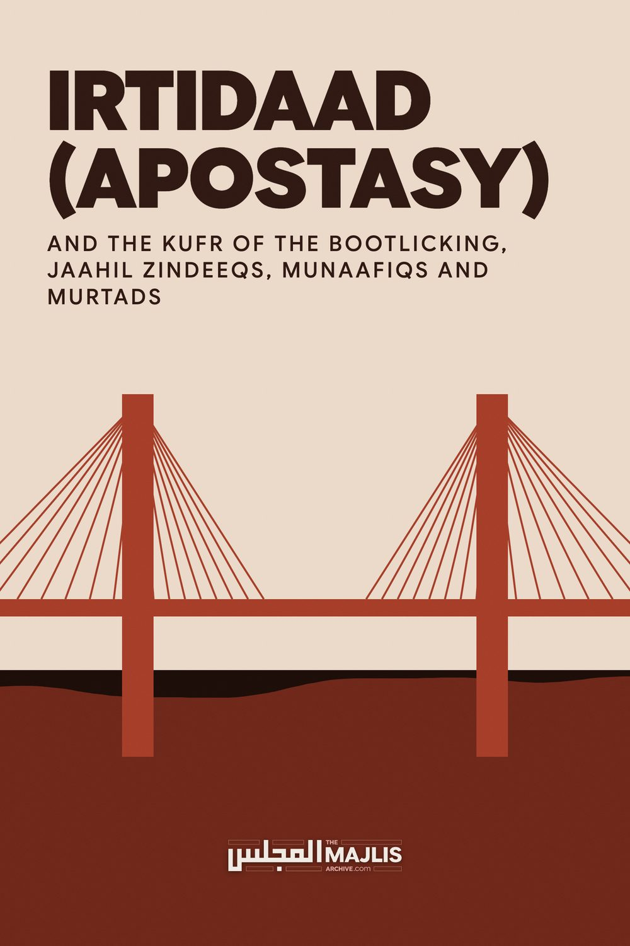

IRTIDAAD (APOSTASY)
The Majlis · Voice of Islam
Mujlisul Ulama of South Africa

About this edition
This is a reproduction by The Majlis Archive (themajlisarchive.com) of a publication of The Majlis, Mujlisul Ulama of South Africa, made and published with their permission.
The PDF as The Majlis issued it is the original. This edition was read from that PDF's own structure and checked against it letter for letter; where the two differ, the PDF is correct.
Checked: 72 paragraphs, 0 differing; a second, independent PDF reader finds 100.0% of the PDF's words here.
Nothing has been reworded, added or removed.

AND THE KUFR OF THE BOOTLICKING, JAAHIL ZINDEEQS, MUNAAFIQS AND MURTADS
By:
Mujlisul Ulama of South Africa

Port Elizabeth
"This Day have I (Allah) perfected for you your Deen, and (on this Day) have I completed for you My Favour (Islam),
And chosen for you Islam as your Deen.
(Al-Maaidah, Aayat 3)
"Then, We have established you on a Shariah regarding (all your affairs). Therefore, follow it (this Divine Shariah), and do not follow the vain desires of those who know not (who are morons)."
(Al-Jaathiyah, Aayat 18)
"What! Do you search for the law of jaahiliyyah? And, whose law is more beautiful than the Law of Allah for a people who has yaqeen (resolute faith in Allah)?"
(Al-Maaidah, Aayat 50)
Islam was completed and perfected more than 14 centuries ago, hence Nubuwwat terminated with Muhammad (sallallahu alayhi wasallam) more than 14 hundred years ago. The Qur'aan explicitly and emphatically declares the perfection of Islam – Allah's Law – His Shariah – which Allah Ta'ala depicts as His Favour for the Ummah.
The very finality of Nubuwwat, perfection and completion of the Divine Shariah are the absolute evidence for this Shariah ever remaining in the same state as it was during the era of Khairul Quroon. It does not tolerate the slightest interpolation, change, and re-interpretation as the modernist juhhaal with western colonized brains advocate at the behest of their western kuffaar masters whom they obsequiously bootlick.
Should there have been any need for a new Shariah, Allah Ta'ala would not have terminated the Chain of Nubuwwat which had initiated with Hadhrat Aadam (alayhis salaam). The Chain would have continued until the Last Day. But Divine Wisdom dictated that in view of the perfection, completion and finalization of Allah's Law for His creation, Nubuwwat after Muhammad (sallallahu alayhi wasallam) would be a redundant institution.
Reinterpretation is effectively man-made, nafsaani fiction presented as 'law' which in reality is satanically spawned and presented under 'islamic' hues to beguile the ignorant masses.
Juhhaal posing as 'scholars' and 'mujtahids' are disgorging considerable kufr drivel and flotsam in their comments on the recent Sudanese case pertaining to adultery and apostasy (irtidaad). It is not our intention in this dissertation to comment on the merits and demerits of the Sudanese case since the true facts of the saga are ambiguous or unknown. The only source of information hitherto available on this issue is what the rotten, rabidly anti-Islam, anti-Muslim western media feed to the masses. It is therefore unintelligent to comment on the case on the basis of what the stercoraceous western media reports.
The purpose of this discussion is twofold: (1) To state Allah's Law on the issue of Irtidaad (apostasy – renouncing Islam by a professed Muslim), and (2) To debunk the copro-rubbish which the paper 'mujtahids'- the juhhaal who dwell in the limbo of Jahl-e-Muraqqab -- peddle in compliance with the command of their western masters who have colonized their brains.

IRTIDAAD
Irtidaad (apostasy) according to the Shariah, is to renege from the Deen of Islam and to embrace kufr whether by intention or an act of kufr or a statement of kufr, even if the commission of kufr is in jest.
Spelling out the effect and consequences of irtidaad, the Qur'aan Hakeem declares:
"Whoever apostatizes (commits irtidaad) from his Deen, and dies
(in the state of irtidaad), verily, he is a kaafir. Their deeds are eliminated in this world and the Aakhirat. Indeed, they (the murtads)
are the companions of the Fire. They will dwell therein forever."
(Al-Baqarah, Aayat 217)
The Qur'aan condemns the murtad to eternal damnation. He/she will remain in Jahannam forever. Their punishment in the Fire will be never-ending.
Irtidaad is the vilest of all acts and words of kufr. All deeds of virtue rendered prior to irtidaad are destroyed. The murtad's nikah is automatically nullified, and he is deprived of inheritance.
The murtad will be apprehended and detained for three days. He/she will be counselled. If the male murtad is adamant on his irtidaad after three days, he will be forthwith executed with the sword. If the murtad is a female, she will be detained in prison indefinitely, even for life. She will be released only after embracing Islam.
There exists Ijma' of the Ummah on the execution of the murtad. There is no difference of opinion among Fuqaha of Islam on this issue. Rasulullah (sallallahu alayhi wasallam) had commanded:
"He who changes his Deen, kill him."
"The blood of a Muslim is not lawful except three:
Adultery, murder and one who renounces his Deen."
On the occasion when Rasulullah (sallallahu alayhi wasallam) dispatched Hadhrat Muaaz Bin Jabal to be the governor of Yemen, he instructed him:
"Any man who commits apostasy from Islam, then (first) call him
(to Islam). If he refuses, then smite his neck."
There is consensus of all authorities that the murtad shall be put to death. However, if the murtad is a female, she shall be imprisoned according to Imaam Abu Hanifah. But according to all other authorities of all Math-habs, she too shall be executed.
Although the consequence of irtidaad is execution, this is the right of only the Islamic State. It is not permissible for an individual or a group of individuals to execute a murtad. He may be executed only in an Islamic State after the due process of the Shariah has been followed.
In an article in defence of murtads, one murtad/munaafiq, Rashied Omar states:
"No state or government should intervene in or criminalise someone's personal choice of religion. Choosing or changing one's religion is not a crime – it's a basic human right." This baatil view of kufr is attributed to the zindeeq by the Daily News.
There is complete unanimity of the Fuqaha of all Math-habs that a murtad must be executed. In Islam, it is the obligation of the Islamic State to intervene, criminalise and execute the scum who changes his religion. While in an Islamic state non-Muslims are free to switch from religion to religion, this exercise is not tolerated in so far as Muslims are concerned. Rashied Omar has simply disgorged kufr lurking in the heart by advocating a view which has absolutely no validity in Islam.
The Qur'aan and the Sunnah are explicit and emphatic in the decree to eliminate murtaddeen. Islam is the Qur'aan and Sunnah. It is not the flotsam which self-styled 'scholars' disgorge.
MA and PHD degrees conferred by the University of Cape Town or any other secular university, whether 'Muslim' operated or kuffaar, do not elevate a man to the pedestal which is occupied by an Islamic Scholar or Aalim of the Deen. Chaps sporting such degrees are basically juhhaal in terms of the Sharia. Their opinions of kufr are the type of ghutha which confirms the abode of Jahannam for its proponents.
Contrary to the claim made by the Daily News, there is no 'growing community of Islamic scholars worldwide" who align themselves with the kufr view which the modernist juhhaal promote. Those who deny the Shariah's law pertaining to the execution of murtads are modernist munaafiqeen and juhhaal. They are not Ulama of the Deen. The 'religious' products produced by secular universities are all bootlickers of their kuffaar western masters. Their views and opinions are flotsam and jetsam which eliminate Imaan. Despite them professing to be Muslims, they themselves are murtads.
The Daily News states: "Omar argues that among the core principles of Islam, as enunciated in the Qur'aan, is the verse that reads "Let there be no compulsion in religion". This verse establishes the importance of one's own personal religious convictions and as such matters of conscience cannot be forced on anyone."
This view further illustrates and confirms the jahaalat and kufr of its proponent. The relevant Qur'aanic verse cited here refers to non-Muslims. Non-Muslims may not be compelled to convert to Islam. The issue which constitutes our subject is irtidaad (apostasy), not conversion to Islam. The Qur'aanic verse stupidly cited refers to the prohibition of forcefully converting non-Muslims. It does not relate to irtidaad. When the miscreant 'scholar' lacks this awareness, it speaks volumes for his jahaalat in the field of the Uloom of the Deen.
The Qur'aan commands the utilization of force on those who violate the teachings of the Shariah. Thus, the Qur'aan provides for hand-amputation for theft, flogging for fornication, execution, impalement and public display of the dead bodies of highway robbers, execution for murtads, etc. The force used in Islam's penal code is not a secret. Rasulullah (sallallahu alayhi wasallam), himself had ordered the execution of murtads. Mr.Omar cannot impart any lesson in Qur'aan-Understanding to Rasulullah (sallallahu alayhi wasallam), the Sahaabah and the illustrious Fuqaha of Islam. There is absolutely no scope in the Shariah for accommodating the kufr views of re-interpreting the ahkaam of the Shariah - a kufr exercise which the modernist juhhaal 'scholars' have lapped up from the vomit of the orientalist enemies of Islam staffing the so-called 'Islamic Study' faculties in shaitaan's universities.
The Daily News further says: "Omar expresses relief that in recent decades there has emerged a growing community of scholars who argue for more lenient and humane positions on apostasy."
This view is clear-cut kufr. What the murtad avers here is that the laws which Allah Ta'ala had revealed to Muhammadur Rasulullah (sallallahu alayhi wasallam) are 'inhumane'. The kufr and irtaad are thus confirmed. As mentioned earlier the 'growing community of scholars' is a figment of the hallucination of the juhhaal. In Islam these aberrations are not scholars. They are juhhaal who dwell in the domain of Jahl-e-Muraqqab.
Furthermore, in stating this kufr view there is an acknowledgement of the fact that for fourteen centuries, Islam's command pertaining to irtidaad was something at variance with the "more lenient" position which the modernist munaafiqs have propagated so belatedly as a couple of decades ago. The Shariah is not a couple of decades old. The Shariah is Allah's Law which He Himself had perfected and finalized more than fourteen centuries ago. Thus the Qur'aan Majeed declares:
"This Day have I (Allah) perfected for you your Deen, and I have completed for you My Bounty, and chosen for you Islam as your Deen."
Islam is not what murtads and munafiqs have introduced a couple of decades ago. Islam is the Divine Code of Life embedded in the Qur'aan and Sunnah. Islam is not at the mercy of these modernist zindeeq murtads for interpretation and exposition. It is what the Fuqaha of this Deen had formulated and codified fourteen centuries ago. There is absolutely no scope for shoving into its framework the slightest element of modernist kufr. Refuting the laughable stupidity of the denial of the utilization of force for asserting the domination of Islam, the Qur'aan Hakeem commands the Islamic Rulers:
"Fight (Qitaal/Jihaad) those from the People of the Book (Yahood and Nasaara) who do not believe in Allah and the Last Day nor do they accept as haraam what Allah and His Rasool have made haraam nor do they follow the Deen of Haqq (Islam)— fight them - until they subserviently pay the Jizyah whilst they are in humiliation." (Aayat 29, At-Taubah)
With regard to Jizyah, its imposition is for non-Arab kuffaar. As far as Arab kuffaar are concerned, there is no Jizyah for them. There are only two options for them: Islam or the Sword. If a kaafir Arab refuses to embrace Islam, the Shariah orders his execution.
There are numerous laws of Islam which explicitly impose the use of force to compel acceptance of the ahkaam of the Deen. The contention of there being 'no force in the Deen', is the effect of orientalist indoctrination which has convoluted the brains of the modernist bootlickers of the west. The Qur'aanic verse which prohibits force, pertains exclusively to compelling non-Muslims to embrace Islam.
The Daily News stating another moronic view of the westernized murtad bootlickers and bootleggers, writes:
"They (i.e. the modernist murtads) furthermore argue that the hegemonic classical Muslim position failed to separate the issue of simple apostasy to treason."
This averment is another veiled contention of kufr. The "hegemonic classical Muslim position" is the position of the Qur'aan and of the Sunnah. It is the position of the Sahaabah, and it is precisely this Qur'aanic position which the Fuqaha transmitted to the Ummah, and the first wrung in the Ladder of the Fuqaha are the Students of the Sahaabah. There has never been two positions in Islam on the issue of apostasy. Apostasy (Irtidaad) is the worst act of treason. There is no greater and viler act of treason in Islam than irtidaad.
The modernist juhala zindeeqs, munaafiqs and murtads have exhibited their stupidity with their kufr attempt at differentiating between apostasy and treason. While there is a difference in kuffaar law which accepts apostasy as a 'right' of the individual, in Islam there is absolutely no difference. On the contrary, irtidaad is the highest category of treason. Whilst lesser categories of treason are tolerable, acquitable and forgivable, and for which execution is not mandatory, there is only the death sentence for apostasy (irtidaad), if the murtad (apostate) intransigently and satanically opts for his apostasy. The Islamic concept of treason does not exclude apostasy. The attempt by these modernist murtads to portray a difference between apostasy and treason, is due to their stupidity, indoctrination and bootlicking of their orientalist masters. It must be reiterated and emphasized that in Islam irtidaad is the worst act of treason for which the sentence is execution after a respite of three days.
Quoting the murtad so-called 'scholar, the Daily News says:
"This recent and widely publicized incident of apostasy once again highlights the urgent need for Muslim scholars to seriously re-examine traditional FIQH (jurisprudence) rulings on leaving the fold of Islam."
This is a laughable, stupid plot which is doomed to fail. In fact, it has already been put into action more than a century ago by the orientalist enemies of Islam who have lined up these modernist zindeeqs to peddle the pernicious plot under 'Islamic' guise. These modernist munaafiqs who are the real enemies from within the folds of the Muslim community, have for decades laboured tediously and abortively to scuttle the whole of Islam with their kufr interpretations shoved into their kufrized brains by the orientalists at the so-called 'Islamic Studies' faculties at the kuffaar universities where all these zindeeq bootlickers and bootleggers scavenged their scrap 'knowledge'.
These western bootlicking 'intelligentsia' who are notorious for licking up the spittle and vomit of their masters are in for terrible surprises. Their nefarious, satanic goal of scuttling the Classical Shariah with its Classing Fiqh will ever remain an empty pipedream for them. While they may hallucinate a're-examination' of Allah's Shariah, it will never take place. Such a shaitaani process will remain a theme of futile discussion in the venues of kufr where they brainwash morons with Muslim names, but with kufr hearts. Conforming the veracity of our claim, Allah Ta'ala declares in the Qur'aan Hakeem:
"They (these zindeeqs together with their kuffaar masters) plot to extinguish the NOOR (Shariah) of Allah whilst Allah intends to complete His NOOR even though the (bootlicking munaafiqs) abhor it."
Furthermore, Rasulullah (sallallahu alayhi wasallam) assured us:
"There will ever remain a group (of Ulama-e-Haqq) of my Ummah who will fight on the Haqq until the Day of Qiyaamah………"
These modernist zindeeqs, munaafiqs and murtad may continue with blowing hot air. They will never succeed to destroy Islam with its Classical Shariah whose edifice is firmly raised on the foundations of the Classical Fiqh of the Sahaabah and Aimmah-e-Mujtahideen. Sounding the coup de grace for the plot of these zindeeqs, munaafiqs and murtads, the Qur'aan majeed states:
"In fact, We hurl the Haqq onto baatil. Then it (the Haqq) crushes out its (baatil's) brains, then suddenly it (baatil) vanishes)."

