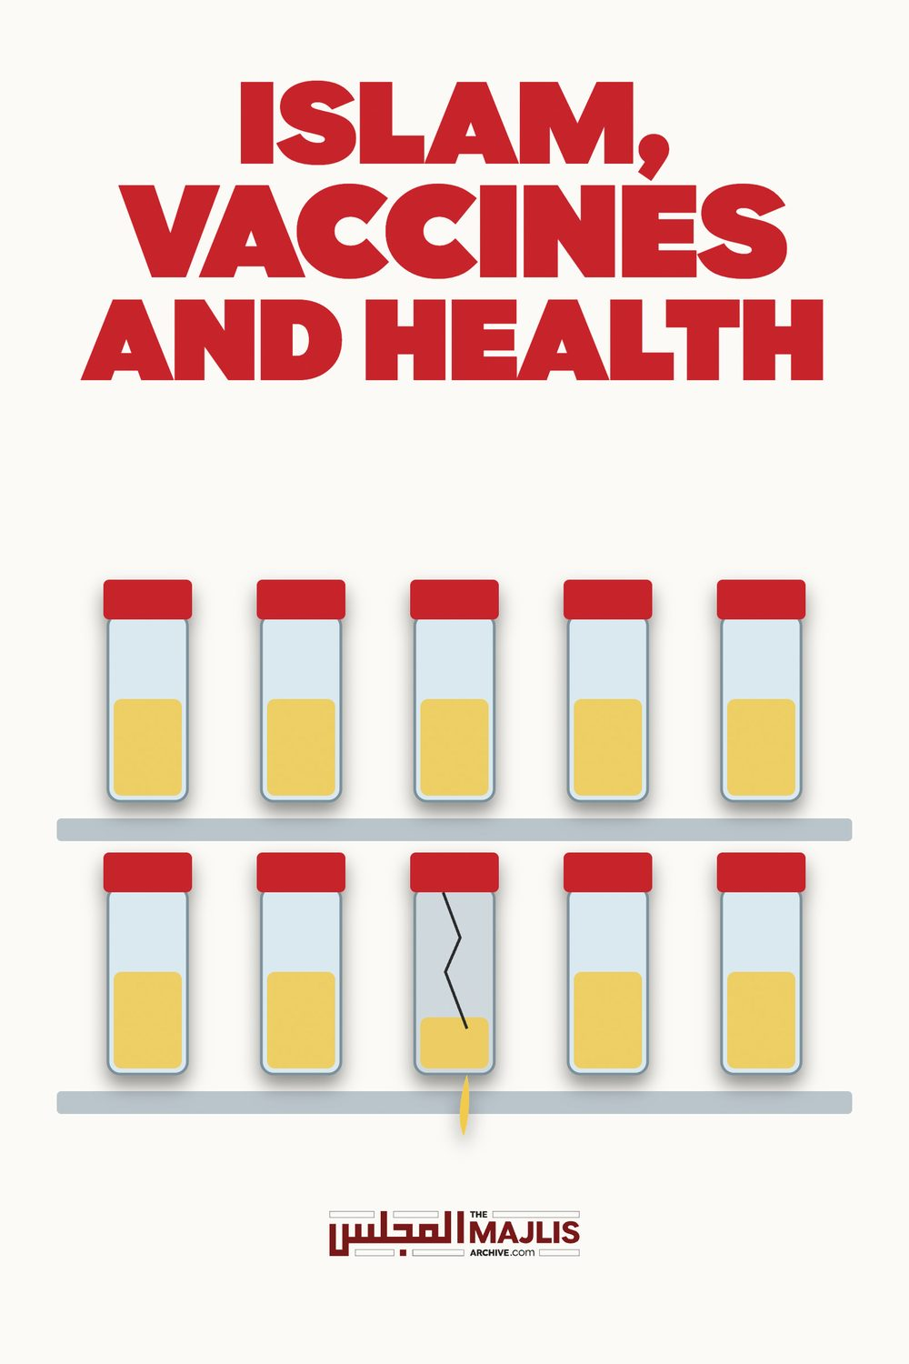

Islam Vaccines & Health
The Majlis · Voice of Islam
Mujlisul Ulama of South Africa

About this edition
This is a reproduction by The Majlis Archive (themajlisarchive.com) of a publication of The Majlis, Mujlisul Ulama of South Africa, made and published with their permission.
The PDF as The Majlis issued it is the original. This edition was read from that PDF's own structure and checked against it letter for letter; where the two differ, the PDF is correct.
Checked: 73 paragraphs, 0 differing; a second, independent PDF reader finds 100.0% of the PDF's words here.
Nothing has been reworded, added or removed.

A. Majid Katme, MBBCh, DPM (medical doctor) Spokesman, Islamic Medical Association (UK) January 21, 2011
We are giving our innocent children haraam (forbidden) substances and harmful chemicals that destroy their natural immune systems, causing disease, suffering and death. All Muslim doctors and parents should be aware of vaccine ingredients, and of the failed efficacy of vaccines. The harm is clearly greater than the benefit. The time has come to take a stand for truth.

Vaccine Ingredients
Vaccine ingredients include heavy metals, pus from sores of diseased animals, horse serum, calf serum, faecal matter, foetal cells, urine, macerated cancer cells, sweepings from diseased children, formaldehyde (a carcinogen used in embalming fluid), phenol (a carcinogen capable of causing paralysis, convulsions, coma, necrosis and gangrene), lactalbumin hydrolysate (an emulsifier), aluminium phosphate (an aluminium salt that is corrosive to tissues), retro-virus SV- 40 (a contaminant virus in some polio vaccines), antibiotics (e.g., neomycin tm) that lead to antibiotic resistance, chick embryo (as a growth medium for the virus), sodium phosphate (a buffering salt), and foreign animal tissues containing genetic material (DNA/RNA) from the growth medium. Vaccines are also contaminated with mycoplasma, bacteria, monkey viruses and various adjuvants. Heavy metals include thiomersal (mercury) as a preservative and aluminium as an adjuvant. Mercury and aluminium have each been proved to damage the brain and nervous system. In some cases, thiomersal has been replaced by another neurotoxin known as 2PE. Vaccines also contain monosodium glutamate (MSG), sorbitol, and gelatine. Many of these ingredients are not allowed for Muslims, Jews, Hindus or vegetarians.
By:
Young Mens Muslim Association
PO Box 18594 – Actonville – Benoni – 1506
South Africa way, don't let any indoctrinated doctor tell you vaccines do not cause autism. Do your own research. Sexual immorality and adultery are stirred by offering our daughters HPV vaccination against cervical cancer. Notably and incredibly, the HPV vaccine is shown to make some recipients even more susceptible to cervical cancer. According to many scientific reports, there is additional concern that some vaccines cause infertility and are used for clandestine population control. The proper role of medicine is to work to find and prevent the root cause of disease, not treat symptoms or fill the body with chemicals and vaccines.

A Fatally-flawed System of Intervention
Vaccination is based on the long-discredited theory that stimulation of antibodies in the human body equals protection from disease. This theory has not only failed to be proved, but has been repeatedly disproved. Stimulation of antibodies does not equal immunity and certainly does not equal permanent immunity. The presence of antibodies is merely a sign of exposure to a disease, which is just one small aspect of what makes up the immune system. Children, with underdeveloped and immature immune systems, receive today about 25 separate vaccines by the age of 13 months. There is no doubt this irresponsible system disrupts and can even destroy the development of their immune systems forever. Vaccines commonly given to children in the United Kingdom today include – TWO MONTHS: diphtheria, tetanus, acellular pertussis, HIB meningitis and polio + pneumococcal (six components, two needles); THREE MONTHS: diphtheria, tetanus, acellular pertussis, HIB meningitis and polio + meningitis C (six components, two needles); FOUR MONTHS: diphtheria, tetanus, acellular pertussis, HIB meningitis and polio + pneumococcal + meningitis C (seven components, three needles); 12 MONTHS: HIB meningitis and meningitis C (two components, two needles); 13 MONTHS: measles, mumps, rubella + pneumococcal vaccine (four components, two needles). This reflects a grave medical assault inflicted on the small, weak, defenceless bodies of our innocent children.

Islam and Medical Science Must Oppose Vaccination
The case against vaccination is first an Islamic one, based on Islamic ethos regarding the perfection of the natural human body's immune defence system, empowered by great and prophetic guidance to avoid most infections. The case against vaccination is also a medical and health-related one. Incredible evidence, unbeknownst to most, has emerged in the West regarding the many serious health hazards that affect those who have been vaccinated.

Islam and the Immune System
Colostrum in breast milk, a rich source of myriad antibodies, is extraordinarily important in conveying immunity to the child during the first few days after birth. Breastfeeding up to two years gives incredible immunity into the future. Medical studies evidence the amazing protection of breastfeeding against infections, even including poliomyelitis. The first two years of life are a crucial time during which the child's body will develop a natural and mature immune system. Vaccination disrupts and damages the natural process of human development. God (Allah), the Creator, the Designer, has organised for the destruction of most germs and viruses through the natural process of entry-and-defence via skin, mucous, and the stomach. This process is very different from injection of a vaccine directly into the body without crossing natural defence barriers. Twenty-five weakened diseases are destructively pushed by needlepoint into the bodies of our fragile children at a stage when they are developing their own natural defence systems. Infection and disease are medically proven to regularly succumb to spontaneous, self-remitting recovery. Childhood bouts with infectious disease help build the immune system against future attacks. As our

Just a Few of the Monstrous Problems
Unthinkably, vaccine studies do not include placebo groups. Instead, they use other vaccines in "control" groups, making it impossible to properly note actual rates of adverse events between a test group and real control group. No research has been done on the long-term effects of vaccines. Post-marketing data of reactions, injury and death go ignored. Moreover, the system lacks individualization. Apparently, one size fits all. There is no pre-screening for immune problems and allergies. Overloading the human body with infections and sub-infections will irreparably disrupt and destroy the immune system. Chemicals in vaccines induce allergies, asthma, and autoimmune disease, including autism. By the beloved physician and prophet Muhammad, peace be upon him, has told us, for every disease there is a cure. The final holy book, Al
natural, it is no wonder that science and medicine have found them to be so incredibly dangerous. A well-orchestrated pharmaceutical industry plan of scaremongering exists to create fear in parents who do not vaccinate their children. Doctors and governments have been indoctrinated and corrupted by a gigantic and incredibly powerful industry into advocating obligatory vaccination, contrary to health and human and religious rights. This has happened not to advance health, but for profit. Vaccines should not be pushed or forced on anyone.
Qur'an, is an awesome medical source for both prevention and cure of disease. To best prepare the body, the Muslim should use natural and permissible nutrition from Tayyib (natural) food and drink. Of further importance, we need to address the root causes of morbidity and mortality: poverty, malnutrition, lack of clean drinking water, lack of a healthy and natural foods, lack of proper sewage, and toxins in the environment and body. The Islamic behaviour of seeking halal (lawful) and avoiding harram has been linked to health throughout time by many Muslim doctors and scientists, especially in the field of preventative medicine. Great care should be given to personal hygiene, including hand washing at about 25 times per day (15 times before the five daily prayers during wudu [absolution]). Properly practising daily personal hygiene will avoid many infections. Many fruits and other healthy foods prescribed in Islam have been found to prevent disease and strengthen the immune system, including olive and olive oil, ginger, grapes, pomegranate, vinegar, rosemary and figs. Islamic-prescribed complementary medicine protects us from disease and strengthens our natural immune system, including honey, fasting, prayer (meditation), Du'A (special prayer) for the sick, black seed, Hijama (blood cupping), holy fruits and foods, breastfeeding, aromatherapy, Zam Zam (drinking holy water at Makkah, Saudi Arabia at the time of pilgrimage), and laying on of hands with a special prayer. Frequent exposure to the sun for vitamin D and a diet rich in vitamin D prevents many diseases. Islam prohibits Muslims from taking any harmful medicine or substance. Even where there is doubt or controversy, Islam orders us to leave it completely. This applies to vaccines.

The Case for Opposing Vaccination
• It disrupts and destroys the natural immune systems of our innocent children
• It produces many physical and medical problems • It increases antibiotic resistance among many patients • It can make many people sterile or infertile • It contains many harmful chemicals like mercury and aluminium
• It lacks scientific, independent evidence of efficacy and safety
• It contains many haraam substances for the 1600 million Muslims in the world (the latest of which is the vaccine for Meningitis for the Muslim Pilgrims who are going to Hajj was found to contain pork, which is harram.)
• It also contains substances which are prohibited for Jews, Hindus and vegetariansIt is unhygienic and full of filth
• It wastes trillions of dollars and is making the people and governments in poor third world countries poorer and more in debt, and the drug companies filthy rich

The Truth Be Told
Harram in many vaccines include human foetuses, gelatine from pork, alcohol, and human and animal parts. These najis (unclean), haraam ingredients are not given in a state of emergency to save life at present. It is ridiculous to introduce myriad infective agents into millions of people as a "just in case" prevention of future infection. It is very wrong that Muslim doctors have adopted a medical intervention that contains so many haraams and harmful chemicals. In Islam, the human body is holy. We should protect and keep it natural, pure, healthy and safe. As vaccines are neither pure nor
• It is medically unethical, as it took us away from dealing with the causes of the diseases and work on prevention. It is a very wrong medical practice to use a vaccine against every ill
• It lacks transparency and informed consent. Most parents, the public, and even doctors are not aware of its harms, ingredients and cost
• A rising number of doctors, health professionals and parents are joining the campaign against vaccination (websites below)

Childhood Vaccine Exemption Rates Increasing Nationwide
• We have many natural ways to build a natural strong immune system to fight most infections
• We have many natural, safe alternatives • Incredibly, the Big Pharma producers of vaccines are
Mike Barrett Activist Post It seems as though the "necessity" of childhood vaccinations, widely voiced by many mainstream health officials and government figureheads, is simply not being accepted by parents around the country.
exempt from any liability or prosecution, regardless of the number of people who die or are injured
• Our innocent children are suffering and they gave no consent at all for the vaccines forced on them. This constitutes a medical assault Web Resources
While the rates of children receiving vaccines remains high, we are seeing an increase in childhood vaccine exemption rates. In eight different states, more than 1 in 20 public kindergartners are not receiving all the vaccines that the government 'requires' for school attendance.
• Muslim site containing a wealth of health and vaccine information http://www.missionislam.com/health
• HeathyMuslim.com http://www.healthymuslim.com • International Medical Council on Vaccination

Where are the highest vaccine exemption rates?
www.vaccinationcouncil.org Additional Web Resources:
States in the West and Upper Midwest currently hold the highest vaccine exemption rates.
In Washington, an overall 6 percent of public school parents decided against at least one of the vaccines "required" for their child's attendance, while some specific locations in Washington have exemption rates as high as 20 or even 50 percent.
http://avn.org.au http://www.mercola.com http://childhealthsafety.wordpress.com http://www.naturalnews.com http://www.theoneclickgroup.co.uk http://www.nccn.net/~wwithin/vaccine.htm http://inquirer.gn.apc.org/vaccio.html http://www.novaccine.com http://vaccinationdangers.wordpress.com http://www.philipincao.com http://vran.org http://www.themothermagazine.co.uk http://www.arnica.org.uk/resources.html http://www.thenhf.com/page.php?id=9 http://www.beyondconformity.co.nz/sites-of-interest http://www.thinktwice.com http://www.cryshame.com http://www.vaccineriskawareness.com http://www.drtenpenny.com http://www.vaccine-side-effects.com http://www.fourteenstudies.org http://www.vacinfo.org http://www.informedparent.co.uk http://www.vaclib.org http://www.jabs.org.uk http://www.vactruth.com http://www.jayne-donegan.co.uk http://www.whale.to/vaccines.html ________________ Dr. A. Majid Katme challenges the use of vaccination both within the religion of Islam and within medicine. Dr. Katme was born in Lebanon and resides in the United Kingdom, where he is a spokesman for the Islamic Medical Association UK. A campaigner for natural and Islamic medicine, Dr. Katme presents each week on a weekly health show on IQRA (Sky 826) in the United Kingdom, and is additionally a radio broadcaster on three Muslim radio programs each week.
Some other states with high vaccine exemptions rates are: • Alaska • Colorado • Minnesota • Vermont • Oregon • Michigan • Illinois
In addition, vaccine exemption rates increased in over half of the states, including many of the states with already high exemption rates. Alaska, Arizona, Kansas, Hawaii, Illinois, Michigan, Montana, Oregon, Vermont, Washington, and Wisconsin were all states with increasing vaccine exemption rates.
such small children really are,' said Jennifer Margulis, a mother of four and parenting book author.
Why are parents refusing vaccines for their children?
Parents nationwide simply aren't buying into the claim that vaccines are absolutely necessary. There is a massive distrust in the pharmaceutical industry as well as in officials and legislators pushing for vaccines. If you are one of the parents who is thinking about partaking in vaccine exemption for your child, it is vital that you know that medical, religious, and philosophical reasons for exemption are at your disposal. Take advantage of these possibilities today, as there is a distinct possibility that the United States government will soon come after the exemptions through abuse of the legal system.
Parents just aren't seeing what health and government officials seem to think is so clear about vaccine safety, necessity, and effectiveness. Could it be that parents are reluctant to get their children vaccinated due to the not so flattering history of many vaccines? The flu vaccine alone has been tied to convulsions, Guillain-Barre syndrome, and a number of other negative health effects. Gardasil is also a heavy hitter when it comes to serious health problems, with the vaccine leading to many deaths and thousands of hospitalizations.
Even more compelling is the severe lack of evidence highlighting the effectiveness of the shots. The Cochrane Database Review, the gold standard within the evidence-based medical model for determining the effectiveness of common medical interventions, does not lend clear scientific support to the theory that flu vaccines are safe or effective. Shockingly, these authoritative reviews reveal that there is actually a severe lack of evidence demonstrating the effectiveness of influenza vaccines in children under 2, healthy adults, the elderly, and healthcare workers who care for the elderly. Other research reported on by The Lancet shows that the flu vaccine only prevents the flu in 1.5 out of every 100 adults injected with the flu vaccine.
Explore More:
1. How to Avoid 'Mandatory' Vaccinations Through Exemption | Vaccination is Your Legal Choice 2. Survey | Parents Waking Up to Vaccine Dangers 3. Meningitis Vaccine Now Pushed on Toddlers 4. Immunize Your Child or Lose Benefits, Parents Told 5. Vaccine Induced Inflammation Linked to Type 2 Diabetes Epidemic
Please visit Natural Society for more great health news and vaccine information.
Maybe these are some reasons why parents are refusing vaccines for their children.

VACCINATION IS A DANGEROUS CURSE
But the possibility of one vaccine causing damage isn't the only reason parents are skeptical of vaccines. The amount of shots children are given is of great concern, with the cumulative effect leading to vaccine-induced and heavy metal toxicity. By the age of 6 a child may receive 24 pricks. Not only is the number of vaccinations alarming, but parents rightfully feel that many of the vaccines are downright unnecessary, further off-putting parents and leading to vaccination refusal.
The following episode is an extract from the book, VACCINES: ARE THEY REALLY SAFE AND EFFECTIVE? By Neil

Z.Miller:
'My name is Janet Ciotoli. I am a New York state mother whose children have reacted to the DPT vaccine". "Our oldest child's reaction had alarmed us; swollen, red hot leg; high-pitched prolonged screaming; high fever; diarrhea and vomiting Being parents for the first time, we were scared and
'Many of the vaccines are unnecessary and public health officials don't honestly know what the effect of giving so many vaccines to called the doctor. He assured us that this was normal for some children to react this way. Ryan continued to receive his remaining DPT series of shots [the recommended schedule of shots is at 2 months, 4 months, 6 months, 18 months, and 4 to 6 years] with the same reactions following each one. The doctor continued to reassured us that this was normal. Our second son, Richie, received his first DPT vaccination at 2 months of age. Within hours, Richie displayed similar symptoms as our first child-a red-hot swollen leg, diarrhea, and cat-like screaming. But he had no fever and I felt thankful for that. I didn't get my usual baby smiles that day. He looked at me with dark eyes and I couldn't understand why his hands were so cold.' Holding him was like holding a little ragdoll [sic]. Richie's symptoms became noticeably alarming as the day wore on and that evening I called the doctor explaining our baby's continuing reaction to his DPT shot. He did not appear alarmed, but suggested we could have him checked at the emergency room if we wanted. We asked him to meet us at the hospital but he said it wasn't necessary for him to be there, that someone else would check our baby. The next 5 minutes were our son's last. Richie died in my arms, The ambulance was en route as I administered CPR to our lifeless child. My husband and our 5-year-old son watched paralyzed as I tried desperately to give life back to our baby. At that instant, our world came crashing down. Our baby had been dying all day and we didn't even know it. How could this possibly happen? We were always told that immunizations protected our children. My husband and I were led behind a drawn curtain in the emergency room. There our Richie lay on a stretcher, cold and lifeless. My baby's scream of grief and pain will forever ring in my ears". (vaccines: are they really safe and effective? By Neil Z. Miller. Pg. 39)

WHAT THEY SAY ABOUT THE VACCINE BOOK:
* As a new mother this book deeply affected me. Before reading it I read all that I could on the subject and decided to wait. But I agonized over whether or not to vaccinate my baby. After having read the compelling evidence and tragic stories in this book, I am extremely grateful that I chose not to vaccinate my healthy, happy child. I strongly recommend this book to all concerned parents", (Rayna Siegler Dineen, M.A., Early Childhood Educator.)
* This book should be required reading for every parent-tobe. Parents think that pregnancy and birthing are difficult. This is nothing compared to the risk they face when they see the pediatrician for the child's "mandatory" vaccinations. This book has all the makings of a sci-thriller- the frightening part is that it's true, and it's happening to us," (Jane Watson, Registered Nurse).
* There are grounds for questioning both the safety and efficacy of current childhood vaccination programs. These reasons are reviewed with clarity and thoroughness in the main body of this book", (Harold E. Buttram, M.D.).
* Neil Miller's book on vaccines should be read by every parent and every health professional. I only wish It had been available when my wife and I had to make the difficult decision of whether or not to vaccinate our daughter " (Marvin Surkin, Ph.D., Natural Health Practitioner).

