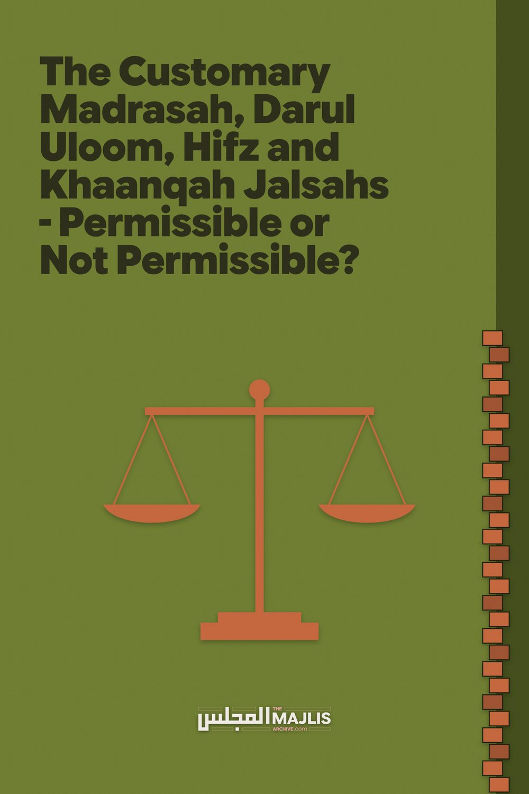

JALSAHS – PERMISSIBLE OR NOT PERMISSIBLE?
The Majlis · Voice of Islam
Mujlisul Ulama of South Africa

About this edition
This is a reproduction by The Majlis Archive (themajlisarchive.com) of a publication of The Majlis, Mujlisul Ulama of South Africa, made and published with their permission.
The PDF as The Majlis issued it is the original. This edition was read from that PDF's own structure and checked against it letter for letter; where the two differ, the PDF is correct.
Checked: 69 paragraphs, 0 differing; a second, independent PDF reader finds 100.0% of the PDF's words here.
Nothing has been reworded, added or removed.

By:
Mujlisul Ulama of S.A.
Port Elizabeth, 6056 Rep. of South Africa

The Customary Madrasah, Darul Uloom, Hifz and Khaanqah Jalsahs – Permissible or Not Permissible? Time to Reflect in Earnest
The Principal of a Madrasah requested Hadhrat Maulana Ashraf Ali Thaanvi (Rahmatullahi alayh) to attend the Madrasah's Jalsah. Hadhrat Thaanvi (Rahmatullahi alayh) responded as follows:
Assalaamu Alaykum Warahmatullahi Wabarakaatuh In the letter prior to this one I had expressed my reluctance to attending the jalsah, and stated the obstacle. This was even witnessed by Respected Maulana … Sahib with his own eyes. It is possible that by the time it is the jalsah this obstacle is overcome.
Now I wish to present some Shar'i obstacles in attending, only by way of mashwarah. Although being so brazen in front of Ulama is not free of bad manners, but on the one side I see Naseehat being part and parcel of Deen and Ma'moor Bihi (A Command of Allah), and on the other side trust in your consideration and courtesy. Then, in my opinion, there is hope of being delivered from error.
These factors have permitted me to freely express my thoughts. If, truly, I am wrong then I sincerely wish that my thoughts be rectified.
The summary of these Shar'i obstacles is that when carefully viewed and evidenced by experience, the major reason for conducting these jalsahs is twofold; receiving donations and broadcasting one's activities.
We can also describe this as the honour and prestige of the madrasah, which boils down to hubb-e-maal and hubb-e-jaah
(love for money and love for fame) which have been prohibited in numerous Nusoos (Qur'aan and Hadith injunctions).
Although when money and fame are desired for the sake of Deen then this is not condemned, but it is debatable whether on such occasions (jalsahs) the Deen is the objective or the dunya. So, even though ta-weel is made (that is, defences are made to justify the jalsahs) and it is said to be for the Deen, however, Allah Ta'ala has made a yardstick for every intention whereby the validity or corruption of intention can be gauged.
Now on these occasions (of madrasah jalsahs), if one reflects, the sign of talab-dunya (seeking the world) is evident. Let us expand on this. If the Deen was the objective then anything contrary to the Pleasure of Allah Ta'ala would not be adopted. But since such (haraam) things are opted for, it clearly shows that the objective is the dunya. By way of example some of these factors are enumerated hereunder.
1. In asking for donations the Rules of the Shariah are not observed. The Injunction of the Shariah is: "A man's money is not lawful without his heartfelt consent". In collecting funds schemes are devised to apply pressure on the hearts of those addressed, be this pressure in the form of coercion, embarrassment or empathy. People on whom this pressure is applied are targeted. In front of the audience, needs of the madrasah are presented. It is insisted that they attend the jalsah. It is known for certainty that a rich man will fear insult and humiliation coming empty-handed. The madrasah authorities broadcast their expenses; the rich guest fears disgrace.
2. Riya (ostentation) being haraam is a Shar'i Hukm. In most cases in such functions the giver harbours riya in his heart. The cause of this riya is also sinful. (In other words, the jalsah is the occasion of this riya, hence the jalsah is sinful.)
3. The Ulama frequently go to the doors of the rich and engage in flattering them.
4. If they (the Ulama) get money which they understand not to be halaal, they will never refuse to accept the money. It is possible that a person whose income is predominantly interest or who takes frequent bribes gave something (to the madrasah) and openly or quietly the money was returned this donor.
5. They mostly project the status of their madrasahs much higher than it actually is, either explicitly or by implication. This translates to falsehood and deception.
6. If someone questions something about the madrasah, and he is right, it is never accepted. On the contrary, they will attack the person and labour to refute the question, even though in their hearts they know that it is the truth. This is subversion of the Haqq.
7. If another madrasah is established nearby, then in spite of this new madrasah being in a good state they (the authorities of the older madrasah) will look at it (the new madrasah) as if it is a thorn tree and in their hearts they will wish for its demolition and termination, whereas it is something to be happy about that Deeni work is being carried out at several places. However, for fear of the new madrasah becoming famous and contributions increasing for the new madrasah and diminishing for their madrasah they are unhappy over this new madrasah.
8. They publicise their activities, praise themselves, give preference to their own madrasah, show off their work to be better and more intensive and for this they are at pains to increase the volume of their Ta'leem and introduce kitaabs which are beyond the capacity of the students to show the magnitude of the work being carried out, whether the students understand the work or not.
From the above signs the first four are love for wealth not for the sake of the Deen and the last four are signs of love for fame not for the sake of the Deen. Due to the basis being corrupt the effects produced are just the same.
9. There is israaf (wastage) mostly in these jalsahs. A lot of money goes into the travelling expenses of those whose attendance is not necessary at all together with their entourages. Sometimes meals, etc. are also arranged at the madrasah's expense. The meals are lavish. Non-guests also eat at these venues and in most cases, in fact with certainty it can be said that the donors' permission was not taken for this. To claim that there is implied permission is not accepted because those who donate themselves criticise such expenditure.
10. In some places these jalsahs are conducted in the Musjid. The Musjid is then turned into a lounge with noise and clamour, worldly talk, despicable poems and many other vile acts which are witnessed taking place in the Musjid. When it is forbidden to engage in even such permissible activities in the Musjid for which the Musjid is not meant, then what should be said about these vile acts?
11. With such activities instead of the desired dignity and honour, the Ulama are scorned upon and despised in the eyes of the people of the dunya because actual honour is in selfsufficiency and simplicity. The fruits of this scorn are that they do not prefer Ilm Deen for their children thinking that this (disgrace) awaits such people. In this case, the jalsahs come within the ambit of mannaa'iyyat lil khair (preventing good).
12. Incompetent pupils are shown off as competent to swell the number of graduates and students who have passed. And so forth.
If these thoughts are rectifiable then please do rectify them, otherwise I do not compel you to comply and accept. However, at least let these be plausible reasons for my absence, and do forgive me. Was-Salaam (End of Hadhrat Thaanvi's Response)
The Muhtamim (Principal) Sahib's Reply Assalaamu Alaykum Warahmatullahi Wabarakaatuh
Hadhrat Aqdas's response has been received. Perusing the contents I gained satisfaction and joy. Shukr unto Allah, since the inception of laying the foundation of this madrasah I have abhorred those things which you have written. Here, no one likes pretence. The foundation of the madrasah rests on Tawakkul. Donors are not pressurized into contributing. Whoever wishes, joins in the contribution. Whoever wishes not to, is free to refrain.
We never have in mind those things for work rendered for the sake and pleasure of Allah. Whatever Allah Ta'ala wills, we are pleased with.
It is futile to entreat worldly-minded people. For this reason in this madrasah only those few people contribute who give with sincerity. There is no need to ask them repeatedly. That is not my habit also. Such action is debasing in my opinion.
My only intention in organizing a madrasah jalsah is that those people who do contribute are, without understating or overstating, informed of the madrasah's state of affairs, and awarding prizes to the qualified students to please them, so that their hearts are not broken. Also, some Ulama can come together and give bayaan and naseehat so that people can be guided and people can benefit.
Hitherto funds have been explicitly collected for the purpose of the jalsah, for the travelling costs of the Ulama and for those who attend the jalsah. This has nothing to do with contributions given to the madrasah. Allah Ta'ala put this in my heart at the very beginning.
We do not entreat anyone to attend the jalsah and no one goes to the homes of the rich. We purposefully concentrate on the poor. We have furthermore ascertained that the rich attend not because of shame. Hence they are not even given invitations and no effort is made in this direction. Personally, giving invitations to them is abhorrent to me.
To strive to ruin a madrasah which opens alongside one's madrasah is foolish and stupid. Shukr unto Allah, that there is no competition of madrasahs here. We have no interest in opposing others. In fact, we wish for the progress of other madaaris. Opposition to other madaaris is a felony against Allah and His Rasool. Such a person harbours malice against the Deen.
Since the dastaar-bandi (turban-tying) has become a ceremony and an exhibition, and the madaaris have adopted it thinking it to be good, hence I have not formed a good opinion about this. It has therefore been discontinued in this madrasah.
From this brief letter Hadhrat Wala can understand what my purpose is in conducting a jalsah; whether it is hubb-e-dunya or something else. Without hesitation, do give naseehat if you see anything else against the Wish of Allah and against the Shariah. Wallah! I will be extremely grateful unto you. I will consider you to be a well-wisher.
Since the madrasah does not have enough area space the courtyard of the Musjid has been proposed for the jalsah. But as far as possible I take into consideration all the prohibited factors and emphasise same to the people. This is in view of no other alternate venue.
My intention in the jalsah is not at all to collect funds and seek popularity.
In so far as the standard of Ta'leem is concerned, through Allah Ta'ala's grace we do not have that problem. In fact, the Mudarriseen (Teachers) are urged as far as possible to teach the students comfortably, regardless of the amount covered of a kitaab being less.
Furthermore, the number of students is disclosed accurately. I trust that you will respond in good conscience and grant me the opportunity to thank you.
(End of the Muhtamim Sahib's Letter)
Hadhrat Thaanvi's Response Assalaamu Alaykum Warahmatullah Your letter has brought me joy. May Allah Ta'ala increase the barkat in your noble objectives and sincerity of intention. And may Allah Ta'ala make us needy servants benefit from the fuyoodh and barakaat of your madrasah and similarly from the fuyoodh and barakaat of all the Madaaris of Islam.
Your letter has brought contentment that, Masha-Allah, your gaze is on such matters and you have concern for same. But, the condition of all the madaaris is merely that in the jalsah no evil transpires intentionally. However, the problem remains and continues that the obligation of discarding something is not conditional to intentional evil. In fact, unintentional evil is sufficient.
It is already accepted that many jalsahs, in fact all are plagued with the previously stated evils. It is also evident that to stop these is necessary as far as possible. It is prohibited (manhi anhi) to popularize such wrongs intentionally and unintentionally. In this scenario, if some muhtamim sahib conducts a jalsah with extreme care, then although he may not be directly involved in the wrongs, but there is no doubt that he is a cause for the spreading of the wrongs in other careless jalsahs.
In many issues the Fuqaha have strongly debarred some permissible acts simply to close the avenues (saddan lil baab) and to uproot corruption (hasman li maaddatil fasaad). In this regard the Muhaqqiqeen Ulama in this age debar the customary maulood, faatihah and urs gatherings, regardless of the organizer being cautious in I'tiqaad and Amal. The reason for this is that others who are careless will have justification. It will lead to these becoming widespread among irresponsible people. This rule applies equally and consistently to gatherings of da'wat and gatherings of the madaaris. After observation it suffices to reflect.
The benefits of these jalsahs you have stated are not disputed. However, when benefits and wrongs clash then preference is accorded to the effect of the wrongs, when the benefits are not categorized as essential in the Shariah. In what we are discussing it is obvious that there is no Shar'i Zaroorat. In fact, even the benefit is not confined to this particular way. Helpers could be informed with a written report. Students could be awarded without any ceremony associated.
In so far as bayaans are concerned, firstly it is difficult to openly give naseehat to the audience of such gatherings. Consideration for ill feelings prevents that. Then this objective (that is, hidaayat and naseehat) can be fulfilled independently in good measure. Therefore, I am still unable to attend. Was-Salaam (End of Hadhrat Thaanvi's Fatwa of Prohibition)

OUR COMMENT
The evils of jalsahs enumerated by Hadhrat Maulana Ashraf Ali Thanvi (Rahmatullah alayh) had already plagued these ostentatious, merrymaking functions many decades ago. If Hadhrat Thanvi had to witness the evil jalsahs of our era, he would have been absolutely appalled.
All the evils enumerated by Hadhrat Thanvi are to be found in greater degree in the jalsahs of today. Every Tom, Dick and Harry institution has clambered on the jalsah bandwagon. Wallaah! The aim is nothing but to show off. Ostentation, riya. Takabbur and israaf are the primary factors of moral filth bedevilling these functions of the nafs. Trust funds are squandered for haraam merrymaking. Whilst the Ummah at large is suffering under grinding poverty and gross ignorance which drives people into the traps of kufr, the madrasah and mock khaanqah people abuse and misappropriate public funds to gluttonously eat and feed people who devour luxury and delicious foods thrice a day at their homes to the extent of contracting a host of incurable diseases.
There is no surprise in the sicknesses – physical and spiritual – from which the Ulama are today suffering. Their gluttony, hub-e-jaah and hub-e-maal have made them obese, extremely lethargic and fearful of proclaiming the Haqq. Their excessive indulgence in the demands of the nafs has induced them to abandon Amr Bil Ma'roof Nahy Anil Munkar.
There is no goodness in these jalsahs which should be abandoned in entirety. But, instead, knew brands of jalsahs are being evolved by the miscreant ulama. An unheard of jalsah nowadays on the rise, is the so-called 'islahi jalsah'. This is indeed a great travesty. It is an illustration of the total lack of understanding of the methodology and objective of Tasawwuf. It is a stupid mockery of the Deen in the name of the Deen.
After Hadhrat Maulana Ashraf Ali Thanvi (Rahmatullah alayh) had explained the numerous evils attendant to jalsahs, the Muhtamim (Principal) of the Darul Uloom in his response pointed out that none of the evils mentioned by Hadhrat Thanvi and which ruined all other jalsahs, would occur in his jalsah. He was fully in agreement with Hadhrat Thanvi's appraisal and the prohibition, but he explained that his particular jalsah would be bereft of all these evils, hence he desired Hadhrat Thanvi to grace his jalsah with his presence.
Hadhrat Thanvi, in his response, despite accepting the explanation of the Muhtamim and believing that his particular jalsah would be free of the evils, nevertheless, he (Hadhrat Thanvi) declined the invitation and refused to attend. The reason given was that others would justify their haraam jalsahs on the basis of the Muhtamim's jalsah which would be free from the many evils which plague all jalsahs.
Although Hadhrat Thanvi did not further pursue the discussion with the Muhtamim, he (Hadhrat Thanvi) had subtly drawn attention to the tricks of the nafs which the Muhtamim had not understood. Whilst his particular jalsah may have been free from the manifest evils associated with all jalsahs, the malady of hub-e-jaah (love for fame) did bedevil even this jalsah which was ostensibly different from other jalsahs.
The issue of doling out prizes to the students is actually motivated by the disease of hub-e-jaah. What is the need for handing out prizes to students at a public function which has absolutely no basis in the Sunnah, yet the Book of the Sunnah – the Qur'aan Majeed – which was taught 14 centuries ago is the self-same Qur'aan which is being imparted today to the students. Why are the prizes not given to the students during normal Madrasah time when only students and the class Ustaadh is present?
Firstly, doling our prizes to Darul Uloom students is shaitaaniyat and nafsaaniyat. Darul Uloom students are pursuing the Knowledge of the Aakhirah. Sincerity has to be cultivated in them. They should not study on the basis of the incentive of prizes. The Qur'aan and all related branches of Knowledge are for the sake of Allah Ta'ala, not for worldly gains and objectives.
Secondly, it is a custom acquired from the kuffaar. It has no basis in the Sunnah. Thirdly, should an Ustaadh wish to make a gift to a Student for excellent study, it should be in an impromptu basis in class or out of class without a stupid function of riya and israaf where the name of the student will be announced and the gift doled out in the presence of a stupid crowd of onlookers.
Furthermore, the bayaans of functions are simply part of the superfluous paraphernalia of the merrymaking function of riya and israaf. Such ostentatious bayaans have hardly any beneficial impact on the audience whose presence at the function is for the sake of merrymaking – to eat, talk drivel, go to toilet and waste time and money. As Hadhrat Thanvi has pointed out, there are other avenues for delivering bayaans.
The evil disease of jalsahs has now gripped even females. Girls madrasahs which in the first instance are abnormal aberrations in the community are no longer lagging behind Darul Ulooms in conducting these stupid haraam wasteful jalsahs which have become real concerts where clowns perform and sing naa'ts and nazams. Females also attend. It is one dark sin piled on another dark sin.
The Ulama have become blind. They are spiritually blind and morally corrupt, hence they hallucinate so many stupid 'daleels' to justify what is manifestly haraam. They should for a moment cast aside their emotions and read Hadhrat Thanvi's naseehat to the Muhtamim with intelligence and a desire to understand the Haqq. Then, they will not fail to understand the evil of the jalsahs in which they are embroiled.

