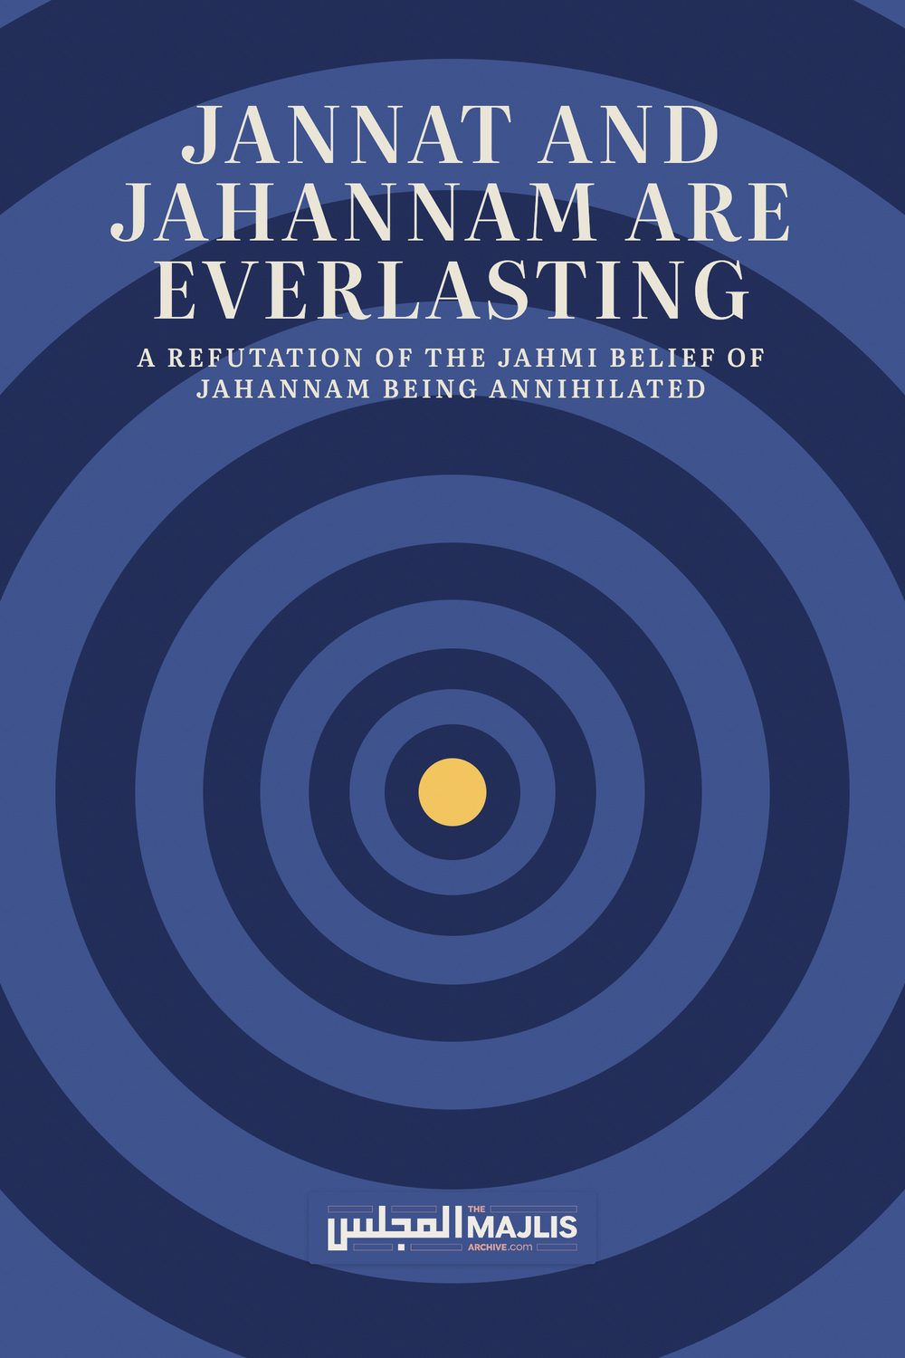

JANNAT AND JAHANNAM ARE EVERLASTING
The Majlis · Voice of Islam
Mujlisul Ulama of South Africa

About this edition
This is a reproduction by The Majlis Archive (themajlisarchive.com) of a publication of The Majlis, Mujlisul Ulama of South Africa, made and published with their permission.
The PDF as The Majlis issued it is the original. This edition was read from that PDF's own structure and checked against it letter for letter; where the two differ, the PDF is correct.
Checked: 220 paragraphs, 0 differing; a second, independent PDF reader finds 98.3% of the PDF's words here.
Nothing has been reworded, added or removed.

JANNAT AND JAHANNAM ARE EVERLASTING A REFUTATION OF THE JAHMI BELIEF OF JAHANNAM BEING ANNIHILATED
BY MUFTI ZAMEELUR RAHMAAN
OF U.K.
Published by THE MAJLIS PO BOX 3393 PORT ELIZABETH 6056 SOUTH AFRICA

Pseudo-Salafi Claim of Imam al-Tabari Supporting the View of Fana' al-Nar

By Mufti Zameelur Rahman
Every Muslim of sound belief knows that Hellfire is eternal and without end, and that its inhabitants will abide in it forever. Recently, some pseudo-Salafis have tried to undermine this definitive Islamic belief, even claiming that some of the pious Salaf took the position that Hellfire will end. They also claim that Imam al-Tabari (224–310 AH) supported this position in his tafsir.
In fact, the view of Hellfire ending is a heresy that originated with Jahm ibn Safwan (d. 128 AH). It is ironic that pseudo-Salafis, who claim to be the greatest opponents of Jahmi heresies, include within their ranks those who endorse or make excuses for one of the worst Jahmi beliefs of kufr.

Jahmi Belief Opposes Consensus Imam Abu 'l-Hasan al-Ash'ari (260–324 AH) states:
"All Muslims – besides Jahm – state that Allah will make the inhabitants of Heaven stay forever in Heaven and make the disbelievers stay forever in Hell." (Maqalat al-Islamiyyin [al-Maktabat al- 'Asriyyah], 1:229)
He also states:

"Jahm was isolated in advocating the belief that Heaven and Hell will perish and come to an end." (ibid., 1:338)

He also states:
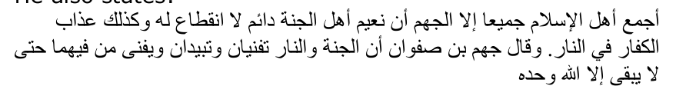
"All adherents of Islam agree – except for Jahm – that the bliss of the inhabitants of Heaven is eternal without interruption, and likewise the punishment of the disbelievers in Hell. Jahm ibn Safwan said that Heaven and Hell will perish and pass away, and their inhabitants will perish therein, until none remains but Allah alone." (ibid., 2:167)
It is likely in response to this heresy of Jahm ibn Safwan that Imam Abu Hanifah (80–150 AH) said in al-Fiqh al-Absat:
"Whoever states that they (i.e. Heaven and Hell) will perish after their inhabitants enter them, he has disbelieved in (the words of) Allah – Exalted is He – because he has denied eternity (khulud) in them." (Majmu' Kutub wa Rasa'il wa Wasaya al-Imam alA'zam [Maktabat al-Ghanim], p.334)
Imam Abu Hanifah also said:

"Jahm ibn Safwan is a disbeliever (kafir)." (Tarikh Baghdad [Dar al-Gharb al-Islami], 15:515)
Imam al-Tahawi (239–321 AH) includes the belief in the eternity of Heaven and Hell in his famous and widely-accepted text on the creed of the Salaf:

"Heaven and Hell are creations. They will neither perish nor come to an end."
Jahmi Belief in Fana' al-Nar (Hellfire Ending) is Kufr Commenting on a hadith from Sahih Muslim that indicates Heaven is eternal, al-Munawi (952–1031 AH) states: "This is explicit in showing that Heaven is eternal and will never end. Hell is the same. Jahm ibn Safwan claimed that they both will end because they are temporal. No one from the adherents of Islam followed him in this. In fact, they declared him a disbeliever on account of it." (Fayd al-Qadir [Dar al-Ma'rifah], 6:241) Al-Munawi then refers to the misguided view of Hellfire specifically ending, stating that it was a position defended by Ibn Taymiyyah (661–728 AH), who was "misguided and caused (others) to be misguided". (ibid.)
Describing beliefs that are accepted by consensus and whose denial constitutes disbelief by consensus, Ibn Hazm (384–456 AH) states:
"Hellfire is real and it is an abode of punishment forever, without ending and without its inhabitants ending – forever and without end. It was prepared for every disbeliever opposing the religion of Islam." (Maratib al-Ijma' [Dar al-Fath], p.676)
Commenting on this statement of Ibn Hazm, Taqi al-Din al-Subki (683–756 AH) states:
"There is no doubt in this because it is something known by necessity from the religion and the evidences multiply converge upon it." (al-I'tibar bi Baqa' al-Jannati wa 'l-Nar, p.105)
He also states:
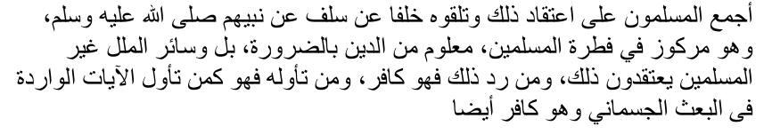
"The Muslims have agreed on this belief (of Hellfire not ending). The later generations received it from the earlier ones who received it from their Nabi (sallallahu alayhi wasallam). It is something ingrained in the nature of Muslims, known by necessity to be from the religion – indeed, even all other religions besides Muslims believe this. Whoever rejects this is a disbeliever, and whoever explains it away is the same as someone who explains away the verses about bodily resurrection – and he too is a disbeliever." (ibid., p.132)
In his critical notes on Maratib al-Ijma', Ibn Taymiyyah did not rebut Ibn Hazm's above comment. However, in later life, Ibn Taymiyyah inclined to the heretical view of Hellfire ending, for which he was refuted by the likes of Taqi al-Din al-Subki (683–756 AH), Taqi al-Din al-Hisni (752–829 AH), 'Ala' al-Din al-Bukhari (779–841 AH), Ibn Hajar al-'Asqalani (773–852 AH) and others.
Imam al-Qurtubi (d. 671 AH) states:
"Whoever says (disbelievers) will exit (Hell), that the Hellfire will remain completely empty and fall to ruin, that it will perish and cease to exist, he has strayed from the requirement of reason and opposed what the Messenger (sallallahu alayhi wasallam) brought and what the people of Sunnah and the upright imams have unanimously agreed upon. He follows other than the way of the believers, so 'We shall turn him (over) to what he has turned to, and burn him in Hell – and it is an evil destination.' (Qur'an, 4:115)" (al-Tadhkirah bi Ahwal al-Mawta wa Umur al-Akhirah [Maktabah Dar al-Minhaj, p.926)
In other words, those who deny that Hellfire is eternal are guilty of disbelief and are themselves doomed to eternal damnation.
Sinan al-Din Yusuf al-Amasi al-Hanafi (d. 1000 AH) states:
"Whoever says that a disbeliever will be forgiven on the Day of Resurrection, or he will come out of Hell after entering it, or his punishment will stop, he has disbelieved in what Allah sent down to the prophets." (Tabyin al-Maharim [Dar al-Risalah], p.461)
Referring to an individual who believed Hellfire will end, 'Allamah Zafar Ahmad al-'Uthmani (1892–1974 CE) said:
"This person has denied the necessities of religion and definitive matters of Islam, so has become a disbeliever and apostate. The marriage to his wife has become void. He must renew his iman, repent and renew his marriage." (Imdad al-Ahkam [Maktabah Dar al-'Ulum Karachi], 1:135)
The Qur'an & Hadith Are Unequivocally Clear on Hellfire Being Eternal The verses and authentic hadiths on the topic are both numerous and unequivocally clear. The verses use cognates of the term "khulud" to describe the disbelievers' presence in Hell. "Khulud" can refer to either (a) eternity or (b) a very long period. However, khulud in the context of the Qur'an undoubtedly means eternity. The Qur'an states:
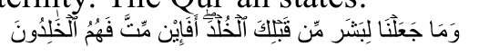
"We did not assign immortality (khuld) to any human being (even) before you. So, if you die, will they live forever (khalidun)?" (Qur'an, 21:34)
Here it is obvious that "khuld" and "khalidun" do not refer to merely "a long period" because there were people before the Prophet (sallallahu alayhi wasallam) who lived for exceptionally long periods. It is thus clear that what is meant by "khuld" here is "eternity". The verse means human beings will not live for eternity within the life of this world. In the life of the next world, however, human beings will live for eternity. The Qur'an thus refers to Heaven as "the garden of eternity" (jannat al-khuld) and Hell as "the punishment of eternity" ('adhab al-khuld).
The Qur'an emphasises the meaning of eternity and everlastingness by adding "abada" (forever) in some places. For example, the Qur'an states:
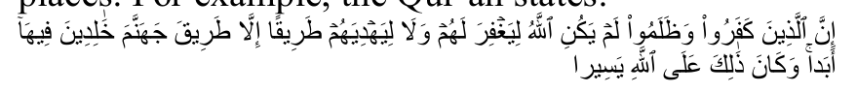
"Surely those who disbelieved and transgressed (and died in this state), Allah will not forgive them, nor will He guide them to any path, except the path of Hell, to abide permanently therein – forever. That is easy for Allah." (Qur'an, 4:168–9)
Abu 'l-Su'ud (d. 982 AH) comments that the addition of "abada" here "eliminates the possibility of interpreting khulud to mean 'a long stay'." (Irshad al-'Aql al-Salim, ISAM, 2:542) Furthermore, the passage is clear that Allah will not pardon disbelievers in the next life nor show them any path, i.e. of favour, reward or goodness. They will be shown only "the path of Hell", in which they will abide for all eternity. The message of the passage is thus explicitly clear that no possibility exists for disbelievers besides eternal punishment and damnation in Hell.
Similarly, the Qur'an states:
"Surely, Allah has cursed the disbelievers and has prepared for them a blazing fire, to abide permanently therein – forever. They will not find any ally or helper." (Qur'an, 33:64–5)
Commenting on this passage, Imam al-Tabari states:
"'To abide permanently therein, forever,' that is, remaining in the blazing fire eternally, without end." (Tafsir al-Tabari [Hajr], 19:188)
The verses on this topic are very numerous. Imam al-Subki quotes a number of them in his al-I'tibar bi Baqa' al-Jannati wa 'l-Nar and then states:
"There are so many other verses carrying the same meaning, negating the possibility of ta'wil (interpretation) and necessitating definitiveness in this (belief). It is similar to the verses that indicate bodily resurrection, whereby the possibility of ta'wil is negated, and whoever does ta'wil (to explain it away), we rule him to have disbelieved." (al-I'tibar bi Baqa' al-Jannati wa 'l-Nar, p.120)
The Qur'an not only explicitly affirms eternal, unending punishment in Hellfire for disbelievers, it also explicitly negates other possibilities of relief. For example, it states the punishment will not be made lighter (Qur'an, 2:86, 2:162, 3:88, 16:85, 35:36). Of course, if the punishment were to end or Hellfire was itself destroyed, the punishment would have been "made lighter". The Qur'an also states disbelievers will not emerge from Hell (Qur'an, 2:167, 5:37) and they will be made to experience perpetual, continuous torment. (Qur'an, 4:56) Further, it negates that the permanent inhabitants of Hell will die or pass away. (Qur'an, 35:36, 14:17, 20:74, 87:13)
The Qur'an refers to certain Jewish people who claimed that they will not suffer punishment in Hell except for "numbered days" i.e. for a finite, fixed period. The Qur'an responds:
"Not so, whoever earns evil and his sin (i.e. disbelief) has surrounded him – those are the companions of the Fire. They will abide permanently therein." (Qur'an, 2:81)
The Qur'an thus refutes quite directly the notion that the punishment in Hell will be for a limited duration.
Given the above evidence, a true believer in the Qur'an and authentic Hadith cannot possibly entertain the notion that a disbeliever will eventually come out of Hell or that Hell will eventually perish.
Shubuhat Pseudo-Salafis (and others) who support or defend the view of Hellfire ending operate in the same fashion as typical modernists/revisionists: distorting the clear meanings of definitive texts and clutching onto isolated and ambiguous statements. For some, the motivation is a defence of Ibn Taymiyyah. Recall that Allah states about the Jews and Christians that "they took their rabbis and monks as lords besides Allah" (Qur'an, 9:31). That is, they placed the judgements of their rabbis and monks over the clear judgements of Allah. In the same way, some pseudo-Salafis put the judgements of Ibn Taymiyyah in this matter over the Qur'an – Allah forbid.
The primary doubts that they clutch onto are: (a) a verse of the Qur'an that refers to the disbelievers remaining in Hell for "ages" (ahqab); (b) two verses that mention "except what/as Allah wills" and "except what/as your Lord wills" (Qur'an, 6:128; 11:107) after mentioning permanent punishment in the next life; and (c) some alleged statements of the pious Salaf. Scholars like Taqi al-Din al-Subki and others have responded adequately to these weak doubts many centuries ago.
As for the verse that describes the disbelievers as abiding in Hell for "ages" (78:23), the word "ages" is an indefinite noun that can also be understood as "unending ages" (al-I'tibar bi Baqa' al-Jannati wa 'l-Nar, p.135). This is precisely how Qatadah ibn Di'amah (60–118 AH), one of the leading authorities of the Salaf, explained the verse. Imam al-Tabari reports:
"On the authority of Qatadah: Allah has said, 'Abiding therein for ages': it is that which has no end; whenever one 'age' passes, another 'age' follows." (Tafsir al-Tabari, 24:25)
Al-Subki described this as the position of the vast majority. (al-I'tibar bi Baqa' al-Jannati wa 'l-Nar, p.142) Others have said that the "ages" refer to ages of a specific type of punishment, after which, as the passage continues to state: "We will only increase you in punishment." (Qur'an, 78:30) Meaning, after those "ages" pass, they will move to other forms of punishment that are more severe.
As for the verses that state "except what/as Allah wills" or "except what/as your Lord wills" (6:128; 11:107), various understandings of this exist. Some have said that it refers to sinful believers who will enter Hell and then be removed. Others have said that it refers to the duration the inhabitants of Hell will spend outside Hell proper in other forms of punishment, or to the duration spent during judgement before entering Hell. Others have said it means "unless Allah wills," in the sense that no one compels Allah to punish, but rather He does so based on His power and will. (Ma'ani al-Qur'an ['Alam al-Kutub], 3:79)
The passage of Surah Hud also states regarding the permanent residence in Heaven, "except what/as your Lord wills" (Qur'an 11:108). Yet, even pseudo-Salafis would accept it as a definitive belief that Heaven is permanent without end, and that denying this constitutes disbelief.
Statements of the Salaf As for the claim that some of the Salaf held the view of Hellfire ending, Imam al-Subki said:
"Allah forbid! I exonerate the Salaf from this and do not believe a single one of them said such. Rather, only some (ambiguous) words were reported from some of them that can be interpreted (in a correct manner)." (al-I'tibar bi Baqa' al-Jannati wa 'l-Nar, p.133)
As 'Ala' al-Din al-Bukhari (779–841 AH) said, it is an incorrect method of arriving at a conclusion about a matter of belief to use ambiguous, isolated reports and cast doubt on the explicit texts of the Qur'an and mass-transmitted Hadith. (Muljimat al-Mujassimah [Dar al-Dhakha'ir], p.38)
One of the statements quoted from the Salaf is that of 'Amir al-Sha'bi (19–104 AH):
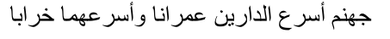
"Hell is the quicker of the two abodes to be filled with residents and quicker to turn to ruin." (Tafsir al-Tabari, 12:582)
As al-Subki pointed out, if taken literally this would mean even Heaven will turn to ruin! (al-I'tibar bi Baqa' al-Jannati wa 'l-Nar, p.155)
Imagine a Jahmi claiming that both Heaven and Hell will end, arguing from verses 107–108 of Surah Hud combined with this statement attributed to al-Sha'bi. How will pseudo-Salafis counter this Jahmi line of argumentation?!
Al-Sha'bi's statement can easily be interpreted to refer to the section of Hell that contains the sinful believers. That is, Heaven will be filled more slowly and Hell more quickly, but eventually the section of Hell in which sinful believers reside will be depleted.
Another statement quoted from the Salaf is one
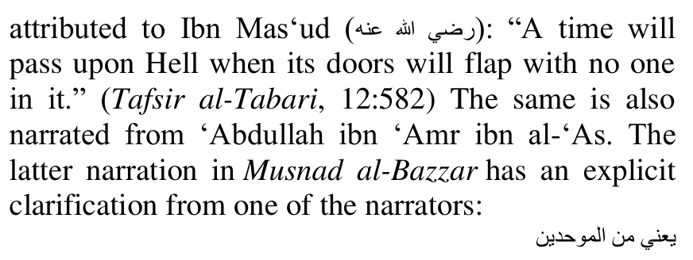
"Meaning, from the monotheists." (Musnad al-Bazzar, no.2478)
Imam Ahmad ibn Hanbal (164–241 AH) said about this narration:
"If it has a basis – that times will pass upon Hell with no one in it – it refers only to the section (of Hell containing) monotheists." (al-Jami' li 'Ulum al-Imam Ahmad [Dar al-Falah], 15:184)
Hence, Imam al-Baghawi (433–516 AH) notes about this narration:
"Its meaning according to Ahl al-Sunnah, if it is established, is that no one from the believers will remain (in Hell). As for the sections of the disbelievers, they will be forever full." (Tafsir al-Baghawi [Dar Taybah], 4:202)
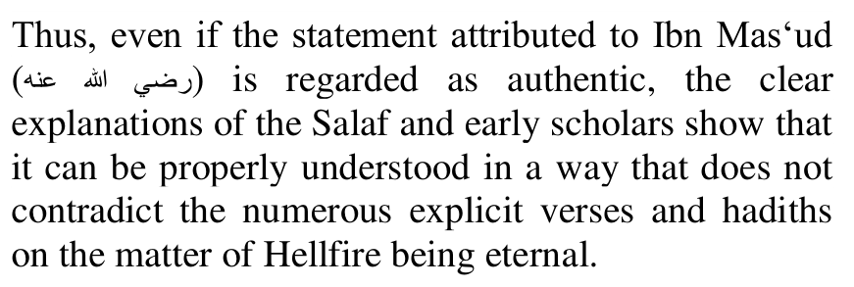
In another narration attributed to Ibn 'Abbas, Hellfire is said to "consume its inhabitants." (Tafsir al-Tabari, 12:582) Even if authentic, it means, as stated by Ibn al-Jawzi: "Allah will order Hellfire to consume and annihilate them (i.e. its inhabitants) and He then renews their creation, and thus the exception (in Qur'an, 11:107) refers to this state." (Zad al-Masir [Dar Ibn Hazm], p.673)
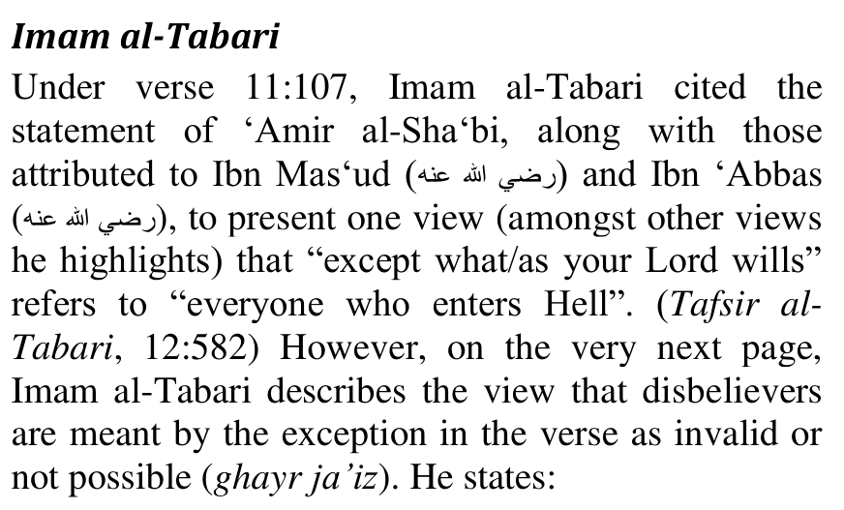
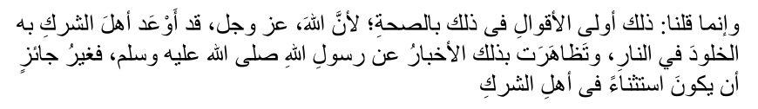
"We only said that this position (i.e. that the verse applies to the sinful believers) is the most sound on the matter because Allah, Glorified and Exalted is He, has warned the polytheists of eternity in Hell, and the reports from the Messenger of Allah (sallallahu alayhi wasallam) have multiply converged on this. Thus, it is not valid that it is an exception regarding the polytheists." (Tafsir al-Tabari, 12:583)
Thus, al-Tabari makes it explicitly clear that he does not consider the understanding that disbelievers will exit Hell as a valid interpretation of Qur'an, 11:107. It may be that what al-Tabari was noting is that these reports (from al-Sha'bi, Ibn Mas'ud and Ibn 'Abbas) were mistakenly assumed to support this view, while the reality is otherwise. As is evident from the citations from al-Bazzar and Imam Ahmad – both of whom predate al-Tabari – the Ahl al-Sunnah understood the narration mentioning a time when "no one will be left in Hell" as applying specifically to the sections of Hell containing sinful believers.
Conclusion In summary, it is neither true that any of the Salaf held the view that Hellfire will end, nor that Imam al-Tabari supported such a position.
The method employed by some pseudo-Salafis in justifying this position – by latching onto ambiguous texts or isolated statements to cast doubt on clear and definitive proof-texts – is no different from the tactics of the worst of heretics and distorters. Such a dangerous approach to beliefs can easily be used to undermine or overturn other established matters of religion.

OUR COMMENT
The belief in the eternity of Jannat and Jahannam is inextricably embedded in the Aqeedah of Islam. It is a belief in which there has never been any difference since the era of the Sahaabah.
The Jahmi sect which propounds the annihilation of Jahannam is a deviate sect which has left the fold of Islam. Deviates have always existed, but have been vehemently rebutted by the Authorities of the Shariah whenever they (the deviates) attempted to cunningly introduce their beliefs of kufr into the fabric of Islam.
The Qur'aan and the Ahaadith are explicit and emphatic in declaring the belief of the everlasting nature of Jannat and Jahannam. Thus, it is glaring kufr to propound a corrupt theory which conflicts with a Belief which is stated with the greatest of clarity in the Qur'aan and Hadith, and which the Ummah has unanimously believed in since the era of the Sahaabah.
It is the satanic stupidity of zindeeqs in every era, at the behest of Iblees, to present distortions and convolutions as Islamic beliefs. This is always the snare of Iblees to deviate Muslims from Siraatul Mustaqeem and to dismantle and destroy Islam. In our current age, Shaitaan has fielded many diverse cunning traps to entangle Muslims into the meshes of kufr. Among these satanic snares the worse is western kufr education with its emphasis on atheism.
Qur'aanic verses are distorted and given corrupt meanings to extravasate support for the kufr theories which the deviates propound. The agents of Iblees will take an aayat, submit it to their whimsical ideas, then utilize their corrupt opinion to deny the mass of Aayaat and Ahaadith on which the Aqaaid and A'maal of the Ummah are based and on which Ijma' has been formulated from the very inception of Islam. This is the cunning and trick which all zanaadaqah – kuffaar professing to be Muslims – employ in their plot to scuttle Islam.
Since the vast majority always consists of the followers of shaitaan, the deviates succeed in finding many ignoramuses to swallow the kufr they excrete. In this era of fitnah and fasaad, they also have the advantage of the satanic social media platforms – platforms of filth, fisq, fujoor and kufr. In this mass of najaasat all of the Ulama-e-Soo' are enmeshed and are promoting the religion of Iblees. It is essential to understand that every molvi/sheikh, regardless of who he may be and regardless of his following of juhala, if his snout is portrayed on these media of filth, then understand that he is among the Ulama-e-Soo'.
The belief of Jannat and Jahannam perishing and being annihilated was the kufr belief of Jahm bin Safwaan. It was this Jahmi Jahannami who had propagated this kufr belief. Imaam Tabari (Rahmatullah alayh) did not subscribe to the Jahannami's kufr belief.
Among the kufr beliefs of Jahmi Jahannami was fatalism. He believed that the human being has absolutely no power of acting. All actions of man are compelled by Allah Ta'ala in the same way as inanimate objects act.
He concurred with the Mu'tazali sect in negating the eternity of the Sifaat (Attributes) of Allah Azza Wa Jal. He believed that Allah Ta'ala lacked knowledge of something prior to its creation.
The believer in the annihilation of Jannat and Jahannam, selected an isolated Aayat from a mass of Qur'aanic verses which categorically confirm the everlasting nature of Jannat and Jahannam. Aqeedah (Belief) is never the effect of whimsical interpretation. Aqeedah is not formulated by means of interpreting Qur'aanic verses and Ahaadith.
Aqeedah is categorically and explicitly stated by Allah Ta'ala and His Rasool (Sallallahu alayhi wasallam). But the deviates select a Verse, submit it to their interpretation for fabricating a belief which is refuted by numerous Dalaa-il of the Shariah. They will deny numerous Aayaat to trade their personal opinion which they seek to bolster with the Qur'aan.
There is absolutely no basis in Islam for claiming that Jannat and Jahannam will one day be annihilated. Such a belief is explicit kufr which cancels one's Imaan.

ALLAH IS THE OWNER OF ALL THE BEAUTIFUL SIFAAT (ATTRIBUTES)
"He is Allah besides Whom there is no deity except
Him. He is the Knower of the Ghaib (the unknown/unseen and of Shahaadah (the Known and the Seen).
He is Allah besides Whom there is no deity except Him. He is the Sovereign, Al-Quddoos (the
Purest/Holiest).
(He is) As-Salaam (the Giver of peace); Al-Mu'min (The Protector); Al-Muhaimin (The Ever Vigilant);
Al-Azeez (The Mighty), Al-Jabbaar (The
Overpowering); The One of Greatness. Pure is Allah above the deficiencies they ascribe to Him.
He is Al-Khaliq (The Creator); Al-Baario (The One Who creates without the requisite of a pre-plan); Al-Musawwir (The Fashioner). For Him are the Beautiful Names (i.e. Attributes). Whatever is in the heavens and earth glorifies Him. He is Al-Azeez (The
Mighty), Al-Hakeem (The Wise)."
(Al-Hashr, Aayaat 22, 23, 24)
Deviates who deny certain vital aspects of Islamic Aqeedah are in reality in denial of the Sifaat (Attributes) of Allah Azza Wa Jal, and such denial in reality is tantamount to the denial of the existence Allah Azza Wa Jal. A being without the magnificent Sifaat which are predicated to Allah Azza Wa Jal, can never ever be the Khaaliq (Creator) in Whom we, the Mu'mineen, believe and Who is the Creator of the millions and billions of universes.
The negation of the Sifaat of Allah Azza Wa Jal is not an innovation of our time. It is kufr which has existed for thousands of years before Islam. The Greek philosophers – Plato, Aristotle, Socrates and the like – are the pioneers in this satanic discipline of Kufr. While they asserted belief in a creator, their concept was so ridiculously weird that it was tantamount to denial of Allah Azza Wa Jal – Allah Ta'ala with His Unique and Wonderful Attributes of perfection as we know and believe in.
The Mushrikeen of Arabia as well as mushrikeen of all hues and locations also subscribed to a creator. But all their concepts of a deity are weird and tantamount to the denial of Allah Azza Wa Jal.
During the early stage of Islam, the Mu'tazili sect, emulating their satanic atheist masters of philosophy innovated the evil of denying of the Sifaat of Allah Azza Wa Jal. Based on such denial, they innovated some exceptionally evil beliefs pertaining to Allah Ta'ala.
In brief these followers of Iblees, among whom Jahm, was a chief, had stripped Allah Azza Wa Jal of His beautiful Sifaat of excellence and perfection. Then these illegitimate progeny of Iblees substituted the Divine Sifaat with the attributes of ignorance, deficiencies, weakness and the like which they attributed to Allah Ta'ala.
The claim that Allah Ta'ala becomes aware of something only after He has created it, besides being crudely illogic and revolting to Imaan and Aql, is among the worst kinds of kufr.
The satanic heretics who had wildly and widely deviated from Siraatul Mustaqeem to initiate their sects and beliefs of kufr were in fact akin to the mushrikeen who had fabricated their own personal concepts of godhood, then clung to the kufr as if it was revealed to them directly from Allah Ta'ala whilst in reality, they merely believed in and worshipped names and mirages fabricated by their minds wallowing in Satanism. For the worshippers of their own fabrications, Nabi Hood (Alayhis salaam) said to his people:
"Verily, Rijs (Filth/Punishment) and Wrath from your Rabb have afflicted you. Do you dispute with me regarding such names (baseless concepts) which you and your forefathers have fabricated? Allah has not revealed any confirmation (proof) for it."
(Al-A'raaf, Aayat 71)
Similarly, Nabi Yoosuf (Alayhis salaam) said:
"Besides Him (Allah), you worship only names
(baseless concepts) which you and your forefathers had fabricated. Allah did not reveal any evidence for this. The decree is (the prerogative) of only Allah."
(Yoosuf, Aayat 40)
In the same way do the deviates who profess to be Muslims, argue. They innovate their own whimsical concepts which are in violent conflict within the same vein do we say to the deviates, heretics and blasphemers: What is your basis for your blasphemous beliefs? Did Rasulullah (Sallallahu alayhi wasallam) and the Sahaabah propound the kufr you are excreting on the basis of your personal whimsical understanding and interpretation of isolated Qur'aanic verses which you bend and misinterpret to eke out some flimsy straws for your view of kufr despite your interpretation being in diametric conflict with all the Qur'aanic and Hadith Nusoos on the topic under discussion?
Thus it is seen that the moron heretics desperately seeking to extravasate 'proof' for their kufr in a statement of Tabari which they mutilate with their own interpretation. Even if we have to momentarily assume that Tabari believed in the annihilation of Jahannam, the fact that he appeared on the Islamic horizon about 250 years after Rasulullah (Sallallahu alayhi wasallam), is more than adequate for dismissing the claim of kufr which all the illustrious Authorities of the Shariah before him had vehemently negated. Thus, Imaam Abu Hanifah (Rahmatullah alayh) branded Jahm as a kaafir because of his belief of kufr. But the reality is that Tabari never subscribed to the kufr belief of Jahannam ever ending. He believed in the beliefs propounded by the Qur'aan and Sunnah and on which there exists Ijma' of the Ummah from the very inception of Islam, from the era of the Sahaabah.
The ludicrousness and glaring kufr of baseless concepts pertaining to Aqeedah are palpably clear to those in whose hearts Imaan is embedded. Aqeedah is Belief which was taught by Rasulullah (Sallallahu alayhi wasallam) and to which the Sahaabah subscribed without fabricating their own concepts based on interpretation. Aqeedah relies on only Wahi (Revelation). Logic and interpretation have absolutely no share in the formulation of Aqeedah which the Nabi propounded. Therefore, the vital question which should be answered by the deviates, and which they will not answer is: When in Islam did the belief of annihilation of Jannat and Jahannam develop? They will not answer because such brazen blasphemy (kufr) never existed in the ranks of the Sahaabah.
On the contrary, the Authorities of the Shariah of the earliest eras of Islam and thereafter throughout the history of Islam, had always resolutely and vehemently rejected this kufr notion.
When the modernist deviates and zanaadaqah of our age find any tenet or belief of Islam unpalatable for their nafs heavily impregnated with the atheist cult of the west, they invariably dig into Islamic sources in the satanic attempt to extract some evidence for their corrupt and satanically convoluted beliefs.
Although the Aqaaaid (Beliefs) are stated with the greatest clarity and are confirmed with Unanimity (Ijma') since the era of the Sahaabah, the deviates seek to neutralize these Beliefs with Qur'aanic verses of ambiguous meanings despite the Qur'aan affirming the exact opposite of their kufr copro theories. On the Day of Qiyaamah, in the Divine Court, Nabi Isaa (Alayhis salaam) exonerating himself from the shirk of trinity of Bani Israaeel, and being fully aware of the eternal punishment in store for the mushrikeen, will say:
"If You punish them, verily, they are your servants, and if You forgive them, verily, You are The Mighty,
The Wise."
(Al-Maaidah, Aayat 118)
Rejecting the possibility of forgiveness for the mushrikeen, Allah Ta'ala will respond:
"This is the Day when the truth of the Saadiqeen will benefit them. For them are Gardens below which flow rivers, Therein shall they dwell forever and forever (Khaalideen Abadan)."
(Al-Maaidah, Aayat 119)
Although Nabi Isaa (Alayhis salaam) will be fully aware of the everlasting punishment of Jahannam for the mushrikeen, nevertheless with his focus and hope on the prerogative power of Allah Azza Wa Jal, he will say: "If you forgive them, verily, they are your servants (i.e. creatures)".
The promises which Allah Ta'ala makes do not negate His prerogative powers. He is free to do with His creation as He wills. There is absolutely nothing to restrict or curtail Him in anything. If Allah Azza Wa Jal decides to revoke His Promise and assign all the Ambiya and all the Mu'mineen to Jahannam, and similarly forgives shaitaan and all the kuffaar, then enter them in Jannat, who is there to question Allah Ta'ala and to restrict Him?
Now if a follower of Iblees utilizing his copro brains formulates a belief of forgiveness and Jannat for Shaitaan on the basis of the prerogative power of Allah Ta'ala and the verses mentioning 'exception', then his kufr will be glaring and undeniable. The agent of Iblees will be asked to substantiate his belief with the Nass of the Qur'aan and Hadith. His copro brain is not a daleel.
Understand well that all created entities and powers are limited in their faculties and abilities. The hearing of the ear is limited. The vision of the eye is limited, the functional ability of every limb in the body and of everything created is limited. The brain cannot be excluded from its natural constraints of limitation.
Allah Ta'ala is the Uncreated Being with infinite powers and attributes. It is impossible for the created mind with its limitations to ever encompass the infinite Sifaat of Allah Ta'ala. Thus whatever concepts are fabricated regarding the Sifaat of Allah Azza Wa Jal are shenanigans of the nafs utilizing a brain severely restricted by limitation which is the incumbent predication of its created nature.
The denial of the Sifaat and curtailing or limiting the operation of the Sifaat of Allah Azza Wa Jal within the confines of the created brain are the inspirations of Iblees who gains control of the brains of morons who are either extremely defective in faith or bereft of faith. People of true Imaan do not venture into domains which are unfathomable, and which can never ever be encompassed by the created human mind even on the Day of Qiyaamah when mysteries will be unravelled.
The true Mu'min recites Ta'awwuz (seeks the refuge of Allah from shaitaan) when shaitaani thoughts about the Zaat and Sifaat assault him. Allah Ta'ala says in this regard:
"When evil from shaitaan assaults you, then seek refuge with Allah. Verily He is the Hearer, The
Knower.
Verily, when villainy from shaitaan assaults those who have taqwa, they resort to thikrullah. Then they see (and understand) the reality (of shaitaan's ploy."
(Al-A'raaf, 200 and 201)
In bygone times, some millennia ago, the Greek philosophers, the 'intelligentsia' of the era, becoming too big for their boots, denied the Existence of Allah Azza Wa Jal, in their own fabricated weird, stupid manner. They evolved concepts which superficially acknowledged the existence of a Creator, but with either extremely defective attributes or without attributes. For example they excreted from their satanized brains that Allah Ta'ala is a creative energy. Creation emanates from Him without His conscious planning and control. He simply has no control over what emanates from him just as the sun has no control over the rays and heat emanating from it.- Nauthubillaah! While the reality was the denial of the existence of the Creator, to soothe the religious perceptions of the masses, they bamboozled them with a 'creator' who is an inanimate object devoid of consciousness and attributes.
Today, in this era of technology, the Satanists lurking in the Muslim community, who believe themselves to be the 'intelligentsia' and who deny the existence of Allah Azza Wa Jal in cunning ways of Satanism, are the moron products of western secular education. Since the Beliefs of Islam militate violently against the ideology they have acquired from their atheist masters, these zanaadaqah (heretics/murtads), resort to absolute baatil ta'weel (baseless/invalid interpretation) of Qur'aanic verses and Ahaadith to fabricate meanings which are in diametric conflict with the Aqaaid expounded in the Qur'aan and Hadith, but which the morons believe uphold the ideology of their atheists masters.
The idea of the annihilation of Jannat and Jahannam is one such corrupt belief excreted by their copro minds wallowing in Satanism. For these morons, the kuffaar being subjected to everlasting chastisement in Jahannam is at variance with 'justice', hence they are at pains to fabricate a belief which refutes this imaginary 'injustice' which they attribute to the Aqeedah of the everlasting existence of Jahannam. But they have no proof for their idea. It is the product of their thinking and understanding. It is not substantiated by Wahi. Absolute certitude is exclusive with Wahi.
Those who deny the everlasting nature of Jannat and Jahannam are in reality imputing lies to Allah Azza Wa Jal. They are implying that all the promises pertaining to Khulood and Abadan mentioned in the Qur'aan a 'million' times are all lies and a chimera for extracting obedience from us. The repeated refrain in the Qur'aan for Jannatis and Jahannamis is: "Therein shall they dwell khaalideen (everlastingly)
and abadan (forever and forever)."
It is emphasis multiplied.
Allah Ta'ala addresses His servants – those whom He has created – in a manner which they understand. His assurance is not a false chimera. He mentions terms which human beings understand. It is therefore the imputation of deception to Allah Ta'ala to imply that his statements (abadan and khaalideen) serve the objective of beguilement – beguiling us into believing what is not true, and what is contrary to what we have understood from the explicit assurances of Allah Azza Wa Jal. The understanding which we acquire from the terms stated by Allah Ta'ala is the only true and valid conception.
It is indeed a mentally suffocating conception and heart-breaking for the Mu'mineen to ghastly contemplate that a time will dawn when they will be annihilated along with Jannat, never again to see the light of existence. Such cruelty and injustice which the vile Jahmis and their followers are attributing to Allah Azza Wa Jal, are inconceivable for Allah Azza Wa Jal, the Master of all Attributes of excellence and perfection. There exists not a vestige of evidence in the Shariah for the corrupt conception of the Jahmi Jahannamis.
It is a snare of Iblees to entangle people, especially Muslims, in futility and nonsense in his scheme to destroy Imaan. Whether Jahannam is everlasting or not, there is no benefit for a person to engage in mental gymnastics to fathom the reality. Never will any concept he fabricates be able to affirm with certitude the fate of the kuffaar in the Hereafter.
Whatever, his mind proffers will be his personal and whimsical fancy and notion unsubstantiated by Wahi. Why then would a Muslim squander his brains and time to fabricate a concept which remains a personal opinion?
The true Mu'min believes that Allah Ta'ala is Samee' (The Hearer), Baseer (The One Who sees), Qadeer (All Powerful), Aadil (Just), Rahmaan (The Merciful), etc. Therefore, whatever He will do with His creation in the Hereafter will be proper and just. Our personal ideas will not alter the position of the fate of the kuffaar or of anyone. Whatever Allah Ta'ala has decreed for the kuffaar by way of punishment, will be just. Fabrication of concepts to soothe one's feelings is of no avail. So, whether one believes in the everlasting nature of Jahannam or not, the position decreed by Allah Ta'ala will prevail.
Issues pertaining to the prerogative powers of Allah Azza Wa Jal should never be submitted to intelligence for review. The products of intelligence will not change the decrees of Allah Azza Wa Jal.
"When Allah intends something, He says:
'BE!' and it comes into existence." (Qur'aan)

