

Kitaabus Salaat
The Majlis · Voice of Islam
Mujlisul Ulama of South Africa

About this edition
This is a reproduction by The Majlis Archive (themajlisarchive.com) of a publication of The Majlis, Mujlisul Ulama of South Africa, made and published with their permission.
The PDF as The Majlis issued it is the original. This edition was read from that PDF's own structure and checked against it letter for letter; where the two differ, the PDF is correct.
Checked: 1,341 paragraphs, 0 differing; a second, independent PDF reader finds 99.8% of the PDF's words here.
Nothing has been reworded, added or removed.

KITAAB -US-SALAAT

(MUSLIM PRAYER BOOK)
RASULULLAH
(SALLALLAAHU ALAYHI WASALLAM)
SAID:

"SALAAT IS THE MI'RAAJ OF THE MU'MINEEN."

PREFACE
This important manual on Salaat was first published in 1978. Owing to world-wide demand, the initial stock of 30 000 copies was exhausted in 1981, and a second edition was brought out in 1982. However, the popularity of the Kitaab continued to grow and, despite distribution on a selective basis, stocks of the second edition dwindled away within six years. Effort had to be initiated towards a re-print, and Alhamdulillah! the Third Edition of "Kitaabus-Salaat" is now in your hands.
It will be observed that apart from a new cover photograph and the inclusion of this Preface, some significant additions have been made which should enhance the usefulness of the Kitaab.
It is our fervent Duaa that may Allah Ta'ala bestow His Gracious Rewards upon all Muslims who assisted in making this magnificent production a reality.
1 ZiI-Hajj 1409 5 July 1989
ISBN 0-620-13943-9

THE MUSALLAA OR EID GAH
RASULULLAH ((Sallallahu alayhi Wasallam)) said:
"Whoever adheres to my Sunnah at the time of the corruption of my

Ummah, will obtain the reward of a hundred martyrs."
The above Hadith of Rasulullah ((Sallallahu alayhi Wasallam)) as well as many others inform us of the great thawaab and merit in reviving the Sunnah practices of Islam. It is obligatory upon Muslims to accord special attention to the restoration of forgotten and lost practices of our Nabi ((Sallallahu alayhi Wasallam)). One such lost and forgotten practice of Islam is the PERFORMANCE OF THE EID SALAAT IN THE MUSALLAA (EID GAH).
The Shariah commands that the Eid Salaat be performed on an open field near the outskirts of the town or city. The regular practice of Rasulullah ((Sallallahu alayhi Wasallam)), the Sahaabah and all the great learned men of Islam as well as of the Ummah down the corridor of the centuries of Islamic histoty was to perform Eid Salaat in the Musallaa or an open field. In the books of Islam, it is recorded:
"Nabi ((Sallallahu alayhi Wasallam)) used to perform the salaat of both Eids at a place in the open plain outside Madinah
Munawwarah..."
(Ibn Hajar)
"The basis and proof for this is that verily, Nabi ((Sallallahu alayhi Wasallam)) would go out to the Musallaa. He did not perform the
Eid Salaat in his Musjid (i.e. Musjidun Nabawee) despite the elevated rank of his Musjid excepting on one occasion because of rain."
(Ibn Qayyim in Zaadul Ma'aad and Qustulaani in Al-Mawaahibil-Ladunniyah.)
"Many Ahadith in this regard have been narrated in the Kitaabs of
Hadith and in others"
(Fataawa Darul Uloom)
"It is clear from the Ahadith that Nabn ((Sallallahu alayhi
Wasallam)) always performed the Eid Salaat in an open plain with the exception of a single occasion when it rained and he performed the Salaat in the Musjid"
(Fataawa Imdaadiyyah)
"Proceeding to the open field (Musallaa) for the Eid Salaat is Sunnat even if the Jaami' Musjid is large enough to contain the community
This is the correct view.
(Durrul Mukhtaar)
The authentic and authoritative books of Islam make it abundantly clear that performance of Eid Salaat on an open field at the outskirts of the town is a Sunnat practice of Rasulullah ((Sallallahu alayhi Wasallam)) and the Sahaabah. In the technical language of the Shariah, the term "sunnat" has classifications. What classification does the Eid Salaat in the Musallaa belong to? The following is the ruling of the Shariah:
"Proceeding to the Musallaa on the days of Eid for the Salaat according to the authentic and correct view of the general body of
Fuqahaa is Sunnatul Muak-kadah and not Mustahab".
(Majmu-atul Fataawa)
"The Eid Salaat in the Musallaa is Sunnatul Muak-kadah."
(Bahrur Raa-iq and Talbees)
"To proceed to the open field is Sunnatul Muak-kadah even if the Jaami' Musjid is sufficient to contain the people. Therefore, if they perform the Eid Salaat in the city Musjids without valid reason (e.g.
rain), the salaat is valid, but they have discarded the Sunnah. This is the correct view."
(Zaheeriyyah)
The aforementioned references as well as numerous more in other books of the Shariah emphatically state that the performance of Eid Salaat in the Musallaa is Sunnatul Muak-kadah. According to the Shariah, deliberate neglect of a Sunnatul Muak-kadah injunction invites the Wrath of Allah Ta'ala. It is not permissible to forego a Sunnatul Muak-kadah without valid Shar'i reason.
In South Africa generally and in the Cape Province in particular, this Sunnah of the Musallaa has become non-existent. It is, therefore, incumbent upon Muslims to vigorously revive this Sunnah of our Nabi (Sallallahu alayhi Wasallam). The Sawaab for reviving this gone and forgotten Sunnah is indeed tremendous.
Any vacant ground on the outskirts of the town will suffice for the purpose of the Musallaa (Eid Gah). Although it is best to secure a permanent plot of land, fenced off for the specific purpose of Eid Salaat, any ground at the end of the town (where the buildings have stopped) will suffice for this purpose. A vacant ground within the confines of the buildings e.g. a vacant school ground, etc. will not serve the purpose of the Musallaa. It is essential that the Musallaa be located on the outskirts of the town.
MASAA-IL PERTAINING TO JAMA'T OR CONGREGATIONAL SALAAT64

INTRODUCTION
"Verily Salaat prevents one from shameful and forbidden things; and the remembrance of Allah is greatest" (QURAN 29:45).
"Salaat is the best of all that has been ordained by Allah" (Holy Prophet - Sallallahu alayhi Wasallam).
Salaat occupies a lofty position in the religion of Islam. Its performance is the foremost duty of a Muslim after he has brought faith in the Oneness of Allah Ta'ala and the prophethood of His holy Messenger, Nabee Muhammed (Sallallahu alayhi Wasallam). It is a most special act of Divine worship which he is called upon to perform five times daily without fail. The pages of the Qur'an and Hadith are replete with injunctions which enjoin Salaat on us. It is of such paramount importance that it has been described as a pillar and foundation of faith.
Salaat, if offered with a sincere heart, proper devotion and mental concentration, contributes to the cleansing of the heart, ridding it of the impurities of sin and ultimately transforming one's entire life. It engenders love for piety and promotes fear of Allah in man. Islam has laid greater emphasis on the institution of Salaat than on other religious obligations. Whenever anyone came to Rasoolullah (Sallallahu alayhi Wasallam) with a view to embrace Islam, he was expected to uphold his Salaat with regularity. Hence after Imaan, Salaat is the bedrock of Islam.
From a study of the traditions of our Holy Prophet (Sallallahu alayhi Wasallam) we learn that Rasoolullah (Sallallahu alayhi Wasallam) denounced the giving up of Salaat as the way of the unbelievers. He is reported to have said:
"That which separates a believer from infidelity is simply the Salaat" "He has no share in Islam who does not offer Salaat"
Rasoolullah (Sallallahu alayhi Wasallam) sounded a note of warning to Muslims that if they gave up Salaat their conduct would be associated with that of the unbelievers.
What a great act of virtue and felicity it is to offer Salaat regularly and how disastrous it is to neglect it, is beautifully summarised in the following prophetic words:

'Whoever will offer the Salaat properly and regularly it will be for
him on the Last Day a source of light, a proof of his faith and a means to salvation. (On the other hand) Whoever will not offer it carefully and regularly it will be for him neither a source of light, nor a proof of faith, nor a means of salvation, and the end of such a

person will be with Qarun, Fir'aun, Haman and Ubai-bin-Khalaf"
The ignominy and disgrace that the defaulters of Salaat will be subjected to on the Day of Judgment, has been aptly described in the Holy Qur'an:
"The day that the shin shall be laid bare, and they shall be summoned to bow in adoration, but they shall not be able, their eyes shall be cast down - ignominy will cover them, seeing that they had been summoned aforetime to bow in adoration while they were hale and healthy (and had refused). "(LXVIII:42).
According to the above Qur'anic verse mankind will be summoned to bow down in adoration before Allah Ta'ala on the Last Day. Only the fortunate ones, who had during their lifetime made it a practice to be regular in their Salaat, will find no difficulty in bowing down. Those who, in spite of being healthy and strong, had not observed Salaat in this world, will discover to their dismay that their backs had suddenly grown stiff with the result that they will remain standing with the infidels unable to prostrate before their Lord and Creator. Such will be the humiliation and disgrace for the defaulters of Salaat! May Allah Ta'ala save us from such ignominy!
In view of the overriding importance of Salaat in the life of a Muslim there is a great need for a booklet dealing comprehensively with this subject. To practise upon this compulsory injunction of Islam it is imperative for Muslims to acquire sound knowledge of this important subject. Alhamdolillah through the Grace, Mercy and Help of Allah Ta'ala this booklet, entitled, "Kitabus Salaat" is presented to you for your perusal and guidance. This simple presentation fulfils a long-felt need in the field of Islamic education in South Africa. It is an invaluable contribution from an Aalim who has dedicated this service to Allah Ta'ala and wishes to remain anonymous.
'Kitabus Salaat" will not only serve as a useful text-book in Madressas but its benefits will even extend to Muslim students as well as other youth who have passed the Madressa stage. Even new converts to Islam, desirous of equipping themselves with the basic knowledge of Salaat and its practical application in daily life will derive tremendous benefit from this booklet. It is undoubtedly a notable contribution. .. a booklet embodying a wealth of information. "Kitabus Salaat" is a must for every Muslim home, madressa or school. It would be highly appreciated if, after perusal, any errors are detected, these are brought to our notice.
May Allah Subhanahu Wata'ala accept this humble service from us and reward the author abundantly for his untiring effort in producing this work. May Allah grant him long life, prosperity, good health and toufeeq to continue with his selfless sacrifice in the cause of Islam. .. Aameen.

"Successful indeed are the believers Who are humble in their Salaat" (23:1-2)?

NECESSARY TECHNICAL TERMS OF FIQH
There are Eight Classes of Divine Laws regarding the deeds and actions of man:
(i) Fardh; (ii) Waajib; (iii) Sunnat (iv) Mustahab; (v) Haraam; (vi) Makrooh-Tahrimi (vii) Makrooh Tanzihi (viii) Mubaah.

FARDH
Fardh is a Divine Command which is established by such proof known as Daleel Qat-i (Absolute Proof). One who neglects a Fardh injunction without any valid Islamic excuse is termed by the Shariah as a Faasiq
One who rejects a Fardh injunction is termed a Kaafir and is beyond the pale of Islam.
Fardh is subdivided into two classes: (i) Fardh Ain, (2) Fardh Kifaayah.
1. Fardh Ain is a duty which is compulsory upon every Muslim. Neglect of Fardh Ain without a valid (Islamic) reason warrants punishment, and such a person is described as a Faasiq.
2. Fardh Kifaayah is a compulsory duty, which, if discharged by a few members in a community, will absolve the whole community. However, if not a single person in the community executes it then the entire community will be liable and sinful.

WAAJIB
Waajib is a Divine Command established by proof known as Daleel Zanni (or such proof which although very strong, but of a lower category than Daleel Qat-i). One who neglects or rejects a Waajib injunction is termed a Faasiq.

SUNNAT
Sunnat refers to such deeds as practised by Rasulullah (Sallallahu alayhi Wasallam) or his Sahabah (Radhiallahu anhum. )Sunnat is divided into two classes:
1. Sunnatul Muak-kadah, 2. Sunnatul Ghair-Muak-kadah.
Sunnatul Muak-kadah is an action which was steadfastly upheld by Rasulullah (Sallallahu alayhi Wasallam) or his Sahabah (Radhiallahu anhum) and was not left off without valid reason. One who constantly neglects it is also termed a Faasiq.
Sunnatul Ghair-Muak-kadah is an act which was practised by Rasulullah (Sallallahu alayhi Wasallam) and his Sahabah (Radhiallahu anhum), but which they sometimes left off without any excuse.
Execution of Sunnatul Ghair-Muak-kadah warrants great Sawaab (reward) and failure to carry it out does not warrant punishment.
It is also known as Sunnatuz-Zaa-idah as well as Sunnatul-Aadiyah. (Definitions of Technical Terms continued on page 79)

CONDITIONS FOR THE VALIDITY OF SALAAT
There are several things which have to be fulfilled before starting the actual Salaat or Namaaz. If any one of these things is absent the Salaat will not be valid and may not be performed. These necessary things are known as the Shuroot or Conditions preceding Salaat. The Shuroot of Salaat are as follows:
1. Tahaarah or purity; 2. Satare Aurah or Covering of one's Aurah 3. Istiqbale Qiblah or Facing the Qiblah, 4. Niyyat or intention of Salaat; 5. Time.
The abovementioned Shuroot of Salaat will now be briefly explained.

1. TAHAARAH OR PURITY
There are two types of impurities which affect the human being. These are:
(i) Janabat, which is known as the Greater Impurity or Hadthe Akbar;
(ii) Hadth which is known as the Lesser Impurity or Hadthe Asghar.
Janabat is that state of impurity which follows:
(i) Sexual intercourse; (ii) Discharge of semen; (iii) Haiz or menses; (iv) Nifaas or confinement (child-birth).
Hadth is that state of impurity which results from the following acts:
(i) Answering the call of nature; (ii) Emission of anything from the hind and front private parts; (iii) Passing wind from the hind private part
(N.B. The passing of wind via the front part — as is the case in some kinds of sickness — does not bring about the state of Hadth.);
(iv) Flowing of blood from any part of the body; (v) Flowing of puss from any part of the body; (vi) Vomiting a mouthful of matter; (vii) Sleeping while lying down or sleeping whilst leaning against some object
(viii) Unconsciousness; (ix) Audible laughter during the course of performing Salaat excluding Janazah Salaat.
It is necessary for the Musalli (i.e. the one who performs Salaat) to be purified from both states of impurities, viz., Janabat and Hadth, before commencing Salaat. Purification from the state of Janabat is attained by taking Ghusal (complete bath), and purification from Hadth is attained by making Wuzu (ablution).
(N.B. Ghusal and Wuzu will be explained in a different booklet, entitled: Kitabut-Tahaarah.)
Besides Tahaarah (Purity) of the body, Tahaarah of the place whereon Salaat is performed is also necessary. The place or spot on which Salaat is performed must be pure and clean.
It is also essential that the clothing donned by the Musalli be pure and clean.

2. SATARE AURAH OR COVERING OF ONE'S AURAH
Aurah means that part of the human body the covering of which is compulsory.
The aurah of a man is that part of his body from the navel to the knees.
(N.B. The navel is not included in the Aurah, but the knees are part of the aurah and have to be covered.)
The aurah of a woman is her entire body — from head to feet — excepting the face and the hands.
Before commencing Salaat it is compulsory to have one's aurah covered.

3. ISTIQBALE QIBLAH
Istiqbale Qiblah means to face the direction in which the Holy Ka'ba is located. The Musalli must face the Qiblah when performing Salaat.

4. NIYYAT
The Musalli must form the Niyyat (Intention) in the mind of the particular Salaat about to be performed.

5. TIME
The various Salaats must be performed after entry of their respective times. A Salaat cannot be performed prior to its appointed time.

MASAA-IL (RULES) PERTAINING TO THE SHUROOT OF SALAAT
1. If a female don such transparent clothing or transparent head-covering that part of her aurah is visible, her Salaat is null and void.
2. If during the course of Salaat one-fourth of any part of the aurah, e.g. one-fourth of the thigh; one-fourth of the head (in the case of females) is revealed for the duration of three Tasbihs, the Salaat is rendered void.
(N.B. The duration of three Tasbihs is the time taken to recite "Subhanallah" thrice, i.e. about three seconds.)
3. If some impurity is on the Musalli's clothing, Salaat may be performed with the impure clothing provided no water is available within a radius of one Islamic mile.
(An Islamic mile is equal to approximately one and one-fifth English miles.)
4. If on a journey one has sufficient water for only one act, i.e. the water is sufficient for either making Wuzu only or for removing the impurity from one's clothing, then the water must be used for cleansing one's clothing and instead of Wuzu, Tayam-mum is to be ade. (This rule will apply if sufficient water for only one act exists and no water is available within a radius of one Islamic mile.)
5. It is not necessary to make niyyat or intention for Salaat by means of uttering. The mere intention in one's mind will suffice, i.e. to intend in the mind: "I am performing the Fardh of Zuhr or the Sunnat of Zuhr, etc."
There is no need for the lengthy niyyats recited by people when making Salaat.
6. If one wishes to recite the niyyat, it will suffice to say: "I am performing the Fardh of Fajr — I am performing the Sunnat of Zuhr", etc.
7. Whilst making niyyat, say, for instance Zuhr, one utters Asr instead, the Salaat will be valid provided one has in mind that Zuhr is being performed.
8. If by error one utters (whilst making niyyat) six rakaat or three rakaat in place of four rakaat, the Salaat will be valid.
9. In performing Sunnat, Nafl or Taraweeh Salaat, it will be sufficient to intend that: "I am performing Salaat." If the words, Sunnat, Nafl and Taraweeh were not added, the Salaat will be valid. However, in the case of Sunnat and Taraweeh Salaat it is better to add in one's Niyyat the terms, Sunnat or Taraweeh.
10. (a) If the Musalli happens to be in a place where he is unable to determine the direction of the Qiblah nor can he locate someone who could indicate the Qiblah to him, then the Musalli should ponder about the direction of the Qiblah and face that direction which his heart attests to be the Qiblah.
(b) If he faces any direction without pondering, his Salaat will not be valid.
In the case of No, 10(a), if after Salaat it is established that the direction was in fact not the Qiblah, then too the Salaat will be valid.
11. If during the course of performing Salaat the Musalli realises that he is not facing in the direction of the Qiblah, he should turn towards the Qiblah immediately upon such realization and proceed with the Salaat.
12. It is permissible to perform Salaat inside the Ka'ba Sharief. If Salaat is performed inside the Holy Ka'ba, any direction may be faced.

THE TIMES OF SALAAT THE TIME FOR FAJR SALAAT
Appromixately 1 ½ hours before sunrise a dim whitish glow appears vertically in the eastern horizon. Soon after this vertical glow, a brightness appears horizontally in the eastern horizon. This horizontal glow spreads instantly along the horizon becoming larger and larger until after a short while it becomes light. The time for Fajr Salaat commences with the appearance of this horizontal glow in the eastern horizon. This time marked by the appearance of the horizontal glow is known as Fajre Awwal or Subh Sadiq (True Dawn). The time for Fajr Salaat lasts until sunrise.

THE TIME FOR ZUHR SALAAT
The time for Zuhr Salaat begins immediately after Zaw-waal or midday. The time of midday or Zaw-waal is calculated by dividing the hours of daylight by two, and adding the result to the time of sunrise, e.g.:
1. Example:
Sunrise 6.30 a.m.
Sunset 5.30 p.m. i.e. Number of Daylight hours = 11 hours Divide by two 11 ÷ 2 = 5 ½ hours Add to Sunrise time 6.30 + 5.30 = 12.00 i.e. Zaw-waal will be at 12 p.m.
2. Example:
Sunrise 5.10 a.m.
Sunset 7.30 p.m. i.e. Number of Daylight hours 14 hours, 20 minutes.
Divide by two 14 hrs. 20 min. ÷ 2 = 7 hrs., 10 min.
Add result to sunrise time: 5.10 + 7.10 = 12.20 i.e. Zaw-waal is at 12.20 p.m.
It is forbidden to perform Salaat at the time of Zaw-waal. After approximately five minutes (i.e. five minutes after Zaw-waal) Zuhr time commences.
The time for Zuhr Salaat lasts until the length of the shadow of an object becomes twice the size of the object plus the size of the shadow which was cast at the time of Zaw-waal.
Example:
The shadow of a yardstick at Zaw-waal was four inches. The time for Zuhr Salaat will remain until the shadow of the yardstick attains a length of two yards and four inches, i.e. twice the length of object plus shadow of Zaw-waal.

TIME FOR ASR SALAAT
Asr time begins immediately upon the expiry of Zuhr time, and lasts until sunset. However, it is Makrooh (reprehensible) to delay the performance of Asr Salaat until the sun's rays become yellowish and dim as is the case before sunset.

TIME FOR MAGHRIB SALAAT
Immediately after sunset the time for Maghrib Salaat commences, md ft lasts until the white glow of twilight remains.

TIME FOR ISHAA' SALAAT
The time for Ishaa Salaat begins immediately after expiry of the time of Maghrib, i.e. immediately after the white glow of twilight disappears. lshaa time lasts until Fajre Awwal or Subh Sadiq (true dawn). The moment Fajre Awwal enters, lshaa time expires.
(The terms Fajre Awwal and Subh Sadiq have already been explained under the heading: The Time for Fajr Salaat.)

MASAA-IL PERTAINING TO SALAAT TIMES FORBIDDEN TIMES OF SALAAT
1. It is not permissible to perform any Salaat whatsoever at the following times:
(a) At Sunrise; (b) At Midday (Zaw-waal); (c) At Sunset.
Salaat could be performed about 15 minutes after sunrise; five minutes after midday and immediately after sunset.
(d) Before sunset when the suns rays lose their heat and become yellowish.
No Salaat can be performed during this time excepting the Asr Salaat of that day if it has not yet been performed.
NB. It is not permissible to delay the performance of Asr Salaat until this time. However, if Asr Salaat was not yet performed then it has to be performed even in this Makrooh (reprehensible) time.
(e) When the Imam is delivering the Friday or Eid Khutba.
2. It is not permissible to perform any Sunnat or Nafl Salaat after the Fardh of Asr has been fulfilled. Qadha Salaat, however, may be performed after the Fardh of Asr.
3. During the time of Fajr Salaat it is not permissible to perform any Nafl Salaat.
Qadha Salaat may be performed during the Fajr time.
4. If one performs the Fardh of Fajr without first performing the Sunnat of Fajr, it is not permissible to make the Sunnat after the Fardh of Fajr. The Musalli will have to wait until after sunrise in order to perform the Sunnat of Fajr which was missed.
5. While performing Fajr Salaat, if the sun rises, the Salaat is not valid and will have to be repeated as Qadha. However, if the sun sets while Asr Salaat is being performed, it (Asr Salaat) will be valid.
6. During summer it is Mustahab (preferable) to perform Zuhr Salaat a considerable time after midday, and during winter it is Mustahab to perform Zuhr Salaat soon after midday.
7. It is Mustahab to perform Fajr Salaat when it is a bit light.
8. It is Mustahab to perform Ishaa' Salaat just before one-third of the night has passed.
_______________ooOoo_______________

AZAAN
1. Azaan is the Call to Salaat. It is Sunnat to recite the Azaan for the five daily Salaats and Juma' (Friday) Salaat.
2. Azaan is recited by men only. Azaan given by a female is not valid.
3. When giving Azaan, the Muazzin (i.e. the one who recites the Azaan) must face the Qiblah.
4. Azaan should be given for Qadha Salaat as well. If the Musalli is performing several Qadha Salaat at once he should recite the Azaan for the first Qadha Salaat, thereafter he has the option of either reciting the Azaan for the other Qadha Salaats or be content with only the Iqaamah.
5. It is Sunnat to be in the state of Wuzu when reciting Azaan. However, it is permissible to recite the Azaan without being with Wuzu.
6. It is not permissible to recite the Azaan for a Salaat prior to the entiy of the time of that particular Salaat.
7. If Azaan is recited before the commencement of the time of the Salaat, such Azaan will not be valid. The Azaan will have to be repeated.
8. The Azaan should be recited in a loud voice, pausing after the various phrases.

THE AZAAN

(ALLAHU AKBAR)

Allah is the Greatest
(To be recited four times)

(ASH-HADU-AL-LAA ILAAHA IL-LAL-LAAH)

I bear witness that there is none worthy of worship, but Allah.
(To be said twice)

(ASH-HADU-AN-NA MUHAM-MA-DUR-RASOOLUL-LAH)

I bear witness that Muhammad is the Messenger of Allah.
(To be said twice)
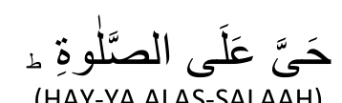
(HAY-YA ALAS-SALAAH)

Come to Salaat
(To be said twice)
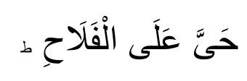
(HAY-YA ALAL-FALAAH)

Come to Success.

(ALLAHU-AKBAR)

Allah is the Greatest
(To be said twice)

(LAA-ILAAHA, IL-LAL-LAAH)

There is no God but Allah
(To be said once)

THE METHOD OF RECITING THE AZAAN
The Masnoon (Sunnah) method of giving Azaan is as follows:
The Muazzin should be purified from both categories of impurity, i.e. Hadthe Akbar (the State of Janabat) and Hadthe Asghar (the state of Hadth). He should mount a raised or high place which is beyond the confines of the Musjid and face the Qiblah.
(N.B. The Azaan should not be given inside the Musjid.)
Facing the Qiblah he should insert the forefingers of both hands in his ear openings. He should then recite the Azaan in a loud voice (not shouting).
Whilst reciting the words:
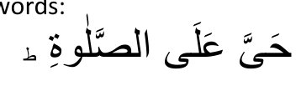
the Muazzin should turn his face towards the right side in such a manner that his breast and feet are not turned away from the Qiblah.
While reciting
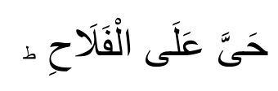
the face should be turned to the left side in a similar manner as described above.
During the Azaan recited for Fajr Salaat the following sentence should be repeated twice after

(AS-SALAA-TU KHAIRUM-MINAN-NOUM)

Salaat is better than sleep.
After reciting Allahu-Akbar —
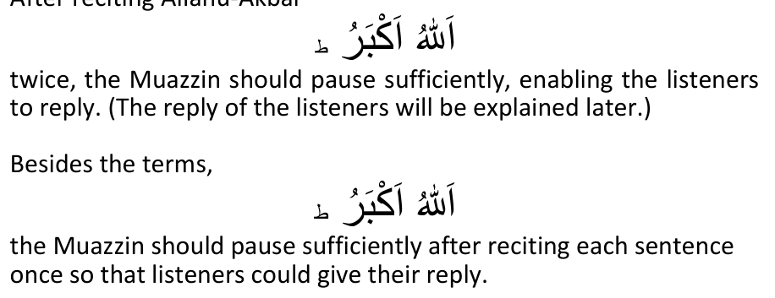

THE IQAAMAH
The Iqaamah is similar to the Azaan, but differs from the Azaan in the following respects:
I. The Iqaamah is recited inside the Musjid whereas the Azaan is called from outside the precincts of the Musjid.
2. The Iqaamah is recited in a soft voice while the Azaan is called out loudly.
3. During lqaamah, the fingers are not inserted in the ear-openings as is the case in Azaan.
4. The Iqaamah is recited rapidly while the Azaan is called out haltingly.
5. The sentence,

6. During the Iqaamah of the five daily Salaats the sentence
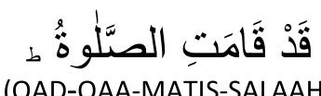
(QAD-QAA-MATIS-SALAAH)

Salaah has begun. is repeated twice after reciting
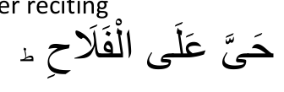
7. During Iqaamah the face is not turned right and left as in Azaan. 8. The Iqaamah is recited when the congregational (Jama' Salaat) is about to begin.

MASAA-IL PERTAINING TO AZAAN AND IQAAMAH
1. It is Mustahab for a Musafir (traveller) to recite the Azaan (i.e. when he performs his Salaat).
2. The Azaan and Iqaamah in the Musjid are sufficient for all the people of that particular neighbourhood. Thus if the Azaan and lqaamah were already recited in the Musjid, it will be Mustahab for one performing Salaat at home to recite the Azaan and lqaamah.
3. It is Makrooh (reprehensible and forbidden) to recite the Azaan and lqaamah in a Musjid wherein the congregational Salaah is performed daily with Azaan and lqaamah. However, in a Musjid where no fixed arrangements exist regarding the lmam and Muazzin, the Azaan and Iqaamah should be called out by every group or individual performing Salaat therein.
4. It is Makrooh (forbidden) for a female to recite Azaan or iqaamah.
5. Azaan and Iqaamah are called out for only the Fardhe Ain (the five daily and Juma) Salaats.
6. It is Mustahab for those who hear the Azaan to reply, i.e. they should silently repeat the terms recited by the Muazzin. Listeners should reply during the pause made by the Muazzin after each sentence. However, after the sentence
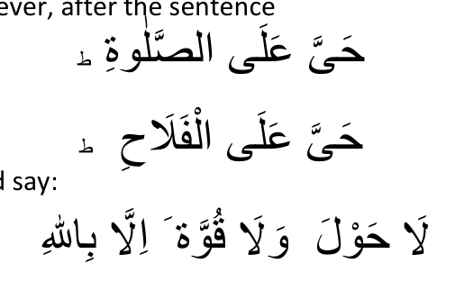
and listeners should say:
(LAA-HOU-LA WA-LAA-QUW-WATA IL-LAA BIL-LAAH)

There is no strength nor power but with Allah.
During the Fajr Azaan, after the sentence
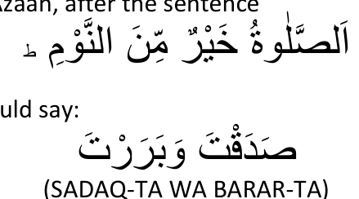
the listeners should say:
(SADAQ-TA WA BARAR-TA)
After completion of the Azaan, listeners should recite Durood Sharief and the following dua:
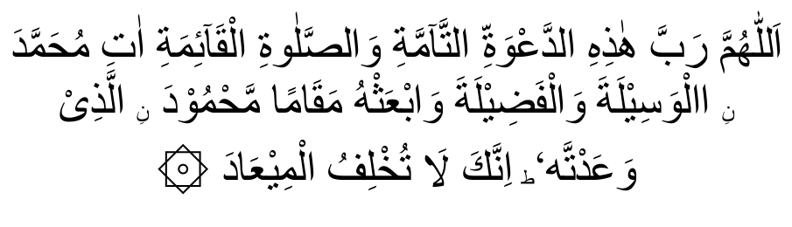
(ALLAHUMMA RAB-BA HA-ZI-HID DA'-WA-TIT TAM-MATI WAS
SALAA-TIL QA-IMATI AA-TI MUHAMMADANIL WASEE-LATA WAL FAZEE-LATA WAD-DARA-JA'TAR- RAFI-ATA WAB ATH-HO MAQA-MAM MAHMOODA NILLAZI WA AT-TAHU WAR-ZUQNA SHAFA-ATA-HU YAU-MAL QIYA-MATI IN-NAKA LA TUKH-LI-FUL MI-AAD.)
O Allah, Lord of this Perfect Call and everlasting prayer, Bless Mohammed with Utmost nearness to Thee, Grant him perfection, And raise him to the high station Thou hast promised him: Bestow his intercession On the Day ofJudgement Verily Thou goest Not back on Thy promise.
7. It is also Mustahab to reply to the Iqaamah. The replies to Iqaamah are the same as in Azaan, and after the sentence
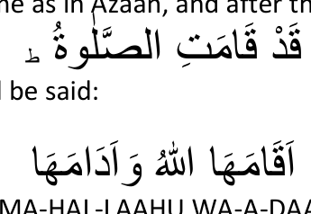
the following should be said:
(AQAA-MA-HAL-LAAHU WA-A-DAA-MA-HA)

May Allah establish and perpetuate Salaat
8. Reply to the Azaan should not be made during the following acts:
(i) While performing Salaat.
(ii) While listening to any Khutbah — whether it be the Juma' Khutbah, Nikah Khutbah, etc.
(iii) While in the state of Haiz (menses) and Nifaas (confinement). (iv) While answering the call of nature.
(v) While eating.
(vi) While indulging in sexual relations.
9. The second Azaan of Juma' (Friday) Salaat should be given inside the Musjid in front of the Mimbar.
10. The Muazzin should stand while calling out the Azaan. If the Azaan was given whilst sitting, it should be repeated. However, if one recites the Azaan for one's own Salaat (and not for congregational Salaat), while sitting, then it is not necessary to repeat the Azaan although one should not unnecessarily recite the Azaan sitting.
11. It is Mustahab to close the ear-holes with the fingers during Azaan.
12. To recite the Azaan while in the state of Hadthe Akbar is Makrooh Tahrimi (forbidden). The repeating of such Azaan is Mustahab.
13. It is Makrooh Tahrimi to recite the Iqaamah while one is in the state of either Hadth Akbar or Hadthe Asghar. However, it is not Mustahab to repeat this Iqaamah as is the case with Azaan.
14. It is sunnat to recite the various sentences of the Azaan and lqaamah in sequence. If an error is made in the order of the Azaan or Iqaamah such an error should be rectified by repeating the misplaced sentence in its proper sequence. e.g. Instead of
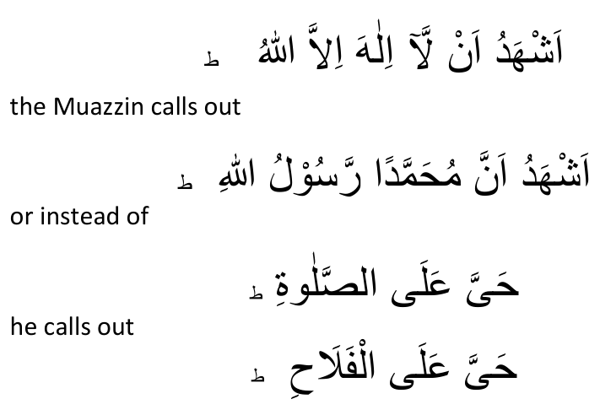
the Muazzin calls out or instead of
In the first instance the sequence of the Azaan is set in order by calling out
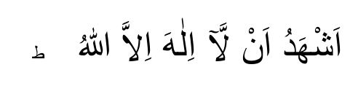
and then repeating the sentence,
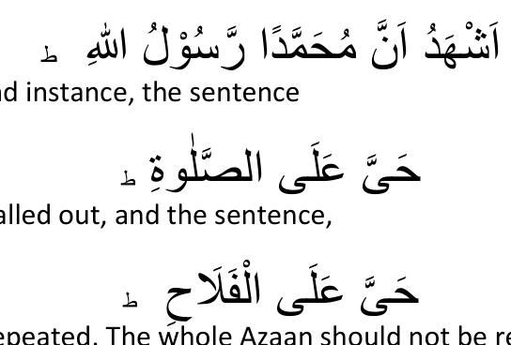
In the second instance, the sentence should be called out, and the sentence, should be repeated. The whole Azaan should not be repeated. 15. If during the course of giving the Azaan the Muazzin for some reason or other could not complete the Azaan, e.g. he became ill or unconscious — itwill be Sunnate Muakkadah to repeat the whole Azaan.
16. If one's Wuzu breaks during Azaan or Iqaamah it is better to complete the Azaan or Iqaamah, and after completion thereof Wuzu should be performed.
17. The calling of the Iqaamah is the right of the one who called out the Azaan. However, he may give another person consent to recite the Iqaamah.
18. The Muazzin should complete the lqaamah in the same spot where he had begun it. He should not move from place to place while reciting the lqaamah.
19. If after Iqaamah has been given, the Imam engages in performing the Fajr Sunnats, then the time taken by the Imam to perform the Sunnats of Fajr shall not be considered as considerable, hence, there will be no repetition of the lqaamah.
_______________ooOoo_______________

HOW TO PERFORM SALAAT
Salaat consists of units. Each unit is called a Raka't. There are two Rakat, three Raka't and four Raka't Salaats in the Fardh or obligatory category of Salaat.
Each unit or Raka't consists of the following essential component parts:
1. The posture of standing erect which is called Qiyaam.
2. Recitation of some verses of the Holy Qurán. This is termed Qiraat.
3. The posture of genuflexion or bowing lowly which is called Ruku'.
4. The posture of prostration or placing the forehead on the ground. This is called Sujood. Each unit or Raka't has two Sujoods. i.e. the prostration has to be performed twice in each Raka't.
Every two Raka'ts are followed by a sitting posture. In other words it is necessary to sit in a kneeling-type posture after completing two Rakats of any Salaat. This kneeling posture is known as Qa 'dah.
Two Sujoods (prostrations) are always separated by a kneeling posture. This kneeling posture, which separates one Sujood from the other, is called Jalsah.

THE METHOD OF PERFORMING A TWO-RAKA'T SALAAT THE POSITION OF QIYAAM
The Musalli stands erect, facing the Qiblah, gaze cast down. He forms the Niyyat (intention) for his Salaat and says:

(ALLAHU AKBAR).
As he utters

he raises both hands upwards towards his head in such a manner that the palms of both hands face the Qiblah, and the hands should be raised to a height where the thumbs are in line with the lobes of the ears. Once the hands reach the required height (i.e. the earlobes), the Musalli should immediately bring them down and fold them below the navel. When folding the hands, the Musalli should ensure that:
(i) the right hand is on top of the left hand.
(ii) the right hand should clasp the left hand in such a manner that the thumb and little finger of the right hand encircle the left-hand wrist, and the other three fingers of the right hand should be spread horizontally along the left forearm immediately above the wrist.
Once the hands have been folded as explained above, the Musalli should recite the following:

(SUB-HAANA-KAL-LAAHUMMA WA BI-HAMDI-KA WA TA-BAARAKAS-MU-KA WA TA-AALA JAD-DU-KA WA LAA-ILAA-HA
GHAY-RUK.)
Glory unto You, O Allah! All Praise unto You. Blessed is Your Name and Most High is Your Majesty. There is none worthy of worship, but You.
(N.B. This is known as Thana.)
After reciting Thana, the Musalli recites Ta'ow-wuz, i.e.:
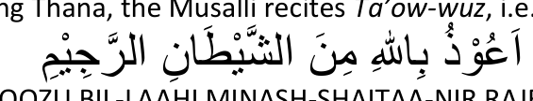
(A-OOZU BIL-LAAHI MINASH-SHAITAA-NIR RAJEEM.)

I seek the protection of Allah from Shaitaan, the accursed.
After ta-ow-wuz recite Tasmia i.e.

(BISMILLA-HIR RAHMANIR-RAHIM.)

In the Name of Allah, the Ben eflceni the Merciful.
After Tasmia recite Surah Fatiha and thereafter recite a few verses of the Holy Quran:

SURAH FATIHA:

(AL-HAMDO LIL-LAHI RAB-BIL AA-LAMEEN. AR-RAHMAANIR-RAHIM. MAA-LIKI YOU-MID-DEEN. IY-YA-KA NA'BUDU WA-IY-YA-KA
NAS-TA-EEN. IH-DINAS-SIRAATAL MUSTA-QEEM. SIRAA-TAL-LATHEENA AN-AMTA ALAI-HIM. GHAIRIL MAGH-DHOO-BI ALAI-HIM
WA-LAD-DHAAL-LEEN.)
Praise be to Allah, Lord of the worlds. The Beneficent the Merciful; Owner of the Day of Judgment. Thee (alone) we worship; Thee (alone) we ask for help; show us the straight path. The path of those whom Thou hast favoured. Not the (path) of those who earn Thine anger nor of those who go astray.

SURATUL KAUTHAR


Lo! (Oh Prophet!) I have granted thee the Fount (of abundances) so shall be without posterity.
pray unto thy Lord and sacrifice. No doubt it is thy insulter who

SURATUL IKHLAAS
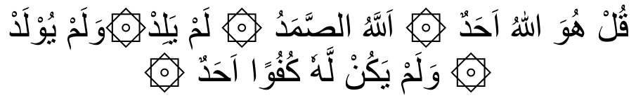
(QUL HUWAL-LA-HU AHAD ALLAHUS-SAMAD LAM YALID WA-LAM
YU-LAD. WA-LAM YA-KUL-LAHOO KUFU-WAN AHAD.)
Say (O Prophet!): He is Allah, The One and Only. Allah the Eternal, Absolute. He begetteth not, nor was He begotten; And there is none like unto Him.

SURATUL FALAQ

(QUL A-OO-THO BI RAB-BIL FALAQ. MIN SHAR-RI MA KHALAQ. WA-MIN SHAR-RI GHA-SI-QEEN ITHA WAQAB. WA-MIN SHAR-RIN-NAF-FATHATI FIL-UQUD. WA-MIN SHARRI HA-SIDIN ITHA HASAD.)
Say (O Prophet!): I seek refuge with the Lord of the dawn; from the mischief of all creations, from the mischief of darkness as it over spreads, from the mischief of those women who practise secret arts breathed on knots. And from the mischief of the envious one as he

practises envy.

SURATUN NAAS

(QUL A-OO-THU BI RAB-BIN NAS. MA-LI-KIN NAS. ILA-HINNAS. MIN
SHAR-RIL WAS-WA-SIL KHAN-NAS. AL-LATHI YUWAS-WISU FI
SUDOO-RIN-NAAS. MI-NAL JINNATI-WANN-AS.)
Say (O Prophet!): I seek refuge with the Lord of Mankind, the King (or Ruler) of Mankind, the God of Mankind, from the mischief of the sneaking whisperer who whispereth (evil) unto the breast of Mankind whether of Jinn or of mankind.
(NB. The posture of Qiyaam ends at this point, i.e. after completing the recital of a few verses of the Holy Quran. Sura Fatiha, together with a few other verses of the Holy Quran, are known as the Qiraat.)
At the end of the Qiraat, the Musalli should utter

(ALLAHU AKBAR)
and go into Ruku or the posture known as genuflexion.

THE FORM OF RUKU
In this posture the Musalli clasps both knees with his hands, the fingers being outspread. The head and back should be in line. The Musalli should not hump his back. The head should not droop, but be kept erect in line with the back.
The arms should be separated from the body without the elbows bulging out. The gaze should be fixed on one's feet. In the position of Ruku, recite the following Tasbih:

(SUB-HAA-NA RAB-BIYAL-ATHEEM.)

Oh! Glory unto my Creator, the Majestic.
This tasbih should be recited at least thrice.

THE QAUMAH'
After reciting the above Tasbih in Ruku, the Musalli should say:

(SAMI-ALLAHU LIMAN HAMIDAH)

Allah has heard him who praised Him.
This is known as Tasmiah.
As the Musalli recites this he rises out of Ruku and stands erect and recites the Tahmeed i.e.:

(RAB-BANAA LA-KAL HAMD.)

Oh our Creator! AllPraise belongs unto You.
This position of standing erect after the Ruku is called Qauma. The Qauma ends with the reciting of the Tahmeed.

SUJOOD
After reciting Tahmeed the Musalli utters:
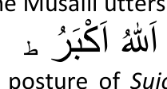
and goes down into the posture of Sujood or Prostration. As the Musalli goes into Sujood, he places on the ground firstly his knees, then both hands. The head is placed on the ground between the two hands. The fingers are held together facing the Qiblah, the thumbs being in line with the eyes, but a few inches away from the eyes. As the head goes into Sujood, the nose should firstly touch the ground and then the forehead. Both arms must be kept away from the sides of the body. Both feet should be planted firmly on the ground with the toes bent in the direction of the Qiblah.
In this posture of Sujood (or Sajdah) the Musalli recites at least thrice the following Tasbih:


Glory unto my Creator the Most High.
After reciting this Tasbih, the Musalli raises first his forehead, then his nose, and finally his hands. The Musalli then goes into the kneeling posture, known as the Jalsah i.e. the posture which separates or intersperses two Sujoods. As the Musalli raises his head from the Sujood he utter:

(ALLAHU-AKBAR)
and enters the Jalsah. When sitting in Jalsah the left foot is spread out horizontally on the ground, the Musalli resting on it. The right foot is placed on the ground in a perpendicular (standing up)
position with the toes facing the Qiblah. The hands are placed on the thighs with the fingers held together facing the Qiblah very close to the knees. In the Jalsah position the Musalli utters:

(RAB-BIGH-FIR-LI WAR-HAM-NI.)
Oh my Creator! Foigive me and have mercy upon me. There is no Masnoon Du'aa in Fardh Salaah during the Jalsah in the
Hanafi Math-hab.
Thereafter, uttering

(ALLAHU-AKBAR.)
he goes into the second Sujood which is exactly the same as the first Sujood.
The end of the second Sujood heralds the end of the First Raka't.

THE SECOND RAKA'T
After completing the Second Sujood of the First Raka't the Musalli says

(ALLAHU-AKBAR.)
and enters the Qiyaam posture of the Second Raka't, i.e. he once again stands erect, folding his hands on top of each other as explained previously. During the Second Raka't the following things will NOT be carried out as was the case in the first raka't:
(i) The hands will not be raised to the ears.
(ii) Thana will not be recited.
(iii) Ta-ow-wuz will not be recited.
Further, the entire Second Raka't will be performed in exactly the same manner as the First Raka't with the three aforementioned exceptions.

THE QA'DAH
Once the Second Sujood of the Second Raka't is completed, the Musalli utters:
(ALLAHU-AKBAR.)
and sits in the kneeling position, i.e. the exact position he assumed in the Jalsah. This kneeling posture at the end of the Second Raka't is termed Qa'dah. (The kneeling posture between Sujoods is called Jalsah.)
During the Qa'dah the Musalli recites Tashah-hud as follows:
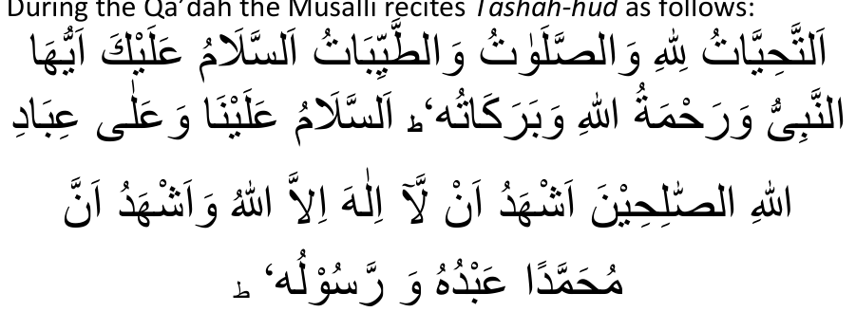
(AT-TAHIY-YATU LIL-LAAHI WAS SALA-WAATU WAT-TAY-YIBATU
ASSALAMU ALAIKA AY-YUHAN NABIY-YU WARAH MATUL-LAHI
WABARAKATUH. ASSALAAMU ALAINA WA-ALA IBADILLAHIS-SAALIHEEN. ASH-HADU-ALLAA-ILA-HA IL-LAL-LAHU WA-ASH-HADUU
ANNA MUHAMMADAN AB-DUHU WA RASOOLUH.)
All our oral, physical and monitory prayers are only for Allah. Salutation to you O' Prophet! and Allah's peace and His blessings be on you. Blessings of Allah be on us and on all those worshippers who are pious. I testify that there is none to be worshipped but Allah and I testify that Muhammad (peace be on him) is His worshipper and Messenger.
(a) If the Salaat which is being performed is a Two-Raka't Salaat, Durood and Dua should also be recited after the Tashah-hud.

DUROOD
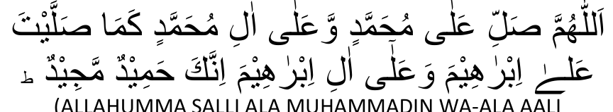
(ALLAHUMMA SALLI ALA MUHAMMADIN WA-ALA AALI
MUHAMMADIN KAMA SAL-LAITA ALA IBRAHIMA WA-ALA AALI
IBRAHIMA IN-NAKA HAMIDUM-MAJEED.)
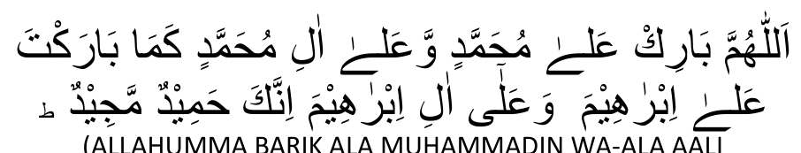
(ALLAHUMMA BARIK ALA MUHAMMADIN WA-ALA AALI
MUHAMMADIN KAMA BARAK-TA ALA IBRAHIMA WA ALA AALI
IBRAHIMA IN-NAKA HAMIDUM-MAJEED.)
Oh Allah! send Thy mercy on Muhammad (peace be on him) and on his seeds as Thou hast sent Thy mercy on Ibrahim and his seeds. No doubt! Thou art Great and Praiseworthy! Oh Allah! send Thy blessings on Muhammad (peace be on him) and on his seeds as Thou hast blessed Ibrahim and his seeds. No doubt! Thou art Great and Praiseworthy.

DUA

(ALLAHUMMAGH-FIR-LI WALl-WA LI-DAY-YA WALI-USTATHI WALI JAMI-IL MU'Ml-NEE-NA WAL MU'MI-NATI WAL MUSLIMEE-NA WAL
MUSLIMA-TI BI RAHMATIKA YA ARHAMAR-RAHIMEEN.)
O Allah! Forgive my parents and my teachers and the believing men and women and the Muslim men and women with your mercy, O Thou the Most Merciful of those who show Mercy.
After the Dua the Musalli terminates his Salaat by making what is called Salaam.
Salaam is made by saying

(ASSALAA-MU-ALAIKUM WA RAH-MATUL-LAH.)

Peace upon you and the Mercy of Allah.
and simultaneously turning the head towards the right-side focussing one's gaze on the right shoulder. The above Salaam is then recited a second time, turning the face to the left side with the gaze fixed on the left shoulder this time.
Your Salaat has now been completed.
(b) If the Salaat which is being performed is a Three-Raka't Salaat, the Musalli, after reciting only Tashah-hud (at the end of the second raka't) enters the Third Raka't by once again assuming the Qiyaam posture. The Third Raka't is performed in exactly the same manner as the second Rakat. However, if the Salaat is a Fardh Salaat then in the Third and Fourth Raka't only Surah Fatiha is recited. Other verses of the Holy Quran are not added as was done in the First and Second Raka't.
After the second Sujood of the Third Raka't has been completed, the Musalli again assumed the posture of Qa'dah. In this final Qa'dah (which is termed Qa'dah Akhirah) Tashah-hud, Durood and Dua are recited. After the Dua the Salaat is completed by making the two Salaams as already explained.
(c) If the Salaat is a Four-Raka't Salaat, the Musalli does not assume the Qa'dah posture at the end of the Third Raka't, but goes immediately into the Qiyaam of the Fourth Raka't. It is only after the second Sujood of the Fourth Raka't that the Musalli sits in Qa'dah. In this Qa'dah which is the Qa'dah Akhirah, the Musalli recites Tashah-hud; Durood and Dua. He then ends the Salaat by making both Salaams.
N.B. In all types of Salaat, the posture of Qa'dah follows at the end of every second raka't, i.e. after every two raka'ts will come the posture of Qa'dah.
If it is the Qa'dah Akhirah, (Final Qa'dah), Tashah-hud, Durood and Dua are recited.
If it is not Qa'dah Akhirah, only Tashah-hud is recited.
If the Salaat being performed is a Two-Raka't Salaat, the Qa'dah after the second raka't is the Qa'dah Akhirah.
If it is a Three-Raka't Salaat, the Qa'dah at the end of the Third Raka't is the Qa'dah Akhirah.
If it is a Four-Raka't Salaat, the Qa'dah at the end of the Fourth Raka't is the Qa'dah Akhirah.

THE SALAAT OF A FEMALE
A woman performs Salaat in the same manner as a man does. However, there are certain differences which are enumerated hereunder:
1. In the beginning of the First Raka't, during the Takbeer Tahreemah, a woman does not raise her hands to the ears. She raises them only shoulder-level, and keeps them (the hands) concealed in her outer-garment (Jilbaab or Burqah).
2. When folding the hands, a woman places both palms on the chest — the right palm on top of the left palm.
3. The Ruku' of a female is a slight bow, with the tips of the fingers just touching the knees. The arms should be placed together with the sides of the body, and both ankles should touch each other.
4. In Sajdah, her feet will not be kept erect, but will be placed horizontally on the ground, pointing towards the right. She must not separate her arms from her body as a man does. She should draw her body inwards as much as possible, the stomach touching the thighs.
5. In Jalsah and Qa'dah as well, she rests her posterior on the ground (instead of on her leg as is the case with a man) with both her feet spread out on her right side horizontally on the ground.
6. In certain Salaats a man can recite the Qiraat loudly but it is not permissible for a female to recite the Qiraat loudly.
_______________ooOoo_______________

THE POSITION OF THE CONSTITUENT PARTS OF SALAAT THE FARD CONSTITUENTS
There are SIX parts of Salaat which are Fardh (i.e. the compulsory nature being absolute). If any of the Fardh constituent parts are not carried out the Salaat is null and void — irrespective of whether the Fardh has been missed out intentionally or unintentionally.
The Six Fardh constituents of Salaat are:
(i) Takbeer Tahreemah (ii) Qiyaam (iii) Qiraat (iv) Ruku'
(v) Sujood (vi) Qa'dah Akhirah — the duration of which is equal to the time taken to recite Tashah-hud.
1. Takbeer Tahreemah, viz. After making Niyyat (Intention) for the Salaat to say:

(ALLAHU AKBAR.)
2. Qiyaam, viz. The posture of standing during which the Qiraat is recited.
3. Qiraat viz, to recite some verses of the Holy Quran.
4. Ruku' viz, the posture of bowing down.
5. Sujood viz, the posture of prostrating.
6. Qa'dah Akhira, viz, the Final sitting posture in the last Raka't of any Salaat. This sitting is Fardh to the extent of the duration of Tashah-hud.
If any of the Fardh constituents are left out or not fulfilled, the Salaat is rendered Baatil (Null and Void). The Salaat in such a case must be performed again.

THE WAAJIB CONSTITUENTS OF SALAAT
The following parts of the Salaat are Waajib:
1. Surah Fatiha.
2. To add at least three verses of the Holy Quran after Surah Fatiha. 3. Tarteeb, viz, to fulfil the various constituent parts (i.e. the Fard and Waajib parts) in their appropriate order as described in the section dealing with the method of performing the Salaat. 4. Qa'dah Ula, viz, to sit after every two Raka'ts — the duration of the Qa'dah being the time taken to recite the Tashah-hud.
N.B. Qa'dah Ula is the Qa'dah which occurs during a Salaat and not at the end of a Salaat. Thus, in a Three-Raka't Salaat, the Qad'ah after two raka'ts will be Qa'dah Ula; in a Four-Raka't Salaat, the Qa'dah after two raka'ts will be Qa'dah Ula.
5. To recite Tashah-hud in every Qa'dah.
6. Dua Qunoot viz, to recite Qunoot in the Third Raka't of Witr Salaat.
7. Qaumah, viz, to stand erect after the Ruku' before going into Sujood.
8. To make the Salaam.
9. Ta'deel viz, to fulfil all parts of the Salaat with dignity and respect — without any haste.
If the Musalli omits any of the Waajib constituents (besides Ta'deel) unintentionally, the error must be rectified by the performance of Sujoodus-Sahw. (Sujoodus-Sahw will be discussed in a different chapter.).
If the Salaat is performed without observing Ta'deel, the Salaat, though valid, is rendered improper. Sajdatus-Sahw is not performed for the defect of failing to observe Ta'deel.
All other parts of the Salaat, besides the Fardh and Waajib constituents, are Sunnat and Mustahab factors. The Musalli should strictly adhere to all the Sunnat and Mustahab factors of Salaat. He should not omit any of these without good reason. However, no Sujoodus-Sahw is performed if any of the Sunnat and Mustahab factors are omitted.

MASAA-IL PERTAINING TO SALAAT
1. After Surah Fatiha, the Musalli should recite at least three verses of the Holy Quran or one such verse which is equal in length to three short verses.
2. After Ruku' if the Musalli rose slightly, but did not go into the Qaumah position then he should repeat his Salaat.
3. If, after one Sujood, the Musalli merely lifted his body slightly without sitting in the jalsah, and then went into the second Sujood — then only one Sujood has been performed. The whole Salaat is thus nullified and has to be repeated.
4. In a three and four-raka't Fardh Salaat it is Waajib to add some verses of the Quran after Surah Fatiha in only the first two raka'ts. However, if a Surah is added to Surah Fatiha in the third as well as fourth raka't the Salaat will be perfectly valid.
5. If in the third and fourth raka't of a Fardh Salaat the Musalli recites only

(SUB-HAA-NAL-LAH)
thrice without even reciting Surah Fatiha, the Salaat is valid and in order. However, it is better to recite Surah Fatiha in the third and fourth raka't as well.
6. In the third and fourth raka't of a Fardh Salaat, if the Musalli maintains silence — i.e. he does not recite anything — the Salaat is valid and in order, but his Qiyaam must be equal to at least the time taken to recite three times:

7. A female should recite everything of her Salaat silently in such a manner that only she, herself, is able to hear her voice.
8. A male, if performing Salaat alone, has the choice of reciting the Qiraat aloud or silently. However, he may recite the Qiraat aloud in only the following Salaats:
(a) In both raka'ts of Fajr.
(b) In the first two raka'ts of Maghrib and Ishaa' Salaat.
9. It is Sunnat to maintain the length of the Qiraat of the first raka't slightly longer than the Qiraat of the second raka't.
10. It is Mustahab to fix one's gaze during Qiyaam on the spot which will be touched by the head in Sujood; during Ruku on the feet; during Sujood on the nose; during Qa'dah and jalsah on the lap; and whilst making the Salaams, on the shoulders.
11. The Musalli should endeavour to withhold any urge to yawn. However, if he is unable to restrain himself, he should cover his mouth with the back of his hand. He should restrain himself as well from coughing and clearing his throat.
12. It is Waajib upon the Musalli to learn sufficient Tajweed so as to recite the Quran correctly.
13. If the same Surah is recited in both raka'ts, the Salaat is valid. However, the Musalli should not recite the same Surah in both raka't unnecessarily.
14. During the Qiraat, the Musalli should not recite in the second raka't a Surah or verses which are anterior (coming first) to the Surah or verses recited in the first raka't. The Surah or verses recited in the second raka't should be posterior (coming after) to those recited in the first raka't.
(N.B. The anterior and posterior order is with regard to the order and sequence of the Surahs compiled in the Quran.)
Thus, if in the first Raka't Surah Feel is recited, Surah Takaathur should not be recited in the second raka't because in the Holy Quran Surah Takaathur appears first and Surah Feel appears after it. In other words, with regard to the order of Surah Arrangement Surah Feel is posterior to Surah Takaathur.
It is Makruh Tahrimi to discard this anterior-posterior order in the Qiraat of Salaat. But, no Sajdatus-Sahw is performed for discarding this order of Qiraat — recitation in Salaat.
15. It is Waajib to recite both Surah Fatiha plus a Surah or some verses of the Quran in every raka't of Witr, Sunnat and Nafl Salaat.

FACTORS WHICH NULLIFY SALAAT
1. Speech:
(a) speaking whether intentionally or unintentionally, nullifies Salaat. Even the uttering of a word such as ah or oh will break one's Salaat.
(b) In unnecessarily clearing one's throat, if a sound is emitted, the Salaat breaks. However, should it become necessary to clear the throat, the Salaat will then not be nullified in this case.
(c) If one, by force of habit, uttered
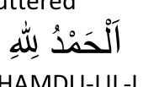
(A L-HAMDU-LIL-LAH)
while sneezing in Salaat, the Salaat does not break. However, one should not say
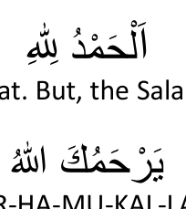
when sneezing during Salaat. But, the Salaat will break if the Musalli replies
(YAR-HA-MU-KAL-LAH)
to another who has sneezed.
(d) During Salaat to reply

to someone greeting you breaks Salaat.
(e) If, during Salaat, the Musalli utters

upon hearing some good news or he utters upon hearing of someone's death, the Salaat breaks.
2. Action:
If an action, which does not form part of Salaat, is done during Salaat, the Salaat is nullified. For example, to recite the Qiraat looking inside the Quran; to button one's shirt; to walk; to eat; to drink.
3. If during Salaat one's chest is turned away from the Qiblah, the Salaat breaks.
4. Laughing aloud during Salaat nullifies the Salaat.
_______________ooOoo_______________

ACTS WHICH ARE REPREHENSIBLE AND FORBIDDEN DURING SALAAT
Certain acts during Salaat are Makruh Tahrimi. If the Musalli commits these acts his Salaat is not nullified, but the Sawaab (Reward) of the Salaat is reduced and he sins in doing them. These Makruh Tahrimi acts are:
1. To fiddle with one's clothing, beard and hair.
2. To crack one's fingers.
3. To glance to the right or left.
4. To sit in Qa'dah or Jalsah in a way other than described in the section dealing with the method of Salaat.
5. To place the hands on the hips.
6. To perform Salaat facing another.
7. To perform Salaat on a carpet or cloth with pictures on them. 8. To perform Salaat wearing clothing with pictures on them. (N.B. Pictures here means pictures of people or animals.)
9. To lengthen considerably the second raka't more than the first raka't.
10. To fix a particular Surah for a Salaat.
11. To place the head during Sujood on a higher level than the place whereon the feet are resting. If the spot on which the head is placed is higher than one span (9 inches), the Salaat is not valid. If the spot is less than a span, the Salaat is valid, but to do so unnecessarily is Makruh.

ACTS WHICH JUSTIFY THE
BREAKING OF SALAAT
1. The Musalli may break his Salaat in order to avoid any loss, harm or injury to life or property no matter if the property involved is of little value.
2. It is Fardh to break one's Salaat in order to save life or prevent injury to people.
_______________ooOoo_______________

THE FIVE DAILY SALAATS
The performance of Salaat five times daily is obligatory (Fardh) upon all adult Muslims — male and female. The Five compulsory Salaats are:
1. Fajr 2. Zuhr 3. Asr 4. Maghrib 5. Ishaa.
The times for the Five daily Salaats have already been explained in the section, The Times of Salaat.

THE NUMBER OF RAKA'TS OF THE FIVE DAILY SALAATS
1. Fajr Salaat has a total of four raka'ts composed as follows: (i) Two Raka'ts Sunnate Muaqqadah.
(ii) Two Raka'ts Fardh.
2. Zuhr Salaat has twelve raka'ts as follows:
(i) Four Raka'ts Sunnate Muaqqadah.
(ii) Four Raka'ts Fardh.
(iii) Two Raka'ts Sunnate Muaqqadah.
(iv) Two Raka'ts Nafl.
3. Asr Salaat has eight raka'ts as follows:
(i) Four Raka'ts Sunnate-Ghair-Muaqqadah (ii) Four Raka'ts Fardh.
4.Maghrib Salaat has seven raka'ts as follows:
(i) Three Raka'ts Fardh.
(ii) Two Raka'ts Sunnate Muaqqadah.
(iii) Two Raka'ts Nafl.
5. Ishaa' Salaat has seventeen raka'ts as follows: (i) Four Raka'ts Sunnate-Ghair-Muaqqadah.
(ii) Four Raka'ts Fardh.
(iii) Two Raka'ts Sunnate Muaqqadah.
(iv) Two Raka'ts Nafl.
(v) Three Raka'ts Witr.
(vi) Two Raka'ts Nafl.
_______________ooOoo_______________

THE DESCRIPTION OF WITR SALAAT
To perform the Witr Salaat is compulsory. The first and second raka't of the Witr Salaat is performed in the same manner as the first and second raka't of a Fardh Salaat. But in the Third Raka't of the Witr, after reciting Surah Fatiha and a Surah or some verses of the Quran, the Musalli utters

(ALLAHU AKBAR.)
and simultaneously raises both hands to the ears (as is done at the beginning of Salaat). Thereafter he folds both hands in the usual manner just below the navel. The Musalli now recites Dua-Qunoot and after the Qunoot he goes into Ruku and completes the Salaat in the normal manner.
DUA-E QUNOOT
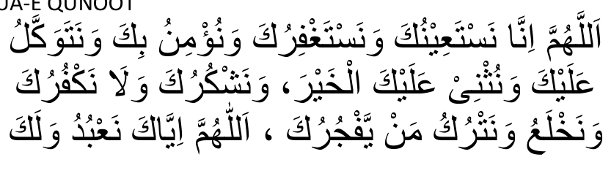
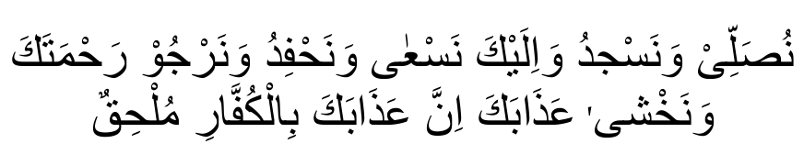
(ALLAHUMMA INNA NAS-TA-EE-NUKA WA NAS-TAGH-FIRUKA WA NU'MINU BIKA WA NA-TAWAK-KALU ALAIKA WA NUTH-NI ALAIKAL KHAIR WA NASH-KURUKA WALA NAK-FURUKA WA NAKH-LA-U WA
NAT-RUKU MAIY-YAF JURUKA ALLAHUMMA IY-YAKA NA'BUDU
WALAKA NUSALLI WA NASJUDU WA ILAIKA NAS-A WA NAH-FIDU
WA NAR-JOO RAHMATAKA WA NAKH-SHA ATHABAKA INNA
ATHABAKA BIL KUFFARI MULHIQ.)
Oh Allah! we beseech Thy help and ask Thy pardon and believe in Thee and trust in Thee, and we praise Thee in the best manner and we thank Thee and we are not ungrateful to Thee, and we cast off and leave one who disobeys Thee. Oh Allah! Thee alone do we serve and to Thee do we pray and prostrate and to Thee do we flee and we are quick in doing so and hope for Thy blessings; and fear Thy chastisement. No doubt, thy chastisement overtakes the unbelievers.

QADHA SALAAT
Qadha, with regard to Salaat, means: to fulfil or perform a Salaat after expiry of the time of that Salaat.
It is a very great sin to neglect one's Salaat and delay its performance so much so that the time for it expires. It is not permissible to forego the performance of a Fardh Salaat without a valid reason. (Valid reasons will be explained in a separate Section.) At any rate, if a Fardh Salaat has not yet been performed and its time has already expired, it is obligatory to make Qadha of that Salaat without any delay. To delay in performing the Qadha Salaat is also a sin.
It should be remembered that the obligation of the Fardh Salaat is never waived by the Shariah (Law of Allah). No amount of repentance can secure exemption from Salaats which have not been performed in the past. Even a lifetime of Fardh Salaats not performed must be fulfilled by means of Qadha.

MASAA-IL PERTAINING TO QADHA
1. It is not necessary to wait for any particular time to perform Qadha Salaat. For example, if Zuhr Salaat was missed, it is not necessary to wait for another Zuhr time in order to make Qadha of the missed Zuhr Salaat. Several Qadha Salaats could be performed all at once. However, one should not perform Qadha during Makruh times.
2. Someone missed several Fardh Salaats, but the number of the Salaats he missed does not exceed Five. Besides these five Salaats, which he did not perform he is not liable for any other Qadha Salaats of the past. In this case it is not permissible for him to perform an Adaa Salaat before performing the Five Qadha Salaats for which he is liable. If he performs his Adaa Salaat before fulfilling his Five Qadha Salaats, his Adaa Salaat will not be valid. After performing the Five Qadha Salaats he will have to repeat his Adaa Salaat. However, if the time remaining for the Adaa Salaat is so little that if he engages in fulfilling the Qadha Salaats his Adaa Salaat will also become Qadha, then in such a case he should perform his Adaa Salaat, and thereafter engage in the performance of the Qadha.
3. If Qadha is being performed of several Salaats — the number not exceeding five — Tarteeb or the compulsory order of the Salaats has to be maintained, viz, the Salaat which was missed first should be performed as Qadha first; and the Salaat missed next should be performed as Qadha after performing the first, and so on.
For example, Zuhr, Asr, Maghrib and Ishaa Salaat were not performed in the due and respective times. Now when performing Qadha of these four Salaats, Tarteeb (Order or Sequence) must be observed because the number of Qadha Salaats does not exceed five. Hence, firstly Zuhr will have to be performed, then Asr, then Maghrib and finally Ishaa.
4. If one is liable for six or more Fardh Salaats, i.e. six or more Salaats were not performed in their due times, then one's Adaa Salaat may be performed before performing the Qadha Salaat. When the number of Qadha Salaats exceeds five, then the observance of Tarteeb is not Waajib or necessary. In this case one may perform Qadha of the Salaat in any order.
6. Witr Salaat is an obligatory Salaat, hence, if it is missed its Qadha must be performed. If one missed the Ishaa Salaat, Qadha of both the Fardh and Witr will have to be performed before engaging in the performance of Fajr Salaat. It is not permissible to perform the Fajr Salaat, if only the Fardh of lshaa (which was not performed the previous night), was fulfilled in Qadha. The Witr will have to be performed in the Qadha as well.
7. Only Qadha of Fardh and Witr Salaat is made. Besides the two raka'ts Sunnat of Fajr, Qadha of Sunnat and Nafl Salaat is not necessary. If the Qadha of Fajr is being performed before Zawwaal (mid-day) then Qadha of the Fardh, as well as the Sunnat, should be performed. However, if the Qadha of Fajr Salaat is being made after Zawwaal, only the Qadha of the Fardh should be made.
8. If so little of Fajr time remains that only two raka'ts could be performed in that time, then in such a case only the Fardh of Fajr should be performed, and about twenty minutes after sunrise, Qadha of the two Fajr Sunnats should be performed.
9. If one is liable for several Qadha Salaats, one should stipulate in the Niyyat (intention) when making the Qadha which Qadha Salaat is being made. For example, if Fajr, Zuhr and Asr Salaats have been missed, then when making Qadha it should be intended:
"I am making Qadha of Fajr Salaat — or Zuhr Salaat" — as the case may be.
If it is not stipulated in the Niyyat which Qadha is being performed, the Qadha will not be valid.
10. If one did not perform Salaat for a number of years, then too, Qadha of all the missed Salaats must be performed. If it cannot be remembered how many years' or months' Salaat were not performed, one should continue making Qadha Salaat (making Qadha of Fajr, Zuhr, Asr, Maghrib and Ishaa — Fardh and Witr) until one is fully satisfied that all the Qadha Salaats have been discharged.

MASAA-IL PERTAINING TO SUNNAT AND NAFL SALAAT
1. During the daytime it is permissible to perform either two raka'ts Nafl or four raka'ts Nafl With a single Tasleem (i.e. say:
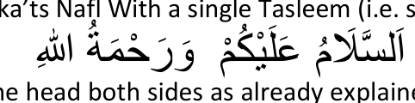
and turning the head both sides as already explained.) It is Makruh, during the daytime, to perform more than four raka'ts Nafl with one Tasleem.
(N.B. This does not mean that only four raka'ts Nafl can be performed during the daytime. Any number of Nafl may be performed, but during the daytime Nafl can be performed in only batches of two raka'ts or four raka'ts.
2. During the evenings or at night-time it is permissible to perform six or eight raka'ts Nafl with one Tasleem. However, even at night it is not permissible to perform Nafl Salaat in batches greater than eight raka'ts — i.e. more than eight raka'ts with one Tasleem must not be performed.
3. Once a Niyyat for Four Raka'ts Nafl has been formed, one should perform the full four Raka'ts. In the first Qa'dah (i.e. the sitting position at the end of the second raka't) of the Sunnat and Nafl Salaat the Musalli has a choice of reciting At-tahiyaat, Durood and Dua or only At-tahiyaat (Tashah-hud).
(N.B. In a Four-Raka't or Three-Raka't Fardh or Witr Salaat it is not permissible to recite Durood and Dua after Tashah-hud in the first Qa'dah.)
If in the first Qa'dah of a Four-Raka't Nafl Salaat Tashah-hud, Durood and Dua were recited, the Musalli should commence the third raka't with Thana. And, if only Tashah-hud was recited, the Musalli should begin the third raka't with Tasmia — i.e.

and Surah Fatiha — he should omit Thana in this case.
Similarly, if a Niyyat is made to perform eight raka'ts Nafl with one Tasleem, the Musalli has the choice of reciting in each Qa'dah besides Qa'dah Akhirah (i.e. the Last Qa'dah), either Tashah-hud, Durood and Dua or only Tashah-hud. If he chooses to recite only Tashah-hud then the raka't following the Qa'dah should be commenced without reciting Thana.
4. Once the Musalli begins with a Nafl Salaat, it becomes obligatory upon him to complete it. If he breaks it he becomes a sinner and shall have to make Qa'dah of it. However, every two raka'ts of Nafl is regarded as a separate Salaat. Thus if a Niyyat is formed to perform four, six or eight raka'ts and the Musalli, after commencing the Salaat breaks it, say for instance in the first or second raka't, Qa'dah of only two raka'ts must be performed.
5. The Musalli made Niyyat to perform four raka'ts Nafl Salaat. After two raka'ts, he recited Tashah-hud, Durood and Dua, and in the third or fourth raka't he broke the Salaat. In this case as well only two raka'ts Qa'dah have to be offered.
However, if the Musalli did not sit in the Qa'dah after the second raka't, then Qa'dah of all four raka'ts has to be offered.
6. If, after beginning with the four raka'ts Sunnat of Zuhr, the Musalli broke the Salaat, then he must make Qa'dah of the full four raka'ts.
7. It is permissible to perform Nafl Salaat in the sitting position. But, if it is performed while sitting, without any valid reason, the Sawaab (Reward) of the Salaat is reduced by half.

SALAATUL MAREEDH OR SALAAT OF THE SICK
The performance of Salaat is of prime importance. The Shariah lays great emphasis on its fulfilment. Even illness is not a valid reason, according to the Shariah, for neglecting one's Salaat. As long as one enjoys sufficient health or strength, the Salaat shall be performed standing. However, if due to illness the Musalli finds that he is not able to stand and perform Salaat then he must sit and perform it. If he is unable to even sit and perform his Salaat, he may lie down and discharge the obligation of Salaat.
1. The way of making Ruku whilst performing Salaat in the sitting position, is to bow the head to almost reaching the knees.
2. If the Musalli, due to illness, is unable to make Ruku and Sujood, he should make the Ruku and Sujood by means of signs of the head, viz, bending the head for Ruku and lowering it a bit more for Sujood.
3. If the illness is so serious that one does not have sufficient strength to even sit and perform Salaat, one may in such a case lie down and perform it. Pillows should be placed under the head or back enabling the head to be raised. The legs should be outstretched towards the Qiblah, but if possible, the legs should be drawn up. Salaat should then be performed in this position making Ruku and Sujood by the indications of the head.
4. If the illness is such that it is not possible to perform Salaat by even signs of the head, then in this case Salaat cannot be performed. Should the condition of the sick person remain in this state for more than twenty-four hours, the obligation of Salaat is waived. Even after recovering, no Qa'dah is to be performed for missing any Salaat under such extreme conditions of illness.
5. Unconsciousness for more than twenty-four hours is a factor which waives the obligation of Salaat. In this case, even after regaining consciousness, no Qa'dah is to be offered for the Salaat missed in the state of unconsciousness. If, however, the state of consciousness lasted less than twenty-four hours, Qa'dah of the missed Salaat will have to be made upon regaining consciousness.
6. While performing Salaat, if the Musalli becomes sick and cannot continue the Salaat standing, he may sit and complete the Salaat or he may even lie down, if unable to sit.
_______________ooOoo_______________

SALAATUL MUSAAFIR OR THE SALAAT OF ONE ON A JOURNEY
A Musaafir (traveller) in the terminology of the Shariah is one who undertakes a journey of forty-eight miles with the express intention of travelling. The Shariah bestows certain concessions on the Musaafir, and with regard to Salaat these concessions are:
1. Instead of Four raka'ts Fardh he makes only two raka'ts. 2. He may not perform all the Sunnat Salaats if he so desires.

MASAA-IL
1. A Musaafir performs two raka'ts Fardh Salaat instead of four raka'ts. The reduction of two raka'ts from a Four-raka't Fardh Salaat is compulsory. It is, therefore not permissible for him to perform four raka'ts Fardh Salaat. The reduced Salaat for the Musaafir is known as Qasr.
2. If the Musaafir is a Muqtadi and the Imam is a Muqeem (i.e. a non-Musaafir), he (the Musaafir) shall follow the Imam and perform the four raka'ts in full.
3. The Musaafir is entitled to discard the performance of all the Sunnat Salaats besides the two Sunnat raka'ts of Fajr. He should perform these two raka'ts as the Shariah lays great emphasis on it. Although he is fully entitled not to perform the other Sunnats, it is advised that he should perform these if he has sufficient time and is in no hurry.
4. Qasr or reduction in Salaat does not apply to Sunnat and Nafl Salaat. These have to be performed in full, if the Musaafir decides to perform them (Sunnats and Nafl).
5. Qasr is applicable to only the four raka'ts Fardh of Zuhr; the four Fardh of Asr; and, the four Fardh of lshaa. The two raka'ts Fardh of Fajr, the three raka'ts Fardh of Maghrib and the three raka'ts Witr of lshaa must be performed in full.
6. Once he sets out on a journey of three Manzils (forty-eight miles) or more, the Musaafir qualifies for this concession as soon as he is beyond (outside) the limits or boundaries of the town.
7. The only condition for one to be a Musaafir according to the definition of the Shariah is a journey of forty-eight miles or more.
The manner and means of transport are of no consideration. Thus even if the journey is undertaken in luxury and comfort, travelling by road, air or sea, one is still a Musaafir in terms of the Shariah, and as such it is obligatory to perform the Qasr Salaat. It is a sin if the Musaafir performs four raka't Fardh.
(N.B. A Musaafir who performs four raka'ts Fardh of Zuhr is just as guilty as one who performs six raka'ts Fardh instead the decreed four.)
8. The Musaafir, after reciting Tashah-hud at the end of the second raka't, by error, gets up and performs the third and fourth raka't as well. In this case two raka'ts will be Fardh and the other two raka'ts will be regarded as Nafl. But, Sujoodus-Sahw must be made. If Sujoodus-Sahw was not made the Musaafir should re-perform his Qasr Fardh. The first four raka'ts will then be regarded as Nafl.
However, if the Musaafir did not sit in the Qa'dah after the second raka't, the entire four raka'ts thus performed will be NafI. Sujoodus-Sahw must be performed in this case as well.
9. On the journey the Musaafir decides to stay over at a certain place for a period of fifteen days. Once he makes this intention, he no longer qualifies for the Qasr concession. He now must perform all his Salaats in the usual manner — i.e. full four raka'ts. If after the decision to stay for fifteen days or more, the MusaafIr decides to leave before fifteen days, he will still have to perform his Salaat in full.
He will again qualify for the concession of Qasr when he travels from this place (i.e. where he intended to stay 15 days) to another which is at least forty-eight miles away.
10. A Musaafir stays over at a place without making any intention of the number of days he will be living there. In this case he must perform Qasr Salaat so long as he did not decide on staying for fifteen days or more. If he is undecided with regard to the period of his stay he shall have to perform Qasr even though he prolongs his stay for years in that place, but at no time did he make up his mind to stay for fifteen days.
11. One intends to undertake a journey of forty-eight miles from a certain point (which we shall call A). The destination (which we shall call B) is 48 miles from A. But between A and B is one's home town.
In this case the traveller does not quaIify for the concession of Qasr despite the fact that his journey is 48 miles.
12. A woman set out on a journey of more than 48 miles while she was in the state of her menstruation. The distance covered by her in her state of menses will not be taken into consideration. The distance of 48 miles necessary to secure for her the concession of Qasr will be reckoned from that point where she attained purification from her menstrual period. Hence, if she attained the state of purity at point A and from A to her destination the distance is 48 miles or more, she qualifies for Qasr Salaat.
13. In the process of performing Salaat a Musaafir decides to remain at that particular place for fifteen days. In this case the Musaafir ceases to be a Musaatir in terms of the Shariah, and he must read in full the Salaat in which he is engaged.
14. If a person migrates and settles permanently in another town then the original home town ceases to be his home town. The other town now becomes his home town. Thus, if he happens to be on a journey and visits his original home town he must perform Qasr Salaat there.
15. When Salaats, which were missed on a journey, are fullfilled (Qa'dah) at home, these should be performed Qasr — i.e. Zuhr, Asr and Ishaa' Fardh must be performed two raka'ts each.
16. If Salaats were missed at home, and the Musaafir decides during his journey to make Qa'dah of these, he has to perform them in full — i.e. four-raka'ts.
17. After marriage a woman decides to live permanently in her husband's home town. Her parent's home town now ceases to be her home town. If she visits her parents and the distance of her parent's home town is 48 miles or more from her new home town, she must perform Qasr Salaat, provided that she did not decide to stay with them for fifteen days or more.
18. If one happens to be travelling by train or ship, Salaat must be performed on time even on the moving train or ship. If the movement of the train or ship makes it difficult for the Musalli to stand and perform the Salaat, he may sit and perform it.
19. While engaging in Salaat the ship or train changed direction. In this case the Musalli should turn in the very process of his Salaat and face the Qiblah.
20. If the Imam who leads the Salaat happens to be a Musaafir, he should perform Qasr Salaat. After he completes two raka'ts the congregation should complete their Salaat by adding another two raka'ts. In this case, after the Musaafir Imam recites the Tasleem, the congregation rises and completes the Salaat. Each member must perform on his own another two raka'ts in the same spot, but should neither read Surah Fatiha nor Qiraat. When the Musaafir Imaam says

the congregation does not follow — i.e. the Muqtadees do not make the Salaams along with the Imam. They will make the Salaams after completing their four raka'ts.
21. It is Mustahab for the Musaafir Imam to say:

(ATIM-MOO SALATA-KUM FA-ANA QAU-MUN SAFAR-UN.)

Complete your Salaat, for I am a Musaafir.
The Musaafir Imam should say the above after the Tasleem.
_______________ooOoo_______________

SUJOODUS-SAHW
Sujoodus-Sahw means the performance of two additional Sujoods (prostrations) in order to compensate for a defect in the Musalli's performance of Salaat. The defect or fault, however, must have been committed by error — by mistake, and not intentionally. If the defect was caused intentionally, no Sujoodus-Sahw can be performed.
1. If one or more of the Waajib constituent parts of Salaat were not fulfilled or carried out by error, Sujoodus-Sahw must be performed.
2. The Method of Peforming Sujoodus-Sahw:
After reciting only Tashah-hud in Qa'dah Akhirah, recite

(ASSALA-MU-ALAIKUM WA-RAH-MATUL-LAH.)
and turn the head towards the right.
(N.B. Only this one Salaam is made.)
After making this one Salaam perform two Sujoods as usual, sit in Qa'dah and complete the Salaat as usual, i.e. recite Tashah-hud, Durood, Dua and make Tasleem.
3. If the Musalli, in error performs the two Sujoods of Sahw before making the one required Salaam, the obligation of Sujoodus-Sahw is discharged and the Salaat is in order.
4. If, in error, the Musalli performed two Rukus or three Sujoods, he must then perform Sujoodus-Sahw.
5. If during the process of Salaat the Musalli pauses to think about what should be recited — and if the duration of this pause is the time taken to recite
(SUB-HAA-NAL-LAH)
thrice, i.e. three or four seconds — he must perform Sujoodus-Sahw.
(N.B. A pause of three or four seconds at any stage or juncture in the Salaat will necessitate the performance of Sujoodus-Sahw.)
6. If in Qa'dah Ula (First sitting posture) of a four-raka't or three raka't Fardh Salaat, the Musalli by error recited Tashah-hud twice, he must perform Sujoodus-Sahw.
7. After Tashah-hud in Qa'dah Ula of a three or four raka't Fardh Salaat the Musalli, by mistake started to recite the Durood Sharief. If he recited of the Durood as much as

(ALLAHUM-MA SAL-LI ALAA MUHAM-MADIN)
or more, the performance of Sujoodus-Sahw is compulsory. However, if he recited less than the above, viz.
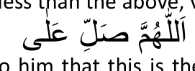
and then it occurred to him that this is the Qa'dah Ula, Sujoodus-Sahw is not to be performed in this case.
8. If Tashah-hud is recited twice by error in any Salaat, Sujoodus-Sahw has to be performed.
9. If the Musalli forgets to sit in Qa'dah Ula of a three or four raka't Fardh Salaat, and remembers so while rising, he should immediately return to the Qa'dah position as long as he has not yet entered into the Qiyaam posture. In this case no Sujoodus-Sahw is to be performed.
However, if the Musalli has already taken up the Qiyaam posture then he should not return to the Qa'dah position, but should complete his Salaat, and perform Sujoodus-Sahw at the end.
10. A Musalli performs a three or four-raka't Fardh Salaat and forgets to sit in Qa'dah Akhira:
(a) While rising if he recalls the error he should sit immediately and complete the Salaat. No Sujoodus-Sahw is to be performed in this case.
(b) If the error is recalled by the Musalli after he entered into the Qiyaam position, he should return to the Qa'dah position as long as he did not complete this extra raka't1. After assuming the Qa'dah position, the Salaat should be completed, but Sujoodus-Sahw has to be performed in this case.
(c) The error is recalled only after completion of the extra raka't. In this case, if the Musalli is performing a three raka't Fardh Salaat, he should complete the Salaat after this extra fourth raka't. No Sujoodus-Sahw is performed in this case. However, the four raka'ts thus performed become Nafl. The Fardh Salaat must be repeated.
1 N.B. The raka't will be considered completed once the head touches the ground in the first Sujood of the raka't.
If the Musalli is performing a four-raka't Fardh Salaat, the extra raka't will be the fifth. He should add another raka't making a total of six raka'ts. In this case Sujoodus-Sahw has to be performed. The six raka'ts thus performed become Nafl as well. The Fardh Salaat has to be repeated.
11. A Musalli sits in Qa'dah Akhira, recites Tashah-hud but rises into the fifth raka't thinking it to be the Qa'dah Ula. As long as this extra raka't is not completed the Musalli should return to the Qa'dah, and complete the Salaat. Sujoodus-Sahw is necessary in this case. If the extra raka't has been completed, then:
(a) If the Salaat is a three-raka't Fardh, it (the Salaat) should be completed after this extra (fourth) raka't and Sujoodus-Sahw must be performed. The Four raka'ts become Nafl. The Fardh has to be repeated.
(b) If the Salaat is a four-raka't Fardh, the extra raka't will be the fifth raka't. A sixth raka't should be added, and the Salaat is completed on the sixth Rakaat. Sujoodus-Sahw is to be performed in this case. Four raka'ts are regarded as the Fardh Salaat and two raka'ts become Nafl. The Fardh Salaat is not to be repeated in this case.
12. If the Musalli forgets to sit in the First Qa'dah during a four raka't Nafl Salaat, he should return to the Qa'dah as long as the third raka't has not been completed. Sujoodus-Sahw must be made after the fourth raka't. If the Musalli did not return to the Qa'dah, but completed the third raka't, then, too, Sujoodus Sahw must be made at the end of the Salaat.
13. Doubt regarding the Number of Raka'ts:
During the course of performing Salaat the Musalli doubts the number of raka'ts he has performed, i.e. whether he has performed three or four, etc., raka'ts.
(a) If the Musalli is not in the habit of doubting the number of raka'ts, i.e. such doubts are not common to him, then he should repeat the Salaat afresh.
(b) If such doubts are common to the Musalli, then in this case he must ponder into the number of raka'ts he has performed, and accept the verdict given by his mind. If he is able to conclude that he had performed two, three or four raka'ts, he should accept this conclusion. No Sujoodus-Sahw is necessary in this case.
(c) If the Musalli is unable to arrive at any decision, then in such a case he should opt for the lesser number — i.e. if the doubt is between two and three raka'ts, he shall consider that he has performed only two raka'ts; if the doubt is between three and four, three shall be considered as the number already performed; if the doubt is between one and two raka'ts, one raka't shall be considered. And, in all these instances the Musalli shall sit in Qa'dah and recite Tashah-hud in each raka't and perform Sujoodus-Sahw in the final raka't of the Salaat.
14. If, after completion of the Salaat, a doubt arises in the Musalli's mind as to the number of raka'ts performed, then he should not accord any consideration to this doubt. The Salaat has been discharged in order. However, if the Musalli, after completing the Salaat, recalls with certainty that he had performed, for example, only three raka'ts instead of four, then he should rise and perform another raka't, and make Sujoodus-Sahw. But, if the Musalli spoke or turned away his chest from the Qiblah or indulged in any act which nullifies Salaat, the Salaat shall have to be repeated. In this case he cannot merely perform one additional raka't.
15. If a doubt as to the number of raka'ts occurs after reciting Tashah-hud in the final raka't, then too, such doubt is to be discounted. The Salaat is valid in this case.
16. If during the performance of Salaat the Musalli committed several such mistakes which necessitate Sujoodus-Sahw, then only one Sujoodus-Sahw is to be made for all the errors committed. In one Salaat Sujoodus-Sahw is not performed twice.
17. After making Sujoodus-Sahw, the Musalli again made such a mistake which necessitate Sujoodus-Sahw. In this case another Sujoodus-Sahw is not performed. The Sujoodus-Sahw performed the first time suffices for the error committed thereafter.
18. The Musalli committed a mistake which necessitates Sujoodus-Sahw, but he completed his Salaat, forgetting to make the required Sujoodus-Sahw. The omitted Sujoodus-Sahw should, in this case, be made even after termination of the Salaat as long as the Musalli did not indulge in any act which nullifies Salaat. If any such act was committed, the Sujoodus-Sahw cannot be performed. The Salaat must be repeated.
19. The Musalli made Niyyat to perform three raka'ts or four raka'ts Fardh Salaat, but he ended the Salaat in error by making Salaam after two raka'ts. The Musalli should rise and complete the Salaat, adding the necessary one or two raka'ts. Sujoodus-Sahw must be performed here.
20. In the first or second raka't of Witr Salaat the Musalli recited, in error, Qunoot. He shall still have to recite Qunoot in the third raka't and Sujoodus-Sahw must be performed.
21. While performing Witr Salaat the Musalli is unable to decide whether he is performing his second or third raka't. In this case he should consider his present raka't as the second raka't but he must recite Qunoot in this "second" raka't as well as the following third raka't. Sujoodus-Sahw should be performed in this case.
22. It is not permissible to make Sujoodus-Sahw if the Musalli deliberately omits any of the Waajib acts. In such a case the entire Salaat will have to be repeated.
_______________ooOoo_______________

THE PERFORMANCE OF SAJDAH TILAWAT IN SALAAT
In the Holy Quran there are fourteen Sajdah-Tilawat. Wherever there appears the term

in the margins of the pages of the Quran, Sajdah has to be made when that particular verse is recited.
1. If the Musalli recites a Sajdah-verse in Salaat, he has to make one Sujood immediately after reciting the verse. After performing the Sujood-Tilawat the Musalli proceeds to complete his Qiraat in the Qiyaam position. After Qiraat, he performs his Ruku and proceeds with his Salaat as usual.
2. If, after reciting, the verse of Sajdah the Musalli does not make the required Sujood but proceeds to recite a further two or three verses — he may still execute the Sajdah-Tilawat. If, after reciting the Sajdah-verse, the Musalli recited more than three verses, he may not then perform the Sajdah. He becomes a sinner.
3. The Sajdah-Tilawat, which was not fulfilled during Salaat, cannot be performed after the Salaat. The only recourse open is to make Istighfaar — seek forgiveness for this lapse.
4. After reciting a verse of Sajdah the Musalli goes immediately into Ruku and while in Ruku he makes Niyyat (intention) that this Ruku is executed on behalf of the Sujood-Tilawat as well. In this case the obligation of Sujood-Tilawat is discharged.
5. In the abovementioned (No. 4) example, if the Musalli does not form any Niyyat in Ruku, then the Sujood of Tilawat will be discharged once he makes the Sujood of his Salaat. In this case the making of Niyyat in Sajdah is not necessary.
6. While performing Salaat the Musalli hears another person reciting a verse of Sajdah. In this case the Musalli should make the Sajdah-Tilawat after completing his Salaat.
_______________ooOoo_______________

JAMA'T SALAAT OR CONGREGATIONAL PRAYERS CONDITIONS FOR THE VALIDITY OF JAMA'T
1. Islam, i.e. The Musallis must be Muslim.
2. Aaqil i.e. The Musallis must be sane and sober.
3. Niyyat of Iqtida The Muqtadi2 must, together with his Niyyat for Salaat intend that he is performing Salaat behind the Imam. 4. It-tihaade Makaan. i.e. The place of the Imam and Muqtadi should be the same.
2 Muqtadi = The Musalli who performs Salaat in Congregation behind the Imam.
If the distance between the Imam and the Muqtadi is so much that two Safs (rows) of Musallis could be accommodated, the place of the Imam and Muqtadi will not be considered as being the same, and the jama't will not be valid. The distance between Imam and Muqtadi should not be so great that two rows of worshippers could be accommodated in the intervening space (i.e. between Imam and Muqtadi).
5. Validity of Imam's Salaat For the Salaat of the Congregation to be valid it is necessary that the Salaat of the Imam be valid. If for some reason the Salaat of the Imam becomes null, the Salaat of the Jama't will likewise be nullified.
6. The Muqtadi must not be in front of the Imam.
If the heels of the Muqtadi are ahead of the heels of the Imam it will be considered that the Muqtadi is in front of the Imam, and the Jama't will not be valid, i.e. the Salaat of the Muqtadi will not be valid.
7. Association in the Arkaan of Salaat.
Besides the Qiraat, the Muqtadi should closely follow the Imam in all the postures of Salaat. The Muqtadi should fulfil the various postures of Salaat either with the Imam or immediately after the Imam, e.g. the Muqtadi enters Ruku, Sajdah, etc. together with the Imam or he enters these positions after the Imam had entered them. (N.B. Should the Muqtadi enter any posture before the Imam, he (Muqtadi) should remain in that position until the Imam also obtains that position.)
Once the Imam has entered that position and the Muqtadi is still holding the same posture, the condition of Association is fulfilled, e.g. the Muqtadi went into Ruku before the Imam. For the validity of the Muqtadi's Salaat it is necessary that he prolong his Ruku until the Imam meets up with him.
8. Equivalence of State of Imam and Muqtadi The state of the Muqtadi should either be lesser or equal to that of the Imam, The state of the Muqtadi must not be higher than that of the Imam.
Examples:
(i) One who cannot recite the Quran properly can follow an Imam who does not recite correctly.
(ii) One who is able to recite correctly cannot follow an Imam whose recitation is incorrect.
(iii) Males cannot follow a female Imam.
(iv) The Imam cannot be one who has not yet attained the age of puberty if the Muqtadis are of age.
(v) One who performs a Nafl Salaat can join the Imam who is performing a compulsory Salaat.
(vi) One who performs a compulsory Salaat cannot become the Muqtadi of one who is performing a Nafl or Sunnat Salaat. (vii) If the Muqtadi is in the state of purity he cannot perform Salaat behind an Imam who is described as a Mazoor.
(viii) The Muqtadi cannot intend performance of a Fardh Salaat other than the Fardh performed by the Imam.
9. The Imam should not be a person upon whom it is necessary to perform Salaat alone, e.g. a Masbooq (who is a congregant or Muqtadi who joined the Jama't after one or more raka'ts were already performed), who fulfils the raka'ts (which he had missed) after completion of the Imam's Salaat. It is not permissible to become a Muqtadi of the Masbooq.
_______________ooOoo_______________

MASAA-IL PERTAINING TO JAMA'T OR CONGREGATIONAL SALAAT
1. Jama't is a Shart (Condition) for juma' (Friday), and Eid Salaat. These Salaat are not valid if performed individually. They must be performed in Congregation.
2. Jama't for the Five daily Salaats is Waajib (compulsory). It could therefore not be discarded without valid reason.
3. Jama't for Taraaweeh Salaat is Sunnatul Muakkadah.
4. Jama't for Salaatul Kusoof (Salaat performed at the time of the eclipse of the sun) is Sunnatul Muakkadah.
5. Jama't for the Witr of Ramadaan is Mustahab.

MASAA-IL PERTAINING TO JOINING THE JAMA'T
1. Should one reach the Musjid of one's locality at a time when the jama't Salaat had been completed, it is Mustahab then to go to another Musjid in order to perform the Salaat in congregation. Alternatively, one may return home and perform the Salaat in Jama't in the company of one's housefolk.
2. If, after one has already performed Fardh Salaat, one happens to be at a place where that very same Salaat is being performed in Jama't, one should join the jama't if Zuhr or Isha is being performed. However, if Fajr, Asr or Maghrib is being performed one must abstain.
3. Commencement of the Congregational Salaat while one is performing the very same Fardh alone.
After one has already started to read one's Fardh Salaat, one finds that the same Salaat is being performed in congregation. In this case several Rules apply as follows;
(i) If it is a Two Raka't Fardh (i.e. the Fardh of Fajr) terminate the Salaat immediately if the Sajdah of the first raka't has not yet been made, and join the congregation. If the Sajdah of the first raka't has been made then complete both raka'ts and thereafter do not join the jama't.
(ii) If it is a Three-Raka't Fardh (i.e. Maghrib), then end the Salaat as long as the Sajdah of the second rakaat has not yet been made, and join the Jama't. If the Sajdah of the second raka't has already been made, then complete the Salaat and do not join the congregation.
(iii) If it is the Four-Raka't Fardh of either zuhr or Ishaa then
(a) end the Salaat if the Sajdah of the first raka't has not been made, and join the Jama't.
(b) If Sajdah of the second raka't has been made then complete the performance of Two Raka'ts join the Jama't.
(c) If the third raka't was commenced but its Sajdah had not yet been made then terminate the Salaat forthwith and join the Jama't. If the Sajdah has been made, then complete the four raka'ts and join the Jama't.
(iv) If it is the Four Raka'ts Fardh of Asr then
(a) end the Salaat if the Sajdah of the first raka't has not yet been made, and join the Jama't.
(b) If the Sajdah of the second raka't has already been made then complete two raka'ts and join the Jama't.
(C) If the third raka't was commenced but its Sajdah had not yet been made then terminate the Salaat forthwith and join the Jama't. If the Sajdah has been made, then complete the four raka'ts and do NOT join the Jama't
N.B. The manner in which to end the Salaat is to make a single Salaam while standing, i.e. say "Assala-mualaikum warah-matullaah", and turn the head towards the right.
4. If, after one has started with Nafl Salaat the congregational Fardh Salaat commences, one should complete two raka'ts although a Niyyat for four raka'ts was made.
5. If, after having started with the four raka'ts Sunnatul Muakkadah of Zuhr, the Fardh in congregation commences, one should complete the four raka'ts and then join the jama't.
6. Once the Jama't is in progress one should not commence with Sunnat and Nafl Salaat. However, with regard to the Sunnats of Fajr, it should be performed if one is confident that one will be able to join the Fardh Jamaat after completion of the two Sunnats. If one feels that engagement in the two Sunnats will cause one to miss the Fardh which is being performed in Jama't then one should omit the Sunnats and join the Jama't. In this instance it is preferable to make Qadha of the missed two raka'ts Sunnatul Muak-kadah of Fajr provided it is done after sunrise, but before midday (Zawwaal).
7. If one fears that by observing all the Sunnat and Mustahab factors in the two raka'ts Sunnatul Muak-kadah of Fajr the Jama't will be missed, then the Salaat should be performed observing only the Fardh and Waajib factors.
8. The two raka'ts Sunnatul Muak-kadah of Fajr which one intends performing after the congregation has already started, should be performed outside the confines of the Musjid. If such a place is not available, then it should be performed behind some pillar in the Musjid or in a remote corner — furthest from the congregation. It is Makrooh Tahrimi to perform any Salaat in a place where the Fardh Salaat is being performed in Jama't.
_______________ooOoo_______________

MASAA-IL PERTAINING TO THE MUQTADI AND THE IMAM
1. The appointed Imam of a Musjid enjoys the priority right to lead the congregational Salaat in the Musjid. In his presence no one is entitled to lead the Salaat without his consent.
2. It is compulsory (Waajib) for the Muqtadees (congregants) to perform in accordance with the Imam in all Waajib and Fardh factors of the Salaat. It is not Waajib for the congregants to act in accordance with the Imam in the observance of the Sunnat and Mustahab factors. Hence, if the Imam happens to be a Shafi, it is not necessary for the Hanafi Muqtadees to follow him in the observance of Rafa' Yadain (raising the hands to the ears during the course of Salaat). Similarly, it is not necessary for the Hanafi Muqtadi to recite Qunoot in the Fajr Salaat when the Shafi Imam does so.
3. If there happens to be only one Muqtadi, he should stand on the right side of the Imam and slightly behind him (i.e. not in line with him).
4. If, after the Jama't started with a single Muqtadi, more congregants enter, the first Muqtadi should move to the rear of the Imam so that a row of congregants is formed behind the Imam. However, if the Muqtadees are not aware of the relevant Masaa-iI
(as is generally the case nowadays), the Imam himself should move forward so that a row of congregants is formed behind him.
5. Children, who have not yet reached the age of puberty, should form their rows behind the men.
6. It is Makrooh to form a second saff (row) when there is space available in the first Saff.

THE TYPES OF MUQTADI
There are three types of Muqtadi (a person who performs Salaat in congregation), viz.:
Mudrik, Laahiq, Masbooq.
Mudrik is a congregant who joined the Jama't from the beginning and remained until the completion of the Salaat.
Laahiq is one who missed a Raka't or more for some reason after having joined the Jama't.
Masbooq is a congregant who joined the jama't after having missed a Raka't or more.

THE LAAHIQ
1. If, after joining the Jama't, one's Wudhu broke, it will be permissible to leave the congregation, make Wudhu anew and join in the Jama't again. In the interval in which the Laahiq leaves the congregation it is not permissible for him to talk or do any such act which nullifies Salaat.
2. The Laahiq, with regard to the Raka'ts which he has missed, will be considered as the Mudrik. Therefore, like the Mudrik does not recite Qiraat, so the Laahiq, too, will not recite Qiraat but will remain standing (in Qiyaam) silently. Also, like the Mudrik who makes an error and will not perform Sujoodus-Sahw, so the Laahiq, too, will not perform Sujoodus-Sahw for any error or omission of the Waajib acts.
3. The Laahiq, upon rejoining the Jama't, must firstly fulfil the Raka'ts which have been missed and if after completing the missed Raka'ts the Jama't is still in progress, he should unite with it (the Jama't). If, after fulfilling his missed Raka'ts the Jama't has ended its Salaat, he (the Laahiq) should complete his Salaat alone.
For example: A Muqtadee's Wudhu broke during the second Raka't. He, therefore, leaves the Jama't and renews his Wudhu. On returning, he finds the Imam in the last Raka't. What should he now does?
He should Join the Jama't (stand in the Saff) and perform firstly the Raka'ts which he has missed. He must not join the Imam in whatever posture he may be in. In this example his Wudhu broke during the second Raka't, hence this Muqtadi (the Laahiq) should proceed to read the second, third and fourth Raka't without reciting any Qiraat in the Raka'ts he is thus making. In this example it is obvious that he will not be able to link up with the Imam since he (the Laahiq) has yet three Raka'ts to make while the Imam is in the last Raka't. In this case the Laahiq merely completes the three Raka'ts missed.
However, if in some case the Laahiq, after fulfilling his missed Raka'ts manages to link up with the Imam then he shall complete his Salaat with the Imam.
For example: The Muqtadee's Wudhu breaks in the first Raka't of Ishaa Fardh Salaat. He quickly goes to renew his Wudhu and upon returning he finds the Imam in Tashah-hud of the second Raka't. The Laahiq joins the congregation and performs the Raka'ts he has missed. If the Imam is now in the fourth Raka't, when the Laahiq has finished three Raka'ts, then he (the Laahiq) should join up with the Imam in the fourth Raka't and complete the Salaat with the Imam.

THE MASBOOQ
The Masbooq is the late-comer who joins the Jama't after a Raka't or more has been performed.
1. The Masbooq should merely follow the Imam and complete the Raka'ts which he had missed, after the Jama't has ended. After the Imam makes both Salaams, the Masbooq should rise and perform the Rak'ats which he had missed in numerical order; i.e. when he rises to fulfil his Salaat he should perform firstly Raka't number one, then number two and so on.
2. The Masbooq should recite Qiraat in those Raka'ts in which the Imam recited, viz, the first two Raka'ts.
3. With regard to Qa'dah the Masbooq must include in his calculation of "every two Raka'ts" the Raka'ts performed with the Imam.
Example: The Musalli joins the Jama't of Zuhr after three Raka'ts have been completed. After the Imam makes the Salaams, the Masbooq should rise and perform three more Raka'ts. The first Raka't which he will be performing after the ending of the Jama't will be his Raka't number one. He will, therefore, have to recite Qiraat in that Raka't, and after this Raka't he will sit in Qa'dah because added to the Raka't performed with the Jama't, this Raka't will be the second. After reciting Tashah-hud in this Raka't (which is Raka't number one insofar as Qiraat is concerned, and Raka't No. 2 with regard to Qa'dah) the Masbooq will rise and perform another Raka't in which he will also recite Qiraat since this will be regarded as his second Raka't for Qiraat purposes. No Qa'dah will follow this Raka't. After this Raka't, the Masbooq performs another Raka't in which he may either recite Surah Fatiha or stand in silence since this is his third missed Raka't in which there was no Qiraat. At the end of this Raka't, he will sit in Qa'dah Akhira and complete his Salaat as usual.
4. If the Masbooq, while fulfilling his missed Raka'ts, makes some mistake regarding the Waajib factors of Salaat then he must rectify the error with Sujoodus-Sahw.
_______________ooOoo_______________

THE JUMA' SALAAT
1. The Juma' (Friday) Salaat is obligatory upon all Muslim male residents of a town or city. Juma' Salaat takes the place of Zuhr Salaat.
2. The time for Juma' Salaat is the same as that for Zuhr.
3. The Friday Khutbah is a condition (Shart) for the validity of the Juma' Salaat. Without the Khutbah, the Juma' Salaat is not valid.
4. The Juma' Salaat consists of a total of fourteen Raka'ts as follows:
4 Raka'ts Sunnatul Muaqqadah 2 Raka'ts Fardh 4 Raka'ts Sunnatul Muaqqadah 2 Raka'ts Sunnatul Muaqqadah 2 Raka'ts Nafl
5. When the Imam rises to deliver the Khutbah it is not permissible to recite, to make Zikr, to perform Salaat or to talk. It is Waajib to listen attentively to the Khutbah.
6. If, after commencing with the four Raka'ts Sunnatul Muaqqadah, the Imam starts with the Khutbah, one should complete the Salaat.
7. The Khutbahs are recited before the Fardh Salaat. These Khutbas are Fardh.
_______________ooOoo_______________

THE EID SALAAT
1. The performance of two Raka'ts of Salaat on the occasions of Eidul Fitr and Eidud Dhuhaa is Waajib.
2. The two Raka'ts Salaat of Eid is followed by two Khutbahs which are Sunnat but to listen to them is Waajib.

3. HOW TO PERFORM THE EID SALAAT
(i) Niyyat: "I intend to perform two Raka'ts Eidul Fitr (or Eidud Dhuhaa) Salaat with six Waajib Takbeers behind this lmam."
(ii) After Niyyat the Imam will proclaim 'Allahu-Akbar' Reciting "Allahu-Akbar" silently the Muqtadi raises his hands to the ears and folds them as usual. Recite Thana in this position.
(iii) After Thana, the Imam will proclaim "Allahu-Akbar" thrice, each time raising the hands to the ears and then releasing them along the sides. Reciting "Allahu-Akbar" silently each time, the Muqtadi follows the Imam and raises his hands with each Takbeer to the ears and then releases them on the sides.
(iv) After the third Takbeer the hands are folded as is usual in Qiyaam, and the Imam will now commence the Qiraat —i.e. Surah Fatiha and some verses of the Quran.
(v) After Qiraat, the Raka't will be completed as usual with Ruku and two Sajdas.
(vi) In the second Raka't after the Qiraat, the Imam will proclaim "Allahu-Akbar" and raise his hands to the ears and release them. The Muqtadi should do likewise. The Imam will recite altogether three takbirs after the Qiraat in the second Raka't. When the Imam says "Allahu-Akbar" the fourth time (in the second Raka't) then do not raise the hands, but go immediately into Ruku. The rest of the Raka't is completed as usual.

TAKBEER-E-TASHREEK

(ALLAHU-AKBAR ALLAHU-AKBAR LAA-ILAAHA IL-LALLAA-HU WAL-LAA-HU AKBAR ALLAHU AKBAR WA-LILLAA-HIL HAMD.)
1. This Takbeer is known as Takbeer-e-Tashreek. It is Waajib to recite this Takbeer aloud once after every Fardh Salaat starting after the Fajr Salaat of the Day of Arafah (9th Zil-hajj) and ending after the Fardh Salaat of Asr on the 13th Zil-hajj.
2. Women must recite this Takbeer silently, although its recitation is not Waajib for them.
3. The reciting of this Takbeer aloud after every Fardh Salaat as mentioned is Waajib only if the Salaat is performed in Jama't.
4. It is not Waajib upon the Musaafir to recite this Takbeer.
5. Those upon whom this Takbeer is not Waajib (viz, women and Musaafirs) if they happen to be the Muqtadis of one upon whom the Takbeer is Waajib then its recitation will be compulsory upon them as well, but the women shall recite it silently.
6. If the Imam forgets to recite the Takbeer the Muqtadis should immediately recite it and not wait for the Imam to commence.

WHAT TO DO WHEN JOINING THE EID SALAAT AFTER IT HAS ALREADY BEGUN
1. If one joins the Eid Salaat after the Imam has already recited the Eid Takbeers of the first Raka't, then
(a) If one has confidence that after reciting the Takbeers one will be able to unite with the Imam in Ruku, then make the Niyyat for the Salaat and recite the Takbeers in Qiyaam.
(b) If one fears that by reciting the Takbeers in Qiyaam one will not be able to unite with the Imam in Ruku then immediately after Niyyat, join the Imam in Ruku and recite the Takbeers (silently) in Ruku instead of the normal Ruku Tasbeeh, but do not raise the hands (in Ruku) while reciting the Takbeers.
If the Imam emerges from Ruku before you could complete the Takbeers join him. The balance of the Takbeers are waived.
2. If one has missed a complete Raka't of the Eid Salaat, it should be fulfilled as follows:
After the Imam makes the Salaams, rise and recite Qiraat. After the Qiraat recite the Takbeers and complete the Salaat as usual.
_______________ooOoo_______________

SALAATUL JANAAZAH (THE FUNERAL PRAYER)
1. The janaazah Salaat is in fact a dua (prayer and supplication) on behalf of the dead.
2. The Shuroot (conditions) of other Salaats are applicable to Janaazah Salaat as well.
3. The Mayyit (the dead) should be placed in front of those performing the janaazah Salaat. The Imam should stand in line with the breast of the Mayyit.
4. Two things are Fardh in Salaatul Janaazah, viz.:
(i) To recite "Allahu-Akbar" four times.
(ii) Qiyaam — to perform the Janaazah Salaat standing.
There is no Ruku, Sajdah, etc. in Salaatul janaazah.
5. Three things are Sunnat in Salaatul janaazah, viz.
(i) Hamd — to recite the Praises of Allah Ta'ala.
(ii) Durood upon Rasulullah (iii) Dua for the Mayyit.
6. Jama't (congregation) is not a condition for the validity of Salaatul Janaazah. Hence, if even one person — man or woman — performs it, the Fardh obligation is discharged. But, the need to perform this Salaat in Jama't is of overriding importance since it is a dua for the Mayyit.

7. HOW TO PERFORM SALAATUL JANAAZAH.
The Mayyit should be placed in front with the Imam standing in line with the Mayyit's breast. It is Mustahab to form three rows behind the Imam. If there are only seven people — one of them being the Imam — three should stand in the first Saff (row), two in the second Saff and one in the third Saff.
The following Niyyat is then recited (or an intention is made in the mind):
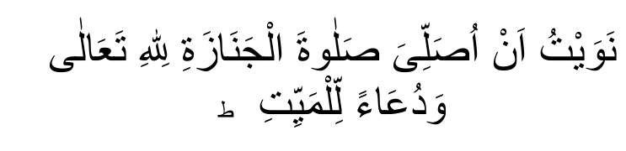
(NA-WAY-TO AN-USAWLLI SALAATAL-JANAAZATI LILAAHI TA-AALA WA-DUAA AL-LIMAYYITI)
(I make Niyyat of performing Salaatul Janaaah for Allah Ta'ala and as a dua for the deceased.)
After Niyyat recite "Allahu-Akbar" and raise the hands to the ears (as in other Salaats) and fold as usual. Recite now Thana:
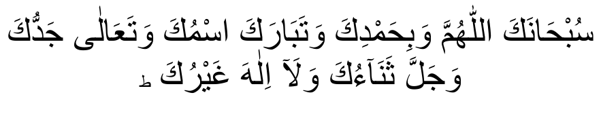
(SUB-HAANA-KAL-LAA-HUMMA WA BI-HAMDI-KA WA TABAA-RAKAS-MUKA WA TA-AALA JAD-DU-KA WA-JALLA THANAA-UKA WA
LAA-ILAAHA GHAY-RUK)
Glory unto You, O Allah! All Praise unto You Blessed is Your Name and Most High is Your Majesty. There is none worthy of worship but

You.
After Thana, recite again "Allahu-Akbar" once, but do not raise the hands. After this Takbeer recite Durood-e-Ibrahim.
Durood-e-Ibrahim:
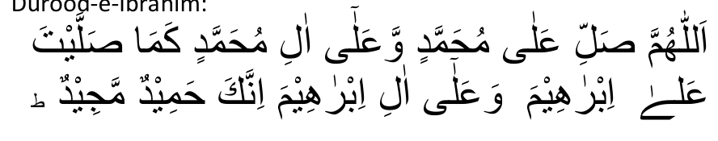
(ALLAHUMMA SALLI ALA MUHAMMADIN WA-ALA AALI
MUHAMMADIN KAMA SAL-LAITA ALA IBRAHIMA WA-ALA AALI
IBRAHIMA IN-NAKA HAMIDUM-MAJEED.)
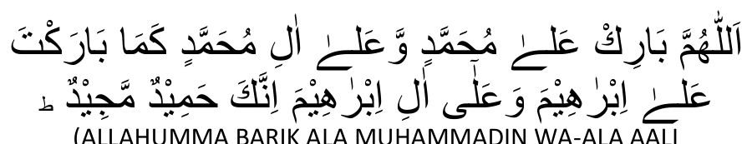
(ALLAHUMMA BARIK ALA MUHAMMADIN WA-ALA AALI
MUHAMMADIN KAMA BARAK-TA ALA IBRAHIMA WA ALA AALI
IBRAHIMA IN-NAKA HAMIDUM-MAJEED.)
Oh Allah! send Thy mercy on Muhammad (Sallallahu alayhi Wasallam) and on his seeds as Thou hast sent Thy mercy on Ibrahim and his seeds. No doubt! Thou art Great and Praiseworthy! Oh Allah! send Thy blessings on Muhammad and on his seeds as Thou hast blessed Ibrahim and his seeds. No doubt! Thou art Great and Praiseworthy.
After Durood-e-lbrahim recite "Allahu-Akbar" again once (but do not raise the hands), and recite a dua for the Mayyit. If the Mayyit is a baaligh (of age) male or female recite the following dua:
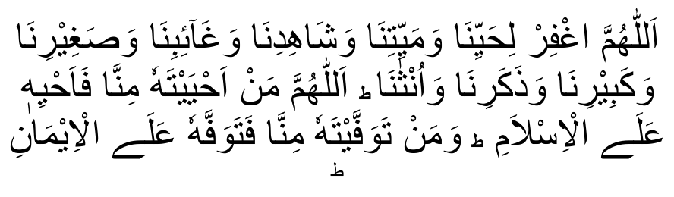
(ALLAHUMMAGH-FIR-LI HAIY-YINA WA MAIY-YITI-NA WA SHAHIDI-NA WA GHA-IBI-NA WA SAGHEE-RINA WA KABEE-RINA WA THAKA-RINA WA UN-THANA ALLAHUMMA MAN AH-YAI-TAHU MIN-NA FA-AH-YIHI A-LAL ISLAM WA MAN TAWAF-FAITAHU MIN-NA FATAWAF-FAHU ALAL IMAN.)
Oh, Allah, forgive our living and dead, present and absent, big and small men and women. Oh, Allah, whoever among us, is kept alive, by Thee, be kept alive on the path of Islam and to whom Thou cause

to die, let him die with Islamic faith.
If the deceased is a Na-baaligh (under age) boy, recite:

(ALLAHUMMAJ-AL-HU LANA FARATAU WAJ-AL-HU LANA AJRAU
WA-THUKHRAU WAJ-AL-HU LANA SHA-FI-AU WA MUSHAF-FA-A.)
Oh Allah, make this child a source of our salvation and the pain of his parting a source of reward and benefits for us. Make him a recommendation for us and the recommendation which Thou hast accepted.
If a Na-baaligh girl, recite the same dua as for a Na-baaligh boy but recite on all the three places "Aj-Alha" instead of "Aj-Alhu" and

(SHA-FI-ATAU WA MUSHAF-FA-ATAN.)
instead of
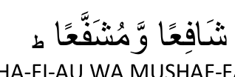
(SHA-FI-AU WA MUSHAF-FA-A.)
After the dua, recite again once "Allahu-Akbar". Again do not raise the hands. After this fourth Takbeer make the Salaams as is done in other Salaats.
8. The Imam recites the four Takbeers and the Salaams aloud and the Muqtadis silently.
_______________ooOoo_______________
NOTE: —
The Masaa-il appearing in this booklet are based on the Hanafi Mazhab.

DEFINITIONS OF TECHNICAL TERMS
(Continued from page 11)

MUSTAHAB
Mustahab is an act which Rasulullah (Sallallahu alayhi Wasallam) and his Sahaabah did occasionally. One who fulfils a Mustahab deserves Sawaab. There is no sin in not doing it.

HARAAM
Haraam refers to a prohibition which is established by proof known as Daleel Qat-i (Absolute Proof). The perpetrator of Haraam is termed a Faasiq and the one who rejects a Haraam becomes a Kaafir.

MAKROOH-TAHRIMI
Makrooh-Tahrimi is a prohibition established by proof known as Daleel Zanni (or such proof which although very strong, is of a lower category than Daleel Qat-i). One who commits Makrooh Tahrimi is a Faasiq, and the one who rejects it is also a Faasiq.

MAKROOH-TANZIHI
Makrooh-Tanzihi refers to such an act which if NOT done will warrant Sawaab, and if done then it will not be a punishable offence.
N.B. — It should be remembered that commission of Makrooh-Tanzihi only OCCASIONALLY will not be a punishable offence. However, committing Makrooh-Tanzihi constantly becomes a punishable offence.

MUBAAH
Mubaah is an act which if done does not warrant Sawaab and if not done then it will not be a punishable offence. In other words, it is an act which is merely permissible.

TARAAWEEH SALAAT
Taraaweeh is the special Salaat which the Shariah has ordained for the month of Ramadhaan. Taraaweeh Salaat consists of twenty raka'ts and its performance is Sunnatul Muakkadah. It has to be performed each night during the month of Ramadhaan. Deliberate omission of Taraaweeh Salaat is sinful.

THE WAY OF PERFORMING TARAAWEEH SALAAT
Taraaweeh Salaat commences on the first night of Ramadhaan and ends on the last night of Ramadhaan.
The most preferable method is to perform Taraaweeh in units of two raka'ts. Taraaweeh Salaat is performed in jamaa'at (for males) after the lshaa Fardh and Sunnatul Muakkadah, but before the Witr Salaat.
Niyyat of "Taraaweeh" or just "Sunnat" should be made, e.g. say: "I am performing two raka'ts Taraaweeh (or Sunnat) behind this lmaam."
There is no specific niyyat formula to recite. The niyyat may be made by uttering it verbally or merely making the intention in the heart.
After every four raka'ts there will follow a pause which should preferably last as long as it would take to perform four raka'ts Salaat. However, it is permissible to shorten the pause. During this interval, which is known as "Tarweehah", everyone should engage in some form of lbaadat, e.g. dhikr, tasbeeh, istighfaar, durood, etc. The Ibaadat during the Tarweehah (the pause after every four raka'ts) is to be made individually and silently. The Shariah has not ordered any specific and collective form of lbaadat for the Tarweehah (pause). If one so desires, one may merely remain seated without reciting anything.
After the twenty raka'ts Taraaweeh Salaat have been completed, a collective dua will be made silently. After the dua, the Witr Salaat will be made in jamaa'at.

RECITATION OF THE QUR'AAN SHAREEF DURING TARAAWEEH
It is Sunnatul Muakkadah to complete the recitation of the Qur'aan Shareef once during Taraaweeh of the whole month of Ramadhaan. If a Haafizul Qur'aan is not available, the Taraaweeh could be performed by reciting any Surah or Aayaat of the Qur'aan Shareef.

MASAA-IL PERTAINING TO TARAAWEEH SALAAT
1. Although it is best to perform the Witr Salaat after Taraaweeh, it is permissible to perform it before Taraaweeh.
2. It is Mustahab for the pause (Tarweehah) after every four raka'ts to be the duration of four raka'ts Salaat.
3. During the recitation of the Qur'aan in the Taraaweeh, the Aayat:

(BISMILLA-HIR RAHMAANIR-RAHIM)

(In the Name of Allah, the Beneficent the Merciful)
should be recited once aloud in the beginning of some Surah so that the Qur'aan Shareef is properly completed. If this is not done, the recitation will not be complete, but will be one Aayat (verse) less.
4. The Shariah does not require that the recitation of the Qur'aan Shareef be completed on the 27th Night or any particular night. The Qur'aan in Taraaweeh Salaat can be completed on any night.
5. The custom of making collective dua after every four raka'ts Taraaweeh as well as the custom of reciting aloud in unison some forms of tasbeeh and Dhikr after every two raka'ts and/or four raka'ts Taraaweeh are contrary to the Sunnah. Such innovatory (bidah) practices should be shunned.
6. If after having performed Taraaweeh Salaat it transpires that the Ishaa Fardh was not valid for some reason, e.g. Ishaa was inadvertently performed without wudhu, then both the Ishaa and the Taraaweeh will have to be repeated.
7. If a group of people did not perform the Ishaa Fardh in jamaa'at for some reason, but performed it individually, then Taraaweeh too must be performed individually. This group cannot on its own perform Taraaweeh in jamaa'at. However, if they join a Taraaweeh jamaa'at in which there are people who had made the Ishaa Fardh in jamaa'at then their (i.e. those who did not perform lshaa in jamaa'at) Taraaweeh will be valid.
8. If someone arrives in the Musjid after the Ishaa Fardh has been completed and Taraaweeh commenced, then he should first perform his Ishaa Fardh and then join the jamaa'at in Taraaweeh.
He should perform the Taraaweeh raka'ts which he had missed, after the Witr. This person shall perform the Witr in jamaa'at.
9. If the Imaam erroneously omitted qa'dah (sitting) in the second raka'at and proceeded into the third raka't, the muqtadees should call his attention by exclaiming "Subhaanallaah!" However, if for some reason the lmaam continues, he can and should return to the qa'dah of the second raka't as long as he has not entered the Sajdah of the third raka't. If before making the sajdah of the third raka't the Imaam realises his error, he should return to the qa'dah, make Sajdah Sahw as usual and complete the Salaat. But, if he completes the third raka't (the third raka't will be considered completed with the first sajdah) then he should add a fourth raka't as well, and make Sajdah Sahw and complete the Salaat. In this case, the four raka'ts will be considered as only two raka'ts for Taraaweeh purposes.
10. It is not permissible to appoint a naa-baaligh (a child who has not attained puberty) to lead the Taraaweeh even if he happens to be Haafiz of the Qur'aan. Salaat performed behind a minor is not valid.
11. It is Makrooh Tahrimi (forbidden act) for women to perform Taraaweeh in jamaa'at. They should perform it individually and at home; not in the Musjid.
12. In some places Surah lkhlaas (Qulhuwallaah) is recited thrice in every raka't of Taraaweeh. This is contrary to the Sunnah. This method is Makrooh Tahrimi.
13. A collective dua (i.e. dua by the whole jamaa'at) will be made only after the twenty raka'ts Taraaweeh and not after the Witr Salaat.
14. Niyyat for the twenty raka'ts Taraaweeh could be made only once in the beginning when commencing the Taraaweeh. It is not obligatory to renew the niyyat after every two raka'ts although it is best to do so (i.e. to renew the niyyat.)
15. The time of Taraaweeh Salaat commences after lshaa Fardh and lasts until the expity of Ishaa times, viz.: until just before Fajr.

SOME DETESTABLE PRACTICES IN REGARD TO TARAAWEEH
1. Some people, due to laziness, do not join the Taraaweeh Salaat together with the Imaam but delay their entry into the Salaat for a while. After Surah Faatihah has been recited, at times even after some Aayaat have been recited, and even worse, when the Imaam is about to enter the ruku' they fall into the Salaat. This is an abominable practice. It is Makrooh Tahrimi and sinful to do so.
2. Some people consider the performance of Taraaweeh insignificant after the Qur'aan Shareef has been completed. After completion of the Qur'aan Shareef they feel that they have discharged their obligation, and they absent themselves from Taraaweeh Salaat. This practice is wrong and sinful. Taraaweeh remains of equal importance throughout the month of Ramadhaan. It is equally incumbent to perform Taraaweeh before and after completion of the Qur'aan Shareef.
3. Some people believe that it is necessary to complete the Qur'aan Shareef in Taraaweeh on the 27th night. There is no Shar'i basis for this custom. In fact, the emphasis on this practice has made it innovatory (bi'dah). It is essential, therefore, to discontinue it. The completion of the Qur'aan in Taraaweeh can take place on any night of Ramadhaan.
4. The custom of rewarding the Haafizul Qur'aan on the 27th night for having recited the Qur'aan is not permissible. Payment for reciting the Qur'aan is haraam. By so doing, the thawaab of the whole Taraaweeh is destroyed. Such payment will not be permissible even if it is given in the form of a gift, for in reality it is no gift because it has been reduced to a customary and near obligatory practice. It is by far superior to recite Taraweeh from Surah "Alam Tara Kayfaa" (i.e. Surah "Feel") rather than have a Haafiz who has to be paid for the recitation of the Qur'aan. The purpose of Taraaweeh is Ibaadat — to gain the Pleasure and Thawaab of Allah Ta'aala. Such Pleasure and Thawaab will not be obtained by paying for the Qur'aan's recital.
5. The practice of reciting the names of the Khulafa-e-Raashideen after every four raka'ts is contrary to the Sunnah, hence innovatory. It is not permissible to do so.
6. The practice to recite some form of Dhikr, tasbeeh or dua collectively and aloud after every four raka'ts is an innovatory custom, hence not permissible.
7. The practice to make collective dua after the Witr Salaat is also contrary to the Sunnah, hence not permissible. Whoever wishes to make dua may do so at any time individually (inaudibly).
_______________ooOoo_______________

TAHYATUL WUDHU
"Tahyatul Wudhu" consists of two raka'ts and is performed after Wudhu has been made. The Hadith Shareef has stated much significance (fadheelat) of this Salaat. However, one should be careful that this Salaat is not performed at a Makrooh time, for no Salaat is permissible in the Makrooh times.
_______________ooOoo_______________

TAHYATUL MUSJID
"Tahyatul Musjid" is the Salaat which is performed to honour Allah Ta'ala upon entering His House, viz., the Musjid. Tahyatul Musjid consists of two raka'ts which is usually performed upon entering the Musjid and before sitting down. Rasulullah ((Sallallahu alayhi Wasallam)) ordered that two raka'ts Salaat be performed upon entering the Musjid and before sitting down. This Salaat is thus Sunnat.
*This Salaat should not be performed at a Makrooh time. If one enters the Musjid and it happens to be a Makrooh time then recite only the following (4 times):
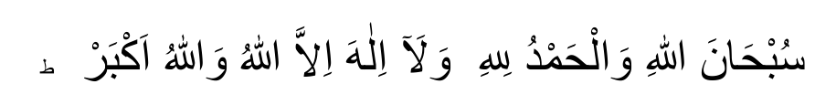
(SUBHAANALLAAHE WALHAMDULILLAAHE WALAA ILAAHA
ILLALLAAHO WALLAAHO AKBAR)
Purity belongs to Allah and praise be to Allah and there is none

worthy of worship besides Allah and Allah is Greatest.
After having recited this, recite Durood Shareef.
*Niyyat for this Salaat is to intend the performance of Tahyatul Musjid. As has been mentioned before, niyyat is the intention of the heart.
*Tahyatul Musjid is not restricted to two raka'ts. One may perform four raka'ts as well.
*If one enters the Musjid and the Juma' Khutbah has commenced or is about to commence, then one must not perform Tahyatul Musjid.
*If one enters the Musjid and the Fardh Jamaa'at is in progress, then one should not perform Tahyatul Musjid; the Fardh Salaat in which one will join in will take the place of Tahyatul Musjid as well. One will obtain the thawaab of Tahyatul Musjid in this case even if niyyat was not made.
*If, after entering the Musjid, one sat down and thereafter performed Tahyatul Musjid, the Tahyatul Musjid will be valid although it is best to perform it before sitting.
*If one visits the Musjid several times during the day, it will suffice if one performs Tahyatul Musjid once only.
_______________ooOoo_______________

ISHRAAQ
Ishraaq Salaat is performed about fifteen minutes after sunrise. Regarding this Salaat, Rasulullah ((Sallallahu alayhi Wasallam)) said:
"He who performs Fajr Salaat with jamaa'at and remains seated in the same place engaging in Dhikr until after sunrise and thereafter performs two raka'ts nafl Salaat, will obtain the thawaab of one Hajj and one Umrah."
Although the best way to perform Ishraaq is as described in the abovementioned Hadith, nevertheless, the Ishraaq Salaat will also be discharged if one did not remain in continuous Ibaadat after Fajr Salaat. Where the Ishraaq is performed after having engaged in some other activity, the thawaab, however, will be less.
_______________ooOoo_______________

SALAATUD DHUHAA (CHAASHT)
The Hadith Shareef explains great significance of Salaatud Dhuhaa. The time for this Salaat commences after one-third of the day has passed. Its time remains until Zawaal. Salaatud Dhuhaa consists of up to twelve raka'ts. One may perform two, four, six, eight, ten or twelve raka'ts.
Hadrath Aisha (radiallaahu anhaa) used to perform eight raka'ts Salaatud Dhuhaa. She said that even if her parents arose from the grave, she would not leave Salaatud Dhuhaa to go and meet them. From this emphasis the importance of this Salaat is evident.
_______________ooOoo_______________

SALAATUL AWWAABEEN
The Nafl Salaat performed after Maghrib Salaat is called "Salaatul Awwaabeen". The minimum number of raka'ts of this Salaat is six raka'ts and the maximum number is twenty raka'ts. This Salaat may also be performed in two raka't or four raka't units although it is better to perform it in two raka't units. Rasulullah ((Sallallahu alayhi Wasallam)) said that whoever performs six raka'ts after Maghrib will have his/her sins forgiven even if such sins are as much as the foam on the ocean.
_______________ooOoo_______________

TAHAJJUD
Of all the Nafl Salaat, the greatest in rank is the "Tahajjud Salaat". The Ahaadeeth speak much about the great significance of this Salaat. The time of Tahajjud is greatly efficacious for the acceptance of dua.
Tahajjud Salaat is performed in the latter part of the night. After having gone to bed one should rise late in the night and engage in this wonderful ibaadat which has always been the practice of the great and pious people. The minimum number of raka'ts in Tahajjud is four and the maximum is twelve raka'ts. This Salaat can also be performed in two raka't or four raka't units. The niyyat for this Salaat is simply to intend that one is performing Tahajjud.
(N.B. — The niyyats for the other Nafil Salaats mentioned in these pages should be made in a similar manner, naming the particular Nafil Salaat being performed.)
If one lacks the courage to get up late in the night, then one should at least make an effort to perform four raka'ts with the niyyat of Tahajjud after the two Sunnatul Muakkadah of lshaa. Although the thawaab will not be the same as Tahajjud being performed in its proper time, nevertheless, the Authorities of the Deen have advised this method of Tahajjud for those who know that they will not be able to get up in the night for Tahajjud.
Rasulullah ((Sallallahu alayhi Wasallam)) said the Tahajjud Salaat is a medium (i.e. a very great and efficacious medium) of gaining nearness to Allah Ta'ala. At the same time, it is an expiation for sins while it strengthens one's will power in the fight against the lowly nafs. Every Muslim should, therefore, make the greatest of effort, combat the laxity of the nafs and compel it to submit to the performance of this Salaat. Tahajjud is the time when the servant is closest to Allah Ta'ala.
There are no specific Surahs to be recited in this Salaat. Any Surah may be recited in any raka't. The practice of fixing Surah Ikhlaas for the Tahajjud Salaat is contrary to the Sunnah and should not be adhered to.
_______________ooOoo_______________

SALAATUT TAUBAH
Salaatut Taubah consists of two raka'ts which should be performed after one has committed a sin. After performing these two raka'ts one should raise one's hands sincerely and humbly in dua and repent abundantly.
_______________ooOoo_______________

SALAATUT HAAJAT
This Salaat is performed when one is in need or in difficulty. Rasulullah ((Sallallahu alayhi Wasallam)) said that whoever is in need of something should make a perfect Wudhu (i.e. observing all the rules and aadaab of Wudhu) and perform two raka'ts Salaat. After the Salaat recite the praises of Allah Ta'ala and recite durood shareef. One may recite any amount and any formula of praises — Tahmeed and Tasbeeh — as well as any amount of Durood Shareef. Thereafter make a fervent dua for the fulfilment of the need. This Salaat is called "Salaatul Haajat".
_______________ooOoo_______________

SALAATUT TASBEEH
The Ahadeeth Shareef speaks much of the fadheelat (blessing) and thawaab (reward) of Salaatut Tasbeeh. Hadhrat Abdullah Ibn Abbaas (radiallahu anhu) narrates that Rasulullah ((Sallallahu alayhi Wasallam)) said to his uncle, Hadhrat Abbaas Bin Abdul Muttalib (RA.):
"O Abbaas! O my uncle! Should I present to you a gift? Should I bestow something to you? Should I inform you of something greatly beneficial? Should I show you such an act which, if you render it, Allah Ta'ala will forgive all your sins — old and new, those committed in error and those committed deliberately, sins committed publicly or privately? That act is to perform four raka'ts (Salaatut Tasbeeh). . .. (After Rasulullah (Sallallahu alayhi Wasallam) taught him the way of performing this Salaat, he said):
"If possible, perform this Salaat daily; if you are unable then perform it once a week! If you are unable, then perform it once a month; if you are unable, then perform it once a year and if you are unable to do even this, then perform it at least once in your whole lifetime."

THE METHOD OF PERFORMING SALAATUT TASBEEH
This Salaat consists of four raka'ts. It is called "Salaatut Tasbeeh" because the following Tasbeeh is recited repeatedly in the Salaat:
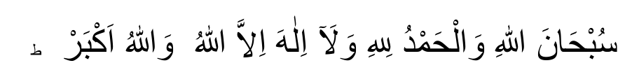
(SUBHAANALLAAHE WALHAMDULILLAAHE WALAA ILAAHA
ILLALLAAHO WALLAAHO AKBAR)
Purity belongs to Allah and praise be to Allah and there is none

worthy of worship besides Allah and Allah is greatest.
The above Tasbeeh is recited three hundred times in Salaatut Tasbeeh.
In some narrations, the following words are also said to have been recited along with the above Tasbeeh:
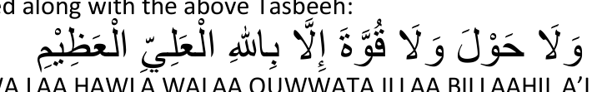
(WA LAA HAWLA WALAA QUWWATA ILLAA BILLAAHIL A'LIYYIL
A'THEEM).
And there is no power, no might, but from Allah, The Most High, The

Greatest.
It is, therefore, of greater metit to add these words to the Tasbeeh mentioned above.
There are two ways in which this Salaat may be performed.

THE FIRST METHOD
First Raka't. After reciting Surah Faatihah and a Surah, remain standing and recite the Tasbeeh 15 times. Make ruku. After the normal ruku' tasbeeh (i.e. Subhaana-Rabbiyal-Azeem 3 times) recite the above Tasbeeh 10 times. After ruku, recite the Tasbeeh 10 times in qaumah (i.e. the standing position after ruku'). In Sajdah recite the Tasbeeh 10 times after the normal sajdah tasbeeh (i.e. Subhaana-Rabbiyal-Aalaa 3 times). In jalsah (i.e. the sitting position between two sajdah) recite the Tasbeeh 10 times. In the second sajdah recite the Tasbeeh 10 times after the normal sajdah tasbeeh.
After the second sajdah do not stand up immediately. Sit and recite the Tasbeeh 10 times. Thereafter commence the second raka't.
The Tasbeeh is recited 75 times in one raka't as outlined above. The same procedure will be followed in every raka't. The total Tasbeehs recited will thus be 300.

THE SECOND METHOD
In this method also 300 Tasbeeh are recited. The only difference is that the Tasbeeh will be recited 15 times after Thanaa but before Surah Faatiha. After having recited a Surah, the Tasbeeh will be recited 10 times. After the second sajdah of every raka't the Tasbeeh will not be recited 10 times as is the case in the first method.
The following table will assist you in grasping the occasions when the Tasbeeh has to be recited.
FIRST METHOD SECOND METHOD After Qiraa'at 15 times After Thana, but (but before Ruku') before Surah Fatiha 15 times In Ruku 10 " After Qiraa'at 10 " In Qaumah 10 " In Ruku 10 " In first Sajdah 10 " In Qaumah 10 " In Jalsah 10 " In first Sajdah 10 " In second Sajdah 10 " In Jalsah 10 " After second Sajdah In second Sajdah 10 " while sitting 10 (After second Sajdah
Tasbeeh is not recited
75 in sitting position __
N.B. In the first method the Tasbeeh will be recited 10 times before Tashah-hud in the second and fourth raka't.
In the second method the Tasbeeh will not be recited before Tashah-hud in the second and fourth raka't.
*Niyyat for this Salaat is to merely make the intention that one is performing Salaatut Tasbeeh.
*There is no specific Surah to be recited in Salaatut Tasbeeh.
*In counting the number of Tasbeehs recited, the tongue should not be employed. If the counting is done verbally, the Salaat will be nullified. The Tasbeeh should be counted by pressing the fingers in the position in which they are. After the Tasbeeh has been recited once, one finger should be lightly pressed. In this way, the number will be remembered.
*If the Tasbeehs of a particular occasion in this Salaat are omitted in error, then recite the missed Tasbeehs in the next ruku or part of the Salaat, e.g. if the Tasbeehs before Surah Fatiha were omitted, recite these after the Qiraa'at; if the Tasbeehs between the two Sajdah (i.e. of jalsah) were omitted, then recite these in the second Sajdah; if the Tasbeehs of Qaumah were omitted, recite these in Sajdah. However, do not recite omitted Tasbeehs in Qaumah, jalsah and after the second Sajdah in the first and third raka't. Hence, if you forgot to recite the Tasbeehs in ruku then do not recite these in Qaumah. In Qaumah recite only the Tasbeehs of Qaumah. The Tasbeehs missed out in ruku should be recited in the first Sajdah.
*If for some reason Sajdah Sahw became necessary and if some Tasbeehs were omitted at some stage, and not as yet fulfilled, then recite the omitted Tasbeehs in the Sajdah Sahw. However, remember that Sajdah Sahw has not Tasbeehs of its own; hence do not recite additional Tasbeehs when making Sajdah Sahw. The number of Tasbeehs for the four raka'ts of Salaatut Tasbeeh is 300. Therefore, it is impossible to recite only such Tasbeehs in Sajdah Sahw, as were missed out earlier and not fulfilled.
_______________ooOoo_______________

SALAAT BEFORE PROCEEDING TO THE QABRASTAAN (CEMETERY)
It is sunnat to perform two raka'ts Salaat before proceeding to the qabrastaan.

SALAATUL ISTIKHAARAH
"Istikhaarah" means to seek goodness. Here it means the way of seeking advice and goodness from Allah Ta'ala. Salaatul Istikhaarah consists of two raka'ts. When one intends to embark on any project, e.g. trade, journey, marriage, etc. then one should seek the advice of Allah Ta'ala, and make dua for protection and goodness. According to the Hadith of our Nabi ((Sallallahu alayhi Wasallam)) it is only an unfortunate person who fails to seek the aid, advice and goodness of Allah Ta'ala when intending to embark upon something. The Hadith Shareef has exhorted much the observnce of Salaatul Istikhaarah. Isha'Allah, you will not regret if you make this Salaat and only thereafter decide whether to proceed with the intended project or cancel it.

THE METHOD OF PERFORMING SALAATUL ISTIKHAARAH
Salaatul Istikhaarah consists of two raka'ts. This Salaat is performed at night just before going to bed. Once the Salaat has been performed, go to bed immediately. Do not indulge in any activity after Salaatul Istikhaarah. Recite any Surah in these raka'ts. It is performed as any other Nafl Salaat. After the Salaat make a fervent dua, with much concentration. The dua which should be recited after this Salaat is as follows:
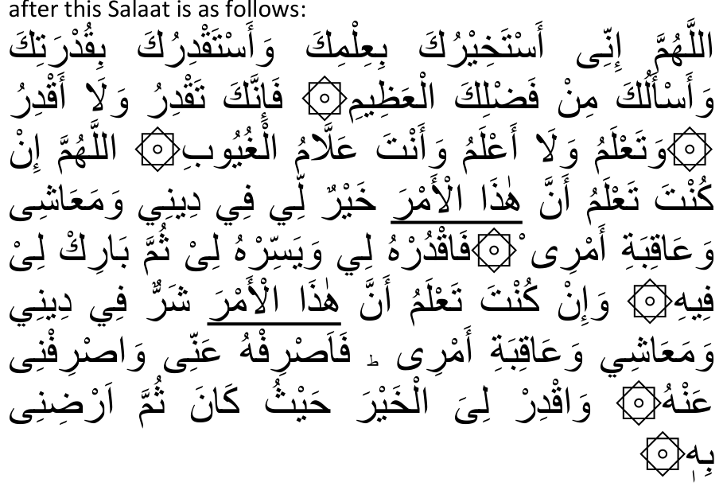
(ALLAHUMMA INNEE ASTAKHEERUKA BI I'LMIKA WA ASTAQDIRUKA
BIQUDRATEKA WA AS-ALOKA MIN FADHLI KAL A'THEEM. FA
INNAKA TAQDERU WALAA AQDERU WA TA'LAMU WALA A'LAMU WA ANTA ALLAAMUL GHUYOOB. ALLAHUMMA IN KUNTA TA'LAMU
ANNA HAA
THAL AMR KHAYROON LEE FEE DEENEE WA MA-AASHEE WA
AAQEBATE AMREE. FAKDURHU LEE WA YASSIRHU LEE THUMMA BAARIK LEE FEEHEE. WA INKUNTA TA'LAMU ANNA HAATHAL AMR
SHARROON LEE FEE DEENEE WA MAA AA'SHEE WA AAQEBATE
AMREE. FA ASRIFHU ANNEE WA ASRIFNEE ANHU. WA AQDIR
LIYALKHAYRA HAYTHO KANA THUMMA ARDHINEE BIHI.)
O! Allah. Behold I ask You the good through Your Knowledge, and ability through Your Power, and beg (Your favour) out of Your infinite Bounty. For surely You have Power, I have none. You know all I know not. You are the Great Knower of all things.
O! Allah if in Your Knowledge this matter be good for my faith
(Deen) for my livelihood and for the consequences of my affairs, then ordain it for me, and make it easy for me, and bless me therein.
But if in Your Knowledge this matter be bad for my faith, for my livehhood and for the consequences of my affairs, then turn it away from me, and turn me away therefrom, and ordain for me the good

wherever it be, and cause me to be pleased therewith.
_______________ooOoo_______________

SALAATUS SAFAR
This Salaat is to be performed before setting out on a journey. Before leaving home perform two raka'ts "Salaatus Safar".
After returning from the journey, it is Sunnat to first go to the Musjid and again perform two raka'ts Salaat, remaining thereafter for a while in the Musjid.
Regarding Salaatus Safar, Rasulullah ((Sallallahu alayhi Wasallam)) has said:
"A man has not left anything better at home (when he departs on a journey) than these two raka'ts which are performed at the time of a journey."
It is Mustahab to perform two raka'ts Salaat wherever one breaks one's journey and intends to stay over at such a place for a while.
_______________ooOoo_______________

SALAATUL KHAUF
Whenever some fear, disaster or natural calamity overtakes one, e.g. storm, flood, earthquake, plague, etc., two or more raka'ts Salaat should be made. Thereafter, dua should be made seeking the aid of Allah Ta'ala. This Salaat is called "Salaatul Khauf". Salaatul Khauf is also made individually; there is no jamaa'at for this Salaat. Everyone should engage in this Salaat individually at home.
_______________ooOoo_______________

SALAATUL KUSOOF
On the occasion of the eclipse of the sun the Shariah has ordered that a Salaat be performed. This Salaat is known as "Salaatul Kusoof'. Rasulullah (Sallallahu alayhi Wasallam) said that when an eclipse occurs one should become fearful (of Allah's Punishment) and engage in istighfaar, Dhikr, and dua. Salaatul Kusoof consists of two raka'ts and is performed in jamaa'at.
*There is neither Azaan nor Iqaamat for Salaatul Kusoof.
The Qiraa'at will be recited inaudibly.
The Qiraa'at in this Salaat should be exceptionally long, e.g. Surah Baqarah.
*The Ruku and Sajdah should also be very lengthy.
*After the Salaat, a collective dua will be made by the jamaa'at. *AlI should remain in making dua until the end of the eclipse. However, if it is time for sunset then the dua should be ended and the Maghrib Salaat performed.
*Some people wrongly believe that it is not lawful to eat or drink during an eclipse. This belief has no Shari basis.
_______________ooOoo_______________

SALAATUL ISTISQAA'
"Salaatul Istisqaa" is the Salaat enjoined by the Shariah in the event of a drought. Istisqaa' means to petition for water. Salaatul Istisqaa' consists of two raka'ts and the method of performing it is as follows:
The entire Muslim community should gather on the out-skirts of the town in the veld. Everyone should put on simple garments and set out for the gathering-place on foot. Little children and old people should also go along. Not a single kaafir should be taken along. It is not permissible to permit the kuffaar to participate in this momentous occasion. Two raka'ts will be performed in jamaa't. Salaatul Istisqaa' has neither Azaan nor Iqaamat. The Imaam will recite the Qiraa'at audibly (jahr). The Imaam will thereafter recite two Khutabhsas on the Day of Eid. After the Khutabhs the Imaam will stand and face the Qiblah. He will raise his hands and petition Allah Ta'ala for rain. All those present should also make dua for rain.
This procedure of Salaat should be repeated for three consecutive days. Salaatul lstisqaa' should not be performed for more than three days.
* If after having performed Salaatul lstisqaa' on the first day, it rains, then too, complete the three days.
*It is best (mustahab) to fast on these three days.
* Drought is the effect of sin committed in abundance. It is a form of Allah's Punishment. Hence, during a drought everyone should resort to istighfaar and taubah in abundance and discharge whatever rights are unfulfilled or usurped, be such rights in regard to Allah Ta'ala, e.g. Salaat not performed, Zakaat not paid, or be these rights in respect to people, e.g. debt deliberately not paid, wealth of others usurped or taken in a haraam way, etc.
* It is Sunnat for the Imaam to invert his chaadar (the outer sheet which he wears). i.e. he should turn the inside out. This is to be done while making the dua for the rain after the two Khutbahs have been recited.

(ALLAHUMMASQINAA GHAYTHAM MUGHITHAM MUREE-AM
MUREE-AN-NAAFI-AN GHAIRA DHAAR-RIN AAJILAN GHAYRA
AAJILIN).
O Allah! Give us rain, abundant, wide-spread, producing herbage, benefiting without doing injury, in haste without delay.
_______________ooOoo_______________

SALAATUL KHUSOOF
The Salaat which is performed on the occasion of the eclipse of the moon is called "Salaatul Khusoof'. This Salaat is made individually wherever one may be and not in jamaa'at. Preferably this Salaat should also be lengthy. Salaatul Khusoof also consists of two raka'ts. It is not Sunnat to perform this Salaat in the Musjid. It should be performed at home.
_______________ooOoo_______________

QUNOOT-E-NAAZILAH
QUNOOT-E-NAAZILAH is the Dua to be recited when a calamity or some hardship overtakes the community or nation, e.g. natural disaster, plague, war, etc.

THE METHOD OF RECITING QUNOOT-E-NAAZILAH
The Dua known as Qunoot-e-Naazilah is recited in Fajr Salaat in the second raka't after completing the ruku' and while standing in the Position known as Qaumah (i.e. the standing posture after ruku). While reciting Qunoot-e-Naazilah the hands should be left at the sides.
This Dua should be recited with humility and in a voice lower in tone than when reciting Qiraa't. The Muqtadis should softly say 'Aameen' every now and again at the pauses in the Dua. Those among the Muqtadis who have memorized the Dua may themselves recite it.
NOTES:
(1) Qunoot-e-Naazilah is recited in only the Fajr Salaat. It is not permissible to recite it in any other Salaat.
(2) Jamaat is not a condition for the validity of Qunoot-e-Nazilah. A Munfarid (one who performs Salaat alone) and a woman may also recite Qunoot-e-Naazilah.
(3) Women who recite this Dua should not do so audibly.
(4) Qunoot-e-Nazilah is not restricted to one specific Dua. According to the occasion, appropriate Duas from among the Masnoon Duas may be recited.

QUNOOT-E-NAAZILAH
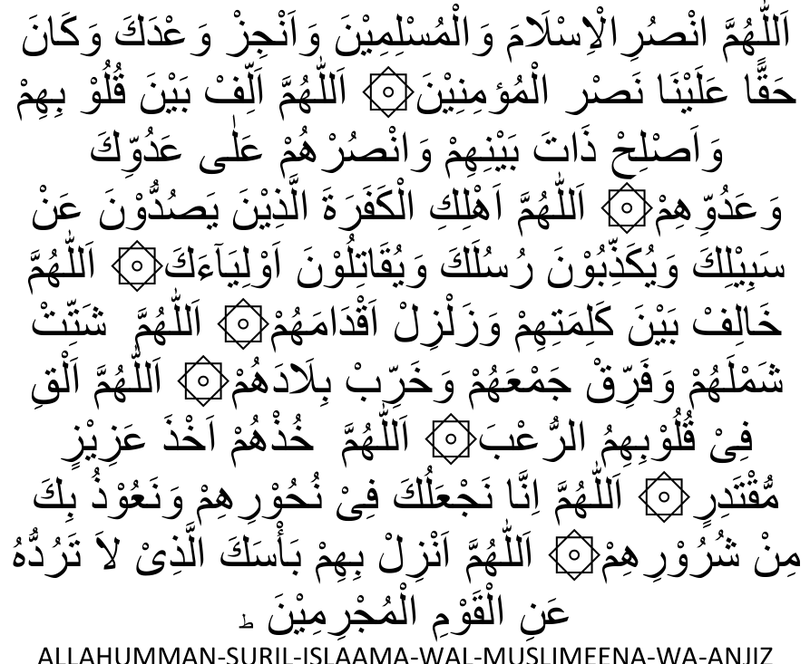
ALLAHUMMAN-SURIL-ISLAAMA-WAL-MUSLIMEENA-WA-ANJIZ WA'DAKA-WAKAANA-HAKKAN-ALAYNAA-NASRUL-MU'MINEEN. ALLAHUMMA-ALLIF-BAYNA-QULOOBIHIM-WA-ASLIH-THAATA BAYNI HIM-WANSURHUM-ALAA-ADUWWIKAWA'ADUWWIHIM
ALLAHU MMA-AHLIKIL-KAFARATALLATHEENA YASUDDOONA ANSA BEELIKA-WAYUKATH-THIBOONA RUSULAKA WAYUQAATILOONA
OWLIYAA-AK.
ALLAHUMMA KHALIF BAYNA KALIMATII-IIM WA ZALZIL
AQDAAMAHUM.
ALLAHUMMA SHATTIT SHAMLAHUM WAFARRIQ JAM-AHUM WA
KHARRIB BILAADAHUM.
ALLAHUMMA ALQI FI QULOOBIHIMUR RU'B.
ALLAHUMMA-KHUTH HUM AKHTHA AZEEZIM MUQTADIRIN
ALLAHUMMA INNAA NAJ-ALUKA Fl NUHOORIHIM WANA
OOTHUBIKA MINSHUROORIHIM
ALLAHUMMA ANZIL BIHIM BA'SAKAL LATHI LAATARUDDUHU
ANILQOWMIL MUJRIMEEN.
_______________ooOoo_______________

ABNORMAL TIME ZONES
(1) In places where the sun remains above or below the horizon for a period of months, as is the case at the Poles where it is said that the day and the night each is six months, the five daily Salaats will be performed by calculation of the time. For every 24 hours five Salaats (Fajr, Zuhr, Asr, Maghrib and Isha) will be performed. The times of the nearest region may be taken.
(2) Rasulullah ((Sallallahu alayhi Wasallam)) said that Dajjaal will remain on earth for 40 days. The first day will be equal in duration to one normal year; the second day will be equal to one month; the third day will he equal to a week and the balance of the days will be normal days. When asked about the performance of Salaat during such abnormal days, Rasulullah ((Sallallahu alayhi Wasallam)) instructed that Salaat should be performed by calculating the time, i.e. in every 24 hours five Fardh Salaat will have to be performed.
(3) In places where the night is excessively short. e.g. a night of two or three hours, Salaat will have to be performed on time. Where normal sunrise and sunset occur, each Salaat has to he performed at its appointed time, the shortness of the night being no factor for concession.
(4) In some places there is no Isha time. Immediately after the ending of Maghrib time Subh Saadiq (Fajr time) commences. In such places the performance of Ishaa and Witr remains obligatory. After commencement of Subh Saadiq, Athaan for Ishaa should be given and Isha Salaat be discharged. Thereafter Fajr Salaat will be performed.
_______________ooOoo_______________

MAGHRIB SALAAT DURING RAMADHAAN
During the month of Ramadhaan it is permissible to delay the Maghrib Jamaat Salaat by a few minutes to enable Musallis to complete their Iftaar with ease. However, an excessive delay is Makrooh. The delay should not be more than the time taken to perform two raka'ts Salaat.
Iftaar does not mean participation in a full meal. The Sunnat method of Iftaar is to break the fast either with some dates or a drink of water.
Nevertheless, those who have a lavish Iftaar should not delay too much. A delay of about four or five minutes after the Athaan is not improper.

MAGHRIB AND ISHA SALAAT TIMES
Isha Salaat time commences immediately after the ending of Maghrib time. Thus, there is no interval between Maghrib and Isha times. In most places about one and half hours have been fixed after sunset for the commencement of Isha Salaat. This should not be understood to mean that Maghrib Salaat may be performed even one and half hours after sunset. The one and half hours after sunset which have been adopted in most places do not indicate the ending of Maghrib time nor the exact commencement of Isha time. Maghrib time ends with the disappearance of the white glow (Shufaq-e-Abyadh) in the western horizon where the sun sets. Simultaneous with its disappearance Isha time commences. The inhabitants of a place should plot the exact time for the ending of Maghrib and the beginning of Isha by physical observation.
Another view of the Hanafi Math-hab is that Maghrib time ends with the disappearance of the red glow (Shufaq-e-Ahmar) in the western horizon. With the disappearance of Shufaq-e-Ahmar the time for Isha will commence. This phenomenon occurs long before the disappearance of the white glow (Shufaq-e-Abyadh). However, the Fatwa (verdict) of the Hanafi Math-hab is on the view of Shufaq-e-Abyadh (the white glow). But, in places where the night is extremely short such as the lands in close proximity to the Poles, it will be permissible for people to avail themselves of the Red-glow (Shufaq-e-Ahmar) view to enable them to commence Isha and Taraaweeh earlier.
ATHAAN
(1) It Is Sunnat to call the Athaan from a raised place outside the Musjid, e.g. from the Minaret. Hadhrat Bilaal (radhiallahu anhu) used to proclaim the Athaan from the roof of the Musjid. In fact, a raised place on the roof was erected for him for this purpose.
(2) If the Athaan is heard from several Musjids, it is best to reply to each Athaan although answering only one will suffice.
(3) In a place where Juma' Salaat is performed in several Musaajid, it will be obligatory to cease trading at the time of the Athaan which is proclaimed in the Musjid where one intends to perform Juma' Salaat.
(4) It is not permissible for a Muath-thin to recite the Athaan in two different Musjids, e.g. he calls the Athaan for Zuhr in one Musjid, then proceeds to another Musjid to recite the Zuhr Athaan there as well.
(5) It is not a Sunnat practice to raise the hands when making Dua after Athaan. In fact, this practice has become a bid'ah (innovation) in view of it having been made near compulsory.
(6) When the Athaan is being proclaimed, one should not make Salaam to anyone. It is not Waajib (compulsory) on a person to answer the Salaam of one who greets while the Athaan is being recited.
(7) When the second Athaan on Fridays for the Khutbah is announced, musallis should not verbally reply to it.
(8) During the Iqaamah while reciting Hayya Alas Salaah and Hayya Alal Falaah, it is permissible to either turn the face to the right and left respectively or to refrain from turning the face. Both ways are permissible.
_______________ooOoo_______________

IMAAMATE AND JAMAAT
(1) The official Irnaam has a greater right to lead the Salaat than a visiting Aalim. The trustees of a Musjid do not have the right to insist on the Imaam to allow a visiting Aalim to lead the Salaat.
(2) If one joins the Jamaat Salaat after the Imaam has made one Salaam, the Salaat of the late-comer will not be valid. He has to begin the Salaat afresh.
(3) When one arrives in the Musjid at such a time that the jamaat has already begun and the first saff (row) is full, one should adopt the following procedure: Wait in expectation of the arrival of another musalli with whom a saff may be made immediately behind the Imaam. If by the time the lmaam is about to go into Ruku' no one has arrived, then the Musalli should stand alone directly behind the lmaam.
(4) If there is a gap in any of the saffs on account of a musalli having left his position to make wudhu, etc., then a newcomer about to join the Jamaat should fill the gap even if it means that he has to cross the path of the Musallis in the saffs.
(5) If a musalli's wudhu breaks while in Jamaat Salaat, he should immediately leave to renew his wudhu. He is permitted to pass either through the saffs or he may go to the end of the saff and move out where the rows end.
(6) The daily five Fardh Salaats should preferably be performed in the Musjid of one's neighbourhood. If one happens to be in the vicinity, then it will not be permissible to unnecessarily bypass one's Mahallah (neighbourhood) Musjid to perform Salaat in another Musjid. Even if one happens to be alone in the Mahallah Musjid, then too, one should not leave to perform Salaat in another Musjid for the sake of obtaining Jamaat. It is best to perform Salaat in one's Mahallah Musjid even if there is no Jamaat taking place.
(7) On Fridays the Mahallah Musaajid (the Musjids in the surrounding neighbourhoods) should close and all Musallis should proceed for Juma' Salaat to the Jaami' (central) Musjid. However, if there is some valid reason or it is difficult for the musallis to go to the Jaami' Musjid then it will not be improper to perform Juma' Salaat in a Mahallah Musjid.
(8) It is not permissible to establish a Jamaat Khaanah in close proximity to a Musjid. All Musallis should proceed to the Musjid for Salaat. This prohibition is further emphasised in the case of Juma' Salaat. It is prohibited to a greater degree to perform Juma' Salaat in a Jamaat Khaanah when there happens to be a Musjid in close proximity. Those who persist in such improper action are guilty of perpetrating an act of fisq.
(9) If a Musalli wishes to leave immediately after the Jamaat Salaat without waking for the completion of the congregational Dua, it will be permissible to do so for a valid reason. However, it is Makroóh to leave before the Dua if one has no pressing need. The Dua referred to here is the Dua which is made immediately after the Fardh Salaat. The reference is not to the innovated practice known as 'Faatihah Thaaniyah' (the second dua) which is made collectively after the Sunnat and Nafl Salaat in some places. The second dua custom is not permissible.
(10) If a Musalli joins the Jamaat while the Imaam is in ruku', his (the Musalli's) raka't will be valid if he is able to join the Imaam in ruku' after having recited Takbeer Tahrimah in Qiyaam or in such a position which is closest to Qiyaam (standing). The raka't of the late-comer will not be valid if he joins in the ruku' while reciting Takbeer Tahrimah.
(11) It is not permissible to perform Jamaat Salaat at home before the Jamaat Salaat in the local or Mahallah Musjid. When one is able to attend the Musjid for Jamaat Salaat, then it is sinful to arrange a Jamaat at home. However, this will be permissible for a valid reason, e.g. illness, departure on a journey before the time of the jamaat in the Musjid, etc.
(12) If one has already missed the jamaat at the Musjid then it will be permissible to perform jamaat Salaat at home.
(13) After Qa'dah Akheerah (the final sitting) the Imaam by error stood up and performed another raka't, viz., the fifth. Thereafter he performs a sixth raka't. If in the jamaat there happens to be a Masbooq (one who joined the Jamaat after having missed a raka't or more) it is not permissible for him to join in the extra raka'ts which the lmaam is performing by error. He should complete his own missed raka'ts. If he joins the Imaam in the additional raka'ts his (Masbooq's) Salaat will be rendered invalid.
(14) A Musalli joins the Jamaat at such a time when the lmaam is about to make the Salaam. If he (Musalli) joins the Jamaat and finds sufficient time to recite Takbeer Tahrimah while standing before the lmaam makes the Salaam, his iqtidaa (Salaat behind the Imaam) will be valid even if he is not able to join in Qa'dah.
(15) When the lmaam is in Qa'dah Akheerah the Masbooq should only recite Tashahhud. He should not recite Durood Shareef and Dua. But if he does so by error, Sajdah Sahw will not be necessary. During the Imaam's Qa'dah Akheerah the Masbooq is also permitted to recite Tashahhud more than once.
(16) When the Masbooq enters the jamaat just before the Imaam has made the Salaam, he (Masbooq) should complete the recitation of Tashahhud, then only rise to complete the missed raka'ts.
(17) If the lmaam recites a few aayats silently by error in a jahri Salaat (i.e. a Salaat in which the Qiraa't has to be recited audibly) and then on remembering starts the recitation aloud, then Sajdah Sahw has to be made.

SALAATUL MUSAAFIR (The Salaat of a traveller)
The meaning of Musaafir has already been explained on page 53. Some further masaa-il (rules) in general pertaining to the Musaafir will now be mentioned.
(1) Watn-e-Asli is the original, hometown or place of residence of a person. Watn-e-Iqaamat is a temporary place of residence where the Musaafir makes a niyyat (intention) of staying for fifteen days or more.
(2) In Watn-e-Iqaamat the traveller is no longer regarded as a Shar'i Musaafir. Thus, he has to perform his Salaat in full in Watn-e-Iqaamat.
(3) On leaving Watn-e-Iqaamat on a journey to a place 48 miles or more, the Watn-e-Iqaamat is cancelled. After the journey if the Musaafir returns to the place which was his Watn-e-Iqaamat he will be a Musaafir there as long as he does not make a niyyat of staying fifteen days or more.
(4) On returning to one's Watn-e-Asli one ceases to be a Musaafir even if the intention to stay there is not 15 days. Even if one returns to Watn-e-Asli briefly, just for an hour or so, then too one does not remain a Musaafir. Salaat has to be performed in full.
(5) A woman who marries in another town will become the Muqeem (resident) of the town where her husband resides. By marriage and the decision to set up home with her husband, her original hometown ceases to be her Watn-e-Asli. Now her Watn-e-Asli is the hometown of her husband. If she happens to visit her parents in her previous hometown, she has to perform Qasr Salaat. (6) If a Musaafir by error forms a niyyat of four raka'ts Fardh and then recalls this error during the Salaat, then he should perform only two raka'ts.
(7) A person becomes a Musaafir when he sets out on a journey to a place 48 miles or more from his hometown. The 48 miles' distance is measured from the boundary (limit) of one's hometown. In terms of the Shariah the boundary of the town is where the buildings of the town end. If adjacent to these buildings at the end of the town there happens to be such vacant land which is used for the needs and purposes of the town's inhabitants, then such land will also be included within the town limits. Such vacant land is termed Finaa-e-Misr.
Once the traveller reaches beyond this limit he will be known as a Musaafir and Qasr Salaat will be permissible and valid even if he has not yet travelled 48 miles. The condition for the validity of the Qasr Salaat is the niyyat to travel 48 miles or more and the practical act of setting out on the journey.
In places where there is no vacant land beyond the town limits in view of the buildings of an adjacent town commencing immediately beyond the boundary of one's hometown, the town limits will be the point which is normally considered by the people to be the end of the town. In such cases, i.e. where the buildings of adjacent towns adjoin, the simplest method will be to accept the municipal boundary as the point from which the 48 miles will be measured. However, where the town has an effective ending with no buildings of an adjacent town to be considered, the municipal boundary will not be accepted for calculating the 48 miles. In this case the actual boundary will be where the buildings of the town and its Finaa-e-Misr end.
_______________ooOoo_______________

SALAAT IN THE AIR
Salaat will be valid only if performed on the ground. Thus Salaat performed in a plane while not valid on the basis of the principles of the Shariah, nevertheless, the Ulama have ruled that it is best to perform Salaat in the plane when one is certain that the plane will not land within the Salaat time. However, in view of difference of opinion among the Muftis on this issue it is best to repeat the Salaat after landing. According to some senior Ulama it is Waajib (compulsory) to repeat the Salaat after landing.
_______________ooOoo_______________

MASAA-IL (RULES) PERTAINING TO SALAAT IN GENERAL
(1) While performing Salaat if some blood appeared in the nostril without it flowing out of the nostril, the Salaat will be valid.
(2) A person faces a direction after being convinced that it is the Qiblah. On account of there being no one to point out the Qiblah, he had adopted the direction after Taharri (reflection). However, in reality he was facing the wrong direction. A person appearing on the scene and being aware of the correct direction should physically turn the musalli in the direction of the Qiblah.
(3) It is not permissible to conduct two Jamaats in one Musjid, e.g. in a Musjid with two floors, one Jamaat performing Taraaweeh on the ground floor and another jamaat on the upper floor; this constitutes two jamaats in one Musjid.
(4) An Imaam, thinking that Sajdah Sahw is Waajib on him, made the Sajdah. Afterwards it transpired that Sajdah was not necessary. The Salaat of both the Imaam and the Muqtadis is valid.
(5) It is forbidden to have the trousers below the ankles. The thawaab for a Salaat performed in this condition is negated. In addition one is guilty of a sin. This applies for all times, not only for Salaat.
(6) It is not permissible to perform Nafl Salaat in jamaat, other than those described on page 95.
(7) When performing Nafl Salaat at night it is permissible to recite the Qiraa't audibly. This is not permissible when performing Nafl Salaat during the day.
(8) While a Munfarid (one who performs Salaat alone) is permitted to recite the Qiraa't audibly during Fajr, Maghrib, and Isha Salaat, he should recite silently all the Takbeers, the Tasmee'- Sam iallaahu liman hamidah.
(9) During Fardh Salaat it is Makrooh to skip one Surah when reciting the short Surahs, e.g. if Surah Alam Tara is recited in the first raka't, Surah Ara-aital lathi should not be recited in the second raka't; if Surah Ithaa Jaa-a is recited in the first raka't, Surah
Qulhuwallaah should not be recited in the second raka't. However, it will not be Makrooh if two or more small Surahs are skipped. This rule applies to only Fardh Salaat. Omission of small Surah in Nafl Salaat is permissible.
(10) Changing one's niyyat (intention) during the course of Salaat is not valid, e.g. the Musalli intends Fardh Salaat, but during the course of the Salaat he changes his niyyat and intends Sunnat Salaat. The niyyat is not valid and his Salaat remains Fardh. A change of niyyat could only be effected by breaking the Salaat and starting afresh.
(11) Immediately after Salaat all types of Sajdah are forbidden. It is not permissible to make even Sajdah Tilaawat immediately after Salaat.
(12) When one misses the jamaat Salaat in the Musjid, do not proceed to the Musjid for performing the Fardh Salaat alone. In such an event perform the Fardh Salaat at home.
(13) It is Waajib to remain in Sajdah and Ruku' for the duration of one Tasbeeh.
(14) While going into Sajdah the Musalli should not place hands on his knees. However, when rising up into Qiyaam it is Mustahab to place the hands on the knees.
(15) Throughout the Sajdah it is Waajib to place at least one foot on the ground for the duration of one Tasbeeh (i.e. Subhaanallaah). However, it is Sunnatul Muakkadah to place both feet on the ground for the whole duration of the Sajda. Therefore, one who neglects this obligation is guilty of sinning. If both feet were raised off the ground for the whole duration of the Sajdah, the Salaat should be repeated.
(16) It is Makrooh to perform Salaat in such garments which are so tightfitting that the shape of the body is discerned. This especially immoral if the shape of the satr shows. Salaah performed in such haraam clothings has to be compulsorily repeated. This applies specially to those who perform Salaat in shirts and tight-fitting pants which reveal the shape of the satr when the Musalli goes into Sajdah.
(17) It is permissible for a person sitting in front of a Musalli to move off.
(18) If a Musalli performs Salaat while wearing a neck-tie, the Salaat should be repeated. It is not permissible to wear a tie.
(19) If the Musalli performs Salaat with garments which were acquired by theft, the Salaat should be repeated.
(20) If by error the Musalli recites Surah Naas in the first rakat then he should again recite Surah Naas in the second raka't.
(21) A Musalli starts to recite Surah Naas in the first raka't. While reciting the Surah should he realize his error, he should not discontinue the Surah, but should complete it and again recite the same Surah in the second raka't. It is Makrooh Tahrimi to discontinue the recitation. Similarly, if for example the Musalli recites Surah Lahab in the first raka't and starts with Surah Nasr in the second raka't, he should not discontinue Surah Nasr when he realizes his error. On the contrary he should complete the recitation of Surah Nasr.
(22) The SaIaat will not be valid if the Musalli recites from an open copy of the Qur'aan Majeed placed infront of him.
(23) If Dua Qunoot is recited twice during Witr Salaat, Sajdah Sahw does not become necessary.
(24) If the four raka'ts Sunnatul Muakkadah of Zuhr were not performed prior to the Fardh Salaat, these should be performed after the Fardh Salaah, i.e. first perform the two raka'ts Sunnatul Muakkada after the Fardh, then the four which were omitted.
(25) After completing all the raka'ts of Isha Salaat, a Musalli realizes that his Isha Fardh is not valid since he had performed only two raka'ts. In this case he has to repeat his Fardh as well as the two raka'ts Sunnatul Muakkada. There is no need to repeat the witr.
(26) Whenever the Fardh Salaat has to be repeated for some reason then the Sunnatul Muakkadah which follows the Fardh should likewise be repeated. Witr and Nafl need not be repeated.
(27) lt is Makrooh Tahrimi to perform Sunnat Salaat in the Musjid while the Jamaat is in progress. The Sunnats of Fajr on such an occasion should be performed outside the Musjid. If this is not possible then perform it behind a pillar inside the Musjid or in a far corner. But, it is not permissible to perform Sunnats in close proximity of the saffs (rows) of Musallis.
(28) If the Musalli by error does not sit in the third raka't of Witr but completes the fourth raka't with Sajda and then recalls that this is the fourth raka't, then the Witr will not be valid. The four raka'ts become Nafl. Sajdah Sahw is not necessary in this case. However the Witr will have to be repeated.
(29) The two raka'ts Nafl Salaat after the Witr should be performed standing. While performing Nafl in the sitting position is permissible, the thawwab is reduced by half. Some people believe that it is best to perform the last two raka'ts Nafl of Isha sitting. This is incorrect.
(30) On page 86 under the heading: "Salaatud Dhuhaa", there appears the following statement:
"The time for this Salat commences after one third of the day has passed."
The time mentioned in the abovementioned statement refers to the afdhal (best) time. However, the time for Salaatud Dhuhaa actually commences immediately after Ishraaq Salaat has been performed.
(31) If while performing the Tahajjud Salaat, Subh Saadiq (Fajr time) commences, the Thahajjud will be valid.
(32) Nafl Salaat commenced during a Makrooh time should be discontinued and after passing of the Makrooh time the Salaat should be made qadhaa. However, if someone completed the Nafl Salaat during Makrooh time, then although there will be no qadhaa for this Salaat, nevertheless, the musalli will be guilty of having sinned.
(33) The validity of Tahajjud Salaat does not depend on first sleeping. One who stays awake until late may perform Tahajjud even before going to bed.
(34) During Taraaweeh Salaat the lmaam omitted the Qa'dah (Sitting) in the second raka't. By error, thinking that he is performing the second raka't, he goes into the third raka't. After completing the third raka't he makes Sajdah Sahw and ends the Salaat. The Taraaweeh is not valid, i.e. the two raka'ts Taraaweeh should be repeated.
(35) When Jamaat Salaat has commenced, late-comers should not run in order to obtain the lmaam in Qiyaam or Ruku'. It is in conflict with the Sunnah to run for this purpose.
(36) If by error the Musalli recites Durood Shareef in Qa'dah Ulaa (the first sitting) of the four raka'ts Sunnatul Muakkadah before the Juma' Fardh, then Sajdah Sahw should be made. The same rule applies to the four raka'ts Sunnatul Muakkadah of Zuhr Salaat as well as the four raka'ts Sunnatul Muakkadah after the Juma' Fardh.
(37) The Athaan and the Iqaamah of the local Musjid will suffice for one who, for some reason, performs his Fardh Salaat at home. Although it is not necessary for such a Musalli to recite the Athaan and lqaamat, it is nevertheless better that he does recite the lqaamah.
(38) If by error the Musalli made both Salaams, then too, he can still make Sajdah Sahw.
(39) A Musalli, by error, made Salaam first to the left side. In this case he should thereafter make the Salaam to the right side without repeating the left Salaam. There is no need for Sajdah Sahw for this error.
(40) If any impurity is in one's pocket the Salaat will not be valid even if it is enclosed in a container.
(41) The Musalli should not make Sajdah Sahw merely on account of a doubt. However, if he does by error make Sajdah Sahw merely because of a doubt, his Salaat will be valid, but he should refrain therefrom. Sajdah Sahw on the basis of a mere doubt is not permissible.
(42) When the Musalli omits a few aayats in a Surah and continues the Qiraa't from elsewhere in the Surah, the Salaat will be valid although one should not do so unnecessarily.
(43) If the Musalli forgets to recite a Surah after Surah Faatihah in both or one of the first two raka'ts of Fardh Salaat, then he should recite the Surahs in the last two raka'ts. Whether he recites it in the last two raka'ts or not, he has still to do Sajdah Sahw for having omitted the Surahs in the first two raka'ts or in one of the first two raka'ts.

"Verily Salaat prevents one from shameful and forbidden things; and the remembrance of Allah is greatest"

(QURAN 29:45)

"Salaat is the best of all that has been ordained by Allah"

(Holy Prophet - Sallallahu alayhi Wasallam)

