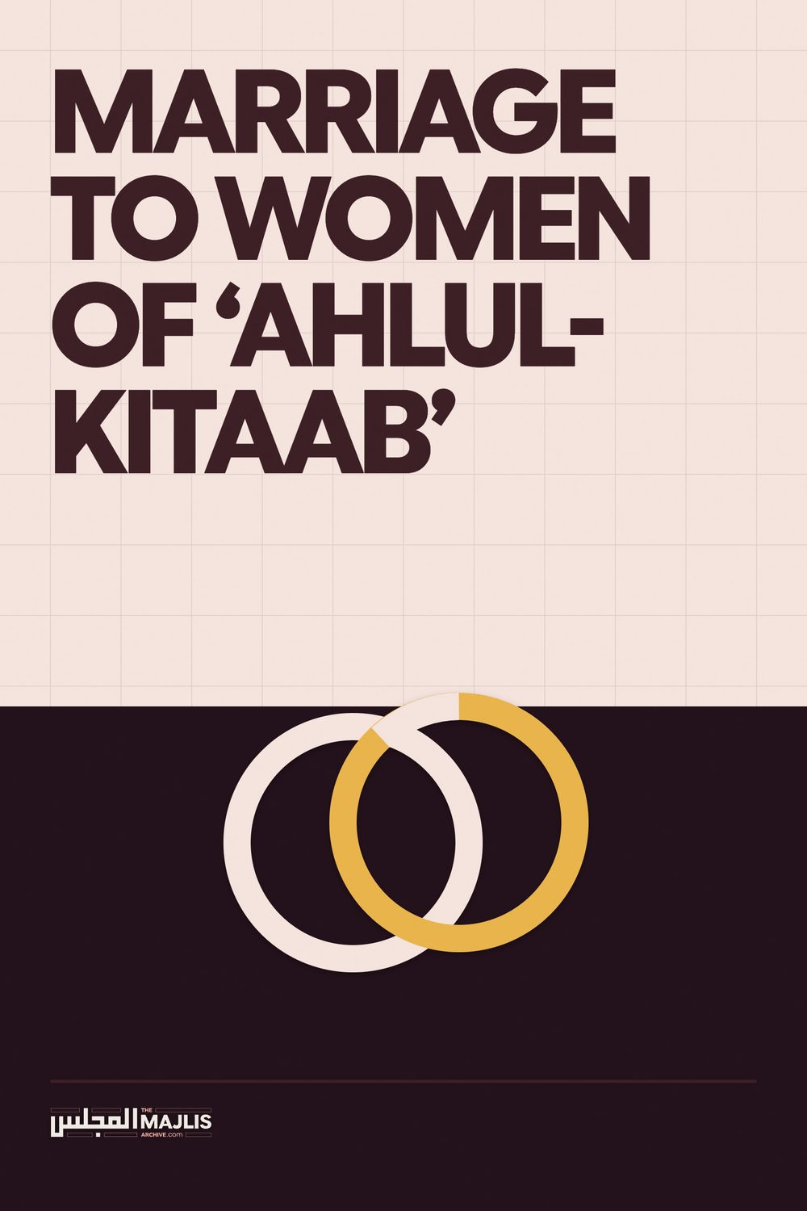

Marriage to Women of Ahlul-Kitaab
The Majlis · Voice of Islam
Mujlisul Ulama of South Africa

About this edition
This is a reproduction by The Majlis Archive (themajlisarchive.com) of a publication of The Majlis, Mujlisul Ulama of South Africa, made and published with their permission.
The PDF as The Majlis issued it is the original. This edition was read from that PDF's own structure and checked against it letter for letter; where the two differ, the PDF is correct.
Checked: 48 paragraphs, 0 differing; a second, independent PDF reader finds 100.0% of the PDF's words here.
Nothing has been reworded, added or removed.

QUESTION:
Is it permissible for a Muslim male to marry a Christian or Jewish woman whilst she retains her Christian/Jewish religion? In the Qur'aan permission to marry them is clearly stated. However, some Ulama say that it is not permissible as long as they retain their respective religions.

ANSWER:
The Qur'aan and Hadith are not the grazing pastures for every Tom, Dick and Harry. No one has the right in this age to extract verses from the Qur'aan and narrations from the Ahaadith, then submit these to personal opinion and issue 'fatwa's of corruption.
The Ahkaam (laws) of the Shariah are based on inviolable principles which have been formulated by the Aimmah-e-Mujtahideen on the basis of the Qur'aan and Sunnah. The rulings of the Aimmah-e-Mujtahideen constitute the final word. There is no scope for reinterpreting the Shariah which was completed and perfected in the very age of Nubuwwat, and transmitted to posterity by the Sahaabah of Rasulullah (sallallahu alayhi wasallam).
Qur'aanic and Hadith permissibilities and even Mustahab acts are governed by rules and principles. An act may be permissible at one time, and impermissible at another time. An act may even be Mustahab originally, but bid'ah at a later stage.
According to some Sahaabah it is not permissible to marry the women of the Ahl-e-Kitaab (Jews and Christian) (i.e. while they remain non-Muslim). According to Hadhrat Abdullah Ibn Umar (Radhiyallahu Anhu) it is not permissible. When asked about this question he would reply that the decree of Allah Ta'ala in the Holy Qur'aan:
"And marry not the polytheist (mushrikeen) women until they believe"
is an explicit prohibition.
Abdullah Ibn Umar (Radhiyallahu anhu) then said:
"I know not of a greater "mushrik" (polytheist) than one who believes that Isaa Ibn Maryam (alayhis salaam) or any other servant of Allah is god." (Ahkaamul Quraan-Jassaas)
Once Maimoon Bin Mahraan (Radhiyallahu Anhu) said to Abdullah Ibn Umar (Radhiyallahu anhu):
"We inhabit a land in which the majority of people are of Ahlul Kitaab. Can we therefore marry their women and eat their Thabeehah (slaughtered animals)?"
In answer, Abdullah Ibn Umar (Radhiyallahu Anhu) recited two verses of the Qur'aan. The one verse pertained to the prohibition of marrying the mushrik women, and the other verse concerned the permissibility of marrying women of Ahl-e-Kitaab. Maimoon bin Mahraan said:
"I too am aware of these two verses. I too recite them in the Qur'aan. What I wish to know is the Shariah Ruling on this question having in view both these verses."
In reply, Abdullah Ibn Umar (Radhiyallahu Anhu) again recited the two verses without advancing any explanation. The Ulama have interpreted this reluctance of Abdullah Ibn Umar (Radhiyallahu Anhu) to elaborate, to mean that he was not satisfied that marrying women of the Ahl-e-Kitaab was permissible.
In view of the detrimental effects stemming from marriage to women of the Christians and Jews – detrimental for the husband, and his children, in fact for the entire Ummah – the majority of the Sahaabah and the Taabi-een regard marriage to the women of Ahl-e-Kitaab as 'Makrooh' (i.e. Makrooh Tahreemi which is reprehensible and prohibited) notwithstanding the fact that marriage to them is valid.
There is a difference between permissibility and validity. An act may be valid, but not permissible. For example, it is haraam to issue three Talaaqs in a single statement or to issue Talaaq whilst the wife is in the state of haidh or nifaas. Nevertheless, the Talaaq thus issued is valid. So, despite the validity, it remains impermissible.
Similarly, if a man frequents the Musjid with only a loin cloth covering his satr (from the navel to the knees) and performs Salaat in this manner, or even if he performs Salaat in this way at home, then despite the validity of his Salaat, it will not be permissible to perform Salaat in this lewd manner when adequate garments are available to cover the entire body respectfully.
Permissibility does not necessarily stem from validity. A valid act can be even a forbidden act. Furthermore, an act could be initially permissible, but due to accretion of harmful factors, evil and fitnah, it becomes impermissible. An example of this is the prohibition on females attending the Musjid. Initially, during the time of Rasulullah (sallallahu alayhi wasallam), it was permissible for women to go to the Musjid for Salaat. However, due to the danger of fitnah, the Sahaabah prohibited this permissibility, and all the Fuqaha thereafter emphasized the prohibition which remains intact to this day.
The same prohibition has been extended to women attending Walimahs. Initially it was permissible for them. But due to the fitnah and fasaad of the times, it is no longer permissible for them to attend any of these functions.
A man is the mahram for his mother-in-law, daughter-in-law and stepmother. Despite the relationship of mahramiyyat, the Fuqaha have ruled that a degree of hijaab for them is necessary. Due the element of fitnah (sexual lust) he should not be alone with these mahram females. In short, any Mubah (permissible) act will become impermissible if fitnah accompanies it.
Marriage to a Christian or Jewish woman whilst she retains her religion of kufr and shirk is fraught with extremely grave dangers, especially in this age. The men themselves are of weak Imaan. There are innumerable cases of the husbands themselves becoming Christians. When a man of high Taqwa marries a Christian, the end result is the conversion of the wife to Islam. Nowadays it is the opposite. We observe many cases in which the husband abandons his Imaan.
In the first place, only men extremely weak in Imaan – men who are totally lacking in Islamic morals and extremely deficient in Imaan who contemplate such marriages, and who are prepared to live with women who practises kufr, shirk, wallow perpetually in the state of filth and janaabat, consume pork and carrion, consume liquor, mingle freely with males, dress immodestly and scantily, attend all types of haraam functions, indulge in music, dancing, attend church and participate in everything which is haraam in the Shariah. Whereas in bygone times, even Christian women had a good idea of the meaning of religion. In the early days, Christians too observed ghusle-janaabat and ate only halaal food. But today, they wallow in filth, eat filth and will feed the husband haraam filth.
And about the worst and vilest consequence is the loss of the children. Either all or some of the children will attend church with their mother. The father whose Imaan is questionable is a colossal Dayyooth (Cuckold) or his wife's poodle. The woman will rear the children as Christians. And, even if they bear Muslim names, their entire outlook on life will be Christian. We can testify that as a result of one man having entered into such a marriage, almost his entire progeny of children, grandchildren and great grandchildren are either Christians or near Christians. Those who still call themselves Muslims, are dangling on the brink of kufr and Jahannum.
Marriage to the women of the Ahl-e-Kitaab is initially permissible. However, due to the disastrous consequences of such marriages, it is no longer permissible for a man to marry a Christian or Jewish woman whist she retains her religion of kufr and shirk.
In Ahkaamul Qur'aan, Jassaass (Rahmatullah alayh) narrates from Shafeek Bin Salmah that Huzaifah Bin Yamaan (Radhiyallahu Anhu), a prominent and very senior Sahaabi, upon reaching Madaa-in married a Jewess. When Hadhrat Umar (Radhiyallahu anhu) was informed of this he wrote to Huzaifah (Radhiyallahu anhu) to divorce the woman. In reply Hadhrat Huzaifah (Radhiyallahu anhu) enquired whether this woman was unlawful for him. Ameerul Mu'mineen Umar Ibn Khattaab (Radhiyallahu anhu) wrote in reply:
"I am not saying that she is Haraam upon you. However, in these women generally there is no chastity and modesty. I therefore fear that through the agency of these women immorality will enter into your homes."
That was during the noblest of ages and the men involved were the noblest men of the highest degree of Taqwa, and despite the initial permissibility, Hadhrat Umar (radhiyallahu anhu) ordered Hadhrat Huzaifah (radhiyallahu anhu) to divorce the woman, and that was precisely what he did in compliance with the command.
Imaam Muhammad bin Hasan (Rahmatullah alayh) states that the Hanafi Fuqaha (Jurists) have accepted this view, viz., marriage to the Ahl-e-Kitaab women while not being haraam, is nevertheless Makrooh (i.e. Makrooh Tahreemi which is a forbidden act) because of the other detrimental factors related to such marriages. Allaamah Ibn Humaam (Rahmatullah alayh) states in Fathul Qadeer that besides Huzaifah (Radhiyallahu anhu), Talha and Ka'b Ibn Maalik (Radhiyallahu anhuma) also married women of the Ahl-e-Kitaab in view of the permission granted in the verse of Surah Maa-idah, but when Umar (Radhiyallahu anhu) heard about it he was greatly displeased and ordered them to divorce these women.
(Tafseerul Mazahari)
The age of Ameerul Mu'mineen Umar Ibn Khattab (Radhiyallahu anhu), was the "best of ages". It was a time when there was no possibility of a Jewish or Christian women marrying a Muslim and then plotting against Muslims. There was absolutely no fear of the husband becoming a kaafir or even tolerating any act of kufr in his home. That was a time when the only fear was the possible admission of immorality into the homes of Muslims as a result of marriage to such women, or because of mere beauty, Muslim men may prefer them thus creating difficulty and hardship for Muslim women. However, Umar (Radhiyallahu anhu) compelled these great personalities (among the Sahaabah) to divorce their (non-Muslim) wives.
If a picture of the existing time (i.e. our modern times with their accompaniment of immorality and general weakness of Imaan) was in front of the Sahaabah, one could imagine what their reaction would have been (regarding marriage to non-Muslim women of the Ahl-e-Kitaab).
It is also abundantly clear that there was no possibility of immorality entering into the homes of the likes of Hadhrat Huzaifah, Hadhrat Talhah and Hadhrat Ka'b (Radhiyallahu anhum) as a result of having married women of the Ahl-e-Kitaab. However, Hadhrat Umar (Radhiyallahu anhu) was the personality about whom Rasulullah (sallallahu alayhi wasallam) said:
"If there had to be a Nabi after me, it would have been Umar."
The firaasat of Nubuwwat was inborn in him. In order to close the door of fitnah for the future Ummah, he ordered these eminent Sahaabah to divorce their non-Muslim wives.
Many of the present day people who record themselves as "Christians" and "Jews", in fact regard Christianity and Judaism as curses. Neither do they accept the Taurah and the Injeel nor do they accept Nabi Musaa and Nabi Isaa (Alayhimas salaam). With regard to faith they are atheists. They have no religion. They describe themselves as "Christians" and "Jews" mainly because of nationality (i.e. because they were born as such). It is quite obvious that such women inspite of being regarded as Jews and Christians, but in fact are atheist are never halaal (permissible) for Muslims.
On the assumption that the women are believing Christians and Jews, then too, to marry them would be an invitation for one's worldly as well as Deeni destruction. There have been many a plot which was engineered (by the kuffaar) and introduced among Muslims via the agency of such marriages. It has been witnessed in this age that a single woman has been responsible for the annihilation of entire Muslim kingdoms and regimes. This question is a matter so disastrous that leaving aside the question of Haraam and Halaal (permissible and not permissible) no person of intelligence will venture into it.
In short, it is incumbent upon Muslims in the light of the Qur'aan, Sunnah and the practice of the Sahaabah to totally abstain from the women of Ahl-e-Kitaab in this age.
The aforegoing discussion on the question of marriage to Jewish and Christian women while they maintain their respective faiths is an extract from "Ma'aariful Qur'aan", the Commentary of the Qur'aan, by Hadhrat Mufti Muhammad Shafee (Rahmatullah alayh), the previous Grand Mufti of Pakistan and India. The correct Islamic view has been clearly explained by Mufti Sahib. No one should therefore be in doubt about the dangers inherent in marriages across the religious line notwithstanding the fact that marriage to women who are in fact members of the Ahl-e- Kitaab is initially permissible. However, since the initial permissibility has become encumbered with numerous Imaan-threatening dangers, it is no longer permissible to marry such women whilst they retain their religions of kufr and shirk.
It should be borne in mind that marriage to women of Ahl-e-Kitaab is not incumbent upon Muslims. Mere permission has been granted. It is merely Mubah, and that too if the husband's and resultant children's Imaan and Akhlaaq are not threatened. Mere permission is not to be interpreted as "Sunnah" of the Sahaabah, despite the Sahaabah's knowledge of this permission granted by the Qur'aan. The general practice and opinion of the Sahaabah was abstention. It is therefore, essential to take into consideration the disaster and destruction to Imaan and Akhlaaq which follow in the wake of such marriages.
It must also be remembered that when evil or harmful effects associate themselves with a practice which is not only permissible, but even Mustahab and based on the Sunnah, then abstention from even that Mustahab practice becomes incumbent as long as the evils are associated with it. Now if this is the Shariah ruling pertaining to even Mustahab practices, then it (this ruling of abstention and prohibition) will apply to a greater extent to a practice which is not Mustahab but merely "permissible". Taking into consideration the excessive weak state of Imaan of Muslims today, their general apathy towards the fulfilment of Islamic practices, their substitution of Rasulullah's Sunnah with the customs and practices of the west, their apologetic attitude whenever there happens to be a clash between western or some other material concept with Islamic concepts, their moral decadence, etc., then it is obligatory upon Muslims to abstain from marriages in which the women remain attached to their faiths of Christianity and Judaism.
Too many cases have been witnessed and are being enacted daily in which the husband although born a Muslim, but due to abject weakness of Imaan, sacrifices Islamic teachings and sometimes his very Deen and Imaan, bowing to the pressure exerted by this non-Muslim wife. The children of such a union, nowadays, generally, opt for kufr. Desire and preference should, therefore, be cast aside in favour of the larger interests of one's Deen and Imaan. The life of this world is but transitory. Rasulullah (Sallallahu alayh wasallam) said: "This world is 'carrion' ". It therefore does not behove the Mu'min to sacrifice his eternal Bliss of the Hereafter for the "carrion" of this world, and for the misery and disaster which such marriages are almost sure to bring in their wake.

