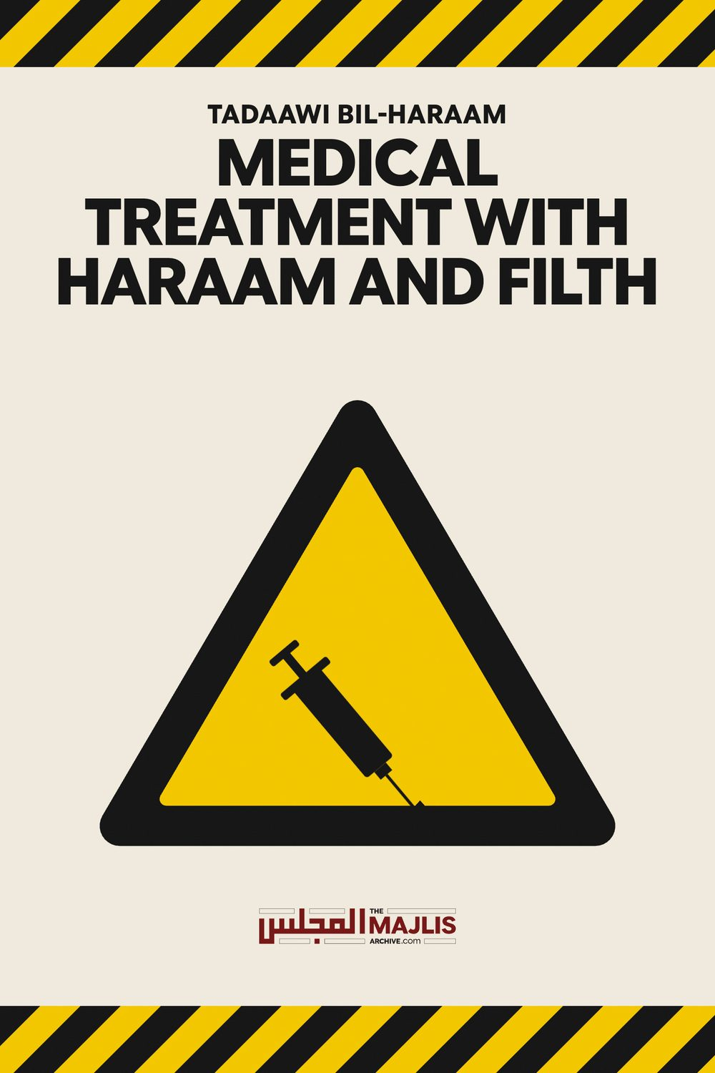

Medical Treatment With Haraam And Filth
The Majlis · Voice of Islam
Mujlisul Ulama of South Africa

About this edition
This is a reproduction by The Majlis Archive (themajlisarchive.com) of a publication of The Majlis, Mujlisul Ulama of South Africa, made and published with their permission.
The PDF as The Majlis issued it is the original. This edition was read from that PDF's own structure and checked against it letter for letter; where the two differ, the PDF is correct.
Checked: 69 paragraphs, 0 differing; a second, independent PDF reader finds 98.8% of the PDF's words here.
Nothing has been reworded, added or removed.

Mujlisul Ulama of S. A. P.O. Box 3393 Port Elizabeth 6056, South Africa

FILTH AS MEDICINE
Question Regarding blood donation a Mufti says that to donate blood is permissible when there is a need. Since the need for a transfusion develops at any time, it is permissible to donate blood to a blood bank, but the blood must be given free and may not be sold. Is this fatwa correct? In support of the fatwa the Mufti quotes the following text from Ad-Durrul Mukhtaar:
"It is permissible for an ailing person to drink urine, blood and eat carrion for medical treatment when a Muslim physician informs him that there is cure in it, and when a lawful (remedy) as a substitute is not available.
If the physician says that these (haraam substances) will hasten recovery (from the sickness), then there are two views."
Then providing an interpretation for the Hadith of Ibn Mas'ood (Radhiyallahu anhu), namely: "He (Allah) has not created your shifa (cure) in substances made haraam for you.", Allaamah Shaami mentions: 'This possibly means that it applies to such a sickness for which a medicine which is not haraam is available..........It is also valid to say that the prohibition is lifted on account of haajat (need). Thus in the case of need it will not be said that the shifa' is with haraam. Verily, it will be with halaal."
Please comment on this confusion.

ANSWER
The confusion is the effect of the Mufti not applying his mind, and simply extracting texts from the kutub for mass consumption.
Firstly, the Hadith narrated by Hadhrat Abdullah Ibn Mas'ood (Radhiyallahu anhu) is the determinant which establishes prohibition. The ihtimaal (possibility) mentioned in Shaami is extremely far-fetched. It is a mere 'possibility' – a figment of personal opinion which does not override the Hadith which states the law with the greatest clarity. The opinion unsubstantiated by Nass, in fact which is in conflict with the Nass, has to be incumbently set aside regardless of the calibre of the Aalim who flourished 12 centuries after Rasulullah (Sallallahu alayhi wasallam).
The rule of Tadaawi bil haraam (medical treatment with haraam substances) is not denied. It is a separate mas'alah which relies on other evidences of the Shariah. For the sustainment of this mas'alah the interpretation which argues away the clear import of the Hadith of Hadhrat Ibn Mas'ood (Radhiyallahu anhu) is uncalled for and not valid. The irrefutable fact is that Allah Azza Wa Jal has not ordained the shifa' of his Ummah in filth – in najaasat – and substances which He has made haraam, and which are abhorrent to Imaan. Blood, urine, faeces, pus, carrion and all types of najaasat are repugnant and repulsive for Muslims.
It is the natural attribute of kufr to incline to and prefer filth and haraam while the natural attribute of Imaan is to repel all these disgusting items of filth. Thus the Hadith narrated by Hadhrat Abdullah Ibn Mas'ood (Radhiyallahu anhu) has literal application and is not the subject for elimination by way of some flapdoodle interpretation which is bereft of Islamic validity.
There are three essential conditions for the permissibility of medical treatment with haraam substances:
(1) The haajat (need) is real. It is a life-threatening situation or the patient suffers severe pain.
(2) The total unavailability of a halaal medicine. (3) Its shifa' (curing property/ability) must be confirmed by an expert Muslim physician.
While Tadaawi bil haraam is permissible when the necessary conditions are found, it does not follow that filth and haraam substances should be stored for future use. When the emergency develops, then on the basis of the aforementioned conditions, the haraam substances may be used if available. It is not permissible to plan treatment with najaasat and haraam substances for future use.
It is not permissible to establish urine banks, faeces banks, blood banks and pork carrion banks for future use in cases of emergencies. The establishment of such banks is the effect of atheism. Muslims nowadays are overwhelmed by the influence and brain-washing of the atheists, hence every filth and haraam substances are considered to be absolute medical necessities. But Rasulullah (Sallallahu alayhi wasallam) said that there is a cure, i.e. a halaal cure, for every disease. However, whilst the kuffaar medical fraternity is diligent in using filth for discovering new medicines, the Muslim medical fraternity, obsequiously follows in their footsteps. They have become supine bootlickers. Instead of parting ways and branching off into halaal, they too believe that blood, urine, faeces and all types of filth and najaasat are the primary cures for diseases. This attitude portrays their extreme Imaani deficiency and even lack of Imaan. They lack trust in the advices and claims of Rasulullah (Sallallahu alayhi wasallam).
It should be well understood, and this is not difficult for a Muslim, that filth and haraam are not for normal use. The law of consuming pork applies when a person is on the verge of death due to hunger. The concession to consume just sufficient pork or a haraam substance is for an emergency or when there is an extreme need. It is not to be developed into a norm or a normal practice.
The same applies to Tadaawil bil haraam. The use of haraam elements as medicine is the absolutely very last resort. It does not follow from this concession that Tadaawi bil haraam be elevated to a normal and an acceptable institution for everyday use regardless of the stringent conditions for permissibility lacking.
According to the kuffaar cult of life, filth and unlawful substances have been developed as a primary institution of medical treatment and medicine. It is not a concession or an exception for the kuffaar. The western medical establishment has incorporated najaasat and haraam into its sphere of treatment. In fact, it constitutes the most important constituent of its methodology. Filth is integral to western medicine.
Our muftis with their extremely myopic vision and supine deeni attitude have accepted this kuffaar satanic institution as the acceptable norm for all cases and circumstances. But they labour in self-deception and they hoodwink the unwary masses with the Tadaawi bil haraam rule.
Treating sicknesses with filth and haraam is the very first resort of the kuffaar medical establishment into which Muslim doctors have been assimilated and swallowed. Since Muslim doctors acquired their medical knowledge at the boots of their kuffaar tutors, their brains are fitted with such straitjackets which do not permit them to see or understand the folly and villainy of the filth and haraam which are being utilized as normal and primary methods of treatment.
The fatwa of the mufti in fact is a licence for regarding as permissible the use of najaasat and haraam for normal and everyday medical treatment irrespective of the factor of haajat as specified by the Shariah. Blood transfusion is a standard and a normal procedure to adopt regardless of the lack of the Shar'i conditions on which permissibility is based. In fact, najaasat is the first option of the western medical establishment.
While there are millions of pure, halaal and beneficial substances in the plant and stone kingdoms from which medicine could be made, the focus of the kuffaar medical experts is primarily on blood, urine, faeces, pus, carrion and every kind of filth. That is the effect of their kufr, and Muslim doctors have inherited this filth from their kuffaar superiors.
Hadhrat Mufti Muhammad Shafi (Rahmatullah alayh), in his Jawaahirul Fiqh, in his discussion on Tadaawi bil haraam, being cognizant of the evils of najaasat and haraam substances, states:
"Firstly, whatever Allah Ta'ala has declared haraam and prohibited, is for the benefit of humanity, and is based on great wisdom (Allah's Wisdom). It is quite apparent that Allah Ta'ala is Aleem (The All-Knowing One), Khabeer (The One Who is Aware) and Hakeem (The One of Wisdom). No decree of His is futile and without benefit. Therefore, the only possibility for ordaining substances to be haraam is that they are harmful for mankind. Even if some benefit is discernable in these substances, then too the harm is overwhelming.
Some of the harms affect the physical body while some are such harms which ostensibly are not related to the physical body. However, these are harms which are detrimental for the human Soul. These harmful effects exercise a great influence on moral character and attitude.
Everyone understands the first type of harms, namely that which is harmful for the physical body.
All medical systems are aware and acknowledge the harms of such substances, e.g. carrion, etc.
However, spiritual health and disease are not tangible, hence not visible to the eyes. There is no instrument by which this could be measured. The medical physicians are unable to diagnose these conditions. Only those who are the physicians of the Rooh understand these intangible or spiritual harms (caused by najaasat and haraam). They are able to diagnose spiritual health and sickness. In their view spiritual health is of greater importance than physical health.
Whatever the Shariah has made haraam and prohibited is only for the benefit and well-being of people. These substances sometimes harm the body, sometimes the soul and sometimes both." (End of Mufti Shafi's naseehat)
It does not behove Muslims to focus on and even incline towards najaasat and haraam. Such an attitude is inherent to the shayaateen and the kuffaar. Establishing blood banks, faeces banks, urine banks, pus banks, pork banks and banks of all types of filth is not permissible. Such acts of filth are integral to satanism and it has a natural affinity with the kuffaar. Kufr and shaitaaniyat are extremely compatible.
In an emergency filth and najasaat may be used for medical treatment provided the essential three conditions are fulfilled. It will be permissible, not incumbent. Medical treatment is not Waajib. We wonder if the mufti will relish a bowl of faeces for curing a grievous disease if the kuffaar doctors assure him of shifa'. There are medical and curing properties in even the faeces of swines. But about Insaan, the Qur'aan Majeed states:
"Verily, We have ennobled the progeny of Aadam and We have granted them control in the land and on the ocean, and We have given them Tayyibaat (pure, wholesome and halaal foods)......."
It is indeed a sad and a dismal commentary on the brains of the muftis who are at pains to establish najaasat and haraam as a first, primary and normal practice of medical treatment on the misconceived basis of the rule of Tadaawi bil haraam which may be invoked in only cases of emergency and dire need. But this rule cannot be presented as a basis for permissibility of donating blood, faeces, urine, etc., for future use. In fact, the issue of 'future use' is hallucinatory in view of the fact that these types of filth are now considered the first and primary options. The argument for permissibility of blood, faeces, urine and pork banks is bereft of Shar'i daleel and in conflict with Imaani rationality.
The contention that blood, urine, etc. may not be traded is a laughable incongruence. The hallucinated permissibility of blood and urine banks applies to a scenario of dire need and emergency. When in such circumstances it becomes permissible to consume blood, urine, faeces and pork, then what debars the permissibility of trading in these substances of filth? Assuming that in cases of real and dire need the faeces is available only at a price, then by the same token that eating the faeces has been made halaal by the mufti, buying the faeces will be permissible to a greater degree. Paying for the faeces, blood, urine and pork is of a lesser nauseating gravity than actually consuming these artefacts of Iblees. The mufti has simply disgorged the impermissibility after having lapped it up from somewhere. Furthermore, the norm today is to pay exorbitant prices for the filth available at hospitals where the transfusion takes place.
Furthermore, the norm today is to pay exorbitant prices for the filth available at hospitals where the transfusion takes place.
And, regarding transfusion of blood, Imaam Shaafi's view should exercise a salubrious effect on the mufti sahib. In Kitaabul Umm, Imaam Shaafi' (Rahmatullah alayh) says:
"If a person transfuses blood under his skin, and there is growth on it, then it is incumbent on him to extract this blood and repeat all the Salaat which he had performed after having transfused the blood (into his body)."
Commenting, Mufti Shafi (Rahmatullah alayh) says in Jawaahirul Fiqh:
"Blood is part of the human being. When it is extracted from the body it is najis. The actual demand of this is that generally it is haraam to transfuse the blood of a person into another person. Being part of the human body demands this, and it being najaasat ghaleezah demands hurmat."
This is the actual ruling of the Shariah, and this ruling may not be swept under the carpet to accommodate the filthy, haraam institutions of the western kuffaar. In the absence of the three Waajib conditions stipulated by the Shariah for the permissibility of Tadaawi bil Haraam, the general practice of transfusing blood prevalent nowadays is haraam.
Erosion of the ahkaam of the Shariah is the effect of desensitization which in turn is the effect of wide-scale prevalence. This erosion is further fostered and aggravated by the lackadaisical attitude of the muftis of this era. Their lack of in depth understanding due to lack of Taqwa which is an alien concept for them, renders them incapable of comprehending the damage they are causing to the Shariah of Allah Ta'ala. They just bend backwards to accommodate within the Shariah just every haraam and filthy practice and institution of the kuffaar. This bootlicking culture is extremely lamentable. While it is understandable and acceptable that doctors whose brains are harnessed by their kuffaar masters and tutors, this miserable and repugnant attitude is not expected of the ulama.
Haphazard and piecemeal application of the principles of the Shariah is haraam. A perfect example of this type of convoluted application of a Shar'i principle is the rule of Tadaawi bil haraam. This principle is supposed to be applied only if the requisite demands of the Shariah are satisfied. But the muftis are utilizing this principle to halaalize filth and haraam in normal circumstances when the necessary Shar'i conditions are non-existent.

CONCLUSION
(1) Tadaawi bil haraam is an established principle of the Shariah. There is no contention regarding this issue. But there are essential conditions for its lawful operation. These have already been explained.
(2) Establishing blood banks, faeces banks, urine banks, pork banks and the like of najaasat banks will always be haraam. Storing filth and haraam substances for future anticipated cases of need is not permissible.
(3) Tawakkul (Trust in Allah) and Tafweedh (Assigning one's affairs to Allah), are Waajib commands stated in the Qur'aan and Ahaadith. The very minimum Waajib degree of these attributes for the masses is to abstain from transgressing the limits of the Shariah. While the higher degrees of Tawakkul and Tafweedh are the preserve of the Auliya-e-Aarifeen, observance of the Zahiri Shariah is Waajib for all Muslims. This fact is not understood by the ulama of this era, hence all the corruption which their corrupt fatwas excrete.

AAYAAT FOR SHIFAA' (CURE)
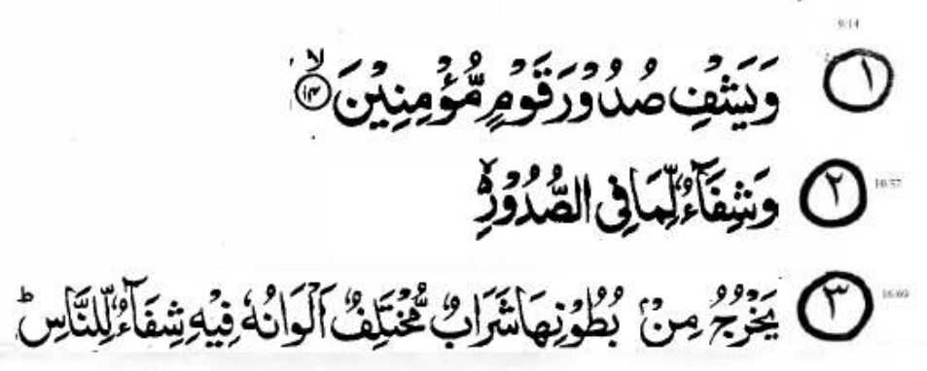
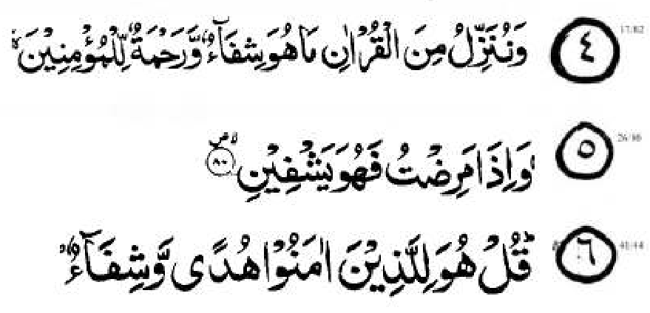

FOR SHIFAA' (CURE)
• Recite Surah Faatihah 3 or 7 times • Recite the 6 Shifaa Qur'aanic verses • Blow on the patient or yourself if you are the patient.
• Do this amal daily. Even better is to do it more than once daily.
• Do the same amal and blow on water and drink. • Make constant Dua for Shifa' and recite Istighfaar in abundance because most of our sicknesses are due to: a) Sins, including the sin of over-eating. The Sages of
Islam say that the root of all sicknesses is the stomach.
b) Usurping and trampling on the Huqooq (Rights) of others. If this is the case, then make amends regarding usurped and unfulfilled Huqooq because without having made amends, Taubah and Istighfaar are of no avail.
c) Consuming haraam and mushtabah food d) Consuming food laced with chemical ingredients such as preservatives, colourants, emulsifiers, stabilizers, and a litany of E Numbers which conceal the true nature of the poisons which you consume.
With your right hand, lightly rub on the painful part seven times and with each rub recite:
