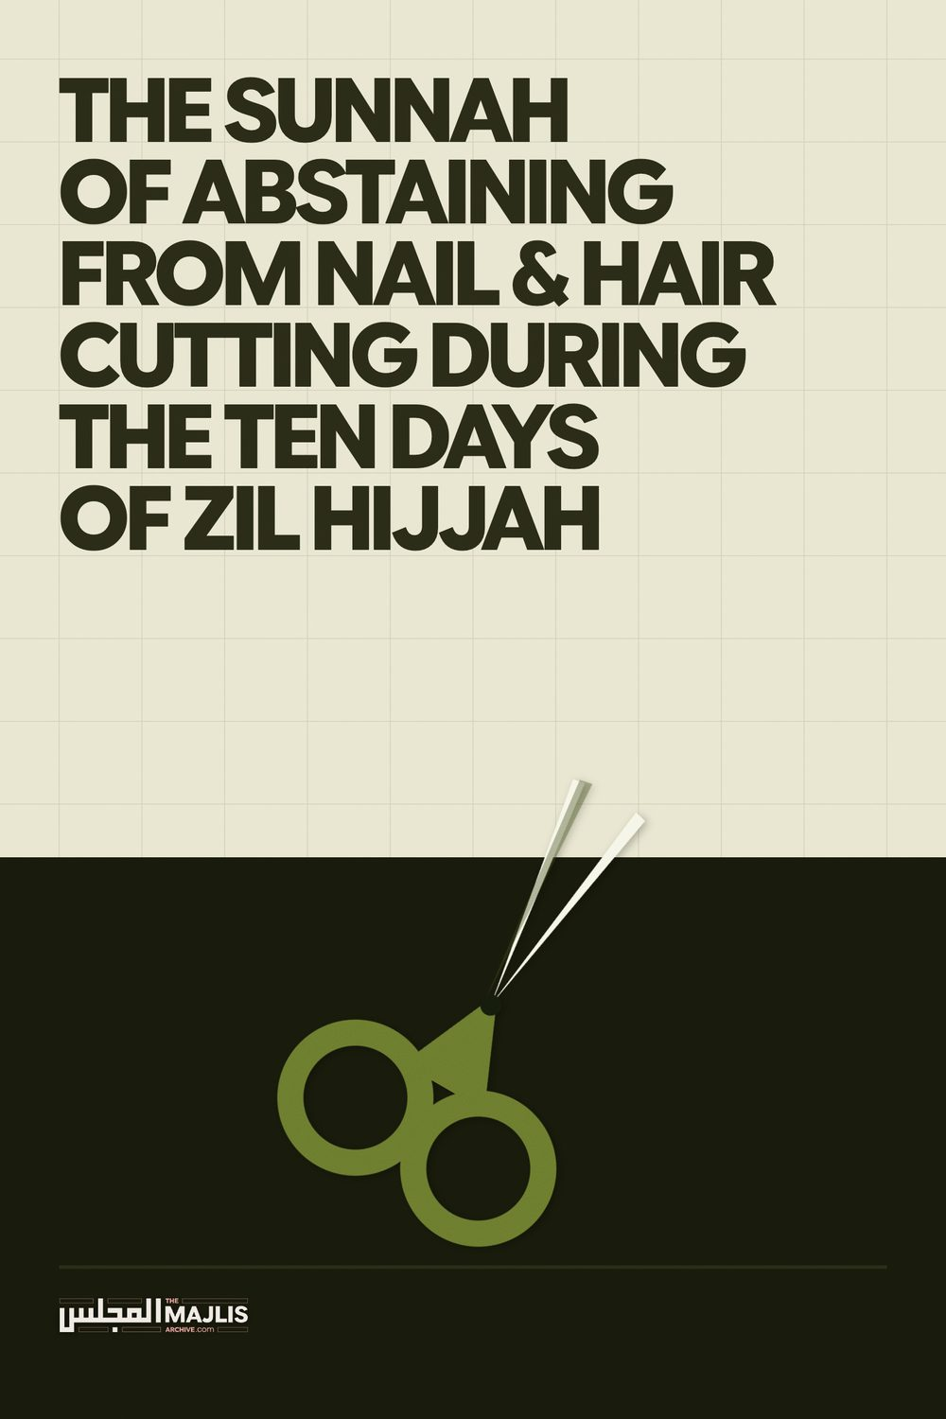

NAIL AND HAIR CUTTING DURING FIRST TEN DAYS OF ZIL-HAJJ
The Majlis · Voice of Islam
Mujlisul Ulama of South Africa

About this edition
This is a reproduction by The Majlis Archive (themajlisarchive.com) of a publication of The Majlis, Mujlisul Ulama of South Africa, made and published with their permission.
The PDF as The Majlis issued it is the original. This edition was read from that PDF's own structure and checked against it letter for letter; where the two differ, the PDF is correct.
Checked: 232 paragraphs, 0 differing; a second, independent PDF reader finds 97.4% of the PDF's words here.
Nothing has been reworded, added or removed.

THE SUNNAH OF ABSTAINING FROM NAIL & HAIR CUTTING DURING THE TEN DAYS OF ZIL HIJJAH

MUJLISUL ULAMA OF SOUTH AFRICA Port Elizabeth South Africa

REMINDER!
IT IS NOT PERMISSIBLE FOR THOSE WHO ARE MAKING QUR'BAANI TO SHAVE HAIRS AND TO CUT NAILS DURING THE FIRST NINE DAYS OF ZIL HAJJ. NAILS SHOULD BE CUT AND HAIRS REMOVED AFTER ONE'S QUR'BAANI HAS BEEN MADE. THEREFORE ENSURE THAT YOUR HAIRS ARE REMOVED AND NAILS CUT ON THE LAST DAY OF THIS MONTH OF ZIL QA'DH. IF YOU ARE UNABLE TO ASCERTAIN THE TIME OF YOUR QUR'BAANI ON THE 10TH ZIL HAJJ (THE DAY OF QUR'BAANI), THEN YOU MAY SHAVE THE HAIRS AND CUT THE NAILS AFTER A COUPLE OF HOURS AFTER EID SALAAT.

THE PLOT OF IBLEES
The publication of this Reminder appeared to be umbrage to some molvis and sheikhs. One molvi/sheikh published a couple of pages loaded with futile technicalities in his attempt to rebut the importance of this mas'alah, viz., the need to refrain from removing hairs and nails during the first 9 days of Zul Hajj for those undertaking Qur'baani.
While some rejected in entirety this Command of Rasulullah (Sallallahu alayhi wasallam), others taking cognizance of the Hadith of Prohibition, diluted the importance and claimed that avoiding cutting is Mustahab. But this conclusion is in denial of the emphasis assigned to this practice by Rasulullah (Sallallahu alayhi wasallam).
Before presenting the dalaa-il to substantiate the importance of abstention, it is prudent to discuss the imperative importance of Mustahab. The popular idea of Muslims of this era is to view Mustahab with disdain (Istikhfaaf). The motivation for abstention from Mustahab is pure nafsaaniyat, hence Mustahab practices are even despised. That is why the miscreant darkened several pages with Fiqhi technicalities and oblique conclusions in his abortive attempt to dislodge Mustahab from the status assigned to it by the Shariah.
The idea that Mustahab is a license for neglect and abandonment of such Sunan acts designated Mustahab in terms of Fiqh, is a satanic snare. It is the initial process of nibbling at the seams of the Shariah to dismantle the Deen. Nibbling at the Mustahabbaat is shaitaani twiddling; it is a foul venture motivated by nafsaaniyat. The ultimate consequence of such shaitaani nibbling and twiddling is the elimination of the pristine pure Deen. However, despite the satanic endeavours of the deviated molvis and sheikhs to dilute the Shariah, this Deen of Allah Ta'ala will not be deracinated as was the fate of the Shariats of Nabi Musaa (Alayhis salaam) and Nabi Isaa (Alayhis salaam). Allah Azza Wa Jal has declared in the Qur'aan Majeed His Protection for this Deen, hence it shall remain in its original perfected form regardless of the satanic attempts by the agents of Iblees.
"Verily, We have revealed the Thikr, and verily, We are its Protectors."
What remains today of the Shariah of Nabi Musaa (Alayhis salaam) and of the Shariah of Nabi Isaa (Alayhis salaam)? Nothing! Not even remnants! The followers of these Ambiya (Alayhimas salaam) had initially twiddled with their Shariats. Then they nibbled at the seams, making changes by diluting the Ahkaam. It was their evolutionary process of dismantling the Shariats, step by step until there remained not a semblance of the true Deen which their respective Ambiya (Alayhimus salaam) had propagated.
The modernist molvis/sheikhs have adopted the same process of diluting the Shariah by trifling with it, then nibbling at the seams to rubbish away not only the importance and significance of the Mustahabbaat, but to prepare the ground for the erosion of the Sunnat Muakkadah, Waajib and Fardh Ahkaam. In other words, the plot of Iblees is to strive for the ultimate elimination of the Deen. Since Iblees is stupid, he believes that the goal he had achieved germane to the Shariats of the former Ambiyaa (Alayhimus salaam), is also achievable regarding Islam. Just as Iblees had enlisted the aid of the molvis and sheikhs of the Yahood and Nasaara, today he is doing the same with the molvis and sheikhs of Islam. With spurious arguments has he succeeded to enrol droves of molvis and sheikhs into his pernicious scheme of dismantling the Shariah.
The starting point for dismantling the Shariah is the Mustahab category of Ahkaam. If he succeeds to take the Mustahab fort guarding Imaan, he will then proceed to assault and capture the other fortresses. Imaan is in the midst of several forts protecting it. The outermost fort is the Fortress of Mustahab. Now, since Mustahab is not compulsory, and abstention is not a punishable offence in the Aakhirah, Muslims of deficient Imaan – a deficiency created by western kuffaar education – deem it appropriate to abstain at whim and fancy. Such satanic abstention is licenced and accorded credibility and even respectability by the Fiqhi technicalities extravagated by miscreant molvis/sheikhs who have an exceptionally lukewarm bond with the Shariah.
With this lackadaisical attitude, in fact inimical attitude, towards the Ahkaam of the Shariah the ground is laid or the snare of Iblees is set for the erosion of the pristine pure Shariah. Understand well that Mustahab does not mean abstention from the hukm is permissible. This idea of permissibility leads to the total abandonment of the Sunnah. Many Sunnah acts have been abandoned on the basis of this satanic principle. Mustahab is an integral part of the Sunnah about which Rasulullah (Sallallahu alayhi wasallam) said:
"He who clings to my Sunnah when my Ummah is corrupt, will receive the reward of a hundred martyrs."
Rasulullah (Sallallahu alayhi wasallam) made this statement in anticipation of the incremental abandonment of the Sunnah with the passage of time.
Hadhrat Shah Abdul Haq Dehlawi (Rahmatullah alayh) states in his Kitaab, Maa Thabata Bis Sunnah: "From among the Sunan which the people have abandoned is that a person who intends sacrificing whether it be a Fardh or a Nafl sacrifice, is that he should not cut from his hair and nails until he has sacrificed, for verily Muslim has narrated from Umm-e-Salmah (Radhiyallahu anha) that Rasulullah (Sallallahu alayhi wasallam) said: "When the ten days enter and any of you intends to sacrifice, then he should not cut anything from his hair and his body." In another narration it is mentioned (with emphasis): "Never should he cut his hair and never should he cut his nails."
Abstaining from cutting the hairs/nails during the ten days is an almost abandoned Sunnah, hence the need to revive it and to gain the thawaab of a hundred Shuhada. But the deviate claims that this commanded abstention is "not even recommended"!
In fact, we find ourselves in the era regarding which our Nabi (Sallallahu alayhi wasallam) said: "Then there will dawn an age when the one who holds on the Sunnah will be like the one who holds a burning coal."
The Sunnah The Sunnah encompasses all Ahkaam regardless of their Fiqhi status. It is of imperative importance for the progress of Imaan to tenaciously hold on to all the Ahkaam which include the Mustahabbaat. It does not behove those who lackadaisically claim that avoidance of cutting the hair/nails is Mustahab, to abstain from giving practical expression to this Sunnat act commanded by Rasulullah (Sallallahu alayhi wasallam) with emphasis. Contrary to the claim of the miscreant molvi/sheikh, Rasulullah (Sallallahu alayhi wasallam) did emphasize abstention. He had prohibited the act which the deviates fob off a 'mere' Mustahab and being devoid of significance. Insha-Allah, the evidence for the emphasis shall be forthcoming towards the end of this dissertation.
The Attitude and Practice of the Sahaabah and the Salafus Saaliheen It was the attitude and practice of the Sahaabah and of all people of Taqwa in every age to give practical expression to all the teachings and advices of Rasulullah (Sallallahu alayhi wasallam) regardless of the Fiqhi categories into which the Sunnah was classified during the era of the Fuqaha.
Hadhrat Ibn Abbaas (Radhiyallahu anhu) narrated that Rasulullah (Sallallahu alayhi wasallam) saw a man with a ring of gold on his finger. Then, he (Rasulullah – Sallallahu alayhi wasallam) removed the ring, threw it away, and he commented: "Do you intend placing a burning coal of the Fire in your hand?" After Rasulullah (Sallallahu alayhi wasallam) had left the scene, it was said to the man: "Take your ring and derive benefit with it (e.g. his wife could wear it or could sell it)." He responded: "By Allah! I shall never take it since Rasulullah (Sallallahu alayhi wasallam) had thrown it away." (Muslim).
Commenting on this episode, Imaam Nawawi (Rahmatullah alayh) said: "In this (reaction of the Sahaabi) is his determination on obeying the command of Rasulullah (Sallallahu alayhi wasallam), and abstention from what he has prohibited, and refraining from (indulgence) in concession by means of weak interpretations. (Sharh Saheeh Muslim)
The Sahaabi did not resort to the Fiqhi technicality of gold being permissible to sell, etc., for benefiting from the ring. It was perfectly permissible to sell the ring or to give it to a female. However, he took cognizance of the displeasure and pleasure of Rasulullah (Sallallahu alayhi wasallam), and of the fact that Rasulullah (Sallallahu alayhi wasallam) had thrown away the ring. So how could he act in contravention of the emotional stance adopted by Nabi (Sallallahu alayhi wasallam) who had discarded the ring despite the Fiqhi permissibility of selling it or the permissibility of the ring for females?
Once when Rasulullah (Sallallahu alayhi wasallam) was going somewhere with a group of Sahaabah, he saw an elevated dome being built on a house. He said: 'What is this? The Sahaabah said that it was the building of a certain Ansaari. Rasulullah (Sallallahu alayhi wasallam) remained silent.
While Rasulullah (Sallallahu alayhi wasallam) was in his majlis (Ta'leemi gathering), the owner of the building came as was his usual practice. The Sahaabi greeted with Salaam, but Nabi (Sallallahu alayhi wasallam) without responding turned away his face to display annoyance. The Sahaabi repeated his Salaam several times. However, Rasulullah (Sallallahu alayhi wasallam) turned away his mubaarak face and did not respond. He understood that Rasulullah (Sallallahu alayhi wasallam) was offended. The Ansaari Sahaabi was shattered with grief.
He made enquiries to ascertain if Nabi (Sallallahu alayhi wasallam) had made any comments about him. He was informed that while Rasulullah (Sallallahu alayhi wasallam) had not made any comment about him, he had displayed dissatisfaction when he saw the house under construction. The Sahaabi was then convinced that the cause of annoyance was the
'mansion' he was building. Without saying a word he went straight to the building site and had his mansion demolished. He raised the building to the ground and transported away all the rubble, leaving not a semblance of the building.
This was the attitude of the Sahaabah. They did not seek fulfilment for nafsaani desires under cover of the technicalities of Fiqh. For the Pleasure of Allah Ta'ala and Rasulullah (Sallallahu alayhi wasallam) the Sahaabi demolished the entire structure. Technicalities and permissibilities did not feature in practical implementation of the commands of Rasulullah (Sallallahu alayhi wasallam). It was not of their ways for the purpose of nafsaani satisfaction to conjecture on the issue of makrooh tanzeehi and makrooh tahrimi. Every act which was viewed with disdain by Rasulullah (Sallallahu alayhi wasallam) was haraam for them.
A Sahaabi whilst walking heard someone calling from behind: "Raise your izaar (lungi)! It is best for purity and lasting longer". The izaar was actually touching the ground. He turned to look and saw that the caller was Rasulullah (Sallallahu alayhi wasallam). The Sahaabi said that it was an old izaar, hence it does not matter if it is despoiled by the ground. Rasulullah (Sallallahu alayhi wasallam) then said: "Is my example not sufficient?" The Sahaabi looked and saw that the izaar of our Nabi (Sallallahu alayhi wasallam) was midway on the forelegs. Thus, did he adjust his izaar.
The determinant for the Sahaabah was the way of Rasulullah (Sallallahu alayhi wasallam). The objective of Fiqh is not to circumvent the Sunnah and to institute concessions (Tarakh-khus) as a norm. The objective is obedience to the Commands of Allah Ta'ala and His Rasool (Sallallahu alayhi wasallam). These Commands are classified into a variety of categories by the Fuqaha. But the motive for the classification never was abandonment of any aspect of the Sunnah nor was it to dilute fervent and resolute adherence to Mustahab acts.
However, the deceptive idea which jaahil molvis are conveying and which appeal to the people of the nafs, is that certain acts disliked and disapproved by Rasulullah (Sallallahu alayhi wasallam) are only makrooh, not haraam. This idea is in fact tantamount to kufr. It is Istikhfaaf with the commands of the Shariah. Thus, the furthest the deviates will venture in their acknowledgement of a prohibited practice is to say that it is 'makrooh tanzihi' which to them means permissible. But this idea is egregiously baseless and it is in fact a ploy of Iblees to begin nibbling at the seams of the Shariah with the objective of dismantling Islam.
A prohibition which is technically described as Makrooh Tanzeehi is not a license for reckless indulgence and permissibility. The prohibition stated by Rasulullah (Sallallahu alayhi wasallam) must incumbently be observed. Abstention from it is essential regardless of the Fiqhi classification. It is despicable to be snug in the commission of Makrooh Tanzihi acts. It is reckless and abhorrent to proffer arguments in a bid to dilute the prohibition. In order to fob off the importance of such prohibitions classified as Makrooh Tanzihi, those who lack Aql go to the extent of advocating abstention, hence they abortively labour to present technical Fiqhi arguments to convey the idea that abstention and abandonment are permissible.
In this era of great fitnah and lukewarm attachment to the Deen, the muftis are propagating the cultivation of a lackadaisical attitude towards the Ahkaam of the Deen. The obligation of the Mufti is to bring Muslims closer to the Deen and to strengthen their bond with Allah Ta'ala, and this is possible only by means of resolute adherence to the entire Shariah. Fiqhi technicalities should not be promoted to open up the avenue of laxity regarding the Ahkaam of the Deen. The consequence of such a disdainful attitude is the weakening of Imaan.
While the Ummah is wallowing in oceans of fisq, fujoor, bid'ah and even kufr, the muftis of today are adding fuel to the conflagration with their putrid fatwas which deviate Muslims from the Maqsood of life on earth.
Some sincere Muftis too suffer from this disease of opening avenues of fitnah with their fatwas stemming from extreme short-sightedness. For example: Consider the example of I'aanat alal Ma'siyat (Aiding sin). The Qur'aan categorically forbids aiding in sin and transgression. But, muftis lacking in vision and wisdom, suffering from fossilization of the Aql, not only issue the fatwa of the permissibility of building a church/temple, but even promote it by presenting the Arabic texts from the kutub to convince the moron questioner who understands neither head nor tail of the quoted ibaaraat (texts from the kutub of Fiqh).
They cite, for example from Fataawa Hindiyyah, where it is mentioned that aiding in building a church is 'permissible'. On the basis of this statement, they go crazy with delight to promote all the haraam contracts which Muslim builders enter into with the kuffaar. On this basis they will justify the building of Hindu temples of shirk in Dubai and elsewhere wherein even the ruler of the state and his wife worshipped in accordance of Hindu rituals of shirk.
Whilst they stupidly cling to the aforementioned text like a dog clinging to a bone, they are either stupidly unaware or conveniently overlook that in the very same Kitaab it is mentioned that if a non-Muslim asks the way to the church/temple, then to show him the direction is kufr. Just view the great disparity between 'permissibility' of building a church / temple, and the mere act of pointing in the direction of the church / temple being kufr.
The objective of this brief discussion is not to explain the application of the conflicting masaa-il. This is not the occasion for it. We are merely drawing attention to the jahaalat and incompetence of the muftis who are either real juhala, or mudhilleen (those who misguide). They follow in the footsteps of the Ulama of Bani Israaeel whose trademark was rendering haraam into halaal, and vice versa as it served the interests of the donors or the nafs.

CUTTING THE NAILS AND HAIR DURING THE FIRST NINE DAYS OF ZIL HAJJ
The molvi/sheikh who propagates permissibility in conflict with the Command of Rasulullah (Sallallahu alayhi wasallam) avers:
"Hanafi Position: According to the Hanafi madhab, the prohibition of cutting nails or trimming hair for non-pilgrims during the first ten days of Dhu al-Hijjah is not considered obligatory or even recommended. It is permissible to cut hair and nails during these days even if one intends to perform Qurbani."
The jaahil denies even the Mustahab status stemming from the Command of Rasulullah (Sallallahu alayhi wasallam) – Mustahab according to some Ulama, hence he says:
"...not considered obligatory or even recommended."
He has without a vestige of shame, blatantly negated the emphasis accorded by Rasulullah (Sallallahu alayhi wasallam) to the Prohibition. The temerity with which he has rebutted the emphasis of our Nabi (Sallallahu alayhi wasallam) is absolutely abhorrent and in fact kufr. How can a Mu'min ever aver that an emphatic command of Rasulullah (Sallallahu alayhi wasallam) is "not even recommended"?
A Faqeeh validly interpreting a Command to have a Mustahab status is understandable. But to fob off an emphatic Command and deny it even the Mustahab status is pure shaitaaniyat.
His first argument This stupid view propagated by the molvi/sheikh is conspicuously baseless. Germane to this topic, he presents the following Arabic text of the Hadith:
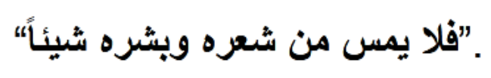
Dwelling deceptively on this Hadith, he says:
"The lack of command (amr): The Hadith uses the phrase 'let him not remove....' which in Arabic is
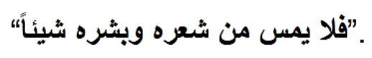
According to the Hanafi principles of usul al-fiqh, a mere prohibition in a non-legislative context does not establish obligation unless supported by other evidences."
What does a 'mere prohibition' mean? If an act is prohibited, it logically follows that it is not permissible. What is meant by 'non-legislative' in the context? A prohibition is not permissible. Describing it with the epithet 'mere' confirms the attitude of Istikhfaaf.
Regarding his presentation of the Hadith and his averment of 'lack of command (amar)', he is guilty of chicanery. He has selectively cited one version of the Hadith which prohibits cutting/trimming the hair and nails. In fact, even the narration selected by the deviate is a 'command' (amar). It commands abstention. The translation of the Hadith quoted by him is:
"When (the first) ten days (of Zil Hajj) begin and any of you intend making qur'baani, he should not cut from his hair nor from his body anything."
(Sunan Ibn Maajah)
These are the commanding words of Rasulullah (Sallallahu alayhi wasallam). He conveniently casts a blind eye on the Hadith stated in Muslim Shareef. In this Hadith the Command of the prohibition is emphasized. In the Hadith recorded in Muslim, Rasulullah (Sallallahu alayhi wasallam) said:
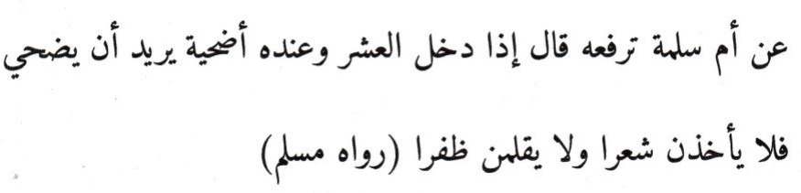
"He should never cut the hair, and he should never cut the nails." (Muslim)
The Noon Ta'keed (noon for emphasis) with which both the negative verbs are suffixed, emphasizes the prohibition. Thus it is not a 'mere prohibition' or an insignificant order.
This Hadith with the emphasis is also narrated by Abu Daawood and Tirmidhi. However, the deviate has deemed it appropriate to ignore this very important Hadith in which the Prohibition is emphasized. Why has he omitted this Hadith from his discussion? He has proffered views of some Fuqaha, cited from Kutub of Hadith and Fiqh, but he refrained from proffering this Hadith. Thus, he has perpetrated chicanery and is guilty of Kitmaanul Haq (Concealing the Truth).
His claim that the Hadith, even the one he has quoted, 'lacks command (amar)', is baseless and stupid. The one cited by him is a command ordering a prohibition. The other Hadith which he has attempted to conceal, adds emphasis to the prohibition. Thus, in effect Rasulullah (Sallallahu alayhi wasallam) said: "NEVER EVER trim the hair and NEVER EVER clip the nails..."

His second argument Proffering his second argument, the chap says:
"Contradiction with other hadiths: There are narrations where the Prophet (Sallallahu alayhi wasallam) trimmed his nails and hair outside the hajj context during Dhu al-Hijjah, which is taken to mean that the above hadith does not imply obligation or even encouragement."
This argument is flaccid and spurious. It is baseless. If the Prohibition emphasized by Rasulullah (Sallallahu alayhi wasallam) "does not imply even encouragement", then what does it imply? Did our Nabi (Sallallahu alayhi wasallam) issue a meaningless, futile command? Nauthubillaah! How can a statement of Rasulullah (Sallallahu alayhi wasallam) ever be devoid of substance? The Qur'aan, rebutting the rubbish disgorged by the deviate says about the statements of Rasulullah (Sallallahu alayhi wasallam):
"He (Muhammad) does not speak of desire. It (his talk) is nothing but Wahi revealed."
Assuming that Rasulullah (Sallallahu alayhi wasallam) did cut his nails during the first 9 days of Zil Hajj, it is stupid and perverse to claim that the Hadith does not even imply encouragement when in fact the Hadith explicitly commands abstention/prohibition with emphasis.
By implication, the moron has attributed contradiction to Rasulullah (Sallallahu alayhi wasallam). By means of his lopsided baseless interpretation he attempts to negate the Command of Rasulullah (Sallallahu alayhi wasallam) with an act which he has assumed executed by Rasulullah (Sallallahu alayhi wasallam).
Even if our Nabi (Sallallahu alayhi wasallam) had cut his nails and trimmed his hair, this act may not be proffered to negate and scuttle the explicit command of our Nabi (Sallallahu alayhi wasallam). For his seemingly conflicting act, there has to be presented a suitable interpretation without negating the explicit emphatic command of prohibition.
The fellow has conveniently refrained from citing the Hadith pertaining to Rasulullah (Sallallahu alayhi wasallam) having cut his nails/hair. Should he proffer it, it shall be discussed and the spuriousness of his argument based on it shall be validly refuted, Insha-Allah.

His third argument In his third argument he avers:
"Lack of practice among the Sahabah in this regard: According to Hanafi scholars, the practice of refraining from cutting hair and nails in these ten days was not commonly practiced among the companions outside of the pilgrims in Hajj."
This is a claim bereft of evidence. It is baseless. It is inconceivable that the Sahaabah who were aware of the command issued by Rasulullah (Sallallahu alayhi wasallam) would intentionally violate the Prohibition.
It should be understood, that when a rule or command was issued by Rasulullah (Sallallahu alayhi wasallam), not all the Sahaabah were immediately apprized. There was delay in the order filtering through to all the Sahaabah. Many who were not present in Madinah and who never returned to Madina remained unaware of many Ahaadith which ordered new practices.
Thus, if some Sahaabah had not acted in conformity with the Prohibition due to being unaware, their act may not be tendered to negate the explicit, emphasized command of Rasulullah (Sallallahu alayhi wasallam).
It was in this vein that Imaam Abu Hanifah (Rahmatullah alayh) had said to his Fuqaha Students that if they became aware of any Saheeh Hadith which conflicted with his Fatwa, they should discard his fatwa and issue the fatwa in compliance with the Hadith. There is no Faqeeh and no Imaam of Math-hab who had claimed to have encompassed all the Ahaadith. That was the reason for the numerous retractions by the Fuqaha. When new Hadith evidence came to light, they would retract their earlier fatwa.
Furthermore, regardless of widespread practice not having been recorded, the irrefutable fact of the explicit Command of Rasulullah (Sallallahu alayhi wasallam) is well substantiated.
Imaam Nawawi (Rahmatullah alayh) narrates in his Sharah of Muslim that some people in a hamaam (public bathroom) were removing their hairs during these days before Eidul Adha. Those in charge of the hamaam said:
"Verily Saeed Bin Al Musayyab disapproved of this and prohibited it." (The narrator says) 'Then I met Al-Musayyab and mentioned this to him. He said: 'O Son of my Brother! This Hadith has been forgotten and) practice on it) has been neglected. Umm-e-Salmah (Radhiyallahu anha) said: 'Rasulullah (Sallallahu alayhi wasallam) said: 'When the ten days enter and he among you who intends to sacrifice, should never cut from his hair nor ever remove anything from his body."
For the mental refreshment of the deviate, we cite the qualifications of this illustrious Taabiee, Hadhrat Saeed Bin Al Musayyib (Rahmatullah alayh).
"He was the Sayyid (Chief) of the Taabieen during his time. He was one of the (top) Seven Fuqaha of Madinah among the Ulama-e-Aamileen. He heard (Hadith) from the very senior Sahaabah such as Uthmaan Bin Affaan, Ali Bin Abi Taalib, Zaid Bin Thaabit, Abu Musaa, Sa'd, Aaishah, Abu Hurairah, Ibn Abbaas, Muhammad Bin Salmah and Umm-e-Salmah (Radhiyallahu anhum).
Qataadah said: "I did not see anyone of greater knowledge than Saeed Bin Al Musayyib." Ibnul Madani said: "He was of the Ajal (illustrious, most senior) Taabieen." (At-Tabaqaarul Kubra of Ibn Sa'd)
Thus, Saeed Bin Al-Musayyib acquired the mas'alah from these illustrious Sahaabah. He did not suck the Hadith from his thumbs. His Asaatizah were from the most senior Sahaabah.
The aforementioned narrated episode illustrates that even during the early era of Islam, many were not aware of this mas'alah of prohibition. The claim of the prohibition not having been widespread is therefore spurious and has to be set aside since it is in conflict with the express command of Rasulullah (Sallallahu alayhi wasallam). This is a command which interpretation and opinion cannot dislodge from its importance and its status of prohibition.

"Not even recommended"
This averment is corrupt. It is despicable to allege that a hukm, the prohibition – emphasized by Rasulullah (Sallallahu alayhi wasallam) is "Not even recommended". Such temerity is indeed fearful. While technically it is said that the order is not for Wujoob, it may not be said that it is "not even recommended". Was the emphasis applied by Rasulullah (Sallallahu alayhi wasallam) futile, bereft of meaning? Nauthubillah!
The Fuqaha state: "Negation of Wujoob does not negate Istihbaab, hence it is Mustahab..." (Shaami)
Imaam Abu Ja'far At-Tahaawi (Rahmatullah alayh) said:
"This position that he adopted regarding the prohibition on trimming one's nails or shaving one's hair for anyone who intends to offer a sacrifice (from the livestock he owns) during the first ten days of Dhu al-Ḥijjah has also been reported from the Companions of the Messenger of God (peace and blessings be upon him). They adhered to that practice in this matter.
For example, there is a narration reported by Ibrāhīm ibn Marwān from Qatāda: It is said that Kathīr ibn Abī Kathīr asked Saʿīd ibn al-Musayyib about Yaḥyā ibn Yaʿmār (who was living in Khorasan). Yaḥyā said: "When the first ten days of Dhul-Ḥijjah begin and a man buys his sacrificial animal and dedicates it, he should refrain from cutting any of his hair or nails." Saʿīd replied, "He has spoken correctly. The Companions of the Messenger of God (peace and blessings be upon him) used to do (or say) just that."
Similarly, another narration by Ibrāhīm ibn Abī Dāwūd from Kathīr relates that Yaḥyā ibn Yaʿmār of Khorasan said: "If a man purchases his sacrificial animal and dedicates it, and then the first ten days of Dhul-Ḥijjah arrive, he should refrain from cutting his hair or nails until he performs the sacrifice."
Qatāda said that he mentioned this ruling to Saʿīd ibn al-Musayyib, and Saʿīd affirmed it, saying, "Yes." Qatāda asked, "From whom is this ruling, Abu Muḥammad?" Saʿīd answered, "From the Companions of Muḥammad (radhiyallahu anhum)."
This narration negates the claim of the practice not having been widespread among the Sahaabah. While many may not have been aware of the rule, the claim that it was an unknown issue, "not even recommended" despite the emphasis of Rasulullah (Sallallahu alayhi wasallam), is the effect of intellectual miscegenation.
The Views of the Fuqaha "...In a Riwaayat it is mentioned: "Never cut from the hair and never cut the nails." The Ulama differ regarding the person who intends sacrificing. Saeed Bin Al-Musayyib, Rabeeah, Ahmad, Ishaaq, Daawood and some Ashaab of Shaafi' said that it is haraam for the person to cut anything of his hair and nails until he has sacrificed (his animal).
Shaafi and his As-haab said that it is Makrooh Tanzeehi, not haraam. Abu Hanifah said that it is not Makrooh. Maalik said in one narration it is not Makrooh, and in another narration it is Makrooh, and in one narration it is haraam...
The one who abandons this prohibition, abandons the Sunnah according to Maalik, Shaafi and Abu Hanifah. According to them, abstention from shaving the hair and cutting the nails (during the ten days) is Sunnah."
(Al-Mafaateeh fi Sharhil Masaabeeh)
"He who intends to sacrifice, should not take (cut) from his hair nor from his body anything during the ten days. The obvious meaning of this (Hadith) is Tahreem (that it is haraam) to cut the hair. This is the view of some of our (Hambali) Fuqaha. Ibnul Munthir narrated it from Ahmad, Ishaaq and Saeed Ibn Al Musayyib. Al-Qaadhi and a group of our As-haab said that it is Makrooh."
(Al-Mughni of Ibn Qudaamah)
"The view of our Math-hab (i.e. the Shaafi Math-hab) is that the removal of hair and nails during the ten days for the one who intends to sacrifice, is that it is Makrooh Tanzihi. Maalik and Abu Hanifah said that it is not Makrooh. Saeed Bin Al Musayyib, Rabeeah, Ahmad, Ishaaq and Daawood said that it is haraam." (Al-Majmoo' of Nawawi)
"When the ten days enter, then the one who intends sacrificing should not cut anything from his hair and nails as this has been narrated from Umm-e-Salmah from Nabi (Sallallahu alayhi wasallam). Muslim has recorded this Hadith. This is the view of Shaafi, Ahmad, and the general body of the Fuqaha of Hadith." (Lataaiful Ma-aarif of Ibn Rajab Al-Hambali)
"The narration of Abu Hanifah stating that it (cutting the nails and hair) is not Makrooh negates Makrooh Tahreemi, not Makrooh Tanzeehi (that is that it is Makrooh Tanzeehi)." (I'laaus Sunan)
The irrefutable fact, regardless of the Fiqhi difference pertaining to the status of the Prohibition, is that this is a practice in adherence to the Sunnah - an emphasized Sunnah - of our Nabi (Sallallahu alayhi wasallam). Only those who are bereft of respect for the Sunnah, demonstrate blithe disregard for the Sunan of Rasulullah (Sallallahu alayhi wasallam). That is why the deviate chap is capable of the satanic audacity of labelling an emphasized Sunnah to be "not even recommended."
A Salubrious Analogy Every Muslim knows that it is HARAAM to leave the hairs and nails for more than 40 days. This is the unanimous ruling of all Math-habs. In this regard, Shaami narrates:
"Leaving it (beyond 40 days) is Makrooh Tahrimi on the basis of the narration of Al-Mujtaba. Furthermore, there is no valid uthr (excuse-basis) for leaving it beyond forty days. He (the one who leaves it for more than 40 days) is deserving of punishment. Abu As-Saood narrating from Ash-Sharhul Mashaariq of Ibn Malik narrated that Muslim narrated from Anas Ibn Maalik:
"A time limit was set for us concerning clipping nails, trimming the moustache and plucking the armpit hairs, and that we should not leave it for more than forty days."
All the Fuqaha base this ruling of Haraam on the statement of Anas Bin Maalik (Radhiyallahu anhu). Furthermore, merely on the basis of the Statement of the Sahaabi is the act of leaving the hairs/nails for more than 40 days HARAAM.
It is indeed salubrious that despite there being no explicit Hadith – no Sareeh Hadith – of Rasulullah (Sallallahu alayhi wasallam), the Fuqaha have unanimously branded the act Haraam. Now what conclusion should be drawn from a Hadith explicitly stated by Rasulullah (Sallallahu alayhi wasallam) with emphasis (Ta'keed)?
Summing up this issue, Maulana Abdul Hayy (Rahmatullah alayh) said in At-Ta'leequl Mumajjad: "It is the clear view that it (the Prohibition of cutting nails/hair) was issued in obedience to the Statement of Rasulullah (Sallallahu alayhi wasallam) that whoever intends to sacrifice and sees the Hilaal of Zul Hijjah should not take (cut) from his hair and nails until he sacrifices (his animal). Narrated by Muslim."

AN INTRIGUING ANOMALY
A Mufti prepared the following article to highlight an anomaly –anomaly which adds to the demolition of the stupid, disrespectful treatment the deviate had accorded to the Hadith and practice which Rasulullah (Sallallahu alayhi wasallam) had emphasized and which the jaahil satanically dismissed, saying "not even recommended".
The deviate had dismissed the Hadith of Rasulullah (Sallallahu alayhi wasallam) very abrasively by saying that the Hadith which prohibits nail and hair cutting belongs to the Khabr-e-Aahaad class of Narrations, hence the emphasis of incumbency may not be conferred to it.
The Mufti's dissertation, appearing below, thoroughly debunks the drivel of the deviate. The Mufti comments on the status of a narration which is not an explicit Hadith of Rasulullah (Sallallahu alayhi wasallam). Aggravating the weakness of the narration is huge difference among the Muhadditheen regarding the reliability of the narration on which the Fuqaha have based the Prohibition of keeping the hairs for more than 40 days. They unanimously rule that it is HARAAM to leave the hairs for more than 40 days, and this has been the practice of the Ummah since the earliest eras of Islam notwithstanding the discrepancy attached to the narration.
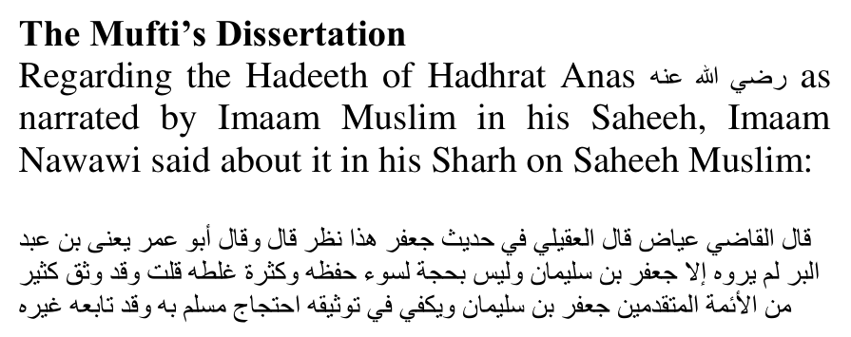
Qaadhi `Iyyaadh said: "Al-`Uqayli said that some weakness exists in this Hadeeth of Ja`far. He said: 'And Abu `Umar, i.e., Ibn `Abdil Barr said: 'Nobody has narrated it except for Ja`far ibn Sulaimaan, and he is not a hujjah, because of his weak memory and numerous mistakes."
I (i.e., Imaam an-Nawawi) say: 'Many of the early A'immah had regarded Ja`far ibn Sualimaan as being thiqah (trustworthy; reliable). Sufficient for his tawtheeq is the fact that Muslim used him as hujjah, and other (A'immah) followed (Imaam Muslim) in this as well."
The most authentic Hadeeth on the topic is this one in Saheeh Muslim, which is more authentic than the one in Sunan Abi Daawud and elsewhere. Imaam Nawawi regarded the Hadeeth as Saheeh because Imaam Muslim himself had regarded it as Saheeh. However, Imaam Nawawi mentions that Imaam Ibn `Abdil Barr al-Maaliki regarded Ja`far ibn Sulaimaan as having weakness. Besides Imaam Ibn `Abdil Barr, there were some other senior Muhaddithoon who had also had reservations about him. In the Kitaab, "Dhikru man ikhtalafal `Ulamaa'u wa Nuqqaadul Hadeethi feehi" of Imaam Ibn Shaaheen, it is mentioned:
1. Imaam Yahyaa ibn Sa`eed al-Qattaan would not write the Ahaadeeth of Ja`far ibn Sulaimaan.
2. Muhammad ibn `Abdillaah ibn `Ammaar said: "He (Ja`far ibn Sulaimaan) is dha`eef."
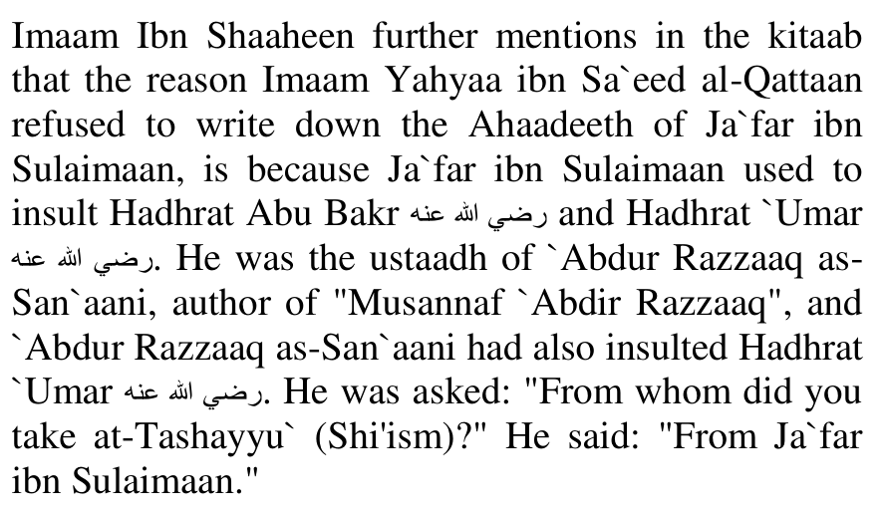
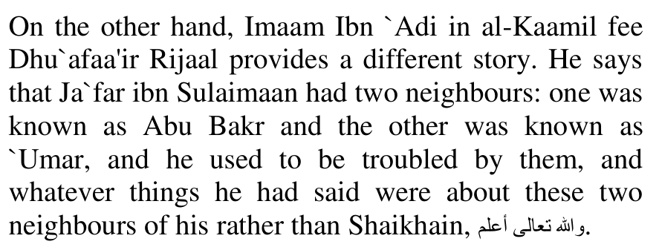
Imaam Abul Hasan al-`Ijli says in ath-Thiqaat: "(Ja`far ibn Sulaimaan) was thiqah, but he had tashayyu` in him."
Imaam Ibn Abi Haatim ar-Raazi says in al-Jarh wat-Ta`deel: "I heard Ahmad ibn Sinaan saying: 'I saw `Abdur Rahmaan ibn Mahdi having no interest in the narrations of Ja`far ibn Sulaimaan.' Ibn Sinaan said: "And I too find his narrations burdensome (i.e., I have no interest in them)."
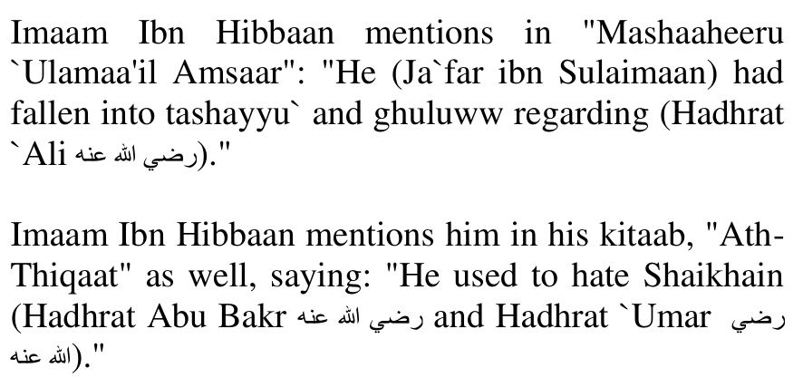
Further on, he makes a much more severe statement regarding him. He says:
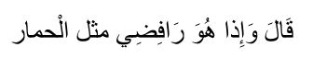
"He was a raafidhi, like a donkey."
Imaam Ibnul Jawzi said about him in adh-Dhu`afaa wal-Majrooheen: "Some of his narrations are munkar. He hated Abu Bakr and `Umar. Yahyaa ibn Sa`eed regarded him as dha`eef, though Ibn Ma`een said he is thiqah."
In Siyar A`laamin Nubalaa', Imaam adh-Dhahabi refers to him as: "The Muhaddith of the Shias."
He further says: "`Abdur Razzaaq accompanied him a lot, and through him he fell into tashayyu`."
He also narrates from Imaam Ahmad ibnul Miqdaam who said: "We were in a majlis of Yazeed ibn Zuray` when he said: 'Whosoever goes to Ja`far ibn Sulaimaan and `Abdul Waarith, let him not come near me."
Imaam Ibn Sa`d says about Ja`far ibn Sulaimaan ibn at-Tabaqaatul Kubraa: "He was thiqah, but had dhu`f, and he had fallen into tashayyu`."
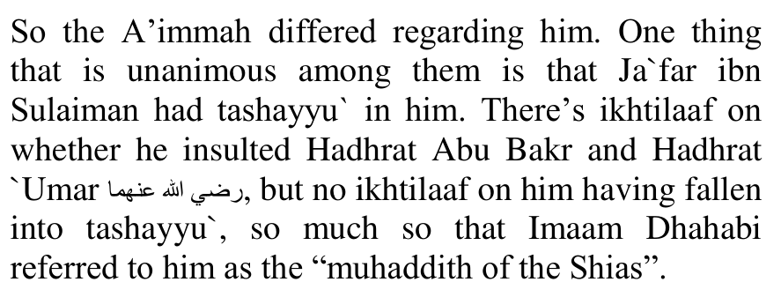
The narration in Sunan Abi Daawud also goes through this very same Ja`far ibn Sulaimaan, so for all of those A'immah who dismissed the narrations of Ja`far ibn Sulaimaan, they wouldn't have accepted either one.

THE HADITH NARRATED BY IMAAM MUSLIM—THE HADITH WHICH EMPHASIZES THE PROHIBITION

"NEVER EVER trim the hair and NEVER EVER clip the nails..."
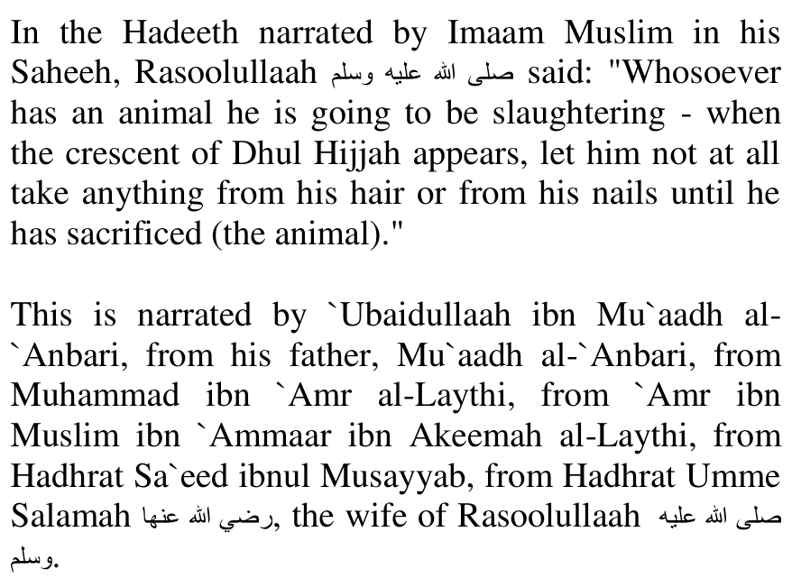
Regarding `Ubaidullaah ibn Mu`aadh al-`Anbari:
Imaam Ibn Abi Haatim ar-Raazi says in al-Jarh wat-Ta`deel: "I heard my father saying that he is thiqah. My father and Abu Zur`ah narrated from him."
Imaam adh-Dhahabi praises him in Siyar A`laamin Nubalaa as: "The unparallelled Imaam, the thiqah, Abu `Amr al-`Anbari al-Basri.
He narrated from his father, and Mu`tamar ibn Sulaimaan, and Yahyaa ibn Sa`eed al-Qattaan, and Khaalid ibnul Haarith, and Wakee` ibnul Jarraah and their generation.
From those who narrated from him were Muslim, Abu Daawud, Bukhaari, Nasaa'i through an intermediary, Abu Zur`ah, Abu Haatim, `Uthmaan ad-Daarimi, Zakariyyaa ibn Yahyaa Khayyaat, Ja`far al-Firyaabi, Abul Qaasim al-Baghawi and many others.
Abu Daawud said: 'He had memorised approximately 20,000 Ahaadeeth.'
Abu Haatim ar-Raazi said: 'He is thiqah."
Al-Khateeb al-Baghdaadi said about him: "He was praiseworthy, thiqah. An intelligent man among men.
Al-Watheeq ibn Yusuf said: 'I never saw anyone more intelligent than `Ubaidullaah ibnul Hasan (i.e., ibn Mu`aadh al-`Anbari).'
Abu `Ubaid Muhammad ibn `Ali al-Aajuri said: 'I said to Abu Daawud Sulaimaan ibnul Ash`ath: 'Is `Ubaidullaah ibnul Hasan (i.e., ibn Mu`aadh al- `Anbari) a hujjah according to you?' He said: 'He was a faqeeh."
Then, regarding his father, Mu`aadh ibn Mu`aadh al- `Anbari:
Imaam Ibn Abi Haatim ar-Raazi said about him in al-Jarh wat-Ta`deel: "`Amr ibn `Ali as-Sayrafi said: 'I heard Yahyaa ibn Sa`eed saying: 'There is nobody like Mu`aadh ibn Mu`aadh, not in Basrah, Kufa or the Hijaaz.'
Abu Bakr al-Asadi said: 'I heard Ahmad ibn Hanbal saying: 'Mu`aadh ibn Mu`aadh had the highest level of tathabbut in Basrah.'
Yahyaa ibn Ma`een said: 'Mu`aadh ibn Mu`aadh is thiqah."
Al-Khateeb al-Baghdaadi said about him in Taareekh Baghdaad: "He was thiqah.
From those who narrated from him were his two sons, `Ubaidullaah and al-Muthannaa, and `Ali ibnul Madeeni, and Ahmad ibn Hanbal, and Yahyaa ibn Ma`een, and Abu Khaithamah, and Sa`daan ibn Nasr and others.
`Amr ibn `Ali Abu Hafs said: 'I heard Yahyaa al-Qattaan saying: 'I sought Hadeeth with two men from the Arabs: Khaalid ibnul Haarith ibn Saleem al-Hajeemi and Mu`aadh ibn Mu`aadh al-`Anbari. Wallaahi, if they ever preceded me to a Muhaddith, they would not write anything down until I was presentt. If Mu`aadh and Khaalid ibnul Haarith followed me, I wouldn't care who among mankind opposed me.'
[From an Imaam the likes of Imaam Yahyaa ibn Sa`eed al-Qattaan, that is a massive praise.]
Muhammad ibn `Ali al-Aajuri said: 'I heard Abu Daawud saying: 'It has reached me from Ahmad - ibn Hanbal - that he said: 'I have not seen anyone more intelligent than Mu`aadh.'
Abu Bakr Ahmad ibn Muhammad ibnul Hajjaaj said: 'I heard him, i.e., Ahmad ibn Hanbal saying: 'Mu`aadh ibn Mu`aadh is a coolness of the eyes in Hadeeth.'
Yahyaa ibn Ma`een was asked about (Mu`aadh al- `Anbari), so he said: 'He is thiqah.'
Muhammad ibn Sa`d said: 'Mu`aadh ibn Mu`aadh was given the kunyah of Abul Muthannaa, and he was thiqah."
Imaam adh-Dhahabi praised Mu`aadh ibn Mu`aadh al- `Anbari in Siyar A`laamin Nubalaa, as: "The Qaadhi, the Imaam, the Haafizh, Abul Muthannaa al-`Anbari al-Basri.
An-Nasaa'i said: 'Mu`aadh is thiqah, thabt."
Regarding Muhammad ibn `Amr al-Laythi:
Imaam Ibn Hibbaan says about him in ath-Thiqaat: "He used to make mistakes."
Al-Marwadhi said: "I asked him (i.e., Imaam Ahmad) about Muhammad ibn `Amr, so he said: 'Yahyaa narrated from him. He sometimes used to make such Ahaadeeth marfoo` which others used to make mawqoof, and this was from his side. He went to alA`mash, but (al-A`mash) did not honour him." [Al-`Ilal]
Ibn Haani' said: "I heard him saying: 'Muhammad ibn `Amr used to narrate some Ahaadeeth and make them mursal, but make them musnad for others." [Masaa'il Ibn Haani']
Ibn Haani' said: "He was asked: who of the two is more beloved to you: al-`Alaa ibn `Abdir Rahmaan, or Muhammad ibn `Amr?' He said: 'Al-`Alaa is more beloved to me. Muhammad ibn `Amr is mudhtaribul hadeeth." [Masaa'il Ibn Haani']
Imaam adh-Dhahabi says about him in Siyar A`laamin Nubalaa: "The Imaam, the Muhaddith, the Sadooq, Abul Hasan al-Laythi al-Madani.
An-Nasaa'i said: 'There is no problem with him.'
Abu Haatim said: 'He is saalihul hadeeth.'
Yahyaa ibn Sa`eed was asked about Muhammad ibn `Amr, so he said to the questioner: 'Do you want pardon or should we be severe?' (The questioner) said: 'Rather, be severe.' He said: 'He is not from those you want.'
Al-Jawzajaani said: 'He is not strong.'
Ibn `Adi said: 'Maalik narrated from him in the Muwatta', and I hope that there is no problem with him."
Imaam Suyooti said about him in Is`aaful Mubatta' fee Rijaalil Muwatta: "He was declared thiqah by an-Nasaa'i, Ibnul Madeeni, and his son, Yahyaa al-Qattaan, and Abu Haatim."
Thus, regarding this one raawi, Muhammad ibn `Amr, some Muhaddithoon said that he is thiqah, and others said that he is not strong, etc. However, they did not say he is a liar, or mudallis, etc., nor did they fault his `Aqaa'id or `Amal on Deen, etc.
Finally, regarding `Amr ibn Muslim al-Laythi: Najr `Abdur Rahmaan Khalaf states in Mu`jamul Jarh wat-Ta`deel li-rijaalis Sunanil Kubraa: "Ahmad ibn Hanbal and Yahyaa ibn Ma`een used to say: '`Amr ibn Muslim was a student of Taawus. He wasn't strong."
Imaam Ibn Hibbaan said about him in ath-Thiqaat: "`Amr ibn Muslim al-Jundi, from the people of Yemen. He narrated from Taawus and `Ikrimah. Ziyaad ibn Sa`d, Ma`mar and Ibn `Uyainah used to narrate from him."
Ibnul Jawzi said about him in adh-Dhu`afaa wal-Matrookeen: "Ahmad and Yahyaa declared him dha`eef."
Ibn Zuraiq al-Maqdisi states in "Man Takallama feehid Daaraqutni fee Kitaabis Sunan": "Daaraqutni said: '`Amr ibn Muslim is not strong."
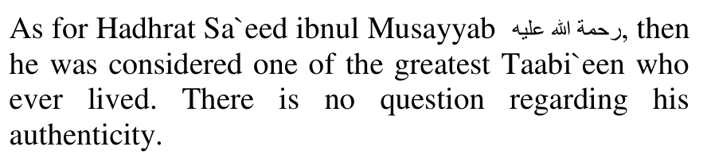
In summary, there are two raawis in the isnaad who were considered "not strong", and one of them was considered dha`eef by some Muhaddithoon. However, none of the A'immah found any serious issue with them - it was just a matter of regarding them as weaker than other raawis. There were no accusations of rifdh, tashayyu`, bid`ah, or things like fabricating, etc.
(End of the Mufti's dissertation)
Tashayyu', that is Shiah inclinations. The status of Haraam has been conferred to the more than 40 day Prohibition based on the narration of Ja'afar ibn Sulaiman.
Comparatively, the narration pertaining to leaving the hair/nails for more than 40 days, is substantially weaker than the Hadith which emphasizes the Prohibition of cutting hairs/nails during the 10 days of Zil Hajj for those who intend making Qur'baani.
However, despite this great disparity in the Chains of Transmission, the ruling of Haraam is raised on the 'weaker' narration. Now what conclusion should be drawn of the Prohibition which is based on a Hadith of higher status and in which Rasulullah (Sallallahu alayhi wasallam) emphasizes the Prohibition?

CONCLUSION
The Shar'i status of abstinence, that is to abstain from cutting the nails and hair during the ten days of Zul Hijjah for those who are offering Qur'baani, oscillates between Wujoob and Istihbaab. According to those Fuqaha who say that cutting is Haraam, abstinence is Waajib. According to those who say that cutting is not haraam, it is Mustahab. But no one claims that abstinence is "not even recommended".
When a hukm vacillates between haraam and mubah, the safest course – the necessary course – for practical adoption is to regard it as being haraam. Thus the effort of the deviate to dislodge the importance of a Sunnah emphasized by Rasulullah (Sallallahu alayhi wasallam) is despicable.
The technicalities should necessarily be set aside in order to revive the Sunnah practice.
Sunnah practices may not be disregarded or viewed with an attitude of insignificance merely because of the Mustahab designation. Such an attitude will scuttle a mass of masaa-il of the Istihbaab class. Washing each limb thrice during wudhu, beginning from the right side, making masah of the neck, khilaal of the fingers, ears and toes, entering the toilet with the left leg and emerging with the right leg, performing Salaat with the entire body covered and not sufficing with only the satr covered, Tahajjud Salaat, Ishraaq Salaat, Chaasht Salaat, Awwaabeen Salaat, Tahyatul Wudhu, Tahyatul Musjid, and innumerable other acts which the Ummah adheres to may not be dismissed with the satanic comment of falsehood, 'not even recommended', simply because of the technical Mustahab designation.
All the Ahkaam of the Sunnah, regardless of their Fiqhi designation, are for practical implementation. They are not designed for antiquating and for mere theoretical and theological discussion in Madaaris. Thus, the function of the Fiqh classifications and principles are not for antiquating any aspect of the Sunnah. These classifications and principles have to be correctly employed when there is a valid need for concession.
When a Sunnah has been abandoned or dismissed as being insignificant then it becomes Waajib to emphasize its practical implementation. It then comes within the purview of the Hadith:
"He who adheres to my Sunnah at a time of the corruption of my Ummah, will receive the reward of a
100 martyrs."
The Abbaasi Khalifah Haroon Rashid having disguised himself attended the Hadith gathering of a Muhaddith. The Muhaddith narrating a Hadith of Rasulullah (Sallallahu alayhi wasallam) said: "Rasulullah (Sallallahu alayhi wasallam) loved eating dubbaa (dhodi/marrow)." Someone in the gathering remarked: 'I don't like eating dubbaa.' The Khalifah, unable to restrain his wrath, revealed himself and commanded: "An-Nat' was-Saif" (the leather and the sword). The Zindeeq criticizes the Hadith of Rasulullah (Sallallahu alayhi wasallam)." Boiling with rage, the Khalifah repeated his command thrice.
In those days when a man was executed, the execution was carried out on a leather carpet and with the sword, hence the Khalifah called for the items to have the zindeeq executed. However, the passionate pleading of the Muhaddith saved the life of the zindeeq.
Now is eating dubbaa Waajib? Does abstention from eating dubbaa warrant execution with the sword? Is eating dubbaa Sunnat, Mustahab or Mubah? There is no need to answer these questions. Of importance – imperative importance – is that every act of Rasulullah (Sallallahu alayhi wasallam) is beloved to genuine Muslims, and genuine Muslims do not expend effort to denigrate this importance.
Thus the actual answer for the deviate who has demeaned the emphasized Sunnah of Rasulullah (Sallallahu alayhi wasallam) with his audacious criticism: "It is not even recommended", is An-Nat' Was Saif! An-Nat' Was Saif! An Nat' Was Saif!

