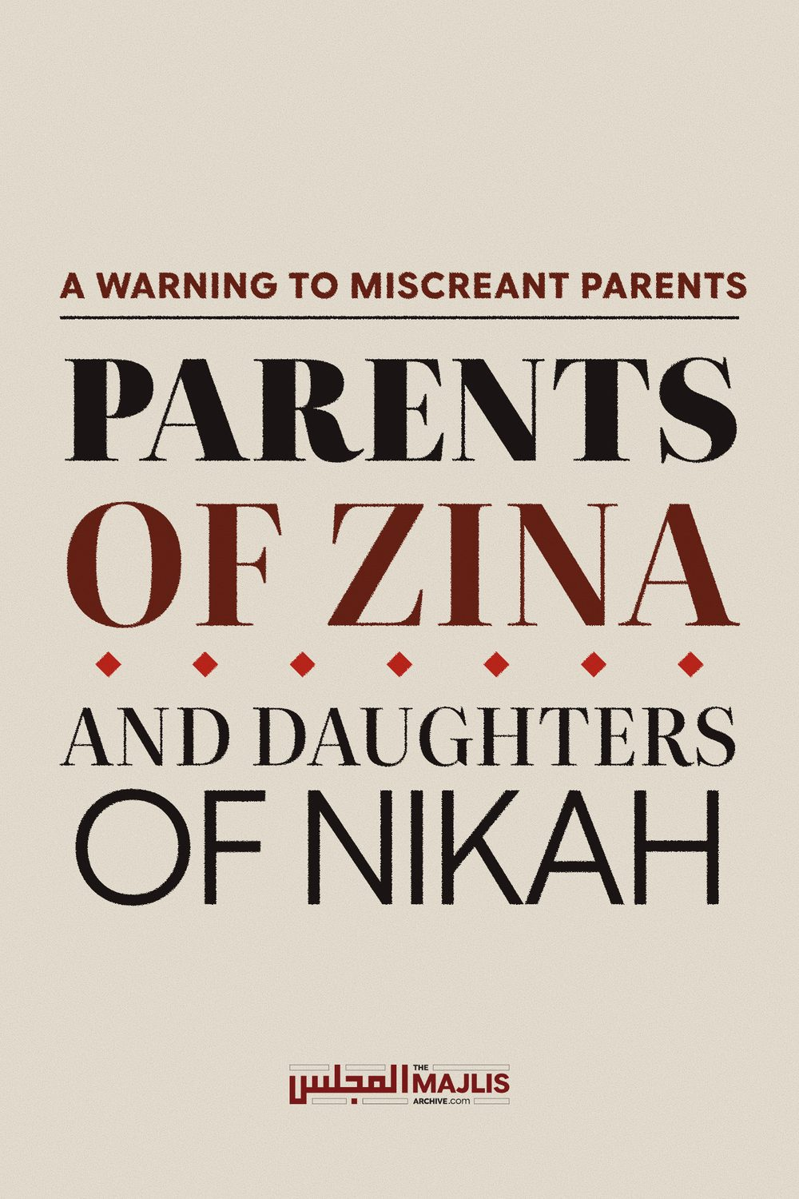

PARENTS OF ZINA AND DAUGHTERS OF NIKAH
The Majlis · Voice of Islam
Mujlisul Ulama of South Africa

About this edition
This is a reproduction by The Majlis Archive (themajlisarchive.com) of a publication of The Majlis, Mujlisul Ulama of South Africa, made and published with their permission.
The PDF as The Majlis issued it is the original. This edition was read from that PDF's own structure and checked against it letter for letter; where the two differ, the PDF is correct.
Checked: 84 paragraphs, 0 differing; a second, independent PDF reader finds 100.0% of the PDF's words here.
Nothing has been reworded, added or removed.

A WARNING TO MISCREANT PARENTS

THE MAJLIS PO Box 3393
Port Elizabeth, 6056

QUESTION
A serious problem experienced by many many parents nowadays is their daughters marrying without parental consent boys whose characters are immoral. The girl and the boy strike up a haraam illicit relationship at secular school or at university. They conduct an extremely immoral and even vulgar relationship. Their whatsapp messages are worse than vulgar. Many indulge in the ultimate act of zina.
Sometimes the sin of their haraam relationship of zina dawns on the immoral couple. They regret and resolve to reform. However, since they are in love and trapped in the relationship they want to legalize the relationship with marriage.
Now comes the problem. The parents despite being aware of the zina relationship of their daughter – sometimes it has endured for years – act like wild bulls seeing red. They are up in arms. They want nothing of the sort. While they were silent during the long zina relationship, they refuse to consent to Nikah. They are determined to see their daughter complete her secular studies, gain a university degree and become self-sufficient in the field of earning money. Thus, as far as the parents are concerned, marriage is out of the question.
Such refusal has even led to elopement and also having the Nikah performed secretly without the consent of the girl's Wali (father, etc.). Is the Nikah valid? Is the refusal of the parents valid? Please offer guidance in the light of the Shariah. This is a very serious problem and numerous parents and their children are caught in this scenario.

UNIVERSITY – THE ZINA AND VICE CAULDRON
It is essential to firstly understand what a kuffaar secular school/college/university is. These kuffaar 'educational' institutions are dens of vice. These places are infested with the immoral filth of promiscuous intermingling of the sexes, extreme lewdness, lesbianism, homosexuality, wine-drinking, music, pornography, drugs and fornication.
Vigorously aggravating this wicked, satanic, immoral and haraam atmosphere is the stark immoral filth and blatant kufr of the educational curriculum.
This admixture of kufr and immorality renders the evil of a brothel relatively mild. Thus, the lesser of the evils is the brothel den of fornication/adultery. However, since the chimera of money dangles in front of the rubbish parents who ruin their Imaan by bartering away the Haya (Imaani shame and modesty) and even the virginity of their daughters for the sake of a worldly kufr educational profession which will lead their children to Jahannam, these evil parents prefer the greater evil of the university den of zina and kufr for their daughters.
The first consequence of the parental assignment of their daughters to the worse den of filth and fornication is the effacement of the father's Wilaayat. Such a vile father who displays the attributes of a pig ceases to be the Wali of his daughter. Such parents, in addition to them losing the right of Wilaayat, lose even their Imaan for condoning the zina relationship of their daughter and for opposing the Nikah bond commanded by Allah Ta'ala.
The brains of these parents grovel in the gutter. They are like khanaazeer and they brazenly display their kufr with their condonation of their daughter's zina and their opposition to Nikah. The objective for this satanic attitude is nothing other than the pecuniary objective promised by the donkey degree of the university.

LET THEM GET AND DIGEST THE SHARIAH'S MESSAGE
It is essential for these evil parents to understand the following consequences of their wayward, haraam and immoral casting of their daughter in the cauldron of the educational brothel of vice and immorality:
(1) The father's right of Wilaayat is extinguished.
(2) Along with this extinguishment, his Imaan is also destroyed as an effect of condoning the zina relationship and attempting to block the Nikah.
(3) His daughter is no longer in need of his consent for the Nikah she contemplates.
(4) The Nikah she has performed is VALID no matter how abhorrent it may be to the Khinzeer father who has ruined her dunya and her Jannat by flinging her into the Cauldron of Zina. The tantrums of the parents are of no avail.
(6) This type of father is no longer a valid Shar'i mahram for his daughter. A man who paves the path of Jahannam for his daughter by laying a carpet of fornication for her can never act as her Wali and Mahram.

ADVICE FOR THE FORNICATING GIRL AND BOY
It is absolutely necessary for the fornicating couple to terminate their haraam zina relationship. Zina is of a variety of kinds. Rasulullah (Sallallahu alayhi wasallam) mentioned about the zina of the eyes, zina of the mind, zina of the limbs, etc. It is Fardh to abstain from zina of all kinds. But such abstention is well neigh impossible in the university hell of fornication.
Girls who have been compelled by their evil parents to attend university, should become defiant and refuse regardless of the consequences of parental wrath. The criterion is the Pleasure and the Displeasure of Allah Ta'ala, not the wishes of parents – such wishes and instruction, if obeyed will lead to Jahannam.
If the couple on account of extreme Imaani deficiency is unable to terminate the zina relationship, then it will be WAAJIB to legalize the relationship with NIKAH, and to hell with the opposition of parents. The father's consent is no longer a requisite. The circumstances are satanically abnormal, hence the father's Wilaayat is extinguished.

THE NIKAH
In the scenario depicted in the question, which is an uncontestable reality. The only solution is Nikah.
If a Musjid Imaam or a Molvi cannot be found to perform the Nikah, the couple should perform their own Nikah. Some Muslim boys and girls trapped in the university cauldron of zina, in desperation become Shiahs, not for accepting Shiah beliefs, but to avail themselves of the filthy Shiah practice of mu'tah (legalized prostitution) which is halaal in the Shiah religion.
Never destroy your Imaan and your everlasting life of Jannat simply for 'legalizing' your haraam zina relationship the Shiah way. The process of Nikah is extremely simple in terms of the Shariah. The presence of an Imaam/Molvi/Sheikh and recitation of the Khutbah are not imperative requisites for the validity of a Nikah.

THE SIMPLE PROCEDURE OF NIKAH
As a last resort, that is, parental refusal and an imam being unavailable for the Nikah, the boy and girl trapped in zina should perform their own Nikah.
The essential conditions for the validity of Nikah are only:
(a) The presence of the boy and girl, if she has no representative.
(b) The Ijaab (Proposal) which could be by either the boy or the girl.
(c) The Qubool (Acceptance).
(d) The presence of two Muslim male witnesses to hear the Ijaab and Qubool.
Although the Mahr is necessary, it is not a condition required for the validity of the Nikah.
The Mahr should be decided on mutually between the boy and girl. However, the girl should not agree on an amount which is less than the Mahr amount of her family females. It is best to settle on Mahr-e-Faatimi which the boy could pay in instalments at a later date if the cash is not affordable.
At the Nikah ceremony, the boy should say audibly so that the witnesses can clearly hear: "Aabidah, I have accepted you in Nikah as my wife. Do you accept me as your husband?
The girl should audibly respond: "Yes, I have accepted you in Nikah as my husband."
This simple procedure ends and validates the Nikah. If anyone present is able to recite the Nikah khutbah, it will add barkat to the Nikah. However, if all present are stupid – as generally are university students – then abstention from the Khutbah will not affect the validity of Nikah.
Never keep the Nikah secret. Publicize it. Zina is a secret affair. Nikah is a public issue.
We have explained the solution and the simplicity of emerging from zina into the Bliss of Nikah. Shame is in zina, not in Nikah. Nikah is a sacred bond which comes with numerous virtues and responsibilities. Ignore the outcry of your miscreant parents and stupid society and be concerned with the Pleasure and Displeasure of Allah Ta'ala.
Repent for your years of zina. Allah Ta'ala forgives all sins. The Qur'aan Majeed states:
"(O Muhammad!) Say to My servants who have oppressed themselves, not to despair from the Mercy of Allah, for verily, Allah forgives all sins."

DISEASED BRAINS OF SOME FATHERS
A girl who was trapped in an illicit relationship which developed at kuffaar school, had eloped with the boy. After eloping, the Nikah was performed. The father has portrayed his kufr insanity with his vile outpourings. While he had accepted the zina of his daughter, he has and is still insanely ranting and raving.
In this regard we reproduce here two letters: (1) The letter of her father-in-law, and (2) The letter of the man's daughter. She makes shockingly lamentable revelations of the filthy haraam misconduct of her own father whom she accuses of having sexually molested her.

Father-in-law's letter
Assalamu Alaikum
Below is a message sent by my daughter-in-law to some of her family members.
Please review the father's unnatural, immoral behaviour towards his teenage daughter. What is the status of a father who touches his daughter with lust? (He is worse than a pig – The Majlis) What is the status of this father's nikah? (His wife is haraam for him. He is living in the state of adultery with his wife – The Majlis)
Please make maaf for all the takleef that we have recently caused you. We are indeed in the era close to Qiyaamah. May the Almighty Allah Ta'ala protect us all. Ameen. Jazak Allah (End of letter)

The Daughter's letter

'EXPOSING' CAN GO BOTH WAYS.
My upbringing (regarding him – that is her father) was extremely uncomfortable. His touches on my bum, thighs, etc. were a normal thing, right until this year. He used to offer to wash me in the toilet or scrub my back, etc. in the shower as some kind of sick joke.
He'd come to cover me at night when I'm asleep and always first uncover me so that I am exposed. Then put the bedding on top of me. He used to get in bed and sleep with his grown daughter, behind or on top of me, in questionable positions.
Kissing my feet ever since I can remember, was a regular occurrence for which I continually expressed my disapproval. I was told that after I'd left, he'd sniff my clothes etc. my father would go through my things, and conduct cupboard searches while i was at madrasah this year. We have all sinned. I admit to my own wrongdoings, but i have made and will continue to make taubah.
What is the need to expose your own daughter and bring shame on your name? Only someone sick and twisted will relish his daughters conversations, will download a pdf converter to keep screenshots in a legible format, will make designated albums of his daughters conversations on his phone. He begged my husband after the nikah was done to 'preserve my innocence & respect my body'. Not only that, but he continues to send explicit graphic messages to my husband and now he's asking to see videos. He has to be stopped. His thumbs are too happy typing, too happy to send my father in law a 1200 page document. We won't open or read any further messages or folders as it's not worth it to gratify him. My father has broadcast everything that has happened to his jamaat friends who thrive on gossip, to the musalees who love the action, and to basically anyone who will listen to him, his brothers included – the same ones who don't hesitate to send death threats that longer faze us.
I have been told that if something happens to my mother, it'll be my fault. Maam & masejee have sent threats for our nikah to frail. Verily, everything is in the Hands of the Almighty. I left home to do the right thing, to make everything halaal. My father doesn't care about me and that's the brutal truth. If he could have me home and in a broken mental state, he will do anything to get me home – the same father who made sexual positions to my husband and father-in-law, who disgraced me openly, who is pitting everyone against me. He is twisted and is wholeheartedly enjoying the documents he's brooding over. I've messaged him, and detached myself from him completely and from anyone else who still believes he's right. He's the reason I didn't come for Eid, the reason I didn't meet mum yesterday, because him and his brothers and friends can only send whatsapp threats and that's where their power trip ends. (End of letter)
This is the letter of the girl who had married without the consent of the villain who is her father, and whose shaitaaniyat she describes in her letter. How can a man with such a horribly diseased mind ever be the Wali and Mahram of his daughter?
There are innumerable similar cases of incest and near-incest perpetrated on girls by those who are supposed to be their Shar'i guardians and protectors. We have numerous such cases on our files.

DISQUALIFICATION OF A MAHRAM
Q. When will a mahram be disqualified from acting as the Wali of his daughter for the purpose of marriage?
A. According to the Hanafi Math-hab, while the consent of the Wali for marriage is Waajib (compulsory), the validity of the Nikah is not reliant on his consent. If the girl marries herself without the Wali's consent, then despite the major sin she commits, the Nikah will be valid. But according to the other three Math-habs, the Nikah will not be valid.
She will be sinful if she has no valid reason for overriding the Wali and not gaining his permission. However, when her first Wali is a disqualified faasiq, she should seek the permission of the next Wali, e.g. grandfather, paternal uncle.
A mahram is disqualified if he flagrantly indulges in fisq and fujoor. For example, he is a modernist who denies the Shariah's laws of Hijaab, shaves his beard, abstains from Jamaat Salaat, etc. Furthermore, a faasiq wali is not a valid mahram along a journey for even his daughter and wife. A man who rejects purdah or who is unconcerned if his wife is exposed to men, is a dayyooth villain. It is not permissible for a wife, daughter, sister, etc. to be on a journey with him. He does not fulfil the Shariah's criteria for being a mahram.
A father who allows his daughter to study at an 'educational' brothel such as a university, is disqualified. The daughter does not need his permission when marrying. Such fussaaq/fujjaar fathers turn a blind eye on the zina relationship which their daughters strike up with even kuffaar males at university. But when the Hindu or Christian boy embraces Islam in order to marry the girl with whom he was conducting a zina relationship, then the parents flare into rage, decry the daughter and refuse consent. The girl in this scenario should know that she is not in need of the consent of her evil, faasiq, faajir parents. She should proceed to halaalize the relationship with Nikah. While zina is tolerable for her parents, Nikah is not.

THE NIKAH CERTIFICATE
The Nikah certificate provides evidence of a valid nikah. It is also required sometimes for legal purposes. If a girl forced into the educational brothel (university) by her parents enters into Nikah without parental consent and without an Imaam/Molvi officiating, then she may apply to the Mujlisul Ulama of S.A., PO Box 3393, Port Elizabeth 6056, e-mail mujlisul.ulama@gmail.com, for a Nikah Certificate. Insha-Allah, the Mujlisul Ulama will assist with the necessary Nikah Certificate.

