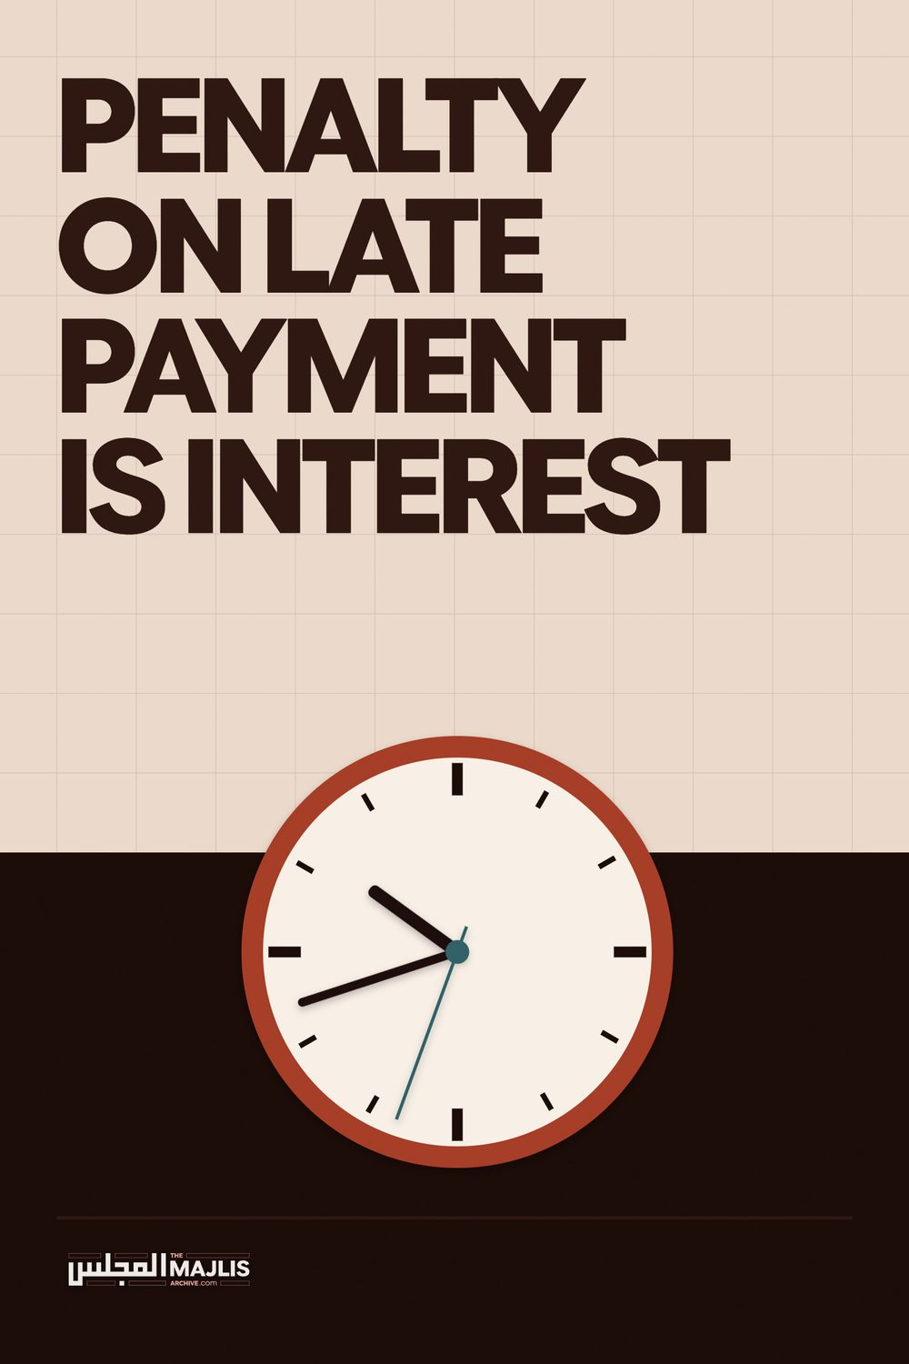

Penalty On Late Payment Is Interest
The Majlis · Voice of Islam
Mujlisul Ulama of South Africa

About this edition
This is a reproduction by The Majlis Archive (themajlisarchive.com) of a publication of The Majlis, Mujlisul Ulama of South Africa, made and published with their permission.
The PDF as The Majlis issued it is the original. This edition was read from that PDF's own structure and checked against it letter for letter; where the two differ, the PDF is correct.
Checked: 84 paragraphs, 0 differing; a second, independent PDF reader finds 100.0% of the PDF's words here.
Nothing has been reworded, added or removed.

PENALTY ON LATE PAYMENT IS INTEREST
By Mujlisul Ulama of S.A

South Africa

PENALTY ON LATE PAYMENT IS INTEREST THE 'PENALTY' CHARGE OF BANKS IS RIBA
HE SO-CALLED 'Islamic' banks being followers of the kuffaar capitalist system operate their business dealing in precisely the same form and method as the non-Muslim banks do. The only difference is that the deceptive banks belonging to Muslims employ Islamic terminology and use baseless interpretation to give an Islamic hue to their baatil transactions.
We propose to discuss in this pamphlet some issues in this regard and the capitalist mentality which has discoloured and disfigured the eyes and minds of the Muslim bankers who devour Riba under various ploys and guises.
1. In a pamphlet issued by Albaraka Bank, the following question is
posed: "is the Bank allowed to charge an administration fee (for providing a settlement figure)?"
Answering its own question, the Bank says: "Yes ,the Bank is allowed to charge an administration fee equal to the actual cost incurred by providing the settlement figures."
Firstly, the method of calculating 'settlement figures' is a method which the Muslim bank has adopted from the kaafir bank. Even the Muslim bank follows the exact method of deducting future interest charges in the method adopted to arrive at a 'settlement figure'. A creditor in Islam is allowed to reduce the debt for the debtor at his discretion, whim and fancy. He is not bound to adopt the kuffaar system of calculating the 'settlement'. The capitalist system is thoroughly governed by riba. At every step riba is involved. Even in calculating the 'settlement' figure, riba is a crucial factor. The Muslim bank employs the very same system.
The mentality of the Muslim banks, is the mentality of riba-capitalist. A debtor is given a reduction or his debt is waived in obedience to the express Qur'aanic command to do so and thereby gain thawaab and the Pleasure of Allah Ta'ala. For this laudable goal, there is no need to resort to the riba system of the people who are driven to insanity by the touch of shaitaan on account of the riba they devour. When Allah Ta'ala is kept in mind – and this is a Waajib injunction for Muslims – then there is no need to calculate a 'settlement' figure on the basis of the riba system employed by the non-Muslim banks.
The Muslim banks claim that they do not charge interest in their dealings. If this is true, what calculation is there and what calculation cost are involved in 'working' out a 'settlement' figure? The bank owner has to open his mouth after consulting his heart to say what the 'settlement'; figure is. The Qur'aan commanding waiving of the debt describes it (the deduction/waiver) as 'Sadqah'. There is no need to utilize the riba-capitalist method of interest-deduction to arrive at a settlement figure. Since the settlement figure is merely the amount which the debtor has to pay after the bank owner has opened his mouth to state the amount, the question of 'incurring costs for providing a settlement figure' is Islamically absurd and downright stupid. It is stupid in Islamic terms. But in the concept of the riba-capitalists, it is an essential method to employ because the reduction involves only interest – haram riba. Hence, some 'calculation' becomes necessary. The Muslim banks operating the very same riba system, conduct themselves in the same manner in which their non-Muslim riba-counterpart act.
If the Muslim bank owners divest their minds of the kufr mentality of the capitalist riba world, they need not bamboozle their Muslim clients with 'working out costs'. In fact there are no such costs. They present this excuse to ensure that they do not waive part of the actual and original debts. The calculation is necessary to ensure that only the 'excess' part is waived. The reduction operates in only in the excess, hence the deception of calculating a 'settlement' figure. While the bank is entitled to refuse a reduction, it should not deceive clients with its ' calculating costs' which is simply a device of the kuffaar system.
Besides the prohibition of the aforementioned riba-charge for 'working out' a 'settlement figure', the method of the settlement or giving a discount adopted by Albaraka Bank is not permissible and falls within the category of riba. Explaining its method, Albaraka Bank states: "It is also the sole right of the Bank to suggest a full settlement figure and a new settlement date."
The "ne settlement date" which the Bank stipulates and to which the client (the debtor) agrees, effectively renders the deal haram. While giving a discount is the sole right of the bank, it (the Bank) has no right to stipulate a new settlement date in the type of installment contract which it has already concluded with the client. In this regard we shall content ourselves with a reference to Mufti Taqi Saheb to whom Albaraka Bank ostensibly has offered its taqleed allegiance, albeit when it suits its capitalistic monetary designs and motives. One the issue of settlement prior to due date, Mufti Taqi Saheb writes in his book, Introduction of Islamic Finance:
"for these reasons, the majority of the jurists hold that if the ealier payment is conditioned with discount, it is not permissible. However, if this is not taken to be a condition for earlier payment, and the creditor gives a rebate voluntary on his own, it is permissible. The same view is Taken by the Islamic Fiqh Academy at its annual session."
When it suits them, the capitalists in our community quote Mufti Taqi Saheb voraciously and in abundance in an attempt to browbeat other Ulama, but they conveniently sidestep his view which are in conflict with their flagrant riba policies and methods of operation.
The present system of 'prior' settlement' adopted by Albaraka Bank is not permissible notwithstanding the fact that a lawful alternative exists, but which does not suit the riba-palates of the bankers.
2. Albaraka Bank's pamphlets states: "The Bank, as the creditor, has a
clause in its contacts which states that if a debtor fails to pay an installment on due date, the debtor undertakes to pay a fixed amount to charity (the charity clause)."
The modernists have a peculiar trait of dishonesty, especially when their monetary interest are concerned. It is common and conspicuous knowledge that modernists are the enemies of Taqleed. They have no respect for the Taqleed of even the great Aimmah Mujtahideen such as Imaam Abu Hanifah (rahmatullah alayh). They consider themselves worthy of discarding the Waajib Taqleed of Islam. However, if their pecuniary interest can benefit from making Taqleed of even someone who has no rank in relation to the Aimmah-e-Mujtahideen, then they will readily proclaim him to be 'eminent', 'distinguished', 'great' and 'illustrious' in a bid to fool laymen who have no understanding of the Law. Suddenly they feel snug in making Taqleed of the liberal view expressed by Mufti Taqi Usamini Saheb.
Let it be clearly understood that the so-called 'charity clause' is a Riba Clause. The so-called 'charity charge' is a clear-cut Riba charge in the meaning of the Shariah's definition of Riba. Mufti Taq Saheb's view of permissibility is baseless. It has no validity in the Shariah Interest is haram by the absolute directive of the Qur'aan and Ahaadtih. There is absolutely no scope for this permissibility advocated by Mufti Taqi Saheb. We have answered his arguments I detail in our book The Penalty of Default. Whoever wishes to have the book, may write to us.
The argument of the Maliki Jurist is misleading. In our book on the refutation of this haram interest charge, it appears as follows: "However, this is misleading. Neither AL-Hattaab nor any other Maaliki Fuqaha have cited the example of 'interest on late payments' The Maaliki Fuqaha, not even the minority to whom Hadhrat Mufti Taqi Saheb has made reference, claimed that the interest penalty can be legalized on the basis of a self-imposed Yameen.
Hadhrat Mufti Taqi Saheb has incorrectly fitted his personal view into a context which leads readers to the conclusion that this specific example of interest-penalty has been legalized by some Maaliki Jurists when in reality it is not so. The view of the interest penalty becoming lawful on the basis of a self-imposed vow is the opinion of only Hadhrat Mufti Taqi Saheb. This example is not given by Al-Hattaab. All Maaliki Fuqaha unanimously condemn and ban interest on late payments."
We have pursued this argument and its refutation in detail in our book, The Penalty of Default? Let us assume for a moment that a Maaliki jurist had in fact legalized the riba charge. In the case, it will be set aside in view of the absolute and stringest prohibition stated emphatically and with great clarity in the Quraan and Hadith. On the assumption that a Maaliki jurist did legalize this particular example of haraam interest, then we refer Hadhrat Mufti Taqi Saheb to page 52 of his book, The Legal Status of Following a Math-hab. In his book, Hadhrat Mufti Taqi Saheb writes:
"Imam Abdullah ibn Ja'far (apparently) allowed singing with musical instruments; Imam Qasim ibn Muhammad allowed pictures which did not have any shadows; Imam A'mush held the opinion that fasting started with sunrise and not at dawn; Imam Ataa ibn Abu Rbaah maintained that if Eid fell on a Friday, both the Friday prayer and the Afternoon (zuhr) prayers would be dropped and there would be no salaat until Asr; Imam Dawood Tai and Imam Ibn Hazm both believed that a person could see his potential fiancé in the nude, and Imam ibn Sahnoon has supposedly allowed anal intercourse"
Commenting on the state of affairs of such obscure and in fact, wrongly narrated views, Mufti Taqi Sahab says on page 52 of his book: "…. Following every Imam would give rise to a new school of thought based on carnal desires and the devil's temptations, making a mockery out of religion in this manner is not permissible."
Just as Mufti Taqi Saheb will not advocate any of these obscure views which are in diametric conflict with the Shariah notwithstanding their attribution to distinguished Islamic personalities, so too is it expected of him to set aside any obscure view which he has stumbled across, but which conflicts with the Jamhoor.
Furthermore, Hadhrat Mufti Taqi Saheb is a Hanafi Muqallid. He may not diverge from the Hanafi Math-hab, especially when the matter pertains to the pecuniary interests of a handful of modernist capitalist bankers, and moreover when the opinion he tenders is in violent conflict with both the express teachings and spirit of the Qur'aan and Hadith. The monotonous and repeated reference to Maaliki jurists by a Hanafi Muqallid in endeavours to find permissibility for Shar'i prohibitions does not bode well for Muslims. Modernists and deviates are being allowed the facility of leaning on Ulama for seeking support for their worldly enterprises which are in clear conflict with the Shariah.
Hadhrat Mufti Taqi Saheb is expected to follow this very same principle which he has espoused in his book. He should desist from satisfying the carnal desires of the riba-capitalists in the Ummah by digging up obscure, minority views and presenting his personal opinions on the basis of untenable interpretations. He possesses no right to leech out an obscure view which even the Jamhoor Maaliki Fuqaha reject, then to use it as a basis to rescind the absolute Qur'aanic and Hadith prohibition of riba-a prohibition on which there exists the 14 century Ijma' of the Ummah of all Math-habs.
In short, there is absolutely no Shar'i basis and no scope for the permissibility of the interest charge which the banks deceptively market under the brand of 'penalty and charity'. This is a plain interpretation of shaitaan to satisfy the 'carnal desires and the devil's temptations' of the capitalist bankers in our community.
3. In a silly bid to substantiate the haraam riba view, Albaraka Bank
says: "Although this payment may appear to be Riba (Interest) it is clearly not, as the amount is paid by the debtor to charity and not to the creditor."
Much intelligence is not required to see through the falsity of this stupid argument. Even a laymen not versed in the intricacies of Shar'i uloom can readily understand the insipidity and fallacy of this argument. The end does not justify a haram deed. If a man gambles with the intention of passing all the proceeds to charity and not deriving any benefit whatsoever for himself, does the act of gambling become halaal? A sin does not become lawful if the end for which it is perpetrated is noble. Charity does into render riba Halaal.
The charge for late payments is riba since it is stipulated by the creditor. His intention of diverting the riba to charity does not extricate the riba from the confines of prohibition. It remains haram riba. There is absolutely no basis in the Shariah for legalizing riba if it will be given to charity in the same way that gambling and prostitution cannot be legalized to serve the cause of charity.
The Bank offers the following stupid argument: "…. it is clearly not (Riba) as the amount is paid by the debtor to charity and not to the creditor".
They have indeed descended to a ludicrous low ebb of argumentation. The above statement is like saying: it is clearly not gambling as the amount (won in gambling) is paid by the gambler to a charity. No sensible Muslim will ever accept this argument to be valid. Riba does not cease to be Riba if the debtor pays the interest money to a charity at the behest and command of the creditor. The creditor (Albaraka Bank) compels the debtor to pay its riba charge to charity at the discretion and will of the Bank, in the same way as someone compels another to gamble and contribute the proceeds thereof charity or to commit prostitution and hand over the ill-gotten gain to charity.
4. Albaraka Bank compounding its falsehood claims: "The payment of
an amount to charity due to non-payment by the debtor on the occurrence of a future event is generally not permissible. However, Muslim jurists are unanimous that they are permissible if they are permissible if the contract and obligations are Tabarru, i.e. contract of donations and suretyship. The payment to charity on purely commercial contract, such as sale and lease fall outside this and are not permissible."
The bank here trips over itself in self-contradiction. It firstly recognizes the hurmat (being haraam) of the interest penalty. Then it baselessly seeks to justify it by citing an imaginary unanimity of the jurists. There is not a single Faqeeh who has opined that the haram interest charge on late payments is permissible. Let the Bank produce its proof for its imagined unanimity.
Bank dealings – its leasing, selling, etc. contracts are purely commercial transactions. The question of Tabarru' (Kindness, Charity, Donation) simply does not arise. It is furthest from the minds of riba-intoxicated capitalists. It is a shameless displace in audacity and deception to even attempt to give a Tabarru' hue to the heartless nature of the contracts and transactions of these riba-banks.
Muslims should clearly understand the following in regard to these so-called Islamic banks:
1. They operate like the kuffaar Riba banks.
2. The penalty on late payment of installments is 100% Riba. 3. It is not permissible to invest in these Riba banks in the same way as it is not permissible to invest in the non-Muslim banks.
4. Their Unit Trust schemes are not permissible. Our detailed explanation will, Insha' Allah, be published soon.
5. Their takafol (insurance) schemes are haraam conventional kuffaar insurance covered with the thin veneer of Islamic terminology. Such insurance is just as haram as conventional insurance of the kuffaar insurance companies. In fact, 'Takafol' insurance is conventional insurance. Insha' Allah, our discussion on this topic will published soon.
"Those who devour riba do not stand except as one whom the Shaitaan has driven to insanity with (his) touch. That is so because they say: 'Trade is only like riba', whereas Allah has made lawful trade and has made riba haram."
(Qur'aan, Surah Baqarah, Aayat 275)

THE CURSE OF RIBA
- "The devourer of Riba: He who devours riba will be resurrected insane on the Day of Qiyaamah"
- "The ultimate consequence of riba is decrease (in wealth and its barkat), even though it (apparently) is an increase (in wealth)."
- "Allah has assumed upon Himself not to allow four (types of) persons entry into Jannat nor will he allow them to taste of the bounties of Jannat: an alcoholic, a devourer of riba, a devourer of the property of an orphan and one who is disobedient to his parents."
- "Riba is a conglomeration of 72 sins, the lightest of these (72 sins) being like fornicating with one's own mother. And, the worst riba is to ruin the reputation of a Muslim."
- "There are 72 sins in riba, the lightest of which is like fornicating with one's own mother during (one's) state of Islam. One dirham of riba is worse than committing zina (fornication) more than 33 times. On the Day of Qiyaamah, Allah will command all people, good and bad, to stand at attention except the devourer of riba. He will not stand except as a man whom shaitaan has driven to insanity by his embrace."
- "A nation among whom zina and riba have become rampant, has invited the punishment of Allah to settle on them."
- "On the Night when I was taken on the (Mi'raaj) Journey when we reached the seventh heaven, I gazed upwards, and I suddenly saw lighting and thunder. I then came upon a community of people. Their stomachs were as (large as) houses in which were serpents which could be seen from outside their stomach. I said: "O Jibraeel? Who are these people?" He said: "They are the devourers of riba."
- "I have no responsibility towards a man who devourers riba."
Subscribe to:

The Majlis "Voice of Islam"
Presenting the Knowledge of Islam, the Qur'aan and the Sunnah in Pristine Purity.
Presenting the Deen of Islam as propounded and practised by
Rasulullah (sallallahu alayhi wasallam) and his illustrious
Sahaabah (radhiyallahu anhum).
Rates R30.00 (South Africa) US$15 (Neighbouring States)
US$20 (Rest of the world)
Send your subscriptions to:
The Majlis, Subscription Dept.

South Africa

Printed by: As Saadiqeen Islamic Centre (A.S.I.C)
Email: assaadiqeen@gmail.com www.asic-sa.co.za

