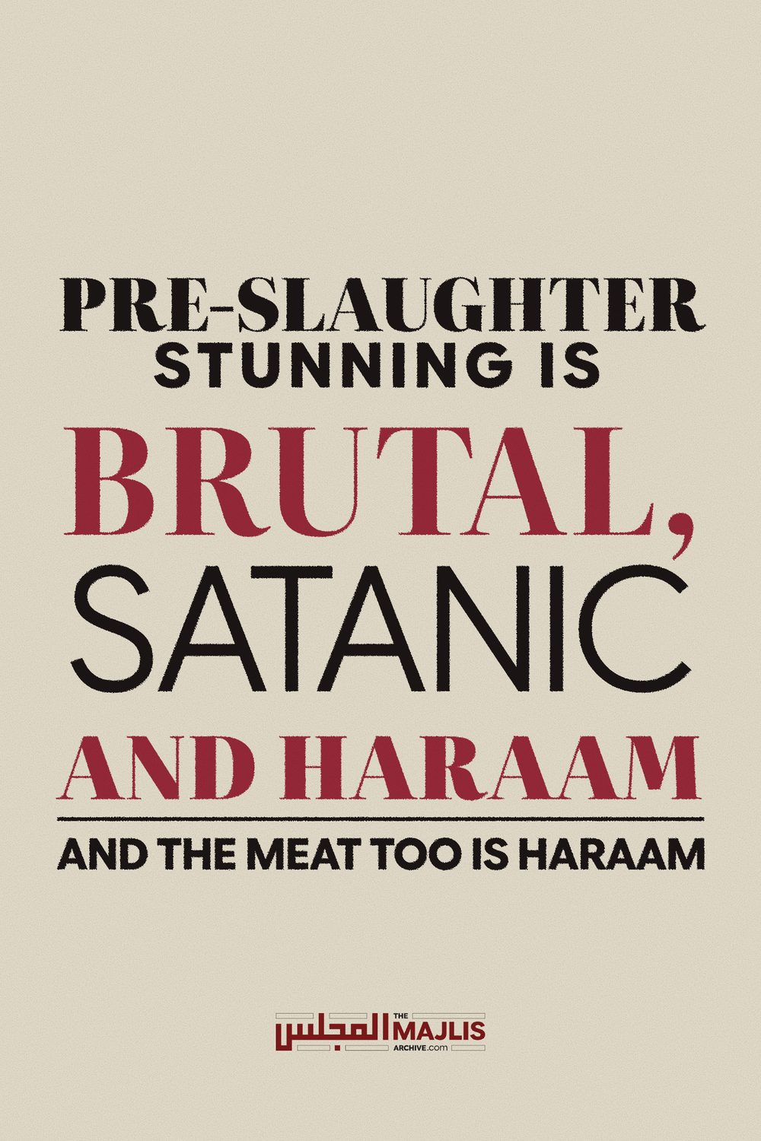

PRE-SLAUGHTER STUNNING IS BRUTAL, SATANIC AND HARAAM
The Majlis · Voice of Islam
Mujlisul Ulama of South Africa

About this edition
This is a reproduction by The Majlis Archive (themajlisarchive.com) of a publication of The Majlis, Mujlisul Ulama of South Africa, made and published with their permission.
The PDF as The Majlis issued it is the original. This edition was read from that PDF's own structure and checked against it letter for letter; where the two differ, the PDF is correct.
Checked: 59 paragraphs, 0 differing; a second, independent PDF reader finds 100.0% of the PDF's words here.
Nothing has been reworded, added or removed.

PRE-SLAUGHTER STUNNING IS BRUTAL, SATANIC AND HARAAM AND THE MEAT TOO IS HARAAM

By: The Majlis PO Box 3393 Port Elizabeth, 6056 South Africa

STUNNING IS HARAAM - CONSUMING STUNNED ANIMALS IS NOT PERMISSIBLE

STUNNING – A BRUTAL ACT OF A BRUTAL SHAITAANI SYSTEM OF KILLING ANIMALS
Question In its fatwa on stunning animals before slaughtering, the Mufti of Darul Ifta Azaadville says:
"However, the wrongfulness of the act of stunning does not influence the lawfulness (Hillat) of the meat of the animal which was stunned, and does not necessarily mean that all stunned animals are Haraam to consume… If one is certain that the animal was indeed alive at the time of a proper Halaal slaughter, then the meat of such an animal will be Halaal to consume. On the other hand, if it is established that the animal was indeed dead at the time of slaughter, such an animal will be Haraam to consume…"

Answer
How will every man in the street be able to establish if the stunned animal/chicken was dead or alive at the time of the killing? Millions and millions of chickens are brutally killed daily. So how should Muslims establish what the mufti says in his fatwa?
This is a typical zig zag fatwa which is an art in which today's muftis are adept. They excel in sitting on the fence. Neither are they here nor there. Not on this side nor on the other side. While a fatwa is for public consumption and for providing guidance to the masses, this fatwa of Azaadville simply compounds the issue and leaves the community in the limbo of ambiguity. It just does not offer any guidance whatsoever.
The only thing the mufti has done was to regurgitate technicalities from the Fiqh Kutub. Every Tom, Dick and Harry is fully aware of the Hanafi technicality that if there is life in an injured animal at the point of slaughter, the meat will be halaal although the Shaafi' Math-hab differs with this view of the Hanafi Math-hab. According to the Shaafi' Math-hab all the chickens and animals stunned -100% of them – are Haraam. The Shaafi' definition of life in this context differs with the definition proffered by Imaam Abu Hanifah (Rahmatullah alayh).
Imaam Abu Yusuf (Rahmatullah alayh) and Imaam Muhammad (Rahmatullah alayh), who are next in rank to Imaam Abu Hanifah (Rahmatullah alayh) are in agreement with the Shaafi' view which is also the view of the other Math-habs. An injury which for a certainty leads to the death of the animals is fatal. Such animals which never recover and will die as a consequence of stunning thus are haraam according to the Shaafi' Math-hab and numerous of the Hanafi Fuqaha.
Despite the view of Imaam Abu Hanifah, all stunned meat in our time and context is Haraam, not only in terms of the Shaafi' Math-hab and the view of many very senior Hanafi Fuqaha such as Imaam Abu Yusuf (Rahmatullah alayh) and Imaam Muhammad (Rahmatullah alayh), but on the basis of the reality of the following facts:
(1) Innumerable animals die as a consequence of stunning. Thus, such animals and chickens are subjected to mock slaughter after they have died. To ascertain this reality it is necessary to refer to researches made by independent Muslims and kuffaar experts. The word of the carrion certifying devils is absolutely rotten. They may not be consulted for ascertaining this fact.
(2) The system of killing the animals is absolutely brutal and satanic. It is HARAAM to proffer Kitaabi technicalities to accord acceptability and permissibility for this shaitaani system of brutal killing which Rasulullah (Sallallahu alayhi wasallam) had termed "Shareetatush Shaitaan (the slaughter of the devil).
(3) The total lack of viable Muslim supervision. We are not dealing with an isolated animal which was injured and quickly slaughtered. We are dealing with a huge, colossal, monstrous Satanic commercial industry in which the objective is only pecuniary – haraam boodle. The assurances of these devils cannever be accepted. But zig zag muftis will base their zig zag fatwas on a technicality torn out from the Kutub and applying it to a context for which the technicality was never intended. The technicality was not intended by the Fuqaha to give credibility, acceptability and permissibility for Shareetatush Shaitaan.
So, regardless of the zig zag argument that if the animal shows signs of life, its meat is halaal, the issue is that these muftis are halaalizing a satanic system of brutal killing which the Akaabir Ulama have branded as tantamount to kufr. If one peruses the fatwa of Hadhrat Maulana Ashraf Ali Thanvi (Rahmatullah alayh) and of other Akaabir Ulama, one immediately perceives the abhorrence and the hurmat which extends to the so-called 'halaal' meat – halaalized by the zig zaggers.
On the other hand, the fatwa of Azaadville dilutes the abhorrence and provides a loophole and an escape route for the likes of the shayaateen of SANHA. Despite what the mufti says in his fatwa of the hurmat of the system, it rings hollow because it does not stem from the basis of Ikhlaas and concern for the Shariah, hence the welfare of the animals is of absolutely no concern to the mufti despite the fact that he is aware of the concern and severe rebuke of Rasulullah (Sallallahu alayhi wasallam) for the haraam brutal act of mutilating the animal prior to slaughter.
The function of a mufti in the acquittal of his fatwa should not be fence-sitting designed to please this one and that one, nor should it be the introduction of technicalities suited for the Talaba in the Madaaris. The mufti should understand that his fatwa should be an instrument to guide the people and to bring them closer to Allah Ta'ala by means of creating in them the understanding of Taqwa which is the theme of the Qur'aan Majeed from page one to the end, and which is so conspicuously and vigorously propounded and propagated by the Ahaadith and Sunnah, and so diligently adopted practically by the Sahaabah and the Auliya. But today, due to the corrupt motives of the Molvis and Muftis in general, Taqwa has become a strange concept to frown on.
The extremely lackadaisical, in fact inimical attitude shown towards Taqwa makes the fatwas of today a zig zag advice which dilutes the Maqsood of the Deen and opens up wide avenues for Mushtabah and Haraam to make inroads. Thus, the ruin of the Ummah is primarily at the doorstep of these zig-zag muftis and molvis.
The fatwa of Azaadville is for condoning the evil, and blatant haraam operations of outfits such as SANHA. Therefore the fatwa of the Azaadville Mufti is designed to provide a licence for their brutal system of Shareetatush Shaitaan to perpetuate the devilish profession of haraam certification by the likes of SANHA. It is for this reason that the mufti's emphasis is on his hallucinated hillat of the killed animals and chickens whereas the intelligence and heart of a Man of the Deen should be concerned with the gross and flagrant violations of the Shariah - such violations which at a bare minimum are, as described by Hadhrat Maulana Ashraf Ali Thanvi (Rahmatullah alayh) as being tantamount to kufr, and according to us who are fully cognizant with the reality on the ground, it is brazen kufr.
It is kufr because:
• The kuffaar system of killing is being preferred over and above the Thabah system ordained for this Ummah by Allah Ta'ala.
• This kufr preference has rendered the Islamic system insignificant in the eyes of the vast majority of Muslims. Even Muslims who operate commercial killing plants, have absolutely no regard for the Waajib Islamic system of Thabah.
• Animals and chickens killed by the Haraam shaitaani system are so-called 'slaughtered' after having been killed by stunning and other torture methods. Animals are killed on a massive scale prior to Shareetatush Shaitaan which these muftis and their handlers (SANHA, etc.) term 'thabah' to hoodwink Muslims and to promote the sales of the Carrion Cartel of certifiers.
• The Thabah system of the Shariah has been practically abrogated by not only human shayaateen such as SANHA, but by the maajin and moron muftis who extravasate haraam licences of permissibility from Fiqhi technicalities which have no application in the commercial mass killing of animals context prevalent in this age.
The emphasis of the mufti should be on the preservation of the purity of the Shariah, the Imaan and Akhlaaq of the Ummah. Instead, the emphasis is on providing scope for the haraam, cruel kuffaar system of killing which produces haraam meat to which Muslims have become addicted on a massive scale, thus ruining and destroying their health and Imaan. Allah Ta'ala commands in the Qur'aan Majeed:
"O People! Consume what is halaal and tayyib and do not follow in the footsteps of shaitaan. Verily he is your declared enemy. He instructs you with only
Fahsha (immorality) and Munkar (evil), and to utter about Allah (and His Shariah) what you know not."
Aayaat and Ahaadith of this nature are of no concern to the muftis of this age. Worldly objectives – Hubb-e-Maal and Hubb-e-Jaah – are their motivating factors. That is why they issue zigzag fatwas which misguide, instead of guide. Solely for providing scope for the likes of SANHA has the mufti diverted focus from the 100% satanic haraam killing system to his convoluted conception of hillat which he seeks to justify with Fiqhi technicalities which have no relationship to the massive devilish killing system on which pivots the production of the Carrion(Jeefah) certified by the agents of Iblees.
Despite there being more than adequate 'scientific' evidence of the experts to convince any sincere person - Muslim or Kaafir – that stunning and other brutal pre-slaughter methods kill innumerable animals, the mufti is at pains to proclaim the killed animals and chickens 'halaal'.
Let us momentarily assume that all the animals brutally killed by the devilish kuffaar system are 'halaal', then too, the mufti has no right to proclaim such meat produced by the Devil's system of killing to be halaal. It is imperative that he issues a fatwa of hurmat which he could say is hurmat lighayrihi. However, setting aside the assumption, we say that without doubt the killed animals and chickens are haraam. The Mufti should have formulated his fatwa in the light of the amal of the Sahaabah and the attitude of the Fuqaha in general. Sahaabah would refrain from eating even halaal meat if the slaughter was not 100% in accord with the Shariah.
According to the Shaafi' Math-hab, despite the meat being halaal, it is Makrooh Tahrimi (forbidden and sinful) to consume the meat if the slaughter is not in strict accord with the Shariah. Today's miscreant moron 'scholars' of the Shaafi' Math-hab, labour to convey the idea that animals are halaal even if Tasmiyah is not recited. They will cling to this technicality while conveniently ignoring that their Math-hab's Fatwa is that it is not permissible to consume such meat. Furthermore, if Tasmiyah is intentionally neglected on the basis of it being insignificant and not necessary, then such a belief will be kufr.
The issue of wholesale and massive neglect of Tasmiyah on the chickens which are killed by the million on a daily basis, is another issue which has to be explained in another article. This discussion pertains to brutal acts inflicted on animals prior to slaughter.
It is grossly erroneous for the mufti to divert focus from the killing system to the question of hillat of the meat. On the contrary, the focus should be on the satanic killing system, not on the meat/chicken. While the mufti says: "Yes, we should try our best to consume meat which was not stunned and support Muslim businesses who supply unstunned meat.", his advice rings hollow and in fact is drivel because he is fully aware that the vast majority of Muslims are addicted to the carrion halaalized by SANHA, Shaitaan & Co. It is the imperative obligation of the mufti to endeavour to wean Muslims from their carrion addiction.
His statement "best to consume" 100% halaal and tayyib meat produced by the Shariah's Thabah system, is a gross understatement, lackadaisical and detracting from the fundamental importance of consuming only meat produced by the Islamic system.
Another misleading statement of the mufti is: "The wrongfulness of the act of stunning does not influence the lawfulness (Hillat) of the meat of the animal which was stunned…." At the very least, we shall exercise Husn-e-Zann (a good opinion) and say that the mufti has not applied his cognitive senses. He made this statement with application of his mind. How can the meat produced by the system of Iblees not be influenced with shaitaaniyat? The Shariah is not a conglomeration of Fiqhi technicalities. The greater force and emphasis of the Shariah is on the preparation for the Meeting with Allah Ta'ala, and this necessitates purification of the nafs and a high degree of spiritual elevation which is acquirable only on the basis of Taqwa, Tawakkul, etc.
Most certainly, 'the wrongfulness of the act' does influence 'the lawfulness of the meat.' Meat which is the product of Shareetatush Shaitaan will be influenced by satanism. The barkat is eliminated and shaitaaniyat afflicts the meat. This shaitaaniyat exercises a detrimental effect on of Rooh of the Mu'min. There are innumerable episodes and advices of the Auliya to convince a sincere Muslim of the spiritual and even physical harms of consuming even halaal food which is not tayyib or halaal food which is affected with doubt or contaminated with dirt or with even the touch and gaze of fussaaq, fujjaar and zaalimeen. How can a mufti disgorge such an egregiously false statement as to say that the haraam, shaitaani system of brutally killing animals does not exercise an affect on the meat? The so-called 'lawfulness' of the meat is greatly affected by the satanic system of brutal killing.
The mufti says in his fatwa:
"The stance of our Darul Ifta is also that stunning prior to slaughter is an unacceptable and un-Islamic method ……."
This lackadaisical acquittal is mere cosmetic and designed to mislead and detract from the actual objective of the fatwa which is to provide scope for permissibility of the devilish operation of the likes of SANHA. That is why, the mufti ends off his zigzag fatwa with the emphasis on his imaginary 'hillat' of the meat. Instead of emphasizing the hurmat of the system of the devil and instructing Muslims to abstain from satanically produced meat and chickens, his motive is to keep the avenue of hillat open for the likes of SANHA. It is also the practice of Azaadville Darul Ifta to send its ifta students to gain experience from SANHA on 'halaal' slaughtering and the so-called devilish 'halaal' slaughtering system on which SANHA basis its copro-certification of jeefah (carrion). It is an utter disgrace for the Madrasah to allow its students who will tomorrow be regarded as molvis and muftis to be indoctrinated and brainwashed by a rubbish jeefah certifier who demonstrates blithe disregard for the Shariah. Halaalizing stunning of animals as does SANHA is an illustration of gargantuan hypocrisy which is stunning. It is imperative that the Madrasah puts an end to the disgraceful practice of demeaning and despoiling its Talaba - the practice of submitting them to SANHA's indoctrination. What concern and what respect will such molvis show for the Shariah when their Imaani inhibition to haraam is desensitized and even eliminated during their student-days?
Imaam Maalik (Rahmatullah alayh) was informed that the butchers had dug a huge hole and were slaughtering animals around the hole. Animals were being slaughtered in full view of other animals. Imaam Maalik (Rahmatullah alayh) instituted immediate steps to debar the butchers from slaughtering. They had to be firstly educated of the Shariah's system of Thabah before a licence would be issued to allow them to slaughter.
The concern of Imaam Maalik (Rahmatullah alayh) was not the hillat of the meat. Despite the actual Thabah being correct, he prohibited them from slaughtering because the method of their system was haraam. What can be said about the vile, brutal, satanic system halaalized by human devils? The mufti is more concerned about finding latitude to accommodate the haraam shaitaani killing system than the system ordained by Allah Ta'ala.
For the Azaadville mufti, he believes that he has scored a wonderful point over the questioner by minimizing the notoriety and satanism of the haraam 'close to kufr' killing act. Thus he emphasises that it is "close to kufr", not kufr. Is "close to kufr" an act which should be accommodated? A person who becomes addicted to 'close to kufr' acts, will soon be trapped into kufr.
If the mufti had the Deen at heart, he would have applied his mind correctly. He would have concentrated on the 'close to kufr' brutality, and not seek loopholes for accommodating the likes of SANHA. The mufti knows why he is zigzagging with his fatwa. Allah Ta'ala says in the Qur'aan Shareef:
"In fact, man has insight over his nafs even if he puts forth excuses."
The muftis nowadays make great endeavours to fool themselves. They smother their Imaani conscience with corrupt interpretation and stupid 'hikmah' to disgorge such fatwas which widen the chasm between the masses and Allah Ta'ala. Instead of seeking ways to remedy the evils in Muslims, they churn out such fatwas which entrench the haraam in which Muslims are trapped. The mufti's fatwa is designed to accommodate the kuffaar system of slaughter and to condone the consumption of the meat produced by a brutal system described as Shareetatush Shaitaan by Rasulullah (Sallallahu alayhi wasallam).
The kuffaar system of killing is the issue, not the hillat of the meat. Muslims should develop an abhorrence for consuming meat and chickens produced by a most abhorrent devilish system of killing. Besides the issue of the actual method of killing, we have explained in detail in many articles and booklets why the meat and chickens of this evil killing system are haraam. All of this information is available on our website.

