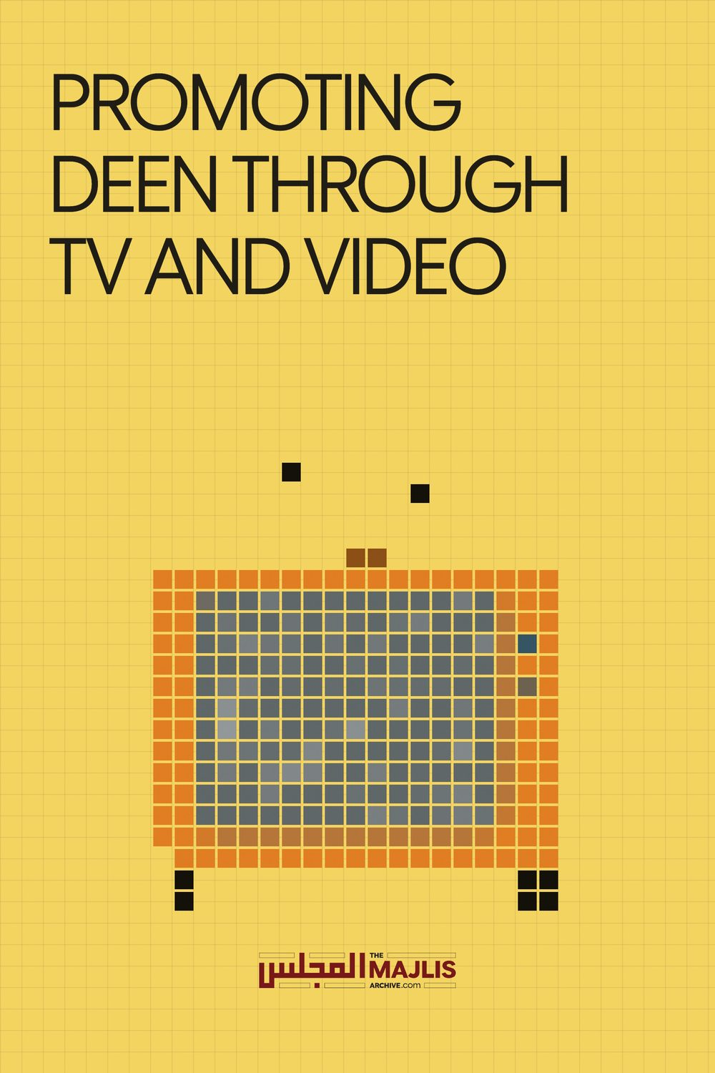

PROMOTING DEEN THROUGH TV AND VIDEO
The Majlis · Voice of Islam
Mujlisul Ulama of South Africa

About this edition
This is a reproduction by The Majlis Archive (themajlisarchive.com) of a publication of The Majlis, Mujlisul Ulama of South Africa, made and published with their permission.
The PDF as The Majlis issued it is the original. This edition was read from that PDF's own structure and checked against it letter for letter; where the two differ, the PDF is correct.
Checked: 58 paragraphs, 0 differing; a second, independent PDF reader finds 100.0% of the PDF's words here.
Nothing has been reworded, added or removed.

Published by: YOUNG MEN'S MUSLIM ASSOCIATION P.O BOX 18594, Actonville, 1506 Benoni, Gauteng South Africa

HARAAM PROMOTION OF DEEN BY TV AND VIDEO
BY HAZRAT MAULANA ABDUL HAMID (DB) – PRINCIPLE OF DARUL ULOOM AZAADVILLE AND SENIOR KHALIFA OF HAZRAT MAULANA HAKIM AKHTAR (RA)
The Ulama and public are faced with a dilemma regarding the usage of the television as a means for defending and promoting the Deen of Islam. Some look at it as a necessity and feel it should be allowed, while others are of the opinion that there is no real necessity, thus its usage should remain impermissible, as it has always been. Those who justify its usage do so on the following premises:
REASON 1 – Islam is constantly under attack and it is our duty to defend it.
Our feelings regarding this – Islam has been under attack since its very inception. During the era of Rasulullah sallallahu alaihi wasallam and the Khulafae Rashideen, in Makkah Sharif, and thereafter in Madinah Sharif, Islam witnessed the greatest of threats and attacks that shall probably ever be made against it. The answer to these attacks however, was always given on our (Islam's) platform and not on the platform of the kuffar, i.e. Islam counter attacked all those attacks solely on the basis and with the aid of the Quran Majid.
It is quite clear that the kuffar and hypocrites would neither, with an open heart, read the Quran Sharif, nor would they ever be prepared to listen to it. Their work was only to object. The Quran Sharif gave answers to all the objections levelled against it, but at the same time explained that these answers shall only satisfy those who believe, those whose hearts are not filthy, those truly searching for the truth. Today the disbelievers are utilizing the TV in their attack against Islam, tomorrow they will make movies against it, and very soon they are sure to utilize their women in their war against Islam, (in fact they have already done so), are we going to now follow suit in repelling their attacks? Are we going to utilize the very material, no matter how filthy it may be, in our counter attack?!
Those non believers who are interested in Islam, have, are, and shall always be able to find their road to Islam, without the aid of the TV! From the fact that Ayaat would be revealed in answer to the objections of the disbelievers, we learn that it is our prime duty to provide answers to the doubts that the enemies of Islam attempt to create within the minds of Muslims. To do this however, there are more than enough permissible avenues that could be utilized; viz. the Masjid Mimbar, especially on the day of Jumuah, pamphlets and literature, Bayans of the Ulama etc.
REASON 2 – We have to propagate Islam.
Our feelings regarding this – There are more than enough permissible methods available for doing this, as explained above.
REASON 3 – If we are not going to use these TV channels which have been offered to us, then salafis and others shall grab the opportunity. We will be left out in the cold and will then be able to do nothing but grumble under our breaths about it.
Our feelings regarding this – The same applies here as has been explained under No. 1 above. We have sufficient means available and we just cannot allow ourselves to become followers of the enemies of Islam in choosing our methods of propagation, even though we be threatened that if we do not take the opportunity others shall grab it. If we are offered to eat stool, which we will never do, and if we don't take up the offer others will grab it, so if they want to eat stool, let them. And if the whole world starts eating stool, it does not mean that we must follow suit. If they want to, let them do it.
REASON 4 – A dubious convention of 2005 in Bangalore in India is cited for the legality of TV. According to information received from one of the conveners of the convention, the convention was initially arranged to bury, once and for all, the controversy surrounding the permissibility and use of TV for Islamic purposes. It was on this basis that many Ulama attended the convention. But alas, when the convention started, it was hijacked by the hosts and its theme changed into 'looking at the permissibility of TV and its usage for religious/political purposes.
During the convention, many spoke out against its permissibility, but the hosts would silence them with phrases such as, 'your time is up; give others a chance to speak; you are too loud; your approach is too strict and harsh; etc. In short, the whole convention was hijacked and steamrolled. This information was obtained from a senior and very reliable Ustad of Darul Uloom Deoband.
While writing this article I had been informed by a Mufti who was present throughout the three day convention that the final decision and verdict of the conference was issued by Hazrat Mufti Saeed Palanpuri DB of Darul Uloom Deoband. Hazrat, who had been appointed as head of all the proceedings, announced that the use of the TV cannot be declared permissible for Deeni purposes!
At that point, Hazrat Maulana Asad Madani RA commented that people are becoming murtad and you are still discussing whether it is permissible or not. Mufti Saeed Sahib looked at him, smiled, and maintained his stand that it is not permissible. The convention ended on this decision. The information dished out to us is completely in contrast to what transpired there! Even if this convention wasn't surrounded with so many question marks around it, it is in any case not a fatwa, but merely the opinions of those mentioned, who are not even Muftis!
According to information we have, one such Aalim told the Ulama of the Jamiat that leave the muftis alone, it is a political need of the time! If this is true, it is a very serious statement! If one were to spell out these words it would spell out as, 'Leave the Shariah, inter alia, leave Quran and Hadith and look at the political needs of the time!
The very fatwa of Darul Uloom Deoband, and so many other muftis and Darul Ulooms, who have always been seen as the true bastions of knowledge, do not permit the usage of TV at all for any purpose.
It is also very surprising and shocking that none of the muftis or Darul Ulooms of South Africa itself were ever consulted on the issue, forget getting a fatwa from them. Not even the resident muftis of the Jamiat itself!?
Let us now examine some of the harms and dangers of using the TV, even if for Deeni purposes.
1. It is mentioned in Bukhari Sharif that the worst punishment on the Day of Judgement shall be meted out to those who make pictures (of animate objects). One of the main objections to the use of the TV is the usage of pictures of animate objects. In another hadith, narrated by Imam Ahmed, a few other groups have been mentioned who shall also be receiving the most severe punishment on the dreadful Day of Qiyamat. Amongst them is that wretched soul who had killed a Nabi! "The worst punishment on the Day of Qiyamat shall be meted out to the one killed at the hands of a Nabi, or the one who killed a Nabi, the leader who opens the doors of evil, and the picture makers!" (Ahmed)
We can well imagine what a serious crime it is to kill a Nabi, and consequently what a terrible punishment will be meted out to such a person! This same punishment is mentioned for those who make pictures! In the making of pictures, all such people shall be included in the warning of receiving the worst punishment, who voluntarily participated in having it made; viz. those who make the pictures, those who voluntarily allow their pictures to be made, etc.
In which ever way these pictures are made, all who involved themselves in its process and aided it, even those who would view it voluntarily, could be in danger of facing this punishment. Whether it is by pencil, carved out, digital, or whatever process, it makes no difference, since its end is nothing but a picture. The warnings that have been issued are with regards to everything related to pictures of animate objects.
The issue behind these warnings is the picture itself, and not the way it is made. We can go into technicalities, discussing whether it is a, picture or not, but the bottom line is that in the eyes of simple minded folk, 'it is a picture' and it is on the understanding of the simple minded that laws in Islam have been issued. And then, to make the prohibition of TV even stronger, the very makers of these pictures have themselves declared it to be pictures in their manuals and encyclopedias!
2. In adopting the TV as a medium of imparting the knowledge of Islam, we shall be departing from the ways of our pious predecessors, whereas we have been commanded to tread in their noble path. Great warnings have been mentioned for those who depart from their ways! For example, Allah says: "Then after the pious came those who departed from their ways, destroyed the institute of salaah and followed their passions (their desire for pride and show); soon they shall meet a terrible fate!" "Then after the pious came those who inherited the knowledge of the Book of Allah, but preferred the useless things of this world (viz. pride and money) and vainly hoped that they will be forgiven!"
Why have we departed from the ways of our pious, illustrious, learned and noble elders? Why have we departed from the ways of Hazrat Mufti Sanjalvi RA, Hazrat Maulana Abdul Haq Umarjee RA, Hafiz Abdur Rahman Mia RA, Maulana Ansari RA, Maulana Muhammad Akhalwaya RA, Maulana Salloo RA, Maulana Abdul Qadir Manekpuri RA, Maulana Zubair Ali RA, Maulana Ahmed Hathurani RA, Maulana Ahmed Garda RA etc, etc?
Why have we abandoned the teachings of our pious predecessors under whom our Asatizah studied, amongst whom were giants like Hazrat Maulana Muhammad Zakariya RA, Hazrat Mufti Shafi RA, Hazrat Maulana Maseehullah Khan RA, and their Asatizah, with Hazrat Thanwi RA, Hazrat Madani RA, Hazrat Maulana Rashid Ahmed Gangohi RA, Hazrat Maulana Qasim Nanotvi RA etc. being in the frontline?
By abandoning their teachings and not treading in their path, we shall ultimately be separating ourselves from our glorious, noble, protected chain that links us directly to Rasulullah Sallallahu alaihi wasallam!
We can never accept new, Islamic models and abandon the classic model of Rasulullah Sallallahu alaihi wasallam! This alone is the path to Jannah, and that is where we want to reach and no where else! Rasulullah sallallahu alaihi wasallam ordered that we grasp firmly to the path which he sallallahu alaihi wasallam and the Sahaba RA treaded, as though we are biting onto it with our molars.
Let us not depart from our original and true path – the path of Jannah – and trade it in for some evil path of destruction! We don't have a choice in many issues which are beyond our control (though we should still cherish and love those ways); however, in things that are in our control, we should not depart from the original.
3. From the time that people began regarding photography of animate objects as permissible, the Rooh (spirit) of Islam began disappearing! Posh hotels and shopping malls had done already so much damage in eradicating the spirit of Hajj and Umrah. Now all this photography and videos have added nails to the coffin of the spirit of Iman and Islam! With TV Islamic programs, the entire spirit of Deen (true islam) will be removed, as has already happened in the middle east and other countries.
"Soon nothing will remain of Islam except its name, and nothing of the Quran but its writing (i.e. Islam and Quran shall become a mere custom, with none really concerned regarding what it really wants)"
A body without a soul is dead, it is not worthy of anything! So it has or will become of us. We will only be happy with an outward show of things, whereas there shall be no life and reality left. People will listen to Islam on the radio or watch it on TV and will feel that they have shown their loyalty to Islam, but will forget that practicing Islam is what is required! As it is, many are already found glued to the radio, spending valuable hours of the day and night of Ramadan, with no other purpose but to find answers for the Ramadan Quiz, or merely to just enjoy the entertainment. With so many hours being wasted, when shall the time for practice ever come?
Now if Islam has to come on TV, the little reality that is still left shall also be obliterated and only an outward show of Islam will remain. We may fool ourselves that we are good Muslims, but in the Aakhirah will we realize where we stand, but then it shall be too late.
CONCLUSION
Even if a fatwa is obtained on the permissibility of using TV for religious purposes, the harms in it are so many, and so grave, that for fair and reasonable thinking people, it can never be even envisaged. It will destroy the very fabric of our Deen.
Inevitably people will go onto other TV channels, which will totally destroy them, as has been witnessed and confessed to by Qadianis and Christians themselves, that they erred greatly by using the TV for their religious purposes. They confess that they lost, in particular, their youth to the devil in the process. Will our eyes still not open?!!
By Ulama appearing on TV, the public will regard it as permissible, and soon extend its permissibility to other programs, like news, sports, etc. and eventually to all the other filth and dirt that appears on the screen! And the sin of this will ultimately fall upon those who are promoting it! The TV is basically a means of entertainment, crime, and sexual vulgarity as affirmed by the experts of this field (Non Muslims). At the moment, those who watch news, sports, etc. regard it as wrong, and switch it off on Jumuah and during Ramadan, etc. but with Ulama now appearing on the screen, that sense of guilt will also vanish and no respect for Jumuah, Ramadan, etc will remain, nor will the urge or time to practice on Deen remain. Together with all this, the question shall always remain: is it correct for women to stare at men?
The means and methods of maintaining and promoting items and ideologies differ, as the item differs! The method of moving an ox wagon is by drawing it with oxen, this method cannot be used to fly a jet – there you need jet fuel! How stupid would it not be to attempt flying a jet with oxen!
Islam is the greatest power. It cannot be drawn and promoted by baatil and false, devilish means of Satan! Devilish means will only spread devilism. The truth of Islam will only flourish with pure and noble means. If the shoes don't fit, nobody chops his toes to make the shoes fit, either stretch the shoes or buy a bigger size! If Islam doesn't fit into modern times, do not cut and chop Islam, rather make the modern world fit into Islam!
The Tablighi jamaat has shown their success in being able to gather the hugest religious crowds and influence people from all sections of society – even non Muslims are influenced and are well introduced to the Tablighi jamaat. This they have accomplished without the use of any media means – radio or TV! Deen has spread to the four corners of the world without radio and TV! Why the sudden need today??
Our Asatiza (teachers), sitting on their places of teaching in Dabhel, Tadkeshwar etc. perhaps never traveled out of their provinces, yet they spread true Deen to the four corners of the globe. Through the Makaatib, Deen is being preserved and coming into the lives of millions. The Khanqahs have worked miracles throughout the annals of Islamic history in preserving and promoting Deen and in producing men of Imaan and Islam – not iron and steel. What is iron or steel in front of Imaan and Islam – absolutely nothing!
With Islamic schools, radio stations, and now TV, the information of Deen may increase, but Deen will be destroyed! In the beginning stages of Radio Islam, listeners were asked what they had benefitted from the radio station. A youngster phoned in to say that before he should read 5 paras of Quran Sharif, now he does not read at all! He is hooked on the radio, listening the whole day! Where is he ever going to find the time to practice? Deen is not to have information, it is to practice! When are the veils of our hearts going to be lifted? Are we ever going to come out of our cocoons, which the enemies very subtly have jailed us into?!
From first hand information that I have received, the agents of the devil study our Deen, and where they find dangers which we have been warned about in the Quran and Hadith, they use those very dangers to ensnare and trap us! For example, the Hadith that nothing will remain of Islam but it's name, that wealth and women are a fitna (test) for this Ummah etc. – the enemy promotes these very things in the Ummah to trap them – and they use the scholars, albeit in a very subtle form, at times not even known to those who are being used, for their sinister plots. These scholars in their ignorance and innocence still regard themselves as heroes and champions of Islam, and view the true upholders of the pristine Deen of Nabi Sallallahu alaihi wasallam as those of the camel age, backwards, etc.
Rasulullah sallallahu alaihi wasallam with great emphasis ordered that we grasp firmly onto Deen that he had brought. The Deen that we have been ordered to hold unto is not a new salafi or Turkish model of Deen of the 21st century, but rather the Deen of 1400 years ago!
Allah orders – "Believe like the Sahabah believed (of 1400 years ago)"
"If they believe as they (the Sahaba RA) believed, then are you guided (otherwise not)"
"(The munafiqeen said) Must we believe like these idiots (backward, camel age people, those with blinkers on their eyes etc."
"(Allah replies to their question) Know full well that it is they who are the idiots (i.e. those who regard themselves as advanced and modern)"
"Islam began as a stranger and shall return as a stranger as it began. So give glad tidings to the strangers." (Muslim Sharif) The Guraba (strangers) are those who 'look out of this world' and belong to the 'camel age'.
A hadith mentions that in later times, to hold on to true Deen will be like holding embers in the hand. This doesn't refer to a watered down Deen of the modern age, but rather to the original true Deen.
May Allah be pleased with us, guide us all to the correct path and accept it from us. Aameen.
(Please note – in the above article, the word TV has been used to include video bayans as well)

