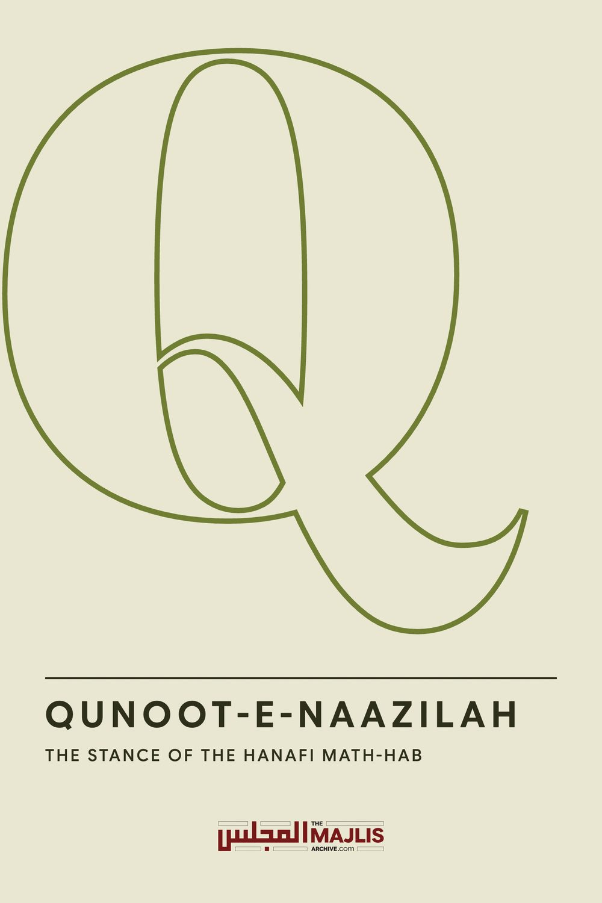

QUNOOT-E-NAAZILAH THE STANCE OF THE HANAFI MATH-HAB
The Majlis · Voice of Islam
Mujlisul Ulama of South Africa

About this edition
This is a reproduction by The Majlis Archive (themajlisarchive.com) of a publication of The Majlis, Mujlisul Ulama of South Africa, made and published with their permission.
The PDF as The Majlis issued it is the original. This edition was read from that PDF's own structure and checked against it letter for letter; where the two differ, the PDF is correct.
Checked: 128 paragraphs, 0 differing; a second, independent PDF reader finds 100.0% of the PDF's words here.
Nothing has been reworded, added or removed.

THE STANCE OF THE HANAFI MATH-HAB

MUJLISUL ULAMA OF S.A. PO BOX 3393 PORT ELIZABETH SOUTH AFRICA, 6056

QUNOOT-E-NAAZILAH
The controversy centering on Qunoot-e-Naazilah is the effect of jahaalah. Muslims of the Ahlus Sunnah Wal Jama'ah, which excludes the moron Salafis of our era, are not expected to become ensnared by the Salafi deceptive presentation of Ahaadith. The Ahlus Sunnah in our context of this era is confined to the Four Math-habs – Hanafi, Maaliki, Shaafi' and Hambali.
There are numerous Fiqhi differences in the masaa-il of the Mathaahib. It is the belief of the genuine followers of these Math-habs that all Four are on the Haqq, hence there is absolutely no need for dispute and enmity among the followers of the Math-habs. The differences of the Four Math-habs should be accepted and respected.
The Muqallideen should rigidly adhere to the masaa-il of their respective Math-habs without reviling one another over differences.
The topic of this discussion is Qunoot-e-Naazilah. In this brief article we present the viewpoint of the Hanafi Math-hab. It is not our intention to refute the dalaa-il of the other Math-habs. Followers of the other three Math-habs are at liberty to follow the rulings of their respective Math-habs. But they should exercise extreme care and refrain from bigotry and enmity on account of the different stance of the Hanafi Math-hab – a stance which is based on solid Shar'i dalaa-il.
According to the Hanafi Math-hab, Qunoot-e-Naazilah is Mansookh (Abrogated). The Hanafi Fuqaha have their valid Shar'i dalaa-il which we present in this brief article. This article is not an attempt to hoist the Hanafi Math-hab on Shaafis or Maalikis or Hambalis. It is meant for followers of the Hanafi Math-hab.
The advocacy of the Hanafi Math-hab is making dua silently and individually without any ostentation. But these moron Salafis of our time are fitnah mongers, hence they are at pains to disprove the stance of the Hanafi Math-hab.
The Hanafi Fuqaha have solid and valid dalaa-il to disprove the views of the other Math-habs; they have arguments to refute the narrations of the other Math-habs. However, since it is not our intention to embark on a futile exercise of disproving any of the Four Math-habs which we believe are the Haqq, we shall not venture into the realm of refuting the dalaa-il of the other Math-habs.
Destructive futility is the job of the moron Salafis who seek to impose their brand of the 'sunnah' on the followers of the Ahlus Sunnah Wal Jama'ah. For them the Qur'aanic response suffices:
"When the jaahiloon address them (the people of Haqq), they say (to the juhala): 'Salaam on you."

QUNOOT-E-NAAZILAH –THE HANAFI DALAA-IL
The dalaa-il (proofs) of the Hanafi Math-hab for the Naskh (Abrogation) of Qunnot-e-Naazilah
(1) Hadhrat Ibn Mas'ood (Radhiyallahu anhu) and a Jamaa't of the Sahaabah (Radhiyallahu anhum) narrated that Nabi (Sallallahu alayhi wasallam) recited Qunoot in Fajr Salaat for a month. In his Qunoot he cursed Rial and Zakwaan, and he would say: … Then (after the month) he abandoned it (Qunoot).
Bazzaaz narrated it in his Musnad, and At-Tabraani in his Mu'jam, and Ibn Abi Shaibah in his Musannaf, and At-Tahaawi in Al-Aathaar. All of them narrated from the Hadith of Shareek Al-Qaadhi.
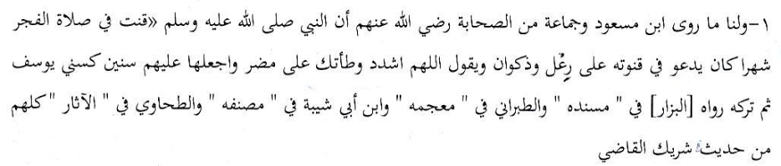
(2) Abu Humzah Maimoon Al-Qassaab narrated from Ibraaheem who narrated from Alqamah who narrated from Abdullah who said: "Rasulullah (Sallallahu alayhi wasallam) recited Qunoot only in Subh (Salaat)
for a month, then abandoned it. He did not recite it before nor thereafter. (Tahaawi)
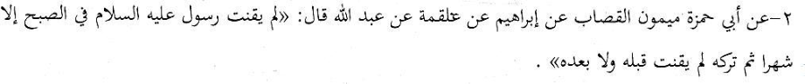
(3) Imaam Tahaawi said: "Ibn Abi Daawood Al-Muqaddami narrated to us that Abu Mi'shar narrated that Abu Humzah narrated from Ibraaheem who narrated from Alqamah who narrated from Ibn Mas'ood (Radhiyallahu anhum) who said:
"Rasulullah (Sallallahu alayhi wasallam) recited Qunoot for a month… When he was victorious over them, he abandoned Qunoot.
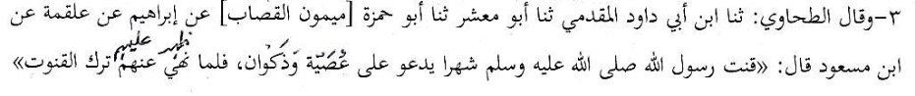
(4) Ibn Mas'ood (Radhiyallahu anhu) would not recite Qunoot in his Salaat. (Tahaawi)
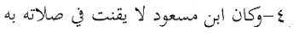
(5) Abdullah Bin Umar (Radhiyallahu anhuma) also narrated from Rasulullah (Sallallahu alayhi wasallam). He informed that Allah Azza Wa Jal had abrogated it (Qunoot) when he revealed to Rasulullah (Sallallahu alayhi wasallam) the Aayat: "You - O Muhammad!- have no option in the matter. Either He will forgive them or punish them for verily, they are zaalimoon." Aal Imraan, Aayat 128 (Tahaawi)
This Verse was revealed when Rasulullah (Sallallahu alayhi wasallam) was cursing the mushrikeen during the recitation of Qunoot.
Thus, this according to Ibn Umar (Radhiyallahu anhu) constitutes abrogation (i.e. Qunoot was made Mansookh by this Aayat). Therefore, he would not recite Qunoot after (the demise) of Rasulullah (Sallallahu alayhi wasallam). In fact, he would criticize those who recited Qunoot." (Tahaawi)
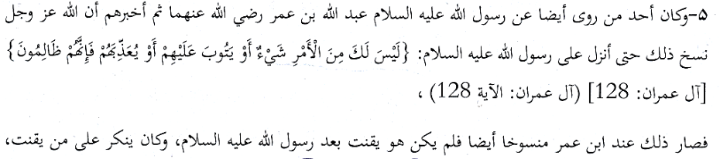
(6) Abdur Rahmaan Ibn Abi Bakr narrated about Qunoot recited by Rasulullah (Sallallahu alayhi wasallam). He informed that Allah Azza Wa Jal had abrogated it (Qunoot) with His Aayat:
"You – O Muhammad! – have no option in the matter. Either He will forgive them or punish them for verily, they are zaalimoon." Aal Imraan, Aayat 128 Therefore, in this is the Wujoob (incumbency / compulsion) of abstaining from Qunoot in Fajr." (Tahaawi)
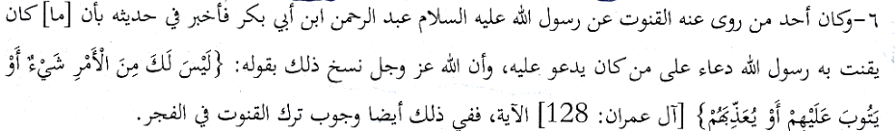
(7) "Muhammad Bin Al-Hasan narrates in his Kitaab Al-Aathaar that Abu Hanifah informed us, narrating from Hammaad Bin Abi Sulaimaan who narrated from Ibraaheem Nakh'i that Nabi (Alayhis salaam) was not seen reciting Qunoot in Fajr until he departed from the dunya."
After reciting Qunoot for a month in Fajr on the occasion of the episode of Beer-e-Moonah, Rasulullah (Sallallahu alayhi wasallam) did not again recite Qunoot.
(8) Ibn Maajah narrates in his Sunan from Muhammad Bin Ya'la, from Anbasah Bin Abdur Rahmaan, from Abdullah Bin Maati', from his father, from Umme Salmah (Radhiyallahu anha): "Verily, Rasulullah (Sallallahu alayhi wasallam) prohibited Qunoot in Salaatus Subh."
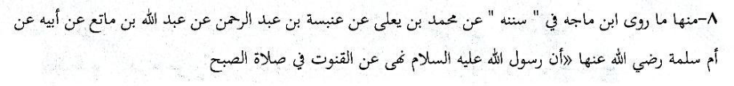
(9) It is narrated from Ibn Umar (Radhiyallahu anhu) that he said: "It is certainly bid'ah. Except for one month Rasulullah (Sallallahu alayhi wasallam) did not recite Qunoot. Thereafter he abandoned it." Bishr Bin Harb narrated it from him. (Ibn Adi in Al-Kaamil)
Baihqi said: "He is Dhaeef. Ath-Thahabi said: "Some of them (Muhadditheen) authenticated him, and An-Nisaai' deducted from him (i.e. used his narration as daleel)."
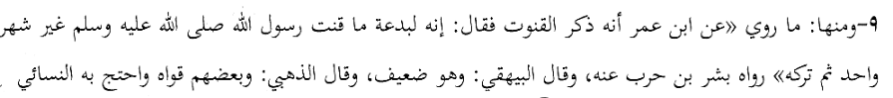
(10) Tirmizi, Nisaai' and Ibn Maajah narrated from Abi Maalik Al-Ashjaee who said: "I said: 'O my father Did you not perform Salaat behind Rasulullah (Sallallahu alayhi wasallam), Abu Bakr (Radhiyallahu anhu) and Umar (Radhiyallahu anhu)?' He said: 'Yes.' I said: 'Would they recite Qunoot in Fajr?' He said: 'O my son, it is an innovation.'
(11) Baihqi narrated from Abu Mijlas. He said: 'I performed Salaat with Ibn Umar (Radhiyallahu anhu), Subh Salaat. He did not recite Qunoot. I then said: 'Do you not recite Qunoot?' He said: 'I do not remember any of our Ashaab (reciting Qunoot in Fajr)." Ath-Thahabi commented: This narration from Ibn Umar (Radhiyallahu anhu) is Saheeh. Despite his rigid adoption of the Sunnah and him not remembering it (Qunoot) indicates that abstention from it (Qunoot) was permanent."
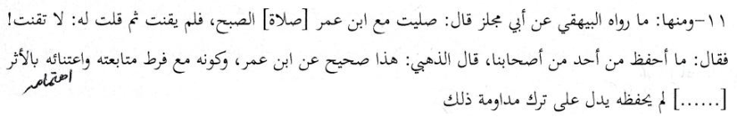
(12) "It is correct that Nabi (Alayhissalaam) had recited Qunoot in Maghrib Salaat, however, then one of the two unanimously was abrogated. Similarly was the other (abrogated)." (Aini)
(13) It (the view of abrogation) is supported by that which Bukhaari and Muslim narrated from Saeed and Abu Salmah from Abu Hurairah (Radhiyallahu anhu) who said: 'When Rasulullah (Sallallahu alayhi wasallam) intended to curse anyone, he would recite Qunoot after Ruku'… He would recite it audibly until Allah Ta'ala revealed:
"You - O Muhammad!- have no option in the matter. Either He will forgive them or punish them for verily, they are zaalimoon." Aal Imraan, Aayat 128 (Aini)
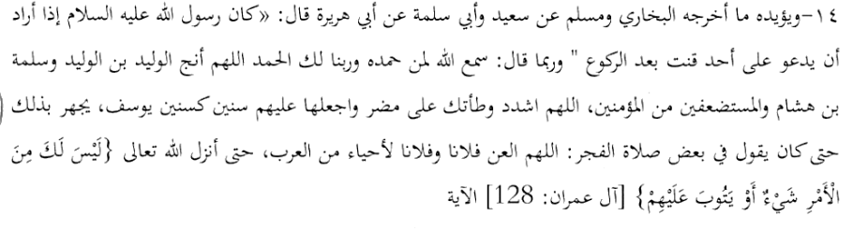
(14) Among the dalaa-il (for the abrogation of Qunoot) is that which has been narrated from Shaibaan who narrated from Ghaalib Bin Farqad who said: 'I stayed with Anas Bin Maalik (Radhiyallahu anhu) for two months. He did not recite Qunoot in the morning Salaat (Tabaraani). If abrogation was not established by him, he would not have refrained from it." Abu Zur'ah said: 'Shaibaan is truthful.' (Aini)
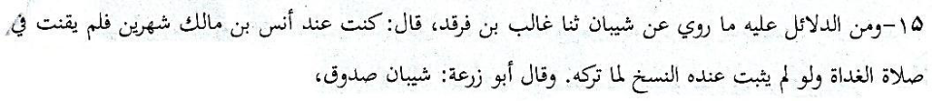
(15) Naafi' narrated from Ibn Umar (Radhiyallahu anhu) who said: "I performed Salaat behind Rasulullah (Sallallahu alayhi wasallam), Abu Bakr (Radhiyallahu anhu), Umar (Radhiyallahu anhu) and Uthmaan (Radhiyallahu anhu). They did not recite Qunoot. (Fathul Baari of Ibn Rajab) And, Alqamah, Masrooq, Al-Aswad and Amr Bin Maimoon performed Salaat behind Umar (Radhiyallahu anhu) who did not recite Qunoot. (Aini)
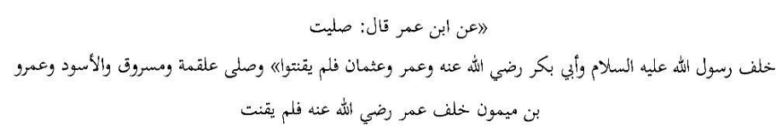
(16) Ibn Hibbaan narrated in his Saheeh, and Baihqi also from him (Abu Maalik Ashjaee): "I (Taariq Al-Ashjaee) performed Salaat behind Nabi (Sallallahu alayhi wasallam). He did not recite Qunoot. I performed Salaat behind Umar (Radhiyallahu anhu). He did not recite Qunoot. I performed Salaat behind Uthmaan (Radhiyallahu anhu). He did not recite Qunoot. I performed Salaat behind Ali (Radhiyallahu anhu). He did not recite Qunoot." Then he said: 'O my son: verily it is bid'ah."
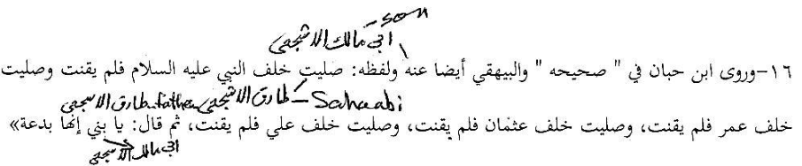
(17) Ibn Abi Shaibah narrated in his Musannaf: "Ibn Abi Khaalid narrated from Abis Samaa', from Saeed Bin Jubair that verily, Umar (Radhiyallahu anhu) would not recite Qunoot in Fajr.' And, Abdur Razzaaq narrated it from Ibn Uyainah and from Abi Khaalid. In At-Tahtheeb of Ibn Jareer At-Tabari it is mentioned:
Shu'bah narrated from Qataadah from Abish Sha'thaa' from Ibn Umar (Radhiyallahu anhu) similarly."
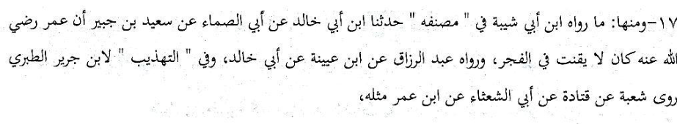
(18) Ash-Sha'bi said: "Abdullah (Radhiyallahu anhu) would not recite Qunoot. If Umar (Radhiyallahu anhu) –his father – had recited Qunoot, then Abdullah Ibn Umar (Radhiyallahu anhu) would have recited Qunoot. Abdullah Bin Umar (Radhiyallahu anhu) said: 'If the people walked in a valley and a mountain pass, and Umar (Radhiyallahu anhu) walked in (a different) valley and mountain pass, I will certainly walk in the valley and mountain pass of Umar (Radhiyallahu anhu)."
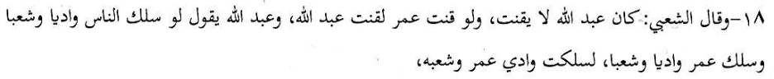
By this statement, Abdullah Ibn Umar (Radhiyallahu anhu) who did not recite Qunoot emphasized his abstention on the basis of the abstention from Qunoot of Hadhrat Umar (Radhiyallahu anhu).
(19) Ibraaheem and Qataadah said: "Abu Bakr (Radhiyallahu anhu) and Umar (Radhiyallahu anhu)
did not recite Qunoot until both departed (from this world)."
(20) Shu'bah narrated from Qataadah from Abi Mujliz: 'I said to Ibn Umar Al-Kabeer (Radhiyallahu anhu): 'What prevents you from Qunoot?' He said: 'I do not remember it (being recited) by anyone (of the senior Sahaabah)."
(Aini, Tabari in Tehzeebil Aathaar)
(21) Qataadah narrated from Alqamah from Abu Dardaa' (Radhiyallahu anhu): "There is no Qunoot in Fajr." (Aini, Tababari in Tehzeebil Athaar)
(22) Abu Mas'ood Ar-Raazi recorded in Usoolus Sunnah, and he firstly stated the Hadith of the one who said: 'Verily, Qunoot is an innovation.' Verily, Nabi (Alayhis salaam) recited Qunoot for a month then abandoned it.' Tirmizi said: "This Hadith is Hasan, Saheeh and the practice is according to it by the majority of the Ulama. At-Tabari narrated it from Ibn Kuraib."
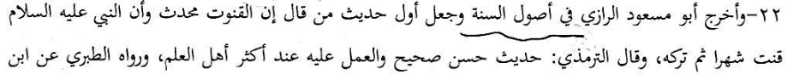
(23) Ibn Umar (Radhiyallahu anhu) was asked regarding Qunoot in Fajr Salaat. He said: 'No! By Allah! We do not know this."
(24) It is narrated from Saeed Bin Jubair that he said: "I testify that I heard from Ibn Abbaas (Radhiyallahu anhu) saying: 'Qunoot in Fajr Salaat is bid'ah.' Ibn Mundah narrated it."
(25) Laith Bin Sa'd said: "I did not recite Qunoot for 40 or 45 years except behind an Imaam who recited Qunoot." And, he said: 'I narrate in this matter the Hadith which came from Nabi (Alayhis salaam) that verily, he recited Qunoot for a month or for forty days until Allah Ta'ala revealed:
"You – O Muhammad! – have no option in the matter. Either He will forgive them or punish them for verily, they are zaalimoon." Aal Imraan, Aayat 128
Then Rasulullah (Sallallahu alayhi wasallam) abandoned it. He did not recite Qunoot thereafter until when he met Allah Azza Wa Jal. Thus, from the time I carried this Hadith, I refrained from Qunoot."
(Aini, Ibn Rushd in Bidaayatul Mujtahid)
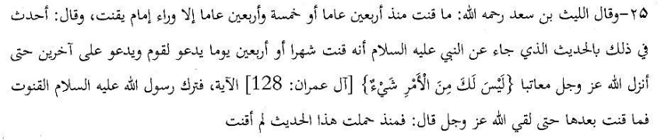
(26) Anas (Radhiyallahu anhu) narrated: "Verily, Nabi (Sallallahu alayhi wasallam) recited Qunoot for a month then abandoned it." Narrated by Abu Daawood and An-Nisaai'
The majority of the Ulama are of the view that Qunoot should not be recited in the Salawaat (plural of Salaat) on the basis of this Hadith and the Hadith after it. Some are of the view that Qunoot should be recited in Fajr. This is the view of Malik and Shaafi' (Rahmatullah alyhima). In fact Ash-Shaafi' said that if a calamity befalls the Muslimeen, Qunoot should be recited in all the Salawaat. He interprets the statement: 'He abandoned it' (as mentioned in the narrations) to mean that Rasulullah (Sallallahu alayhi wasallam) abandoned cursing the tribes mentioned. (Teebi)
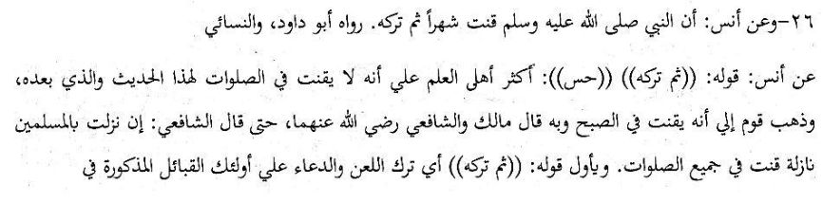
(27) "Then we say in negation to that before it: 'Verily, it (Qunoot) is mansookh (abrogated) as the Author of Hidaayah has explicitly stated, on the basis of what Al-Bazzaaz, Ibn Abi Shaibah, At-Tabraani and At-Tahaawi- all of them – have narrated from the Hadith of Shareek from Abu Humzah Al-Qassaab from Ibraaheem from Alqamah from Abdullah Ibn Mas'ood (Radhiyallahu anhu) who said: 'Rasulullah (Sallallahu alayhi wasallam) did not recite Qunoot in Subh except for one month then he abandoned it. Neither did he recite Qunoot before this (occasion) nor thereafter." (Ibnul Humaam)
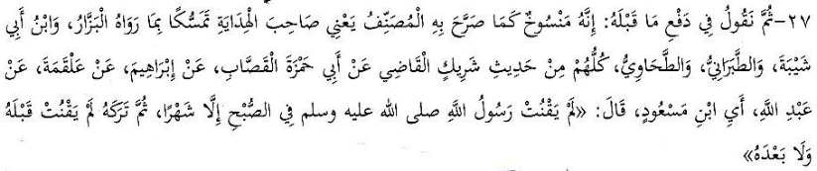
(28) "I (i.e.Ibnul Humaam) say with clarity regarding this issue pertaining to negation in general (of Qunoot) that which Abu Hanifah narrated from Hammaad Bin Sulaimaan from Ibraaheem from Alqamah from Abdullah Ibn Mas'ood (Radhiyallahu anhu): 'Verily, Rasulullah (Sallallahu alayhi wasallam) never recited Qunoot in Fajr except one month which was not the case before this nor after it. He only recited Qunoot during that month while cursing some people of the mushrikeen."
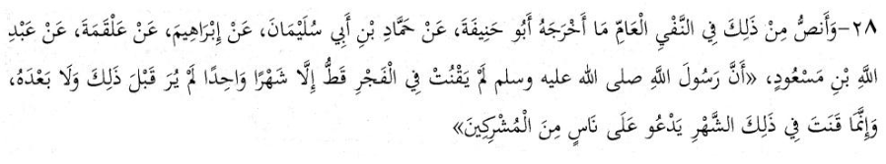
(29) Alqamah narrated: 'Abdullah Ibn Mas'ood (Radhiyallahu anhu) would not recite Qunoot in Salaatus Subh.' Tahaawi narrated it.
(30) "Alqamah Bin Qais said: 'I met Aba Dardaa' in Shaam. Then I asked him about Qunoot. He did not recognize it (i.e. did not know anything about Qunoot).' Tahaawi narrated it.
(31) "Naafi' narrates from Ibn Umar (Radhiyallahu anhuma): "He (Ibn Umar) would not recite Qunoot in any Salaat." Tahaawi narrated it.
(32) "Amr Bin Dinaar said: "Abdullah Bin Zubair would perform Subh Salaat with us in Makkah and he would not recite Qunoot." Tahaawi narrated it.
(33) "Abu Ja'far Tahaawi said: 'Thus, this is Abdullah Ibn Mas'ood (Radhiyallahu anhu) who never recited Qunoot at any time whilst the Muslimoon were at war with their enemy in the entire regime of Umar (Radhiyallahu anhu) or in the greater part of it (his Wilaayat). He (Ibn Mas'ood) would not recite Qunoot for it (the war). And, this is Abu Dardaa' (Radhiyallahu anhu) who rejected Qunoot, and Ibn Zubair (Radhiyallahu anhu) would not recite it whist at the time of being at war…..
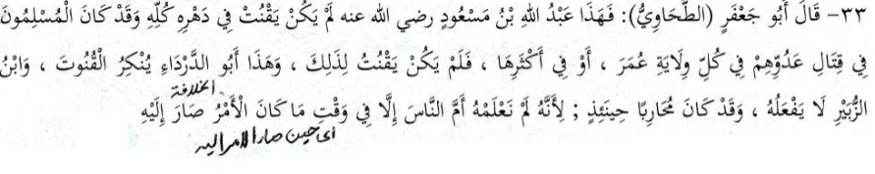
(34) "Abu Uthmaan An-Nahdi said: 'I performed Salaat behind Abu Bakr (Radhiyallahu anhu) for years and behind Umar (Radhiyallahu anhu) similarly, but I did not see any one of the two reciting Qunoot in Fajr." Imaam As-Sarakhsi and Al-Kaasaani narrated it."
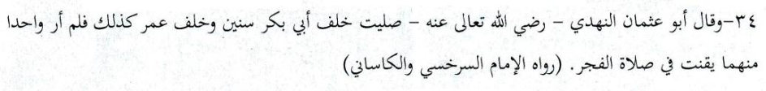
(35) Al-Qassaab narrated: "Shabaabah narrated from Qais Bin Rabee' from Aasim Bin Sulaimaan who said: 'We said to Anas Bin Maalik (Radhiyallahu anhu) that some people are of the opinion that Nabi (Sallallahu alayhi wasallam) perpetually recited Qunoot in Fajr.'
He (Anas) said: 'They have lied. Rasulullah (Sallallahu alayhi wasallam) recited Qunoot for one month cursing those Mushrikeen who were living." (Ibnul Humaam in Fathul Qadeer; Tabari in At-Tahzeeb, and Ibnul Haadi in At-Tanqeeh)
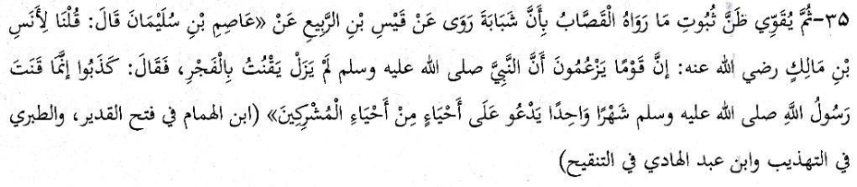
(36) One of the strongest arguments of the Ahnaaf is the explicit view of Imaam Abu Hanifah (Rahmatullah alayh), Imaam Abu Yusuf (Rahmatullah alay) and Imaam Muhammad (Rahmatullah alayh). These three illustrious Fuqaha and Aimmah Mujtahideen are the fundamental Pillars of the Hanafi Math-hab.
Elaborating the issue of Qunoot-e-Naazilah, Allaamah Zafar Ahmad states in I'laaus Sunan:
"It is apparent from the elaboration of At-Tahaawi in Ma'naaul Aathaar that Abu Hanifah and his two Companions (Imaam Abu Yusuf and Imaam Muhammad) are of the view that there is no Qunoot except in only Witr. There is no Qunoot during the state of war, nor at any other occasion.
Abu Ja'far (Imaam Tahaawi) said: This is Abdullah Ibn Mas'ood who did not recite Qunoot in his entire life despite the Muslims being at war with their enemies….
And here is Abu Dardaa' (Radhiyallahu anhu) who rejected Qunoot. And Ibn Zubair (Radhiyallahu anhu) did not practice it whilst he was at war…
It is thus established on the basis of what we have mentioned that Qunoot in Fajr is inappropriate whether during the state of war or on any other occasion… This is the view of Abu Hanifah, Abu Yusuf and Muhammad (Rahimahumullah Ta'ala).
Testifying for what we have narrated in this matter is the absolute Sukoot (silence) of the Ashaabul Mutoon on the issue of Qunoot Naazilah. Similalrly (is the absolute silence) of Ashaabush Shuroo' such as the Authors of Al-Hidaayah, Al-Badaai' and others. Furthermore, even Qaadhi Khaan has not made reference to it in his Fataawa … The narrations of Anas (Radhiyallahu anhu) and Abu Hurairah (Radhiyallahu anhu) support this view (of the Ahnaaf Aimmah)." (I'laaus Sunan, Vol.6)

THE VIEWS OF THE OTHER THREE MATH-HABS

Maaliki Math-hab
Qunoot is recited in only the Fajr Salaat

Shaafi' Math-hab
Qunoot-e-Naazilah is permissible in all the Fardh Salaat.

Hambali Math-hab
Qunoot-e-Naazilah is permissible in all the Fardh Salaat.

CONCLUSION
In the Kutub of the Fuqaha-e-Mutaqaddameen of the Ahnaaf are Baabs (chapters) for even Salaatul Istisqaa' (Salaat for Rain), Salaatul Kusoof and Khusoof (Salaat on the occasion of sun and moon eclipses), despite these Salawaat being extremely rare. Then there are elaborate details mentioned in the Kutub pertaining to Masnoon and Mustahab acts such as the number of times the Tasbeeh should be recited in Ruku' and Sajdah, the sitting positions, the method of raising the hands, etc. But there is total silence regarding Qunnot-e-Naazilah. No reference whatsoever is made in the Kutub of the Mutaqaddimeen, neither in the Mutoon nor in the Shurooh, to Qunoot-e-Naazilah.
This attitude and action of the Hanafi Aimmah Mujtahideen and Fuqaha of the earliest era of Islam are voluminous and explicit evidence for the Naskh (Abrogation) of Qunoot-e-Naazilah regardless of the meandering and vacillating views expressed by the Hanafi Ulama of many centuries later.
Thus, no one should begrudge us for adhering to the Fatwa of the Aimmah Mujtahideen of our Math-hab – the Fatwa of Imaam Abu Hanifah, Abu Yusuf and Muhammad who were the Imaams of Ijtihaad during the noblest of Ages. No one should attempt to impose on us the views of Allaamah Shaami and of the Hanafi Ulama who appeared on the scene many centuries after Imaam Abu Hanifah and others of the Aimmah.
Understand well, that if someone seeks to browbeat us by citing Allaamah Shaami, he will not succeed because we shall clobber, flatten and demolish him and his arguments with Imaam Abu Hanifah, Imaam Abu Yusuf, Imaam Muhammad, the illustrious Author Badaa'i, and of Hidaayah and many others. May the Rahmat of Allah Ta'ala be on them all.
We have presented the view of the Hanafi Math-hab to show that our stance is based on solid Dalaa-il of the Shariah. The intention is not to refute the arguments and stance of the other Math-habs. The Muqallideen should follow their own respective Math-habs. All Four Math-habs are the Haqq.

