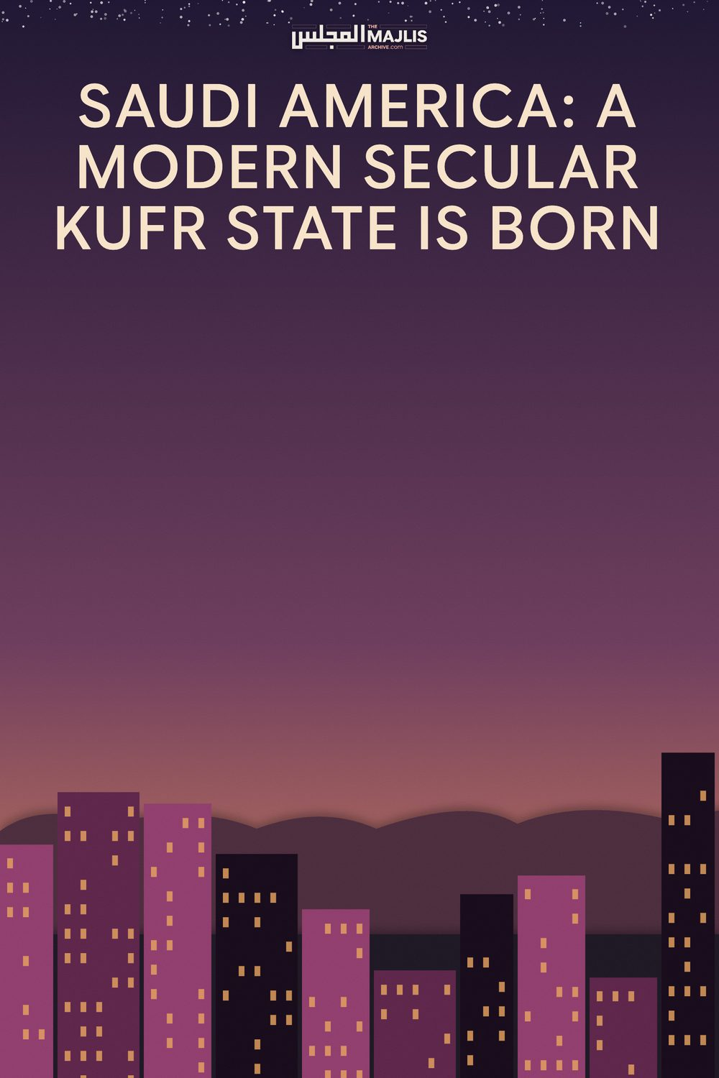

SAUDI AMERICA: A MODERN SECULAR KUFR STATE IS BORN
The Majlis · Voice of Islam
Mujlisul Ulama of South Africa

About this edition
This is a reproduction by The Majlis Archive (themajlisarchive.com) of a publication of The Majlis, Mujlisul Ulama of South Africa, made and published with their permission.
The PDF as The Majlis issued it is the original. This edition was read from that PDF's own structure and checked against it letter for letter; where the two differ, the PDF is correct.
Checked: 29 paragraphs, 0 differing; a second, independent PDF reader finds 100.0% of the PDF's words here.
Nothing has been reworded, added or removed.

Published by:
Young Men's Muslim Association, PO Box 18594, Actonville, Benoni,
1506, South Africa
From being the most powerful, honourable, respectable, chivalrous, pious, progressive, courageous and admirable nation once on earth, the Arab leaders of today have sullied the name and the race of our most noble Prophet Muhammad (may peace and blessings be upon him). The present Arab powers, far from their previous prestige, have indeed greatly deteriorated in stature to such an extent that they are now known for everything un-Islamic. These include their exploitation of labour, oppression of others, opulent and deca dent lifestyles, betrayal of their own race, war mongering, extremism in religion, manipulation and selective application of religion, and the cherry on the top – their open love, alliance, and adoration of USA and Israel. If this love was kept hidden in the heart, one could still be in doubt, but the Arab leaders have demonstrated themselves their willingness to be the Zio-Western underdog and poodle on all levels: economic, social, political and even religious. The only thing now left to change is the Saudi flag. The pure Kalimah (Islamic Creed) should be removed and be replaced by a woman in a bikini.
But being a friend of the devil is no ordinary task. You need to do two things to be afforded this disgraceful privilege. Firstly, you have to sell your religion – a demand which is currently being fulfilled; and secondly, you have to take your Lord and Protector to be the mighty West, the formidable East, or anyone else besides the One Almighty. This has already been done many decades ago. In return, you get protection of your throne and license to kill your own people.
These leaders profess Islam outwardly, but our most noble Prophet Muhammad (may peace and blessings be upon him) desisted from the type of behavior openly exhibited nowadays. For starters, our most noble Prophet Muhammad (may peace and blessings be upon him) refused to be crowned a king by the Quraish, to be treated like a king, to live like a king, to dress like a king, to be given the powers and privileges of a king, and to being given the status of a legislator king. But today's Arab rulers want to be styled as "King" and 'Emirs." What difference is there then between them and people like Firoun, Qarun, and Abu Jahal? Let it be known that such leaders do not represent the Muslim ummah, nor the lands they rule over. Rather, they represent the great demon Iblees, and his terrorist henchmen in the USA, UK, France, India, Israel and in other countries leading the trend of mass murder, mass corruption, and mass destruction on earth. Muslims do not regard such leaders as their guides, even if they are styled "Custodians of the Two Holy Mosques," and appear in holy garb now and then. They are just secular political leaders who have turned their back on Islam and are enjoying the sunshine and hay of this earth for as long as they can.
Although Arab treachery has been prevalent for many years, albeit covertly, it has now taken a bold twist with the rise of the present Crown Prince MbS, a mere lad of 32, who seem to be bent on satanising the Holy Lands upon which our noble Prophet Muhammad and his venerable Sahabah (Companions) trod. Swinging from the ultra-conservatism to ultramodernism, women who were forced to don full body covering and not allowed to drive at all, are now allowed to go naked on 'international standard' resort beaches, travel without maharim (legal guardians), seek employment in the private sector, and attend musical concerts, cinemas and night clubs. The once feared "Shariah Police" are now not only downsized, but also downdumbed. Having previously had far reaching powers, they now can only offer friendly 'advise' to transgressors with no legal clout at all. Shops can now remain open during prayer times, and nude billboards are appearing all over the scene. The new reforms have largely taken women out of the sanctity of their homes and transformed them into sexual symbols.
But more fearful developments have taken place on the religious front. For years, leading scholars bold enough to criticize the policies of the Kingdom have been silently jailed, but this year more than 40 top-ranking shuyookh have been jailed in one fell swoop - jailed solely because they speak the truth to a tyrant taghoot. Shortly thereafter, the world was shocked when one the famous royal blue-eyed Imams of the Haram said that Israel is an ally to the Muslims, and an Imam who spoke out against Israel on a Jumu'ah platform was dubbed "an escaped madman" and forcibly removed from the podium. Sadly, all the current Imams and teachers in the country are state-owned and state-controlled. Teaching Islam for them is just like teaching a history lesson to a bunch of 8 year olds. Every talk is scripted and monitored, and every lesson delivered is recorded.
But if this is not serious enough, to further appease their western patrons, all the university and madrassah Islamic textbooks of the country have been sent to the Pentagon for "revising and modernizing." I have not seen any of these "Pentagon approved" textbooks yet, but I'm pretty sure they will probably contain the following teachings:
1) All religions are equal. The Jew, Christian, Buddhist, Hindu and Taoist are all equal. Everyone can pray in anybody's temple, in whichever way, via an idol, an image or a bonfire, it will be the same God. Any person from any race can intermarry too, and the forbidden teachings of one religion will not apply to followers of the next religion.
2) Muslims are a peaceful people. When others murder, rape or bomb them, it's because of their own sins, and a form of well-deserved divine punishment upon them. There is no such a thing as Jihad, speaking the truth or defending the oppressed. Even when children of six and grandmothers of 68 are gang raped, mind your own business, as these are internal issues of different countries.
3) The current Muslim western-approved political leaders are your true leaders and spiritual guides. They are not the law, but above the law and divine. They need to be obeyed in all respects, even in the disobedience of the One and True Almighty. Fear them, not the Almighty. They are wise, powerful, sinless, and your ticket to peace.
4) Everyone has a choice on how to live and to treat their body. The LGBT (Lesbian, Gay, Bisexual, & Transgender) movement is legitimate, and sexual perversity is a natural disposition. Qur'anic references to homosexuality refers to the act of rape (forced sexual intercourse), not the nature of the intercourse.
5) Israel has a right to exist and is unilaterally entitled to the land they illegally invaded. Masjid al-Aqsa belongs to the Zionists, since the conquest of Jerusalem by Sayyadina Umar ibn al-Khattab is not recognized by international secular law. Besides, both being Semite, the Jews and Arabs are brothers. The Palestinians and all those who support the resistance constitute an "Axis of Evil" and must be eradicated.
6) Everyone should adopt Sufi Islam and indulge in all forms of weird dancing and chanting to enhance their spiritual states. The study of the Qur'an, Sunnah and any authentic Islamic literature should also be abandoned. Rather just blindly follow and over-venerate your Shaikh (Sufi Mentor) who would most probably be on the payroll too. If you want to protest or say anything against the government, do so in a peaceful online petition or in a controlled street demonstration. Remember, trouble-makers are always marked.
7) The current world order is not to be challenged. Politically, your fate is sealed and humiliation is your destiny. All things good and pure are now old-fashion. If a Muslim desires a peaceful existence, he/she should modernize and be in the service of the prevalent philosophy. There is no such a thing is ummatic brotherhood, a desire to unify the Muslim world under a righteous Caliph, forbidding the evil or promoting the good. Every person should be for himself, and avail himself to all the attractions and pleasures of the world currently on offer, even in the Holy Lands.
Now having firm control over the religious class and the masses, even the Royal family and political elite have not been spared. In a blitz operation, over 200 members of Saudi elite were held to ransom in the Ritz Hotel, and only released after their fortunes were looted, and their economic and political clout vastly diminished. Everything now seems to be in control for MbS, but things are looking bleak. When the Saudis held fast to their religion, they were prosperous to a degree. But as soon as they started modernizing and war mongering, things have changed. Saudi currently is heavily indebted to the IMF. Unemployment continues to rise, taxes have been introduced, and the price of oil is continuing to fall. In foreign affairs, the war in Yemen & Syria, and the dispute with Qatar appear to be in stalemate.
Our Lord Almighty says that one who lives a life in the remembrance of his Lord will be prosperous, and those who don't will have poverty stare them in the face. This is exactly what is happening in Saudi today. The more ills in the form of resorts, cinemas, casinos, concerts, night clubs, musicals, comic cons, and forbidden entertainment is introduced to bridge the deficit, the more people will suffer. As an example, a beach resort is proposed to be built on the Red Sea between the towns of Umluj and Al-Wajh in northern Hejaz. This project will involve '50 islands upon 34 000 square kilometers in a global up-market tourism and leisure mega-development' and will be 'governed by laws on par with international standards.' This will allow women to wear bikinis in the pool and beach areas
Vision 2030 is aimed at bringing prosperity to this beleaguered country, but by 2030, the country may be already turned to dust. A hadith speaks about Madinah al-Munawwarah becoming desolate at the end of time, and huge armies emanating from Sham attacking the forces of Imam al-Mahdi in Makkah al-Mukarramah. These are all signs that as Saudi is responsible for the destruction of Yemen, Syria and Palestine, the same plight will befall it. It will become lawless, leaderless, desolate, and a playfield for the superpowers of the time.
Lastly, there are many pro-Iranians who gleefully read articles such as this condemning the Saudis, but little do they know that the Saudi about-turn in 2017, was already done by Khomeni in 1979. The Shi'ah have a 40 year start in apostasy over the Saudis! Khomeini, like MbS, was a Shi'ah asset who not only disfigured Islam beyond recognition (Shi'ism equals Zionism), but whose presence in the Middle East have kept the Arabs in balance. The only difference is that the Bedouin Arabs are not polished diplomats enough to hide their alliances with the Zionists, but the Iranians are. The Shi'ah have been secretly funded by Israel to destabilize the Arab world for four decades now, and have also been granted the green light by the UN to develop nuclear capability. In retrospect, the Arabs have not been allowed to win an easy war in Syria and Yemen despite their vast weapon arsenals in seven years, but they are stupid enough not to realize these glaring discrepancies. In the ultimate end, both the Arabs and the Persians will join the forces of Dajjal in order to fight the true Muslims. On whose side will you be then?

