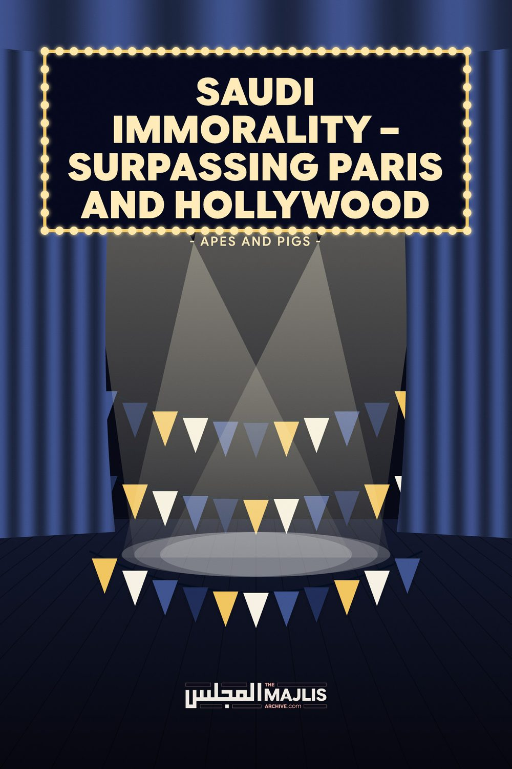

SAUDI IMMORALITY
The Majlis · Voice of Islam
Mujlisul Ulama of South Africa

About this edition
This is a reproduction by The Majlis Archive (themajlisarchive.com) of a publication of The Majlis, Mujlisul Ulama of South Africa, made and published with their permission.
The PDF as The Majlis issued it is the original. This edition was read from that PDF's own structure and checked against it letter for letter; where the two differ, the PDF is correct.
Checked: 76 paragraphs, 0 differing; a second, independent PDF reader finds 100.0% of the PDF's words here.
Nothing has been reworded, added or removed.

By: The Majlis PO Box 3393 Port Elizabeth, 6056, South Africa

APES AND SWINES
"Shall I inform you of something worse by Allah in terms of punishment? The one whom Allah has cursed, and on whom is His Wrath, and from them He has transformed into apes and swines whilst they worship the devil. They are the ones whose position is the vilest. They are the most deviated from the Straight Path."
(Al-Maaidah, Aayat 60)
"We said unto them: 'Become disgraceful apes!"
(Al-Baqarah, Aayat 65)
The Najdi-Saudis have initiated the stage for Allah's awful punishment – the Athaab of immoral, reckless fussaaq and fujaar being transformed into apes and pigs. As sure as night follows day, fussaaq and fujjaar of this Ummah will be disfigured and transformed into apes and swines by the Athaab of Allah Azza Wa Jal.
Singing and music Rasulullah (Sallallahu alayhi wasallam) said that among the signs of Qiyaamah will be the preponderance of singing and music for public entertainment. Liquor too will be publicly served. This immorality will be committed by people who will profess to be Muslims. At such a time whilst people will be enjoying the satanism of music and singing females, Allah Ta'ala will inflict them with a terrible punishment. They will be disfigured and transformed into apes and swines – baboons and pigs in the literal meaning.
Rasulullah (Sallallahu alayhi wasallam) said: "People from my Ummah will consume liquor giving it some other (fancy) name. Musical instruments (will be playing over the heads) and singing girls (will be singing and dancing for them). Allah will cause the earth to swallow them, and from among them He will transform into apes and pigs"
"People from my Ummah will be sleeping during the night after having indulged in play and amusement (such as the filth taking place in Saudi Arabia), then in the morning (when they wake up) they will have become apes and swines."
"I take oath by That Being Who has sent me with the Truth! This world will not end until the occurrence of khasf, qazaf and maskh."
(Khasf: Swallowing by the earth; sinking into the earth Qazaf: Showers of stone from the heaven Maskh: Disfiguration and transformation into apes and swines)
The Sahaabah asked: 'When will that happen, O Nabi of Allah?' Rasulullah (Sallallahu alayhi wasallam) said: "When you see women on saddles (i.e. driving vehicles); when singing women are in abundance; when false testimony will become prevalent; when homosexuality and lesbianism will become the norm."
"During the last of times (Aakhiruz Zamaan) people from my Ummah will be disfigured (and transformed) into apes and swines. (Shocked and in surprise, the Saahabah asked): O Rasulullah! Will they be testifying that there is no deity but Allah, and that you are His Rasool, and will they be fasting?" Rasulullah (Sallallahu alayhi wasallam) said: "Yes!" Someone then said: "What will be their condition (for such a disaster befalling them), O Rasulullah!? Rasulullah (Sallallahu alayhi wasallam) said:
"They will be indulging in music¸ singing women and dufoof (musical drums), and they will be consuming liquors. Then they will sleep during the night after their indulgence in liquor and amusement. In the morning they will wake up to find themselves transformed into apes and swines."
The stage for the transformation of Satanist villains into pigs and apes is being set in Arabia. The Saudi Najdis have made the arrangements for this stage of immorality. These Najdis are the vile culprits who are the repositories for the realization of the predictions made by our Nabi (Sallallahu alayhi wasallam). The stage is being set by these evil Saudi-Najdi murtaddeen for the disfiguration and transformation of people into apes and pigs. Their hearts have already been transformed into the hearts of apes and swines, hence the gigantic upheaval of immorality, fisq, fujoot and kufr is underway in Saudi Arabia. Now remains the time for the physical transformation of their bodies into apes and pigs as predicted by Rasulullah (Sallallahu alayhi wasallam).
Tens of millions of dollars have been squandered by the evil kuffaar Saudi regime to prepare the biggest live music festival in the Middle East, and this will be taking place just about 50 miles from Baitullah, the Holy Ka'bah. Furthermore, this swinery is being planned for 41 consecutive days. Immoral kuffaar fujjaar – fornicaters and sexual perverts – will be the 'featuring stars' at this music festival of Iblees.
King Salman and his murtad son, masquerading as Muslims, who are today at the helm of affairs in Najdi Arabia, are arranging all of this satanism and immorality which are defiling the Holiest Land of Islam. These two miserable characters are devil-incarnate, hence satanism, and immorality of every kind of perversion have overnight spread throughout the country. Musical festivals have already taken place right outside Musjidun Nabawi with reckless flagrancy and in blatant rejection of the Commands of Allah Ta'ala – Commands which had earlier formed the Law of Saudi Arabia. Today the Shariah has been brutally eliminated in Arabia to make way for the manifestation of Trump's cult of immorality and kufr.
Any Shaikh who proffers Deeni advice regarding the evil of Trump's cult, is immediately assigned to the dungeons to languish there in misery and suffering without recourse to any court of law. In fact, there is no valid Shar'i court in the country which the Najdis have disfigured for making it palatable and presentable to Trump and the Western kuffaar in general.
It is indeed the vilest insult – insult to Islam and the Ummah – that the murtad ruler of Arabia still has the satanic audacity and stupid temerity of labelling himself as 'custodian' of the two holy sanctuaries of Islam. There is no relationship between this westernized murtad and Islam. However, to befool and befuddle ignoramuses, this miserable chap occasionally dons Arab garments to project himself as the 'custodian'. In reality, Iblees is his custodian.
In the murtad rulers of Arabia is the reflection of the kufr condition of the vast majority of the populace. These vile rulers are mirroring the kufr and villainy of the people. Rasulullah (Sallallahu alayhi wasallam) said: "Your deeds are your rulers." Allah Ta'ala appoints over people only such rulers as they deserve. Never will Allah Ta'ala appoint immoral rubbishes and oppressors to rule a nation if its vast majority lives in submission to the Shariah. It is Allah's Sunnah to impose the dictatorship of immoral and cruel oppressors over people who are drowned in fisq, fujoor and kufr.
Hadhrat Hasan Basri (Rahmatullah alayh) said: "By Allah! Fitnah is nothing but the punishment of Allah." In this context, fitnah refers to the oppression and brutality of Satanist rulers of the ilk of the Salman characters of Arabia, and of villains such as Sisi of Egypt, Asad of Syria, and others of the legion of Iblees.
MBS is the mirror While we criticize these satanic rulers, we should not lose focus from the fact, that they have been installed by Allah Ta'ala to punish the grossly disobedient people who have eliminated their Imaan with fisq, fujoor and kufr. Rasulullah (Sallallahu alayhi wasallam) said: 'Verily, Allah said: "I am Allah. There is no deity but Me. I am the King of kings and I own the kings. The hearts of kings are in My Hand.
When the people obey Me, I turn the hearts of their kings towards them with affection and mercy. When they disobey Me, I turn the hearts of their kings against them with cruelty and oppression. Then they inflict severe punishment on the people." Therefore, do not engage yourselves in cursing the kings. On the contrary, involve yourselves in My Remembrance (Thikrullah) and in obeying Me. Then I shall take care of you against your rulers."
Undeniably, the ruling kuffaar regime of Arabia is Allah's punishment for Muslims, especially for the Muslims of Saudi Arabia whose immorality the murtad rulers have brought to the fore.
Nabi Musaa (Alayhis salaam) asked Allah Ta'ala: "O my Rabb! You are in the Heavens while we are on earth. What is the sign of your Wrath and Pleasure? Allah Ta'ala said: "When I appoint the best of you to be your ruler, then he (the ruler) is the sign of my being pleased with you. And, when I appoint your worst (scoundrel) to be your ruler, then he is the sign of my Wrath for you."
The rise of faasiq/faajir scoundrels to power and leadership is a sure sign of Qiyaamah. In this regard Rasulullah (Sallallahu alayhi wasallam) said:
"When knowledge is imparted for reasons other than the Deen; when men obey their wives; when a person is insolently disobedient to his mother (parents); when a man brings close to him his friend and distances himself from his father; when voices are raised in the Musaajid, and when people appoint as their ruler their worst scoundrel (faasiq), then await red storms, earthquakes, khasf, qazf and maskh."
This answers the MBS conundrum and the deluge of fisq, fujoor and kufr which is today overwhelming the Holy Lands. MBS is merely the epitome of the moral rot, fisq, fujoor and kufr of the Saudi populace – the vast majority of them. They are now in the stage mentioned in the following Qur'aanic Aayat:
"When We intend to destroy the (people) of a land, then We command its affluent ones (i.e. give them rope to hang themselves). Then they (embark on a drunken stupor) of fisq (and fujoor). Then the order (of Punishment) is decreed for them. Then We utterly destroy them."
The murtad Saudi-Najdi regime has demonstrated breath-taking ignorance and reckless elimination of the Shariah to be substituted with Trump's kufr system of immorality. The total metamorphosis which the country is undergoing so swiftly demonstrates the shaitaaniyat and irtidaad which were embedded in Saudi society. If the people were Muslims, it would not have been possible for a murtad to dismantle the Shariah which has all along from the inception of the Saudi regime been the Constitution of the Land. The worst kind of satanic vitriol is unleashed against any Aalim or intelligent layman who dares to question the satansim which is currently gripping and defiling the Land of Islam.
No one should be deceived by the Salaat and other Islamic rituals ostensibly displayed by the people. The hypocritical portrayal of Islam is no evidence for Imaan. In this regard, Hadhrat Abdullah Bin Amr (Radhiyallahu anhu) narrating a Hadith said:
"An age will dawn when people will assemble in their Musaajid and perform Salaat while not a single one among them will be a Mu'min."
No one should be deluded by external professions of Islam and display of rituals.
America's statue of liberty Reporting this grotesque and bizarre development, the Arab News, states:
JEDDAH: On July 3, a replica of the Statue of Liberty, alongside one of Elvis Presley, the Las Vegas welcome sign and the Hollywood sign, appeared on the Jeddah Waterfront.
The installations were part of Jeddah Season, and a program within the festival called "Las Fallas," taken from the Valencian festival to herald the arrival of spring, that will see the cultures of six nations celebrated.
The icons were installed just in time for July 4, the national "Independence Day" holiday when Americans celebrate the birth of the US. It also heralded the arrival of the US segment of the "Las Fallas" festivities.
As well as the installations, popular music and dancing were also showcased, with dance shows by troupes performing to songs by the likes of Rihanna, Bruno Mars and Elvis.
Acrobatic basketball Following the dancing, a team of boys specializing in acrobatic basketball, the "Face Team," performed, using trampolines to score baskets involving flips and tricks of increasing complexity.
They interacted with the audience, even calling children up to participate on the stage, helping them to jump from the trampoline to the basket, and teaching them to spin basketballs on their fingers.
Balazs Doborhegyi, "Face Team" operations manager, told Arab News: "The audience here was amazing, they reacted to the performances and if the team asked them to clap or make noise, they gave us double."
He jokingly added: "The weather is a bit humid for us though."
Anthony Harwood, the former editor of the Daily Mail commenting on the statue of liberty in Jeddah, said:
"So, for now, we're treated to the grotesque spectacle of the Statue of Liberty being wheeled out on the Jeddah Corniche as part of some tacky display of Americana, along with a Hollywood sign, a Welcome to Vegas sticker, an Uncle Sam hat and an Elvis Presley statue – all set to the Bruno Mars song, Uptown Funk."
Even kuffaar are appalled by the hypocrisy of the murtad regime dancing to the tune of their master Trump.
Even lesbians are spitting on the hypocrisy of the Saudi murtaddeen. One of the world's worst faajiraat, pulling out of the Saudi concert of satanism, said:
Hip-hop star Nicki Minaj pulled out of a concert in Saudi Arabia because she said she wants to show support for the rights of women and LGBTQ people along with freedom of expression.
In a statement, the chart-topping Trinidadian rapper told the Associated Press news agency, after "careful reflection I have decided to no longer move forward with my scheduled concert at Jeddah World Fest".
"I believe it is important for me to make clear my support for the rights of women, the LGBTQ community and freedom of expression," she said.
Minaj - whose real name is Onika Tanya Maraj - was originally scheduled to headline the concert on July 18.
Utterly bereft of the slightest stitch of Imaani inhibition, the murtad ruler of Najdi Arabia had gone to great lengths and sunk into the deepest depths of the sewer drain to acquire the zina services of a lesbian (Nicki Minaj) to perform at his shaitaani concert. This woman is a vociferous campaigner of LGBTO (the lesbian-gay-sexual pervert mobs) 'rights'.
However, even this arch-Lesbian has spurned the overtures of the spineless murtad MBS shaitaan.
The presence of the statue of liberty and the statute of Elves Presley in Jeddah whilst intriguing and inexplicable to most Muslims, poses no conundrum for the people of Ilm. The stage is being set for the materialization of Rasulullah's prediction. Among the signs of the Impending Hour of Qiyaamah, according to our Nabi (Sallallahu alayhi wasallam) will be that the Arab women of the tribe of Dous will "gyrate around idols with their buttocks weaving and swaying".
Rasulullah (Sallallahu alayhi wasallam) said: "The Hour (of Qiyaamah) will not be established until the buttocks of the women of (the tribe) Dous gyrate around zul khalasah."
'Zul khalasah was the idol of shirk of the Dous tribe during the Jaahiliyyah era.
Al-Kirmaani said that Qiyaamah will arrive only when the women of the tribe of Dous dance around the idol called zul khalasah. They will become kaafir and return to the worship of their idol of the Jaahiliyyah era.
Thus, as lamentable as it may be, the introduction of the American idol into Arabia for setting the stage for idol-worship should not be surprising. It is no wonder that Rasulullah (Sallallahu alayhi wasallam) had refused to make dua for the Najdis. He made dua thrice for the People of Shaam and Yemen. However, even on being requested, Nabi (Sallallahu alayhi wasallam) declined. On the contrary he said that in Najd are the "horns of shaitaan".
"Rasulullah (Sallallahu alayhi wasallam) supplicated: "O Allah! Grant us barkat in our Shaam and in our Yemen." The Sahaabah said: 'And in our Najd?' Rasulullah (Sallallahu alayhi wasallam) responded: "O Allah! Grant us barkat in our Shaam and in our Yemen." (The Sahaabah again asked): 'And in our Najd?' Rasulullah (Sallallahu alayhi wasallam) said: "Over there will be earthquakes, anarchy and mischief (fitan –plural of fitnah), and the horns of shaitaan rise there."
Now, with fisq, fujoor, zina and kufr being flagrantly perpetrated on the massive scale being currently enacted, the horns of the devil are better understood, and the refusal of Rasulullah (Sallallahu alayhi wasallam) to make dua for the Najdis. The Saudi regime is shaitaan-incarnate. These villains constitute another face of Iblees.
Even immoral kuffaar faajiraat of the prostitute class are appalled by the Najdi satanic cultural trimmings designed for the gratification of the immoral lusts of the murtad ruler at the behest of the insane Trump. This MBS murtad character vieing for the limelight by licking the boots of Trump, has penetrated into the depths of immoral degeneration which leaves even Iblees aghast, just as Iblees was aghast at the kufr of Fir'oun who had claimed divinity for himself.
A westernized Saudi faajirah who has no truck with the Deen, appalled at the degree of immorality accompanying the Najdi concert of zina, fisq and fujoor, commented on the participation of the kaafirah hip-hop star, Nicki Minaj:
"She's going to go and shake her xxxx and all her songs are indecent and about sex and shaking xxxx and then you tell me to wear an abaya. What the hell?"
This was her comment on the devilish advice of the Saudi regime for women to come to the satanic zina concert dressed with abayas. This satanic hypocrisy is indeed a bizarre plot of the devil. Anyhow, even this female agent of Iblees (i.e. Minaj) has now pulled out of the abominable Najdi concert although for entirely different reasons.
Although all Muslim countries have for decades adopted kufr law and have by degrees abolished the Shariah, no country has hitherto descended into the depths of the sewer drains to so flagrantly organize and portray immorality – zina, fisq and fujoor of the worst kind as the murtad-kufr Saudi regime is currently doing. Every vestige of Islamic shame and every iota of Imaan have been extinguished from the Saudi kuffaar masquerading as Muslims. Both the rulers and the participating public have completely abandoned Islam. In fact, the Saudi-Najdis have surpassed the mushrikeen of the pre-Islam era of Jaahiliyyah in immorality.
About these developments, Rasulullah (Sallallahu alayhi wasallam) said: "An age will dawn when nothing of Islam will remain except its name….." So while these Saudi murtaddeen are professing to be Muslims, in reality they are kuffaar.
What relationship can there ever be between Islam and the filth of 'Las Fallas', the statue of liberty, the statue of Elvis Presley, the Las Vegas welcome sign, the Hollywood sign, etc.?
Worse to come The evil being played out in Saudi Arabia currently is not the worst. The worst is yet to come. Rasulullah (Sallallahu alayhi wasallam) said that during the times of the reign of supreme fitnah, people who pass by graves will yearn to be underground – to be dead with their Imaan intact. There will be no sanctuary where the true Mu'min will be able to take refuge. Nabi (Sallallahu alayhi wasallam) said that the Mu'min will flee from city to city, town to town, village to village, mountain to mountain with his Imaan like a hunted fox with the hunter on its trail in hot pursuit. Such dangerous times for the true Mu'mineen are yet to dawn. May Allah Ta'ala save us and take us from this dunya with our Imaan intact.

