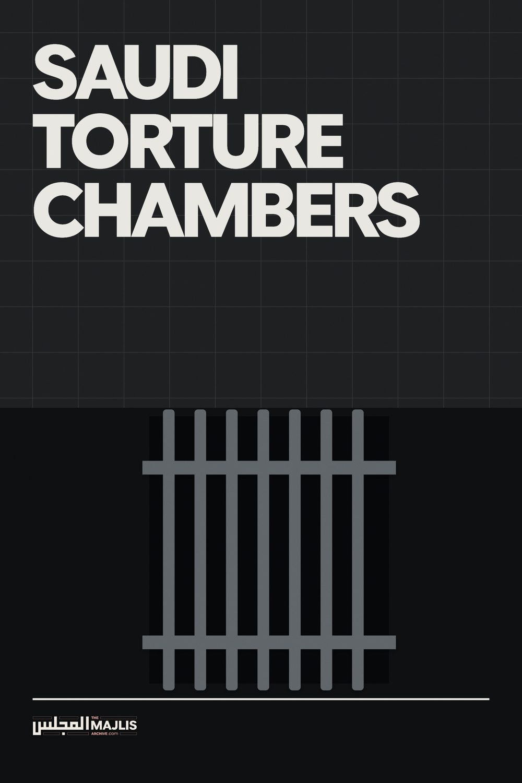

Saudi Torture Chambers
The Majlis · Voice of Islam
Mujlisul Ulama of South Africa

About this edition
This is a reproduction by The Majlis Archive (themajlisarchive.com) of a publication of The Majlis, Mujlisul Ulama of South Africa, made and published with their permission.
The PDF as The Majlis issued it is the original. This edition was read from that PDF's own structure and checked against it letter for letter; where the two differ, the PDF is correct.
Checked: 53 paragraphs, 0 differing; a second, independent PDF reader finds 100.0% of the PDF's words here.
Nothing has been reworded, added or removed.

As a finishing point, the former Egyptian Interior Minister, Zaki Badar, was sacked from his post because he was too harsh and inhumane in this torture methods, and many people died under his custody. The Saudi Interior Ministry duly hired him and he helped to organise the various torture methods on the brothers. He was Prince Naif's personal advisor on how to deal with Islamists. Praise be to Allah that he died whilst on a recent visit to the USA.
Since being released, all the brothers have had their passports confiscated so that they cannot travel abroad. Furthermore, some brothers still suffer from permanent injuries inflicted on them in Ar-Ruwais. We ask Allah to release our brothers still inside: Hassan As-Sarehi, Muhammad Hamdi Al-Ahdal (Abu Asim Al-Makki), Abu Ishaq Al-Makki, Abu Shaheed Ash-Sharqi and others. Praise be to Allah, this only makes us stronger, as Allah says in the Quran:
"Do you really think that you will enter Paradise, until Allah has decided from amongst you, those that make Jihad and those who are patient?" [Quran 3:142]
A Mujahid Brother Azzam Publications BCM Uhud London WC1N 3XX United Kingdom E-Mail: info@azzam.com
By AZZAM PUBLICATIONS BCM Uhud London WC1N 3XX United Kingdom
In Ar-Ruwais, we were not allowed to supplicate to Allah (make dua) with our hands outstretched. Perhaps the interrogators knew in the bottom of their hearts the hadith of the Prophet (SAWS) that "there is no veil between Allah and the supplication of the oppressed one." We had to urinate in one litre bottles infront of the other brothers and attend to other needs in public as well.

THE SAVAGE TORTURE CHAMBERS OF THE SAUDI TAWAAGHEET (DEVILS)
The interrogators constantly swore at and abused those working for Islam, amongst the scholars, Mujahideen and callers to Islam. They said that Sheikhs Salman Al-Owdah and Safar Al-Hawali (in Al-Hair Prison, Riyadh, since September 1994) were khawaarij (dissidents) and kafirs (disbelievers).
The following is a report exposing the gruesome, brutal, immoral and satanic acts of horrendous torture perpetrated by the kuffaar Saudi authorities masquerading as Muslims. This report was issued in 1998 when about 2,000 Mujahideen were held in the torture-hell of the Saudi regime. Today approximately 40,000 brothers including numerous Ulama and academicians are languishing in the most horrid and brutal conditions for which Saudi torture chambers have acquired infamy and notoriety. – Report issued by Azzam Publications of United Kingdom.
There was one separate wing of Ar-Ruwais just for women. Here, they would keep the wives, daughters, mothers and sisters of the brothers. They brought the wives of one of the brothers and threatened to rape her unless the brother confessed to the crimes that they were accusing him of. The brother duly signed anything they asked him to. One brother escaped the country before he was arrested, so the Saudi Interior Ministry imprisoned seven women members of his family, for eight months, as a ploy to ask the brother to return. It was common for them to strip brothers naked and make fun of their privates. All this is from the country that calls itself Balad-ut-Tawheed (The Land of Tawheed) and whose ruler calls himself Khadim-ul-Haramain Ash-Sharifain (The Custodian of the Two Holy Mosques).
The names of some of the torturers at Ar-Ruwais are: Adnan Filimblaan (he was the worst)
Talib Ad-Dhabbaagh Al-Qusayfaan (I cannot remember his first name)
Ghazi Al-Judaibi Al-Zagzoug (he was the Head of Ar-Ruwais Prison, who is known to grovel to the Interior Minister, Prince Naif)
In the midst of all this torture, As-Sarehi told his interrogators: "Bring me a sheet of paper and I will sign it confessing to every single crime that you accuse me of. I killed President Kennedy, I killed King Faisal, I carried out the Riyadh and Al-Khobar Explosions, anything you want." His interrogators replied that that was not good enough; they wanted to know how he done it. He replied to them "I am telling you, I did not do these crimes, so how can I tell you how I did them?"

SAUDI TORTURERS RAPE MUJAHIDEEN DURING INTERROGATION
~~~~~~~ From time to time, Azzam Publications would like to bring authentic news reports to everyone around the world. We would like to say that our news is verified, authenticated and from DIRECT sources, not Western media or anything like that. If you do not hear from us for some time, then that is not because nothing is happening around the world, but we do not have any AUTHENTIC DIRECT news to tell. The following news article should be read from beginning to end for maximum effect. This and previous news articles may be found on our web site.
I saw another brother in prison, Abu Asim Al-Makki (Muhammad Hamdi Al-Ahdal), who was famous for his heroic feats in the famous Battle for Tishin, Bosnia, in 1992. In this operation, he lost one leg and has been paralysed in one arm ever since. Abu Asim, who is already disabled, was beaten with shoes on his face. The interrogators beat him with baton on his disabled limbs and spat in his face. His face also looks like he has undergone severe physical and mental torture.
Another brother famous for heroic feats in Afghanistan, Abu Ishaq Al-Makki was in Yemen. Prince Naif (the Saudi Interior Minister) travelled to Yemen and took this brother back in his own plane. He has been tortured severely in prison, stripped naked and beaten.
As this news bulletin goes to press, there are still currently over 2000 Mujahideen that have been imprisoned in Saudi Arabia during the latest oppression that began a few days before Hajj, 1998. Azzam Publications has managed to conduct another exclusive interview with one brother who spent some time in a Saudi prison within the last few months. He was arrested when he returned from a land of Jihad, and released after one year, when no evidence of criminal activity was found on him. Azzam Publications is still in contact with this brother and able to answer any questions relating to it.
One night whilst I was in prison, and the conditions were extremely tough upon the brothers, I met one of the brothers who saw a dream before Salat-ul-Fajr one night. He saw the Messenger of Allah (SAWS) and the Messenger (SAWS) said to him: "Inform the brothers on my behalf, that the angels are competing amongst themselves in writing down their rewards." This dream of the brother brought some relief and encouragement to the rest of the brothers. However, we did not say who had this dream, else that brother would be tortured for having the dream in the first place.
We would like to say that what you are about to read is not a fabricated or second-hand account. This account was taken DIRECTLY from the mouth of the brother who underwent this torture and spoke to his brother inmates. After our last report titled: 'Torture in Saudi Prisons: Exclusive Report', some defenders of the Saudi regime stated that they did not deny the report, but that it must have been exaggerated. This is a stance similar to the disbelievers at the time of the Prophet (SAWS), who said to him: "We do not say that you are a liar, but we say that what you have brought is false." Defenders of the Saudi regime will nonetheless continue to make further excuses after this second torture report and say that this is a made-up story or that it is lies. In this case:
whole war and, due to the high risk encountered, it was known as the Lion's Den Operation of Afghanistan. Many notable Mujahideen personalities participated in this operation, such as Usama bin Ladin, Abu Zubair Al-Madani and Sheikh Tameem Adnani amongst many others. Sheikh Abdullah Azzam was in the second line of the Front. The mastermind and commander of this operation was Abu Abdur-Rahman As-Sarehi. As-Sarehi was the teacher of Ibn-ul-Khattab (the Ameer of the Foreign Mujahideen in Chechnya) and taught Ibn-ul-Khattab much of what he knew, from the time he came to Afghanistan as a young teenager, until he left for Tajikistan, as a brilliant commander.
AZZAM PUBLICATIONS PUBLICLY CHALLENGES SUCH PEOPLE, UNDER THE WITNESS OF ALLAH (SWT) TO SWEAR TO ALLAH THAT THEY BELIEVE THAT THIS IS A FABRICATED ACCOUNT, THAT THIS ACCOUNT HAS BEEN EXAGGERATED, THAT THIS DID NOT HAPPEN IN A SAUDI PRISON AND THAT THE PRISON OFFICERS NAMED BELOW DO NOT WORK FOR THE SAUDI INTELLIGENCE SERVICES, INVOKING THE ETERNAL CURSE OF ALLAH (SWT) UPON THEMSELVES IF THIS ACCOUNT IS TRUE.
After the explosion of the US Army base in Riyadh, the Saudi Government requested the Pakistani Government to extradite As-Sarehi, as he was living in Peshawar at the time. They accused As-Sarehi of involvement in this explosion, though without a shred of evidence. The Pakistani Government agreed to hand over As-Sarehi to the Saudi Government in return for two of the topmost Pakistani drug smugglers imprisoned in Saudi Arabia and awaiting execution. After four brothers were executed in Saudi Arabia for allegedly plotting the Riyadh explosion, the Saudi Government should have released Hassan As-Sarehi, but they continued to detain him. He has now been in prison for over three years and the following things have been done to him:
We say that, IF, AFTER READING THIS ACCOUNT, ANY MUSLIM STILL HAS DOUBT IN HIS HEART AS TO WHETHER OR NOT THE SAUDI GOVERNMENT IS AN AMERICAN BACKED GOVERNMENT AND AN ENEMY TO MUSLIMS ALL OVER THE WORLD, THEN THEY MUST SIT DOWN AND CHECK THEIR IMAN BECAUSE MAYBE THEN THERE IS SOME DEFICIENCY IN THEIR IMAN AND THEIR CLAIM IN BEING A MUSLIM.
THIS IS AN EXAMPLE OF TORTURE THAT IS STILL BEING CARRIED OUT IN THE PRISONS OF A COUNTRY THAT CLAIMS TO BE AN ISLAMIC SALAFI GOVERNMENT WHOSE LEADER IS DUBBED AS THE AMEER-UL-MUMINEEN (CHIEF OF THE BELIEVERS).
His neck was stretched away from his body so that it is permanently disabled. He can no longer turn his neck from side to side. He has been stripped naked and made to stand for weeks on end. He was subjected to electric torture from all the three types of electric torture equipment, including 'Cinderella'. He has been denied visits from his family. His body has become very weak now and his face is disfigured, like someone who has undergone severe physical and mental torture.
EYE-WITNESS ACCOUNT OF TORTURE IN SAUDI PRISON. YOU MAY FIND SOME PARTS DISTURBING, BUT WE HAVE INCLUDED EVERYTHING BECAUSE IT IS THE TRUTH AND ALLAH IS WITNESS TO THAT. ~~~~~~~~~~ hands and spine. My body turned black and red due to the beating. Six months on, I still have pains in my spine due to this beating. They swore at me and cursed my mother.
In the Name of ALLAH, the Most Merciful, the Most Kind
Sometime after I returned from a land of Jihad, soon after the Hajj season, I was asked to report at the headquarters of the Saudi Interior Ministry in my city. I was told that I was needed for questioning for a period not exceeding two weeks. I was then taken to the famous Ar-Ruwais Interrogation Centre in Ar-Ruwais District, Jeddah. Unlike the Al-Hair maximum security prison in Riyadh, where Dr. Sheikh Salman Al-Owdah and Dr. Sheikh Safar Al-Hawali have been in detention since September 1994 (over four years now), Ar-Ruwais Interrogation is not publicly known by international human rights organisations such as Amnesty International and Red Cross. The Saudi Government continues to deny the existence of such a place. Ar-Ruwais Interrogation Centre is also the place where Sheikh Abu Abdul-Azeez, the initiator of the Jihad in Bosnia was held for fifteen months (he has since been released but is banned from leaving the country) and Abu Abdur-Rahman Al-Sarehi, the mastermind of the famous Lion's Den Operation against the Soviet Army in Jaaje, Afghanistan, 1987: undoubtedly the most brilliant operation conducted by the foreign Mujahideen against the Soviets in the ten year Soviet occupation of Afghanistan, is still being held.
At other times, I was ordered to stand for hours on end and the soldiers would beat me if I tried to sit down. I know one Algerian brother who was forced to stand for three months. He was beaten on the soles of his feet and blood was dripping from them. They removed his clothes and inserted a baton into his rectum.
Another brother had his beard plucked hair by hair until there was not a single hair left on his face. Other brothers had pins and other sharp objects inserted into their private parts. I saw many brothers with signs of electric torture on their bodies.
Ar-Ruwais Centre uses three types of electric torture. One is a hand-held stun gun, another is the size of a car battery and the third is a huge, sophisticated machine, which was known to the interrogators as 'Cinderella'. Cinderella is a unit into which the entire body of the victim is inserted. His arms, legs and waist are tied down with strong straps, whilst electric current is applied to him. It is electronically controlled and fully computerised. Some brothers have suffered permanent brain damage as a result of torture in this machine. [Note by Azzam Publications: it is important to point out that no Muslim country has the technology to produce such a sophisticated machine. A British company in Selly Oak, Birmingham, UK, is famous for its custom-made 20ft and 40ft fully-equipped torture chambers, which are sold to Muslim countries. This point was also debated in Parliament by some British MP's.]
When I arrived at the prison, I was placed in a large room with about ten other brothers. I was placed in such a room because all the solitary confinement cells were full. I saw at least five corridors of cells, each corridor housing about 75 brothers, totalling over 350 brothers. This was only in my section: there are other sections to the Centre. I knew just over half of these 350 brothers, as I met them in various lands of Jihad. There was also one corridor specifically for women, where mothers, sisters, daughters and wives of brothers were housed. It is important to note that there are NO common criminals in Ar-Ruwais. Ar-Ruwais is a special, secret interrogation centre/ prison, specifically for 'political prisoners'.
I met Abu Abdur-Rahmān As-Sarehi (real name Hassan As-Sarehi) in Ar-Ruwais. As-Sarehi was one of the most brilliant Mujahideen commanders in the Afghan Jihad. In Jaaje, 1987, the Mujahideen mounted a daring and spectacular attack against a powerful Soviet offensive involving Land and Air power. It was one of the most famous battles during the Prince Naif, the Saudi Interior Minister, continues to deny the existence of political prisoners in Saudi Arabia.
They asked this question to all the brothers, so that once the brothers sign the paper stating that they believe this, they will pass a fatwa (religious edict) on them, stating that they are khawaarij (dissidents), who can lawfully be killed. During these four hours, they said and did the following things to me. "In Islam, whatever is necessary to establish an obligation, then that thing itself becomes an obligation. It is an obligation upon us to protect this country, so it is permissible (Halal) for us to commit homosexual acts upon you in order to protect this country. We can rape you now and kill you now. We are authorised to do so." He then laughed and mentioned the verse in the Quran, (Surah Ta-Ha (20), Verse 55) jokingly: 'From it we created you, and into it we will return you &' citing his evidence for raping me. It was at that moment that I vowed to myself that if ever I saw this man outside the prison, I would kill him and not fear the consequences.
I spent the first three days in this communal cell, with no problems. After that my name was called from a list and I was asked to follow the guards. They took me to a special room, containing many unusual objects: this was one of the many torture chambers in the prison. I was joined by two individuals: one guard and one interrogator. When I said 'Assalamualaikum' to him, he swore at me and then he came and began to play with my beard, making fun of it. He was clean-shaven of course.
This interrogator spoke to me for about one hour, during which he said the following points to me:
"We are stronger and more powerful than you. You are not Mujahideen, you are homosexuals, you are dogs, you are women."
"All your affairs are in my hands. If I want, I can kill you, I can order the guard to rape you and no-one has power to stop me if I want to do this."
The interrogator then proceeded to read out a list of crimes that I was supposed to have committed. The soldier continued to beat me to force me to confess to these crimes, until I shouted to the interrogator:
"You came here because you did such-and-such crime and said such-and-such thing." even though he had no evidence for any accusation.
"BY ALLAH, I did not do those things!"
The interrogator then said to me, "Allah, leave Him to the side. This is between me and you: it has nothing to do with Allah."
After this first hour, he left and another interrogator entered the room. He was larger and stronger than the first interrogator. He had a large beard, a garment that was above his ankles and clear marks of prolonged prostration on his forehead. He handcuffed me and began to ask me some questions. For the next two hours, he continued to ask me the same question, whilst the soldier continued to beat me on the soles of my feet with a baton:
He then threatened to rape me and tried to remove my trousers, but I resisted. Some brothers in the prison were stripped naked. Others saw the interrogator order the soldier to remove his trousers and underwear as a means of threatening them. At least one brother I know was actually raped. Other brothers refuse to speak about this topic, due to their shame and honour, but there were other brothers who were raped as well.
"Do you believe that King Fahd is a kafir and that the Saudi Government is a government based on kufr?"
By the end of these two hours, my feet were bleeding and had swollen to twice their size. My toenails had come off.
During the interrogation sessions, the interrogator continued to beat me with a baton and a whip, on my face,

