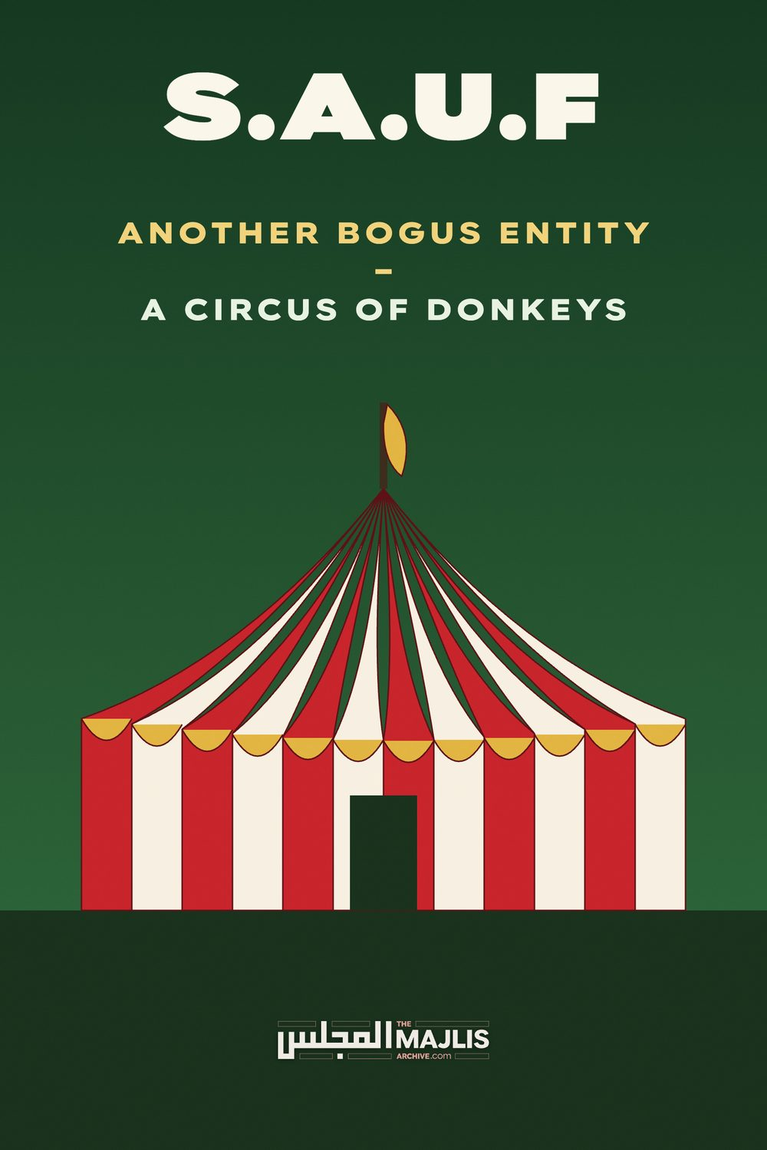

SAUF - Another Bogus Entity
The Majlis · Voice of Islam
Mujlisul Ulama of South Africa

About this edition
This is a reproduction by The Majlis Archive (themajlisarchive.com) of a publication of The Majlis, Mujlisul Ulama of South Africa, made and published with their permission.
The PDF as The Majlis issued it is the original. This edition was read from that PDF's own structure and checked against it letter for letter; where the two differ, the PDF is correct.
Checked: 129 paragraphs, 0 differing; a second, independent PDF reader finds 98.8% of the PDF's words here.
Nothing has been reworded, added or removed.

S.A.U.F

ANOTHER BOGUS ENTITY A CIRCUS OF DONKEYS

THE HUFAALAH RASULULLAH (SALLALLAHU ALAYHI WASALLAM) SAID:
"THE SAALIHOON (I.E. THE PIOUS ULAMA AND AULIYA) WILL DEPART (FROM THIS WORLD) ONE AFTER THE OTHER (IN QUICK SUCCESSION). THEN THERE WILL REMAIN 'HUFAALAH' (RUBBISH, MUCK, FLOTSAM, JETSUM, SEWER WASTE) LIKE THE HUFAALAH OF DATES AND BARLEY."

THE FLOTSAM MOLVIES OF EVIL
In the aforementioned Hadith, Rasulullah (Sallallahu alayhi wasallam) in an objugatory tone, sums up the conglomeration of waste matter which had assembled recently in Johannesburg for their circus performance of fisq (flagrant vice), fujoor (immorality) and kufr in which they excel, and which has become their registered trademark. The conglomerate of Rubbishes and Donkeys fitted by Iblees with an outer veneer of 'religion', abortively attempted to acquit themselves in the name of Islam as spokesmen of the Deen and representatives of the Ulama. Describing these agents of Iblees, Allah Ta'ala says in the Qur'aan Majeed:
"Thus have We created for every Nabi enemies who are shayaateenul Ins and Jinn (human and jinn devils). They mutually inspire one other with statements of adorned deception. If your Rabb had willed, they would not have been able to do so. Therefore, leave them and that (falsehood) which they fabricate."
(Al-An'aam, Aayat 112)

THE GATHERING OF DONKEYS AND RUBBISHES
The NNB Jamiat (the No Name Brand jamiat of Fordsburg), masquerading as 'jamiatul ulama south africa, in its advert to promote the haraam, shaitaani meeting of donkeys and rubbishes, states:
"The 8th Southern Africa Ulama Conference --- During the weekend of 28th to 30th October 2016, well over 800 members of the Ulama fraternity converged at the 8th Southern Africa Ulama Forum..........."
Firstly, this 'forum' was nothing other than a merrymaking talkshop where fisq and fujoor are traded in 'deeni' guise. The crowd of 800 morons was trapped in the den of Iblees. Few of the morons present were valid ulama even in the academic sense, leave alone the Qur'aanic concept of Ulama. The molvis should not be mistaken for Ulama. Most of them lack the ability to even correctly traverse the texts of the Kutub, leave alone understanding the meanings of the texts. The imperative requisite for a valid Aalim of the Deen is khashiyat (fear which engenders genuine humility). In this regard, the Qur'aan Majeed states:
"Verily, of His servants only the Ulama fear Allah."
The participants of the forum of fisq and fujoor are Donkeys and Rubbishes bereft of the slightest vestige of khauf and khashiyat, yet they howled in the name of Islam to hoodwink the morons who had gathered to listen to the villainy which was being dinned into their ears.
The few villains who have some textual ability are confirmed members of the fraternity of EVIL ulama (ulama-e-soo') in the employment of shaitaan, and whose function is to serve Iblees in his pernicious plot to mutilate and destroy the Deen in the name of Islam. Iblees has fielded this Circus of Donkeys and Rubbishes into which stupid molvis lacking the ability of applying the mind, have been ensnared. Describing the 800 donkeys of the circus, the Qur'aan Majeed states:
"The similitude of those who had the obligation of bearing the Tauraah (but) then (miserably) failed to bear it, is like the example of a DONKEY which carries books. Evil indeed is the likes of a people who falsifies the Aayaat of Allah." (Al-Jumuah, Aayat 5)
Many of these simpletons have however understood the evil of the circus hence they have written to us to lament the evil and haraam which they had observed. We shall reproduce extracts from their letters as first-hand information of the haraam shenangians which had transpired at the haraam Circus of Donkeys and Rubbishes.
At this juncture it is necessary to offer some naseehat to the simple and stupid molvis who had attended, but who were fortuntely disappointed by the evil plot of kufr which even their simple brains had understood. There was no conundrum in understanding that it was haraam to attend the Circus of Evil and Villainy. Those molvis who are now anonymously criticizing the haraam events of the Hufaalah, were complicit in having promoted the evil assembly of the progeny of Iblees.
Rasulullah (Sallallahu alayhi wasallam) prohibited attendance at haraam shows and functions. Those attending are guilty of supporting the baatil and kufr of the Hufaalah even if they had no such intention. Their very presence at the haraam circus damns them. They have the obligation of repenting – making Taubah, for their attendance at the haraam Circus of Hufaalah. Their participation is worse than attending a cinema or a casino.
Only such persons whose intention at the inception was to infiltrate and gain firsthand information for passing on to the Upholders of Haqq for Amr Bil Ma'roof Nahy Anil Munkar, had permission from the Shariah to attend. But for the balance of jaahil molvis, their participation was pure nafsaaniyat notwithstanding their belated dissociation from the fisq, fujoor and kufr which they have observed.

A MOLVI'S LAMENT
We reproduce here the Lament of a Molvi who had attended the Circus of the Donkeys and Rubbishes. We shall make brief comments on certain observations, and elaborate further later on, Insha-Allah, in this article. Our comments appear in bold italics in the brackets.
Pouring out his lament, the Molvi says:
"As far as the Saturday night panel discussion went it was far from mature or scholarly. For many Ulema it was an embarrassment, a great disappointment and an indication of the wrong direction some of our Ulema (donkeys and morons) are going searching for solutions.
Some felt these Ulema (Hufaalah) have hijacked this platform to share their concocted view of the way forward. (There was no hijacking. From the very inception of this talkshop of rubbish and triviality years ago, it always had been a platform of baatil and khuraafaat.)
Others felt that they are too insecure in their own right and are venting out their own feelings of inferiority. (The donkeys and rubbishes are the bootlickers of westernism.
Their bootlicking aptly portrays their gross intellectual inferiority and moral bankruptcy.)
This showed glaringly in the idolization of individuals like NAK and Yasmin Moegahmed etc. (Human Shayaateen are always spineless, hence they seek refuge even under the skirts of faasiqaat and faajirat. They are the worst specimens of dayyoosiyat.)
Yet others saw it as a desire to get their new flavour of Islam 'accepted' to a certain degree through public discussion amongst the main Ulema fraternity, so that when they go ahead with their new version they will not receive much resistance or rebuke.
(This is old hat. The Molvi has been asleep for many years, hence he is blissfully ignorant of the mutilation to the Deen which the NNB jamiat crowd and other Hufaalah of their ilk have been conniving, plotting and propagating for decades. They have laboured to halaalize many explicit prohibitions of the Shariah. The so-called 'main ulema fraternity' have all along conducted themselves as "Dumb Devils" in the words of Rasulullah –Sallallahu alayhi wasallam). These mujrimeen (criminal) silent ulema are guilty of the capital crime of having abandoned Amr Bil Ma'roof Nahy Anil Munkar. Not only have they abandoned their Waajib obligation, they silently and actively collaborated with the NNB jamiat rubbishes and donkeys in their shaitaani attempt to wrought kufr changes to the Shariah of Allah Azza Wa Jal.)
Some Ulema even shared the view that it is all market share related. To get themselves universal recognition, popularity, acceptance and followers they need to seem 'advanced' and
'liberal' in their views, thus the desire to disassociate themselves with 'hanafiyyat', 'deobandiyyat' and also the easiest tool....the call for 'liberation' of women etc.
(Yes, the Circus of Hufaalah's objective is blatantly hubb-e-jah and hubb-e-maal – thecrave for name, fame and money. Women – "the snares of shaitaan" – have been harnessed by these NNB jamiat donkeys and rubbishes to further their satanic conspiracy for the achievement of their despicable nafsaani lusts.
*10 shocking / laughable points of Sat. Night's panel discussion
*1. A SWOT analysis was apparently done from 13 different non-Ulema candidates...
Whether the right qualified candidates were chosen or not for the interviews, the questions summarised and put forward were mainly the panellists normal Ishkaals on their alma maters and uneasiness to identify themselves with anything orthodox.
(The Hufaalah are corrupt and rotten to the core. In the early stage of their 'ilmi' career they acquitted themselves as if they comported with orthodoxy, i.e. with the Sunnah. Later when they had to obtain a licence for radio shaitaan, they were forced to denude themselves. They had no option but to unmask themselves thereby displaying the hidden kufr and their true agenda of fisq and fujoor.)
*2. There were too many contradictions in the SWOT summary.
(Those whose hearts are saturated with worldly and nafsaani lusts, are embodiments of contradictions. They wander aimlessly like mad dogs and swines in the wilderness of ahwaa').
13 Non-ulema were apparently interviewed but a so-called 'aalimah' was constantly quoted. (More appropriately a shaitaani JAAHILAH.)
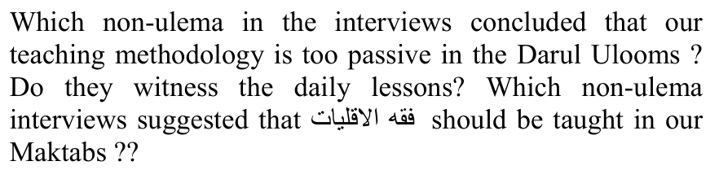
A term some of our Ulema are not even aware of. (We too confess that we are unaware of this moronic 'fiqh'. It is incumbent to clarify some issues pertaining to the Darul Ulooms of this era. They have become Signs of Qiyaamah. The Knowledge of the Deen is being imparted for worldly objectives. The cultivation of Morality (Akhlaaq-e-Hameeda) is alien to a Darul Uloom. In fact, the environment of the Darul Uloom nowadays are not at all conducive for the attainment of the Maqsood of Ilm. The Darul ulooms are bereft of Roohaaniyat. The Asaatizah are primarily mercenaries, concealers of the Haqq, contorters of the Haqq, bootlickers of donors and of the rich, fence sitters and "Dumb Devils". Taqwa is an alien concept for them. They frown derisively at the mention of Taqwa. They have drifted so far from the Deen that Fatwa appears to them as Taqwa. Despite the Qur'aan Majeed being replete with commands and exhortations to cultivate Taqwa, the Darul Ulooms portray an antithetical stance. The Darul Ulooms have abandoned their obligation of defending and safeguarding the Deen. They come within the purview of the Qur'aanic aayat:
"And if you turn away (abandon your duty), then He will substitute you with another people. Then they will not be like you (who have become bootlickers of the wealthy and of the rulers)."
Interviewees (or panellists) views were wrongly portrayed to be the public opinion of Ulema and was generalized to a great extent. (The perennial plot of the NNB jamiat with its Reverend Abraham Bham & Co. Is to achieve name and fame, hence these Hufaalah characters so desperately labour to trade the false idea of them being the representatives of the Ulama and of the Muslim community of the country. This is the underlying plot of the UUCSA dispute. It is an insane craving and lust for cheap and filthy 'glory'.
*3 Claims were made from the front that it is *IMPERATIVE* to send our daughters to University. Note the jump from impermissibility, over permissibility with conditions, right into IMPERATIVE.
(Insanely trodding in the footsteps of the western kuffaar, the NNB Rubbishes and Donkeys, are hell-bent on immoralizing Muslims in the same way in which this satanic plot was achieved in the Christian world. Just as zina has become an acceptable and even respectable cult in the west, so too is the shaitaani desire for the Muslim Ummah. The primary tool for denuding women of their hayaa (shame and modesty) and transforming them into prostitutes and objects for the fulfilment of the inordinate carnal lusts of the agents of Iblees, is the university. These 'educational' brothels are the most fertile ground for manufacturing prostitutes, zindeeqs and atheists. The NNB crowd is in cahoots with this satanism. The chimera of secular 'education' is dangled as the subterfuge for achieving their unholy, shaitaani pernicious designs. Whilst this development is extremely lamentable, it is not surprising. According to the Hadith, in times in close proximity to Qiyaamah, zina (fornication) will be committed in public, i.e. the actual act of zina. Universities are an advanced stage in the introduction of public zina. Shaitaan has now harnessed molvis into this revolting scheme. Thus, explicit haraam has become 'waajib' for the NNB rubbishes and donkeys masquerading as 'ulama'. There can no longer be doubt in the explicit kufr of those who propound the kufr of university brothel-education being 'waajib' for females. By explicit kufr is meant kufr in the technical meaning. That is, they have become murtads. Salaat behind them is not valid. Their nikah has ended. The offspring they will be producing will be illegitimate. There is no valid ta'weel for their kufr claim of university education being 'imperative' for Muslim girls. The ultimate fate of these vile donkeys and rubbishes according to the Hadith will be the Athaab of having to circumambulate (make tawaaf) their own entrails in Jahannam.)
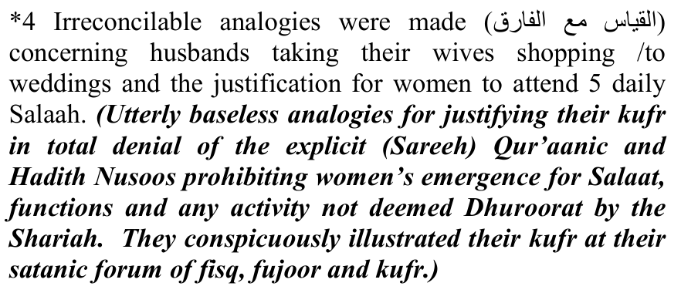
*5 Deen starting with the support of Hazrat Ghadija RA and ending in the lap of Hazrat Ayesha RA was twisted to try and indicate women's position as public icons.
(Such is the convoluted reasoning of brains warped by kufr. The fallacy of this shaitaani argument should be manifest to all those whose Imaan has not become convoluted by kufr and spiritual darkness (zulmat). The stupidity and absurdity of this averment require no intelligent argument for its disposal. The motive for this disgorgement is glaringly the conspiracy to 'liberate' and 'emancipate' Muslim women in western style from the holy Fetters of the Deen to sacrifice them at the altar of the carnal lusts and beastly behests of the sex maniacs and perverts of the forum of Iblees. Their precedent for attaining this shaitaani goal is the Christian paradigm of the West.)
*6 It was humorous to hear the warped logic that in today's time there is a greater fitnah for women to stay in their homes than to emerge and attend daily Salaah.
(Along with being 'humourous', it is also satanic. It is the effect of shaitaan having urinated on their brains. And, it is the effect of rijs (filth) divinely cast, which has disfigured their minds rendering them incapable of intellectual discernment, hence the disgorgement of kufr flotsam and sewerage waste. About these warped brains, the Qur'aan Majeed says:
"Thus does He (Allah) cast RIJS (FILTH) on those who lack Aql (intelligence)."
questioned it was covered up by 'this is just a discussion, not a fatwa'....
(Yes, it was a discussion and a propagation of kufr. The Donkeys and Rubbishes are capable of only concocting kufr which they peddle in the name of the Deen. They are too stupid to understand their blatant denial of explicit Qur'aanic, Hadith and Fiqhi texts.)
*8 When promoting their ideology of moving away from the Manhaj of our Akaabireen and adopting an all embracing stance, they were questioned as to what module are they asking us to adopt now...?? No adequate answers were given.
("They are deaf, dumb and blind." (Qur'aan)
*9 They portrayed themselves as champions of fixing the racial divide, but the entire program and specifically the panellist discussion was an apt example of using our 'black' Ulema as window dressing.
(The hallucinated 'racial divide' between 'black' and nonblack ulama is a fallacious effect of their inferiority inherited from the apartheid regime. Thus, the window-dressing show.)
*10 You tube was promoted and normal Ilmi dissemination (the Way of the Sunnah) and Wa'z were relegated in a shocking manner. These are just a few of the many inconsistencies in the panel discussion.
(Nothing better can be expected from those who are propagating kufr and scheming to eliminate the hayaa of Muslim women.)
It is academic dishonesty of the highest degree to try and portray one's own individual ideas as Deen and the way forward. Worst is to try and convince Ulema of the same, sully the august names of our institutes, tarnish the image of our Akaabireen and plant poisonous ideas in the young Ulema's minds.
The best and right thing for them to do is to return to the Manhaj of our Akaabireen and Asaatiza. (This cannot be expected of shayaateen in human form. It is calling for the reformation of Iblees and his progeny).
If they are not ready for that, then they should be man enough to go ahead with their modern views (of fisq, fujoor and kufr) in their individual capacity and publicly disassociate themselves from our Manhaj instead of trying to drag us all through the mud (of their rijs, fisq, fujoor and kufr) ,and give a ring of authenticity and 'acceptance' to their ideas.
(Insha-Allah, they will miserably fail in their satanic plot. Those who hide under the skirts of women are spineless. Their trade is fraud and deception. They seek name and glory from the platform of our Akaabireen, camouflaging their schemes with shaitaani 'zukhruful qaul' as the Qur'aan says. The Haqq will smash out their putrid, vermiculated brains convoluted with satanism.)
May Allah Ta'ala guide us all to the straight path. May He keep us steadfast and may He forgive us for our shortcomings. (Aameen thumma Aameen)
(End of the Molvi's lament)
"AND WE SHALL DRIVE (AND DRAG) THE MUJRIMEEN (CRIMINALS) TO JAHANNAM THIRSTY." (MARYAM, AAYAT 86)

THE MUJRIMEEN – CRIMINALS
In his Lament, the Molvi Sahib has adequately highlighted the villainy of the Forum of Shaitaan organized by the Donkeys and Rubbishes of the NNB and other miscreants inimical to Allah's Shariah. This satanic forum since its inception has not presented a single constructive Deeni activity or project. It has remained a shaitaani talkshop of merrymaking. They excel in only eating gluttonously, excreting and disgorging kufr drivel, and patting themselves for what they hallucinate as a tremendous success. Their talkshops are 'full of sound and fury signifying nothing' – plain nothing. They are experts in wasting public funds for their haraam merrymaking.
The shaitaani agenda of the conglomerate of Donkeys and Rubbishes is twofold: Immoralizing Muslim women and mutilating the Shariah by their convoluted process of 'reinterpretation' to hammer out a religion of kufr, but still dub it 'islam'. It is indeed gratifying that numerous simpletons who had participated in the haraam forum have realized the danger of the NNB juhala. They are beginning to see the light of the gross deviation and satanic propagation of the devils in human form. It is our supplication that Allah Ta'ala bestows to them sufficient courage to proclaim the Haqq and resolutely uphold the obligation of Amr Bil ma'roof Nahy
Anil Munkar.
The shaitaani characters of the haraam forum are in fact worse than donkeys. In the words of the Qur'aan, "they are more astray" than the dumb cattle and sheep.
The attempts or plots to mangle and destroy Islam by the kuffaar process of re-interpretation or mutilation which is the satanically evolutionary process to which Christianity has been subjugated, is perennial, and will exist until the Last Day. But all these devils should not labour under any misapprehension regarding the resolute opposition of the Haqq. This dunya is the field and arena for the conflict between Haqq and baatil. In every age Allah Ta'ala fields sufficient forces of the Haqq who despite being vastly numerically inferior, succeed to smash out the brains of the conglomerates of Iblees. The Qur'aan Majeed declaring the defeat and destruction of the forces of baatil, states:
"In fact We strike the Haqq against baatil. It then smashes out the brains of baatil, and it (baatil) suddenly disappears. And for you (O conglomerate of Donkeys and Rubbishes!) is Al-Wail (Jahannam) because of (the falsood of kufr, fisq and fujoor) you fabricate." (Al-Ambiya, Aayat 18)
These Rubbishes are fleeing from Allah's Shariah with their baatil interpretations of kufr. Depicting these humur (DONKEYS), the Qur'aan Majeed says:
"What is the matter with them! (What has constrained them) to turn away from the Naseehat (of Haqq)? They (act) like WILD DONKEYS fleeing from a lion......... (In reality) they have no fear for the Aakhirah..." (Mudath-thir)

THE CORRUPT AGENDA OF THE CONSPIRACY OF THE DONKEYS AND RUBBISHES
It is palpably clear – as clear as daylight – that the ulterior motive of the forum organized by the Circus of Donkeys and Rubbishes is to recast the Shariah into a mould which appeases their western masters and which brings within its scope all the concepts and practices of the capitalist West. Women's immoral 'emancipation', the capitalist system of economy and the entire social system of the immoral west are the goals of the new 'shariah' of the Devil – Iblees-in-Chief - which the forum of donkeys and rubbishes is painfully labouring to sell to the Ummah. In their opinion, the only way for this achievement, is to present their shaitaani wares from a platform decorated with 'islamic' colours.
Their agenda which could not be concealed, has exposed their true colours of kufr. Never is it possible for one who has Imaan in the heart to propagate that it is 'imperative' (Waajib) for Muslim girls to attend universities which are the worst hot-beds of fisq, fujoor and kufr. Fornication, immorality of a variety of kinds, flagrant dalliance with the opposite sex, drugs, music, public display of nudity, anarchy, etc., etc. are all integral constituents of university life. How is it ever possible for a true Muslim to promote the horrible, rubbish idea of kufr – that attending university is incumbent for Muslim girls whom the Shariah prohibits from even projecting their voice, appearing in public, emerging from the home, attending the Musjid, participating in walimahs, going to the graveyard, etc.? Every imaginable act of immorality constitutes an integral part of kuffaar university life. The recent reign of anarchy at universities over fees and the lewd participation of 'muslim' girls should be more than adequate to convince sane and sincere Muslims of the evil and villainy of these abodes of satanism. Yet, this Donkey-Rubbish cartel portrays these 'educational' brothels as being 'imperative' for Muslim girls!!!
No one should dwell in ignorance regarding the pernicious agenda of the organizers of the Circus of Donkeys and Rubbishes. One of the most lamentable aspects in this scenario is the inexplicable fear which is being displayed by such Ulama who concede the villainy and immorality of the Circus Donkeys, yet they seek refuge in a fortress of silence thereby courting the Wrath of Allah Azza Wa Jal, and making themselves valid candidates for the Athaab of which the Qur'aan warns:
"Beware of such a FITNAH (PUNISHMENT) which will overtake not only the transgressors among you."
The silent molvis – the "DUMB DEVILS" – will all be consumed by the universal Divine Chastisement when Allah Ta'ala ultimately issues His Decree. The Juhala and Humur if the NNB jamiat are extravasating maximum capital for their satanism from the silence of the discerning Ulama.
The Ummah and its lands are aflame, burning and bleeding to death, but these Donkeys and Rubbishes congregate to make merry and perform to the gallery. Whilst Muslims are suffering world-wide, being maimed, tortured, killed and expelled from their homes and lands, the conglomerate of buffoons indulge in futile talkshops, eating and excreting.
They waste colossal amounts of public funds for their fun and feasting. Just imagine the waste of travelling, feasting and entertaining expenses for 800 Donkeys. Their hearts are like stone. About characters of this kind, the Qur'aan Majeed says:
"Then their hearts became hard like stone, or harder (than stone), for verily from some stone gush streams, and verily, some stones split and water emerges, and verily some stones roll (from heights) because of fear for Allah." (Baqarah)
Could all this huge amount gushed down the drain of shaitaani waste not have been diverted to the suffering masses of Muslims elsewhere? Thus, whilst the Ummah is burning and bleeding, the Donkeys and Rubbishes organize a Circus talkshop for passing stupid and ineffectual resolutions which they miserably fail to implement. Over the years they have not succeeded to give practical expression to a single one of all their hollow professions and proclamations of drivel made at their annual circus shows.
About flotsam 'scholars' of this type, Ibn Hazm al-Andalusī, the famous Aalim of Andalus (Spain), said: "Do not be deceived by these Fussaaq. Don't be deceived by these Fussaaq who claim to be scholars while they are wearing the skins of sheep on hearts of wolves." This is in fact a Hadith which depicts the ulama-e-soo' – such as the Donkeys and Rubbishes which had assembled in Lenasia to talk rubbish, eat and excrete at public expense, misapproapriating charitable funds – funds which are supposed to be for the suffering Ummah.
The NNB jamiat proudly and stupidly states: "This biennial forum (of Donkeys and Rubbishes – The Majlis) returned to Johannesburg after sixteen years since the inaugural one which took place at Crescent of Hope South Africa's facility in Magaliesburg in 2001. In the intervening years SAUF (the juhala of this Circus – The Majlis) has been to Harare, Gaberone, Lusaka, Maputo, Lilongwe as well as Durban."
What has this Circus of Buffoons and Clowns achieved in the 16 years? From whence did they derive the funds for their holidaying? Besides, talking drivel, eating and excreting, what constructive Deeni work has been executed in the practical domain?
Then, the NNB jamiat, makes the following claim to illustrate the hollowness and drivel of the Donkey forum:
"The forum, this year, had a series of lectures by ulama and other (juhala) speakers focussing of the social, political and ideological challenges facing the Ummah and the opportunities that exist in order to advance the cause of Islam."
All laughable nonsense. This is a hollow pronouncement of hot air, "full of sound and fury signifying nothing" – absolutely devoid of substance. A lot of big trash talk bereft of reality. Which "cause of Islam" has this stupid Circus ever advanced? The Ummah is right now while they are gluttonously feasting and excreting and talking rubbish, bleeding profusely and aflame, but these 'scholars for dollars' content themselves with idle and futile talk, fantasizing about schemes, and hallucinating plans which they can never and will never give practical expression. In fact, they lack even the intention of acting practically and doing even a little field work to serve the cause of Islam and tend to the wounds – spiritual, moral and physical wounds of the Ummah. They are all mercenaries and opportunists, obese in physique and spiritually bankrupt.
In the drivel they speak from the podium, they seek to convey the impression that the destiny of the world is in their hands, yet they scavenge public funds for their feasting and excreting. They are indeed the Hufaalah predicted by Rasulullah (sallallahu alayhi wasallam).
The NNB jamiat disgorges nonsense upon nonsense, about global politics and such stupidities embracing grandiose schemes of international import, but it miserably fails to resolve simple matrimonial issues and applications of Nikah annulments right at its doorstep. They operate a sort of 'marriage bureau/tribunal to hear and annul marriages, but they have miserably failed in this field. Many of the cases are left suspended in midair. We have had to handle a number of unfinished cases of marriage annulment applications which were submitted by women to the NNB jamiat. They have portrayed crass impotency in this sphere as well as in other fields of community affairs. Their capability only excels in blowing hot air, presenting red herrings, organizing rubbish talkshops, squandering public funds in merrymaking gatherings, feasting and excreting, all to gratify their inordinate lusts of hub-e-jah and hubb-e-maal.
It is clear from the insipid commentary given by the NNB jamiat of the proceedings of the Circus of Donkeys and Rubbishes, that they are a bunch of sciolists who are egotistical narcissists in love with their own hallucinations of their 'greatness' and 'glory'.

THE LAMENT OF ANOTHER BROTHER WHO HAD ATTENDED THE CIRCUS
"This may sound bad, strange and out of line, but nevertheless I feel it's important that it be brought up so that those who share similar thoughts do not feel that they are scratching their heads alone. ........
I was surprised to learn today that many ulama intentionally stayed away as they "Know what to expect. As usual, brainwashing sessions with one sided panels"
I specifically refer to 2 aspects that I personally was feeling "ill" trying to digest.
I thought (for the past 2 days) that I must be wrong and schooled wrong regarding these issues, however I heard someone talking tonight on his own, echoing the same thoughts and feeling I had... so perhaps I'm just too anxious to hear more from those who hold the "other outdated" thinking.
1- The drive to make ulama realise that they need to "fit in with the influential, sophisticated, educated part of society", for if you don't, you will jeopardize the progress of the ulama fraternity. Don't get me wrong, i agree 100% that ulama cannot be the ones coming late to class and not fulfilling tasks, but the intention must be due to a sense of amanah in the heart for the sake of Allah. I just feel that a sense was created that ulama need to be more impressed with "university standards" as that's the most important thing.
(However, Rasulullah –Sallallahu alayhi wasallam-said to Hadhrat Aishah -Radhiyallahu anha – "If you intend to link up with me (in Jannat), then content yourself with such worldly provisions which are sufficient for a horse-rider (on a journey). Beware of sitting with the wealthy, and never regard a garment to be old (and be discarded) as long as you can patch it." This is the lifestyle of Islam.)
2- The drive to encourage women going to university. .....It ties up to the first point in the sense that if you go to university, you are effective, if not, you won't be effective. To me this was a nightmare. It is throwing the hayaa (Akhlaaq and Imaan) of the ummah into the hands of the modern, western, atheistic philosophy.
3- The way it was portrayed is that if our girls don't do gynecology, no Muslim child will be born. We need to think out of the western box.
4- My simple plea is that we must realise that there is a global attempt to "enlighten" (immortalize and kufricize) Muslims as Christianity and Judaism were. By us going and looking up to universities (I call them athiest temples), we are falling straight into the trap (of the western kuffaar whose agents are the Donkeys and Rubbishes.)
5- .........We need to come to grips with certain realities. The modern muslim will look up to ulama if they sing to the modern tune. If you don't, you are out. Let's not be so naive and think that most of the Muslims are looking for good. Most are merely looking for an 'aalim' (a scholar for dollars – a vile agent of Iblees) who will smile and entertain them and show them a loophole when they need it.
6- I ask forgiveness from Allah for anything incorrect and ask Allah for guidance through these rough times Muslims are going through globally, ideologically more than militarily. If they kill our bodies, we can hope for Al-Firdaws al-A'ala If they kill our aqeedah, we will be in Al-Naar Khaalideena feehaa."
(End of Lament)
The Ummah is surrounded by shaitaani and enemy forces on all fronts. The worst of the enemies are the evil molvis and sheikhs who operate from behind the facade of hollow and hypocritical religion. There is no single ideology of satanism which has harmed this Ummah so much as the ulama-e-soo' in every era of Islamic history.
At a time when the kuffaar were sealing the demise of the Muslim empire in Spain and the Arab lands, the ulama-e-soo' – the palace 'scholars for dollars' and the hordes of bootlicking 'ulama' and poets who graced the courts of the Sultans – were drunkenly engaging and "focussing on the social, political and ideological challenges" and in grandiose schemes which their hallucination conjectured for them. In like manner, today the ulama-e-soo' such as the NNB jamiat with its bogus, paper organizations, the MJC and others of similar ilk, are trapped in rubbish talkshops, utterly oblivious of the flames of jahaalat, kufr, fisq, fujoor and other worldly miseries which are devouring the Ummah.
The Ummat today is rotten to the core. It is in an advanced stage of putrefaction. Its impotency, degeneration and humiliation are total. But these obese, squanderers of public funds continue recklessly with their ineffectual talkshops where nothing but drivel and shaitaaniyat are disgorged. They have no care for the burning and bleeding of the Ummah. As long as they are snug in affluence provided by Zakaat and Lillah funds, enjoying their jetting, merrymaking, feasting and excreting at their haraam talkshops, the suffering of the Ummah at large is not their concern.
Understand well, that the rotten and corrupt state of the masses is the reflection of the corruption of the ulama. The primary cause for the rotten state of the masses must be incumbently attributed to abstention from Amr Bil Ma'roof Nahyi Anil Munkar of the ulama fraternity. In this treachery, the silent ulama are all complicit. Had the ulama diligently executed their Waajib obligation, the masses would not have been grovelling in the filth of fisq and fujoor in which they are today sinking incrementally.
Instead of constantly reminding the masses of the Deen and warning them against their villainous perpetrations, the ulama-e-soo' join in the evil of the masses. They condone and promote the haraam, fisq and fujoor of the masses. What should then be expected of the Ummah?
Never in their stupid talkshops do they attend to the fisq and fujoor, the bid'ah and kufr of the masses. They only speak the drivel of 'socio-political, ideological, and international events of their science of stupidology. All their functions are bereft of any goodness and direction.
About these villains, Rasulullah (Sallallahu alayhi wasallam) once said to the Sahaabah:
"Seek refuge with Allah from Jubbul Huzn. (The Sahaabah) asked: 'O Rasulullah! What is Jubbul Huzn (The Pit of Grief)?' He said: "It is a Valley in Jahannam. Daily Jahannam asks Allah 400 times to protect it from (the intense heat) of Jubbul Huzn." (The Sahaabah) asked: 'Who will enter it?' Rasulullah (Sallallahu alayhi wasallam) said: "It has been prepared for the Qurraa' who display their deeds, and verily, the worst of the Qurraa' are those who visit the rulers (and the wealthy)." (In the context 'qurraa' refers to molvis, sheikhs, imams and the like who are supposed to be the leaders of the Ummah).

