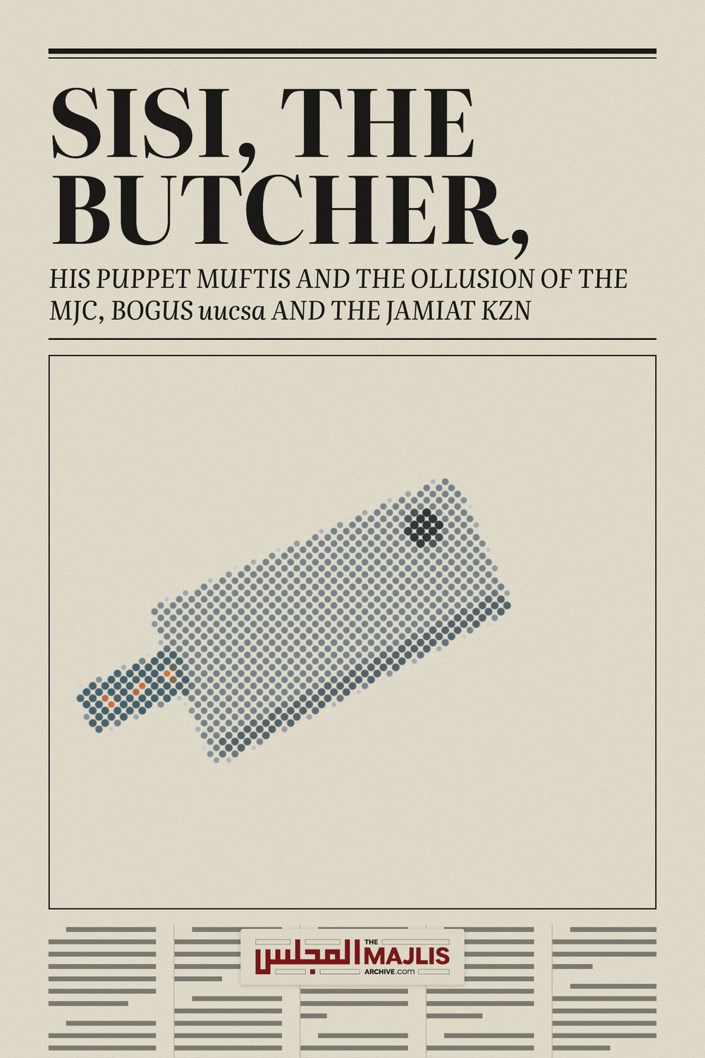

SISI, THE BUTCHER
The Majlis · Voice of Islam
Mujlisul Ulama of South Africa

About this edition
This is a reproduction by The Majlis Archive (themajlisarchive.com) of a publication of The Majlis, Mujlisul Ulama of South Africa, made and published with their permission.
The PDF as The Majlis issued it is the original. This edition was read from that PDF's own structure and checked against it letter for letter; where the two differ, the PDF is correct.
Checked: 81 paragraphs, 0 differing; a second, independent PDF reader finds 100.0% of the PDF's words here.
Nothing has been reworded, added or removed.

SISI, THE BUTCHER, HIS PUPPET MUFTIS AND THE OLLUSION OF THE MJC, BOGUS uucsa AND THE JAMIAT KZN
By:
The Majlis – PO Box 3393 –
Port Elizabeth – 6056 – South Africa

THE MJC AND JAMIAT KZN – BED-FELLOWS IN HARAAM
Vindicating the MJC on the issue of hosting Sisi's mufti who was supposed to have visited South Africa, is tantamount to collaboration with Sisi. On the eve of the proposed and expected arrival of the group of Sisi's murderer 'scholars for dollars', we had published an article condemning the MJC and its bedfellow, the KZN Jamiat. A brother taking objection to our criticism, sprung to the defence of the MJC and Jamiat KZN. His letter and our response follows hereunder

THE OBJECTION
"The Majlis has made a serious allegation on both the MJC and the Jamiat KZN in the article, 'HOSTING MURDERER SISIS'S MURDERER MUFTIS'. On the other hand, the MJC has refused to host the Egyptian Mufti and the Jamiat KZN has distanced themselves from the same, the transcripts of which are in the public domain and in your possession.
It is obvious that someone is not truthful. As the Majlis has made the allegation, it is duty of the Majlis to either provide the proof that substantiates this allegation or to retract its statement and apologize to these bodies for slander against them.
Proof should be actual and not speculation. Proof is not emails written to UUCSA or MJC requesting details or confirmation of the visit from which their agreement to host is speculated. Both the statements of the MJC and Jamiat KZN are in the public domain wherein it is clear that they are not hosting the Egyptian Mufti. Your proof must therefore be from the MJC and the Jamiat KZN directly where they have agreed to this hosting.
I hope you would answer this query honestly and directly as per Allah's saying, "O you who believe! Guard your duty to Allah, and speak words straight to the point." And not try to deflect the issue by speaking of the ills of the aforementioned organisations or attacking me for asking a valid query or going on any other tangent.
My query is specific to your allegation against the MJC and Jamiat KZN that they have agreed to host the Egypt Mufti's delegation; an allegation which both organisations publicly deny. Please provide proof of your allegation or fear Allah and retract your statement."

OUR RESPONSE
Either you have intentionally donned blinkers of bias to avoid seeing and understanding the truth or you are a simple moron lacking in understanding, hence your drivel outpour.
While you cite our one article, you conveniently ignore the facts stated in the article in which is mentioned the statements of the official of the Jamiat KZN, and our explanation of our criticism of the Jamiat.
Our article to which you have made reference is dated 18 September 2016 while the MJC's letter is dated 20 September 2016. Furthermore this letter of the MJC dated two days after our article, was released in the public domain, several days after it was sent to the Egyptian Embassy.
The MJC's letter was a belated WITHDRAWAL from an arrangement/undertaking it had with the Egyptian embassy to host the murderer mufti. Thus, in its letter to the embassy, the MJC said:
"The Muslim Judicial Council (SA) regrettably informs the Egyptian Embassy that it would NO longer be able to facilitate such a visit to South Africa."
Note: The emphasis on the word 'NO', is the MJC's, not ours.
When the MJC Carrion Clique realized the mess they had become entangled in after having arranged to host the Butcher's murderer mufti, it felt constrained to WITHDRAW or RENEGE from the undertaking it had given the Egyptian embassy regarding hosting the Thugs.
Confirming the MJC's agreement with the Egyptian embassy to host the murderer mufti, Maulana Ahmad Mohammedy (the Jamiat's Ameer) said:
"How can we even think of hosting the criminal who endorsed the death sentence against President Muhammad Morsi is beyond my understanding.
MJC can expect serious backlash if the community discovers who Mufti Shawki is. MJC detractors will have a field day. .......The general membership of MJC MUST be considered as they are the ones who will have to face the music on the ground."
This further confirms the arrangement/agreement already made by the MJC with the Egyptian embassy to host Sisi's murderer mufti. Although Maulana Mohammedy was clearly upset by the MJC's decision, he later came out in its defence simply because he and his Jamiat (i.e. the leadership cartel) are in an unholy embrace with BOGUS uucsa. This has already been explained in our article over which you have glossed with your blinkers of bias.
The MJC's belated WITHDRAWAL from its already-arranged hosting event coming after our condemnation, does not exculpate it from the evil complicity with the Egyptian embassy. Pressure after the agreement had constrained the WITHDRAWAL.
Our criticism of the Jamiat's role, despite Maulana Mohammedy's anti-Sisi statement, was on account of his treachery and lying in a haraam embrace with the mudhilleen of the MJC, and his decision to join the baatil, paper body, BOGUS UUCSA. All of this has been explained in our article, but you have chosen to remain blind or cast blinkered eyes on these facts of reality. Having joined the shaitaani BOGUS ucsa, Maulana Mohammedy turned his back on the Haqq – on the Sunnah and the Shariah. In so doing, he has betrayed Allah Ta'ala, the Ummah and the Deen. He can no longer be spared from public criticism. We see nothing but ulterior worldly and nafsaani motives in his mannerism of conducting the affairs of the Jamiat. He has therefore become persona non grata in terms of the Shariah.
Our criticism which was prior to the MJC releasing its letter in the public domain, as well as our criticism of the treacherous KZN Jamiat, were based on solid proof, not on speculation as you have duped yourself into hallucinating. Even before both these miserable so-called ulama entities had published their statements in the public domain, we had issued our article. The basis for our article was a letter which BOGUS uucsa which Maulana Mohammedy and his tiny clique have joined, had submitted to the court to highlight the hallucinated 'importance' of BOGUS uucsa. We have printed that letter in our article, but you portray dumbness. You have not bothered to understand the letter. Read our article again without your blinkers of bias and understand that the MJC had already planned the hosting, and with or without Mohammedy's knowledge/consent had arranged for the Jamiat KZN to host the murderer mufti. Maulana Mohammedy is the office of BOGUS uucsa in Durban where the murderer was supposed to have been hosted.
Who had arranged for the Jamiat KZN to host the murderer? From Mohammedy's statement, it is clear that he was against the idea. This therefore confirms that BOGUS uucsa with Reverend Abraham Bham, Qalb Patel and some MJC sheikhs, ignorant of even basic Istinja masaa-il and excelling in carrion halaalizing, who were in charge of the Sisi debacle, had treated the Jamiat KZN as a supine poodle. They had arranged for the Jamiat to host the murderer even without having acquired the Jamiat's consent. That was the sequel of the Jamiat's treacherous embrace of the BOGUS uucsa cartel. The Jamiat KZN has sold its body and soul in becoming a haraam bed-fellow of the charlatans of BOGUS uucsa. It should now not yelp when it is criticized for its betrayal of the Haqq. When Mohammedy became aware of this development, he began issuing his anti-Sisi yelping.
Let us now briefly respond to your individual baseless flotsam contentions. You say:
"The Majlis has made a serious allegation on both the MJC and the Jamiat KZN in the aforementioned article. On the other hand, the MJC has refused to host the Egyptian Mufti and the Jamiat KZN has distanced themselves from same, the transcripts of which are in the public domain and in your possession."
Rebuttal Yes, our 'allegation' is serious, but factual notwithstanding the belated MJC's statement which appeared in the 'public' domain after we had published our criticism. The facts are:
• The MJC had arranged with the Egyptian embassy to host Sisi's mufti.
• Our information was acquired from papers which BOGUS uucsa had submitted to the Pretoria High Court.
• The MJC or BOGUS uucsa had unilaterally decided that the Jamiat KZN would be acting as the mufti's host in Durban. The letter in the Court confirms this fact. We say 'unilaterally' because Mohammedy objected after this fact became known.
• The MJC belatedly realized the storm which it would be creating if it went ahead with its plans of hosting the mufti.
• The MJC was thus constrained to withdraw and renege from the agreement, especially since the Jamiat KZN, a member of BOGUS uucsa, had also objected.
• Our article appeared before the belated letter of the MJC was published in the public domain. Remove the blinkers and look at the dates.
You say: "It is obvious that someone is not truthful. As the Majlis had made the allegation, it is duty of the Majlis to either provide the proof that substantiates this allegation or to retract its statement and apologize to these bodies for slander against then."
Rebuttal No one has been untruthful in this matter. Your bias has constrained you to baselessly jump to the defence of fussaaq and traitors. Neither you nor the two vile entities you are vindicating have any genuine feeling and consideration for the Deen, hence your stupid and insipid defence of the indefensible.
Did it ever occur to you to ever criticize the MJC for the multitude of public and flagrant haraam misdeeds it has perpetrated at every step of its existence? Did you open your mouth in defence of Islam and its Haqq and of the upholders of Haqq despite the haraam carrion scandals and other haraam misdeeds of the MJC being enacted in the public domain? If you do not understand that the MJC is a veritable Iblees destroying the Deen and misleading its flock, then you too are shaitaan-incarnate. What has compelled you to stand up in flabby defence of an entity which leads its ignorant flock to Jahannam?
You must be trapped in hallucination if you expect us to apologize to an entity which has lost all Imaani bearings – which comprises of shayaateen in human form – who are wolves in sheep's skin – which is a curse for its flock? You must be hovering on the brink of insanity if you expect the Haqq to apologize to baatil. It is our Waajib obligation to cut down and demolish baatil, not to confer any honour and respectability on people whose mission it is to destroy Islam.
The same goes for the Jamiat KZN who has finally thrown off its mask of deception to embrace and lie in bed with the shayaateen of the MJC and the shayaateen of the NNB Jamiat, and the shayaateen grave-worshippers under cover of BOGUS uucsa.
By 'jamiat kzn' we refer to the small cartel of Juhala and Mudhilleen under Mohammedy who has committed the worst treachery by betraying the Haqq. There are numerous Molvis of the Jamiat and Molvis who have long ago dissociated from the Jamiat who are in stark disagreement with this cartel's leadership. It is just unfortunate that their spineless attitude prevents them from proclaiming the Haqq and giving the cartel the boot.
The jamiat's dissociation from Sisi's mufti is meaningless. It still lies in bed with the MJC who is extremely 'regretful' of having been forced to withdraw from hosting the mufti. Stating its regret, the MJC says in its letter to the Egyptian embassy: "Thus, the Muslim Judicial Council (SA) regrettably informs the Egyptian Embassy that it would NO longer be able to facilitate such a visit to South Africa."
Thus, the MJC is still in full support of Sisi and his murderer muftis. It is Sisi who controls the Al-Azhar university which is run by his puppet muftis, and with this institution, the MJC has a strong relationship. Confirming this, the MJC states in its letter: "The MJC leadership places on record its continuous commitment to the partnership with the Al-Azhar University and wishes to express its sincere gratitude for your understanding."
Only donkeys can claim to be unaware of the conspicuous reality of Al-Azhar and its muftis being the puppets of Sisi, The Butcher and Murderer. You must hang your head in shame for having sprung to the defence of the MJC, that is, if you have not lost your soul and Imaan.
Our proof stares you glaringly in the face. We issued our statement on 18 September whereas the MJC's flabby, bootlicking letter with its half-hearted and fully regretful withdrawal of its prior agreement appeared several days thereafter in the public domain. Our detailed explanation from which you have selectively taken is the proof for the Haqq. This present article further clarifies and substantiates the proof. Just remove the blinkers of bias and fear Allah Ta'ala, and supplicate to Him to guide you to the Haqq and to protect you against the evil of defending men of baatil such as the MJC and the Jamiat KZN's leadership cartel.
You aver in your letter: "Proof should be actual and not speculation."
Rebuttal You are the one guilty of speculation. We have structured our case on facts and our motivation is to uphold the Haqq of the Deen and to confront and combat the innumerable shayaateen in human form such as the MJC and the Jamiat cartel. They are all sell-outs who have no care and no concern for the Haqq. They misuse the name of the Deen for achieving their ulterior, corrupt, worldly and nafsaani motives.
You say: "...it is clear they are not hosting the Egyptian Mufti."
Rebuttal The MJC was constrained to renege from its agreement, hence it had no option but to abstain from hosting the mufti. Look at the issue in a broader perspective – in the backdrop of our full explanation, not selectively and not subjectively. Ask Allah Ta'ala to create some abhorrence for baatil in your heart. If your Dua is accepted, then when Haqq suffers a setback or Haqq has faltered, your heart will bleed, not rejoice and not spring to the defence of the forces of baatil and the agents of Iblees.
Uttering stupidity, you say: "Your proof must be from the MJC and the Jamiat KZN directly where they have agreed to this hosting."

Rebuttal
Remove your blinkers of bias and use your brains when reading:
• Our article dated 18 September 2016, days before the MJC's 'public domain' red herring.
• The MJC's letter to the Egyptian embassy, which speaks volumes for the MJC's agreement to host Sisi's mufti.
• Mohammedy's statements dated 19 September 2016 (days before the MJC's 'public domain' act constrained on it by developing circumstances. Mohammedy's statements clearly imply the MJC's agreement to host Sisi's mufti.
• The letter which BOGUS uucsa had submitted to the High Court. This letter appears together with our article which you have read with blinkered eyes. The objective of this letter was to show the Court how very 'important' BOGUS uucsa is. Its 'importance' was being illustrated with this letter to show that it (BOGUS uucsa) has direct contact with the Sisi government via the agency of the Al-Azhar puppet with its rubber-stamping muftis of villainy.
There is widespread discontent among the Natal Ulama regarding the current leadership of the Jamiat KZN. The 'leadership' has lost its Islamic bearing, hence, like a lost poodle, it looks askance at baatil groups for direction and for even directives. Thus, this lost 'leadership' is meekly following the juhala of the NNB jamiat of Fordsburg, dancing to the tune piped by Reverend Abraham Bham, and even the Barelwi Qabar Pujaaris. It is further cuddling BOGUS uccsa for support.
The policy of cuddling baatil bodies for support and direction illustrates the deviation of the Jamiat's current 'leadership'. We warn them with the Naseehat of Hadhrat Junaid Baghdaadi (Rahmatullah alayh) who said:
"Whoever searches for izzat (honour/respect) by means of baatil, Allah will disgrace him with the Haqq."
Regarding the treachery of the 'leadership' – treachery with the Haqq – Hadhrat Umar (Radhiyallahu anhu), warning the ilk of the Jamiat's current 'leadership', said:
"He who deceives (and stabs in the back) the servants (i.e. the Servants of Haqq) Allah will disgrace him."
We warn the 'leadership' of the Jamiat KZN that its dalliances with the groups of baatil will disgrace them. It is time or time long overdue, for Maulana Mohammedy and his cartel to take stock and engage in Muraaqabah to understand the road of baatil and dhalaal which they have adopted by ditching the Haqq and clambering on board the evil, rickety, haraam bandwagon of the forces of baatil, viz. NNB jamiat, MJC, BOGUS uucsa and the Qabar Pujaari groups.
Referring to the disastrous path adopted by the current Jamiat 'leadership', an Aalim who is a member of the Jamiat KZN, sent us a press photo of ulama-e-soo' posing for the camera at the recent haraam Nkandla so-called 'dawah' debacle, and along with the photograph, he commented as follows:
"The Ulama of Deoband were at one time very cautious with regards to the taking of photos. The young and 'famous' ulama (i.e. notorious vile cartel of molvis – The Majlis) have now chosen a new path in posing for the camera.
Once the Sunnis (i.e. the Barelwi grave-worshippers – The Majlis) were pointed out as wrong-doers by posing for the cameras, but today, what face do the Deobandis have — basically we are licking our wounds.
Shame on these 'lovely' looking molvis. The Dunya have they achieved and pomp in the eyes of the masses. (The Brother's conclusion is erroneous. They have achieved fame in the eyes of Iblees. The masses scorn and despise bootlicking molvis. – The Majlis) May Allah save us all.
Very sad to note that Molana Raffiq Mohammad who was not re-elected as secretary general of Jamiat kzn is again on the prowl. Adv. Emran Vawda recently resigned as Secretary General, and Molana Raffiq Mohammad quickly and quietly slipped in as 'Secretary General'. (Another BOGUS post occupied by a BOGUS jaahil molvi – The Majlis). One wonders if the elders and the Shura of Jamiat knows that. (Are there still elders in the Jamiat's Shura? If there are, they are lost. The 'secretary general' nomdeplume is hilarious. Their primary activity is to idle and catch flies and flees in Alpine Road. – The Majlis)
This all became evident and apparent when Molana Mohammedy and Abdullah Khan suddenly pulled out from the Nkandla episode, while Molana Raffiq Mohammad a few days later confirmed his position as Secretary General of Jamiat and knew nothing of the non- participation for the event. It seems the Jamiat is a cartel of Molanas - Mohammedy, Raffiq Mohammad and Abdullah Khan. As for Molana Mohammedy, hat in hand, he was quite on the event while Darul Ihsan (i.e. Darush Shaitah -The Abode of the Devil – The Majlis) took the lead.
Previously too, the 'famous' Molana Raffiq Mohammad was placed in difficult position when his peer sconned him. By the way, Molana Raffiq Mohammad now works for Waleed Sadi — probably his tenth job— where and what next?"
(End of the Molvi's letter)
The Jamiat's lost 'leadership' had also conducted itself disgracefully during the Nkandla shaitaani debacle. While the clique was promoting the haraam event from the inception, it later discerned the gross error and satanism being promoted under guise of 'dawah'. Thus, they silently, like thieves, pulled out of the event without making a public announcement.
When they finally realized that the event was haraam satanism, they had upon themselves the Waajib obligation of announcing to the public their withdrawal and the reasons therefor. But after having been in support of the satanic 'dawah' event, their quiet withdrawal did not serve the Haqq. They simply created obfuscation. Due to this obfuscation, some morons had, just like you, queried our criticism of the Jamiat which had not participated in the event. In the absence of a public announcement, there was no way we were made aware of their withdrawal. Fence-sitting is a salient feature of the current 'leadership' of the KZN Jamiat. The Jamiat's 'elders' must fully share the blame for the present putrid state of the Jamiat's affairs and for its incremental degeneration down the slippery path into the quagmire of baatil.
In conclusion, our advice to you, if you do have some iota's of Imaani conscience, is to reflect and endeavour to assess the motive for having sprung to the defence of the baatil MJC whose historical track record is cluttered with haraam, fisq, fujoor, bid'ah and kufr. And, also reflect and meditate on the Jamiat's Mahommedy cartel getting into bed with BOGUS uucsa.
Peace on those who follow the Hidaayat of Allah.

