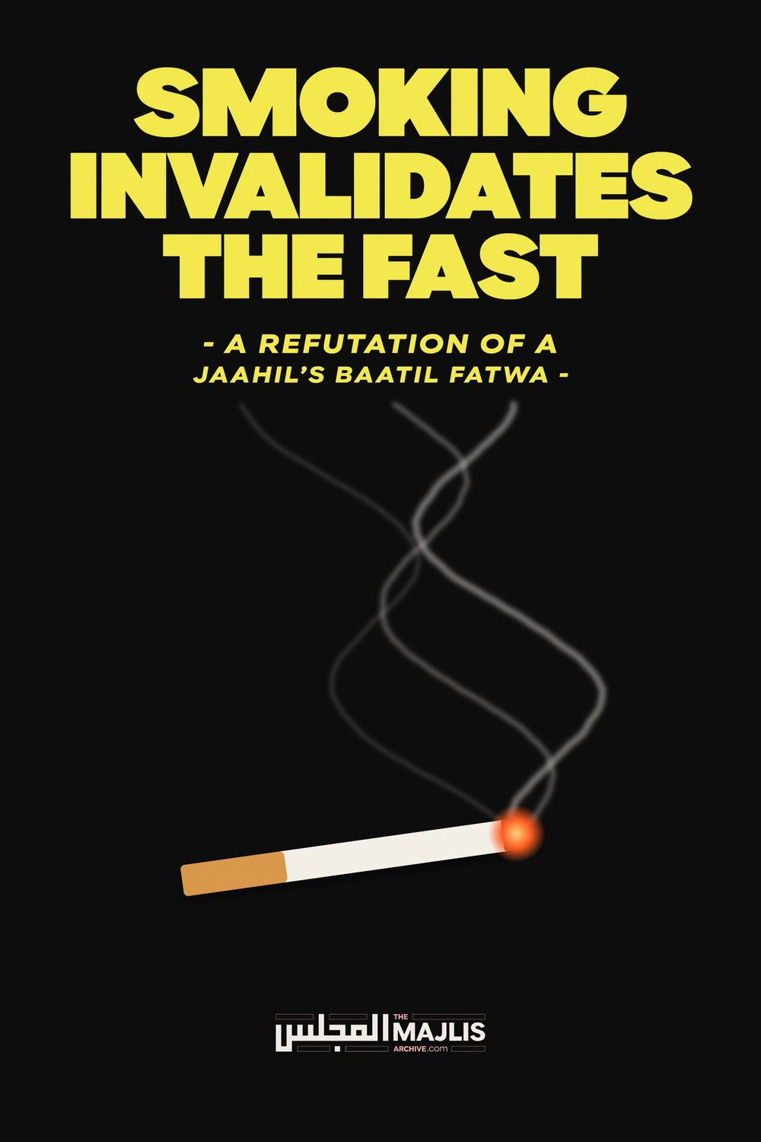

SMOKING INVALIDATES THE FAST
The Majlis · Voice of Islam
Mujlisul Ulama of South Africa

About this edition
This is a reproduction by The Majlis Archive (themajlisarchive.com) of a publication of The Majlis, Mujlisul Ulama of South Africa, made and published with their permission.
The PDF as The Majlis issued it is the original. This edition was read from that PDF's own structure and checked against it letter for letter; where the two differ, the PDF is correct.
Checked: 78 paragraphs, 0 differing; a second, independent PDF reader finds 100.0% of the PDF's words here.
Nothing has been reworded, added or removed.

BY THE MAJLIS P.O. BOX 3393, PORT ELIZABETH SOUTH AFRICA

THE MUDHIL'S BAATIL SMOKING VIEW
According to the U.K. Zindeeq, Faasiq, deviate Atabek Shukorov, who has set himself up as an 'authority' of the Hanafi Math-hab, smoking tobacco and using an inhaler do not invalidate the fast. This jaahil has disgorged some absolutely spurious and stupid arguments to bolster his corrupt view which is in diametric conflict with the Fatwa of all Four Math-habs of the Ahlus Sunnah Wal Jama'ah.
The Fuqaha of all Four Math-habs have unanimously ruled that smoking breaks the fast. According to the Hanafi Math-hab, intentionally smoking during Ramadhaan necessitates the obligations of Qadha as well as the 60 day Kaffaarah. Seeking to overturn the Ijma' of the Four Math-habs, this modernist Zindeeq exhibits his jahaalat which confirms that he is ignorant of the Shar'i concept of Saum. He does not know even the proper meaning of Fasting.
His article of jahl portraying his jahl-e-murakkab (compound ignorance), is bereft of even a shred of Shar'i evidence for his haraam view. He has miserably failed to cite even a single text from any of the Fuqaha of any of the Math-habs to bolster his haraam fallacy structured on the basis of corrupt personal opinion.
Fasting is an injunction of the Shariah. Fasting has been ordained for Muslims since the era of Rasulullah
(Sallallahu alayhi wasallam). Its definition cannot be re-interpreted on the basis of the logic of a copro-jaahil whose brains are operating within the constriction of the straightjacket of western modernity. In his article he has presented absolutely no Shar'i daleel for his haraam view. He abortively attempts to prove his baseless view in terms of analogies which are fallacious. His fallacies shall, Insha-Allah, be dissected and demolished further on in this article.

HANAFI MATH-HAB
"He who inhales medicine, then perceives the taste of the smoke in his throat, should make qadha of the fast." (As-Sulaimaaniyyah)
"If water drawn into the nostrils reaches the brains, then qadha is obligatory." (Al-Khazaanah, narrating from Imaam Abu Hanifah – Rahmatullah alayh)
(The same ruling will apply to smoke inhaled intentionally).
"If he (intentionally) causes smoke to enter into his throat, his fast is invalidated, regardless of the type of smoke it may be. Thus, if he brings the incense close to him and smells its smoke, hence causing it to enter into his throat whilst he is aware of his fast, then his fast is broken. Whether (it be the smoke of) oudh, ambar or anything besides these two because it is possible to refrain from causing the muftir from entering the stomach. (Muftir is something which invalidates the fast.) Numerous people are oblivious of this fact." (Haashiyatut Tahaawi ala Duraril Hukkaam)
" Or he intentionally causes smoke to enter his stomach or his brain, then the fast is invalidated because of the presence of something which breaks the fast. This applies to the smoke of substances other than ambar and oudh. And, in these two Kaffaarah also becoming incumbent is not far-fetched. Likewise (is the ruling) regarding the latest type of smoking which has been innovated in this age. (i.e. smoking tobacco and cigarettes) (Maraaqil Falaah)
"On this basis, regarding the bid'ah which has been innovated presently—when it is smoked, Kaffaarah becomes obligatory. We supplicate to Allah for forgiveness and protection." (Maraaqil Falaah Sharh Noorul Eedhaah)
"If he causes smoke to enter his throat, the fast is invalidated regardless of the type of smoke even if it is of oudh or ambar whilst he is aware (that he is fasting), for it is possible to abstain from it." (Durrul Mukhtaar)
"From this, the ruling pertaining to smoking (tobacco) is known. In a poem Ash-Shurumbulaali said in his Sharah of Al-Wahbaaniyyah: "Its smoker during the fast, there is no doubt in the fast being invalidated." (Raddul Muhtaar)
"If he inhales medicine and perceives its taste in his throat, he has to make qadha of the fast." (Binaayah)
"If he causes it to enter into his throat, his fast is invalid. Thus if he inhales its smoke and causes it to enter into his throat, his fast breaks." Majma'ul Anhaar)

MAALIKI MATH-HAB
"The reaching of smoke in the throat by burning (something), e.g. oudh, similarly the smoke from a boiling pot of food, invalidate the fast just as the vapour by smoking a pipe." (Manhul Jaleel Sharh Mukhtasar Khaleel)
"It is obligatory to abstain from whatever reaches the throat, be it a substance which dissolves or not." (Manhul Jaleel)
"He who inhales smoke or anything besides it whilst fasting, verily the fast is invalidated, for verily, the nose is the upper passageway reaching the throat. On him is qadha (of the invalidated fast). And if it is during Ramaadhan, then (also) he will be liable for azaab (punishment) if he deliberately does so. .......Al-Lakhmi said: 'Snuffing is prohibited. The snuffer is able to prevent it reaching the throat. There is no difference (of opinion) in the invalidation (of the fast)."
"What do you say regarding a person who smokes during the day of Ramadhaan? Is Kaffaarah obligatory?"
Answer: "Yes, Kaffaarah is obligatory if it reaches in his stomach. ........In Al-Mukhtasar (it appears): Regarding the smoke which (is acquired) by smoking, it invalidates (the fast) because it is a physical form. It reaches the throat. In fact sometimes it reaches even the stomach."
"What do you say regarding the placement of smoke in the mouth between the lower lip and the teeth and spitting out the saliva tainted with it? Will the fasting person's fast be invalidated, and will Kaffaarah be incumbent if this was done intentionally during Ramadhaan without valid reason?"
Answer: Placement of smoke in this manner in the mouth is in conflict with the reality of fasting which is to withhold from the lusts of the stomach and private organs from the rise of Fajr Saadiq until the completion of sunset with an intention......Its taste reaches the throat, for verily, the brain derives enjoyment from it just as the enjoyment of the smoke derived by sucking a pipe or by snuffing with it from the nose, or (this described in the question) is worse. There is no doubt in the invalidation of the fast and the obligation of the Greater Kaffaarah if this is done intentionally during Ramadhaan without valid reason. Fitr (the fast breaking) is more confirmed by it (i.e. the smoking) that the fitr resulting from oiling the head and the taste reaching the throat from the pores, and (more confirmed) that inhaling the vapours from a (boiling) pot (of food). This is well-known to the masses. When they hear that someone saying that the fast is not broken or that he hesitates in saying this (i.e. that the fast is broken), then they are surprised by it, and they attribute such a statement and hesitation to ignorance and little awareness (of reality). (Such as the ignorance of this copro-jaahil, Atabek). ........Therefore, how is it possible to aver that it does not invalidate the fast. Or to hesitate (in saying that it breaks the fast)?
Abdul Haqq has narrated in Tahzeebut Taalib from As-Sulamaaniyyah: 'He who inhales medicine and perceives its taste in his throat, then most certainly his fast is broken.......They (the Fuqaha) have said that one who inhales vapour from a pot of food, very his fast is broken, for verily, the vapours of food have a physical form which strengthens the brain. Thus, the resultant acquisition is like that acquired by eating. It is not hidden that the mouth is the nearer to the throat than the nose and the pores of the head, and it (the mouth) is wider than both........." (Fathul Ulal Maalik fil Fataawa ala Math-habil Imaamil Maalik)
"When the vapour of a pot of food reaches the throat, the fast is invalidated and qadhaa is incumbent. From this (i.e. the same ruling applies) is the vapours of smoking with a reed (or pipe).
When the vapour of bukhoor or the vapour of a pot (of food) reaches the throat, then qadha become obligatory because both of them are is physical body formed." (Bulghatis Saalik li-Aqrabal Masaalik)
"Vapours arising from lighting a pipe, and similarly the vapour of a pot—when it reaches the throat, qadha is compulsory. And from this is also with a pipe, etc., for verily, it reaches the throat. In fact (it reaches) the stomach."
(Haashiyah Ad-Dusooqi ala Sharhil Kabeer)

SHAAFI' MATH-HAB
"In Baijurmi: The smoking which has now developed, which is called At-tatun,-May Allah curse the one who has initiated it – verily it is of the evil innovations. Our Shaikh Az-Ziyaadi used to issue fatwa in the beginning that the fast does not break because at that time he was not aware of its reality. However, when he saw its effect from the pipe with which it is smoked, then he retracted (his earlier view) and issued fatwa that it breaks the fast." (I'aanatut Taalibeen)
"And from it (i.e. the things which invalidate the fast) is the popular kind of smoking." (Nihaayatuz Zain)
"But, smoking tobacco is excluded (from the things which do not break the fast), for verily, from it physical form is acquired." (Bushral Kareem)
"The popular smoking invalidates the fast just as the smoke of a wick." (Tuhfatul Habeeb ala Sharhil Khateeb)
"If the vapour is from the popular smoking of this time, then it breaks the fast."
(Futuhaarul Wahhaab)

HAMBALI MATH-HAB
"He who swallows smoke intentionally, his fast is invalid."
(Mataalib Ulun Nuha fi Sharhi Ghaayatil Muntaha)
"He who swallows smoke intentionally, his fast is invalid."
(Kashful Qinaa' ala Matnil Iqnaa')
In the Kitaab, Al-Mausooatil Fiqhiyyah, the following is mentioned:
"The Fuqaha are unanimous that the popular smoking during fasting breaks the fast because it is among the mufttariyaat (the things which break the fast)."
As his basis for his fallacy, Atabek citing from Hanafi texts, says:
"The red box states that dust particles, smoke, the taste of remedies/medicines and the smell of perfume do not break the fast. This evidence can also be found in the other authoritative works of the Hanafis such as Bahe-ur-Taiq, An-Nahr, Fath al-Qadir and Wilayah.
It is also to be found in a large number of Hanafi texts that using a steam room whilst fasting does not break your fast. In a steam room you are breathing in water vapour which also potentially enters your oesophagus (food), with a much larger volume or 'dose' of water than is given by an inhaler (albeit not pressurized).
The abovementioned trash is the only 'daleel' which Atabek has managed to hallucinate for his fallacious view that smoking does not break the fast.
Either he has deliberately and conveniently ignored the explicit texts stating the breaking of the fast with intentional smoke inhalation to be found in the large number of Hanafi texts, or he is unable to understand what is written in these authoritative kutub of the Ahnaaf and of the other Math-habs. The very same kutub from which he has cited the above, clearly state that intentional smoke inhalation breaks the fast. Refer to the references from the Hanafi texts quoted above.
There is absolutely nothing in the "red box" to bolster the trash disgorged by Atabek. Since he is not all that stupid to have understood the reality in the "red box", he conveniently refrains from presenting the translation of the text from Al-Muheetul Burhaani. The text states:
"When dust, smoke, the taste of medicine and the fragrance of perfume is perceived in the throat, it does not invalidate his fast because abstention from it is not possible."
This refers to the taste, dust, etc. entering the throat involuntarily and of its own accord, not by an act of the Saa-im (Fasting person). This distinguishing factor shall be explained further on.
Explaining the issue which appears to be an unfathomable conundrum for the deviate Atabek, the Kutub of the Ahnaaf state:
"It is said in Al-Burhaan: His fast does not break if dust enters his throat or the effect of the taste of medicine, because it is not possible to abstain from it as is mentioned in
Al-Fath. I say that from this stems that when it is possible to abstain from dust which enters the throat, then the fast will be invalidated if he does so (i.e. if he intentionally casues it to enter into his throat). Az-Zaylai said: 'When dust or a fly enters his throat (i.e. of its own accord) whilst he is aware of his fast, his fast does not break because he is unable to prevent this. Thus it resembles smoke (which enters of its own accord, not intentionally inhaled). This (ruling) is according to Istihsaan (application of discretion). However, according to Qiyaas the fast breaks because of a muftir reaching the stomach. ...The reason for (adopting) Istihsaan is the inability to prevent it, hence it is like the moisture which remains in the mouth after rinsing (the mouth).
In Fathul Qadeer it is mentioned: "When vapour and dust enter the throat (of their own accord), the fast does not break, for verily, abstention from their entry is not possible from the nose when the mouth is closed." I say: On this basis when he causes smoke to enter into his throat regardless of the type of smoke whilst he is aware of his fast, then his fast breaks. Whether it be (the smoke) of oudh or ambar or anything else because of the possibility of abstention from causing a muftir to enter in the stomach. Numerous people are oblivious of this."
The deviate Atabek conveniently or ignorantly overlooks this categorical statement in Haashiyah Shurumbulaalui as well as in all other Hanafi texts.
In Maraaqil Falaah, it is mentioned: "...Or if he causes smoke to enter into his stomach or brain by his intentional action (then the fast will break) because of the presence of fitr........The same (ruling applies) to the smoking (i.e. of tobacco) which has been innovated in this era."
In Raddul Muhtaar it appears as follows: "(The fast does not break if) dust or a fly or smoke enters the stomach whilst he is aware of his fast because of the impossibility to abstain from it. This is in terms of Istihsaan. The benefit (i.e. the logical conclusion) of this is that if he causes smoke to enter his throat whilst he is aware of his fast, the fast will break regardless of the type of smoke whether it is oudh or ambar because of the possibility of abstaining from it. Therefore be aware (and ponder) over this as Ash-Shrumbulaali has elaborated."
Elaborating on the entry of dust or a fly or smoke which does not invalidate the fast, it is said in Raddul Muhtaar: "i.e. It (the dust, fly or smoke) entered of its own accord with the action of the fasting person."
From all the Hanafi texts, it is abundantly clear that the Fuqaha have made a clear and categorical distinction between involuntary and voluntary inhalation of smoke. All the Hanafi kutub explicitly mention that while involuntary inhalation of smoke does not invalidate the fast, voluntary and intentional inhalation does invalidate the fast. The deviate has utilized the ruling applicable to involuntary inhalation to cigarette-smoking which is voluntary and intentional inhalation of smoke laden with harmful substances such as tar, nicotine, etc. which end up as solid formations inside the body.
In having ignored the ruling of the Fuqaha pertaining to voluntary and intentional inhalation of smoke, and deceptively and stupidly utilizing the ruling of involuntary inhalation for extravasating his copro-fatwa of baatil, Atabek has committed chicanery and skulduggery.
All the Fuqaha are unanimous in proclaiming the invalidation of the Fast if the fasting person intentionally inhales smoke.
In his three-page trash article, in more than two pages he abortively attempts to logically 'prove' that an asthma inhaler does not invalidate the fast. His stupid 'proofs' towards this end have already been refuted and demolished in the aforegoing discussion. Towards the end of his article of ghutha he arbitrarily, without making even an attempt to present any Shar'i daleel, claims that smoking cigarettes, tobacco, pipe and the like does not break the fast. Since he is totally bereft of Shar'i dalaa-il for his haraam excretion, he has miserably failed in his attempt. It is difficult to believe that he is unaware of the Consensus of the Fuqaha on this issue, namely, mal-oon smoking invalidates the fast. Smoking tobacco is not an act which has been innovated yesterday. Muslims have been smoking the accursed substances for several centuries, having acquired the accursed practice from the western kuffaar.
As explained above, the Fuqaha make a clear distinction between involuntary inhalation of smoke and intentional inhaling. Whilst the former does not break the fast, the latter does invalidate the fast. It is indeed mind-boggling to believe that the intentional inhalation and consumption of a physical substance with all its poisonous, harmful and haraam effects does not render the fast invalid. The deviate jaahil treats this serious issue with extreme insignificance. Lacking in fear for Allah Ta'ala he is prepared to destroy the Ramadhaan Fasts of innumerable stupid Muslims who are addicted to the shaitaani practice of smoking in the style of the inmates of Hell. He appears to have no Imaani idea of accountability and the assumption of the burdens of the sins of others whom he is satanically misguiding.
Indeed it is only a brain deranged and destroyed by the affliction of RIJS divinely inflicted on the followers of shaitaan that fails to understand that the intentional inhalation of clouds of poisonous smoke filled with poisonous tar, nicotine, etc., which gather and block the lungs, arteries, and the other organs of the body do not invalidate the Fast. The inhalation of tobacco smoke which travels from the mouth and nose down the throat into the lungs and other organs, including the stomach, causes all these organs to rot with cancer. The throat rots, the lungs rot, the heart rots the liver rots, the pancreas rots, the kidneys rot and the rest of the body putrefies. The smoke enters the brain and causes it to also rot.
All substances, be it inedible, which are intentionally ingested and which reach the throat or the brain or the stomach, nullify the Fast. Only zindeeq juhala deny this Shar'i reality. The Fuqaha state that even ignoramuses wonder at the jahl of the one who holds the view that the intentional ingestion of smoke via the mouth does not break the fast.
The Fatwa of the Fuqaha, viz., smoking invalidates the Fast, has not been designed for deterring people from this haraam poison as the deviate seeks to convey. The objective of the Fatwa is to save the
Ramadhaan Fasts of people – stupid people – who may be misled by moron Haatibil Lail Zindeeq so-called 'scholars' who are bereft of valid Ilm of the
Deen.

