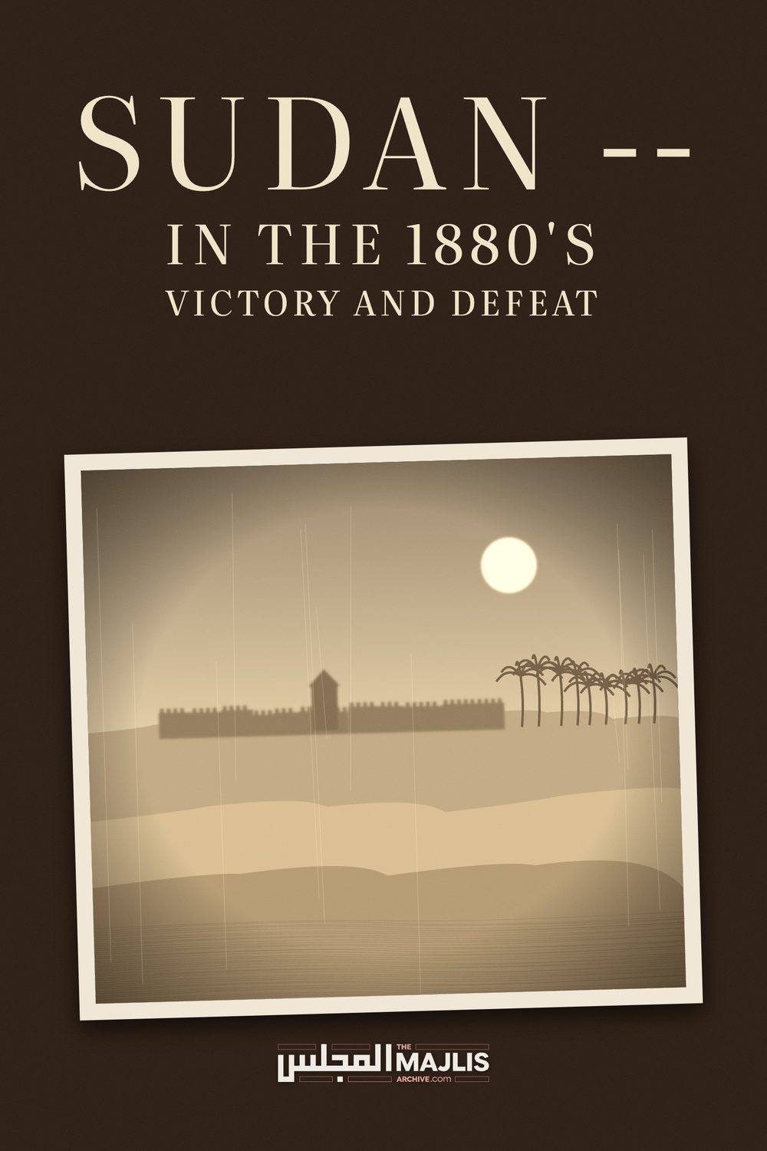

SUDAN - IN THE 1880's
The Majlis · Voice of Islam
Mujlisul Ulama of South Africa

About this edition
This is a reproduction by The Majlis Archive (themajlisarchive.com) of a publication of The Majlis, Mujlisul Ulama of South Africa, made and published with their permission.
The PDF as The Majlis issued it is the original. This edition was read from that PDF's own structure and checked against it letter for letter; where the two differ, the PDF is correct.
Checked: 53 paragraphs, 0 differing; a second, independent PDF reader finds 100.0% of the PDF's words here.
Nothing has been reworded, added or removed.

Young Men's Muslim Association, PO Box 18594, Actonville, Benoni, 1506, South Africa ln 1881, in the Sudan, a leader emerged as if from out of the sands. He was a man of the desert, a mystic and a man of God. His name was Muhammad Ahmad and claimed to be the "Expected One", the true "Mahdi". He soon gathered a force of followers from the desert tribes, and declared jihad.
The Mahdi's Army grew and his revolt spread. The Dervishes (as they came to be known) captured towns and defeated small Egyptian forces sent to destroy them.
Then, in 1883, the Turkish governor of Egypt hired William "Billy" Hicks, a retired British Colonel and several British subordinates to lead a modern army into the Sudan and crush the Mahdi. Hicks Pasha had at his disposal 10,000 regular infantry armed with modern rifles, 1,000 irregular cavalry, 14 field pieces and 6 Nordenfelt multiple barrel machine guns.
On paper it was an imposing force. But the infantry had been recruited from pardoned rebels and the cavalry were undisciplined bashibazouks. In the words of Winston Churchill, it was "perhaps the worst army that has ever marched to war": unpaid, untrained, undisciplined, its soldiers having more in common with their enemies than with their officers.
The Mahdi awaited them, with 40,000 spear and sword-armed tribesmen. They had few rifles and no field guns; but they had something perhaps even greater. The Mahdi promised them a miracle, and they believed him.
They also knew the desert.
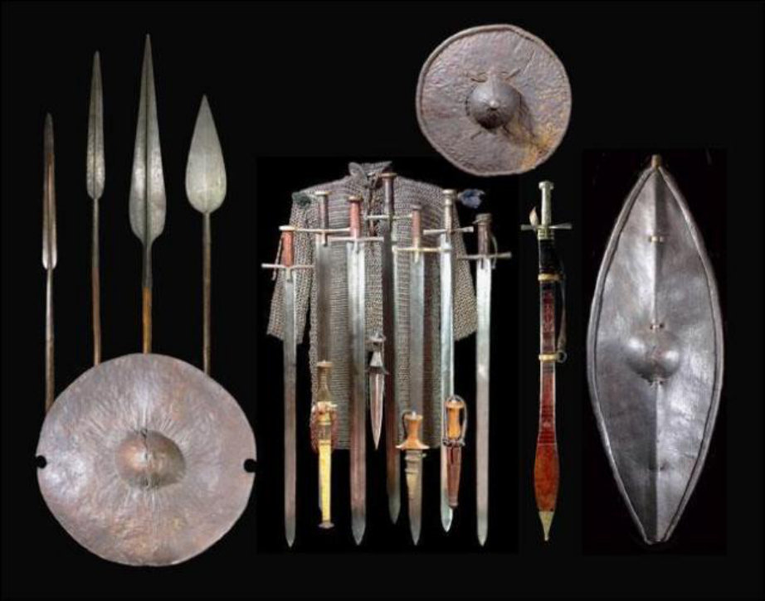
Dervish weapons, shields, and a mail shirt
The Mahdi retreated, and Hicks pursed. Further and further the Mahdi drew his enemy, and Hicks followed; slowed by an immense train of 5,000 camels. The Egyptians withered in the blistering desert heat, their water supplies dwindling. Day after day, they marched on, the Dervishes always just beyond their reach.
Finally, his army spent, Hicks ordered a retreat back to El Obied. It was then the Mahdi stopped retreating, and turned on his enemy. The Egyptians were soon surrounded. For two days their square held, until it collapsed. Hicks and all of the European officers perished; and only 500 survivors returned to Egypt. They left in the Mahdi's hands all of their equipment. If formidable with spear and sword, how dangerous would the Dervishes now be with modern weapons?
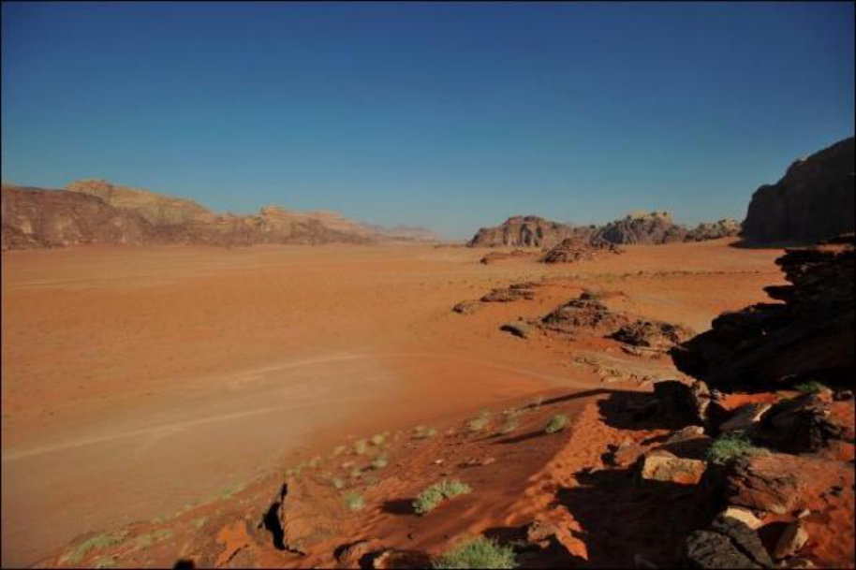
The harsh, forbidding Sudanese desert. It was in just such terrain that Hick's column was destroyed by the Dervishes.
The loss of Hick's army was a deep embarrassment to both Egypt and British government. While technically a part of the Ottoman Empire, Egypt was effectively under the protection of the British Empire. Its army was trained and led by British officers. Pride aside, of more concern was the loss of more than 8,000 rifles and the 14 pieces of modern artillery. The government of Prime Minister William Gladstonewas forced by an outraged public to take action.
In contrast to his arch political rival, Disraeli, Gladstone was a staunch anti-imperialist; and was loath to commit British forces to a war in the Sudan. However, to ease British public opinion, Gladstone appointed a retired national hero, General Charles "Chinese" Gordon, as Governor-General of the Sudan. While most famous for having led the Chinese Imperial government's "Ever Victorious Army" to final victory in the Taiping Rebellion; Gordon had served as Governor of the Sudan in the 1870s, where he had suppressed the slave trade. It was a popular appointment both in Britain and in the Sudan.
But Gordon was not sent to the Sudan to fight the Mahdi. He had no troops at his disposal, and none were promised should he get himself into trouble. He was sent in hopes that his name alone would rally support to the government and against the Mahdi; and failing that, to organize the evacuation of all European personnel from the Sudanese capital, Khartoum.
Gordon arrived in Khartoum in February, 1884. However, Gladstone had overestimated both the dampening effect Gordon's arrival in the Sudan would have on the Mahdist revolt; and Gordon's willingness to obey orders. Once ensconced in the Governor's palace in Khartoum, Gordon began calling for Gladstone to send troops to help his beloved Sudanese in resisting the Dervishes. Meanwhile, he spent the year preparing Khartoum to stand siege till relief arrived.
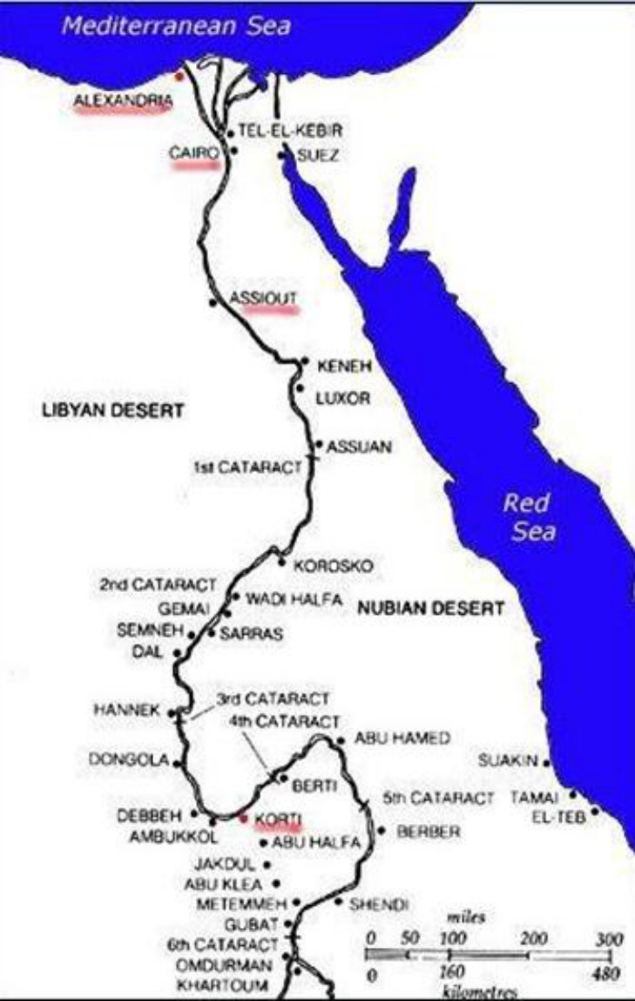
As the Mahdist revolt spread, Gordon and Khartoum were increasingly isolated. A loose Dervish blockade of the city began on March 18, 1884, with the telegraph line to Cairo being cut and river traffic interdicted. Fearful for their hero's life, the British press and public called for a relief expedition. A stubborn and incensed Gladstone resisted as long as was politically possible. Then, in August 1884 he ordered a British relief force to Gordon's rescue.
Called the Khartoum Relief Expedition (or, more popularly in the press, the Gordon Relief Expedition), a force of 4,500 crack British regulars were placed under the command of Field Marshal Garnet Wolseley, Britain's most eminent general. Steaming from England to Alexandria, the expedition then set out from Egypt and up the Nile in two columns. The largest was led by Wolseley himself, and traveled south down the Nile by riverboats. The other, the elite Camel Corps, was commanded by Sir Herbert Stewart. These took the direct route from Wadi Halfa across the desert.
Stewart's force, 1,400 strong, was composed of some of the best units in the British army:
1. The Heavy Camel Corps, comprised of the Household Cavalry, Dragoon Guards, Dragoons and Lancers.
2. The Guards Camel Corps, comprising Grenadier, Coldstream and Scots Guards and Royal Marine Light Infantry.
3. The Mounted Infantry Camel Corps, drawn from the 1st Battalion the Sussex Regiment.
4. Four light field pieces and a small Naval Brigade manning a Gardner machine gun completed the force.
The men of the Camel Corps, 1885
Contrary to what was portrayed in the 2002 film, The Four Feathers, the men of Stewarts command did not wear the traditional British redcoat. Instead, they wore grey tunics, cord breeches and pith helmets stained brown. The infantry of the Sussex Regiment wore khaki tunics. The British troops were all armed with the Martini-Henry breach-loading rifle, equipped with a 22 inch sword-bayonet. Both infantry and cavalry units were mounted on camels, except for the 19th Hussars, who alone retained their horses, and carried carbines and swords instead of rifles.
As Stewart's column neared the oasis of Abu Klea on January 16, 1885, pickets of the 19th Hussars encountered parties of Dervishes. It could be seen that a large force was waiting at the wells and ready to give battle. The British had left the last water some 43 miles before and were in need of replenishment. Nevertheless it was apparent that Abu Klea could only be taken by assault. Stewart halted two miles short of Abu Klea and camped.
The following morning, January 17 the British waited a Dervish attack behind a zereba (hedge) of thorn brush they had erected around their camp. Mounted parties were sent out to skirmish with the Dervishes, in hope of stinging them into a costly assault on the well-defended British camp. When the Mahdist failed to take the bait, Stewart broke camp. Forming up his command into a large, hollow square with the camels in the center, Stewart's dismounted force advanced on the wells of Abu Klea.
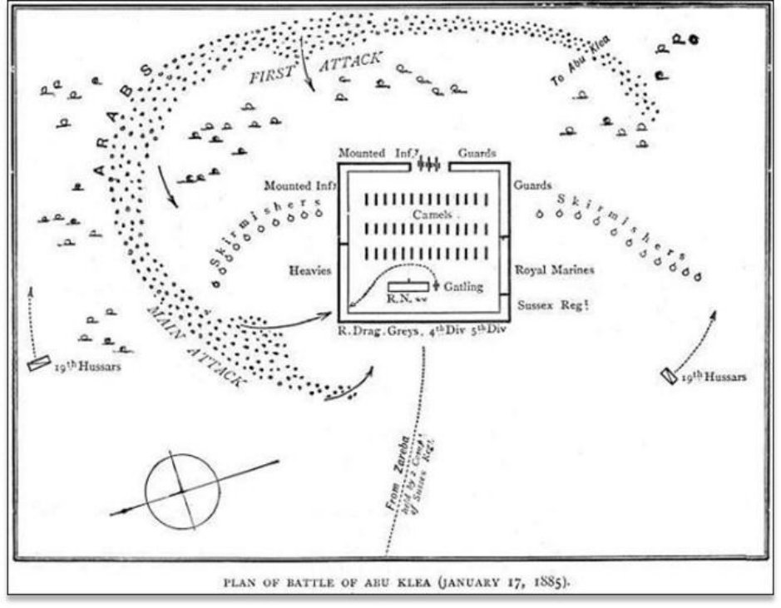
Awaiting him was a 13,000 strong force of fierce Dervish warriors.
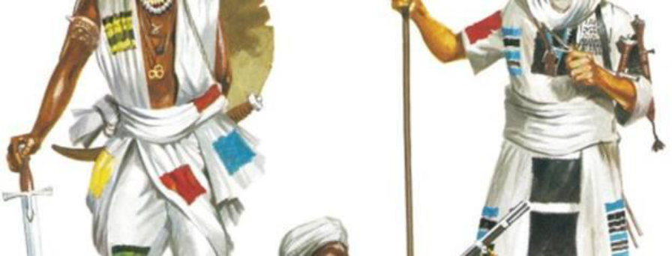
Mahdist/Dervish warriors
For Herbert Stewart and the British, the Battle of Abu Klea began with inauspiciously with mishap. At around 9:30am, as the British square wheeled to the right to move onto higher ground, the Dervishes emerged from the concealment of a nearby gully and charged the square. At this critical juncture, the British fire was hampered by the presence of their own skirmishers between them and the enemy. These had to be permitted to regain the square before volley fire could commence. The rapidly approaching Dervishes followed close on the retreating skirmishers, consequently coming to within 200 yards or less of the square before the first volleys could be delivered; depriving the British of long-range fire.
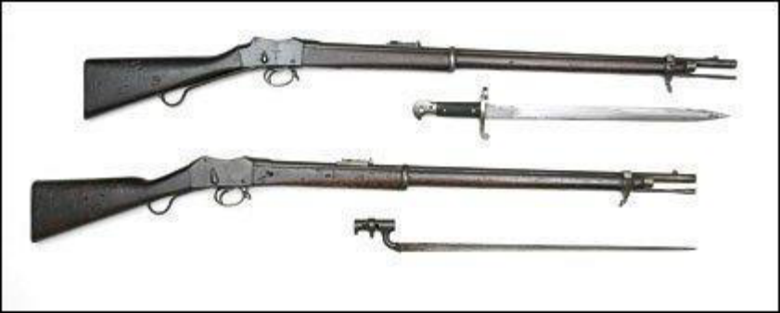
The Martini-Henry rifle with bayonet types
Near disaster loomed when, at this most inopportune moment, a potentially fatal gap opened in a corner of the square. This was partially due to the uneven nature of the ground, and to the inexperience of the Naval Brigade and the dismounted cavalry contingents, who were attempting to fight as infantry. The Dervish charge was delivered at the section of the square held by the Mounted Infantry Regiment of the Camel Corps. Captain Lord Beresford of the Naval Brigade brought his Gardner gun from its position at the rear of the square and took it out through the Mounted Infantry line and opened fire on the charging warriors. But after firing just some 70 rounds, the Gardner gun jammed; something it had an unfortunate tendency to do. Before it could be cleared the Dervish spearmen swarmed over and overwhelmed the detachment; slaughtering all but Lord Beresford, who fell under the gun, along with one of the junior men.
Despite this reverse, the heavy volley firing from the Mounted Infantry and shrapnel from the 3 guns in their front repulsed the Mahdist charge, which coursed around the left face of the square to fall on the gap, where the Heavy Cavalry Camel regiment was posted.
The troopers of this Regiment were defending themselves with the long infantry rifle, a weapon they were unfamiliar with. The cavalry officers had no experience in defending an infantry square. The result was perhaps predictable: swarming forward, the Dervishes penetrated through and into the square.
At this moment the renown Colonel Frederick Burnaby of the Horse Guards rushed forward to stem the tide. A large man who famously loved a good fight, Burnaby waded into the oncoming horde. Fighting with sword from horseback, Burnaby fenced with onrushing warriors, till a thrusting spearman, coming from his flank, caught him in the throat, mortally wounding him.
Rushing past the dying Burnaby and on into the interior of the square, the Dervishes were balked by the mass of camels packed into the interior, which prevented the Dervishes from smashing into the exposed rear ranks of the British troops on the opposing faces of the square. As the camels scampered out of the way, the rear rank of the Mounted Infantry in the front-face of the square, and the Foot Guards and Royal Marines on the right-face turned about; and opened a devastating fire on the blood-mad Dervish warriors. Their attack was soon broken, and thrown back.
The battle was only ten, frantic minutes long. It resulted in 76 dead and 82 wounded British soldiers.
The Mahdists took approximately 1,500 casualties. By 4 pm, the British had taken the wells and the Dervish force was in retreat. Winston Churchill, in his book "The River War" called the fight at Abu Klea "the most savage and bloody action ever fought in the Sudan by British troops…"
Two days later, Stewart was mortally wounded by a stray bullet in a skirmish. The advance continued unabated. Concerned with Wolseley's column approaching as well along the river, the Mahdi decided to order an assault on Khartoum, before the relief columns could arrive to break the siege. Despite his careful preparations, Gordon's defenses crumbled and the city fell. Gordon died on the steps of his palace to a Dervish spear.
The death of Gordon The Gordon Relief Expedition arrived at Khartoum two days later. Finding Gordon and the European nationals dead, the British withdrew; and the Mahdi took complete control of the Sudan. Six months later, the Mahdi died of typhus. But the Dervish state continued on for another 14 years, till Britain sent a second army under Sir Herbert Kitchener to finish what Wolseley and Stewart had begun.
Some of the artwork in this article has been reproduced with the permission of Osprey Publishing.

