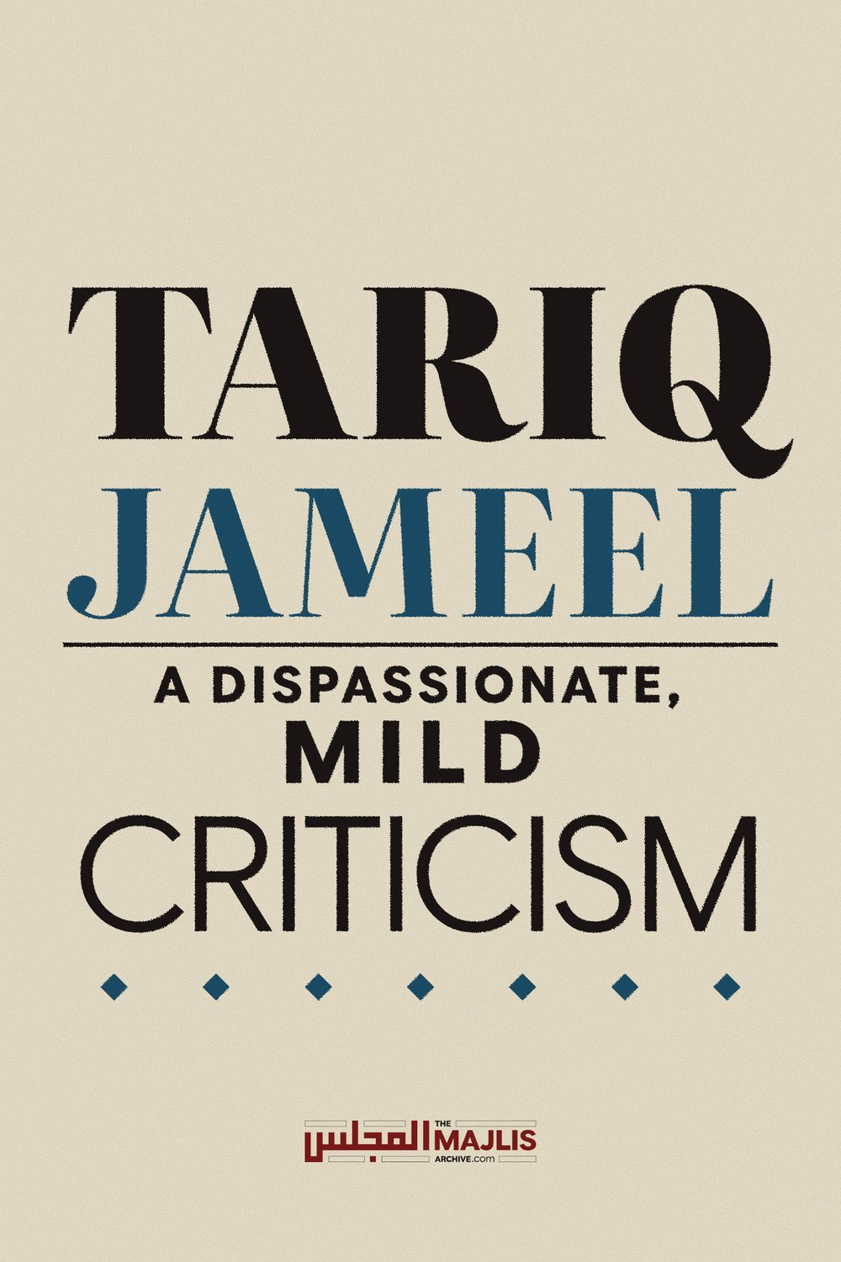

Tariq Jameel, A Mild Criticism
The Majlis · Voice of Islam
Mujlisul Ulama of South Africa

About this edition
This is a reproduction by The Majlis Archive (themajlisarchive.com) of a publication of The Majlis, Mujlisul Ulama of South Africa, made and published with their permission.
The PDF as The Majlis issued it is the original. This edition was read from that PDF's own structure and checked against it letter for letter; where the two differ, the PDF is correct.
Checked: 151 paragraphs, 0 differing; a second, independent PDF reader finds 84.8% of the PDF's words here.
Nothing has been reworded, added or removed.

Maulana Taariq Jameel's Bayaans – A Cause for Concern

This article1 attempts to answer a basic question: Is it safe for the layperson to listen to the bayaans of Maulana Taariq Jameel Saheb?
By 'safe' is intended Deeni safety.
In probing this question, the following six points will be concisely considered:
A. Al Kalimatul Haadi
In September 2010 Mufti Muhammad Eesa Khan Saheb published a book entitled:
(The guiding word toward the straight path, in reply to the one who conflated the truth with many falsehoods). The book is in Urdu and about 360 pages. In this book Mufti Eesa Saheb discussed, in detail, many errors of Maulana Taariq Jameel Saheb of Pakistan, the famous Tablighi orator. His problematic statements were transcribed and then refuted.
Upon completion, the book was presented to certain senior Ulama of Pakistan for their comments. The following Ulama endorsed the book.
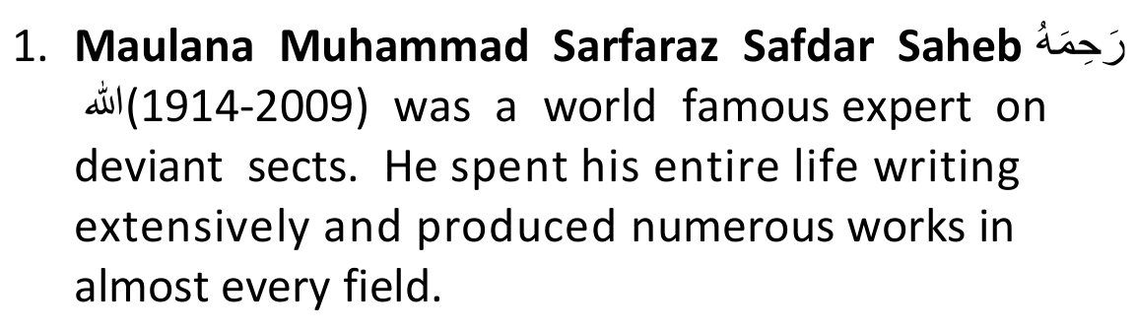

1 This article uses of hyperlinks. To make use of these one is required to be connected to the internet. Click / tap on the texts highlighted in blue, which will then take one to the related document or audio clip. This may take time depending on the speed of the connection.
He exposed and in detail refuted the works of the deviant sects. Upon hearing some of the objectionable statements made by Maulana Taariq Jameel Saheb, he commented:
He [Maulana Taariq Jameel Saheb] is an agent of the deviant sects.
2. Professor Ghulaam Rasool Adeem Saheb.
3. Maulana Fadhl Muhammad Yusufzai Saheb, the
Ustaad of Hadith at Jamiah Islamiyah, Binnori Town, Karachi.
Many eminent South African Ulama are graduates of this world famous Darul Uloom.
Maulana confirmed that definitely some of Maulana Tariq Jameel's statements deserved to be taken to task.
4. Maulana Husain Shah Saheb of Balochistan.
At some stage Maulana Taariq Jameel Saheb apparently retracted some of his previous statements.
Commenting on such apparent retraction, Maulana Husain Shah Saheb writes:
I carefully studied [Maulana] Taariq Jameel's all-inclusive retraction and his incorrect defensive interpretations. I tried to weigh them against his original errors. It appears as if [Maulana] Taariq Jameel has not made any retraction at all, since he is not yet convinced that his lessons were satiated with incorrect beliefs.
5. Professor Qadi Muhammad Taahir Ali Alhaashimi of Hazara.
6. Mufti Abdul Waahid Saheb. Darul Iftaa, Jamiah Madaniyah, Lahore.
7. Maulana Muhammad Sardar Saheb. Darul Uloom Arabiyyah, Hangu. Pakistan.
8. Maulana Muhibbun Nabi Saheb. Darul Uloom Madaniyyah. Lahore.
9. Maulana Saajid Husain Muaawiyah Saheb, Abbottabad.
10. Maulana Muhammad Siddiq Saheb. Principal Jamiah Rashidiyyah. Rawalpindi.
11. Qaari Fath Muhammad Saheb. Sargodha.12. Maulana Muhammad Sulayman Saheb. Rawalpindi.
13. Maulana Sayyid Abdul Maalik Shah Saheb.
Gujranwala.
14. Mufti Zafr Iqbal Saheb. Principal Madrasah Miftaahul Uloom. Bhakkar. Pakistan.
15. Maulana Muhamad Nawaz Balooch Saheb.
Gujranwala.
[One of the reasons for recording these names is to dispel the possible notion that the concern around Maulana Taariq Jameel Saheb's statements is an isolated or obscure view.]
Some of the ustaads and Muftis from Jamiah Ashrafiyyah, Lahore, called for Maulana Taariq Jameel Saheb. When he appeared before them, they presented him with a list of his unacceptable statements.
Maulana Taariq Jameel Saheb verbally accepted his error and retracted from these statements. In order to verify this, Maulana Taariq Jameel Saheb was requested to sign a document confirming the same. He refused.
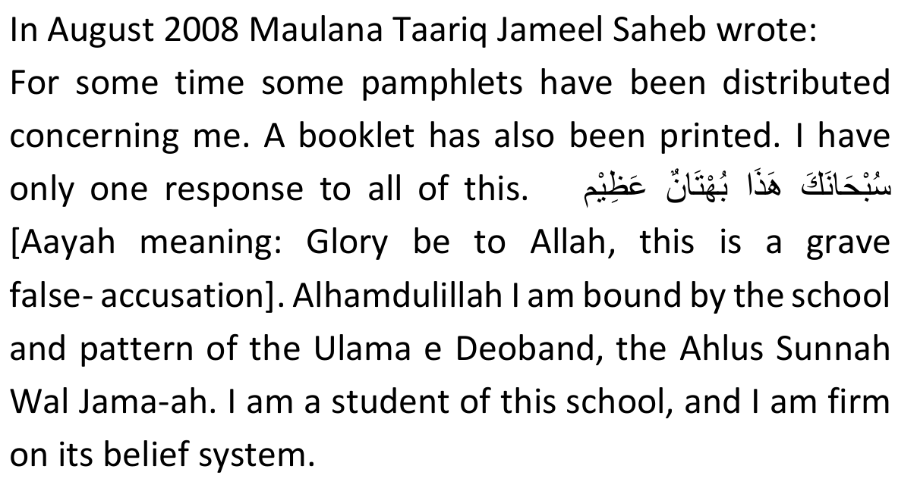
This was shortly after his apparent retraction at Jamiah Ashrafiyyah, Lahore. It begs the question: If he admitted that he was in error, what does he mean by saying that this is a grave false-accusation? One cannot have it both ways: admitting and denying the charge. It places in question whether there was a genuine retraction.
Mufti Muhammad Eesa Khan then presented Maulana Taariq Jameel Saheb a copy of the statements of concern in order to seek clarity. He offered Maulana Taariq Jameel Saheb the opportunity to clarify his statements. Maulana Taariq Jameel Saheb ignored the offer. Maulana Taariq Jameel Saheb followed it up with a written statement saying:
If in my lectures different impressions are to be found, it is due to my error in expressing myself, not an error in my beliefs.However one will note in respect of these contentious statements that Maulana Taariq Jameel Saheb expresses himself quiet clearly.
It is not simply a matter of ambiguous expressions. Mufti Muhammad Eesa Khan then sent Maulana Taariq Jameel Saheb a message via Hajee Muhammad Naeem, inviting him to Gujranwala in order to discuss the statements. Hajee saheb conveyed the reply that Maulana Taariq Jameel Saheb is not prepared to come to Gujranwala.
Mufti Muhammad Eesa Khan thereafter felt that he had exhausted the avenues of giving Maulana Taariq Jameel Saheb an opportunity of redeeming or explaining himself. He thus felt the need to write a refutation of these statements and to publish the same.
The book is rather lengthy, and it is not practical to condense the book in few lines2. Hence those who are able to comprehend Urdu are urged to first read the book before passing comment on this sensitive issue.
Even if one does not agree with the entire contents of the book, this much is evident that Maulana Taariq Jameel Saheb has made many contentious, problematic and Controversial statements.
Some of these are bound to put the layperson into serious doubt in respect of certain fundamental issues of Deen.
2 My apologies to the reader. I only had a few hours to spare in writing this brief article. Had there been more time, much more material on the topic could have been presented. Also, few people nowadays have time to read lengthy articles.If we revert to the core question this article seeks to answer, namely: Is it safe for the layperson to listen to the bayaans of Maulana Taariq Jameel?, a careful study of the book will produce a clear answer in the negative.
B. Maulana Taariq Jameel's praise or Maududi
Abul A'la Maududi (1903 - 1979) was a religious scholar who founded the Jamaat-i-Islami in 1941. On the surface his writings were inspirational and he managed to gain a large following. However, surreptitiously hidden within his writings were poisonous teachings which eat away at the fundamentals of Islam.
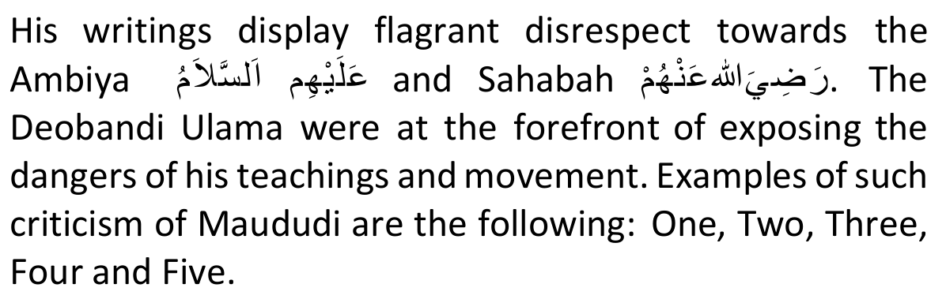
In this clip Maulana Taariq Jameel Saheb has unreserved and immense praise for Maududi. It effectively pours water on all the efforts the Deobandi Ulama have made in combatting this scourge.
The issue is not about which group one belongs to – the
Deobandi School or Jamaat-i-Islami. The more pressing issue is the danger to one's Imaan that lurks below the apparent appeal of Maududi's teachings.
Maulana Taariq Jameel Saheb has expressed similar sentiments of praise regarding the Shia. Maulana Taariq Jameel's ardent followers defend his stance by saying that he is not ignorant, and fully understands that Maudidiasm and Shiasm are wrong.
He only makes such statements in order to win over the members of these sects. They hasted to point out that as a result of him expressing such sentiments he was invited to address the Jamaat-i-Islami and the Shiah.
Such an invitation was never previously extended to any Deobandi Aalim. Without interrogating the veracity of these claims, let us for a moment generously assume that they are true in conceding that he is two-faced.
Such a viewpoint is very selfish and narrow minded. It only takes aim from a certain vantage point. Maybe Maulana and his close followers are blessed to know the truth. But what about the many thousands of lost souls out there in the real world who are prepared to grab onto any "?-ism" that catches their fancy?
From the perspective of the ignorant layman who is fresh and green, if he had to hear such praises, according to his mind-set the impression created is that there is nothing objectionable about Jamaat-i-Islami or Shiasm.
Hence such a person will, without reservations, become comfortable with the teachings of Maududi and the Shia under the confidence that it has the imprimatur sanction of an internationally popular Islamic orator who draws unmatched crowds. In this manner the layperson will be putting his/her Deen in danger.
The second danger of such doublespeak is that the Shia and Jamaat-i-Islami leadership, whether sincerely or out of mischief, could announce that there cannot be anything seriously wrong with Shiasm or Jamaat-i-Islami since a famous person like Maulana Taariq Jameel Saheb has praised them.
Here is South Africa, Shia proselytists have already intimated that if Shiasm was as bad as the others make it sound, a person like Maulana Taariq Jameel Saheb would never have praised them. They thus propose that shiasm is not as evil as the "extremists" would want the public to believe, and that Shiasm should therefore be accommodated within the banner of Islam.
In such situations the Ulama, whose duty it is to defend the faith of the Muslims, have no option but to publicly declare that persons such as Maulana Taariq Jameel Saheb cannot be relied upon. In response thereto, his ardent followers then react by labelling these Ulama "extremists". The enemies of Islam thereafter sit back and laugh at the ensuing circus.
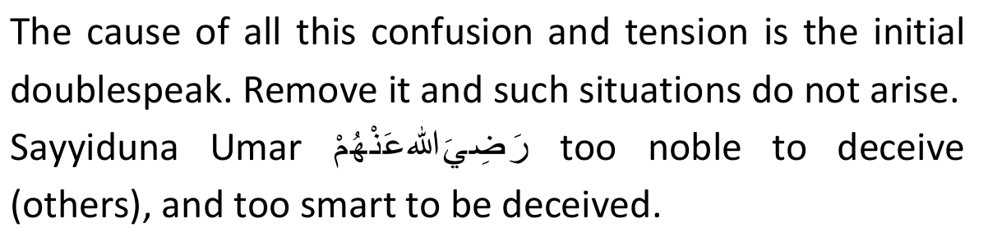
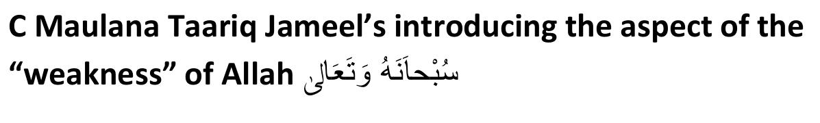
Clips One and Two deal with the same topic. It appears that Maulana Taariq Jameel Saheb was combatting the Barelvi position whereby some of their leaders say that the Imaams of the Haramain are kaafir, and hence Salaah behind them is not permissible.
We obviously do not agree with that stance. Notwithstanding certain differences we have with the Imaams of the Haramain, we maintain that they are Muslim and that Salaah behind them is permissible.
What is of concern is how Maulana Taariq Jameel Saheb goes about establishing his point.
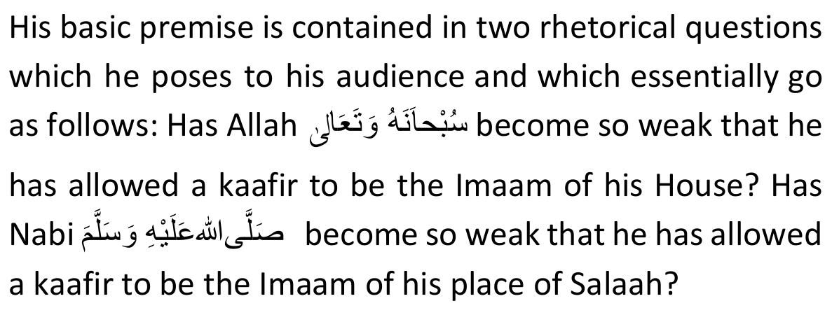
Maulana Taariq Jameel Saheb could have easily addressed the issue without raising these spurious arguments. The underlying teaching implicit and concealed within these two questions is extremely dangerous. It goes contrary to certain very basic and fundamental core beliefs of Islam.
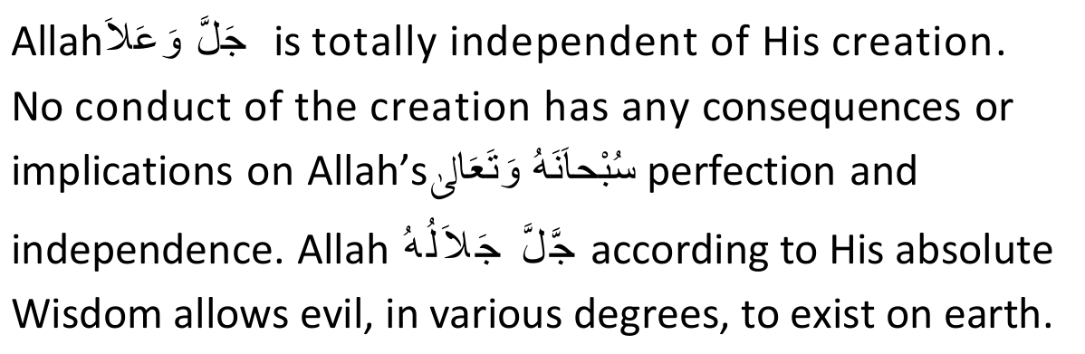
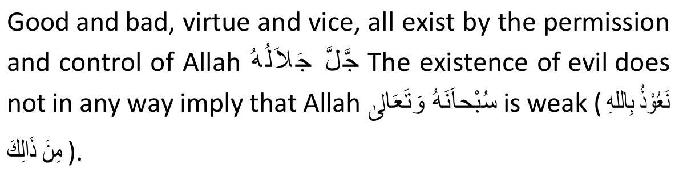
This is supported by the famous Hadithul Qudsi wherein
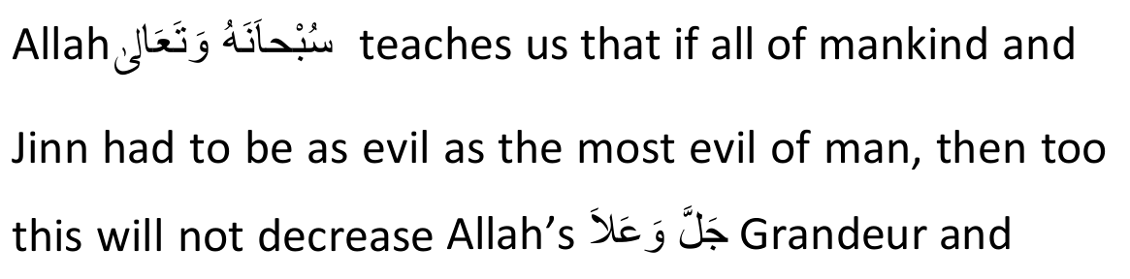
Greatness in the least bit.
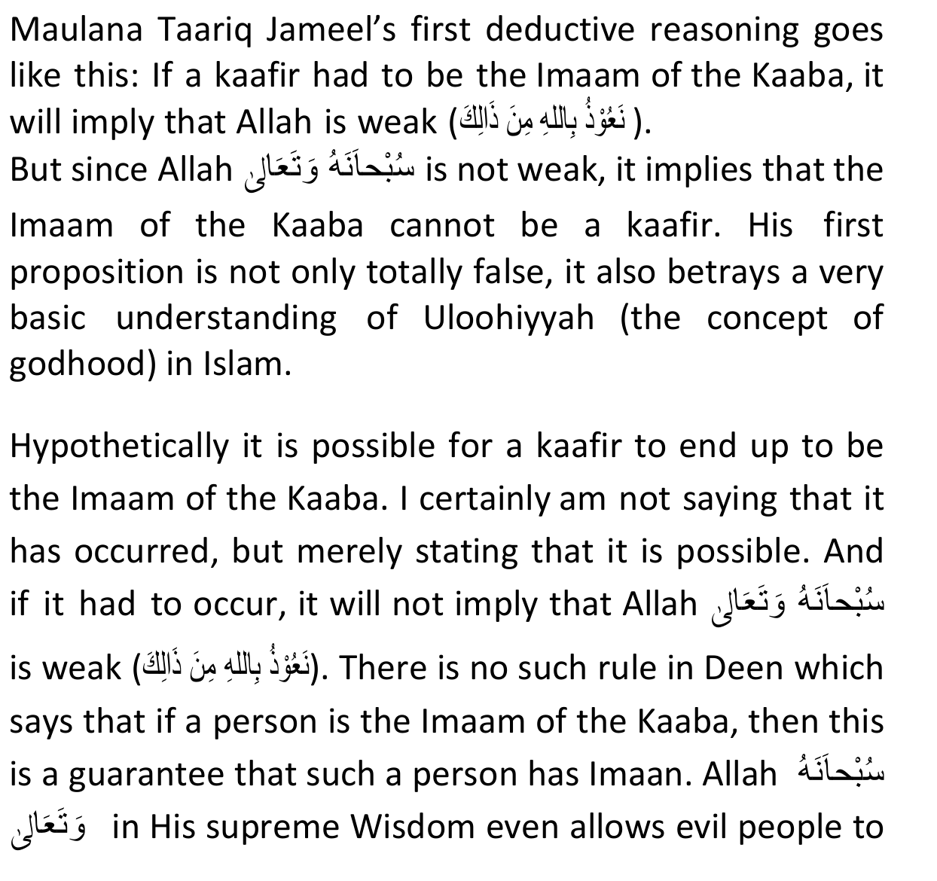
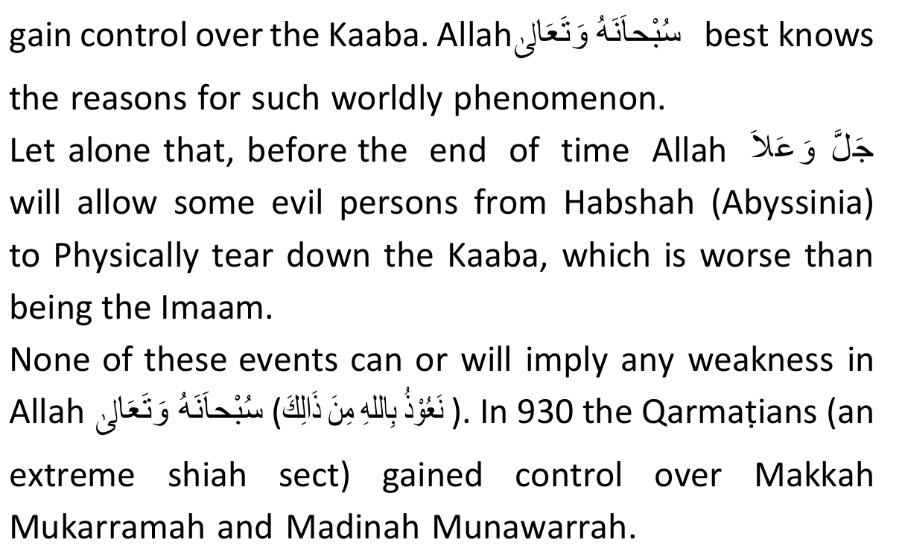
In 930 the Qarmatians (an extreme Shiah Sect) gained control over Makkah Mukarramah and Madinah Munawarrah. They desecrated the Zamzam well with corpses of the Hujjaaj and took the Hajrul Asward from Makkah Mukarramah to al-Hasa.
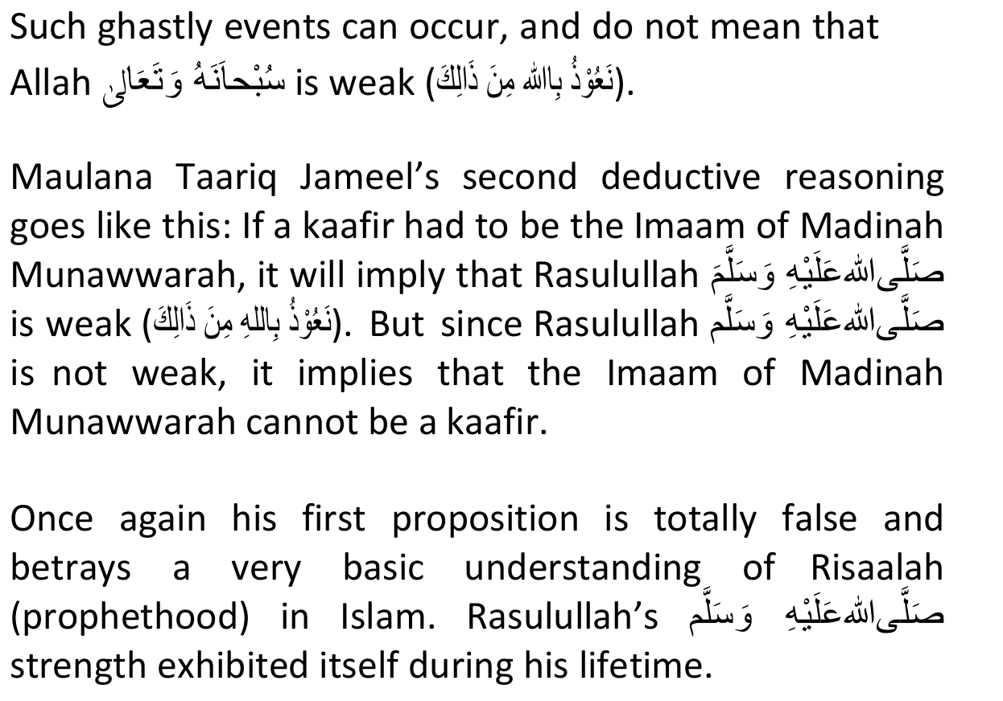
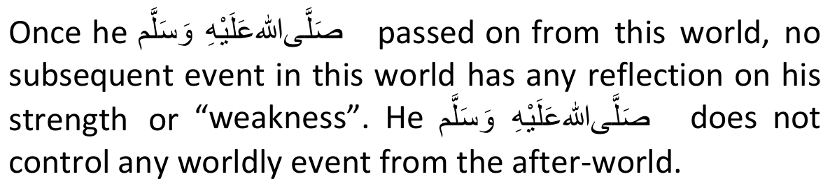
The concepts underpinning Maulana Taariq Jameel's statements have serious implications for the listener's Imaan.
The average person will not be able to discern how he/she is being led toward an incorrect understanding of Tawheed and Risaalah. Hence it is not safe for such persons to be exposed to these bayaans.
D. Maulana Taariq Jameel on Me' raaj
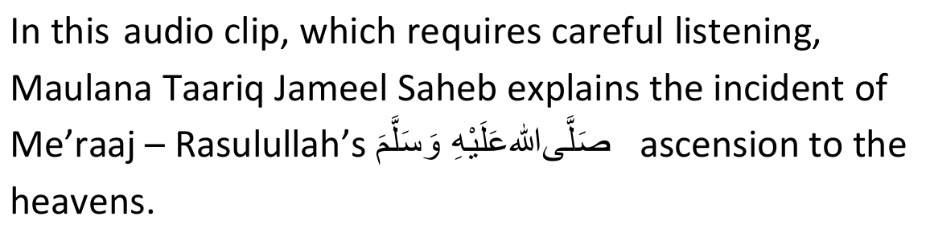
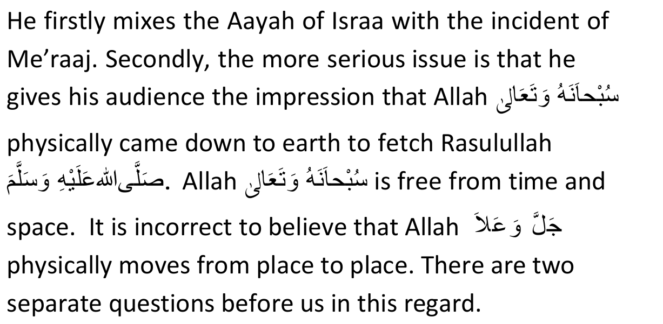
(a) Can Maulana Taariq Jameel Saheb redeem himself in respect of this specific clip? If one wants to give him the
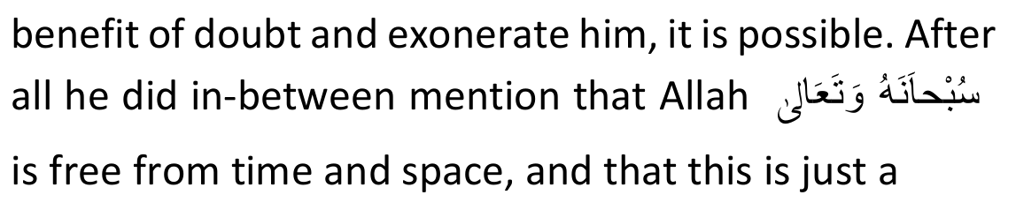
mode of expression. This is not where our main concern lies.
(b) Is the Deen of the commoner being compromised by exposure to this clip?
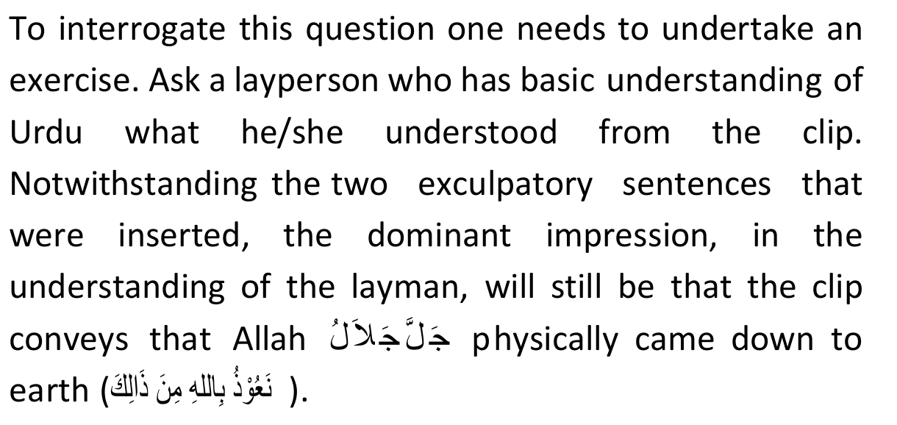
The average person does not have sufficient understanding whereby he/she can compute that the two exculpatory sentences were meant to cancel out or override what was mentioned in the other sentences.
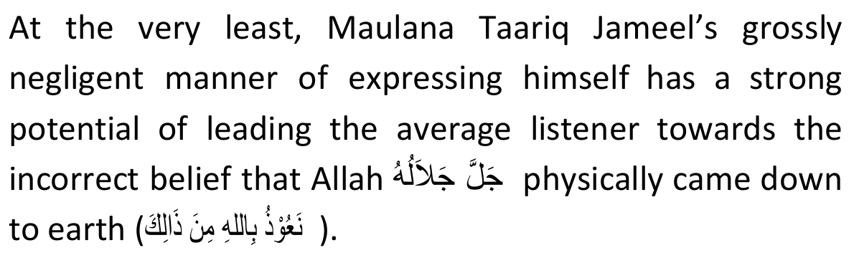
Maulana Taariq Jameel's bayaans contain many unreliable narrations, such as this one which states that
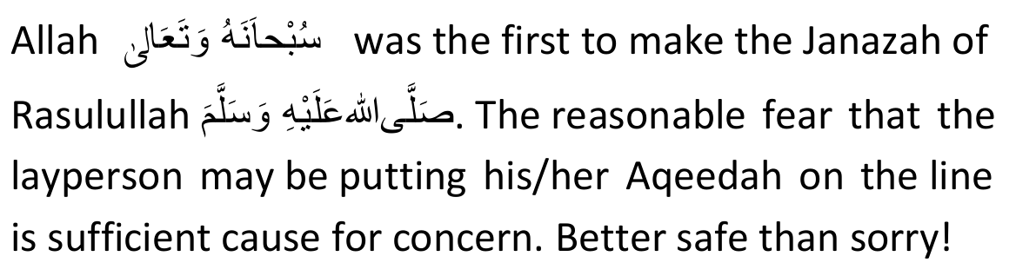
E. Mufti Zar Wali's s oundi ng of w ar ni ng s with regards to Maulana Taariq Jameel
Mufti Zar Wali Khan is a senior Aalim of Pakistan, and the founder of Jamiah Arabia Ahsan- Ul-Uloom.
In clips One, Two and Three he sends out, in very stern terms, a clear warning against Maulana Taariq Jameel Saheb. All I wish to establish from the three clips is that:
(a) Mufti Zar Wali Saheb had an opportunity to personally engage Maulana Taariq Jameel Saheb with respect to some of his contentious statements,
(b) Maulana Taariq Jameel Saheb made certain admissions to Mufti Zar Wali Saheb, and
(c) Based on such interaction, Mufti Zar Wali Saheb felt it his duty to warn the public against Maulana Taariq Jameel Saheb.
[Note: Whatever else appears on the clips are issues best dealt with directly with Mufti Zar Wali Saheb, should anyone have a concern. He may be contacted via the madrasah website http://ahsanululoom.org/.
It would be grossly unfair to expect me to be his self-appointed spokesman.]
Now when a senior, well-respected and reliable Aalim, also from Pakistan, who had the opportunity of questioning Maulana Taariq Jameel Saheb sets off warning sirens, this would surely be sufficient reason for the layperson to, at the very least, adopt a cautionary position.
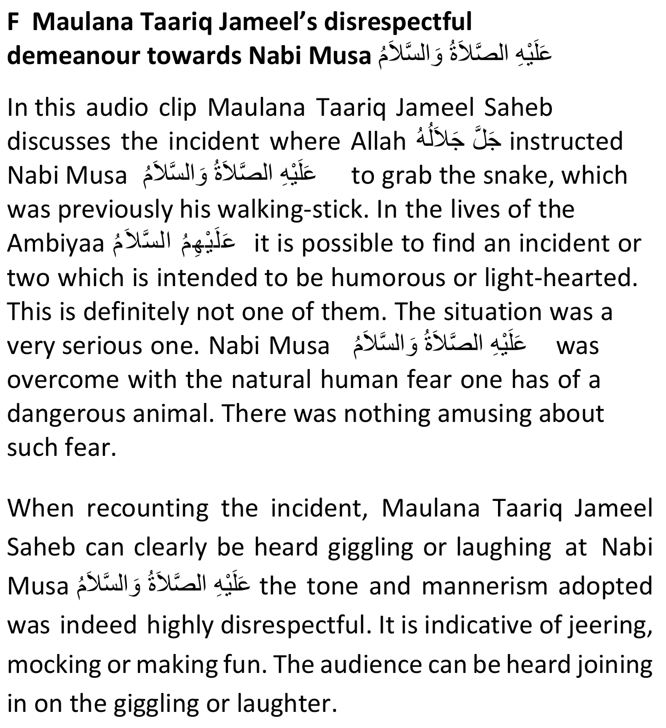
Sadly in many quarters giving bayaans have become theatrical.
The performer leads the audience, who must follow suite otherwise the bayaan loses its lustre and drive.
The average member of the congregation sheepishly follows the mob mentality. If the speaker, who is a world renowned orator, is doing it and the other members of the audience are unhesitatingly aping him, it must be acceptable in terms of how the layman thinks.
It would be extremely rare for the layperson in such a situation to apply his independent mind and immediately slam on the brakes. Herein lays the grave danger for the ordinary folk.
They don't realise that they are caught up in the ambience of the speaker and audience, hence dropping their guard and placing their Imaan in jeopardy.
The clip sends cold shivers down one's spine. One cannot avoid the following question from crossing the mind: Have the speaker and audience lost their Imaan? What was the need for such theatrics? What purpose does it serve?
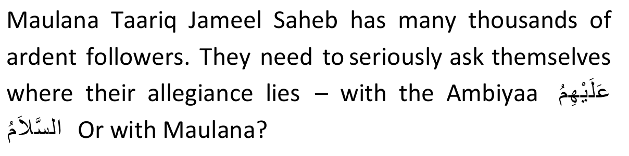
Without a shadow of doubt there is Imaani danger for a person to sit in such bayaans wherein grievous disrespect of a Nabi is shown.

Conclusion
The world and its entire contents are not even worth the wing of a mosquito. We all know that we will have to leave our worldly possessions behind one day. Yet, if we can afford it, we go the extra mile and acquire one further layer of security over our possessions. Our Deen, which is infinitely more valuable, deserves a higher degree of protection and concern. It will not even cost us to abstain from that which could possibly put our Deen at risk.
The above brief words are motivated by our sense of duty to protect the Deen of the masses. We advise the public, for the safety of their Deen, to abstain from listening to the Bayaans of Maulana Taariq Jameel Saheb.
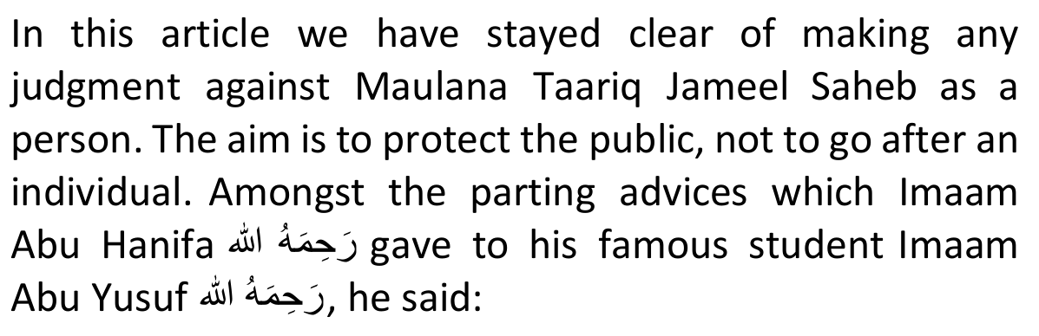
"Do not go after the faults of people, rather search out their correct deeds. If you come to know of some bad in a person, don't mention it, but rather try to look for some good which you could then mention. (This should apply) except in the matters of Deen.
There (in matters of Deen) if you see some bad in a person you must mention it to the people so that they do not follow this person and guard themselves against him".
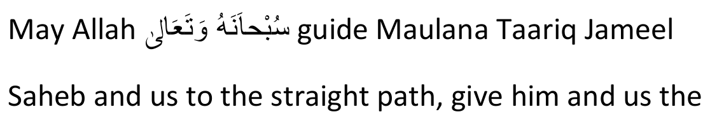
ability to admit our errors, to make sincere tawbah and to die on Imaan.
Emraan Vawda
72 June 2018

Comment by The Majlis
Whilst Emraan Vawda's article states the reality which has ruined the Imaan of TARIQ DAJJAAL, it takes into consideration the reaction of people more than the Pleasure of Allah Ta'ala.
It is not permissible to deal mildly and respectfully with brazen enemies of the Deen who utilize the public platform to misguide and lead to Jahannam the unwary and ignorant masses. Such Mudhilleen as Tariq Jameel may not be addressed with honourable titles such as 'Maulana Saheb'.
Devils of the TARIQ DAJJAAL type come within the purview of the Hadith: "Hate for Allah's sake".
For the likes of this human devil, the criticism has to be in Qur'aanic terminology, not in the manner indoctrinated by kuffaar universities. In this respect, the article renders an injustice to Allah Ta'ala, Islam and the lost Muslim community.

