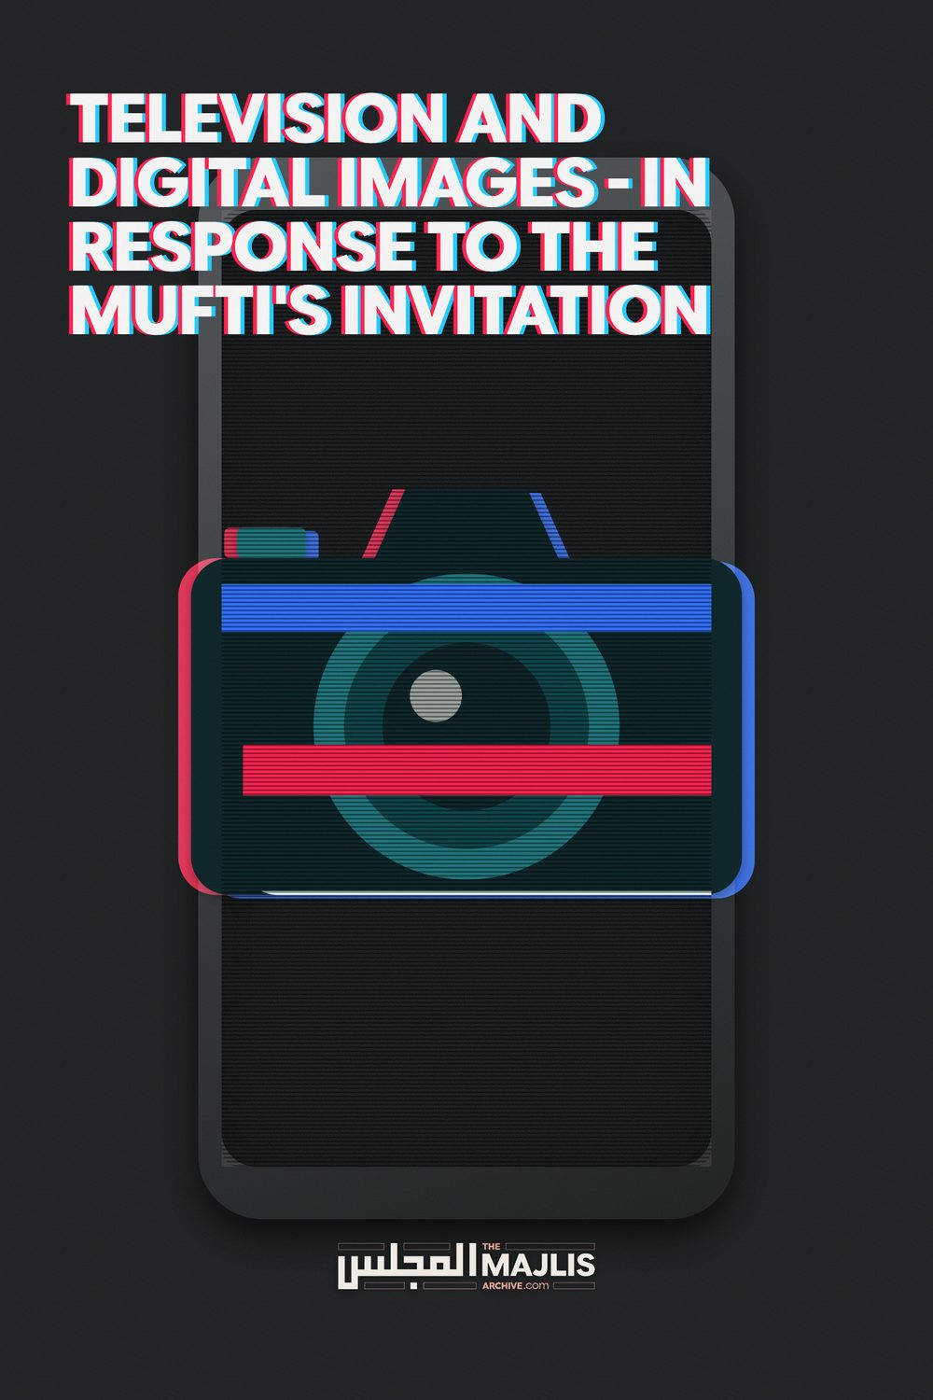

Television And Digital Images
The Majlis · Voice of Islam
Mujlisul Ulama of South Africa

About this edition
This is a reproduction by The Majlis Archive (themajlisarchive.com) of a publication of The Majlis, Mujlisul Ulama of South Africa, made and published with their permission.
The PDF as The Majlis issued it is the original. This edition was read from that PDF's own structure and checked against it letter for letter; where the two differ, the PDF is correct.
Checked: 805 paragraphs, 0 differing; a second, independent PDF reader finds 98.7% of the PDF's words here.
Nothing has been reworded, added or removed.


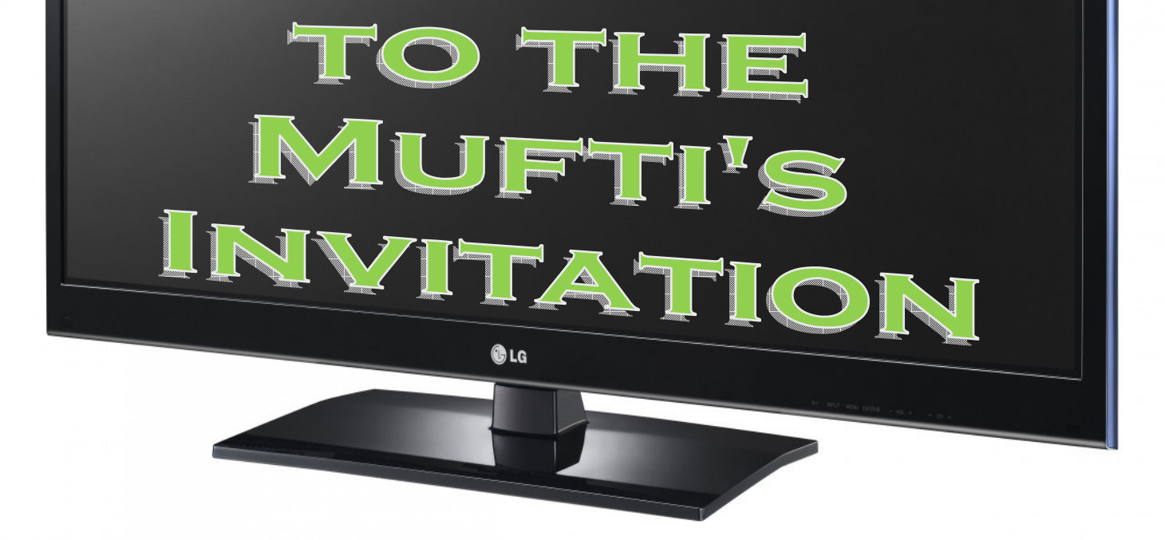
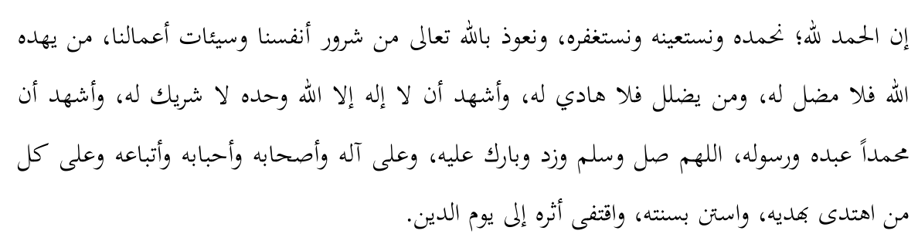

Introduction
It is observed that from the major sins prevalent in society today, no sin is more widespread and has a greater footprint than that of the production of images. In this age of rapid technological progress, hardly a person goes by who does not have a camera on his person, as an accessory to the ubiquitous mobile phone. One cannot escape the display of these images in their various forms, be they print, television or the various screens such as mobile phones, computer screens, tablets and other innumerable gadgets. The challenge of avoiding this sin has become so overwhelming that many have opted to throw in the towel and simply go with the flow.
This brings to mind the following Hadith.
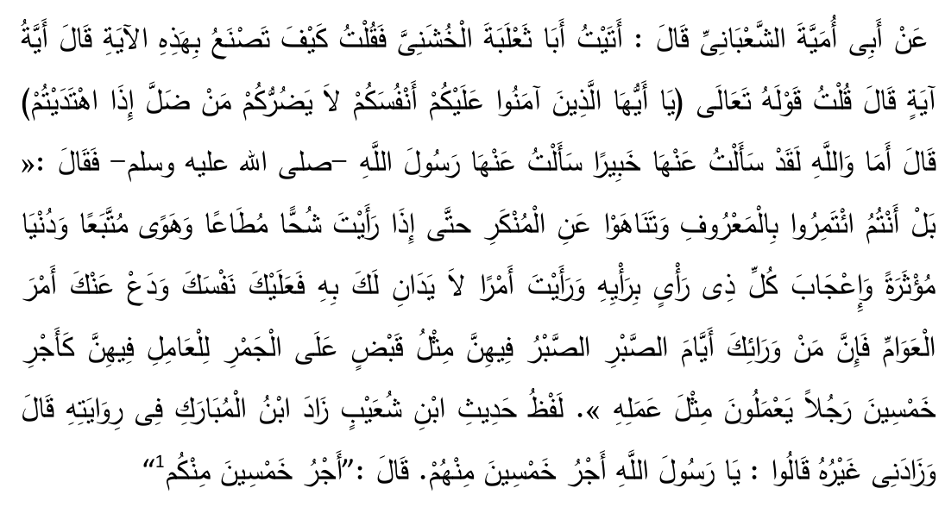
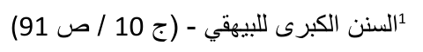
Abu Umayyah Ash Sha'baani says that I came to Abu Tha'labah Al Khushani  and asked: What do you have to say regarding the Aayah of the Qur'aan O people of Imaan, Be concerned about yourself. Those who are misguided will not harm if you are rightly guided. He replied: By the oath of Allah, I have asked a truly learned person regarding this Aayah. I asked Rasulullah  regarding it and he said: "(This Aayah does not mean you should distance oneself from the people) Rather, you should continue to enjoin the good and forbid from the evil until such time that you discern (certain phenomenon, which are) miserliness that is obeyed, desires that are followed, the world is given preference to (over the hereafter), each person is conceited over his own opinion, and you observe affairs over which you have no control. At that time be concerned about yourself and leave the affairs of the public, for beyond that there will be the days of patience, in which patience will be like holding onto burning ember. Those who act (on the Deen) during that time will receive the reward of fifty amongst you who did the same act. (In other words those who are steadfast will receive the reward of fifty Sahaabah  .)
It appears that those days have arrived where holding on firm onto one's Deen is like holding onto burning ember. We are in an era where sins are justified, desires followed, the fugacious world is given preference and conceited personal opinion is used to override the Shari'ah.
In respect to the present day forms of image making, all these factors seem to have converged. Added thereto is the justification of this sin, which only serves to compound its gravity. According to the above Hadith, in such a time one is excused in abandoning the public and being concerned about one's own Aakhirah. The present state of despondency has resulted in hesitation in writing on the topic2, for there are very few out there desirous of following the truth.
However, I happened to come across a very slight glimmer of hope that prompted me to write this treatise. A certain respected Mufti whose view is used by many to justify this sin has himself invited a rebuttal of his position. This call by the respected Mufti produced the following dilemma.
2 After expression of this apprehension, I came across a similar sentiment expressed by Mufti Muhammad Shafi Saheb (rahmatullahi alayh) in Jawaahirul Fiqh, vol. 7 pg. 186.
On the one hand this respected Mufti is notorious for turning a blind eye to valid criticisms raised against his views3. After years of unsuccessfully writing to him for explanations4 of his stance on a number of issues, all hope was lost. There appeared to be nothing achievable in addressing his arguments.
The other side of the coin is that his invitation is before us, resulting in a possibility that the respected Mufti may consider the submissions recorded below. There is also the possibility of earning the respected Mufti's Dua mentioned ahead. Allah  alone is the final judge as to the respected Mufti's internal sincerity in his invitation. However, from the external dimension, one would expect that, upon reading this treatise, he either retracts from his error or publicly defends his view with sound Shar'ee counter-arguments. Doing neither of the two would be a reflection of the true nature of his invitation.
The dilemma was solved by reverting to the following Aayah, whereafter it was finally resolved to pen this treatise. Allah  says in the Qur'aan Majeed:
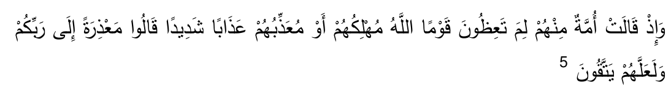
And remember the time when a group from amongst them (the nation who were sinning together with justifying their sin) asked (those who were admonishing the sinners): Why are you admonishing such a people who Allah  is sure to destroy or give a severe punishment? They replied: So that we may be excused before Allah , and perhaps the sinners will adopt taqwa (and thereby desist from their sin).
3 See the public statement made by Maulana Saleemullah Khan Saheb (Daamat barakaatuhu) dated 20 Ramadhan 1429.
4 With regards to the same Mufti, Sheikh Taha Karaan writes:
"Such questions are best answered by the person concerned himself: It is to [this] Mufti that we should turn if we want to know the answer. This brings in an important angle: Those 'ulama who venture into the field of Islamic finance and lend their names to financial products owe their colleagues answers. That much is part and parcel of the responsibility. It should not happen that questions are asked and never answered. Inaccessibility will only fan the fires of suspicion. If queries cannot be fielded by those 'ulama themselves then their students have a duty to either act as liaison for their mentor, or speak for him in such of his opinions as they share." (Emphasis added). Comment on Mawlana Yusuf bin Ya'qub's discussion on Penalty Fees, pg. 2. 4 October 2008
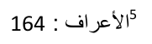

The Invitation
The respected Mufti writes:
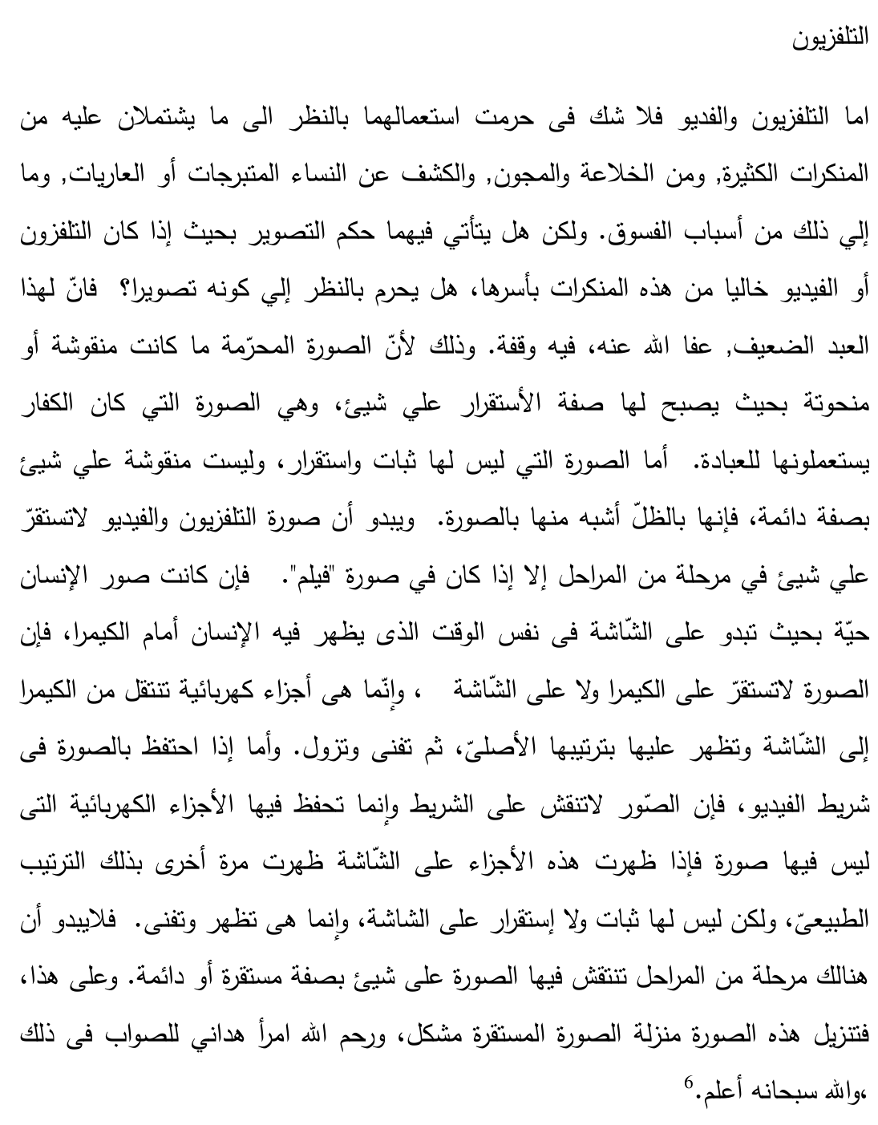
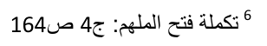
Television. As far as television and video go there is no doubt in their usage being Haraam from the perspective of the many evils that they incorporate, such as pornography, lewdness, the exposition of revealing and naked women as well as many other forms of sin. However, does the ruling of Tasweer apply to them in the sense that if the television or video is totally free from these evils will it then be Haraam to view the television or video on the basis of it being Tasweer (image)? This weak servant has reservations on this question. The image that was Haraam was that which was drawn or sketched permanently on some medium. This was the picture which the Kuffaar use to worship. As far as that image which is not permanent nor is it drawn or sketched onto some permanent medium, this more closely resembles a reflection than a picture. It is clear that the image of the television and video does not permanently exist on any medium during any of its stages except in the case of film. If it is an image of a living person in the form that it appears on the screen at the exact moment during which the person is standing in front of the camera the image does not permanently exist on either the camera or the screen. It is simply electric impulses that pass from the camera to the screen and the original form of the item appears thereon. It thereafter disappears. If the image is captured on a video cassette the image is not sketched or drawn on the cassette. Electric impulses are merely recorded which do not have any shape or form. When these electric impulses travel onto the screen this original natural form then appears on screen. This image on the screen does not exist permanently thereon. It appears and disappears. Therefore at no stage is the image permanently drawn or sketched on any medium. Based on this, to place this image (found on the television or video) on the same status as a permanent image will be difficult. May Allah Ta'ala have mercy on that person who guides me to the correct view in this matter. And Allah  knows best.
A number of important points emerge from this quotation.
1. The respected Mufti claims that the image that appears on the television screen is, despite it being an image, a permissible form of imagery. He postulates that only those images which appear on a permanent or durable medium are Haraam.
2. He avers that the image appearing on the television screen more closely resembles a reflection of an object in a mirror. It does not resemble a (hand drawn) picture.
3. He expresses a Dua for that person who is able to point out to him the correct position in this matter.

Delineating the topic
Our topic concerns modern day electronic imagery. This takes on many forms, the picture created on the television screen being just one. Television includes the CRT (cathode ray tube), LED (light-emitting diode), LCD (liquid crystal display) and Plasma versions, with their variant subdivisions7. Other screens such as computer monitors, camera screens, mobile phones, DVD-players, tablets and host of other similar devices are also embraced by this discussion. In general, the discussion has an impact on any form of imagery or visual representation.
When reference is made to impermissible images, it applies to animate objects. The imagery of non-animate objects is permissible.
The topic however does not traverse the following areas:
7 Some writers who have commented on the topic have attempted to draw a difference between various methods of forming the image. It is submitted that nothing really turns of the different techniques used to create the image.
1. There are many natural scenes which a person may not glance at with the naked eye. The viewing of any imagery of such a scene will likewise not be permissible. Hence the respected Mufti agrees that the viewing of members of the opposite gender (with certain obvious exceptions), immodest scenes and pornography would be impermissible. These forms of imagery are excluded from our discussion.
2. The respected Mufti concurs with us that images produced on photographic paper or digital images that are printed out on paper, sometimes referred to as a 'hard copy', are likewise impermissible. Etchings, paintings, drawings, carvings and statues are similarly unanimously impermissible. Images captured on negatives or cinematographic film are also agreed upon to be impermissible. In brief, if the images are produced on a durable or permanent medium, the respected Mufti agrees with us that such images are impermissible.8
3. There are circumstances where the 'Ulama permit certain forms of imagery out of need, such as for security purposes, to combat crime and out of necessity like in the case of passport photographs and driver's-licence photographs. When do these concessions apply and what the contours of this permissibility may be are not covered in the discussion below.
4. Very small images of even animate objects are permissible. The scope of this category of exception is not traversed.

Explicit Texts
Some Ahaadith and Aathaar9 concerning images and image-making follow in random order.
8 See pg. 54 9 Statements of the Sahaabah .
Hadith No. 1.
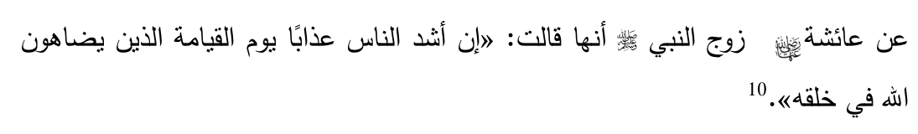
It has been narrated from Sayyidatuna 'Aa-ishah
: "Those who will be most severely punished on the day of Qiyaamah will be those who challenge Allah  in as far as His exclusive quality of being the Creator is concerned."
Hadith No. 2.
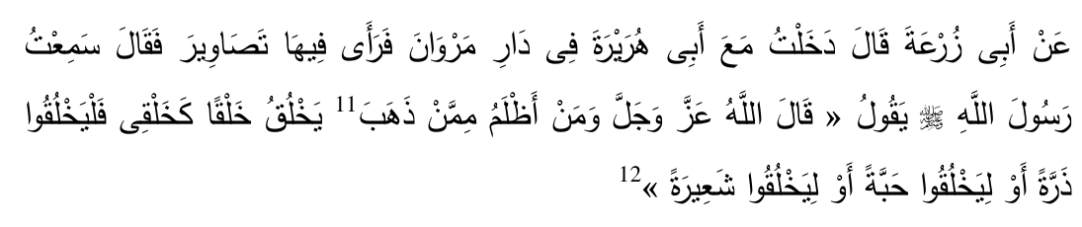
Abu Zur'ah records that I accompanied Sayyidina Abu Hurairah  to the home of Marwaan bin Al-Hakam. He noticed images therein and then commented: "I heard Rasulullah  saying, quoting from Allah : "Who can be more oppressive than that person who attempts to create some form of creation like My creation? He should attempt to create a grain of sand and he should attempt to create an ear of corn or he should attempt to create a seed or he should attempt to create a barley seed."
The words "attempts to create like My creation" are an explicit record that the 'illah in image-making being Haraam is that of imitating Allah .
A number of pertinent points are to be considered from this and the other Hadith.
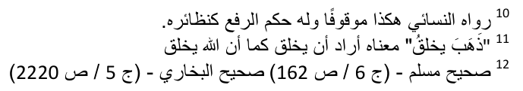
1. When a person produces an image of an animate being, he is imitating or copying Allah .
2. This is a deeming provision of the Shari'ah. In other words, whenever an image of an animate being is produced, the Shari'ah automatically views this to be act of imitation.
3. The act of creating, i.e. producing something from nothing, is the exclusive preserve of Allah . Therefore the image-maker is attempting to imitate Allah  in respect of one of His exclusive attributes. This is akin to shirk (polytheism), hence the gravity of this sin.
Mullah Ali Qari (rahimahullah) states:
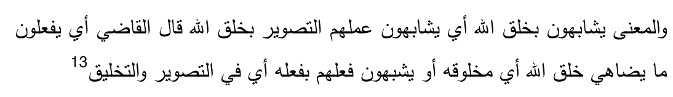
The reasoning is that they imitate the creation of Allah , i.e. they match their act of making an image with the act of Allah  creating something. Qadi says it means that they do that which challenges the beings created by Allah , or it could also mean that they match their act with Allah's  act in as far as forming and creating.
who forms or shapes.
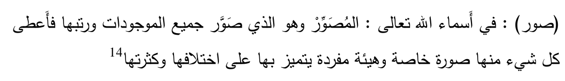
One of the Names of Allah  is Al Musawwir. He is the one who forms or shapes all beings and gives them order/structure. He gives each one a unique form and separate appearance which distinguishes it from the rest of creation, notwithstanding their huge number and mutual differences. (For example, each human has a unique physical identity that distinguishes him/her from countless others).
The Qur'aan Majeed mentions:
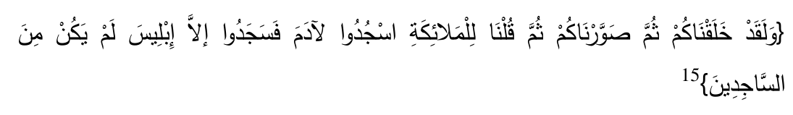
Allah  says: And surely we created you, then shaped you, and then said to the angels: Prostrate to Aadam. They prostrated, save for Iblees. He was not from those who prostrated.
Allah  says: He is the one who shapes you in the wombs in whatever manner He desires. There is no deity besides Him, the all Mighty, the all Wise.
The word As-Soorah, also sometimes expressed as At-tasweer, epigraphically means to form or shape.
When the infinite verb "to form or shape" applies to Allah , it refers to His shaping the original from pure non-existence. When this term is used in respect to man, it refers to the shaping of an image of the original, for man cannot create the original. This image, in whatever form it takes, is called Soorah in Arabic and Tasweer in Urdu.
In this treatise, the term Soorah is translated as "image". It will be clear from the discussion to follow that the term Soorah applies to two-dimensional as well as
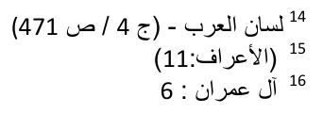
three-dimensional forms of visual representation. An example of the former is a photograph on paper, whilst example of the latter is a statue. Only the former is referred to as a picture, hence translating the term Soorah as "picture" will be unduly restrictive. The term refers to any form of visual representation / graphic depiction / reproduction of the form and shape of the original.
5. The image-maker is considered to be the most oppressive. Oppression entails the misplacing of an attribute. The attribute of Allah  is being assigned to the creation. The image-maker is thus deserving of the most serious form of punishment.
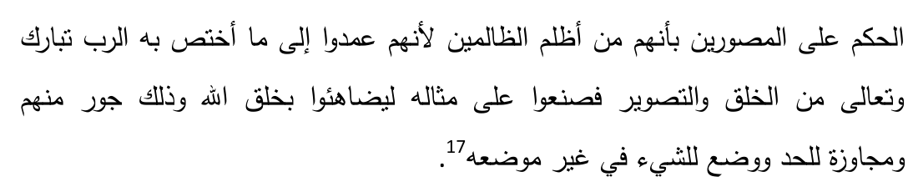
Denouncing image-makers as the most oppressive is for the reason that they attempt to challenge Allah  regarding that quality which is exclusive to Allah , namely that of creating and forming or shaping, as this implies that they place a matter in an incorrect position and they have exceeded all the limits. Therefore they can be termed as the most oppressive.
Imaam Nawawi (rahmatullahi alayh) comments:
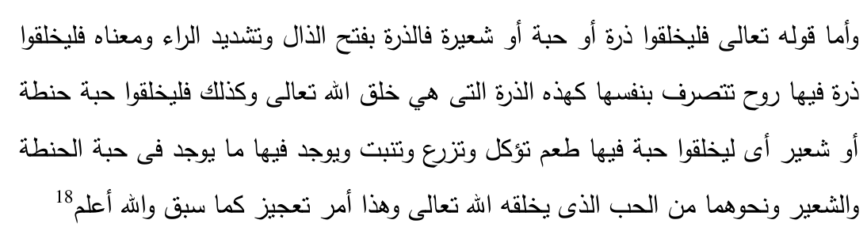
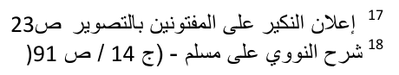
With respect to the words of the Hadith quoting Allah  "they should create an ear of corn or grain of wheat or grain of barley" is a form of rebuke of such persons and an indication of their inability. The meaning of this Hadith is that they should create an ear of corn that has life within it and which can grow on its own. This is the type of ear of corn that Allah  creates. Similarly they should produce a seed of wheat or barley which is alive, has taste and is edible and can also grow, similar to grain which Allah  creates. This is a command that is given to demonstrate inability.
6. The deeming provision applies objectively, and is not dependent on the subjective state of the image-maker. In other words, should the thought of imitating not even have crossed the mind of the image-maker, this would be immaterial.
7. This act of imitation is further deemed to be a challenge to Allah . The image-maker is effectively telling Allah : "Do you think that you only can create? See, I too can create."
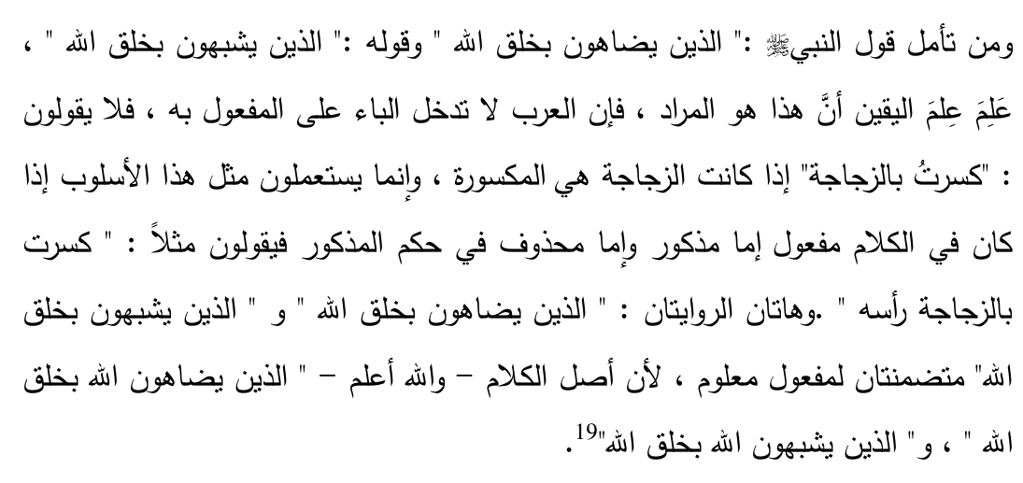
If one has to ponder over the wordings of the Hadith one will come to the conclusion that here the person who makes up the image is actually challenging Allah  in relation to some of the creation of Allah . From a grammatical perspective the letter 'Baa' is not normally attached to the object of a verb. Therefore the object of the verb is assumed. The translation will be "those (subject) who challenge (verb) Allah  (object) in relation to some of
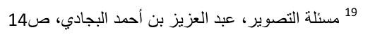
the creations of Allah ". In this sentence the object of the challenge (i.e. Allah ) is assumed by means of grammatical inference.
8. Allah  will, on the Day of Qiyaamah, respond to this challenge by commanding the image-maker to carry out the act of creation. As if, so to say, Allah  will address the image-maker thus: "In the world you challenged me as far as the act of creation. You claimed you can create. Let us see. Go ahead, prove your claim and create something like an ear of corn." This instruction will be given to demonstrate and make manifest the inability of the image-maker to live up to the challenge made on earth.
9. The reason why the image-maker will be instructed to produce something simple like an ear of corn or a barley seed will be to emphasise the person's gross incompetence. In this world he was effectively claiming his ability to create an animate being, whereas in the hereafter he will be unable to produce even an inanimate form of creation. This further stresses the degree of his helplessness.
Commenting on this Hadith, Hafiz Ibn Hajar (rahmatullahi alayh) says:
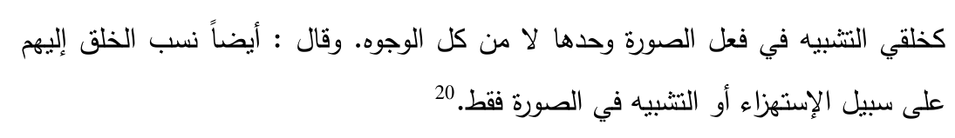
The words "like My creation" is a comparison in relation to only the image created and not a general comparison (what is meant by this is that the Hadith rebukes the person who attempts to create in the manner Allah  Creates. This person does not have to create in the complete form and manner in which Allah  does so. By simply creating the image of the creation of Allah , he is nevertheless attempting or deemed to have attempted to imitate the act of creation which is the exclusive action of Allah ). Ibn Hajar (rahmatullahi alayh) goes on further to say that here attributing the action of creation to image-makers is in the form of mocking (here Allah  is mocking
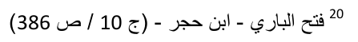
at them that they are simply attempting to equate themselves with Allah  by creating an image whereas they are unable to create the real thing) or the comparison is only in respect of outer form or impression.
Hadith No. 3.
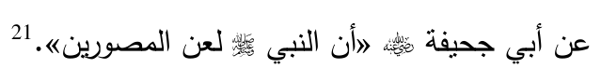
Sayyiduna Abu Juhaifah  reports that Rasulullah  cursed the makers of images.
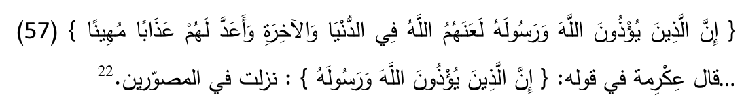
It has been narrated from Ikrimah (rahimahullah) in respect of his explanation of the aayah of the Qur'aan where Allah  says "Verily those who (desire to) cause harm to Allah and His Rasul , Allah  has cursed them in this world and the hereafter, and has prepared for them a disgraceful punishment." He says this refers to those who make images.
Hadith No. 4.
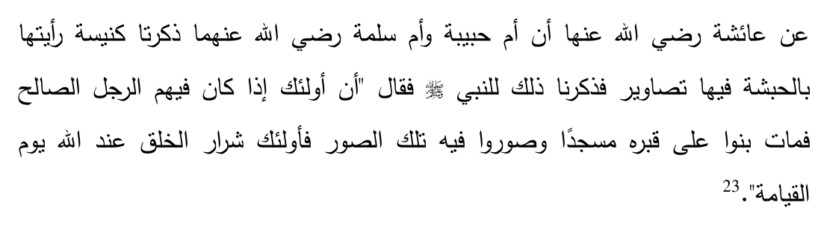
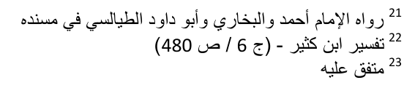
reports that Umme Habibah and Umme Salamah
(the two noble wives of Rasulullah  ) once made mention of a church that they had seen in Habshah (Abyssinia) in which there were images. So they mentioned this to Rasulullah . Rasulullah  replied: "These people were such that when any pious person amongst them passed away they built a place of worship over his grave and they formed images of this person at this place of worship. These are the worse of the creation of Allah  in the Sight of Allah  on the Day of Qiyaamah."
Imaam Nawawi (rahmatullahi alayh) comments on this topic.
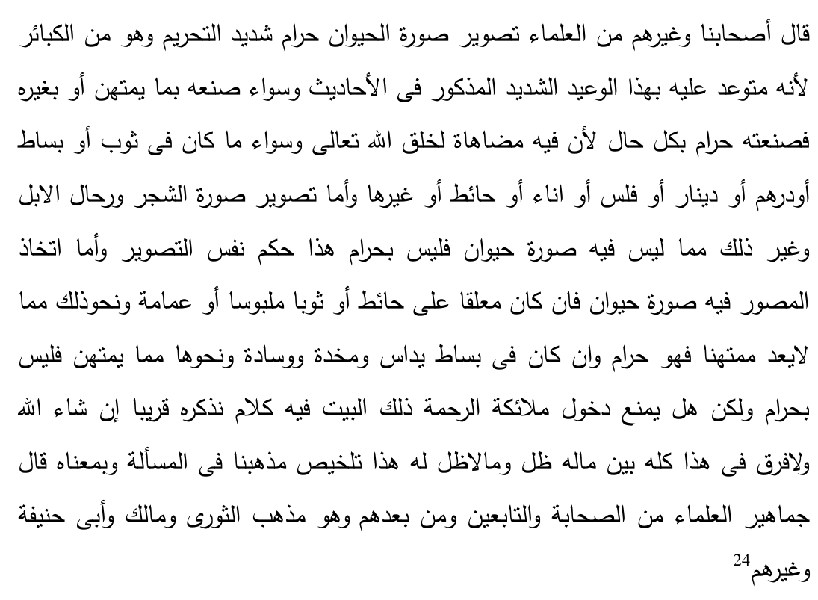
Our companions and other 'Ulama as well are of the view that making up an image of a living being is Haraam, to a very severe degree and it is counted amongst the major sins regarding which severe warning has been sounded which have been mentioned in the Ahaadith. This applies equally whether a person uses an item that is looked down upon or not. The very keeping of an image, in all circumstances, is Haraam because to do so is to challenge the
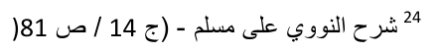
exclusive quality of Allah  being the Creator. This applies equally whether the image is created on a cloth or a sheet that is spread out or a gold or silver coin or a small coin used as change or a vase, on a wall or otherwise. There is no difference in this whether the image has a shadow or does not have a shadow. This is the crux of our Math-hab on this issue. The overwhelming majority of 'Ulama hold the same view from amongst the Sahaabah , the Tabi-een and those after them. This is also the Math-hab of Imam Thauri, Maalik, Abu Hanifa and others (rahmatullahi alayhim).
Hadith No. 5.
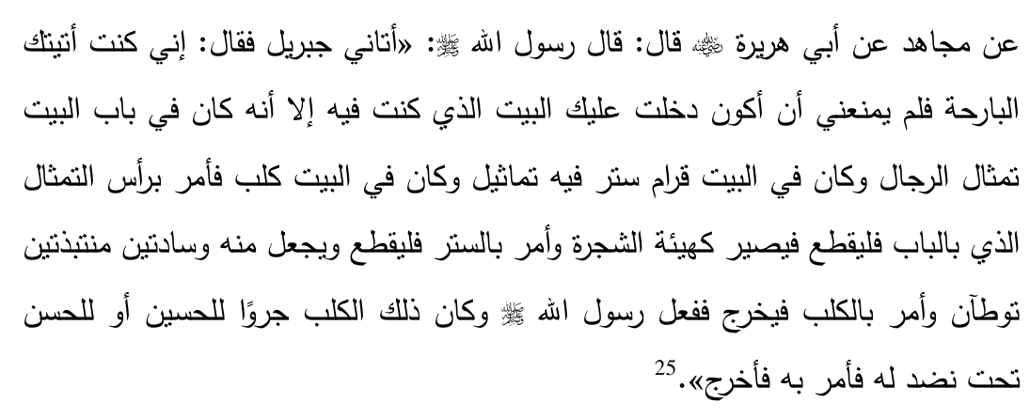
Sayyiduna Abu Hurairah  reports that Rasulullah  said "Jibraeel came to me and said 'I came to you yesterday and the only reason I did not come into the house in which you were was that at the door of the house there were images of men and in that house were curtains on which were images and in the house was a dog.' Jibraeel instructed that the heads of the images that were at the doorway be cut off so that the image resembled a tree and he instructed that the curtain be cut up and a few cushions be made of it in a manner that it is trampled upon and he instructed that the dog be removed." Rasulullah  did so. This dog was a puppy belonging to either Sayyidina Husain  or Sayyidina Hasan  which happened to be under a raised couch. Rasulullah  gave the instruction and the puppy was removed.
Hadith No. 6.
Sayyiduna Shaibah bin Uthmaan  reports that Rasulullah  said: "Oh Shaibah efface (wipe out) every image in the home."
The words "every image" explicitly convey generality. An image may only be excluded based on sound Shar'ee proof.
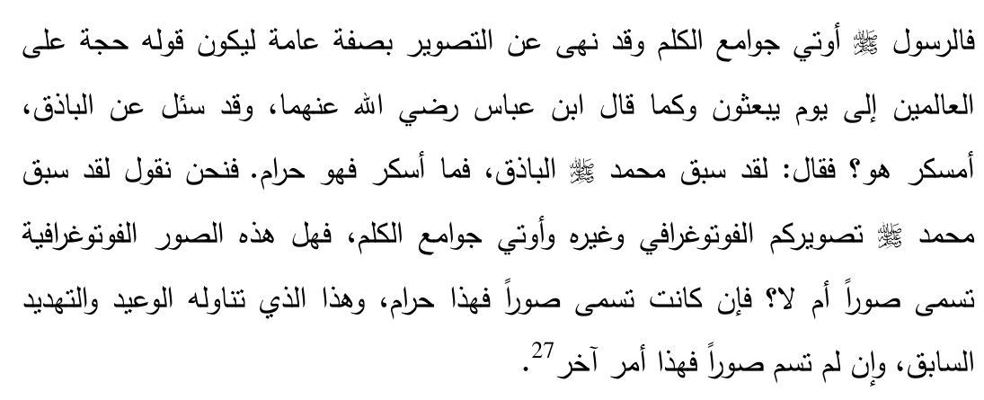
Rasulullah  was given the gift of concise speech. He prohibited from images in general terms, so that his words may serve as a proof for all the worlds until the day they will be resurrected. Similarly, when Sayyiduna Ibn Abbas  was once asked about Baathiq (a type of intoxicating drink that only then came about), he replied: Rasulullah  has already decided in the matter of Baathiq. Rasulullah  has already given us the guiding principle that whatever intoxicates is Haraam. (In other words, although Rasulullah  did not mention the word Baathiq, he did mention the illah, hence he covered thereby whatever all new developments in which this illah of intoxication will be found). We also say: Rasulullah  has already mentioned photography and other forms of images. He was given concise speech (few words with profound and far-reaching meaning). Is a photograph called a Soorah (image) or not? If it is, it is Haraam. Therefore the severe warnings (mentioned in the Ahaadith) apply. If it not called a Soorah, then that is something else.
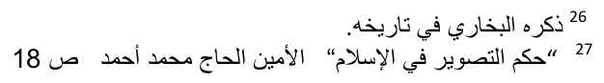
Hadith No. 7.
Sayyiduna Ali  reports from Rasulullah : "The angels do not enter that home in which there is an image, a dog, or a person in the state of ritual impurity."
Hadith No. 8.
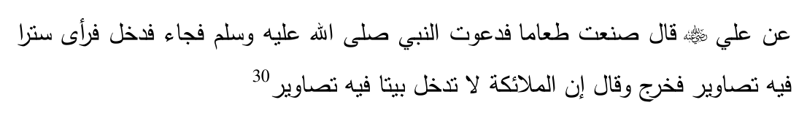
Sayyiduna Ali  reports: "I prepared some food for Rasulullah  and I invited him. He arrived and entered. When he saw a curtain which had some pictures on it he left and said: 'The angels do not enter that home in which there are images.'"
The laws of Islam were revealed gradually and the Sahaabah  were in a constant learning process. They did not intentionally disobey this prohibition. In all probability, Sayyiduna Ali  was at the time not aware of the prohibition, hence was taught by Rasulullah  and was also given one of the reasons for the prohibition.
Hadith No. 9.
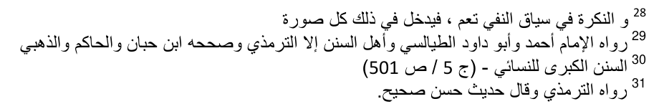
Sayyiduna Jaabir  reports that Rasulullah  prohibited from images in the home and he prohibited from the making of images.
Hadith No. 10.
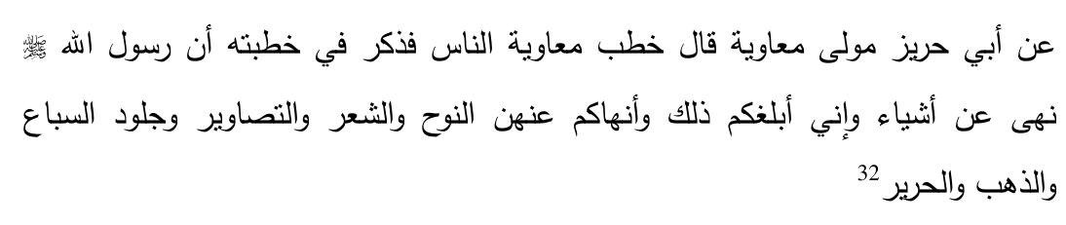
Sayyiduna Muaawiyah  reports Rasulullah  prohibited certain things. I am conveying these to you and also prohibit you from the same. They are: false crying, poetry, images, the hides of wild animals, gold and silk.
Hadith No. 11.
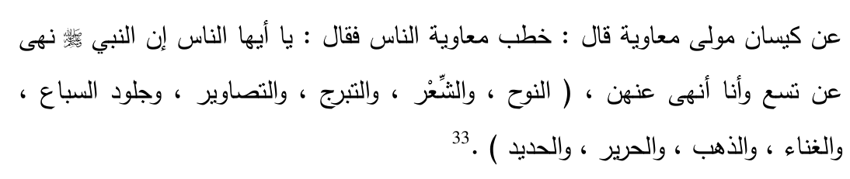
Qaisaan the freed slave of Sayyiduna Muaawiyah  reports that on one occasion Sayyiduna Muaawiyah  addressed the people and said: "O people Nabi  prohibited you from nine things and I too prohibit you from these, false crying, poetry, exposure of the body, pictures, the hide of wild animals, singing, gold, silk and iron."
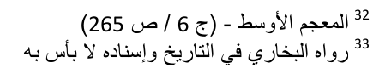
Hadith No. 12.
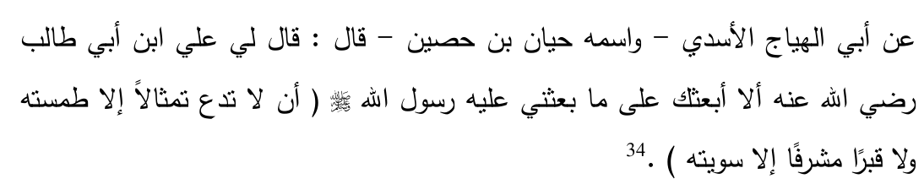
Abul Hayyaaj narrates that on one occasion Sayyiduna Ali  asked me: "Should I not dispatch you to carry out a task which Nabi  dispatched me? (That task was) 'That you should not leave any image except that it be effaced nor any raised grave except that it be flattened'"
Hadith No. 13.
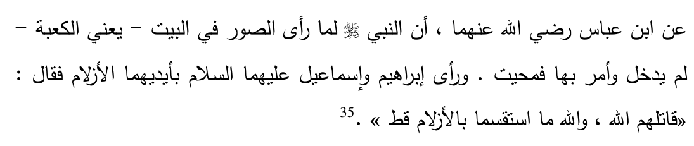
It is narrated by Sayyiduna Ibn Abbas (radiyallahu anhuma) that Nabi , upon seeing images in the Ka'ba, refused to enter it but rather gave instructions, following which the images were wiped out. He saw the images of Sayyiduna Ibrahim depicting that they had arrows of divination in their hands, so Nabi  commented: "May Allah Ta'ala destroy them (those who made these images). By the oath of Allah these two (Sayyiduna Ibrahim and Ismail and
Ismail
) never engaged in divination with arrows."
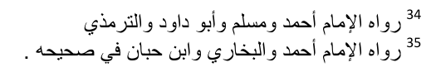
Hadith No. 14.
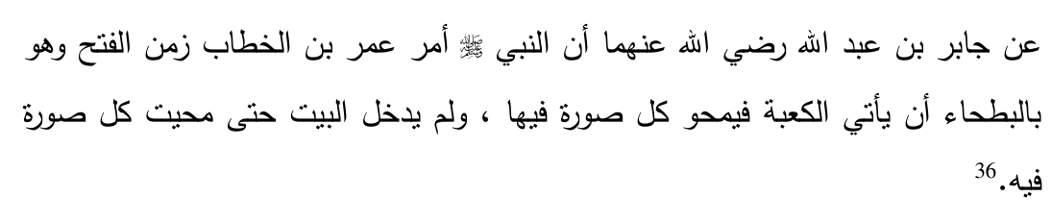
It is narrated by Sayyiduna Jaabir bin Abdillah (radiyallahu anhuma) that Nabi  instructed Sayyiduna Umar bin Khattaab  on the occasion of the conquest of Makkah, whilst they were at a place called Bat-haa that he should go to the Ka'ba and wipe out every image therein. Nabi  did not enter the Ka'ba until such time that all these images were wiped out.
Again the general term "every image" is used.
Hadith No. 15.
that Nabi  would not
It has been narrated from Sayyidatuna 'Aa-ishah leave anything in his house in which there were images except that he removed it.
Hadith No. 16.
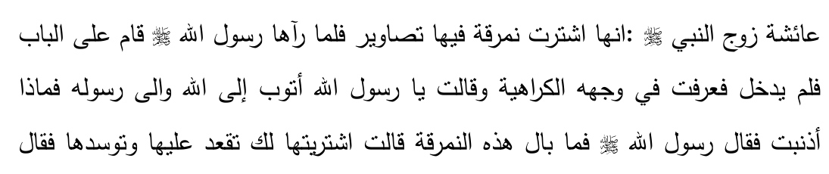
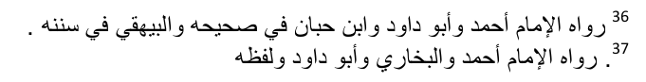
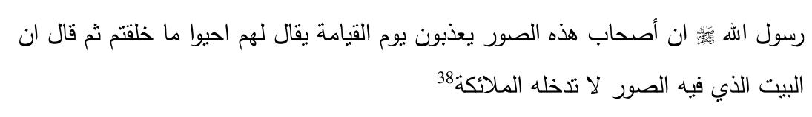
Sayyidatuna 'Aa-ishah reports "I purchased a cushion which had images on it. When Rasulullah  saw it he stood at the doorway and he did not enter the home. I noticed from his face his displeasure and therefore said: "O Rasulullah  I repent towards Allah and His Rasul, what have I done wrong?" Rasulullah  said: "What is the matter with this cushion?" She replied: "I purchased it so that you may sit on it or lean against it." Rasulullah  said "The makers of these images will be punished on the Day of Qiyaamah and it will be said to them 'bring to life that which you have created'" and he  also said "the angels do not enter the homes in which there are images."
Hadith No. 17.
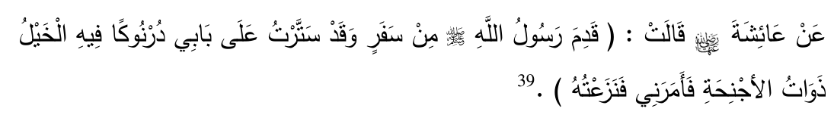
reports that "Rasulullah  returned from a journey
Sayyidatuna 'Aa-ishah whereas in the meanwhile I had put up as a curtain on the doorway a Durnook (a curtain that has loose hanging fibres at the end) which had images of winged horses on them. Nabi  instructed me and I removed them."
Hadith No. 18.
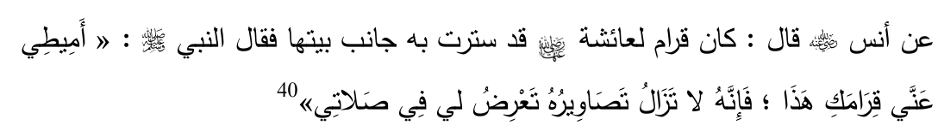
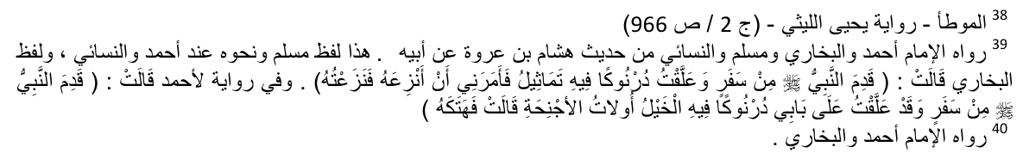
Narrated from Sayyiduna Anas : "Sayyidatuna 'Aa-ishah had her own private chambers in the corner of the house which she covered. Rasulullah  instructed: "Remove from me this curtain of yours since the pictures on it continue to divert me in my Salaah."
Initially, Rasulullah  gave instruction of only shifting the curtain away. Later on this rule was replaced by the total removal of the image.
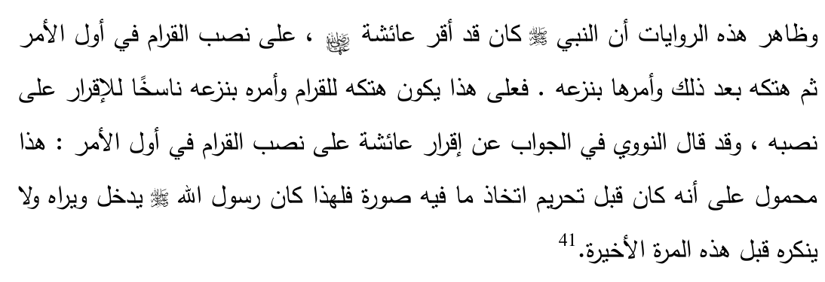
It is understood from these narrations that initially Rasulullah  did not instruct that the pictures be removed. Thereafter when the prohibition came from the side of Allah  Rasulullah  instructed that the curtain with images on them be removed. Initially Rasulullah  only expressed his displeasure in as far as this being a distraction. However when the prohibition was introduced Rasulullah  instructed that the curtain be removed in total.
Hadith No. 19.
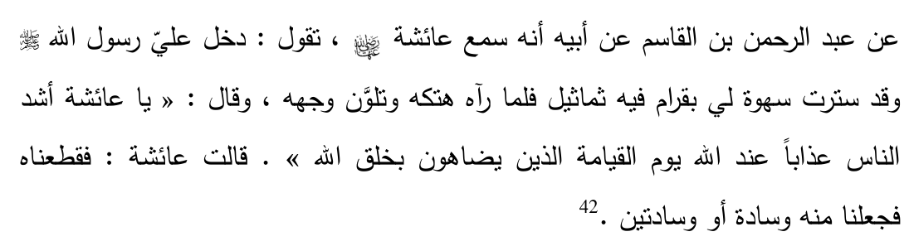
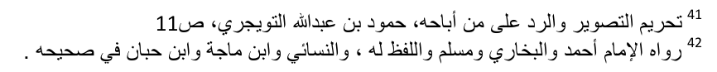
reports that once Rasulullah  entered into my chamber whilst I had covered it with a curtain which had images on it. When Rasulullah  saw it he pulled it down and the colour of his face changed. He said: "O 'Aa-ishah the people who will receive the severest punishment in the sight of Allah  on the Day of Qiyaamah will be those who challenge Allah  as far as His exclusive quality of being the Creator." Sayyidatuna 'Aa-ishah then says "I cut it up and I made one or two cushions with it."
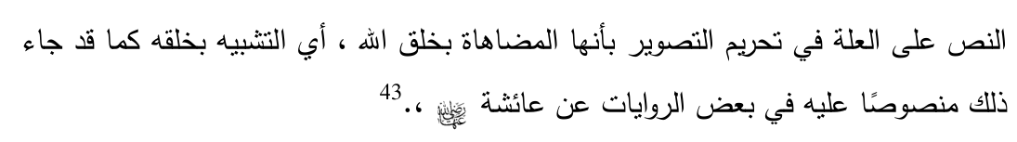
The clear text identifies the 'illah (ratio essendi) as being the challenging of Allah  in as far as His act of creation is concerned. It is to resemble the act of creation as has been explicitly mentioned in some of the narrations narrated from Sayyiditina 'Aa-ishah
Hadith No. 20.
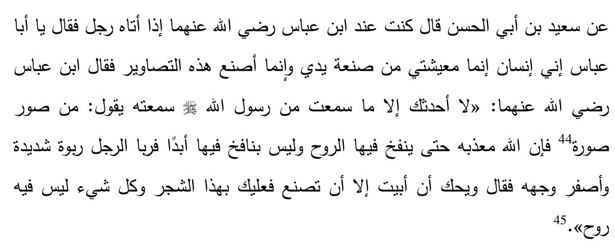
Saeed bin Abil Hassan mentions: "I was with Sayyiduna Abdullah bin Abbas (radiyallahu anhuma) when a person came to him and asked him "O Abul Abbas, I am a person who earns his living through his hands. I make these images." Abdullah bin Abbas  replied, "I will only narrate to you that which I
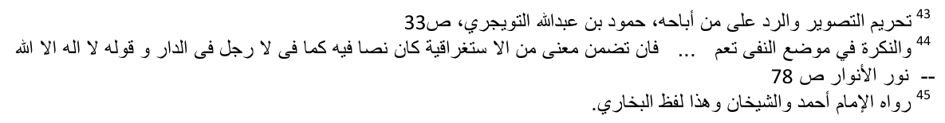
heard from Rasulullah . I heard him saying 'whoever draws an image Allah Ta'ala will punish him. Allah Ta'ala will continue to punish this person until such time that he is able to blow the soul into the images. This person will never ever be able to blow any soul into this.'" This person swelled up and became yellowish in the face. Sayyiduna Abdullah bin Abbas  then mentioned "Woe to you! If you cannot refuse except working with your hands then you may resort to trees (you may form images of trees) and any other item that does not have a soul in it (inanimate objects)."
Hadith No. 21.
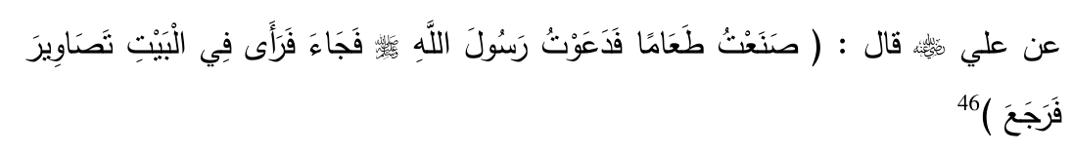
It has been narrated from Sayyiduna Ali  who says "on one occasion I had some food prepared and I invited Rasulullah . When he arrived at the home he noticed some pictures and therefore he returned."
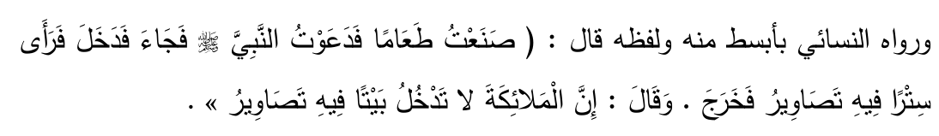
Another narration of the same Hadith has it such: Sayyiduna Ali  reports "I prepared some food and I invited Rasulullah . Rasulullah  entered and he saw a curtain which had pictures therefore he left and he said: 'The angels do not enter that home in which there are images'"
Hadith No. 22.
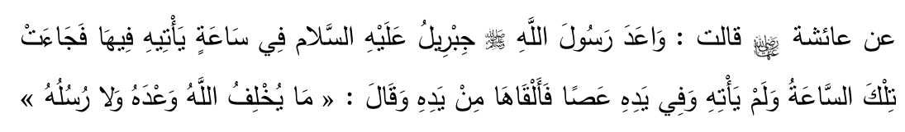
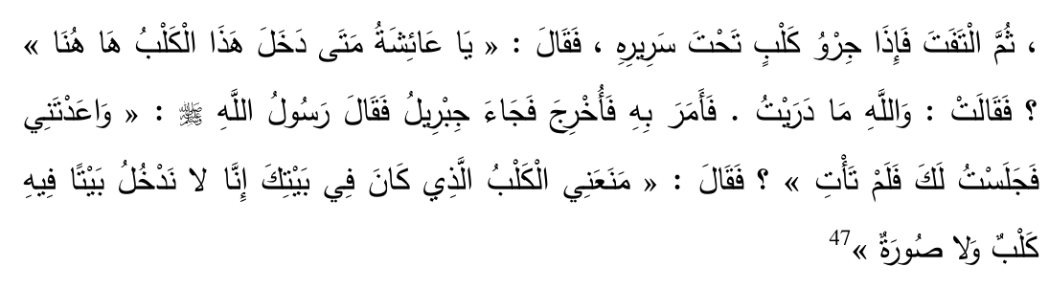
It has been narrated from Sayyidatuna 'Aa-ishah who says: "Jibraeel once promised to visit Rasulullah  at a particular time. When that time arrived Jibraeel did not come. Rasulullah  had at that time a walking stick in his hand. He dropped it from his hand and commented "Allah and His Messengers do not go against their promises." Thereafter he turned around and he noticed a puppy under the bed. Rasulullah  said "O 'Aa-ishah when did this dog enter here?" She replied: "By the oath of Allah I am not aware." Rasulullah  gave an instruction and the dog was removed. Thereafter Jibraeel arrived and Rasulullah  asked "You promised to meet me. I was sitting and waiting for you but you did not arrive." Jibraeel replied "The dog which was in your home prevented me. We do not enter a home in which there is a dog or an image."
Hadith No. 23.
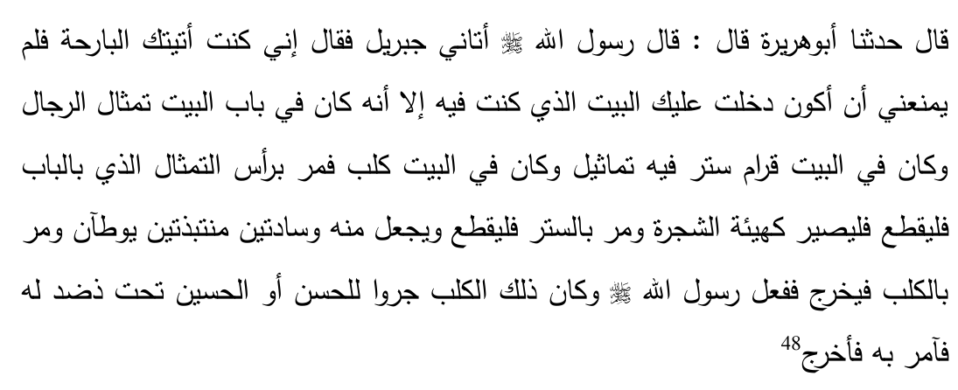
It has been narrated from Sayyiduna Abu Hurairah  that Rasulullah  said "Jibraeel came to me and said 'I came to visit you yesterday morning. The only reason that prevented me from entering the home in which you were
was that at the doorway there were some images of men and in the house was a curtain which had images and in the home was a dog. Therefore give an instruction in respect of the heads of these images which were in the doorway that they should be cut off so that the images now look like trees, and give an instruction regarding the curtains that they be cut up and they be made into one or two mats or cushions that are trampled upon and give an instruction regarding the dog that it be removed. Rasulullah  did so. The dog was a puppy belonging to either Sayyiduna Hasan or Husain (radiyallahu anhuma) which was under a raised sofa. So the instruction was given and it was removed.
Hadith No. 24.
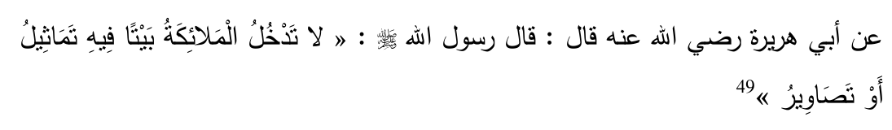
Sayyiduna Abu Hurairah  reports that Rasulullah  said: "The angels do not enter that home in which there are statues or images."
Hadith No. 25.
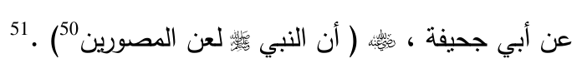
It has been narrated from Abu Juhaifah  that Nabi  cursed all the makers of images.
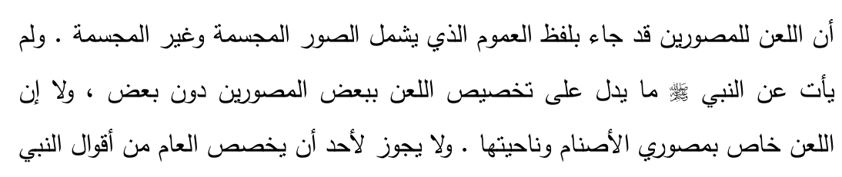
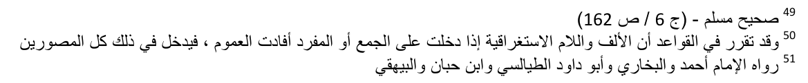
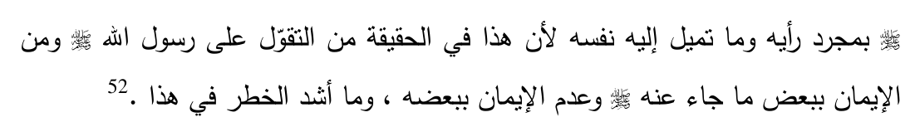
Commenting on this Hadith, Sheikh Tuwayjiri53 says: The curse of the image-makers appears in words that denote generality. This includes images that have no body (two-dimensional) and those that have a body (threedimensional). There is no Hadith showing any exception of the curse of some image-makers, and not others. Nor is there any indication that this curse is confined to the idol-makers or the like. It is not permissible for any person to restrict the generality of the Hadith based on his personal views or inclinations. Any such restriction would be a false attribution to Rasulullah  and to believe in part of his teachings and not others. What a dangerous affair this certainly is.
Hadith No. 26.
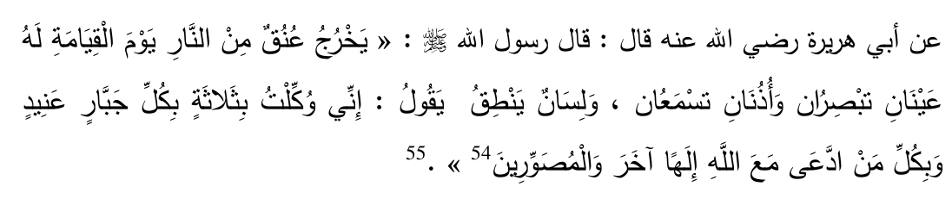
It is narrated from Sayyiduna Abu Hurairah  that Rasulullah  said: "On the Day of Qiyaamah some necks will emerge from the Fire of Jahannum. These necks will have two eyes that can see and two ears that can hear and tongue that can speak. It will say 'I have been appointed to deal with three classes of people, all the rebellious tyrants, all those who associated a god with Allah  and all the makers of images."
Hadith No. 27.
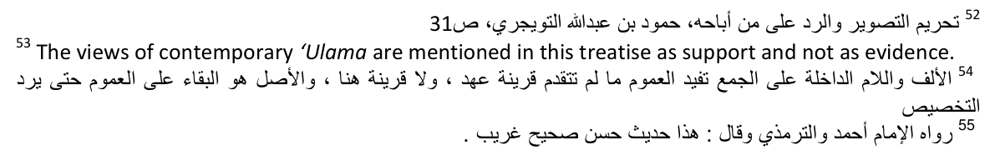
53 The views of contemporary 'Ulama are mentioned in this treatise as support and not as evidence.
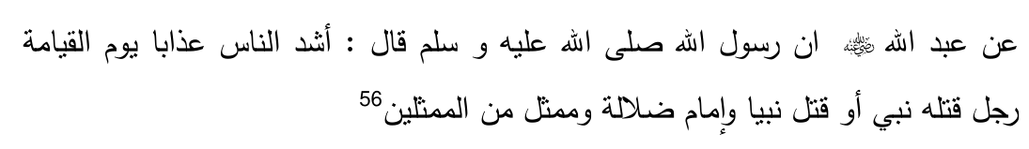
Sayyiduna Abdullah bin Umar  reports that Rasulullah  said: The worst punished on the day of Qiyaamah will be (three categories of people, the first of which is) a man who a Nabi killed or he killed a Nabi, (second) the leader of misguidance and (third) one who imitates or copies (Allah  ).
Other Ahaadith57 indicate that the worst punished would be the image-makers. Imaam Tahaawi explains that both the set of Ahaadith refer to the same person, i.e. the image-makers are the ones who attempt to imitate Allah .
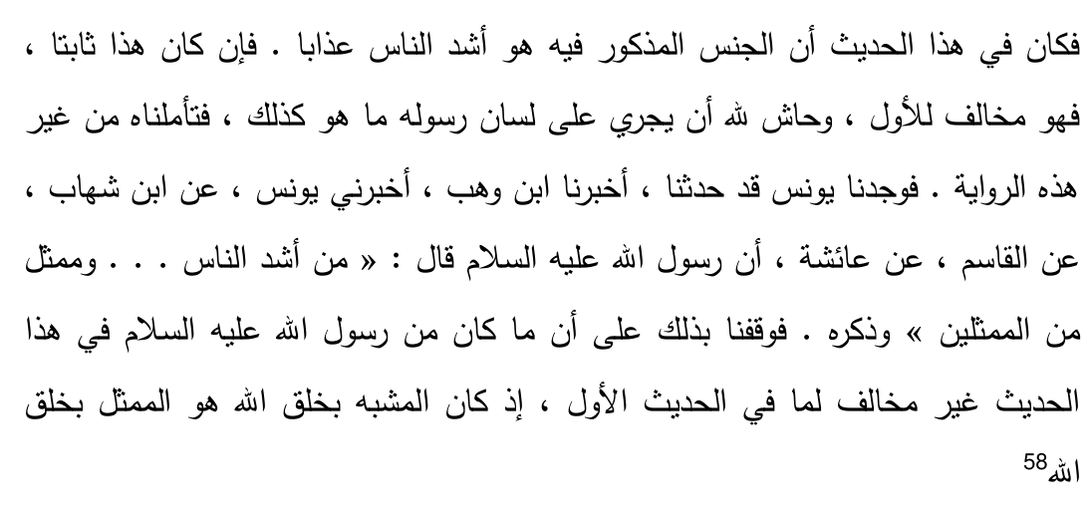
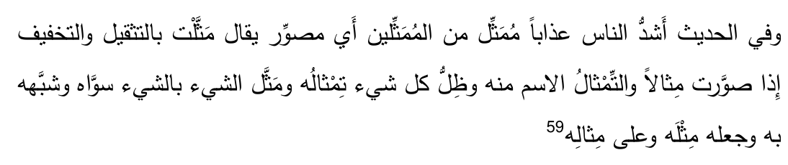
The author of Lisaanul Arab says: In the Hadith where it states "the severest in punishment will be one of the imitators", it means the image-makers. The
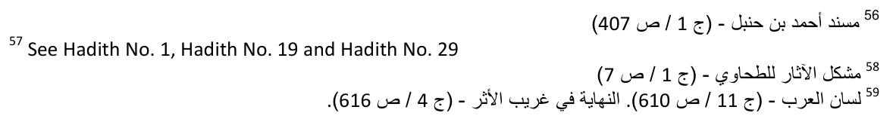
word "imitate" is used to refer to "the forming or shaping of a sample". The word "timthaal" (commonly translated as "statue") is derived from the same word. The shadow of an object is regarded to be the imitation of the object. For one thing to imitate the other (has a few meanings, which are) the two are equated or put on the same footing, or to copy or compare one against the other, or to make a sample, or produce a like.
Hadith No. 28.
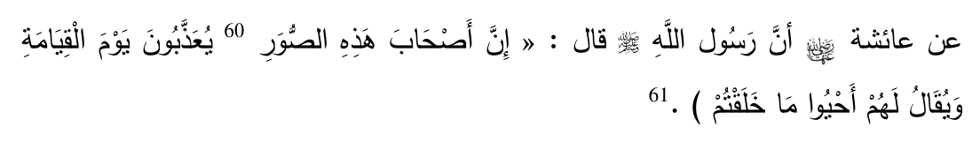
that Rasulullah  said: "The
It has been reported by Sayyidatuna 'Aa-ishah makers of these images will be punished on the Day of Qiyaamah and it will be said to them 'bring to life that which you created.'"
Hadith No. 29.
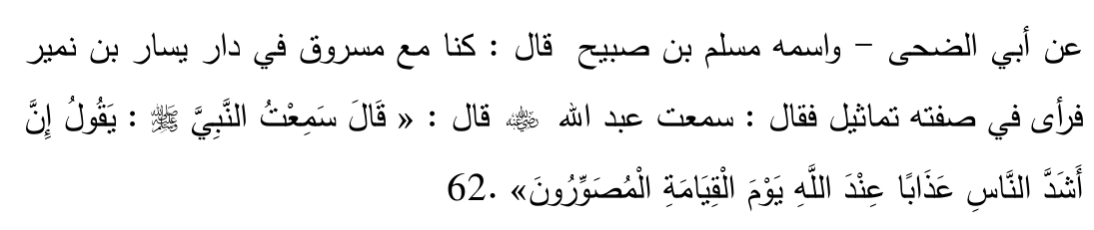
Abu Duhaa mentions we were with Masrooq in the house of Yassaar bin Numair. He noticed on the balcony some images so he mentioned "I heard Abdullah bin Umar  reporting that he heard Rasulullah  saying "The people who will be the most severely punished on the Day of Qiyaamah in the sight of Allah  will be the image-makers."
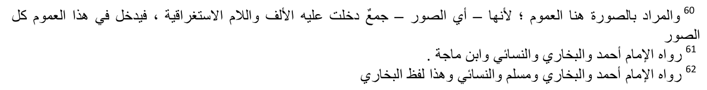
Hadith No. 30.
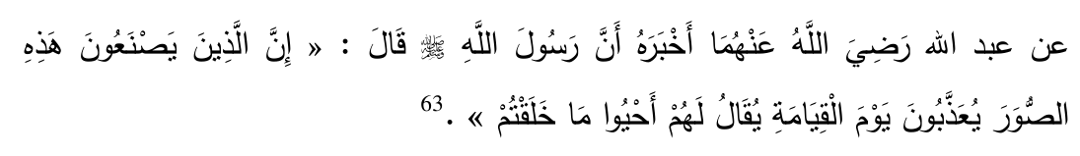
Sayyiduna Abdullah bin Umar (radiyallahu anhuma) reports that Rasulullah  said "Those who make these images will be punished on the Day of Qiyaamah and it will be said to them 'bring to life what you created.'"
Hadith No. 31.
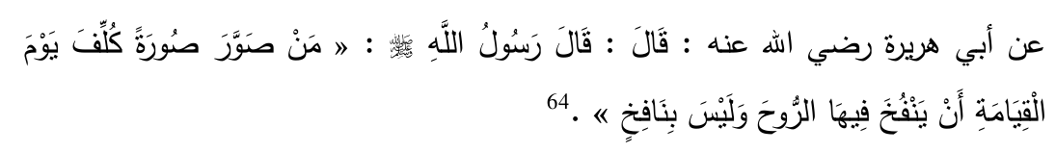
It has been reported by Sayyiduna Abu Hurairah  that Rasulullah  said "Whoever makes up an image he will be responsible to blow soul into that image on the Day of Qiyaamah whereas he will not be able to blow a soul into that image."
Hadith No. 32.
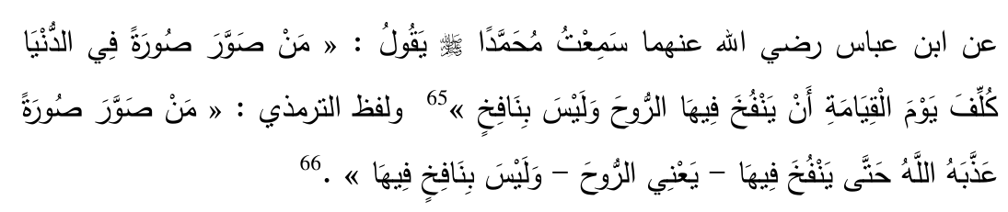
It has been reported by Sayyiduna Abdullah bin Abbas (radiyallahu anhuma) that I heard Rasulullah  saying "Whoever makes up an image in this world
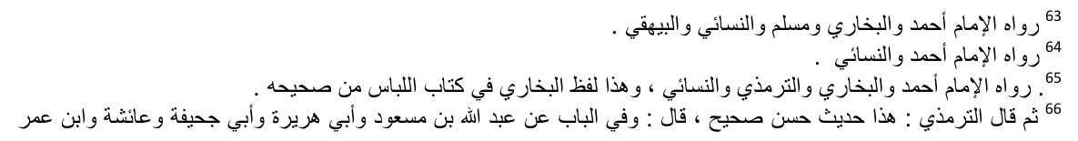
will be responsible on the Day of Qiyaamah to blow into it soul. He will not be able to do so."
Hadith No. 33.
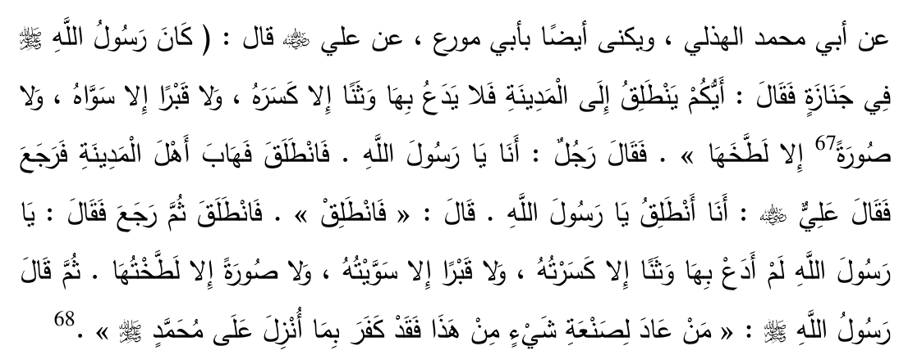
Abu Muhammad Alhuzili relates from Sayyiduna Ali  who said that Rasulullah  on one occasion was engaged in a Janazah (burial) (which would mean that he was outside of the city at the graveyard). Rasulullah  asked "Who of you will go to Madinah Munawwarah and will not leave any idol except that it is broken nor leave any raised grave except that it is flattened, nor leave any image except that it is effaced?" One person said: "O Rasulullah  I will do so." He went out and he warned the people of Madinah Munawwarah. Thereafter he returned. Sayyiduna Ali  then offered (realising that this person had not fulfilled the mission on which Rasulullah  sent him) "I will go O Rasulullah ." Rasulullah  told him "You may go." He went and thereafter returned and said "O Rasulullah  I did not leave any idol except that I broke it nor did I leave any grave except that I flattened it nor did I leave any picture except that I effaced it." Thereafter Rasulullah  said "Whoever repeats the production of these things he has denied that which has been revealed on Muhammad ."
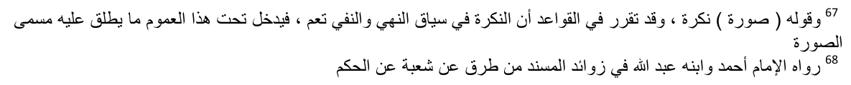
Hadith No. 34.
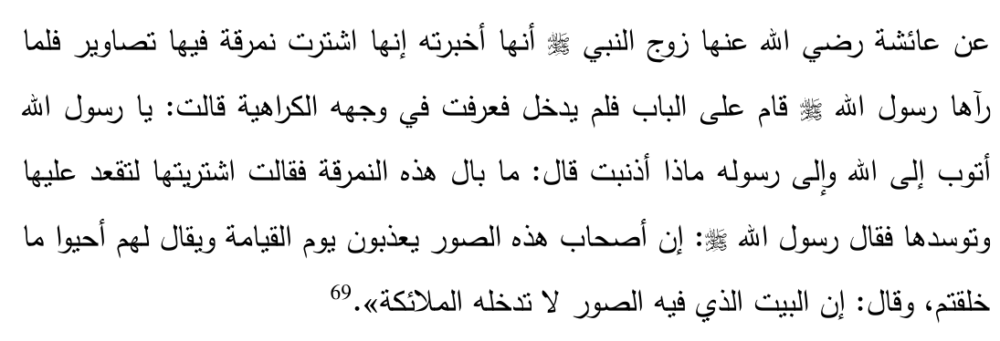
Sayyidatuna 'Aa-ishah reports that she once purchased a pillow which had some images on it. When Rasulullah  noticed this he stood by the door and did not enter the home. When she noticed Rasulullah 's disapproval she said "O Rasulullah  I turn in repentance towards Allah and His Rasul. What have I done wrong?" Rasulullah  asked "What is this pillow?" She replied "I purchased it so that you can sit on it or lean against it." Rasulullah  said "Those who make these images will be punished on the day of Qiyaamah and it will be said to them 'bring to life that which you have created'" And Rasulullah  also said "The angels do not enter that home in which there are images."
Hafiz Ibn Hajar (rahmatullahi alayh) comments:
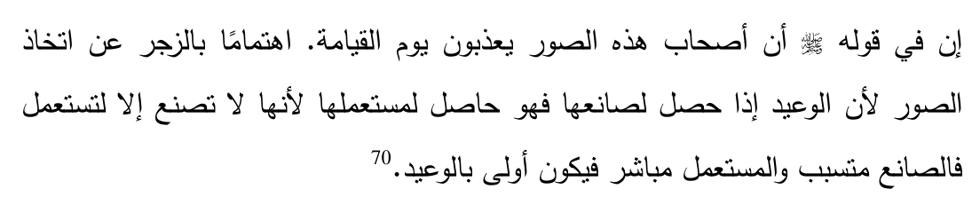
In the Hadith of Rasulullah  "Verily the makers of these images will be punished on the Day of Qiyaamah" is a special warning to those who use images because since the severe warning addresses the maker, it will apply to the user as well because an object is made for usage and the maker is simply the means whereas the user is the actual objective, so therefore the user is more deserving of this warning.
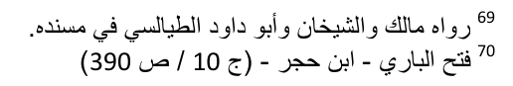
Hadith No. 35.
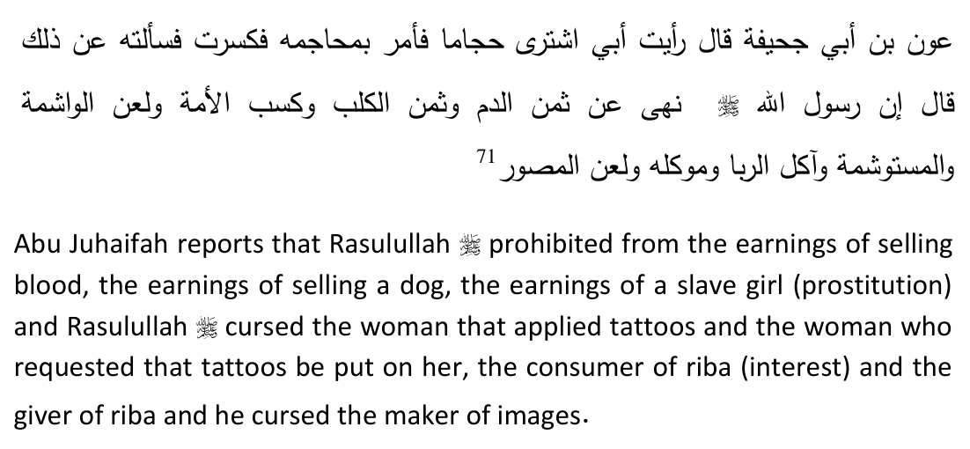
Hadith No. 36.
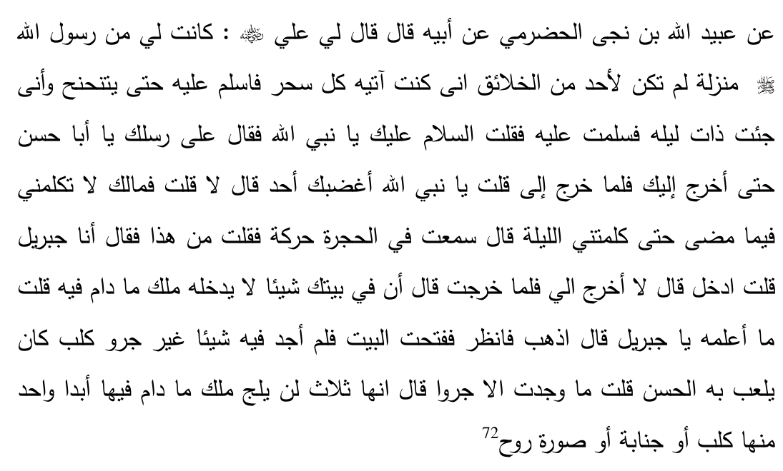
Sayyiduna Ali  says: "I had such a close position and relationship with Rasulullah  that no one else had. I use to come and visit him every morning and make salaam (greet) him until such time that he would say 'Ahem' (he would acknowledge my presence). One night I came to him and made salaam to him by saying Assalaamu alaika Ya Nabi (O the Prophet of Allah ).
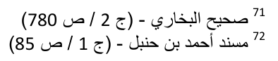
Rasulullah  said "Carry on, unless I come out O Abu Hasan". When later he came out to me I asked him: O Rasulullah  has somebody made you angry? He replied: No. I asked him: "What is the reason that on the previous occasion you did not reply to me, and told me to carry on until you would come out to meet me later?" Rasulullah  said: "I heard some sounds from within the room so I asked: Who is there? The reply came that 'I am Jibraeel
'. So I said enter and he replied: 'No you rather come out to me'. When I went out Jibraeel said: 'There is something in your house as a result of which no angel will enter therein as long as that thing is in your house'" Rasulullah  replied: "I am not aware of it O Jibraeel
." He said: 'Go and look'. When I opened the house I did not find anything besides a puppy which Hasan  use to play with. I went out and I informed Jibraeel that I found nothing besides a puppy. Jibraeel said: 'There are three such things that as long as any of them is in the house the angel will not enter at all. One is a dog, the second is a person in the state of janaabah (ritual impurity) and the third the image of a living being'"
Hadith No. 37.
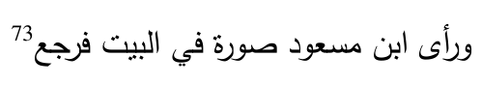
Ibn Masud  once saw some images in a home therefore he returned (he did not enter that home).
Hadith No. 38.
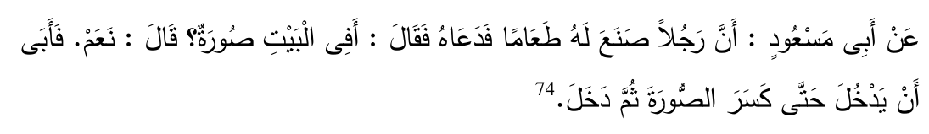
Abu Masud  says that once somebody prepared a meal for him and invited him. He asked if there were any images in the house. The reply was in the
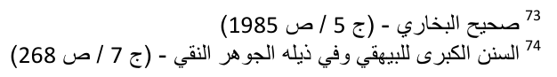
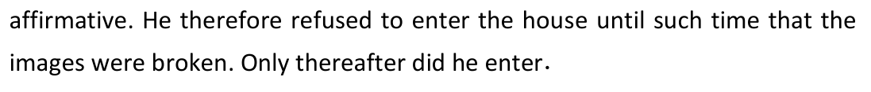
Hadith No. 39.
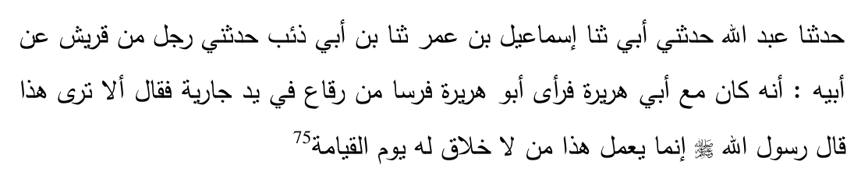
The narrator says that he was with Abu Hurairah  when he saw a horse (a doll in the shape of a horse) made of rags in the hand of a small girl, who then said: "Don't you see this. Rasulullah  said 'Only that person would do this (make such a doll) who has no share (of goodness) on the Day of Qiyaamah.'"
Hadith No. 40.
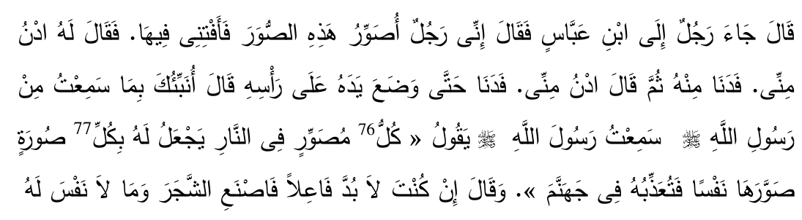
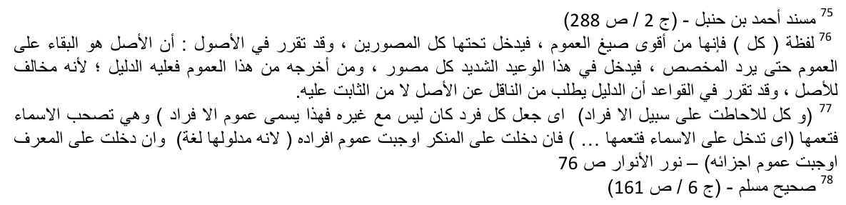
A person once came to Sayyiduna Ibn Abbas and said: I make these images (as an occupation). Give me a fatwa regarding it. He replied: Come closer. The man came closer. Again he said 'Come closer', and the man drew even closer. Sayyiduna Ibn Abbas placed his hand on the man's head and said: I will inform you of what I heard from Rasulullah . I heard Rasulullah  saying: "Every image-maker will be in the fire (hell). A separate life will be given to him for every image he produced which will punish him therein." Sayyiduna Ibn Abbas said: If you really need to make images, then make images of trees and objects that do not have a soul.
These Ahaadith and the important points drawn from them must serve as the starting point in evaluating the respected Mufti's claims. It is only based on the foundational principles derived therefrom that a true assessment of his theory could proceed.
The discussion shall now shift to an easy and simple understanding of the images under discussion. Once such a comprehension is achieved, this will then be tied up with the foundational principles derived above from the Explicit Texts.

The Television Image Simplified
The very basic understanding of what a television entails seems to have evaded the respected Mufti. We therefore present a really simple explanation of the television to bring it within the grasp of the reader. Those who are technically minded will have to excuse the conspicuous lack of sophistication and technicality.
The scenario being painted is an imaginary one simply to illustrate the basic concepts and to bring it within the grasp and understanding of the most common of the laymen.
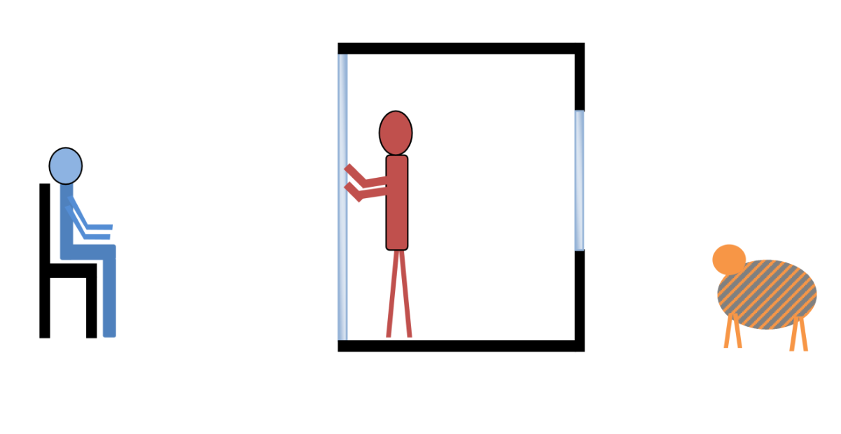
STAGE 1: Consider we have a room or a booth which is made up on one side of a large sheet of opaque (semi transparent) glass. On the other end of the room is a window leading to the rear. Outside the observation window is a tiger. Inside this room stands an artist (in red). On the outside facing the glass is an observer seated (in blue). The artist looks at the tiger and thereafter paints a picture of the tiger on the glass. This is done the traditional way by the use of paint and an artist's paintbrush. The observer cannot see the artist because the glass is opaque. However he does see the image of the tiger made on the glass.
Permissible Impermissible
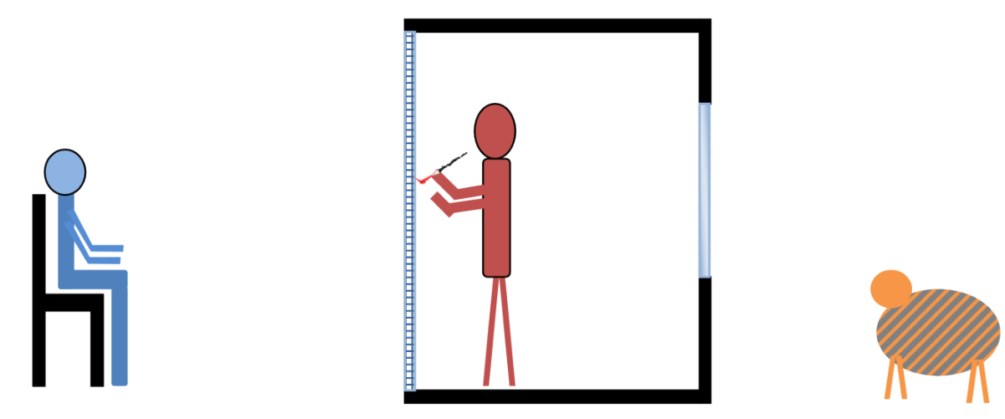
STAGE 2: The artist divides the screen into a billion small squares. Instead of drawing by means of strokes with his paintbrush he rather fills in each square with a colour. Therefore he produces a picture by means of a mosaic. Because each square, called a pixel, is extremely minute the observer does not discern any difference whatsoever. In his eyes the picture is exactly the same as when the artist was using his paintbrush and applying paint by means of strokes. The artist turns around, looks at the tiger, works out what colour needs to be filled placed in each pixel and accordingly applies one colour in each pixel. In this way the image of the tiger is created on the screen.
Permissible Impermissible
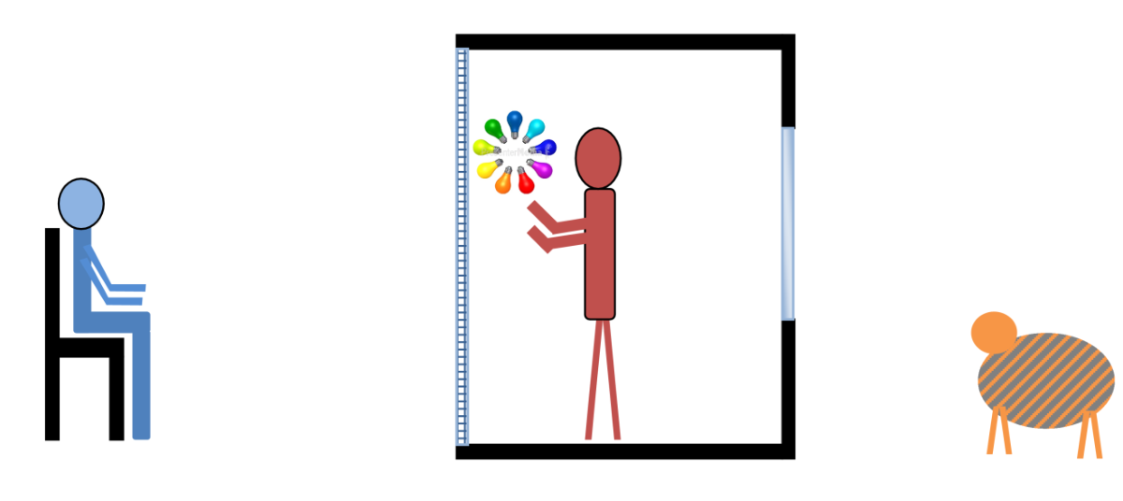
STAGE 3: The artist, instead of applying paint into each pixel, installs a light bulb in each pixel. He is able to individually control the colour that glows from each of these billion light bulbs positioned in each pixel. Here too he looks at the tiger and works out what colour needs to be applied in each pixel and accordingly sets each light bulb to glow at the corresponding colour. To the observer on the left there is absolutely no difference. In his eyes he still sees the same image of the tiger which was originally observed when the artist was using paint and strokes with the paintbrush.
Permissible Impermissible
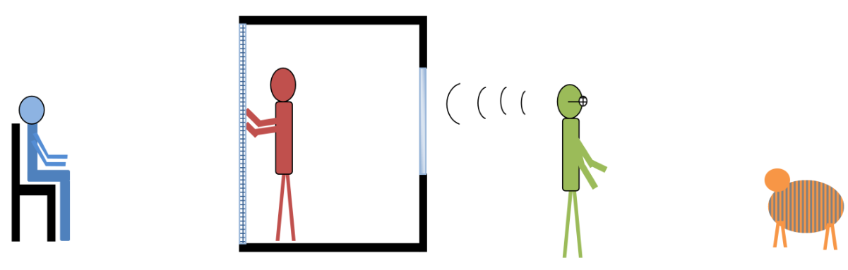
STAGE 4: The tiger has in the meanwhile moved a little away from the observation window. The artist therefore employs the assistance of the watch-out man (in green). This watch-out man has divided the lens of his spectacles into a billion squares. By viewing the tiger through this special spectacle he is able to work out the colour that needs to go in each pixel. He then verbally communicates this to the artist who accordingly applies each colour to the respective pixel by means of ordering each light bulb to glow at a particular colour. Once again to the observer on the left there is absolutely no difference. He sees before him the same image of the tiger as before.
Permissible Impermissible
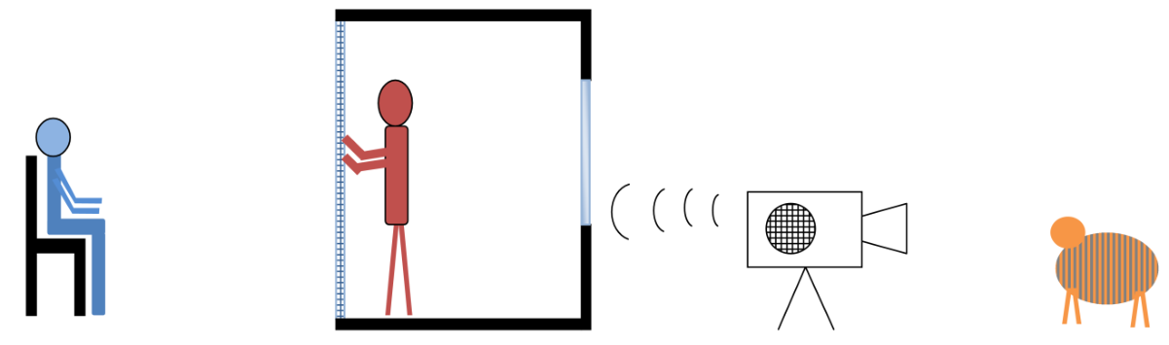
STAGE 5: The watch out man in green gets tired of his job. He therefore invents a machine that is able to observe the tiger, work out the colour that is to go in each pixel, and is able to verbally shout out this colour to the artist. Once again the artist makes the necessary adjustments to each light bulb and accordingly the picture is formed. To the observer the result is the same.
Permissible Impermissible
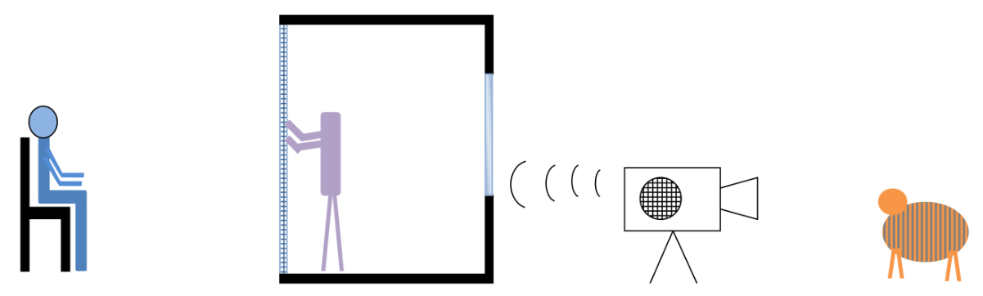
STAGE 6: The artist in the booth, learning from the watch-out man in the green, also becomes tired of his job. He therefore invents a robot (in purple), who takes over his function of adjusting the colour in each light bulb on the screen. The image is now created by two machines: the robot that replaced the artist and the machine that stood in for the watch-out man.
Permissible Impermissible
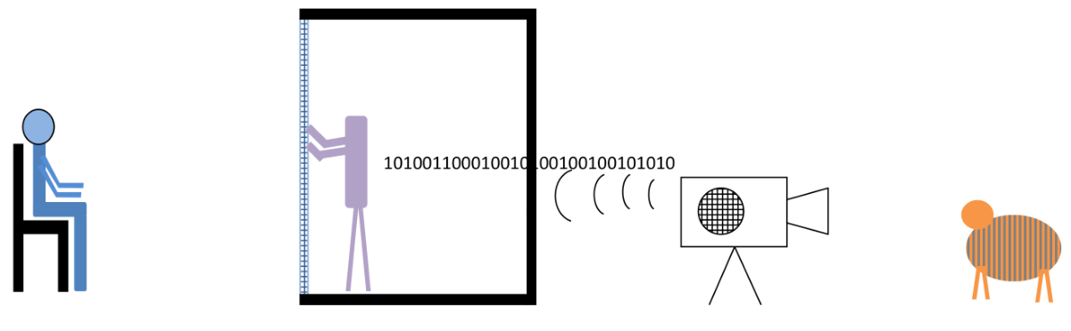
STAGE 7: The two machines agree to communicate in their own language, known as binary language, which is made up of O's and 0's. They do not have any need to communicate in human language and therefore can understand each other more efficiently in their own language.
Permissible Impermissible
STAGE 8: Assuming that upon the tiger moving the two machines are able to repeat these processes at a very high speed. They are able to quickly create the full still image of the tiger, remove such an image and replace the previous image with the image of the tiger in its new position. The process is repeated 50 times per second. The result to the observer is that he is viewing a moving picture (a movie).
Permissible Impermissible
The booth represents the television set and the watch-out man in green represents the camera. What passes between them are not rays of light. Rather it is a communication, earlier on by voice and later in computer language.
For the purposes of our discussion the following crucial questions need to be answered:
1. Is the image created on the screen during each stage Haraam? If it is said that the image in each stage is Haraam we will have to logically conclude that the image appearing on the television screen must accordingly be Haraam.
2. If at any stage it is said that the previous stage was Haraam but the subsequent stage is permissible then the one making such a claim79 needs to provide proper Shar'ee arguments to distinguish the one stage from the other. If no sound argument is presented then there can be no basis for distinguishing one stage from the other.
It is with conviction submitted that there are no differences between the various stages, and that the image created in each stage is Haraam.
Based on the analogy we have drawn, it must follow that the image on the television screen is Haraam to produce.

Comparison with the Mirror
The respected Mufti's theory that the image on the television screen resembles the reflection on a mirror will now be appraised. It appears that some very basic concepts have evaded the respected Mufti, hence the conclusions he makes. An explanation is given of some rudimentary concepts related to light. These lessons are generally taught at a primary school level.

Absorption
The first concept is that of absorption. Natural light (also called white light) consists of electromagnetic radiation at various wavelengths. If these wavelengths are expanded or split up the colours of the spectrum become distinct or visible.
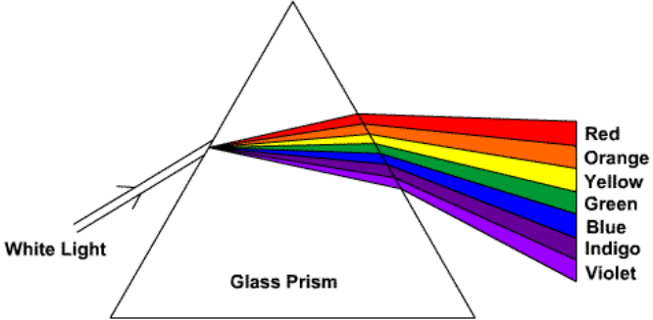
When light strikes an object some of these rays are absorbed by the object while others are reflected (diffused reflection). The colours that are reflected effectively represent the colour of the object, so if the object was blue all the other colours of the spectrum are absorbed within the object whilst blue is reflected which then enters into the eye. The eye then perceives the object as a blue object.
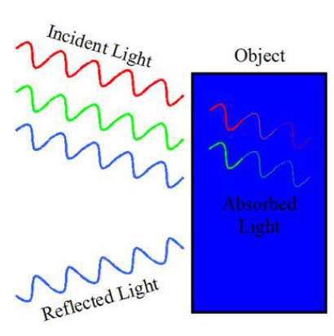
The object that does the absorption is considered to be the object that is being observed or looked at.

Reflection
The second basic concept is that of reflection, to be more precise spectral reflection. This applies to a very smooth surface such as a mirror or still water.

Light approaches the object at which absorption takes place. Only certain colours are reflected from the object. These rays of reflected light then hit the mirror. They bounce off the mirror at an angle equal to the angle at which they approached the mirror. This manner of bouncing off the mirror is known as the law of reflection.
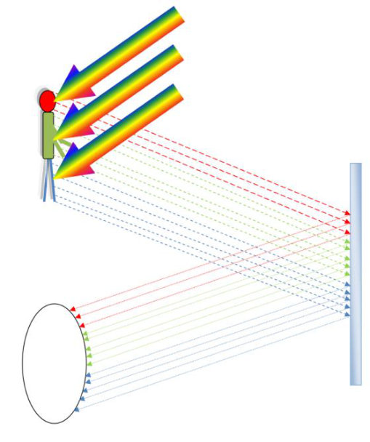
When a person observes an object via reflection on a mirror there is an illusion that the object is straight ahead in the line of sight of the observer whereas in reality it is not. Rather it is at an angle from the observer. This angle will depend on the angle of incidence.
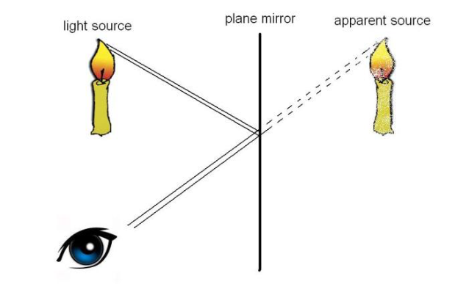
When a person observes an object via a mirror, it is the object that is being observed or seen, and not an image of the object. This can be proven by three observations.
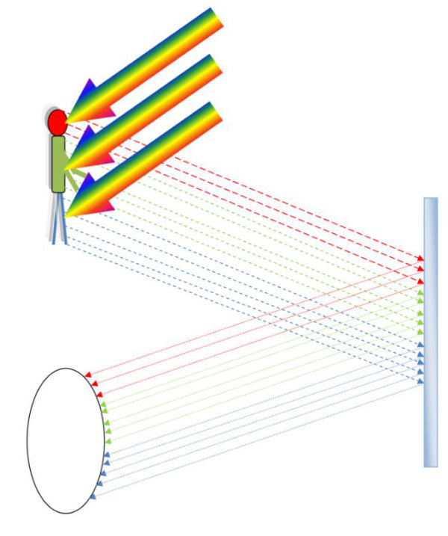

First Observation
Natural light, represented by the arrow in the rainbow colours, strikes onto the object. This object then reflects only certain colours in the direction of the mirror. The head reflects red rays, the shirt reflects green rays and the trousers reflect blue rays. These rays then bounce off the mirror and enter into the observer's eye.
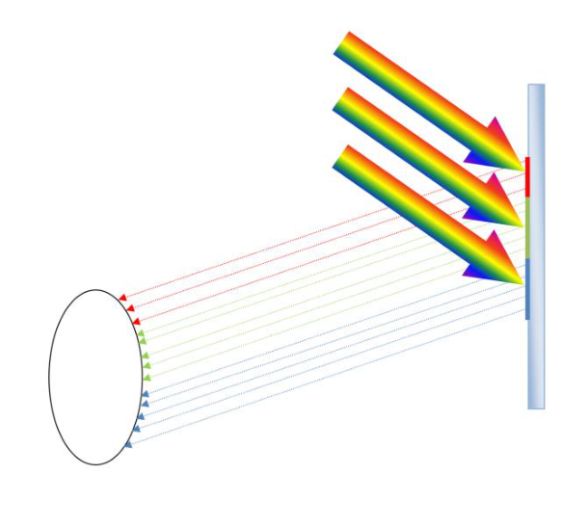
If the mirror produced an image that sits on the surface of the mirror then absorption would have taken place on the surface of the mirror. In other words natural light would have struck the mirror and at that point the upper portion of the image would have reflected red rays, the middle portion would have reflected green rays and the lower portion would have reflected blue rays. However this is not what takes place. The actual absorption takes place on the object and not on the surface of the mirror. This proves that a mirror does not produce an image that sits on its surface.

Second Observation
The eye is endowed by Allah  to focus at various lengths80. The distance to which it is focussed is referred to as the focal length. If a person observes the reflection of an object bouncing off a mirror, the observer is actually observing the object and not an image of the object.
80 This is called Ocular Accommodation.
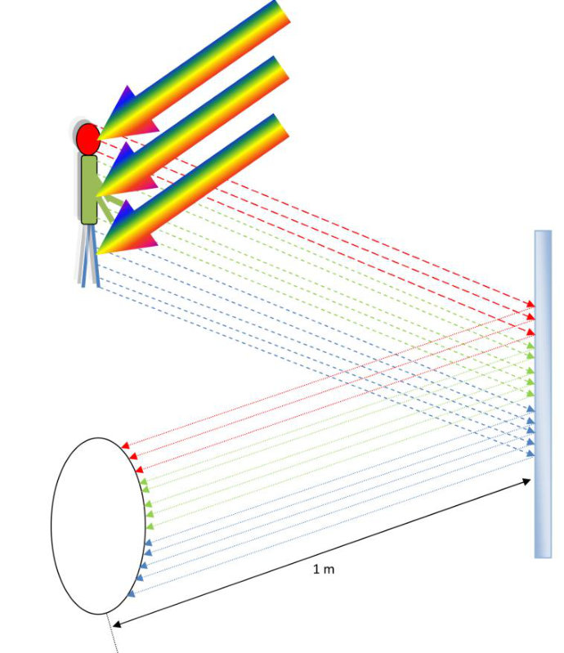
If the object was placed one metre away from the mirror and the observer stands one metre away from the mirror the eye is focussed at two metres. Similarly if the object is placed five metres away from the mirror and the observer stands one metre away from the mirror the focal length will be six metres. This demonstrates that the observer is looking onto the object and not onto an image of the object.
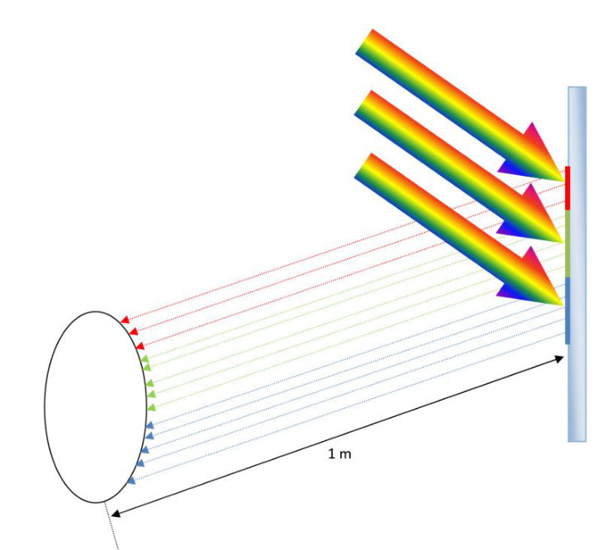
If, hypothetically, the mirror had to produce an image sitting on the surface of the mirror then the focal length would have only been the distance between the observer and the mirror. In other words if the object was placed five metres away from the mirror and the observer stands one metre away from the mirror the focal length to which the observer focuses his eye should have been one metre if there was an image. But this is clearly wrong. This further demonstrates that when observing an object on the mirror the observer is looking at the object and not an image produced on the surface of the mirror, or anywhere else for that matter.

Third Observation
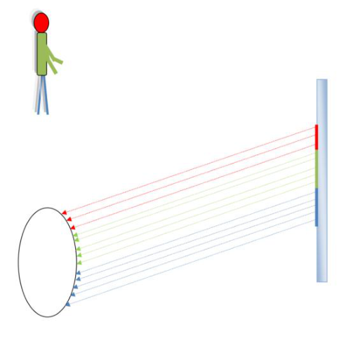
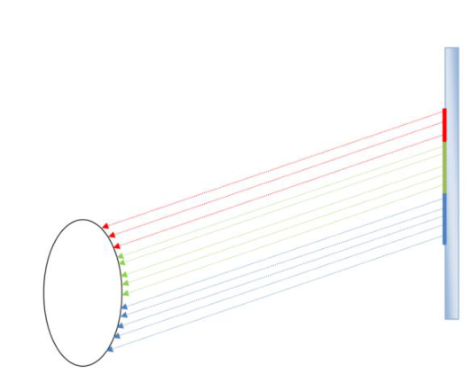
If the original object is removed, there is nothing to see. If it were an image, it would have existed independent of the original, and would be observable even in the absence of the original.
It is an established fact that vision of the object is not possible without the object, indicating that in reflection, there is no entity (i.e. no image) that has an independent existence.
It has been demonstrated by means of the three observations that there is vast difference between the reflection off a mirror and an image created on the screen.
What is surprising is that this explanation of the clear difference between the mirror reflection and the television image is so elementary and simple that one wonders how someone can claim that the television image more closely resembles the mirror reflection. The science behind it is of a primary school level.

Possible Misunderstanding
The respected Mufti may have been misled by the illusion of the mirror. This could be illustrated by the following scenario.
Assume we have a television set, a camera placed on top of it (similar to the webcam camera) and a mirror placed next to the camera. All three face the same direction. If a person walks past these three with his right shoulder facing them, at first blush, the person may get the impression that the behaviour of the camera is exactly the same as the behaviour of the mirror. When the person passes the television set he notices an image of himself appearing on the right end of the screen then moving over to the centre and then disappearing on the left edge of the screen. A similar observation is made in respect to the mirror, that he first notices an impression of himself appearing on the right edge of the mirror then passing over to the centre of the mirror and finally exiting on the left edge of the mirror. The apparent notion gained is that both the television screen and the mirror behave the same.
What this illusion or apparent impression does not take into account is the fundamental difference between the image on the television screen and the reflection on the mirror. In the case of a television screen we are dealing with an image that is created by human design. That image sits on the surface of the television. In the case of the mirror there is no image produced. We have demonstrated above that a mirror does not produce an image that sits on its surface. So in the case of the television we are dealing with something that is created, produced or manufactured by human design. The reflection on a mirror is not an image that is produced, for there is no image whatsoever. The impression or the illusion to the eye can be referred to as a virtual image but it is not a real image. It is not a visual reproduction of the original object.
The virtual image or illusion that appears on the mirror cannot exist independent of the object. If the object moves away the virtual image disappears. However in the case of the television screen the image exists independent of the object. The picture can be captured and displayed even after the object has moved on. This further demonstrates that by observing the television one is looking onto a created image whereas when looking onto the mirror one is looking at the object itself and not an image of the object.
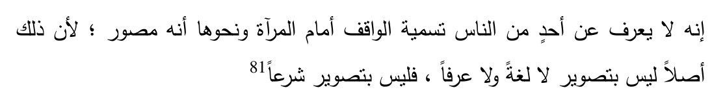
No person would ever call a person standing in from of a mirror "image-maker". This is so since there is no formation of an image: neither literally, nor is it considered so in the norm of society. Therefore, in terms of the Shari'ah as well it will not be termed as an act of producing an image.
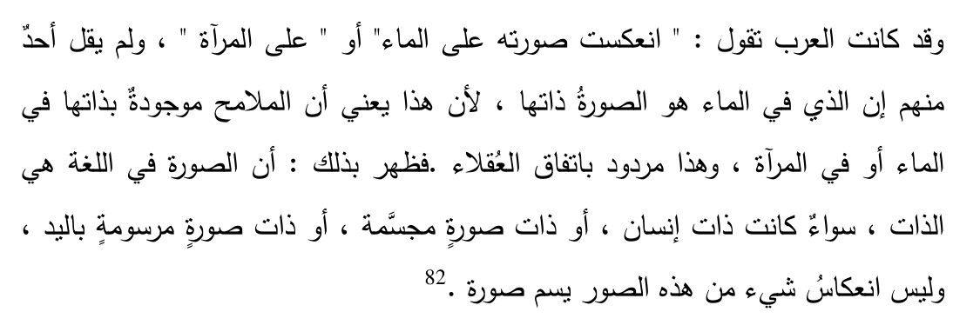
The Arabs say that the image was inverted on the water or on the mirror but no one is of the view that that which is on the water is the image itself because this will imply that the actual lines or strokes are found on the surface of the water or the mirror, but this is unanimously illogical. Therefore one can understand that the term Soorah literally refers to the Thaat (independent existence) of an item, whether it be the form or the shape or the essence of the human being or whether it be the essence of a solid body or of the shape which is drawn by hand. The mere reflection of any of these is never termed as a Soorah.
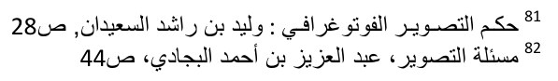

Does an Amalgamated Source Matter?
Assume a person wishes to create an image within a dark space or room. Traditionally he may employ the following ingredients:
1. A light source, for example a lamp 2. A sheet of paper 3. Paint and paintbrush
By strokes of the paintbrush he produces an image. The light source shines onto the image. That image then reflects83 innumerable number of rays of light. One ray of light may exit the lamp and strike the red paint on the page whereby a red ray of light leaves the page and enters into the eye of the observer. The same applies to the infinite number of other rays of light. In this way the traditional image is observed. Now what would be the position if this person is able to combine all three ingredients into one? Instead of producing the red ray of light with the traditional materials he is able to produce a red ray of light that emerges from a specially constructed instrument. A light bulb is designed which is able to emit rays of light according to the colour which it is instructed to create. All the person has done is to combine and simplify the process by producing the red ray of light directly, instead of using lamp, paper and paint. The overall effect is exactly the same. The observer sees the same image before him. Digital imagery involves the production of a huge number of small light bulbs producing controlled rays of light, collectively making up the image. No substantial difference can be discerned between the two situations and in terms of the Shari'ah the outcome and result of both processes should be one and the same. Therefore an image produced by means of digital imagery should hold the same position of being impermissible as an image created by means of hand drawing.

Permanency
The respected Mufti alleges that the image on the Television screen is not permanent. What exactly is meant by this is not all too clear.
83 Diffused reflection
A person could set an image to appear fixed on his computer monitor. No change comes about for a month, for example. On the other hand an image could be drawn on a white-board and then quickly erased. The latter image may last for only a few seconds. Could it be said that the image that lasted a few seconds on the white-board was permanent whilst the unchanged image on the monitor was not permanent? According to the respected Mufti's theory, the image on the white-board would have to be classified as permanent, whereas that on the monitor would not. This appears to be incongruous.
In both images there is a continuous stream of light particles – photons – emerging from the image onto the eye. These photons are not fixed. In every fraction of a second one set of photons leaves the image, enters the eye and disappears. The next set of protons do the same and the process is repeated an enormous number of times per second. In view of this continuous process, it is difficult to understand what the respected Mufti means by permanency. There is no one single set of light rays that remain permanent.

The False Manual v Mechanical Dichotomy
As mentioned above84, the respected Mufti is in agreement that hard copies are impermissible, and fall under the grave warnings sounded in the Ahaadith mentioned.
Some writers have attempted to draw a distinction between hand-made images and those produced mechanically. Here the term "mechanical" incorporates both analog and digital. At times they have expressed the same difference in the form of distinguishing between those images which have been created via the medium of the human mind and those that are produced mechanically without the human mind being employed in any of the stages of the formation of the image. Their argument is on the lines that at the time of revelation, all the images in vogue were produced by hand. This includes hand drawn pictures, etchings, carvings, wood-cut and statues. They allege that the prohibition must be confined to these categories of images. Mechanically produced images, so their argument goes, came about later and are hence not covered by the various Ahaadith on the topic. Another argument they present is that these hand produced images have their source in the human mind.
84 See pg. 6
The mind, either by observation or imagination, or a combination of both, formulates a mental picture which is then expressed in the form of a hand-made image. A mechanically formed image is formed from the light reflected off the original, passing through a machine, and onto a durable medium. Light passing through the lens of a camera falls onto a negative, which is transferred onto photographic paper. It does not pass through the human mind at any stage.
These arguments have been sufficiently answered in other works85 and are not transferred in this treatise. Notwithstanding our difference with the respected Mufti, we are in agreement with him that these arguments hold no water. The respected Mufti therefore concurs with us that it makes no difference whether an image is produced mechanically or by hand. Our difference with the respected Mufti lies in the bifurcation between images produced on a durable medium and those produces on any medium. He only holds the former to be impermissible, whilst we hold all images to be impermissible.
The hermeneutical approach to the above mentioned Explicit Texts shall now be expanded upon.

Islamic Law Semantics
85 See Jawaahirul Fiqh, vol. 7 pg. 336. By way of example, one such answer is:
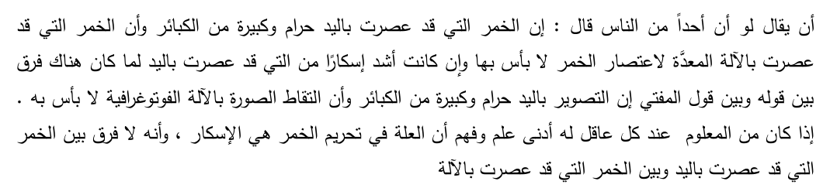
If somebody has to say that the wine that he squeezed by hand is Haraam and to drink it will be a major sin whereas wine that is squeezed by means of some machine designed for this purpose will be permissible even though the wine produced by the machine has a greater degree of intoxication than the hand-produced wine, then such a statement will be no different than the statement of that Mufti who says that the image produced by hand is Haraam and a major sin whereas the image produced by a camera (or other forms of creating images) is permissible. Now that every intelligent person can understand, even though he may not be very learned, that the underlying factor in wine being Haraam is the factor of intoxication and therefore no difference derives from the fact whether the wine is produced by hand or mechanically.
In Usool ul Fiqh discourse, the meanings of words are divided into three categories86.
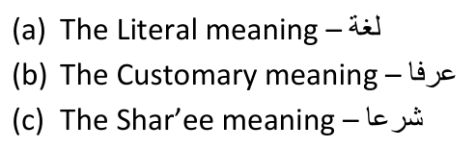

The Literal Meaning
This refers to the original meaning for which the word was coined. The word "dog" has been coined for the fury four-legged animal that barks. This is the literal meaning of the word.
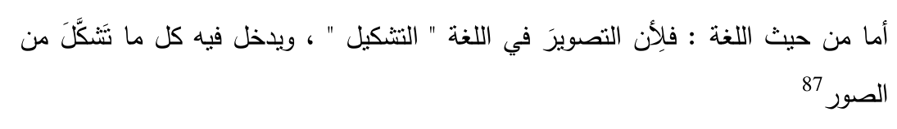
In as far as the literal meaning, the word Tasweer means to form or shape. Therefore any image that has been formed or shaped will be included.
From a literal perspective, there can be no doubt that the image that appears of the television screen and other digital media is formed or shaped by human intervention, hence these images are Soorah.

Customary / Technical Meaning
A word sometimes takes on a meaning separate from its literal meaning in a particular community. If that community consists of a particular discipline of learning, the customary meaning then serves as the technical meaning within that discipline.
The word "Company" literally means to be with someone. However, in the legal community it refers to a form of business entity. In the military community it means
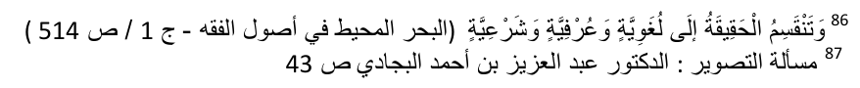
a small unit made up two or three platoons. These meanings are distinct from the literal meaning.
In as far as the word Soorah, there does not exist a separate and distinct customary/technical meaning independent of its literal meaning.
The long and short of it is that if one had to point to the image on a television screen and ask a person fluent in Arabic: Is this a Soorah, one will certainly get an affirmative answer.

Shar'ee Meaning
A word sometimes assumes a distinct technical meaning in the context of the Shari'ah. Expressed in another way, if the technical meaning (as explain above) is that of the community of experts of the Shari'ah, then the meaning is the Shar'ee meaning.
The word "Salaah" literally means to make Dua -- to beseech, beg, implore or pray. However, the Shari'ah has used this word in the meaning of offering an act of devotion in the form of standing, reciting the Qur'aan, bowing and prostrating etc. This meaning attributed to the word is distinct and separate from the literal meaning.
It is a requirement that the separateness and independency of the Shar'ee meaning must be so clear that all those who are acquainted with the Shari'ah will attest to its distinctness88.
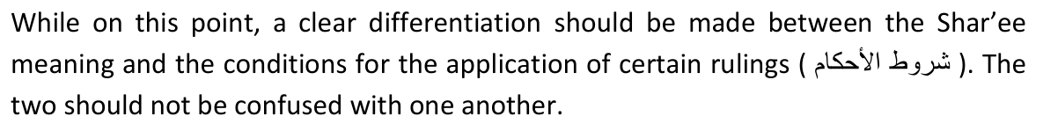
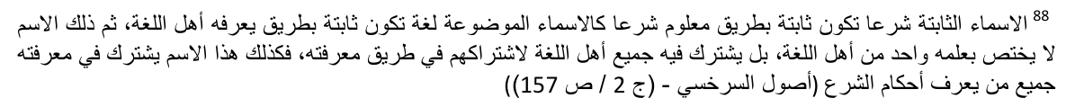
For a person to be deserving of capital punishment for intentional murder, one of the requirements is that he must have used a weapon that is designed to kill. This is a condition for the application of a particular ruling (hukm). However, in the absence of this condition, it cannot be said that the Shar'ee meaning of "murder" is likewise absent. Rather, should a person kill using an instrument not designed to kill, the Shar'ee meaning of "murder" will still be found, but the hukm (liability for capital punishment) is not applicable.

Application
Reverting to the topic at hand, as I understand the respected Mufti's theory, he is of the view that the word Soorah has a Shar'ee meaning, and that this Shar'ee meaning is not found in digital images. I understand him to say: In terms of the Shari'ah a Soorah is only a Soorah if it is on a durable medium. If an image is not on a durable medium, then it is not a Soorah in terms of the Shari'ah, and hence the prohibition does not apply.
I cannot imagine him to say a digital image is neither Literally nor Customarily a Soorah. That would be downright absurd, and it would be useless ever having any meaningful discussion with any person who would make such a preposterous claim. Hence the only option is to assume that he has given the word Soorah a Shar'ee meaning.
Let us then examine this claim. Did the Shari'ah give the word Soorah a distinct and separate meaning? My answer to this question is in the negative. It is up to the respected Mufti to provide proof of such a claim should he wish to sustain it. Let alone all the experts of the Shari'ah attesting to this, I have not come across a single mention of a separate Shar'ee meaning of the word Soorah in any book. To the contrary, I have found support for my contention that the term Soorah applies in its literal meaning, and no other.
It is recorded in the Encyclopaedia of Fiqh:
The terms Tasweer and Soorah, in the terminology of the Fuqaha (Jurists), are the same as their literal meanings.
It is now up to the respected Mufti to substantiate his claim of 'durable medium' being part of the Shar'ee meaning of the word Soorah.
The entire edifice of my argument is fairly simple. The images on the television screen and other digital images are Soorah. The Divine texts prohibit Soorah in general. Hence these images are prohibited.
When the matter is settled by the clear Ahaadith of Rasulullah , coupled with the meaning of the word Soorah, in my view there is no need to even consider Qiyaas.
However, for the sake of completeness and foreshadowing a belated attempt to give some kind of justification to the permissibility advocated by the respected Mufti, the possible application of Qiyaas to the topic on hand shall be deliberated below. This is also necessitated by the subliminal inferences in the respected Mufti's writing that he has somewhat relied on Qiyaas.

The Role of the 'Illah in Juridical Predictability and Certainty
In any developed system of law, jurists always strive to maintain and nurture two vital characteristics, namely predictability and certainty. Uncertainty and subjectivity are to be reduced to the absolute minimum. The Shari'ah as a divine system of law epitomises a system based on revelation yet dynamic enough to meet the needs of all developments that were to come post the period of revelation. The overall structure of the Shari'ah, in particular the development of the Matha-hib, takes the features of certainty and predictability to such heights unparalleled by any other system of law.
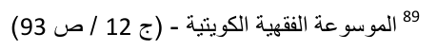
Those ignorant of the detailed laws and procedural rules contained within the Matha-hib are blissfully unaware of the exceptionally high degree of development of the Shari'ah. Some of these ignorant persons are under the impression that the judge in an Islamic court has an open and unfettered discretion, and applies his mind arbitrarily to the facts before him. For example in the case of Clerk vs. Harleysville Mut Casualty Company90, Judge Dobie said:
[W]e cannot torture these words into fanciful meanings; we cannot ignore what appears to have been a crisp legislative distinction expressed in terms that are anything but uncertain. We sit, after all, as an appellate court, administering justice under the law, not as an ancient oriental cadi, dispensing a rough and ready equity according to the dictates of his own unfettered discretion.
In another case, Colonial Trust vs. Goggin91, the judge stated such:
We do not sit like a kardi under a tree dispensing justice according to considerations of individual expediency.
These erroneous stereotypes have been thoroughly refuted by John Makdisi in "Legal Logic and Equity in Islamic Law" 92
Allah  mentions in the Qur'aan93:
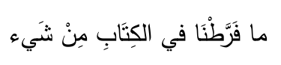
We have not left out anything in the book (this Qur'aan).
Therefore every possible legal question that could arise in this world up to the end the of last day has been dealt with in the Qur'aan. The Qur'aan lays the foundations for the core sources of the Shari'ah. The first is the Qur'aan itself, the second being the Sunnah of the Rasulullah , the third being Ijmaa' and the fourth Qiyaas (analogical extrapolation). Every single contingency that is to occur on earth is
90 Clark v. Harleysville Mut. Casualty Co., 123 F.2d 499, at 502 (1941 91 230 F. 2D 634,636 (90H CIR. 1955)
92 American Journal of Contemporary Law 63, 63-66 (1985)
covered by one or more of these sources of the Shari'ah. Man is not left to his own free will in so far as determining the Divine Law in relation to any new development. The Shari'ah has made adequate provision for the solution of every legal question that is to arise.
From these four sources the one that plays the most crucial role in as far as determining the Divine Law in relation to new developments is that of Qiyaas.
There are four essential elements of Qiyaas, called its Arkaan or pillars:
1. The Asl -- original or principle case.
2. The Far' -- the novel issue requiring determination 3. The 'illah which is the common effective feature found both in the Asl and the Far' and 4. The Hukm -- the ruling in the Asl which is then extended to the Far'.
By way of example, to illustrate the application of these terms consider the issue of narcotic drugs. These drugs are a recent development and were not present at the time of revelation. Therefore they are not explicitly mentioned in the Divine texts (Qur'aan and Hadith). However alcoholic beverages were explicitly mentioned in the texts. Alcoholic beverages will be the Asl (the principle case). The narcotic drugs are the Far' (the novel case to be determined). The Hukm would be the prohibition or impermissibility to use such a substance. The Jurist may then look into the Asl to determine the 'illah (the effective cause). If it is determined that the effective cause is intoxication, the Jurist then investigates whether the same factor is found in the Far' (narcotic drugs). If so the Hukm (rule of impermissibility) is extended from the Asl (principle case) to the Far' (novel issue). The conclusion would be that narcotic drugs are also impermissible.
The 'illah should not be confused with the Hikmah, which is the wisdom or rationale behind a particular ruling. The Hikmah of a particular rule is the attainment of certain benefits or the avoidance of certain harms, which can be viewed as the ultimate objective of the Law. However the extension of rules does not pivot on the Hikmah but rather on the 'illah (effective cause).
Qiyaas is also a structured process that ensures that the Jurist's ratiocination, reasons and rationalisations are guided by and held subservient to the Divine texts (Qur'aan and Hadith). Such guidance prevents the law from being applied arbitrarily on the basis of mere personal preference or expediency. The detailed disciplining rules that are essential for a valid form of Qiyaas to be constructed have been recorded with much detail in the works of Usool-ul Fiqh (theory of law). It is not possible to fully discuss these rules in this brief treatise. However certain pertinent aspects will be highlighted herein. What is most crucial is that the Jurist seeking to unravel the ruling in relation to a novel case is bound by a set of predetermined rules. Personal reasons and ad hominem inclinations have no place in the developed structure of the Shari'ah. By measuring Qiyaas against a well systemised set of uniform rules, it is easy to determine whether the conclusion of a particular Jurist in relation to a given case is correct or not. That determination is not left to personal fancy or arbitrary capricious opinions.
Each of the above four pillars of Qiyaas has its own peculiar requirements. It is not possible to detail all these requirements in this treatise. Special focus is given to the requirements of the 'illah.
There are approximately 20 conditions that the 'illah must fulfil in order to satisfy the process of Qiyaas. Some 'Ulama have mentioned more than 20 conditions, for example Al-Aamidi94 has mentioned 31 conditions. Here too it is not possible that all these conditions be expanded upon in this treatise. Only a few pertinent conditions are mentioned below as they have relevance to the topic on hand.

Condition No. 1
The 'illah must be Zaahir (evident) and not Khafi (obscure). By the terms Zaahir is meant that the 'illah must be evident or manifest. The opposite of the term Zaahir is Khafi which means vagueness and ambiguity. This refers to "the hiddenness" of the feature. The particular 'illah must be easily discernible.
By way of example the 'illah for the transference of ownership in the transaction of sale is that of consent or expression of free will. This is something hidden within the heart which cannot be detected from the external senses. It is therefore obscure and hidden. For this reason the inner satisfaction and intention of the parties cannot serve as the 'illah for the transference of ownership. Therefore the Shari'ah has,
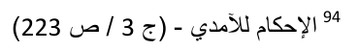
instead of using this feature as the 'illah, preferred the expressed consent of the parties to be the 'illah. This expression of consent is something that is apparent and conceivable by the senses. Therefore it complies with this requirement of the 'illah.
It has been contended by some that the 'illah for images being impermissible is the factor that images are "likely to lead to the worship of these images". This aspect of likelihood is something that is not apparent or Zaahir. Therefore it cannot serve as the 'illah. If it was the 'illah then those images which most likely would not lead to the worship of such an image will not be impermissible. For example the kindergarten picture mentioned below95 is such that it would be farfetched to presume that such a drawing would likely lead to the worship of such an image. Despite it being extremely remote that the Kindergarten Picture will be worshipped, it is nonetheless Haraam to produce such a picture. This goes to show that "likely to lead to the worship of these images" cannot be the 'illah, otherwise it would not have been Haraam.
However the feature of "actually being worshipped" is a separate factor altogether. In other words should there be any image that is actually worshipped, for example the Christian cross, then such an image will be impermissible based on this factor. This is a separate 'illah altogether. Put differently, an image could be impermissible for different reasons. The impermissibility could arise from the fact that it is being worshipped or it could arise from it being a visual representation of an animate object. At times it is possible that both these forms of 'illah converge, as in the case of pictures of Hindu gods.
However when dealing with an image of an animate object that is not worshipped, for example a picture of a dog, we are only dealing with the 'illah of it being a visual representation of an animate object.
Ibn 'Arabi (rahimahullah) has alerted us to the fact that these are two separate 'illahs, and the one does not negate the other. He says:
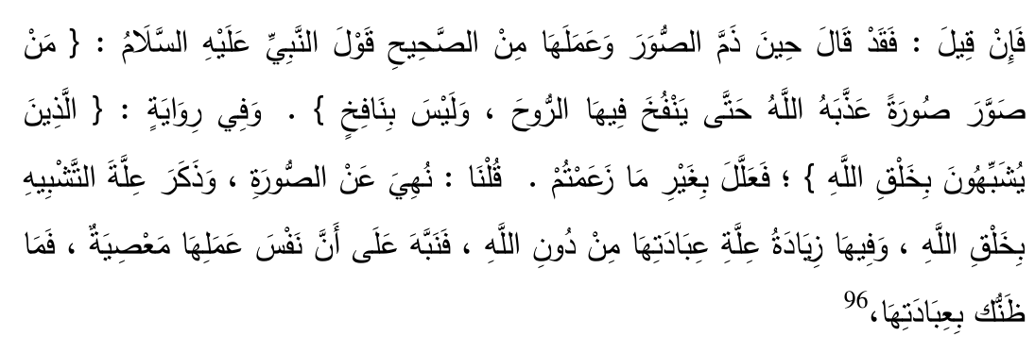
If an interlocutor had to ask:
Now that the Saheeh Ahaadith have disparaged images and its production, for example the Hadith "Whoever makes an image, Allah  will continue to punish him until he is able to blow the should into that image, whereas he will not be able to do so.", and in another narration "Those who imitate the act of creation of Allah", here the 'illah appears to be different from the one you identified.
We would reply:
Images have been prohibited. Rasulullah  has mentioned the 'illah to be of imitating the act of Allah's creation. This is over and above the 'illah of worshiping beings other than Allah . This indicates that the act itself (of producing an image) is a sin. What then would happen with (the additional factor of) worshiping the image? (i.e. it will be a greater sin).
The respected Mufti is of the view that since only images made on durable forms of media led to the worship of such images, only images on durable media are impermissible. It appears that the respected Mufti has considered "likelihood to lead to worship" to be the sole 'illah, and the other 'illah of imitation is ignored. The likelihood to lead to worship is not the only 'illah for the prohibition of images.
It is humbly submitted that the 'illah of "likelihood to lead to worship" is Khafi (obscure or hidden), and hence reliance cannot be placed on this 'illah for the purpose of Qiyaas. This likelihood is an internal state of mind, which cannot be externally determined.
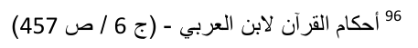
The 'illah must be mundabit (inherently determinate), in other words it must be applicable in all circumstances regardless of change in time, person, place or circumstances. Put differently the 'illah must be fixed, determinate and precise. The actual parameters and boundaries of this 'illah must be determined.
The reason for this condition is that, if the 'illah is not mundabit then the process of Qiyaas would be an inaccurate process. As mentioned above Qiyaas forms part of the science of determining novel cases from established cases. This science, like all other sciences, is based on precise and accurate rules.
Referring to the example above of the factor of "the likelihood of leading to the image being worshipped", even if assumed that such a factor is Zaahir then too it will be mudtarib. In other words this factor would be such that it cannot be precisely determined. If an adult has to draw the Kindergarten Picture, we could conclude that there is a very farfetched probability that such an image would be worshipped. On the other hand should a Bid'ati draw the face of his Peer (spiritual mentor) there is a stronger likelihood of such an image being worshipped.
Then if we take the case of a person who draws the image of what the Hindus refer to as their god. It is almost certain that such an image will be worshipped. It is clear that the determination of this factor, namely the likelihood of such an image being worshipped, is such that it differs from case to case. This in the terminology of the Jurists will fall under the category of mudtarib, i.e. it differs from person to person and case to case. Since the 'illah cannot be Mudtarib we conclude that this factor of the likelihood of an image being worshipped cannot serve as the 'illah.

Condition No. 3
The 'illah must be Munaasib. This means it must have an appropriate and reasonable relationship to the Hukm. What is meant by appropriate is that it must be appropriate in the light of the Hikmah and the Maqasid ush Shari'ah. The Hikmah, as explained above, refers to the underlying rationale or wisdom behind a rule. The Maqasid ush Shari'ah are those fundamental and primary objectives of the entire edifice of the Shari'ah. There is a very strong interplay between the 'illah, Hikmah and the Maqasid ush Shari'ah. The Maqasid ush Shari'ah serves as a benchmark by which the Jurists can determine which feature of the case is in fact the 'Illah. It also serves as a means of removing arbitrariness from the determination of the 'illah. The goal of this condition, and in fact all the other requirements of the 'illah, is to decrease, to the greatest extent rationally possible, the approximation that results from human fallibility and to increase the probability of a conclusive and definite determination of the 'illah. Therefore in order for a particular identified 'illah to be considered as the most appropriate 'illah there must be a rational link between this 'illah and the Maqasid ush Shari'ah in such a manner that the Hikmah is also achieved. The higher the degree of causality between the identified 'illah and the Maqasid ush Shari'ah, the stronger the likelihood of such an 'illah being the most appropriate.

Condition No. 4
The 'illah must be Muta'addi (transitional). The very objective of identifying the 'illah is for the process of Qiyaas to apply. If the 'illah (effective cause) is such a factor that cannot be found anywhere else except in the original case then the object, which is the process of Qiyaas, is lost. The very purpose of Qiyaas is to solve the issue of a novel case. On this issue the Jurists have two approaches, the Hanafis do not permit Takhsees 'illah whereas the other Jurists allow it. Takhsees 'illah is the process whereby such an 'illah is identified which is only found in the original case and therefore cannot be extended to any novel case. The Hanafis say that since the process of Qiyaas cannot be achieved by such a supposed 'illah, the factor identified is in fact not the 'illah. The 'illah exists solely for the purposes of Qiyaas, i.e. to transfer the Hukm.
The other Jurists allow Takhsees 'illah, for they hold the view that the purpose of identifying the 'illah is not limited to the process of Qiyaas. One could, they argue, identify the 'illah in order to better understand the wisdom, and underlying rationality in the Hukm. This creates greater conviction in the veracity of the Hukm. However this latter group of Jurists also agree that in the event of Takhsees 'illah taking place Qiyaas will not be valid so therefore all the Jurists are in the agreement that if Takhsees 'illah does take place Qiyaas fails.
The respected Mufti has applied a mode of reasoning which is akin or in line with Takhsees 'illah. It appears that he has taken the view that in determining the 'illah one has to consider all the various features that existed in the original case at the time of revelation. If we had to apply this ad infinitum then Takhsees 'illah will definitely apply.
For example if a particular Hadith mentions a ruling and that Hadith addressed a particular Sahaabi. If one then had to enumerate all the features found in that particular circumstance, Takhsees 'illah will definitely apply. Assuming one had to argue that the name of the Sahaabi was Zaid, he was male, he was an adult, he lived in Madinah Munawwarah, he was tall, he was from the Aws tribe, he had three children, was a trader, lived in a single storey house, he had two wives and so on. One will then have to conclude that this particular rule that was addressed to this Sahaabi will only apply to another person who has the name Zaid, lives in Madinah Munawwarah, has three children etc. The effect would be that the rule will be confined to the original Sahaabi and would apply to no other person. The important underlying lesson from this requirement is that, the mere fact that this particular feature may have existed in the original case, does not imply that that feature must necessarily form part of the 'illah. There definitely would be many features that are found in the original case but do not qualify as being an integral part of the 'illah.
We have identified the 'illah to be imitating or copying Allah  by the production of the image. The respected Mufti has averred that the 'illah should be imitating Allah  by the production of an image on a durable medium. In reply to the question of where this feature of "on a durable medium" was derived from, the respected Mufti is most likely to reply that this was the feature present in the images that were in vogue at the time of revelation. In this lies the fundamental flaw of his reasoning. The mere fact that a feature may have been present at the time of the injunction does not imply that that feature must necessarily form part of the 'illah. There will definitely be many features that were present at the time of the instruction being given but yet do not form part of the 'illah.
The source of the respected Mufti's error lies in the notion that, when making Qiyaas, the 'illah must contain all the features that were present in the original case. The entire discussion around this point can be summed up in one statement of the Fuqaha (Jurists).
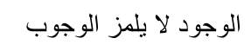
The mere existence of a factor does not necessitate it being a requirement
In other words, the mere fact that the images produced at the time of revelation were on durable media, it does not follow that in order for the same Hukm (ruling) to apply, such feature must necessarily be found.
The respected Mufti's reasoning, if taken to its logical conclusion, is self-destructive. If the respected Mufti claims that all the features found at the time of revelation have to be present in the novel case, then we are dealing with Takhsees 'illah, which we have demonstrated above, cannot apply.
If he avers that some features are to be taken into account, and not all, then the question arises: Which ones, and how does one go about identifying the factors to be included. If it is left to the whims and fancies of the Jurist making the Qiyaas, we are relying on an arbitrary basis, which is nugatory of the very word and spirit of Usool ul Fiqh.
If the respected Mufti claims that the aspect of "on a durable medium" is founded on sound reasoning, then the Mufti bears the onus to demonstrate what relationship this aspect has on the Hikmah and the Maqasid ush Shari'ah. In other words it is up to the Mufti to show that the Maqasid ush Shari'ah can only be achieved if this aspect is included, and will be defeated if this aspect is abandoned.
Taking the respected Mufti's reasoning further, another person could come along and reason, on the very same grounds as the Mufti does, that at the time of revelation the images in vogue were all produced by hand. The conclusion thereof would be that mechanically produced images ought to be permissible. However, we have mentioned above that the respected Mufti is in agreement with us that hard copies are impermissible. Whatever answer the respected Mufti may proffer to such an argument will be our very answer to the Mufti's theory. And if the Mufti cannot proffer an answer to such an argument, then his theory will be self-contradictory.
The 'illah we have identified, namely that of imitating Allah , is Muta'addi (transitional) and applies to all types of images. It is respectfully submitted that the Mufti's restriction of this factor to only that imitation that takes place on a durable medium is capricious and deserves to be rejected.

Condition No. 5
The 'illah must not be an attribute that runs counter to the textual authorities or seeks to alter the law of the text. If the explicit text has discounted a particular feature it is obvious that that feature cannot serve as the 'illah. Furthermore should such a feature be identified as the 'illah which, by necessary deduction, implies that the nature of the text will be altered then such a feature cannot serve as the 'illah.
We have identified the 'illah to be imitating or copying Allah  by means of the production of an image. As mentioned above the respected Mufti has identified the 'illah to be the imitation of Allah  by means of producing such an image that appears on a durable medium. If we had to accept the 'illah as proposed by the respected Mufti it would imply that those texts which make mention of the 'illah were not sufficiently demarcated. The Ahaadith mentioned above use the terms such as "They challenge Allah in respect to the quality of His Creation", "those who copy Allah " or "those who produce a sample of Allah ". These various expressions of the 'illah are Mutlaq (unqualified). If we had to accept the 'illah as proposed by the respected Mufti it will imply that these texts have to then be converted into being Muqayyad (qualified/restricted). In other words a correction will have to be implied into these texts that these were too broad and now need to be narrowed with the additional requirement of it being on a durable medium. The respected Mufti has not been able to provide a single text which mentions this requirement which he alleges to be part of the 'illah. Furthermore even if his additional feature is deduced by Ijtihad (legal reasoning) then too this will not be acceptable since an 'illah would demand an adjustment in the authoritative texts. Therefore by employing this additional feature the respected Mufti's identified 'illah violates this condition and on this ground alone his suggested 'illah is to be rejected.

Condition No. 6
The 'illah must be such that it prompts the ruling. This is a separate requirement. Above we have mentioned that one of the requirements of the 'illah is that it must be Munaasib, i.e. it must be appropriate. Over and above it being appropriate it must also prompt and spur on the Hukm (ruling). In other words the 'illah must be the driving force, the impetus and the most likely cause for the Hukm.
Applying this requirement to the topic under discussion the question that arises is whether the additional requirement, as proposed by the respected Mufti, that the image be on a durable medium, serves as a sufficient cause for the Hukm (ruling). It is easy to understand that the production of an image, which is then deemed to be a challenge to Allah  and to be a form of imitating Allah , is the effective and driving cause for the act being Haraam (impermissible). However the question to be begged is whether the additional requirement of it being on a durable medium serves any cause. In other words can it then be said that an image created on a durable medium is logically more challenging to Allah , or imitating Allah in a greater degree, when compared to that image that is produced on a non-durable medium. Does this additional feature spur on, prompt or drive the ruling? It definitely does not. It has no causal relationship with the outcome. Therefore if one had to compare the two suggested expressions of 'illah, it is far more probable that the 'illah we have identified is the most appropriate when compared with the one identified by the respected Mufti.

Condition No. 7
The 'illah may be compound. Some Jurists take the view that the 'illah must be a single feature of the Asl. However the majority of Jurists hold the view that the 'illah may be compound -- a combination of several features which operate as a unit. As discussed above the feature we have identified to be the 'illah is the act of imitating or copying Allah  by means of the production of an image. This contains several features which operate as a unit. Such a compound 'illah is acceptable to the majority of Jurists.

The Apparent Closer Resemblance
The respected Mufti avers:
As far as that image which is not permanent nor is it drawn or sketched onto some permanent medium, this more closely resembles a reflection than a picture.97 With respect, the Mufti has totally missed the important understanding of comparison based on principles of Fiqh (Islamic Jurisprudence). When resemblance is taken into account, it is not just any resemblance that matters; rather it is resemblance in the 'illah that carries the day.
By way of example, if the issue of cocaine had to be the novel question under investigation, it could be claimed that cocaine more closely resembles other permissible food substances than wine. Someone could argue that:
(a) Wine is a liquid, whereas cocaine is solid in powder form; (b) Cocaine is white whereas wine is red; (c) Cocaine is sniffed whereas one drinks wine; (d) Cocaine is a by-product of the poppy seed, whereas wine is produced by fermentation and is not a direct by-product; (e) Wine was prevalent at the time of revelation, whereas cocaine was not.
In a similar manner a whole string of common features between cocaine and other permissible substance could be enumerated.
To counter this one would simply consider the similarity in respect of the crucial factor – the 'illah – which is intoxication. In that respect cocaine has a greater resemblance to wine than to any other permissible substance. It is this resemblance that matters and not other forms of resemblance on the basis of factors that have no bearing on the Hukm (the outcome of being Halaal or Haraam).
In the case of images the crucial factor – the 'illah – is that of imitating Allah . It is on this basis that the resemblance must be weighed. On the one end of the comparison scale we place the reflection of the mirror, in the centre we place the digital image, and on the other end we place the image on a solid medium. We then pose the question of whether the digital image in the centre is closer, or more closely resembles the reflection or the solid image. However, when deliberating on this question, we qualify it by asking: closer in respect of imitating Allah . It is only when the question is thus qualified that the proper question is posed.
Our answer is, that in as far as imitating Allah , there is no resemblance between the digital image and the mirror reflection. However, there is a strong resemblance between the digital image and the solid image. Hence it must be concluded that the digital more closely resembles a solid image than a reflection. It thus follows that the contention of the respected Mufti quoted above is palpably incorrect.

Result
The upshot of the few conditions mentioned above is that ratiocination, i.e. the process of identifying the 'illah, is not arbitrary. It is not for the respected Mufti to make a subjective decision of what the 'illah is based on his personal leanings. He is obliged to justify his preferred 'illah in the light of the disciplining rules.
Whilst we have not discussed all the various conditions and requirements of the 'illah in detail, a central theme emerges. These conditions are designed, and quite successfully so, to eliminate arbitrariness, imprecision, indeterminacy and subjectivity in the determination of what constitutes the 'illah. The purpose is to produce, to the greatest extent rationally possible, a definitive, objectively predictable identification and articulation of the 'illah. In this manner, extension of the law cannot be made loosely. Rather, extension of the law must be the result in the change in the 'illah of the Hukm and also take into account the relationship and interaction between the 'illah, the Hikmah and the Maqasid al Shari'ah.
At times the 'illah is provided for in the text. Such an 'illah is referred to as Al-'illa tul Mansusah. We have demonstrated above that in the issue under discussion the 'illah has been identified in the texts themselves and therefore they do not need to be determined by means of Ijtihad (legal reasoning).
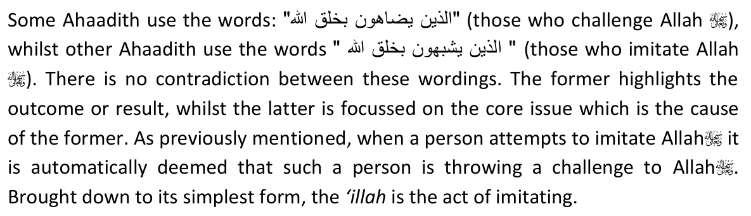
This feature is present in the images produced by the television, as well as other digital media. Hence it is incomprehensible why these images should not be Haraam.
We shall now discuss a few glaring comparisons and easy analogies to support our viewpoint.

The Kindergarten Picture
Most readers would have come across the type of picture being illustrated. A four-year-old draws a cat by first making two circles. Legs and a tail are added to the larger circle. Ears and eyes are added to the smaller circle, followed by a nose, mouth and whiskers. The components are separated below as not to form the actual picture. The reader would get a mental picture of what is being referred to. This shall be called the "Kindergarten Picture".
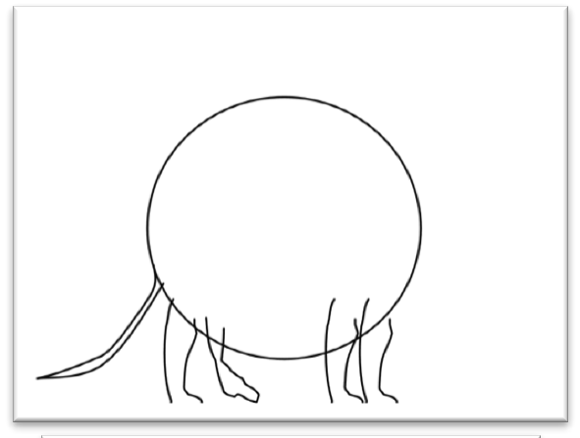
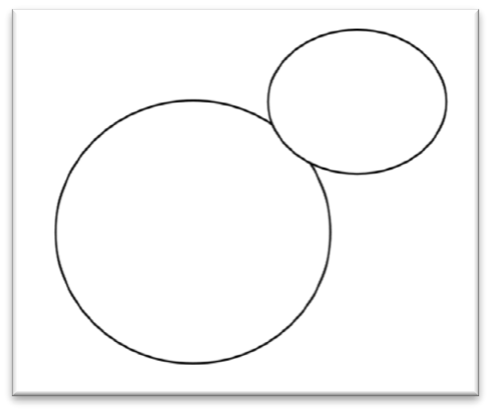

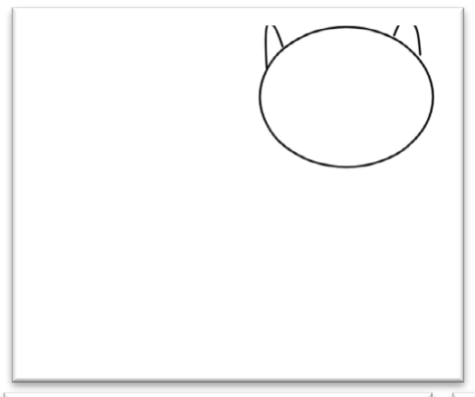

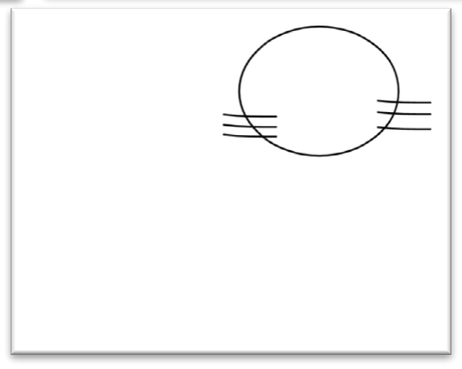
It is submitted that the 'Ulama are unanimous that it is Haraam for an adult to draw the Kindergarten Picture. Those who do not prefer the picture as explained above may substitute it with any crude, simple and primitive form of hand-drawn picture which will serve as the lowest common denominator of what would be Haraam to draw.
The adult drawing such a picture is deemed to be attempting to copy or imitate Allah . Such a person is challenging Allah , and is therefore in the curse of Allah . The displeasure of Allah  descends on such a person.

A Rational Principle related to the degree of resemblance
The purpose of copyrighting an original is to prevent others from copying the original invention or design. The owner of a copyright takes offence at the one copying the original. Many a time the copyright-owner is prejudiced thereby. The closer the resemblance between the copy and the original, the more likely it would be that the owner would be offended.
It logically follows that should the owner of the original take offence at a poor copy, it is only rational and expected that the owner would be offended by a near-perfect copy.
Both the Ferraris below are imitations. If the Ferrari Company had to take action against the manufacturer of the first which is of poor quality, but not the second which is far-closer to the original, one would have to conclude that the Company is acting irrationally.


Allah  is the creator and originator of all that we see around us. In particular, He has given special form and shape to animals, to the extent that animals can be distinguished amongst their own species by their facial features. It is Allah's  prerogative to declare some of his creation "copyrighted", and others not. He  has informed us, via His Rasul , that He is offended and angered by any image made of an animate object. On the other hand, He has permitted images of inanimate objects.
Allah's  actions are always rational.
Compare a digital photograph of a cat with the Kindergarten Picture mentioned above. It is obvious that the digital image has a closer semblance to the original than the Kindergarten Picture. When put side by side, the average onlooker would conclude that the Kindergarten Picture hardly ever resembles a real cat. Yet despite the similarity being tenuous and faint, it is nonetheless Haraam.
The respected Mufti is in effect claiming that Allah  is offended and angered by the crude Kindergarten Picture but has permitted the refined digital photograph of a cat. Such a conclusion defies logic. It is manifestly irrational. The respected Mufti has a duty to explain why such a poor quality copy is offensive, but not a better quality copy. The 'illah in this crime is the act of copying or imitating. Surely the degree of likeness is the deciding factor, and not the method of production.98
98 One scholar wrote the following in the context of photographs, which also finds application in digital imaging:
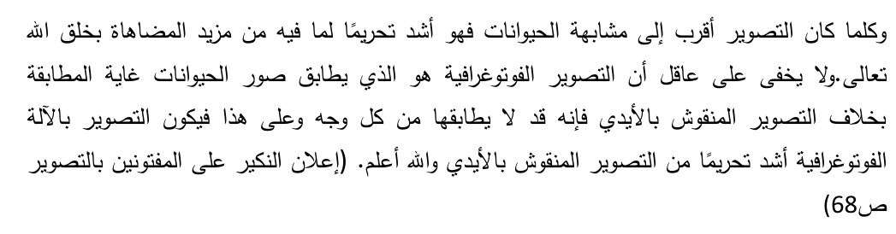
The greater the degree of resemblance between the image and the actual animate object, the greater the degree of prohibition would be because the extent of challenging and attempting to resemble Allah  is greater when the image is closer to the original. It is quite clear to every intelligent person that a photograph resembles the original item to a very high degree when compared to a hand drawn image. Most often the photograph resembles the original in every respect. It therefore follows a photograph should be prohibited to a higher degree when compared to the hand produced image.
Another writes:
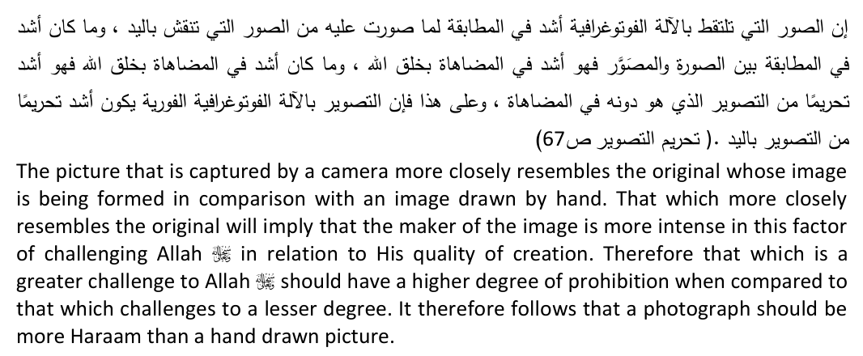
He adds:
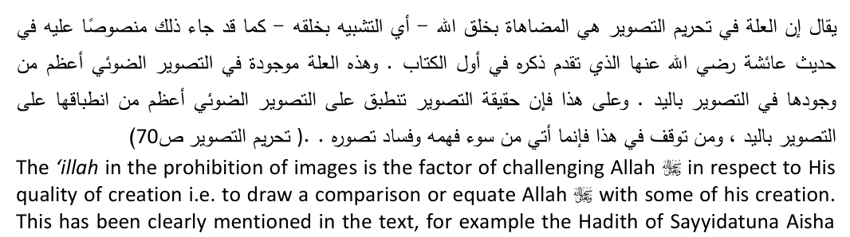
which has passed. This 'illah is present in photographs to a greater degree when compared to its presence in hand drawn pictures. Therefore the application of the term Tasweer applies to a greater degree to photographs than hand drawn pictures. Anyone who has any reservations in this respect then this is an indication of his lack of understanding and his inability to conceptualise realities.
The inferences that could logically be drawn from the respected Mufti's claim are too ghastly to mention. Allah  forbid, it could lead to attributing irrationality to Allah . May Allah  save us all. We therefore earnestly beg the respected Mufti to retract from his error.

Practical Difference
Another imaginary scenario is presented for the purpose of illustration. The aim is to beg the question of whether there is a practical difference between the two methods of image making.
Zaid and Bakr are neighbours. They go on a trip to a game park. Zaid takes along a camera which uses photographic film, whilst Bakr uses a digital camera.
Elsewhere he writes:
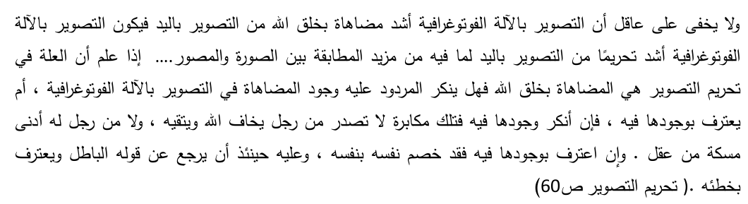
It is quite clear to every intelligent person that photography is a more severe form of challenging Allah  in as far as His act of creation is concerned when compared with hand-drawn pictures, therefore the severity of the prohibition when compared to hand-drawn pictures should be greater because in photographs there is a greater resemblance between the original and the image….. If it is acknowledge that the Illah (ratio essendi) in the prohibition of images is the factor of challenging Allah  in as far as the act of creation is concerned then the question arises whether the opposition denies this factor being found in photographs (and other modern forms of images) or do they deny the existence of this factor? If they deny it then this is pure obstinacy which is unbecoming of a person who fears Allah  and is Taqi (has Taqwa). Similarly it is unexpected from a person who has the least degree of intelligence. If it is acknowledged that this factor is found, this should produce an internal debate within the person (in other words he now needs to explain to himself why, despite this factor being found, he considers these forms of images to be permissible). In this latter case it is required of him to retract from his incorrect view and acknowledge his error.
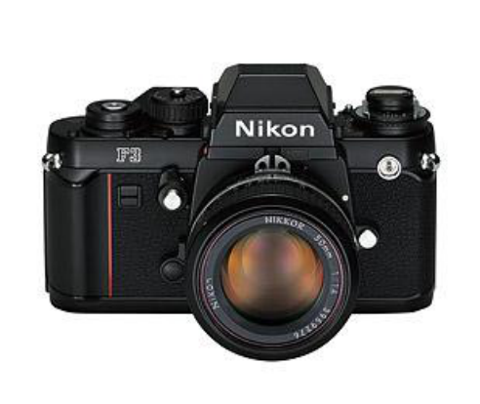
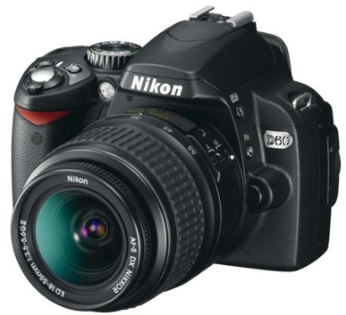
Zaid Bakr
They both take pictures of the same lion. When Zaid returns home, he has the pictures processed at a Photo Lab. He then has the photograph framed in a traditional art frame and displayed in his lounge.
Bakr on the other hand simply transfers the picture from his camera onto a Digital Frame. This is a digital screen that is used to display still pictures, and can be hung up on a wall or made to stand erect on a table top.
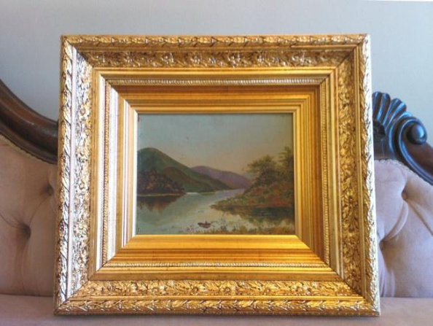
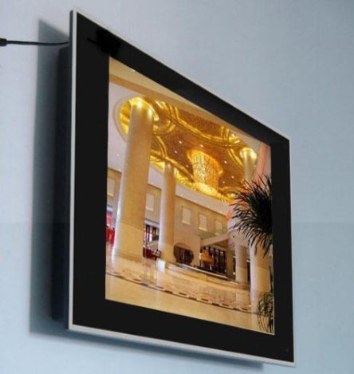
Zaid Bakr
Imagine that both have the same picture of a lion, the only difference is that one is a hard copy, whilst the other is a digital image.
The following point is one that should truly send shivers down the spine of every Aalim and Mufti.
When a person gives a fatwa, he is in effect speaking on behalf of Allah . By inference, he is saying that Allah  has approved this or disapproved that. A Mufti is one who interprets and conveys the laws as legislated by Allah .
In the bygone days when a king issued a decree, he would not disseminate it directly to his subjects. A special court attended, called the muwaqqi' (one who rubberstamps or approves), used to check the decree, convey it in simple language, attach the royal stamp or seal to it, and then dispatch it to the four corners of the kingdom. The subjects would only accept those decrees that had the royal seal. Ibn Qayyim (rahmatullahi alayh) has written a work on Usool-ul Fiqh (theory of law) which he titled99 "Informing those who attach the seal of approval on behalf of the Lord of the worlds". In choosing this name he wishes to draw the attention of the Muftis (in general) that their office is a precarious and grievous one, for a Mufti is making a statement of behalf of Allah .
Returning to the above illustration, the respected Mufti in question is saying that although Zaid and Bakr stood next to each other and took pictures of the same lion, in the eyes of Allah  Zaid is sinful and Bakr is not. The internal mechanisms of their respective cameras causes one to earn the displeasure of Allah , whilst the other is totally absolved thereof. Outwardly there appears to be no difference, yet according to the respected Mufti, Zaid is liable to earn the curse of Allah , and nonetheless Bakr who is standing next to him doing the same action is not.
When the angels of mercy descend, they will not enter Zaid's house for he has a hard-copy of a lion displayed therein. As long as the image is displayed, he is earning the anger of Allah . However, the angels have no reason to stay away from Bakr's house, even though he is displaying an image of the same lion. Allah , according to the respected Mufti, is not angered at Bakr's display. In effect the respected Mufti is telling us that the angels check on the type of frame used, and if it is a digital picture frame, they have no qualms in entering such a home. They do however have a problem with hard-copies. The cause of the approval or disapproval is not the existence of an image, but rather pivots on what instrument is used to produce and display the image.
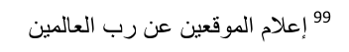
On the day of Qiyaamah, Zaid will be eligible to be included in those who will be punished most severely, whilst according to the respected Mufti's fatwa Bakr will not be taken to task for his image of the lion. In other words the two will be very far apart: one will be in the worst punishment and other scot-free. Yet their actions were so close that there is hardly any discernible difference to the unwary observer. If Zaid, upon seeing Bakr free of accountability, had to question why only he is being punish, what answer can be expected? Will it be said that the vast difference of treatment is solely on account of him using the wrong equipment?
The cry and plea being extended to the respected Mufti is to apply basic commonsense. Apart from the technical arguments, simple logic should be able to demonstrate the fallacy of his theory. Allah  forbid, if commonsense does not prevail, it will imply, Allah  forbid, that Allah  acts in an irrational manner as demonstrated above.
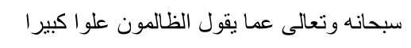
Purified is He, and He is far above that which the oppressors attribute to Him.

Holograms
Modern technology has advanced at a phenomenal rate. Scientists are now able to produce a three-dimensional visual reproduction of an object in thin air, without any hard surface. These images are commonly known as holograms.
This visual image or reproduction is developed by the intercession of lasers. It is possible to have a full image of the original, representing all angles and dimensions. In other words, one would be able to walk around that image and view the different features as if one had the original before one. While standing in front of the image of a dog, one would be able to view the face, and by then moving around to the rear one could view the hind legs. Full- motion images are possible, whereby one could see the dog running, jumping etc.
To this, science has now incorporated two other dimensions: sound and touch. The sound made by the dog could be recorded and reproduced in tandem with the visual image. The net effect is that one gains the visual and aural perception that the dog is before one. It is now also possible to create the perception of touch. In other words, by extending one's hand and touching the spot of air where the laser lights intersect, a feeling is generated on the skin whereby the person comprehends the sensation of touch, as if the person were touching the actual object. Not only is the person seeing a moving image of the dog, hearing its bark, but also feels the fur on the dog's back. All this happens without any solid object or surface before the person.
It is also possible to capture the data from an original, transmit it over a distance, and then reproduce its image elsewhere. Therefore a special camera could be set up in China, capture the image of a Panda, relay it over the internet, and then produce a full hologram in London of a walking, furry and noisy Panda in front of an audience in real time. All of this could take place without the image being projected on any durable or hard medium.
Applying the respected Mufti's theory, the production of such images should be permissible as there is no durable medium.
Once again, the comparison must be drawn with the Kindergarten Picture. The rudimentary reproduction in the form of the child's crude drawing is sufficient to have crossed the line between permissible and impermissible, yet the respected Mufti would want us to believe that the advanced, refined and almost true-to-life reproduction in form of a hologram is nonetheless permissible. Such a conclusion would be manifestly absurd, and is sufficient to demonstrate the colossal error underlying the respected Mufti's theory.

A Famous Mufti Cannot Be Wrong?
The respected Mufti has erred. All mortals are susceptible to error and no human is infallible. It is precisely because the 'Ulama can and do err that we have been warned against using such errors of the 'Ulama to justify our sins.
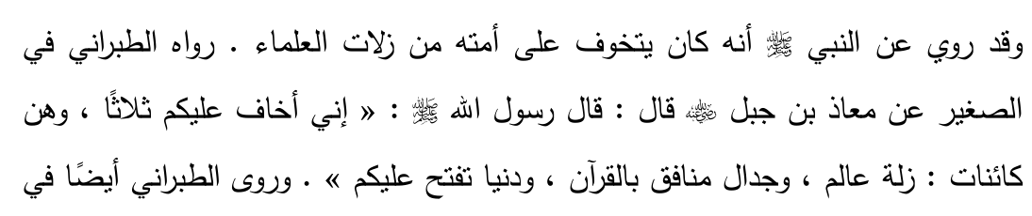
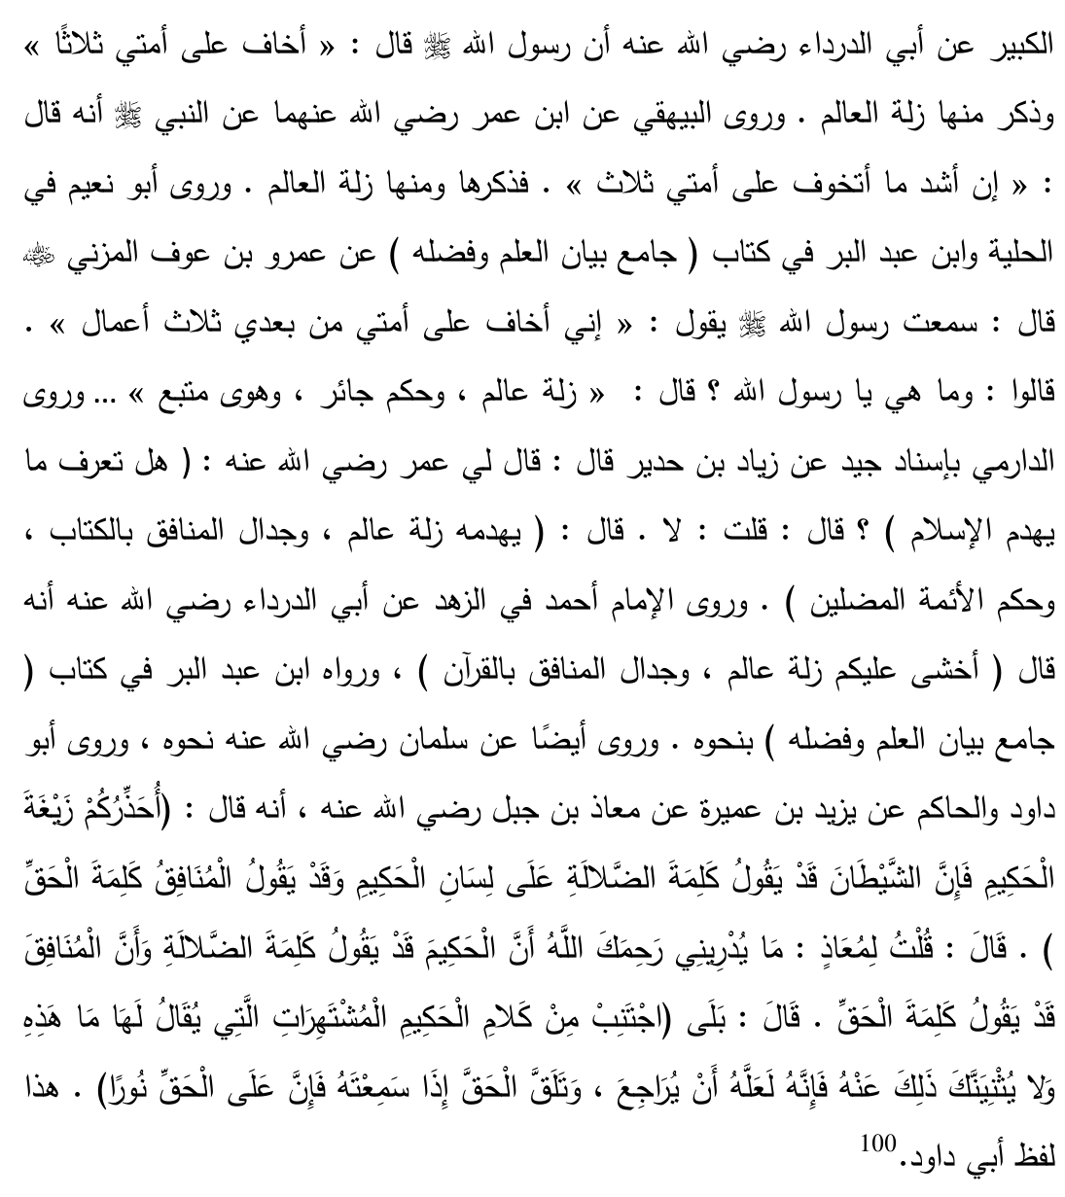
It has been narrated from Rasulullah  that he warned his Ummah against the slips and errors of the 'Ulama. Imam Tabrani narrates in his Sagheer from Muaz bin Jabal  that Rasulullah  said "I warn you against three things and these three will definitely occur: The slip of an Aalim (scholar), the debates of the Munaafiqeen (hypocrites) in relation the Qur'aan and the Dunya (world) being opened to you." Imam Tabrani also narrates in his Kabeer from Sayyiduna Abu Ad-Dardaa  that Rasulullah  said "I fear regarding my Ummah three things", and he included in this the slip of the Aalim. Imam Bayhaqi relates from Sayyiduna Abdullah bin Umar (radhiyallahu anhuma) narrating from Rasulullah  that he said: "The things that I fear the most for my Ummah are three" and he included in this the slip of the Aalim. Abu Nuaim
narrates in his Hulya and Ibn Abdur Albar reports in his book "Jamioo bainal ilmihi wa fadhlih" from Amr bin Auf  who said that I heard Rasulullah  saying: "I fear regarding my Ummah after me three actions." The Sahaabah  asked: "What are they O Rasulullah ?" Rasulullah  said: "The slip of an Aalim, the rule of an oppressor and passions that are followed."… Imam Daarami has reported from Ziyaad bin Hudari who said that Sayyiduna Umar  asked him: "Do you know what destroys Islam?" I replied: No. He responded: "The following destroys Islam: the slip of an Aalim, the debate of the munafiqeen in relation to the Qur'aan and the leadership of misguided rulers." Imam Ahmed narrates in his kitaab Az Zuhd from Abu Dardaa  that he said: "I fear for you the following; the slip of and Aalim and the debate of the munafiqeen in relation to the Qur'aan." Imam Abu Dawood and Haakim narrate from Yazid bin Umayrah who narrates from Muaz bin Jabal  that he said: "I warn you of the crookedness of the wise person because Shaytaan sometimes causes a word of misguidance to appear on the tongue of the wise person and at times a hypocrite mentions a true statement." He said he asked Muaz : "How will I recognise that a wise person has, on the occasion, mentioned words of deviance and that a hypocrite mentioned the truth?" He said: "Certainly! Abstain from that statement of a wise person which when it becomes well known then the people begin to exclaim (in surprise) 'What is this? Such a statement cannot come from such a person! Perhaps this person will retract from this statement and follow the truth when he hears of it because the truth always has a special glow with it'".
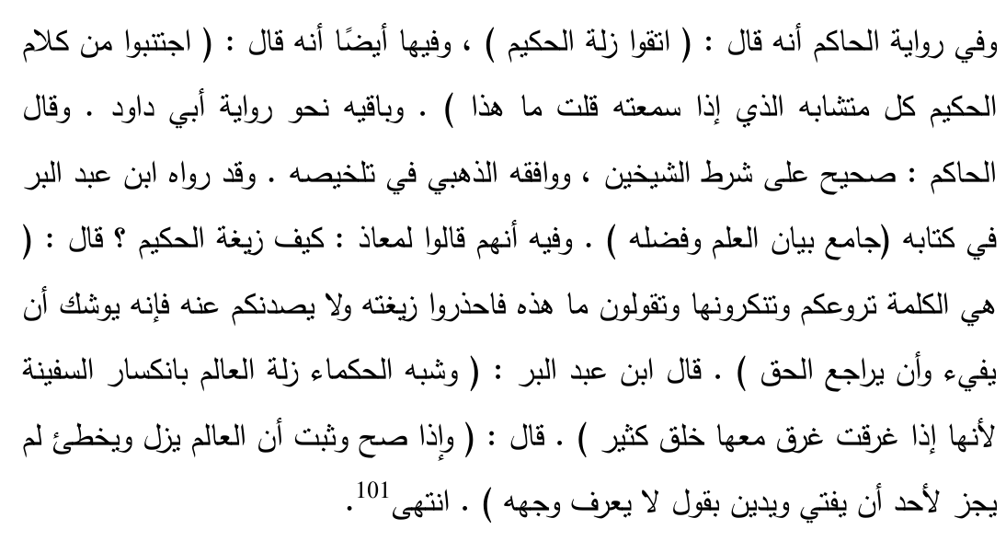
According to the narration of Haakim: "Fear the slip of the wise person" and it has also been mentioned "Abstain from those statements of the wise person which are inexplicable, which when you hear them you exclaim "What is this?". It is also been narrated somebody asked Sayyiduna Muaz : "How is it that a wise person can be deviated?" He replied: "It is that statement which appals you, you reject it and you begin questioning: What is this? Beware of such deviance. This statement should not stop you from benefitting from such a person because perhaps this person may realise and return to the truth." Ibn Abdul-Barr says the sagacious persons have given a parable of the slip of an Aalim to the breaking of a ship because when a ship sinks a huge number of people also drown. He also mentions: "Now that it has been established that an Aalim does err and slip it is not permissible for any person to give a fatwa or to rely on their Aalim's view when the reasoning or source behind it is not known."
On the one hand the public is not absolved once it is clear that the respected Mufti has erred. On the other hand, the respected Mufti will nonetheless have to carry the burden of the sin of all those who follow him. It is quite a different matter if the respected Mufti comes up with sound Shar'ee arguments to substantiate his position. Thus far this has been lacking.
The following Hadith serves as a warning to all engaged in the precarious but necessary task of issuing fatwa:
Rasulullah  said: "Whoever gives a fatwa without sure knowledge the sin will be on the one giving the fatwa."
In relation to images, some 'Ulama have mentioned:
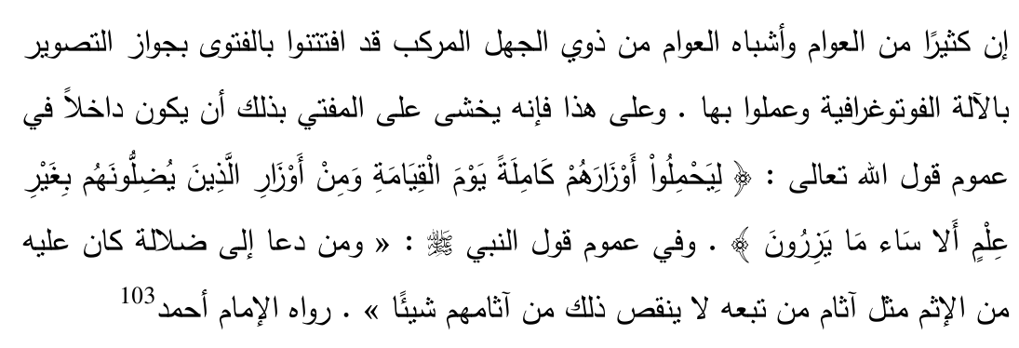
Now that it is known that many people follow the fatwa of permissibility of photography (and other forms of modern day images) the respected Mufti should fear that he will be included in the application of the Aayah of the Qur'aan where it is mentioned: "They should carry their burdens completely on the Day of Qiyaamah as well as the burdens of those whom they had misguided without knowledge. Alas! Evil indeed is that which they will carry".
And the Aalim should also fear that he will be included in the general purport of the Hadith of Rasulullah : "Whoever calls towards misguidance, will bear his sin as well as the sins of those who had followed him whilst their (the followers) sin would not decrease in the least."
As a reminder to writer hereof first, and to all readers thereafter, the following Hadith contains grave admonition.
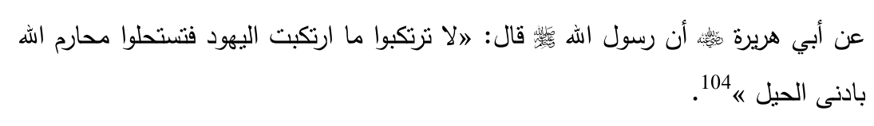
Sayyiduna Abu Hurairah  reports that Rasulullah  said: "Do not get involved in that which the Jews have got involved, as a result of which you will make Halaal that which Allah  has made Haraam with the slightest ruse".
We invite the respected Mufti to review his fatwa, and in the light thereof either retract or provide sound reasons to defend it. This was the method of the Sahaabah.
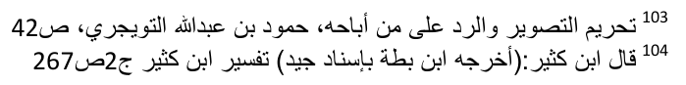
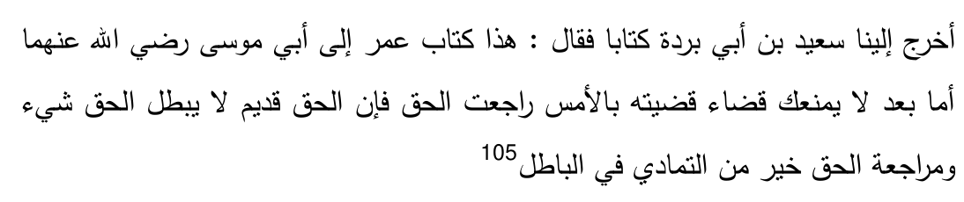
Saeed bin Burdah presented us with a letter and said: "This is the letter which Umar  wrote to Abu Musa  which reads: 'After (praising Allah  I say) -- No decision that you have made yesterday should prevent you from returning to the truth because the truth is timeless (the truth is independent of our existence, it existed from before and will exist in the future) and nothing cancels out the truth. Therefore to revert to the truth is better than being stubborn upon falsehood.'"
No Mufti, no matter how famous he may be, is unerring. The apparent embarrassment attached to a retraction should not be a barrier to the proclamation of the truth. Nay, there is honour in acknowledging one's mistakes before that day when all will be exposed. It should not be that on the day of Qiyaamah a person's limbs and heart give testimony that the only reason why there was no retraction was the concern over public opinion of one's status.

Issues any Defence Must Address
On the contrary, should the respected Mufti or anyone else (including his protégés) wish to defend his stance, it is imperative that they address the following questions:
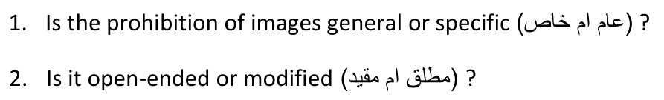
3. If it is specific or modified, what is the Shar'ee proof for this?
4. Is the illusion that appears on the mirror a reproduction created by human intervention?

6. On pages 39 to 44 a simplified illustration is given of the television screen. If is it contended that this illustration does not reflect the reality of the television screen, what is the reason for such a contention.
7. Eight stages are mention in that illustration. If it is averred that any one stage is impermissible whilst another is permissible, then on what Shar'ee grounds is the distinction drawn?
8. After taking into account the three observations mentioned on pages 47 to 50, is it still maintained that the mirror illusion is a permissible form of image? If so, on what basis, and what is the explanation for the three observations?
9. What precisely is meant by permanency in the claim that a digital image is not permanent106?
10. Does the respondent agree that photographs and hard-copies of animate objects are impermissible? If so, does he agree that it is not a requirement for impermissibility that the image must be produced manually?
11. Does the term Soorah have a distinct Shar'ee meaning, and if so, what is the proof for this?
12. Is this issue of digital images to be decided by Qiyaas, and if so, why has it not been settled by Nass (Explicit Texts)?
13. If Qiyaas applies, what is the 'illah, and what is the proof for such an 'illah? Further, does that identified 'illah meet all the requirements of an 'illah, and more particularly, is it Munaasib?
14. Which of the two more closely resembles the original: the Kindergarten
Picture or a Digital Photograph?
15. In the example provided on pages 78 to 81, if it maintained that there is a Shar'ee difference between the positions of Zaid and Bakr, what is the basis for such a claim, and does such a difference conform to logic?
16. Are holograms of animate objects permissible?
17. If so, which of the two more closely resembles the original: A hologram or the
Kindergarten Picture?
106 See page 55.
I trust that any person wishing to respond to this treatise will be honest enough as to not evasively sidestep these important questions.
Out of fear that the discussion may become prolix, culmination follows with an important fatwa.

Fatwa of Darul Uloom Deoband
We take comfort that our stance is not an isolated one. A huge contingent of 'Ulama have publicly denounced the respected Mufti's stance on Television107. Our position is confirmed by one of the highest offices of Fatwa in the world, the spiritual home of our heritage in the last century, Darul Uloom Deoband.
Mufti Habibur Rahmaan, the chief Mufti of Darul Uloom Deoband, said specifically with regards to digital photography: "It is astonishing108 that despite knowing the consequences and punishments related to pictures a fatwa of permissibility was given." This is dated 21st Jamadul Ula 1430.
The same Mufti Habibur Rahmaan writing on behalf of Darul Uloom Deoband says: "The scene produced on the screen by means of the digital system is an image in terms of the Shari'ah."
This fatwa was issued on the 28th Rabi-ul Aakhir 1430 and it has been approved by the following Muftis:
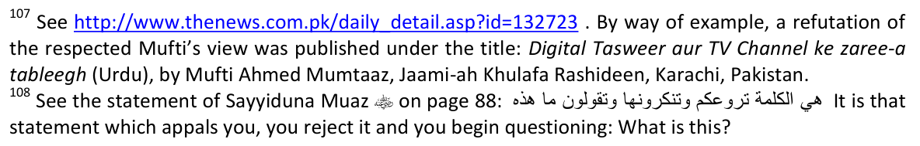
1. Mufti Mahmood Hassan Bulandshari 2. Mufti Fakhrul Islam 3. Mufti Waqaar Ali 4. Mufti Zainul Islam Qasimi

Conclusion
The respected Mufti's invitation has been taken up, and it has been shown that the Mufti has erred in his reasoning. The outcome is that the production of images of animate objects on the television screen and other forms of digital imagery is Haraam. It is imperative that all those who fear Allah  to desist from any involvement with such forms of imagery.
May Allah  grant the respected Mufti the strength to retract from his erroneous view. In doing so a large portion of the Ummah will be saved from this grievious sin.
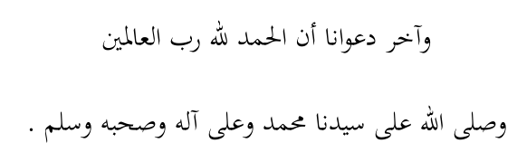

Revised109:
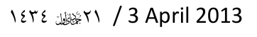
109 My sincere appreciation to Maulana A S Desai of Port Elizabeth and Mufti Sajid Patel of London for drawing my attention to errors in the previous version.

