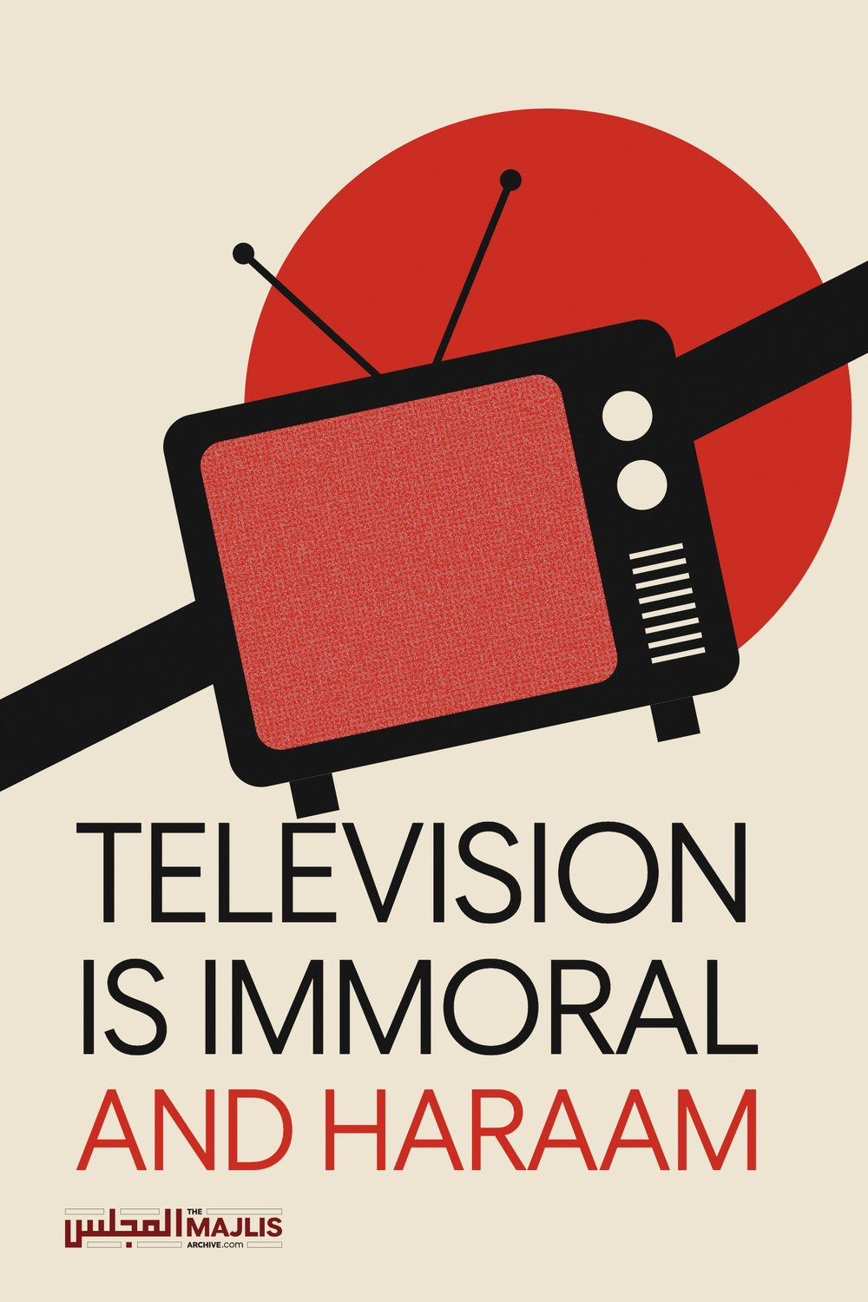

TELEVISION IS IMMORAL AND HARAAM
The Majlis · Voice of Islam
Mujlisul Ulama of South Africa

About this edition
This is a reproduction by The Majlis Archive (themajlisarchive.com) of a publication of The Majlis, Mujlisul Ulama of South Africa, made and published with their permission.
The PDF as The Majlis issued it is the original. This edition was read from that PDF's own structure and checked against it letter for letter; where the two differ, the PDF is correct.
Checked: 43 paragraphs, 0 differing; a second, independent PDF reader finds 96.6% of the PDF's words here.
Nothing has been reworded, added or removed.

DARUL ULOOM ZAKARIYYA SOUTH AFRICA

The Stance Of Darul Uloom Zakariyya With Regards To The TV
Respected Ulama al-Kiraam and to whom it may concern!
Assalamu 'Alaykum Wa Rahmatullahi wa Barakaatuhu…
The following has not been written with the intent to criticise but rather because it is incumbent upon every Muslim, especially those who are affiliated with the pristine Deen of Allah Ta'ala to encourage the truth (Tawaasi Bil Haqq) and to differentiate between righteousness and falsehood. Hence, we have penned the following at your service:
It is an accepted fact that the TV is and has been amongst the most lethal Dajjali weapons and tools of misguidance. Its harms are limitless and it relentlessly indoctrinates immodesty into society. Simply put, if alcohol is 'The mother of all evil', then the TV is the 'The mother of immodesty'. And it is a well-known fact that the enemies of Islam have been using it to destroy our pristine Deen and the Ummah. Therefore, you will notice in their past and present scheme of wars that they will first launch a full scale moral war by degrading the Islamic values and lifestyles of those targeted and then only will they invade their land and homes.
Not only is the TV an evil in itself, it openly promotes evil in all its forms. The following are some of the evils that the TV promote indiscriminately that can be observed by any unbiased, sensible and honest person.
• Nudity
• Promiscuous intermingling of the genders
• Alcohol and drug consumption
• Violence and crime
• Music
• Photography
All of the above are indisputably impermissible, and these are just a few examples. Hence, the TV and all that is affiliated to promoting its usage is impermissible.
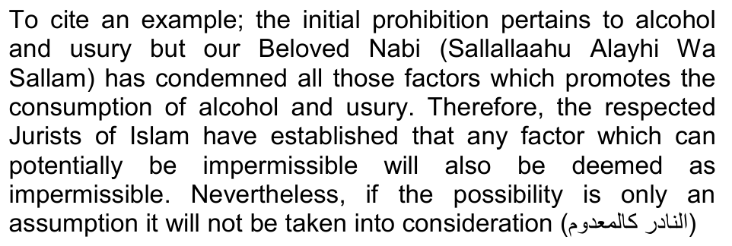
At this point we need to analyse the implications of whether the TV is a potential threat that promotes the impermissible or is this merely an assumption based on conjecture? Well, the obvious answer is that all those with sound knowledge and understanding have concurred that it is surely and definitely a tool promoting misguidance which has limited benefit. At this point we need to have a look at the following well known maxim of the Fuqaha pertaining to understanding the objectives of the Shariah:
"Preventing harm takes precedence over acquiring benefit." This maxim means that if an individual is in the process of doing something beneficial, but that act is accompanied by harm then he/she should leave that action so as to not be affected by the harm. So whenever there is a clash between harms and benefits the prevention of harm takes precedence even if it leads to the loss of beneficial things. The Hadith of Rasūlullah (Sallallaahu Alayhi Wa Sallam) states, "Stay away from that which I have prohibited for you and do what I have commanded you to as much as you can." (Sharh al-Qawaid al-Fiqhiyyah Pg. 205 - Shaykh Ahmad Bin Shaykh Muhammad al-Zarqa)
❖ The general Muslim public will consider that the TV is permissible due to the Ulama al-Kiraam's participation and involvement in TV programmes. Hence, they will introduce the TV in their homes on the pretext of necessity and eventually it will destroy the Muslim homes by becoming its adornment. And certainly, the wrath and consequences will be borne by those who deemed it permissible.
❖ The apprehension related to its detriments will come to an end. Hence, its negative impacts will become widespread, thus outgrowing the consideration for abstaining from evils and immodesty. Alhamdulillah, at least there exists some sort of consideration regarding its evilness, that upon the visit of an Aalim of Deen or upon the dawn of the Mubarak month of Ramadaan, the TV is switched off. If the Ulama are involved in TV programs, it is certain that the Muslim Ummah will lose that very little bit of regard for Deen which is currently holding by a thread.
❖ As for those countries which had issued the verdicts of permissibility, please have a look at the evils that have engulfed them. Its negative impacts and detriments has corroded these societies to such an extent that there are reports of individuals who have succumbed to the snares of TV and perpetrated the most shameless of sins such as incest.
❖ It is not sufficient to say that if we do not seize this opportunity then the enemies of Islam will spread corruption and evil. The fact of the matter is that their efforts have been ongoing for ages and our benefit in using such avenues is much less in comparison to its harms and detriments.
❖ It is compulsory to abstain from that which is recommended when it has the potential of opening the doors of evil and corruption and it is not permissible to object at such aversions.
❖ It will create dissension amongst the Ulama thus presenting an opportunity to those who want to spread corruption and mischief.
❖ To use the statement of the great Jurist of Islam, Hadhrat Imam Abu Hanifah (RA)," One should greet those who are engaged in frivolities so that at least for a few moments they become engaged in good and righteousness", is incorrect. Because issuing the verdict of permissibility for its usage will create more opportunities for people to individually and collectively become engaged in unnecessary and harmful frivolities.
❖ It is totally incorrect to say that 'We need to change in conformity to modern times', but instead we should endeavour to ensure that all our affairs related to the propagation of Deen is free from factors that are reprehensible in the Shariah.
❖ Please take the statement of Hadhrat Gangohi (RA) into consideration when there was a request that an individual who did not conform to the Shariah to be appointed as a trustee of Darul Uloom Deoband. Hadhrat said, "To appoint such an individual as a trustee is a sin and shows total disregard of the Shariah and it is not necessary to run the Darul Uloom in such a situation." Nonetheless, if those who are seeking the verdict of permissibility see certain benefits in this matter, they must take heed of the fact that 'Its harms are greater than its good'
❖ Certainly, 'Necessity removes restriction' is an important and established juridical rule from the Quran and the Sunnah. During the times of necessity to use the impermissible is established from this very principle. But, it is also incumbent upon us that we analyse the extremes which makes the impermissible, temporarily permissible.
This Deen belongs to Allah and He has taken the responsibility of preserving His Deen. We are only required to use those avenues which are permissible, to promote and propagate the Deen of Allah Ta'ala.
❖ Currently, the most fruitful effort pertaining to the promotion and propagation of the Deen has been undertaken by the Tableeghi Jamaat. Did they use the TV?
❖ It is certain that evil and corruption will spread through the TV, yes, someone may or may not acquire some beneficial information from it from time to time, but that also at the detriment
: of losing the light of one's Imaan.
❖ We need to question ourselves as to whether we have used the established avenues of the Shariah for the propagation of Deen, to its fullest or not?
❖ Rationally and from a Shari perspective, the most stringent rules pertaining to the prohibition of TV is not enough.
❖ Those claiming permissibility, the most they have been able to establish is a very narrow margin of convenience. Is that sufficient to create dissension amongst the Ummah?
❖ Certain Ulama viewing video clips on their phones is their personal doings and hence cannot be established as the dictates of the Shariah.
❖ The change of times is telling us that soon every home will be invaded by the evils of TV. Doesn't this warrant us to be precautious and to abstain from such filth?
❖ Finally, as long as the TV industry is not free from those factors which are impermissible and reprehensible within the Shariah, to seek the verdict of permissibility and to become involved in TV programs is a very slippery slope and tantamount to inviting the curse and wrath of Allah Ta'ala.
One should not appear on TV programs but should rather follow the guidelines of the effort of Tableegh and establish Deeni programs at various Masaajid and venues. To impress the general public by appearing on TV is possible but to actually benefit the Ummah through Islaah (spiritual reformation) is practically impossible. Nowadays, the youth are spending lengthy hours on similar avenues such as the internet, tablets etc. Sadly, instead of improvement this has resulted in their destruction, depravity and has driven them away from their duties and obligations.
AND ALLAH TA'ALA KNOWS BEST AND UNTO HIM IS OUR RETURN
Wa Alaikumus Salaam Wa Rahmatullahi Wa Barakaatuhu Darul Uloom Zakariyya Hadhrat Maulana Shabbier A. Saloojee Sahib Hadhrat Mufti Radha Ul Haqq Sahib Hadhrat Mufti Muhammad Ali Sahib Hadhrat Maulana Alauddeen

