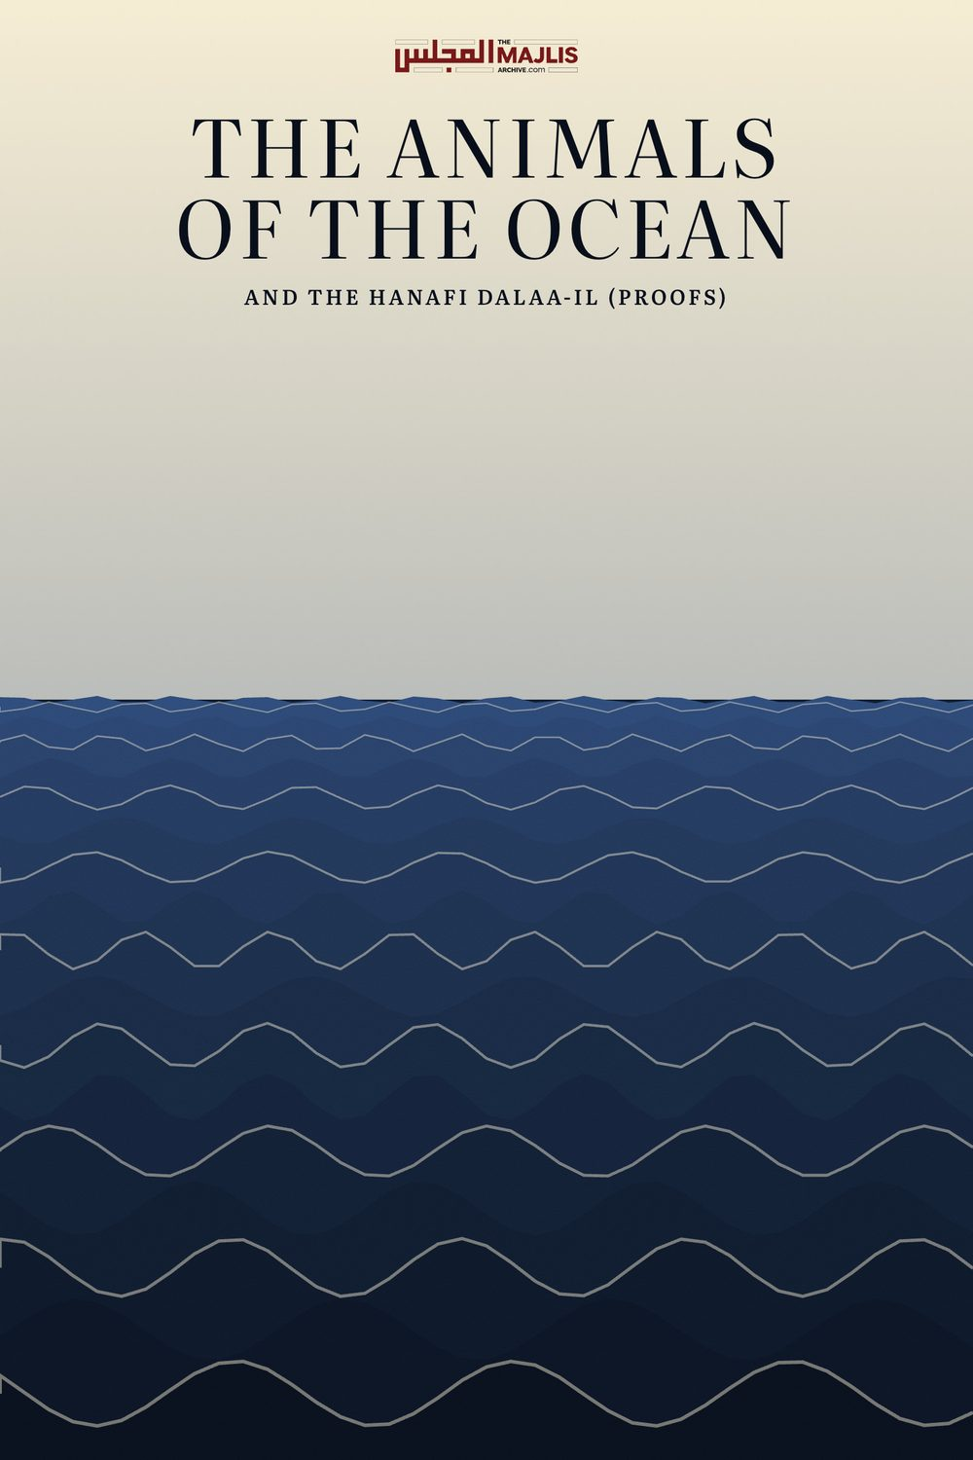

The Animals of the Ocean and the Hanafi Dalaa-il (Proofs)
The Majlis · Voice of Islam
Mujlisul Ulama of South Africa

About this edition
This is a reproduction by The Majlis Archive (themajlisarchive.com) of a publication of The Majlis, Mujlisul Ulama of South Africa, made and published with their permission.
The PDF as The Majlis issued it is the original. This edition was read from that PDF's own structure and checked against it letter for letter; where the two differ, the PDF is correct.
Checked: 83 paragraphs, 0 differing; a second, independent PDF reader finds 100.0% of the PDF's words here.
Nothing has been reworded, added or removed.

BY: MUJLISUL ULAMA OF SOUTH AFRICA

Published by: Young Men's Muslim Association, P.O.Box 18594, Actonville 1506 South Africa

INTRODUCTION
Among the Four Math-habs of the Ahlus Sunnah Wal Jama'ah there is difference of opinion on the question of the permissibility and prohibition of consuming sea animals. The verdict vacillates between Hurmat and Hillat (Prohibition and Permissibility). Some say that all sea animals are halaal; some say most are halaal. However, according to the Hanafi Math-hab all sea animals besides fish are haraam. Only fish is halaal. Each Math-hab has its dalaa-il (proofs) based on the Qur'aan and the Sunnah.
This question has been settled and finalized long ago – almost fourteen centuries ago. After its finalization, there has not been any further argument among the followers of the Math-habs on this issue as well as other issues of differences among the Four Mathaahib. The Fuqaha and even the ordinary followers of the Mathaahib have adopted a broadminded tolerant attitude towards the differences of the Math-habs. Since it is the belief of the Ahlus Sunnah that all Four Math-habs are the Products of the Qur'aan and Sunnah, the differences have been accepted without rancour and bigotry. These differences are confined to academic circles –to the Madaaris where Students of higher Deeni Uloom engage in the technicalities of dalaa-il.
In recent times there has developed the deviated Salafi sect whose adherents are the blindest muqallideen (followers) of their Imaam Ibn Taimiyyah. While they put out that they arrive by their views on the basis of their study of the Qur'aan and Hadith, they are too dishonest to admit that they are too stupid to make a direct study of the Qur'aan and Hadith. They crib from the writings of Ibn Taimiyyah and disseminate the story of being independent researchers and scholars.
Among the Salafis are two categories of muqallideen of Ibn Taimiyyah. The one class consists of totally ignorant followers who are constrained to follow blindly whatever their muqallid 'scholars' dish out to them. The other class are the so-called 'scholars' who are deceitful since they are the ones guilty of cribbing from the writings of Ibn Taimiyyah, but lack the decency to acknowledge that they are following his views and opinions.
The members of this deviated sect teach that all sea animals are halaal. In the process of the propagation of their view they find it expedient and imperative to castigate Hadhrat Imaam A'zam, Imaam Abu Hanafi (rahmatullah alayh). They claim that the Hanafi view on the question of sea animals is devoid of Shar'i basis and that it is the product of personal opinion. It is to dispel this slander against the illustrious Imaam of the Hanafi Math-hab that we have prepared this concise booklet which presents the Qur'aanic and Sunnah dalaa-il of the Hanafi Math-hab.
The aim of this booklet is not to assault the dalaa-il of the other Three Math-habs since all Four Math-habs constitute the Ahlus Sunnah Wal Jama'ah. The aim is merely to refute the slander of the deviate Salafi sect which claims that the Hanafi view lacks Qur'aanic and Sunnah proofs. It is only Shaitaan who has harnessed the deviates to churn up theoretical arguments fourteen centuries after the settlement of the differences. And, the aim of Iblees is to keep Muslims perpetually engrossed in unnecessary strife and to mislead the followers of the Sunnah from Siraatul Mustaqeem into Dhalaalah (Deviation) which is the path of the modern-day Salafi sect.
The scurrilous attacks which the Salafis launch against Imaam Abu Hanifah (rahmatullah alayh) in particular, testify to their jahaalat (crass ignorance) and shamelessness. Great Aimmah-e-Mujtahideen and Fuqaha of the Khairul Quroon epoch hung their heads in submission to the grandeur of the Uloom and Taqwa of Imaam A'zam (rahmatullah alayh). The greatest Fuqaha of all Math-habs, acknowledge the superiority of Imaam A'zam. The statement of Imaam Shaafi' (rahmatullah alayh, viz., "We are the children of Abu Hanifah in Fiqh", is more than adequate commentary of the lofty status occupied by Imaam Abu Hanifah (rahmatullah alayh) in the Firmament of Islamic Uloom.
Every great and illustrious authority of the Shariah in all ages have stood up in honour of Imaam Abu Hanifah, but we find these ignorant blind muqallideen of Ibn Taimiyyah in this belated age slandering the great Imaam. May Allah Ta'ala save us from the consequences of blasphemy and slander.
Mujlisul Ulama of S.A.
Jamaadal Ula 1425 July 2004
THEIR ARGUMENTS NO. 1 The strongest argument which the legalizers of sea animals (i.e. fish and all other animals which inhabit the sea) tender for their view is the Qur'aanic aayat:
"Lawful have been made for you hunting of the ocean and its food, (this being) a benefit for you and the travellers." (Surah Maaidah, aayat 96)
The legalizers translate: the term 'sayd' to mean 'game' or the hunted animal. In terms of their translation they claim the aayat means that all animals hunted in the ocean are halaal. The aayat states clearly that its (the ocean's) food is halaal. The aayat is general in import and does not confine seafood to fish as the Hanafis claim.

THE HANAFI RESPONSE
The first error is in the translation. The term 'sayd' in the context of this aayat is what is called in Arabic grammar Ism Masdar (root word or infinitive verb) which means to hunt. In the context of this verse –the context shall soon be shown, Insha'Allah – the term does not refer to the hunted animal. It refers to the act of hunting. Thus the translation is: Hunting in the ocean has been made lawful for you.
In this sentence of the aayat, two separate things are mentioned – hunting and food. Two things have been made lawful: Sea-hunting and its food. If the term 'sayd' is interpreted to mean the hunted sea animal, then the translation would be: Lawful have been made for you the sea animal and the sea food. This will lead to the conclusion that sea animal and sea food are two different things. But this conclusion is absurd and the erroneous translation has produced the absurdity.
Furthermore, the literal meaning of the term sayd is the meaning of the masdar (to hunt). The meaning of the hunted animal is derived by interpretation and is a figurative meaning. To opt for the figurative meaning at the expense of sacrificing the literal (haqeeqi) meaning without valid daleel is arbitrary and baseless. There has to be strong reason for abandoning the literal meaning and adopting the figurative meaning. The Ahnaf (the Hanafi Fuqaha) have adhered to the literal meaning.
The daleel for retention of the literal meaning is the next sentence in the very same aayat. The translation of the aayat is as follows:
"Lawful have been made for you hunting of (the animals) of the ocean and its food, (this being) a benefit for you and the travellers, and unlawful has been made for you hunting wild animals) of the land as long as you are in the state of ihram."
(Surah Maaidah, aayat 96)
Firstly, it should be noted that this aayat refers to those who are in the state of Ihraam. For those who are in the state of Ihraam the Shariah decrees that hunting in the sea is lawful while hunting on the land is unlawful. Thus in the context of this aayat, the first sentence (i.e.saydul bahr) is conjoined (atf) to saydul barr). The aayat thus means: Hunting of sea animals is halaal for the muhrim while hunting of wild animals of the land is haraam for him.
If the figurative meaning of sayd (viz., animals) has to be accepted, and not the literal meaning (viz to hunt), it will mean that it is not permissible for the muhrim to eat the meat of halaal wild animals. But this is not so. It is permissible for the muhrim to eat the meat of wild animals of the land as long as he himself had not hunted the animal nor was he in any way whatsoever instrumental in catching or hunting the animal. This clarifies that the literal meaning applies here, not the figurative meaning.
Among the legalizers of all sea animals there are those Fuqaha who exclude frogs, crabs, poisonous creatures, crocodiles, eels, sea-pigs and the like from the permissibility. Inspite of their claim that the aayat applies to all sea animals, they do make these exceptions. This establishes that there is no consensus on the claim that the aayat in question means that all sea animals are halaal.
A view of the Shaafi Fuqaha is that the likes of animals which are haraam on the land are also haraam in the oceans. Thus, sea pigs, sea dogs, sea lions, etc. are haraam because their counterparts on the land are haraam. Imaam Ahmad Bin Hambal (rahmatullah alayh) also excludes frogs from the permissibility because of the Hadith which prohibits its killing for use in medicine.
It is argued that the prohibition of the frog is due to its croaking being Tasbeeh. Rasulullah (sallallahu alayhi wasallam) said: "Its croaking is Tasbeeh." In otherwords, it recites the praises of Allah Ta'ala. Hence, the prohibition of killing it is due to its Tasbeeh. This argument is extremely flimsy. Even if it is momentarily accepted that the prohibition to kill and eat the frog is due to its reciting the praises of Allah Ta'ala, the fact remains that it is excluded from the comprehensive permission to consume all sea animals which the legalizers assert. Thus it is conceded that the aayat is not unrestricted., and does not apply to all sea animals.
Secondly, reciting of Tasbeeh cannot be a cause for prohibition to slaughter or kill and consume an animal. The Qur'aan Majeed states:
"The seven Heavens, the earth and whatever is therein—and everything recites His praise, but you do not understand their Tasbeeh."
There are several Qur'aanic verses which emphatically state that everything in creation glorifies Allah and recites His praise. Does this mean that nothing can be eaten on account of the fact they they all praise Allah Ta'ala? It should thus be clear that the argument of tasbeeh is devoid of substance.
The actual reason for the prohibition of using parts of the frog in medicine is stated by Rasulullah (sallallahu alayhi wasallam) himself when he was asked about it. In a Hadith cited in Badaaius Sanaai', Rasulullah (sallallahu alayhi wasallam) said:
"It is a filthy creature from among the filthy creatures."

ITS FOOD
The claim that 'its food', i.e. the food of the sea, is not restricted to fish and applies to all sea animals is incorrect. It is incorrect because there are other dalaa-il which restrict the meaning of seafood to fish. Insha'Allah, the other proofs will be presented as we proceed with this discussion.
This Qur'aanic aayat is supposed to be the strongest proof of those who legalize all animals of the sea. But, in reality there is no proof in this aayat for their contention. The aayat speaks about the permissibility of hunting in the sea for a muhrim, and in the course of this context it states that the food of the sea is lawful. The Hadith describes the meaning of the food of the sea which is lawful.
No. 2 The second argument of the legalizers of sea animals is the Hadith:
"Its (the ocean's) water is pure and its carrion is halaal."
On the basis of this Hadith it is claimed that the term 'carrion' in this Hadith has been used in an unrestricted sense. It applies to all sea animals since the Hadith states 'the carrion of the ocean'. It is incorrect to restrict it to fish as the Ahnaaf aver. In Ahkaamul
Qur'aan of Jassaas, the following comment appears on this Hadith:
"He who has expertise of Hadith does not employ as proof this narration."
Even if this narration has to be accepted as proof, it is explained by another Hadith, viz.:
"Two carrions (dead animals) and two bloods have been made halaal for us: fish and locusts……."
The two carrions thus are only fish and locusts This Hadith asserts the exclusion of these two carrions from the prohibition of carrion stated in the Qur'aanic aayat:
"Haraam has been made for you carrion….." and the aayat:
"Except that it be carrion (which then will be haraam)…"
The prohibition of carrion stated in these Qur'aanic verses applies to carrion of both the land and the sea. However, the Hadith has excluded the two carrions from this prohibition. It is now clear from this Hadith that by carrion in the context of the sea is meant only fish. Rasulullah (sallallahu alayhi wasallam) himself explicitly mentioned that the meaning of carrion here is fish, not sea animals in general. It is therefore, improper to generalize the term and include all sea animals in the carrion. The Qur'aan prohibits carrion and the Hadith excludes only fish and locust from the prohibited carrion.
Furthermore, the Qur'aan in general prohibits lahmul khinzeer (the flesh of a pig). This Prohibition applies equally to sea pigs. It is arbitrary to confine it to land pigs. This is further proof in refutation of the claim that all sea animals are halaal. In fact many Fuqaha have excluded the sea pig from the permissibility of 'all sea animals'.
The Hadith which prohibits using the frog as an ingredient in medicine also confirms that the permissibility is not applicable to all sea animals. The seafrog is also a sea animal. If its consumption was lawful, Rasulullah (sallallahu alayhi wasallam) would not have prohibited its use in medicine. Thus all sea animals besides fish will be in the category of the frog insofar as prohibition is concerned.
NO. 3 In this argument the Hadith of Jaabir (radhiyallahu anhu) is cited. In this Hadith mention is made of a huge animal of the sea which the Sahaabah ate. The Hadith states:
"Verily, the sea threw out for them (the army) an animal which is called Al-Ambar. They ate of it."
In this lengthy Hadith it is mentioned that the Sahaabah were three hundred in number and they ate of this sea animal for a month. They had brought some of the flesh to Madinah and even Rasulullah (sallallahu alayhi wasallam) ate of it.
This Hadith is not a proof for the claim that the huge animal was not a fish. In a Hadith in Bukhaari it is clearly mentioned: "The sea threw out a fish called Al-Ambar."
This narration has been reported in different versions. Most versions mention 'fish'. In the narration of Al-Khaulaani it is said: "Suddenly we beheld a huge fish." In the narration of Amr Bin Dinaar, it is said: "Then the ocean cast out for us a dead fish." The term 'hoot' is used for fish in this Hadith. This word covers all types of fish.
The experts of the Arabic language say:
"Al-Ambar is a huge ocean fish."
Furthermore, the episode of the huge fish was a miracle (Mu'jizah) of Rasulullah (sallallahu alayhi wasallam). It is fully within the power of Allah Ta'ala to have created such a huge fish which sufficed for an army of 300 for a whole month. It is unreasonable to infer from the size of the animal that it was not a fish. All evidences refute this assumption.
And how did the meat of such a huge dead animal stay fresh and fit for human consumption for a whole month. Within days, the stench of a dead whale on the beach drives people a kilometre or two away to the confines of insanity. Gas masks have to be worn by those who have been hired to dispose of the dead animal. The very fact that this huge fish remained fresh for a whole month is further evidence for the miraculous nature of this episode.
The fact that several Hadith narrations and the experts of the Arabic language explicitly say that Al-Ambar mentioned in the Hadith in question is a huge fish, should suffice to confirm that the 'huge animal cast out by the sea' mentioned in the Hadith of Hadhrat Jaabir (radhiyallahu anhu) was a fish.
NO. 4 The legalizers, in substantiation of their contention, cite the following Hadith narrated by Bukhaari:
"Everything in the ocean is mathbooh, ( i.e. it has been slaughtered)."
This Hadith also refers to fish. In Fathul Baari is mentioned the Hadith of Hadhrat Umar and Hadhrat Ali (radhiyallahu anhuma) with a highly authentic Isnaad:
"All fish have been slaughtered already (by Allah Ta'ala)."
Should it be accepted that thabah was effected to all animals in the sea, it does not follow therefrom that to consume all animals of the sea is halaal. If a wild animal or a dog is slaughtered in the Name of Allah, its flesh becomes taahir (clean), but not halaal for consuming. Thus thabah does not render every mathbooh halaal for eating.
If it has to be accepted that since thabah has been effected to everything in the sea, the logical conclusion of the logic employed, will be that every animal in the sea is halaal, we see that Aimmah-e-Mujtahideen and some Fuqaha contend that certain sea animals are haraam. This confirms that there is no consensus on the contention that by virtue of the thabah mentioned in the Hadith, all sea animals are halaal because no one claims that absolutely every sea animal is halaal.
The following Hadith of Hadhrat Umar and Hadhrat Ali (radhiyallahu anhu) narrated by Baihqi with an excellent Sanad, clinches this argument by eliminating all doubt:
" Thabah has been effected to all locusts and fish." If the mathbooh (having been slaughtered) has to be accepted as the factor for the permissibility of sea animals, then there is no reason for any of the legalizers to exclude any sea animal from the permissibility, yet this is not the case. The only difference they have with the Ahnaaf is a quantitive one. While the legalizers aver that some sea creatures are haraam, the Hanafi viewpoint is that all sea creatures besides fish are haraam. Thus, it is baseless to present the Qur'aanic aayat as an argument in refutation of the Hanafi standpoint. While the legalizers claim that all sea creatures are halaal, they nevertheless do make exceptions which break down their own argument.

AL-KHABAAITH
Allah Ta'ala states in the Qur'aan Majeed: "And he prohibits them from impure (filthy) creatures."
In a Hadith, Rasulullah (sallallahu alayhi wasallam) described the frog as "a filthy creature from among the filthy creatures". Khabaathah (filthiness/impurity) is a factor of prohibition. Most of the sea creatures which people consume such as shrimps, crayfish, lobsters, etc. feed on the filth in the oceans. Their status as being from the al-khabaaith is also a factor of prohibition.

SUMMARY
(1) The Qur'aanic verse which is supposed to be the strongest proof of those who legalize sea creatures other than fish, in reality is not proof for the claim that all sea animals are halaal. The aayat mentions the permissibility of sea-hunting for the muhrim.The Aayat only states that the food of the sea is lawful, but it does not explain the meaning of sea food.
(2) The Hadith which states that the carrion of the sea is halaal is explained by another Hadith which explicitly mentions that this carrion is fish which is halaal.
(3) The huge animal which the sea had cast out for the Sahaabah was also a fish according to several Hadith narrations. It was furthermore, a miraculous episode which cannot be cited as proof for the contention that all sea animals are halaal.
(4) The claimants of all sea animals being halaal also exclude from their contended permissibility some creatures, and this exclusion is inconsistent with the logic they utilize to criticize the Hanafi viewpoint.
(5) In view of the fact that the Qur'aanic aayat cited by the legalizers does not state the permissibility of all sea animals, the reference has to be only the Hadith. But according to the Hadith, only fish is halaal.
It should now be clear that the view of the legalizers of all sea animals is based on erroneous interpretation. The view of the Ahnaaf is sound and the strongest. And, Allah knows best.

