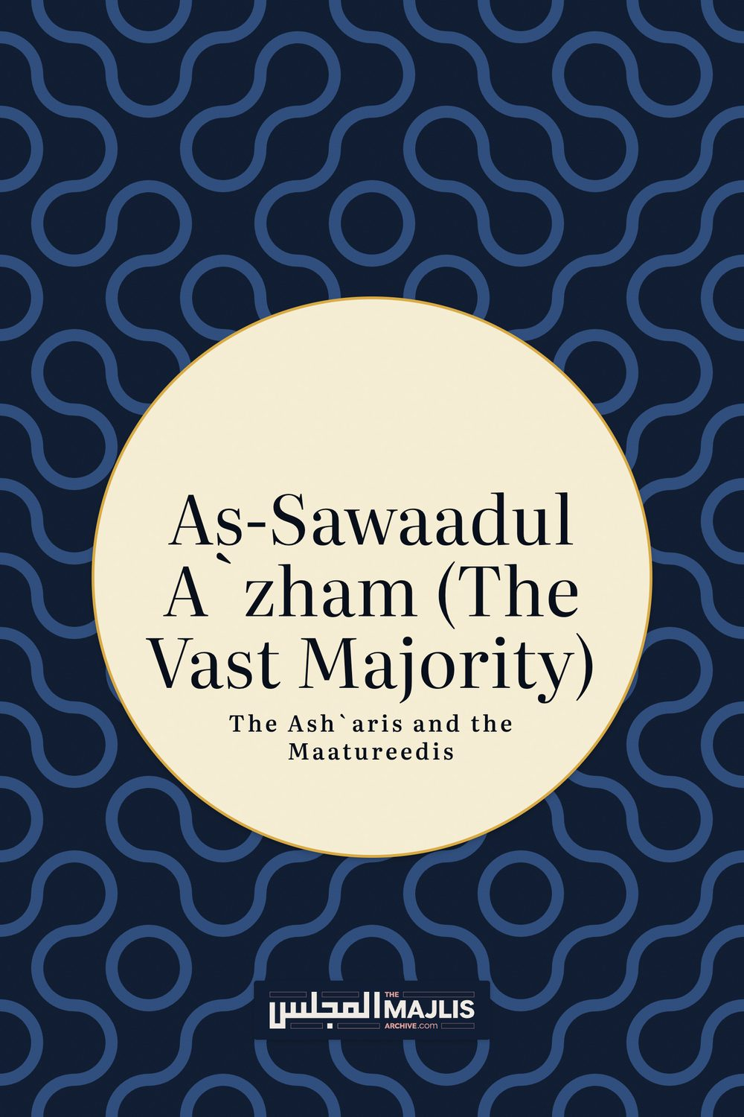

The Ash`aris and the Maatureedis
The Majlis · Voice of Islam
Mujlisul Ulama of South Africa

About this edition
This is a reproduction by The Majlis Archive (themajlisarchive.com) of a publication of The Majlis, Mujlisul Ulama of South Africa, made and published with their permission.
The PDF as The Majlis issued it is the original. This edition was read from that PDF's own structure and checked against it letter for letter; where the two differ, the PDF is correct.
Checked: 257 paragraphs, 0 differing; a second, independent PDF reader finds 71.3% of the PDF's words here.
Nothing has been reworded, added or removed.

By Muhammad Huzaifah ibn Adam
PUBLISHED BY: As-Saadiqeen Islamic Centre PO Box 818 De Deur, 1884 South Africa
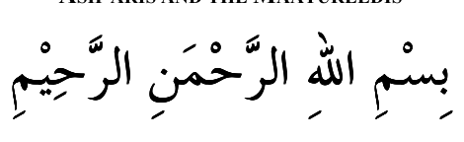

As-Sawaadul A`zham:

(The Vast Majority)
The Ash`aris and the Maatureedis In brief, the purpose of this booklet is to debunk the ridiculous claim of the Salafis that "the Ash`aris and Maatureedis were always just a fringe, heretical cult, and were the minority."
The reality is that all the years, the "vast majority" of the Ummah have been Ash`aris and Maatureedis. That is the case right up until the present day.
We shall list hereunder some of the well-known A'immah who were Ash`aris and some who were Maatureedis. Bear in mind that this is just a brief list and not an exhaustive one; the actual number of `Ulamaa throughout the ages who were Ash`aris or Maatureedis is innumerable.
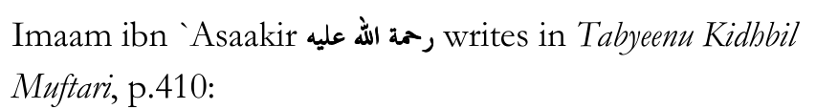
"The majority of the `Ulamaa in all the lands were upon the Ash`ari Madh-hab (in `Aqeedah), and the A'immah of all the cities in all eras called towards it. Were there any of the Fuqahaa of the Hanafiyyah, the Maalikiyyah and the Shaafi`iyyah except that they were either in agreement with it, or attributed themselves to it, or were pleased with the praiseworthy effort he (Imaam al-Ash`ari) had made in the Deen of Allaah?"
"Shaykhul Islaam Al-`Izz ibn `Abdis Salaam mentioned that the Shaafi`is, the Maalikis, the Hanafis and the great ones among the Hanbalis were all unanimous upon the `Aqeedah of (Imaam al-Ash`ari). His contemporary, the Shaykh of the Maalikis of that time, Imaam Abu `Amr ibn al-Haajib, agreed with him on this, as did another contemporary of his: the Shaykh of the Hanafis of that time, Imaam Jamaal-ud-Deen al-Haseeri."
[Note: There is very little difference between the Ash`ari `Aqeedah and the Maatureedi `Aqeedah; in most cases it is just semantics. Thus, many `Ulamaa of the past when using the term "Ash`ari `Aqeedah" included the Maatureedi `Aqeedah in that as well. The Salafis of today do the same: when they condemn "The Ash`aris", they are including the Maatureedis in that at the same time. The term Ash`ari was often used to refer to both the Ash`aris themselves as well as the Maatureedis, on account of the two Madh-habs being almost exactly the same. That is the reason why here, Imaam Al-`Izz ibn `Abdis Salaam, even though he mentions Imaam al-Ash`ari, he is referring to both the Ash`ari Madh-hab and the Maatureedi Madh-hab of `Aqeedah.]

Some A'immah Who Were Ash`aris:
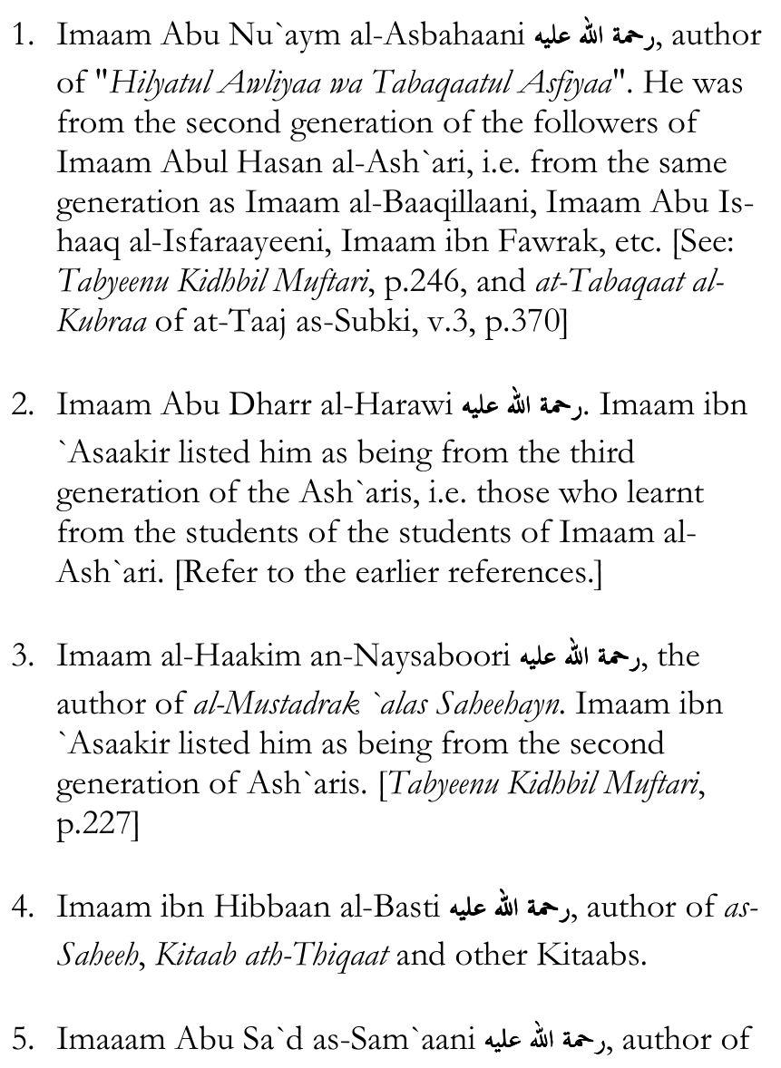
Kitaabul Ansaab.
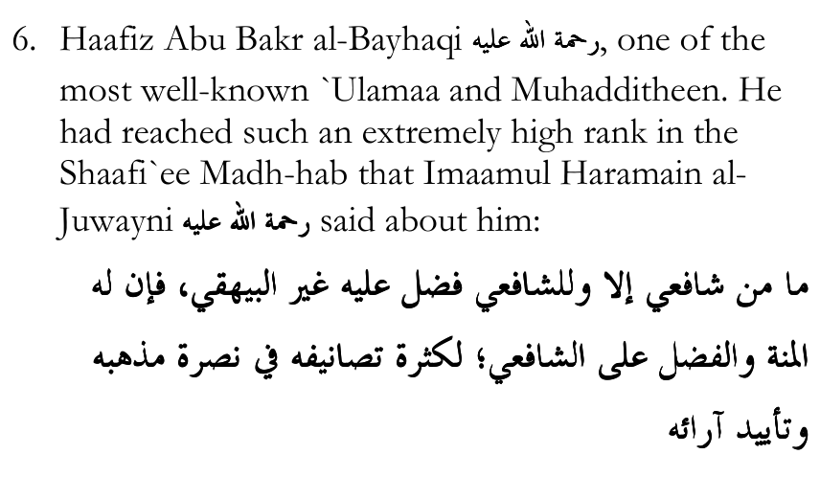
"There is no Shaafi`ee except that Imaam ash-Shaafi`ee has a virtue over him (i.e. did him a favour) except Imaam al-Bayhaqi; he did Imaam ash-Shaafi`ee a favour (by being a Shaafi`ee) and has a virtue over him, on account of the numerous Kitaabs he authored in support of his Madh-hab and his views."
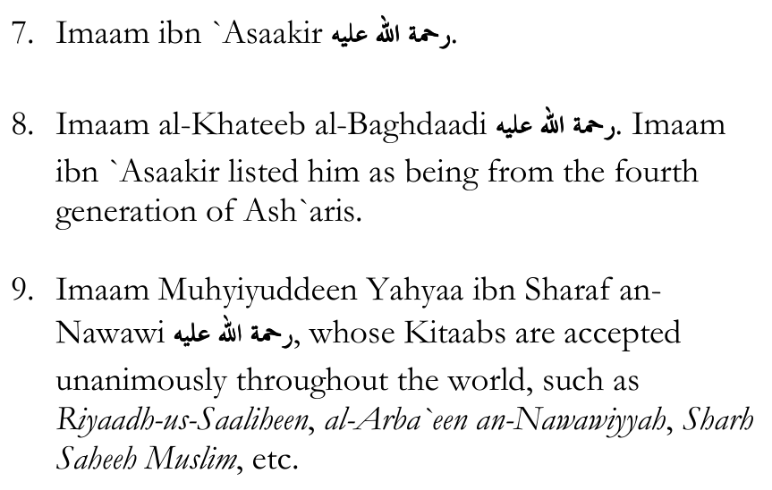
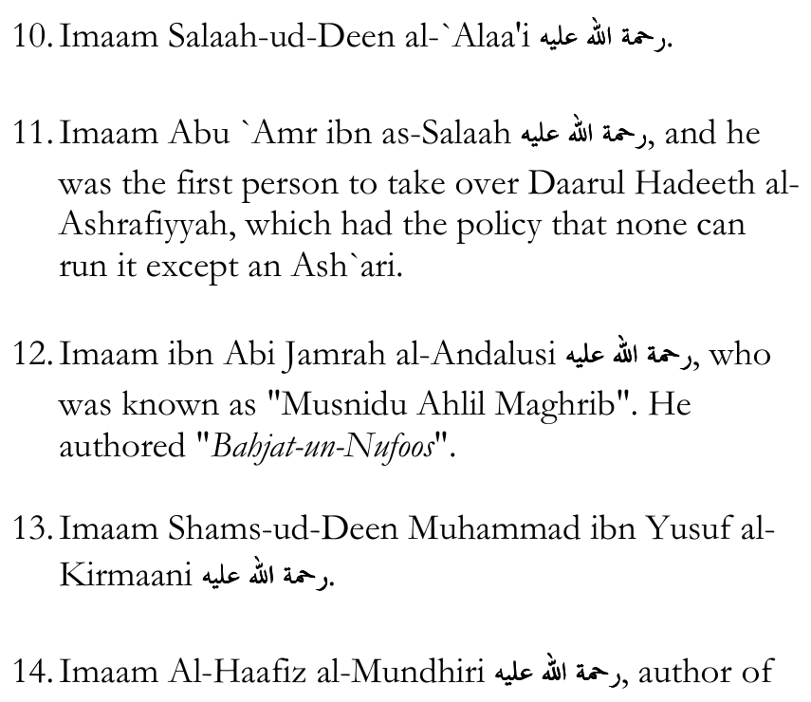
at-Targheeb wat-Tarheeb.
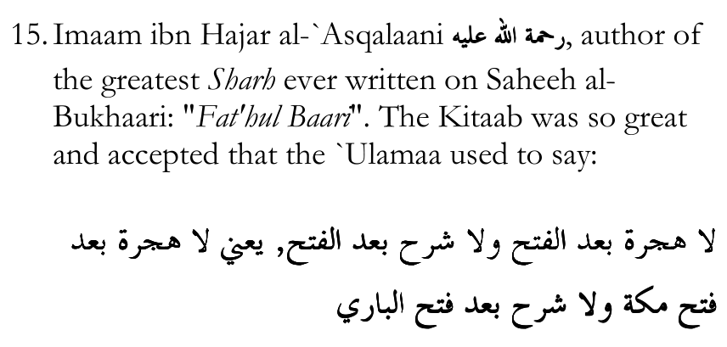
"There is no Hijrah after al-Fat'h and there is no Sharh after al-Fat'h, i.e. there is no Hijrah after Fat'he Makkah, and there is no (need for a Sharh) after Fat'hul Baari."
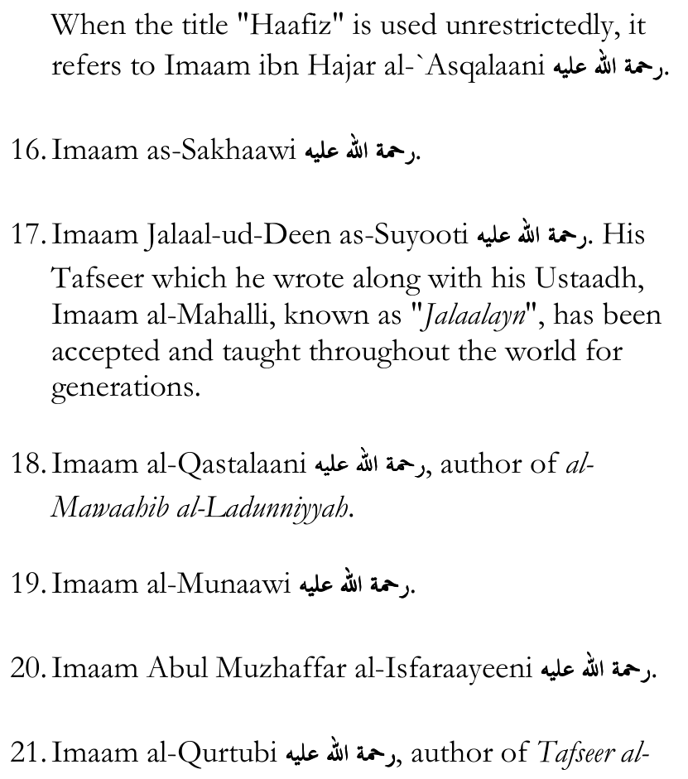
Qurtubi.
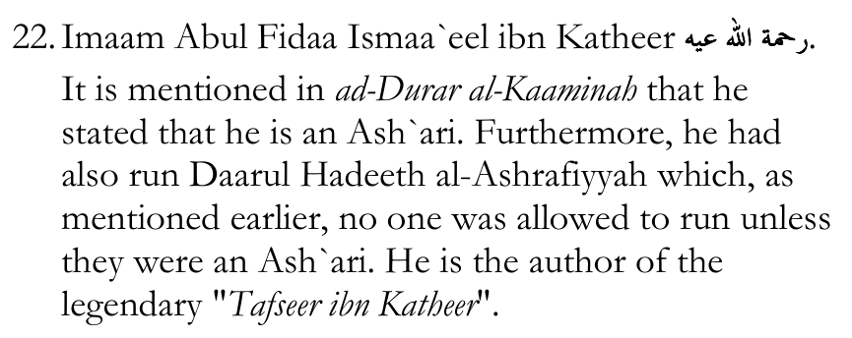
of "Tafseer al-Muharrar al-Wajeez".
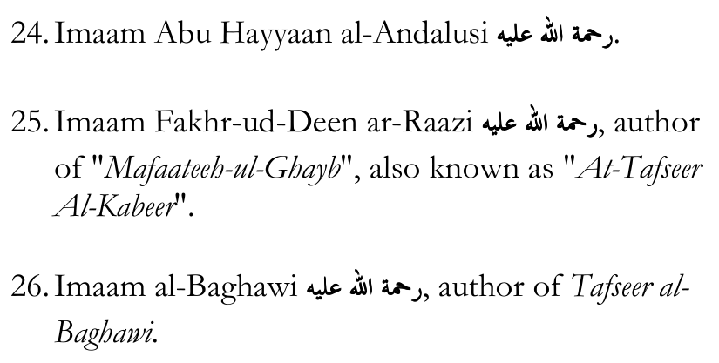
27. Imaam Abul Hasan `Ali an-Naysaaboori al-Waahidi
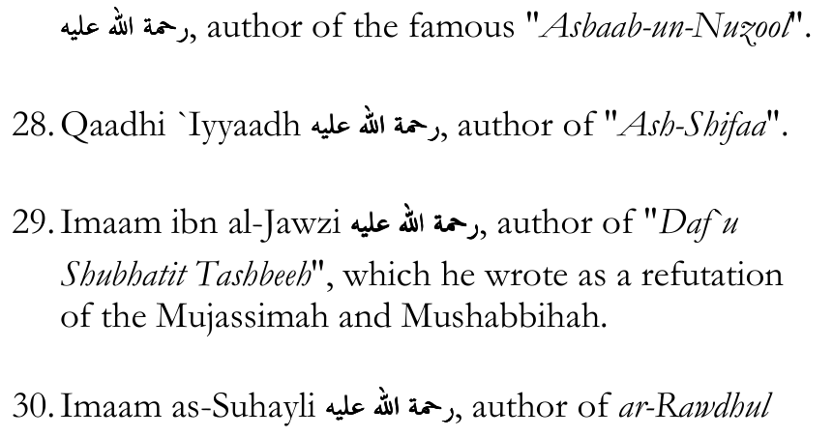
Aneef.
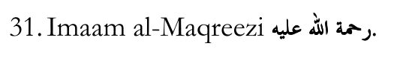
the most famous A'immah of all time.
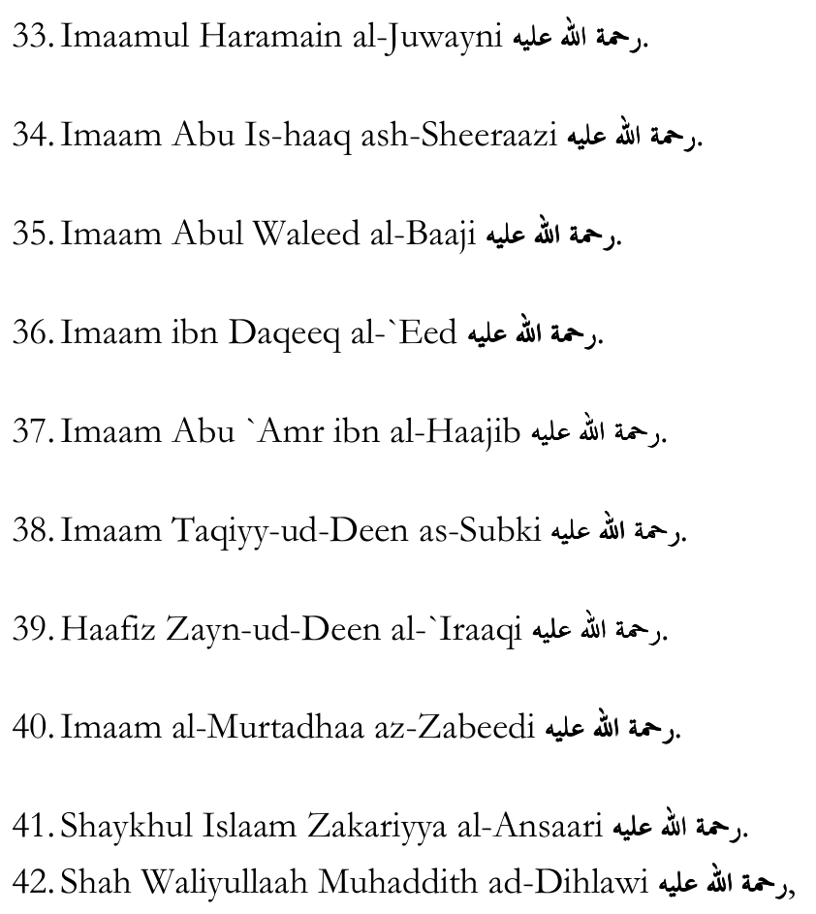
one of the greatest `Ulamaa of Hind of all time.
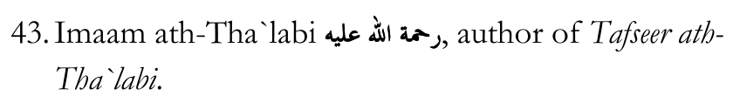
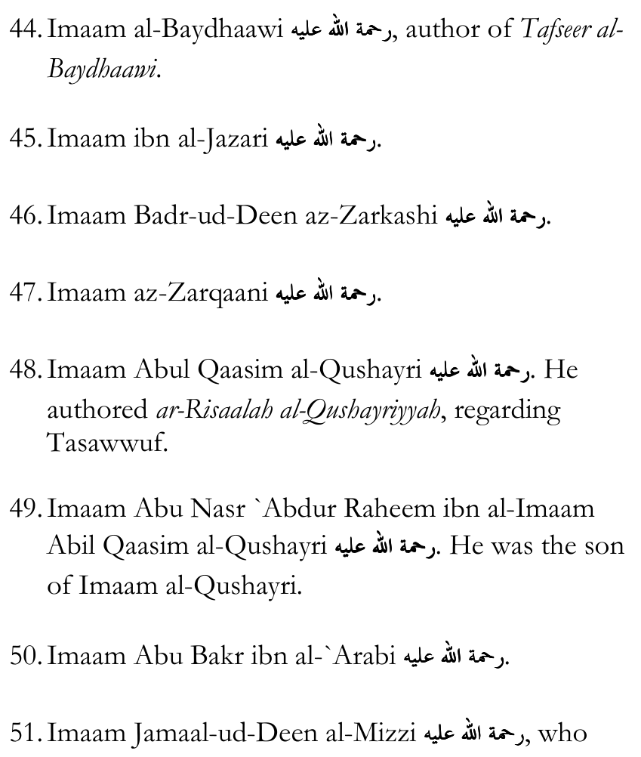
passed away in the year 742 A.H.
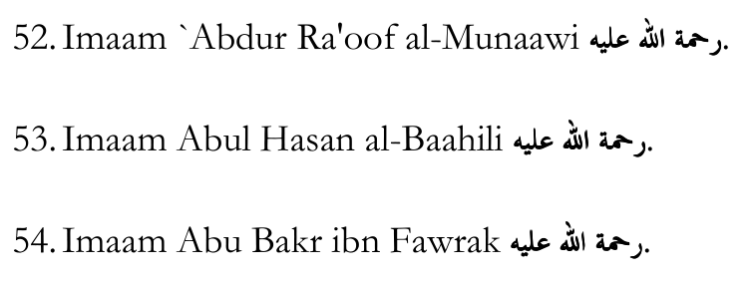
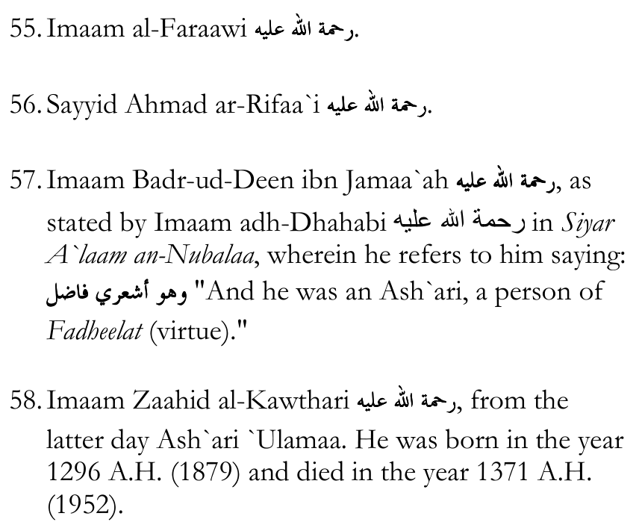

Some A'immah Who Were Maatureedis:
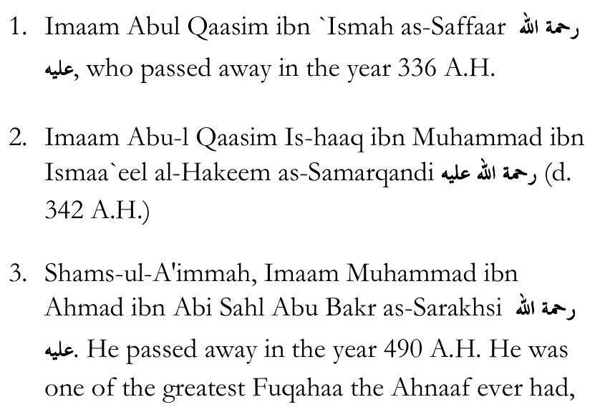
and in fact, more than that, he was one of the greatest `Ulamaa of all time. He spent 15 years in prison, during which time he wrote the 15-volume "Al-Mabsoot" despite not having access to papers or a pen, and without having a single Kitaab with him in prison to reference. He would dictate to his students and they would write down. He thus authored the entire 15-volume "al-Mabsoot" from memory, without needing a library, or anyone to check things up for him, and without the computers and technology of today. Yet, al-Mabsoot is one of the greatest Kitaabs ever written, and Imaam as-Sarakhsi is one of the most important figures in the Hanafi Madh-hab, so much so that Imaam ibn `Aabideen writes in Raddul Muhtaar, quoting `Allaamah at-Tartoosi: "We do not act (on a ruling) which opposes (the ruling) of Mabsoot of Sarakhsi. We do not rely on any (Kitaab) other than it. Fatwaa is not given except upon it (al-Mabsoot)."
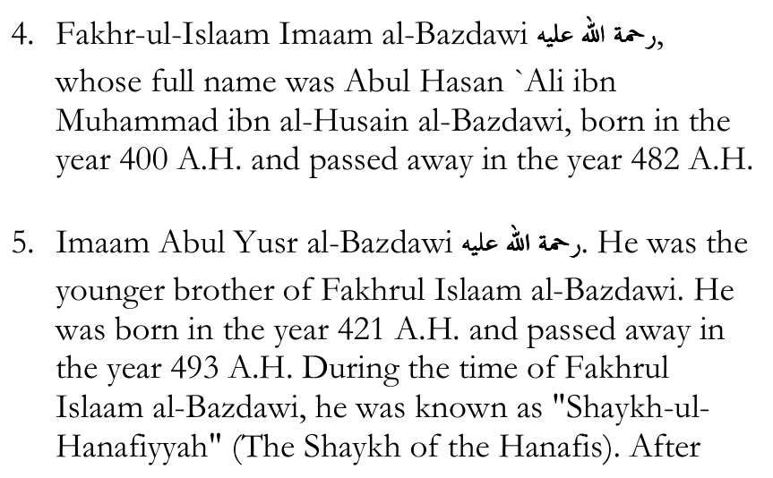
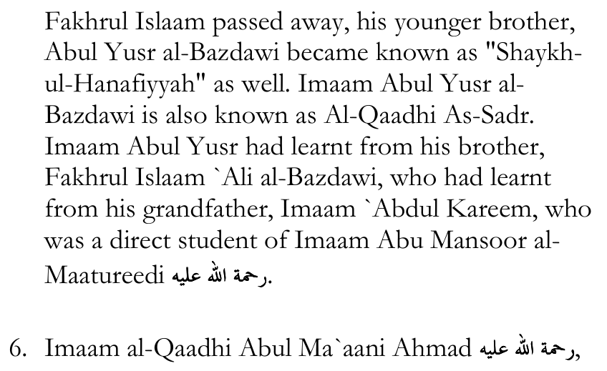
the son of Imaam Abul Yusr al-Bazdawi.
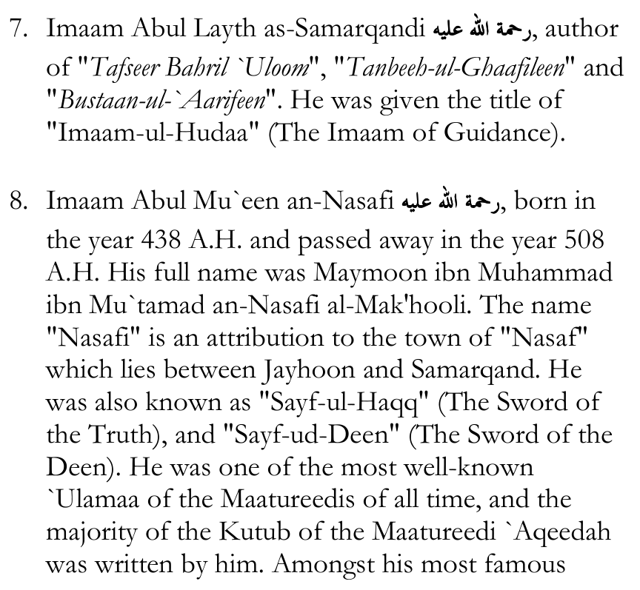
Kitaabs on Maatureedi `Aqeedah are: Bahr-ul-Kalaam, Tabsiratul Adillah, at-Tamheed and others. In fact, Tabsiratul Adillah fee Usool-id-Deen is regarded as the biggest reference for Maatureedi `Aqeedah.
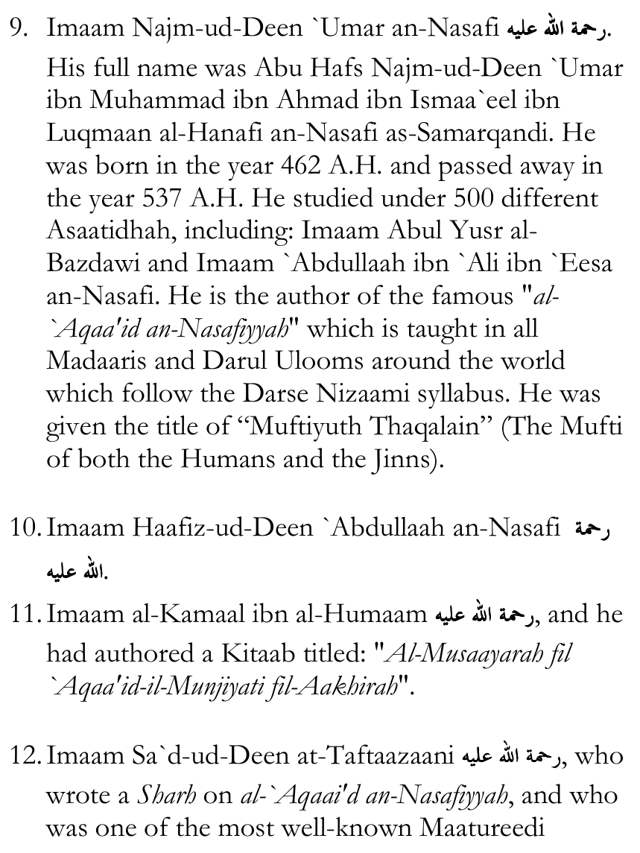
A'immah. He was born in the year 712 A.H. and passed away in the year 792 A.H.
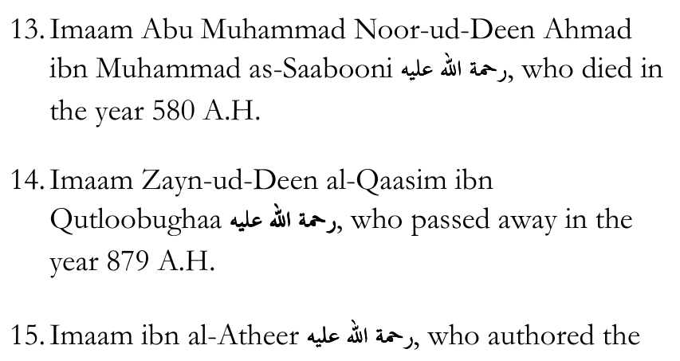
famous "al-Kaamil fit-Taareekh".
A.H. and passed away in the year 816 A.H.
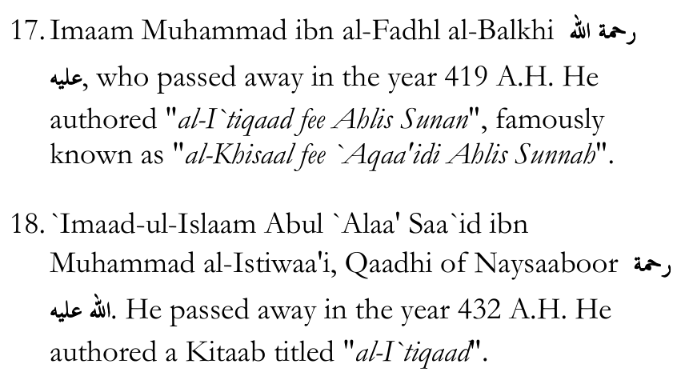
19. Imaam Muhammad ibn al-Muzhaffar al-Baghdaadi
in the year 488 A.H. He authored "al-Bayaan fee Usool-id-Deen".
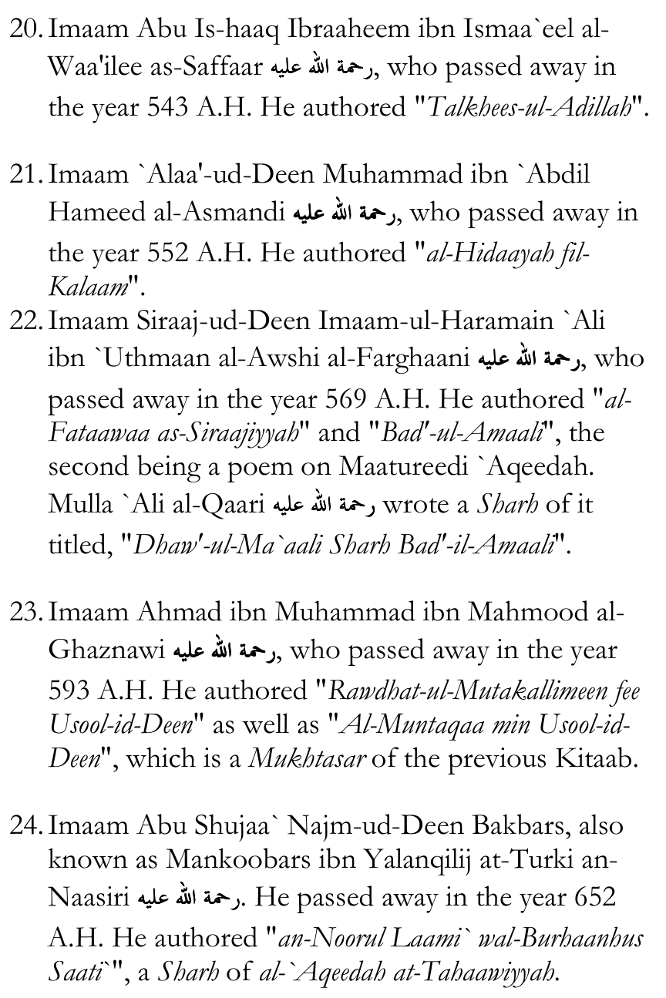
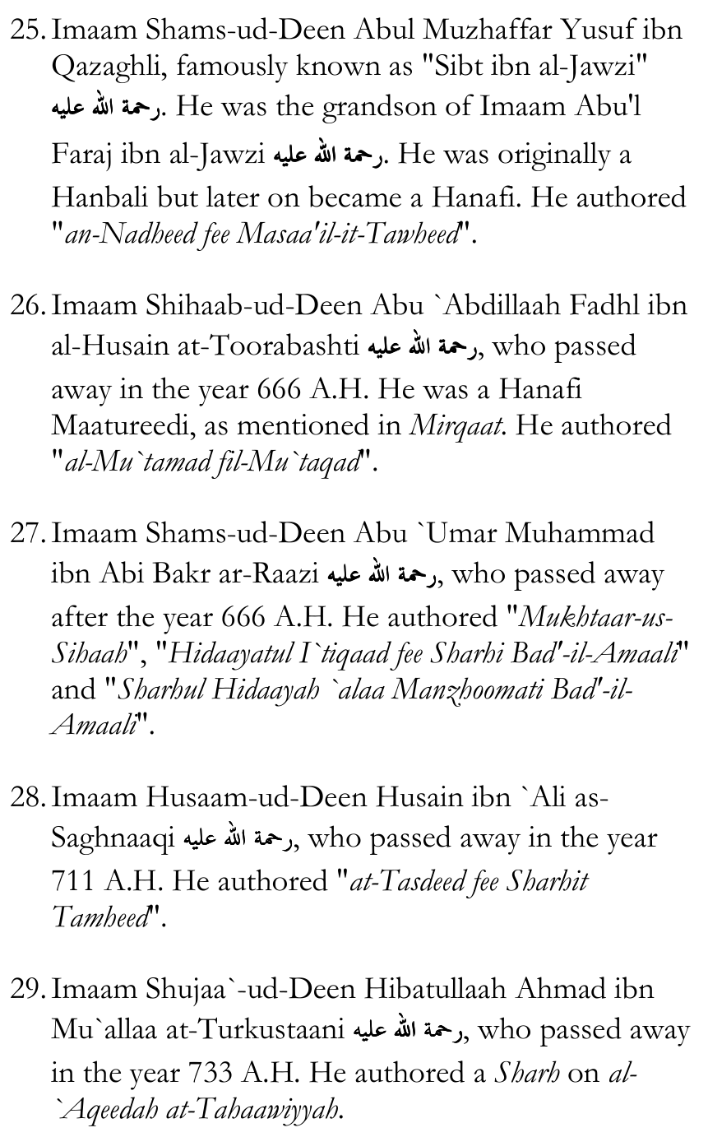
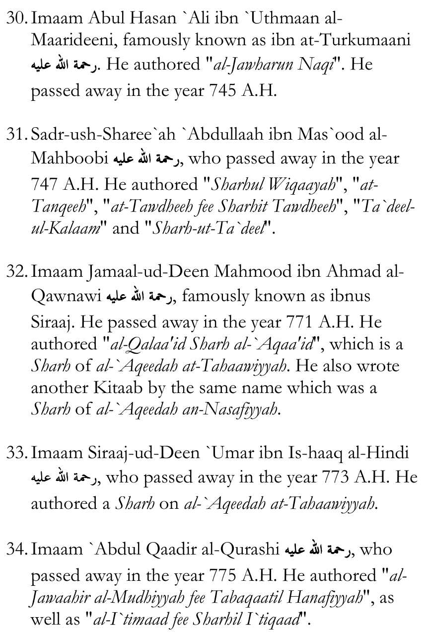
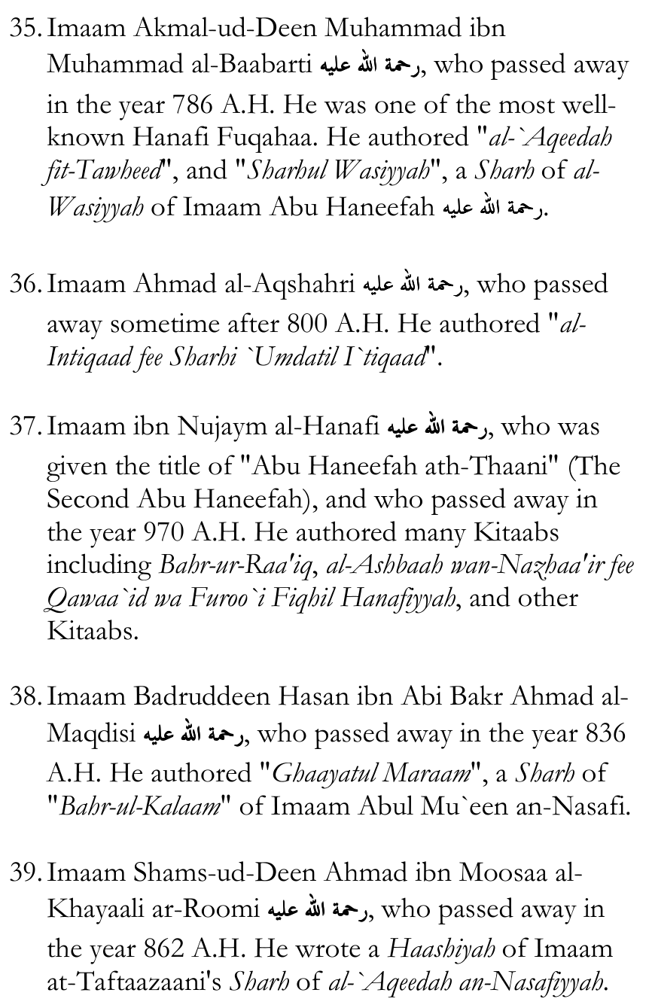
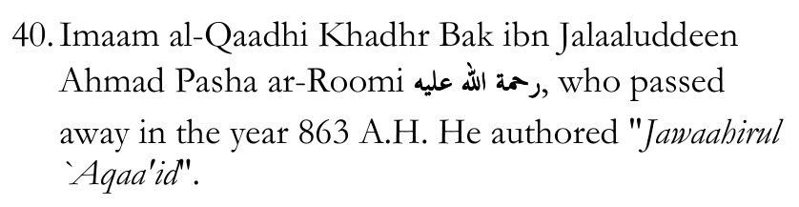
41. Imaam Sa`d-ud-Deen Abus Sa`aadaat Sa`d ibn Muhammad an-Naabulusi al-Maqdisi, famously known as ibn ad-Dayri and titled "Qaadhiyul Hanafiyyah" (The Qaadhi of the Hanafis). He passed away in the year 867 A.H. He authored "Sharh al-`Aqaa'id an-Nasafiyyah" and "Sharh al-Musaayarah".
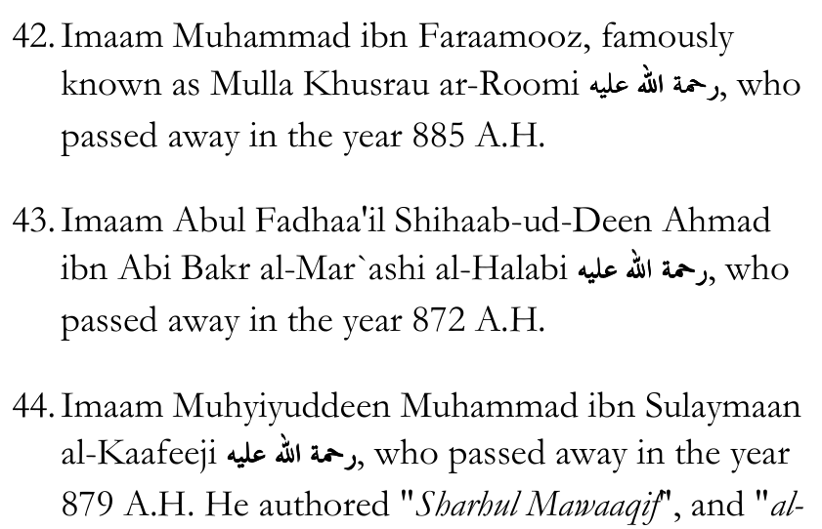
Anwaar fee `Ilm-it-Tawheed Alladhee Huwa Ashraful `Uloomil wal-Akhbaar".
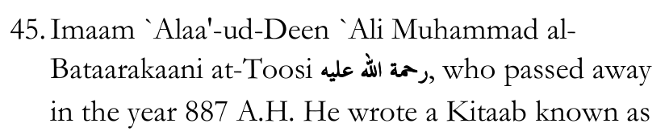
"adh-Dhakheerah" wherein he refuted the philosophers. Sultaan Muhammad al-Faatih gave him a gift of 10,000 Dirhams for having written this Kitaab.
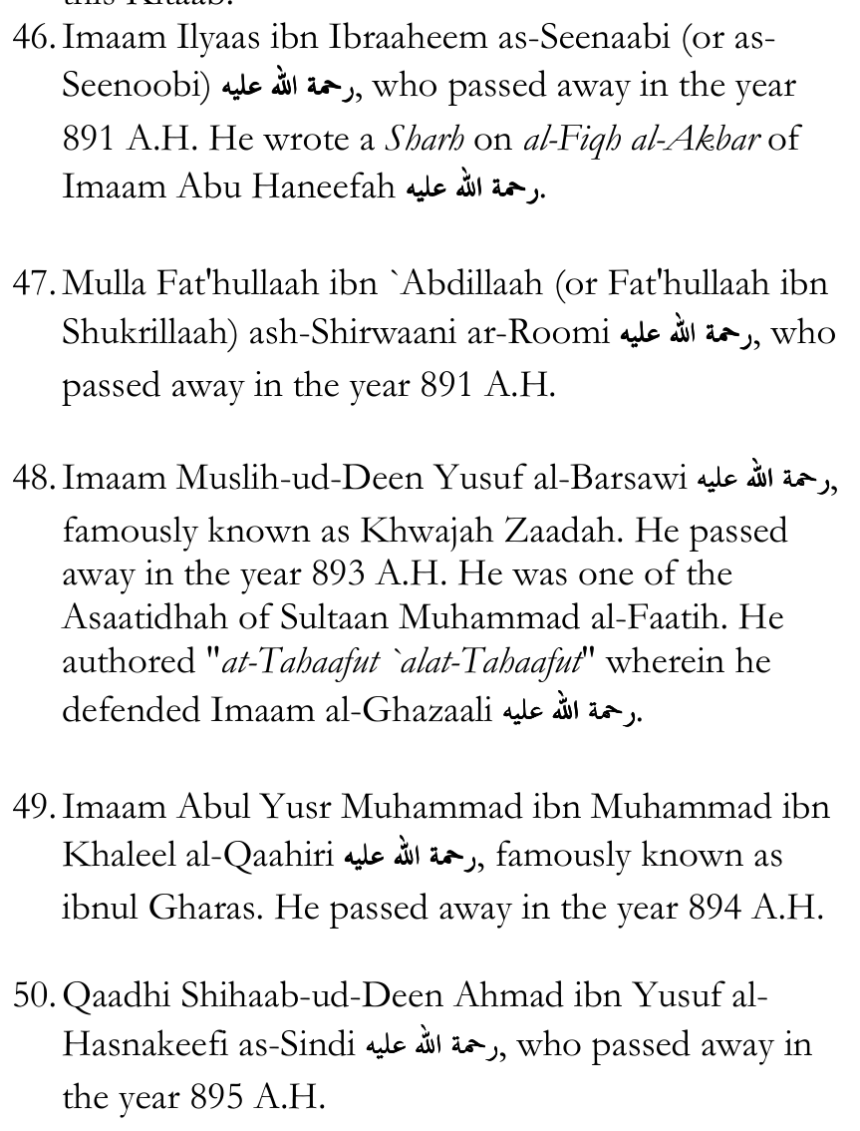
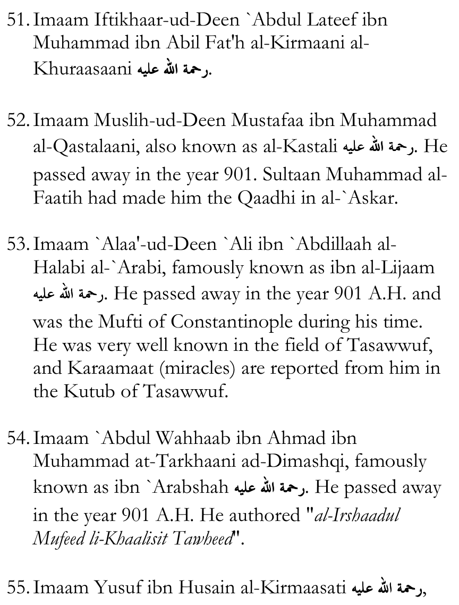
who passed away in the year 906 A.H.
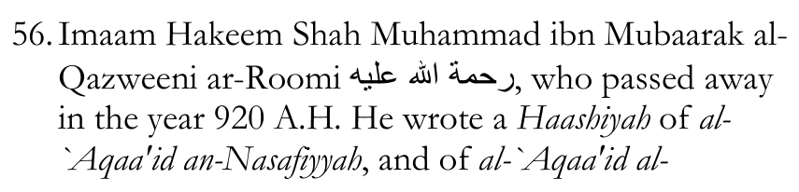
`Adhudiyyah, and of Tahaafatul Falaasifah (The Collapse of the Philosophers).
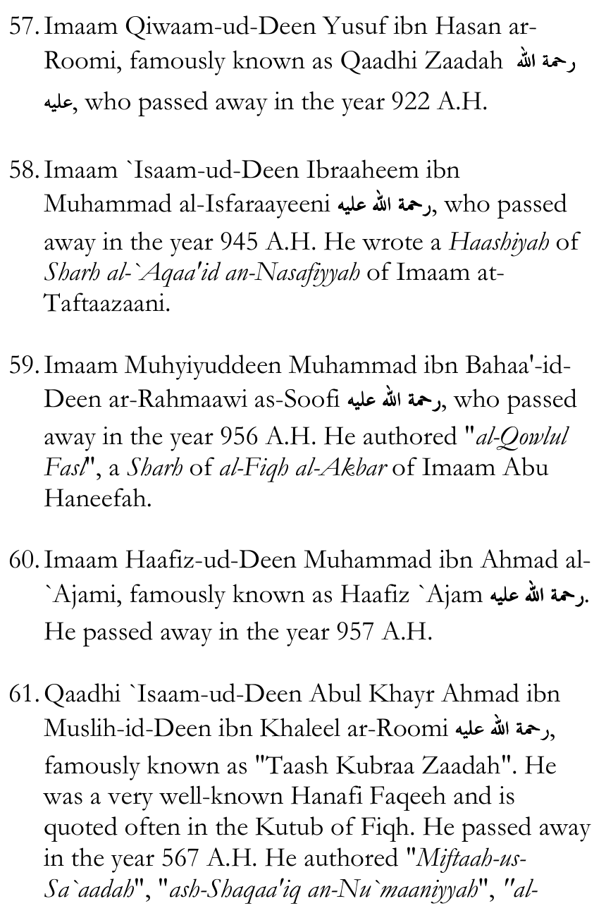
Ma`aalim fee `Ilmil Kalaam" and "Ajallul Mawaahib fee Ma`rifati Wujoobil Waajib".
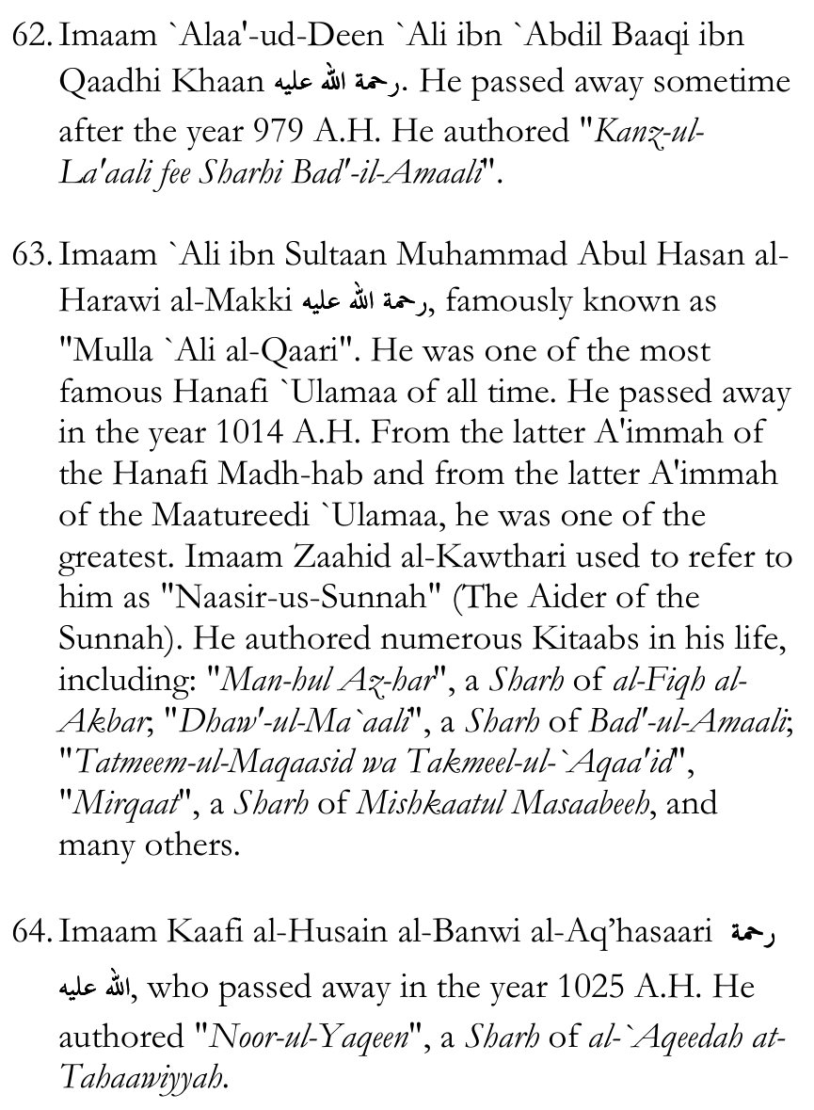
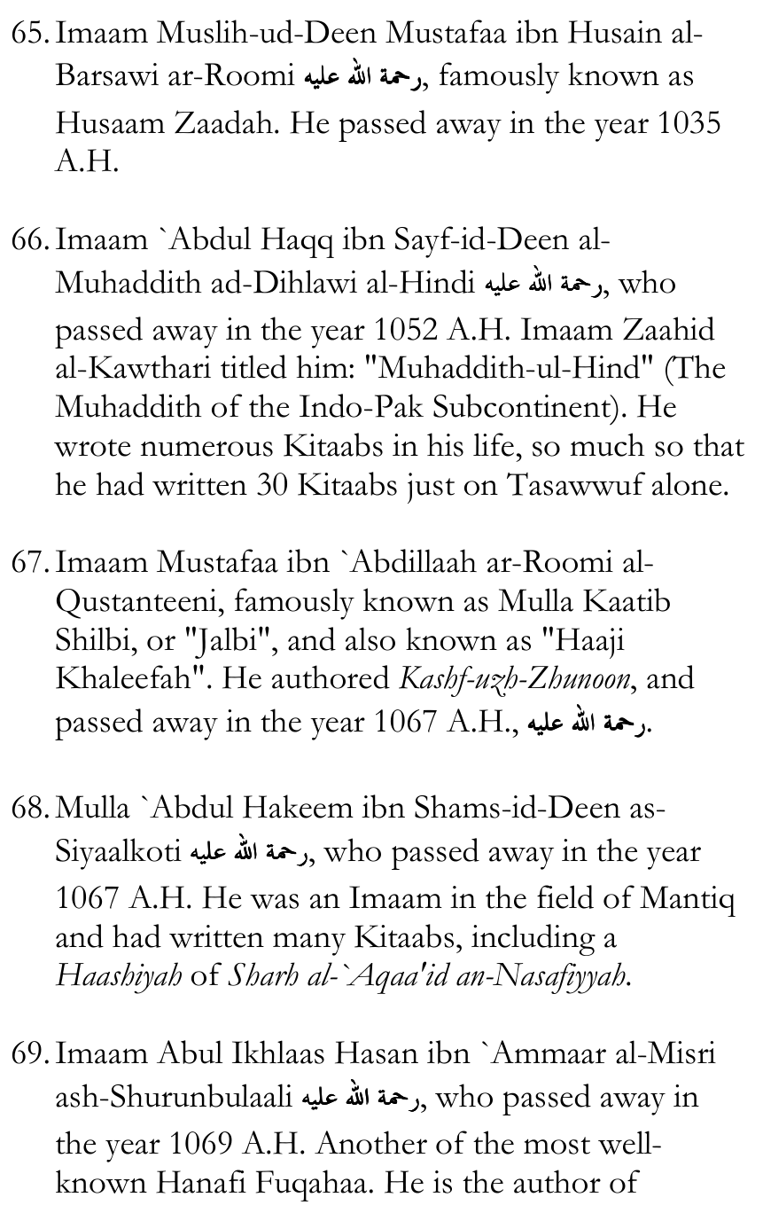
"Maraaqiyus Sa`aadaat fit-Tawheed wal-`Ibaadaat", and the famous "Noor-ul-Eedhaah", and other Kutub.
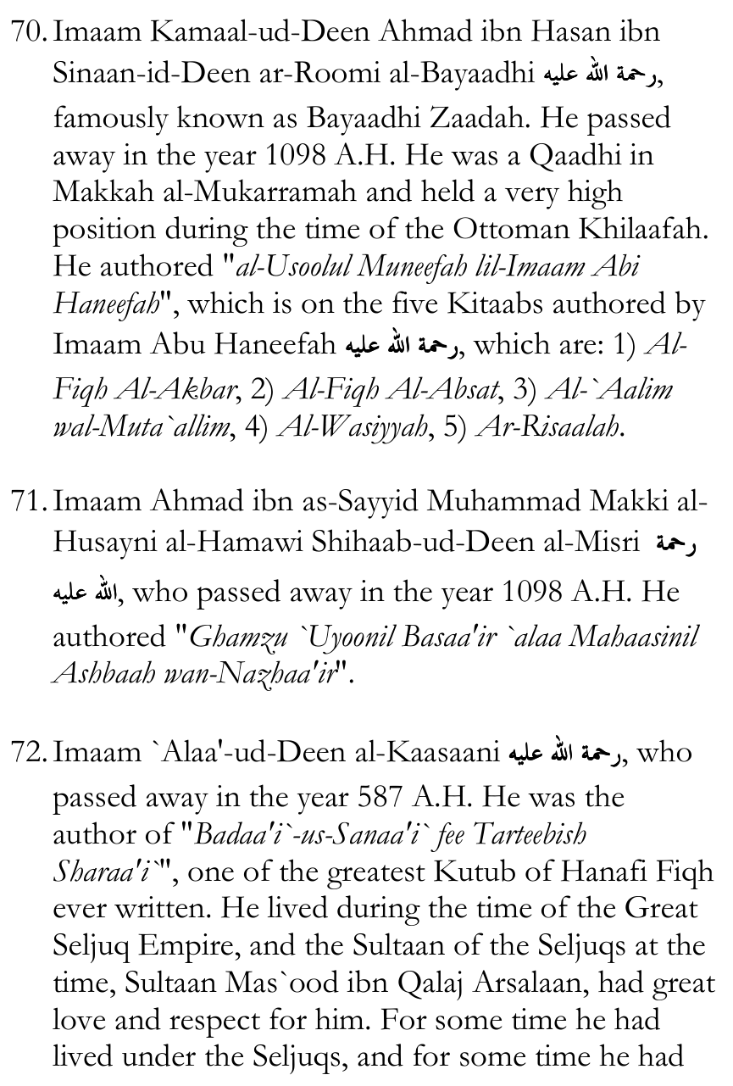
also lived under Sultaan Noor-ud-Deen Zangi who also had a great love and respect for him. Imaam al-Kaasaani was known for being fearless in propagating the Haqq. Till the day he died he used to ride a horse, and wherever he went he carried a spear with him. The `Ulamaa of his time used to ride donkeys or mules, considering this to be more humble, but he refused to ride except on a horse, and his favourite food throughout his life was a certain dish of meat that was cooked with water and hummus.
Imaam al-Kaasaani passed away in the year 587 A.H. and was buried in a graveyard of Halab (Aleppo) that was exclusively for the Ahnaaf. He was buried next to his wife, Faatimah.
Imaam Dhiyaa'-ud-Deen Muhammad ibn Khamees al-Hanafi narrates that as Imaam al-Kaasaani was about to die, he began reciting Soorah Ibraaheem, and as he reached the Aayah:
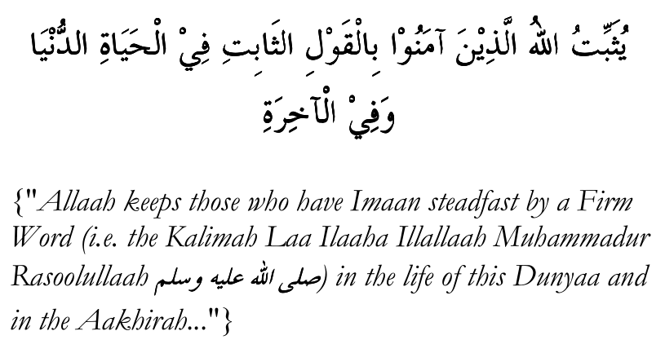
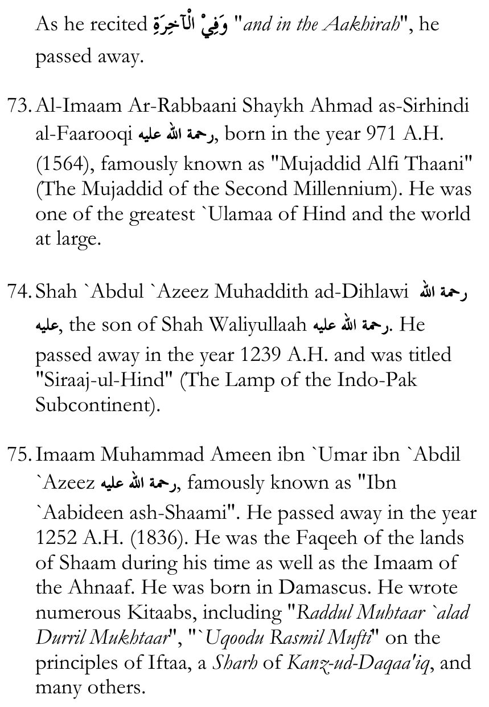
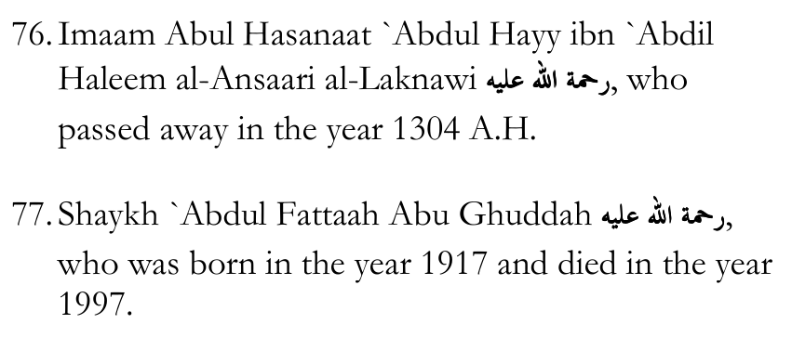

Important Figures Who Were Ash`aris or Maatureedis:
1. The Mujaahid Sultaan of Great Seljuq, Alp Arsalan
2. Nizaam-ul-Mulk, the Wazeer of Alp Arsalan and later on his son, Malik Shah, was an Ash`ari. He established "al-Madaaris an-Nizhaamiyyah", which taught the Ash`ari `Aqeedah to people far and wide, and for this reason he is despised by the Salafis, who accuse him of "spreading Ash`arism among the masses".
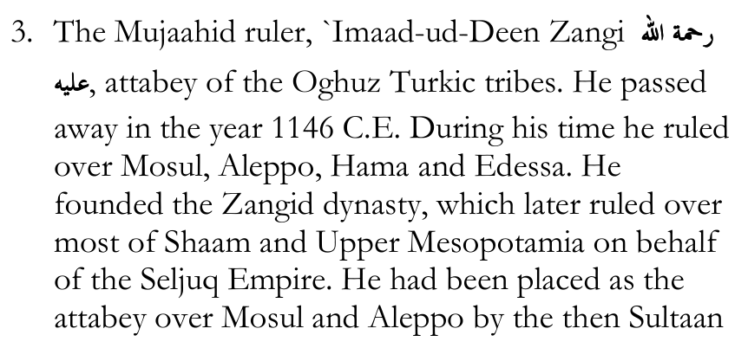
of Great Seljuq, Mahmud II. He was a Hanafi, Ash`ari.
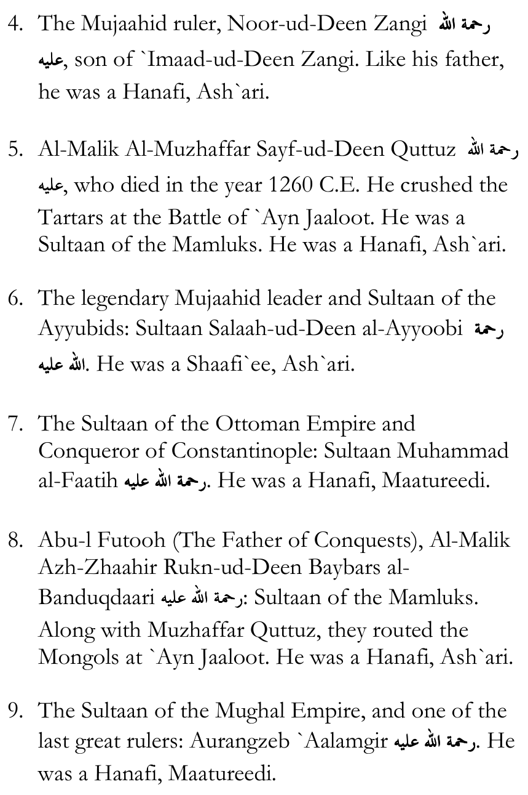
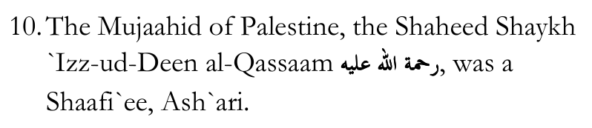
11. The Lion of the Desert, the Shaheed Shaykh `Umar
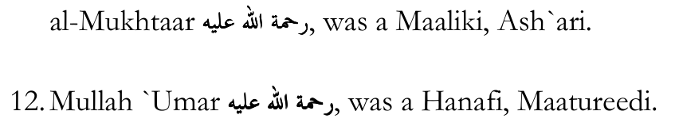

Darul Uloom Deoband
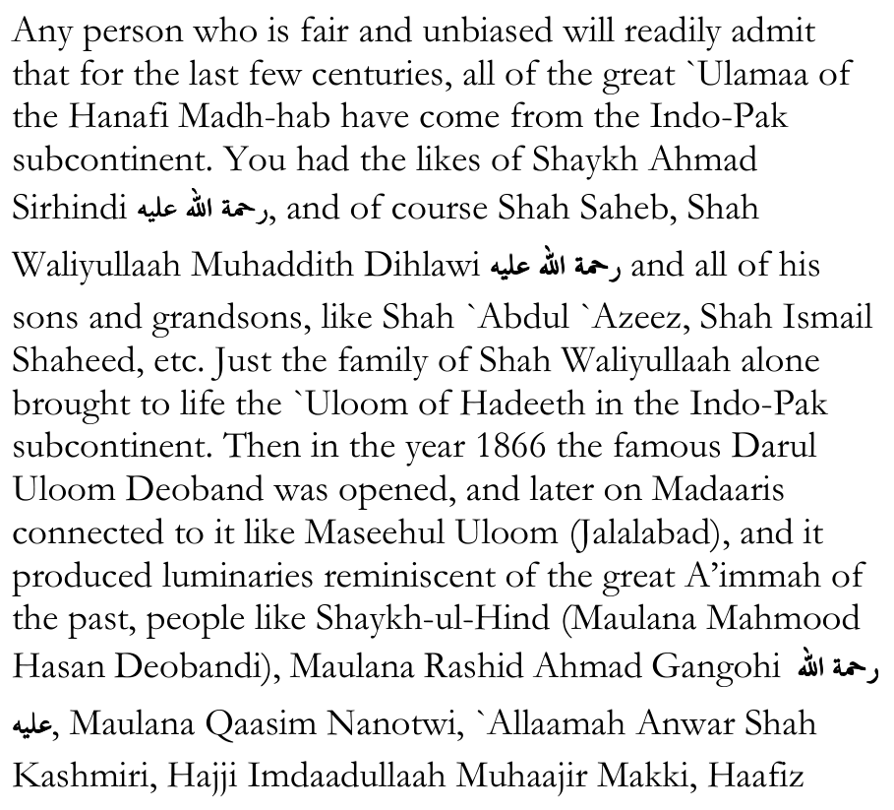
Dhaamin, Hadhrat Thanvi, Mufti Mahmood-ul-Hasan Gangohi, Maulana Yusuf Binnori, Maulana Khaleel Ahmad Saharanpuri, Shaykhul Hadeeth Maulana Zakariyya Kandhlawi, Hadhratji Maulana Maseehullah Khan Sherwani, Mufti Shafi Usmani, Maulana Husain Ahmad Madani, Maulana Shabbir Ahmad Usmani, Maulana Zafar Ahmad Thanvi, Maulana Sayyid Ataullaah Shah Bukhaari, Qaari Tayyib Saheb, Maulana Rashid Ahmad Ludhyanvi, Maulana Yusuf Ludhyanvi, Mufti Nizaam-ud-Deen Shamzai, Maulana Ilyaas Kandhlawi, Maulana Yusuf Kandhlawi and innumerable others.
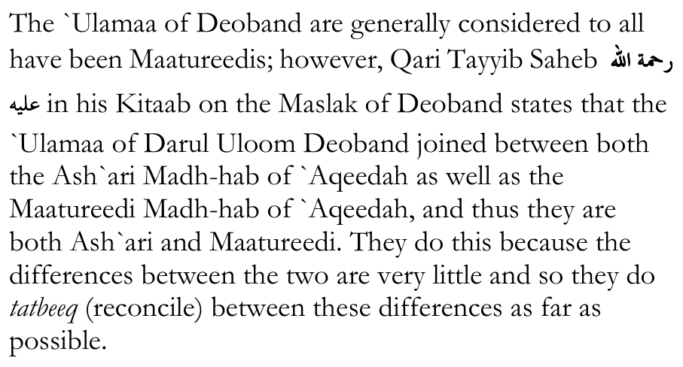
Nevertheless, the entirety of Darul Uloom Deoband and all of its affiliates such as Maseehul Uloom in Jalalabad and others, all of the senior `Ulamaa of the past who studied at these institutes were unanimously Ash`aris or Maatureedis, or, like Qaari Tayyib Saheb said, they were both.
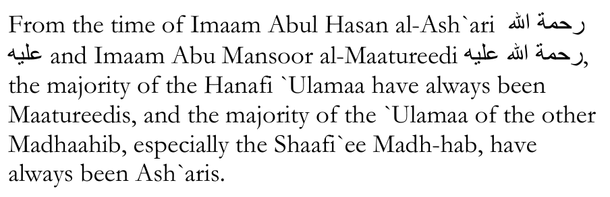

An Important Point
Imaam Ahmad ibn Hanbal, Imaam al-Bazzaar, Imaam at-Tabaraani, Imaam al-Haakim, Imaam ibn `Abdil Barr, Imaam al-Haythami, Imaam ibn Hajar al-`Asqalaani, Imaam adh-Dhahabi and even Imaam al-Bukhaari (in at-Taareekh al-Kabeer) all narrate the following Hadeeth:
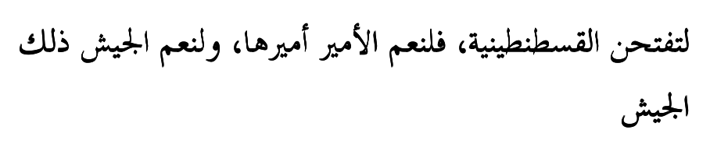
"Constantinople shall be conquered, and what an Excellent Ameer (Ni`mal Ameer) is that Ameer (i.e. of the army that conquers it) and what an Excellent Army (Ni`mal Jaysh) is that army (that conquers it under him)."
Imaam al-Haakim and Shams-ud-Deen Imaam adh-Dhahabi have both graded this Hadeeth as Saheeh. Imaam al-Haythami said that the narrators are thiqaat (reliable; trustworthy). Imaam ibn `Abdil Barr said that the Isnaad (chain of narrators) is Hasan.
On the 20th of Jumaadal Oolaa of the year 857 A.H. (29th of May, 1453), Constantinople was conquered by a "Hanafi Maatureedi", Muhammad al-Faatih, along with an army of Mujaahideen, all of whom were Hanafis, Maatureedis.
Some historians state that the number of Mujaahideen with him numbered somewhere between 50,000 to 80,000, but according to the Turkish historian, Muhammad Fareed Bey ibn Ahmad Fareed Pasha in his Taareekh ad-Dawlah al-`Aliyyah al-`Uthmaaniyyah, there were 250,000 Mujaahideen.
Regardless of how much some people hate this fact, they cannot deny it: Constantinople was not conquered by a Salafi who graduated from Madinah University or Muhammad ibn Saud University; it was conquered by a "Hanafi, Maatureedi". The Saudis can conquer nothing and nobody.
The "Great Seljuq Empire" were Hanafis. The Mamluks were Hanafis. The Ottomans were Hanafis. The Ghaznavids were Hanafis. The Khiljis were Hanafis. The Ottomans ruled for 600 years, thus having the longest Khilaafah in Islaamic history.
In reality, for the larger part of the history of this Ummah, the rulers were Hanafis and the "Official Madh-hab" of all these dynasties was the Hanafi Madh-hab. A second, important point to note is that all of them, in addition to being Hanafis, were Ash`aris and Maatureedis.
This debunks the ridiculous, laughable claim made by the Salafis, that "the Ash`aris and Maatureedis were always just a fringe, heretical cult, and were the minority."
Besides the Saudi regime of today, when have the Salafis ever been the rulers?
And the Saudi regime of today is not even Salafi anymore. They are just bootlickers of America. They themselves reject what they term "Wahhaabism", which is what the Saudi state was founded on. Today it is displeasing to America so they have to do away with it and edit the books.

The View of the Salafis
Saalih al-Fawzaan:
He was asked: "Are the Ashaa`irah and Maatureediyyah counted as being from Ahlus Sunnah wal-Jamaa`ah?"
He said: "They are not counted. No one has ever counted them as being from Ahlus Sunnah wal-Jamaa`ah. They call themselves Ahlus Sunnah but they are not from Ahlus Sunnah."
Sulaymaan ibn Sahmaan:
In the Kitaab of Imaam as-Safaareeni, "Lawaami`ul
Anwaar", he states that the Ash`aris and Maatureedis are from "al-Firqatun Naajiyah" (The Saved Sect). Sulaymaan ibn Sahmaan objects to this, writing:
"This is flattery on the part of the author - may Allaah Ta`aalaa have mercy on him - in including the Ash`aris and Maatureedis as part of Ahlus Sunnah wal-Jamaa`ah. How can someone who does not affirm the `Uluww of ar-Rabb Sub-haanahu wa Ta`aalaa above His Heavens and His Istiwaa' on His `Arsh, be part of Ahlus Sunnah wal-Jamaa`ah?"
[Note: What he is referring to here is that Ash`aris and Maatureedis do not believe that Allaah Ta`aalaa is physically located above the heavens, i.e. in a place, and physically sitting on the `Arsh. The true view of Ahlus Sunnah wal-Jamaa`ah is that Allaah Ta`aalaa is free from space and time. Allaah Ta`aalaa created space and time.]
`Abdur Rahmaan ibn Hasan Aal ash-Shaykh, the author of Fat'hul Majeed writes:
"This group (i.e. the Ash`aris) that attribute themselves to Abul Hasan al-`Ash`ari, they describe Rabbul `Aalameen with the qualities of one who is non-existent. They have lied greatly against Allaah and have opposed the Ahl-ul-Haqq from the Salaf, and the A'immah and their followers, and they have opposed even the one they attribute themselves to, because Abul Hasan al-Ash`ari, in his book, "al-Ibaanah", clearly expressed his affirmation of the Sifaat. Thus, this group which has deviated from the Haqq, they have freed their Shayaateen (from having to do any work) by themselves preventing people from the Path of Allaah. They reject the Tawheed of Allaah in Al-Ilaahiyyah. They permit Shirk which Allaah does not forgive. They permit for others to be worshipped besides Him. They reject His Tawheed
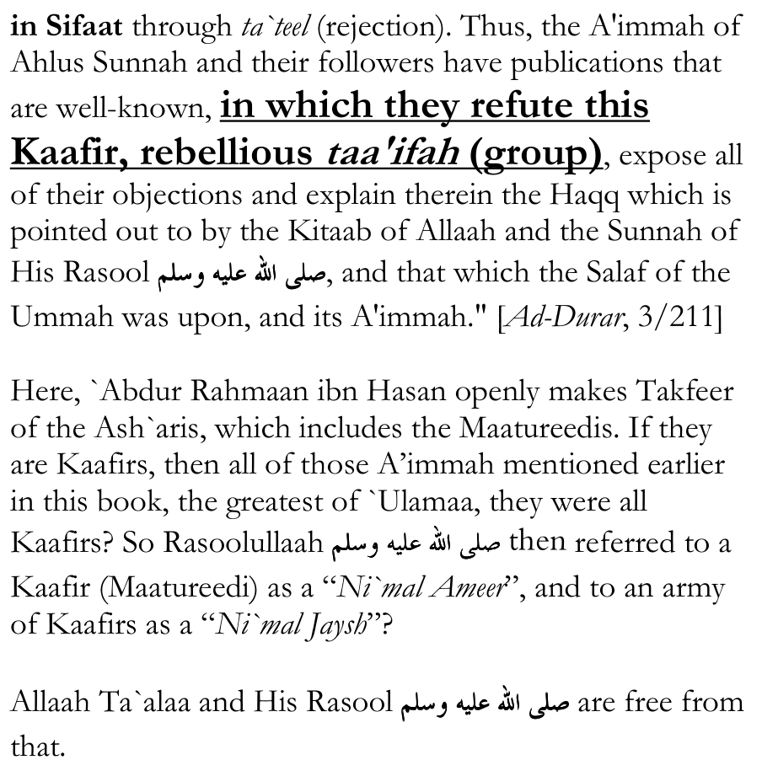
`Abdul Lateef ibn `Abdur Rahmaan ibn Hasan Aal ash-Shaykh:
Commenting on the Ash`aris and Maatureedis, he said:
"These people are from the most deviated of mankind and the furthest from the guidance of the Mursaleen, let alone them being from the `Ulamaa of the Muslimeen."
[Note: "Aal ash-Shaykh" means "the family of the Shaykh". The Shaykh being referred to is Muhammad ibn `Abdil Wahhaab an-Najdi. `Abdur Rahmaan ibn Hasan was from the most well-known of the grandsons of Muhammad ibn `Abdil Wahhaab. He is `Abdur Rahmaan ibn Hasan ibn Muhammad ibn `Abdil Wahhaab. He was born in the year 1779 C.E. `Abdul Lateef is his son, who was born in the year 1810 C.E.]
Hamad ibn `Ateeq:
Advising his students, he said: "Let the seeker of truth beware of the books of the Ahl-ul-Bida`, like the Ash`aris and Mu`tazilah and their likes, because in (those books) are such doubts and oppositions to the Nusoos of the Kitaab and the Sunnah which have taken many people out of the Straight Path." [Ad-Durar As-Saniyyah, 3/357]
Rabee` ibn Haadee al-Madkhali:
He was asked: "Are the Ash`aris from Ahlus Sunnah except when it comes to the Names and Attributes (of Allaah)?"
He answered: "No. They have a lot of issues with them, and are the Names and Attributes (of Allaah) something small?! The Ash`aris in these times are Tijaaniyyah, Marghaniyyah, Suhrawardiyyah, Soofiyyah, grave worshippers, the majority of them. We ask Allaah for well-being. They named themselves Ash`aris and they named themselves Ahlus Sunnah."
For the sake of brevity, only a few quotes from the Salafis have been presented here, including the quotes of two of the grandsons of Muhammad ibn `Abdil Wahhaab: `Abdur Rahmaan ibn Hasan, and his son, `Abdul Lateef. The view of all of the Salafis is that the Ash`aris and the Maatureedis are deviants. This is a point upon which they have ittifaaq (consensus of opinion). The only difference between them is that some of them will go as far as to make Takfeer of the `Ulamaa who are Ash`aris and Maatureedis, and even lump them in with the Shia Kaafirs, the Khawaarij, etc., whereas others adopt a more "cautious" approach, saying that Ash`aris and Maatureedis are Muslims but are not from Ahlus Sunnah wal-Jamaa`ah. Nevertheless, what they all agree upon is that the Ash`aris and Maatureedis are Baatil sects.
If this view is accepted, it would necessitate the belief that after the Khayr-ul-Quroon, the true Islaam was lost and the majority of the `Ulamaa deviated from the Straight Path, to be brought back centuries later by Imaam ibn Taymiyyah, and then it was lost again after Imaam ibn Taymiyyah died until it was brought back centuries later by Muhammad ibn `Abdil Wahhaab, and the entire Ummah for over 1,200 years were unaware of the `Uloom of Hadeeth until al-Albaani emerged on the scene in 1914.
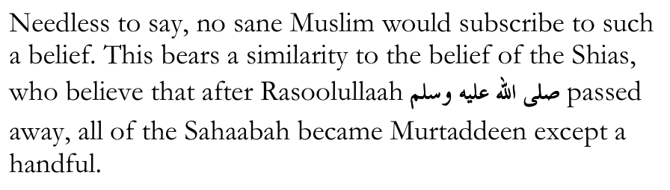
If a person reads the list of the `Ulamaa given above who were either Ash`ari or Maatureedi, and he reads the eras in which they lived, he will see that for centuries after centuries, from the time of Imaam Abul Hasan al-Ash`ari and Imaam Abu Mansoor al-Maatureedi until the present day, the vast majority of the `Ulamaa have been either Ash`aris or Maatureedis. Just as how, from the time of the Four A'immah, i.e. Imaam Abu Haneefah, Imaam Maalik, Imaam ash-Shaafi`ee and Imaam Ahmad ibn Hanbal, the `Ulamaa and the entire Ummah have followed one of the four Madhaahib. Every `Aalim was either an Ash`ari or a Maatureedi in `Aqeedah, and in Fiqh he was either a Hanafi, or a Maaliki, or a Shaafi`ee or a Hanbali. Once, again, this was the case with the vast majority. A'immah of the calibre of Imaam Muhammad ibn al-Hasan ash-Shaybaani, Imaam Abu Yusuf, Shams-ul-A'immah as-Sarakhsi, Fakhrul Islaam al-Bazdawi, Imaam al-Kaasaani, Saahib-e-Hidaayah Imaam al-Margheenaani, Imaam Abu Bakr ar-Raazi al-Jassaas and so many others, they all chose to follow the Hanafi Madh-hab rather than being "Ghayr Muqallideen".
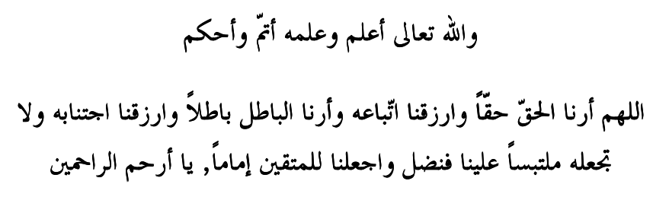
- Muhammad Huzaifah ibn Adam Friday, 27th of Rabee`-uth-Thaani, 1440 A.H. - 4th of January,

