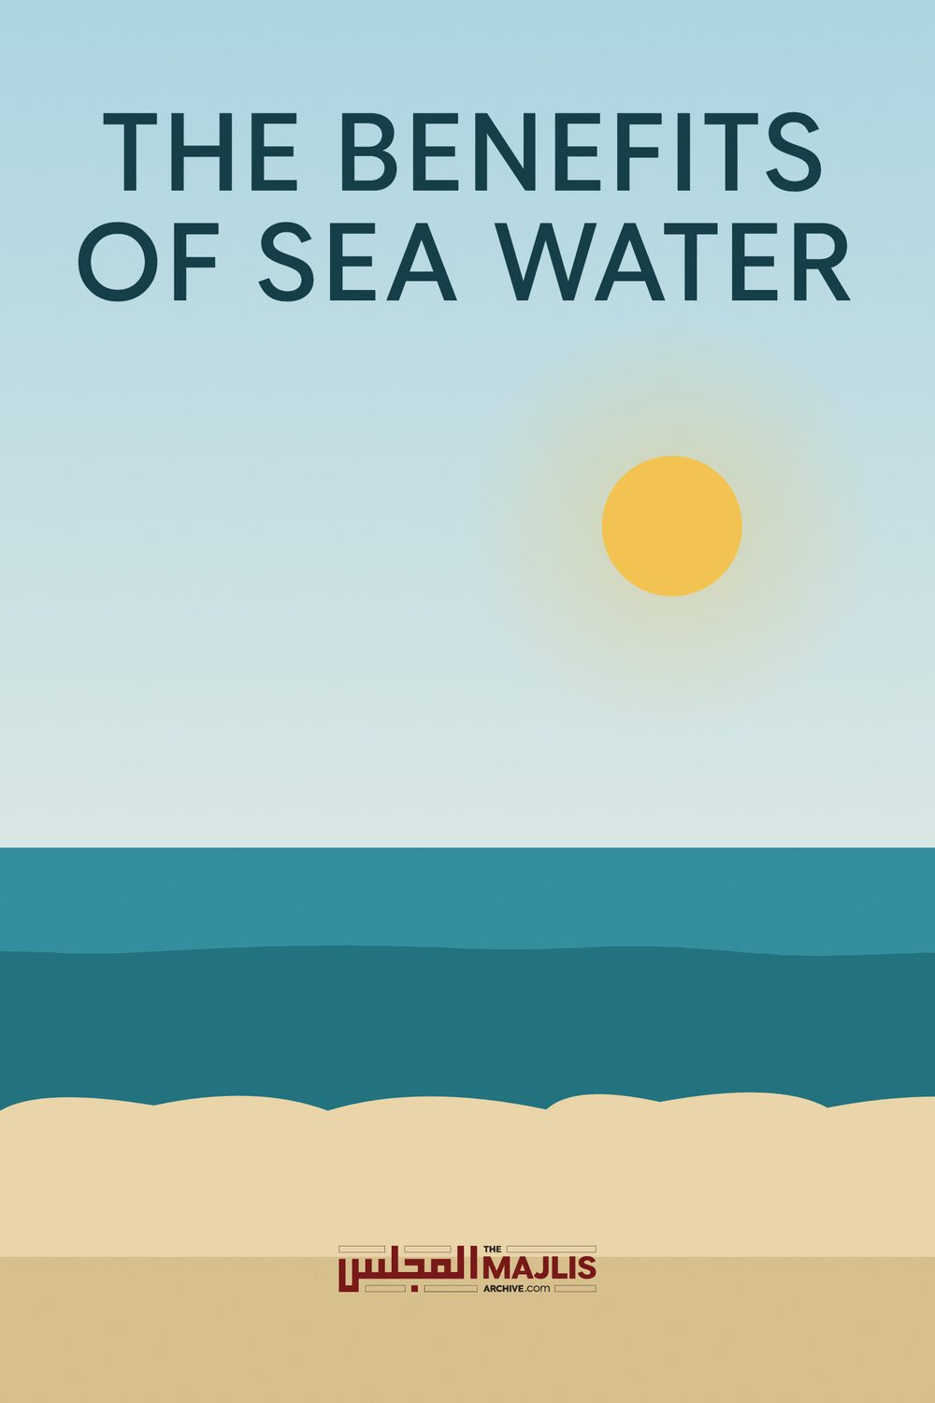

THE BENEFITS OF SEA WATER
The Majlis · Voice of Islam
Mujlisul Ulama of South Africa

About this edition
This is a reproduction by The Majlis Archive (themajlisarchive.com) of a publication of The Majlis, Mujlisul Ulama of South Africa, made and published with their permission.
The PDF as The Majlis issued it is the original. This edition was read from that PDF's own structure and checked against it letter for letter; where the two differ, the PDF is correct.
Checked: 98 paragraphs, 0 differing; a second, independent PDF reader finds 100.0% of the PDF's words here.
Nothing has been reworded, added or removed.

6056, South Africa

SEA WATER
First of all, sea water is a miracle treatment for acne and semi-permanent scars. Salt is an excellent curing, clearing, and cleansing agent. ... Salt water has been used as a cleanser for thousands of years. It helps rid the skin of toxins and cures cuts.
Health benefits of the beach and sea water - Desroches Hotel
What are the uses of salt water?
Add ½ a teaspoon of salt to a cup of warm water, as recommended by Adirondack Oral & Maxillofacial Surgery. Rinse your mouth every two to three hours for the first few days after surgery, then use it three to four times a day thereafter. You can use the rinse to soothe and heal mouth sores.
How a Salt Water Mouth Rinse Benefits Oral Health - Colgate Why is sea water good for your skin?
Sea salt is packed with healthy skin-friendly minerals like magnesium, calcium, and potassium, which is exactly what makes it so beneficial to various skin conditions. It absorbs the toxins in the body and on the skin, including acne-causing bacteria, and works to treat infections and encourage the healing process.
5 Surprising Beauty Benefits of Salt Water | StyleCaster
Salt Water Flush Takeaways By drinking a beneficial mixture of real sea salt dissolved in water, you're able to push waste through the body, release toxins and improve digestion. A salt water flush is designed to help you cleanse your colon and digestive system by bringing on a forced bowel movement.
Salt Water flush safest way to cleanse the Colon and Detox - Dr. Axe
What are the benefits of using sea salt?
Is sea salt good for your face?
Salt helps to cleanse pores deeply, balance oil production and thwart bacteria that can instigate breakouts and acne. Try it: Mix one teaspoon sea salt with four ounces of warm water in small spray bottle until salt is dissolved. Mist on clean, dry skin, avoiding eyes. Use daily or twice daily.
9 Ways to Use Salt for Gorgeous Skin, Hair, Teeth, and Nails
What does salt do to the body?
Rarely do we think about what goes into nature's most common treasures, like salt. This natural mineral comes straight from the earth, formed into crystals from a combination of sodium and chloride. It is naturally found in seawater, making up at least three percent of our world's oceans. And when seawater is trapped, the water evaporates and leaves salt crystals behind.
Despite what you may have heard about sodium and your health, a natural source of salt holds vital nutrients that are important in maintaining optimal wellness. First, salt provides key minerals like sulphur, calcium, sodium, magnesium, silicon, boron, potassium, bromine and strontium. With its rich mineral content, salt can help with weight loss, reduce asthma symptoms, improve blood sugar levels and regulate heart health.

ABSTAIN FROM REFINED TABLE SALT
However, be aware that not all salts are created equal. Table salt, for example, is highly processed and bleached before it makes its way into that little glass bottle. Unfortunately, during mass production, manufacturers strip it from anything good for your health. The result is a product that has no resemblance to its original form and it can even harm your health. When doctors warn against consuming too much salt, table salt is what they are referring to.
For your skincare routine, and health in general, try using these unprocessed varieties:
Sea salt for skin Salt water made with sea salt or pink Himalayan salt is best.
Natural sea salt contains the many minerals that our bodies need, like magnesium, calcium, sodium and potassium. All of these play a role in the health of our skin, allowing cells to communicate with each other and heal issues that crop up. When you don't have enough of a mineral, you'll see pesky symptoms such as skin dryness, dullness, irritation and blotchiness. Luckily, sea salt can naturally improve hydration and strengthen the outer layer of the skin to keep you looking healthy.
Pink Himalayan salt for skin Despite the name, there are actually no salt mines in the Himalayan mountain range. The pink salt slabs come from the Khewra Salt Mine in Pakistan, roughly 300 miles west of the Himalayas. As the second largest salt mine in the world, people have been gathering this commodity for more than 2,000 years. Only in the last decade or so has it become popular in Western culture. The salt is comprised of 95 percent sodium chloride. The rest is a mix of polyhalite and other minerals, which give the salt its characteristic pink hue. Because of the lack of processing, it still contains the beneficial minerals that your skin will love.
How salt water can benefit your skin Since salt water therapy has been used for centuries around the world, including ancient Greece, there is strong anecdotal evidence that it works wonders on the skin. A handful of studies have found that salt water bathing is particularly effective for troublesome skin conditions, like psoriasis.
Salt water is said to benefit your skin in the following eleven ways:
• Closes open pores • Soaks up excess oil • Balances oil production • Kills acne-causing bacteria • Diminishes scars • Heals scrapes and cuts • Exfoliates dead skin cells • Restores skin's natural pH • Improves skin barrier function • Enhances hydration • Reduces inflammation
Reduce acne with salt water treatment Apply warm salt water directly to acne to kill the bacteria.
If you're lucky enough to live near the ocean, perhaps you already know this beauty secret. But if you don't live on the coast, simply whip up some warm salt water the next time you have a breakout. Try mixing one cup of purified water with one tablespoon of sea salt. Use a cotton ball to gently apply salt water to acne and let it dry.
By the way, if you try this treatment and your acne still doesn't clear up within a day or two, perhaps your diet is the culprit. Make sure to avoid sugar, processed junk, gluten, peanuts, yeast and dairy for awhile to see if your skin clears up. Eat plenty of leafy greens, lean sources of protein and healthy fats like coconut oil and avocados — your skin and waistline will thank you.
Drink salt water to heal from the inside out Drink salt water, called sole, to improve digestion, detoxify your cells and more.
The nice thing about salt water is that there are more than a few ways to use it. A glass of warm salt water, called "Sole," is a great way to start your day and promote healing internally. Provided that you use a natural form of salt (and avoid drinking sea water), it'll promote hydration, aid digestion, reduce inflammation, improve your sleep, detoxify your cells, improve your bone health and more.

Sole Ingredients
• Unrefined natural salt • Filtered water Equipment
• Quart-size mason jar with plastic (not metal)
storage cap Instructions
1. Fill mason jar one-third full with unrefined, natural salt.
2. Fill the jar with filtered water, leaving two inches at the top.
3. Cover the solution with storage cap.
4. Shake and let it sit for 24 hours.
5. Check in 24 hours to see if all salt crystals are dissolved, then add a little more salt.
6. When the salt no longer dissolves, the Sole is ready.
7. Store covered on a counter or in a cupboard. The antibacterial and antifungal properties of the Sole will help make it last indefinitely. Enjoy!
— Hilary Lebow

HEALTH BENEFITS OF SEA WATER
by Joseph Eitel
Overview Sea water, such as that found in oceans, contains approximately 35 grams of salt per liter of water, according to the National Weather Service. This salty water offers several health benefits, although it should be noted that drinking excessive sea water, or salt water for that matter, can potentially lead to several diseases, including hypernatremia. Using sea water as a form of therapy, also known as thalassotherapy, has been around for centuries and was used by the Ancient Egyptians.
Skin Sores And Ear Infections
An Australian study published at the National Institutes of Health website suggests that salt water swimming pools can have a positive effect on pyoderma (skin sores) and
"perforations of the tympanic membrane" (ear infection) in children under the age of 17. The study concluded that the incidences of these two medical issues decreased by 50 percent in Aboriginal children after regular exposure to the sea water in newly constructed salt water swimming pools. The study goes on to say that "swimming in a salt water pool provides the equivalent of a nasal and ear washout and cleans the skin."
Treatment For Atopic Dermatitis Atopic dermatitis is a type of chronic skin disease characterized by inflamed, itchy skin; it's also a type of eczema. A Japanese report published by the National Oceanographic Data Center, suggests that sea water is an effective treatment for atopic dermatitis. The sea water provides itching and burning relief to those with this type of eczema. The study goes on to say that the treatment is more effective when deep sea salt water is used rather than surface sea water because of the various bacteria found near the surface.
Bronchitis Relief Inhaling sodium chloride, or salt from sea water, in aerosol form is called halotherapy. Traditionally, this type of therapy was accomplished through prolonged exposure to salt mines and other high salt concentrated areas, but today the same effect can be reproduced via aerosol forms of salt. This type of therapy was used in a 1995 study for treating patients suffering from acute bronchitis. The results showed favorable changes in metabolic activity, normalization of serotonin levels, and a decrease in the unbalance of the lipid peroxidation-antioxidant system. Halotherapy is commonly used in Europe and other Eastern countries as a treatment for COPD, or chronic obstructive pulmonary disease, as well as for other types of respiratory diseases.
Psoriasis And Psoriatic Arthritis Treatment Sea water treatment has been shown to improve the effects of psoriasis and psoriatic arthritis in patients suffering from the diseases.
References National Weather Service: Sea Water

o National Institutes of Health: Swimming Pools Provide Health Benefits
o National Oceanographic Data Center: The Application of Deep Sea Water in Japan o Pub Med.gov: The Use of Halotherapy for the Rehabilitation of Patients with Acute Bronchitis and a Protracted and Recurrent Course
The Health and Beauty Benefits of Salt Water Many of us have been told that sea water is good for us. We have been told to "take our troubles to the water," but what does the ocean really do for our health?
Well, let's start off with the basics. We are made up of water. Our bodies consist of about two-thirds water, and the only mineral we can ingest is salt. We have the elements of sea water within our systems, so how does swimming in the ocean help us?
First of all, sea water is a miracle treatment for acne and semi-permanent scars. Salt is an excellent curing, clearing, and cleansing agent. Sodium chloride helps to cleanse the skin and is effective for mild acne. Instead of using harsh chemicals that can damage pores and cause scarring, try taking a trip to the waves instead.
Salt water heals cuts and sores. Have you ever been told to go into the ocean for your scrapes? Salt water has been used as a cleanser for thousands of years. It helps rid the skin of toxins and cures cuts. That's why it is often recommended that we gargle with salt water. Salt also dries out the pus in wounds. It may sting when you first touch the water, but when you come out, your sores should be much less painful than they were before you went in.
Salt water also acts as a natural shampoo. Have you noticed that your hair is extremely dry after coming out of the water? This is because the salt in the ocean removes excess oils. If you have a particularly greasy scalp, then salt water is an excellent way to strip those heavy oils. Bathing in sea water also adds volume to your hair, especially if you use many products. The salt gets rid of the built-up chemicals from conditioners, hair sprays, and gels, and thus your hair isn't nearly as weighed down. The water even gets rid of dandruff, especially when the salt particles are large, because it acts as an exfoliant to your scalp.
It clears your nasal passageways. If you've ever gone into the water with a stuffed nose, you know that the moment salt water enters your nose, tons of goop comes seeping out. Gross, right? If you've ever had a stuffed nose, you may have used a neti pot full of salt water to cleanse your sinuses. Doctors often recommend flushing the nostrils with salt water to help alleviate built-up mucus. Why use a neti pot when you can just go for a swim? Don't worry, whatever goes into the water gets cleansed by the ocean's natural janitors, the algae and sea plants.
Finally, swimming in sea water helps you stay fit. This is perhaps the most conventional of the beach's benefits. When you are swimming, you use muscles in your shoulders, arms, and legs that aren't used in any other activity. That's why swimming is often recommended as a great way to exercise. Even treading water at a fast pace will burn 590 calories an hour if you weigh less than 130 lbs. If you weigh more, then it burns even more calories.
Is it Healthy to Drink Salt Water?
You've probably heard that drinking salt water is bad for you, and this is certainly true if it is your only source of hydration. Salt water is called a hypertonic fluid because it has a salinity level of 35. It contains almost four times the amount of salt than human blood! Too much salt causes cell shrinkage and wreaks havoc on our bodies. If you drink too much salt water, you will actually deplete your body of fluids.
You may have been told that salt is bad for you, and it is true that excess sodium is not healthy. However, if you have good health, watch your diet, and do not overindulge in salty foods, drinking a solution of salty water can be good for you. Small doses of unrefined sea salt can be very beneficial to your health, since salt has many trace minerals and nutrients your body needs. Salty water and drinks are imbibed after a heavy workout by extreme athletes to help them regain the salt and fluid they lost in sweat. Salt water was used in ancient Ayurvedic practices to cleanse and detox the body. Some say drinking salt water helps clean and repair your digestive tract. Among other benefits, salt helps to:
• maintain a healthy balance of blood sugar • regulate your metabolism • boost the immune system • maintain bone strength • alleviate inflammation • maintain healthy skin
Instead of drinking seawater (which may be too impure or salty), most proponents of doing a salt water flush simply drink a big glass of moderately-salty water when they get up in the morning. Simply dissolve anywhere from 3 or 4 teaspoons of good salt (sea salt, Himalayan salt, or iodized salt is fine) in about 4 cups of water and drink.
Consult your doctor before you add any salt to your diet.

Himalayan Pink Crystal Salt
The health benefits of using natural Himalayan Crystal Salt may include:
• Controlling the water levels within the body, regulating them for proper functioning • Promoting stable pH balance in the cells, including the brain.
• Encouraging excellent blood sugar health • Aiding in reducing the common signs of aging • Promoting cellular hydroelectric energy creation • Promoting the increased absorption capacities of food elements within the intestinal tract • Aiding vascular health • Supporting healthy respiratory function • Lowering incidence of sinus problems, and promoting over-all sinus health • Reducing cramps • Increasing bone strength • Naturally promoting healthy sleep patterns • Circulator support • Promotes kidney and gall bladder health when compared to common chemically-treated salt
• Contains 84 essential minerals required by the human body • 85% sodium chloride, 15% trace minerals
The Harms of Common Table Salt • "Purified", a process that involves re-crystallization at over 1,200 degrees Fahrenheit (649 degrees Celsius) which strips away natural minerals • The refining process involves the use of aluminium, ferro cyanide, & bleach • 97.5% sodium chloride, 2.5% additives • Depleted of its natural minerals • Includes anti-caking compounds • Sometimes fluoridated in non-US countries

HIMALAYAN SALT LAMPS
• Purifies the Air - removes bacteria, dust, allergens, smoke and mould from the air
• Reduces Stress and Depression - emits uplifting, positive charge of energy
• For Feng Shui - lamps are usually appealing and calming. They assist in opening blocked energy in your home or workplace How They Work Himalayan salt lamps, when heated with a candle or light bulb, emit negative ions which binds to air pollutants (positive ions). This causes them to lower to the ground level, leaving the air fresh. Negative ions are believed to produce beneficial biochemical reactions in our bloodstream that increase levels of serotonin.

