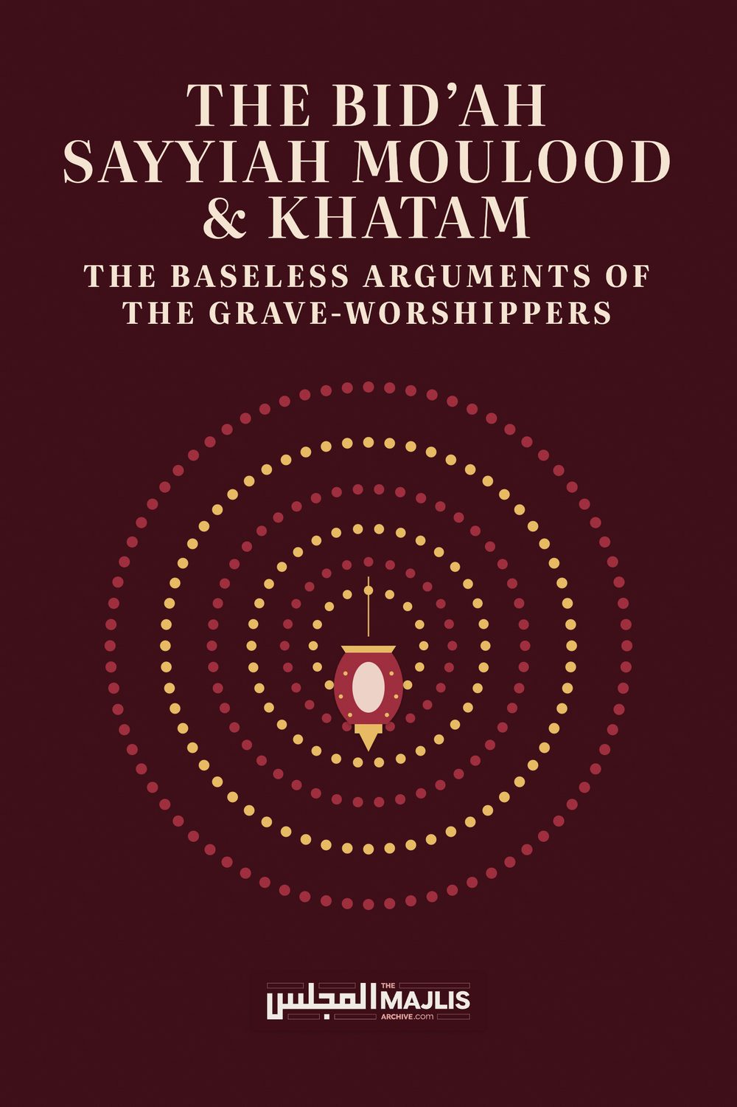

The Bid'ah Sayyiah Moulood & Khatam BASELESS ARGUMENTS
The Majlis · Voice of Islam
Mujlisul Ulama of South Africa

About this edition
This is a reproduction by The Majlis Archive (themajlisarchive.com) of a publication of The Majlis, Mujlisul Ulama of South Africa, made and published with their permission.
The PDF as The Majlis issued it is the original. This edition was read from that PDF's own structure and checked against it letter for letter; where the two differ, the PDF is correct.
Checked: 324 paragraphs, 0 differing; a second, independent PDF reader finds 98.8% of the PDF's words here.
Nothing has been reworded, added or removed.

The Bid'ah sayyiah Moulood & khatam The BASELESS ARGUMENTS OF THE GRAVE-WORSHIPPERS

MUJLISUL ULAMA OF SOUTH AFRICA PO BOX 3393 PORT ELIZABETH 6056 SOUTH AFRICA

PREFACE

THE QABAR PUJAARIS (GRAVE WORSHIPPERS)
The Qabar Pujaaris (Grave Worshippers) who flourish predominantly in the Indian subcontinent, are the main upholders of a variety of evil customs and practices of shirk and bid'ah. This brief treatise deals with two Bid'ah practices of the Qabar Puja sect, viz. Moulood/Mawlid/Meelaad and Khatam practices of the 3rd day (Teeja), 40th day (Chaaliswa) and the like. Besides these two evil bid'ah acts, they are drowned in a deluge of bid'ah and shirk basically related to grave-worshipping.
The first known Aalim of Haqq who was also one of the greatest among the Auliya of India and also a Muhaddith, Hadhrat Shah Waliyullah (Rahmatullah alayh) had dubbed these people of bid'ah and shirk 'Qabar Pujaaris' (Grave Worshippers) since many of their evil shirki practices pertain to actual grave-worship. He states in his kitaab, Balaaghul Mubeen:
"It is necessary to know that the fitnah of grave worship is a disease. These Qabar Pujaaris are also called peer-parast (worshippers of their peers). These Grave Worshippers regard their evil act of grave worship to be superior to even Namaaz, Roza, Hajj, Zakaat, Masnoon Wazaa-if, e.g. Durood Shareef, etc.
According to the Qabar Pujaaris, Qabar Puja (grave worship) is an adequate substitute for everything. For them worshipping graves is an adequate substitute for Namaaz, Roza, etc. But, they do not consider any Ibaadat decreed by Allah Ta'ala to be an adequate substitute for Qabar Puja.
They believe that participation in the functions such as Urs, Nauchandi, etc. is of greater importance than the Fardh Ibaadaat and acquisition of Ilm. Their vilest act is that they hasten to these graves with their worldly needs and problems. Then they stand with reverence and humility at the graves to supplicate for the fulfilment of their needs. Yet, they do not display one tenth of such reverence in the Musaajid in the presence of Allah Ta'ala Who is Omnipresent (Haazir-Naazir).
Mentioning the name of the inmate of the grave, they call on to him and they supplicate to him. They appeal to him for rizq and for children……They indulge in innumerable acts of shirk in the manner the mushrik Hindus do in the presence of their idols."
Shah Waliyullah (Rahmatullah alayh) had written much in refutation of the Qabar Pujaaris. He was never a supporter of the numerous acts of bid'ah of these miserable grave worshippers.

INTRODUCTION
"Every bid'ah is in the Fire."
(Hadith)
The Ahaadith in condemnation of Bid'ah (Innovation) are numerous and well-known to even the people of Bid'ah.
Bid'ah (Innovation), regardless of its outer façade of 'ibaadat' is reprehensible and haraam. Bid'ah is shaitaan's plot to demolish Islam. That is why Rasulullah (Sallallahu alayhi wasallam) said:
"He who honours a man of Bid'ah assists in the demolition of Islam."
The Shariat of Nabi Musaa (Alayhis salaam) and the Shariat of Nabi Isaa (Alayhis salaam) were demolished with the shaitaani plot of bid'ah. Thus, the Sahaabah did not tolerate the slightest deviation from the Sunnah – the Sunnah as they had acquired it from Rasulullah (Sallallahu alayhi wasallam).
Even senior, sincere Ulama and Mashaaikh were victims of the extremely subtle bid'ah plot which shaitaan cunningly prepared to enmesh them into his tentacles. The laity (awaamun naas) as well as molvis whose knowledge is not grounded, became ensnared by the outer 'ibaadat' façade with which shaitaan adorns the acts of bid'ah. Thus, while their gaze is focused on the 'good' factors, their short-sightedness does not permit them to understand the danger inherent in innovation regardless of the 'good' factors and regardless of the innovated practice being practised without the evil acts which are generally associated with bid'ah customs such as moulood, urs, fixed day khatams, etc. Bid'ah per se is haraam even if bereft of evils. Bid'ah itself is evil, hence even Salaat innovated in conflict with the Shariah will be Bid'ah Sayyiah, i.e. evil, dark bid'ah. For example, adding a raka't or two to the Fardh Salaat or performing Salaat in a prohibited time.
The only 'daleel' which the promoters of bid'ah manage to have discovered is the statements of some senior Ulama, e.g. Ibn Hajar, Sakhaawi, Qastalaani (Rahmatullah alayhim). Yet, they fail to understand that these Ulama appeared on the scene some 7 and 8 centuries after the Sahaabah. Islam did not commence centuries after the Sahaabah. It is therefore, ludicrous to bypass the Sahaabah and to present as daleel the views of Ulama who appeared many centuries after the perfection and finalization of Islam.
The Pivot of the Shariah is the Jamaat of the Sahaabah, not Ulama who flourished 8 centuries after the Sahaabah. Therefore, if any statement/opinion of such Ulama conflicts with the Practice of the Sahaabah, it
(this Practice) may not be interpreted for acceptance while the amal of the Sahaabah is made subservient to the views of the Ulama of 8 centuries after the Sahaabah. On the contrary, the conflicting views of the Ulama shall be interpreted and set aside, not cited as daleel. Of primary importance is the Sunnah of the Sahaabah.
Great Ulama too err. Many have erred grievously, hence the warning of the Fuqaha is: "He who grabs (as daleel) the nawaadir of the Ulama has made an exit from Islam." In fact, the Qur'aan prohibits subservience to the opinions of the Ulama when these conflict with the established Shariah. Thus, the Qur'aan Majeed castigating the people of Bani Israaeel, says:
"They took their ahbaar (ulama) and ruhbaan
(buzrugs) as gods besides Allah, and they also took
Isaa, the son of Maryam (as a god)."
There are simple issues which even the laity (awaamun naas) can readily understand, hence Rasulullah (Sallallahu alayhi wasallam) said: "Seek a fatwa from your heart." The acts of Bid'ah which have been fabricated by men of the Nafs had no existence during the golden era of Islam known as Khairul Quroon. This was the Age which Rasulullah (Sallallahu alayhi wasallam) describes as the 'Best of Ages". It was the Era of the Sahaabah, Taabieen and Tab-e-Taabieen. It was the Era in which flourished the greatest Fuqaha and Aimmah Mujtahideen of Islam such as the illustrious Imaams of the Math-habs and the Muhadditheen.
The era of Dhalaal (Deviation and Falsehood) set in after the Khairul Quroon. Confirming this fact, Rasulullah (Sallallahu alayhi wasallam) said:
"Honour my Sahaabah, for verily, they are your noblest, then those after them (the Taabieen), then those after them (the Tab-e-Taabieen). Thereafter
KITHB (Falsehood) will become prevalent.
For guidance we look at the Qur'aan and the Sunnah. No one understood the Qur'aan and Sunnah better than the Sahaabah. Therefore, it is a grievous and an egregious error to submit the ways and practices of the Sahaabah to the opinions of later Ulama. The correct approach is to submit the opinions of the later Ulama to the Sunnah as understood and practised by the Sahaabah.
If it is not possible to reconcile the statements of the Ulama with the Sunnah of the Sahaabah, then the former should be discarded. But, never can the Sunnah of the Sahaabah be set aside and discarded. Understand this fact well! Moulood and Qur'aan khatams as are being practiced in these times had absolutely no existence in the Khairul Quroon era.
The custom of moulood was innovated about six centuries after the Sahaabah. It was a massive, extravagant merrymaking custom of feasting and picnicking introduced by a worldly king. Ulama who associated with the king, with their focus on the 'good points' issued fatwas of permissibility without realizing the lasting damage being inflicted on the Ummah and on Islam.
The judgment of Ulama becomes clouded and their discernment is cast into disequilibrium by associating with kings and rulers. That is why Rasulullah (Sallallahu alayhi wasallam) said: "Verily, the vilest – most hated – Qurra' by Allah are those who visit the rulers."
Rasulullah (Sallallahu alayhi wasallam), advising and guiding all Muslims, said: "Seek a fatwa from your heart." Every intelligent, sincere Muslim can readily comprehend the error of bid'ah being sanctioned and praised by some Ulama many centuries after the Sahaabah. The sincere heart of the Mu'min understands that the Shariah stems from the Qur'aan and the Sunnah, not from the obscure, dubious views of Ulama who appeared many centuries after the Sahaabah.
Blind acceptance of such views and fatwas of the Ulama which appease the nafs, was the attitude of Bani Israaeel whom the Qur'aan castigates:
"They (the people of Bani Israaeel) took their ahbaar (ulama) and ruhbaan (buzrugs) as gods besides Allah, and they also took Isaa, the son of Maryam (as a god)."
This is not the way of the People of Islam. They are instructed to consult their conscience – the hearts and to apply their minds to understand the truth.

THE MOULOOD / MAWLID / MEELAAD BID'AH
"EVERY BID'AH IS DHALAALAH (DEVIATION), AND EVERY DEVIATION WILL BE IN THE FIRE." (Hadith)

"VERILY, ALLAH DEPRIVES EVERY PERPETRATOR OF BID'AH FROM TAUBAH." (Hadith)

THE BASELESS ARGUMENTS OF THE BID'ATIS
In their abortive attempt in support of the bid'ah of moulood, the promoters of bid'ah say:
'Imam Al-Hafiz Abu Al-Fadl Ibn Hajar said: "The origin of the Mawlid celebration is an innovation that was not transmitted from any of the righteous predecessors of the three centuries, but despite that it included good points and their opposites. So whoever seeks out the good points in his celebration and avoids their opposites, it is a good innovation." (The translation is not ours)

OUR COMMENT
The argument is baseless. Despite conceding that moulood is such a bid'ah for which there is no basis in Khairul Quroon, Ibn Hajr (Rahmatullah alayh) nevertheless, labours on its assumed 'good points' to extravasate permissibility.
Adding a few raka'ts after Fajr Salaat could be argued as being a 'good point'. Fasting on the Day of Eid has 'good points'. Similarly, numerous innovations have 'good points'. However, the 'good points' do not transform the bid'ah practice into a permissible act nor into a meritorious act. Despite the imagined 'good points', the entire bid'ah act is BAD and haraam.
Rasulullah (Sallallahu alayhi wasallam) said: 'Whatever is innovated into this Deen of ours is mardood (rejected/accursed)."
"The vilest of deeds are innovations (bid'aat). Every bid'ah is dhalaalah" (deviation leading to Jahannam).
The Bid'atis say:
"Imam Al-Sakhawi said: "If there was nothing in that except humiliating Satan and making the faithful Muslims happy, it would be enough. If the people of the cross took the birth of their prophet as a greater holiday, then the people of Islam are more deserving of honor and more worthy. May God have mercy on the man who took the nights and days of this blessed month as holidays so that they would be a greater burden on those who have the slightest illness in their hearts and the most exhausting disease." (This English translation is not ours)

OUR COMMENT
The venerable Imaam Sakhaawi (Rahmatullah alayh) has indeed committed a grave error in his discernment.
Drawing support for moulood from the customs of Christian mushrikeen is lamentably ludicrous.
Far, very far from shaitaan being humiliated by practising bid'ah, on the contrary, shaitaan is delighted by bid'ah. In fact, it is shaitaan who influences men to introduce bid'ah. It is shaitaan who deceives and deviates them with imaginary 'good points' of the practices he inspires them with. Shaitaan is the Chief Originator of bid'ah. Bid'ah is one of his most potent tools and traps with which he ensnares and deviates even senior Ulama notwithstanding their sincerity. Such Ulama who become ensnared in the bid'ah traps of Iblees lack foresight. They are simple-minded and fail to understand the harms intrinsic in bid'ah. Thus, Rasulullah (Sallallahu alayhi wasallam) said:
"He who honours a man of bid'ah aids in the demolition of Islam."
Muslims may not be "made happy" with bid'ah. Muslims should be taught to be happy with the Deen as revealed by Allah Ta'ala – as taught by Rasulullah (sallallahu alayhi wasallam), and as practised by the Sahaabah, Taabieen and Tab-e-Taabieen during the Khairul Quroon era. After this era, Rasulullah (Sallallahu alayhi wasallam) said: 'Kithb (falsehood) will become prevalent." Thus, moulood is Kithb.
The statement: "If the people of the cross took the birth of their prophet as a greater holiday, then the people of Islam are more deserving of honour and more worthy.", appears to be a lie attributed to Imaam Sakhaawi. It is indeed absolutely ridiculous, to say the very least, to suck justification and permissibility for moulood from the Christian custom of Christmas. If the venerable Imaam had indeed made this statement, it may not be cited and presented as daleel for the haraam moulood custom.
The Fuqaha and Ulama have said: 'Whoever extracts daleel from the errors/obscurities (nawaadir) of the Ulama has made his exit from Islam.'
The mind is staggered and boggled by the argument that proffers a custom of the mushrikeen as daleel for a bid'ah. We do not base the practices of the Deen on the beliefs and customs of the people of the cross. The abode of the people of the cross is Jahannam.
The statement: "May God have mercy on the man who took the nights and days of this blessed month as holidays so that they would be a greater burden on those who have the slightest illness in their hearts and the most exhausting disease.", is a ludicrous, inexplicable conundrum devoid of substance. Did the Sahaabah, Taabieen and Tab-e-Taabieen not understand the significance of the nights and days of Rabiul Awwal? Why did the illustrious Souls of Khairul Quroon not celebrate these days and nights in the way in which the promoters of moulood do? We follow the Sahaabah, not Imaam Sakhaawi nor Ibn Hajr nor any other promoters of Bid'ah regardless of their seniority and Ilmi erudition.
The Bid'atis presenting the opinion of another luminary, say:
"Al-Qastalani said: 'And the people of Islam, after three centuries, continue to celebrate the month of his birth, peace and blessings be upon him, and they hold banquets and give charity on his nights in various forms, and they show joy, and increase their charitable deeds, and they take care to read the story of his noble birth, and from his blessings every abundant virtue appears upon them....". (Translation, not ours)

OUR COMMENT
Qastalani's comment defies credulity. He has failed to recognize the many evils attendant to the bid'ah of moulood. Assuming that moulood was not accompanied by the evil elements, then too it will be a bid'ah to be shunned since it is an innovation shoved into the Deen centuries after the era of the Sahaabah – a bid'ah which according to Rasulullah (Sallallahu alayhi wasallam) is mardood (rejected and accursed). It is wretched regardless of its outer facade of ostensible 'ibaadat because it is not part of the Deen. It is an innovation inspired by Iblees.
Yes, it was centuries after the Sahaabah that shaitaan infused into the brains of Muslims to innovate a custom which the Sahaabah had never known. Surely, the Sahaabah had greater love for Rasulullah (Sallallahu alayhi wasallam) than the entire Ummah! The Sahaabah were better informed of the birth of our Nabi (Sallallahu alayhi wasallam), but it never occurred to them nor to the Taabieen nor to the Tab-e-Taabieen to innovate the drivel which the later ulama lauded without realizing that the drivel of moulood was the inspiration of Iblees.
No one prohibits reading the stories of Rasulullah (Sallallahu alayhi wasallam). But what induces the people of bid'ah to select the month of Rabiul Awwal to read and tell these stories, and to cloak the story-reading with functions of merrymaking and other paraphernalia for which there is no origin in the Sunnah? The Sunnah is the entire life story of Rasulullah (Sallallahu alayhi wasallam). It has to be compulsorily implemented practically in our daily life. It is not antique to be relegated to the museum of Rabiul Awwal from whence it is annually extricated, put on show, then forgotten for another year. This is the way of the kuffaar. It is a pathway in which even senior Ulama became ensnared by Iblees.
Joy, delight, pleasure and the like should be in the way expressed by the Sahaabah, not in the deviations of people who appeared centuries after Rasulullah (Sallallahu alayhi wasallam).
Those who desire 'blessings', should implement the Sunnah in their daily lives. Blessings are not acquired from innovations. On the contrary, bid'ah invites wrath –the Wrath of Allah Azza Wa Jal.
Reading the life episodes of Rasulullah (Sallallahu alayhi wasallam) is not moulood. No one has ever opposed reading about the Mubaarak life of Rasulullah (Sallallahu alayhi wasallam). In fact, daily in every Madrasah, the Ahaadith of our Nabi (Sallallahu alayhi wasallam) are the dominant subject. The focus of criticism is the bid'ah Moulood custom which is a complex baatil custom consisting of many evils. We are not speaking of story-telling.
The promoters of bid'ah say:
"Celebrating the birth of the most honorable of creation should be at the level of the one celebrating it, in terms of commitment, faith, and lack of affectation... As for what we must stay away from, they are the superstitions that the Fatimid and Mamluk eras left us, such as making special sweets for the birth, and holding banquets that the rich enjoy, not the poor, and other such abhorrent things. We must stay away from dancing circles that overthrow the minds and introduce chaos into the minds of Muslims." (This is not our translation)

OUR COMMENT
The Sahaabah would have been the very first to celebrate the birth of Rasulullah (Sallallahu alayhi wasallam) if any kind of celebration had any merit and if it was permissible. The most Honourable one of creation existed during the era of the Sahaabah. Why did they not celebrate his birthday? It is of the ways of the kuffaar to celebrate birthdays.
Bid'ah, being the innovation of Shaitaan, invariably attracts evil, waste, superstitions, haraam merrymaking functions and shirk. Iblees adorns bid'ah with 'good points' and he camouflages his innovations with 'deeni' hues and 'noble' intentions. The Sunnah becomes contaminated with satanic bid'ah practices which transform the Sunnah beyond recognition; the Sunnah is displaced. In fact entire new customs are innovated which have no origin whatsoever in the Sunnah.
In the trajectory of shaitaani bid'ah, the original Sunnah, if there was a Sunnah practice, is displaced and the innovations remain to be rigidly practiced and regarded as Sunnah. Hence, anyone who abstains from the innovated practice is castigated and branded anti-Sunnah and accused of having shunned the Sunnah. Stating this fact, Hadhrat Abdullah Ibn Mas'ood (Radhiyallahu anhu) narrating a Hadith said:
"What will be your condition when you are enveloped by a Fitnah which will make the elderly senile and the young will grow old. The people will regard it (the bid'ah fitnah) as being Sunnah. If anything from it is omitted, the people will say that the Sunnah has been abandoned." The Sahaabah asked: 'When will that be?' He replied: 'When your Ulama (of the Haqq) have departed; when your qaaris have become abundant; when the umara have become abundant; when the trustworthy will be few; when the dunya will be pursued with the amal of the Deen, and when Ilm will be imparted for purposes other than the Deen."
This is the attitude of the people of Bid'ah. They resort to takfeer of those who abstain from their merrymaking moulood functions. They accuse them of being disrespectful to Rasulullah (Sallallahu alayhi wasallam). In fact, they have elevated their haraam merrymaking moulood functions to a pedestal higher than even Salaat, leave alone the entire edifice of the Sunnah.
"Abhorrent things" always become attached to bid'ah just as parasites become attached to the animals they leech.
Continuing their narrative, the Bid'atis say:
"The matter is very simple if we investigate those actions that are not approved by religion or reason, and adhere to what our great religion allows us. Let us make this great occasion a moment to hold ourselves accountable, and draw inspiration from the fragrant biography to take from it a lesson to guide us and follow."

OUR COMMENT
Did the Sahaabah not know that the blessed birth of Rasulullah (Sallallahu alayhi wasallam) was a "great occasion"? Why did they not deem it appropriate and necessary to give a specific form consisting of a conglomerate of innovations to this 'great occasion'? Why did they not introduce 'moulood'? The simple answer is that it is a dark, evil bid'ah inspired by Iblees.
Bid'ah regardless of how 'beautiful' it may appear, it is a plot and trap of Iblees, and it is never approved by Islam which Allah Ta'ala had completed and perfected during the very age of Rasulullah (Sallallahu alayhi wasallam). No one can supersede the Sahaabah in the matter of love for our Nabi (Sallallahu alayhi wasallam).
Even if Haafiz Al-Qastalaani is reborn many times and if he devotes the entire years of all his lives praising our Nabi (Sallallahu alayhi wasallam), he will not attain the rank of the dust under the shoes of the Sahaabah. It is indeed lamentable that these illustrious Ulama who surfaced 7 and 8 centuries after the Sahaabah had failed to understand the villainy of a practice which has absolutely no origin and no sanction in the Sunnah of the Sahaabah. They have indeed slipped grievously in this regard notwithstanding their profound Knowledge.
We have to hold ourselves "accountable" every day of our lives, and not postpone the Hisaab (Reckoning) for the month of Rabiul Awwal when merrymaking functions negate the amal of muhaasabah (accountability) and muraaqabah. The gluttony and merrymaking for which these moulood functions are notorious are shaitaani inspirations. The issue of muhaasabah finds no accommodation in these nafsaani functions of joy and merrymaking. On the contrary, all these functions of joy gravitate the mind to the dunya, not to the Aakhirah.
Rasulullah (Sallallahu alayhi wasallam) said: "Increase the remembrance of Maut", and "Take an account (of yourselves) before an account will be demanded." Thikr-e-Maut and Muhaasabah have to be incumbently practised daily, not postponed for Rabiul Awwal. Even in Rabiul Awwal, moulood is a carnival affair – an Ibleesi function akin to the celebrations of the mushrikeen and kuffaar.
The way of accountability has been shown to us by Rasulullah (Sallallahu alayhi wasallam). The Ummah is not in need of new-fangled methods of merrymaking innovated centuries after the era of Rasulullah (Sallallahu alayhi wasallam). With their innovations they imply and ingeniously impute imperfection to the Deen, hence the need for innovating practices which did not exist during Khairul Quroon and which the bid'atis elevate higher than even acts of the Sunnah.
Lessons from the "fragrant biography" of Rasulullah (Sallallahu alayhi wasallam) are available daily and are required to be practically implemented in our daily life. The objective of the "fragrant biography" is not singing songs of praise and story-telling during Rabiul Awwal. These bid'atis forget about the 'fragrant biography' all year round, and extract it from the museum where they have antiquated it by expunging it from their daily lives. The objective of the 'fragrant biography' is the practical implementation of the Sunnah in our day to day life. Merrymaking functions and singing songs never were of the Sunnah of the Sahaabah.
Drawing support from the error of Imaam Suyuti, the Bid'atis say:
"Imam Al-Suyuti, may God have mercy on him, said: Praise be to God, and peace be upon His chosen servants. The question arose about celebrating the Prophet's birthday in the month of Rabi' al-Awwal. What is its ruling according to Islamic law? Is it praiseworthy or reprehensible? And will the one who does it be rewarded, or not? The answer I have is that the origin of the Mawlid celebration, which is the gathering of people, reading whatever is easy from the Qur'an, and narrating the news that came about the beginning of the Prophet's command, peace and blessings be upon him, and the signs that occurred at his birth, then a table is spread out for them to eat, and they leave without doing anything more than that, is one of the good innovations for which its doer will be rewarded, because it includes glorifying the status of the Prophet, peace and blessings be upon him, and showing joy and good tidings at his noble birth."

OUR COMMENT
The venerable Imaam Suyuti (Rahmatullah alayh) has grievously erred in his understanding. All bid'ah is evil. New practices shoved into the Deen are shaitaani inspirations.
The claim that the perpetrators of moulood will be rewarded is baseless. There is no Nass and no valid daleel to substantiate this opinion. On the contrary, people of bid'ah are severely reprimanded in the Hadith. The so-called 'good points' with which the bid'ah is painted are in fact 'zukhruful qawl' (adorned statements) of shaitaan designed to deceive.
Did the Sahaabah fail for not "showing joy and good tidings" moulood style? Did they not understand something which Imaam Suyuti applauds? The ostensible cause for displaying joy moulood style is the birth of Rasulullah (Sallallahu alayh wasallam). That Cause existed during the age of the Sahaabah. So why did they not discern the need for celebrating the birthday of our Nabi (Sallallahu alayhi wasallam)? Even great Ulama sometimes slip disastrously, and along with them slip innumerable people of the Ummah.
A "good intention" does not necessarily validate a practice. Stealing, gambling, fornicating, etc. with good intentions do not become lawful on the basis of any good intention. The 'good intention' must necessarily be scaled on the Balance of the Shariah. Indeed Imaam Suyuti (Rahmatullah alayh) has grievously erred on the issue of the bid'ah of moulood.
Regarding Imaam Suyuti and Ibn Hajar, Hadhrat Maulana Ashraf Ali had commented that their vast knowledge of Hadith is so mountainous that they are able to crush one on whom they fall. But as far as ijtihaad is concerned, their discernment is flaccid. The bottom line for rejecting what Imaam Suyuti (Rahmatullah alayh) claimed regarding moulood is that there is no Shar'i daleel for the bid'ah which they term 'beautiful'. It was not even hinted by Rasulullah (Sallallahu alayhi wasallam) and there is no basis whatsoever for it in the Sunnah.
Whatever has been innovated into the Deen after the era of Khairul Quroon is Mardood (rejected, despised and accursed) regardless of the external paraphernalia of deceptive 'deeni' adornment. Rasulullah (Sallallahu alayhi wasallam) said:
"Honour my Sahabah for verily, they are your noblest; then those after them, then those after them. Thereafter KITHB falsehood) will become prevalent."
The Bid'atis say:
"He was asked about the ruling on the Mawlid celebrations and the dhikr that many people do in this time. Are they a Sunnah, a virtue, or an innovation? If you say that they are a virtue, is there any report from the Salaf regarding their virtue or any news? Is gathering for a permissible innovation permissible or not? And if because of them or because of the Tarawih prayer there is mixing and gathering between women and men, and with that there is companionship, conversation, and dealing that is not acceptable according to the Shari'ah?"
The rule of Sharia is that no matter how much the harm outweighs the benefit, it is forbidden. Tarawih prayer is a Sunnah and the aforementioned reasons occur because of it. So are people prevented from doing it or does that not cause any harm?"
He replied by saying: The Mawlid celebrations and remembrances that are performed among us, most of them include good, such as charity, remembrance, prayers and peace upon the Messenger of God, may God bless him and grant him peace, and praising him, and evil, indeed evils, if they were nothing but women seeing strange men, and some of them do not contain evil, but they are few and rare."
There is no doubt that the first category is forbidden due to the well-known established rule: that warding off harm takes precedence over bringing about benefits. So whoever knows that something evil will occur in what he does of that, then he is a sinner and a disobedient sinner. And supposing that he did good in that, perhaps his good is not equal to his evil. Do you not see that the Lawgiver was satisfied with what was easy of good, and weaned from all types of evil when He said: 'If I command you to do something, then do as much of it as you can, and if I forbid you from something, then avoid it.' So ponder it and you will learn what I have established, that evil, even if it is little, is not permitted in any of it; and good is satisfied with what is easy."

OUR COMMENT
This is indeed a meandering, obscure argument which zigzags between two opposites – vice and virtue without presenting a clear-cut Shar'i ruling to guide the masses. Regardless of whatever good is perceived in a 'moulood' devoid of evil acts, it remains bid'ah to be shunned since the Shariah provides no room for bid'ah. It is an undeniable bid'ah, and no amount of mental jugglery and sophistication with deceptive 'good points' justify innovation, for Rasulullah (Sallallahu alayhi wasallam) and the Sahaabah had stringently prohibited the introduction of new acts of ostensible 'ibaadat'. Hence, Hadhrat Ibn Mas'ood (Radhiyallahu anhu) had expelled a group of musallis from the Musjid branding them 'Bid'atis'. He called them Bid'atis and expelled them from the Musjid despite the only deed they were doing was Thikrullah. They were reciting only Allaahu Akbar, Subhaanallah and Alhamdulillah. However, since the method of their 'ibaadat' was in conflict with the Sunnah, they were branded to be people of Bid'ah, hence the imperative need for their expulsion from the Musjid.
Now what would have been the reaction of Hadhrat Abdullah Bin Mas'ood (Radhiyallahu anhu) if he was present in this era in which the moulood has been fabricated and innovated, and even grossly aggravated by blatantly haraam elements?
Continuing with their flapdoodle argument, the Bid'atis say:
"The second section: Sunnah, which is included in the hadiths that were reported regarding specific and general remembrances, such as the saying of the Prophet (peace and blessings of Allaah be upon him): "A group of people do not sit remembering Allaah except that the angels surround them, mercy covers them, tranquillity descends upon them, and Allaah mentions them among those who are with Him." Narrated by Muslim. It was also narrated that the Prophet (peace and blessings of Allaah be upon him) said to some people who sat remembering Allaah and praising Him for guiding them to Islam: "Gabriel (peace and blessings of Allaah be upon him) came to me and informed me that Allaah is bragging about you to the angels." ... The questioner, may Allaah benefit from him, said: Is gathering for permissible innovations permissible? His answer: Yes, it is permissible. In the hadeeth: "Every innovation is misguidance, and every misguidance is in the Fire." This is understood to refer to what is forbidden and nothing else. Whenever dhikr or tarawih prayer or something similar is forbidden in that gathering, it is obligatory for everyone who is able to forbid it, and for others to refrain from attending it, otherwise they will become partners with them. Hence, the two sheikhs clearly stated that sitting with the immoral and keeping company with them is among the sins."

OUR COMMENT
This averment is incongruous. The atrociously translated passage makes the averments contradictory and nonsensical. It is not clear what exactly is said in this atrocious translation. Nevertheless, it will suffice to say that the Ahaadith which extol Thikrullah do not provide scope for innovation.
The Sahaabah had understood these Ahaadith better than what Ibn Hajr, Sakhaawi and Qastalaani had understood. If these Ahaadith provide vast latitude for the introduction of Thikr in any form, then Hadhrat Ibn Mas'ood (Radhiyallahu anhu) would not have branded the thaakireen bid'atis nor would he have expelled them from the Musjid. This attitude of this illustrious senior Sahaabi demonstrates the abhorrence for bid'ah regardless of the 'beautiful' outer facade with which it is adorned.
There is absolutely no valid daleel for moulood. It is a bid'ah custom accompanied by many evils.

THE MERRYMAKING BID'AH KHATAM FUNCTIONS
"THE VILEST OF ACTS IS INNOVATION. EVERY BID'AH IS DHALAALAH (DEVIATION)." (HADITH)

ALL KHATAM FUNCTIONS ARE MERRYMAKING BAATIL, SHAITAANI ACTS OF BID'AH
THE 'TEEJA', 'SHAHSMAAHI' AND 'BARSI' MERRYMAKING FUNCTIONS OF THE DEVIATES ARE HARAAM ACTS OF BID'AH INSPIRED BY IBLEES

THE BID'AH OF QUR'AAN KHATAMS
Some Bid'atis justifying their 3 days, 7 days, 40 days, 6 months and 1 year khatam functions, presenting their flapdoodle argument, say:
"The origin of Esal-e-Swab is in the Qur'an but it is carried out in different manner in different communities. For example, to preach Islam to invite others to the Deen is proven but the methods are different for different situations. For example Islamic circles are held on Saturday's or Sunday's some but it is not mentioned in the Qur'an or Hadith that they should be held on these evenings. In the same way, the origin of Esal-e-Swab is in the Qur'an and Hadith and to call it an innovation is not right. Teeja (Fatiha made on the 3rd day after a person's death), Daswaa (the l0th day after Chaliswaa (on the 40 day after), etc. are all branches of lsaal-e-Thawaab." (This English rendition is not ours)

OUR COMMENT
The deceptive argument to bolster the bid'ah of the khatams is skulduggery in which the bid'atis are adept.
Isaal-e-Thawaab, that is, the reward of good deeds being transferred to the deceased, is permissible. There is no contention in this regard. The argument pertains to the innovation of practices which are then established as incumbent customs of Isaal-e-Thawaab. This is the point of contention.
There is a difference between good deeds rendered on any random day and customs innovated and fixed for rendering good deeds. The criticism of the Ulama is directed to the innovated custom which is accorded the status of wujoob, that is, 'made compulsory', and passing it off as Sunnah, hence abstention therefrom is castigated. Those who abstain from the innovated customs are upraided and accused of abandoning the Sunnah. Thus the analogy with preaching (Tabligh) on any selected day is fallacious.
Hadhrat Abdullah Ibn Mas'ood (Radhiyallahu anhu) narrating a Hadith said:
"What will be your condition when you are enveloped by a Fitnah which will make the elderly senile and the young will grow old. The people will regard it (the bid'ah fitnah) as being Sunnah. If anything from it is omitted, the people will say that the Sunnah has been abandoned." The Sahaabah asked: 'When will that be?' He replied: 'When your Ulama (of the Haqq) have departed; when your qaaris have become abundant; when the umara have become abundant; when the trustworthy will be few; when the dunya will be pursued with the amal of the Deen, and when Ilm will be imparted for purposes other than the Deen."
All these khatams predicated with specific days come within the purview of the castigation of this Hadith narration. The specific days attached to the khatams are of pivotal importance for upholding these innovated khatam customs. While reciting the Qur'aan Majeed as Isaal-e-Thawaab is an ibaadat, there is absolutely no basis for fettering this ibaadat with a specific number of days such as the 3rd, 7th and 40th day.
From whence did these miserable Qabar Pujaaris (Grave Worshippers) acquire the directive for innovating specific days for Isaal-e-Thawaab? Did they receive 'wahi' (revelation)? Is it mentioned anywhere in the Qur'aan and Sunnah? Is there any such directive in the Khairul Quroon era? What entitles them to arrogate to themselves the innovation of a practice in the form of an 'ibaadat'?
Specifying days for Ibaadat is the right of only Rasulullah (Sallallahu alayhi wasallam). Thus, the specific virtues of fasting on specific days was announced by Rasulullah (Sallallahu alayhi wasallam). Fixed day Ibaadat is an important injunction of Islam. But no one besides Rasulullah (Sallallahu alayhi wasallam) had the right to stipulate specific days for Ibaadat.
Among the fixed days of Ibaadaat are the Masnoon Fasting on Mondays, Thursdays, the Day of Arafaat, 10th Muharram, 15th Sha'baan and the Month of Ramadhaan, etc. Other acts of Ibaadat stipulated for fulfilment on specific days are the two Eids, the Acts of Hajj, The Days of Hajj and the Days of Qur'baani. The Shariah has not stipulated any fixed days for Isaal-e-Thawaab.
This Ibaadat of Isaal-e-Thawaab existed during the age of Rasulullah (Sallallahu alayhi wasallam), the Sahaabah, Taabieen and Tab-e-Taabieen. But, never did any of these illustrious Souls of Islam fix any day for Isaal-e-Thawaab. But centuries later come the Rubbish Ahl-e-Bid'ah among whom are the Qabar Pujaaris (Grave Worshippers) with their stupid innovations of 'teejah', daswa, chaaliswa, etc. Just who invested them with the authority to specify dates for Isaal-e-Thawaab? Rasulullah (Sallallahu alayhi wasallam) and the Sahaabah imparted the lesson of Isaal-e-Thawaab. Thus, Isaal-e-Thawaab per se is valid and meritorious. But it comes unfettered with the nonsensical paraphernalia which the Qabar Pujaaris attach to it.
It should be well understood that the days fixed by the morons for Isaal-e-Thawaab are not on account of any convenience. These specific days have been incorporated into the Deen as if they are acts of the Sunnah. They are burdens imposed on the community. Hence, all over the world where the people of bid'ah are found, Isaal-e-Thawaab is considered incumbent on these specific days.
Further aggravating their bid'ah they have developed Isaal-e-Thawaab into a compound custom. It has become a function - a congregational function of so-called 'ibaadat' when in reality it is a merrymaking gathering where gheebat is a salient feature. Qur'aan-reciting is the outer facade of 'ibaadat' for self-deception.
Isaal-e-Thawaab is the individual's act of ibaadat. It is not a collective/congregational ibaadat. It is not restricted to Tilaawat of the Qur'aan. Any good deed is a valid substratum for Isaal-e-Thawaab. But these rubbish bid'atis have elevated it to the pedestal of Sunnah or even higher, hence those who refrain from these innovations are labelled pejoratively with demeaning epithets.
If Rasulullah (Sallallahu alayhi wasallam) had given charity on any specific day, it was a random day not specified to be a Sunnah day for executing the act of Isaal-e-Thawaab. If for example, Nabi (Sallallahu alayhi wasallam) had given charity on the 7th day as the Qubar Pujaaris claim, it does not follow that organizing gatherings for collective Qur'aan reciting, and merrymaking with cakes, samoosas, etc. has become Sunnah and that such fabricated functions should be accorded the status of incumbency and those refraining from the innovation be branded heretics, etc.
If, for example, Rasulullah (Sallallahu alayhi wasallam) had given charity on the 3rd and 7th day, then this is not a basis for fabricating a custom which has no relevance to Sadqah/charity. The Bid'atis do not fix days for distributing monetary Sadqah. They have innovated specific days for congregational Qur'aan reciting accompanied by merrymaking and gluttony. There is no resemblance with the Sadqah given by Rasulullah (Sallallahu alayhi wasallam).
Furthermore, if Rasulullah's charity of the 3rd or 7th day was designed to be a Masnoon act, then surely the Sahaabah would have been the first to have upheld this practice. It would then have constituted a permanent part of the Shariah. It would have existed during Khairul Quroon and the Aimmah Mujtahideen and the Fuqaha in general would have commented on it in the same way as they have elaborated on the large variety of Ahkaam of Shariah. But there is no basis whatsoever in the Khairul Quroon nor in the works of the Fuqaha in substantiation of the specified days of the Qabar Pujaari bid'atis.
The moron Qabar Pujaaris say:
"The Holy Prophet gave charity on behalf of Ameer Hamza (Radhiyallahu anhu) on the 3rd, 7th and 40th day, as well as on the 6th and 12 month subsequent to his demise..... This is the source for Fatiha on the 3rd day (Teeja), after 6 months (Shashmaahi) and a full year afterwards (Barsi)."
These morons have conspicuously exhibited their compound jahaalat with this averment. These acts of Sadqah have no relationship to the merry- making functions where group-reciting takes place and where food, etc. are served. Why did the Sahaabah not fabricate teeja, chaliswa and barsi stupidities based on what the Grave Worshippers say is the 'source'? Why did the Sahaabah not fix these dates as Sunnah for giving charity? The answer is simple: The objective was the Sadqah not the days it was given whereas the significance of fasting on the Masnoon days is fettered to specific days.
If there had been significance in the stupid teeja and chaaliswa bid'ah customs, these would have been practiced by the Sahaabah. On what basis do these grave worshippers innovate the custom of having congregational Qur'aan reciting on the 3rd, 7th day, etc. when there is absolutely no basis for substantiating it in the Sunnah of the Sahaabah? There is no logical basis for claiming that the 'source' for the bid'ah of 3 and 7 day khatams is the monetary charity which Rasulullah (Sallallahu alayhi wasallam) gave once in his lifetime on some random days.
Furthermore, the act of Nabi (Sallallahu alayhi wasallam) was monetary charity, not congregational Qur'aan recitation on the 3rd, 7th, 10th, 40th day for every Sahaabi who died during his time.
If there was even a semblance of validity in what the morons claim to be their 'source' for their bid'ah, the entire life of Rasulullah (Sallallahu alayhi wasallam) and the Sahaabah would have been punctuated with these khatams each time a Sahaabi died. But the Qabar Pujaaris miserably fail to cite even one single incident of such fixed day congregational Qur'aan recitation function. 124,000 Sahaabah had died, countless thousands of Taabieen and Tab-e-Taabieen had died. But there never was even a single episode of 3 day, 7 day and 40 day khatam organized for them. The 'source' of the Bid'atis is bunkum imagination and stupid skulduggery dictated by the nafs and Iblees.
Another moronic claim of the Qabar Pujaaris is their statement:
"Charity should be given from the day the deceased pass away until seven days."
Firstly, charity (Sadqah) is not collective reciting of the Qur'aan Majeed on fixed days innovated without Sunnah basis. There is absolutely no relationship between Sadqah and collective Qur'aan recitation.
While charity may be given from the first day, it is not a structured Sunnah practice. Charity may be given on any day, but the claim that it should begin on the first day and be continued for seven days has no basis in the Sunnah. In fact, the Qabar Pujaaris do not dole out monetary Sadqah on seven consecutive days after the death of someone. Furthermore, even if assumed that it is an 'established' Sunnah practice (but which it is not), then too, it is never a basis for fabricating the innovation of 3 day, etc. congregational Qur'aan recitation in the way the Buddhists and Hindus recite their holy books
Proffering another moronic 'daleel' for the fixed day khatam bid'aat, the Qabar Pujaaris say:
"On Thursday nights. the soul of the deceased returns to his home to see whether people give out charity on his behalf or not." -Ibid This reveals the source of the practice in some areas of continuously giving out charity in the form of rotis from the day of demise until the seventh day after."
If the Arwaah (Souls) of the dead do visit any home on Thursday night, from whence did the 'roti' custom come? Why is Sadqah for the deceased fixed with rotis on a particular day. The 'rotis' custom is a stupid bid'ah fabricated by Juhala. Why does the custom run for only seven days, why not life-long in view of the fact that the soul is claimed to visit his/her home every Thursday night?
Then why restrict the charity to 'rotis'? What is the basis in the Sunnah for doling out rotis for seven days from day one of the death? Just from which sewer drain did they fish this stupidity? Furthermore, what relationship does this 'charity' have with the organized Qur'aan congregational recitation? Then above all, did the Sahaabah, Taabieen and Tab-e-Taabieen practice this stupid bid'ah? At what juncture in Islam's history did this bid'ah develop? Did the Sahaabah organize any congregational Qur'aan function on the basis of charity given or on the basis of the visiting of the souls? Did the Sahaabah have the custom of roti distribution on the 7th night beginning on a Thursday night?
Indeed the roti custom, the collective reciting of the Qur'aan, the specific days appointed for such functions and all paraphernalia associated with these practices and customs are evil acts of bid'ah inspired into these deviated miscreants by Iblees. It is 'wahi' from shaitaan.
"Verily, the Shayaateen assuredly inspire their friends
(the kuffaar and the Bid'atis) so that they dispute with you (the People of the Sunnah). If you follow them, then, verily, you shall be mushrikoon."
(Al-An'aam, Aayat 121)
The belief of souls visiting their homes every Thursday night is a corrupt figment of the nafs. Firstly, the fabricated narration avers that it is Friday night, not Thursday night. There is no reality to this belief. It is based on fabrication. The Souls are in Barzakh. If any Soul is permitted by Allah Ta'ala to assume some form and to come to earth, it is within the power of Allah Ta'ala. But the reality is that this is not a belief of Islam.
Regarding the narration on which the roti custom concoction is based, Hadhrat Maulana Rashid Ahmad Gangohi (Rahmatullah alayh) states in his Fataawa Rashidiyyah:
"Nowhere is it proven that the Arwaah of the Mu'mineen visit their homes on Friday night. These riwaayaat are Wahiyaqat (nonsensical fabrications). Never believe these narrations. These narration are baseless."
In Fataawa Darul Uloom it is mentioned:
Question: "It has been heard from many Ulama that the Arwaah come to the homes of their relatives on Jumi-raat (Friday night). They yearn for thawaab, and after performing Jumuah Namaaz, they return. Is this authentic or not?
Answer: This is not an established fact."
While the unreliable and unauthenticated narrations may not be presented for establishing any Aqeedah (Belief), no one denies the merit of acts of Isaal-e-Thawaab. The issue of contention are the concocted customs which progressively attract evil practices. The thrust of the criticism is directed at the bid'ah customs concocted centuries after the era of the Sahaabah.
Rasulullah (Sallallahu alayhi wasallam) and the Sahaabah having visited the Quboor (graves) and making dua and offering acts of Isaal-e-Thawaab are not denied. But no specific custom on specific days existed for the execution of Isaal-e-Thawaab.
The Qabar Pujaaris say:
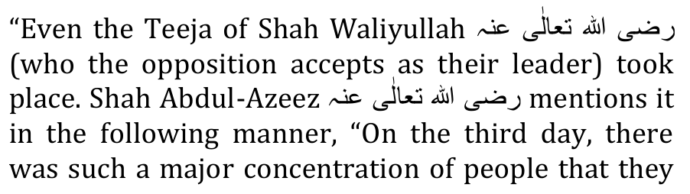
were beyond count. There were 81 counted Khatams of the Holy Quran but definitely more than this amount. There is no estimation of how many times the Kalima Tayyiba was read." –Malfoozoat-e-Abdul-Azeez, Pg. 80
These moron Bid'atis are adept in distortion and in selective quotations. Shah Abdul Azeez (Rahmatullah alayh) was narrating the bid'ah which had been organized by Peer Muhammad Khaan and others. Assuming that Shah Abdul Azeez had organized it, then too the merrymaking third day function was bid'ah regardless of who was responsible for having organized the haraam bid'ah function.
But the reality is that Shah Abdul Azeez (Rahmatullah alayh) was staunchly against these bid'ah forgeries. Shah Abdul Aziz (Rahmatullah alayh) in response to a question said:
"A person has the option of delivering the thawaab of his deeds to Buzrugs, but to fix a day or month for this is bid'at. " (Fataawa Azeezi)
Furthermore, at this bid'ah function which had been organized for Shah Waliyullah (Rahmatullah alayh), an Aalim of the Haqq stood up and proclaimed it Bid'ah. But the dishonest Qabar Pujaari morons have deleted it from the aforementioned quotation cited by them. Conveniently and dishonestly, displaying their trademark of chicanery, the Qabar Pujaaris have omitted from their citation, the following:
"Someone from the progeny if Hadhrat Mujaddid Alfe Thaani (Rahmatullah alayh) said to an Aalim: 'This act of Hadhrat (the organizer) is Bid'at." That buzrug responded: "Thousands have seen this act which the Molvi Sahib has enacted. Therefore, of what benefit is it to mention it (that is to say that it is Bid'at)? No one will accept it, therefore you should adopt silence."
It is indeed lamentable that even buzrugs become transformed into "dumb devils" when overwhelmed by the preponderance of customary practices which have become so entrenched that even sincere Ulama and Buzrugs slink into silence thereby courting the Wrath of Allah Azza Wa Jal for abdicating from the Pedestal of Amr Bil Ma'roof Nahy Anil Munkar. Reegarding such damnable, haraam silence, Rasulullah (Sallallahu alayhi wasallam) said: "He who is silent regarding the Haqq is a dumb shaitaan."
A glaring and lamentable example is the comment and advice of the Buzrug who said: "Of what benefit is it to say that it is Bid'at. No one will accept."
Yes, no one will accept because Hadhrat had fallen by the wayside, submitting to the pressure of the miscreant juhala masses. This disease of shaitaani dumbness exists today in almost all the Ulama, even the sincere ones. They fail to understand that hidaayat (to guide) is not in their power and cannot be achieved by their effort. Hidaayat comes from only Allah Ta'ala. Reminding Rasulullah (Sallallahu alayhi wasallam) of this reality, Allah Ta'ala says in the Qur'aan:
"Verily you (O Muhammad!) cannot guide those whom you love. But Allah guides whomever He wills, and He knows best whom to guide."
The obligation of the Ulama, is exactly the same as that of the Ambiya. They only have to deliver the clear Message of the Haqq. "Upon us is only the delivery of the Clear Message." (Qur'aan)
Understand well, that the satanic third day function which had been organized by Peer Muhammad Khaan was a dark, evil haraam Bid'ah regardless of the silence at that time of even Shah Abdul Azeez (Rahmatullah alayh). Our criterion is the Shariah which Rasulullah (Sallallahu alayhi wasallam) had delivered from Allah Ta'ala to the Sahaabah and which has reached us reliably and authentically via these Sahaabah about whom Rasulullah (Sallallahu alayhi wasallam) said:
"Honour my Sahaabah, for verily they are your noblest, then those after them, then those after them. Thereafter KITHB (Falsehood) will preponderate."
The third day carnival function comes fully within the scope of KITHB. We have to follow the Sahaabah, not the glaring errors and acts of bid'ah of Buzrugs who appeared on the scene a thousand years after Rasulullah (Sallallahu alayhi wasallam).
In addition, these vile Grave Worshippers conveniently refrain from mentioning the anti-bid'ah pronouncements of Shah Waliyullah (Rahmatullah alayh).
There is no objection against anyone who fixes a day/time for his own Sadqah or for his act of Isaal-e-Thawaab. For example, it is mentioned in the Hadith that the thawaab for virtuous deeds in the month of Ramadhaan is 70 times more. Now, if someone in his private capacity distributes Sadqah in Ramadhaan on the basis of this Hadith, no one will label it bid'ah.
Rasulullah (Sallallahu alayhi wasallam) said that Ramadhaan is an auspicious month for Ibaadat. But it does not follow that congregational merrymaking functions should be fabricated whether in Ramadhaan or at any other time.
It should also be understood that Sadqah and Ibaadat in general should not be delayed in anticipation of the arrival of Ramadhaan for the acquisition of greater reward. If someone's Zakaat for example is due in Muharram, he may not withhold it and delay the distribution for Ramadhaan. Or if there is a real need to give Sadqah to someone long before Ramadhaan, the person may not be turned away and advised to come in Ramadhaan for collecting the Sadqah.
The promise of greater thawaab is to encourage people to render acts of Ibaadat more in Ramadhaan. Give more Sadqah, perform more Salaat, Tilaawat, etc. But an auspicious time is not a basis for fabricating a custom which never existed during the Khairul Quroon era.
Since the month of Ramadhaan for greater reward is substantiated by Nass, it will be valid for the greater thawaab to render more acts of ibaadat. In this regard, Shah Abdul Azeez states in Fataawa Azeezi:
"A practice for which exhortation and a fixed time is not substantiated from Rasulullah (sallallahu alayhi wasallam), is baseless (abath). It is in conflict with the Sunnah, and conflicting with the Sunnah is haraam. This is never permissible. However, if someone wishes he may give charity secretly on any day possible so that in the event of it becoming known a custom will not develop."
Shah Abdul Azeez (Rahmatullah alayh) explicitly and emphatically negates fixing of days for acts of Ibaadat, and he encouraged secrecy to avoid the practice of ibaadat developing into a custom.
Our Leader – the Leader of the Ummah – is Rasulullah (Sallallahu alayhi wasallam), and he had commanded obedience to his Sahaabah"
"Honour my Sahaabah, for verily they are your noblest, then those after them, then those after them. Thereafter KITHB (falsehood) will become prevalent."
We do not follow any practice/custom innovated centuries after the era of Khairul Quroon mentioned in the authentic Hadith. After this era, customs in the form of 'ibaadat' come within the purview of KITHB stated by Rasulullah (Sallallahu alayhi wasallam).
Thus, if Shah Abdul Azeez (Rahmatullah alayh) had participated in the bid'ah of 'Teeja', centuries after the Sahaabah, it does not follow that it is a valid Sunnah or practice of Islam. We do not follow the errors of the Ulama, be they our seniors. Following the errors of seniors was the practice of Bani Israaeel. Castigating the Yahood and Nasaara for such evil conduct, the Qur'aan Majeed states:
"They (Bani Israaeel) took as gods their ahbaar (ulama) and ruhbaan (buzrugs) besides Allah, and they also took Isaa, the son of Maryam, (as a god besides Allah)." (A-Taubah, Aayat 31)
Allaamah Abdul Wahhaab Sha'raani and other Fuqaha said:
"He who clings to the nawaadir of the Ulama (presenting it as daleel) has made an exit from Islam."
The deviate bid'atis should present the Sahaabah as daleel, not such Ulama who had appeared on the horizon centuries and even a thousand years after Rasulullah (Sallallahu alayhi wasallam). Islam did not come into existence 7 and 8 hundred years after Rasulullah (Sallallahu alayhi wasallam). But, these Grave Worshippers are swift in making takfeer of Muslims who do not follow practices and customs which were innovated many centuries after the Sahaabah.
People derive joy from innovated practices, hence they congregate in large numbers to participate in the merrymaking bid'ah customs while they are lethargic in adherence to the daily Jamaat of the Five Fardh Salaat. Bid'ah customs are most pleasing to the nafs. The author of all such customs is Iblees who succeeds in ensnaring even senior Ulama who fall prey to him on account of their simplicity.
Shaitaan has indeed cast the intellect of even some seniors into disequilibrium, convincing them of the
'merit' of innovated practices which in reality are devoid of any merit. These customs lack Shar'i substance. The very fact of their innovation centuries after the Sahaabah should be an adequate daleel for understanding that such innovations come fully within the stricture of Rasulullah (Sallallahu alayhi wasallam):
"Whatever is innovated into this Amr (Deen) of ours is Mardood."
The Qabar Pujaaris further argue:
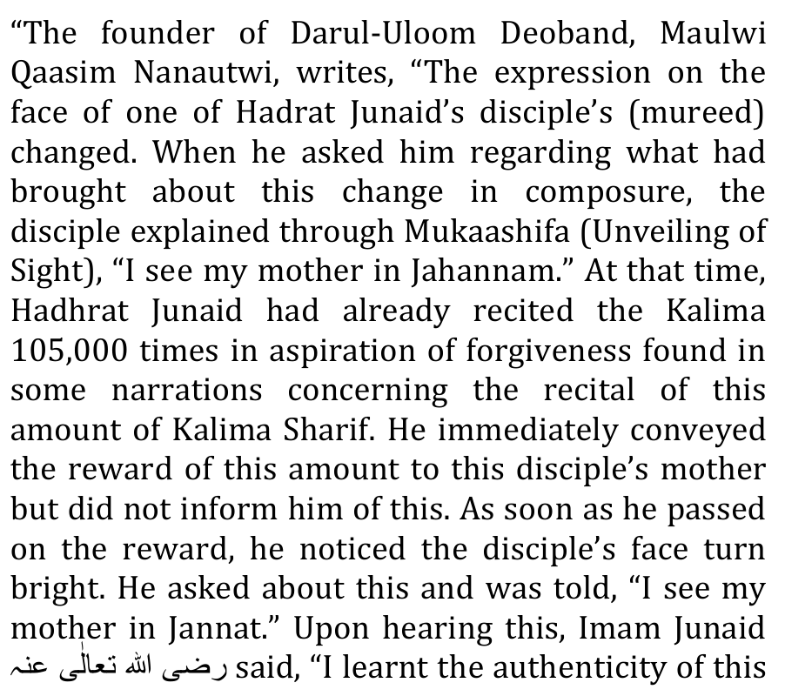
young man's Unveiling of Sight (Mukaashifa) through the Hadith, and the authentication of whatever the Hadith said was from it." – Tahzeerun-Naas, Pg. 24 This proves that the forgiveness of the deceased is what is hoped by conveying the reward of 105,000 Kalima Sharif and this is what is read on Teejas (the 3rd day after one's passing away)."
It is indeed stupid and weird to cite an Aalim as daleel when these miserable Qabar Pujaaris believe that Hadhrat Maulana Nanotwi (Rahmatullah alayh) is a 'kaafir' and one who is 'extremely disrespectful to Rasulullah (Sallallahu alayhi wasallam)". Furthermore, there is nothing - absolutely nothing – no daleel whatsoever – in whatever Hadhrat Nanotwi had narrated about the personal practice and experience of Hadhrat Junaid Baghdaadi (Rahmatullah alayh).
The anecdote of Hadhrat Junaid is not a basis for the fabrication of the bid'ah of 'teeja', etc. No one denies the merit of reciting the Kalimah even a million times and supplicating to Allah Ta'ala to transfer the thawaab to a mayyit. The contention pertains to the bid'ah custom, not to the recitation of any Thikr which an individual inclines to recite a million times or which he has adopted as his personal practice regardless of his buzrigiyat status.
Proof is not requested for the averment that the deceased derives benefit from acts of Isaal-e-Thawaab. Proof should be presented for the validity of the stupid, merrymaking bid'ah customs per se, fabricated and introduced centuries after Rasulullah (Sallallahu alayhi wasallam). Hadhrat Junaid's personal amal is not a daleel for claiming validity for the 'teejah' and similar other acts of bid'ah. In addition, Hadhrat Junaid did not specify the third day for his personal amal.
Even the mukaashafah stated, which cannot be presented as daleel, does not have the remotest basis for fabricating a custom then passing it off as a necessary act of Ibaadat akin to Sunnah or higher than Sunnah.
The deviates then say:
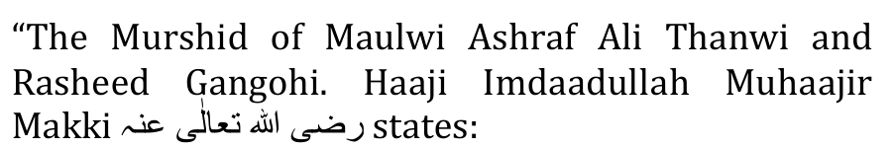
"There can be nothing said against the conveyance of reward {lsaal-e-Thawaab} to the souls of the deceased, If Isaal-e-Thawaab is done with the belief of obligation or specification of it occurring only in a particular time or period, it is prohibited."
(Our comment: This much is not being denied. This is our belief. This is the Sunnah. But the accretions are baseless and acts of bid'ah. –Mujlisul Ulama).
Continuing their insipid stupidity, the Grave Worshippers quoting Haaji Imdaadullah, say:
"However. if this is not the case and lsaal-e-Thawaab is appointed and completed for a convenient wisdom, there is no problem, e.g. the Jurists (Fuqahaa) have allowed specifying a particular Surah in namaaz based on a wisdom (hikmat). This is the general practice of Mashaaikh in Tahajjud Salaah." – Faisla Haft-Mas'ala."
This statement due to the atrocious translation is incomprehensible. What is the 'convenient wisdom'? Whatever it may be, it is never a valid basis for innovating acts in the form of worship for the Ummah at large to meticulously observe. It will be bid'ah sayyiah.
Whatever the Jurists (Fuqaha) have allowed is based on sound daleel of the Qur'aan and Ahaadith. The Fuqaha did not suck from their thumbs bid'ah practices for which there is no basis in the Sunnah. The Jurists have specified that it is Makrooh to fast only on the 10th of Muharram. A day should be added. This specification of the Jurists may not be proffered as daleel for specifying a particular day for an unfettered Sunnah act.
The Grave Worshippers say:
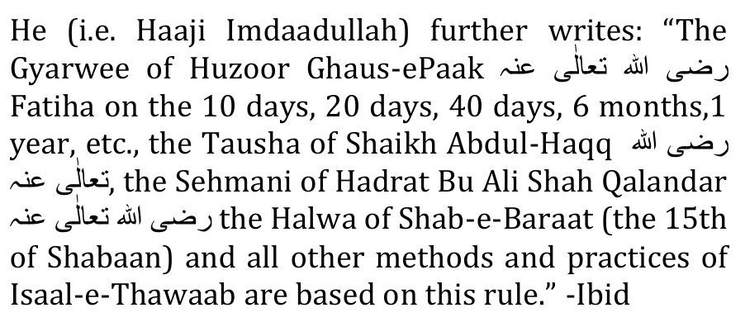
These writings of the Peer Sahib have conclusively decided the matter yet some of their followers still want to go against them and label Muslims doing Isaal-E Thawaab as innovators."
Nothing is 'conclusively decided' by this averment of Hadhrat Haaji Sahib who came onto the scene of Islam 13 centuries after Rasulullah (Sallallahu alayhi wasallam). Only the Qur'aan and Sunnah decides Deeni issues conclusively. Hadhrat Haaji Saahib (Rahmatullah alayh) had grievously erred in his understanding of these bid'ah issues, hence Hadhrat Maulana Rashid Ahmad Gangohi (Rahmatullah alayh) had ordered that the booklet (Haft-e-Mas'alah) be burnt, and this order was executed. It was burnt because it constituted a dangerous treatise for deviation.
Regardless of the status of Hadhrat Haaji Imdaadullah (Rahmatullah alayh), his understanding of bid'ah was severely flawed. His senior Mureeds, viz. Hadhrat Nanotwi, Hadhrat Gangohi and Hadhrat Thaanvi, had rejected his views stated in Haft-e-Mas'alah. Hence it is pure chicanery of the Qabar Pujaari Bid'atis to proffer Haft-e-Mas'alah as a daleel to refute the contention of these illustrious Ulama who had always criticized, denounced and rejected every stupid bid'ah for which the deviates are grasping at straws in their futile and flapdoodle bid to substantiate their khuraafaat.
Arguing in support of their bid'ah, the Qabar Pujaaris say:
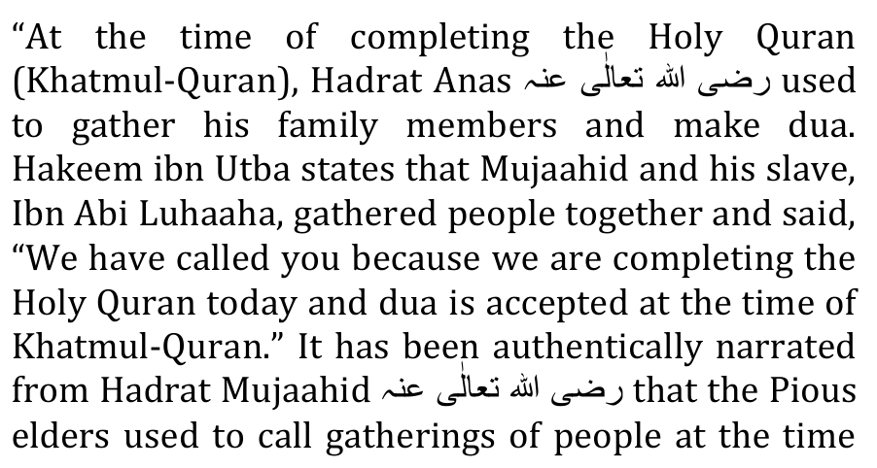
of Khatmul-Quran and say, "Mercy descends in this time." – KilaabulAskaar, Baabu Tilaawatil-Quran Dua is accepted at the time of the Quran being completed (khatam). Isaal-e-Thawaab is also a dua. Attending a gathering where the khatam of the Quran is been made is a opportunity for the acceptance of dua. Thus, these gatherings is also the practice of the pious predecessors."
The Sahaabah were better acquainted with Hadhrat Anas (Radhiyallahu anhu) and his ibaadat practices, yet they did not cultivate a custom based on his practice. The fact is that an individual Sahaabi's personal amal is not a custom for adoption by the Ummah if the Body of the Sahaabah did not adopt it as a Sunnah nor was the individual's practice adopted as Sunnah in the Noblest of Ages (Khairul Quroon). Therefore, it is baseless to proffer the personal amal of Hadhrat Anas (Radhiyallahu anhu) as the daleel for the mass congregational, merrymaking khatam practices which have been innovated.
No one is denying the acceptance of Dua upon a Khatam of the Qur'aan Majeed. The innovated congregational practice which did not exist during the Khairul Quroon is denied and rejected. Make as much dua as you wish when completing the Qur'aan Majeed. But abstain from fabricating and frauding a practice into the Deen - a practice which was not taught by Rasulullah (Sallallahu alayhi wasallam) and the Sahaabah.
While Hadhrat Anas (Radhiyallahu anhu) gathered his family members, it was not a gathering to attend an established custom of the Sunnah. It was the random practice of a Sahaabi which any Muslim may follow without fabricating a permanent public custom. These bid'ah khatam customs have become so embedded that those who do not participate or who do not subscribe to it are labelled 'kaafir'. Whilst the moron deviates cite the amal of a single Sahaabi – an amal which NEVER developed as a Sunnah among the Sahaabah – they are ominously silent regarding the non-existence of the khatam customs during the age of Rasulullah (Sallallahu alayhi wasallam) and the Sahaabah, and the Taabieen, and the Tab-e-Taabieen. The acceptance of Dua upon khatam of the Qur'aan Majeed is not the point of contention. The bid'ah customs which were fabricated after the Sahaabah are being criticized and rejected.
The Islam and Sunnah which we know and follow were initiated by Rasulullah (Sallallahu alayhi wasallam) and the Sahaabah whereas the 'islam' which the juhala Qabar Pujaaris and deviates of like strictly follow came into existence centuries after the Sahaabah. We do not subscribe to that theology which had no existence during the age of Rasulullah (Sallallahu alayhi wasallam) and the Sahaabah.
The Juhala Qabar Pujaaris say:
"Now we will discuss a few things concerning with Esal-e-Swab to which according to some misguided people are, innovations.
When a person dies, Muslims offer Alms, "Sadaqa", on his behalf and pray in congregation. In these gatherings Islamic teachings are preached; This serves as a way to preach or spread Islam. Through these gatherings, the deceased receive benefit because Muslims pray for his/her forgiveness and others get knowledge of Islam. The poor get benefit from these Alms or charity. As you can see if you look at it from any angle, it is not an innovation."
Most certainly it is a Bid'ah regardless of the angle from which it is viewed. The method and custom in which the good deeds are rendered were not taught by Rasulullah (Sallallahu alayhi wasallam). While Isaal-e-Thawaab was taught, the methods and customs of the bid'atis had no existence during the age of Rasulullah (Sallallahu alayhi wasallam).
Individuals are free to offer Sadqah and make Dua as much as they wish for the thawaab to reach the deceased. But they have no right to adopt such methods and fabricate such customs which were not part of the Sunnah during the age of Rasulullah (Sallallahu alayhi wasallam) and the Sahaabah.
It was precisely to reject the later bid'aat which would be contaminating the Deen that Rasulullah (Sallallahu alayhi wasallam) said:
"That which is innovated into this Deen of ours is Mardood (rejected)."
Bid'ah are such practices which are given the form of ibaadat whilst they had no existence during the age of the Sahaabah. Innovations are practices with an external 'ibaadat' covering. These same moulood and khatam Bid'atis have also innovated dua after the Janaazah Salaat thereby implying that the Masnoon method of Janaazah Salaat is imperfect, hence the need to fabricate a dua after the Janaazah Salaat. They will argue that the dua benefits the mayyit. Was Rasulullah (Sallallahu alayhi wasallam) and the Sahaabah not aware of this? Why did they not make a dua after the Janaazah Salaat. Just as the Qabar Pujaaris have no valid daleel for their dua after Janaazah Salaat, so too are they bereft of a valid daleel for their khatam customs.
Displaying compound jahaalat (ignorance), the Qabar Pujaaris say:
"Some people raise the question that a day should not be fixed for this, in that fixing such a day is "Haram" in Islam. The answer to this question is that if "fixing a day" is Haram, Esal e sawaab will be haraam if it is said that outside of this day it will not be Esal-e-Sawab, (like Qurbani, Hajj and Salaah times are fixed), but Esal-e-Sawab on a fixed day is just for convenience of relatives and friends for "Du'a". Like any Islamic conference, the date of it is fixed in advance. Alternatively, like Salaah "Jamat" time is unlike fixed. No one can become an innovator because of this. In the same way, to fix a day for "Du'a" for the deceased is not an innovation. Even Bukhari Sharif has a chapter which discusses the permissibility of appointing times. This is only done for ease. Today, Jalsas, exams, vacations, etc. are all appointed and planned in Madrassahs so that people may reach the Madrassahs without being called every year. Indeed, this is their only intention in this matter."
If there was a need to fix a specific day for dua, Rasulullah (Sallallahu alayhi wasallam) would have been the very first to have ordered it, and it would have become an established Sunnah among the Sahaabah. Rasulullah (Sallallahu alayhi wasallam) had fixed days for Masnoon fasting and days for other acts of ibaadat. Thus, if there was any need for such fixation for dua, it would never have escaped the mind of Rasulullah (Sallallahu alayhi wasallam), and it would most assuredly have been a Sunnah among the Sahaabah. This absence in the Khairul Quroon era is the strongest daleel for the evil bid'ah which the morons have innovated into the Deen.
The averment that if fixing a day for dua is haraam then Isaal-e-Thawaab will also be haraam is a stupid shaitaani 'logical' deduction which exhibits the degree of jahl-e-murakkab of the Bid'atis. No one claims that Isaal-e-Thawaab is haraam. But fixing a specific day and developing it into a congregational practice, and elevating it to the status of Wujoob as if it is Sunnah and incumbent is haraam.
Also, no one has claimed that "outside of the fixed day" Isaal-e-Thawaab is haraam nor has it been said that "inside" the fixed days Isaal-e-Thawaab is haraam. What is being said is that fixing a day for this ibaadat – a day which has no substantiation in the Sunnah, is bid'ah.
The days of Qur'baani, Hajj, etc. have been fixed by Rasulullah (Sallallahu alayhi wasallam) on the command of Allah Ta'ala. This fixation by Rasulullah (Sallallahu alayhi wasallam) may not be transferred to personal practices which are then elevated to incumbent 'Sunnah' practices.
Far from fixed days for dua being for convenience, it is an imposition of inconvenience (takleef), difficulty and waste of money. Dua consists of raising the hands and moving the lips or only moving the lips without even raising the hands. This simple method of dua taught by the Shariah knocks the bottom out from the rubbish which the Grave Worshippers are claiming as 'convenience'. It is shockingly lamentable and exceptionally stupid to believe and to claim that there is convenience in a congregational 'dua' custom which has no origin in the Sunnah. By what stretch of logic and brainology can the organization of a merrymaking function for collective dua ever be more convenient than the individual making a silent, heartfelt dua at home in strict accord with the command of the Qur'aan and the practice of the Sunnah?
Regarding Dua, Allah Ta'ala says:
"This is a narration of the mercy of your Rabb on His slave, Zakariyya.
(Remember) when he called (made dua to) His Rabb a silent (secret) dua."
(Maryam, Aayat 2 & 3)
"Call unto your Rabb in humility and silently. Verily, He does not love those who transgress.
(Al-A'raaf, Aayat 55)
Rasulullah (Sallallahu alayhi wasallam) had explained the method of making Dua. Dua should be made silently and with humility. The fabrication of a merrymaking function for making dua is pure satanism. The Qur'aan mentions the manner of Dua of the Ambiya and commands silence and humility during Dua. A merrymaking function for collective dua is in entirety nugatory of the Qur'aanic method of Dua and of all etiquettes pertaining to Dua. The function organized for 'dua' is gross transgression which is prohibited in the aforementioned Aayat of the Qur'aan Majeed.
The claim that the function is for making 'dua', is a shaitaani LIE. A Dua requires no function and no congregation. In the name of Dua the deviates, morons and Qabar Pujaaris are gratifying their nafsaani lust, and this is a sign of Qiyaamah. It is mentioned in the Hadith that among the Signs of Qiyaamah is that "the dunya will be pursued with the amal of the Aakhirah". Dua is an amal of the Aakhirah. The congregational merrymaking function satanized with gluttony, etc. is a nafsaani objective, hence the 'teeja', etc. functions of the morons are all designed for nafsaani gratification.
Ease and convenience are in the method prescribed by the Shariah. There is no ibaadat as simple and as convenient as Thikruallah and Dua in the method of the Sunnah. What does Dua for the deceased entail? Sitting in the comfort of your home, you could recite the Qur'aan Majeed as much as your heart desires or just Surah Ikhlaas thrice. Then raise your hands in supplication to Allah Ta'ala to have the thawaab of your Tilaawat and Dua transferred to the mayyit of your choice. This is the pure, simple unadulterated method of the Sunnah. It is bereft of inconvenient, expensive, haraam encumbrances.
This method of the Sunnah saves you from driving to a function which will be bedevilled by even sinful acts. The Sunnah method precludes the fitnah and dangers of the roads and public venues. There is no show, ostentation and wasting of money in merrymaking in the simple Sunnah method.
A Buzrug walking through a Qabrustaan saw by way of Mukaashafah numerous Arwaah scurrying all over the Qabrustaan gathering something. Wonderstruck, he supplicated to Allah Ta'ala to unravel the mystery of this scene. Allah Ta'ala inspired him to ask one of the Souls. The Buzrug did so and was told: "An Aalim had passed through this Qabrustaan last Friday. Whilst walking he recited Surah Ikhlaas thrice. His recitation resulted in such an abundance of thawaab which we have been gathering for seven days."
This is the simplicity, ease, comfort and barkat of Isaal-e-Thawaab in the simple Sunnah way unfettered with the darkness of innovations of the Grave Worshippers. Isaal-e-Thawaab requires no fixed days, no gatherings, no money spending, no inconvenience, no emergence into the public – no takleef whatsoever – and no merrymaking where gheebat and other sinful acts have become customary when the morons indulge in their gluttony of feasting after their so-called 'ibaadat' in the name of Isaal-e-Thawaab. In reality, these khatam functions are a mockery of Ibaadat.
The Juhala Qabar Pujaaris say:
"In Islam is it permissible for a person to fix a time, or date for voluntary (Nafal) prayer?"
Any individual may fix for himself a time for any ibaadat. This is not being contended. A man may fix his Tahajjud time, his Tilaawat time, his Thikr time, etc. In so doing, he is not introducing a new 'ibaadat' practice into the Deen. Rasulullah (Sallallahu alayhi wasallam) had not specified fixed times for Nafl ibaadat, hence everyone is free to perform these Nafl acts of ibaadat according to his convenience.
The discussion pertains to the merrymaking public functions fabricated by the moron bid'atis who have innovated into Islam their nafsaani 'teeja', etc. customs which are beset with evil acts. In fact, if it be assumed that these innovated customs are without evil factors, then too, they are haraam bid'ah. Dua and Tilaawat were among the main acts of Ibaadat of the Sahaabah. We are obliged to follow the Sunnah of the Sahaabah, not the damnable functions innovated by moron deviates centuries after the Sahaabah.
If bid'ah is given room in Islam, nothing of pure Islam will remain just as nothing remains of the Shariat of Nabi Musaa (Alayhis salaam) and of the Shariat of Nabi Isaa (Alayhis salaam). These functions are all Mardood Bid'ah
The Juhala say:
"Imam Bukhari writes one day after the Fajar prayer, the Prophet Muhammad [May Allah bless him and grant him peace] asked Bilal [May Allah bless him and grant him peace], tell me what good deeds you do because I heard your foot steps in Jannat. Bilal replied the only thing I do is after I make Wudu I pray Nafal how much Allah (Almighty.) wills me to do.
(Bukhari: Chapter of Salaah)
Hafidhh Asqalani writes in his commentary on this Hadith. We can understand from this Hadith that it is permissible for a person to fix a time for his/her voluntary prayer. (Fath-ul-Bari Book of Salaah)."
The only thing this Hadith mentions is that Hadhrat Bilaal (Radhiyallahu anhu) would make two Raka'ts Tahyatul Wudhu after having made Wudhu. Obviously, he had no fixed times set aside for making Wudhu. It is certain that Hadhrat Bilaal (Radhiyallahu anhu) was always in the state of Wudhu. He would make wudhu whenever his wudhu broke. Wudhu does not break at predetermined fixed times. Thus the 'fixed time' factor raised on the basis of this Hadith is laughable drivel.
It is indeed weird to base any fixed time fabricated act on this Hadith which has absolutely no reference to fixed-time ibaadat. The qiyaas of Hafidh Asqalaani (Rahmatullah alayh) is palpably faasid (inavlid). The Qabar Pujaari morons in support of their mullock are really clutching at straws like a drowning man. Hadhrat Bilaal (Radhiyallahu anhu) did not delay making wudhu for a fixed time. He made wudhu immediately after his wudhu was nullified. He did not have any fixed time for making wudhu. The conclusion of fixed times for wudhu is exceptionally weird and absolutely baseless, to say the least.
Peddling their bullock, the Grave Worshippers say:
"There is a prayer (Du'a) said for the deceased for this we can fix a time that suits our self. We can give charity for them, keep fast for them and also we can get together and read Qur'an for them. For the people who get together and read Qur'an, we could be hospitable by providing for them by giving food and drink. This is all done with the intention of Sawab (blessings). For example, when Islamic circles are held, there are usually refreshments held after and this is carried out with the intention of blessings. This is one way of doing Esal-e-Sawab. There are many other ways of doing Esal-e-Sawab."
There is not one 'prayer' which could be made for the Amwaat. There are numerous Adiyah (duas), and Tilaawat of the Qur'aan is the best form of Dua for the mayyit. No one disputes this fact.
Giving charity on behalf of the deceased is not disputed. Fasting and sending the thawaab forth for the deceased is not being disputed. However, organizing merrymaking functions is not necessary for Sadqah and for Fasting. The function is the snare of Iblees. Bid'ah is one of the most potent weapons and traps of Shaitaan.
But "to get together and read the Qur'aan for them", is rejected. This is the ploy of Iblees. In subtle ways does shaitaan introduce bid'ah in a valid Amal. He adds some urine to pure water to contaminate the entire contents of the bucket. There is absolutely no daleel in the aforementioned Hadith pertaining to Hadhrat Bilaal (Radhiyallahu anhu) or in any other Hadith for fabricating a function- a merrymaking function – just for Dua and Tilaawat. All of this can be done and has to be executed at home with humility and without any carnival atmosphere.
Bid'ah is not acceptable on the basis of a good intention. Shaitaan uitilizes the trap of 'good intention' to establish bid'ah in his nefarious bid to dismantle the Sunnah.

BID'AH AND KUFR
Shah Waliyillah (Rahmatullah alayh) says in his Kitaab, Al-Balaaghul Mubeen:
"Don't make my grave an occasion of eid."
(Hadith)
"This closes the avenue for the entry of fabrication as the Yahood and Nasaaraa do with the graves of their Ambiya. They have made the graves places of eid (festival)."
"It was the practice of the idolaters and fire-worshippers of Hindustan to fix a day of gathering every year. Huge crowds assemble on this day. Those who worship the Auliya, following in the footsteps of these idolaters and fire-worshipers, have innovated may 'eids'. They organize urs at the graves of their Auliya. Like the Hindus, they too have singing, music and sport."
In his Tafheemaaul Ilaahiyyah, Shah Waliyullah (Rahmatullah alayh) states:
"Of the great acts of bid'ah is that people have fabricated many acts regarding the graves (of the Auliya). They have made the graves places of carnivals."
Shah Abdul Azeez (Rahmatullah alayh) says in Fataawa Azeezi:
"People have fixed a date annually in the name of urs. They don (new) garments as they do on the day of Eid. Dancing, music and other acts of bid'ah such as prostrating to the graves, making tawaaf of the graves, etc. are perpetrated. All of this is haraam. In fact some acts are tantamount to kufriyaat."

