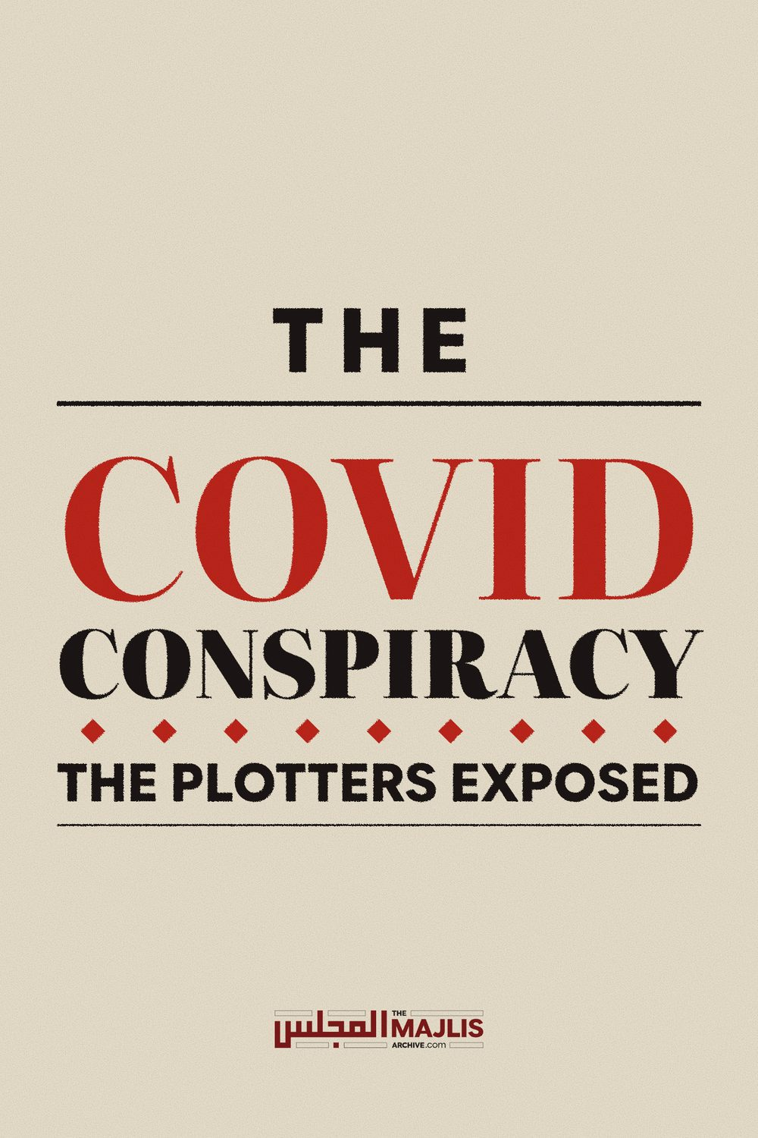

THE COVID CONSPIRACY
The Majlis · Voice of Islam
Mujlisul Ulama of South Africa

About this edition
This is a reproduction by The Majlis Archive (themajlisarchive.com) of a publication of The Majlis, Mujlisul Ulama of South Africa, made and published with their permission.
The PDF as The Majlis issued it is the original. This edition was read from that PDF's own structure and checked against it letter for letter; where the two differ, the PDF is correct.
Checked: 83 paragraphs, 0 differing; a second, independent PDF reader finds 100.0% of the PDF's words here.
Nothing has been reworded, added or removed.

THE PLOTTERS EXPOSED
Published by:
REVEALED: 26 out of the 27 Lancet scientists who trashed theory that Covid leaked from a Chinese lab have links to Wuhan researchers
• The Lancet letter published in March 2020

called claims that Covid-19 originated in lab 'conspiracy theories'
• It was signed by 27 scientists from across

the globe working in virology and other medical science fields
• The widely-read letter effectively ended all

debate about origins of the global coronavirus pandemic
• Investigation by The Telegraph has found
26 out of 27 had connections to China's Wuhan Institute of Virology By Chris Jewers For Mailonline
Published: 11:24 BST, 11 September 2021 | Updated: 18:11 BST, 15 September 2021 e-mail
Of the 27 scientists who wrote a letter in The Lancet medical journal dismissing the possibility that Covid-19 originated from a Wuhan lab, 26 have links to its Chinese researchers, their colleagues or its benefactors, a new investigation has revealed.
On March 7 last year, the influential journal published the letter in which the 27 scientists said they 'strongly condemned conspiracy theories' surrounding the origins of the coronavirus pandemic that has impacted all corners of the world.
All debate into whether Covid-19 had man-made origins or leaked from the lab in Wuhan - the Chinese city that was ground-zero for the virus - was effectively shut down by the letter.
Of the 27 scientists who wrote a letter in The Lancet medical journal dismissing the possibility that Covid-19 originated from the Wuhan Institute of Virology (pictured), 26 have links to its Chinese researchers, their colleagues or its benefactors, a new investigation has revealed However, an investigation by The Daily Telegraph newspaper into the signatories has found that 26 of the 27 had some link to the Wuhan Institute of Virology, where the leak was suspected - calling into question their impartiality.
Signatories include Dr Peter Daszak, the British president of EcoHealth Alliance, which funnelled money into controversial research at a Wuhan Institute of Virology, and UK Government scientific adviser Sir Jeremy Farrar. Only one - Dr Ronald Corley, a microbiology expert from Boston University - has been found to have no links back to funders or researchers at the Wuhan institute.
Below, the MailOnline looks at those signatories named by The Telegraph's investigation - and other key figures and organisations - to have links with the Wuhan Institute of Virology.
Dr Peter Daszak Zoologist, EcoHealth Alliance, New York
The orchestrator of the letter, British zoologist Peter Daszak, was already found to have a conflict of interest through him being president of the US-based EcoHealth Alliance, which has funded research at the Wuhan Institute of Virology.
Despite declaring no conflicts of interest at the time the letter was penned, The Lancet was forced to publish an addendum to the letter acknowledging Daszak's connection to EcoHealth Alliance.
The letter played a key role in suppressing early debate on the pandemic's origins, but its credibility has since been questioned after details emerged of the involvement of Peter Daszak (pictured), a major financial backer of the Wuhan Institute of Virology (WIU)
Chinese virologist Shi Zhengli (left) is seen inside the P4 laboratory in Wuhan, capital of China's Hubei province on February 23, 2017 In an email made public through Freedom of Information requests, Mr Daszak is said to have revealed on February 8 that he composed the letter after being asked by 'our collaborators' in China for a 'show of support'.
Scandal hit Dr Daszak has since been removed from the UN-backed Lancet commission looking at the origins of the pandemic.
However, The Telegraph has reported that five other signatories also worked for the same organisation. None of whom declared their involvement.
Two such signatories include Dr William Karesh, an infectious disease expert and Professor Hume Field, veterinary sciences expert.
Dr Jeremy Farrar Tropical medicine expert and SAGE adviser & The Wellcome Trust, London
The newspaper also found that three of the signatories were from Britain's Wellcome Trust.
Signatory Sir Jeremy Farrar, a member of the UK's Sage and the director of the Trust, has in the past published work with George Gao, the head of the Chinese Centre for Disease Control and Prevention, whom he has described as 'an old friend'.
Dr Gao, who studied at Oxford University, is a former research assistant at the Wellcome Trust. Mr Daszak has claimed Dr Gao supported his nomination to the National Academy of Sciences, according to The Telegraph.
The Chinese scientist also has connections to Shi Zhengli, the scientist who has become known as 'batwoman' on account of her research into bat coronaviruses in Wuhan. Her team discovered a virus in 2013 which is the closest ever previously found to Sars-Cov-2 - the virus that causes Covid-19.
Two other signatories - Dr Josie Golding and Professor Mike Turner - are known to have current or past connections with the Wellcome Trust.
Dr Golding is the Trust's Epidemics lead, while Prof. Turner is a Parasitology expert at the University of Glasgow, and formerly worked with the Trust.
George F. Gao, head of China's Center for Diseases Prevention and Control, attends a session at the China Development Forum in Beijing, China March 20, 2021 Speaking to the MailOnline in June on the lab leak theory, Dr Farrar said: 'The origins of Sars-Cov-2 are not yet certain — it is possible the origin will never be fully established — but nature is a powerful force and, in my view, the most likely scenario is that the virus crossed from animals to humans and then evolved in humans.
'The best scientific evidence available to date points to this. It is most likely it crossed the species barrier to infect and then adapt to humans at some point in 2019, but there are other possibilities which cannot be completely ruled out and retaining an open mind is critical.
'There is no place for unsubstantiated rumour, or conspiracy theories often fuelled for political purposes.'
Professor Linda Saif Microbiology expert, The Ohio State University Microbiology expert Professor Linda Saif, another signatory, spoke at a workshop in Wuhan in May 2017 along with Dr Shi and Dr Gao. The workshop was partly organised by the Wuhan Institute of Virology.
The level of security in Chinese labs was among the topics discussed at the workshop, while Professor Saif's talk covered animal coronaviruses.
Professor Linda Saif The Global Virome Project
Two more signatories on The Lancet letter are in the leadership team of the Global Virome Project - an organisations whose goal is to detect and identify 99 percent or more of potential zoonotic viral threats.
Mr Daszak is the treasurer of the Global Virome Project, while Dr Gao helped launch it, with EcoHealth Alliance as one of its partners.
The Global Virome Project took over from the Predict project, which discovered more than 1,000 unique viruses in animals and humans.
But according to The Telegraph, the Predict project was also found to have part-funded contentious work by Wuhan researchers on bat coronaviruses, which were altered to see if they could infect humans.
The funds for the research were provided by the EcoHealth Alliance.
Professor John Mackenzie Tropical infectious diseases expert, Curtin University, Perth, Australia Professor John Mackenzie Tropical infectious disease expert Professor John Mackenzie who works out of Curtin University in Perth, Australia, was another of the signatories.
The investigation has found that he did not disclose that he was still listed as a committee member of the the Scientific Advisory Committee of Centre for Emerging Infectious Diseases at the Wuhan institute.
Professor Kanta Subbarao Virology expert, The University of Melbourne, Australia
Professor Kanta Subbarao Virology expert, The University of Melbourne, Australia Professor Kanta Subbarao, another signatory from the University of Melbourne, spoke at a conference on emerging diseases in Wuhan in 2016 which was part-organised by the the Wuhan Institute of Virology.
Prof. Subbarao was still chief of the US-based National Institute of Allergy and Infectious Diseases (NIAD) Emerging Respiratory Viruses Section.
Five more of the letter's signatories have all been found by the investigation to have published articles with Professor Ralph Baric.
Professor Prof Ralph Baric While Prof Baric was omitted from the list of signatories, he was collaborating with Shi Zhengli and the Wuhan Institute of Virology, researching genetically manipulated coronaviruses to see if they could be made to infect humans.
Earlier this year, Republicans in the US argued that the virus was possibly genetically modified, and cite an interview with Baric in which he said it was possible to engineer a virus, 'without leaving a trace.'
Baric was initially asked to add his name to the letter by Mr Daszak, with emails between the pair recently coming to light ahead of The Lancet letter's publication, showing that the pair decided to mask their association with the Wuhan institute to avoid looking 'self-serving'.
Mr Daszak told Prof Baric that he would publish the letter in such a way that it doesn't 'link it back to our collaboration so we maximise an independent voice'.
Professor Peter Palese Microbiology expert, Icahn School of Medicine, New York
Professor Peter Palese A number of those who signed the letter have since changed their stance with some calling for a full inquiry into the origins of Covid-19.
Speaking to the MailOnline in June, Professor Peter Palese - a microbiology expert from Icahn School of Medicine, New York, said: 'I believe a thorough investigation about the origin of the Covid-19 virus is needed.
'A lot of disturbing information has surfaced since the Lancet letter I signed, so I want to see answers covering all questions.'
Asked how he was originally approached to sign the letter and what new information had come to light specifically, Professor Palese declined to comment.
Professor Stanley Perlman Microbiology expert, University of Iowa Signatory Prof Stanley Perlman, of the University of Iowa, told The Telegraph: 'It is difficult to eliminate a possible lab leak as part of the process, so this still needs to be considered.'
Professor Charles Calisher Microbiolgy expert, Colorado State University
Professor Charles Calisher, who signed the letter downplayed the letter to The Telegraph, saying that the intention behind it was never to suggest Covid-19 might have not originated in nature, but rather that there was a lack of data to make such a claim.
Professor Bernard Roizman Microbiology expert, University of Chicago Professor Bernard Roizman told the Wall Street Journal in May that since signing the letter, he has become convinced that the deadly virus was released by a 'sloppy' scientists. Dr Ronald Corley Microbiology expert, NEIDL Institute, Boston Out of the 27 signatories of the Lancet Letter, The Telegraph reported that it could find no connection between just one and the Wuhan Institute of Virology - Dr Ronald Corley from Boston University.
Reacting to the findings of the investigation, researchers into the lab-leak theory who were blocked and branded conspiracy theorists called it an 'extreme cover up' on Friday, the newspaper reported.
Molecular biologist Prof Richard Ebright, of Rutgers University, fought to uncover the truth behind the Covid pandemic.
He told The Telegraph that after the June addendum that disclosed that Daszak had connections to the Wuhan institute, the other 27 signatories were invited to offer any of their own competing interests.
'Incredibly, only Daszak appears to have done so,' Ebright told the newspaper.
'Conflicts of interest were not reported for any of the other 26 signers of the letter – not even those with obviously material undisclosed conflicts such as EcoHealth employees and Predict contractors.'
Angus Dalgleish, professor of oncology at St Georges, University of London, warned that it could now be too late to fully learn the origins of Covid-19 because of what he called 'stalling', but remained hopeful that the evidence 'is out there'.

DID COVID LEAK FROM A WUHAN LAB? THE EVIDENCE FOR AND AGAINST
Evidence for Wuhan lab-leak theory An article in the respected Science journal on May 14 kick-started the surge in interest for the lab-leak theory.
Some 18 experts wrote in the journal that 'we must take hypotheses about both natural and laboratory spillovers seriously until we have sufficient data'.
Later that month, a study by British Professor Angus Dalgleish and Norwegian scientist Dr Birger Sørensen claimed it had 'prima facie evidence of retro-engineering in China' for a year.
The study included accusations of 'deliberate destruction, concealment or contamination of data' at Chinese labs. It followed statements from the WHO Director General, US and EU that greater clarity about the origins of this pandemic is necessary and feasible to achieve.
Previously, the theory had been dismissed as conspiracy by most experts, partly because of its association with President Donald Trump.
President Joe Biden in May ordered a full investigation into the origin of the pandemic virus and demanded scientists work out whether there is truth to the theory.
The head of the World Health Organization insisted just a day earlier that the theory that Covid emerged from a Wuhan lab has not been ruled out — as he said China should help solve the mystery out of 'respect' for the dead. The body's director-general, Dr Tedros Adhanom Ghebreyesus, suggested that Beijing had not cooperated fully as he urged more 'transparency' in the continuing investigation.
Evidence against the theory Several other sects of the scientific community continue to suggest the virus could only be natural in origin.
A series of recent papers pointed to the virus evolving in animals before being transmitted to humans, in the same way as all other previously discovered coronaviruses. The first study, published in Scientific Reports, showed some 47,000 wild animals from 38 species were sold across four markets in Wuhan between May 2017 and November 2019.
The authors, including Dr Chris Newman, an evolutionary ecologist at Oxford University, claimed the evidence showed the conditions for animal-to-human transmission were in place in Wuhan.
But they acknowledged there was no proof Sars-CoV-2 was present or originated in any of these animals.
A joint World Health Organization-China investigation also concluded it was 'very likely' the virus jumped from bats to humans via an as-yet-unknown intermediary animal.

