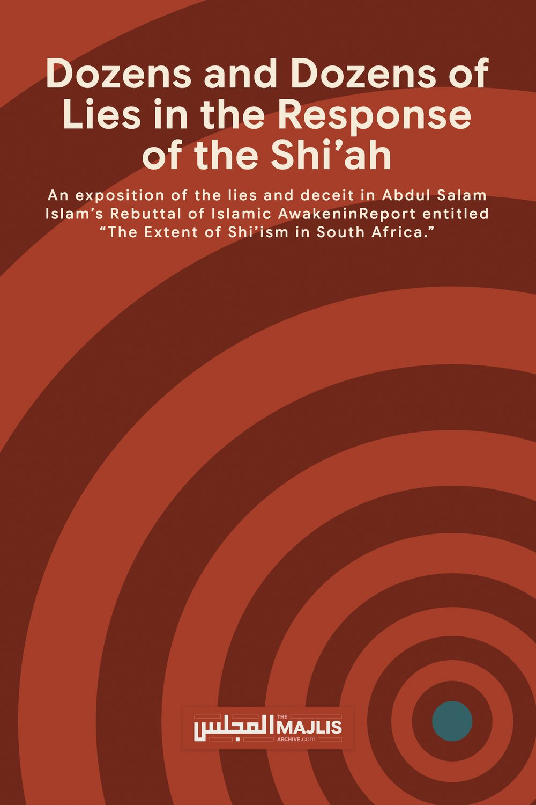

The extent of Shi'ism in South Africa
The Majlis · Voice of Islam
Mujlisul Ulama of South Africa

About this edition
This is a reproduction by The Majlis Archive (themajlisarchive.com) of a publication of The Majlis, Mujlisul Ulama of South Africa, made and published with their permission.
The PDF as The Majlis issued it is the original. This edition was read from that PDF's own structure and checked against it letter for letter; where the two differ, the PDF is correct.
Checked: 2,067 paragraphs, 0 differing; a second, independent PDF reader finds 97.4% of the PDF's words here.
Nothing has been reworded, added or removed.

Introduction
hopefully repent and embrace mainstream Islam. Further, this report provides us with an excellent opportunity of substantiating our facts that we had previously stated.

BEWARE OF PROPAGANDA AGAINST SHI'ISM
history before he was eventually murdered:
halal their honor. The belief instilled by the ulama's andmujtahid of Shi'ah is that their biggest enemy is the Ahlus Sunnah. This is because the Sunni people are considered najis in the sight of the Shi'ahs, to the extent that even if they cleanse a thousand times, the najis will not vanish.
knowledge, Najaf, the dominion of the imams, to do mut'ah with many women. Such as the ulama' Sayiid Shadr, Barwajardi, Syairazi, Qazwani, Sayyid Madani and many others.
very beautiful. Imam requested from her father, i.e. Sayyid Sahib, to present the girl to him so that he could do mut'ah with her. So the father agreed to it, feeling very pleased. So Imam Khomeini slept and the girl was in his embrace, while we heard the cries and screams of the child.
nikah mut'ah with another man. This is damage upon damage! Nobody can imagine how the feelings of a husband who finds out that the wife who is under his care have mut'ah with another man.
After having enough, that personage divorced her. She swore that she was pregnant from the relationship with Sayyid Sadr, because no one else did mut'ah with her except Sayyid Sadr. After her daughter turned into an adult, she became a beautiful lady and ready to be married. But her mother found that the daughter had been pregnant. When enquired about it, she said that she had had nikah mut'ah with Sayyid Sadr and her pregnancy was because of that nikah mut'ah. The mother was taken aback and lost control and said that Sayyid Sadr is her father. And then the mother told the story to her daughter, his flesh and blood! In Iran, such incidents are happening countless times!

Concerning Khumus
Qur'an is fake. When reading and examining our references that are mu'tabar, I found the names of other books claimed by our ulama's as being revealed to Rasulullah SAW and that those books were specially dedicated to Ali RA. Those books are Al-Jami'ah, Sahifah An Namus, Sahifah Al-Abithah, Sahifah Dzuabah As- Saif, Sahifah Ali, Al-Jufr, Mushaf Fatimah, Al- Qur'an. Regarding the mushaf Fathimah, from Ali bin Said and Abu Abdullah AS (Ja'afar As Sadiq), he said, "We possess the the mushaf Fathimah, it contains the verses of the kitabullah, it was revealed to Rasulullah and his family and was written personally by Ali with his hand."(Bihar Al Anwar, 26/48).
who do not know anything in the name of khumus and contributions in the festivals and then ride on a luxury car and practice nikah mut'ah with beautiful women? Or do I have to leave this pleasure, abstain from the haram deeds and blast out the truth because one who is silent from the truth is a mute Satan.
from Islam. We are just demonstrating why they are not Muslim. However, if they can repent and give up their satanic cult, we will gladly embrace them and admit them into our ranks. Islam is the only true monotheistic religion, and it's never too late to embrace it.
wife of the Prophet. It should be known that Imam Malik issued a fatwa of kufr on the Shiites for this reason.
day such that they combine Asr and Dhuhur and pray them at the same time, and they combine Maghrib and Isha and pray them together.
from it. The Shiites do the same. The Jews move to and fro while saying their prayers. The Raafizis (Shiites) do likewise.
conquered Persia ,the superpower of the time, with zeal and faith were early Bedouins, who worshipped their carnal desires and they spread havoc and destruction. And this is the main reason why many Shiite Iranians have hatred towards Umar ibn al-Khattab because the later overrun the mighty and arrogant Persian Empire. In the Iranian city of Keyshan, there is a street by the name of Firouzi. By the side of this road lies the ground of Firouzi which holds the tomb of Abu Lu'lu al-Majusi, the killer of the Great Sayyadina 'Umar (RA). The Shi'ite Iranians call him "Baba Shujahudeen" or the "brave of religion" and they present their respect and condolences to him on the day he died. By giving the attribute of "Baba Shujahudeen" to Abu lu'lu leaves two impressions:
dispute and differ; except those upon whom your Lord has bestowed His mercy. And for this did He create them, and the word of your Lord will be fulfilled: l will fill Hell with jinns and men altogether." (Qur'an 11-118, 119)
preserving our Islam from the pollution of deviant beliefs like Shi'ism, and we have no desire to unite with pretenders.
Lahore)
exist now, contrary to what Shi'as believe. Therefore, there will never be any person appearing in the future who will fulfil all the characteristics and signs of Imam Mahdi. Some Shia may follow the Anti-Christ, thinking he is Shia's Imam Mahdi because there are many similarities between them (click here for an in-depth analysis of this point).
follows him is a follower, and who fights him is an apostate, and who rejects him will perish. Ali is the Light of Allah in His earth and His proof on His servants. Ali is the sword of Allah against His enemies, and the inheritor of the knowledge of His Prophets. Ali is the Upper Word of Allah, and the word of his enemies is the lower. Ali is the Master of the Appointees (Awsiya), and the Appointee of the Master of Prophets. Ali is the Prince of Believers (Amir-ul-Mu'mineen), leader of "al-Ghurr al-Muhajjalin" and the Imam of all Muslims, Allah does not accept the faith except of those who accept his (Ali's) Wilayah and declare allegiance to him." (Al-Amaali: Ibn Babawaih Al-Qummi, 3rd Council, p.19, Narration 6)
whom he attributes falsely to one of Shia's Imams, Imam al-Rida: "Thereafter, (thanking Allah) Muhammad (s.a.) was the trustee of Allah for His creatures. When he was taken away from this world we, Ahl al-Bayt inherited him, thus, we are the trustees of Allah over His earth. With us is the knowledge of the sufferings, the death, the genealogy of the Arabs and the birth of Islam. We know the man when we see him in the truth of faith or hypocrisy. Our followers (Shi'a) are listed (with us) by their names and the names of their fathers. Allah has established a covenant with them and with us. They land wherever we would do so and enter wherever we would enter. There is no one who follows Islam except us (and our followers). We are the noble saviors and the descendents of the prophets and of the children of the successors of the prophets. We the ones to whom the book of Allah, the Most Holy, the Most High, has come exclusively. We, of all people, have the first priority (closeness) to the book of Allah. We, of all people, have the first priority (closeness) to the Messenger of Allah. For us, Allah formed His religion."
were not even alive at the time of all of the prophets so here is a major contradiction in the Shia faith!
Imams is false" (Ibid, p.277)
Power. (Shab-e-Qadar, p.569)
36. Imamate is equal to Prophethood. (Tohfa-tul-Awaam, p. 7)
Adam, Noah, the family of Abraham and the family of Imraan above the (families of the) worlds," 'Allamah Ali ibn Ibrahim AI-Qummi - one of the early Shi'ite commentators – said: 'The Imam said: 'The words: "The family of Muhammed" were also revealed along with "the family of Ale Imraan." They (referring to the Companions of the Prophet S.A.W.) removed the words "The family of Muhammad" from the original text." (Al-Qummi, Tabriz edition, pge 54, 1315 AH)
Sahabah has been regarded as he yardstick of guidance, which also includes the Ahlul Bait. This is as illustrated by a hadith of the Rasulullah shallallahu 'alaihi wasallam as narrated by Irbadh bin Sariyah (RA):"…So hold fast to my sunnah and the examples of the Rightly Guided Caliphs who will come after me (Khulafa Al-Mahdiyin Al-Rashidin). Adhere to them and hold them fast. Beware of new things (in religion) because every heresy is a misguidance." (Ahmad, Abu Daud, At-Tirmidhi, Ibn Majah, Al-Hakim and Ad-Darimi).
najiyah and wandered away from Al-Quran, Al-Sunnah and ijma' of the ummah." See Ar-Ruhaili, Dr. Ibrahim bin Amir, Mauqif Ahl Al-Sunnah wa Al-Jamaah min Ahl Ahwa' wa Al-Bid'a (Indonesian
However, the few Muhajirs in the assembly protested against this attitude and this led to a dispute and disorder of a serious nature and a war between the Muhajirs and Ansars seemed possible. When the situation took this ugly turn, Mughirah ibn Shubah (RA) left the trouble spot and came to the Prophet's Mosque to relate what was going on in Saqifah Banu Sa'idah. (Tareekh Al-Islam,Vol.1, pp.273-274).
was their reaction:
it's irrational to believe that such people would allow anyone reject the saying of Prophet(saw) regarding the issue of Caliphate, if at all Ali(ra) was made Caliph by Prophet(saw).
then he must be persuaded to follow the rest of the people. If he persists, then fight with him for leaving that which has been accepted by the believers. And Allah shall let him wander misguided and not guide him. (Nahjul-Balaghah, Letter 6)
the Ansar, and those who followed them in goodness – Allah is well pleased with them.}. al-Tawbah [9:100]
Look how easy they distort texts from the Shariah, just to make them fit to their ugly desires!
10. Prophet Mohammad's wife, Hafsa, was an indecent woman. (Tohfa-e-Hanfia Dar Jawab Tohfa-e-Jaffria, p. 123)
examples for this slander of his; saying: "His, the Exalted, statement:
"The Decisive Speech in Affirming the Distortion of the Book of the Lord of Lords" is a book written by the Najafee scholar Al-Haaj Mirza Husayn ibn Muhammad Taqee An-Nooree At-Tabrisee who died in the year 1320H. The book was printed in Iran in the year 1289 AH. The Shi'ah rewarded him for this writing of his by burying him within the edifice of the Murtadee Shrine in An-Najaf within the room of the apartment of Banoo Al-Adhmaa, the daughter of the Sultaan An-Naasir Li-Deenillaah. It is the lounge of the apartment of the tribe to the right of the entrance to the Murtadee courtyard from the Qiblah door in An-Najaf Al-Ashraf; at the most holy of places according to them.
Mushaf of Fatimah, upon her be peace, is?' I said: 'What is the Mushaf of Fatimah, upon her be peace?'
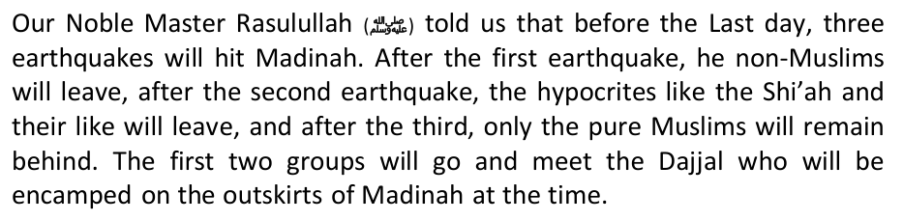
written – Is this not only used after the Names of the Prophets?
38. Why have separate Madressah arrangements in Dubai if Shia and Sunni are one?
like how the Jews used St. Paul to horribly corrupt Christianity beyond recognition and introduce foreign theological notions in it, they used 'Abdullah ibn Saba, the son of Black Yemenite Jewess of San'aa, Yemen, to horribly distort Islam. The Shi'ahs are rightly ashamed that a Jew spun their religion for them, but we will demonstrate this fact from the writers of Shi'ah scholars themselves. Why not a single Shi'ah scholar disputed this fact throughout this period?
to the announcer of the news: 'You are a liar, if you are to bring his head in seventy bags, and brought seventy witnesses testifying to his death, we'll insist that he did not die nor murdered, and (he) shall not die till he rules the globe' ". (Firaq al-Shi'a: Nubakhti, pp. 43-44)
bin Othman said: I heard Abu Abdullah [as] saying: "May Allah curse Abdallah bin Saba', he claimed a divineship for Amirul-Mu'mineen (Ali). By Allah, Amierul-Mu'mineen was voluntarily the slave of Allah. Woe to him who lie about us, for there are people who say about us what we don't say about ourselves, we clear ourselves to Allah from them, we clear ourselves to Allah from them'."
Another Persian historian, in his "Tareekh Shi'I," confirmed: "When Abdullah bin Saba' learned that the opposition to Othman in Egypt was greater, he went there and pretended the knowledge and righteousness until the people trusted him. After he established himself there, he started to propagate his ideas and theory, that for each Prophet was an appointed successor, and the appointee (wasi) of the Apostle of Allah and his successor is no other than Ali, who is blessed with knowledge and Fatwa, ornamented with generousity and courage, and known for his honesty and righteousness. He further said: The Ummah has wronged Ali, usurped his right, the right of Khilafah (succession) and Walayah (allegiance). It is incumbent upon you all to aid and support him. He (immediately) revoked his obedience and allegiance to Othman, and touched many Egyptians with his sayings and deeds, and they revolted against Othman." (Tareekh Shi'i: Rawdat As-Safa, vol.2, p. 292, Tehran Ed.)
In order to achieve this, the entire interpretation of Islamic history was "re-evaluated" in the light of the notion of the "oppressed Imams." As the Imams were no more alive to grant impetus to Shi'ism, the Shi'ite architects then "reworked" history, manipulated it, and created such sensationalism in it so as to keep the flame of hatred burning till doomsday. Sunnis lament the murder of Caliph 'Uthman (RA), but they do not re-enact his death every year in order to rekindle the age-old feuds and bring it to bear on the present. This is exactly what the Shi'ahs do with the martyrdom of Sayyadina Hussain (RA) at Karbala, and the day Caliph 'Umar (RA) was killed at the hands of the fire- worshippinng Abu Lulu Majoosi, for who they have built a shrine in Iran. They CRAVE for tension and hatred with the Sunnis.
Shi'a also quote a hadith in the Sunni books where the Prophet (pbuh)says he is leaving Muslims with two precious things, that which if Muslims hold on to, shall not go astray. However, Sunni believe in a hadith which says the Book of Allah and the Sunnah. Nevertheless, the hadith of the Prophet is found in Sunni sahih hadith books: Jabir bin Abdullah said: "I saw the Messenger of God during his Hajj, on the Day of Arafah (on his last pilgrimage). He was upon his camel Al-Qaswa, giving a Khutbah, so he said: O People! Indeed, I have left among you, that which if you hold fast to it, you shall not go astray: The Book of God (Quran) and my Family, the People of my House (Ahlul-Bait). (Sahih) Sunan al- Tirmidhi, Volume 6, Chapter 31, Hadith No. 3786
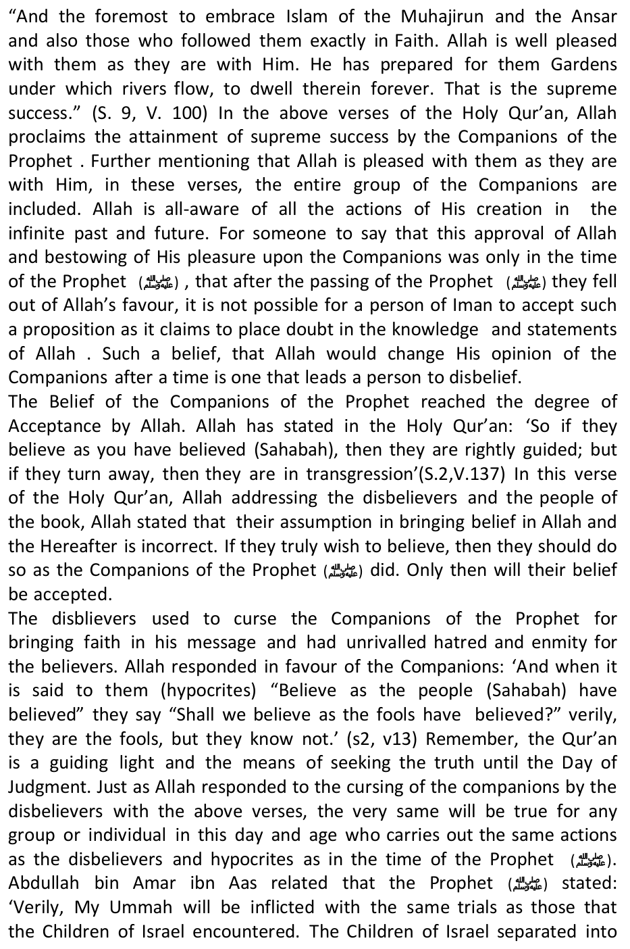
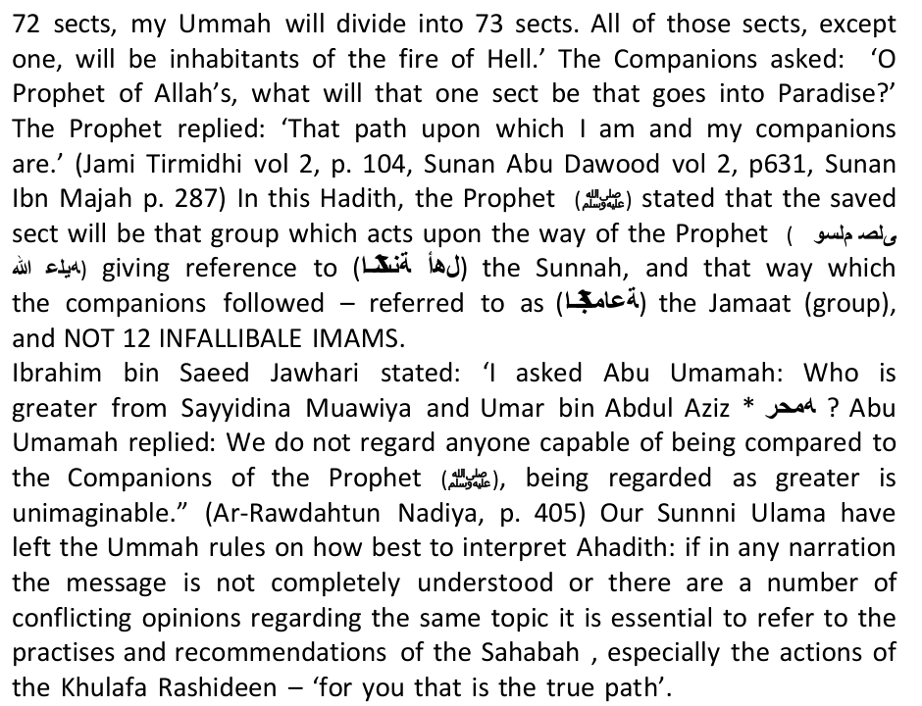
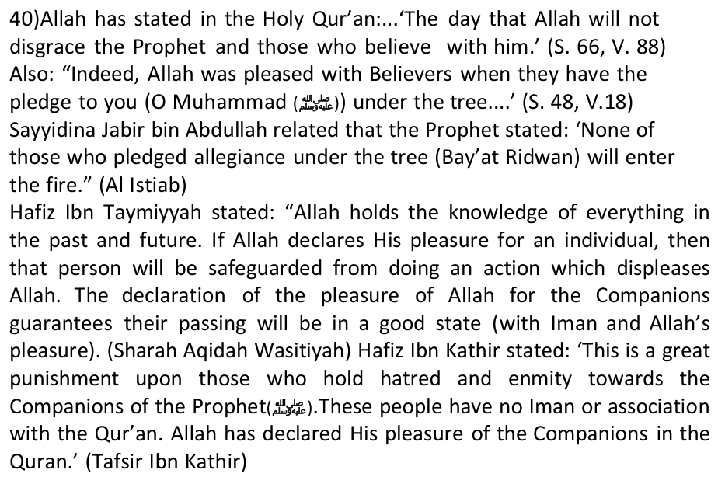
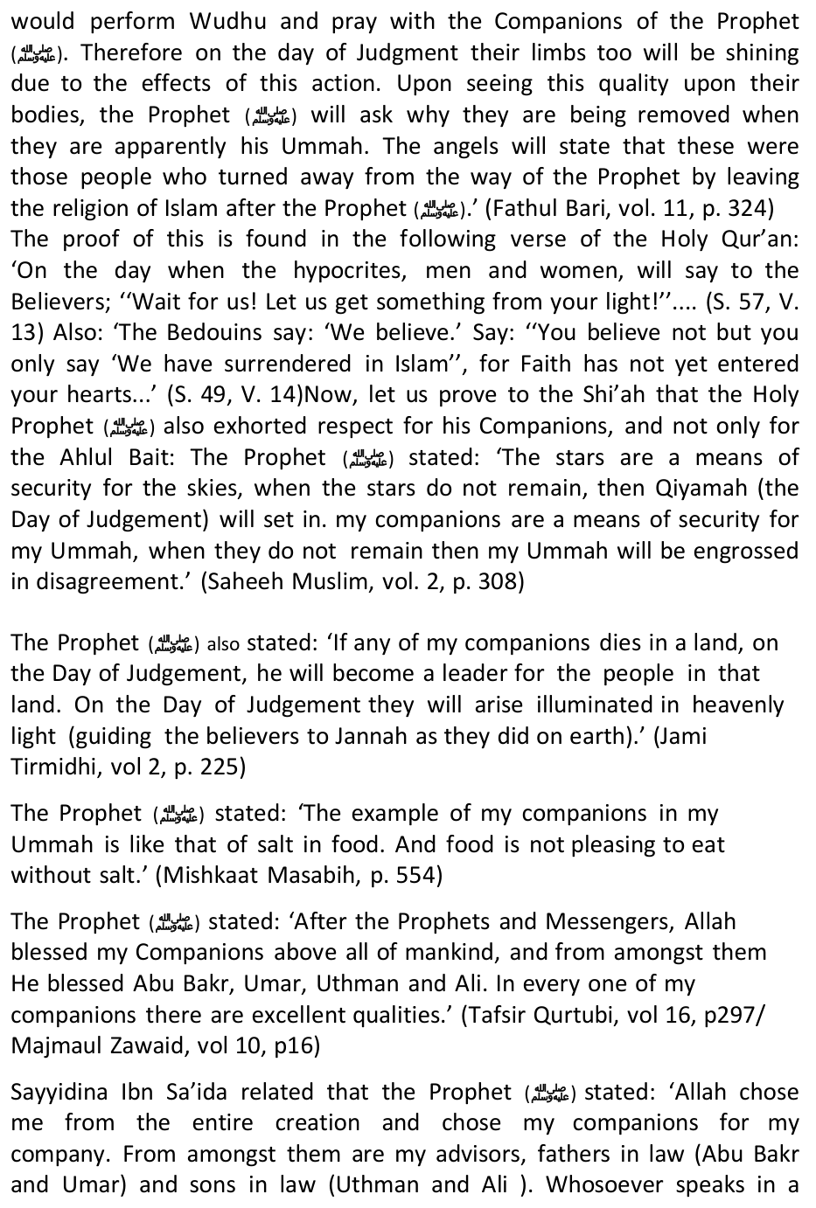
negative way of my companions, upon them is the curse of Allah, the Angels and the entire mankind and on the Day of Judgement no action (good deed) of theirs will be accepted.' (Tafsir Qurtubi, vol. 16, p. 297)
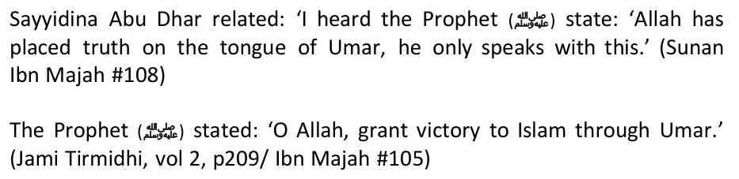
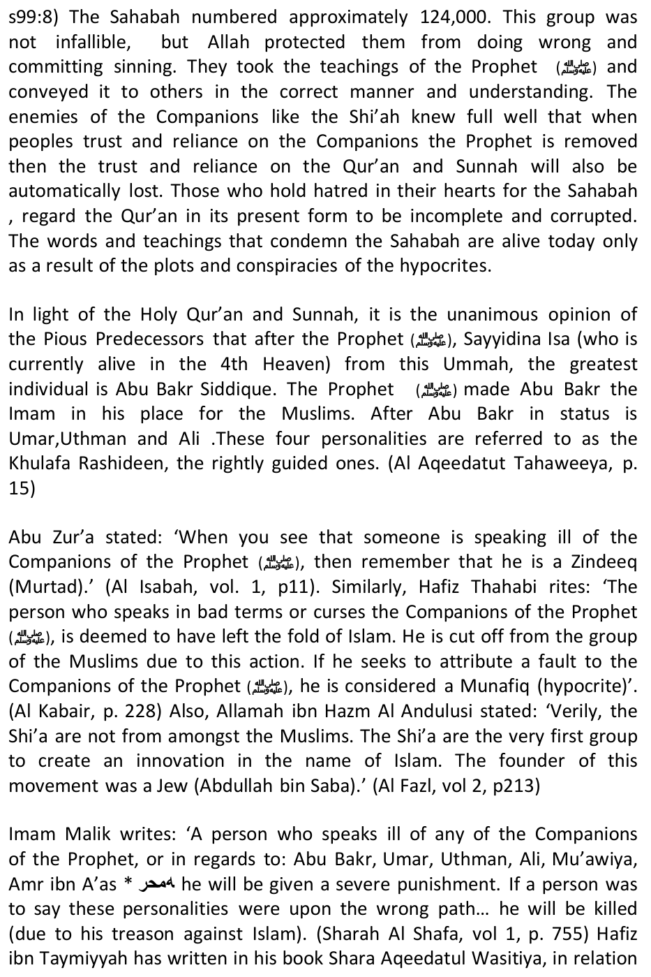
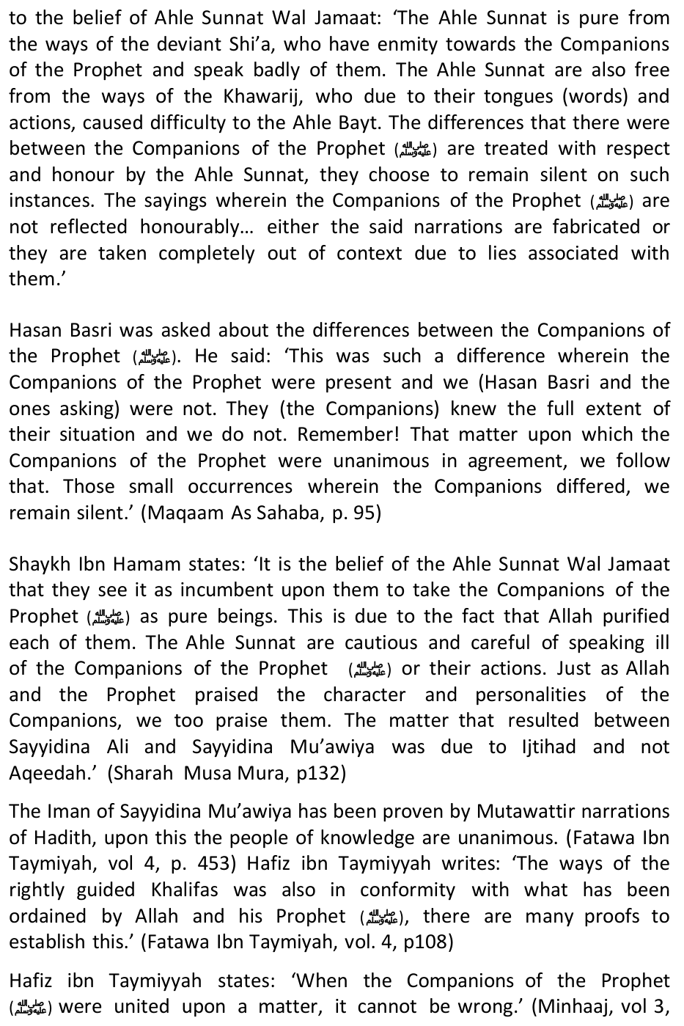
p. 66) It is related from Ahmed bin Hanbal 'For us, the ruling of the Sunnah is that way upon which the Companions were.' (Fatawa Ibn Taymiyah, vol 4, p. 155) Imam Shafi states: 'The Companions of the Prophet, in knowledge, sense, Deen and virtue are greater than us. In every condition, it is better for us to take the opinion of the Companions above our own.' (Fatawa Ibn Taymiyah, vol 4, p. 158) Hafiz ibn Taymiyyah states: 'Upon the foundation of the Holy Qur'an and Sunnat and Ijma of the Ummah, the status of the Companions of the Prophet is second only to the Prophets and Messengers of Allah. For this reason, you will not find a person from the Muslims who will not accept the greatness of the Companions. In this matter, the only ones who cause disputes and problems are the Rawafid Shi'a, in reality they are ignorant.' (Minhaaj us Sunnnah, vol 1, p. 167)
the ways of the Sahabah in belief, knowledge and action.' (Ulema Deoband ka Deeni Maslak, p. 119)
Muslims or for the protection of Islam. There is not one. We can write few pages on the details of the above historical events, but you can check them up for yourself in Hodgson's, Venture of Islam, or in Lost Islamic History of Firaas Alkhateeb amongst many other neutral western authors of history.
the Islamic State in official papers and documents." Many believe that this an Iranian inspired step to frighten the West that the Bashar al Assad regime is the only bulwark against the new Islamic bugaboo.
replace Assad's.
remained largely unscathed.
based in Iran from 2002 onward was known to the U.S. government at the time.
According to al-Shorfa.com a web site sponsored by USCENTCOM, "The Iranian regime's continued interference in Syrian affairs is rooted in preserving its economic and political interests in the region."
authorities at ISIL's headquarters in rural western Aleppo earlier this year, said Syrian journalist Mohammed Abdullah.
carried out by the very jihadists he himself had sent to Iraq years previously.
electorate who wanted reform and reconciliation (and voted in a close election for national unity candidate Ayad Allawi) and made sure that the disastrous status quo was maintained: that miserable, incompetent, divisive, Nouri al-Maliki (Iraq's anti-Western, pro-Iran, fundamentalist Shiite prime minister) continued in power.
support of Iraq and Saddam Hussein. Iran fought the two countries, United States engaged in an undeclared yet bloody naval war and air war, while Iraq fought a land war attitudes of the government or regime of the Sunni Nations that are more subservient to U.S. pressure and hostile towards Hamas, not many people know how actually is the attitude of iman of the Shi'ahs on Al-Quds and Masjidil Aqsa, whether it be among their mufassir or even from among the Ulama's of Aqeedah who become the main marja of the Shi'ah people in the world.
Strangely, when glorifying Masjid Kufah, for it is inside it that Imam Ali b. Abi Thalib was buried, the Shi'ahs have the world spreading the light and guidance.
them think that Masjidil Aqsa is the Masjid which is located in the heaven and right above Al-Quds or Makkah" (footnote, Dr. Mahmud Ibrahim, pg.41) The Jewish propaganda that questions the position and status of Masjidil Aqsa in the belief of the Muslims whose majority are having theaqeedah of Ahlus Sunnah wal Jamaah, is also supported by some splinters of thoughts of the orientalists.
Ali's rights to caliphate, not to mention the Bani Umayyah who are clearly accused of massacring and oppressing the Ahlul Bayt and their followers, and it is very obvious that Sultan Salahudin Ayyubi had destroyed the power of the daulah of Shi'ah Ismailiyah, the twin brother of Shi'ah Imamiyah, namely the Daulah of Fatimid in Egypt, before he subdued the strength of the Crusaders.Now the question is, why are the world Shi'ah groups paying a big attention to the issue of Al-Quds and Masjidil Aqsa today? How many international seminars had been held and also national seminars held by the Indonesian counterparts that are pro-Shi'ah which carry the theme of the liberation of Al-Quds. We suspect that the Shi'ah attention to the issues of Al-Quds and Masjid Aqsa these days are more due to political factors, not purely ideologically religious.
(trademark). They also, since the last decade, fixed every last Friday of Ramadhan as The Al-Quds International Day. The central issue of Al-Quds indeed is very central and easy for winning the trust and sympathy of the Sunni Muslim public in the Islamic world.
If Iran is not the only Islamic state that openly opposes US arrogance and its desire for global dictatorship and hegemony, then who does?
movement was then somewhat restored until once again destroyed at the end of the nineteenth century. After WWI, the former regions of the Ottoman Empire were divided into varying puppet regimes. For aiding to undermine the Ottoman authority in the region, Ibn Saud was duly rewarded with the creation of the Kingdom of Saudi Arabia in 1932. One year later, in 1933, the Saudis granted oil concessions to California ArabianStandard Oil Company (Casoc), affiliate of Standard Oil of California (Socal, today's Chevron), headed by Rothschild agent, and chief among [US so-called] Illuminati families, John D. Rockefeller. Since that time, Saudi Arabia has been the most important ally to the West in the Middle East, not only providing ready access to its plentiful oil reserves, but also in tempering Arab aggression against Israel. Due to the evident hypocrisy of the regime, it has been necessary to suppress the ensuing dissent with brutality till today.
and their ideology, praising the Lebanese resistance movement Hezbollah for liberating south Lebanese lands in the 33-day war against Israel in 2006. Bouthaina Shaaban, the political and media adviser to Syrian President Bashar al-Assad, said on March 3 that Israel is dispatching officers and undercover agents to Syria to join the foreign-backed armed men. The Syrian official further stated that there were undercover agents among the wounded militants recently treated by Israel.
A fighter from the Islamist Syrian rebel group Jabhat al-Nusra is seen in front of a burning vehicle during the Syrian civil war - Reuters
Palestinian Islamist militant groups with arms.
"In my letter to my NAM counterparts, I have denounced Zionist regime's disproportionate violence against defenseless people which violate all human criteria," the minister said.
admitted to the charge, and (Ali) ordered him to be executed. The People cried 'O Chief of Believers! Do you execute a man calling to your love, Ahlul-Bayt, to your allegiance, and disowning your enemies?' He (Ali) then exiled him to al-Mada'in (Capital of Iran back then). Some of the knowledgeable companions of Ali [as] narrated that Abdullah bin Saba' was a Jew who embraced Islam and sided with Ali [as]. That he was of the opinion, at the time when he was a Jew, claiming that Yousha' bin Noon is after Moses. After his submission to Islam, after the demise of the Prophet [pbuh], he claimed the same for Ali [as]. He was the first to publicly mandate the Imamah of Ali [as], disowning his enemies, and debated his opposers. From thence, those who oppose Shi'ism say: The origin of Shi'ism is rooted in Judaism. When Abdullah bin Saba' heard of the demise of Ali while in (his exile at) al-Mada'in, he said to the announcer of the news: 'You are a liar, if you are to bring his head in seventy bags, and brought seventy witnesses testifying to his death, we'll insist that he did not die nor murdered, and (he) shall not die till he rules the globe' ". (Firaq al-Shi'a: Nubakhti, pp. 32-44)
be ruined, namely he who loves me too much and the love takes him away from rightfulness, and he who hates me too much and the hatred takes him away from rightfulness. Verily, I am not a prophet, and there is nothing revealed to me. But I work according to the Book of Allah and the Sunnah of his Prophet (pbuh) as much as I can. So whatever I have asked you in regards to obeying Allah, it is your duty to obey me whether you like it or not." [Ahmad]
falsehood than the Raafidite Shi`ites." [Ibn Taymeeyah, Minhaaj as-Sunnah an-Nabawiyyah, vol. 1, page 39] On another occasion he said, "Narrate knowledge from everyone you meet, except the Raafidite brought was the truth and all of it was conveyed to us by the way of the Sahaba. What those disbelievers wish to do is to cast doubt on the reliability of our narrators in order to invalidate the Quran and the Sunnah. Thus the disbelievers are the ones most deserving defamation."
How does a learned man muster courage to accuse proponents of justice of being destructive? Is it Muslims or enemies of Islam, surely one does not expect a Muslim to make such an allegation. Maulana Khalid Dhorat and company have the audacity to accuse the only political power that upholds the values of Islam of destroying Islam. He further accuses Ayatollah Khomeini of being an American puppet and of British descent. Rouhullah Khomeini was born on the 24th of September 1902 in Iran. His father was Agha Mustafa Mujtahid Kamareh'i. Rouhullah was the grandson of Sayyid Ahmad, and the great grandson of Deen Ali Shah.
and Hazrat Ali (used to do)".
required by his own religious belief, in order to gain the confidence and unstinted support of the Shias, but restrains himself from drawing up the charge sheet of treachery, apostasy and infidelity etc., against the first two Caliphs and the Companions, in general, and assassinating their characters. In exercise of caution and prudence, he has not mentioned even once the names of the first two Caliphs throughout the book even though it deals, as its title indicates, with the Islamic Government. Anyone having rudimentary knowledge of Islamic history knows that, after the Prophet of Islam, its most glorious and exemplary period in Islamic History was the reign of the first two Caliphs 1. Khomeini, however, adopted the prudent technique of skipping over the reigns of the first two Caliphs even where it was necessary to mention these for the sake of historical continuity. Two example of it are being furnished below.
Bakr and Hazrat Omar and the Companions, as a whole, should be treated as they are spoken of in the Shi'ite reports and traditions. Now, let us see what Khomeini has to say about the nomination of Hazrat Ali by the Prophet nd his successor, Caliph and Head of the Islamic State. He writes in Al- Hukumat-ul-Islamia: "We firmly believe in the doctrine of Wilayat (Imamate) and we, also, firmly believe that it was necessary for the Prophet of Islam to name the Caliph who was to succeed him, and he acted accordingly." (P. 18). He goes a step further and says that "the nomination of the Caliph and successor by the Prophet was the act which marked fulfillment of the mission of Apostleship." (p. 19). At another place, he observes more explicitly that: "If the Prophet of God (peace be upon him) had not nominated his successor it would have meant that he had not conveyed the message of God to the Ummat which he was duty bound to do, and failed in the fulfillment of the mission of Apostleship". (p. 23).
(Revelation) and ordered that he should convey the command to the people in respect of the person who would be his successor and Caliph and hold the reins of government, and preach and proclaim the command. The Prophet, then, obeyed the command and nominated Amir-al-Mominin Ali for the Caliphate", (pp, 42-43). Also, "On the occasion of the Last Pilgrimage and at Ghadir-e-Khum, the Prophet nominated Ali to be the ruler after him. From thence sprang up animosity in the hearts of his followers", (p. 131). And, again: "He nominated Amir-al-Mominin Ali to be the ruler of the people after him. This office of Imamate and Wilayat went on being transferred from one Imam to the next Imam till it reached its culmination in the absent Imam, the Awaited Mehdi."
and welfare of the community till the end of time in their lust for power and rule. Does history offer any other example of such a failure of a mentor or reformer? A graver consequence would be that the whole of Islam would lose its believability for it was through these very Companions that it had reached the Ummat. Obviously, no reliance could be placed on persons in respect of belief and faith who were so faithless and selfindulgent.
and Israel and their lackeys against Muslims in Palestine, Afghanistan, Iraq, Syria, Bahrain, Egypt, Libya…?
Wa Salaamu Alaykum Wa Rahmatullahi Wa Barakaatuh
Wa salam wa Rahmatullah,
Finally, we have no political loyalties. Our loyalty is with Allah and his Rasul (SAW) in its true sense. We will glady unite with Iran or with any other Muslim country, provided their ideological basis is correct and are not into dirty politics. You normally reflect what is within you. Mr Islam and the Sh'ahs are full of harted, kufr, evil. They project their image amongst everyone and they portray that to the world, not realizing that all pople are not fools. The Zionists portray the Palestinians as terrorists, yet it's the opposite. The Shi'ahs believe the Sunnis within the Ahlus Sunnah Wal Jama'ah as apostates, but the reverse is true.
You must join that army which will come from Khurasaan." (Ibn Adi)
in 'Kitab al-Fitan, Baab Kharuj al-Mahdi' and 'Mustadrak' al-Hakim. Hakim classified it as saheeh on the conditions set by al-Bukhari and Muslim and al- Dhahabi agreed. Ibn Kathir wrote about it in his 'al-Nihaya (al-Fitan wa al-Malahim)' that its isnaad is 'qawii' (strong). al-Albani considers some of the chains as unacceptable, but writes the hadith is correct in meaning without the addition, 'he is the Khalifah of Allah, the Mahdi.' He rates the isnaad of Ibn Majah from 'Alqama from Ibn Mas'ud as hasan which does not have the words, 'khalifa-tullah.' He then goes on to discuss why this addition is not acceptable.
Christians will raise the crucifix and refer the victory to it. At this, a Muslim will become angry, and will pull the crucifix down, at which, the Christians will unite breaking all treaties with the Muslims.The Christians will demand their wanted people, to which the Muslims will answer:"By Allah! They are our brothers. We will never hand them over." This will start the war. One-third Muslims will run away. Their 'Tawbah' (Repentance) will never be accepted. One-third will be killed. They will be the best 'Shaheed' (martyrs) near Allah. The remaining one-third will gain victory, until, under the leadership of Imam Mehdi, they will fight against Kufr (non-believers).. (Ibn Majah)Reported on a chain of transmission on the authority of Kaab "The sign of the Mahdi's appearance will be war banners coming from the west, lead by a man with a disability from "Kinda" (Nuaym son of Hammad, Al-Fitan page 205)
Christians shall say to their leader: 'We shall relieve you of the Arabs,' and they shall gather up for the great battle (al-malhama). They shall come to you under eighty flags, each flag gathering 12,000 troops." [approx. 1 million]
suburbs of Damascus and his general followers will be the people of Kulaib Tribe.He attack(so fiercely) that he will cut the bellies of Women and kill children. To fight against him, the people of the Tribe of Qais will gather. Sufyani will fight them and kill them so much that no valley will be left without their dead bodies.
peace be upon him, said: "If you see him give him your allegiance, even if you have to crawl over ice, because surely he is the Caliph of Allah, the Mahdi. If you see the black (meaning war) flags coming from Khurasan (Afghanistan), join that army, even if you have to crawl over ice, for this is the army of the Caliph, the Mahdi and no one can stop that army until it reaches Jerusalem."(Ibne Majah Page 300, Also in Ahmad's Musnad, al-Haakim's Mustadrak and others.
Khurasan. Their turbans will be black and their clothes white. At their front will be a man named Shuayb, the son of Salih, from Tamim. They will defeat the companions of The Sufyaani until he comes to the House of Jerusalem where he will establish his power for the Mahdi, and he will be supplied with three hundred (men) from Syria after his arrival and the matter will be settled for the Mahdi in seventy-two months (six years)."
from the east led by a man from Tamim called Shuayb, the son of Salih who will restore what is in their hands from the captured people of Kufa and he will kill them. Then, another army from The Sufyaani will go to Medina and pillage it for three days and thereafter proceed towards Mecca until they find themselves in a desert. Then, Allah will send Angel Jibra-eel and say to him, 'Chastise them!' So he will beat them with his leg once and Allah will cause them to be swallowed up. None will remain except two men who will return to The Sufyaani to inform him of the swallowing-up of his army, but this will not scare him. Several men from the Quraysh will escape to Istanbul and The Sufyaani will send to the leader of the Romans who will return them to him and he will slit their throats together with their followers.
There will be a great battle there.
Those authorities include the Muslim World League which gave a deliverance on the subject on the 9th of Ramadan 1400 AH (1980), and another at its 3rd annual conference in Safar, 1408/1987; the Ministry of Endowment and Religious Affairs in Morroco, 1400h., ash-Shaikh al-Habib Bal-Khojah, the Jurist consult of the Tunisian Republic; his eminence, ash-Shaikh Abdul-Aziz bin Baz, ash-Shaikh Nasirud-Deen al-Albani, the leading authority in the science of the Prophetic tradition; and many other scholars in the Muslim world.
Muhammad sallAllahu 'alayhi wa sallam. "Say, 'I do not say to you, I possess the treasures of Allah, nor do I know the unseen." (6.50) The same words were uttered by Noah to his people. Allah also addresses His Messenger: "Say, 'I have no power to do you harm or benefit."(73.21) And Allah the Exalted says addressing His Messenger: "Say, 'I have no power to do myself harm or benefit." (7.188)
of the known substance by mating the male and female. There is none of Adam's posterity who was created out of light, nor was any of them light before he was created. Similarly, he who claims that a human being has access to the unseen, has control over the disposal of the affairs, or is infallible to slips, not subject to oblivion, has knowledge equal to that of Allah, and is qualified in the same way as the Lord, is an infidel who does not believe in Allah, and a polytheist who makes out of the creatures contenders with Allah equal to Him. Far above is He from what they ascribe to Him.
opposition to the Book of Allah, to the Sunnah of His Messenger, and to the consensus of the Muslim Ummah.
However, suppose a progressive, pro-Western regime ruled Iran, representing no threat? War discussions would be unnecessary. Yet many forget that, until 30 years ago, exactly such a regime led Iran, until it was toppled with the help of the same U.S. foreign policy establishment recently beating war drums.
Middle East itself, he favored peace with Israel and supplied the beleaguered state with oil.
Du Berrier commented:
deadly struggle against terrorism, most of which was fueled by the bordering USSR, which linked to Iran's internal communist party, the Tudeh. SAVAK, which had only 4,000 employees in 1978, saved many lives by averting several bombing attempts. Its prisons were open for Red Cross inspections, and though unsuccessful attempts were made on the Shah's life, he always pardoned the would-be assassins. Nevertheless, a massive campaign was deployed against him. Within Iran, Islamic fundamentalists, who resented the Shah's progressive pro-Western views, combined with Soviet-sponsored communists to overthrow the Shah. This tandem was "odd" because communism is committed to destroying all religion, which Marx called "the opiate of the masses." The Shah understood that "Islamic Marxism" was an oxymoron, commenting: "Of course the two concepts are irreconcilable — unless those who profess Islam do not understand their own religion or pervert it for their own political ends."
Sovereign's helicopter was going to land for the official welcome. At the exact moment, when courtesies were being exchanged on the White House lawn, these people produced sticks and bicycle chains and set upon the others.... Thus, the whole world was allowed to see riotous scenes, on
Khomeini and the Media Cabal
Corporation) into a propaganda organ.
Iran's generals into giving in without a fight." "Huyser directly threatened the military with a break in diplomatic relations and a cutoff of arms if they moved to support their monarch."
Army officers, who had been instructed by General Huyser not to resist the revolution, were put to death. Before dying, many exclaimed, "God save the King!" "On February 17," reported du Berrier, "General Huyser faced the first photos of the murdered leaders whose hands he had tied and read the descriptions of their mutilations." At the year's end, the military emasculated and no longer a threat, the Soviet Union invaded Afghanistan. More Iranians were killed during Khomeini's first month in power than in the Shah's 37-year reign. Yet Carter, Ted Kennedy, and the Western media, who had brayed so long about the Shah's alleged "human rights" violations, said nothing. Mass executions and torture elicited no protests. Seeing his country thus destroyed, the exiled Shah raged to an adviser: "Where are the defenders of human rights and democracy now?" Later, the Shah wrote that there was not a word of protest from American human rights advocates who had been so vocal in denouncing my "tyrannical" regime! It was a sad commentary, I reflected, that the United States, and indeed most Western countries, had adopted a double standard for international morality: anything Marxist, no matter how bloody and base, is acceptable.
Does this explain the sudden attitude change toward Iran expressed by Henry Kissinger, beginning in the mid- seventies? Kissinger's links to the Rockefellers, whose fortune derived primarily from oil, bolsters the Shah's view on the situation. However, other factors should be considered.
President Bush tried to do was kind of create a Sunni axis against the Shi'a Iran, by arming our Sunni allies, our so-called moderate Sunni allies...I'm not exactly sure if that's the best idea going forward, because as you know, this is not the Middle East that we were dealing with during the Bush administration. We no longer have just a handful of dictators that we can tell what to do."
circles such as the presidents, kings and leaders of the Arab nations, even the Hamas movement which is conducting armed resistance against Israel as I write.
cleansing against the Sunni Arabs in Iraq, along with the efforts of isolation against them in Southern Iraq. Coupled with the call to divide Iraq based on sect groups, as well as prompting the American troops to carry out arrests, captivity, murders, destruction and cleansing against alliance is another side of the face of Iran and the Hizbullah as the icons of resistance of the Islamic World. A fact which is rarely exposed and only existing "behind the scene."
This Shi'ah Safawist Project is at least built on five points:
the whole population of Iraq.
unacceptable that Lebanon is being destroyed and its people killed just because of the provocative behavior of the proponent of the Safawist-Persianist project called the Hizbullah and its executions are accomplished by Israel. It is unacceptable that dark military operations are being made as an arena to stall the time for building the Nuclear Weapons project of Iran-Safawists, that would someday be represent the military strength, but also the power of the ideologies and masses. Each of the Shiah, `1`Al-Qaeda and the West (in which includes Israel and the crony rulers that have not yet collapsed). The three of them are the most potential powers to control the Middle East after the crisis. Due to that, it is interesting to analyze what would the Middle East be like in 10 or 20 years from now.The West and Israel: The West and Israel are always in the position of supporting any regime that rules in the Middle East as long as the two conditions are met; not supporting terrorism and being cooperative in selling oil to the West. They basically do not make a fuss of the repressive attitudes of the regimes against their subjects. Even if they voice out criticisms, it is no more than a 'lips sweetener' as a high-level political platitudes.
as there was no rival. But today, the rivals are already many.
and the Persians are represented by Iran. And Iran, since the old days, has always been a major cause of problems, because it was destined to be a fertile land for the expansion of the various deviations and malice. It's no surprise in the history of Persia, they most often associated themselves and were always mutually cooperative with the Jews.
7. Iran is also not bothered by Al-Qaeda, different from Saudi Arabia or the West. It's reasonably so because Al-Qaeda can only operate where there is a base of its Sunnis, while Iran has very few Sunni adherents. Meaning, Iran's economy and military strength is in a stable condition, no other meaningful disturbance.
After 30 years, Iran became a force to be reckoned with. It has extensive influence in the Islamic world. Iraq is already within the control of Iran after America left, although not fully. If it is success in Bahrain, the number of Shiah states will increase. And there will be many more. On the other hand, also after 30 years, the global jihad successfully established a strong influence in Afghanistan, a part of Pakistan, Iraq (although partly), Somalia, Chechnya, Kashmir and a number of other armed upheaval regions. Sooner or later, the big battle between the global Mujahideen against Iran will erupt. Because, after America has weakened, Iran has to be cleaned out from the Middle East.
fight them is the responsibility of all, not one sect or one party. The at graves (the Shi'ahs treat their Imams as Gods and ask them directly center for Wahhabis. 4) Al-Sunnah mosque in Shiraz. Confiscated after the murder of Dr. Muzaffar Ban who founded it, and transformed to a centre for selling video and audio tapes produced by the revolutionary guard. 5) Sheikh Faydh mosque. This is an ancient Sunnah mosque in Mashhad, one of the main Shi'ah centres of the world. The government could not tolerate the continued existence of this mosque in the city, so it demolished it in 1993, under the supervision of the revolutionary guard, who also demolished adjoining centres which were used as guest houses and Qur'an memorisation centres. The demolition orders came from Khameni personally, the present spiritual leader of Iran. What is amazing is the fact that the demolition of this mosque occurred immediately after the government- sponsored demonstrations against the demolition of the Babary Mosque in India by the Hindus. 6) Ahlus Sunnah School, Talish. The government confiscated the Ahlus Sunnah school at Talish -North-West of Iran. Sheikh Quraishy, the principal of the school was also arrested and alleged confessions were obtained from him under torture. 7) Aaban mosque Mashhad city. They confiscated the land, demolished the walls, and expelled the trustee. 8) Shiahs also repair the roads from time to time, eg. in the city of Zahdan, in order to demolish Sunnah houses, mosques and schools in the name of alleged reconstruction;

BRIEF INTRODUCTION OF THE SHEIKH
The Sunni Muslims in Iran number about 15 to 20 million, living mainly in the mountainous and border regions. They are mainly Kurds, Turks, Baluchis, and Arabs. There is also a good number living in the cities.
This promise, however, was blatantly dishonest as soon as the regime became stronger. The land allocated for constructing the mosque was confiscated, as well as the offices and bank accounts of the Consultative Council, whose scholars, members and supporters- both men and women-were detained.
because neither us nor our parents accepted Shi`ism or Magiasm!
scholars), and candles (the general activists); we will first extinguish the large spotlights." This stage has been accomplished as they have killed most of the prominent scholars. "Then we will extinguish the smaller lights"; in this respect many activists have been killed and many others exiled. "Then we will turn the fan to put out the candles." This is an indication of the final stage of forcing people into Shi`ism against their will.
under torture after being accused of Wahhabism.
Khomeini personally, the spiritual leader of Iran. What is amazing is the fact that the demolition of this Mosque occurred immediately after the government-sponsored demonstrations against the demolition of the Barbary Mosque in India by the Hindus.
for this reason, you will not find any value placed on a council." This is a great shame. Whilst we are living in the twentieth century, we find a third of the population of a nation deprived of their most basic rights. Is there any other country on the face of the earth which prevents its people from choosing names like Umar, Aishah, Hafsah, Abu Bakr, Zubair, or most of the names of the companions amongst the ten fore-told of Paradise?
appoint one Sunni official. Had Khatemy taken this opportunity, the tyranny and oppression would be reduced dramatically, however, I do not think that he intends or is able to bring equality between Sunnis and the others. I have sent an open letter to him in this respect.
and the people of their creed. I advise these people to be conscious of Allah and have some concern for their creed and those who subscribe to the same creed. Their visits are proof against us and cause us harm and lead to the murder of many of our members. They are like puppets in the hands of the political regime, they say to us: "Here are your Imaams, your scholars and Sheikhs, they are praying behind us, visiting the grave of the Imaam, and do not ask us for a separate Mosque for themselves in Tehran, they say we pray all together in one Mosque, so why do you differ with your scholars? You must be a Wahhabi!"
father. On the contrary the Sabais enjoyed great latitude during his tenure and spread the message of friction and disunity without much restraint. They intensified their efforts to inject the poison of dissension into the veins of the Muslim body. Some of them felt inclined towards Sayyadinna Muawiyyah (RA) and some of them joined the Kharijis. Hadhrat Hassan had almost lost his grip over them.
intends to negotiate with Muawiyyah and hand over the affairs of Khilafat to him." They added: "These people will turn infidels if he does so."
surety. Half of the amount was to be shelled out immediately while the remaining half would be paid in Kufah. Ubaid Ullah moved towards Muawiyya's army with his special companions during the night. When the people found their leader off the scene, Hadhrat Qais bin Saad led the prayers and acted on his behalf. Hadhrat Hassan realized that the people were determined to humiliate him. He felt that they had switched their loyalties. They ridiculed him as a result of the twist in their motives, accuse him of infidelity, looted his property and legitimized his murder. Most of the people around him were mischief—mongers. They were all out to harm and humiliate him. His own Shias and the Shias of his father were too few to put up a meaningful and effective resistance to the Syrian onslaught.
whether he lives in the east or in the west. You dislike grouping, peace and reconciliation but these are better that rift, fear, spite and enmity which you appear to relish. My father Hadhrat Ali used to say that we should not look down upon the leadership to Muawiyyah because if we discard him, it will be like the irreversible chipping of heads off the shoulders that carry them.
reconciliation the only way out of the intractable situation. The Shia historian Yaqubi relates that Hadhrat Hassan ibn 'Ali (RA) had lost a large quantity of blood when he was brought to Madain. The malady had taken a serious turn. The people had left him. Hadhrat Muawiyyah came to Iraq and took over the reign of Khilafat because the supporters of Sayyadina Hasan had BETRAYED HM. When Hadhrat Hassan realized that he didn't have the strength to fight and his friends had deserted him and were absolutely unwilling to collide with him, he patched up with Hadhrat Muawiyyah (RA). He ascended the pulpit, praised Allah and then addressed the people: "You were rewarded with Allah's blessing on account of our ancestors but you shed one another's blood on account of our descendants. Therefore I have patched up with Hadhrat Muawiyyah ibn Abu Sufyan (RA) and handed over the Khilafat to him and I can't say whether it is a test of you faith or a source of benefit for a limited period."
"Allah is great! O Hassan! you have committed infidelity – as you father had done before you, and then he inflicted such a heavy blow on his thigh with a spear that his thigh bone was fractured. The people pounced at Jarah and squashed him under their feet. They brought Hadhrat Hassan to Madina but the spear-wound was a constatn source of pain and torture. He restrained his anger and bore the pain and greif with fortitude caused by his own followers until he died by the end of Safar in 47 A.H. at the age of forty five years and six mounts. Some of the scholars opine that he was born during Ramadhan in 3 A.H. and the tenure of his Khilafat streteched over six years and five months.
He was minkaah (oft- marrying), mitlaaq (oft-divorcing), and misdaaq (extremely generous in his dowry payments). Al-Dhahabi cites from Ibn Sirin the report that one time al-Hasan gifted to a woman one hundred servant-girls, each carrying 1,000 dirhams. Ibn Kathir in the Bidaya relates that one day he divorced two women of different tribes at the same time and he sent to each one 10,000 dirhams and a gourd of honey. Jarir b. Hazim said the people of Kufa loved him more than they had loved his father, Allah be well-pleased with both of them. It is known that he exhausted his entire fortune twice and Ibn `Abbas said al-Hasan went to Hajj on foot 25 times. Due to this practice, many historians aver that one of his ex-broter in-laws murdered him. There is no truth in the fact that Sayyadina Mu'awiyah (RA) had him poisoned as Sayyadina Hassan (RA) posed absolutely no threat to him!!
Hussain bin Ali. When Walid pressured Hadhrat Hussain to pledge fealty to Yazid, he left for Makkah where he stayed for a few days.
you'll also find a number of helpers and supporters there. Stay there and seek the good will of the people. From there you should write to citizens of Iraq out their Amir. If they have the power to extradite him and there is no one to oppose you, then you are welcome to go there. I don't rule out their treachery. If they don't act up to your wishes, then you should stay put. The place is riddled with castles and valleys."
Islam, he left behind a pleasant and favorable impression. He always launched a tempestuous attack (on the enemy). People attached great expectations to him and had evolved a consensus around him. When he marched towards Muawiyyah, every one had supported him except the Syrians. Even otherwise he enjoyed a better status than Muawiyyah but in spite of all this the people degraded and disgraced him. They were reluctant to wage Jehad; greed and lechery overpowered them. They not only prickled and annoyed him but also opposed him tooth and nail until he tasted the cup of martyrdom. Then the treatment they extended to your elder brother after the death of your father is not hidden from you either. You are a direct witness to these happenings and yet you are ready to ho to them who opposed your father and brother. You want to fight against the residents of Syria and Iraq and the person who wields greater power than you and who is fully laced with arms. People fear him more and expect more from him. I came to know that you have set out towards them, they will bribe the people with wealth and goods. People are creatures of flesh. Those who have promised to help and support you will turn against you. Those who seem to love you at present are the ones who will insult you later. Therefore fear God and don't go there."
preferred my city to others?"
drink. When she asked him what had happened, he reeled off to her the entire gamut of events. She suddenly softened towards him and provided him shelter where he could hide himself. When his son came home, he found out that he was hiding there. Next morning he conveyed the news to Muhammad bin Ashath who conveyed it to Ibn Ziyad. Ibn Ziyad murdered him. He also murdered Hani' bin Marwah when he was calling out to the children of Murad for help. He was the chieftain of the tribe. When he rode on his horse, four thousands armoured people and eight thousands footmen accompanied him. If his enemy Banu Kandah had responded to his call, the number of his armoured companions would have risen to twenty thousands. But all of them displayed nauseating cowardice and chicken-heartedness and failed to heed the call of their leader. This was the first round of their betrayal even before their Imam arrived.
Kufah as veritable paradise where they would laze and roll away their time in utter luxury. They were the least inclined to face the ordeal of a rough life.
The Shia historian Yaqubi—who, in the opinion of Wellhausen, was highly fanatic and extremely partisan—mentions that when the Kufis martyed him, they plundered his goods and belongings and escorted the ladies to Kufah. When the ladies entered Kufa, the women of that town came out of their houses screaming and beating their chests. Hadhrat Ali bin Hussain remarked: "If they are mourning for us, then who has murdered us?" I would like reproduce here the words of the German historian Wellhausen, who has a soft corner for the Shias: "The populace in Kufah did not want to help the Government, but inspite of their disinclination to help, they did not join the ranks of the enemy. Even those people who had dispatched letters to Hadhrat Hussain, sworn their loyalty and sincerity, kept away during the hour of trial and did not extend the hand of cooperation towards him. The maximum that they did for him was to watch the gruesome spectacle of his martyrdom from a distance and shed crocodile tears over the gory outcome. People who stayed with him till the end could be counted on fingers: for instance, Abu Thamamah Saidi, the treasurer of the public exchequer, Ibn Aosjah etc fought beside them on the battle field. Some of them had joined them on the way, and there were others who had supported them till the last hour out of a feeling of human sanctity, though they had neither any links with them nor did they happen to be among their Shias. The historians have especially under- scored the discrepancy between the followers who did not flutter a feather (in support of the Imam) and the non- followers who went the whole hog to help him and put his followers to shame. More painful is the fact that not only the Quraish but the Ansar as well had drawn themselves away from Hadhrat Hussain. When he left Madinah, not one of them accompanied him. Among the Shias of Kufah, very few people actively supported him. The 63 A.H. revolution was not caused Ali's progeny and Hadhrat Ali bin Hussain had no link with it at all. The people who came out against these insincere and lily-livered rulers were the overt enemies of Shias and had served the Umayyids as their most humble servants. It means the war was not waged out of religious considerations."
Hadhrat Hassan, but when he set off to fight against Hadhrat Muawiyyah, they betrayed him at Sabat Madain. The second treachery was that they scribbled letters to Hadhrat Hussain bin Ali and invited him to visit Kufah. When he landed in Karbala, the Kufis betrayed him and, instead of supporting him, they supported Ubaidullah bin Ziyad. The fourth person they played the hoax on was innovations of Shiaism. All of them utilized their spurious love of the house of Ali as a label for the completion of their nefarious interests. The Jews injected the concept of "return of resurrection" into the body-frame of Shi'ism and the Shias had declared the fire of hell unlawful for their community. If any Shia was thrown into hell, he would stay there only for a few days. Under the influence of Christian beliefs, they held that the Imam enjoyed a divine status. The Imam is the converging point of divine and non-divine attributes. Prophethood is interminable. A Prophet is the receptacle of divinity. He develops an inalienable union with the Godhead and their separation becomes impossible.
the other hand was Hadhrat Hussain who, inspite of the heavy odds against him, had refused to knuckle under and preferred to resist the force of tyranny and oppression. Hadhrat Hussain clearly knew that the forces of Yazid out-numbered his men but he did not bend under their numerical pressure and embraced martyrdom along with his companions on the battle field. He obviously preferred the chess board of war to the negotiation table of humiliating peace. If Hadhrat Hassan was justified in his stand, the conduct of Hadhrat Hussain was unjustified either as he felt more crippled and handicapped compared with his brother. And if Hadhrat Hussian's action was justified it would automatically invalidate the action of Hadhrat Hassan. on account of this fundamental complication, the Imamat of the two brothers because suspect in their eyes. Some of them squirmed out of the commitment to their Imamat and started piping the tunes called out by other people.
Hussain which he accepted and repaired his own house and the house of 'Aqil bin Abi Talib that were in a delpidated condition. Later, he sent him forty thousands dinar which he declined to accept because he had by that time articulated his beliefs. Mukhtar was the person who persuaded people to acknowledge the Imamat of Muhammad bin Haniyyah.
and Persian genus. The Arabs love freedom and independence; the Persians love slavishness and humility. The election of a Caliph after the Prophet was something unexpected for them which they found extremely gritty to swallow or digest. They believed only in the law of inheritance as it was compatible with their servile outlook. It was, therefore, part of their conviction that as long as Muhammad lived, none on his sons could replace him. Hadhrat Ali also favoured his appointment as Caliph. Therefore it was essential that Khilafat should circulate only among Ali's also favoured his appointment as Caliph. Therefore it was essential that Khilafat should circulate only among Ali's progeny as part of an inviolate heritage.
Imam Bukhari has supported it in his "Sahih" with special reference to his Hadith "Ba-Tariq Hamadaniyyin" (the people who were Hadhrat Ali's closest associates). Rather, he himself often expresses: "(If I am serving as a porter at any one of the gates of Paradise, I would tell the Hamadains to enter Paradise fearlessly. Imam Bokhari attributes a tradition to Suffiyan Thauri who is a Hamadiani and he has ascribed it to Muhammad ibn Hanfiyyah. He said: I asked my father who was the best person after the Prophet (peace be upon him)?
led him to label Shi'a Muslims manifest disbelievers. What is his agenda and why is it in favor of the enemies of Allah, because Islam does not teach hatred. Allah encourages Muslims to care for one another, why is Maulana Dhorat pushing Muslims away from the guidance of Allah?
but clear Kufr. To expose why isn't the Ja'fari School a madhhab (but a cover-up for an obnoxious creed), consider these points:
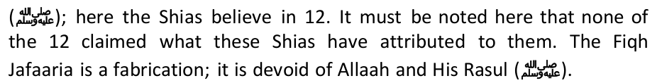
Imaan of ourselves, our families, and the Ummat at large.
It is narrated in Shi'ah books that sparrows should be killed because they are Sunni and they love Sayyyadina Abubakr (RA) and Umar (RA). Shi'ism is the sect of hatred and violence. Ref: Anwar Numania, page 211: "It is narrated that sparrow loves fulan (Abubakr) and fulan(Umar) and it is a Sunni. It should be killed in any way possible and executed and then eaten".
was made halal (permissible) in the Book of Allah, when (Prophet) Lot said: 11:78 Here are my daughters, they are purer for you and he knew it was not the vagina they were after." [Tafseer al-Ayyashi, vol.1, p.157; Bihaar al-Anwaar vol.21, p.98; Tafseer al-Burhaan vol.2, p.230] Narrated Abdullah bin Abi Ya'foor: I asked Abu Abdullah about approaching women thru their anus, he said: No Problem. He then recited: 2:223 Your women are as tilth unto you, so approach your tilth when (or how) ye will ." [Tafseer al-Ayyashi, vol.1, p.110; Bihaar al- Anwaar Baqir al-Majlisi, vol.23, p.98; al-Burhaan fee Tafseer al-Qur'an: Hashim al-Bahraani, vol.1, p.219; Wasaa'il al- Shi'a: al-Hur al-Amily, vol.3, chpater 73: An-Nikaah wa Aadabuh]. This is another evidence on how mentally sick these Shi'ite Priests are, and how Satanic they get to distort the Words of Allah or their meanings to lead their followers to behave as the people of Prophet Lot, whom Allah has condemned in all Scriptures.
those whom Allah the Exalted said about them: 5.14 From those too, who call themselves Christians, We did take a covenant, but they forgot a good part of the Message that was sent them. Surely, a time will come when they will remember that portion, and when the Qa'im (Mahdi) arise, a group of them will come to his support, but never marry anyone of the Kurdish (people) for they are part of the Jinn (demons) whom the screen was lifted from them" Ibid, narration 2
Narrated few of our friends on the authority of Ahmad bin Abi Abdillah, from his father, from Wahab, from (Imam) Abu Abdullah [as] said: Amirul-Mu'mineen (Ali) [as] said: Men were created from Earth, and all they care for is the land. As for the woman, she was created from the man, and all she cares for is men, O Men, lock up your women". al- Kafi ( fil Furoo' ): al-Kulainy, Kitaab al-Nikah, Chapter What's Recommended for Women Who Reached pubery…; vol.5, p.337, narration 6.
truthful brothers and make lots of them, for they are your ornament in times of peace and your fort in times of need. Consult in your affairs those who fear Allah, and love the brothers according to their level of righteousness. Try to avoid the bad women, and ever be watchful of the best of them, if they enjoined good on you, disobey them so they won't have a hope to have you obey them in that which is no good". Al-Amaali: Ibn Babawaih al-Qummi, 50th Council, Narration No.8, p. 250.
Chapter of the Ten, Section: Lust Is Ten Parts, p.338, Narration 28
AlTabRassy said: "Alkafi among the four shia books (AlTahzeeb, Alkafi, AlIsTibSar, mun la YahDuruhu Alfaqeeh) is like the sun among the stars, and who looked fairly would not need to notice the position of the men in the chain of hadiths in this Book, and if you looked fairly you would feel satisfied and sure that the hadiths are firm and accurate "[Mustadrak Al-Wasa'el, volume 3, page 532] So according to Shi'ite scholars, all the above filth we came across is authentic and reliable.
pulled at it, and I have not seen such a courageous man......." 5
to me did, that is the Holy Prophet." 10. This statement showed that Abu Bakr was not legally elected as the Holy Prophet (SAW)'s first successor. Mubàrakfurï wrote in the commentary of this tradition that it indicated ijmà' that the Holy Prophet (SAW) did not appoint Abu Bakr as his successor, just as ibn Ràwandï thought that ibn 'Abbàs was appointed and the Shï'ahs think that 'Alï was appointed. If one thinks that anyone of them were indeed appointed, it would mean that the was the answer.14
It has been narrated by 'Irbàd ibn Sàriyyah that the Holy Prophet (SAW) delivered an inspiring speech due to which eyes started tearing, and the hearts were moved. He said, "I urge you to listen and to obey, for you will notice much conflicts after me, so be steadfast upon my way and the way of the four rightly-guided caliphs. And avoid innovations
Historical facts prove that the Prophet (pbuh) did appoint a successor a few months before his death, on what is termed The Farewell Pilgrimage, when the Prophet (pbuh) made his religious trip to Mecca, after completing his pilgrimage, he left Mecca for Medinah. On his way back, a verse was revealed: "O Messenger! Deliver what has been sent down to you from your Lord; and if you don't do it, you have not delivered His message; and Allah will protect you from the people ..." (Qur'an 5:67)
other.
that Ja'far had two neighbours who would constantly harass him. He named them Abþ Bakr and 'Umar, whenever he would abuse caliphs Abu Bakr and 'Umar, he would say that he meant his two neighbours. 'Abd al-Haqq Dehlawï said that any narration which supported the tendencies of any deviate sect would be rejected; and if the narration does not support any of his ideals, it would be accepted. In the above case, because this addition of words supports the Shi'ite tendencies of Ja'far ibn Sulaimàn, it will be rejected.32 tradition.34
their wishes were brought to naught and the Prophet presented 'Alï as a guide and leader of Islàm to the people. After 'Alï, this heavy and necessary duty of guide and leader was left upon the shoulders of his family."35
designate a weakling to be his successor?
2014, he said, "Our enemies have caused disunity among us with their plans. We are so hostile to each other that the Zionist regime has never enjoyed so much peace and stability." "Muslims should not offend each other's sacred figures or scholars and we have emphasized that offending is not allowed." He said: "But if a few ignorant Shi'a or Sunni fanatics started offending each other's Holy beliefs, it shouldn't be considered as the criterion or standard; it
Do the clean work of Allah instead:
"O Allah, they are the people of my house. Remove from them abomination and purify them a complete purifying".
Hàrithah and the 'Ashsharah al-Mubashsharah (RA).
This rank of superiority is based on the amount of sacrifice the Sahàbah offered for the cause of Islàm. The status of those who embraced Islàm after the hijrah, even if they toiled harder than those who accepted Islàm prior to that, will still be much higher than the efforts required in establishing anything infinitely greater, than merely promoting or propogating it.
any case." 43
Furthermore, to prove that Ali, Hassan, Hussein and their descendants are the successors of the Prophet, Shi'as quote the below hadith from Tirmidhi. Sayyidina Zayd ibn Arqam (RA) reported that Allah's Messenger (pbuh) said, "I am leaving behind with you that which if you hold fast, you will not go astray after my death. One of them is mightier than the other the Book of Allah, a rope hanging down from the heaven to earth. And (the other), is my family-people of my household. Both of them will not separate till they come to me at the pond. So, watch out how you represent me in them." No 3813, Tirmidhi, Vol II, p 678.
Holy Prophet (SAW) requested any one the Companions to go and spy upon the enemy camp, none of them volunteered to do so. 48 would probably not have been stated here in response to his question. In his Al-Sàrim al-Maslul (The Unsheathed Sword), ibn Taimiyyah has recorded the opinions of many Sunnï scholars on the issue:
Medinite Anšàr, the Prophet (SAW) said, "The sign of faith is love for the Anšàr, and a sign of hypocrisy is hating them." 53Once 'Umar ibn al-Khattàb intended to slash the tongue of his son 'Ubaidullàh for abusing Miqdàd ibn 'Amr when having an argument.
that indeed the SAhabah were all hypocrites, and out of the fold of Islam. A few verses are cited here, out of the 150, which are brought to support al-Samàwï's claims:57 of a very refined group of people who lived at that time, and they were the Šaåàbah.58
He had different beliefs than me; he was Shia while I was Sunni. We always argued upon the differences. He had a way with making things sound bettter than what they were. Soon I became very confused.
in Mutah, oftentimes preying on innocent Sunni, non-Muslim and Shia girls. This has become a major problem on university campuses world-wide.
a similar instance occurs in the Sunnah, in the hadeeth of Abu Hurayrah (RA) according to which the Messenger of Allaah (peace and blessings of Allaah be upon him) said: "Woman is like a bent rib, if you try to straighten her you will break her. If you want to enjoy her, then enjoy her while she still has some crookedness in her." (Narrated by al-Bukhaari, 4889; Muslim, 1468). Does "enjoy" mean sleeping temporarily with her in this instance? Never.
of Allaah (peace and blessings of Allaah be upon him) forbade it on the day of Khaybar and (he also forbade) the meat of tame donkeys." (Narrated by Muslim, 1407)
reports of some girls as young as 8 and 10, to send to Arab countries. The number of Iranian women and girls who are deported from Persian Gulf countries indicates the magnitude of the trade.
Mutah abroad. And in Qom, the center for religious training in Iran, when a Mutah prostitution ring was broken up, some of the people arrested were from government agencies, including the prostitution. Reuters recently quoted Shahrbanou Amani, a female parliamentarian, as calling the Chastity Houses "an insult and disrespectful to women." Particularly discomforting is that there are
"Anything that the two parties agree upon." (Al-Kafi)
receive the same reward as the two who engage in Mutah." (Al-Kafi)
contracts Mutah three times." (Al-Kafi)
http://www.al-islam.org/organizations/AalimNetwork/msg00476.html)
took the practice underground, meeting in out-of-the-way apartments and hotels — and rarely telling even family members. leasure marriages began to resurface after the fall of Baghdad in 2003. One reason is that Shiites…have a greater ability to shape social mores than they did under Saddam, a Sunni Arab whose top aides were also Sunnis.
which is something absolutely unacceptable in Islam," he says. Al-Zaidi, the Sadr City lawyer, says his motivations are spiritual. In 2002, he says he persuaded a Sunni widow to enter of Imam Ali and one who performs it four times will attain my rank". (Tafseer Minhaj-ul-Siddiqeen, Vol. No. 1, Page No. 356)
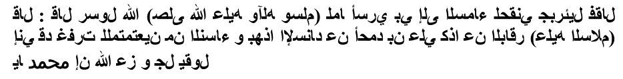
disunity and hatred.
do such deeds openly.'
trace will resemble the trace of blister as when an ember is dropped on one's foot which would make it swell, and one would see it swollen but there would be nothing inside. People would be carrying out their trade but hardly will there be a trustworthy person. It will be said, 'in such-and-such tribe there is an honest man,' and later it will be said about some man, 'What a wise, polite and strong man he is!' Though he will not have faith equal even to a mustard seed in his heart." No doubt, there came upon me a time when I did not mind dealing (bargaining) with anyone of you, for if he was a Muslim his Islam would compel him to pay me what is due to me, and if he was a Christian, the Muslim official would compel him to pay me what is due to me, but today I do not deal except with such-and-such person.
I encourage all Muslims to unite in declaring the Oneness of God, enjoining what is good and forbidding what is evil. For more information refer to: http://ahlulbaytsa.co.za/ the rule. For Shia, the twisted form of Taqiyya is a prescribed duty and a pillar of their faith. Shi'ism could not stand without it. They learn the principles and methods of Taqi'ah and they practice it.
clear proofs and guidance, which we clarified in the Book (Qur'an), will be cursed by Allah ...." (2:159)
just as you sent prayers upon the family of Ibraaheem, and send blessings upon Muhammad and upon the wives and descendants of Muhammad, just as You sent blessings upon the family of Ibraaheem. Verily, You are full of praise and majesty."
Ahl Al-Bayt is its dwellers, Ahl Al-Mathhab (sect) is its who believe in it, Ahl Al-Rajul is his wife, and Ahl Al-Nabi is his wives, his daughters, and his son-in-law i.e. Ali may Allah be pleased of him."
Al-Kisa'a (the narration of the cloak) that is narrated by Muslim. The mother of Believers, Aa'ishah says: "One day, the messenger of Allah left the house at the afternoon and he was wearing a cloak. Then Hasan bin Ali came and the Prophet took him under his cloak. Next Hussain bin Ali came and the Prophet took him under his cloak. After that Fatima came and the Prophet took her under his cloak. Finally, Ali came, and the Prophet took him under his cloak. Then the Prophet said: "And Allah only wishes to remove all abomination from you, ye Members of the Family, and to make you pure and spotless"

FACTUAL RESPONSE TO A REPORT BY ISLAMIC AWAKENING
When I finished reading the references that are mu'tabar, I got some paper, and then kept them, hopefully one day Allah will determine a decision for me. I beg Allah for help in explaining this truth. There would be a lot of accusation, fitnah and murder attempts that would be met if one exposes the deviations of Shi'ah, but I had already considered all those, and they did not prevent me from doing it.
Let us refer to the words of Allah SWT, "But let them who find not [the means for] marriage abstain [from sexual relations] until Allah enriches them from His bounty...." (An Nur:33).
If the book was dictated by Rasulullah and written by Ali, why did he hide it from his ummah? Allah SWT says, "O Messenger, announce that which has been revealed to you from your Lord. And if you do not, then you have not conveyed His message...." (QS Al-Maidah: 67).
---The Jews stated that there can be no fighting in the way of God unless the Messiah (Dajjal) comes and the sword descends. Similarly the Shi'ites stated that that there can be no fighting in the way of God unless Qaem appears and an announcer will call from the sky.
While praying, the Jews let their outer garments touch the ground. The Shiites do likewise.
Firstly it makes it clear the Abu Lu'Lu is the spiritual father of the Shiites.
Umar ibn Ali ibn Abi Talib, Abu Bakr ibn Ali ibn Abi Talib,
You be the judge. Can anyone entertaining the above beliefs about Allah be called a Muslim?
In the same book, Khomeini also states regarding the Imams: "...because we cannot imagine the Imams being forgetful or negligent, and we believe that they perceive all things which could benefit Muslims..." and "The Imam's teachings are like the Qur'an...they must be implemented and followed."
4. "The Imams know when they will die, and they do not die except by their own choice" (Ibid, p: 258) Now, this is a clear statement of blasphemy. Only Allah knows when a man will die! And these Shia say that their Imams have control over the timing of their death. This is major blasphemy and "shirk" (polytheism) for any one to believe in all the things that the Shia say about their Imams!
Let us examine what the Shia's main reference books say about their Imams:
16. An Imam knows his hour of death and his death is under his control. (Usool Kaafi, Vol.1, p. 258)
37. All Prophets had to recognize and accept the Wilayat of Ali (meaning that Ali is Wali of Allah) before they were appointed as prophets. (Tareekh-e-Shia, p.18)
C. "It is clear from all of these traditions and quotations from the Family of the Prophet that the present Quran is not the complete Quran which was revealed to the Prophet. In fact, there are verses that contradict that which was revealed; verses that have been distorted and places where omissions have been made such as the names of Ali, the Family of Muhammad and, on several occasions, there were the names of the hypocrites. Moreover, the present order of the Quran is not according to the preferred order of Allah and His Messenger. Ali ibn Ibrahim (a renowned commentator) also holds this opinion.' (Mullah Muhsin Kashani in his Tafseer as-Saafi, vol. 1, pge 32)
translation, Pustaka Al-Kautsar, 2002) p. 13.
Ansar would have again raised the swords to follow the saying of Prophet (saw), and would have demanded to make Ali (ra) as Caliph and nothing could have stopped them from doing so, since they were strong as it was their city and Abubakr and Umar came from the weaker tribes of Quraish not from the stronger tribes like Bani Hashim. But nothing as such occurred, which proves that Prophet (saw) never appointed a Caliph to succeed after him.
The following narration is truly shocking, as it is disgusting. It is mentioned in Al-Kaafee: Chapter: "A Mentioning of As- Saheefah, Al-Jafr, Al-Jaami'ah, and the Mus-haf of Faatimah, upon her be peace."
He said: 'It is a Mushaf which contains three times the like of your Qur'aan. Rather, it does not contain one letter of your Qur'aan.' I said: This, by Allah, is knowledge.' He said: 'Indeed it is knowledge; and that's not it.' Then he remained silent for a while and he said: 'Indeed we have knowledge of what was and knowledge of what is up until the Hour is established.' I said: 'May I be sacrificed for you; this indeed is knowledge.' He said: 'Indeed it is knowledge; and that's not it.' I said: 'may I be sacrificed for you; what, then, is knowledge?' He said: '(Knowledge of) that which occurs by night and by day; the affair after the affair and the thing after the thing up until the day of Standing.'"
11. In the same way (AS) is used after Hadhrat Zainab or the Imams - Is this not special to the Prophets?
39. From any reliable and authentic Shia book prove the following 39 to 48; Taziah in Muharaam?
The second Shi'ite scholar was Abu Amr bin Abdul Aziz al-Kashshi. He is authenticated thus: "He is trustworthy (thiqah), an adept, an expert in traditions and men, very knowledgeable, well founded in faith, on the upright path......The most important books on biographies of men are four, which are heavily depended on and (considered) the four basic pillars in this field, the most important and earliest of all is: Ma'rifat al-Naqileen anil-A'immah As- Sadiqeen (Knowing the Transmitters on The Authority of The Truthful Imams) known as Rijaal al-Kash-shi". (Rijaal al-Kash-shi: al-Najaashi, Introduction)
Narrated Yaqoub bin Yazeed from Ibn Abi Omair and Ahmad bin Muhammad bin Issa, from his father and al-Husain bin Sa'eed, from Hishambin Salim, from Abu Hamza al-Thumali said:Ali bin al-Husain[as]said:
Like this, there are hundreds of other books that affirmed that Shi'ism started with this Jewish Yemenite who pretended to "Love the Ahlul-Bayt" and sought justice for them, as a plot to crack the unity of the Muslim Ummah who crushed the Jewish tribes in the Arabic Peninsula. It is not amazing therefore, that the alliance between the Jews and the Persian Majoos (Zoroastrians) prosper to revenge from those who destroyed their dreams and humiliated a civilization not long ago, which was one of two super powers in the world. This is why Shi'ism prospered mainly in the land of the Fire worshippers, Persia, and continues so till today.
In his "Firaq al-Shi'a," Abu Muhammad al-Hasan bin Musa al-Nubakhti, one of the foremost known Shi'i historian, believes that Shi'ism did not start until the demise of the Apostle: "The Messenger died in the month of Rabi' al- Awwal, in the year 10 of Hijra at age 63 and the duration of his prophethood was for 23 years, and his mother is Aaminah bint Wahab bin Abdi Manaaf bin Zuhra bin Kilaab bin Murra bin Ka'b bin Lu'ay bin Ghaalib. (At his death) The Ummah was divided into three groups. One group was called the Shi'ites, who were the Shi'ites of Ali bin Abi Taleb [as] and from them all Shi'i sects broke away. Another (group) claimed the right of succession, i.e., al-Ansaar, who called for the inauguration of Sa'd bin Ubadah al-Khazraji. A (Third) group tilted toward giving the Bay'ah (allegiance) to Abu Bakr bin Abi Qahaafah, with an excuse that the Messenger did not name a particular successor rather left it for the Ummah to chose whom it wills...." (Firaq al-Shi'a: pp. 23-24)
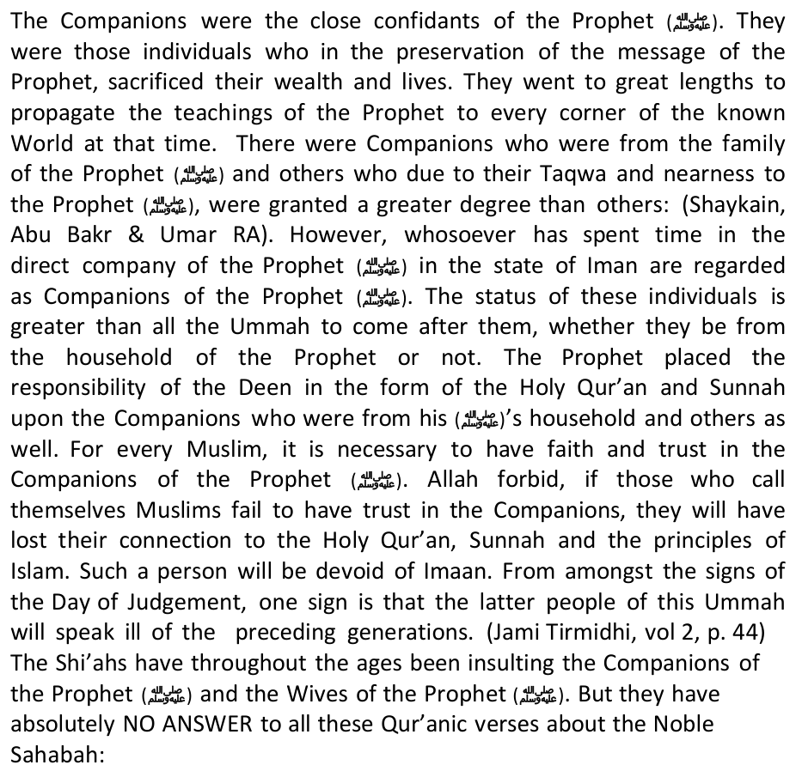
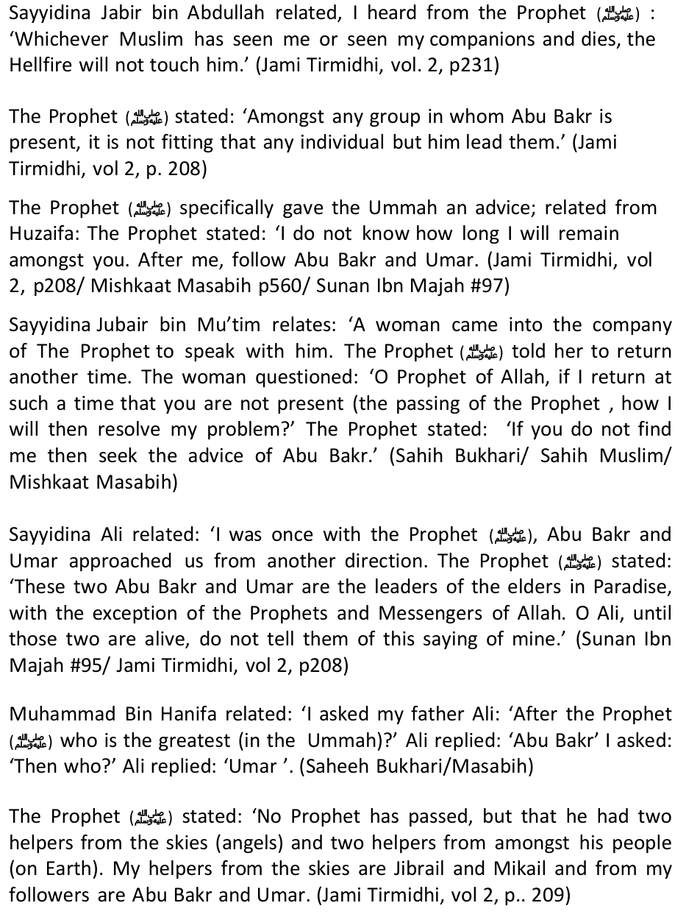
One of Shi'ah's blog (www.yahosein.com) in the Arab world ever questioned the status and position of Masjidil Aqsa in the eyes of Shi'ah. Strangely, one of the participants of the discussion clearly stated that "Masjid Al-Quds, according to Shi'ah and the deviated sects (Ahlus Sunnah, in it), is acknowledged to have been built by the number two thief (an allegory for Khalifah Umar), and in it was a wooden mimbar (pulpit) which is popularly known as the Salahuddin's mimbar, where Sultan Kharabuddin (destroyer of religion, a nickname for Salahudin Ayyubi among the Shi'ahs) read khutbah, it is so very sad that there are people of Shi'ah who grieve and cry when the Jews are digging the areas around Masjidil Aqsa."It seems to us, the attention of the vile Shi'ah these days to the issues of Palestine and Al-Quds is by nature caused by non-ideological political factors. Because, if looked at the aqeedah or ideology of Shi'ah with regards to Masjid Al- Aqsa, it is very clear that it is not regarded as holy and not more special than Masjid Kufah, Karbala, Kubah Samarra, Najaf and others. The only reason left is the factors of politics.As we know, Iran, since the revolution of Khomeini, has been enthusiastic in the efforts to export its Shi'ah revolution to the entire Islamic world and working night and day in order to spread the Shi'ah thoughts with all the resources that they have.For that purpose, the Shi'ah, as the first phase, they could be accepted by this absolute majority of the Muslims who are Ahlus Sunnah and not be suspected of bringing Shi'ah thoughts. They see that the issues of Palestine and Al-Quds, since a few decades ago, have become a central issue, as well as hot at the same time, in the eyes of the world Muslims. It is for that reason that the politicians and ulama's of Shi'ah raise this issue as their commodity of 'sales'
Therefore, the core point is being exploited politically for the spreading of the Shi'ah thoughts, is by portraying that, as if it was indeed the heroism of Shi'ah that defeated Israel in the Hizbullah war in 2006, as well as the manouver of Ahmadi Nejad, the president of Iran, who continuously brags that he would crush Israel and wipe it out from the world map.
Iran only blows hot air about opposing the West. It has done nothing to oppose the USA as yet, and nor has it done anything for the Palestinians to date. In fact, the Iranians use Palestine as a flag of Sunni-Shi'ah Unity – just as the Saudis use the "Custodinaship of the two Holy Moques" to legitimize their rule. The Shi'ahs, as you know as you also practice it, use the theme of Hajj, Unity, Al-Quds, Opposition to the West, freedom of speech … or any popular slogan that catches the imagination of the masses, to win the people over, then impose their fithy ideology on them.
Both Iran and Saudi Arabia are today enemies of the ummah.
In another letter to director of UNICEF, the Iranian labor minister said that massacre of civilians, innocent children in particular, is intolerable and contravenes all human and international regulations.
"Today's signing ceremony underscores the strong partnership between the United States and Qatar in the area of security and defense and will help improve our bilateral cooperation across a range of military operations," said Pentagon Press Secretary Rear Adm. John Kirby
So, the number one ENEMY of the Shi'ah is their own FIRST IMAM!
*Sayyadina 'Ali (RA) said: "There will appear, at the end of time, people claimed to be from our Shia, but they are not from our Shia. They have a nickname called Rawafid (Rejecters). If you meet them, KILL THEM for they are polytheists."
Shi`ites, because they invent Hadeeths and adopt them as part of their religion." [Ibid, p. 38]
*Ibn Hazm al-Andalusi: One day during the period of Muslim rule in Spain, Imam Abu Muhammad ibn Hazm was having a debate with some Spanish Catholic priests about their religious texts. He brought before them evidence of textual distortions in the Bible and the loss of original manuscripts. When they replied by pointing out to him Shi`ite claims also being distorted, Ibn Hazm informed them that "Shi`ite could not be used as evidence against the Quran or against Muslims because they are not themselves Muslims." [Ibn Hazm, al-Fisaal fee al-Milal wa an-Nihal, 2/78 and 4/182] Further, Shi'ah claims have been rebutted by numerous other early scholars like Ibn Taymiyah in Minhaaj as- Sunnah, AzZahabi in Muntaqaa min Minhaaj al-I`tidaal, Ibn Katheer in his history book al-Bidaayah wa an- Nihaayah, Ibn al-Jawzi in Talbees Iblees, al-Qadi ibn al-Arabi in al-`Awasim min al-Qawasim, At-Tahaawi in al- `Aqeedah at-Tahaawiyyah, and Al-Qadi Abu Ya`laa.
*Muhammad Rashid Rida: This scholar was among those who worked sincerely for rapprochement between the Sunnis and the Shi'ites, and they in turn pretended moderation for his benefit. However, in the midst of his efforts they caught him by surprise, by presenting him with some of their books which slandered Islam. He then replied to them in a paper called As-Sunnah wa ash-Shiain which he exposed their doctrines and idolatrous practices.
your brother.
('Silsilah al-Ahadeeth al-Da'eefah wa al-Maudu'a', vol 1, p. 195-198, Hadith #85)
*Note: Genreral Richard Meyers, commander of the US Joint chiefs of staff decalared the war on Afghanistan in October 2001 on crutches.
Narrated with sound chains from Dhu Mikhbar al-Najashi by Abu Dawud, Ahmad, Ibn Majah, Ibn Hibban, and al- Hakim who declared it sahih and al-Dhahabi concurred. See Shaykh Shu`ayb Arna'ut's documentation of this hadith in his edition of Sahih Ibn Hibban (15:101- 103 #6708-6709).

Christian Control
*Note: Where is the tribe of Qais? Emperor Jahangir ordered his courtier to search for the origin of the Pashtoons and so the famous book Makhzan e Afghani" was written in 1635, which also confirms the orgin of Pashtoons from the lost tribes and also tells about the the tribe of QAIS.It tells us that the Qais was friend of Companion of Dear Prophet (salallaho alayhay wa sallam) and was the first person among Pathans who reverted to Islam. Most of the Pathan tribes consider Qais as their ancestor and therefore the Pathans can also be considered as the tribe of Qais.Arabs Will be less in Number Narrated Umm Sharik: I heard Allah's Apostle (peace be upon him) said: The people would run away from the Dajjal seeking shelter in the mountains. She said: Where would be the Arabs then on the day? He said: They would be small in number. (Muslim.)Yellow Banners/ Flags Ammar, the son of Yasir, may Allah be pleased with both of them, said: "When As-Sufyaani reaches Kufa and kills the supporters of the family of Muhammad, praise and peace be upon him, the Mahdi will come and the bearer of his Banner will be Shuayb, the son of Salih."
Black Banners Will Establish Power for Mahdi [a.s]
Al Hasan Al Basri said:"A man of medium stature will come from Ar-Ray (a far-eastern town). He will be dark and from` the children of Tamim — a Wasaj, named Shuayb son of Salih with four thousand men. Their clothes will be white and Banners black, and at his front is the Mahdi. He meets no one that he does not defeat and scatter."
At that time a voice will come from Heaven saying: 'O people, surely Allah prevents dictatorship, tyrants and their followers for you and gives leadership to the best of the nation of Muhammad. So join him in Mecca — he is the Mahdi!" Then, Hudhayfah asked: 'O Messenger of Allah, how shall we know him?' He replied: "He is a man from my children, he looks like the men from the children of Israel, upon him are two white cloaks with frayed edges"Qutwaani" cloaks. His face is like a colorful, glittering star, upon his right cheek there is a black mole and he is forty years old. Al Abdal and those looking like them will come to him from Syria. An-Nujaba will come to him from the dwellers of Egypt and groups of dwellers from the east, and those looking like them until they all gather together in Mecca and so they will pledge their allegiance to him between Al Rukn and Al Makam. Then he will direct himself towards Syria with Gabriel at his front and Michael at his middle and the dwellers of Heaven and Earth will be joyful because of him. Water will be plentiful in his country and the river will be spread and treasures found. When he reaches Syria he will slay The Sufyaani under the tree, the branches of which grow in the direction of Lake Tiberias and he will kill Kalb. So the loser of that Day of Kalb is he who does not gain even a rein." Hudhaybah asked: 'O Messenger of Allah, praise and peace be upon him, how is it permitted to kill them when they believe in the Oneness?' The Messenger of Allah, praise and peace be upon him, replied: "O Hudhayfah, they are at that time apostates, they claim that wine is permitted and do not pray." (Narrated by Hudhayfah and are found in the references of Abu Nuaym, At-Tabarani, and Abu Amru Ad Dani.)
Women will be taken prisoner, and men will have their throats cut like sheep.' (Muntakhab Kanzul Ummal, vol. 5, p. 38)
Ever since this book was published, the Muslim scholars have been issuing their deliverances condemning Khomeini to apostasy for the following reasons:
If the Messengers of Allah and His angels have no power to do themselves benefit or harm, nor any of them has command over the affairs, rather all of them are slaves belonging to Allah, and are subservient to His command, the claim that the alleged Imams have control over the atoms of the universe and assume the universal vice-regency constitutes a plain Kufr, unbelief, and shirk, or attribution of copartners to Allah in His most exclusive attribute, the Lordship; exalted be He above what they attribute to Him. The claim that the Imams have a special status with Allah attained by neither a close angel nor a sent Messenger is a lie related- to those Imams, an assertion of polytheism and apostasy.
4. Attributing excellence to those who are not prophets, distinguishing them above the Messengers and Prophets, is an act of disbelief and polytheism, because Allah has selected the Messengers and the Prophets from mankind as Allah has selected the Messengers and the Prophets over the rest of the believers is known by necessity from the religion, and agreed upon by the Muslim nation, rejected only by the apostate who deny the Oneness of Allah, justice and faith. Thus the assertion that Ali, may Allah be pleased with him, was better than Prophets Ibraheem, Noah or Yunus bin Matta, is an assertion of disbelief. The Prophet SallAllahu 'alayhi wa sallam said, "It does not behave a believer to say, "I am better than Yunus bin Matta." It is not permissible for a believer to claim excellence over Yunus bin Matta, the Prophet, may peace be on him, even though Allah refers to his behavior when he left his people in anger thinking that Allah would not deal him severe punishment, but instead would send him to different people. Allah says, "The fish swallowed him while he was blameworthy." (Qur'an - 37:142) He was blameworthy for having left his people without seeking permission from Allah. "We cast him on a bare tract of land, and he was sick." That was a lesson for him, and a dear message that Prophets and Messengers were also susceptible to admonishment and punishment were they to behave other than they were expected, yet they doubtlessly occupy the rank of superiority over all mankind, a rank which can be reached by no believing follower of the Messengers, regardless of how pious he might have been. Therefore, neither Ali bin Abi Taalib and his offsprings nor those who are superior to them, such as Abu Bakr and Umar, may Allah be pleased with them all, have excellence over the Prophets, for the Messengers and the Prophets are the best of the believers by virtue of being chosen by Allah and having the revelation sent down to them. Thus considering Ali or any of his offspring superior to a Prophet, Messenger or to an angel is surely blasphemy, apostasy in clear
It is known that Ali himself never made such an assertion, nor did any of his sons, the believers. Rather, he said, "I surely am one of the Muslims". Nor did he claim excellence over Abu Bakr al-Siddiq and Umar. How then could he rank himself above the Prophets and Messengers, and the close angels? No! It is just a false allegation made up by the liars to add another crime in their record of notoriety against the pious believers.
received after the death of the Messenger of Allah is 'Kafir' and 'Zindiq'.
Meet the Shah
On the home front, the Shah protected minorities and permitted non-Muslims to practice their faiths. "All faith," he wrote, "imposes respect upon the beholder." The Shah also brought Iran into the 20th century by granting women equal rights. This was not to accommodate feminism, but to end archaic brutalization.Yet, at the height of Iran's prosperity, the Shah suddenly became the target of an ignoble campaign led by U.S. and British foreign policy makers. Bolstered by slander in the Western press, these forces, along with Soviet-inspired communist insurgents, and mullahs opposing the Shah's progressiveness, combined to face him with overwhelming opposition. In three years he went from vibrant monarch to exile (on January 16, 1979), and ultimately death, while Iran fell to Ayatollah Khomeini's terror.
For Western TV cameras, protestors in Teheran carried empty coffins, or coffins seized from genuine funerals, proclaiming these were "victims of SAVAK." This deception — later admitted by the revolutionaries — was necessary because they had no actual martyrs to parade. Another tactic: demonstrators splashed themselves with mercurochrome, claiming SAVAK had bloodied them.
television, as an accompaniment to the arrival of the Imperial Couple.
Meanwhile, internationalist forces rallied around a new figure they had chosen to lead Iran: Ruhollah Khomeini. A minor cleric of Indian extraction, Khomeini had denounced the Shah's reforms during the 1960s — especially women's rights and land reform for Muslim clerics, many of whom were large landholders. Because his incendiary remarks had contributed to violence and rioting then, he was exiled, living mostly in Iraq, where Iranians largely forgot him until 1978.
Journalists descended in droves on Neauphle-le-Château; Khomeini gave 132 interviews in 112 days, receiving easy questions as their media organs became his sounding board. Nahavandi affirms that, within Iran "the Voice of America, the Voice of Israel and, especially, the BBC virtually became the voice of the revolution, moving from criticism, to overt incitement of revolt, and from biased reporting, to outright disinformation."
"It was therefore necessary," the Shah wrote, "to neutralize the Iranian army. It was clearly for this reason that General Huyser had come to Teheran."
Exile
Carter faced a dilemma. Iran wanted the Shah's return — for a degrading execution — in exchange for the American hostages. However, a direct trade might humiliate the United States.
Although the Shah maintained a neutral stance toward Israel, during the 1973 Yom Kippur War, he allowed critical supplies to reach Egypt, enabling it to achieve a balance of success, and earning Sadat's undying gratitude, but wrath from influential Zionists. Did this impact the West's attitude change in the mid-seventies?
http://www.newsy.com/videos/u-sfinalizes-Behind the "supposed" antagonism portrayed by Iran and the Hizbullah, a few quertions neeed to be raised: Are these Shi'ah movements really struggling for the glory of Islam? What is the actual goal of these movements? Is there a connection between Iran and the Hizbullah, as well as the other Shi'ah movements in the Middle East? Whatever have been done by these two movements behind their antagonism against America and Israel? The answers and explanations to the above questions are hoped to become an objective assessment on the "the real facet" of these two Shi'ah movements.
the Sunnis, against the masjids, institutions and Sunni movements.
To attract the sympathy of the world and so as to be accepted as a part of the Islamic World, this Shi'ah Safawist movement makes the Palestinian issue as a political commodity. The Palestinian issue is played so that there would be emotional involvement of the whole Muslim community in the world. The attempt to play the Palestinian issue is carried out by various steps as follows:
3. The Zone of Syria: The Syrian Government –which is a strategic ally of Iran- has done a variety of extensive efforts to arrest and cleanse the people of Syria. They apply restrictions against the institutions of Islamic education, and provide spaciousness for the Shi'ah institutions, whereas Shi'ah in Syria absolutely has no real existence. The Syrian Government also protect the efforts of the Shi'ah missionaries in the midst of the Muslims in Syria, giving citizenship to the people of Shi' ah who come from Iran and Iraq, as well as and narrowing the space of the people of al-Ahwaz who take refuge in Damascus. Syria is also preparing itself as the base for attacking Lebanon and Jordan, of course by using the issue Palestine as a 'weapon' for the interest of this alliance.
used to destroy the Arab nation and the Muslims.
The West has long known the authoritarian attitude of Hosni Mubarak, Gaddafi and other tyrants towards their people, but was only silent all these while, not doing any meaningful action. The West had been hostile towards the regime of Muammar Gaddafi only because he ordered the bombing of an aircraft belonging to the West at Lockerbie. It was totally unrelated with his brutality against his people. After Gaddafi 'apologized' to the West, the West could afford to be embracing Gaddafi, as if there was no problem before. It's reasonably so because he was cooperative in selling his country's natural resources, and more importantly, he was very anti-Al-Qaeda and terrorism (jihad). But when Gaddafi started to be abandoned by his people and cornered, the West was not reluctant to cast him out. This pattern became the standard attitude of the West against whichever regimes in the Middle East, in fact in the world.
But this by no means mean that the West is already paralyzed. They are still potent and dangerous, but it is no longer the single player in taking advantage of the momentum of this kind of upheaval, not to mention in a region as important as the Middle East which is the main theater of the world turmoils.
Iran is currently in a golden age with its Shiah. Since it stopped waging war against Iraq in the 80's, the concentration of its practice is only in spreading influence through its Shiah teachings to the entire regions, or even the world. In fact, Indonesia is being made as an object of serious cultivation. Not less than 300 Indonesian students are groomed every year with the Shiah teachings in Qum, Iran and other cities to become the cadres of Shiah fighters in the land of Indonesia. They are known to be cunning, because it does not bring in a new Prophet, but only rebukes the Prophet's Sahabahs. But the essence of its teaching is instilling burning hatred against the Ahlus Sunnah wal Jama'ah who are the majority in the world today. It may be said that Iran is having more chance in taking advantage of the upheavals in the Middle East compared to the West, due to a number of factors:
With all these considerations, hence it can be inferred that Iran with its Shiah will continue to flap its wings to a number of territories in the Middle East and North and SOUTHERN Africa to imbed its hegemony. The era of upheaval and its fruit afterward, in the form of an openness, can be taken advantage of to its full potential by Iran, at a time when other regional Sunni countries are busy with their own businesses.
people, while he is guilty of that. Any claim should be supported by evidence, where is his evidence? A claim that Iran issued a fatwa promising Shi'as paradise for killing Sunni's should be supported by evidence, otherwise it will be treated like a propaganda that it is.
responsibility now is saving Iraq, saving our country, saving the holy places of Iraq from these sects."
– open polytheism), you could be labelled a "Wahabi" and taken to court and face extreme sentences;
The Shia clerics in Iran are attempting to establish more control over the Sunni seminaries. This is being done by implementing the so-far unenforced "Bylaws of the Council for Planning Curricula of Sunni Seminaries" (CPCSS) which, among other things, required each Sunni seminary to be under the control of a council that reports to Ayatollah Khamenei (the council is run by President Ahmadinejad, though the Supreme Leader has ultimate veto power). On June 21, Hojatoleslam Abbas Farzi, the secretary of the CPCSS, told Fars news agency that 98 percent of Sunni seminaries in the country had been reorganized, restructured, and registered.
Sheikh Abdul Rahmaan al-Baluchy completed his secondary education in Iran, after which he was admitted to the Islamic University of Madinah Munawwarahin 1979 where he studied Arabic before joining the Usuluddeen (Principles of Faith) and Da'wah college. He reached his second year of studies before the policy to expel Iranian students was implemented. He went to Syria to complete his Shari'ah studies at Damascus university, were he graduated in 1984. He also studied under the scholars of Damascus, such as Sheikh Abdul Qadir al Arna' out and others. Upon graduation, he enrolled for his Masters degree at al Awza'y college in Beirut were he graduated in 1989. His thesis was on the Baluchy people and Baluchistan. He enrolled for his PHD at the same time college and graduated in 1995. His P H. D. thesis was on " The Transformation of Islamic Thought In Iran from Sunni to Shiah during the Safawi Rule." This same topic was not accepted for his Masters Degree owing to certain political reasons. He currently directs the Ahlus Sunnah Association of Iran, London Office.
The regime continued in its efforts to destroy the infrastructure of Ahlus Sunnah, spreading between their ranks deviations, innovations and acts of Shirk. They unashamedly told the imprisoned students of Sheikh Zadah: "We hoped that you would have taken up arms against us, so we could have had an excuse to uproot you, as we did with the other parties."
The regime planted the seeds of conflict amongst the scholars of the Ahlus Sunnah, and strode to deride the character of the notable scholars, replacing them with government servants.
As you can see, the tragedy of Ahlus Sunnah in Iran is unlike any tragedy in the world, considering the nature of the race problem, the falsification of news by the Iranian official press. Government cronies, and the positions of many Muslim movements and activists on the outside who are siding with Iran. Although Muslim minorities everywhere are facing calamities and catastrophes on a large scale the situation in Iran is further exacerbated under the government of Taqiyah (deceit), lies and hypocrisy, in the name of "Unifying the different sects." Yet it simultaneously slaughters the Sunni scholars and casts their dissected and mutilated corpses into the streets and the garbage dumps. Whereas the plight of Muslims is broadcasted internationally, no TV station or newspaper dares to highlight the case of Sunnis in Iran. Ahlus Sunnah are deprived of their basic civil, social and human rights, not to mention the right of political participation and equality with the Shiah. The erection of a Sunni school or Mosque in Iran is regarded as an unpardonable crime. Many Sunni Muslims, who supported such projects (even if it were in the past), were imprisoned, killed, or had their beard shaved for merely contributing to the building of a Mosque or to any simple activity relating to Ahlus Sunnah. There are also hundreds of periodical prisoners and many killed purely on suspicion. The following are only some of the names of prominent scholars who have been kidnapped, poisoned or killed:
· Sheikh Nasser Sabhani was one of the leaders of Sunnah in Kurdistan who conducted many educational courses. He was arrested after refuting the false accusations of Kufr directed at Umar (radhiallahu anhu) by Khomeini in his famous book "Al-Hukumah al-Islamiah" (The Islamic Government). He was killed in 1992 in prison and his relatives were denied from witnessing his funeral and prayer.
· Ahlus Sunnah school, Talish. The government confiscated the Ahlus Sunnah school at Talish — North-west of Iran. Sheikh Quraishy, the principal of the school was also arrested and alleged confessions were obtained from him under torture.
"What is the policy of Ahlus Sunnah for their future dealings with this situation? Does the declaration of the Afghan Islamic Emirate have any effect on the internal situation?"
These developments have been sketched out by Shi'ah scholars like al-Mufid, Urbili, Majlisi etc. in their respective books. They have referred to Sayyadina Muawiyyah (RA)'s advance towards Iraq: "Hadhrat Muawiyyah marched towards Iraq to secure a point of vantage, but when he reached Jasr Manbaj, Hassan also moved into action. He sent a message to his officials to make preparation for a confrontation and also asked the people to come out in the name of Jihad. The people felt that the call of Jihad was too heavy a burden for them to carry. But some of them responded to the call and an assortment of people joined him. Some of them were his Shias and the Shias (supporters) of his father. Others believed that war must by waged against Hadhrat Mu'wiyyah at any cost. There were still others who relished mischief as well as the spoils of war. Some of them were the victims of skepticism, others of fanaticism. They were the willing slaves of their chieftains and were the least attached to their faith. He set out on a witch hunt for these people until he arrived in Hamam Umr. Then passing through Dir Ka'ab, they camped at Sabat in the low-lying area of Qantarhah. They spent the night there. In the morning he tried to test the loyalty of his companions to discriminate between friends and foes and to wage a purposive and better-conducted war with Hadhrat Mu'awiyyah and the Syrians. He commanded all of them to rally at a specific spot.
Then his OWN SHI'AHS attacked his tent, looted his goods and even pulled the prayer mat from under him. Abdur Rahman bin Abdullah bin Jaal Azdi assaulted him, whisked away the shawl from his shoulders. He sat down shawlless on the ground, the sword dangling from his neck, them called for his horse. But his Shias and special companions surrounded him on all sides and protected those he wanted to punish. He told the people to call Rabi and Himlan. When they came, they pushed the people away and he set out on his journey again. He was accompanied by a number of other people as well. When he passed through Muslims Sabat, Jarrah bin Sanan of the Asad tribe attacked him. He held the bride of his horse.
Hadhrat Muawiyyah dispatched a letter of conciliation to him. He also mentioned in his letter the letters of his companions in which they had expressed their intention of either handing him over or killing him. He offered a package of terms and conditions to bring about a reconciliation, and to agree to these terms was what the times clearly dictated, but Hadhrat Hassan did not trust him and mistook his gesture of sincerity for and ill-conceived pretense, though, on account of the treachery and disloyalty of his companions, the best course for him was to accept his offer of conciliation. I have already stressed the fact that his companions were a bunch of rogues. They were scoundrels and seemed determined to install some one else as their Amir in his place. Most ho them wanted to spill his blood and hand him over to his adversaries.
Then he climbed down the pulpit. The people said to him: "You have uttered these words because you want to resign and dish out the Khilafat to Hadhrat Muawiyyah." Therefore they flared up, rejected his contention, looted the goods, snatched away his shawl and pounced upon the slave maid who was with him and they splintered into different groups. One group clearly played his tunes while the majority of people supplied the discordant notes. He said: (O Allah! I need your help) He ordered the people to march and they marched away. Somebody brought his horse to him and he jumped on it. Some of his friends surrounded him but the others protected him and the march continued. Sanan bin Jarah Asadi accompanied him to Sabat and stayed with him. He came closer to him and spoke to him in rather confidential tones. Then he struck his spear at his thigh with such force that it almost touched the bone.
Hadhrat Hassan ibn 'Ali (RA) went even a step further. He not only handed over the Khilafat to Hadhrat Muawiyyah, but also pledged fealty at his hand alongwith his brothers and commanders of the army as Kashi has reported from Jafar bin Baqir: "Muawiyyah wrote to Hadhrat Hassan: you, Hadhrat Hussain and the companions of Ali should come to see me. Thus when they came to Syria, Qays bin Saad bin Ubadah Ansari was also with them. Hadhrat Muawiyyah (RA) gave them permission to enter. Muawiyyah said to Hassan: "Come and pledge to me." Hadhrat Hassan pledged at his hand. Then he asked Hadhrat Hussain: "Get up and pledge to him." He also stood up and pledged at his hand. Then he addressed Qays: "Come and pledge to him." He looked towards Hadhrat Hussain for orders, who said:
So, Sayyadina Hassan died DUE TO WOUNDS INFLICTED UPON HIM BY HIS OWN SHIA.
Meanwhile the citizens of Iraq dispatched a number of letters to him which assumed the form of an unbroken series of messages. The last letter he received was from Hani' bin abi Hani' and Said bin Abdullah Khithami. The letter is reproduced here: "We begin with the name of Allah! To Hussain bin Ali from his Muslim Shias. You should come immediately. Everyone is waiting for you. They do not acknowledge any body else as their Imam. Therefore you should come as soon as possible". Another Shia historian, Masudi, writes: "When Hadhrat Muawiyyah died, the residents of Kufah dispatched innumerable letters to Hadhrat Hussain bin Ali that they had disciplined themselves to take the oath of allegiance at his hand. They wrote: "We would prefer to die than to pledge fealty at the hand of some on else. That is why we do not participate in the Friday and congregational prayers". Another letter contained the following message: "The gardens are lush and green and the fruits have ripened. Therefore you can come whenever you like. The army awaits your arrival".
Hadhrat Hussain replied: "O my cousin! I know you are my will-wisher and sympathizer. But Muslims bin 'Aqui has sent me a letter in his own hand that all the people there are agreed to take the oath of allegiance at my hand. Therefore I have decided to visit them." Ibn Abbas explained: "I know these people to the roots of their hair. I have tried and tested them. What they did to your father and brother is not hidden form you. They will conspire against you in complicity with their Amir and pack you off straight to martyrdom."
Hadhrat Hussain replied: "O, my cousin! May god bless you! Your opinion has come the hard way. Whatever God has decided, must be implemented." Then Abu Bakr, Harith bin Khalid bin 'As bin Hisham Mukhzuma called on the governor of Makkah. They were reciting the verse (There are so many advisers who are disobeyed and the one who can guess hidden things equates advice with trash and bilge). I reproduce below the whole episode from books written by Shia scholar and historians to expose the treachery and cowardice of the Shias.
Ibn Ziyad replied: "You have been too much in the dark," and then he drew aside the cover from his face. He recognized him and opened the gate. People exclaimed: "He is Ibn Marjana," and then they stones at him. He ignored them and entered the palace. When Muslim heard the news of his arrival, he hid himself in the house of Hani' bin Urwah Muradi. Ziyad sent Muhammad bin Ashath bin Qais to fetch Hani'. When he was brought to Ziyad, he asked him about Muslim, but he gave a blank reply. When Ibn Ziyad spoke to him a little bluntly and ruthlessly, Hani' said" I am under obligation to your father Ziyad and I would like to pay it back. Would you like a piece of good advice?" Ibn Ziyad asked: "What is that?" Hani replied: "Pack up your wealth and goods and make a straight dive for Syria along with your family and children before any harm comes to you. Now the right person has arrived: one who has a better claim to rule than you has arrived." On hearing this, Ibn Ziyyad said: "Bring him closer to me." When he was brought closer, he smote him with his stick on his face with such force that his nose snapped and he receive a wound on his forehead. The flesh on his face flaked off and he broke the stick on his head and face.
In the meantime, Hadhrat Hussain had left Madinah and had arrived in Qadisiyyah where he happened to meet Hur Yazid Yamimi who asked him: "O grandson of the Messenger! Where are you heading?" He replied: "I am heading towards this city." Hur informed him that Muslim ibbn 'Aqeel, his viceroy, had been martyred. He also gave him details of his torture and the agony Muslim ibn 'Aeel had suffered at the hands of the Kufis and the functionaries of the state. He advised him to return as Kufa hardly held any hope of better prospects of him. He found Hur's advice reasonable and pragmatic and decided to retrace his steps. But Muslims' brother, out of righteous anger, became intransigent and swore not to return until they avenged the murder of his brother or received martyrdom in the process. Hadhrat Hussain replied there was hardly any point in living after they had all died.
When the morning came, he commanded his companions to take their animals to water. The animal drank to their content and they set out on their journey. When they reached Batn 'Aqbah, they encamped there. He met Umro bin Lozan, a chief of Banu Akrimah. He asked him: "Which way are you heading?" Hadhrat Hussain replied: "I am heading towards Kufah." The chief said: "I make you swear by God that you should go back. You are not going to Kufah but you are going to face the points of spears and the blades of swords. If these people, who have dashed off letters to you, side with you during the battle and furnish you with arms and weapons, it'll be in the fitness of things for you to go there. But as things stand, the situation is replete with danger and your visit will be most inexpedient." He replied:
Baghdadi observes: "The Rafidihis of Kufah are notorious for their meanness and treachery. These two flaws have become almost proverbial. It is generally stated: "Abkhil min Kufi" (that person even beats the Kufis in spite) and "Aghdar min Kufi" (that person is even more treacherous than the Kufis).
Yazid bin Ali bin Hussain bin abi Talib. They supported him against Yousaf bin Umar, but snapped out of their allegiance to him, and in the thick of battle, handed over Yazid bin Ali to his enemy who put him to death.
Shi'ism also encouraged and publicized the concepts cherished by Brahmins, philosophers and pre-Islamic Zorostrians which became the raison d'tre of Shi'sim. Some of the Persians also put on the mask of Shiaism and revved up their activities against Banu Umayyah. The fact was that they loathed the Arab rule and wanted to strengthen their own rule. Maqrizi observes that the Persians had an edge over all other nations. They attached to themselves meliorative epithets while they conferred on others pejorative labels. They strongly believed in the master-slave dichotomy, reserving the first half of the polarity for themselves and distributing freely the second half among the people of the world. When the Arabs defeated them, though ironically, they regarded them the least dangerous! Therefore on various occasions, they floated the balloon of their conspiracy against Islam, but each time the Muslims, by the grace of Allah, pricked it and it burst in the mid air. When they had been frequently frustrated in direct and overt confrontations, they found it more effective and convenient to rely on indirect and underhand strategies. Therefore, some of them slipped into Islamic garbs and under the pretext of love of the Ahl-i-Bait.
But the rest of Hadhrat Hussain's companions clung to their faith in his Imamat as they had done in the past. After Hadhrat Hussain, these people split into three gorups. One of the groups believed in the Imamat of the thesis that after Hadhrat Hassan and Hussain there nobody who could be closer to Amir-ul-Mominin than Muhammad bin Hanfiyyah as Hadhrat Hussain was more entitled to the Imamat after the death of Hadhrat Hassan, Muhammad bin Hanfiyyah is most deserving of the Imamat. The second group believed that Muhammad bin Hanfiyyah is Imam Mehdi, and Hadhrat Ali had predicted about him. No one among the Ahl-i-Bait can either oppose him or deny his Imamat nor can he draw his sword out of the sheath without his permission and then hand over the Khilafat to him in the same way. Similarly, Hadhrat Hussain's war with Yazid also carried his sanction. It was Muhammad who had appointed Mukhtar bin Abi Ubaid as the governor of Iraq and Syria and ordered him to avenge the blood of Hussain by killing his murderes.
Wellhausen has given maximum space to him in his book: "It is generally stated about Mukhtar that he is a magician (Tabri Vol. 2, P. 730), that he is anti-Christ (Tabri, P. 686). He is generally dubbed as a liar. All these epithets were showered on him not because he was a self-styled spokesman of Muhammad bin Hanfiyyah, but because he claimed himself to be a prophet thought he had done it only surreptitiously. But some of his acts clearly betrayed his intentions and reflected his prophetic pretensions. When he spoke, he gave the impression as if he was sitting in the presence of the Lord and knew the hidden secrets of the universe. His linguistic versatility and eloquence also helped
Hadhrat Ali: "Don't you know my son!" Muhammad: "No, I don't."
The Salafis, the Ikhwan and the Saudi wild card
Every year, al-Quds rallies are held worldwide on the last Friday of Ramadan. They are important because they remind the Muslims as well as non-Muslims that the first qibla of Muslims remains under alien occupation. Its liberation is the responsibility of every Muslim.
As Muslims from the Ahle Sunnat Wal Jamaat believe that not only Imaam Abu Hanifa (A.R), but all Imaams of Fiqh were:
Do not listen to glib-tongued Shias. Do not grant them access to your Masaajid or Media platforms.
Trans: By Allah O Ali I love you very much.
Also, the Iranian Employee and former ignorant Sufi, al-Tijani al Samawi, in his conference in Turkey 2008, said that one of the biggest modern Turkish leaders (Mustafa Kamal Ataturk) will be on the same level as Imam Ali (RA) on the day of judgement, although ALL Muslims agree that Ataturk is the biggest Secular Kaffir in the history of Turkey but what can you do...a boot licker is a boot licker:
Ayatollah Fadhallah of Lebanon states in his book an-nikah vol.1, p. 66 that if the woman comes out with a swimsuit then it is permitted to look at her……….and regarding the same matter the permission also includes gazing at the "Auwra" when the woman exposes it, just like in some nude districts or at swimming spots in the beach in some countries. What kind of a religion is this??!!!
What is even more Ironic is that Ayatollah Khamenai gave a fatwa that promotes manipulation of the honor of women: This book entitled "The Answers to Questions" is written by Ayatullah Ali Khamen'ei, the current supreme leader of Iran and the highly respected Shia scholar. Read the question first, and then read the answer that Ayatullah Khamen'ei provides:
By "whom the screen was lifted from them" he meant, the screen or divider which Allah has created between us human and Jinn, where we are unable to see them but they can see us. The Kurds, according to this narration, are a type of demons which we are enabled to see. What an absurdity.
Narrated Muhammad bin Omar bin Salamah bin al-Baraa' al-Hafiz al-Baghdadi: Narrated to us Ahmad bin Abdallah al- Thaqafi Abul-Abbas saying: Narrated to us Issa bin Muhammad al-Katib saying: Narrated to me al-Madayini from Ghiyath bin Ibrahim from the Truthful Ja'far bin Muhammad from his father from his grandfather, peace be on them, said: Ali bin Abi Talib [as] said: The brains of women are in their beauty, and the beauty of men is in their brains". al- Amaali: Ibn Babawaih al-Qummi, the 40th Council, narration No. 9, p.189
Narrated to us Muhammad bin Musa bin al-Mutawakkil [ra] saying: Narrated to us Abdullah bin Ja'far al-Humairi, from al-Fadl bin 'Aamir, from Musa bin al-Qasim al-Bajaliy, from Thuraih al-Maharibiy, from Abu Abdullah [as] from his forefathers [as] saying: The Messenger of Allah [sawa] said: Three (types of people) if you don't wrong them, they will still wrong you: The low class, your wife and your servant". al-Khisaal: Ibn Babawaih al-Qummi, Chapter of the Three, narration 15, p.86. May Allah's wrath be upon the liars who lie on Allah's Apostle.
So our dear Reader don't you see how much absurd are the Ithna Ashari works? Think about it!
On his death-bed, the Prophet appointed Abu Bakr (RA) to lead the prayers in his absence, and none of the Companions, including 'Alï and 'Abbàs who performed behind him, objected to it. Such being the case, after the Prophet (SAW)'s death, none should have rasied the issue of Abu Bakr's legitimacy to rule. Since the case was raised by the Shï'ahs, the following additional proofs were considered by Sunnïs in this matter that Abu Bakr was indeed the most eligible for the post. Though there was no explicit mention (nass jail) of Abu Bakr being the successor of the Prophet (SAW), the following traditions (Ahadith) are clear indications as to exactly who the Holy Prophet (SAW) envisaged:
*In another narration by Abu Bakrah, once the Holy Prophet (SAW) enquired if anyone had seen any dream. One person said, "I saw a scale coming down from the sky. You and Abþ Bakr were first weighed in it, and you out- weighed Abu Bakr. Then Abu Bakr and 'Umar were weighed in it, and Abu Bakr outweighed 'Umar........ until l the I noticed signs of displeasure on the Holy Prophet's face." He (SAW) then said, "It means the caliphate of the Prophet, then Allàh will give kingdom to whomsoever he wishes." 6
Companions enacted a consensus upon a wrong matter, and this matter has been continuously upheld up to today11.
Abu al-Dardà' related that once Abu Bakr came to the Holy Prophet (SAW) with his upper garment trailing behind him. He said, "O Messenger of Allàh, I had an argument with 'Umar ibn al-Khattàb, I then hurried to you and regretted my argument, I then asked him to forgive me and he refused." The Holy Prophet (SAW) then told him thrice, "May Allàh forgive you." 'Umar just then arrived, and he confessed twice, "O Messenger of Allàh, I was in the wrong." The Holy Prophet (SAW) then said, "I was sent as a Messenger to you, when all belied me, Abu Bakr stood with me, and he sheltered me and assisted me with his wealth. Will you then disregard my companion?" 15 because every innovation is evil." 18
The above historically obscure incident of "Ghadeer Khumm" is a very wek attempt by the corrupt Shi'ahs to legitimize the institute of Imaamate, yet it constitutes one of their MAIN ARGUMENTS.
*More than 100 000 Companions attended the Ghadïr Khum address.
the Holy Prophet (SAW) received the last verse of the Qur'àn (5:3) which reads, "This day I have perfected your religion for you and completed my favor to you and I have chosen Islàm to be your religion." How could a verse, which asks the Holy Prophet (SAW) to convey the message of Islàm, follow this concluding verse, especially after the phenomenal crowd of the farewell sermon on the 9th of Dhu al-Hijjah had already attested that the Holy Prophet (SAW) had conveyed the message?
*Fourthly, the word 'walï' in the above context does not mean a legatee or leader, it could mean friend, helper, support, confidante, neighbour, leader, master, benefactor, or manumitted slave as Jazrï had cited in his Nihàyah (Conclusion). Imàm Shàfi'ï has favoured the meaning of Islàmic brotherhood, as is meant in verse 48:11 of the Qur'àn,
Orientalists seem to have a fair consensus on their estimation of the importance of the events at Ghadïr Khumm. While some historians of Shi'ism, such as Momen (who laid more stress on the overall evidence of 'Alï's succecorship, rather than isolated incidences) and Daftary only refer to the event in passing, most scholars recognize the event as being of central importance. Donaldson, in his The Shï'ite Religion, for example, hardly mentioned the other Shï'ah proof texts, yet discusses the Ghadïr Khumm for two full pages. Joseph Eliash in his 'Alï ibn Abi Tàlib in Ithnà 'Asharï Shï'ï Belief, not only devoted an entire chapter to a presentation of this event, but he does not even bother analyzing
Tabàtbà'i has contradicted himself in this statement. In the first pages, he describes the Imàms, including 'Alï, as helpless and being oppressed by the Muslim caliphs and in this argument, he said that Allàh has chosen them to protect Islàm and guide and the Muslim ummah. If they could not protect themselves, how could they protect Islàm and lead the Muslim ummah? Or can this be an indirect accusation that Allàh did not make the right choice! Even the Shï'ite Imàms were accused of being cowards to the degree they considered pretending and lying (taqqiyah) as nine- tenths of Islàm. 36
The story of Ghadïr Khumm only proves, according to the Shï'ah, that the vast majority of the Companions belied the Holy Prophet (SAW) after his death in not instating 'Alï as their leader. It is for this reason that they did not accept any of the ahàdïth of those Šahàbah who did not openly side with 'Alï. For this reason, many traditions were lost to them and they took to fabricating a vast number of them to recover the deficiency, especially in praise of the ahl al-Bait and the Shï'àn 'Alï. They tried to match or better the virtues of Abu Bakr and 'Umar over 'Alï, and denounced the first three caliphs specifically and all the Šahàbah in general.39 has nothing to do with the scholars of either side. They must be stopped though. The scholars and researchers are the standard. I have authored many books none of which though contains any offence towards Sunni scholars or their holy beliefs."
Sayyidah Umm Salamah (RA) said, "And I am with them, O Messenger of Allah!" He said, "You are in your place and you are on the good." No 3812, Tirmidhi, Vol II, p 678.
2) The people of the chamber of Makkah (Dàr al-Nadwah) after 'Umar ibn al-Khattàb accepted Islàm.
All the Sunnï Imàms of the four Madhàhib hold the Šahàbah in high esteem. Imàm al-Tahawï mentioned in his famous
Al-Samàwï questioned one aspect of Shï'ite criticism: does criticizing the Companions deserve banishment from Islàm? In response, according to the vast majority of the Sunnïs, such a person is a Zindïq.49 Abu Zuhrah said, "If you see anyone reviling the Companions, know that he is an infidel, because the Prophet was on truth, the Book of Allàh is truth, and the Companions transmitted both the Qur'àn and Sunnah to us. Verily, they only wish to distort these sources in order to interpolate the divine texts. Indeed, they are the ones to be criticized."50
One day he mentioned the idea of Mutah. He told me that it was a type of temporary marriage, which was Halal even in Sunni books. At first I didn't believe him, but he used sources such as Bukhari and Muslim. I took his word for it, and before I realized, I was into a lot of trouble. I was in Mutah for four years. As time went by, I learnt that I had lost my honor and dignity to someone who had done this to several other girls.
Department of Justice.
hundreds of thousands of prostitutes in Tehran alone, and many of them are girls who are poverty-striken and forced into the now legalized prostitution that is so rampant in Iran.
* The Inexpensiveness of Mutah: The narrator asked Imam Jafar as-Sadiq what the minimum compensation for Mutah could be, and he answered, "One fistful of wheat." (Al-Kafi)
* Blessings of Mutah: The Prophet said, "The man who contracts Mutah once will be saved from the Hellfire. One who contracts it twice will be in the company of virtuous men [in Paradise]. And the one who contracts it three times will be my companion in Firdos [the highest level of Paradise]." (Al-Kafi)
* Mutah - A Deed of Allah's Virtuous Servants: It is narrated that once the Prophet was sitting among his companions and the discussion came to the topic of Mutah. The Prophet said, "Do you know what is the reward of Mutah?" The companions answered, "No," The Prophet then said, "Jibraeel just came to me and said, '0 Muhammad, Allah sends His blessings to you and commands you to instruct your ummah to engage in the practice of Mutah since this is the practice of [Allah's] virtuous servants.'" (Al-Kafi)
former regime. Interest in Shiite customs has accelerated since Shiite parties swept Jan. 30 elections to become the biggest bloc in the new National Assembly. "Under Saddam, we were very scared," says Al-Zaidi, 39, a lawyer from Sadr City, a sprawling Shiite neighborhood in eastern Baghdad. "They would punish people [for contracting Mutah]. Now, all my friends are doing it…"
into a one-year muta'a with him, even though at first she refused.
that a person can be engaged with in temporary marriage at the same time is unlimited!
It is through Unity that Muslims can attain the pleasure of Allah and shun the devil and his agents. Disunity does not benefit Muslims; it benefits the enemies of Islam, and internal strife is the plot of the enemies of Allah.
And finally, Sayyadina Abu Hurairah (RA) reported that the Messenger of Allah (SAW) said,"Before the Hour are treacherous years; in them, the truthful person will be disbelieved, and the liar will be believed; the trustworthy one will be distrusted, and the treacherous one will be trusted. And the base, ignoble one will speak in that time (i.e., he has a voice that is heard by the people)." (Musnad Imam Ahmad)
In April 2014, "Islamic Awakening" undertook a nationwide tour of SA with the world-renowned Shaikh Mumtaazul Haqq Malik of the UK. Our mission was to conscientise the South African Muslim public on the true reality of Shi'ism in a rational way, supported with first-hand Shi'ite sources. Upon the completion of the tour, we compiled a report entitled "An Open Letter to all the Muslims of South Africa: The Extent of Shi'sim in South Africa." Our stance on the matter was simply to expose Shi'ism as one of the many deviant sects prophesized by our Noble Prophet Muhammad (Sallahu alayi wasallam) in order to protect the faith (iman) of the majority Sunnis of South African people. Our aim is not to confront or debate with Shi'ahs, nor to create tension, or to incite violence. Further, our aim is to unite the forces of Truth on a single platform, and to provide clear guidance as to who can join our Unity on the basis of their belief system.
Currenty, everyone with an opinion outside of mainstream Isam is finding a home in Shi'sim, and Shi'sim is accommodating all of them. Some don't even know what creed they are embracing other than a creed of "unity," thus totally changing the face of Shi'ism and making it neo-Shi'ism or liberal-Shi'ism. This is nothing but Talbees-e-Haqq (Contaminatinng the Truth) – another great mischief of the time which will even affect Shi'sim, unless it modifies itself to accomodate all the additional heretic beliefs of its followers.
"Why I Left Shi'ah"--Sayyid Husain Al-Musawi
Almost all the books of Shi'ahs that I studied are full of rough languages and are beyond common sense. Various insults, aspersion and dirty words are scattered in every book. In fact, oftentimes, what's expressed doesn't have sound logic. Please read Al-Kafi, Nahjul Balaghah, Al Ihtijaj and Rijal Kishi. If we want to explore everything that is said about Ahlul Bait, the discussion will be extended, because no one among them is free from the dirty words, foul sentences or contemptible accusations. Many despicable deeds have been attributed to them. Read this riwaayah,"Rasulullah did not sleep until he kissed the front part of Fatimah's face," (Bihar Al-Anwar,43/44). "Rasulullah kept his face on both breasts of Fatimah," (Bihar Al-Anwar 43/78). A very heinous blasphemy, how could
Check out this riwaayah. From Sayyid Fathullah Al Kashani, he narrated in Tafsir Manhaj As-Sadiqin, from the Prophet SAW, verily he said,"Whoever does mut'ah once, his status is like Husain AS; one who does it two times, his status is like Hasan AS; the one who does it three times, his status is the same as Ali Bin Abu Talib; and whoever does mut'ah four times, his status is the same as my status."
The night passed by. When the morning came, we sat down and had breakfast. The Imam looked at me and noticed very obvious signs of unpleasedness and disagreement in my face, because how could he do mut'ah with a little girl, whereas in the house there were girls who are already baligh (adolescent).
Fourth, the fathers out there also feel insecure about their daughters, because it is possible that their daughters would do mut'ah without his permission, and then suddenly get pregnant with God knows who.
Indeed khumus, one-fifth of the property that comes from their livelihood which must be paid by the Shi'ahs, is something that is being exploited in a manner that is very ugly by the fiqh experts and mujtahids. It becomes the main livelihood and revenues of the personages and mujtahids in a very large amount, whereas the nas of the Shari'ah show that the general public of the Shi'ahs are exempted from the obligation of paying one-fifth of the property.
I know that Abdullah bin Saba' is a Jew who founded the Shi'ah Madzhab and sects in Islam. He instilled enmity and hatred amongst them after they were earlier bound by love and iman which united their hearts. "They [think to] deceive Allah and those who believe, but they deceive not except themselves and perceive [it] not." (QS Al-Baqarah:
Maulana Khalid Dhorat had a motive when he compiled an open letter to all Muslims of South Africa. His agenda is discreet, but it is apparent that he intends to cause friction amongst South African Muslims.
---The Jews stated that the daughter of Prophet Ya'qub (AS) left rebellious and was held by a polytheist man, whereas the Shiites state that the great Sayyadia 'Umar (RA) forcefully took hold of the daughter of Sayyaina Ali (ra).
---An extinct sect of the Shi'ites used to believe that Angel Jibra'eelel made an error by revealing to Prophet Muhammad instead of Ali, and thus Gabriel should be hated, and similarly the Jews, they abhore and hate Angel Jibra'eel (AS).
The Jews deem the killing of every Musalmaan to be permitted to them. The Shiites hold the same view.
Uthman ibn Ali ibn Abi Talib, Abu Bakr ibn Hassan ibn Ali,
B. It is not the system of Allah to unite the whole of humanity: "If Allah had so wished, he would made you one nation, but He misguides whomsoever He wants and guides whosoever He wants. And you will be surely about your actions." (Qur'an 16:93) Our salvation lies in purifying Islam by challenging these sects.
Shi'a's are Muslims who testify that there is none worthy of worship except Allah
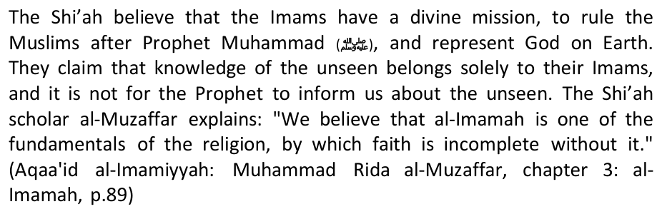
The Shi'ah further, have a tendency to lie and attribute false statements and narration to their Imams. The following are 2 examples of fabricated narrations:
Infallibility of the Imams, just like PROPHETHOOD: The Shi'ha consider the Imams to be completely infallible, do not make even the slightest error. Hence following these Imams, according to Shia's creed, is obligatory on all true Shia Muslims until the Day of Judgment. In fact, reverence for these Imams is so great amongst the Shia that the Imams are believed to be on a level above even the Prophets or the highest ranking angels; A level wherein even the particles of the universe are subservient to them. Khomeini asserts in his book, Al-Hukumah Al-Islamiyyah: "Certainly the Imam has a dignified station, a lofty rank, a creational caliphate, and a sovereignty and mastery over all the atoms of creation. It is definitely a basic belief in our school of thought, that our Imams occupy a rank unattainable by either an angel or a major Prophet. And, according to our narrations of Hadith, before the creation of the universe, the greatest Prophet SAWS, and the Imams - peace be upon them - were in the form of light which Allah made orbit His throne and gave them rank and proximity known only to Him. As was narrated in the hadith on Miraaj, Angel Gabriel said, 'If I were to have come an inch closer, I would have been burnt up.' - that is, by the intensity of the Imam's light. It has also been narrated by them (the Imams) - may peace be on them - that, 'We have certain states in relation to Allah not allowed to an angel or a great Prophet.' A similar status is accorded to Fatima Al-Zahra (Prophet Mohammad's daughter) - may peace be on her..."
This last statement finds its support in a chapter of Al-Kafi entitled: "Surely people have no Truth except what came from the Imams and everything which did not come from them (the Imams) is false."
5. "The Imams have knowledge of whatever occurred in the past and whatever will happen in the future, and nothing is concealed from them" (Ibid, p. 260.) Only Allah knows the future for any person to say that these Imams know the Unseen is committing "Shirk" (polytheism) and takes himself outside Islam.
1.Imam Ali is God. (Jila-ul-A'yoon, Vol. 2, p. 66, pub. in Pakistan
17. To hide a secret and to weep for the sake of an Imam is considered as Jihad. (Usool Kaafi, Vol. No. 2, Page No. 226)
38. Imam Ali (R.A.) was the creation of angel Jibreel (Gabriel). (Al-Majalis Al-Fakhra, p. 128)
D. "Jibraeel used to talk with Fatima after the death of Muhammad." (Jila-ul-A'yoon, vol. 1, pge 198, Multan)
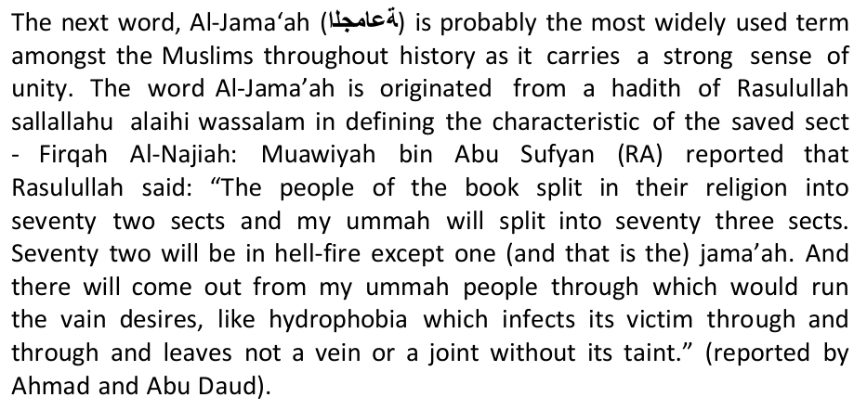
Saad ibn Ubaadah (RA) conveyed the following message to his fellow Ansar: "O Company of the Ansar! You have precedence in religion and merit in Islam that no other tribe of the Arabs can claim. Muhammad remained ten-odd years in his tribe, calling them to worship the Merciful and to cast off idols and graven images, but only a few men of his tribe believed in him, and they were able neither to protect the Apostle of Allah, nor to render his religion strong, nor to divert from themselves the oppression that befell them all. "Until, when He intended excellence for you (O Ansar); He sent nobility to you and distinguished you with grace. Thus Allah bestowed upon you faith in Him and in His Apostle, and protection for him and his Companions, and strength for him and his faith, and Jihad against his enemies. You (O Ansar) were the most severe people against his enemies who were not from among you, so that the Arabs became upright in Allah's Cause, willingly or unwillingly…through you (O Ansar) Allah made great slaughter (of the infidels) in the earth for His Apostle, and by your swords (O Ansar) the Arabs were abased for him. When Allah took (the Prophet) to Himself, he was pleased with you (O Ansar) and consoled by you. "So keep control of this matter (i.e. the Caliphate) to yourselves, to the exclusion of others, for it is yours and yours alone." (The History of al- Tabari, Vol.10, p.2)
1. Sayyadina 'Ali (RA) wrote this letter to Muawiya(ra) when he was having the leadership and authority over Muslim Ummah, So instead of declaring his divine Imamah and asking to believe in it, why would he affirm the supposedly wrong and evil act of Muhajireen and Ansar to be correct, in order to establish before his opponent that his appoint is valid?
He goes on to label Shi'ism as a cult with hateful motives. Is he not aware of the words of Allah (swt) that say "And who is more sinful than the one who prevents (men) from the masjids of Allah, that His name should be remembered in them..." (Qur'an 2:114)? Is he teaching tolerance and unity or hatred and prejudice?
The Messenger of Allah advised Muslims to unite and help one another. 1Allah's Apostle said, "A Muslim is a brother of another Muslim, so he should not oppress him, nor should he hand him over to an oppressor. Whoever fulfilled the needs of his brother, Allah will fulfill his needs; whoever brought his (Muslim) brother out of discomfort, Allah will bring him out of the discomforts of the Day of Resurrection, and whoever screened a Muslim, Allah will screen him on the Day of Resurrection." Book 43, Volume 3, no 622: Sahih Bukhari. If Maulana Dhorat and company honestly believe that Shi'a Muslims are lost, why don't they pay attention to the advice of the Prophet (pbuh) and give them good counsel?
Did Maulana Dhorat and company make any attempts to educate their fellow Muslims, have they sent out booklets or pamphlets in an attempt to guide the so called disbelievers who testify to the same deity they testify to, revere the same Prophet (pbuh) and read the same Quran that they do,
Here, I present a question: If the Shi'ah are angry over the Qur'aan and have reverence for it, then why have they allowed the distorters, as they claim, the opportunity to distort, change, and alter the Qur'an? Where were those whom they claim to be their Imaams; and at the head of them 'Ali ibn Abee Taalib (RA) and those who came after him-and they are free of that which they have ascribed to them. Where were they as it relates to this distortion and manipulation, while within their hands, as they claim, is full rein over the heavens and the earth, the Dunyaa as well as the Hereafter; all of that is subject to their control!?
12. Moreover why only the mention of Hadhrat Zainab (RA) or Hadhrat Zainab (RA) is made and not the names of the pious women of Islam like Hadhrat Ayesha (RA)?
40. To have a Horse parade in Muharaam?
The first Shi'ah scholar to confirm the foundation of Shi'sim to be on the deceit of Abdullah ibn Saba was Abu Muhammad al-Hasan bin Musa al-Nubakhti. Al-Najashi, in his al-Fihrist, authenticated him:"Al-Hasan bin Musa: Abu Muhammad al-Nubakhti, the well versed in dialects, who surpassed the peers of his time prior and after year 300 (hijra)" (Al-Fihrist: al-Najashi, p.47) At-Tusi, in his al-Fihrist, also upheld his credentials: "Abu Muhammad, dialectist and philosopher, was an Imami (shi'ite), an upright in faith, trustworthy (thiqah)....and he is one of the scholars' landmarks" (Al-Fihrist: At-Tusi, p.98) urallah at-Tasturi, in his "Majaalis al-Mu'mineen" wrote of him: "Al-Hasan bin Musa, one of the celebrity of this sect and its scholars. He was a dialectist, a philosopher, an Imami in faith" (Majaalis al-Mu'mineen: Nurallah At-Tasturi, p.177)
Having established the authority of this scholar, let's examine what he has to say about the Jew Ibn Saba': "Some people of knowledge mentioned that Abdullah bin Saba' was a Jew, who embraced Islam and supported Ali. While he was still a Jew, he used to go to extremism in calling Yousha' bin Noon as the appointee (successor) of Moses, thus after embracing Islam - after the demise of the Messenger of Allah [pbuh] - he said the like about Ali. It was him who first publicly announced the mandatory Iamamah for Ali, rejected and disowned his enemies, debated his opponents and called them Kafirs. Hence, those who oppose the Shi'ites often say: The Shi'ites and Rejectors (Rafidah) have their roots in Judaism." (Rijaal al-Kash-shi: Abu 'Amr bin Abdul Aziz al-Kash-shi, p.101 al-Mamaqaani, author of "Tanqeeh al-Maqaal", who is an authoritative Shi'i biogropher quoted the like in his said book, p.184)
'May the curse of Allah be upon those who tell lies about us. Imentioned Abdullah Ibn Saba and each hair in my body stood up, Allah cursed him. Ali (AS) was, by Allah, a proper servant of Allah, the brother of the Messenger of Allah (PBUH). He did not earn the graciousness/honor from Allah except with the obedience to Allah and His Messenger. And (similarly) the Messenger of Allah (PBUH) did not earn the honor from Allah except with his obedience to Allah'."
Abu Ishaaq Ibn al-Nadim, (297-385 h), a famous Shi'ah writer, did not agree to neither of the above theories, he wrote in his "al-Fihrist" that Shi'ism started at the Battle of Camel: "When Talha and Az-Zubair disagreed with Ali and accepted no less than the revenge for the blood of Othman, and Ali mobilized his forces to fight them, those who followed him were then given the title, Shi'ites." (Al-Fihrist, Ibn al-Nadim: p.249)
And it is related from Zurara that he said: I said to Imam Ja'far as-Sadiq that a man from among the descendants of Abdullah Ibn Saba is a believer in (the doctrine of) delegation (tafwid). And he said: And what is tafwid? I (Zurara) said: According to him Allah, the Mighty and Glorious, (in the first instance) created Muhammad and 'Ali, and then delegated the matter (of creation) to them, and these two created and gave sustenance, and caused life and death. The Imam said: He, the enemy of Allah, has lied. When you return to him recite to him the verse of the Chapter of The Thunder: "Or assign they unto Allah partners who created the like of His creation so that the creation (which they made and His creation) seemed alike to them? Say: Allah is the Creator of all things, and He is the One, the Al-mighty" [13: 16]. Then I went to the man and informed him of what Imam Ja'far as-Sadiq had said: And he became as if I had forced him to swallow stones or as though he were struck dumb.
Why do the Shi'ahs select only the Ahadith extolling the virtues of the Ahlul Bait which the general Muslims also believe in. What about all the other Qur'anic verses and Ahadith on the excellence of the Sahabah (Companions)? Why this bias against them?
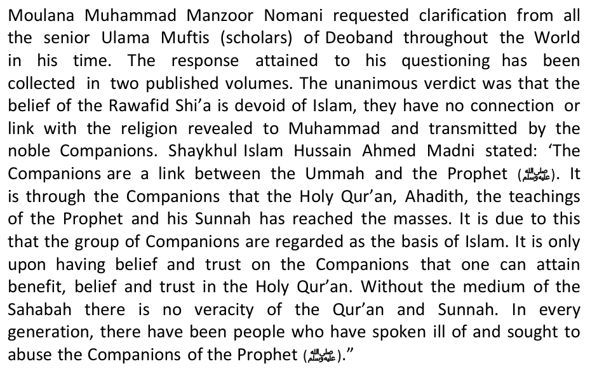
Can the Shi'ah explain their rancor, hatred, and malice at the Sahabah in the light of all the above evidence? Definitely not. Hatred of the Sahabah is a clear sign of disbelief, and the Shi'ah fulfill all the criterion of it.
When Iraq invaded Iran on 22 September 1980, motivated by fears that the Iranian Islamic Revolution in 1979 would encourage insurgency among Iraq's long suppressed Shi'a majority under the leadership of Saddam Hussein
ISIS clashed with its former al-Qaeda branch, already active in Syria, Jabhat al-Nusra or the al-Nusra Front headed by Abu Mohammad al Golani.
The same scenario happened in Iraq. Nouri al-Maliki, who is an Iranian puppet as most Iraqis believe, was about to lose his position as Prime Minister, especially that Sunni, Shi'ite and Kurds leaders unanimously refused to renew his term. Suddenly again, ISIS emerged. The ISIS connection with the Syrian leadership, and hence with Iran, raises serious questions. It was recently noted that President Assad released ISIS operatives from his prisons and for the most part left it alone, sparing it from attacks by the Syrian army. Two leading American analysts just wrote in the Washington Post, "The non-jihadist Syrian opposition insists that ISIS is a creation of Iran."
It is no secret that al-Qaeda has had "long established relations with Iran." Even the former al-Qaeda leader in Iraq Abu Musab al-Zarqawi, who was killed in June 2006 in a special U.S. airstrike, was treated by Iran's Revolutionary Guards of wounds he sustained during fights in Iraq.
In a letter that bin Laden wrote just five days before he died he described a document from his son Saad who had lived in Iran for years which exposes the truth of the Iranian regime. It is obvious that bin Laden and his men were quite distrustful of the Iranian regime, wrote Peter Bergen.
"Iran's current goal is to abort the Syrian revolution and portray the ruling Syrian regime as waging a war on terrorism." The connection between the Iranian regime and al-Qaeda and particularly ISIL is evident.
These documents include Iranian passports and several other documents belonging to fighters from Chechnya and Kazakhstan, in addition to many Iranian SIM cards, he said. This points to a connection between ISIL leaders and Iranian intelligence, he said. The brain-washed rank and file of ISIS are ignorant of the political alliances between ISIS, Tehran and Damascus.
Yet more recently the siege of Deir ez-Zor has been maintained by the army of Bashar al-Assad in the south and by ISIS to the north and east. Among the forces that have been trapped in the middle are the Free Syrian Army (FSA), raising the question of whether ISIS was colluding with the Syrian government and its Iranian allies to defeat the more mainstream elements of the Syrian opposition. Also at the time of writing we read reports of collusion between ISIS and Assad's army in Aleppo.
Iranian puppet PM Maliki at news conference in March 2010 pointing to the photos of two al Qaida leaders killed by US/Iraqi forces. "We're not sliding into civil war and I'm the man that's preventing that," said Maliki. Thanks to the blundering, politics driven, weakling in the White House who's been uselessly trying (through diplomacy, sanctions, and buttkissing appeasement) to stop Iran from going nuclear Obama caved into Ayatollah Khamenei's demands to keep Maliki (a one time refugee in Iran) as Iraq's puppet head of state. What phony concessions and promises Iran made to Obama is anyone's guess. But what is clear is that Obama swallowed the offer hook, line and sinker and joined Iran to ensure Maliki's survival as PM.
This is a strange twist of facts to get Sunni Muslims to support the foxy dodgy Shi'ah in their annual Al-Quds celebration. We are all for the Palestinian cause, but how do the Shi'ah feature in this who are actually HAPPY at the destruction of Palestine in 2006, the Hizbullah of Lebanon succeeded, so they say, in defeating the war machine of Israel and were able to drive them out. The 33-day war of Israel vs Hizbullah, where the Hizbullah came out the victor, is a new commodity brand name marketed by Shi'ah to deceive the Islamic ummah, the absolute majority of which is with the aqeedah of Ahlus Sunnah wal Jamaah. Long before this, there had been of course attempts by the Shi'ahs to exploit this issue of Palestine, for example with the fatwa of Imam Khomeini, the Rahbar of Iran, which fixed the last Friday of the month of Ramadhan as The Al-Quds International Day, but it seemed, it was not so influential and effective in attracting the sympathy of the Sunni Muslims to view the 'Aqeedah of Shi'ah.
A researcher on the subject of Shi'ah, Thoriq Ahmad Hijazi in his book entitled "As Shi'ah wa Al Masjid Al-Aqsa", had presented the results of his research on the position of Masjidil Aqsa in the eyes of the Shi'ah. Hijazi revealed that, almost all of the tafseer books of the Shi'ah's Imamiyah when interpreting the verse of Isra Mi'raj which is popular in Q.S. Al Isra:1, stated that the actual location of Masjidil Aqsa is in the heaven or baytul ma'mur. When said that the laypeople (Ahlus Sunnah) believe that it is the masjid that is located on a hill in the area of Al-Quds, the ulama's of Shi'ah said that Masjid Kufah is greater than Masjidil Aqsa. (see "Tafseer As Safi" written by Al Faydh Al Kashani vol.3/166; "Tafseer Nur Al Tsaqalain" written by Al Huwaizi vol.3/97; "Tafseer Al 'Iyashi" vol.2/302; "Tafseer Bayan As Sa'adah" vol.2/431)
already forgotten the fact that, that Masjid was built by the Muslim Commander who was one of the companions of the Prophet, namely Sa'ad bin Abi Waqqas, one of the 10 sahabahs guaranteed paradise, on the order of Khalifah Umar bin Khattab when the Muslims succeeded in conquering the capital of the Persian kingdom.
He again affirmed, "We have explained that Al-Quds is not going to return to the lap of the Muslims as long as the Muslims have not returned to the laps of Muhammad and Ali alayhima assalam!" (meaning following the aqeedah of Shi'ah). He added in his call, "Come back you all to Muhammad and Ali, surely Al-Quds will return to your laps by Al Mahdi! Liberate Karbala first before anything else, only then think about (the measures to liberate) Al-Quds and the surrounding regions." (Majalah Al Minbar edition 23, March 2002)
Ignas Goldziehr (An Orientalist from Hungary with Jewish blood, 1850- 1920 AD) was the first person who doubted the hadiths about the significance of Masjidil Aqsa that exist today by claiming that Khalifah Abdul Malik bin Marwan during the period of Umayyah, had banned people from going on Hajj to Makkah in the time of fitnah that happened during the time of Abdullah ibnu Az Zubair who proclaimed himself as a khalifah who ruled Makkah.
This strategy is quite successful in anesthetizing and deceiving Sunni ulama's and intellectuals who are naïve with this strategy of Shi'ah, to the point that they, either directly or not, are having a share in helping and defending the Shi'ahs in spreading their teachings in the midst of the Ahlus Sunnah community.
Currently, Shi'ism is providing a home to all false ideologies or to those who have a bone to chew with Sunni orthodoxy. Shi'ism in SA has also attracted modernist elements within it who subscribe to their whims and passions. They regard all religions as equal, even those that Shi'sim would declare as heretical. We are sure the grand architects of Shi'sim sitting in Iran wouldn't like such elements within its fold as it does more harm to their cause then good. Such people are "amateur Mullahs," who take off the mask from the devil, instead of adding another layer on top of it. It is such ameteurs who have given you away in SA, who play a double role, and who have divided loyalties.
In late February, an unnamed Israeli commander admitted that the Israeli military is in contact with the foreign- backed militant and terrorist groups inside Syria. Some reports also say hundreds of terrorists have received treatment in Israeli hospitals and most of them have returned to Syria.
Israel is colluding with Iran and the Lebanon-based militant group Hezbollah to keep Syrian president Bashar al-Assad in power, says a rebel commander.
There is absolutely no authentication for this. Only an offer was made to DECEIVE
He has also urged UNICEF to pave the way to enable the countries to send their humanitarian aid to the oppressed children in Gaza.
The above is the actual reproduction of the following – 'Abdullah Ibn Saba said to Sayyadina Ali: "You are God for sure, so Ali deported him to Madain (Capital of Iran in the past), and it was said that he was a Jew and converted to Islam, And at the time when he was a Jew, claimed that Yousha' bin Noon is after Moses. After his submission to Islam, after the demise of the Prophet [pbuh], he claimed the same for Ali [as]." (Anwar Al-Nu'mania 2/234)
Let us now provide a few early opinions of clear KUFR (Disbilief) on the Shi'ah:
*Sayyadina Ali (RA) said: "With regard to me, two categories of persons will be ruined, namely he who loves me too much and the love takes him away from rightfulness, and he who hates me too much and the hatred takes him away from rightfulness. The best man with regard to me is he who is in the middle course. So be with him and be with the
*Imam Malik: Once Imam Malik was asked about them and he replied, "Do not speak to them nor narrate from them, for surely they are liars." [Minhaaj as-Sunnah, 1/37] During a class of Imam Malik, it was mentioned that the Raafidite Shi`ites curse the Sahaba. In reply, he quoted the Quranic verse, "Muhammad is the Messenger of Allah and those with him are harsh with the disbelievers and gentle among themselves. So that the disbelievers may become enraged with them." He then said, "Whoever becomes enraged when the Sahaba are mentioned is one about whom the verse speaks." [Tafseeer al-Qurtubee, Soorah al-Fath; Editor's note: That is, anyone who is enraged by the mention of the Sahaba is a disbeliever, because the verse says, "…the disbelievers may become enraged with them (Sahaba)."]
*Abul-A'laa Al-Maududi: This great Pakistani scholar wrote an introduction to the book, Ar-Riddah bain al-Ams wa al- Yaum (lit. Apostasy in the Past and the Present) by Muhammad Kazim Habeeb published in 1977. In it, the author wrote of the Imami Ja'fari Shi'ites, "In spite of their moderate views (relative to other sects of Shi'ism), they are swimming in disbelief like white blood cells in blood or like fish in water." Maududi supported these views by praising the author and recommending that the book be done in hardback.
*Dr. Hilali: After living closely to the Shi'ites for some years, the famous Moroccan scholar, Dr Hilali, wrote a paper on them in which he declared them disbelievers.
The title of Ruhullah (The Soul of Allah) is a title of Sayyadina 'Isa (AS) who was born miracuoulsy. How did you give this title to Imam Khomeini? IS it revealed as such in your "secret" Qur'an?
Again, on page 75, the writes: "The Fuqaha (Mujtahids) are after the innocent Imams and during the absence of the last Imam, the Wasi of the Last Prophet (i.e. designated by the Prophet himself to be his successors) and they are conferred with the responsibility of transacting all the business and carrying out all the affairs with which the Imams were entrusted.".
Stressing the need of an Islamic Government, Khomeini remarks: "Both Shariat and intellect go to prove that the establishment of the Government is essential at the present time as it was during the days of the Prophet and Amir- ul- Momineen Ali Bin Abi Talib." (p. 26) At another place, Khomeini observes that the responsibility of the Ulema who are the custodians of the religion, does not end with teaching the precepts of faith, but they should, also, see that these are acted upon. He writes: "The Prophet and Amir-ul-Mominee (Ali) used to preach as well as have it acted upon." (p. 710). At both of these, as, also, at several other places, in his book, Khomeini ignores the periods of the first two Caliphs and from the reign of the Prophet goes straight to the period of Hazrat Ali. He hand hardly any option in the matter, for had he described the governments of the first three Caliphs as Islamic governments, the Shias who were the real source of his strength would have revolted against him and declared him unfit for the high office of Wilayat-ul-Faqih. And if he had expressed his own views and beliefs in respect of them, he would have forfeited the sympathy and cooperation of the non-Shia classes which had become his tools either due to simplicity and ignorance or under the spell of the exciting slogan of Islamic Revolution.
All this is based on a tradition recorded in Usul-e-Kafi which will enable the readers to grasp the full Import of these passages: Imam Jafar Sadiq is reported to have said: When the Prophet (peace be upon him) received the command of God that he should declare the Caliphate and Inmate of Ali after him, the Prophet feared that if he made the announcement many Muslims will turn against him and become apostates and say that he was doing so because of his relationship with Ali, and not under the command of God. He, therefore, begged God to reconsider the order and do not have the proclamation made. Upon it, the following verse of the Quran was revealed: "O Prophet! Whatever
It will now be plain to anyone that a person holding the belief of nomination of Sayyyadina Ali by the Prophet as his successor and Caliph, so firmly and steadfastly as Khomeini does and which is the arch-stone of Shi'ism, will have no other opinion about the holy Companions than what we have indicated above from books of Shi'ite religion and the sayings of the Innocent Imams, i.e., (God forbid) they all had betrayed the trust, were guilty of fraud and faithlessness, and ended up as deserving of the curse of God and the fire of Hell. A brief saying, in this connection, of the fifty Imam, Imam Abu Jafar i.e., Imam Baqir recorded in the most authoritative book of the Shias, Al-Jam'a-ul-Kafi: "After the death of the Prophet (peace be upon him), all his followers became apostates barring three". (One being asked who were those three, the Imam said): "The were Miqdad Ain Al-Aswad, Abu Zarr Ghifari and Salman Farsi. May God shower His blessings upon them". (Vol. Ill, P. 115. Lucknow Edition).
It is worthy of note, here, that Khomeini, like all Shia Ulema of our day, accepts the present Quran to be the real and genuine Quran and rejects the doctrine of alteration and mutation. But, at he same time, he has referred in his book, Al-Hukumat-ul-Islamia, with full reverence to the great Shia ideological scholar and Mujtahid, Allama Nuri Tabrasi, and in support of his own theory of Wilayat-ul-Faqih, cited a tradition from his, Mustadrak-ul-Wasail. (p. 66 of Al- Hukumat-ul-Islamia).
It would have been also better if Mr Islam would've written 15 pages of something positive, instead of a ebuttal which is full of lies, deceit, manipulation and heresies. He didn't even do a cursory research in his rebuttal! Whatever popped up in his brain, he just shot his mouth – and wounded the pride and faith of Shi'ahs in doing so!!
Salamalikum wrwb.
We should not be persuaded into believing that God fearing men are our enemies whilst real enemies of God are indirectly praised. Ayatollah Khomeini wanted for other countries what Iran had: "We shall export our revolution to the whole world. Until the cry "There is no God but God" resounds over the whole world, there will be struggle."
On the authority of Thawbaan (May Allah be pleased with him), the Messenger of Allah said: "If you see the Black Banners coming from Khurasan go to them immediately, even if you must crawl over ice, because indeed amongst them is the Caliph, Al Mahdi." [Narrated on authority of Ibn Majah, Al-Hakim, Ahmad]
You'll join hands with a Christian group and war with another. You'll gain victoryAt that time, you will be present in a plain of great mountains with plenty of trees. In the meantime, the Christians will raise the crucifix and refer the victory to it. At this, a Muslim will become angry, and will pull the crucifix down, at which, the Christians will unite breaking all treaties with the Muslims.The Christians will demand their wanted people, to which the Muslims will answer:"By Allah! They are our brothers. We will never hand them over. This will start the war. One-third Muslims will run away. Their 'Tawbah' (Repentance) will never be accepted.. One-third will be killed.They will be the best 'Shaheed' (martyrs) near Allah The remaining one-third will gain victory(6708,6709 Ibn Hibban)
There is a Hadith of Prophet Muhammad (SAW) about the symbols of the Judgment day that people with the Black Flag will rise up from the land of Khurasaan to fight against Kuffar Alliances in the Final War of Armageddon. Geographically, Syria is a land of great diversity that includes coastline, mountainous areas, steppe, and desert.
Narrated Abu Hurayrah: Allah's Apostle (peace_be_upon_him) said: The Last Hour will not come until the Romans land at al-A'maq or in Dabiq[north of Aleppo( a city in northen syria). An army consisting of the best (soldiers) of the people on Earth at that time will come from Medina (to oppose them). When they arrange themselves in ranks, the Romans will say: Do not stand between us and those (Muslims) who took prisoners from among us. Let us fight them. The Muslims will say: Nay, by Allah, we shall never turn aside from you and from our brethren so that you may fight them.
Nuaim Ibn Hammad on a chain of transmission on the authority of Al Zuhari who said, "If the people of the black flag divide, then the people of the yellow banner will attack, they will gather in the canal of Egypt and the people of the East and the West will fight for seven (days or months or years)…"
Al-Harith son of Hirath & Mansoor
*Note:The best example of the Islamic pattern is Baghdad whose exterior walls are not the same height as the interior ones, with alleys and curves separating them for defensive purposes. Hence Baghdad was also called 'Al Zawra'a'.
1. There is neither a verse in the Qur'an nor an authentic tradition from the Messenger of Allah referring to the eminence or Imamate of the alleged Imams, let alone the alleged status related to them.
3. The assertion that the Imams and the Messenger were light before they were brought into existence is blasphemy, and is not substantiated by the Qur'an, the Sunnah or the consensus of the Muslims. It is a blasphemous lie with which the polytheists from the nation of Muhammad sallAllahu 'alayhi wa sallam resemble their brothers of the other nation who believe Jesus to be the incarnate word of Allah. All the Messengers are created human beings, as Allah says: "Say, Verily, I am only a human like yourselves; it is revealed to me ... " (18.110) Thus the Messenger never was light or created out of light, but rather is like the rest of the sons of Adam except that Allah has distinguished him with the Prophethood and the Message.
5. Al-Maqam al-Mahmood, or the exalted station, shall be occupied only by a single slave of Allah, the Messenger of Allah, Muhammad (sallAllahu 'alayhi wa sallam) referred to by Allah, "Wake up in the night to pray reciting the Qur'an as a Supererogatory act of worship for you. It may be that your Lord will raise you to an exalted station." (Qur'an - 17:79) Al-Maqam Al-Mahmood, or the exalted station, is the privilege of the great intercession granted to the Messenger of Allah, Muhammad sallAllahu 'alayhi wa sallam, who occupies this station and shall be praised by all creatures on the Day of Resurrection. It is also a rank in Jannah granted only to one slave of Allah, who is Muhammad sallAllahu 'alayhi wa sallam as he said: "When you hear the Mu'azzin repeat his words (i.e. the call to prayer), then pray for me, and ask Allah to grant me access to the honorable station of excellence; it is a rank in Jannah. It must belong to one slave of Allah, and I hope to be him." (Muslim). Hence, neither Ali nor any member of his household shall be privileged with such a station. Whoever alleges otherwise is a disbelieving liar who falsely claims access to the knowledge of the unseen, which is restricted exclusively to Allah. Such a claim constitutes clear blasphemy.
Anyone who does not believe in the finality of Prophethood and the severance of revelation is an apostate who does not believe in Allah and His Messages.
From 1941 until 1979, Iran was ruled by a constitutional monarchy under Mohammad Reza Pahlavi, Iran's Shah (king).
Houchang Nahavandi, one of the Shah's ministers and closest advisers, reveals in his book The Last Shah of Iran: "We now know that the idea of deposing the Shah was broached continually, from the mid-seventies on, in the National Security Council in Washington, by Henry Kissinger, whom the Shah thought of as a firm friend."
When the situation was deemed ripe, U.S. Ambassador William Sullivan — the man reputed to have toppled the pro-American government of General Phoumi Nosavan in Laos — was sent to urge the Shah to get out. In
The Western media cooperated. When Carter visited Iran at the end of 1977, the press reported that his departure to Teheran International Airport had been through empty streets, because the city was "all locked up and emptied of people, by order of the SAVAK." What the media didn't mention: Carter chose to depart at 6 a.m., when the streets were naturally empty.
Terror at Home
A shadowy past followed Khomeini. The 1960s rioting linked to him was financed, in part, by Eastern Bloc intelligence services. He was in the circle of the cleric Kachani Sayed Abolghassem, who had ties to East German intelligence. Furthermore, in 1960, Colonel Michael Goliniewski, second-in-command of Soviet counter-intelligence in Poland, defected to the West. His debriefings exposed so many communist agents that he was honored by a resolution of the U.S. House of Representatives. One report, declassified in 2000, revealed, "Ayatollah Khomeini was one of Moscow's
Khomeini's inflammatory speeches were broadcast; revolutionary songs aired on Iranian radio. One journalist, however, stunned Khomeini by bucking the trend: intelligence expert Pierre de Villemarest, hero of the French Resistance in World War II, anti-communist, and critic of the CFR. Interviewing Khomeini, de Villemarest asked:
Huyser only paid the Shah a cursory visit, but had three meetings with Iran's revolutionary leaders — one lasting 10 hours. Huyser, of course, had no authority to interfere with a foreign nation's sovereign affairs.
The Shah's personal tragedy wasn't over. He stayed briefly in Egypt and Morocco, but did not wish to impose risks on his hosts from Muslim extremists. Eventually he welcomed Mexican President Lopes Portillo's hospitality.
Therefore, Panama was selected as intermediary. Following treatment in New York, the Shah was informed he could no longer remain in America, but Panama would welcome him. In Panama, however, the Shah and Empress were under virtual house arrest; it was apparent that it would only be a matter of time before the Shah would be sent to Iran in exchange for the hostages. A special cage was erected in Teheran. Khomeini's followers envisioned parading him in the streets before final torture and bloody execution.
We should not overlook that the Shah opposed the powerful opium trade, now flourishing in the Middle East.
In addition to the similarity of the religious schools of thought, there are links between Iran and the Hizbullah in terms of cooperation and strategic alliance. Many people say that the Hizbullah get weaponry and ammunition aids from Iran. One of the leaders of the Hizbullah was once asked by reporters in 1987: "Are you a part of Iran?" That leader of the Hizbullah replied: "In fact we are Iran in Lebanon and Lebanon in Iran". Besides that, one Hassan Nasrallah symbolically placed the photo of Imam Khomeni (spiritual leader of Iran) in his work room in Lebanon. It turns out that the alliance of the Shi'ah movements was not only between Iran and Hizbullah. DR Muhammad Bassam Yusuf (author of the book "Exposing The Great Zionist-Crusader Conspiracy and Neo Shi'ah Safawis Against Ahlussunnah In The Arab Peninsula" [transl.]), signals the presence of a strategic alliances between the Shi'ah movements in the Middle East. The alliances involved Iran, the Hizbullah, Syria and the Shi'ah groups in Iraq.
1. Teaming up with the Western powers under the command of America to dominate the countries of the Muslims. And the whole world knows well, that Iran has very big role in cooperating with America to bring down Afghanistan and Iraq. The officials of Iran themselves admitted it. Muhammad Ali Abthahi, former vice-president of Iran says: "If it wasn't for Iran, America would have been incapable of occupying Iraq…If it wasn't for Iran, America would have been incapable of subduing Afghanistan."
In the pages of history, it could not be found at all that Iran has ever been involved in a war against Israel or America. In fact, Iran instead has been importing weapons from Israel and America during the war with Iraq (Iran gate). Iran also persuaded and supported the continuity of the American occupation in Iraq. Iran itself intervenes and eases the Syrian government in eliminating its best sons.
The bottom line is, the West sees the potential of the Middle East and North Africa in just two strategic considerations; how far their natural resources can be utilized, and how far are the distance between the rulers and the terrorism movement, as an effort to protect Israel. The problem is, the West, led by America, are being pestered by problems over and over again. The economic crisis that is getting more and more acute, and the moral deterioration of their forces on all battle fronts (to not say defeat) make them choose to be cautious in addressing them. Meaning, this upheaval in the Middle East has already been a bit too late for America and the West in general, because they are already mired in the wallows of Afghanistan and Iraq, that makes them no longer able to move agilely. Previously, when America was still powerful, an upheaval of this kind was going to be a golden opportunity,
Shiah, The Most Real Threat: The time when Hosni Mubarak was in power, behind his inhumanity to the people, there's a geopolitical interest that was not realized, namely his hatred against Iran. Since Iran successfully toppled the tyrannical regime of Reza Pahlevi in 1979, and the direction of the state changed into a pure Shiah state, Egypt never allowed Iran's ship to pass through the Suez Canal. But after Egypt overthrew Hosni Mubarak, for the first time the Suez canal was traversed by Iran's warships.
Iran vs Al-Qaeda and Global Jihadis, culminating in Imam al-Mahdi: The series of trials that Allah gives to the Islamic ummah in order to elevate its status, turns out to have come in turn very quickly. When Al-Qaeda and the activists of global jihad are being tested in terms of their resilience, by fighting against the world superpower – America – in several places at once, the Shiahs with the support of Iran are already writhing. The Shiahs and Iran are ready to wait to be the next enemy after the collapse of America and its coalitions. Around 10 or 20 years from now, Iran with its Shiah will be far more stronger than now. Its feet will be set firmer in some regions.
Mohammad Saeed Shahabi, editor in chief of Arabic language Al-Alam magazine, referred to Ayatollah Khomeini as: The champion of return to Islam: "Imam Khomeini surpassed all boundaries of blind imitation which had overshadowed the Islamic and non-Islamic institutions. While holding Qur'an in his hand, he announced a return to Islam as a real life and blessed this notion with new spirit. The most important task carried out by the late Imam was the implementation of the religion as a political system capable of establishing a government and running the society."
Japan stopped selling Iran machinery used for construction because they are used to publically hang people in the Al- Ahwaz region. Indonesia has also labeled Shi'ism as KUFR.
And to round up these points, I have found some shocking information about Iran in this link too:
"How was the condition of the Ahlus Sunnah before the revolution, did they participate in it, and how and what was their reward from this participation?"
The regime then persecuted any person who dared to call for their rights, and punished them with imprisonment or execution, or degrading their character, as was the case with the martyr Bahram Shakoury. Many Sheikhs were imprisoned, exiled, tortured and humiliated, such as the Baluchistan parliamentarian member Mawlawi Nathar Mohammad who was subjected to sever torture and made false confessions under duress, until he escaped and was able to flee to Pakistan. He was not able to get a visa to enter any of the Gulf countries, not even as labourer. Sheikh Mawlawi Muhyiddeen and Sheikh Dost Mohammed Sirawani were also imprisoned, then exiled tot he city of Najaf Abad, as well as many other Sheikhs. There is also Sheikh Ibrahim Dammini who continues to be imprisoned and put to torture for more than five years.
It then instigated internal conflicts between the scholars, the leaders of the community, and the intellectuals to create an environment filled with distrust and insecurity. They also used some of the ignorant people who adhere to supposedly Sunni Tariqats (orders), to attack the scholars of Ahlus Sunnah, especially Sheikh Ahmad Mufti Zadah, labelling him as a Wahhabi, although the Sheikh did not adhere to the Salafi creed.
· Bahman Shakoury was amongst the prominent scholars of his area, Tonalis, and was active in Da`wah within the intellectuals. He was arrested and convicted with Wahhabism and executed in 1986.
· Dr. Ali Muzhaffaryan was amongst the eminent intellectual Shi`ites who was a cardiac surgeon and the head of Shiraaz Committee of Physicians. He embraced the school of Ahlus Sunnah Wal Jama`ah and then converted his house to a mosque because the government of Shiraaz did not permit the establishment of Mosques. He was arrested and convicted with Wahhabism and American treachery and tortured severely when many Shi`ite youth followed him into Sunnism. He was later released only to be assassinated in 1992.
· Aabaan Mosque Mashhad city. They confiscated the land, demolished the walls, and expelled the trustee.
"Do Ahlus Sunnah have an organised movement? What is the extent of its popularity? And how are the Ahlus Sunnah facing the present situation?"
Our policy with this bitter reality is to be patient and abstain from armed conflict. We do not wish to repeat the experiment in Hama, Halab, Tripoli and others which were very bitter experiments. Particularly as we know that there is no government or even an organisation which dares to or intends to support or sponsor us.
It is a misleading notion to avow that Shi'as killed their Imams, according to historians; Imam Hassan was poisoned because he was seen as a threat to Yazid's caliphate.
When they had assembled, he addressed them: "By God! I believe that by the grace of Allah I am a person with the best motives and intentions as I bear malice towards none, nor do I intend to entertain evil towards anyone in future. Remember, it is always better to express you dislikes while remaining within the party than expressing them while you are split and splintered. Keep it in mind, my friends, that I desire your welfare even better that your own selves. Therefore you should neither oppose me nor contradict my opinion. May God forgive us all, and may He enable you to seek His love and pleasure"!
He carried a long pointed missle in his hand. He said: God is great! O Hassan, you have committed infidelity as your father had done before you. Then he inflicted a blow on his thigh with a spear. The spear tore thorough the tight and penetrated down to the bone. Hadhrat Hassan grappled with him and both of them tumbled to the ground. Meanwhile one of the Shias of Hassan leapt towards them. His name was Abdullah bin Khatal Tai. He snatched the spear from Jarrah's hand and jabbed it into his belly. An other man Zibiyyan bin Ammarah also pounced at him and chopped off his nose. He died instantly. The other man with him was also caught and kille. Hadhrat Hassan was brought to Madain on a cot, and he stayed at the residence of Saad bin Masud Thaqafi who officially represented the Amir-ul-Mo-minin in Madain. Hadhrat Hassan had also retained him in the same office. In Madain he devoted his attention towards his treatment.
His own cousin was also against him and he wanted to degrade him and pass him over to his opponents. The majority of his companions were inclined towards earthly benefits and rewards and had grown indifferent towards the punishments of the next world. However, Hadhrat Hassan secured the trust and confidence of Hadhrat Muawiyyah. He raise all the objections that could possibly be raised. One of the conditions was that the Amir-ul-Mominin will not be persecuted. During prayers he will not be condemend; the Shias of Ali will not be maltreated and justice will be done to everyone. Hadhrat Muawiyah accepted all the terms and pledged to fulfil them Ibn abi al-Hadid adds: When Hadhrat Hassan decided to leave Madain, he addressed the people: You have pledged to me that you will be reconciled to those with whom I am reconciled and you will fight those with whom I fight. By God! At this moment I bear no malice towards any member of my community
Sayyadina Hasan (RA) became unconscious and his friends caught him.
"Pledge at his hand because he (Hadhrat Hassan) is my lmam".
After the patch-up a group of Shias still supported his stand. They also pledged fealty at the hand of Hadhrat Muawiyyah and never wavered in their loyalty and sincerity toward him from 41 A.H. to 60 A.H. The most prominent among this group of Shias were the children of Hadhrat Ali, the children of his children and his wives, Hadhrat Hussain, Muhammad bin Hanifiyyah, Abdullah bin Abbas, the sons of 'Aqil and Jafar' and other distinguished Hashmis who shared and identity of beliefs with the general ren of Muslims and the companions of the Prophet (peace be upon him). They believed that no one should be charged with infidelity and apostasy, that they should make a practical demonstration of unity and solidarity, that hey should paper over their differences and avoid collision and confrontation, that they should strengthen the bonds of mutual love and affection and establish inter-marital relations as has been copiously illustrated in the preceding pages.
Muawiyah wanted to pass the caliphate to his son Yazid, and saw Imam Hassan as an obstacle, it is maintained that Muawiyah incited Imam Hassan's wife to poison him.
When the letters piled up and the Kufi demand turned into an insistent refrain, Hadhrat Hussain sent Muslim bin 'Aqil lbn Abi Talib to Kufah. He also dispatched a letter to the residents of Kufah and told them that the letter was a prelude to his visit. When Muslim arrived in Kufah, the people swarmed round him and pledged fealty to him. They gave their word of honour that they would extend their maximum help and co-operation to Hadhrat Hussain". Mufid adds: "All the Kufis pledged to Muslim while crying and the number of these people exceeded eighteen thousand".
Ah! How truly Ibn Abbas had spoken! How sympathetic was he towards Hadhrat Hussain and how well-informed about the designs of the Kufis! He continued: "If you march in this direction, and Ibn Ziyyad comes to know about your departure, he will mobilize his army and seek an open confrontation with you. The people who have dashed off letters to you will turn into your implacable enemies. If you don't agree to my proposal and are determined to leave for Kufah, then, for God's sake, don't take your wife and children along. By God! I apprehend that you may be martyrred as Hadhrat Uthman was martyrred and his wife and children remained passive spectators".
Masudi remarks that the news of Muslim's arrival in Kufah had been passed on to Yazid ibn Mu'awiyah, the current Caliph, also. He appointed Ubaidullah bin Ziyyad the governor of Kufah. Ubaidullah marched form Basrah at a hurricane speed and arrived in Kufah soon after noon. When he sneaked into Kufah, he was wearing a black tiara which covered his face. He was riding a mule. People were expecting the arrival of Hadhat Hussain, not him. When Ibn Ziyad, the governor of Kufah, saluted the people, they responded with slogans of welcome until he reached the palace. Noman bin Bashir was also inside the palace. He sat down near him and then turned his attention towards him. He asked: "O son of the Messenger of Allah! what is your command? Why have you
Hani' tried to snatch a policeman's sword, but someone pushed him and widened the distance between him and the sword. Hani's companions kicked up a roar at the door, clamouring the death of their companion. Ibn Ziyad threatened them and locked up Hani' in a side-room. He sent out Qadhi Shuraih to tell the people that Hani' had not
Under the circumstances, he gathered all the people and addressed them: "O people! I have received horrifying news. Muslims bin Aqil, Hani' bin 'Urwah and Abdullah bin Yaqtar have embraced martyrdom. Our Shias have betrayed and humiliated us. Therefore any one who likes to leave us is welcome to do so. I'll not be offended in the least". When people heard his words, they started slinking on the right and on the left until, within a short span of time, only those people remained who had set off from Madinah with him – his immediate family. Those who had joined him on the way disappeared into thin air. Only a sprinkling of these people held on to the hem of his companionship. He had consciously uttered these words to offset the false expectations of some of his followers who had joined his raks simply to live in a town whose citizens obeyed the Imam unconditionally. Thus they looked forward to
O God's creature! I am not unaware of it either but no one can prevail over divine plans."
After the martyrdom of Hadhrat Ali, they submitted allegiance to his son
These were the Shias! the Shias of Ali, Hussan and Hussain and this is the treatment they had extended to their Imams and forefathers. I have deliberately discussed it at length because Shi'ism underwent a radical change after this accident. The change related to the new complexion they put on the hoodwink the people. Previously, it was a purely political group: but now it donned a religious mask. At first there was no distinction between the elite and the non- elite and they stood in the same row, though the elite acted as their leaders. But when dangers surrounded them on all sides, they softened their attitude as a result of the persuasion of the Umayyads in Syria. Then their services were utilized AGAINST the Shia movements and they detached themselves from the Shia of Ali which resulted in a further bog of the Shia objectives.
The Shias splintered into three sects after the martyrdom of adhrat Hussain (RA) as has been mentioned by Naubakhti. The details of these sects are:
A number of Shia offshoots and sub-group sprang out of Kaisaniyyah: for example, Karabiyyah, Harbiyyah, Razarmiyyah, Bayaniyyah, Rawindiyyah, Abul-Mulammiyyah, Hasmiyyah, Haritiyyah and many other sects. The common denominator among these sects is the Imamat of Muhammad bin Hanifiyyah and the net-work of beliefs churned out by Abdullah bin Saba. All these sects believe in back-biting, resurrection and transmigration.
in the projection of his image as an extraordinary person.
Muller has also expressed similar views in the relevant book (Vol. 1, P. 327) with the addition that the Persians were deeply and extensively influenced by Hindu views on account of their centuries old association with one another. As a result of this influence, they believed that the king was the light of the divine soul which is transferred from kings to their successors who are in the direct line of lineage. Consequently, political Shi'ism started melting away. The Sabai views were now invested with sufficient strength to elbow them out, and had overtly aggressive designs towards all the genuine Shias.
Hadhrat Ali: "Abu Bakr is the best man." Muhammad: "And who after him?"
This is indeed laughable. The Ahlus Sunnah wal-Jama'ah is not based on hatred, Shi'ism is. To prove our point, let's examine a popular Shi'ah magazine called "Cresecent International." It's the Shi'ah equivalent of TIME magazine of the West in propaganda.
Not masoom (sinless); Not infallible.
The Shiite authentic works also permits homosexuality and sodomy: "(Narrated) Muhammad bin Yahya, from Ahmad bin Muhammad, from Muhammad bin Yahya, from Talha bin Zaid, from Abu Abdullah [as] said:The Messenger of Allah [pbuh] said: Whoever voluntarily let others sexually molest him, Allah will invest him with women's lust." [al- Kafi (fil Furoo') al-Kulainy, Book of Nikaah, Chapter: Who Let Others Sexually Molest Him, vol.5, p.549, narration 1.] Comment: May Allah curse the liars who lie on the Apostle of Allah [saw].
Question: Is it permissible to fertilize the woman's eggs whose husband is sterile by the sperms of a foreign man through putting the sperms in the woman's vagina?
(Narrated) Several of our fellows from Sahl bin Ziyad, from Musa bin Ja'far, from 'Amr bin Sa'eed, from Muhammad bin Abdillah al-Hashimi, from Ahmad bin Yousuf, from Ali bin Dawood al-Haddaad, from Abu Abdullah [as] said:Marry not from the Negros nor the Khazar, for they have uteruses indicate they are unfaithful. He [as] further said: India, Sind and Qind not a single one of them is smart, meaning Qandaharis Ibid, Narration 3. Khazar is the area around the black sea, and Qandahar is in Afghanistan Not to mention that the women are depicted very low and worthless in the Shiite scriptures.
Narrated Muhammad bin Ali Majilwaih: Narrated to us Muhammad bin Yahya al-'Attaar saying: Narrated to us Sahl bin Ziyad al-Adami saying: Narrated to me Othman bin Issa from Khalid bin Nujaih from Abu Abdallah [as] saying:Bad luck was discussed in his presence, he [as] thus said: Bad luck are to be found in three things: in the woman, vehicle (horse, mule, camel, donkey, etc) and house. As for the bad luck in the woman, it is due to her high dowery and her disobedience to her husband, the vehicle is due to its attitude, and the house is due to its narrowness, its bad neighbor and its defects". Al-Amaali: Ibn Babawaih al-Qummi, 42nd Council, Narration No.7, p.199, and in his al- Khisaal, Chapter of the Three, narration 53,p. 100 [A shorter version of this narration is also found in al-Kafi (fil Furoo'): al-Kulainy, Book of Nikaah, Chapter: Nawadir, vol.5, p. 567, narration 51]
Narrated to us my father [ra] saying: Narrated to us Sa'd bin Abdallah, from Ahmad bin al-Husain bin Sa'eed, from Abu al-Husain al-Hadramiy, from Musa bin al-Qasim al-Bajaliy, from Jameel bin Darraj, from Muhammad bin Sa'eed, from al-Muhariby, from Ja'far bin Muhammad, from his father, from his forefathers, from Ali [as] saying: The Messenger of Allah [saw] said: Three (type of situations) are good lie in them: Trickery in a war, promising your wife, and reconciliation between people. There are three (types of situations) where telling the truth becomes ugly: snitching, telling the man something he may dislike about his wife, and to disbelieve the man over the rumor. He further said: And there are three (types of people) sitting with them kills the heart: sitting with the low class, talking to women, and sitting with the wealthy people". al-Khisaal: Ibn Babawaih al-Qummi, Chapter of the Three, narration 20, p.87
Please read the narration once again. Does it make a sense? What is more interesting thou, is the commentary of Ibn Babawaih al-Qummi on this narration. He wrote in the footnote: "Allah the Exalted, created lust in ten parts: Ten for men, and one for women. But that is specifically for Bani Hashim and their Shi'ites. And for the women of Bani Umayyah and their supporters, the lust is ten parts: nine for women, and one for men"
*Jubair ibn Mut'im reported that once a woman came to the Holy Prophet (SAW) and sought an audience with him. The Holy Prophet (SAW) asked her to return and come back some time later. She asked apprehensively, "And if I do not find you here, (the narrator says - as if she feared that the Holy Prophet would pass-away)." He (SAW) replied, "Then you will find Abu Bakr in my place." 1
*Once the Holy Prophet (SAW) announced on the pulpit, "If I were to make anyone my friend on this earth, it would be Abu Bakr. All the windows of houses facing my mosque should be barred, except the one of Abu Bakr." 7
The Holy Prophet (SAW) did not appoint a successor with a written ordinance, in fact he wanted to write this in favour of Sayyadina Abu Bakr (RA), but then he left it. 12He was informed through inspiration that the Muslims would appoint Abu Bakr as the first caliph, so he did not see the necessity of writing it down. None of the Companions ever said that that the Holy Prophet (SAW) appointed anyone besides Abu Bakr, although Sa'd ibn 'Ubàdah initially refused to take the oath at his hands. Once 'Umar ibn 'Abd al-'Azïz sent Zubair to Hasan al-Bašrï to ask him the same question. Hasan al-Bašrï replied, "Have you got a doubt in this matter, By Allàh, Abu Bakr was appointed as a caliph." 13
It was not possible for a caliph to be elected from the Ansàr, as the Holy Prophet (SAW) had said, "The leaders will be from the Quraish; if they rule, they rule justly; when they make a promise, they fulfill it; and if mercy is asked from them, they show due mercy. 19" In another tradition, the Holy Prophet (SAW) said, "Leadership will come from the Quraish, advisorship from the Ansàr, and call to prayers from the Abyssinians." 20
Upon receiving the verse, the Prophet stopped at the pond of Khumm and delivered a sermon to multitudes that were present. "O people, Allah the Most Kind the Omniscient has told me that no apostle lives to more than half the age of him who had preceded him. I think I am about to be called (to die) and thus I must respond. I am responsible and you are responsible, then what do you say?' They said, 'We witness that you have informed, advised and striven. May Allah bless you.' He said, 'Do you not bear witness that there is no god but Allah and that Muhammad is His servant and Apostle, and that His Heaven is true, His Hell is true, death is true, the Resurrection after death is true, that there is no doubt that the Day of Judgment will come, and that Allah will resurrect the dead from their graves?' They said, 'Yes, we bear witness.' He said, 'O Allah, bear witness.' Then he said, 'O people, Allah is my Lord and I am the lord of the believers. I am worthier of believers than themselves. Of whomsoever I had been Master (Mawla), Ali here is to be his Master. O Allah, be a supporter of whoever supports him (Ali) and an enemy of whoever opposes him and divert the Haq to Ali.'
Shï'ite perversion on the Šahàbah are not only limited to the external import of certain verses of the Qur'àn. They also included various historical incidences for which Shï'ites took pains to bring to conformity with these misinterpreted verses. Thus in Shï'ï tradition, one finds another way to prove disobedience and apostasy of the
*It took place on the 18th of the Dhu al-Hijjah 10 A.H. after the 'Farewell' pilgrimage of the Holy Prophet (SAW). The Holy Prophet (SAW) made this address at this place because Allàh revealed verse 5:67 here, "O Apostle, deliver what has been revealed to you from your Lord; and if you do not, then you have not delivered His message; and Allàh will protect you from the people." The Holy Prophet (SAW) then wanted to settle the question of his successorship there as this would now complete his message. Therefore, the Holy Prophet (SAW) made these announcements:
*The whole claimed announcement of the Prophet (SAW) in the context that the Shï'ï scholars attach to it was a blatant lie, as ibn Taimiyah28 has emphasized. The Holy Prophet (SAW) asked Muslims to be kind to his entire household, not just 'Alï. 29If the tradition indicates any special power or privilege for his household, then we should praise the 'Abbàsid caliphs, the offspring of 'Abbàs. Why then do the Shï'ah scholars curse them instead?
What is this 'truth' which follows the decisions that 'Alï makes; opinions that he gives, and the whims that come to his mind? If the Prophet were to pray, "Direct 'Alï to follow the truth wherever right is," then it would seem to be logical.30
"This is because Allàh is the maulà of all the believers, and the disbelievers have no Maulà."
any of the others. Even more telling, the first two editions of the Encyclopaedia of Islàm include detailed and relatively lengthy discussions of the Ghadïr Khumm, but made no mention anywhere of related incidents like the Qirtàs (pen and paper) or the Saqïfah (portico) Banu Sa'ïdah incidents.
After vesting so much of power and authority in 'Alï 37- one of the most courageous Companions known as Asadullàh (The lion of Allàh) who could not stake his claim in the caliphate, the Shï'ahs treated him as a weakling and attribute this saying to him, "The caliphs before me did things which consciously went against the dictates of the Holy Prophet
Sunnïs would not agree to accept the Ghadïr Khumm incident as Shï'ahs outline it, for in accepting it, many tenets of Islàm are compromised – and this is exactly what Mr Islam want to do: to distort Islam!!!
*When Shia's Imam Mahdi (the 12th Shia Imam) comes, he will bring Prophet Mohammad's wife, Aisha, back to life, whip her as a punishment to avenge Prophet Muhammad's daughter, Fatima. (Al-Shafi, Vol. 2, p. 108), (Haq-ul- Yaqeen, p. 139 & 347) & (Hayat-ul-Quloob, Vol. 2, p. 901)
3) Those Sahàbah who migrated to Abyssinia, like Ja'far ibn Abu Tàlib, Abu Salmah ibn 'Abd al-As'ad and the Holy Prophet (SAW)'s daughter Ruqayyah.
'Aqïdah al-Taåàwiyyah:
Qàdi 'Ayàd writes in his Al-Shifà' (The Cure):
Yet, Maulana and company (Islamic Awakening) label the people who heed the Prophet's advice as disbelievers, once again I ask, what is his agenda? Are these forces spreading propaganda against the Shi'as in order to dissuade Sunni Muslim from interacting with Shi'a because they don't want them to be exposed to the truth about Shi'ism from Sunni books? Could it be that our Scholar Maulana Dhorat and company have something to hide?
If it was not for al-Samàwï's challenge, the opinion of ibn Taimiyyah
*According to Imàm Ahmad ibn Hanbal and Màlik ibn Anas as recorded in the Insàf (Justice) of al-Mardàwï, such a person should be severely punished.
It is reported that the Holy Prophet (SAW) had predicted the vilification of the Companions when once he said addressing 'Alï (RA), "O 'Alï, "After me, a time will come when a people will emerge having high-pitched voices, they will be called Rawàfid (Rejectors). If you ever meet them, kill them for they are polytheists." In explaining this tradition, 'Alï said, "They will claim to love the ahl al-Bait but they will be deceiving us. The indication for this will be their revulsion for Abu Bakr and 'Umar." 54
Verse 9:101 which spoke of the hypocrites of Madïnah.
To further his argument, he stated that the Holy Prophet (SAW) used to confide the names of the hypocrites to Åudhaifah ibn al-Yamàn,59 who according to the Shï'ah, was also a hypocrite. How could the Holy Prophet entrust the names of the hypocrites to a hypocrite himself, and still have complete trust in him? Secondly, expelling one from Islàm on the basis of committing sins is the view of the Khawàrij, the rejection of which both the Sunnïs and the Shï'ahs agree upon.60
Yours Truly,
The mahr is referred to here as ajr (lit. dues or wages) in this verse, but this does not refer to the money which is paid to the woman with whom he engages in mut'ah in the contract of mut'ah. The mahr is referred to as ajr elsewhere in the Book of Allaah, where Allaah says: "O Prophet (Muhammad)! Verily, We have made lawful to you your wives, to whom you have paid their Mahr (bridal-money given by the husband to his wife at the time of marriage)…" [al- Ahzaab 33:50]
No Shi'ah can wriggle out of these arguments and still legalise Mut'ah in the name of Islam!!
Police have uncovered a number of Mutah rings operating from Tehran that have sold girls to France, Britain, Turkey, as well. One network based in Turkey bought smuggled Iranian women and girls, gave them fake passports, and transported them to European and Persian Gulf countries. In one case, a 16-year-old girl was smuggled to Turkey, and then sold in Mutah to a 58-year-old European national for $20,000. In the northeastern Iranian province of Khorasan, local police report that girls are being sold in Mutah to Pakistani men. The Pakistani men temporarily marry the girls, ranging in age from 12 to 20; they are also sent to Mutah brothels called "Kharabat" in Pakistan. One network was caught contacting poor families around Mashad and offering to temporary marry girls. The girls were then taken through Afghanistan to Pakistan where they were sent to Mutah brothels to work. In the southeastern border province of Sistan Baluchestan, thousands of Iranian girls reportedly have been sold in Mutah to Afghani men. Their final destinations are unknown.
*The Least Costly Mutah: "Mutah is a marriage that may last for a very short time. It needs no witnesses, and it has no period of 'iddah. The minimum compensation that could be paid to the woman for sexual relations is one dirham."(Al-Kafi)
* Mutah - A Blessing from Allah: No one can close the door of blessings which Allah opens for His servants, Imam Jafar as-Sadiq said,"Mutah is one of the blessings of Allah." (Al-Kafi)
* Mutah - A Ladder to the Stages of Piety: "One who engages in Mutah once attains the status of Imam al-Hussain. One who engages in it twice becomes equal in status to Imam al-Hasan. The one who performs it three times reaches the position of Imam Ali. And he who practices it four times acquires the level and position [equal to that] of the Prophet." (Al-Kafi)
Payments to women vary
Look at these filthy Shi'ah websites:
Nasa'i)
Volume 9, Book 88, Number 230: Narrated Abi Asha'sha: Hudhaifa said, 'In fact, it was hypocrisy that existed in the lifetime of the Prophet but today it is Kufr (disbelief) after belief.'
All of the above traditions point towards the fact that people claiming truth, can not sometimes be taken at face value.
(c) Taqiyya is permitted to protect Muslims. The Shia are practicing it to hide their Shia beliefs, not the Islamic beliefs. In support of their twisted form of Taqiyya, we find the following in Shia's classical reference books:
Lastly, this hadith of Prophet Muhammad (SAW) should serve as a warning: "Whoever is asked for knowledge and conceals it will have a bridle of fire around his neck on the Day of Judgment." (Abu Dawood and Tirmizi)
Although the wives of Prophet Muhammad (SAW) are named as Ahl Al-Bayt in the Ibraahimite Prayer, we would find a better and a clearer declaration that the wives of the Prophet are his household in this narration:
Al-Zubaydi says in Taj Al-Aroos (The Bride's Crown): "Ahl Al-Mathhab is its believers, Ahl Al-Rajul is his wife and children, and this is how the verse: "and was travelling with his family" is explained as his wives and family. Ahl Al- Nabi is his wives, daughters, and his son-in-law Ali. It was said that the descendant of a man is Ahl Al-Rajul. In the Quran: "Enjoin prayer on thy family, and be constant therein," "And Allah only wishes to remove all abomination from you, ye Members of the Family, and to make you pure and spotless," and "let mercy of Allah and His blessings be upon you Ahl Al-Bayt, He is the most benign and most exalted."
In retrospect, it is cleared that the household of Prophet Muhammad are his wives, the family of Ali (Hasan, Hussain, and Fatima), the family of Aqeel, the family of Abbas, and the family of Jaffar. Those are the ones who Prophet Muhammad ordered us to dignify and respect. Hadeeth Al-Thiqlain did not testify to the infallibility of anyone of them, but raised their status. Using the verse of Purification and hadeeth Al-Kisa'a to prove Ali's infallibility is non- sense.
FINALLY, WE AT ISLAMIC AWAKENING (PRETORIA), DITT AND ADL (CAPE TOWN) STILL UPHOLD OUR ORIGINAL BELIEFS ABOUT SHI'ISM AND HEREBY STATE THAT YOUR SKEWED REPORT HAS ONLY SERVED TO REINFORCE OUR BELIEVE IN THE CORRECTNESS OF THE CREED OF THE AHLUS SUNNNAH WAL-JAMA'AH. WE INVITE YOU, WITH KINDNESS AND COMPASSION, TO SAVE YOUR WRETCHED SOULS FROM DOOM UNTIL YOU HAVE BREATH IN YOUR LUNGS, REPENT AND RECANT. THROW OFF THE STIFLING YOLK OF IGNORANCE AND BLINDNESS FROM YOUR SHOULDER, AND BOLDLY EMBRACE THE TRUTH. YOU ARE ALWAYS WELCOME IN OUR CAMP.
By:
Rabi Us Sani 26, 1434 A.H, Saturday, March 9, 2013
The people of Shi'ah have killed the father of our leaders, namely Ayatullah Uzhma Imam Sayyid Abul Hasan Al- Ashfani, a greatest imam of the Shi'ah after the disappearance of the imams until today. There is no doubt that he was a great figure of Shi'ah, however, when he was about to straighten out the manhaj of Shi'ah and cleanse the superstitious that are present in it, they slaughtered him like how they slaughter a goat. Just as they also have assassinated Sayyid Ahmad Al-Kasrawi when he declared himself free of the deviations of Shi'ah and wanted to straighten out the manhaj of Shi'ah, they chopped off the body of Sayyid Ahmad into several parts. There are still many people who suffered the same fate due to their courage in opposing the bathil aqeedah incuded into the madzhab of Shi'ah. And they also want me to suffer the same fate. But it does not frighten me. Suffice it for me to deliver the truth, advise my brothers, give warnings to them and turn away from misguidance. If I want the pleasure of the world, the mut'ah (contract marriage) and khumus (a fifth of the property given by the followers of Shi'ah) have been enough to achieve all those, as done by others other than myself who have become rich in each of their area. Some of them ride the most expensive cars of the latest model. But alhamdulillah, I turned away from those since I recognize the truth.
Rasulullah, the most noble, do all those illogical things?
Whoever is not able to marry in a shar'ie way because of the lack of provision that he has, let him guard his chastity until Allah gives rizq (sustenance) to him so that he is able. Supposing mut'ah is made halal, surely Allah would not have commanded to guard the chastity and wait until the time comes that the affairs of marriage is eased for him. It has been equally known that Islam came to command the virtuous deeds and forbid deplorable deeds. Islam came to actualize the welfare of the Allah's slaves and so that their way of life become well-regulated. On the other hand, it cannot be doubted anymore thatmut'ah will disturb life. Mut'ah propagates uncountable damages.
Regarding the Qur'an, Our ulama's and mujtahids agreed that the Qur'an is the only book that has changed among the books that are recognized by the Shi'ahs. Al-Muhaddiths An-Nuri Ath-Thibrisi has compiled all the evidences and proofs of the occurrence of wide-scale alterations in the Qur'an in his book which he named "The Determiner In Establishing The Occurrence Of Alterations In The Book Of God Of All Gods" (Faslu al-khithab fi Ittsbati Tahrif Kitabi Rabbi Al-Arbab). In his book, he has compiled a thousand riwaayahs which stated that there has occurred alterations. He compiled the words of the fiqhexperts and the ulama's of Shi'ah who openly stated that the Qur'an that is in the hands of mankind today has been changed from the original.
---The Jews delay the Dusk until the stars appear, likewise the Shiites delay the maghrib prayer until the stars appear. The Prophet is reported to have said," My Ummah will remain in the state of Fitra unless they delay their maghrib till the stars appear." He further stated:" Hasten to the maghrib prayer before the appearance of the stars and don't be similar to the Jews for they pray when the stars appear."
Secondly the attribution of "Shujahudeen" shows that the Zoroastrian religion is the real religion for them. Thus the religion of the Rawafid is a mere Magian sect.
Umar ibn Hassan ibn Ali, Abu Bakr ibn Hussein ibn Ali, and that Muhammad is the messenger of Allah. If a person who believes in the Oneness of Allah and the prophethood of Muhammad is not a Muslim, then who is a Muslim?
6. "The Imams have knowledge of all the revealed books, regardless of the languages in which they were revealed" (Ibid, p. 227) As you can see these Shia have elevated their Imams to a God-like level, and the Shia say that there is nothing wrong with this!!!
2. There is no difference between Ali & Allah (meaning they are the same person/ entity). (Jila-ul-A'yoon, Vol. 2, p. 85)
18. Imam Hussain said "By God, Muawiyah is better than the Shia: they have tried to kille me". (Al-Ehtijaj, Vol. 2, p. 290)
39. Imam Ali did Miraaj (made a journey to Heaven during his lifetime) before Prophet Mohammad. (Dewan-e-Jil Ehzan, p. 38)
For an interesting clip on the impossibility of Muslim-Shi'ah unity, please see: http://www.youtube.com/comment_servlet?all_comments=1&v=wVodsT Di6wM
In his assertions, Maulana Dhorat accuses Shi'a Muslims of causing disunity among Muslims, yet he encourages Sunni Muslims to disallow Shi'a Muslims in the community, in the Sunni Masjids for prayer, marriages or educational and social welfare purposes and not to allow Shi'a Muslims in Sunni graveyards.
Sa'd said to him Abubakr (RA): "You have said the truth. We (Ansar) are the ministers while you (Quraysh) are the rulers.[Shaykh al-Albani grades the whole report as Sahih.]
Rational Proof 2: There were many Shi'ah allegations against Sayyadina 'Uthman (RA). The rebels condemned him for not being there in Badr or at Al-Hudaibiya, fleeing from Uhud, collecting the Qur'an, and they accused him of protecting his own camels instead of the camels of everyone in general. We also find other accusations in hadith and history books like, he was accused of lengthening the prayer in Mina and for exiling Sayyadinna Abu Dharr. We can forward to you a detailed rebuttal of all these allegations upon request.
2. According to Shi'ahs, blieving in the Caliphate of first three caliphs is a major sin. So why did Sayyadina 'Ali (RA) prescribe others to continue making that sin? Is this the way of divinely appointed Imam where instead of stopping people from doing a sin and correcting them, the divinely appointed Imam asks them to continue doing that sin?
"O Mary! Submit yourself with obedience to your Lord (Allâh, by worshipping none but Him Alone) and prostrate yourself, and bow down…" (Aali 'Imraan 3:43)
A number of our (the Raafidah's) companions narrated from Ahmad ibn Muhammad from Abdullaah Al-Hijjaal from Ahmad ibn 'Umar Al-Halabee on the authority of Aboo Baseer that he said: "I entered upon Aboo Abdullaah, upon him be peace, and said to him: 'May I be sacrificed for you; I want to ask you regarding an issue. Is there anyone here who will hear my speech?' So Aboo Abdullaah rose and erected a curtain between himself and the others, and I stepped in.
I have cited the narration at length so that the noble reader may see these lies and falsehoods in order that he may increase in awareness regarding the Shi'ah and their religion. In the present era, Al-Khomeini emphasized this belief system regarding the Mus-haf of Faatimah, when he said while counting the things which they are proud of and their extraordinary feats: "We are able to boast regarding the salvation of our Imaams within the month of Sha'baan; the supplication of Husayn ibn 'Ali on the Day of 'Arafat, As-Saheefah As-Sajjaadiyah (the Zaboor of the Family of Muhammad), and the Saheefah of Faatimah, the Book revealed by Allah the Exalted to the Delightful Flower (i.e. Faatimah)"
13. Why absolutely no mention of Hadhrat Ayesha (RA)?
41. To re-act the scene of Karbala in Muharaam?
Now, if these Shi'ites authorities lied about the identity of Ibn Saba', then the possibility of them lying about other matters, like the events of Siffin, the murder of al-Hussain (RA) and other Shi'i dogmas, stands greater. Consequently, if this is the case, doubt will overshadow any and all events and narrations recorded by them.
Narrated Muhammad bin Khalid At-Tayalisi, from Ibn Abi Najran, from Abdullah bin Sinaan said: Abu Abdullah [as] said: "We are a family of truthfulness. But we are not safe from a liar telling lies about us to undermine our truth with his lies in front of people. The Messenger of Allah (PBUH) was the most truthful among people in what he said (Lahjatan) and the most truthful among all humanity; and Musaylima used to lie on him. The Commander of Believers (AS) was the most truthful one among the creation of Allah after the Messenger of Allah; and the one who used to lie on him, and tried to undermine his truthfulness and claimed lies about Allah, was Abdullah Ibn Saba." (Ibid, pp. 100- 101)
The division between the Shi'a and Sunni is rooted in disputes over the proper succession of leadership after the death of the Prophet Muhammad (pbuh) in 632 C.E. The Sunni assert that the Prophet did not appoint a successor and the Shi'as maintain that the rightful successor of the Prophet (pbuh) is Ali the son of Abu Talib and the Prophet's cousin and son-in-law. Although there are disagreements about whether the Prophet (pbuh) did or did not appoint a leader, both sects agree on the importance of a successor. Hence Shi'as do not believe that Allah and his Messenger (pbuh) may have overlooked such an important factor and left it in the hands of the Ummah.
Kamil Mustafa al-Shaybi, another Shi'ah, wrote in his book: "The independence of the term indicating Shi'asm came about only after the murder of al-Husain whereby Shi'ism became an independent entity with a distinctive identity" (The Link Between Sufism & Shi'asm: Mustafa Kamil al-Shaybi, p. 23)
Like this, dozens of Shi'ah historians have been squabbling with no consensus as to when Shi'ism actually started. On such weak grounds does Shi'ism stand!!
In case you have selectively overlooked them, they are presented here for your benefit now:
Till today, Iran is colluding with the West to create unrest in the Muslim world. We can cite dozens of articles in support of our contention. Here is one:
Mamduh Ismail, a Palestinian columnist wrote on his website "Islamway.com", that the axis of Shi'ah Iran-Syria- Hizbullah alliance are the munafiq people who abuse the issue of Palestine for their own interests, as a marketing of the heroism, to their own people and the Muslims people of the world. However, when Gaza was bullied by Israel and bombarded by the Zionists for more than 20 days in late 2008 until January 2009, the Shi'ah axis which appeared heroic in front of the Muslim public of the world turned out to be not helping (not even a single bit) their 'brothers', the Muslims in Gaza who were suffering as a result of the Israeli aggression. Not even one rocket or weapon did they send for helping Hamas who struggled alone defending Gaza from the Israeli aggression. Whereas, they say they are a strong Nation which have military strength that could destroy the Zionist forces. But what happened? What they are doing is just a disgusting hypocrisy (Arabic http://ar.Islamway.com/article/4939 downloaded by this author on 4th July 2012)Lastly, Al-Quds and Masjid Al-Aqsa can only be liberated by the group that receive the help of Allah Ta'ala, they are called Ath Thaifah Al Mansurah (the helped group) who are firm and istiqomah, holding on to the Kitabullah and Sunnah of Rasulullah (SAW), and having an 'Aqeedah that is correct, not even a single bit mixing with the bid'ah and kufr, and the Shi'ah have plenty of these in their creed!!!
Please remember that both Shi'sim and Wahhabism is a creation of the enemies of Islam. Whilst Shi'ism is a creation of the Jews in the first century of Islam, a British spy by the name of Hempher was responsible for shaping of the extreme tenets of Wahhabism. This is mentioned in a Turkish work, Mir'at al-Haramain, by Ayyub Sabri Pasha between 1933- 1938. British policy in its colonies often involved the creation of deviant sects, in order to Divide and Conquer, as was the case with the Ahmadiyya sect of Islam in India in the nineteenth century. The details of this conspiracy are outlined in a document by the name of "The Memoirs of Mr. Hempher" published in series in the German paper Spiegel. It's a first-hand account by Hempher of his mission for his government, which sent him to the Middle East to discover ways to undermine the Ottoman Empire. Among the vices the British were to promote were racism and nationalism, alcohol, gambling, fornication and tempting Muslim women to uncover themselves.
It is a well known fact that Iran does not recognize Israeli government and refers to it as the Zionists regime.
Fri Mar 7, 2014 8: West seeks distance from Syria militants
On February 18, Netanyahu paid a visit to a secret field hospital in the occupied Golan Heights, which offers medical services to the injured militants coming in from Syria. MP/HJL/HMV
Abdulkader Saleh of the al-Tawhid group said that Assad had already lost the civil war but Iran and Hezbollah were continuing the fight opposition groups with the help of Israel.
the world on it.
Rabiei said that labor unions have announced they would stage protests outside UN office in Tehran against the Israeli crimes against Gazans.
Secretary Hagel also used the meeting to express his appreciation for the support that Qatar provides U.S. forces in the country. Today's visit followed Secretary Hagel's visit to Doha last fall, where he met with Minister Attiyah to sign and renew the U.S. – Qatar Defense Cooperation Agreement.
*Our Noble Prophet Muhammad (SAW): Ibrahim reported that his father Hasan said that his father Hasan said that his father Ali bin Abu-Talib (may Allah be pleased with them) said: "The Messenger of Allah said: "There will appear, at the end of time, people who are called Rawafidah (rejecters). They will reject Islam." [Musnad Ahmad] Sayyadina 'Abdullah ibn Abbas (may Allah be pleased with them) reported that The Messenger (may peace be upon him) said: "There will be, at the end of the time, people who are called Rawafid (rejecters). They will reject Islam and spit it out. Thus, KILL THEM for they are polytheists." (Musnad Ahmed) *Ahl-ul-Bayt (the Household of the Messenger): It was reported that Sayyadina Ali (RA) used to repeat the following statement: "The best one after the Messenger of Allah (pbuh) is Abu Bakr. And the best one after Abu Bakr is Umar."
great majority (of Muslims) because Allah's hand (of protection) is with keeping unity." [Nahjul Balagha, sermon 126 about the Kharijites]
*Imam Ibn Hazm quoted a report with an isnad going back to Hishaam ibn 'Ammaar, who said: "I heard Malik ibn Anas say: "Whoever curses Abu Bakr should be whipped, and whoever curses Aisha should be killed." He was asked,
*Imam Al-Alusi: He declared the Raafidite Shi'ites disbelievers because of their defamation of the Sahaba. His position was based on the rulings of Imam Malik and other scholars who were in agreement with him. In reply to their claim to be Ahl Bayt (the Prophet's (pbuh) family), al-Alusi said, "No, they are really followers of the Devils and Ahl Bayt are innocent of them."
*Al-Bashir al-Ibrahimi: While visiting Iraq, this professor who is the leading religious scholar in Algeria saw with his own eyes the Shi'ite book, Az-Zahraa, in which 'Umar ibn al-Khattab - may Allah be pleased with him - is accused of homosexuality. On his return home to Algeria, he exposed the Shi'ites and clearly outlined their principle beliefs and practices.
This is the spiritual and intellectual basis of Khomeini's Revolution and his position is not like that of any other revolutionary leader or head of State, but owing to the fundamental Shi'ite doctrine of Imamate and the Major Absence of the last Imam and the intervening institution of Wilayat-ul-Faqih till the reappearance of the latter, Khomeini is the representative of the Twelfth Imam and the nominee of the holy Prophet as his successor, and, as such, he is entitled to all loyalty and obedience that is due to the Prophet and the Imam, and all the steps he takes are in the same capacity.
Frequesntly Asked Questions
Narrated by Abdur Rehman Al-Jarshi that I heard companion of Dear Prophet(salallaho alayhay wa sallam), Hazrat Amr Bin Marra Al-jamli (R.A) that our Beloved and most Dear Prophet (Salallaho alayhay wa sallam) said: "Surely Black Flag will appear from the Khorasan until the people(under the leadership of this flag) will tie their horses with the Olive Trees between Bait-e-Lahya and Harasta. We asked are there any Olive trees between these places. He said,"If there isn't then soon it will grow so that those people (of Khorasan) will come and tie their horses there." [Ref: Kitab-al-Fitan Page 215. Also at Page 108 in the book "Islam main Imam Mahdi ka Tasawer" by Maulana Professor Muhammad Yousaf Khan,Jamia Ashrafia Lahore,Pakistan.]
Khurasaan in the time of Prophet (SAW) included the whole Afghanistan, Northern parts of Pakistan including Malak and Divison, central Asian states, part of Iran — still a province in the North East of the country is named Khurasaan. Also, some part of Uzbekistan too.
Geographically, Syria can be divided into four regions. A narrow fertile coastal plain runs along the Mediterranean border and extends inland to a narrow range of mountains and hills. The coastal climate is moderate with hot, dry summers and mild, wet winters; the average annual rainfall is this area is between 30 and 40 inches. The mountainous region runs from north to south, parallel to the Mediterranean Sea. The interior semiarid plains region is found to the east of the mountains. Much of the southeastern part of Syria is desert region that extends to the borders of Jordan and Iraq; most of the desert is a rock and gravel plateau that receives less than four inches of rain annually and is extremely hot.
They will then fight and a third (part) of the army, whom Allah will never forgive, will run away. A third (part of the army), which will be constituted of excellent martyrs in Allah's eyes, would be killed. The third who will never be put on trial will win and they will be the conquerors of Constantinople. (and/or Rome)
In the era preceding Qiyamah the Christians will control the whole world. The Christians will reach Khyber.(Hadith quoted in Bab-al-Qeyamah by Muhaddith Shah Rafee-ud-din RA)". (Place in present day Saudi close to Madina. US forces are already positioned there)
Az-Zuhri said: "The black banners will meet in battle with the yellow banners, and they will fight each other up to Palestine. Then the Sufyaani will come out against the people of the east, and when the people of the Maghrib settle in Jordan, their ruler will die. So they will split into three groups; one group that will return to where they came from, one group that will go to the Hajj, and one group that will stay and against whom the Sufyaani will fight. He will defeat them, and they will enter his obedience." (Nu'aym ibn Hammad, Kitab al-Fitan, No. 54)
Said son of Al Musayyab reported: "The Black Banners will come from the East from the children of Al Abbas. Then there will remain whatsoever Allah wishes. Then, small Black Banners will come to fight a man from the children of Abu Sufyaan from the East. They will give their allegiance to the Mahdi." (Nuaym ibn Hammad.)
Some Arabs will fight with Mahdi [a.s] and they will be defeated.
'There will be a city called Zawra between the Tigris and the Euphrates.
Also Al-Zawra'a Park in Al-Mansour Area and almost in a central location of Baghdad.
2. The so-called 'Universal vice-regency' requires, from Khomeini's standpoint, that when those Imams say to a thing Be, it is. ("...and to them submit the atoms of this universe.") This indeed is a quality restricted only to Allah, the Creator, who is far removed from every imperfection. He stands in need of no supporters or helpers in creation nor are there any to share His dominion, as He says: "Say, Call upon Those you allege beside Allah, They control not even the weight of an ant in the heavens nor on the earth, nor have they any share in either, and He has no helper among them." (Qur'an - 34:22) He, extolled be His glory, also says, "Blessed is He Whose hand is the domain, and has power over all things." (Qur'an - 67.1) All the domain is in the hand of Allah alone; He does not pass any portion thereof to any of His slaves. He says,"Those of you who allege beside Him own not 'Qitmeer:" (the thin skin which is upon the datestone). Allah the exalted says, referring to the angels, "They say, 'The Beneficent has taken to Himself a son, far removed is He from what they attribute to Him, Say, they are only honored slaves. They speak not before He speaks and they act only by His commands. He knows what is before them and what is behind them, and they intercede not except for him whom He approves. They are awestricken fearing Him. Whoever of them should say: 'I am a god beside Him, him shall We requite with Hell. Thus do We requite the unbelievers." (Qur'an - 21:26-29)
The alleged Imams were distinguished by nothing of that nature. The assertion that they were light before they were brought into existence, and that they surrounded the throne of Allah, is plain blasphemy and clear deviation. Had this been true, it would have been included in the Book of Allah and in the Sunnah of His Messenger, but it is the falsehood of habitual liars and polytheists. Defying men and attributing lordship to them is tantamount to associating partners to Him, exalted is He from what they attribute to Him. He is the One Who was and nothing was with Him. He is the first, before Whom there was none; He is the Internal underneath Whom there is none, extolled be His glory. He created all by His power and greatness, and by virtue of His saying to a thing Be, it is. He created Adam from the mud of this earth, and made his posterity out
6. The assertion that the alleged Imams have with Allah Subhanahu, a distinct state which cannot be encompassed by a close angel or a sent Messenger, is a fabricated assertion. Where in the Book of Allah, or in the Sunnah of His Messenger can this be found? Or where in the statements of the truthful Imams is this stated? Did Ali bin Abi Taalib, may Allah be pleased with him, or any one of his pious veracious sons claim such a distinct state? Far are they from lying against Allah the Exalt. This lie can never be made by a believer. Because such states are in the knowledge of the unseen, whoever claims this knowledge is a liar and an unbeliever. Allah says, Say, "None in the heavens and the earth knows the unseen save Allah." (Qur'an - 27:65) Allah revealed the unseen only to a Messenger or a Prophet. Whoever alleges that a revelation was
The above considerations reflect on some statements made by Khomeini in his book 'Islamic Government', and prove that he uttered nothing but blasphemy and falsehood, for which the scholars of the Muslim Ummah have condemned him to blasphemy and deviation.
Although Iran, also called Persia, was the world's oldest empire, dating back 2,500 years, by 1900 it was floundering.
Kissinger virtually epitomized the American establishment: before acting as Secretary of State under Republicans Richard Nixon and Gerald Ford, he had been chief foreign-affairs adviser to Nelson Rockefeller, whom he called "the single most influential person in my life." Jimmy Carter defeated Ford in the 1976 presidential election, but the switch to a Democratic administration did not change the new foreign policy tilt against the Shah. Every presidential administration since Franklin D. Roosevelt's has been dominated by members of the Council on Foreign Relations (CFR), the most visible manifestation of the establishment that dictates U.S. foreign policy along internationalist lines. The Carter administration was no exception.
December Mr. George Ball, an instant "authority on Iran," was sent as a follow-up with the same message.
An equally vicious campaign occurred when the Shah and his wife, Empress Farah, came for a state visit to America in November 1977. While touring Williamsburg, Virginia, about 500 Iranian students showed up, enthusiastically applauding. However, about 50 protestors waved hammer-and-sickle red flags. These unlikely Iranians were masked, unable to speak Persian, and some were blonde. The U.S. media focused exclusively on the protesters. Wrote the Shah: "Imagine my amazement the next day when I saw the press had reversed the numbers and wrote that the fifty Shah supporters were lost in a hostile crowd."
Two major events propelled the revolution in Iran. On the afternoon of August 19, 1978, a deliberate fire gutted the Rex Cinema in Abadan, killing 477 people, including many children with their mothers. Blocked exits prevented escape. The police learned that the fire was caused by Ruhollah Khomeini supporters, who fled to Iraq, where the ayatollah was in exile. But the international press blamed the fire on the Shah and his "dreaded SAVAK." Furthermore, the mass murder had been timed to coincide with the Shah's planned celebration of his mother's birthday; it could thus be reported that the royal family danced while Iran wept. Communist-inspired rioting swept Iran.
five sources of intelligence at the heart of the Shiite hierarchy."
How are you going to solve the economic crisis into which you have plunged the country through your agitation of these past few weeks?... And aren't you afraid that when the present regime is destroyed you will be outpaced by a party as tightly-knit and well organized as the [communist] Tudeh?
Prior to execution later by Khomeini, General Amir Hossein Rabbi, commander-in-chief of the Iranian Air Force, stated: "General Huyser threw the Shah out of the country like a dead mouse."
However, in Mexico the Shah received an invitation from CFR Chairman David Rockefeller, who used influence to secure permission for the Shah to come to America for medical treatment. Rockefeller sent a trendy Park Avenue MD to examine the Shah, who agreed — against his better judgment — to abandon his personal physicians and fly to New York for treatment. In October 1979, he was received at the Rockefeller-founded Sloan-Kettering Memorial Hospital for cancer treatment. Here the Shah experienced a fateful delay in spleen surgery that some believe accelerated his death.
However, Anwar Sadat, the Egyptian president and the Shah's friend, discerned the scheme, and sent a jet to Panama, which escorted the Shah and Empress safely to Egypt.
Finally, the Shah was a nationalist who brought his country to the brink of greatness and encouraged Middle East peace. These qualities are anathema to those seeking global governance, for strong nations resist membership in world bodies, and war has long been a destabilizing catalyst essential to what globalists call "the new world order."
30-billion-arms-deal-with-saudi-arabia/
The case of the Syrian leader's (Bashar Al-Assad's) rage against the Lebanese government followed by the resignation of 5 Shi'ah ministers from the Hizbullah indicates the relatedness of the Hizbullah with Syria. DR Bassam Yusuf wrote that there was a meeting in Damascus in 2007 between Iran and Syria to form a strategic alliance, in which the Hizbullah group was also merged. This strategic alliance of the Shi'ah movements are called the Safawist Shi'ah Revival Project. The Alliance wants to restore the glory of the Safawiyah and Fathimiyah dynasties in dominating the power in the Arab peninsula and Africa.
2. The involvement of the Persian Safawists in Iraq by a very perfect cooperation with the top-level leaderships of the Shi'ahs in Iraq, especially those of the Persian race. And it was manifested in the form of cooperations in intelligence, military, economy, politics and religion, with the full support from America, be it militarily or logistically.
1. For more than once, the President of Iran shouted out his empty slogans for the call of the elimination of Israel from the world map.
2. Sparking off the fire of sectarian war, committing group and ethnic cleansing, working hard to divide the region. Expelling the Sunni citizens of Iraq from the provinces where they live together with the Sh'iahs. Coupled with the destructive roles of the Shi'ah spiritual leaders in Iraq to destroy the Sunnis and all institutions that they have. Al- Shirazy urged in his khutbah for the destruction of the Sunni masjids in Iraq. And the Shi'ah did really destroyed hundreds of the Sunni masjids, or turned them into Husainiyat and Shi'ah Safawists centers.
4. The Zone of Lebanon: The Hizbullah and Amal Movement –both are obviously Shi'ah movements- play the role of a false resistance movement. Carrying out resistance against Israel for the sake of keeping the guns to remain in their hands and playing the political lobbying in Lebanon in the interests of the Safawist-Persianist Alliance. Both these movements are openly launching the Shi'ah missions and deliberately provoking Israel to strike Lebanon any time the Safawistic alliance needs it. The efforts to destroy the integrity of Lebanon continues to be done in order to form a Shi'ah state in the State of Lebanon.
Iran itself is using the Hizbullah to provoke the act of the destruction of Lebanon by Israel. It was Iran itself that seized the three islands belonging to the United Arab Emirates. And it was Iran that tries to change the Palestinian resistance movement into becoming a piece of paper which it will easily play with later on, though the stability and security of the entire Arab regions and Islam have to be sacrificed.
The unrest in Bahrain is also troubling, where its demonstrators are Shiah, fighting against the regime which is Sunni. Saudi Arabia is in a dilemmatic position, if it allows the regime of Bahrain to be overthrown by the Shiah demonstrators, it means that the Sunni regime, which obviously is the friend of Saudi Arabia, would be gone. It's clear that Saudi Arabia is in danger, because the threat of the Shiah is increasingly nearing its border lines. Although it will invite a crooked look from the international world, Saudi Arabia feels the need to send an army directly to Bahrain, as an effort to curb the advance of the Shiah. Not much different from Oman, Kuwait and Yemen, all of which hold a large enough potential of the adherents of Shiah. If these people's upheaval can be played well by Iran, it is not impossible that Saudi Arabia will be more and more desperate by the advance of the Shiite Iran's influence in the region. Even before the unrest broke out, the Houtsi rebels in Yemen had already been troubling the Saudi.
1. Iran is a wealthy country with oil money in abundance, beaten only by Saudi Arabia.
Howevver, the Islamic ummah led by Al-Qaeda, the Taliban and other SINCERE global jihad activists are in the midst of being "trained" by Allah to practice the ibaadah of Jihad fie sabilillah, by means of being given an opponent that is top class. This is because, the implementation of the ibaadah of jihad is different from other ibaadah such as Solat and Zakat. In Jihad, there has to be an enemy for it to be accomplished, while in Solat it is enough with facing the Qibla and unfurling a prayer rug. Coincidentally, the starting points of the development of jihad and the plan of action of the Shiahs turns out to be simultaneous. In 1979, the mullahs of the Shiahs successfully muzzled the regime of Reza Pahlevi and established a sovereign Shiah state. In the same year, the Soviet Union raided Afghanistan, which started out to be battled by the Mujahideen with the initial capital of not more than 6 rifles. In 1991, alhamdulillah, the Soviet Union was able to be defeated by the permission of Allah, in fact that empire broke into pieces, only Russia remains. As if we are given a chance to compete in a sprint race with the same starting point; in 1979.
http://www.youtube.com/watch?v=rD8MoSFO44k
Bahman Shakoury was amongst the prominent scholars of his area, Tonalis, and was active in Da'wah within intellectuals. He was arrested and convicted with Wahhabism and executed in 1986;
"Would you kindly give us a glimpse of the history of the Ahlus Sunnah in Iran. The main areas where they are concentrated and their numbers."
The regime then aimed at Ahlus Sunnah schools, and tried to influence their curriculums to incorporate Shiah teachings, labelling anyone who refuses to do so a Wahhabi, a "crime" punishable by death in Iran!
· Sheikh Mawlawi Abdul Aziz was one of the elite leaders of the Ahlus Sunnah who played a prominent role in opposing the Constitution in matters relating to Ahlus Sunnah rights. He was the director of the religious school of Zahdan and the chief of Baluchi armed tribes. He was poisoned in 1987.
"There is no Sunni director in any of the government authorities, ministries, embassies, or local and provincial governments, hospitals or principalities; not even in the lowest government posts anywhere in Iran.."
· Repair of roads. They also repair the roads from time to time, eg. in the city of Zahdan, in order to demolish Sunni houses, Mosques and schools in the name of alleged reconstruction.
Yes, the existence of a Sunni Muslim government in Afghanistan will have a definite effect on us. This is why we are witnessing every effort from Iran to halt the establishment of an Islamic government in Afghanistan. The minister for Iranian foreign affairs declared a number of years before: "We will never permit the establishment of a Wahhabi government in Afghanistan". In view of these devils, any Sunni government is a Wahhabi government. In summary, the existence of any Sunni government is in our interest. It is notable to bear in mind that the Shiah/Safawi State which existed during the Ottoman rule fell at the hands of the Afghan Sunnis.
They looked with amazement at one another when they heard his address and gave vent to wild speculation: What do you think are Hadhrat Hassan's intentions? They concluded: "By God! We guess that he
Meanwhile a number of chieftains secretly wrote to Mu'awiyah that they were ready to pledge to him. They strongly persuaded him to come to them. They assured him that they would either had over Hadhrat Hassan to him as soon as he reached there or kill him. Hadhrat Hassan also came to know about their secret plan. He received a letter from Hadhrat Qays bin Saad. He had dispatched him to Abdullah bin Abbas on his return from Kufah to meet Hadhrat Muawiyyah and to prevail upon him to keep off Iraq. He had also appointed him the leader of the party and told him that in case of his martyrdom Qays bin Saad would act as the leader.
Shia historians have elucidated that the people who had forced Hadhrat Hassan, looted his property and wounded him, belonged to Sabat Madian, the spot to which Hadhrat Ali (RA) had Exiled Abdullah bin Saba. They were deeply impressed by the views and beliefs of Ibn Saba and were actively engaged in their dissemination and publicity. They also included Mukhrtar bin abi Ubaid Thaqafi, a victim of Sabaism, who subsequently gained immense reputation and became the self-styled spokesman of the views preached by the dissembling Jew, Ibn Saba. The historians have mentioned that when Sayyadina Hassan ibn Ali (RA) landed in Madain in a wounded state, Mukhtar knew the whole state of affairs. Mukhtar asked him: "Do you need wealthy and status?" He inquired: "How is it possible?" Mukhtar replied: "You should arrest Hussain ibn Ali and dispatch him to Muawiyyah as a prisoner." Hadhrat Hassan ibn 'Ali (RA) replied: "May God disgrace you and curse your words! Do you expect me to betray the grandson of the
These facts have been endorsed by the fanatic Shia Majlisi in his book "Jila-ul Uyun (written in Persian). Among the Shia Muhaddithin, Abbas Qummi has mentioned them in his "Muntah-il-Amal". Ibn Abi al-Hadid, too, has recorded it in his book "Sharh Nahf-ul-Balaghah". Some other Shia sects sprang out of this episode. Naubakhti observes that when Hadhrat Muawiyyah, they made him the butt of their spiteful criticism, backed out of their belief in his Imamat and affirmed their faith in the will of the people, but the rest of his companions supported his claim to Imamat till his martydom. When he had withdrawn himself from a confrontation with Muawiyyah and had landed in Sabat, Jarah bin Sanan attacked him. He held the bridle of his horse in his hand and shouted:
At the juncture of conciliation between Hadhrat Hassan (RA) and Hadhrat Muawiyyah (RA), many Shi'ahs absolutely discarded Shiaism. Naubakhti observes that when Hadhrat Hassan and Muawiyyah committed themselves to patch- up and Hadhrat Hassan accepted the goods dispatched to him by Hadhrat Hassan accepted the goods dispatched to him by Hadhrat Muawiyyah, thus people started lambasting him. They opposed him, damned his Imamat and concurred with the opinion of the populace. Sabaism had spread most shabbily during this period.
After a few days Hadhrat Hussain received a letter from Muslim: "One hundred thousand people are ready to pledge at your hand. Therefore don't delay". Hadhrat Hussain set out towards kufah after receiving the letter. But Hadhrat Abbas called on him. Hadhrat ibn Abbas was a spring of the Banu Hashim, he was the commander-in-chief of the armed forces of Hadhrat Ali, he was an experienced man and had a better grasp of the psychic make-up of the Shias of his times, as has been attested by Masudi: Hadhrat ibn Abbas said to him: "O my cousin! I have come to know that you intend to visit Iraq. Don't you know that these people are traitors? They are inviting you to fight but you shouldn't make haste. If you want to fight with this tyrant and do not like to stay in Makkah, you should better go to Yemen. It is off the main route and
These were the explicit words of Hadhrat Abdullah bin Abbas and the amount of prestige he enjoyed in the eyes of Hadhrat Ali is no secret. Mufid comments: "Hassan ibn 'Ali constantly suffered at the hands of the Shias who spared no opportunity to humiliate him. They tortured him so much that he was forced to confess: I wish Muawiyyah could exchange you with his men as dinars are exchanged with dirham. He should take ten of you and give me one of his men in exchange."
been murdered. Consequently, they left for their homes.
Then he marched towards Kufah. On the way he chanced to meet another person who informed him about the betrayal and cowardice of the Kufis and told him bluntly that he did not have a single supporter and helper. He added that instead of helping him, the Kufis might turn against him. When the armed forces of Kufah intercepted him, he realized that the actual situation clashed with the promises of help and the assurances of support with which their letters were cluttered and clogged. They had taken a complete turnabout. He asked one of his companions to bring him the two bags containing their letters. He brought the bags and poured out their contents right in front of them.
After the martyrdom of its distinguished people, it transformed itself into a specific movement. The supporters of Sulaiman bin Sard were against the movement of the distinguished personages of different tribes. Mukhtar was, of course, the first person who parasitically instilled new life into the movement. He included the Mawalis (Persians) in the movement as well. Their inclusion was relatively easier on account of their inclination towards religious matters. When the association of the Shias grew deeper with these insurgents, they were stripped of their Arab and national identity. Though the basis of their association was Islam it was not early Islam but and entirely different brand.
Kaisaniyyah: After the martyrdom of Hadhrat Hussain (RA), some of his friends were dazed by the circumstances. They had witnessed two precedents one after the other. The first precedent was established by the conduct of Hadhrat Hussain. Both of them held the stature of Imams for them. Therefore they were at a loss to evaluate their conduct. On the one hand was Hadhrat Hassan who, inspite of the overwhelming number of his companions, had refused to battle with Hadhrat Muawiyyah and offered him the reins of power on a platter; on
Kashi has reported in his book "Rijal" through Muhammad bin Masud, Ibn abi Ali Khiza', Khalid bin Yazid Umri and Hassan bin Zaid, It is attributed to Umar bin Ali that Mukhtar dispatched twenty thousands dinar to Ali bin
However, the martyrdom of Hadhrat Hussain frustrated them. They wanted to dismantle the entire administrative structure that carried the stigma of Hussain's blood. Some of them denigrated everything that was even remotely connected with the Government. However, when they realized that the rulers respected Hadhrat Abu Bakr, Umar, Uthman, and all the Sahabah (Companions) of the Prophet (peace be upon him) and the wives of the Prophet, they disaffiliated themselves from them and started lambasting the pious personalities. They did this out of a sense of deep-rooted indignation.
Hadhrat Ali: "After him, Hadhrat Umar."
by Abu Dharr July, 2014
Meet al-Baghdadi, America's newest "poster boy" by Yusuf Dhia-Allah
Not Divinely appointed or nominated. They are not Knowers of the Unseen. Not higher in status than any Nabi.
Shi'ism was not brought into existence exclusively by the issue of the political succession to the Prophet (pbuh), although this is a matter of great concern. The issue of political succession to the Prophet (pbuh) may be said to be the dynamic element that characterized the Shi'ites into a distinct group, and political victimization in later times.
125 - From Ali bin Abi talib RAA, He said: I was sitting near Ka'abah and suddenly a sheikh with a bent back and a face deformed because of his old age approaches with a walking stick in his hand, So he bends to get nearer to the prophet PBUH while the prophet is resting his back on the Ka'abah, He says: O messenger of Allah make Dua so that Allah would forgive my Sins, the Prophet PBUh said: your efforts are in vain O Sheikh and your deeds are misguided, The Sheikh then left. The prophet PBUH asked me: O Abu al Hassan do you know him? I said: No, He said: That is the cursed Iblees, Ali Then Said: So I ran behind him until I caught up with him and wrestled him to the ground and sat on his chest and choked him with my hand, He Told me: Don't Do It O Abu al Hassan! For I am waiting for the day of judgement, By Allah O Ali I love you very Much and I never despise you, and Anyone who hates you I will make his Father and Mother get him by Zinah so that he becomes a Son of Zinah! So I laughed and I let him go on his way.
http://www.youtube.com/watch?v=9C2pXltI3_8
"(Narrated) Ali bin Ibraaheem from his father from al-Nufaly from As-Sukoony from (Imam) Abu Abdallah [as] said: Amierul-Mu'mineen (Ali) [as] said: (al-Luwaat ma doon ad-dubur, wad-dubur huwal-kufr) Sodomy is in (anything) other than dubur (anal sex), for dubur [has multi meanings] is actually the Kufr (disbelief)". The commentator on al-Kafi wrote: "It is possible to understand (from the statement) that Sodomizing (a man) is permissible" al-Kafi (fil Furoo'): Book of Marriage: Chapter of Sodomy, narration 3, vol.5, p.544. May Allah keep us away from such filth.
Answer: Jurisprudently, there is no harm in fertilizing the woman's eggs by the sperms of a foreign man. However, the woman and the foreign man should avoid anything that leads to haram like looking, touching, and alike. Nevertheless, if a child is born through this method, then the child will not belong to the husband, but will belong to the man who provided the sperms and to the woman who provided eggs and womb. It is highly advisable in such situations to be aware of the matters of inheritance …
"Narrated to us Ali bin Ahmad bin Abdullah bin Ahmad bin Abi Abdillah al-Barqi: Narrated my father, from his grandfather Ahmad bin Abi Abdillah, from his father, from Muhammad bin Abi Omair, from more than one person from the Truthful Ja'far bin Muhammad from his father, from his forefathers, peace be on them, said: One of the companions of Amirul-mu'mineen (Ali) complained to him his women. He [as] thus stood to address the public saying: O people, Obey not the women in any case, nor trust them with money, nor let them be in charge of the children, for if they are left to do what pleases them, they will lead (you) to troubles and aggress the rights of the lords. We found them to be unhesitant when they are in need, impatient when their (sexual) lust at peak, wasteful spending is part of them even if they are old, and self admiring follows them even at their senior age. They don't appreciate the "much" when they are prevented the "little". They forget the good and recall the bad. They rush to falsehood, insist on arrogance and follow Satan. So deal with them at any how, address them well that their deeds be well (as a result). al- Amaali: Ibn Babawaih al-Qummi, the 37th council, narration No. 6, p.172
Following is an interesting narration that induces us to ask whether Ali [ra] treated Fatimah [ra] as he advised the others: Narrated to us Ahmad bin Muhammad bin Yahya al-'Attaar saying: Narrated to us my father from Muhammad bin al-Husain bin Abil-Khattab from Muhammad bin Sinaan, from Abi al-Jarood from Abu Ja'far al-Baqir [as] from his father, from his grandfather [as] saying: Amirul-Mu'mineen (Ali) [as] said: He who places himself in a suspicious position, let him not blame who misjudges him; and he who conceals his secret holds the choice. Any conversation surpasses two (people) will be spread around. Think well of your brother until you see of him otherwise, and think well of a word said by your brother if it is possible to be interpreted as such. Choose the
Several of our friends narrated, from Ahmad bin Muhammad bin Issa, from al-Husain bin Sa'eed, from al-Husain bin
Several of our fellows narrated, from Ahmad bin Muhammad bin Khalid, from Ahmad bin Muhammad bin Abi Nasr, from whoever narrated to him, from Ishaaq bin Ammaar said: (Imam) Abu Abdullah [as] said: Verily, Allah made for the woman the patience of ten men, but when it hits her, she gets the lust power of ten men." al-Kafi (fil Furoo'): al- Kulainy, Kitaab al-Nikah, Chapter The Virtues of Women's Lust Over The Men's, vol.5, p.337, narration 2; al-Khisaal: Ibn Babawaih alQummi Chapter of The Ten, Section: Woman Has Patience of Ten Men, p.339, narration 32
Now this leads us to more important questions after realizing the importance of a successor: who qualifies to be a successor and what is his role. Shi'as believe that Allah and His Messenger (pbuh) did not overlook such an important question, according to Shi'as view Allah through His Messenger (pbuh) did appoint a successor that would not only rule over the community with justice, but also have the knowledge to interpret the Divine Law and its meaning which is likely to be understood by only a small number of people with specialized knowledge. These kinds of people can only be appointed by Allah through His Messenger, based on their purity and knowledge.
*Hudhaifah ibn al-Yamàn narrated that the Holy Prophet (SAW) said, "Follow those after me, Abu Bakr and 'Umar;" 2
Jàbir related that the Holy Prophet (SAW) said, "Last night I saw a pious person comparing Abu Bakr to me, then Abu Bakr to 'Umar, then 'Uthmàn to 'Umar." The Holy Prophet (SAW) then interpreted it thus, "The pious person was me and the comparing was done with regard to the caliphate after me as to who will receive it." 8
'Amr ibn al-'ÀS narrated that after he had returned from the expedition of Dhàt al-Salàsïl, he asked the Holy Prophet (SAW), "Who is the most beloved to you?" He replied, "'À'ishah," and from the males, "Abu Bakr"
Though 'Alï has also a list of accretions which were equally meritorius to that of Abu Bakr, 16the deciding factor was that Abu Bakr was elected as the first caliph, and the Muslim ummah has been commanded to follow him. If competence for the caliphate was only based on merit and virtue, and not on the choice of community, it may be argued that a dozen more Sahàbah could have also laid equal claim to the caliphate and would have formed their own political party. In the end, Abu Bakr did not usurp the caliphate as the Shï'ahs allege and BASE THEIR ENTIRERELIGION UPON and due to which he has been immensely abused. 17
Šahàbah. In the above incident, the matter of the successorship of 'Alï is examined, which took place at a place called Khumm.
*That he was leaving for Muslims two most precious things. One was the Book of Allàh, and the second was his household.
*According to ibn Taimiyyah, the last part of this tradition is fabricated.
In the version of Tirmidhï of the Khumm story (cited by Mr Islam above), there seems to be an indication which supports the Shï'ite contention. The words of it reads thus, "Inna 'Aliyyan minnï wa ana minhu, wa huwa waliyyu kulli mu'minin min ba'dï" (Verily 'Alï is from me and I am from him, and he is the friend of every believer after me).31 The words 'after me' seems to suggest that 'Alï was to be the successor of the Holy Prophet (SAW) after his demise.
Ibn Taimiyyah has opted for the meaning of wilàyah to be taken as the opposite of 'adàwah (enmity) in his Minhàj al- Sunnah. If the meaning of Imamate was intended, the Holy Prophet (SAW) would have used the word wàli, instead of wali. These two meaning become manifest in a saying of the Holy Prophet (SAW) when he said,"Idhà Ijtama'a al-wàli wa al-wali, Qaddim al-Wàlï." (If a friend and a legal heir dispute (in performing the funeral prayer), give the legal heir preference). Even if the meaning of legal heir is taken in the version of Tirmidhï, as Tïbï asserts in Mirqàt, it would mean that 'Alï possessed all the powers of legislation already in the time of the Holy Prophet (SAW). From these angles, the fabrication of the words 'after me' becomes manifest, as the Holy Prophet (SAW) intended 'Alï to be the friend of all in his lifetime already, and not only after his death.33
There is, however, one last anti-Shï'ah insight that may cast a certain doubt on the Ghadïr Khumm incident. To the fourth Imàm, 'Alï Zain al- 'Àbidin, is attributed a very important text, al-Šahïfah al-Kàmilah al-Sajjàdiyyah (The Complete Incantations of Sajjàd). Indeed, educated Shï'is have considered this to be the third most important text in Islam, following the Quràn and, presumably, 'Alï's Nahj al-Balàghah. This text, if the attribution is genuine and the text inspired, must been written during Zain al-'Àbidin's Imàmate, 713-734 C.E. After examining two different editions of this text, it was found that it makes no mention of Ghadïr Khumm. The absence of any reference to Ghadir Khumm in the Al-Šahïfah necessarily casts doubt on the validity of the established Shï'ï concept of Ghadïr Khumm, to say nothing of its celebration before the days of the fourth Imàm. Coming from a text that is not only Shï'ï, but was written by the Imàm himself, this absence is doubly damning.
of Allàh. They broke their covenant with him and changed his Sunnah. Now if I force the people to give up those things and restore the affairs as they had been in the days of the Prophet, my army will be scattered away from me, leaving me alone and helpless."38 How could the Holy Prophet (SAW)
Please tell Grand Ayatollah Makarem Shirazi that if he is sincere on all of the above, then he should burn all the classic works of the Shi'ah mentioned in the footnote above. These are MAINSTREAM Shi'ah books like Al-Kafi, Man La Yahduruhul Faqih, Tahdhib al-Ahkam and Al-Istibsaar, not fanatical Shi'ah elements, as he claims. He should close all the Shi'ah seminaries in Iran, Iraq and wherever in the world as they only preach hatred, and bring their syllabus in- line with the Ahlus Sunnnah wal Jama'ah. All the infallmatory Shi'ah websites and youtube videos should be pulled down, and the Shi'ah as a nation should repent publicly, without taqiyyyah (holy hypocricy).
* Prophet Mohammad's wives, Aisha and Hafsa, are accused of poisoning Prophet Mohammad. (Jila-ul-Ayoun, p. 118)
From the above verse and hadith, it becomes clear that the household of the Prophet (pbuh) includes Ali, Fatima, Hasan and Husayn and that these are the people who have been purified and cleansed of all the impurities. When the Christians of Najran challenged the Prophet to assemble at a specific place so that they together can invoke Allah's curse on whose belief was false, it is the same Ali, Fatima, Hasan and Husayn that Allah instructed the Prophet to take with to that imprecation with the Christians in the following verse: "And if anyone disputes with
4)Those Medinites who took the pledge in the gorge of 'Aqabah. The first group consisted of six males, and the second, twelve people.
48 Shï'ahs quote a famous tradition in this regard: "I am rigidly holding your hips and preventing you from falling into the fire. But you overpower me and dive directly into it." They aver that this refers to the Companions, yet the Qur'àn 3:103 says clearly "You were on the brink of the fire, and I saved you from it." Another tradition which they misquote in this regard is: "When the treasures of Rome and Syria will come in your power, you will have hatred for each other, plot against one another and vie with yourselves." Alas, they do not complete the entire tradition which further says, "……You will then go to the houses of the Emigrants and will incite them against each other." From this piece, it is made clear that those referred to in this tradition were people besides the Companions. Regarding the battle of the Trench issue, this was merely a request of the Holy Prophet, not a command. Allàh (Qur'àn, 33:72) had also only requested the skies and Earth to shoulder the responsibility of the amànah (trust), but they refused this responsibility. Since it was only a request, no punishment befell them. See Dehlawï, Shàh 'Abd al-'Azïz, Tuhfah Ithnà 'Ashariyyha, I'tiqàd Publishing House: Delhi, 1995, pp. 697-720 49 A zindïq is one who acknowledges the Prophethood, and beliefs in the Shi'àr (salient features) of Islàm, but at the same time, adhere to such beliefs which are unanimously branded as kufr (infidelity) according to the sharï'ah. See Desai, A.S., Kitàb al-Imàm, Young Men's Muslim Association: Benoni, 1990, p. 78. 50 Al-'Arabï, Abu Bakr, Al-Awàšim min al-Qawàšim fï Tahqïq Mawàqif al-Šahàbah, al-Maktabah al-Salafiyyah: Raudah, 1396 A.H., p. 34. However, this view is a rather stringent one. Ibn 'Àbidïn al-Shàmï, the known authority on theHanafite school of thought, has written in his Radd al- Mukhtàr 'alà Durr al-Mukhtàr (Maktabah al-Màjdiyyah: Koitah-Pakistan, 1399 A.H., v.3, pp. 320- 322) that those who have voiced the above opinions are a minority group amongst the traditionists, especially ibn al-'Arabï who was more of a mystic than a jurist. They have went against the Ijmà' in this regard. The ultimate verdict for such people is that they have become rebels (bughàt) or have immeasurably strayed from the straight path. According to the majority, such a person's repentance will be accepted, and to slap a verdict of infidelity on him is difficult. Yes, his testimony will not be accepted. Only in two instances will he be rendered a disbeliever: if he accuses 'À'ishah of unchastity or if he denies the Companionship of Abu Bakr. In both instances, if he retracts from his views and repents, it will be accepted of him.
*According to Imàm Shàfi'ï and Isåàq ibn Rahwiah in the ¬abaqàt al-Åanàbilah (The Gradations of the Hanbalï's), it is compulsory to discipline such a person and he should not be forgiven. He should be brutally beaten. If he repents, his repentance should be accepted, but if he repeats the same folly, he should be jailed until he dies or until he retracts his words sincerely.
Verse 9:74 which spoke of the hypocrites speaking words of disbelief. Verse 9:77 which spoke of those breaking their covenant with God. Verse 63:3 which spoke of the false oaths of the liars.
I hope to inform and educate the people about the disease of Mutah, which is spreading rapidly in the Sunni community. It is the goal of certain Shia individuals to do Mutah with innocent girls, who lack knowledge of religion and experience of life. They convince them with their beliefs, and create confusion in their minds. I beg every sister, brother, father, mother, and friend to take a closer look at their dear ones, and make sure they do not become victims to the concept of Mutah.Mutah is a form of temporary marriage whereby a man can "marry" a woman for an agreed amount of time and money (mahr). In Mutah, the husband is not financially responsible for the wife. There are no set limits in this kind of marriage by the Shia. According to Shia beliefs, no witnesses nor a permission of the guardian is needed (the Sunni father does not believe in Mutah), and there is no limit on the number of times one can do Mutah.
Officials of the Social Department of the Interior Ministry are worried about the increase in sexually transmitted diseases. Unlike other Muslim countries which have a relatively low HIV rate in comparison to the rest of the world, Iran is facing a long and hard battle with HIV due to the institution of Mutah, which is not permissible in the Sunni school of thought. At least 500,000 women make their living from Mutah in Iran, and at least 1.7 million women in Iran have engaged in it on a regular basis, according to sources in Tehran.
Sahih al-Bukhari, "Book on Marriage", Hadith 4725; Sahih Muslim, "Book on Marriage", Hadith 2494; Musnad Ahmad ibn Hanbal, Vol. 4, 47, 51, and 55 "We were on an expedition with Allah's Messenger and we had no women with us. We said, 'should we not have ourselves castrated?' He (the Prophet) forbade us to do so. He then granted us permission to contract temporary marriage for a stipulated period giving the women garments; and 'Abdullah then recited this verse, "O you who believe, do not make unlawful the good things that Allah has made lawful for you, and do not transgress. Allah does not like the transgressors." Noble Quran, 5:87; Sahih al-Bukhari, "Book on the Interpretation of the Noble Quran", Hadith 4249, "Marriage", Hadith 4683 and 4686; Sahih Muslim, "Book on Marriage", Hadith 2493; Musnad Ahmad ibn Hanbal, Vol. 1, 385, 390, 420, 432, and 450
* The Convenience of Mutah: Aban bin Tughlaq related that he said to Imam Jafar as-Sadiq, "Often during my travels I come across a very beautiful woman and am not sure if she has a husband or if she is an adulteress or if she is one of dubious character," The imam responded, "Why should you worry about all of these things? Your duty is to believe what she engage in Mutah with her." (Al-Kafi)
* Mutah - A Security for Paradise: "If a man contracts Mutah once in his lifetime, Allah will grant him Paradise." (Al- Kafi)
* Great Reward for Women Who Does Mutah For Free: "For the woman who donates back her compensation to the person who contracts Mutah with her and for the woman who foregoes her dowry, Allah will reward her with 40,000 cities of light and 70,000 dresses of velvet and silk brocade…And Allah will reward her with 70,000 more dresses from Heaven for each quarter of a dirham she donates back… And for each quarter of a dirham Allah will also assign 1,000 angels who will continue writing virtues in her account until the Day of Judgment." (Al-Kafi)
The desperate Shi'ah will do just about anything to get a woman to bed with them!!
Shiites, Sunnis split
To him, pleasure marriages are legitimate in God's eyes. They bring responsibility and formality to what would otherwise be squalid and sinful, he says. "There is a noble goal in this kind of marriage," says Al-Zaidi, still married to his first wife and has five children. "It's to eradicate moral corruption…"
6. "Punishment for Not Performing Mutah: The people who do Mutah are blessed but those who avoid Mutah are cursed until the Day of Judgement."
Let us now see how the Ahlus Sunnnah wal-Jama'ah regard Mut'ah.
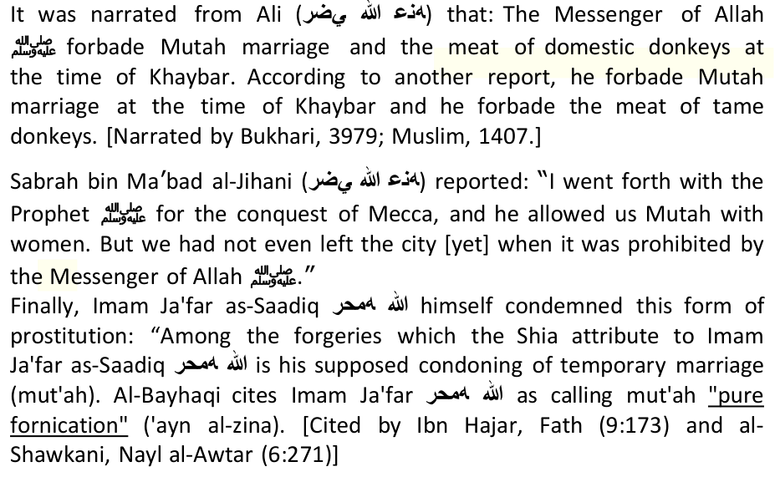
Besides disunity, there is more dangerous phenomenon called HYPOCRICY. The Shi'ahs are the supreme hypocrites of this ummat as we have demonstrated above.
Anas bin Malik reported: "A banquet of bread and meat was held on the occasion of the marriage of the Prophet to Zainab bint Jahsh. I was sent to invite the people (to the banquet),………. The Prophet (SAW) left and went towards the dwelling place of Aa'ishah and said, "Peace and Allah's Mercy be on you, O the people of the house!" She replied, "Peace and the mercy of Allah be on you too. How did you find your wife? May Allah bless you. Then he went to the dwelling places of all his other wives and said to them the same as he said to Aa'ishah and they said to him the same as Aa'ishah had said to him." (Saheeh Al-Bukhari, Tafseer Al-Quran, Surat Al-Ahzab), (Al-Nisa'i, Work of the day and
Three months after we circulated our report, Abdul Salam Islam (abdul.islam14h@gmail.com) who referred his readers to the Ahlul Bayt Foundation SA at the end of his rebuttal, sent us a 14-page factual rebuttal of our report, and also distributed it widely in SA via e-mail. This inaccurate and misleading rebuttal was preceded by some vulgar Shi'ahs who hid under the skirts of the following anonymous name: (muslimwomansbrigade3@gmail.com). They also widely circulated misleading e-mails on how Shi'ahs no more curse the Sahabah and that Imam Khomeini is to be regarded as the savior of the age. Many Shi'ahs in SA caught on to Mr Islam's inaccurate rebuttal, and started copying and pasting his arguments in support of their heretic views, on different websites, unity forums, and whatsapp groups. Academics like Shaheed Mathee (shahid.mathee@gmail.com) openly lauded Mr Islam's holy hyppocricy, and even the newly-formed Shi'ah United Ulema Council (jamiatusa3@gmail.com) stepped up their efforts to make themselves more visible during this time.
If Shi'ahs want "unity" with Sunnis in South Africa, why did the Shi'ah Ahul Bait Foundation celebrate Eidul Fitr on 29thJuly 2004, instead of Mon. 28th July 2014, with thee rest of SA?,I have reproduced Abdul Salam Islam's document word-for-word in the bold black bordered text boxes in this expose, and my rebuttal follows after.
The Testimony Of The Author Before He Was Killed
Indeed, it does not make sense. Say there was a evil man doing mut'ah once, his status is the same as Husain AS; and then mut'ah twice, his status goes up again. That's easy, Are the status of Rasulullah SAW and the imams that low? Even if the person doing mut'ah has attained a high status of iman, is his status the same as the status of Husain, his
Imam Khomaini asked me, "Sayyid Husain, what is your opinion about doing mut'ah with a small child?"
Fifth, most people who do mut'ah allow themselves to do nikah mut'ah but will object if their daughters are wedded by means of mut'ah.They are aware that this mut'ah is similar to zina (fornication) and is an aib (shame) for them, but they themselves are doing it for other people's daughters. Supposing nikah mut'ah is something that is allowed by Shari'ah, why most fathers feel disinclined to allow their daughters or relatives to have nikah mut'ah?
The ruling on paying khumus is just mubah, and it is not obligated upon everyone to pay it out. They are allowed to use those property just as they are using other properties or incomes from their works. There has been a competition among the Sayyids and the mujtahids in obtaining khumus. Therefore, they try to lower the percentage of the khumus taken from the possessions of the people with the goal that the people would come in droves to deposit their khumus to them. So among them, there are those who are doing Satan's ways.
9) After I published my book, "For Allah and then for History (Why I Left Shi'ah – transl.)," then a fatwa was issued from the city of knowledge about the declaration of kafir of myself, the retraction of all my knowledge based titles. All the
It is rather the other way round.
---The Jews were changed into pigs and monkeys and so did it happen on the Shi'ite Rafdhis in the city of Madina al Munawarra and other places. It is stated that their figures were transformed at the time of their deaths.
In SA, to our horror, we found that many Muslim youths had come under the spell of Khomeini, erst while leader of the revolution in Iran. It had occurred simply because although the strident propaganda literature about the legendary exploits of the Iranian leader incessantly poured out- by the Iranian Government had reached the ears of these Muslim youths, but they had remained woefully ignorant about the beliefs and postulates held by the leaders of Shi'ite thought. I, therefore, felt that it was incumbent on me to expose the Shiite jurists and scholars, including Khomeini, through their own writings, so that Muslim youths become informed of the truth, and are thus able to
The Jews do not attach any importance to the provision of Id-dat (waiting period) for divorced women. The Raafizis also are like them in this matter.
Umar ibn Hussein ibn Ali, Uthman ibn Hussein ibn Ali.
C. Ploy of the Shi'ah: The Shi'ah only call for unity in places where they are in the minority. They cleverly do this to gain credibility and acceptance of their kufr in the name of unity. In places where they are in the majority or have political clout, they slaughter the Muslims like in Iran, Iraq, Lebanon, and Syria.
Muhammad bin Yahya, narrated from Ahmad bin Muhammad bin Issa, from Muhammad bin Sinaan, from Muawiyah bin Wahab said: "We departed to Makka and in our company was a righteous old man who does not know about this matter (Shi'ism) and performs the full prayer during travel, and with him was his nephew, who was a Muslim. The old man got sick, so I said to his nephew: If you present this matter (of Shi'ism) to your uncle, perhaps Allah may save him. Everybody said: Leave the old man alone, he seems alright. His nephew did not wait long to say: Uncle, the people became apostates after the Messenger of Allah [peace be upon him] save very few men, and Ali bin Abi Talib [ra] was entitled to the same allegiance that the Messenger [peace be upon him] enjoyed, and after the Messenger of Allah, truth and allegiance was due to him. (The Narrator) Said: The old man took a deep breath and said: I am on this path, and died. So, (later on) we went to (Imam) Abu Abdullah, Ali bin As-Sariy related this story to Abu Abdullah, thus he (Imam Abu Abdullah) said: He is a man from the people of Paradise. Ali bin As-Sariy said: But he did not know a thing about this (Shi'ism) save that hour! (The Imam) Said: What (else) you want from him? By Allah, he entered the Paradise." (Al-Kafi (fil Usool): Al-Kulainy, Book of Faith & Disbelief, Chapter: Things That Allah Gave to Adam [as] At The Time of Repentance, vol.2, p.440, narration 4)
The Shi'ah believe that the Imams have absolute and infinite knowledge. This contradicts what Allah says in the Quran; "Verily the knowledge of the Hour is with Allah (alone). It is He who sends down rain, and it is he that knows what is in the wombs. Nor does anyone know what it is that he will earn tomorrow, nor does anyone know in what land he is to die. Verily with Allah is full knowledge and He is acquainted (with all things)" (Quran 31:34)
7. "No one compiled the Qur'an completely except the Imams, and they encompass all of its knowledge' (Ibid, p. 228) So since the Qur'an was not compiled by the Imams then does that mean that the Quran is fabricated??? These Shia want to even destroy Islam... look at what they say, they even insult the Qur'an!! And it is a well known fact that the Shia have their own Qur'an.
3. Wherever the Quran mentions "Rab" (meaning Lord/God), according to this Shia book, that word should be substituted with Imam Ali's name. (Jila-ul-A'yoon, Vol. 2, p. 66)
19. Imam Mahdi recited the Sura-e-Qadar before his birth. (Jila-ul-Ayoun, Vol. 2, p. 475)
40. The rank of Ali's Wilayat is higher than prophethood. (Hazaar Tumhari Das Hamari, p.52)
But the Quraish disagreed,Then the Ansar made their counter-offer, saying: "O Quraish. There should be one ruler from us and one from you." (Sahih Bukhari, Volume 8, Book 82, Number 817)
Now, regardless of whether any of those things are true or not, or whether he was a corrupt person or not, but what catches the eye is that those people never accused him of usurping the caliphate from Ali, even though those people were major supporters of Sayyadinna 'Ali.
3. Why didn't Sayyyadina 'Ali (RA) practise the concept of Nahi al Munkar(rejection of that which is wrong) but rather affirmed the supposed munkar of Muhajirs and Ansar in order to prove his leadership to be correct?
To this very biased and hate-filled statement of Mr Islam, I remind him of the academic dishonesty of his own Shi'ah scholars. Imam Tirmidhi narrated the following hadith:
Many thanks for the sterling advice, Mr Islam, but before you lecture me on hatred, why don't you admonish your own scholars like Mulla Baqir Majlisi for filling their books with filth and hatred. Here are some examples:
Yes Indeed, Mr Islam (Shi'ah heretic Islam).
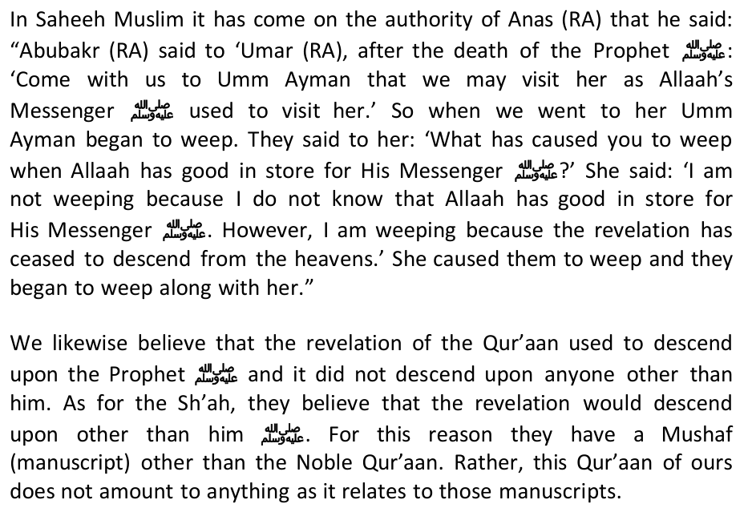
14. Why no (AS) or (RA) after the name of Hadhrat Khadija (RA)?
42. To act the Passion Play in Muharaam?
Having established the authority of this historian from the Shi'ites own sources, let's read what Al-Nubakhti had to say about Ibn Saba': "Abdullah bin Saba', was one of those who slandered Abu Bakr, Omar, Othman and the Companions and disowned them. He claimed that it was Ali [as] who enjoined this on him. Ali arrested him, and upon interrogation, admitted to the charge, and (Ali) ordered him to be executed. The People cried 'O Chief of Believers! Do you execute a man calling to your love, Ahlul-Bayt, to your allegiance, and disowning your enemies?' He (Ali) then exiled him to al-Mada'in (Capital of Iran back then). Some of the knowledgeable companions of Ali [as] narrated that Abdullah bin Saba' was a Jew who embraced Islam and sided with Ali [as]. That he was of the opinion, at the time when he was a Jew, claiming that Yousha' bin Noon is after Moses. After his submission to Islam, after the demise of the Prophet [pbuh], he claimed the same for Ali [as]. He was the first to publicly mandate the Imamah of Ali [as], disowning his enemies, and debated his opponents. From thence, those who oppose Shi'ism say: The origin of Shi'ism is rooted in Judaism. When Abdullah bin Saba' heard of the demise of Ali while in (his exile at) al-Mada'in, he said
But assuming that the foresaid men are Shi'ah liars, and error infiltrated to their books, and therefore their testimony is not a proof (hujjah) nor binding, then we invite you to examine the testimony of those who are "Infallible" and looked at as "Deputies of Allah" whose sayings are equal to Allah's as the Shi'ahs claim:
Hasan bin Ali al-Hilly, another famous Shi'i biographer, says: "Abdullah bin Saba' returned to disbelief and showed extremism. He claimed prophethood, and that Ali [as] was Allah (in the flesh). Ali [as], for three (consecutive) days asked him to repent but he failed, thereupon, he [as] burned him (alive) with seventy other men who attributed divinity to him" (Kitaab al-Rijaal: al-Hilly, p.469, printed in Tehran, Iran 1383 AH)
Lastly, al-Shaykh al-Saduq mentions in his al-I'tiqâdât (p. 100):
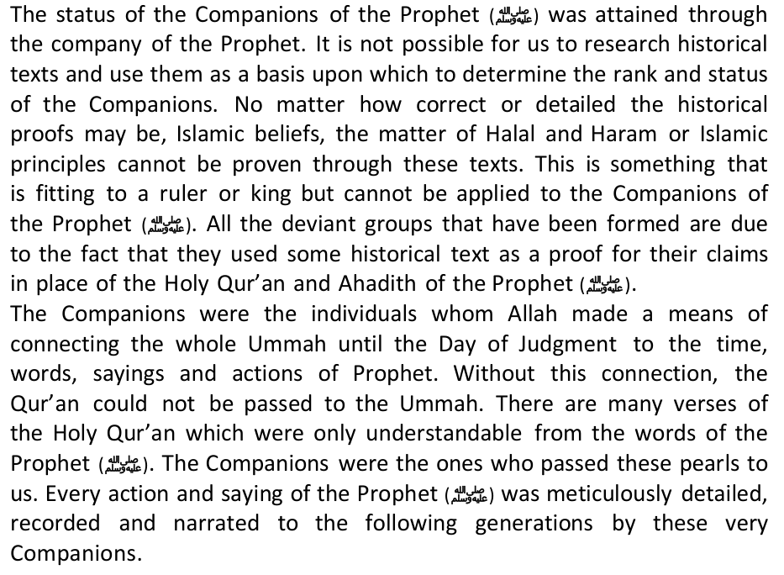
Historically, Shi'as have fought USA
The clash between ISIS and al-Nusra sparked accusations that the former was nothing but a means for the Syrian Military Intelligence Directorate, along with the Iranians, to plant agents of the Assad regime and of Iran within the Syrian opposition, thereby spreading confusion in its ranks and diverting it from the fight against Assad into internecine struggle, according to a report published by the Jerusalem Centre for Public Affairs in June 2014.
David Butter, a leading expert on Syria and an associate fellow at think-tank Chatham House, told Channel 4 News recently that the links between Isis and Syrian intelligence date back to the aftermath of the Iraq war of 2003.
The Iranian regime's relationship with al-Qaeda is not new. In a 2011 decision, a Washington, D.C., district court ruled that Iran had provided al-Qaeda with material aid and support to carry out the Nairobi and Dar Es Salaam bombings in 1998. After the fall of the Taliban, hundreds of al-Qaeda elements fled Afghanistan and sought refuge in Iran.
A letter to bin Laden from his chief of staff dated the 11th of June, 2009 has a detailed account about a group of"mid- level" al Qaeda members who the Iranians had recently released, including three Egyptians, a Yemeni, an Iraqi and a Libyan.
"Since the outbreak of the Islamic Revolution, Iran has worked to establish external bases through some of the armed groups that follow its policy directly, such as Hezbollah's branches in Lebanon, Iraq and Syria."
Iran is Syrian President Bashar Assad's strongest ally, providing military, financial and diplomatic, and propaganda support. The U.S. has repeatedly accused Iran of using its Revolutionary Guards to train and deploy Shi'ite fighters to bolster Assad's forces.
As the conflict in Syria and Iraq continues, more facts about the collaboration between Iran, al Qaeda, ISIS and the Syrian regime will emerge.
Iraqi National Movement's leader and reformer secular Shiite, Sunni-backed Ayad Allawi (feared and hated by Iran and deserted by the US) was robbed by Obama and Iran of the prime ministership in post-election backroom politics. And now the chickens are coming home to roost as a completely demoralized Iraqi army loathing their hyper- partisan, paranoid Shiite leader can't defeat the dreaded, death-loving, Sunni-backed soldiers of ISIS as they sweep over Iraq in murderous rage en route to Baghdad. In short, after stupidly backing Iran's man the wrong against Ayad Allawi (a true pro-Western, uniter, reformer, and anti-Iranian patriot), Obama is calling for political reform as a necessary precondition for intervening militarily in Iraq to defeat ISIS. It's mind-boggling. Is it too late for Iraq? Is the country irreversibly polarized and plunging into sectarian civil war? Has the hour passed for the good Ayad Allawi to save it? The situation is bleak.NECESSARY READING TO UNDERSTAND OBAMA'S COMPLICITY IN THE RUINATION OF IRAQ Ayad Allawi Interview About Iraqi Election and American Interference - SPIEGEL ONLINE Maliki and Iraq's Disaster | David Ignatius-RealClearPolitics U.S. won't intervene in Iraq in absence of political reform by Iraqis, Obama says - The Washington Post
Only after the heroic story of the resistance of the Hizbullah militia in 2006,that a turning point of fitnah tashayyu' happened in the Islamic world, particularly in Sham (Egypt, Syria, Lebanon and Jordan) and South East Asia (Indonesia and Malaysia). Just because of a one-time Shi'ah resistance against Zionist-Israel, who before this were always collaborating in destroying the resistance of the Palestinian people, which was more driven by the political factor to dominate the South of Lebanon as the base of Shi'ah militia nationally by not telling the interests of the war for the sake of Palestine.
The reality of Masjidil Aqsa stated by the mufassir of Shi'ah is also similar to what were stated by the marja' ulama's of Shi'ah in their books of aqeedah, i.e. among others: Muhammad Baqir Al Majlisi in "Bihar Al Anwar" vol.97/405; Abbas Al Qummi in "Muntaha Al Amal"pg.70; Ja'far Al 'Amili in "As Sahih min Sirah Ar-Rasul Al A'zham" vol.3/101; Al Kulayni in the book "Al Kafi" vol.1, page 481).
As understood, Sayyadina 'Umar bin Khattab (RA) is considered as "Dajjal" by the Shi'ahs for having a share in seizing Ali (RA)'s right to caliphate, the same goes with Sa'ad bin Abi Waqqas declared kafir by them for not giving bai'at to Khalifah Ali. In fact, Sayyadina Sa'ad is even nicknamed by the filthy Shi'ah as the "Qarun" of the Muslims. How can a Masjid built by Commander Sa'ad who is "murtad" and on the order of Khalifah Umar who is "kafir" become such noble in the eyes of the 'Ulama's who are the references of the Shi'ahs and their followers?
The Zionist-Jews nation always attempt to review the interpretation of the verses of the Qur'an which mention the specialness of Masjidil Aqsa and doubt the Prophet's hadiths which are declared saheeh by ijma' ulama' of Ahlus Sunnah wal Jama'ah. They said that the word Al-Aqsa means the place of solat in the heaven, and for that purpose
As his counterpoint, Abdul Malik ibnu Marwan built The Dome of Rock (Qubbat Sakhra) at Masjidil Aqsa so that the Muslims would go onHajj to it as an alternative to making Hajj to Makkah which was being ruled by Ibnu Zubair. It was in order to smooth the politic of "Hajj" in the style of Abdul Malik bin Marwan that, according to Ignas Goldziehr, he asked Imam Ibnu Shihab Az Zuhri to invent fake hadiths that explain the significance of Masjidil Aqsa such as the popular hadith about the shaddu rihal(travel far/safar) to Masjid Haram, Masjid Nabawi and Masjidil Aqsa.Goldziehr claimed that all hadiths about the significance of Baytul Maqdis are through the riwaayah of Ibnu Shihab Az Zuhri. (see this discussion in the book "As Sunnah wa Makanatuha fi Tasyri' Islami", by Dr. Musthafa As Siba'i, pg. 189-199, print. Maktab Islami, year 1985). From such exposure, it is clear that the Jews are capitalizing on the Shi'ah hadiths which have the political aim of countering the Khalifahs of Bani Umayyah and to give significance to the holy cities of Shi'ah which exceeds the status of Masjidil Aqsa.With that, it is also clear on how the status of Masjidil Aqsa is in the eyes of Shi'ah. Because they do not acknowledge the specialness of the third holy Masjid and the first qiblat of the Muslims, liberated by Amirul Mu'mineen Umar bin Khattab RA and restored by the Khalifahs of Bani Umayyah, as well as liberated for the second time from the Crusader Forces by Sultan An-Nasir Salahudin Ayyub.So how can they acknowledge the specialness of a Masjid venerated by the notable figures of Ahlus Sunnah who, in all their eyes, are despised. Khalifah Umar bin Khattab was clearly accused of stealing
The Ottoman Sultan brought an end to the first Wahhabi rebellion in 1818, but the sect revived under the leadership of the Saudi Faysal I. The
Related Viewpoints:
The rebel group is one of the largest in Syria. Its nucleus is in Aleppo.
"This is a critically important relationship in the region," said Kirby. "And the secretary is pleased to be able to continue to make it stronger."
Muhammad ibn Abdal-Karim Shahristani wrote:"He (Abdulla ibn Saba) was the first person who claimed imamat of Ali.And around him gathered group of people. This was the first sect which assumed expectation, concealment and recurrence of Imams" (Al-Milal wan-Nihal, page 137) And Sa'ad Bin Abdullah Al Ash'ari Alqummi said in Maraz Kalam regarding Sabians: "Sabians are companions of Abdullah Ibn saba, …Abdullah bin Saba', was the first who slandered Abu Bakr, Omar, Othman and the Companions and disowned them. (Al Maqalat Wal Firaq, page 20)
He also whipped those who claimed that he (Ali) is better than Abu Bakr and Umar. [Ibn Majah]
During that time, people who called themselves Muslims were three groups:
"Why do you say that concerning (the one who curses) Aisha?" He said, Because Allah says concerning Aisha, (may Allah be pleased with her): "Allah forbids you from it (slander her) and warns you not to repeat the like of it forever, if you are believers." (al-Noor 24:17)'"
*Bahjat al-Baitar: When this great Syrian scholar was asked if transactions were permissible with Shi'ites, he replied in a book called Al-islam wa as-Sahaba al-Kiraam bain as-Sunnah wa ash-Shia in which he said, "Political and economic dealings with them are allowed in the same way that they are allowed with states and people with whom there are treaties in spite of differences between their lands and religions and ours. And help can only be sought from Allah."
*Mustafa As-Siba'ee: This eminent Palestinian scholar was also among those who lived with the Shi'ites for a period and worked for rapprochement with them; however, he soon discovered their real intentions and noted them in the foreword of his classic, As-Sunnah wa Makanatuha. He wrote, "Those people continue to hold fast to their books in which slanderous attacks and false descriptions are given of the incidents of disagreement among the Sahaba. Hence their intention behind the call to rapprochement seems to be bringing the Sunnites closer to the Shi'ite creed and not bringing them closer to each other." On another occasion, he wrote, "A Muslim would almost be in a state of total bewilderment and confusion at the audacity of these people towards Allah's Messenger (pbuh) were it not for his knowledge that most of the Rafidites are Persians. Some Persians feigned Islam and used Shi'ism as a cover for the destruction of Islam. There were also among the Persians those who were unable to free themselves from the effects of their former religions and thus they entered Islam with a pagan mentality which did not mind telling lies about the Prophet (pbuh)"
To continue exposing this massive historical fraud, Iran under Khomeini is anything but Islamic. Khomeini's Al- Hukumat-ul-Islamia, consisting of about 150 pages forms the religious and intellectual base of the Iranian Revolution. In it, Khomeini has tried to establish that during the period of Ghaibat-e-Kubra (Major Absence) of the Twelfth Imam (the awaited Mehdi) which has already continued for over a thousand years, and in his own words, may further continue for thousands of years, it is the right, duty and religious obligation of Fuqaha (i.e. Shia Mujtahids - religious directors) that as vicegerents or deputies of Imam-I-Gha'ib (the Absent Imam) they should endeavour to take over the reins of the government and if a competent person from among them rises to led the struggle then in all social mattes and in all matters relating to government, it is the bounden duty of all the other Mujtahids to obey him just as they would obey the Imam, or rather, the Prophet.
Khomeini's inner feelings with regard to the first three Caliphs, however, are fully revealed by the permanent position he has taken. As we have already pointed out, the designation of Hazrat Ali as the Imam and Caliph by the Prophet, as the Shias believe, logically demands that Hazrat Abu has come to you from your Lord, you communicate to the people and proclaim accordingly. In case you do not do so, you will be failing in communication of His message as also in your Prophetic duty".
If the statements of Khomeini are accepted (and they form the base and foundation of Shi'ism) regarding the nomination of Hazrat Ali as his successor and caliph by the Prophet of God and announcing it at Ghadir-i-Khum, it will locally mean that the Prophet of Islam (peace be upon him) failed so utterly (God forbid) in the education, training and character building of his followers (Ummat) as no other Divine Apostle or, even, reformer or preceptor had done. The people he had taught, enlightened and instructed from the beginning of his Apostleship till the end of his life, and who had sat at his feet, spent their lives in his company and listened to his teachings and sermons at all times, turned into such traitors immediately upon his death that they destroyed the very fabric of the order set up by him, under the command of God, for the reform
For the entire Muslim World to turn against Iran was nothing strange. It was only natural in the light of the above facts.
Anyway, your writing as well as those of most Shi'ahs are nothing but hate-filled rhetoric, incitement to hartred, impetus to divide, and calling for war.
We arrived at the last night of Ramadan in most countries. So, what message for this year's Eid should we convey to you? No, it's not going to be a message of grief, sorrow, shame and weakness. That is not why hundreds of children were martyred.
According to the hadith, the revolution will come from the EAST – those with the Black Banners – NOT FROM IRAN.
This is perhaps the reason why the Zionists are uprooting all the olive trees in Palestine and Syria.
At the time, when the Muslim Ummah will have abundance of wealth, gold and silver, the Muslims will be extremely belittled, weak and helpless. The enemy nations will invite each other to pounce upon them as hungry people invite one another for food.
You will make a firm truce with the Christians (al-Rum) until you and they wage a campaign against an enemy that is attacking them. You will be granted victory and great spoils. Then you will alight in a plain surrounded by hills. There, someone among the Christians shall say: 'The Cross has overcome!' whereupon someone among the Muslims shall say: 'Nay, Allah has overcome!' and shall go and break the cross.
*Note: The Jewish defense league also uses a yellow flag. It may also be that the yellow standards from the west, and the black standards from the east actually fight in the canal of Egypt for 7 days/months/years.
Related by Abu Hurayrah: The Prophet Sallallahu 'Alaihi Wa Sallam said: "(Armies carrying) black flags will come from Khurasan (Afghanistan). No power will be able to stop them and they will finally reach Jerusalem where they will erect their flags." (Tirmidhi)
Ali said, "The Prophet said, 'A man named al-Harith son of Hirath will come from Transoxania [Central Asia ] His army will be led by a man named Mansoor. He will be pave the way for and establish the government of the family of Muhammad, just as the Quraysh established the government of the Messenger of Allah. Every believer will be obliged
Imam Mahdi is himself Bani Ismael i.e belonging to progeny of Prophet Muhammad [peace be upon him] and a decendent of Fatima r.a & Ali r.a but he will resemble like the men of Bani Israel.
Thus the angels who are the close slaves of Allah have no command over the disposal of their own affairs, and have no share in His dominion. Similarly all of the Messengers of Allah, who are the best of men, share absolutely nothing with Allah; Allah speaks of the best one of them,
Nahavandi writes:
Sullivan (CFR), a career diplomat with no Middle East experience, became our ambassador to Iran in 1977. The Shah recalled:
On November 16, the Shah and Empress were due to visit Carter. Several thousand Iranian patriots surrounded the White House bearing a huge banner saying "Welcome Shah." However, as Nahavandi reports:
Foreigners, including Palestinians, appeared in the crowds. Although the media depicted demonstrations as "spontaneous uprisings," professional revolutionaries organized them. Some Iranian students were caught up in it. Here the Shah's generosity backfired. As du Berrier pointed out:
Nevertheless, as French journalist Dominique Lorenz reported, the Americans, "having picked Khomeini to overthrow the Shah, had to get him out of Iraq, clothe him with respectability and set him up in Paris, a succession of events, which could not have occurred, if the leadership in France had been against it."
Khomeini didn't reply. The interpreter stood, saying, "The Ayatollah is tired." De Villemarest registered his concern with the French Ministry of the Interior, but reported, "They told me to occupy myself with something else."
The Shah's admission to the United States had another outcome. Partly in retribution, on November 4, 1979, Iranians took 52 hostages from the U.S. embassy in Teheran. (According to Nahavandi, Soviet special services assisted them.) This embarrassed Jimmy Carter, who had done so much to destroy the Shah and support Khomeini. The seizure made the Shah a pawn.
Mohammad Reza Pahlavi died on July 27, 1980. His last words: "I wait upon Fate, never ceasing to pray for Iran, and for my people. I think only of their suffering." In Cairo, a grand funeral honored him. Three million Egyptians followed the procession.
What is the solution to modern Iran? Before listening to war drums, let us remember:
The involvement of the Persian Safawists in Syria to exert the movement of "Shi'ahization" against the Sunni Muslims. Besides that, there was also the granting of Syrian citizenship to the Persian descendants and Shi'ah citizens of Iraq by the Syrian government. And their numbers to date has exceeded 1,000,000 people. Most of them settled in the province of al-Sayyidah Zainab and around it in Damascus.
2. Announcing the alliance of Iran-Syria with a number of Palestinian organizations that have a good image in the eyes of the Arab and Islamic world. The Government of Iran also gave the impression that they would be providing financial aids to the Government of Hamas. But the fact is that, the aids never happen. The aids from Iran is no more than just an empty slogan and promise, because these Safawist-Persianist people could never function except by the motives of race and own circle, and in this case the Palestinian organizations are the people of Sunni.
3. Killing the potential Sunni figures, be they from amongst the academicians, military or religious personages and making efforts to terrorize, drive out or take revenge on Sunni figures.
The resistance against Israel is not earnestly done and the proof is, the Golan Heights is still in a state of calm. The Hizbullah demanded the freeing of the Lebanese prisoners by Israel, but at the same time it does not demand the freedom of the Lebanese citizens who are detained by the Syrian Government. The Shi'ah movement is only playing a political campaign that is not based on facts. This movement is not much different from the Zionist movement, equally wanting to dominate the Middle East based on racist ideology.
Not to mention the Saudi domestic upheaval, which was also spurred on by the adherents of Shiah, who to begin with, are of the Saudi nationals. They are concentrated in the cities of the eastern part of Saudi Arabia, such as Hufuf, Qatif and Awamiya. The Saudi regime who are Sunni are being hit by the people's movement which is mounted up by the Shiah. If this development should go on, it will be getting bigger, making the Middle East in real danger and threat from the Shiahs and Iran. True, history will always rotate in the same axis. If in the past, latent rivalry happened between the Arabs and the Persians, today that his history is repeated. Now the Arabs are represented by Saudi Arabia
2. Iran is not involved in war with any nation, thus their finances are intact.
We are against all forms of tyranny and oppression, including all Arab, Euorpean, and American states. We don't condone any of their misbehavior. Currently there is NO TRUE Islamic government in the world, including the Arab States and Iran.
Sunnis are free and protected in Iran, but Shi'as are persecuted and oppressed in many Sunni majority countries that are ruled by US and Israeli stoogies.
Sheikh Mawlawi Abdul Aziz was one of the elite leaders of Ahlus Sunnah who played a prominent role in opposing the Constitution in matters relating to Ahlus Sunnah rights. He was the director of the religious school of Zahdan and the chief of Baluchi armed tribes. He was poisoned in 1987; http://sonsofsunnah.com/2011/04/15/results-of-the-forced-coversion-of-sunnis-to-shia-by-safavids/
It is an established fact that Iran was a Sunni nation until the Tenth Century of the Hijri calendar. During this period, Iran produced thousands of scholars in every discipline; the most salient of these facts is that the six most authentic Hadith books (i.e. Bukhaari, Muslim, Abu Dawud, etc.) were written by scholars from Iran, or scholars who received their education in Iran. However, when the Safawi Shi'ites took control, they established their government on the skulls of the Sunni scholars and jurists. This was one of the reasons for the evacuation of the largest cities that were at the foremost centres of religious sciences, such as Tibriz, Isfahan, Ray, Tus. Their were many Sunni Muslims that were killed, forced into Shi'ism, or compelled to flee to the mountains, leaving Iran as a centre for conspiracies against Islam and the Muslims. Fredinand, the ambassador to the Austrian King, remarked: "Had it not be for the Safawids in Iran, we would have been reading the Qur'aan this day like the Algerians," meaning that his nation would have been conquered by the Ottoman Muslims. However, the Safawids conspired with the crusaders and the imperialists to halt
Ahlus Sunnah hail from non- Persian people. They were regarded as second class citizens under the Shah regime, since they mostly resided in rural areas, as well as the fact that their creed differed from that of the Shiah. As the Arabs, Kurds, Baluchis and others of Ahlus Sunnah did not have any role in the idolatrous Persian nationalism, they did not have equal rights socially nor economically with Persians "The Chosen People"! The Shah's regime was secular, non- religious, so it dealt with religious and sects in a similar way. Some of the Ahlus Sunnah scholars had apposed the Shah and its secular regime, and some of these scholars initially sympathised with the Khomeini revolution such as Sheikh Ahmad Mufti Zadah as well as a few others, may Allah forgive them. Sheikh Ahmad Mufti Zadah apposed Khomeini shortly after the revolution. He was arrested and imprisoned for 10 years, even though his sentence was only for five years. He was only released when the authorities felt that he was on the brink of death. I was a witness to the words of Ahmad Mufti Zadah to Khomeini in the latter's house when he said: "Khomeini, you promised me an Islamic republic, however you established a Safawi-Shi'ite republic. Although I believe that I am not permitted to raise arms against you [such was his belief, unfortunately], however, I will fight you politically."
"Is there a singlecapital city in the world without a Sunni mosque, with the exception to Tehran - the capital of the Shiah - which has forty Christian churches and a cemetery for the Baha`is..."
However, the double-faced regime was able, through the banner of Islamic unity, to fool many Muslims outside Iran as they ask them to attend their conferences, and transform their way of thinking within a short period of time. They became false witnesses within their own people, beguiling them with what they have been taught about greatness of Islamic unity, without knowing anything about the plight of Ahlus Sunnah inside Iran. They repeat in all simplicity: "We are brothers, there is no difference between us." Despite the imprisonment of the scholars and the demolished Islamic schools, they go to the grave of Khomeini, which has become a worshipped idol, offering their worship, and placing flowers at this grave. Their stance has misled many young minds and opened the way for them to accept and tolerate Shi`ism. A person is further baffled when he realises the superficiality of these people, their oblivion to the reality and their inability to comprehend the situation. They keep on defending the Rawaafidh Shiah who are weaving conspiracy after conspiracy against Ahlus Sunnah.
Moreover, the following are some of the Ahlus Sunnah's Mosques and Islamic schools that were destroyed:
"What in reality is the representation of the Ahlus Sunnah in the various government posts in Iran, such as parliament, ministries, etc.?"
Ahlus Sunnah had organised movements at the outset of the revolution, when parties were still present. However, when the government became stronger, they prohibited all the Salafi groups. The danger of the Sunni groups was obvious, amongst these was the central Shuraa council of the Ahlus Sunnah, the Kurdistan movement for equal rights, the Union of Muslims in Baluchistan, the Majdia movement in Zahran, and others. The funds of these groups were confiscated and presently, there are no openly organised Sunni groups. In fact, the Sunnis in Iran are deprived of rights which are freely given even to the disbelievers, such as charities to care for the orphans and the widows and others.
Mr Islam, it seems lies flow in your veins! Study this brief historical background of your second Imam, of whom you know so little! It was the Shi'ahs themselves who killed their second Imam …
Qays informed him in the letter that they had invited Muawiyyah to a settlement called Hububiyyah. On the other side Hadhrat Muawiyyah sent for Ubaidullah bin Abbas. He fixed a sum of one million dirham as
Messenger of Allah, my own brother?"
Apart fromm the above reason, some scholars say that Sayyadina Hasan (RA) married seventy women, some ninety as found in Tarikh al-Mada'ini. He always travelled with four wives accompanying him.
The rebuttal directly above has adequately dealt with this.
Abu Bakr Hisham also endorsed the views of Hadhrat Ibn Abbas that the Shias were dishonest and traitors. According to Masudi, Abu Bakr bin Harith bin Hisham called on Hadhrat Hussain and said to him: "O my cousin! I like to sympathize with you but I don't know how to express my sympathies!" Hadhrat Hussain replied: "Abu Bakr! You are one of those who cold not be labeled dishonest or insincere. Therefore you are welcome to express your views." Abu Bakr said: "Your father was among the early Muslims who had embraced Islam. After entering the fold of
When Muslim came to know that Ziyyad had maltreated Hani, he came out with the slogan "Ya Mansur" which was immediately taken up by the residents of Kufa and eighteen thousand people instantly rallied to his call. Muslim also marched towards Ibn Ziyad but his companions locked him up inside the place. By evening not even a hundred people were left with him. When he realized that the people were slipping away, he moved towards the carved gate. He had hardly reached the gate that he was left which only three companions; and when he came out of the gate, not a single man accompanied him. He was in a real quandary. He did not know where to go. There was no one to guide him. He climbed down his horse and roamed through the streets of Kufah in a state of utter stupefiction. He was absolutely in a fix as he was stranded.
The Kufis disowned both the letters and the messages. He continued the march till he landed in Karbala. When no army rallied against Hadhrat Hussain, he was convinced that there was no shelter for him. He raised his hands for prayer: "O Allah! arbitrate between us and this nation who had invited us to help us but who have waged war against us instead." Hadhrat Hussain fought bravely and spiritedly until he tasted the cup of martyrdom. The people who fought against him on the battlefield or who put him to martyrdom were all Kufis – THOSE WHO INVITED HIM. There was not a single Syrian who had taken part in the battle. Infact, Shimr Dhil Jaushan, his final slayer, was the brother-Now Shi'ism started assimilating alien views and beliefs. Besides, it split up into different groups and sects. Each person who entertained malice against Islam drew his nourishment from Shiaism. Thus Jews, Christians, Zoroastrians and Hindus, who were keen to include their views into the speculative framework of Islam, relied on the crutches of Shi'ism. Besides, people who wanted to stabilize their particular religion and rebel against their incompetent rulers, found solace in the seductive
His main object was to impress the people and he achieved a reasonable measure of success objective, but the majority of people who were impressed by his objective, but the majority of people who were impressed by his rhetoric and tactics generally belonged to the illiterate masses or were know for their stupidity. However, as his reputation increased, the strategies of the Muslims grew more subtle and comprehensive to beat him at his own game. And when he was finally defeated, the whole world turned against him, and after his murder his memories fell prey to the arrows of convention and ritual. In the initial phase he was condemned alright but no attempt was made to disfigure him. But in the later phase a regular campaign of character-assassination was launched against him which created a distorted impression of his personality on the minds of the future generations: The attempt at disfigurement was motivated mainly by spite and jealousy."
Samura quotes Said bin Hassan who is reported to have heard from Layth bin Salim: "I have lived in the period of early Shias and I know from my experience that they did not prefer anyone to Hadhrat Abu Bakr and Hadhrat Umar in status." Imam Ahmad bin Hanbal (through Suffiyan bin 'Uyyinah and Khalid bin Salmah) attributes it to Masruq who reportedly laid special stress on the love and status of Hadhrat Abu Bakr and Hadhrat Umar and raised it to the level of a tradition. It should be noted that Hadhrat Masruq is considered one of the distinguished Kufi successors of the companions of the Prophet Muhammmad (peace be upon him).
Since it was a person to-person dialogue between Hadhrat Ali and his son, it would not be fair to assume that Hadhrat Ali was dissimulating (lying) at that time and trying to hide his true feelings in the interest of expediency. Muhibbuddin Khatib has noted in the margin of "Al-Muntaqa" that it provides a chronological line of demarcation to
This magazine is filled with hate and propaganda against the Ahlus Sunnnah wal-Jama'ah. Just like how TIME magazine keeps a watchful eye on the enemies of the West, the CRESCENT keeps a paranoid eye on the Sunni world to see how they are progressing. At the moment, the Shi'ahs are very gleeful and happy because the Sunni world is in a royal mess and in turbulence, but if they have to sort their issues out and unite, the disbelieving Shi'ahs will be next on their list. So Shi'ahs, keep watching because one day its going to be your turn !!
July, 2014
"(Narrated) Muhammad bin Yahya, from Ahmad bin Muhammad, from Ali bin al-Hakam said: I heard Safwaan bin Yahya saying: I said to (Imam) al-Rida: a man among your followers requested me to ask you about a matter, which he feared and embarrassed to ask you (directly). He said: What is it? I said: For the man to use the woman's anus. He said: He may. I said: Do you personally do that? He said: We do not do that." al-Kafi (fil Furoo'): al-Kulainy, Book of Nikaah, Chapter: Women's anuses, vol.5, p.540, narration 2. Typical Hypocrisy condemned by Allah [swt] when He said:61:03-04 …Why say ye that which ye do not? Grievously hateful is it in the sight of Allah that ye say that which ye do not. And is typical to the Devil Iblis' behavior 59:16 Like Satan when he says to man "disbelieve": but when (man) disbelieves, Satan says: I am free of thee: I do fear Allah, the Lord of the Worlds.
We are not finished yet. There are more amazing statements for Presentation: We have now here quotations attributed to the Imams that all non Ithna Asharis are children of Adultery: Abi Hamza reports that he said to imam jaffar as sadiq that some of his fellows fabricate regarding those who preceded them. Upon that Imam Jaffar told him to stop taking about them, for the whole mankind except their Shia, are children of adultery (or in other words they are illegitimates)!(Usool al-Kafi, vol.8) Here is the image of the Original Arabic Text:
It was narrated that [Imam] Abu Abdullah said: No infant is born but a certain Satan is in his presence. If Allah knew that he would be of our Shiia, He protects him from that Satan, if he wouldn't be of our Shiia, Satan sticks his finger in his anus, thus becomes a catamite, If it was [the infant] a female, he sticks his finger in her vagina, thus becomes a whore. Allah then afterwards clear what He desire or affirm, for with Him is the book of Knowledge." (Tafseer al- Ayyashi, p. 218 ,Bihaar al-Anwaar, vol.2 p. 1319 ,Tafseer al-Burhaan, vol. 2, p. 300)
Several of our fellows narrated, from Ahmad bin Muhammad bin Issa, from Muhammad bin Sinaan, from Abu Khalid al-Qammaat, from Durais, from (Imam) Abu Abdullah [as] said: I heard him (i.e the Imam) saying: Women were given an intercourse power of twelve (men) and the patience of twelve (men)." Ibid, p. 339, Narration 3. Please compare to the previous narration. Any discrepancy on the part of the "Infallible"? Inspite of all the nonsense and things out of morality we went through, yet we find Many Prominent and Respectable Shiite Scholars praise Usool al Kafi: Muhammad Sadiq AlSadr said: "Although The Shia are on the unanimity of that The four books (Alkafi, AlITibSaar, AlTahzeeb and Mun La YahduRuHu Alfaqeeh) are accepted and *all* the narrations in them are accurate (Saheeh), But they did not call them by the name (Sihaah) like AhlSunnah did " [The Book of shia "Kitab alshia" page 127]
'À'ishah reported that the Holy Prophet (SAW) entered into her house and said, "Call your father and brother so that I write an ordinance for Abþ Bakr." 'À'ishah argued that her father was too light-hearted for the responsibility, upon which the Holy Prophet (SAW) said, "Allàh and the Muslims insist only on Abþ Bakr," and in another narration, "So that none desires it." 3 In another narration, the Holy Prophet (SAW) said, "Order Abu Bakr to lead the prayers." 4 This happened during the entire duration of the Holy Prophet (SAW)'s sickness until his death.
*Samurah ibn Jundub also narrated an incident of a dream. He said, "One person said, O Messenger of Allàh, I saw a bucket appearing from the sky, Abþ Bakr went and caught hold of the rope and drank weakly from the bucket. Then 'Umar and 'Uthmàn came in succession and they drank till they were satiated, but when 'Alï came, the bucket was
10 Abu Dàwud, no: 2939; Musnad Ahmad ibn Hanbal, v.3, p. 355. Baihaqï has also recorded in his Dalà'il al-Nabuwwah a saying of 'Alï on the day of the Camel, he said, "O people, The Holy prophet did not elect anyone as his successor, but we saw Abþ Bakr to be the most fit for the position and we gave it to him........." Hàkim has also narrated in his Mustadrak the following saying of 'Alï, "The Holy Prophet did not elect anyone, so I will also not do so. If Allàh wishes good for the people, then the people will elect the best amongst you after my demise, just like we elected the best amongst us after the death of the Holy Prophet." See al-Suyþ¼ï, Tàrïkh al-Khulafà, pp. 7-8. 11 Al-Mubàrakfurï, 'Abd al-Rahmàn, Tuhfah al-Ahwadhï, Dàr al-Fikr: Beirut, 1968, v. 6, pp. 479-480 12 'Alï was most vociferous of Abu Bakr's position, he said, "Who will put Abu Bakr back when the Prophet of Allàh has placed him forward." After the battle of Jamal, 'Abdullàh ibn Kawà' came to 'Alï and asked him if the Prophet had told him anything with regards to the caliphate, 'Alï replied, "Šalàt is the most important pillar of Islàm and the Holy Prophet placed Abu Bakr as the leader of the prayers in his last illness." See Nubhànï, Yusuf ibn Ismà'ïl, Al-Asàlïb al-Badï'ah fï Fadl al-Šahàbah, pp. 465-466. 13 Al-'Umairah, 'Abd al-Raåmàn, Sharh al-'Aqïdah al-Wasitiyyah, p. 273.
It is incumbent upon the Muslims to accept what the Holy Prophet (SAW) had decreed. Allàh said, "And whoever contradicts the teachings of the Messenger after receiving guidance and seeks another path, we will assign him to his own way and consign him to the blazing fire." 21
Khumm is a place some ninety kilometers northeast of Makkah in the district of Rabïgh through which the highway from Jeddah as well as from Makkah to Madïnah passes. It is situated five kilometers inside to the right of the stretch of desert known as Šahrà' al-Juhfa. Long before the time of the Holy Prophet (SAW), a pond (ghadïr) was situated
*Taking 'Alï's hand and raising it, he said, "Man kuntu maulàhu fa 'Aliyyun maulàhu" 26 (Of whomsoever I am master (mawlà), 'Alï is his master too.)"
He assures us that it is definitely rejected in the context where the Prophet said, "I am the maulà of whom 'Alï is maulà", and the majority of the Sunnï muhaddithun reject it completely. Assuming the Prophet (SAW) had said it, one may ask what is so special about it? In the Qur'àn 66:4, addressing the Prophet, Allàh says, "Allàh is his Maulà, so is Jibra'ïl and all the righteous believers." The righteous believers are the guardians (i.e. friends or supporters), but this does not mean 'masters,' as the Shï'ah infer that the word in the quoted tradition connoted. Furthermore, the Holy Prophet (SAW) did not say that 'Alï was to be his walï or maulà after his death. This argument of the Shï'ï scholars seems to be senseless, especially when we read the authenticated traditions indicating the Holy Prophet (SAW)'s 'indications' for Abu Bakr, 'Umar, and 'Uthmàn as his successors.
*Firstly, it should be known that the words 'Verily 'Alï is from me and I am from him' means that 'Alï had a strong bond with the Holy Prophet (SAW) as far as love, and him being a cousin and son-in-law was concerned. If this meaning is not taken, and instead an inference is drawn as to the successorship of 'Alï, then 'Alï's brother - Ja'far, should also be included in this inference.
There is, however, one aspect of this debate which is in the Shï'ahs favour. According to Hans Wehr's Arabic-English Dictionary, the word maulà has the subsequent meanings: master, lord, protector, client, friend, companion, and associate. The connotation of leadership rather than protection or friendship is therefore ascribed to the word. Emphasizing the element of mastership, however, would only serve to convince Sunnïs of the secondary (i.e. fabricated) origin of the said
Based on this shaky foundation, Tabàtabà'ï nevertheless argued in favour of the necessity of a hereditary system of caliphate. He said while disparaging the Šahàbah on this occasion, "........the enemies of Islàm did everything possible to destroy it... thought that since the protector of Islàm was the Holy Prophet, after his death Islàm would be left without a guide and leader and would thus definitely perish. In Ghadïr Khumm,
35 Tabàtabà'ï, Sayyed Hosein N, Shï'ite Islàm, Free Islàmic Literatures: Houston, 1979, p. 179. 36 See Ušul al-Kàfï, v. 2, pp. 217-223; Tafsïr Šàfï, Tehran, v. 2, p. 482; Jàmi' al-Akhbàr of Bàqir Majlisï, Lahore, p.95; Khomeinï, al-Musawï, Tuhfah al-'Awàm, Shï'ah Book Agency: Lahore, p. 450; and Najafï, Ghulàm. H., Khašà'il Mu'àwiyah, Jàmi'ah al-Muntazar: Lahore, 1973, p. 136. 37 For stories of 'Alïs bravery, see Sïrah ibn Hishàm, v. 1, p. 224; Sïrah al-Halabiyyah, v. 2, p. 104; ibn Kathïr, Al-Bidàyah wa al-Nihàyah, v. 4, pp. 106-109; and Bishmïl, Muhammad Ahmad, Ghazwah al-Ahzàb, Matba'ah Dàr al-Kutub: Beirut, 1965, pp. 214-217. According to the Sunnïs, the title of Asadullàh is conferred upon Hamzah, the uncle of the Holy Prophet who was martyred in the battle of 'Uhud in 3 A.H.. 38 'Askàrï, 'Abd al-Husain, Al-'Alàwiyyun aw al-Nàšïriyyun, Dàr al-Kutub al-Islàmiyyah: Tehran, 1980, pp. 37-41. The above quotation is in direct conflict with a report in Bukhàrï which says that after the death of Fàtimah, 'Alï found that people were averse to him since he had not take the pledge of allegiance to Abþ Bakr. When he eventually gave the pledge, he cited the reason for this as not out of jealousy, but that he was not consulted in the issue of the caliphate, since he also had a right in the decision making process and in
* Abu Bakr, Omar, Aisha & Hafsa poisoned Mohammad. (Quran Translation by Shia Scholar, Maqbool H. Dehlevi, Chap. 28, p. 894)
5) Those Medinites who took the pledge in the gorge of Aqabah for the third time. They consisted of sixty people like Sa'd ibn 'Ubàdah and 'Abdullàh ibn Rawàhah (RA).
"We love the Prophetic Companions, we do not exaggerate in this love nor do we exonerate ourselves from it. We dislike those who dislike them and speak of them in an undesirable way. We only mention them with purity, loving them preserves our religion and faith, while reviling them brings about infidelity and open transgression........and whoever speaks well of the Companions, and the household of the Prophet, he will be saved from hypocrisy in faith." 42
"The Holy Prophet (SAW) gave his Companions their due rights and recognised their status, always reconciled them on any matter of dispute and sought forgiveness on their behalf. The inaccurate picture of the Companions as portrayed by some ignorant historians and Shï'ahs are all lies. We do not harbour suspicion against any of them, and do not probe deep into their matters, but rather respect them for who they were as the Qur'àn and Sunnah has taught us. All of them were just, from the biggest to the smallest; this position will not be compromised by some happenings which occurred between them, because they hold the highest position after the Prophets, and they sacrificed their lives and wealth for the cause of Islàm." 44
We have given ample proof to Mr Islam as he has requested, as to why
*Eminent scholars like Maymunï, Kirmànï, 'Umar ibn 'Abd al-'Azïz used to award up to eighty lashes to such a person.
Another indication as to the infidelity of those who pronounce the Companions as apostates is verse 3:110 of the Qur'àn which speaks as the time of the Šaåàbah to be the best of times. Denouncing the Companions would make their era a time of transgression, darkness and oppression; and the dawn of Islàm as the worst possible phase of history. This is in diametric contrast to what the above verse of the Qur'àn posits to depict.55
Verse 4:62 which spoke the hypocrites averting their faces from the truth.
Shi'a view on temporary marriage
A Concerned Muslim Sister
Thus it becomes clear that there is no evidence in this verse to suggest that mut'ah is permissible.
Shi'a also quote Imam Bukhari narrating that the Prophet allowed Mut'ah: "There came to us the declarer of Allah's Messenger and said, 'Allah's Messenger has granted you permission to have temporary marriage,'— that is mut'ah with women."
One factor contributing to the increase in prostitution and the sex slave trade is the number of teen girls who are running away from home. As a result of runaways, in Tehran alone there are an estimated 25,000 street children, most of them girls. Mutah "pimps" prey upon street children, runaways, and vulnerable high school girls in city parks.
* Mutah is Allowed with Women of Dubious Character: The narrator asked Imam Jafar as-Sadiq, "In al-Kufa there is a woman known for her dubious character. Can I engage in Mutah with her?" The imam said, "Yes, you may engage in Mutah with her."(Al-Kafi)
* Mutah - A Savior from Shirk: "He who contracts Mutah is saved from Shirk." (Al-Kafi)
A woman agreeing to a pleasure marriage that involves a one-time encounter might be able to count on about $100. For a muta'a that runs longer, she might be paid $200 a month, though the amounts vary widely and can depend on whether she has children.
(Source: USA Today,http://www.usatoday.com/news/world/iraq/2005-05- 04-pleasure-marriage_x.htm)
The Shia website can be found here:
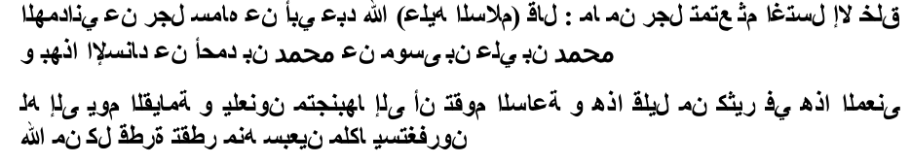
Towards the end of time, these disguised "Muslims" will flourish. Again, lets look at the Sahih of Imam al-Bukhari: Volume 9, Book 88, Number 206: Narrated Hudhaifa bin Al-Yaman: The people used to ask Allah's Apostle about the good but I used to ask him about the evil lest I should be overtaken by them. So I said, "O Allah's Apostle! We were living in ignorance and in an (extremely) worst atmosphere, then Allah brought to us this good (i.e., Islam); will there be any evil after this good?" He said, "Yes." I said, 'Will there be any good after that evil?" He replied, "Yes, but it will be tainted (not pure.)'' I asked, "What will be its taint?" He replied, "(There will be) some people who will guide others not according to my tradition? You will approve of some of their deeds and disapprove of some others." I asked, "Will there be any evil after that good?" He replied, "Yes, (there will be) some people calling at the gates of the (Hell) Fire, and whoever will respond to their call, will be thrown by them into the (Hell) Fire." I said, "O Allah s Apostle! Will you describe them to us?" He said, "They will be from our own people and will speak our language." I said, "What do you order me to do if such a state should take place in my life?" He said, "Stick to the group of Muslims and their Imam (ruler)." I said, "If there is neither a group of Muslims nor an Imam (ruler)?" He said, "Then turn away from all those sects even if you were to bite (eat) the roots of a tree till death overtakes you while you are in that state."
The first step towards disunity is disobeying Allah and disregarding the Quran, hence perpetuating division among Muslims.
We have studied the above website as advised by you, and find it to be full of deception. For example, the section of "Taqiyyyah" actually encourages lying and deceit! The website provides misleading Sunni references, but surprisingly does NOT MENTION Shi'ah narrations in this regard. Typical Shi'ah deception:
In a narration, Shi'ah falsely attribut to the 8th Shi'ah Imam, Ali bin Musa, he said: The one who is not wari (pious) has no religion and the one who does not practice Taqiyyah has no Iman ( deep faith)." So he was asked, "O grandson of the Messenger, until when (is one required to practice Taqiyyah)?" He replied, "Until a certain day (i.e. the day Imam Mahdi appears). Whoever does not practice Taqiyyah before the appearance of Imam Mahdi, is not one of us." (Kashf al-Ghummah Al-Ardabili, pg. 341).
The above is only ONE instance of decdeption. Another GLARING one falls under the heading "Who are the Ahlul Bait?" After much dribbling and scribbling, the author concludes: "Imam 'Ali, Fatimah, al-Hasan, and al-Husayn are the Ahlul-Bayt." What all the other members of the Prophetic Household?
night, 271)
In addition to the Prophetic narrations and to the Arabic Language scholars' sayings, the Quran itself testifies that wives are included in the phrase "Ahl Al-Bayt." The Quran called Prophets' wives as their household. Allah says: "so he said to his family, "Tarry ye; I perceive a fire; perhaps I can bring you some burning brand therefrom, or find some guidance at the fire". And it is known that only Mousa's wife was with him and no one else.
I hope this clarifies the matter for the Shi'ahs, but they will not simply accept it as by doing so, their illogical concept of Imaamat will fall flat on its face!
STOP DISUNITING AND CAUSING HATRED AMONG SUNNIS IN THE NAME OF UNITY LIKE HOW THE KHARIJITES DECEIVED SAYYADINA 'ALI (RA) WITH THEIR CALL OF "JUDGMENT IS ONLY WITH ALLAH." STOP ROBBING THE SUNNIS OF THEIR FAITH BY CALLING FOR THE CURSING OF THE SAHABAH, ENCOURAGING ILLEGITIMATE SEX IN THE NAME OF ISLAM, AND INSULTING OUR PROPHET BY CLAIMING 12 OTHER PROPHETS AFTER HIM.
Abdul Salam Islam (Shi'ah)
Seeing the Ahlussunnah As Najis (Unclean)

Nikah Mut'ah
brother, his father and his grandfather?
Indeed, the outbreak of the practices of mut'ah will plunge the ummah into the lending of the private parts. The lending of the private parts means a man will give his wife or mother to other men. It is very unfortunate, the fatwas about the lending of the private parts are sounded a lot by the ulama's of Shi'ah, such as As Sistani, Sayyid Sadr, Ash Shairazi, Ath Thabathabai and Al Barwajardi. Most of them allow their guests to borrow their wives if the guests are interested and will be lent during the guests' stay.
The true Qur'an is the Qur'an that was with Ali and the imams after him until it will be with Al-Qaim. Due to that, when facing death, Imam Al-Khaui made a will to us, his students and cadres in Hauzah, "Hold tight to this Al-Qur'an until the appearance of the Qur'an Fathimah."
punishments of the murtad people are imposed on me, and it is forbidden for the Shi'ahs to read my book.
---The Jews distorted the Torah similarly the Shi'ites distorted the Quran - by giving wrong explanation and misusing of the verses-like those of tafseer al-Qummi- and alleging that parts of the Quran are changed, missing and deleted out by the Sahabah. Examples of such allegation is that of the respected Shiite scholar at-tabarasi, when he regarded that two surahs: Wilayah and an-Nuraiyn, were deleted out of the official Quranic text by Uthman ibnu Affan.
remain steadfast to the tenets of the Sunni faith.
The Jews do not think that any harm attaches to pronouncing talaaq (divorce) thrice. The Shiites also believe likewise. The Jews tampered with the Tauraat. The Shiites tampered with the Qur'aan. They say that changes and distortions had already been made in the Qur'aan and alterations had been affected in the arrangement of its verses. They further say that the order in which the Qur'aan was revealed has not been retained and the way it is now recited is not proved by a reference to the Prophet (SAW). The Shiites, therefore, maintain that additions and subtractions have been made in the Qur'aan.
The same is the reason behind the exaltation of the descendents of Sayyadina Hussein (RA) solely, and not of the progeny of Imam Hassan (RA). This is because the descendents of Hussein are their own Persian brethren as Imam Hussein (ra) was married to Shahrbano the daughter of Yazgard who was the last Persian Empire. [Shi'ite source: Bihaarul Anwar 45:329] One is amazed to see that the Shiites weep over the martyrdom of Imam Hussein (ra) whereas they never weep over the martyrdom of his brother Abu Bakr ibn Ali ibn Abi Talib and over the martyrdom of his son Abu Bakr. Those who bear those names are from the Ahlul Bayt also.
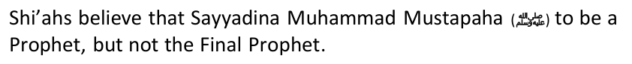
8. "Signs of the prophets are possessed by the Imams" (Ibid, p. 231) The Shia have once again elevated their Imams to a very high level. The Imams they refer too are only human! So why do the Shia worship them.
4. Imam Ali & his descendants are omni-present (everywhere & anytime) and omni-scient (have unlimited knowledge) and these attributes are theirs alone, and therefore are not attributes of Allah. (Jila-ul-A'yoon, Vol. 2, p. 85)
20. When Imam Mahdi comes, he will be naked in daylight. The first disciple to take a pledge of allegiance to him will be prophet Mohammad. (Haqqul Yaqeen, Vol. 2, p. 337)
Then the Ansars and Muhajirs fell into argumentation, and so Abu Bakr (RA) said: "O Sa'ad (ibn Ubaadah)! You know very well that the Prophet had said in your presence that the Quraish shall be given the Caliphate because the noble among the Arab (masses) follow their (Quraish) nobles and their ignoble follow their (Quraish) ignobles."(Musnad Ahmad,vol.1, p.5)
So let us bring before the Shi'ahs some very important points from the above short summary on the historical incident of Saqifah:
4. Interestingly, In this letter Sayyadina 'Ali (RA) threatens Sayyadina Muawiya (RA) that, if he doesn't acknowledges Ali (RA) as the fourth Caliph who was appointed by People, then he would be forced to follow those people who made Ali (RA) the fourth Caliph, even if this happens by fighting. Now what needs to be pondered is that, When the things had got such worse that, Ali (RA) is threatening to fight with Muawiya (RA), then why didn't at that crucial stage, Ali (RA) called those people to believe in his Caliphate. Because when he was prepared to fight any how, then why didn't he invite people to the real and most crucial issue of his divine Caliphate instead of calling them for the supposed incorrect Shura Caliphate? Is it permissible in Islam to threaten or declare a fight with opponents if they reject to accept a supposedly un-islamic belief(i.e shura)?
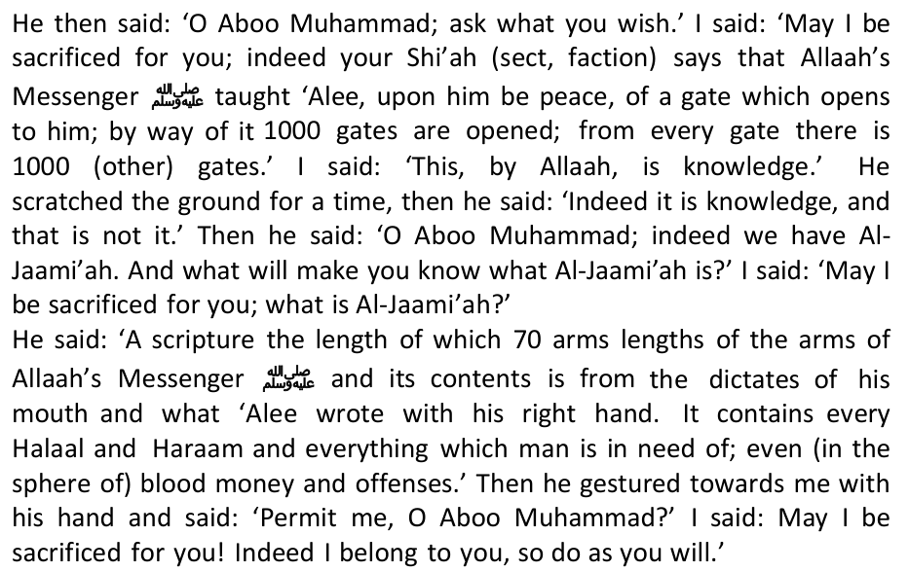
We seek refuge with Allah from deviation and calumny against Him. The "mystery" of the hidden Qur'an is now open for all to see from this Shi'ah tradition. There can be no blatant DISBELIEF than this !!!
15. President Rafasjani stated that Iranian males must engage in "Muta" - temporary marriage--Is this true?
43. The wearing of black clothing in the month of Muharaam?
Narrated to me Muhammad bin Qolawaih: Narrated to me Sa'd bin Abdullah, said: Narrated to us Yaqoub bin Yazeed and Muhammad bin Issa from Ali bin Mahziyar, from Fadalah bin Ayoub al-Azdi, from Abban
Al-Astra Abadi, and examine his testimony: "Abdullah bin Saba' claimed prophethood and that Ali [as] is himself Allah the Most Exalted. Upon hearing this charge, Amirul-Mu'mineen called and inquired it from him. When he admitted, he said to him: back off from this say and repent, may your mother lose you. However; (Ibn Saba') refused, and (Ali) held him for three days, and, still refusing to repent, he therefore burned him (alive)." (Manhaj al-Maqaal: al-Astar Abadi, p.203)
Shi'ite theology was only officially formed in the 4th century AH, with a lot of inconsistency.
Shi'as quote the verse of the Quran where Allah assures Muslims of their guardians. "Certainly your guardian is Allah and His Messenger and those who believe, who establish prayer and give charity while they bow. And whoever takes Allah and His Messenger and those who believe as a guardian, surely the party of Allah will be victorious." Quran 5: 55-56 Shi'a and Sunni scholars unanimously agree that the verse descended about Ali when he gave his ring to a beggar in charity while he was in a state of bowing in his prayer.
The record has to be set straight to shun deceit, Iran (Shi'a) has never initiated war against Muslims and it has always stood against oppressive powers across the world.
Evidence of Iran's Collusion with al Qaeda and ISIS to Help Assad's Regime they obtained confirmations from the riwaayahs of the Shi'ahs which state that Masjidil Aqsa is the name of a Masjid in the heaven, in which the name is similar to the Masjidthat is in Al-Quds today.
We have abundance of evidence to suggest that the Iranians and the Zionists are in cahoots with each other. The Iranians had the choice of signing a "Peace Treaty" with the Sunnis, but they rather opted for siding with the Zionsts and sent in troops to aid Basshar Assad to slaughter the Sunnis inside Syria. Till today, this massacre continues.
For good measure, here is another one:
"Iran and Hezbollah are the ones who are continuing the war in Syria. Iran and Hezbollah are cooperating with Israel to be able to support Assad. Assad has protected Israel's border for 40 years," the opposition leader told the Turkey- based daily Today Zaman.
Its just like the FICTITIOUS claim made by the Iranians that they supplied arm to HAMAS. HAMAS categorically denied it a few days ago. Some came from Qatar, and some were home-made.
Israel has been pounding the blockaded Gaza for 24 consecutive days, killing at least 1,380 people and injuring more than 8,000 others.
…as Israel pins Qatar as Hamas sponsor:
*Sayyadina Ali bin Abu-Talib (RA) said: "The Messenger of Allah called me and told me: "You are like Jesus, Jews hated him till they slandered his mother, and Christians loved him till they put him in the position that is not for him. With regard to me, two categories of persons will
1- Kharijites who said that Imam Ali was a disbeliever and they sent Ibn Muljim to kill him and he did that.
*Abu Bakr ibn al-'Arabi: Abu Bakr ibn al-'Arabi said: "Because the people who slandered Aisha accused a pure and innocent person of immorality, then Allah exonerated her. So everyone who accuses her of that of which Allah has stated she is innocent is rejecting what Allah says, and everyone who rejects what Allah says is a kafir. This is the opinion of Malik, and the matter is very clear to those who have insight."
As far as we know, he had made no effort to conceal his position and the logical consequence of it is that he should strive and endeavour to bring the entire Islamic World, or, rather the whole world under his rule and authority. He has not minced words in saying in Al-Hukumat-ul-Islamia that on the basis of the theory of Wilayat-ul-Faqih only a Shia Faqih or Mujtahid can be the Imam and ruler of the Ummah who believe sin Imamate, in the presence of the Last Imam in the world and in Wilayat-ul-Faqih during all these eleven hundred years of the Major Absence of Imam Mehdi. Now, can there be any doubt that to call the Iranian Revolution a purely Islamic Revolution, and raise the slogan of "wholly an Islamic struggle, neither Sunni nor Shia", at meetings and conferences is a deception to which only those can fall a prey who have not cared to find out the truth about it.
Where are our offices based?: We are based in the field. We are not bureaucratic beggars that need plush offices and hence need to squander the Ummah's resources on operational expenses and salaries. We are with the poor and disenfranchised. Think of us as part of you if you are with the oppressed and the disenfranchised. Think of ourselves, you included, as those described by fa atahumullahu min haythu lam yahtasibu, Allah approached them from a direction unknown to them (Surah Al Hashr).
There are many Prohetic Traditions to prove our point on this, so Iran can conclusivey know that they don't fit into the divine scheme of things. Sunnis can also be aware of basic divine prophecies that prove otherwise:
The Sahabah (R.A) asked with utter worry, "O Prophet of Allah! Would we be very few in number?" Prophet Muhammad (S) replied: "No! You'd be as great in quantity as the foam of the sea is, seen wherever the eye can reach. But you'll be overtaken by 'wahn'." The Sahabah (R.A) asked, "O Prophet of Allah! What is 'wahn'?" He (S) replied: "Love of this world and fear of death!"You'll join hands with a Christian group and war with another. You'll gain victory. At that time, you will be present in a plain of great mountains with plenty of trees. In the meantime, the
The Christians shall kill him, then the Muslims shall take up their arms and the two sides shall fall upon each other.
As they are busy in distributing the spoils of war (amongst themselves) after hanging their swords by the olive trees, Satan will cry: The Dajjal has taken your place among your families. They will then come out, but it will be of no avail. When they reach Syria, he will come out while they are still preparing themselves for battle, drawing up the ranks. Certainly, the time of prayer will come and then 'Eessa (peace_be_upon_him), son of Maryam, descends and will lead them in prayer. When the enemy of Allah sees him, it will (disappear) just as salt dissolves in water and if he ('Eessa) were not to confront them at all, even then it would dissolve completely. Allah would kill them by his hand and he would show them their blood on his lance.(Muslim Book No: 40 No: 6924)
Taliban Also Wears Black Turbans & White Clothes to support them.'" (Abu-Dawud.)
Umm Salamah reported that the Prophet said,"Disagreement will occur at the death of a ruler and a man from the people of Medina will flee to Mecca. Some of the people of Mecca will come to him, bring him out against his will and swear allegiance to him between the Corner and the Maqam. An army will then be sent against him from Syria but will be swallowed up in the desert between Mecca and Medina. When the people see that, the eminent saints (Al- Abdal) of Syria and the best people of Iraq will come to him and swear allegiance to him. Then a man from Quraysh whose mother is from Kalb will appear and send against them an army which will be overcome by them, and that is the Battle of Kalb. Disappointed will be the one who does not receive the booty of Kalb. He will divide the property, and will govern the people by the Sunnah of the Prophet. He will remain seven years, then die, and the Muslims will pray over him." (Abu Dawud)
Iranian Islamic Revolution came as a result of Shi'a clerics opposing and overthrowing Muhammad Reza Shah Pahlavi due to a number of factors, among them being making friends with United States and UK, adopting a strong policy of modernization, secularization, acknowledging Israel as a state and government corruption. Ayatollah Khomeini is the champion of the Islamic Revolution in Iran as opposed to illogical accusations of being obedient to the West, he overthrew a corrupt political leader, Muhammad Reza Shah Pahlavi, and turned Iran into a theocracy.
Bandits dominated the land; literacy was one percent; and women, under archaic Islamic dictates, had no rights.
The alternation of parties does not change the diplomatic orientation of the United States that much. The process of toppling the Shah had been envisaged and initiated in 1974, under a certain Republican administration.... Numerous, published documents and studies bear witness to the fact, even if it was not until the beginning of the Carter administration that the decision was made to take concerted action by evoking problems related to human rights.
Whenever I met Sullivan and asked him to confirm these official statements [of American support], he promised he would. But a day or two later he would return, gravely shake his head, and say that he had received "no instructions" and therefore could not comment.... His answer was always the same: I have received no instructions.... This rote answer had been given me since early September [1978] and I would continue to hear it
The police kept them as far away as possible, but allowed a small number of opponents [again, masked] to approach the railings … close to where the
In his desperate need of men capable of handling the sophisticated equipment he was bringing in, the Shah had sent over a hundred thousand students abroad.... Those educated in France and America return indoctrinated by leftist professors and eager to serve as links between comrades abroad and the Communist Party at home.
In 1978, Khomeini, in Iraq since 1965, was permitted to reside at Neauphlele-Château in France. Two French police squads, along with Algerians and Palestinians, protected him. Nahavandi notes:
Ending the Shah's Rule
U.S. officials pressed the Shah to leave Iran. He reflected:
While in New York, Mexico inexplicably reversed its welcome, informing the Shah that his return would contravenew Mexico's "vital interests." One can only guess at the hidden hands possibly influencing this decision.
Anwar Sadat who, like the Shah, advocated a peaceful Middle East, and defied the American establishment by saving the Shah from infamous death, did not survive much longer himself. The following year, Muslim extremists assassinated him under circumstances remaining controversial.
It was the CFR clique — the same establishment entrenched in the Bush and Obama administrations — that ousted the Shah, resulting in today's Iran. That establishment also chanted for the six-year-old Iraq War over alleged weapons of mass destruction never found. Therefore, instead of contemplating war with Iran, a nation four times Iraq's size, let us demand that America shed its CFR hierarchy and their interventionist policy that has wrought decades of misery, and adopt a policy of avoiding foreign entanglements, and of minding our own business in international affairs.
The above political analysis is just a whole lot of hogwash. Here is a lesson for you in political analysis.
Here are some phenomena of this Safawistic Project:
4. The very obvious attempts in the very vulgar falsification of the demographic calculations of the Syrian populations. And the most obvious proof of that is, the fictitious studies publicized by the Syrian Intelligence that the Syrian Sunni community are the minority, and the percentage of the Sunnis out of the total number of Syrian populations is only 48%. Whereas, the majority of the Syrian population is absolutely made up of the Sunnis, and this is a very obvious fact in Syria.
3. Organizing various suspicious meetings between the Government of Syria and Israel followed by the statement that the Syrian Government is their (the Israelis) choice which should be supported. While the Syrian party also stated their intention to have dialogue with Israel. Whereas, at the same time, the Syrian party are intensively committing ethnic cleansing against their own citizens, carrying out conspiracies against the effort of the Sunni Islam education, while giving supports, or even moral and material assistance to the Shi'ah-Safawist education.
4. The demographic camouflage as that is taking place in Syria in particular, and also as that is happening in Lebanon, Jordan and Iraq.
The systematic explanation above clearly shows the efforts of the Shi'ah Safawist movements (government of Iran, government of Syria, the Hizbullah and Shi'ah Iraqi groups) in trying to dominate the Arab peninsula, especially the area that stretches between Iran and Palestine. An explanation that will help in reading the reality of international politics played by Iran and other Shi'ah Safawist party.
3. Iran has accomplices in all countries in the Middle East with their Shiah teachings. They can be utilized for deflecting the agenda of the reformation, or at least reduce the resistance of the Sunni community against the teachings of Shiah.
We are not lackeys of the Arabs. We speak out against them too, like thousands of others.
Sheikh Abdul Wahhab Khafi played a notable role in exposing the calamities of Ahlus Sunnah outside Iran, especially in Pakistan. He was killed in 1990 under torture after being accused with Wahhabism; the Islamic expansion in France and Vienna.
This occurred during the same meeting where my brother Mawlawi Abdul Aziz, may Allah have mercy on him, the representative for Baluchistan in the Authoritative Council, opposed clause 13 of the Iranian constitution, and then resigned from the Council. He later formed along with Sheikh Zadah the centralised Consultative Council of Ahlus Sunnah, and held two annual meetings, one in Tehran and one in Baluchistan. Mawlawi Abdul Aziz was also able to attain a promise allocation of 10,000 square metres of land in Tehran to build a mosque and a centre for Ahlus Sunnah. This promise was given due to internal and external pressures, when the regime was still weak and
Currently, after two decades of the Shi`ite revolution and the fortification of their rule they have not secured the rights of the Sunni minority, nor their covenants with them. They began by imprisoning the scholars and the Muslim activists, exiling some, and executing others. They also started to expel Sunni Muslims from government, commerce, and manufacturing posts, and to destroy their infrastructure. I still recall what the Iranian Secret Service said vengefully to some of the imprisoned Muslim activists: " You are like the large room with large spotlights (the more eminent scholars) and smaller lights (the general
· Sheikh Abdul Wahhab played a notable role in exposing the calamities of Ahlus Sunnah outside Iran, especially in Pakistan. He was killed in 1990
· Al-Sunnah Mosque in Ahwaz. The first Sunni Mosque to be confiscated before the war with Iraq. It was transformed to a security police centre.
This is an important question. Ahlus Sunnah, who compose approximately one third of the Iranian population, have in all honesty no representation at all. In fact, the situation has reached a stage of oppression and deprivation where Ahlus Sunnah no longer contest these posts and are satisfied with looking to satiate their food needs without being prosecuted.
As for dealing with the present situation, we are currently only able to offer patience and to take one blow after another. They are like the orphans - they do not have a government to defend them or to dare to mention their plight except on special occasions. They do not have Sunni groups outside of Iran to sponsor them apart from what we
"Is there a message to other Sunni Muslims throughout the world from their brothers in Iran?"
All historians have expressed that after the martyrdom of Sayyadina 'Ali (RA), Abdullah bin Saba returned from the place where he had lived as an exile. On his return he spelled out his specific heretic beliefs about Ali. Asfraini writes: "Hadhrat Ali was scared of incinerating the rest of the Sabais on account of the Syrian opposition. Besides, a rift had developed between his friends and companions on the issue. Ibn Saba persisted in belief that the man who had been murdered was not Hadhrat Ali". Shahristani also supports him: "Abdullah bin Saba articulated his specific beliefs after of Hadhrat Ali and his party thronged around him on the basis of these beliefs"
When Hadhrat Hassan ibn 'Ali (RA) perceived that the Sabai threat had acquired ominous proportions, his own Shias were degrading and humiliating him and human blood was spilling all over, he found
He kept on walking until he reached the house of the slave-maid of Ashath bin Qais. He asked for water and she gave him some water to in-law of one of Sayyadina Hassan's wives, and he slew him due to a personal vendetta!
Dozy in his book "Maqalah fi Tarikh-ul-Islam" has also relied on these traditions. He had also invented the concept of "Bada" about Allah to justify his whims. It seems he used prophethood as an instrument or his socio-political elevation and packaged himself in abstract terms. Dozy then goes on and writes in his book (page 20) that the Shias are in fact a Persian sect. This clearly explains the difference between Arabic isolate early Shiaism from later Shiaism.
Examining the Saudi policy of setting the Salafis and Ikhwanis at each others' throats at a time when foreign powers have their fangs embedded deeply into the flesh of the Ummah.
This is classic "victim" or "oppression" propaganda used upto today's times, to ensure that there will be never peace between Muslims and the heretic Shi'ahs. The Jews have used this theology very succesfuly to slay the Arabs.
Source: "Imam Ali wal Jinn" by Abdul Rasool Zainul Deen, page 135. Also in "Saheefat'ul Abrar part 1 page 84".
"(Narrated) al-Hussain bin Ali bin Yaqteen said: I asked Abul-Hassan about the permissibility for the man to have anal sex with women, he said: It
While Allah [swt] says: 49:13. O Mankind, We created you from a single (pair) of a male and female, and made you into nations and tribes, that ye may know each others. Verily the most honored of you in the sight of Allah is (he who is) the most righteous of you", we find that those "Infallible", who are the Deputies of Allah, preach racism in its ugliest form. While the following reports are sad, yet you will find them funny, so here we go: "(Narrated) Ali bin Ibrahim, from Haroon bin Muslim, from Mas'adah bin Ziyad, from Abu Abdullah [as] said: Amirul-Mu'mineen (Ali) [as] said:Beware of marrying the Negros (zunj) for they are a distorted creation." al-Kafi (fil Furoo'): Book of Nikah, Chapter: Whom (the Imam) Disliked for Marriage Amongst the Kurdish, Negros and Others, vol. 5, p. 352, Narration Narrated Ali bin Ibrahim, from Ismael bin Muhammad al-Makki, from Ali bin al-Husain, from 'Amr bin Othman, from al-Husain bin Khalid, from whom he mentioned from Abu Ar-Rabi' al-Shami said: Abu Abdullah [as] said to me:Do not buy anyone who is a negro, but if you must, then (buy) the Nubians, for they are amongst
'Alwaan, from Sa'd bin Tareef, from al-Asbagh bin Nabatah said: Amirul-Mu'mineen (Ali) [as] said: Allah created the lust in ten parts, and has placed nine parts in women and one part for men. If it wasn't for the shyness that Allah gave them according to their lust parts, each man would have had nine women hanging to him." al-Kafi (fil Furoo'): al-Kulainy, Kitaab al-Nikah, Chapter The Virtues of Women's Lust Over The Men's, vol.5, p.337, narration 1.; al-Khisaal: Ibn Babawaih al-Qummi,
Sharaf'Deen Abdul-Hussain Mosawy said: "Alkafi, AlIsTibSaar, AlTahzeeb and Mun La YahduRuHu Alfaqeeh are
This is clear kufr (disbelief) by admission! The Qur'an and Sunnnah are present for all, not only for a "selected few". All the Sahabah had purity and knowledge, not only a mytesrious "few".
*Abu Hurairah reported that the Holy Prophet (SAW) said, "When I was asleep, suddenly I saw a well which had a bucket. I pulled out some water, then Abu Bakr pulled out one or two buckets, and his pulling was weak and may Allàh forgive him then he dropped it because the task was becoming impossible for him. Then 'Umar ibn al-Khattàb snatched away and some of the water spilled out." The Holy Prophet (SAW) then said, "The Prophetic caliphate will last for 30 years, then Allàh will bestow kingdoms to whomsoever he wishes." 9
14 Al-Tirmidhï (Chapter on the virtues of 'À'ishah), op. cit., no: 3879. 15 Al-Bukhàrï (Virtues of the Prophetic Companions), op. cit., no: 186. 16 For example, 'Alï was the only nine when he accepted Islàm; the Holy Prophet was brought up in the house of 'Alï's father Abu Tàlib. This gave them the opportunity to better acquaint themselves to each other; when the Holy Prophet gathered his tribe on mount Safà in order to deliver the message to them, 'Alï was his main source of inspiration; 'Alï was assigned the dangerous task of sleeping on the Prophet's bed on the night of his escape to Madïnah; In Madïnah 'Alï was assigned to the Holy Prophet himself as brothers, while the other Companions were paired to each other; 'Alï was the personal secretary of the Holy Prophet throughout. He wrote treaties on behalf of the Prophet, his grandchildren were the only male issue to have survived into adulthood and he was the standard-bearer in the battles of Badr and Khaiber; in 9 A.H. when the Holy Prophet left for Tabþk, he appointed 'Alï as his deputy. In the same year, it was 'Alï and his family who stood in the mubàhalah (mutual cursing) challenge against the Najràn Christians and many others. For an overview of these as well as the numerous traditions in favour of 'Alï's candidature, see Momen, Moojan, An Introduction to Shï'ï Islàm, op. cit., pp. 11-17. 17 See Farhàwï, 'Abd al-'Azïz ibn Aåmad ibn Åàmid, Al-Nàhiyah 'an ¬a'n Amïr al-Mu'minïn Mu'àwiyyah, Multan, 1979, pp. 3-7.
Then he said, O people, I will go ahead of you and you will arrive at my Pond (in Heaven) which is wider than the distance between Basra and San'a. It has receptacles as numerous as the stars, and two cups of gold and two of silver. I will ask you about the two weighty things that I have left for you when you come to me to see how you dealt with them. The greater weighty thing is Allah's book—the Holy Qur'an. One end is in Allah's hand and the other is in your hands. Keep it and you will not deviate. That other weighty thing is my family (Ahl al-Bayt) and my descendents. The Most Kind the Omniscient had told me that both of them, would not separate until they come to my Pond." This hadith is quoted from authentic Sunni books, al-Tirmidhi, Sunan (Cairo), vol. 5, p. 633.
here which later dried up.
*The Holy Prophet (SAW) also said, "O my God, be a friend of his who is a friend of 'Alï and treat him like a foe he who opposes 'Alï. Help them who help 'Alï and abandon them who go against 'Alï." 27
*Even by glancing at the meaning of this tradition, it does not indicate any special advantage to 'Alï. The Holy Prophet (SAW) had prayed for many believers all sorts of supplications on numerous occasions, this was their individual virtue and not for the purposes of preferring one over the
*Secondly, the above words of the Holy Prophet (SAW) were not only uttered in favour of 'Alï, the Holy Prophet (SAW) uttered the same words to Julaibïb on the day he was martyred at 'Uåud; and also concerning the family of Abu Mþsà al-Ash'arï and the Banu Nàjiyah in praise of a few of their sterling qualities.
32 Al-Mubàrakfurï, Muåammad Ibn 'Abd al-Raåïm, Tuåfah al-Aåwadhï Sharå Jàmi' al-Tirmidhï, Dàr al-Fikr: Beirut, 1995, v. 10. pp. 209-213. 33 Ibn Taimiyyah, Minhàj al-Sunnah, op. cit., v. 4, p. 126.
34 Wehr, Hans, A Dictionary of Modern Written Arabic (ed. J. Milton Cowan), Librairie Du Liban: Beirut, 1980, p. 1101.
SAHABA AND AHLUL BAIT
Besides Shirazi, other Shi'ahs quote a Oct. 2010 fatwa of some Ayatolah inn Iran. We are not really aware of the Fatwa of Oct. 2010 prohibiting Shi'ahs who habitually curse our beloved mother Sayyadina 'Aisha (Radhiallahu 'Anha), but what I can confirm that is that none of the Shi'ahs took heed to it. From then till now, Shiah books, websites, seminaries etc haven't stopped it. The Internet, YouTube (see Yasser Habeeb in particular), Religious Discourses etc still abound with it. Let Shi'ism clean itself of all these COMPLETELY, then we will believe that the above Fatwa is sincere. If not, it's nothing but a cheap propaganda technique based on taqiyya (Holy Hypocrisy).
* Aisha is insulted and described negatively. (Hayat-ul-Quloob, Vol. No. 2, Page No. 879) & (Tohfa-e-Hanfia Dar Jawab Tohfa-e-Jaffria, p. 271 & p. 334)
you after the knowledge has come to you, say 'Let each of us bring our children, our women, our people and ourselves to one place and pray to Allah to curse upon the liars among us'." (Quran 3:61)
6) Those Companions who met the Holy Prophet (SAW) at Qubà when he had migrated from Makkah before entering into Madïnah.
It is observed from the above that the Šahàbah did not earn their respect merely on the basis of being in the Company of the Holy Prophet (SAW), or were inn his family, or that their era simply coincided with the Prophetic era. No, the company of the Holy Prophet (SAW) was a bonus factor towards their elevated position, they still had to strive for their salvation. Allàh says, "Verily the most beloved of you is the one who is the most pious." 45 The Holy Prophet (SAW) also said, "There is no superiority of an Arab over a non-Arab and vice versa, except in the matter of piety."
Muslims should not associate with the heretic Shi'ahs in this rebuttal
*'Àšim al-Ahwal and ibn Abï Musà has said that such a person's Islàm is in doubt.
Notwithstanding these severe pronouncements, al-Samàwï has then brought a number of verses from the Qur'àn which speaks of the infidels, apostates and the hypocrites in general, and has lumped it all to mean the general Companions. He argues thus: can all these verses of the Qur'àn only imply to two or three hypocrites? 56
Verse 4:142 which spoke the prayers of the hypocrites as ostentation.
Also, the time period can be as little as one hour to as long as sixty years. In addition, a man who is permanently married can do as many Mutah as he feels like, even with married women. This is very similar to prostitution indeed. Every day, more and more girls in our community are falling victim to this idea of Mutah presented by the Shia individuals. These girls are helpless in asking anyone for help, especially their parents. Please, teach and inform one another about the idea of Mutah, and our beliefs regarding it. Please do it for the honor and dignity of our Islam and for the love of Allah!
The Iranian government recently passed legislation which created legal whore-houses, brothels which would be officially liscensed under law as "Chastity Houses." Such a name is of course the epitome of Orwellian terminology, and the irony of the name should not be lost to anyone.The Iranian clerics argued that the only way to solve the problem of prostitution is to bring it under state control. In recent weeks, several prominent conservative clerics have proposed that prostitutes be placed in government-run shelters for destitute women to be called "Chastity Houses," where male customers could briefly "marry" them under the Shia belief of Mutah. These brothels would then be run by the Iranian religious clerics, who would ensure that the couples use contraceptives and protective measures. Proponents of the idea argue that it would "eradicate social corruption" by legitimizing sexual relations between the men and women. Under the plan, the couples would register for a temporary marriage under Iran's Shia law.
There is huge difference between between Nikah and Mut'ah, Mr Islam. Let's examine some of the Shi'ah traditions on the subject and see just how "favourable" mut'ah is viewed by the licentious Shi'ah.
* Mutah with Numerous Women: Zararah said, "I asked the Imam with how many different girls one can contract Mutah. He answered, 'with as many as one likes. These women are like hired girls.'" (Al-Kafi)
* Mutah - A Pardon from All Sins: "When a person engages in Mutah, all of his private talking to the woman is recorded as virtues. When he extends his arms towards the woman, this is also written as virtue. When he engages in the sexual act with the woman, Allah forgives all of his sins. When the two take a bath, Allah showers His blessings upon them and forgives their sins equal to the amount of hair [on their bodies]." The narrator inquired in surprise, "Equal to the amount of hair on their bodies?" The imam replied, "Yes, for every one single hair [wet by the water]. But their reward is reduced by the amount of hair that may not be wet." (Al-Kafi)
Finally, Making a living from Mut'a Marriage
However Shi'a refute the Sunni assertion that mut'ah was abrogated, stating that the verses (Qur'an 70: 29 – 31) that Sunni scholars employ to support their assertion that mut'ah was abrogated are verses which were revealed before the verse on mut'ah. Chapter Nisa was revealed in Medina and the two chapters (Mominum and Ma'arij) were revealed in Mecca and the Prophet started in Mecca. They therefore hold the view that an earlier verse cannot invalidate a verse/instruction revealed after it. As a replacement to the claim that God and His Prophet invalidated temporary marriage, they cite the fatwa of Imam Ali where he stated: "Mut'ah was a blessing of Allah upon the Ummah of Muhammad and had Umar not prohibited it the only person to fornicate would be a wretched person." [Tafsir Durre Manthur Vol 2 p. 41 Ayat Mut'ah]
"Clerics who blessed them were hounded by security during the previous regime," he says. "I can assure you, these (muta'a) marriages are flourishing in (Shiite cities) Najaf, Karbala and Kadhamiya in an amazing way. There are a lot of hotels (patronized) by Shiites who approve of such marriages." Shiites and Sunnis both permit men to take more than one permanent wife, but the rival branches of Islam are deeply split over pleasure marriages.
http://www.al-shia.com/html/ara/index.php
According to the Ahlus Sunnah wal-Jama'ah, Mut'ah or temporary marriage refers to when a man marries a woman for a specific length of time in return for a particular amount of money. The basic principle concerning marriage is that
Allah says to Muslims: "And hold fast, all of you to the rope of Allah, and be not divided among yourselves." Quran 3:103. The Prophet says: "Whoever does not care about the affairs of the Muslims is not one of them"
AND OUR DUTY IS ONLY TO CONVEY THE MESSAGE……..
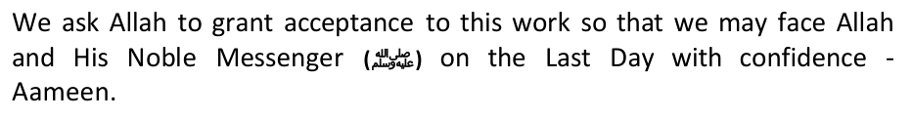
I was born in Karbala, growing up in an environment of Shi'ah people and was cared of by my father, who was a religious person. I studied in a number of schools in the city up until I reached early adolescence. And then my father sent me to Hauzah, sort of like an Islamic boarding school, in the city of Najaf. It was the main city of knowledge, the place of the famous scholars to study religious knowledge, such as Imam Sayyid Muhammad Ali Husain Kasyif Al- Ghita. He was a notable figure in the 'City of Knowledge'. Since then, I started thinking seriously about the issue of knowledge. I studied the madzhab of Ahlul-Bait, but on the other hand I have found reproach and attacks against the Ahlul-Bait.
I asked him, "The most supreme words are your words, what's true is your acts, and you are a mujtahid imam. It is not possible for me to opine or say unless it is in accordance with your opinion and words. It needs to be understood that it is not possible for me to oppose your fatwa."
Sixth, in the mut'ah marriage, there is no witness, announcement, and consent of the female's guardian, and the spousal inheritance law does not apply, but she is just a contracted wife. The allowance of mut'ah will open opportunities for young adults to drown in a puddle of sin that it will corrupt the image of religion. So the danger of mut'ah is very clear from the standpoint of religious, moral and social life. Thus mut'ah is made haram as it contains a lot of dangers.
Imam Khomeini is a very rich person from this khumus. While in Iraq, his wealth was in abundance, that when he departed for France and lived there, he had savings in the form of money in Iraqi Dinar, besides American Dollar which were deposited in the banks in Paris with very high interests. On top of that, indeed, lineage and descendancy is something that can be sold and bought. Whoever wants an honorable lineage that is associated to the Ahlul Bait, there is no other way but to approach his sister or wife to come to the Sayyids for nikah mut'ah with them or he pays a sum of money, so that in that way that he gets an honorable lineage. This is the practice that is not unfamiliar in the city of knowledge. I remembered my honourable friend, Ahmad As Safi An Najafi. I knew him after I had obtained the title of "Mujtahid", we became very good friend despite the big difference in age. He said to me, "My son, Hussain, you shall not dirty yourself with khumus, because it is a haram possession." We engaged in an intensive discussions until I was sure that khumus is a haram possession.
My intention is to show the friction that the Shi'ah is causing amongst Sunnis in SA. Until 1979, Shi'ism was never a problem in SA. Everyone was happy practicing their religion until Shi'ism came along. It is for Sunnis to decide, after studying this exposition of lies and deceit by Abdul Salaam Islam, that Shi'ism is nothing but a variation of Judaism, designed to weaken Islam from within.
--- There are some of the Rafidhi Shi'ahs who don't pray in congregation or they don't hold Fridays stating the this has to be done once the Mahdi appears. Likewise the Jews pray solely stating that congregation should be held once the Jewish Messiah appears.
The Jews have an enmity with Hazrat Jibra'eel (May peace be upon him), and they say that he is an enemy to them from amongst the angels. Similarly, one faction of the Shiites says that Jibra'eel grossly erred in delivering (Wahy) Al-Laah's Message to Hazrat Muhammad (May AlLaah's peace and blessing be upon him) instead of to Hazrat Ali for whom, according to them, it was in fact meant. The Shiites are liars. May they perish till Doomsday!"
Why this negligence? Is it because they have names which are disliked by the Shi'ah Rafadhis and by announcing it to their Shi'ite listeners would expose the love of the Ahlul Bayt to the Noble Sahabah (Companions), especially to Sayyadina Abu Bakr and Umar (RA)?
Lastly, Muhammad Ali Mu'zi, an Iranian Shi'ite researcher in France has stated with pride: "The basic fundamentals of the Zoroastrian religion has entered into Shiaism even in some minute issues. The marriage of Imam Hussein with the daughter of the last Sassanid Empire is a symbol of ancient Iran as Shahrbano became the first mother or lady for the Iranian nation. And this relationship marked the brotherhood between Shiaism and the ancient Magian Iran." For this reason they exalt Salman al-Farsi regardless of the other companions in so much that they claimed about him that he used to receive revelations because he was a "Persian". (Shiite source: Rijaal Kashshi) For this reason we see in their works that Ali ibn Abi Talib said with respect to Kisraa: "God has saved him (Kisraa) from the punishment of hell fire, and hell is made forbidden for him." [Shi'ite source: Bihaarul Anwar 41:14]
D. Sects will never vanish: Prophet Muhammad (pbuh) said: "Verily this nation [of Muslims] will divide into seventy- three sects", and in another narration: "All of them [these sects] will be in the Fire except one.' When asked which it was, the Prophet (pbuh) replied: "The one which adheres to my Sunnah (way of life) and the Sunnah of my Companions." (Sunan Abu Dawud)
A Shia narrator, Ali ibn Ibrahim, has narrated the following statement
Characteristics of the Imams: Below are some shocking polytheistic and anti-Islamic beliefs that the Shi'ah peddle about their 12 Imams, as some of you might have already known that the Shia's beliefs differ significantly in many aspects from Islam:
9. "When the Imams' time comes, they will rule in accordance with the laws of prophet David and his dynasty. These Imams will not need to ask for presentation of evidence before passing their judgments" (Ibid,p. 397) The Shia even believe that their Imams can do what ever they want!! Here they say that their Imams can just pass judgment on anybody! And they say that their Imams will not rule according to the Qur'an, but will rule by the laws of David!! (All Muslims must rule by the Qur'an and Sunnah). This is a proof that the awaited Imam of the Shia is not the one that Muslims believe in, but he is indeed the Anti-Christ (Al-Dajjal). The one that all Jews are waiting for him to be their leader.
5. Imam Ali & his descendent Imams know everything that:
21. Imam Mahdi will kill all the Sunni Scholars. (Haq-ul-Yaqeen, p. 527)
Finally, Mulla Baqir Majlisi has, in detail, recorded in this book concerning what the twelfth Imam will do when he appears. He writes on page 547: "When our Mahdi appears, (the very Mahdi who took the Qur'an and disappeared at the age of five, the very Mahdi who has been absent for the past 1420 years, the one who cannot be seen by anybody), he will kill the Ahlus Sunnah, even before the kuffar, He will wage a war against the Ulama of the Ahlus Sunnah." This is Shi'ism filled with pure hate and fire.
Rational Proof 3: We read in one of the most sacred book of Shi'ahs, that Sayyadina 'Ali (RA) wrote in his letter to Muawiya (ra) stating:
5. Why would Sayyadia 'Ali (RA) say that, what Muhajirs and Ansar did, it was with the pleasure of Allah? If According to Ali (RA) Mujahirs and Ansar rejected the candidate who was divinely appointed as Caliph and elected someone else, then why would Ali(ra) say that it was with pleasure of Allah? Doesn't these words of Ali (RA) falsifies that Shia
1. When Shia's Imam Mahdi (the 12th Shia Imam) comes, he will bring Prophet Mohammad's wife, Aisha, back to life, whip her as a punishment to avenge Prophet Muhammad's daughter, Fatima. (Al-Shafi, Vol. 2, p. 108), (Haq-ul- Yaqeen, p. 139 & 347) & (Hayat-ul-Quloob, Vol. 2, p. 901)
This rebuttal would also serve as booklet or a pamphlet for all Muslims and Shi'ahs of SA, and just as you sent out 1000s of e-mails to just about everyone you could find, you will also hopefully repent and sent this rebuttal out to everyone. We are sure you will also put it on your website and ask the Ahlul Bait SA to do the same, since you are so enamouured and smitten by them.
"It is also (read): '…bow down and prostrate…' As for that which is different from that which Allaah has revealed, then it is His, the Exalted, statement:
16. What is "Muta" if not glorified prostitution?
44. The beating of chests in Muharam?
Sunni references:
By Nehad Ismail
During the invasion of Iraq, Syria would send al-Qaeda operatives to Iraq to attack US forces. Syrian intelligence in full co-ordination with Iran recruited the al Qaeda terrorists to infiltrate the ranks of the Salafis now fighting in Syria. Once free, they broke into Iraqi prisons to liberate their comrades, thereby creating the basis for expanding ISIS.
"The leaders of ISIS have already worked hand in glove with Syrian intelligence, whether supplying them with weapons or supplying money flowing from their racketeering activities around Mosul."
Iran sought to extend its influence to Islamist organisations that follow the takfiri ideology and which had pledged allegiance to al-Qaeda, so it began the process of attracting, co-operating with and training these elements within its territory, and providing them with funds and equipment. Among them were Yassin al-Suri, who is accused of financing terrorism, Mohsen al-Fadhli, al-Qaeda's leader in Iran, and his Saudi deputy Adel Radi Saqr al-Harbi.
In February 2014, The Lebanese Daily Star reported that the Obama administration charged that Tehran is assisting Al- Qaeda operatives based in Iran to transfer Sunni fighters to Syria.
"The first organisation born of the womb of the Iranian intelligence [services] was the Islamic State in Iraq (ISI), which later became ISIL/ISIS under the leadership of Abu Bakr al-Baghdadi." These contradictions raise questions about how far Iran is willing to go in using al-Qaeda and al-Qaeda-inspired groups to implement its policies.
In June, the Islamic State of Iraq and al-Sham (ISIS) humiliated the Iraqi army and focused world attention on Iraq again. What the world does not recognize is the role played by Syrian President Bashar al-Assad helping and strengthening ISIS.
Nehad Ismail is a writer and broadcaster, who writes about issues related to the Middle East from his home in London. Read more stories by Nehad Ismail.
and Iraq's desire to replace Iran as the dominant Persian Gulf state, USA under the administration of President Ronald Reagan intervened in
Once again, just because of that one-time, we were made –due to the bombardment by the pro-Shi'ah mass media of the world- blind and utterly unacquainted with the heroism of the Sunni fighter personages, where tens of thousands of them have fallen in defending Al-Quds and Masjidil Aqsa. Bigs names such as Hasan Al Banna, Mustafa Siba'i, Ahmad Yassin, Abdul Aziz Rantisi, Yahya Ayyash, and a series of the Ahlus Sunnah martyrs vanished away, as if devoured and drown out by the grandeur of the Hizbullah militia figures led by Hassan Nasrallah. Besides the media factor and the embarrassing condition of the political
In fact, Al Hurr Al Amili in the book "Tafsil Wasail Shi'ah ila Tahsil Masail Al Shari'ah" stated that there are only 3 holy sites for the Muslims (of course he means Shi'ah), namely Masjidil Haram in Makkah, Masjid Nabawi in Madinah and Masjid Kufah, it is because of the holiness of Imam Ali b. Abi Thalib (see vol.14/360). This exposure by Hurr Amili is supported by Sheikh Al Saduq, author of the book "Man La Yahdhuruh Al Faqih" which is one of the 4 main reference books of the Shi'ahs, as quoted by Hurr Amili in his book, which narrates ahadith from Amirul Mu'minin Ali b. Abi Thalib that: "It is not recommended to tighten travel except to 3 Masjids: Al Haram in Makkah, Nabawi in Madinah and Masjid Kufah" (vol.3, page 525)
The reality is that before the regime of Ba'ath party in Iraq led by President Saddam Husain was deposed by the 'invisible' coalition of America and Iraqi Shi'ahs in 2003, in 2002 a Shi'ah majalah (magazine) "Al Minbar" in Kuwait made an exclusive reportage about Karbala and Al-Quds. The majalah was headed by Yasir Habib, who caused a big commotion in 2006 for cursing Sayyidah Aishah and the Prophets sahabahs openly in Youtubeto the point that it forced the Rahbar of Iran Ayatullah Ali Khamenei to issue a fatwa that it is haram to insult the symbols of the figures of Ahlus Sunnah for the sake of the unity of Islam.
This is just ONE of them:
The latest Israeli attack proved this, he said. IDF jets struck an arms shipment bound for the rebels.
"Eventually, Sayyadina 'Ali (RA) arrested him, and upon interrogation,
2- Shi'ah who said that he was infallible Imam and Allah had chosen him for leading Muslims.
*Ibn al-Mubarak: Ibn al-Mubarak was reported to have said, Religion is gained from Ahl al-Hadeeth, scholastic theology and crafty exemptions from religious ordinances of Ahl ar-Ray and lies from the Raafidite Shi`ites." [Az- ZahabI, al Muntaqaa min Minhaaj al-I`tidaal, p. 480]
Among other contemporary scholars who have have made similar statements are: Shaikh Ibn Baaz, 'Allama ash- Shanqiti, al-Albani, Ahmad Ameen, Muhibuddeen al-Khatib,an-Nashashibi and Dr. Rashad Saalim.
On pages 26 of this book, Khomeini writes: "A thousand years have elapsed since the disappearance of our Imam Mehdi and thousands of years may yet pass before expedience demands his appearance and, he may come (out)?". One page 49, it reads: "When a Mujtahid who is just and learned stands up for the establishment and organization of the government, he will enjoy all the rights in the affairs of the society that were enjoyed by the Prophet, and it will be the duty of the people to listen and obey (him) and this Faqih-and-Mujtahid ruler will hold the supreme power in the government and the management and control of social and political affairs of the people in the same way as the Prophet
It was only after it that the Holy Prophet made the proclamation at Ghadir-e-Khum.
The Iranian Revolution in 1979 under the leadership of Ayatollah Khomeini marked the end of official relations between South Africa and Iran, because Iran did not want to associate with an oppressive government and imposed a trade boycott in protest against South Africa's then Apartheid policies. Early in 1994, Iran lifted sanctions against South Africa at the demise of Apartheid and reestablished diplomatic relations on 10 May 1994. Ayatollah Khomeini's contribution changed the destiny of a nation, and he wanted to share the Islamic Revolution with other Islamic nations, and to spread it to the entire world. Attempts to do that resulted in a seminar which was attended by 380 Muslims from over 25 Arab and Islamic nations in Tehran to discuss the ideal Islamic government and to free the Islamic world and help it get rid of the demonic Western and Communist influences, but it seems the greater threat to ideal Muslim states are some self-styled Muslim Maulanas themselves. It is strange how our learned scholars spend their precious time compiling vile and deceitful documents side by side with the enemies of Islam and turn a blind eye on the real problems facing Muslims. The plight of the Palestinians is the concern of every Muslim, but Maulana Khalid Dhorat goes out of his way to influence Muslims to hate other Muslims, it would be better and beneficial to him if he had compiled a thirty-six page document on the injustices perpetrated by USA
Look at the following letter which the Shi'ah Jamiat sent out on the eve of Ramadaan 2014 to the Muslims of SA. It's full of lies, malice and hatred. The Shi'ahs know that its intent is only to sow mischief, hence its not SIGNED. Its ANONYMOUS. Also, why did the Ahlul Bait Foundation not declare Eid on the same day as the rest of the Muslims in SA? They celebrated on 29th July 2014, whilst the rest of the Muslims celebrated a day earlier. So much for UNITY!!:
The greeting I give to you, on behalf of Islamic Viewpoints is this – Brave spirits in Gaza proved to the world Islamic Victory is near, very near. Bombs rained down on their families, blowing up body parts in the air, and those zionist criminals came to see the bombing show for fun with drinks and popcorn. Their defeat is certain by now.
Harasta, also known as Harasta al-Basal, is a Syrian city administratively belonging to Rif Dimashq. Harasta has an altitude of 702 meters. It has a population of 38,184 as of 2007, making it the 43rd largest city per geographical entity in Syria.
Allah shall grant martyrdom to that group of Muslims. After that the
*Note: This is the part of the victorious army from Afghanistan-Taliban war facing similar fate in three categories,here connecting the old victorios army's fate with the current victorious army. Hence the victoriours army never lost continuty in its entirety.
Al Hasan Al Basri said: "A man of medium stature will come from ArRay (a far-eastern town). He will be dark and from the children of Tamim — a Wasaj, named Shuayb son of Salih with four thousand men. Their clothes will be white and Banners black, and at his front is the Mahdi. He meets no one that he does not defeat and scatter."
The Prophet (PBUH ) said: "We (I and my family) are members of a household that Allah (SWT) has chosen for them the life of the Hereafter over the life of this world; and the members of my household (Ahlul-Bayt) shall suffer a great affliction and they shall be forcefully expelled from their homes after my death; then there will come people from the East carrying black flags, and they will ask for some good to be given to them, but they shall be refused service; as such, they will wage war and emerge victorious, and will be offered that which they desired in the first place, but they will refuse to accept it till they pass it to a man from my family (Ahlul-Bayt) appears to fill the Earth with justice as it has been filled with corruption. So whoever reaches that (time) ought to come to them even if crawling on the ice/snow since among them is the Viceregent of Allah (Khalifatullah) al-Mahdi."
'Abdullah, the son of Abbas, may Allah be pleased with both of them, said to Mujahid: "If I had not heard that you are like the people of this House I would never tell you this." Whereupon Mujahid said: "It is surely in secret, I will not mention it to someone you hate." So Ibn Abbas told him: "There are four people from the House, from us is As-Saffah, and from us Al Mundhir, and from us the Mansoor, and from us is the Mahdi." So Mujahid said: "Clarify these four for me." He answered: "As for As-Saffah, perhaps he will kill his supporters and forgive his enemy. Al Mundhir will give away plenty of wealth, he will be humble and keep but a little of his rights. The Mansoor, will be given victory over his enemy and part of what was given to the Messenger of Allah, praise and peace be upon him, and that is that his enemies were frightened away from him the traveling distance of two months, whereas the enemy of the Mansoor will be frightened away from him the traveling distance of one month. The Mahdi will fill the earth with justice just as it has been filled with transgression — livestock and foxes will live together peacefully. And the earth will bring forth that which is hidden from its depths — they look like cylinders of gold or silver." (Found in reference to 'Ali ibn Abu Talib)
Narrated by Hudhayfah, The Prophet said: "The Mahdi is a man from my children. His face is like a glittering star, his skin is the color of an Arab, and his body is like that of Israel. He will fill the earth with justice just as it will have been filled by injustice, and the dwellers of Heaven and Earth will be pleased with his Caliphate." (Abu Nuaym, At-Tabarani,
The Shah's destruction required assembling a team of diplomatic "hit men."
until the day I left the country.
When the demonstrations turned violent, the government reluctantly invoked martial law. The second dark day was September 8. Thousands of demonstrators gathered in Teheran were ordered to disperse by an army unit. Gunmen — many on rooftops — fired on the soldiers. The Shah's army fired back. The rooftop snipers then sprayed the crowd. When the tragedy was over, 121 demonstrators and 70 soldiers and police lay dead. Autopsies revealed that most in the crowd had been killed by ammo non-regulation for the army. Nevertheless, the Western press claimed the Shah had massacred his own people.
Around the small villa occupied by Khomeini, the agents of many of the world's secret services were gathered as thickly as the autumn leaves. The CIA, the MI6, the KGB and the SDECE were all there. The CIA had even rented the house next door. According to most of the published witness-statements, the East Germans were in charge of most of the radio-transmissions; and, on at least one occasion, eight thousand cassettes of the Ayatollah's speeches were sent, directly to Teheran, by diplomatic bag.
Iran's situation deteriorated. As Western media spurred revolutionaries, riots and strikes paralyzed Iran. The Shah wrote:
You cannot imagine the pressure the Americans were putting on me, and in the end it became an order.... How could I stay when the Americans had sent a general, Huyser, to force me out? How could I stand alone against
The Issues
Please understand that behind the American hegemony in the world generally and the hegemony of Israel in the Middle East, there are two world actors which, in a frontal way, carry out resistance against the two countries. The actors are Iran (state actor) and the Hizbullah (non-state actor). We can see how a President of Iran, Mahmud Ahmadinejad, spoke out aloud that Israel should be wiped out from the world map. In addition to his consistent stance to continue the nuclear project in spite of the opposition from America and the UN.
5. The joint agreement and conspiracy with America. Publications by the highest spiritual leader of the Shi'ahs in Iraq, in the form of fatwas which forbade resistance against America and labeled the Sunnis as terrorists. And all those were done in line with their mendacious efforts which appeared to encourage resistance against America until the nation of Iraq is independent.
4. The rather deep involvement of the Mossad in Iraq with the support of the American created Iraqi government and helped by the Shi'ah Safawiyah militias in Iraq, to arrest and murder influential Ulama's and Sunni figures in Iraq. Terror acts in the form of abductions, tortures, to murders were committed. And this strategic alliance is even prepared to execute the same measures in the three regions: Iraq, Syria and Lebanon. Due to that, any action undertaken by one of those in the Alliance, is indeed a part of the global project of the Safawists, along the region extending from Iran to Lebanon, including Iraq and Syria in it.
5. Creating fictional conflicts with the Zionist Israel. Whereas, it was just a lure so that Israel would run berserk and then destroy the countries of the Muslims. Hoping that the conditions of other Muslim countries would be the same as Afghanistan and Iraq. There are 4 zones chosen by the Shi'ah Safawists as the initial footstep in the realization of their goals and plans, they are as follows:
The biggest fear of the United States is the Shi'ite rule in the Gulf, they fear that it will lead to anti-US and anti-Western sentiments, because that could mean Iran will have an influence in the Arab majority states.
4. Iran is very close to the spots of upheavals in the Middle East, and the people are having a relatively similar posture, they can also speak Arabic. It is easy for them to infiltrate, especially that it is supported by their aqeedah of Taqiyah, which allows them to pretend to be Sunni to cut up from within.
The sad reality is that the Islamic States which have the capacity of doing it, either base it on a heretic ideologies like Iran, constitutionalism like Jordan, monarchism like Saudi Arabia, Militarism like Egypt or extremism. May Allah remedy this situation soon – Insha Allah.
WARNING: Contains graphic material, although most of it is blurred. Many other video clips in our possession provide ample evidence of this.
Whilst we admit that Islam can not be openly practiced in many Islamic states of the world today, Iran is no exception to this when it comes to practicing Sunni Islam. Consider these facts:
Sheikh Nasser Sabhani was one of the leaders of Sunnah in Kurdistan who conducted many educational courses. He was arrested after refuting the false accusations of kufr directed at Umar (r.a.a) by Khomeini in his famous book 'al- Hukumah al-Islamiah' (The Islamic Government). He was killed in 1992 in prison and his relatives were denied from witnessing his funeral and the prayer;
And we can not forget the very famous interview in this regard:
developing.
Ahlus Sunnah were rewarded under the current sectarian government with a life of dishonour and subjugation, and their situation is far worse - as I have experienced myself. - than that of the Muslims in occupied Palestine. Is there a single capital city in the world without a Sunni mosque, with the exception of Tehran - the capital of the Shiah - which has forty Christian churches and a cemetery for the Baha`is. In all, even the infidel minority have their temples and places of worship, yet Ahlus Sunnah are not allowed to build any mosque or cemetery. Khomeini stated after the revolution: "All the Persians in the world can look at Iran as their nation", they are, therefore, first class citizens of Iran, even if they were Magians from India. As for us, we must be exiled from our land
· South of Tehran. The second Sunni Mosque to be confiscated was in 1982.
There is no Sunni director in any of the government authorities, ministries, embassies, or local and provincial governments, hospitals or principalities; not even in the lowest government posts anywhere in Iran. There are some Sunni parliamentarians just like in most middle eastern countries, however, these are token positions so that the common people can be fooled. Before a person's political nomination is accepted in Iran, he must be approved, by law, by the security agencies which naturally reject any Sunni activist, even if this person was to somehow attempt to appease them. These agencies employ the lowest form of people, and the most vile. This means that even if someone was elected by the people, the council has the right to ostracize him from government. So of what use is such a parliament, especially with respect to the Sunni parliamentarian who does not have a party to protect him? Even if he obtained such a post, what could he possibly offer his people? The whole council therefore has no practical value. This is supported by Khomeini's address to Mawlawi Abdul Aziz after the Iranian revolution: "We do not have a Shuraa process. The principal with us is that the Imaam rules, and imitators follow suit. We took the idea of a council from your creed, initiated a few years ago here (in London).
Sayyadina Hassan (RA) followed in the tracks of his father and waged a war against his thoughts and beliefs. The Shia writer Ibn abi al-Hadid writes: "Abdullah bin Saba appeared after the death of Hadhrat Ali. He was, in fact a Jew but wore the badge of Islam. His followers are called "Sabais". These people believed that Hadhrat Ali had not died but he was still alive among the skies. The thunder is his voice and the lightening is his glitter. Whenever they heard the clap, they uttered (Peace on you, O Amir-ul-Mominin!) These cruel people talked of the Prophet (peace be upon him) in extremely unrefined and indecorous language, accused him of baseless motives and publicly claimed that he had suppressed ninety percent of the divine revelation."
After the death of Imam Hassan, Imam Hussein refused to pledge allegiance to Yazid the Umayyad caliph because he considered the umayyad's rule unjust. For that reason, he left Medina and traveled to Mecca, his caravan was stopped by Yazid's army at Karbala where he was martyred with other members of his family and supporters.
When the Shi'ahs realized that they had reached a point of no return and were absolutely disinclined to give up their sinful way of life, they bade farewel to true Shiaism. Their decision was not an emotional decision. They could not wriggle out of the quagmire of corruption into which they had suck on account of greed and lechery. TILL TODAY, THE SHI'AHS ARE ONLY SINKING DEEPER AND DEEPER IN THIER DISBELEIF. O SHI'AHS, IT'S NEVER TOO LATE TO REPENT. ALLAH IS MOST MERCIFUL. SAVE YOUR SOULS FROM ETERNAL HELLFIRE. Mr Islam, it seems yourself and many Shi'ahs in this country don't even know what is Shi'ism. Study this document inn detail and ask Allah to guide you. REPENT before its too late!!
The world has a new poster boy in al-Baghdadi. Some naive Muslims will be taken in by his brandishing a kalishnakov instead of the sword but it is important to look deeper. Emotional outbursts are no substitute for clear analysis and understanding.
http://www.youtube.com/watch?v=r7aCtj3Dr3U
1 Al-Muslim, (Chapter on the virtues of the Companions), no: 2386. 2 Al-Tirmidhi (Chapter on virtues of Abþ Bakr), op. cit., no: 2663 and 2664. 3 Musnad Aåmad ibn Hanbal, v. 6, p. 48 & 106. 4 Al-Muslim, 'Chapter on Appointing a deputy Imàm when the main Imàm is travelling or has an Excuse,' no: 460; al-Bukhàrï, 'Chapter on Prophets and Who is more Rightful to lead the Prayers,' no: 296.
Sunnï doctors of belief, like al-Tahawï, ruled that whoever gave preference to 'Alï over Abþ Bakr should be lashed equivalent to the number of lashes prescribed for a slanderer. 22 All of the above traditions, and many others, buttress the Sunnï viewpoint that Abu Bakr was indeed the most ratified for the post, and it is incumbent to accept this verdict as such. There is an ijmà' (consensus) on this issue, and therefore there is no need to prove his appointment by means of nass.
Ghadïr Khumm was a famous landmark in the desert, as it was from here that all the routes branched off to various destinations of the country. Thus, Ghadïr Khumm was a kind of junction where all travelers met and rested before proceeding with their onward journey. It was at this place, where in the midst of about 120 000 people, that the Holy Prophet (SAW) pronounced 'Alï as his next successor as Mr Islam and his Shï'ah friends claim.23
*And the Holy Prophet (SAW) also said, "O my Lord, whichever way 'Alï turns, orient the truth in that direction."
28 Ibn Taimiyyah, Aåmad, Minhàj al-Sunnah al-Nabawiyyah fï Naqd Kalàm al- Shï'ah wa al-Qàdriyyah, Maktabah al-Riyàd al-Hadïthah: Riyadh, v. 4, 1979, pp. 84-87. 29 Emphasis has been laid to the kind treatment of the Prophetic Household, and not of making them the successors of the caliphate. Another tradition in Muslim v. 4, p. 1286 reinforces this meaning
*Thirdly, the addition 'and he is the friend of every believer after me,' is an addition of Ja'far ibn Sulaimàn who was famous for his extremist Shi'ï tendencies. Ibn Hajar said that whenever Mu'àwiyah would be mentioned before him, he would curse him; and whenever 'Alï was mentioned, he would sit down and weep bitterly for him. Ibn Hibbàn said
*Aisha and Hafsa were hypocrite and infidel women. (Hayat-ul-Quloob, Vol. No. 2, p. 900)
7) Those Šahàbah who participated in the first battle of Badr. They were forgiven by Allàh.
Imàm al-Ghazàlï says in his Kitàb al-Iqtišàd (Book of Expectation):
He (SAW) also said, "O Fàtimah! daughter of the Messenger, I will not be of help for you (on the day of judgement), O Šafiyyah! aunt of the Messenger, I will not be of help to you. O Banï 'Abd al-Muttalib! I will be of no help to you......."
and we stand firmly by it. Already, hundreds of facts have been given to prove our point.
*Al-Faryàbï has decreed that a person who abuses Abu Bakr is an infidel. His funeral prayer should not be performed and he should be shoved into a hole by means of long poles.
We ask in retrospect: can all the verses of the Qur'àn which speaks of the virtues of the Companions only mean threeor four Companions?
Verse 47:30 which spoke of Allàh exposing those in whose hearts rancour lurks.
Shi'a emphasize that permanent marriage is recommended and encouraged by Qur'an and the teachings of the Prophet and Imams of Ahlul Bayt. They assert that mut'ah (temporary marriage) is an option that should be considered when permanent marriage cannot be afforded or the situation of a person who cannot get married becomes extremely
If everyone practised Mutah, which is what Shi'ism encourages, then we'd all probably die of STDs. There are Shia hadith which say that a man should perform Mutah with a thousand women. The medical implications of the implementation of these Shia beliefs would mean an epidemic of diseases. It is well-known that Shia guys are engaging
Shi'a also refer to Qur'an 4:24 to prove that mut'ah marriage was allowed by God: "And [also prohibited to you are all] married women except those your right hands possess. [This is] the decree of Allah upon you. And lawful to you are [all others] beyond these, [provided] that you seek them [in marriage] with [gifts from] your property, desiring chastity, not unlawful sexual intercourse. So for whatever you enjoy of marriage [temporary marriage] with them, give them their due dowry as an obligation. And there is no blame upon you for what you mutually agree to beyond the obligation. Indeed, Allah is ever Knowing and Wise." Qur'an 4: 24
Even if we were to say for argument's sake that this verse indicates that mut'ah is permitted, we would still say that it is abrogated by the reports in the saheeh Sunnah which prove that mut'ah is forbidden until the Day of Resurrection.
Legalising of prostitution has led to a whole corrupt industry in Iran – based on the misinterpretation of the above hadith. Consider this article:
In one case, a woman was discovered selling Iranian girls to men in Persian Gulf countries; for four years, she had hunted down runaway girls and sold them. She even sold her own daughter for US$11,000. In cities, shelters have been set-up to provide assistance for runaways. Officials who run these shelters are often corrupt; they run prostitution rings using the girls from the shelter. For example in Karaj, the former head of a Revolutionary Tribunal and seven other senior officials were arrested in connection with a Mutah prostitution ring that used 12 to 18 year old girls from a shelter called the Center of Islamic Orientation.
* Numerous Sexual Gratifications in Mutah: "One my have sexual relations with the woman contracted for Mutah any number of times he desires."(Al-Kafi)
* Mutah - A Pardon of Sins for Practicing Women: It is narrated by Imam Baqir that the Prophet said, "When I was being taken to Heaven during the Mi'raj (ascension), Jibraeel met me and told me, 'O Muhammad, Allah has promised to forgive all of the sins of those women who practice Mutah.'" (Al-Kafi)
Zeinab Ahmed, 31, lost her husband in a car accident five years ago. She says she has considered entering into a muta'a contract with a man, but the stigma attached has kept her from doing so. "All my friends who have done this have told me they got married in this way just to meet their sexual desires," Ahmed says, "but later on they started to love that man, and he does not accept to get married permanently. … Most of the men, at the end of the contract, they feel contempt towards the woman."
from blame; But whoever seeks beyond that, then those are the transgressors." [al-Mu'minun 23:5-7]
Also, in Volume 9, Book 88, Number 208: Narrated Hudhaifa: Allah's Apostle related to us, two prophetic narrations one of which I have seen fulfilled and I am waiting for the fulfillment of the other. The Prophet told us that the virtue of honesty descended in the roots of men's hearts (from Allah) and then they learned it from the Qur'an and then they learned it from the Sunna (the Prophet's traditions). The Prophet further told us how that honesty will be taken away: He said: "Man will go to sleep during which honesty will be taken away from his heart and only its trace will remain in his heart like the trace of a dark spot; then man will go to sleep, during which honesty will decrease further still, so that its
This is exactly what the Shi'ah have done!!
Mr Islam, please contact the Ahlul Bait SA and tell them the following: Islam permits Muslims, who are living under imminent and serious danger of persecution, to deny they are Muslims publicly and to practice Islam secretly. This concept is sometimes referred to as Taqiyya. Proper Taqiyya is permissible in Islam, but it is not an obligation and it is not a virtue. While in Shi'ism, Taqiyya is a an obligation, a praised virtue, and an important doctrine in Shiism. Taqiyya has played a significant role in the history of Shi'ism. In Islam, Taqiyya is permitted as a means for individual Muslims, living in exceptional conditions of persecution, to protect their lives. However, proper Islamic Taqiyya does not allow Muslims to twist the beliefs of Islam. More specifically, that means a Muslim should not write a book about Islam and twist or lie about the beliefs of Islam under the excuse of Taqiyya. Proper Taqiyya does not allow him to do so.
"Nine tenths (90%) of religion (Shiism) is Taqiyya (dissimulation), hence one who does not dissimulate has no religion." (Al-Kafi vol.9 p.110)
Who gives the Shi'ah the right to pick and choose who must be included and who excluded from the noble Ahlul Bait?
In the hadeeth of Al-Ifk (the narration of the Lie), the Prophet (SAW), while he was on the pulpit narrating charges of adultery from Ubaydullah bin Abi Salul against the Mother of Believers, Aa'ishah, says: "O people give me your opinion regarding those people who made a forged story against my family. By Allah, I do not know anything bad about her. By Allah, they accused her of being with a man about whom I have never known anything bad, and he never entered my house unless I was present there, and whenever I went on a journey, he went with me" (Saheeh Al- Bukhari, Tafseer AL-Quran, Surat Al-Nur)
In the story of Zulaykha, the wife of Al-Azeez, when she wanted to temp Yousif, Allah says: "She said: "What is the (fitting) punishment for one who formed an evil design against thy family, but prison or a grievous chastisement?"
Like we did with this misleading report of Mr Islam, we can also point out many dozens and dozens of glaring heretical beliefs and mistakes in the above website. Please do not ask people to consult it!!
Was Salaam
The difference between truth and falsehood is that truth is supported by facts and logic, while falsehood is illogical and fabricated. Truth liberates the mind, whereas falsehood incarcerates the mind. Distributing misleading information is known to be a custom of the enemies of Islam, because their intention is to influence the readers and further an agenda.
The most widespread belief among us, the followers of Shi'ah is the prioritization on the Ahlul Bait. In the madzhab of Shi'ah, everything is based on the love for the Ahlul Bait. To disown themselves from the laymen, namely the Ahlu Sunnah, to disown themselves from the three khalifahs and Aishah binti Abu Bakar for their attitude against the Ahlul Bait.
Nikah mut'ah has been practiced in the ugliest forms, the women have been humiliated in the worst humiliations. Most of them (Shi'ahs) fulfill their lusts in the name of religion behind the curtain that is called mut'ah. They have brought riwaayahs that give motivations to do mut'ah, setting and detailing its rewards, as well as punishments on those who do not do it. In fact those who do not practice mut'ah are considered kafir. As Saduq narrated from As Sadiq, he said, "Indeed, mut'ah is my religion and the religion of my father. Whoever denies it, it means he is denying our religion and having the aqeedah of a religion other than our religion," (Man La Yahdhuruhu Al Faqih,3/366). This is the declaration of kafir on those who reject mut'ah.
The Imam Has Mut'ah With A Small Child
Then he said, "Sayyid Husain, indeed the ruling of having mut'ah with a small child is permissible but only with fondling, kisses and squeezing with the thighs. As for the sexual intercourse, indeed she is not strong enough to do it." See also the book of Imam Khomeini entitled "Tahrir Al Wasilah", 2/241, number 12, which allows mut'ah with babies that are still suckling.
It is our duty to give warnings to the general public over this indecent practice, so that they will not accept the fatwas of the personages which allow this immoral and indecent practice. The matter does not just stop here, it even allows doing sodomy to the women. They narrated a few riwaayahs and ascribe them to the imams.
Indeed, the most bizarre and surprising thing is that, all of these books had been handed down from Allah and dedicated to Imam Ali and the imams after him but they are all hidden from the ummah. If Imam Ali really had those books, what is he hiding them for?
The above damning evidence is from one of the present-day highest authorities on Shi'sim, and it would suffice our misguided Shi'ahs in SA like Abdul Salam Islam and his friends at the Ahlul Bait Centre in SA, but since Abdus Salaam Islam has asked for independent references, we will continue...
---The Jews wrote the book with their own hands and stated that this is from God, likewise the Shiites wrote down lies and stated that this is from God. (Al-Kulyani's al-Kafi is full of it). They also fabricated lies and attributed them to the Noble Prophet and his family. It is also well known to the hadith scholars that the Rafdhis/Shiites form the bulk of those narrators who are weak, unreliable and abandoned.
Now, let us see what that great savant of Islaam, Hazrat Mahboob-e-Subhaani, Saiyyidina Shaikh Abdul Qaadir Jilaani, better known as Hazrat Ghaus-i-A'zam (May Allah be pleased with him)' has written about the Shiites in his book Ghunyatut Taalibeen. On page 170 of the book, he says:
Shi'ahs call the noble and venerable Sahaba who overrun the Sassanid Empire as uncivilized Bedouins. Al-Ihqaqi said: "The catastrophes that befell both the Iranian and Roman Empires were because of the Muslim invasion and the Arab treatment. The newly converts who were not accustomed much with the spirit of Islam, had implanted in their hearts hate to the Arabs and to their customs. This was because the conquerors were uncivilized Bedouins who ravaged and destroyed their beautiful cities and cultivated lands, in the east and the west. The thirsty worshippers of carnal desires raided the chastity and honour of these two empires……" (Risalatul Emaan,p.323, Mirza
The above is a blatant lie. Shi'ahs do not believe in the Muslim kalimah as shown in the above illustration. Their credo is different and they entertain heretic beliefs about our Creator, the Mighty and Supreme Allah Ta'ala. These are as follows:
(a) happened in the past,
22. Imam Mahdi will bring new Sharia (divine law) and commandments. (Behar-ul-Anwaar, Vol. 10, p. 597)
… and it is stated in Sunni books. Sayyidina Zayd ibn Arqam (RA) reported that Allah's Messenger (pbuh) said, "I am leaving behind with you that to which if you hold fast, you will not go astray after my death. One of them is mightier than the other the Book of Allah, a rope hanging down from the heaven to earth. And (the other), is my family – people of my household. Both of them will not separate till they come to me at the pond. So, watch out how you represent me in them." Tirmidhi, Vol. 2, page 678, no 3813. How then do learned men unanimously (according to Maulana Dhorat) declare Shi'as as disbelievers?
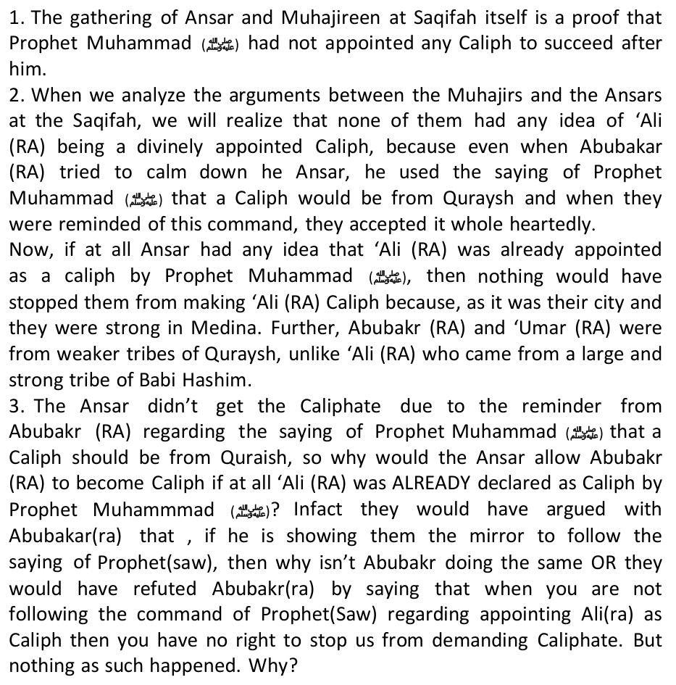
myth that Sayyadinna 'Ali (RA) was divinely appointed Caliph?
2. Prophet Mohammad's wives, Aisha and Hafsa, are accused of poisoning Prophet Mohammad. (Jila-ul-Ayoun, p.118)
17. Do the Shias consider Hadhrat Muawiya (RA) a Muslim?
45. The marriage of Qasim at the time of Karabala?
To freshen your memory, who initiated the following wars?:
Iran's Motivation and Collusion
The accusation, detailed in new sanctions imposed by the U.S. Treasury Department targeting Iranian terror links, suggests Iranian officials are backing opposing sides in the Syrian civil war. The Treasury has information about al Qaeda men in Iran who "assisted extremists and operatives transiting Iran on their way into and out of Pakistan and
ISIS has long been at war with the moderate opposition groups like the Islamic Front and the Free Syrian Army (FSA), who have successfully driven it out of much of its former turf in the north.
A Zionist view of this kind can easily be acquired in some literature such as "Entry Al-Quds" written by F. Buhl, a Jewish academician in the Encyclopedia of Islam. He wrote, "Maybe Rasul (Muhammad) assumed that Masjidil Aqsa is a place in the heaven." (see the book"Fadhail Bayt Al Maqdis fi Makhtutat 'Arabiyyah Qadimah" written by Dr. Mahmud Ibrahim pg. 47, published by Ma'had Al Makhtutat Al 'Arabiyyah, print.1 year 1985)
Israel Colluding with Iran, Hezbollah and Assad, Say Syrian Rebels
"The opposition was going to take over arms, so Israel attacked. There is evidence pointing to this. There were some high-ranking officers with whom [rebels] got into contact. [Those officers] were going to defect from, handing over arms to the opposition.
Minister: Iran's Hospitals Ready to Admit Gaza's Wounded Civilians
To prove that its not Iran who provides arms, read this:
http://www.timesofisrael.com/as-it-battles-hamas-israel-singles-out-its-sponsor-qatar/
3- Sunnis ( Majority of Muslims ) who said that he was a great companion of the prophet and he was a great leader to Muslims but Muslims had chosen him to be their leader not Allah. Read Sayyadina Ali (RA)'s words and then examine the three groups, you will come to the conclusion that the Sunnis are following the middle course advocated by Imam Ali.
*Abu Zur`ah ar-Raazi: This great scholar was quoted as saying, "If you see someone degrade any of the companions of the Prophet, (pbuh), know that he is a disbeliever. Because the Prophet, (pbuh), was real, what he
Khomeini is not only a Shia theologian, Mujtahid and author, but, also, a political personality, a diplomat and leader of a revolutionary movement. The Shi'as are the real source of his strength in the struggle launched by him, but for political expediency, Sunnis, too, have to be used for it as far as possible. Khomeini, therefore, adopts in Al- Hukumat- ul-Islamia the strategy that he mentions the myth of Ghadir-e-Khum and the appointment of Sayyadina 'Ali as the Prophet's successor and Caliph, as
Are we the JUSA in Fordsburg or PE?: No, we represent a cross section of the Muslims across the racial and sectarian "divide"; further we want to even propose solutions to those outside the strict and formal designation of "Muslim". We chose a name that is inclusive of all these in this geographic location. If you think they are more faithful to the geographic description then ask them if they are honestly interested in the welfare of all Muslims in South Africa, which includes those who are Shi'ah and Sufi and Salafi, we can get to all good people who may not be Muslim later!?
Beit Lahia is a town under Palestinian Authority of about 40,000 people in the northern Gaza Strip. It is located north of Jabalia, near Beit Hanoun and the border with Israel. Hamas, an Islamic party, took control of it during the 2005 municipal elections.
Note: The children of Al Abbas have indeed carried black banners in revolt, which occurred some time ago. The Taliban wear black turbans and white clothes, and do carry Black Banners in wartime.
References: Sunan Ibn Majah, v2, Tradition #4082,The History Tabari al-Sawa'iq al-Muhriqah, by Ibn Hajar, Ch. 11, section 1, pp 250-251
About Shuayb, the son of Salih, from Tamim: Ammar, the son of Yasir, may Allah be pleased with both of them, said: "The bearer of the Banner of the Mahdi is Shuayb, the son of Salih."
*Note: The ruler of Syria at that time is the Sufyaani.
and Abu Amru Ad Dani.)
Correction, Shi'ite Kufr Theocracy
The Shah changed all this. Primarily by using oil-generated wealth, he modernized the nation. He built rural roads, postal services, libraries, and electrical installations. He constructed dams to irrigate Iran's arid land, making the country 90-percent self-sufficient in food production. He established colleges and universities, and at his own expense, set up an educational foundation to train students for Iran's future.
The other key player du Berrier named, George Ball, was a quintessential establishment man: CFR member, Bilderberger, and banker with Lehman Brothers Kuhn Loeb. The Shah commented: "What was I to make, for example, of the Administration's sudden decision to call former Under Secretary of State George Ball to the White House as an advisor on Iran? I knew that Ball was no friend."
The Shah, extremely grieved by this incident, and wanting no further bloodshed, gave orders tightly restricting the military. This proved a mistake. Until now, the sight of his elite troops had quieted mobs. The new restraints emboldened revolutionaries, who brazenly insulted soldiers, knowing they could fire only as a last resort.
Foreign-affairs analyst du Berrier reported:
At about this time, a new CIA chief was stationed in Teheran. He had been transferred to Iran from a post in Tokyo with no previous experience in Iranian affairs. Why did the U.S. install a man totally ignorant of my country in the midst of such a crisis? I was astonished by the insignificance of the reports he gave me. At one point we spoke of liberalization and I saw a smile spread across his face.
Henry Precht [the State Department Director for Iran] and the entire State Department?
Why did the American establishment, defying logic and morality, betray our ally the Shah? Only the perpetrators can answer the question, but a few possibilities should be considered.
Ever since 1979, Iran has become increasingly pro-Western and democratic.
Antagonism against America and Israel is also shown by the 'Islamic movement' of Shi'ite Lebanon which is led by Sheikh Hassan Nasrallah, i.e. Hizbullah. The world was surprised by the victory of Hizbullah in the one-month-war against Israel in 2006. Where this victory was very humiliating to Israel, which is known to be strong militarily as it is aided by America, to the point that it can be said that Iran and the Hizbullah have become the icons of the world community in threatening the imperialism and hegemony of America-Israel.
1. The presence of the movement and efforts of ethnic and mazhab
6. The more and more increasing efforts in the arrests conducted by the Government of Syria against the Arab citizens of Iran (al-Ahwaz) who have been seeking refuge in Syria since decades ago. Not only that, some of the figures of resistance of al-Ahwaz (Khalil ibn 'Abd al-Rahman al-Tamimy and Sa'id 'Audah al-Saky) were then surrendered to the Iranian Intelligence.
5. Iran is also self-sufficient technologically, which could become an alternative for the society in the Middle East which rejects the West. Its military is also strong, in fact it could even be the strongest in the region.
Ayatollah Ali Sistani, Iraq's Highest-Ranking Shia Cleric, Issues Fatwa For Shias To Fight ISIS By Mike Obel@MikeObelm.obel@ibtimes.com on June 13 2014 8:23 AM
There's not a single Sunni Masjid in Tehran. There are synagogues and churches, but no Sunni Masjid. This is somehow justified by saying "we're all Muslim, why separate Masjids?" In reality, Shi'ahs are open DISBELIEVERS disguised as the "oppressed" Muslims of the world – similar to the Jews who justify their massacre of innocent Muslims based on their being the most discriminated race on earth. Of this, there is no doubt and we have loads of evidence to prove out point. Tehran has forty Christian churches and a cemetery for the Baha'is too!!
Dr. Ali Muzhaffaryan was amongst the eminent intellectual Shi'ites who was a cardiac surgeon and the head of Shiraaz Committee of Physicians. He embraced the school of Ahlus Sunnah wa al-Jamma'ah and then converted his house to a mosque because the government of Shiraaz did not permit the establishment of mosques. He was arrested and convicted with Wahhabism and American treachery and tortured severely when many Shi'ite youth followed him into Sunnism. He was later released only to be assassinated in 1992;
Nida`ul Islam (The Call of Islam) – Australia (By Sheikh Abdur Rahmaan al Baluchy)
· Tareeth Ham Mosque. This Mosque is in the state of Khurasan. It was transformed to a centre for the revolutionary guard.
We see ourselves as creedal and intellectual extensions of our brothers. What we are facing today is a direct result of our affiliation to the Ahlus Sunnah creed and for no other reason. It is the responsibility of the Muslims in every organisation as groups and as individuals to be concerned over their religion and their faith. We know the reason for the backdown of the authorities and the governments, however, what excuse could there be for the charities, wealthy Muslims, Islamic organisations, and groups? They do not have an excuse before Allah.
Sayyadina Hassan (RA) could not wage war against them in the style of his
Iran-West nuclear talks
It is also gross ignorance of Mr Islam about his own bunk-up chutney religion called Shi'ism!
A little more ridiculous one is the following:
*MutawaTirah* and agreed on the accuracy of its contents (the Hadiths), and Alkafi is the oldest, greatest, best and the most accurate one of them ". [The book of AlMuraja'aat, Muraj'ah number 110 ] ….. MutawaTirah = accurate 100% because it was narrated by many narrators.
Mr Islam, either you are a plain dumb and deaf follower of Shi'ism, or a stupid researcher who hasn't bothered to do some basic research. Many ignorant and haughty Shi'ahs have copied and pasted your rebuttal of mine in their correspondence to me, and to prove various aspects of Shi'ism to each other, not realising that you have brought the very foundations of Shi'sim to it's knees! I'm sure the Ayatollahs of Iran will cruficy and then fry you for such a disservice to their cause!
*'Umar once said towards the end of his reign, "If I have to appoint a successor, it is like how a person better than be did, that is Abu Bakr; and if I do not appoint a successor, then it is like how a person more superior
The tradition at Ghadïr Khumm is the most significant tradition of the Shï'ahs with which they prove the disobedience and apostasy of all the Companions in the delegation of 'Alï. In the words of the Shi'ite Tabàtabà'ï, "For Shi'ites the central evidence of 'Alï's legitimacy as successor to the Prophet is the event of Ghadïr Khumm when the Prophet chose 'Alï to the general guardianship." 24 One finds the following interesting points raised from this incident by the Shï'ahs:25
*The Holy Prophet (SAW) made all the Companions take a pledge of loyalty at the hands of 'Alï, the first three caliphs were the first. The Holy Prophet (SAW) took this pledge for he feared that all the Companions would turn apostate after his demise and thus desert 'Alï.
30 Ismà'ïl, Sa'ïd, The Difference Between the Shï'ites and the Majority of Muslim Scholars, World Assembly of Muslim Youth: Riyadh, 1988, p. 31 The wording of the entire incident is as follows, "The Holy Prophet sent an army and made 'Alï the commander over them. In the process, a maid was found and 'Alï had sexual intercourse with her. The people disliked this act of 'Alï and four people promised that they would inform the Prophet as to what 'Alï had done........." When they returned, all four of them complained to the Holy Prophet, but he ignored all four of them. Then the Prophet stood up, and angrily asked thrice, "What do you want with 'Alï?" He then uttered the above words. See al-Tirmidhï, Sunan, Fàruqï Kutub Khànah: Lahore, n/d., v. 2, p. 212.
Although Shi'as believe that specific members of the Household of the Prophet (pbuh) are the divinely appointed successors of the Prophet, they do not disregard the companionship of the Sahabas nor do scholars encourage hatred towards Sunni. In a meeting held between Sunni Scholars and Researchers, Grand Ayatollah Makarem Shirazi in June
To refresh your memory on the type of hatred upon which Shi'sim is built, these are some of the 1000s of quotes found in Shi'ah books. I suggest that your hatred and vengeance should be turned on the Shiah, not to those who are trying to expose their filth and disbelief. I appeal to you not to be used by the Shi'ah hypocrites to do their dirty work.
* Aisha was a hypocrite. (Hayat-ul-Quloob, p. 867)
This categorization of the superiority and infallbale purity of the Ahlul Bait is nothing but over-veneration bordering on shirk (polytheism) of the Ahlul Bait. The Ahlus Sunnah wal Jama'ah actually give the correct place to the Ahlul Bait in the scheme of things, not the misled Shi'ah who use the pious emotions of the people to ensnare them – just like how the Christians deified Sayyadina 'Isa (AS).
8)Those Šahàbah who migrated from Makkah to Madïnah between the incidents of Badr and Hudaibiyyah.
These traditions prove that being a relative, family member or mere acquaintance or contemporary of the Holy Prophet (SAW) without pious actions, was of no consequence. Allàh had declared everlasting pleasure and forgiveness for the Šaåàbah and his household on account of their sacrifices rendered to the cause of Islàm.46
Now for the benefit of our ignorant and sincerely misled Shi'ah or those who are sympathetic towards them or have been caught in their web of deceit, understand that both Shï'ahs and Sunnïs agree that all the jurisprudential rulings and Islàmic beliefs have been transmitted by the Šahàbah in general, but the Shï'ahs differentiate between the just and the unjust Šahàbah, the unjust of whom were engaged in 'reviling and cursing each other, fighting and eventually killing each other.' 47
*Ahmad ibn Yunus and Abu Bakr ibn Hànà'ï has said that they would prefer eating meat prepared by a Jew and a Christian, but not of one who abuses the Companions.51
Verse 48:11 which spoke of those who prefer the world over fighting in the cause of Allah.
difficult to bear.
The Mutah Pimps
One cleric backing the plan, Ayatollah Mohammed Mousavi Bojnurdi, recently told a newspaper: "We face a real challenge with all these women on the street. Our society is in an emergency situation, so the formation of the Chastity Houses can be an immediate solution to the problem." He added that the plan "is both realistic and conforms
The following are Shia Hadith from the most important of the four Shia books of Hadith, Al-Kafi. It is abundantly clear that these so-called Hadith advocate prostitution and Zinnah, and go against the chastity that is a central tenet of true Islam.
* An Open License with All Women: "Mutah is allowed with all types of women. She may be a virgin, married, widowed or may belong to any sect, group or religion. She may be a Christian, Jew or Muslim. However, Mutah with a Majusi (Magian) woman is permissible only when one is helpless." (Al-Kafi)
* Denying Belief in Mutah: "One who does not believe that we (i.e., the Infallible Imams) will reappear and rule and one who does not believe in the sanctity of Mutah is not from among us." (Al-Kafi)
Question:
Sayyadina 'Umar prohibited it by re-inforcing the command of Rasulullah (SAW). This is one of the consequences of again legaalising it:
Most Shiite scholars today consider it halal, or religiously legal. Grand Ayatollah Ali al-Sistani, the highest religious authority in Shiite Islam, sets conditions and obligations for muta'a on his Web site. ("A woman with whom temporary marriage is contracted is not entitled to share the conjugal bed of her husband and does not inherit from him …") Prime Minister Ibrahim al-Jaafari and other Shiite lawmakers have said they want Iraq's new constitution to use the sharia, or Islamic law, as its basis. That could give muta'a formal legal protection. Sunni Arabs and Kurds, who are mainly Sunni, oppose the idea. But the practice is growing among Sunnis and Shiites alike.
it should be ongoing and permanent. Temporary marriage or prostitution i.e., mut'ah marriage, was permitted at the beginning of Islam, then it was abrogated and became haraam until the Day of Judgment.
It was the Shi'ah who broke the "Door of Peace" by murdering Sayydina 'Umar (RA) according to this narration:
"He who conceals his religion has saved it, and he who makes it public has destroyed it."
Yunus Akhtar
I learned about the issues of Shari'ah to worship Allah, but in it were nas (texts) which show kufr against Allah SWT. "O Allah, what am I studying? Is it possible that all this is the true madzhab of Ahlul-Bait?"
The claim that prohibition only applies specifically on the day of Khaibar, is a claim that is not based on daleel. Besides that, if the prohibition only applies on the day of Khaibar, there must have been an affirmation from Rasulullah. The meaning of the words that mut'ah marriage was forbidden on the day of Khaibar is that, its prohibition commenced on the day of Khaibar until the Judgment Day. As for the words of our ulama's (ulama's of Shi'ah), they are ridiculing of the nas of the Shari'ah.

Other Holy Scriptures
The similarities between the two are too glaring to ignore:
---The Jews abandoned Sayyadina Musa (AS) against the Cannanites stating that,"go and fight you and your Lord, whereas we remain here sitting." Similarly the Shi'ites abandoned Sayyadina Ali (ra), Sayyadina Hussein (ra), and Zayd ibn Zainel Abideen (RA) when they were in the battlefield fighting against the oppressors.
"The Shi'ite faith is much akin to the Jewish faith. According to Allamah Sha'bi, the "love" borne by the Raafdhis (Shi'ites) is like the love borne by the Jews. The Jews hold that no man, unless he is from the House of David, is fit to be an Imam. The Shi'ites reject the claim to Imaamat of any man who is not from the House of Ali Ibne Abi Taalib.
Hasan al Haieeri al-Ihqaqi, As Sadiq library, Kuwait)
Shi'ite traditionsits (muhaditeen) like Abu Faraj al-Isfahani in his Muqatil at-Talibeen-p.88,142,188; Al-Arbali in his Kashful Ghumamah vol. 2, p. 64; and Majlisi in Jila el-'Uyun, vol. 3, page 582, stated that amongst those who were martyred with Hussein in Karbala were Abu Bakr ibn Ali ibn Abi Talib and Abu Bakr ibn Hussein ibn Ali ibn Abi Talib. Why doesn't the ceremonies held during Ashoora not mention the names of the following who were martyred with Sayyadina Hussein? Are they afraid that their dirty lot will be exposed?:
All of the above show that the Iranians of today are same as Iranians 1400 years back. They never really embraced Islam and are the supreme hypocrites of this ummah. O Muslims of SA in particular, BEWARE !!!
E. The practice of the ummat: It has been the established practice of this ummat to respect the acceptable schools (Madhahib) within it, and not to unite all of them. If this is the case with the Haqq, why should we unite with an open deviation (Shi'ism and its Fiqh Ja'fari) which is not even regarded as Truth, and nor is its Mazhab based on the Qur'an, Sunnah, and Ijma of the Sahabah?
1. "All the Imams are infallible just like the prophets. The Shia derive their religion from their immaculate (infallible) Imams" (Usool al Kafi, p. 22) This is a clear statement of kufr (disbelief) from the Shia, as you can see they admit that they derive their religion from their Imams, well this means that if a Shia Imam declares something as forbidden that in the Qur'an is permissible, the Shia would follow their Imams... by this statement the Shia have taken themselves outside Islam.
10. "There is not a single truth possessed by people, save that which originated with the Imams. Everything which did not originate from the
(b) is happening now, and
23. Imam Mahdi will declare himself to be a prophet. (Behar-ul-Anwaar, Vol. 10, p. 550)
O Readers judge, are the Shi'ahs the peaceful people which they claim to be, or a venomous python waiting for the opportune moment to strike?
6. Allah said in Quran: {And the first to lead the way, of the Muhajirin and
3.Abu Bakr, Omar, Aisha & Hafsa poisoned Muhammad. (Quran Translation by Shia Scholar, Maqbool H. Dehlevi, Chap. 28, p. 894)
But again, you bring up the issue of ONE and the same Qur'an.
perform the same hajj that they do, or what they did was to distribute despicable information against Shi'as? Non- Muslims are not allowed into the Holy Mecca and Medina, but Shi'as are allowed because they are Muslims.
18. Why do Iranians prostrate on clay blocks?
46. The hitting of chests with sticks and hands in Muharam?
1. Tafsir al-Kabir, by Ahmad ibn Muhammad al-Tha'labi under verse 5:55
"Assad has a long history of supporting terrorist groups and activity in the region. There have been pictures of ISIS flags on buildings that have escaped shelling and reports of supposed collusion on oil and gas deals."
A CNN report in March 2013 by Peter Bergen focused the spot-light on top al Qaeda members who ended up living in Iran. Among them Sulaiman Abu Ghaith,Osama bin Laden's son-in-law.
Afghanistan."
The Iranian regime's support of groups such as ISIL aims to "project a dark image of the Syrian opposition as nothing but al-Qaeda-affiliated extremist Takfiri groups," said Sami Gheit, an economist and researcher with Al-Sharq Centre for Regional and Strategic Studies.
Here's another wake-up call for you:
In the Al Minbar Majalah edition 23, March 2002, Yasir Habib wrote the heading of an editorial entitled "Before Al- Quds, Liberate Karbala First!", there he said that "Although Al-Quds is special and holy but still the sequence is after Karbala, the position of Quds is not the same as Karbala and the position of the Dome of Rock is also not more special than Hussein, Masjid Aqsa is also not the same as Haram Masjid Kufah… Quds is not the first focus of our attention (Shi'ah), Karbala is our main focus, so before liberating Al-Quds it is wajib for us to liberate Karbala (which was still occupied by the regime of Saddam Husein at that time in 2002)." After it is liberated, Yasir continued, then we will
Israel colluding with terrorists inside Syria: Iran envoy
Israeli airstrike on Syria targets arms shipment to opposition groups, claims rebel commander By Vasudevan Sridharan May 13, 2013 08:12 BST
"Israel hit these posts in fear that the opposition would take over the arms. The arms included heavy artillery as well as air defence systems. This assault, of course, was intended to support the Assad administration," he said. Authorities in Tel Aviv confirmed unofficially that the Hezbollah-bound missile shipment was the target of the aerial bombardment. Israel generally does not divulge details of such operations.
Date and Time:31 July 2014 - 22:10 -
*Sayyadina Hasan bin Ali (r.a.): 'Aasim bin Damrah said to Hasan bin Ali (son of Imam Ali) that the Shi`ites claim that Ali will come back. Then Imam Hasan said: "Those liars lied. If we had known that, his wives would not have married (other men) nor would we have shared his heritage."
In other traditions on the subject, which will be reproduced later, it is added that God had warned the Prophet (peace be upon him) that if he did not announce the Caliphate and Imamate of Hazrat Ali (God forbid), He will send down punishment on him. Dwelling upon it, further, Khomeini says: "And God spoke to His Prophet (peace be upon him) through Wahi
Assalaamualaykum, Below are two of the better Eid messages we wish to share with you along with FAQs (Frequently asked questions).
Gaza's little children turned into shooting practice for israeli dogs. zionists too everything but they couldn't bend Gaza's knees! That is the fact. And that is why Gaza won. The Mumineen won. and the bloody zionists lost. And so did the pathetic so-called Muslim rulers squatting over Cairo, Riyadh, Amman, Baghdad and Damascus. And so did all those hypocritical-celebrity-palace-scholars, whose income comes from religious commerce. And so did all those so called progressive-moderate-Muslims, who wanted to make Palestine a humanitarian issue, they want it to be an issue for the UN and the Red Crescent, which is nothing but garbage and time wasting nonsense. This is an issue for all the Muslimeen. Palestine, Al Quds and Al Aqsa belong to the Muslimeen and we will stand united for them all, like one body, even though the moderates, and the kuffar and the munafiq hate it.
The word "Lahia" is Syriac and means "desolate" or "tiresome". It is surrounded by sand dunes, some rise to 55m above sea level. The area is renowned for its many large Sycamore trees. The Israeli settlements of Nisanit, Elei Sinai, and Dugit that were in close proximity to Beit Lahia were evacuated during August 2005.
Muhammad, son of Al Hanaffia, said:"The Black Banners will come out for the children of Al Abbas. The other black banners will come from
The following article spells out all the details: The same Western powers that maintained the Shah in power, brought Khomeini into power to serve their interests better:
Writes Nahavandi:
French services quickly verified that Libya, Iraq and Russia were providing money. Young Iranians, members of the Tudeh (communist) Party, made up Khomeini's secretariat in France. Working in cooperation with the French Communist Party they provided couriers to pass his orders and tapes into Iran. Their sympathizers in Britain turned the BBC (British Broadcasting
The Carter administration's continuous demand upon the Shah: liberalize. On October 26, 1978, he freed 1,500 prisoners, but increased rioting followed. The Shah commented that "the more I liberalized, the worse the situation in Iran became. Every initiative I took was seen as proof of my own weakness and that of my government." Revolutionaries equated liberalization with appeasement. "My greatest mistake," the Shah recalled, "was in listening to the Americans on matters concerning the internal affairs of my kingdom."
He finally accepted exile, clinging to the belief that America was still Iran's ally, and that leaving would avert greater bloodshed. These hopes proved illusions.
Iran ranks second in the world in oil and natural-gas reserves. Energy is critical to world domination, and major oil companies, such as Exxon and British Petroleum, have long exerted behind-the-scenes influence on national policies.
In the Islamic world, Iran and the Hizbullah are known as the Shi'ah movements. Shi'ah in the Shari'ah terminology means: Those who are guised with the slogan of love for Ali bin Abi Thalib along with his offsprings, that Ali bin Abi Thalib is primer that the entire Sahabahs and that he was more entitled to hold the throne of the leadership of Muslims, the same goes with his offsprings after his death. (Al-Fishal Fil Milali Wal Ahwa Wan Nihal, 2/113, by Ibnu Hazm).
The above phenomena indicate an attitude contrary to the "politics of good-representation" of Iran and the Hizbullah (a part of the Shi'ah Safawist alliance) which are known to be vocal against America and Israel. The involvement of Iran and the Hizbullah in the Sh'iah Safawist
1. The Zone of Iran: In this area, the operation of cleansing against the Sunnis happen extensively. This is followed by making halal their properties, honours and even masjids (keep in mind, that in the whole of Teheran there is not even a single masjid of the Sunnis)
The resistance against the Zionist Israel will certainly get the sympathy of the Islamic world. However, the movement that makes its oppositive efforts as a part of the realization of a goal which is not more dangerous than the project of Zionism in the Middle East itself, is an action outside of humanity. The operator of the project only makes the issue of Palestine as a commodity of trade, while at the same time the Shi'ah movements are killing the Palestinians, seizing their properties and honours. It is unacceptable that the Shi'ah Safawists are committing security intrusions against Syria and Lebanon for the sake of achieving their goals. It is
For once, you are right, Mr Islam.
6. Iran is also consistent in its pretension by appearing hostile to America and Israel, which makes it hard for the people of the Middle East to neglect Iran, eg. in the case of the defense of Gaza.
Misrepresentation of the truth
Whilst we are living in the twentieth century, we find a third of the population of a nation (the Sunni Muslims) deprived of their most basic rights. Is there any other country on the face of the earth which prevents its people from choosing names like Abubaker, 'Umar, A'ishah, Hafsah, Abu Bakr, Zubair etc?
Moreover, the following are some of Ahlus Sunnah's mosques and Islamic schools that were destroyed: 1) Al-Sunnah mosque in Ahwaz. The first Sunni mosque to be confiscated before the war with Iraq. It was transformed to a security police centre. South of Tehran. The second Sunni mosque to be confiscated was in 1982. 2) Tareeth Ham mosque. This mosque is in the state of Kharasan. It was transformed to a centre for the revolutionary guard. 3) School and mosque of Lakour. It is situated near the city of Jabahar in Baluchistan state. The government demolished the mosque and the school in 1987 under the accusation that it was a
· School and Mosque of Lakour. It is situated near the city of Jabahar. In Baluchistan state. The government demolished the Mosque and the school in 1987 under the accusation that it was a centre for Wahhabis.
"Whilst we are living in the twentieth century, we find a third of the population of a nation deprived of their most basic rights. Is there any other country on the face of the earth which prevents its people from choosing names like Umar, Aishah, Hafsah, Abu Bakr, Zubair,..."
I have hope that our Muslim brothers will not just look at us through the policies of their groups and parties, but to look at us through Islam as the martyr Sheikh Abdullah Azzam looked at the Afghan cause.
Till today, the Shi'ah flagellate themselves for having betrayed their beloved Imam Hussein on the plains of Karbala.
Maulana Dhorat asserts that the existence of Shi'ism is for the destruction of Islam. And that Sunni Muslims should not befriend Shi'a Muslims, not be sympathetic towards them or accept them as part of the Muslim community. He labels Shi'as manifest disbelievers and hypocrites and declares them open enemies just like Zionists.
These are some of the articles recently featured on the online edition of this satanic magazine:
Adherents of Islam are called Muslims by virtue of believing in and worshipping Allah and no one else, recognizing Muhammad (pbuh) as His final messenger and believing in the Holy Quran and its authenticity. Other fundamentals include, prayer, fasting in the month of Ramadan, going for hajj in Mecca, and believing in resurrection. Sunni and Shi'a Muslims share these fundamental elements; the same can be said about schools of thoughts in Islam, Maliki, Hanafi, Shafi'i, Hambali and Ja'fari (Shi'a). However, Ja'far's school of thought has always been exiled, despite the fact that no political or social movement has ever been separated from religion. Islam embraces all schools of thoughts which adhere to its pillars.
The Sahabah did deliberate on the matter of Khilafat and Sayyadina Abubakr (RA) was elected. If Abubakr (RA) was not directly appointed, he was rightly elected by all the Šahàbah of the time. 'Alï could have been elected in the same way, but then Islàm does not support a hereditary form of leadership. Perhaps it was the divine wisdom of Allàh that 'Alï was not to be elected in order not to set a precedent of hereditary successorship.
5 Al-Bukhàrï (Virtues of the Prophetic Companions), no: 36-38; Al-Muslim (Chapter on the virtues of the Prophetic Companions), no: 2393; Al-Tirmidhï, (Chapter on prophetic dreams), op. cit., no: 2290. 6 Abu Dàwud (Chapter on dreams), op. cit., no: 4635. 7 Al-Bukhàrï (Chapter on windows in the Mosque), no: 8; Al-Tirmidhï (Chapter on the virtues of Abu Bakr), no: 3660. 8 Abþ Dàwud, op. cit., no: 8 and Musnad Ahmad ibn Hanbal, op. cit., v. 3, p. 355. 9 Abu Dàwud, no: 4638 and Musnad Ahmad ibn Hanbal, v.1, p. 322 and al-Muslim, no: 80- 81.
The last sermon and pilgrimage of the Prophet (pbuh)
23 Sheriff, Ahmad H., Leadership by Divine Appointment, Bilàl Muslim Association: Dar es-Salaam, 1990, pp. 17-29. In the Sunnï books, the correct version is to be found in Tirmidhï (2/298); Mustadrak of Naisbþrï (3/541); and in the Mushkil al-Àthàr of al-Tahawï (2/309). 24 Tabtà¼abà'ï, Sayyed Hossein N, Shï'ite Islàm, Free Islàmic Literature: Houston, 1979, pp. 178-218. 25 For complete Shï'ite narration, see the Ihtijàj of al-Tabarsï, where this traditions spans over 7 pages (28-35). For Sunnï appraisal, see Nu'mànï, M. Manzur, Khomeinï, Iranian Revoluton and the Shï'ite Faith, Jamiatul 'Ulamà'
the rulership. He was in no way against the nomination of Abu Bakr. See al-Bukhàrï, (trans. Muhammad Muhsin Khàn), Kazi Publications: Lahore, 1979 (4th revised edition), v. 5, pp. 381-384. 39 Ajlàn, 'Abbàs Bayumï, Diràsàt fï al-Hadïth al-Nabawï, University of Istanbul: Turkey, 1990, pp. 81-90. The greatest Shï'ï compilation on traditions is the al-Kàfï, which was compiled over a period of 20 years by Muhammad ibn Ya'qub al-Kulainï (d. 328 A.H.). According to Husian Jalàlï (Cairo: 1975, p. 20), it contains 16121 traditions, of which 5072 are authentic (Šahih), 302 are reliable (Muwathaq), 1117 are dependable (hasan), and 9485 are weak (Ða'ïf). The second is the Man Là Yahduruhu al-Faqïh of 'Alï ibn Åasan al-Qummï (d. 371 A.H.) containing 9044 traditions also according to Jalàlï. The third one is the Tahdhïb al-Ahkàm of Abu Ja'far Muhammad ibn Hasan al-Tusï (460 A.H.). According to Yusuf Bahrànï's Dharï'ah (Istanbul: 1979, v. 1, p. 50), it has 93 chapters and 12590 traditions. The fourth compilation is also by al-Tusï named Al-Istibšàr, and it contains 55210 traditions. Sunnï authors like ibn Taimiyyah in his Minhàj al-Sunnah, ibn Jauzï in his Talbïs Iblïs, Jàhis in his Al-Bayàn wa al-Tabyïn, Shàtbï in his Al-I'tišàm, Suyutï in his Tadrïb al-Ràwï and Al-La'àlï al-Mašnu'ah, Kanànï in his Tanzïh al-Sharï'ah, Mulla 'Alï Qàrï in his Tadhkirah al- Maudu'àt, and Albànï in his Silsilah al-Ahàdïth al-Ða'ïfah wa al-Maud'ah, amongst others have tried to weed out the authentic from the fabricated traditions in these Shï'ï compilations.
* Aisha was an infidel woman. (Hayat-ul-Quloob, Vol. No. 2, p. 726)
9) Those who took the oath of allegiance on the occasion of Hudaibiyyah, known as Bai'at al-Ridwàn. They were also promised freedom from hell-fire.
"People either exaggerate in the matter of the Prophetic Companions and the four rightly guided caliphs, or under- rate them. Some give the Companions the quality of being infallible, and some vilify them - do not be from these two groups. Adopt a moderate path. The Qur'àn is replete with the praises of the Muhàjirþn and the Anšàr. We should have the same thought for them, and not harbour suspicion for them. Whatever happened amongst them, we shall say that it happened in the pursuit of truth, although it was not reached. It is better to be wrong in the matter of good thoughts for them, than to be right in the matter of suspicion against them. If one curses the devil, it will not affect him; but to slander the pure Companions only leads to destruction. It is better not to speak at all of these matters in order to avoid the sin of backbiting which occurs in
According to the Shi'ite scholar Tabàtabà'i, this group was further narrowed to only include those Companions who hail from the ahl al-Bait. This "unjust group" were given to anarchy, envy, and hatred, and their sole motive was the amassing of wealth and spreading of sedition and mischief. They were hesitant to obey the Holy Prophet (SAW) even in his own lifetime, and nothing good was expected of them. One example of this was that on the occasion of the battle of the Trench, when the
Those Sunnïs who pronounce the verdict of infidelity (kufr) upon those who disparage and revile the Companions proffer verse 48:29 as proof. This verse describes the true infidels to be always enraged with the Šahàbah - liyaghïza bihim al-Kuffàr. Thus anyone else who is constantly furious at them will fall into the same category.
Some Shi'ahs like Samawi have recorded some 150 verses of the Qur'an
Thereafter al-Samàwï produced a few verses of the Qur'àn which speaks
This is a gross misrepresentation of this verse, and legalising what Allah has permitted! Since when have the Shi'ah become the new legislators, instead of Allah? Desist from this monstrosity, O vile Shi'ah !!!
After this defeat, some Shi'ah say that there are some of the Sahaabah who regarded it as being permissible, especially Ibn 'Abbaas (RA).
Adapted from an article written by Dr. Donna M. Hughes who is a Professor and holds the Carlson Endowed Chair in
Other instances of corruption abound. There was a judge in Karaj who was involved in a network that identified young girls to be sold in to Sharia [Islamic] law."
* Mutah with One Thousand Women: "If one desires, he may have Mutah with one thousand women since these are like hired women." (Al-Kafi)
* Punishment for Not Performing Mutah: The Prophet said, "The men and women who die without performing Mutah even once in their lives will appear on the Day of Judgment with their ears and nose cut and [their faces] deformed." (Al-Kafi)
Is it haram for a woman to make a living at mutah by marrying a man for a short period, receiving a mahr, then observing iddah and marrying another man for a short period and so on so that she is married to say half a dozen men in the year? If it is haram what makes it haram if she is observing the rules for mutah properly? And if it is not haram, does she deserve to be condemned as immoral (or do the men who marry her deserve that)?
Contracts for pleasure marriage strongly favor men.
Shi'a also cite Ibn Qalaba who narrates that Umar said,"During the lifetime of Rasulullah(s) there were two types of Mut'ah, I now prohibit them and shall inflict the punishment of the Zina on its perpetrators." Kanz al Ummal Volume 8 p. 93 Bab Mut'ah.
As well as here:
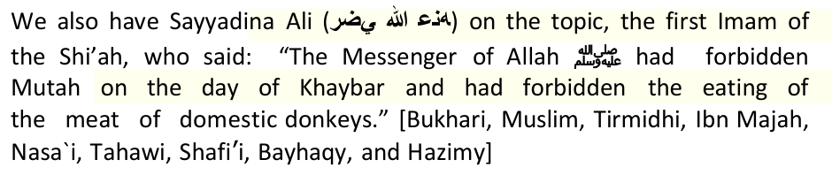
Volume 9, Book 88, Number 216 of Sahih al-Bukhari: Narrated Shaqiq: I heard Hudhaifa saying, "While we were sitting with 'Umar, he said, 'Who among you remembers the statement of the Prophet about the afflictions?' Hudhaifa said, "The affliction of a man in his family, his property, his children and his neighbors are expiated by his prayers, Zakat (and alms) and enjoining good and forbidding evil." 'Umar said, "I do not ask you about these afflictions, but about those afflictions which will move like the waves of the sea." Hudhaifa said, "Don't worry about it, O chief of the believers, for there is a closed door between you and them." 'Umar said, "Will that door be broken or opened?" I said, "No. it will be broken." 'Umar said, "Then it will never be closed," I said, "Yes." We asked Hudhaifa, "Did 'Umar know what that door meant?" He replied, "Yes, as I know that there will be night before tomorrow morning, that is because I narrated to him a true narration free from errors." We dared not ask Hudhaifa as to whom the door represented so we ordered Masruq to ask him what does the door stand for? He replied, "'Umar."
Whereas the first step towards unity is an understanding that when differences of opinion are addressed properly with an open mind, they can be a vehicle to intellectual growth of the Muslim ummah. And Allah says "And do not be as those who divided and differed among themselves afte clear proofs had come to them. It is they for whom there is a terrible torment." Quran 3:105. To those who do good (unite Muslims) Allah says: "Is there any reward for goodness other than goodness." Quran 55: 60
The Shia have taken this permission and mis-applied it. What is wrong with the way Taqiyya is practiced by Shi'ah:
The Hadeeth Al-Thiqlayn indicates to the concept of the Prophet's household clarifying that Ahl Al-Bayt are the relatives of Prophet Muhammad and his wives. Sayyadina Zayd who narrated the Hadeeth Al-Thiqalyn says: "His wives are among his household, but his household are those who charity is forbidden upon them." One asked: "and who are they?" Zayd answered that they were the household of Ali, household of Aqeel, household of Jaffar, and household of Abbas. The first person asked again: "Upon all of them charity is forbidden?" and Zayd answered by a yes"
Now, let us see what language has to say about this issue. Arabic Language scholars are very clear in identifying the wives of a man as his household. Ibn Manthoor says in the Tongue of the Arabs (Lisan Al-Arab): "Ahl Al-Bayt: its dwellers, Ahl Al-Rajul (family of a man) is the closest people to him, and the household of Prophet Muhammad may Allah have peace on him is his wives, his daughters, and his son-in-law who is Ali bin Abi Talib"
Also, Allah says: "Now when Moses had fulfilled the term, and was traveling with his family." Al-Qumi says in his Tafseer: "When the time had come, Musa took his wife, Shu'ayb provided Mousa, and Mousa lead his goats. When Mousa wanted to leave, Shu'ayb told him: "Go, Allah made it privately for you." Therefore, Mousa lead his goats aiming Egypt. Mousa and his wife were in a place when a cold breeze, wind and darkness stroked Mousa and his family. Then, Mousa saw a fire, where Allah said the verse: "Now when Moses had fulfilled the term, and was traveling with his family."
Lastly, we invite Muslims to become literate and READ - as Allah directs us in the opening verses of Surah al-'Alaq. Islam has a pure concept of Tauheed, it's not tainted like that of the Christians, Jews and the Shi'ahs. Shi'ism regards evil as good and good as evil – similar to how the Dajjal will deceive the people. Our Noble Messenger Prophet Muhammad said that 30 Dajjals (super deceivers) will appear before the end of time, and we caution the Muslims from taking these Great Liars as their guides. This is a bitter pill to swallow, but it's better to swallow it in this world, rather than eternally in the next.
(For Islamic Awakening, Ahlus Sunnnah Da'wah League, and Darul Islam Task Team)
It seems strange that a Shi'ah who believes in taqiyyah (holy hypocricy), would start off his flimsy, unsound, unsupported and totally misleading rebuttal with a lecture on truth and falsehood! If Shi'ism is based on truth and on sound doctrines, why did high-ranking educated Shi'ahs repent from this vile satanic creed?
What's rooted in the mind of every Shi'ah, be it the young or the old, the clever or the ignorant, the male of the female, is that the Sahabahs had done injustices against the Ahlul Bait, shed their blood and made
To strengthen further this mut'ah, the name of Rasulullah was even brought in, such as written in "Man La Yahdhuruhu Al Faqih", 3/366,"Whoever does mut'ah with a woman, he will be safe from the wrath of Allah, the Compeller. Whoever does mut'ah two times, he shall be gathered together with the people of goodness. Whoever does mut'ah three times, he will be side by side with me in paradise." It is the spirits of these words that drive the ulama's of the city of
When Imam Khomeini stayed in Iraq, I went back and forth to visit him. I studied under him, thus the relationship between myself and him became so close. At one time, he agreed to go to a city in the framework of fulfilling an invitation, namely the city that is located on the western part of Mosul, That could be reached in about half an hour by car. Imam Khomeini asked me to go along with him. We were received and honoured with an extraordinary honour during our stay with one of the Shi'ah families who lived there. He had pledged allegiance to propagate the creed of Shi'ah in that region. When the visit ended and on our way home, on the road, on our return, we passed through Baghdad and Imam Khomeini wished to rest from the tiring journey. Then he instructed so that we head to a resort area where there lived a man from Iran named Sayyid Sahib. There was a pretty strong friendship between him and Imam.
Mut'ah with Married Women
After wandering in very tiring and painful journey, what should I do? Do I have to remain in the position and office the way it is today, and dredge away the abundant treasures from the simple-minded people
They do this by presenting information selectively, presenting false information, omitting the facts and blatantly lying to produce an emotional rather than rational response to the information presented. Therefore, the purpose of this document is to liberate the mind by presenting facts and reality, exposing deceit, and fostering tolerance in preference to disseminating hatred.
---The Jews don't wipe on their slippers or light shoes (for ablution), likewise the Shi'ites abandon the same thing. (It should be noted that the Jewish ablution is similar to that of the Shi'ites)
A. Shahaadat: "Ashhadu an la ilaha ilaha illAllah, wa Ashadu an Muhammadan Rasulullah wa Ashadu an 'Aliyan wali Allah Wasiyyu Rasulillahi wa Khalifuhu bila Faslin" (Khomeini in Wahdat-e-Islami, June 1984; Sayed 'Ali Haider in Adyaan-e-Aalam) After testifying to the oneness of Allah Ta'ala and the Risaalat of muhammad, the shi'ite kalima also includes the fact that 'ali al-murtadha is the wali of allah ta'ala and the wasi or deputy of the rasul of allah without any any alliance to the other khalifahs.
2. "By listening to the voice of a person, the Imams can tell if the person was destined to go to hell or to heaven; they would thus answer his questions accordingly" (Usool al Kafi, p.185) As you can see the Shia make their Imams out to be some God-like being, can't they see that this is Shirk (worshipping other than Allah, or associating partners with him).
(c) will happen in the future.
24. Imam Mahdi will take revenge against all the sins since Adam (a.s). (Basair-ud-Darajat, p. 83)
Here is how...
From Salim ibn Abdullah which narrated to him that he heard a man
4. Aisha is insulted and described negatively. (Hayat-ul-Quloob, Vol. No. 2, Page No. 879) & (Tohfa-e-Hanfia Dar Jawab Tohfa-e-Jaffria, p. 271 & p. 334)
19. It is written in the Iranian Constitution that only a Shia Ithna Ashari can become President. What about a Sunni Ahle Sunnat wal Jammat becoming President for the sake of Shia Sunni unity?
47. The cutting of heads with razors in Muharam?
2. Tafsir al-Kabir, by ibn Jarir al-Tabari, v6, pp 186, 288-289
Who instigated the martyrdom of the second Caliph of Islam, Sayyadina 'Umar (RA) Who instigated the martyrdom of the third Caliph of Islam, Sayyadina 'Uthman (RA) Who invited Sayyadina Hussain to Kufah then betrayed him, resulting in his martyrdom and his entire family at Karbala?
What would Iran's motivation be to support a Sunni jihadist organizations like ISIS? In Syria, ISIS has forced the West to choose between the regime of Bashar al-Assad or a terrorist outfit. Given that choice, it was assumed that the West would back Assad, as did the Russians and the Chinese.
Alex Rowell writing on the 17th of June in Now Media Me, "Blame Assad for ISIS Rise." He gives examples of the collaboration between ISIS and the Syrian regime.
move to Palestine, and it is from there that we will move on to the rest of
One of the senior researchers in The Academy of Asian and African Studies at The Hebrew University of Jerusalem, Yitzhak Hasson, had been researching the manuscript of the book "Fadhail Bayt Al Maqdis" written by Abu Bakr Muhammad bin Ahmad Al Wasithi. He wrote in his foreword, "It has been understood that the Shi'ah sects do not see the existence of the specialness of this Masjid Bayt Al Maqdis over other Masjids."
launching war of nerves in Syria West
Previously, Assad had accused Israel of aiding the rebels in the civil war.
*Imam Abu Hanifah: It was reported that often Abu Haneefa used to repeat the following statement about the Shi`ites, "Whoever doubts whether they are disbelievers has himself committed disbelief."
Are we Sunni or Shi'ah?: We are neither Sunni nor Shi'ah and consider all these labels a major distraction from reaching Allah.
Abu Abdullah Nuaim Ibn Hammad on a chain of transmission on the authority of Al Zuhari who said " The black flags will come from the East, led by mighty men, with long hair and beards, their surnames are taken from the names of their home towns (i.e. Khosti or from Khost etc.) and their first names are from a "Kunya"(Asmal Masalik Lieyyam
Thawban said, "The Prophet said: 'Three men will be killed at the place where your treasure is. Each of them will be the son of a Khalifah, and none of them will get hold of the treasure. Then black banners will come out of the east…' If you see him, go and give him your allegiance, even if you have to crawl over ice, because he is the Khalifah of Allah, the Mahdi.'" This hadith is reported in Sunan Ibn Majah vol 3 number 4084
Army Of Black Banner consists mainly of Pathans/Bani Israel
Abdullah, the son of Shuraykh, said:"With the Mahdi is the marked Banner of the Messenger of Allah, praise and peace be upon him." On the authority of Thawban, the Messenger of Allah (upon whom be blessings and peace) said: The Prophet Sallallahu 'Alaihi Wa Sallam said: "Before your treasure, three will kill each other — all of them are sons of a different caliph but none will be the recipient. Then the Black Banners will appear from the East and they will kill you in a way that has never before been done by a nation."
Imam Mahdi with his army which is mainly Pashthuns/pathans will fight some Arabs
Sahih ahadith of Muslim Armies with Black Banners to come
To encourage independent cultivation, the Shah donated 500,000 Crown acres to 25,000 farmers. In 1978, his last full year in power, the average Iranian earned $2,540, compared to $160 25 years earlier. Iran had full employment, requiring foreign workers. The national currency was stable for 15 years, inspiring French economist André Piettre to call Iran a country of "growth without inflation." Although Iran was the world's second largest oil exporter, the Shah planned construction of 18 nuclear power plants. He built an Olympic sports complex and applied to host the 1988
George Ball — that guru of American diplomacy and prominento of certain think-tanks and pressure groups — once paid a long visit to Teheran, where, interestingly, the National Broadcasting Authority placed an office at his disposal. Once installed there, he played host to all the best-known dissidents and gave them encouragement. After he returned to Washington, he made public statements, hostile and insulting to the Sovereign.
Iran's last hope: its well-trained military could still restore order. The Carter administration realized this. Du Berrier noted: "Air Force General Robert Huyser, deputy commander of U.S. forces in Europe, was sent to pressure
A factor in the Shah's decision to depart was that — unknown to most people — he had cancer. U.S. Ambassador William Sullivan (CFR) assured the Shah that, if he exited Iran, America would welcome him. Despite the pleadings of myriad Iranians to stay, he reluctantly left. However, shortly after reaching Cairo, the U.S. ambassador to Egypt effectively informed him that "the government of the United States regrets that it cannot welcome the Shah to American territory."
The major oil companies had for years dictated Iranian oil commerce, but the Shah explained:
Under Ayatollah Khomeini's rule, Iran became an Islamic state and cast away the Western-like society that Pahlavi had turned it into. Iran is not at war with Muslims, neither does it see allies in USA and Israel. During the Bush administration USA adopted a strategy of putting pressure on Iran by arming its Sunni neighbours, this was meant to turn Sunni Muslims against Shi'a Muslims. When US was in negotiations with Saudi Arabia over the $30 Billion arms deal, a US analyst commented on CNN in opposition to the motive, indicating that US no longer had a handful of puppets that they can tell what to do, "Remember what
Iran and the Hizbullah are considered as the powerhouse of the struggles of the Islamic World against the hegemony of America and Israel. Iran and the Hizbullah are considered to have given much lessons as to how the world Muslims should respond against atrocities. The popularity of these Shi'ah movements continues to rise and sink the role of the Sunni
2. The Zone of Iraq: Cooperation are carried out with America to undertake such efforts as: the destructions and dividing up of the Iraqi territories, arming the Shi'ah militias to attack the Sunnis, cleansing and expulsion of the Sunnis, and falsifying the percentage of the Iraqi population by spreading false studies which declares the absolute majority of the Shi'ahs, whereas originally the Sunnis occupies 52% of
The tension of the upheaval in the Middle East is getting hotter, although some others are already in the phase of the post-crisis, what remains for them is only to program the future. But some news that developed in the Middle East recently affirms that the Middle East is entering a new era that becomes an arena of competition for the three important components of the world power. The three powers do not simply
The double-faced regime was able, through raising the banner of Islamic unity, to fool many Muslims (like the Amman Accord and the many unity dinners in different places of the world) outside Iran as they ask them to attend their conferences, and transform their way of thinking within a short period of time. Please, you also, don't become a sucker to this. Why don't the Shi'ahs call for unity in places where they are the majority, or where they have political power? Think deeply on this, please; There is no Sunni director in any of the government authorities, ministries, embassies, or local and provincial governments, hospitals or principalities; not even in the lowest government posts anywhere in Iran; Sunnis scholars are either scared into silence or may face prison or death sentences. Ayatullah Al Burqui was a prominent leading Shia figure and when he became Sunni he was shot. He survived but was sentenced to life in prison where he eventually died; In Iran, if you are against asking from the dead
· Al-Sunnah Mosque in Shiraz. Confiscated after the murder of Dr. Muzaffar Ban who founded it, and transformed to a centre for selling video and audio tapes produced by the revolutionary guard.
"Do you expect any change in the policies of the present government towards Ahlus Sunnah after the election of Khatemy?"
I also have a parting word for those who share our creed who visit Iran regularly. We hardly find in any of them any concern towards their religion
The Shi'ah are a cowardly and treacherous nation. They betrayed their first two Imams, and did the same to their third Imam. They lured him to his death. This sounds strange to the Shi'ah as they haave been indoctrinated over the years with lies, so here is some explanation for you ignorant ones …..
ISIS: have guns will fight, even in Saudi Arabia?
by Zafar Bangash July, 2014
The chief cause of the foundation of Shi'ism is that the importance of a successor to the Prophet (pbuh) was addressed during the time of the Prophet (pbuh) and it had to be acknowledged. Considering that there was information that was likely to be understood by the general public, and information which was likely to be understood by only a small number of people with specialized knowledge, which influenced the establishment of schools of thought (madhabs) in the Sunni world. In that sense, Shi'ism came as a realization of the importance of successors of the Prophet (pbuh) who would interpret Islam in the absence of the Prophet (pbuh).
Here is a few more for misguided Shi'ahs to chew on. Maybe they can repent after realizing the filth that Shi'sim is filled with:
After analyzing the above incident, the following can be concluded:
*Aisha is accused of committing adultery. (Quran Majeed by Maqbool Hussain Dehlevi, p. 840)
Please take this as your new gradation of the Sahabah and educate the Shi'ahs on this subject as follows. 'Allàmah al- Qastalànï has mentioned the following gradations of the Sahabah (RA):
10) Those who migrated to Madïnah between the incident of Hudaibiyyah and the conquest of Makkah, like Khàlid ibn al-Walïd and 'Amr ibn al-'Aš.
Trench and those afterwards; (iv) Those who were present for the conquest of Makkah and those afterwards; (v) and Those children who saw the Holy Prophet. 42 Al-Tahàwï, Abu Ja'far Ahmad ibn Muhammad Azdï, Al-'Aqïdah al-Tahàwiyyah, Maktabh al-Ma'àrif: Riyadh, 1990, v.2, pp. 167-169.
43 Al-Ghazàlï, Muhammad, Kitàb al-Iqtišàd, Maktabah Dàr al-Fikr: Beirut, 1987, v.1, pp. 90- 92. 44 'Iyàd, Shihàb al-Dïn, Al-Shifà', Dàr al-Nashr wa al-Tabà'ah: Cairo, 1979, v. 3, pp. 121-124. 45 Qur'àn, sþrah 49 al-Hujuràt (The Private Apartments), verse 10. 46 Nabhànï, Yþsuf ibn Ismà'ïl, Al-Asàlïb, op. cit., pp. 493-500.
47 Al-Samàwï, Muhammad al-Samàwï, Ask Those Who Know, Ansàriyan Publications: Qum, n/d., p. 124.
This commentary concurs with the words of the Holy Prophet (SAW) when he said, "Whoever loathes them, loathes me; whoever injures them injures me; and whoever injures me injures Allàh himself; and whoever injures Allàh, he will soon be caught."52 More specifically, concerning the
53 Bukhàrï, no: 3784 (7/141); Muslim, no: 75 (1/85); Nasa'ï, (8/116); and Ahmad (5/285). 54 Majma' al-Zawà'id (22/10). 55 Ibn Taimiyyah, Al-Šàrim al-Maslul, op cit., p. 559. 56 Al-Samàwï, op. cit, p.131.
of the sins of the believers in general, and in some, of the Companions in specific, but attempted to expel them from the pale of Islàm on the basis of these. Allàh said clearly in the Qur'àn that only shirk (polytheism) cannot be pardonable and which irrevocably expels one from the fold of Islàm. As one notices clearly, none of the Companions mentioned in these verses were ever stigmatized with the sin of shirk:
Even Shi'ahs abhor Mut'ah and know what Mr Islam is saying is a blatant lie! This a plea from a sister from Iran who fell for the trick of Mut'ah
*No Divorce or Inheritance Involved in Mutah: The narrator asked Imam Baqir about the women of Mutah. The Imam said, "She is not among those four [women classified as wives] because she neither needs a divorce, nor is [a child born of her] entitled to any inheritance. She is like a hired woman." (Al-Kafi)
* Mutah with a Young Girl: Jameel bin ad-Dari said that he asked Imam Jafar as-Sadiq if Mutah was permissible with a virgin girl. The Imam said, "There is no harm in it if the girl is not too young. However, all of the collectors of hadith agree that a nine-year-old girl is not considered too young." (Al-Kafi)
* Mutah - A Safeguard Against the Hellfire: Imam Jafar as-Sadiq narrated from the Prophet that "one third of the body is saved from the Hellfire if one contracts Mutah once. Two thirds of the body is saved if one contracts Mutah twice, and the whole body is saved from Hell if one
Answer:
USA Today: 'Pleasure Marriages' (Mutah) Regain Popularity in Iraq
Sunni scholars fear that giving official sanction to pleasure marriages — many of which are only verbal agreements between the couple — are little more than legalized prostitution that could lead to a collapse of moral values, especially among young people. "We have reports about one-hour pleasure marriages that are flourishing among students," says Sheik Ali Al-Mashhadani, a Sunni imam at the Ibn Taimiya mosque in Baghdad. "I'm advising parents to watch their sons very carefully, particularly those who are in the colleges and universities."
http://www.al-shia.com/html/ara/lib/lib.php?id=4&page=5
It was narrated from 'Ali (may Allah be pleased with him) that the Messenger of Allah (peace and blessings of Allah be upon him) forbade mut'ah marriage and the meat of domestic donkeys at the time of Khaybar. According to another report, he forbade mut'ah marriage at the time of Khaybar and he forbade the meat of tame donkeys. [Narrated by al-Bukhari, 3979; Muslim, 1407]
We have understood the differences between the Muslims and the heretic Shi'ah very well, and they are not the type of acceptable differences which we tolerate between the four established Madhahib. This document makes it abundantly clear.
"A believer who does not practice Taqiyya is like a body without a head." (Tafseer al-Askari) "Mix with them (i.e. non-Shia) externally, but oppose them internally." (Al-Kafi vol.9 p.116)
Indeed, this led to the splitting of a person's personality. Because, how does he worship Allah while on the other hand he is kufr against Allah? How does he follow the sunnah of Rasulullah while on the other hand he attacks him? How can he be said following the Ahlul Bait, loving and studying their madzhab, while he insults and mocks him?
How many people who do mut'ah mix up the children and mothers, the women and their brothers, fathers.... and other chaos.
But the gravest of all in the deviations of the Shi'ahs is the presence of other holy scriptures besides Al-Qur'an and that they say that the
Firstly, `Allamah Majlisi, an erudite Shi'ite scholar, has ADMITTED this himself: "Some scholars have asserted that ibn Saba was a Jew who accepted Islam and started voicing his opinion of the `wilayat' (divine appointment) of `Ali. While a Jew, he propounded the exaggerative notion that Yusha ibn Nun was divinely appointed to succeed Prophet Musa, he thus adopted a similar stance with regard to `Ali in relation to the Holy Prophet. He was the first to subscribe to the belief of Imamate, and he openly vitriolated his enemies (i.e. the first three Caliphs) and branded them as infidels. The origin of Shi'ism and rafidizm is thus based on Judaism." (Bihar al-Anwar, vol. 25, p. 287).
---The Jews exalt some their Prophets and Holy men so much that they regard them as deities (in terms of obedience and attachment), whereas they degrade some of the other Prophets and the holy men to such an extent that they call them whores, unchaste, drunkards, corrupt, and idolaters. Similarly, the Rawafid exalt Ali(ra) and his descendents to a status they don't reserve and on the other hand they regard the other Companions of the Noble Prophet (SAW) to be corrupt, hypocrites, idolaters, unchaste(as in the case of Mugheerah ibn Shuba) and whores - as in case of Sayyadia Muawiyah, Amr ibn Al-As, and Umar ibn al-Khattab (RA).
The Jews are of the view that until Dajjaal appears and until Hazrat 'Isa (AS) does not—delayed so long for one reason or another—descend from the heaven, it is wholly wrong to wage a holy war (Jihaad). Similarly, the Raafidhis (Shi'ites) hold that unless Imaam Mahdi appears and unless the heaven testifies to his Imaamat, it is not permitted to unleash a war for the sake of Allah.
According to this Shiite al-Ihqaqi, the noble Companions (RA) who
F. Clean up your religion: If Shi'ahs want unity, why don't they clean up their corrupt beliefs regarding the imperfect nature of Allah, the Messengers, the divinity of their Imams, the Sahabah, the incomplete nature of the Qur'an, taqiyyah (holy hypocrisy) and other such beliefs. Why should Muslims unite with the Shi'ah and give up their salvation for them?
B. Allah speaks lies. (Usool-e-Kaafi, vol. 1, pge 148)
3. "The Imams possess all the knowledge granted to angels, prophets and messengers" (Al-Kulaini, Al-Kaafi, p.255.) Well here is more shirk from the Shia... How can an Imam, who is just a human, know the Unseen? Only Allah knows the Unseen, and think about this. The Imams
(Usool Kaafi, Vol 1, p260 & Vol. 2, p. 10)
25. The Sun will rise from the West at the time of Imam Mahdi's appearance. (Chawdah Sitaray, p. 585)
It is not a secret that Shi'as follow the family of the Prophet and the Quran, because they believe that the Prophet (pbuh) advised them so.
The above hadith affirms the virtue of the Ahlul Bait which the Ahlus Sunnnah wal-Jama'ah do not deny, but it doesn't ask us the take the Ahlul Bait as the ultimate source of DIVINE authority as the Shi'ahs claim. Quite the contrary, the Four Rightly Guided Caliphs and the
The above is an original quotation of. The five pillars of Shi'ism from their own book. It's Salaat (no shahaadat), zakaat, fasting, pilgrimage, and WILAAYAT." Wilaayat means to accept the 12 Divine Imams. This is very different from the five pillars of the Muslims.
from people of Syria asking Abdullah ibn Umar about tammatu of umra to haj, and Abdullah ibn Umar said: Its permitted….
5. Aisha and Hafsa were hypocrite and infidel women. (Hayat-ul-Quloob, Vol. No. 2, p. 900)
If you don't know yet, the Shi'ah Qur'an is very different from the standard Muslim Qur'an. Muslims believe that all of the Qur'aan has been preserved; its wordings as well as its meanings; nothing has been added to it nor has anything been removed from it; confirming His, the Exalted, statement:
"You are the best of peoples ever raised up for mankind; you enjoin Al-Ma'rûf (i.e. Islâmic Monotheism and all that Islâm has ordained) and forbid Al-Munkar (polytheism, disbelief and all that Islâm has forbidden)…" (Aali 'Imraan 3:110)
Allowing Shi'ahs in the Haramain is a political decision. If a dog enters the Haram, it doesn't become a Muslim automatically, and if a Shi'ah enters the Haram, he doesn't become a Sunni all of a sudden! Besides, there are thousands of non-Muslim contractors and security personnel in Makkah and Madinah, did they also suddenly become Muslim?
20. Did Abu Talib die as a Muslim?
48. The additional words in the Azaan?
3. Tafsir Jamiul Hukam al-Quran, by Muhammad ibn Ahmad Qurtubi, v6, p219.
In a response to al Qaeda, Emir Ayman al Zawahiri's latest attempt at reconciliation with the Islamic State of Iraq and the Sham, ISIS spokesman Abu Muhammad al Adnani made a startling admission: Al Qaeda has ordered its fighters and branches to refrain from attacking the Iranian state in order to preserve the terror group's network in the country. (Long War Journal May 2014)
Cynically Iran is exploiting the Western fear of terrorism to make common cause with the West against ISIS. But ample evidence exists to prove Iran's collusion with al Qaeda. The 9/11 Commission Report, had already established that Iran even "facilitated the transit of al-Qaeda members into and out of Afghanistan before 9/11, including future hijackers."
When ISIS was formed in April last year, Syrian activists claimed it served the interests of President Bashar al-Assad and his main ally, Tehran. A report in the Economist magazine 21st June 14 explained how ISIS was less interested in toppling the Assad's regime than fighting other groups. ISIS has been criticized for its attacks on civilians and rival opposition groups. It has never targeted al Assad's regime and not a single barrel bombs has been dropped by the regime on ISIS.
According to U.S. documents and officials, in addition to Abu Ghaith, other of bin Laden's inner circle who ended up in Iran include the formidable military commander of al Qaeda, Saif al-Adel, a former Egyptian Special Forces officer who had fought against the Soviets in Afghanistan, as well as Saad bin Laden, one of the al Qaeda's leader older sons who has played some kind of leadership role in the group. Meanwhile, U.S. intelligence learned that some al Qaeda operatives were living in the northern Iranian town of Chalus, on the Caspian Sea.
The name of a Mr. Sadikov, came up, he is also known as Jafar al-Uzbeki and Jafar Muidinov, serves as a "key extremist smuggler based in Mashhad, Iran, near the country's border with Afghanistan, and has provided visas and passports to numerous foreign fighters, including Al-Qaeda recruits, to facilitate their travel," the Treasury said. According to the Treasury statement, Uzbeki has also provided funding to Abdel-Aziz Khalil, aka Yasin al-Suri, who resumed leadership of Al-Qaeda's Iran-based network after being temporarily detained there in late 2011.
Many of ISIL's practices, including field executions, assassinations and beheadings, aim to tarnish the image of the Syrian revolution, said Mohammed Abdullah, a Syrian journalist residing in Cairo who is documenting the Syrian war, with a focus on the Iranian file. FIGHTING the Free Syrian Army INSTEAD OF SYRIA'S REGIME, ISIS has never engaged the Syrian army or Hezbollah.
OBAMA LOSES IRAQ AFTER COLLUDING WITH IRAN IN KEEPING MALIKI IN POWER AND KILLING POLITICAL REFORM - THE GREATEST SCANDAL OF ALL
An Iranian diplomat says the Israeli regime is in cahoots with the foreign-sponsored militants operating in Syria.
The two-year uprising has fractured into a sectarian conflict. Assad belongs to the minority sect of Alawites, an offshoot of Shiite Islam, which has been confronting huge challenges from Sunni rebels. However, he has been strongly supported by Iran and Hezbollah, both Shiite-dominated.
Obama Sells $11 Billion Worth of Arms to Hamas's Sponsor, Qatar
- See more at: http://pamelageller.com/2014/07/obama-sells-us-sells-11- billion-worth-arms-hamass-sponsor- qatar.html/#sthash.y74xiaDv.dpuf
*Imam al-Shaafi: On one occasion al-Shaafi`i said concerning the Shi`ites, "I have not seen among the heretics a people more famous for
Assalaamualaykum
Brothers in Islam, support the Resistance against the world's worst criminal. When one makes up his mind to do something Allah Subhana Wa Taala will show many doors and paths to the destination.
Mahdiyy Maliki Li Kull-id Dunya Biemrillah-il Malik, Qalda bin Zayd)
Thawban, a companion said: 'Then he said something that I do not remember by heart' then continued to say that the Prophet, praise and
"When the dark people come after the Arabs they will be defeated and thrown into the lowest part of the earth. While these circumstances exist, The Sufyaani will come with three hundred and sixty riders until he reaches Damascus. After a month, he will be followed by thirty thousand from Kalb, so he will send an army to Iraq and kill a hundred thousand in Az-Zawra.
Iran and the Shah: What Really Happened
Olympics (an honor eventually assigned Seoul), an achievement unthinkable for other Middle East nations.
Joining the smear was U.S. Senator Ted Kennedy, whose role Nahavandi recalled in a 1981 interview: But we must not forget the venom with which Teddy Kennedy ranted against the Shah, nor that on December 7, 1977, the Kennedy family financed a so-called committee for the defense of liberties and rights of man in Teheran, which was nothing but a headquarters for revolution. Suddenly, the Shah noted, the U.S. media found him "a despot, an oppressor, a tyrant." Kennedy denounced him for running "one of the most violent regimes in the history of mankind."
The betrayed ruler now became "a man without a country."
In 1973 we succeeded in putting a stop, irrevocably, to sixty years of foreign exploitation of Iranian oil- resources.... In 1974, Iran at last took over the management of the entire oil-industry, including the refineries at Abadan and so on.... I am quite convinced that it was from this moment that some very powerful, international interests identified, within Iran, the collusive elements, which they could use to encompass my downfall.
It is interesting to note that the propaganda used by Maulana Dhorat and company against Shi'as, is the same propaganda used by USA against Islam. USA brands Muslims terrorists which threatens world peace, when USA is the real terrorist state and a threat to world peace. Using the same strategy, Maulana Dhorat and company accuse Shi'as and Iran of twisting words, captivating imaginations and misleading
· Sheikh Fayad Mosque. This is an ancient Sunni Mosque in Mashhad, one of the main Shiah centres in the world. The government could not tolerate the continued existence of this Mosque in the city, so demolished it in 1993, under the supervision of the revolutionary guard, who also demolished adjoining centres which were used as guest houses and Qur`aan memorisation centres. The demolition orders came from
There is a minor change in the policy of the government towards us. Khatemy is not blood-thirsty and does not like the shedding of blood nor the stealing of our money as did Khomeini and Rafsanjany. Khatemi has changed many of the blood-thirsty officials in the Sunni areas with other Shiah who are not as blood thirsty. however, he was not brave enough to
After the death of Hadhrat Hassan, the Shias flocked round his brother Hadhrat Hussain. The most stupendous event and the most glorious episode that occurred during his tenure was his rebellion against Yazid. Yaqubi, one of the extermist Shias, observes that when Yazid was appointed Caliph after the death of his father, he wrote to Walid bin Uqbah bin Abi Sufiyyan, the governor of Madina, to secure the pledge of
Although it is apparent that Maulana Dhorat's aim is to portray fabricated information to influence Sunni Muslims to show contempt towards Shi'a Muslims, but he does not give clear information that
This is the joke of the century!!
Ali Ibn Abi Talib said that he once slept with the Prophet Muhammad (PBUH) and his wife Ayesha in one bed, and under one cover, then the prophet woke up to pray, and left them together [Ali and Ayesha] in the same bed, under the same cover" (Bihaar al-Anwar vol. 40, p. 2) Only a Satanic filth who believes in those narrations would compile
18 Al-Muslim (Chapter on Jumu'ah), no: 240; Ibn Màjah, (Introduction), no: 6, Al-Dàramï, (Introduction), no: 16-23 and Musnad Aåmad ibn Åanbal, op. cit., v. 3, p. 310. 19 Abu Dàwud al-Tiyàlisï, Al-Musnad on the authority of Abu Barzah. 20 Imàm Ahmad, Musnad, on the authority of 'Utbah ibn 'Utbàn. Also see al-Suyuti, Tàrïkh al-Khulafà, 1989, p. 9. 21 Qur'àn, surah 4 al-Nisà (Women), verse 115. 22 Al-'Umairah, Sharh al-'Aqïdah al-Tahawiyyah, p. 298. Here 'Abdullàh ibn Sabà' is likened to Bolis, the person who corroded Christianity and who invented the concept of the trinity. Likewise, he raised 'Alï to the position of divinity until he was burnt by 'Alï himself in 40 A.H.
* An insult to Aisha and prophet Mohammad's companion, Muawiyah. (Tohfa-e-Hanfia Dar Jawab Tohfa-e-Jaffria, p. 65)
11) Those who accepted Islàm on the day of the conquest of Makkah.
51 Ibn Taimiyyah, Ahmad ibn 'Abd al-Halïm Taqï al-Dïn, Al-Šàrim al-Maslul 'Alà Shàtim al-Rasul, Dàr al-Kutub al-'Arabï: Beirut, 1996, pp. 540- 558. 52 Tirmidhï, (5/643); Musnad Ahmad (5/54); Hulyah of Abþ Nu'aim (8/287) Baihaqï's I'tqàd (1/321); Ibn Habbàn (16/244); and Sharh al- Sunnah of al-Baghawï (1/3860).
Verse 9:34, which spoke of the three companions who lagged behind from the battle of Tabuk. Verse 5:54, which spoke of Allàh replacing the Šahàbah with a better people.
A Plea from a Muslim Sister
The translation of the above verse is follows: "…so with those of whom you have enjoyed sexual relations, give them their Mahr as prescribed…" (al-Nisa' 4:24)
The refutation here is the fact that the Raafidi Shi'ahs are following their own whims and desires, because they regard the companions of the Prophet (may Allaah be pleased with them) as kaafirs, then you see them quoting their actions as permissible in this instance and in others!
Women's Studies at the University of Rhode Island.
The Cultural Council for Women, a women's rights group, argue back that such houses would be a "deceitful and thinly disguised" form of
*No Need for Witnesses or Open Declaration of Mutah: There is no need for witnesses or any open declaration in Mutah." (Al-Kafi)
*. The Commission of Mutah: Ali asked the Prophet: "What is the reward of the person who participates in the virtuous deed of arranging the mutual meetings of a man and woman?" The Prophet said, "He will
It is not haram for her to make a living in this way if she follows the rules of Sharia properly. Nor does she deserve to be condemned. This also applies to the men who marry her.
By Rick Jervis, USA TODAY
Short-term marriages were considered idolatry by Saddam's ruling Baath Party in the 1970s and '80s, says Kamal Hamdul, president of the Iraqi Bar Association. Muta'a were punishable by fines or prison, he says. Couples
Married women can't enter a muta'a, although a married man can. Men can void the contract at any time; women don't have that option unless it's negotiated at the outset. The couple agrees not to have children. A woman who
Shi'as maintain that what Allah and His Prophet made lawful will remain lawful until the Day of Judgment; because according to the Noble Quran no one has the authority to make any act lawful or unlawful by his own desire. If there were an interest in banning temporary marriage then God, the All-Knowing would have done so through His Prophet.
Again in Sahih al-Bukhari, Volume 9, Book 88, Number 229, we find mention of treacherous Muslims, which refers to deviant sects like the Rafidi Shi'ah. Narrated Abi Waih: Hudhaifa bin Al-Yaman said, 'The hypocrites of today are worse than those of the lifetime of the Prophet, because in those days they used to do evil deeds secretly but today they
Our task is only to convey the message. Whether Sunnis or Shi'ah accept it or not, its between them and Allah.
(a) Some of the early Shi'ah scholars have incorporated Taqiyya in their classical reference Shi'ah books about the principles of Shi'ism by softening their beliefs in order to make their beliefs "accepyabe." This is extremely dangerous and Islamically unacceptable. It has resulted in the Shi'ah today not knowing the true beliefs of Shiism THEMSELVES. When Shia scholars today read such mild classical books, they say the writers must have used Taqiyya. In other words, what was intended by Shia to deceive Muslims is today deceiving the Shia themselves.
"Taqiyya is necessary and the one who abandons it is excluded from the religion (of the Shia)." (Ehsan-ul-Fatawa Fi Shaeah-e-Aqa'id, p. 26)
Abdulrahman bin Abi Layla, a dignified Companion, says: "Once we asked Prophet Muhammad (SAW) about how to pray on his household although Allah told us how to pray on him. Prophet Muhammad (SAW) answered: "Say: 'O' Allah send prayers upon Muhammad and the family of Muhammad, just as You sent prayers upon Ibraaheem and the family of Ibraaheem. Verily, You are full of praise and majesty. O' Allah, send blessings upon Muhammad and the family of Muhammad, just as You sent blessings upo n Ibraaheem and upon the family of Ibraaheem. Verily, You are full of praise and majesty."
Al-Fayrooz Al-A'abadi says in Qamoos Al-Muheet: "Ahl Al-Amr is its rulers,
Included in the term "Ahl Al-Bayt" are Ali, Al-Hasan, Al-Hussain, and Fatima, may Allah be pleased with them all as it is mentioned in Hadeeth
Sayyid Husain Al-Musawi is not an unfamiliar name among the Shi'ahs. He was a great scholar of the Shi'ahs who was born in Karbala and studied in Hauzah until he got the title "Mujtahid". He also had a special position in the sight of Imam Ayatullah Khomeini. After going through a long spiritual journey, he finally left Shi'ah, because he found so
"Send down your mercy and love O Allah. If not because of Your mercy, I will surely be among those who go astray, in fact among those who lose."
Sayyid Sahib asked us to stay overnight at his place that night and Imam Khomeini agreed. When the time of Isha' came, dinner for us was served. The people who attended kissed Imam's hand and asked him questions regarding a number of issues and Imam answered them. When it was time to sleep and the people had already gone home, Imam Khomeini saw a little girl, her age was around 5 years old but she was
So obvious, the damages caused by mut'ah are very huge and complex. Among others are:
Again, I would like to thank Abdul Salam Islam (no idea if this is his real name or not. Many Shi'ah cowardly hide behind pseudonyms) for taking the time to respond to our report. However, the purpose of this document, it seems, is not to liberate the mind as stated above, but to justify falsehood and evil. The Ahlus Sunnnah wal- Jama'ah love for the pleasure of Allah, and hate evil and falsehood for the pleasure of Allah.
---The Jews regard Al-Jari and Al-Marmahi (two kinds of fish) are forbidden, and the Rafidhi Shi'ahs regard the same.
The Jews delay their Maghrib prayers (Namaaz) until the stars join together. Similarly, the Shiites delay their Maghrib prayers.
He asserts that it was in the spirit of raising awareness of the dangers of Shi'ism. And he maintains that South African Shi'as intend to convert Sunni Muslims to the "open disbelief of Shi'ism", to cause political instability in South Africa, and to discourage unity.
C. Obedience to 'Ali and Hasan is obligatory, not only to Allah. (Usool-e-Kaafi, vol. 2, pge 42) D. 'Ali is also God. (Jila-ul-Ayoun, vol. 2, pge 66)
6. It is a fundamental principle of faith that our (Shia) Imams have ranks higher than the ranks of angels & God's prophets. (Khomeini's book, Hukuma Islamiya, p. 52)
26. Imam Mahdi will appear when only forty two believing Shia will be left on the face of the Earth. (Chawdah Sitaray, p. 571)
You be the judge, can Shi'ahs still be regarded as Muslims.
"Verily, the people who payed allegience to Abu Bakr, Umar and Uthman, have payed allegience to me based on the same principles as the allegience to them. So anyone who was present has no right to go against his pledge of allegience, and anyone who was absent has no right to oppose it. And verily shura (consultation) is only the right of the Muhajirs and the Ansar. So if they decide upon a man and declare him their Imam, then it is with the pleasure of Allah. If anyone goes against this decision,
6. Aisha was a hypocrite. (Hayat-ul-Quloob, p. 867)
21. We see Iranians during Muharaam;
49. How many daughters did Nabi (SAW) have?
Who helped the Mawali (Persians) overthrow the Umayyad Dynasty?
ISIS was established on April 8, 2013, when its subsidiary organization, Jabhat al Nusra, merged with the Islamic State of Iraq (ISI), which itself was a successor to al-Qaeda in Iraq.
>ISIS bases have never been targeted by the Syrian regime. A government adviser told the New York Times' Anne Barnard this was indeed a deliberate policy, designed to "tar" the broader opposition and "frame [the] choice" as either Assad or the extremists.
June 15, 2014Uncategorized
Yitzhak Hasson also presented daleels of hadith which are listed in the book "Bihar Al Anwar" written by Al Majlisi, a foremost marja' of Shi'ah, by writing that "The ulama's of Islam have never agreed that the referred Masjid Al-Aqsa is the Masjid that is in Al-Quds today, because some of
"We will not allow that [to establish Alawite rule]. The Sunnis in the area will not allow it. That is why Assad's forces started performing ethnic cleansing in the area. The massacre in the Banias is one example of these efforts," said Saleh.
Iranian Minister of Labor, Cooperatives and Social Welfare Ali Rabiei voiced Iranian hospitals' readiness for rendering medical services to the Gazans who have been wounded as a result of Israeli army attacks on the besieged enclave. Rabiei said that Iranian hospitals are ready to admit the Palestinians in need of medical treatment if they are transferred to Tehran.
UNCATEGORIZED 19 Comments
How can you help?: Work towards unity and mutual consultation on all affairs! The clergy class want to lecture god-fearing hard working people about beard and kurta when they have never put in a hard day's work and have no concept of hard earned money. Topple the status quo whose first line of defense are the clergy-class. Stop financing them immediately.
Narrated Abu Hurayrah: Allah's Apostle (peace_be_upon_him) said: You have heard of the city, one side of which is inclined and the other is on the coast. They said: Yes, Allah's Apostle (peace_be_upon_him). Thereupon he said: The Last Hour will not come until 70,000 people from the children of Israel attack it. When they land there, they will neither fight with weapons nor shower arrows but will only say: "There is no god but Allah and Allah is the Greatest," and one side of it will fall. Thawr (one of the narrators) said: I think that he said: The area on the coast. Then they will say for the second time: "There is no god but Allah and Allah is the Greatest," and the other side will also fall. They will say: "There is no god but Allah is the Greatest," and the gates will be opened for them and they will enter. They will be collecting spoils of war and distributing them among themselves when a noise will be heard and it will be said: Verily, the Dajjal has come. Thus they will leave everything there and turn to (confront) him. (Sahih Muslim Book No:
Then they will go to Kufa and pillage. When this occurs a banner will come
"Thawbaan reported that the Prophet (Sallallaahu `alayhi wa sallam) said, 'Three will fight for the your treasure (of the Ka`bah), each of them the son of a 'Khaleefah', it will be rendered to none of them. Then from the direction of the East will emerge black flags. Then they will fight you like they have fought none before.' Then some words were spoken which I did not remember. He then said, 'If you see him, give bay`ah to him even if you must crawl over ice. For, verily, he is the 'Khaleefah' of Allah (Khaleefatullaah), the Mahdi". This Hadeeth is found in Ibn Maajah, Ahmad's Musnad, al-Haakim's Mustadrak and others
Written by James Perloff
At the center of the "human rights" complaints was the Shah's security force, SAVAK. Comparable in its mission to America's FBI, SAVAK was engaged in a
Iran's Chaotic Descent by Zafar Bangash July, 2014
Iran is about to start a fresh round of talks with Western powers. What are the prospects of finalizing a deal? It will depend on how far Western powers are able to adopt a realistic attitude toward Iran's peaceful nuclear program rather than living with illusions.
You can not compare Ijtihaad (intellectual exertion) employed by the Sunni jurists like Imam Abu Hanifah to the Wahy (revelation) received by the 12 Imams!
and report them. We would not stop but we would like to go even further in showing more absurdities!
*According to Shï'ï sources, very few Companions did not break their covenant with the Holy Prophet (SAW). The 120 000 Šahàbah who heard the address plotted to deprive 'Alï of his right to be a successor of the Holy Prophet (SAW)? There was no plausible or cogent reason why they could have done this.
* Prophet Mohammad's wife, Hafsa, was an indecent woman. (Tohfa-e-Hanfia Dar Jawab Tohfa-e-Jaffria, p. 123)
1) Those who accepted Islàm in the first Makkan period of Islàm. These included Khadïjah bint Khuwailid, Abu Bakr, 'Alï ibn Abu Tàlib, 40Zaid ibn
12) Those children who saw the Holy Prophet (SAW) upon the conquest of Makkah and participated in the farewell pilgrimage, like Sà'ib ibn Yazïd.41
Verse 8:28, that spoke of betraying ones trust.
* The Price of Mutah:The narrator asked Imam Jafar as-Sadiq, "What should be the minimum compensation for Mutah?" The Imam said,
Wasalaam unintentionally gets pregnant can have an abortion but must then pay a fine to a cleric. Women's rights activists are concerned. Salama Al-Khafaji, a Shiite lawmaker who supports the concept of sharia law but advocates for women's rights, calls the re-emergence of muta'a an "unhealthy phenomenon…"
8. "Allah the Exalted and Majestic forbids intoxicants to the Shia; Mutah is the compensation for this."
It was narrated from al-Rabee ibn Sabrah al-Juhani that his father told him that he was with the Messenger of Allah (peace and blessings of Allah be upon him) who said: "O people, I used to allow you to engage in mut'ah marriages, but now Allah has forbidden that until the Day of Resurrection, so whoever has any wives in a mut'ah marriage, he should let her go and do not take anything of the (money) you have given them." [Narrated by Muslim, 1406]
many deviations and errors in it. This article was excerpted from his book, 'Why I Left Shi'ah (transl.)', his responsibility for Allah and
A woman came to me asking for the incident that befell her. That woman told that she had had nikah mut'ah with an influential personage and ulama', Sayyid Husain Sadr, twenty years ago, and she got pregnant.
Here are some further proofs of Jewish influences on Shi'ism. This leaves no doubt that Shi'ism was started By Ibn Saba. His task was further accomplished by the hypocrite companions of the Imams of the purified Ahlul Bayt like Zurara ibn Ayan, Abu Baseer al Muradi, al-Mufadhaal ibn 'Umar etc.
---Disgrace and cowardice befell the Jews wherever they were and similarly disgrace and cowardice caught the Rafidhi Shi'ahs so much that they resurrected Taqiyya out of extreme fear and humiliation.
The Jews say their prayers while removed from the Qiblah and a bit tilted
We can provide Shi'ahs many more reasons for our stance on not mixing faith with fasleshood, substantiated directly from the Qur'an. We are only
E. All 12 Imams are God. (Jila-ul-Ayoun, vol. 2, pge 85)
7. The Imam possesses more attributes than a Prophet. (Usool Kaafi, Vol.1, p. 388)
27. All angels will swear allegiance to Imam Mahdi. (Chawdah Sitaray, p. 594)
Shi'ahs do not follow the universal Muslim Sunni Qur'an as Mr Islam claims from the above words. These are the proofs:
The eminent Shaykh of the Shi'ahs, al-Muzaffar, in his book "Dalail as-Sidq" (7/275), chapter words of Allama al-Hilli, switched the words of the hadith "Tamattu' of Hajj, to read "Tamattu' with women." What audacity! Here is the proof
7. Aisha was an infidel woman. (Hayat-ul-Quloob, Vol. No. 2, p. 726)
Abu Abdullah, upon him be peace, said to someone who recited this verse as: '(You are) the best nation…' (He said):
a. beating their chests-drawing blood;
50. Karbala took place on the 10th of Muhraam at Asr time. Why the mourning and groaning from the 1st, before the event? Why terminate on the 10th after the event? Does one mourn before the death of a person or after?
Who invited the Mongols (Hukagu Khan) to bring the 'Abbasid dynasty to an end. Didn't ibn al-'Alqami betray his trust?
Iran, according to the report, wished to conceal any past evidence of its cooperation with "Sunni terrorists association with al-Qaeda," but these connections continued.
More And More Evidence Of Iran's Links With al Qaeda
From his Iranian refuge Saif al-Adel authorized al-Qaeda's branch in Saudi Arabia to launch a series of terrorist attacks in the Saudi kingdom that began in the capital Riyadh in May 2003, a campaign that killed scores of Saudis and expatriates. The fact that leading members of al Qaeda were
The US Treasury Department released a statement on 16 February 2012 designating the Iranian Ministry of Intelligence and Security (MOIS) as a supporter of international terrorist organizations.
"In al-Raqa, for example, ISIL spared strategic Syrian regular army positions, despite the fact it controls the bulk of the territory in the province." The three positions are the airport and [the headquarters of] the 17th Division and 93rd Brigade.
Several foreign-sponsored militants in Syria (file photo)
"We all agree that the principal enemy of the Islamic world and Muslims is the Zionist regime (Israel). The regime is currently colluding with the Takfiri terrorists in Syria and is providing medical care for their wounded, and [Israeli Prime Minister Benjamin] Netanyahu proudly visits these terrorists in hospital," said Iran's Ambassador to Lebanon Ghazanfar Roknabadi. He made the remarks in a meeting with former Lebanese Prime Minister Fouad Siniora in Beirut on Wednesday. Siniora, for his part, condemned the last November bomb attacks outside the Iranian Embassy and the recent bombing against the Iranian cultural center in Beirut.
When the world recoils from the atrocities experienced by the Palestinians, Shi'as in the Islamic Republic of Iran support Palestinians, endorse creation of Palestinian state, sends aid to various Palestinian causes, from transporting injured children to hospitals to supplying the
We know that our social presence in this world is bleeding and some of us are hungry and our responsibility is to try to provide for those who are in these adverse times. We know that this is a day of happiness and we have mixed feelings. We want to be happy with those who are immediately with us and we want to share with those who are distances away; with this, we will try to do our best.
This Ramadan is not to be forgotten brothers. This is the blessed Ramadan when over a 1000 Mumin were given martyrdom. In the last 10 nights most of the martyrs fell.
Hadhrat Buraidah (R.A.) says that Rasulullah (Sallallahu Alayhi Wasallam) said: "There will be many armies after me.
40 No: 6979)
So, after reading all these authentic Ahadith, how will Iran ever be a savior for the ummat? Stop fooling everyone, please!!
Long regarded as a U.S. ally, the Shah was pro-Western and anti-communist, and he was aware that he posed the main barrier to Soviet ambitions in the Middle East. As distinguished foreign-affairs analyst Hilaire du Berrier noted: "He determined to make Iran … capable of blocking a Russian advance until the West should realize to what extent her own interests were threatened and come to his aid.... It necessitated an army of 250,000 men." The Shah's air force ranked among the world's five best. A voice for stability within the
On February 1, 1979, with U.S. officials joining the welcoming committee, Ayatollah Khomeini arrived in Iran amid media fanfare. Although counterdemonstrations, some numbering up to 300,000 people, erupted in Iran, the Western press barely mentioned them. Khomeini had taken power, not by a constitutional process, but violent revolution that ultimately claimed hundreds of thousands of lives. Numerous of his opponents were executed, usually without due process, and often after brutal torture. Teheran's police officers — loyal to the Shah — were slaughtered. At least 1,200 Imperial
I've demonstrated, with Shi'ah references, that the Shi'ahs believe in 12 prophets after the Final Prophet, that our present Qur'an is not authentic, their salaat, fasting and zakaat (Shi'ahs believes in khums – 25% alms-tax. To be a Shi'ah, you got to cough up big time) is different, and they belleive in raj'at (coming to life before resurrection). Shi'sim is a chutney for all the confused people of the world – all systems go, and none work.
The Sunni jurists arrived at solutions based on the Qur'an, Sunnah, Ijma (consensus) of the Sahabah, and Qiyas (juridical analogy), whilst the Imams simply sucked out ordinances from their thumbs, with no systematic methodology or sense to them.
Allah [swt] said, in several places in His Glorious Book: 24:30 Say to the believing men that they should lower their gaze and guard their modesty: that will make for greater purity for them: and Allah is well acquainted with all that they do yet we read in the authentic al-Kafi: "Narrated Muhammad bin Yahya, from Ahmad bin Muhammad, from Ali bin al-Hakam, from Ali bin Suwaid said: I said to Abu al-Hasan: I have the problem of looking at the pretty woman, so I (keep) looking at her. He said: Laa Ba's (No Problem) if Allah knows that your intention is true, but beware of Zina, it causes the blessings and faith to perish (al-Kafi (fil Furoo') al-Kulainy, Book of Nikaah, Chapter of Zina, vol.5, p.542, narration 6.) According to this narration Gazing lewdly at women is okay. What is more Ironic and funny is that the prominent and respected Ayatollah Fadallah of Lebanon gave a fatwa permitting to gaze lewdly on naked women!
*The Ghadïr Khumm address most probably took place on the 18th of the Dhu al-Hijjah. On the 9th of the same month,
Let the Shi'ahs break down the tomb of Abu Lu'lu Majoosi, burn all their books, banish all their scholars, and ask the entire nation to repent publicly. After this only, can we believe a little of the above that Shirazi said.
40 Here too, first Abþ Bakr leads, followed by 'Umar, 'Uthmàn, then 'Alï. Imàm Ahmad ibn Hanbal, in his grading of the Companions, did not recognize 'Alï as the fourth in line of superiority. The reason for this was that Imàm Aåmad had not received most of the traditions which postulated the virtues of 'Alï. The few that he had, he feared to include them in his Musnad due to the common belief in his time that 'Alï was imbibed with divine powers. Thus, Imàm Aåmad reached his conclusion regarding 'Alï, not on the basis of factionalism or hatred for him, but due to his technical standard which he laid down for his Musnad. Imàm Ahmad also deemed it permissible for a less capable person to lead the Muslims in the presence of a more capable person if this could prevent mischief. He thus regarded Mu'àwiyah and his followers as fighting a just cause. Though 'Alï was undoubtedly more capable, he could not prevent strife. Imàm Aåmad said, "It is incumbent to obey the Amïr al-Mu'minïn, whether he may be pious or a deviate, or whether they were forcefully subjugated. Whoever does not pledge his allegiance to the leader of his time, dies a death of ignorance." See Abu Zahrah, Imàm Ahmad ibn Hanbal, Dàr al-Fikr: Beirut, 1982, p. 139. Also see Al-Ashuh, Šabrï, Al-Tafkïr 'ind A'immah al- Fikr al-Islàmï, Maktabah Wahbah: Cairo, 1997, pp. 192-193 41 Nabhànï, Yusuf ibn Ismà'ïl, Al-Asàlïb al-Badï'ah fï Fadl al-Šahàbah wa Iqnà' al-Shï'ah, Idàrah al-Šiddïq: Pakistan, 1979, p. 458. Imàm Zarqànï has only mentioned five gradations: (i) The participants of Badr; (ii) Those who accepted Islàm in the early stages and migrated to Abyssinia; (iii) Those who were present in the battle of the
Verse 33:12, which spoke of the help of Allàh in the battle of the Trench (Khandaq). Verse 9:14, wherein Allàh speaks of not guiding the corrupt ones.
I was fourteen years old and my relationship with my parents was on the edge just like any other teenager. I started to become interested in boys. I felt as if no one understood me, not even my friends. I especially didn't feel pretty with my braces. It all changed when I met him. It was fascinating to know that a college student would care so much about me. He was the most wonderful person. He treated me like a queen, and soon we became the best of friends. I felt I could tell him anything. As our friendship progressed, we talked about different topics including religion.
Shi'ahs, as Mr Islam just did now above (he must've cut and paste from somewhere as usual), say that this verse indicates that mut'ah (temporarary marriage) is permissible, and the word 'their mahr (ujoorahunna – lit. their dues or their wages)' is evidence that what is meant by the phrase 'you have enjoyed sexual relations' is mut'ah.
However, to be courteous to their stupidity, we will still say that with regard to those who said that it is permissible, they are among those who did not hear that it had been forbidden. The Sahaabah (may Allaah be pleased with them) – including 'Ali ibn Abi Taalib and 'Abd-Allaah ibn al-Zubayr – refuted Ibn 'Abbaas's view that mut'ah was permitted.
According to an official source in Tehran, there has been a 635 percent increase in the number of teenage girls in prostitution, or rather, Mutah. The magnitude of this statistic conveys how rapidly this form of abuse has grown. In Tehran, there are an estimated 84,000 women and girls in prostitution, many of them are on the streets, others are in the 250 brothels that reportedly operate in the city. The trade is also international: thousands of Iranian women and girls have been been "contracted in Mutah" to foreigners abroad. The head of Iran's Interpol bureau believes that the Mutah trade is one of the most profitable activities in Iran today.
BAGHDAD — In the days when it could land him in jail, Rahim Al-Zaidi would whisper details of his muta'a only to his closest confidants and the occasional cousin. Never his wife.
"A woman who practices muta'a does not usually feel comfortable about it," Al-Khafaji says. "People these days are creating excuses to practice these acts."
The Shi'ah refute that Mut'ah was abrogated because they are an immoral people. Below is a picture of Shi'ah women openly soliciting prostitution in the name of Mut'ah a few weeks ago. Does Islam allow open immodesty like this?
1. "A man should at bare minimum contract Mutah at least once during his lifetime. "
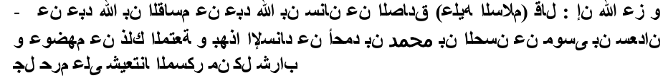
(b) In Islam, Taqiyya is intended to be practiced only under limited circumstances, as an exception to the general rule about openness and honesty. Whereas, for the Shia, Taqiyya is the rule, not the exception of
"The most beloved thing on the surface of Earth is Taqiyya." (Usul Kafi, Part 2. Kitab Imaan wal Kufr, Bab Taqiyyah, Line 12, Riwayah 4, page 217, New Iranian Edition)
Then Prophet Muhammad (SAW) taught them other forms of prayers upon him and his family, and one of the forms is: "O' Allah, send prayers upon Muhammad and upon the wives and descendants of Muhammad,
I again asked myself, "What is the attitude of the notable figures, the imams and those who are considered as ulama's? What is their stance on this matter? Do they see what I see? Do they learn what I learn?"
First, it's violating against the nass (explicit text) of the Shari'ah, for making halal what is made haram by Allah.
The Twelver Ihna 'Ashari Shi'ahs are a misguided and deviated people. They were NEVER Muslims in the first place, so we are NOT expelling them
---The Jews forbid the eating of rabbits and spleen and likewise the Shiites regard the same.
There is no discreet agenda here. It's as clear as daylight and it's our democratic right too, to say it: Our motive is to demonstrate that unity with the Shi'ah is an impossibility. This is called awareness and education, and not "friction and disunity." These are our reasons for our position:
F. We neither accept that God nor Prophet whose successor is Abu Bakr. (Anwaar-e-Naumania, vol. 2, pge 278) G."All Imams are in possession of divine attributes." (Basair-ud-Darajat, pge 23)
8. All Imams are equal in rank and status to Prophet Muhammad (s.a. w). (Usool Kaafi, Vol.1, p.270)
28. An Imam talks before being born. (Ahsan-ul-Muqaal, Vol. 1, p. 327)
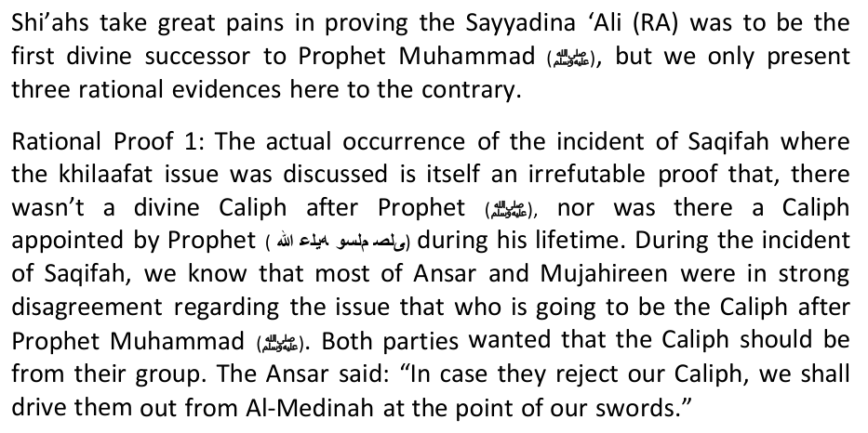
8. Aisha is accused of committing adultery. (Quran Majeed by Maqbool Hussain Dehlevi, p. 840)
b. cutting their heads with razors-drawing blood;
Who established the Safavid dynasty as a rival to the Sunni 'Abbasid and Ottoman Dynasties and started a systematic persecution of Sunnis?
The organization's leader,Abu Bakr al-Baghdadi, who recently announced the Islamic Caliphate. The group announced on the 30th June that it was now called the "Islamic State." An official document was also released in English and several other languages.
> As one ISIS defector told The Daily Telegraph, "We were confident that the regime would not bomb us. We always slept soundly in our bases."
"Unless Iraq wakes up and institutes political reform US forces will not intervene to [crush al Qaida] end the conflict," says Obama.
In his annual report to 2014 the International Labor Organization (ILO), the Iranian minister underscored that cruel bombardment against the Gazans have turned the region into an explosive box.
Where did we study?: Where ever we found Allah to be the priority power in mans life. We refer you to Allah's words ittaqu Allah wayu Allimukum Allah, be aware of Allah's power and He will teach you (Surah Al Baqarah)
Americans have been hearing for several years about potential war with Iran. For instance, on September 17, 2006,Time magazine reported, "The U.S. would have to consider military action long before Iran had an actual bomb." On October 10, under the heading "A Chilling Preview of War," Time warned: "As Iran continues to enrich uranium, the U.S. military has issued a 'Prepare to Deploy' order."
The Saudis may have created a monster that is likely to bite them as well. Should the ISIS invade Saudi Arabia, it will be a fight of a lifetime. Muslims will have a ringside view of a blood-curdling duel between ideological twins.
Abbas betrays Palestinians to please Israel
That's why some of their teachings are simply ridiculous and downright scornful. Here's a fun-fact for the Shi'ah to digest a bit:
Transvaal: Johannesburg, 1986, pp. 113-119. 26 Tirmidhï, Abu 'Ïsà, Al-Jàmi', Fàruqï Kutub Khànah: Lahore, n/d., v. 2, p. 213. 27 Najafï, I. H, Ghadïr Khumm, A Group of Muslim Brothers: Tehran, 1985, pp. 9-19.
Verse 49:14-17, which spoke of the insincerity of the desert Arabs.
58 Musawï, Musà, A Critical Revision of Shï'ah: The Conflict between the Belief and the People, High Islàmic Council of the Americas: Lombard, 1992, pp. 35-36. 59 Kanz al-'Ummàl, 7/124; Tàrïkh of ibn 'Asàkir, 4/97; and Ihyà al-'Ulum al-Dïn of al-Ghazàlï, 1/129. 60 See al-'Izz, 'Alï ibn Muhammad, Sharh al-Tahàwiyyah fï al-'Aqïdah al-Salafiyyah, Maktabah al-Ma'àrif:, Riyàdh, 1972, v. 2, pages 97-99 and 286.
(source: Al-Islam.org,
Al-Mousawi, the Shiite cleric, says the practice of pleasure marriages is open to abuse and misinterpretation. He says he is particularly troubled by kiss-and-tell men. "After they've finished with the woman, they've told their friends about her beauty and given a description of her body,
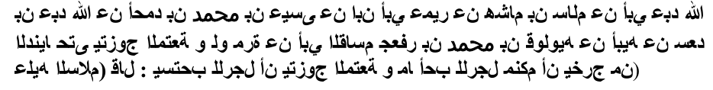
Allah has made marriage one of His signs which calls us to think and ponder. He has created love and compassion between the spouses, and has made the wife a source of tranquility for the husband. He encouraged us to have children and decreed that a woman should wait out the 'iddah period and may inherit. None of that exists in this haraam form of marriage. A woman who is married in a mut'ah marriage, according to the Raafidi Shi'ahs like Mr Islam and his friends, are the ones who say that this is permissible, is neither a wife nor a concubine. But Allah says (interpretation of the meaning): "And those who guard their chastity (i.e. private parts, from illegal sexual acts) Except from their wives or (the slaves) that their right hands possess, for then, they are free
"The Imam has mentioned that Taqiyya is the coolness of his eyes." (Usul Kafi, Part 2, Kitab Imaan wal Kufr, line1, Riwayah 14, page 217, new Iranian Edition].
Although our aim is not to engage the Shi'ahs whom we regard as open disbelievers, we felt that we should respond to this rebuttal so that the Muslim public is not misled by the lies and the inaccuracies contained therein. We however hope that Shi'ahs can also read this report and
---The Jews said only the progeny of David has the authority to rule, likewise the Shiites stated that only the descendants of Sayyaina Ali(ra) should be the Imams or leaders.
---The Jews pray three times a day, similarly the Shiite pray three times a
H. Kalma Tayyibah without "'Ali Waliullah" is false. (Shia Mazhab Haq Hai, Pge 2)
9. Shia must follow the Imam when he is under the state of Taqiya (lying about his true faith). (Usool Kaafi, Vol. 1, p.40)
29. The Imams are NOT born like ordinary human beings from their mothers' wombs. (Jila-ul-A'yoon, Vol 2, p.474)
A. "A man said that someone was reciting the Qur'an in the company of Imam Ja'far. The narrator said that he heard certain verses in the recitation which were not according to the recitation of the people. Imam Ja'far told the person reciting: 'Do not recite like this. Recite as the people recite until the (promised) Mahdi arrives. When the Mahdi arrives, he will recite the Quran according to its original revelation and the Qu'ran compiled by Ali will be recited". (Usul-e-Kafi, vol. 2, page 632).
9. An insult to Aisha and Prophet Mohammad's companion, Muawiyah. (Tohfa-e-Hanfia Dar Jawab Tohfa-e-Jaffria, p. 65)
"Verily We: It is We Who have sent down the Dhikr (i.e. theQur'ân) and surely, We will guard it (from corruption)." (Al-Hijr 15:9)
'(How are they the best when) they killed the chief of the believers ('Alee), Hasan, and Husayn the son of 'Alee!?' So it was said to him: 'How was it revealed, O son of Allaah's Messenger?' He said: 'It was revealed: "You are the best Imaams raised up for mankind…'" Then he said: "As for that which is distorted from it, then it is His, statement:
c. hitting their chests with chains-drawing blood; Is all this humane? Or logical? Is Deen so cruel?
If an author cannot quote information that takes Shi'a Muslims out of the fold of Islam from authentic Shi'a books, then readers are bound to question the truthfulness of the claims and also to question the honor of the author.
Who established the Fatimid Dynasty and entered into an alliance with the Christian Crusades against the Seljukids. They forced the Sunnis to convert to Shi'ism, but many resisted. They also established the Al-Azhar University as a rival to the Nizamiyyah in Baghdad?
ISIS suddenly emerged in Syria, at a time when the collapse of Assad's regime seemed imminent. The emergence of ISIS saved the Syrian regime by threatening the world with an alternative terrorist regime would
While Muslim-majority countries from Afghanistan to Morocco have had their share of bloody al-Qaeda violence over the past decade, Iran has
The Iranian ISIS/ISIL connections
Iranian Documents Found in ISIL's Possession
He also stressed Lebanon's strong opposition to the Takfiri militants
These countries supporting Hamas, Qatar and Turkey, should be punished with sanctions, not rewarded with arms. DoD Statement on Secretary of Defense Chuck Hagel's Meeting with Qatar Minister of State for Defense Affairs Hamad bin Ali al-Attiyah," Defense.gov, July 24, 2014 (thanks to Kenny)
This is definitely not a Sunni versus Shi'a war; it is certain individuals within and outside Islam against the Shi'a. The big question is why? Nobody was against Iran when it was under the pro America Shah Pahlavi administration. But since the Iranian Islamic Revolution which signaled the end of political relations between Iran and USA, a strange thing happened. Muslims and enemies of Islam shared a common hobby, an aversion to Shi'as, particularly Iran. Muslims need to ponder over matters and refuse to be lured into ungodly agendas. Why are Muslims against other Muslims who fight injustice and support the oppressed? How is standing up against USA and Israel's unjust governments destroying Islam?
A felicitous Eid to you and a remembrance of the brothers and sisters who we have around the world who are spending this Eid in the struggle against kufr, shirk, nifaq and hypocrisy. With that in mind, we say and we invoke Allah's presence wherever true Muslims are, and we ask Him that the Hajj, Makkah and Al Madinah regain their centrality in our lives. And we ask Him All Mighty, All Seeing and All Knowing to rid us of such clans and tribes who are interfering in the Hajj, interfering in the affairs of the Muslims to the detriment of the Muslims and to the construction of kufr. We ask Allah, not only verbally, but by what we do, by our lives and everything we have invested in Him to rid us of these munafiqin, these muthabbitin, these muawwiqin, for now and forever. On that day and at that time, we will truly enjoy Eid- an Eid of freedom and liberty, an Eid of self-determination and reliance upon Allah.
May Allah Subhana Wa Taala have Mercy on them. Pray for those little kids who are now with wings flying in al-jannah, for those 4 little boys playing games with the angels in jannat al -firdaus, for those little babies who will be suckled by the angels, for those young men who will be washed by the angels, for those fathers and mothers who will be greeted with Salamun Salama! Ya Allah, these martyrs are an offering for you, please accept them, reward them in Jannah and let them meet their master Ar-Rasul Allah Sallillahu Alihi Wa Alihi Wa Sallam at the Fountain. Let our shaheed rest in Jannah and their dogs burn in hell.
Qays Tribe: Narrated by Hazrat Abu Huraira(R.A) Dear Prophet(Salallaho alayhay wa sallam) said: That a person called Sufyani will appear from the
Ayatollah Khomeini was determined to eliminate foreign influence and spread Islamic revolution over diplomatic relations.
In September 2007, US News & World Report stated: "Amid deepening frustration with Iran, calls for shifting Bush administration policy toward military strikes or other stronger actions are intensifying." And in June 2008, President-to-be Barack Obama declared: "The danger from Iran is grave, it is real, and my goal will be to eliminate this threat."
Fighters of the Islamic State of Iraq and the Syria (ISIS) celebrate on vehicles taken from Iraqi security forces, at a street in the city of Mosul, June 12, 2014. Reuters Iraq's highest-ranking Shia cleric, Grand Ayatollah Ali Sistani, has issued a religious summons to the nation's Shia Muslims to help defend the nation against the Sunni-led Islamic State of Iraq and Syria (ISIS), the New York Times reported Friday.
Its "REGARDING THE DESIRES AS GOD" at its best! (itttiba' al-Hawa)
Although Shi'as do not wage war against the Sahaba, they support their argument on the superiority of the Ahlul Bait by referring to authentic Sunni books. Sayyidina Umar ibn Abu Salaman (RA) stepson of the Prophet (pbuh) reported about this verse: Allah only desires to take away from you all abomination, O people of the household, and to purify you with a thorough purification. (33:33)
Verse 8:6, which spoke of a group who disliked the truth.
The refutation of this is the fact that prior to this, Allaah mentions the women whom a man is forbidden to marry, then Allah mentions what is permissible for mankind, and He commands the man to give to the woman he marries her mahr. The joy of marriage is expressed here by the word enjoyment ('of whom you have enjoyed sexual relations'), it's not prostitution or temporary marriage! To prove our point,
It was narrated from 'Ali that he heard Ibn 'Abbaas permitting mut'ah marriage, and he said, "Wait a minute, O Ibn 'Abbaas, for the Messenger
High unemployment – 28 percent for youth 15-29 years of age and 43 percent for women 15-20 years of age - is a serious factor in driving restless youth to accept Mutah. The Mutah "pimps" take advantage of any opportunity in which women and children are vulnerable. For example, following the recent earthquake in Bam, orphaned girls have been contracted out in Tehran where Iranian and foreign traders meet.
Al-Zaidi hopes to soon finalize his third muta'a, or "pleasure marriage," with a green-eyed neighbor. This time, he talks about it openly and with obvious relish. Even so, he says, he probably still won't tell his wife…
Khomeini stated in his book "Tahir-ul-Wasila", Vol. 2, Page No. 292, "Temporary marriage can be for one day, a night, and even just a few hours!. But for Khomeini, that was not enough so he further states in the same book on Page No.
I need someone to complain about all my confusion and pour out all my sadness to. I finally got the guidance and a good idea, i.e. to do a comprehensive study and reassess all the subject materials that I had received. I read everything I got from the references, be it the mu'tabar or otherwise. I read every book that got into my hands. I pondered to review some of the paragraphs and those nas and I commented based on the ideas that were in my brain.
Second, the fake riwaayahs that are diverse and their attribution to the imams, whereas therein contains vituperations which would unplease a person who still has an atom of iman in his heart.
---The Jews had slandered the chaste and pure Mary the mother of Jesus(as), whereas the Shiites slandered and accused Ayesha (ra) the
A. The existence of numerous sects, the majority of which are deviant, is a predetermined fact: "And if your Lord [Allah] had so willed, He could have made mankind a single unified community, but they will not cease to
I. When God becomes happy, He talks in Persian, when He becomes annoyed, talks in Arabic. (Tareekh-ul-Islam, Pge163)
10. Imams receive divine revelations. (Usool Kaafi, Vol. 1, p. 176 & p. 329- 330)
30. An Imam is born from his mother's thigh (not from his mother's womb). (Ahsan-ul-Muqaal, Vol. 1, p. 325)
'However, Allaah bears witness to that which He has revealed to you regarding 'Alee and the angels also bear witness.'"
22. I am a lay man. Do the Shia have their own Hadith Books?
Who established the Qaramitah to underhand assassinate top 'Abbasid ministers, and who also stole the Hajr-e- Aswad for a period of 19 years and took it to Bahrain?
According to the statement, the new caliphate stretches from Iraq's Diyala province to Syria's Aleppo.
> According to the same Daily Telegraph report, both ISIS and Jabhat al-Nusra have raised millions of dollars through sales of crude oil from fields under their control to the regime.
In saving feckless Maliki's prime ministership our feckless president doomed Iraq to worse than pre-surge sectarian strife verging on all out civil war and regional chaos.
Rabiei, as the current leader of the Non-Aligned Movement (NAM) labor ministers, has written to his counterparts urging them to join hands to help Gazans stop Zionist regime's crimes against humanity.
And say not of those who are slain in the way of Allah: "They are dead." Nay, they are living, though ye perceive (it) not.(2:154)
Lastly, we recommend that Eid salah be attended away from the run of the mill places where they WILL REPLAY THE SAME LP WHICH YOU HEARD 50 YEARS AGO. There are places we recommend such as Masjid Abu Bakr Siddique in Erasmia, Rasooli Centre in Raslow where Moulana AbuBakir Chouglay will open the Eid programme with an inspiring talk on the "Freedom of Speech" at
Sistani's fatwa aims to mobilize Iraq's majority Shia population against the jihadi group, which has gained control of by Ayesha Alam July, 2014
Iblees(Satan) loves and supports Ameer Ali
Verse 9:58, which spoke of those who were unhappy with the Holy Prophet(SAW)'s manner of distributing the zakàt.
292, "Temporary marriage can be performed with harlots and prostitutes."
Concerning the verse, "Verily the most noble of you in Allah's sight is Atqakom (the most God-fearing)", the Shia mis- interpret the word "Atqakom" by falsely claiming that it means: "whose deeds are done by Taqiyya." (Al-I'tiqadat) It is interesting to contrast this with Allah's statement in the Holy Qur'an: "Surely those who hide from people the
J. "Muhammad and his descendants are omnipresent and omniscient, and this is only their quality, not of Allah." (Jila- ul-A'yoon, vol. 2, pge 85,
11. The Imams are the eyes of the God in his creatures and the final authority in the affairs of all human beings. (Usool Kaafi, Vol. 1, p. 145)
31. Yazeed Bin Muawiyah was the real uncle of Imam Ali Akbar bin Hussain (r.a). (Zabhan Azeem, p. 261)
B. In the commentary of 3:33 of the Qur'an: "Certainly Allah has chosen
The Shi'ah scholar, 'Alee ibn Ibraaheem Al-Qumee, who died in the year 307 AH said in the introduction to his Tafseer: "The Qur'an, from it is that which abrogates and from it is that which is abrogated; from it is that which is clear and from it is that which is ambiguous; from it is that which is general and from it is that which is specific; from it is that which is advanced (speech) and from it is that which is delayed (speech); from it is that which is disconnected and from it that which is connected. It has letters (that have been placed) in the place of other letters; and from it is that which is different from that which Allaah has revealed." Then he gave
In Al-Kaafi it has come on the authority of Aboo Abdullah, upon him be peace,that he said: "The Qur'aan which Jibreel, upon him be peace, brought to Muhammad is 17,000 verses."
23. Do they have their own Fiqh - Jafaari Fiqh?
I have provided ample citations from Shi'ite sources above. Readers, please do not refer to Shi'ites as Shi'ite Muslims, please. It's like saying "Jewish Muslims." A Jew is a Jew and a Shi'ah is a Shi'ah. Water and oil can not be mixed!
Who is currently sending arms and troops into Syria to aid Bashar Asad slaughter the Sunnis? Prior to this, with USA- aid, they toppled the Taliban in Afghanistan.
Other evidence of the Iranian regime's involvement with ISIL includes the discovery of official documents and passports issued by the Iranian
Hatred for the Shi'ah, quite the contrary started from time of Sayyadina 'Ali (RA) already! Mr Islam is trying to pull the wool over our eyes yet again! Consider this damning narration:
Kullu Aam wa antum Muttaqun
7:45am, followed by the Eid Salaat and Salawat at 8:00am. Please share any other dynamic places where the problems in the world will be addressed, or join us at Thokoza Park in Soweto where we will join the Muslims there. The talk commences at 715 and the salah commences at 800 on the day of Eid. Ladies are also welcome.
Numerous religious authorities have issued their judicial rulings especting the blasphemy and apostasy of Khomeini.
FACTS ABOUT JA'FARI MADHAB (SHI'A)
It was revealed to the Prophet (pbuh) in the house of Sayyidah Umm Salamah (RA). So, the Prophet (pbuh) called Sayyidah Fatima (RA), Hasan (RA) and Husayn (RA) and covered them with a sheet of cloth, while Ali (RA) was behind him. So, he put the sheet of the cloth over them and said,
Popular destinations for girls sent for Mutah are the Arab countries in the Persian Gulf. According to the head of the Tehran province judiciary, Mutah traffickers target girls between 13 and 17, although there are
Pleasure marriages were outlawed under Saddam Hussein but have begun to flourish again. The contracts, lasting anywhere from one hour to 10 years, generally stipulate that the man will pay the woman in exchange for sexual intimacy. Now some Iraqi clerics and women's rights activists are complaining that the contracts have become…an outlet for male sexual desires.
Third, the damage inflicted by it by allowing mut'ah with a woman who already has a husband. In these circumstances a husband will not feel safe for his wife because of the possibility that later his wife will have
12. The Hujjat (Ultimate proof) of God can not be established without an Imam. (Usool Kaafi, Vol. 1, p. 177)
32. Yazeed was the name of Imam Hussain's son. (Tareekh-ul-Ayema, p.83)
For Muslims, the number of verses in the Qur'aan which we have is 6,236 verses in accordance with what has come by way of the people of Koofah on the authority of Aboo 'Abdur-Rahmaan As-Salamee from Sayyadinna 'Ali ibn Abu Taalib (RA), based upon that which was narrated in the book Naadhimah Az-Zahr by Imaam Ash-Shaatibee and other than it from the books written regarding the knowledge Al-Fawaasil. On this basis, the verses which have been omitted from the Qur'aan, according to this calumny, is 10,764 verses; and the refuge is with Allah!
24. Do they extend their Sehri time?
"The words 'Iraq' and 'the Levant' have been removed from the name of
> Nawaf al-Fares, the defected former Syrian ambassador to Iraq, has claimed the regime ordered a series of suicide bombings in Syria in 2012,
Who lost Iraq? The answer is simple: George Bush broke Iraq then fixed it. Then Barack Obama (the greatest US enabler of Iranian power) broke it all over again-and maybe worse than before. How? By recklessly intervening in Iraqi politics in 2010 and (joining with Islamonazi Iran) effecting the outcome of the national election. What did Obama do? Kowtowing to Iran's supreme (terrorist) leader he stupidly defied Iraq's strife weary
Secretary of Defense Chuck Hagel hosted Qatar's Minister of State for Defense Affairs His Excellency Hamad bin Ali al- Attiyah at the Pentagon today to sign letters of offer and acceptance for Apache helicopters and Patriot and Javelin defense systems valued at $11 billion dollars.
Stay close to your family brothers, buy lots of gifts for kids, be generous in sadaqah and I wish you all Eid Mubarak.
Wa Salaamualaykum Wa Rahmatullahi wa Barakaatuh
Mosul and is threatening to raid Karbala and Najaf.
Mahmoud Abbas, the US-zionist puppet in Palestine has little choice but to carry out the orders given to him by masters. While claiming to be 'president' of Palestine, he betrays his own people.
None of the authentic Sunnï tafàsir of the Qur'àn like al-Tabarï, al-Suyutï and ibn Kathïr accords to the views of al- Samàwï. In fact, Dr. Musà Musawï, the contemporary Shï'ah reformer, added a very meaningful twist to the discussion. He said that the mentioning of the hypocrites in verses 49:14-17, actually pointed towards the prevalence
The renaissance of the pleasure marriage coincides with a revival of other Shiite traditions long suppressed by the
2. "For every shower you take after doing Mutah, you will be blessed. For every Mutah you do, you will get a lot of reward."
13. "The acceptance of Ali's Wilaya is as important as the acceptance of the prophethood of the prophets". (Usool Kaafi, Vol. 1, p. 197)
33. There was no horse named Zuljinah in Karbala. (Zabhan Azeem, p.223)
25. Do they delay their Iftaari time?
ORIGINS OF SHI'ISM
……………… The SHI'AH is the answer to all the above.
There is no such a thing as "Ja'fari Madhhab." This is not a fifth acceptable school within the Ahlus Sunnah wal- Jama'ah. It is nothing
57 Ibid, pp. 126-138.
Al-Qummi said: "One who performs Mut'ah (temporary marriage) once will attain the rank of Imam Hussain, one who performs it twice will attain the rank of Imam Hassan, one who performs it thrice will attain the rank
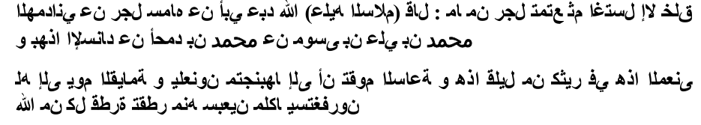
14. Every year, in the Night of Power (Lailat ul Qadr, which occurs in Ramadan), God sends commandments (revelations) to the Imams. (Usool Kaafi, Vol. 1, p. 248)
34. Imams possess authority to declare any thing lawful or unlawful. (Khilaqat-e-Norania, p. 155)
26. Do they make Masah on leather socks?
Maulana Dhorat teaches that Shi'ism was a creation of the Persians in the time of Sayyadina 'Umar (RA) and he further claims that Shi'ism was formed with the aid of the enemies of Islam to ensure that Islam never becomes a political or ideological force in the world. Historical facts trace the origin of Shi'ism to the time of Prophet Muhammad (pbuh), but it became noticeable after the demise of the Prophet.
The above reads more like a confused comic strip, rather than a felicitous greeting!!!
Shia Muslims are particularly worried that ISIS, which regards them as infidels, will trash some of Shia Islam's holiest sites in southern Iraq.
Saudi King roadblock to progress
15. An Angel provides divine revelations to the Imams in the Night of
35. Imamate is a divine rank like Prophethood. An Imam is infallible and every creature in the universe is subject to his command and must obey him. (Tohfa Namaz-e-Jaffria, p. 28)
27. Do they recite peace and salutations on Hadhrat Abu Bakr (RA)?
In addition, please mention one war that the Shi'ites fought against non-
"Iraq and the Iraqi people are facing great danger, the terrorists are not aiming to control just several provinces, they said clearly they are targeting all other provinces including Baghdad, Karbala and Najaf," the statement from Sistani said. "So the responsibility to face them and
28. Do they recite peace and salutations on Hadhrat Umar (RA)?
For the sake of brevity, I was economical in my initial exposition.
July, 2014
29. In Madina we see they do not do so, why?
30. Lately in a Iranian show,they played a Azaan having Hadhrat Ali(RA) it!
Mr Islam, thank you for giving me the opportunity to elaborate. Just
Saudi King Abdullah is the real block to any progress in the kingdom but he thinks only he is fit to rule. The trouble with the Saudi king is that he is alone in his train of thoughts. He thinks that he is a breed apart, a role model for others and knows what is best for every citizen. He treats the national treasury as his personal piggy bank, and assumes his princes-only majlis (democracy Saudi style) can "reach" out to people. He also believes that he is the only one who can rule the country and that Arabia belongs to him and him alone.
An exposition of the lies and deceit in Abdul Salam Islam's Rebuttal of Islamic AwakeninReport entitled "The Extent of Shi'ism in South Africa." By Shaikh Yunus Akhtar
31. In their literature why no praise for Hadhrat Abu Bakr (RA)?
3. "It is blame-worthy to avoid doing Mutah because it is part of the Sunnah to engage in Mutah."
32. Similarly why no praise for Hadhrat Umar (RA)?
33. Similarly why no praise for Hadhrat Usman (RA)?
Significance of Quds Day rallies by Zafar Bangash
34. Similarly why no praise for the Sahaba in general?
July, 2014
They could not see behind them like they could see infront of them. Their excreta was not like that of the Ambiyaa (A.S)
35. If Shia and Sunni is one, then why ask for separate Deeni Syllabus in Pakistan? Why cause riots for this? Why use force to obtain this?
They did not have the authority to make permissible impermissible or the authority to make impermissible permissible.
36. Why have it finally approved?
They are normal Human Beings.
4. "A man may have Mutah with one thousand women."
37. Why have separate Majids in Dubai?
They did not 'make' laws as per their desire but extracted the laws from sources of the Shariat.
A Clear Difference: The Shias believe that the Jafaari Fiqh is not developed via Shaari Sources but attributed to an Imaam who is equal to the Qur'an and can make Haraam-Halaal and Halaal-Haraam. They believe that this Imaam is divinely appointed, nominated and does not need the Qur'aan or the Sunnat. There is a vast difference between an Imaam of Fiqh who is not masoom (innocent) and can err to the Imam of the Jafaari Fiqh who is stated to be masoom (innocent) and someone who cannot err. Study the qualities outlined under the Concept of Imaamology and understand how severely it differs from the qualities of the actual Imaams of Fiqh. Let us make it Simple:
Published by: Mujlisul Ulama of South Africa P.O Box 3393 Port Elizabeth, 6056 South Africa
5. A woman who lets a man do Mutah with her will have all her sins pardoned. It is narrated by Imam Baqir that the Prophet said, "When I was being taken to Heaven during the Miraj (ascension), Jibraeel met me and told me, 'O Muhammad, Allah has promised to forgive all the sins of those women who practise Mutah.'"
They believe in twelve Infallible sinless Imaams who are sinless. If Qadianis are deemed non-Muslims for their stance of regarding Mirza Ghulam Ahmed Qadiani as a prophet, then the Shi'ah are guilty TWELVEFOLD of the same sin which undoubtedly throws them out of the pale of Islam.
This is glaring kufr (disbelief), in the face of which Shi'ism can never ever lay a claim to be Islam. To explain in detail:
The Shi'ah believe in DIVINE Imams, consisting of Sayyadina 'Ali and a select number of his descendants. The number and identity of these Imams varies from one Shia sect to another, some of them believe in only 7 Imams while others believe in 12 Imams. The largest Shi'ah sect (known as the Twelvers) believe in 12 Imams who are: (1) Ali, (2) Al-Hasan, (3) Al-Hussain, (4) Zain Al-Abideen, (5) Muhammad Al-Baqar, (6) Jaffar Sadiq, (7) Moosa Kazim, (8) Ali Al-Ridah, (9) Al-Taqi, (10) Al-Naqi, (11) Hassan Askari, and (12) Al-Mahdi.
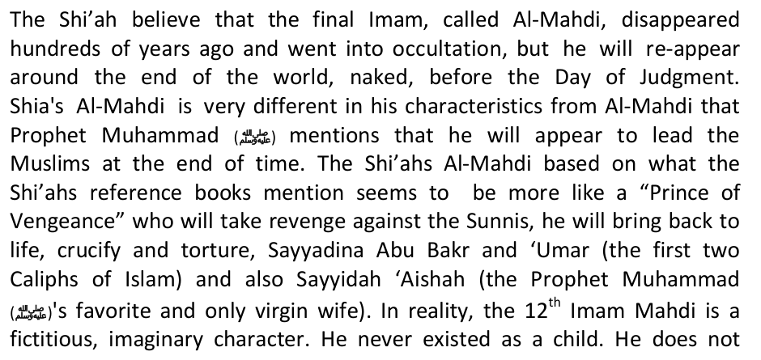
Was Salaam

Like the Qur'aan, Are free from sin, Can make Halaal-Haraam and Haraam-Halaal, Are higher in status than the Ambiyaa (A.S).
Y. Akhtar
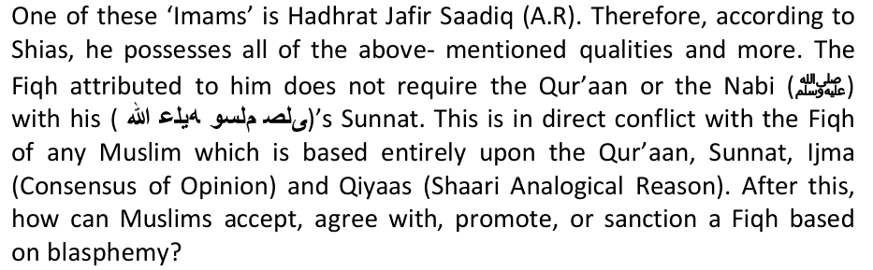

Usage of the word 'Imaam' by the Ahlus Sunnat wal Jammat: When the word Imaam is used – for example: 'Imaam' Abu Hanifa (A.R) or 'Imaam' Bukhaari (A.R), then the word 'Imaam' denotes an expert, an authority, and a leader in that particular field, be it Fiqh, Hadith, Qiraat, Tafseer, Tasawwuf or Ilm e Kalaam. The Ahlus Sunnat wal Jamaat do not attribute the qualities of Imaamat to Imaams that the Shias attribute to their Imaams.
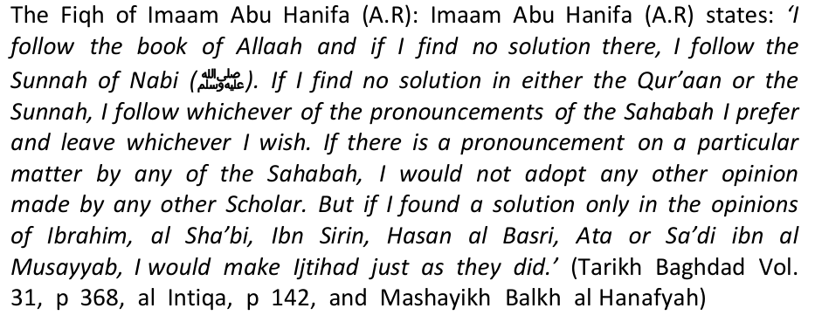
Sayyidina Ibn Abbas related: 'When Umar was martyred, prior to burial his body was prepared and shrouded. Those Companions who were close to him, were close to his body and supplicating for him. Directly behind me was Ali, he was saying: 'May the mercy of Allah be upon you O Umar, I have complete certainty that Allah will keep you with your two companions. As I have frequently heard from the Prophet: 'Me, Abu Bakr and Umar…' 'I went with Abu Bakr and Umar' 'I left with Abu Bakr and Umar.' (Saheeh Bukhari/ Mishkaat al-Masabih)
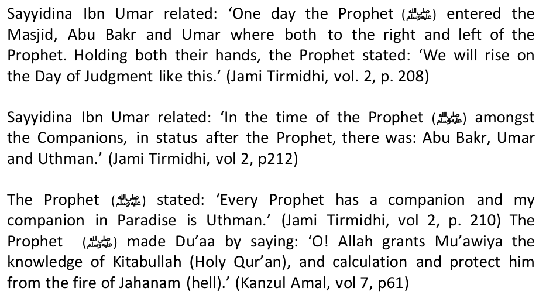
9. The Messenger of Allah said, "When he took me to the skies, Jibraeel (a.s) said: 'O Muhammad, Allah Almighty said: Amongst the women, I will forgive those who make Mutah twice.'"
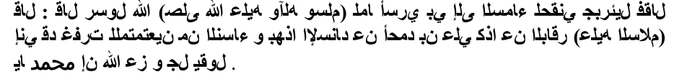
15. Imam Abu Abdullah (a.s) said: "There is no Mutah without two matters defined: time and named wage."
This is the lowest the Shia can get when sleeping with a prostitute and get instant Paradise. However for the Shia this can never be enough. They have still worse to come. Infact the amount of Shia references would be enough to fill a book on this subject.. as the Shia indeed try at every step to justify this forbidden act. In the same Shia book mentioned above (Minhaj), it is written in clear words that the number of women

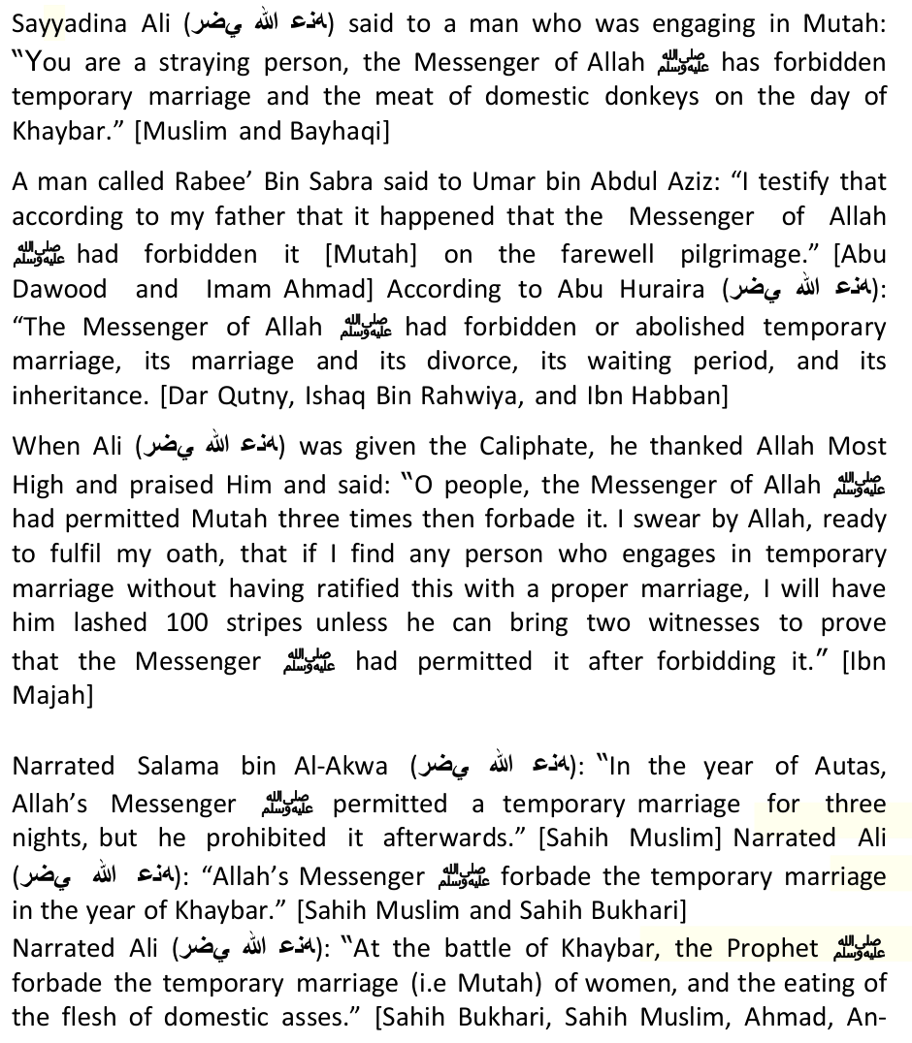
Allah has stated in the Holy Qur'an: 'And those who came after them say: ''Our Lord! Forgive us and our brethren who have preceded us in Faith, and put not in our hearts any hatred against those who have believed...'' (S. 59, V. 10) Ibn Abbas relates in the explanation of the above verse:'Allah has ordered the True Believers (Mumineen) to seek forgiveness for the Muhajireen and Ansar. This is even due to the fact that Allah was fully aware that there would be war and disputes between them (The battle of the Camel). The Scholars of Islam have stated: 'It is clear from this verse of the Qur'an that after the time of the Companions, that any individual (Muslim) who does not love the Companions of the Prophet and make Du'a for their forgiveness has no part in Islam.'
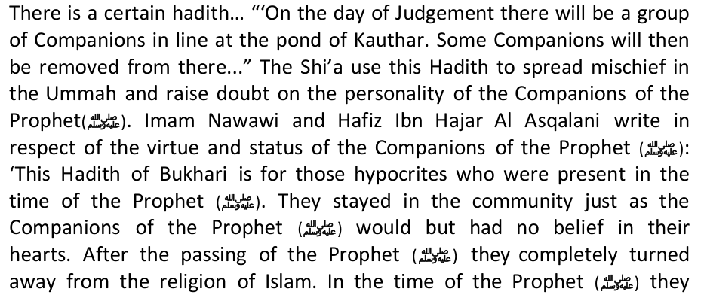

Besides the above arguments, the Twelvers (Ithna 'Asharis) don't regard the Bohras as Muslims, and yet they are permitted to perform Hajj. Did they also suddenly became Muslims? Shi'ahs don't even regard us Sunnis and Salafis as Muslims, so why are we also permitted in Makkah and Madinah?
Mr Islam, I honestly think that you are losing your marbles and not making much sense here. A few Red Bulls to keep your mind alert may do the trick!!
Muslims look up to learned men for guidance, but what happens if the counsel they give is misguided? It is known in academic circles that information should be supported by evidence, otherwise that information has no substance and it qualifies to be branded futile.
Many many questions being asked here! Maybe you, the hotshot Shi'ah, could help us solve the following riddle that thousands of Shi'ahs can not answer satisfactorily for us.
1. Why only 3 salaat times are mentioned in Tehran Times?
2. Are there any Churches in Tehran and their number?
3. Are there any Temples in Tehran and their number?
4. Are there any Sikh Temples in Tehran and their number?
5. Are there any Fire-Worshippers Temples in Tehran and their number?
6. Are there any Sunni Masjids in Tehran and their number? Tehran is the Capital of Iran.
The Qadiani's believed in one imposter as a Nabi after the Final Nabi
7. The Muslims were performing Jumuah Salaat in Tehran at the Pakistani Embassy-does this still go on? Or has it being stopped? And why?
8. Are there any Hifz Madressahs in Iran? Where? How many? Number of Hafiz that qualified during the last 3 years?
9. Are the Shias performing Taraweeh Salaat in Iran? Where? How many Rakaats? Name some Masjids?
10. In literature from Iran after the name of Hadhrat Fathima - (AS) is

The famous Shia Scholar, Ibn Babawaih al-Qummi, nicknamed al-Sadooq (the truthful), wrote: "Our belief is that whoever denies the Imamah of Amirul-Mu'mineen Ali bin Abi Talib and the Imams after him is equal to the denial the Prophethood of all the Prophets. We further believe that whoever recognizes (the Imamah of) Amirul-Mu'mineen but denies one of the Imams, is like one who admits and recognizes all the Prophets but denies the Prophethood of Muhammad [pbuh]. (Al-I'tiqadaat: Ibn Babawaih al-Qummi, p. 103, from: 'Aqeedat al-Imamah, Dr. Ali As-Saloos, p.28)

Al-Mufeed, a leading scholar among Twelver Shi'ites, and who was the teacher of Abu Ja'far At-Tusi who became a top Shia Scholar, wrote as quoted by Al-Majlisi: "The consensus of all Twelver Shia is that whoever denies the Imamah of any Imam, and denies the allegiance imposed by Allah Ta'ala for him (the Imam), then he's a Kafir deviant, deserving eternal Hell." (Bihaar al-Anwaar: Muhammad Baqir al-Majlisi, vol.23, p.390, from Aqeedat al-Imamah: Dr. Ali As-Saloos, p.29)
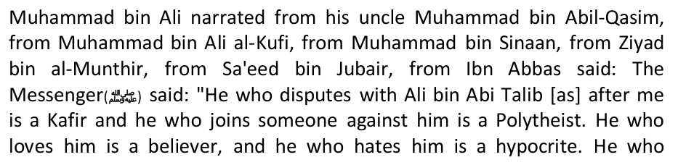

Hakimul Islam, Hadhrat Qari Muhammad Tayib stated: 'The scholars of Deoband have been blessed with a great favour of Allah, in that we do not distinguish between the Companions of the Prophet. The Sahabah were not Prophets or Messengers, but are the greatest in status from amongst the rest of creation. The most pious from amongst the Muslim masses cannot even reach close to the status of the lowest Companion. This is the belief of the Ahle Sunnat Wal Jamat, Alhamdulillah the scholars of Deoband are amongst the true inheritors of

The connotation of Al-Jama'ah refers to none other than that the people of the Sunnah for they certainly are the true followers of Rasulullah and his Companions. In Sharh 'Aqidah At-Thahawiyah, Imam Ibn Abi Al-Izz Al-Hanafi has mentioned, "Al-Jama'ah is the group of Muslimin from the Sahabah, Tabi'in and those of the Muslims who are persistently following them until the Day of Judgment." Jama'ah, in this context specifically means the jama'ah of the sahabah since they were the pioneers through which the foundation and path of the deen were established.
They could have not agreed on matters of misguidance, although this may happened to the later generations as history has proven. Sheikh Al-Islam Ibn Taimiyah in his Majmu' al-Fatawa has summarized the term Ahl Al-Sunnah wa Al-Jama`ah in the following words: "It is called Ahl Al-Sunnah wa Al-Jama`ah because they with the majority of the ummah stand on the truth and not with the separated group, people of innovations, followers of desires, who has deviated far from the firqah alTo summarize the Hanafi Fiqh it is stated: 'Fiqh is planted by Ibn Mas'ood (R.A); watered by Alqamah (R.A); harvested by Ibrahim Naqi (R.A); collected by Hammad (R.A); grounded by Imaam Abu Hanifa (A.R); kneaded by Imaam Abu Yusuf (A.R); made into bread by Muhammad (A.R) and all are eating the ready made bread.' (Durre-Mukhtaar, Volume 1, Page 34) Any intelligent, Imaan-filled person will be able to see the glaring differences between Islaam and anti-Islaam; Haqq and Baatil; Truth and Falsehood; Authentic and Counterfeit. After understanding the basic fundamental difference then there is no need to go into finer details.
How can any sensible human being, let alone a Muslims, adopt a religion that: Legalizes prostitution via Muta (temporary marriage). Regard it rewarding to deceive and lie via Taqiyya (holy deception). Consider swearing, cursing, and abusing to be rewarding via Tabarra (cursing of the Ambiyaa (A.S) and Sahabah (R.A)?
Those who are trying to promote this spurious 'fifth mazhab' called 'Jafari Fiqh' should ponder and deliberate carefully for they are aiding the worst sort of kufr openly. One must study diligently to avoid making wrong declarations. Every effort must be made to protect the

(Fathul Bari Sharah Bukhari vol 2, p269/ Tareekh Baghdad vol. 2, p247/ Ahkamul Qur'an vol. 1, p17)
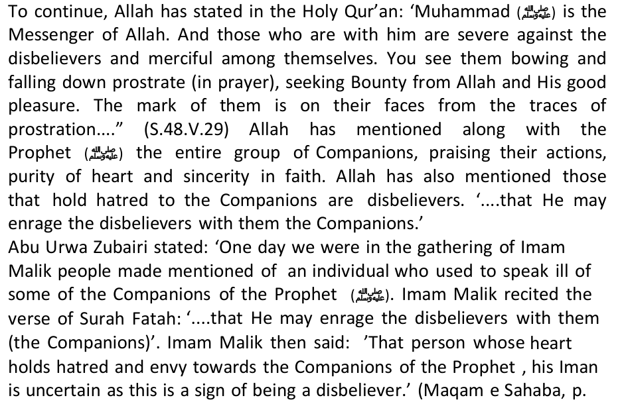
So he gestured to me with his hand and said: 'Even the blood money of this! (as if he was angry)' I said: 'This, by Allaah, is knowledge.' He said: 'Indeed it is knowledge, and that's not it.' Then he remained silent for a while, then he said: 'Indeed we have Al-Jafr; and what will make you know what Al-Jafr is?' I said: 'What is Al-Jafr?' He said: 'A receptacle from Adam which contains the knowledge of the Prophets and the Ambassadors;knowledge of the scholars who have passed from the Children of Israa'eel.' I said: 'Indeed this is knowledge.' He said: 'Indeed this is knowledge; and that's not it.'
Then he remained silent for a while and said: 'Indeed we have the Mus-haf of Faatimah, upon her be peace. What will make you know what the
QURAN
Almighty Allah has promised to protect the Quran from corruption and alteration. "Indeed, it is We who sent down the Qur'an and indeed, We will be its protector." Quran 15: 9 Allah never breaks His promises, so whoever says Shi'as have altered the Quran, belies Allah.
Sunni and Shi'a Muslims believe in the same Quran that was revealed to the Prophet (pbuh).
Yes, Allah never break his promise, that is why the Shi'ah Qur'an is with the invisible non-existent phantom Imam in the cave !!
Conclusion
Attempts to destabilize Islam have been made and will continue to be made, but they will not succeed because Allah has commanded the Prophet (pbuh) to proclaim what has been revealed to him, and He promised him that he will protect him (Quran5:67). Islam is a peaceful religion that teaches tolerance and righteousness, it constantly reminds its adherents that they will meet their Creator and account for their deeds, good or bad. Muslims are encouraged to enjoin what is good, and forbid evil, yet some people direct Muslims towards wickedness, lies,

After researching the Holy Qur'an and collections of Hadith, there are only two conditions upon which the proclamation of war has been threatened by Allah Himself. (1) The consumption and dealing with interest. (2) The ones who trouble Awliya (the pious servants of Allah ). (Sahih al-Bukhari, Kitab al-Riqaq)
Allah has stated in the Holy Qur'an: 'Allah is well pleased with Sahabah and they are well pleased with Allah …' (s9:100/ s58:22/

4. When Ansar wanted to take Caliphate even with the force of sword, they dropped their idea just because of the saying of Prophet(saw), then

"'You are the best of people ever raised up for Mankind; you enjoin good and forbid evil and you believe in Allah....' (S. 3,v. 110)
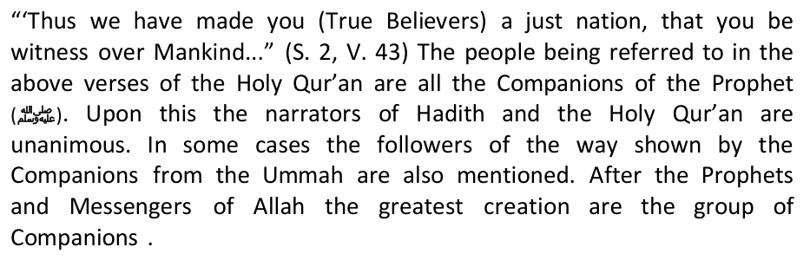

The extent of Shi'ism in South Africa 1
The extent of Shi'ism in South Africa 2


The extent of Shi'ism in South Africa 3
The extent of Shi'ism in South Africa 4
The extent of Shi'ism in South Africa 5
The extent of Shi'ism in South Africa 6
The extent of Shi'ism in South Africa 7
The extent of Shi'ism in South Africa 8
The extent of Shi'ism in South Africa 9
The extent of Shi'ism in South Africa 10
The extent of Shi'ism in South Africa 11
The extent of Shi'ism in South Africa 12
The extent of Shi'ism in South Africa 13
The extent of Shi'ism in South Africa 14
The extent of Shi'ism in South Africa 15
The extent of Shi'ism in South Africa 16
The extent of Shi'ism in South Africa 17
The extent of Shi'ism in South Africa 18
The extent of Shi'ism in South Africa 19
The extent of Shi'ism in South Africa 20
The extent of Shi'ism in South Africa 21
The extent of Shi'ism in South Africa 22
The extent of Shi'ism in South Africa 23
The extent of Shi'ism in South Africa 24
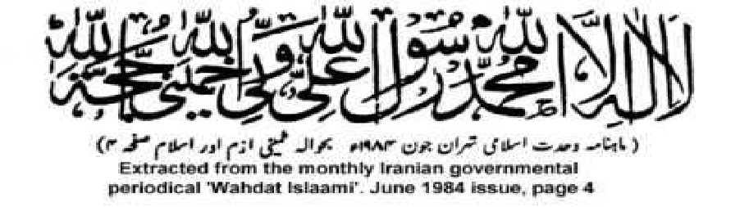
The extent of Shi'ism in South Africa 25
The extent of Shi'ism in South Africa 26
The extent of Shi'ism in South Africa 27
The extent of Shi'ism in South Africa 28
The extent of Shi'ism in South Africa 29
The extent of Shi'ism in South Africa 30
The extent of Shi'ism in South Africa 31
The extent of Shi'ism in South Africa 32
The extent of Shi'ism in South Africa 33
The extent of Shi'ism in South Africa 34
The extent of Shi'ism in South Africa 35
The extent of Shi'ism in South Africa 36
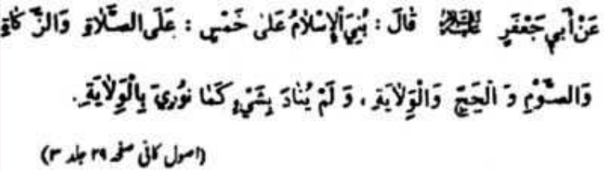
The extent of Shi'ism in South Africa 37
The extent of Shi'ism in South Africa 38
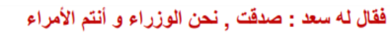
The extent of Shi'ism in South Africa 39
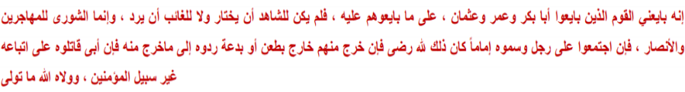
The extent of Shi'ism in South Africa 40
The extent of Shi'ism in South Africa 41
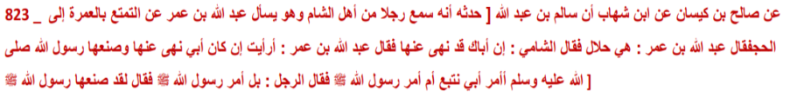
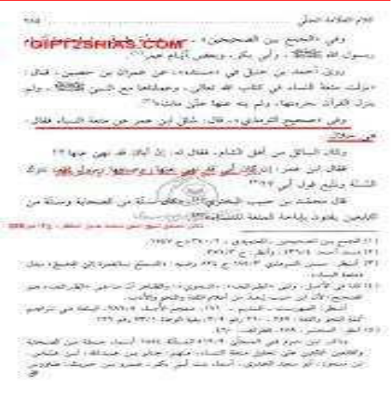
The extent of Shi'ism in South Africa 42
The extent of Shi'ism in South Africa 43
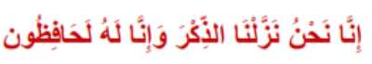
The extent of Shi'ism in South Africa 44
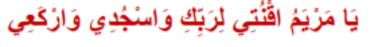
The extent of Shi'ism in South Africa 45
The extent of Shi'ism in South Africa 46
The extent of Shi'ism in South Africa 47
The extent of Shi'ism in South Africa 48
The extent of Shi'ism in South Africa 49
The extent of Shi'ism in South Africa 50
The extent of Shi'ism in South Africa 51
The extent of Shi'ism in South Africa 52
The extent of Shi'ism in South Africa 53
The extent of Shi'ism in South Africa 54
The extent of Shi'ism in South Africa 55
The extent of Shi'ism in South Africa 56
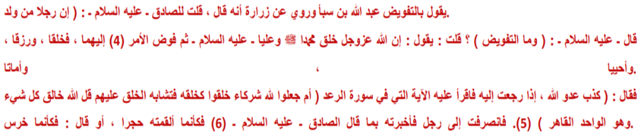
The extent of Shi'ism in South Africa 57
The extent of Shi'ism in South Africa 58
The extent of Shi'ism in South Africa 59
The extent of Shi'ism in South Africa 60
The extent of Shi'ism in South Africa 61
The extent of Shi'ism in South Africa 62
The extent of Shi'ism in South Africa 63
The extent of Shi'ism in South Africa 64
The extent of Shi'ism in South Africa 65
The extent of Shi'ism in South Africa 66
The extent of Shi'ism in South Africa 67
The extent of Shi'ism in South Africa 68
The extent of Shi'ism in South Africa 69
The extent of Shi'ism in South Africa 70
The extent of Shi'ism in South Africa 71
The extent of Shi'ism in South Africa 72
The extent of Shi'ism in South Africa 73
The extent of Shi'ism in South Africa 74
The extent of Shi'ism in South Africa 75
The extent of Shi'ism in South Africa 76
The extent of Shi'ism in South Africa 77
The extent of Shi'ism in South Africa 78
The extent of Shi'ism in South Africa 79
The extent of Shi'ism in South Africa 80
The extent of Shi'ism in South Africa 81
The extent of Shi'ism in South Africa 82
The extent of Shi'ism in South Africa 83
The extent of Shi'ism in South Africa 84
The extent of Shi'ism in South Africa 85
The extent of Shi'ism in South Africa 86
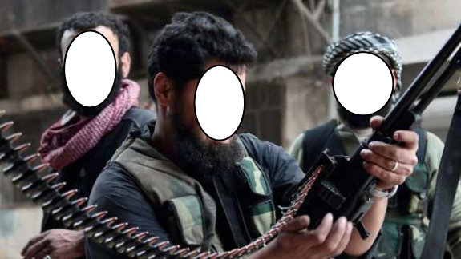
The extent of Shi'ism in South Africa 87
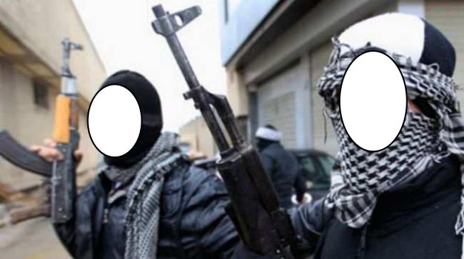
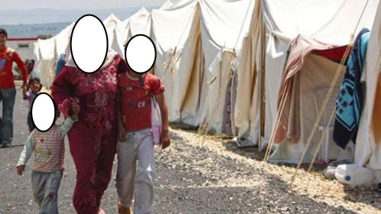
The extent of Shi'ism in South Africa 88
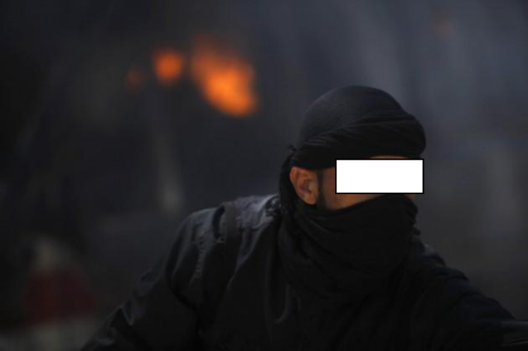
The extent of Shi'ism in South Africa 89
The extent of Shi'ism in South Africa 90
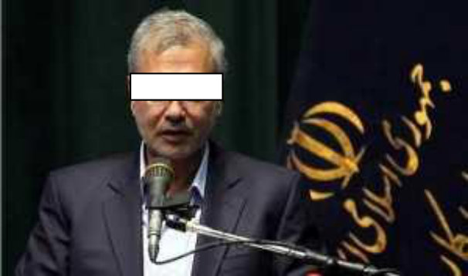
The extent of Shi'ism in South Africa 91

The extent of Shi'ism in South Africa 92
The extent of Shi'ism in South Africa 93
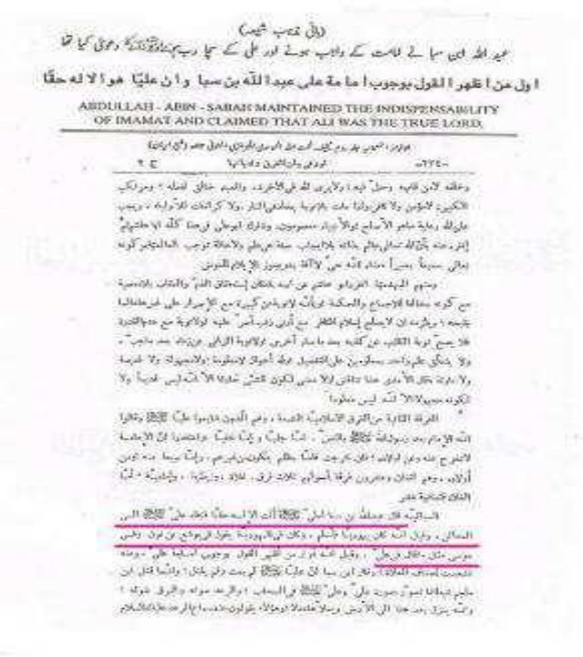
The extent of Shi'ism in South Africa 94
The extent of Shi'ism in South Africa 95
The extent of Shi'ism in South Africa 96
The extent of Shi'ism in South Africa 97
The extent of Shi'ism in South Africa 98
The extent of Shi'ism in South Africa 99
The extent of Shi'ism in South Africa 100
The extent of Shi'ism in South Africa 101
The extent of Shi'ism in South Africa 102
The extent of Shi'ism in South Africa 103
The extent of Shi'ism in South Africa 104
The extent of Shi'ism in South Africa 105
The extent of Shi'ism in South Africa 106
The extent of Shi'ism in South Africa 107
The extent of Shi'ism in South Africa 108
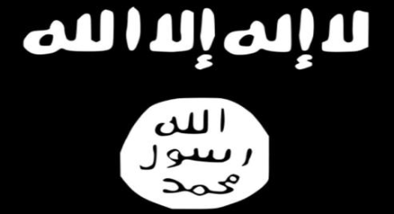
The extent of Shi'ism in South Africa 109
The extent of Shi'ism in South Africa 110
The extent of Shi'ism in South Africa 111
The extent of Shi'ism in South Africa 112
The extent of Shi'ism in South Africa 113
The extent of Shi'ism in South Africa 114
The extent of Shi'ism in South Africa 115
The extent of Shi'ism in South Africa 116
The extent of Shi'ism in South Africa 117
The extent of Shi'ism in South Africa 118
The extent of Shi'ism in South Africa 119
The extent of Shi'ism in South Africa 120
The extent of Shi'ism in South Africa 121
The extent of Shi'ism in South Africa 122
The extent of Shi'ism in South Africa 123
The extent of Shi'ism in South Africa 124
The extent of Shi'ism in South Africa 125
The extent of Shi'ism in South Africa 126
The extent of Shi'ism in South Africa 127
The extent of Shi'ism in South Africa 128
The extent of Shi'ism in South Africa 129
The extent of Shi'ism in South Africa 130
The extent of Shi'ism in South Africa 131
The extent of Shi'ism in South Africa 132
The extent of Shi'ism in South Africa 133
The extent of Shi'ism in South Africa 134
The extent of Shi'ism in South Africa 135
The extent of Shi'ism in South Africa 136
The extent of Shi'ism in South Africa 137
The extent of Shi'ism in South Africa 138
The extent of Shi'ism in South Africa 139
The extent of Shi'ism in South Africa 140
The extent of Shi'ism in South Africa 141
The extent of Shi'ism in South Africa 142
The extent of Shi'ism in South Africa 143
The extent of Shi'ism in South Africa 144
The extent of Shi'ism in South Africa 145
The extent of Shi'ism in South Africa 146
The extent of Shi'ism in South Africa 147
The extent of Shi'ism in South Africa 148
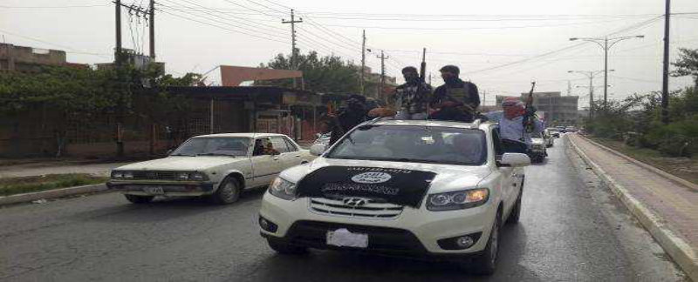
The extent of Shi'ism in South Africa 149
The extent of Shi'ism in South Africa 150
The extent of Shi'ism in South Africa 151
The extent of Shi'ism in South Africa 152
The extent of Shi'ism in South Africa 153
The extent of Shi'ism in South Africa 154
The extent of Shi'ism in South Africa 155
The extent of Shi'ism in South Africa 156
The extent of Shi'ism in South Africa 157
The extent of Shi'ism in South Africa 158
The extent of Shi'ism in South Africa 159
The extent of Shi'ism in South Africa 160
The extent of Shi'ism in South Africa 161
The extent of Shi'ism in South Africa 162
The extent of Shi'ism in South Africa 163
The extent of Shi'ism in South Africa 164
The extent of Shi'ism in South Africa 165
The extent of Shi'ism in South Africa 166
The extent of Shi'ism in South Africa 167
The extent of Shi'ism in South Africa 168
The extent of Shi'ism in South Africa 169
The extent of Shi'ism in South Africa 170
The extent of Shi'ism in South Africa 171
The extent of Shi'ism in South Africa 172
The extent of Shi'ism in South Africa 173
The extent of Shi'ism in South Africa 174
The extent of Shi'ism in South Africa 175
The extent of Shi'ism in South Africa 176
The extent of Shi'ism in South Africa 177
The extent of Shi'ism in South Africa 178
The extent of Shi'ism in South Africa 179
The extent of Shi'ism in South Africa 180
The extent of Shi'ism in South Africa 181
The extent of Shi'ism in South Africa 182
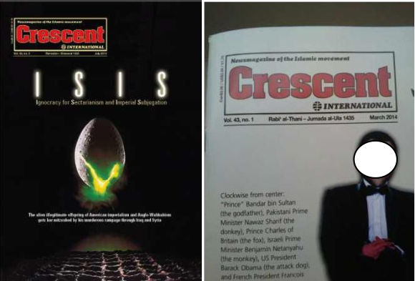
The extent of Shi'ism in South Africa 183
The extent of Shi'ism in South Africa 184
The extent of Shi'ism in South Africa 185
The extent of Shi'ism in South Africa 186
The extent of Shi'ism in South Africa 187
The extent of Shi'ism in South Africa 188
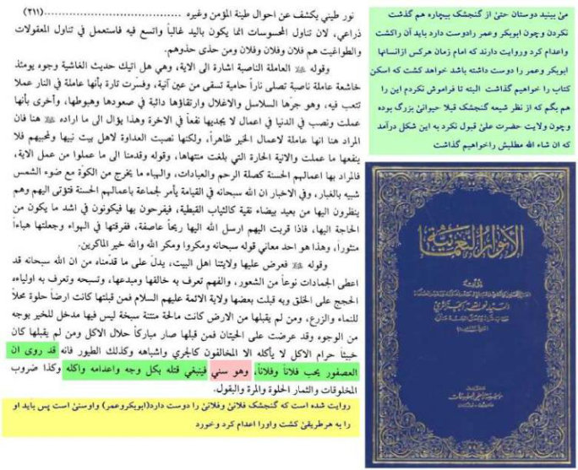
The extent of Shi'ism in South Africa 189
The extent of Shi'ism in South Africa 190
The extent of Shi'ism in South Africa 191
The extent of Shi'ism in South Africa 192
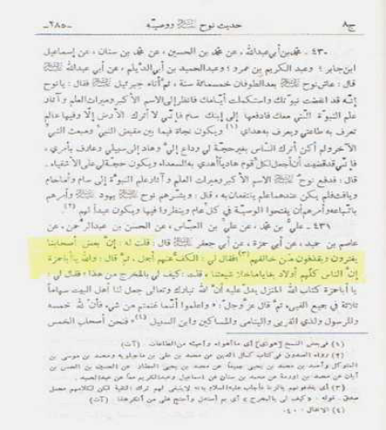
The extent of Shi'ism in South Africa 193
The extent of Shi'ism in South Africa 194
The extent of Shi'ism in South Africa 195
The extent of Shi'ism in South Africa 196
The extent of Shi'ism in South Africa 197
The extent of Shi'ism in South Africa 198
The extent of Shi'ism in South Africa 199
The extent of Shi'ism in South Africa 200
The extent of Shi'ism in South Africa 201
The extent of Shi'ism in South Africa 202
The extent of Shi'ism in South Africa 203
The extent of Shi'ism in South Africa 204
The extent of Shi'ism in South Africa 205
The extent of Shi'ism in South Africa 206
The extent of Shi'ism in South Africa 207
The extent of Shi'ism in South Africa 208
The extent of Shi'ism in South Africa 209
The extent of Shi'ism in South Africa 210
The extent of Shi'ism in South Africa 211
The extent of Shi'ism in South Africa 212
The extent of Shi'ism in South Africa 213
The extent of Shi'ism in South Africa 214
The extent of Shi'ism in South Africa 215
The extent of Shi'ism in South Africa 216
The extent of Shi'ism in South Africa 217
The extent of Shi'ism in South Africa 218
The extent of Shi'ism in South Africa 219
The extent of Shi'ism in South Africa 220
The extent of Shi'ism in South Africa 221
The extent of Shi'ism in South Africa 222
The extent of Shi'ism in South Africa 223
The extent of Shi'ism in South Africa 224
The extent of Shi'ism in South Africa 225
The extent of Shi'ism in South Africa 226
The extent of Shi'ism in South Africa 227
The extent of Shi'ism in South Africa 228
The extent of Shi'ism in South Africa 229
The extent of Shi'ism in South Africa 230
The extent of Shi'ism in South Africa 231
The extent of Shi'ism in South Africa 232
The extent of Shi'ism in South Africa 233
The extent of Shi'ism in South Africa 234
The extent of Shi'ism in South Africa 235
The extent of Shi'ism in South Africa 236
The extent of Shi'ism in South Africa 237
The extent of Shi'ism in South Africa 238
The extent of Shi'ism in South Africa 239
The extent of Shi'ism in South Africa 240
The extent of Shi'ism in South Africa 241
The extent of Shi'ism in South Africa 242
The extent of Shi'ism in South Africa 243
The extent of Shi'ism in South Africa 244
The extent of Shi'ism in South Africa 245
The extent of Shi'ism in South Africa 246
The extent of Shi'ism in South Africa 247
The extent of Shi'ism in South Africa 248
The extent of Shi'ism in South Africa 249
The extent of Shi'ism in South Africa 250
The extent of Shi'ism in South Africa 251
The extent of Shi'ism in South Africa 252

